Genetic Variability, Heritability and Genetic Advance for Yield and Yield-Attributing Traits in Rice (Oryza sativa L.) Under Phosphorus Deficiency

ABSTRACT

Phosphorus-deficient soils can limit rice performance, making the identification of selectable variation under low-phosphorus conditions important for breeding. The 38 recombinant inbred lines (RILs) of Improved Samba Mahsuri (ISM) × LR-299 and their two parents were evaluated as single, unreplicated plots in a four-block augmented design (Federer, 1956) at ICAR-Indian Institute of Rice Research, Rajendranagar, Hyderabad, Telangana, India, during Kharif 2024, under low-phosphorus field conditions, with four check varieties (Rasi, Swarna, ISM, DRR Dhan 60) repeated in every block to supply an independent error term. Block effects were estimated from the replicated checks and used to adjust test-entry values; analysis of variance was then carried out on the 40 block-adjusted entry means and tested against the check-derived error term. Genotypic and phenotypic coefficients of variation (GCV, PCV), broad-sense heritability (h²bs) and genetic advance as per cent of mean (GAM) were computed for days to 50% flowering (DFF), plant height (PH), number of tillers (NT), number of productive tillers (NPT), number of grains per panicle (NGP), spikelet fertility (SF) and grain yield per plant (GY). Entries differed significantly for DFF, PH, NGP and GY; NT and NPT did not differ significantly. PH, NGP and GY combined high heritability (91.65%, 91.97%, 65.72%) with high GAM (32.07%, 43.08%, 36.14%), identifying them as reliable, directly selectable criteria. Entries IX299-160-2, IX299-87-1, IX299-150 and IX299-177 recorded the highest block-adjusted grain yield among the 40 entries evaluated and are proposed as candidate donors for phosphorus-use-efficiency breeding. Plant height, grains per panicle and grain yield are governed predominantly by additive gene action in this population and are recommended as primary selection criteria for phosphorus use efficiency breeding, with the four identified entries advanced for further, replicated evaluation.

Keywords
Rice; phosphorus deficiency; heritability; genetic advance; genetic variability; augmented design

1. INTRODUCTION
Rice (Oryza sativa L.) is the staple food crop for more than half of the world's population, and a considerable proportion of the rice-growing area is characterised by phosphorus (P)-deficient soils, particularly across peninsular India, where fixation by iron and aluminium oxides renders much of the native and applied phosphorus unavailable to the plant (Holford, 1997). Unlike nitrogen, phosphorus applied as fertiliser exhibits limited mobility in the soil and is only partially utilised within a single season. Genetic improvement for phosphorus-use efficiency, therefore, offers a more sustainable solution than fertiliser management alone (Wissuwa & Ae, 2001). Recent reviews describe the genetic regulation of phosphate acquisition and utilisation in rice as relevant to improving phosphorus-use efficiency (Lu et al., 2023). Physiological and genetic differences in phosphorus uptake and utilisation have also been reported among rice genotypes, including comparisons involving Improved Samba Mahsuri (Kohli et al., 2025).
Prior to the initiation of a breeding programme targeting a particular trait (Allard, 1960), it is essential to establish that the trait exhibits genuine genetic variability in the population under study, since a trait of physiological importance is of limited utility for selection if the variation observed is largely attributable to experimental error rather than genotype (Johnson et al., 1955). Partitioning of phenotypic variance into its genotypic and environmental components, and its expression as heritability and genetic advance, remains the most direct approach for making this distinction (Panse & Sukhatme, 1954; Burton & De Vane, 1953; Robinson et al., 1949; Comstock & Robinson, 1952). Combining-ability analysis in rice under aerobic growing conditions has likewise identified variation in yield-related genetic responses, although these findings relate to the specific parental materials and conditions examined (Ojah et al., 2025).
Genetic variability for yield and yield-attributing traits under low-phosphorus stress has been reported in rice (Solangi et al., 2020; Singh et al., 2021; Basavaraj et al., 2022); however, such estimates are specific to the germplasm, environment and experimental design employed, and are only as reliable as the error term against which they are tested. In unreplicated germplasm trials, which are routinely encountered while screening large numbers of breeding lines such as recombinant inbred lines (RILs), an augmented block design with replicated checks provides a practical means of obtaining a valid error term without replicating every entry (Federer, 1956). A low-phosphorus field study using an augmented block design also reported genetic variability for rice yield and associated traits (Harisha et al., 2024). In a separate investigation of rice accessions grown in low-phosphorus acidic soils, grain yield and phosphorus-use efficiency varied among the evaluated genotypes (James et al., 2024).
These findings do not, however, establish whether the Improved Samba Mahsuri × LR-299 recombinant inbred lines evaluated here have sufficient variation in yield-attributing traits to support selection under low-phosphorus field conditions.
The present investigation employs this approach in an RIL population derived from Improved Samba Mahsuri × LR-299, evaluated under low-phosphorus field conditions, with the objective of determining which yield-attributing traits possess sufficient genetic variability to serve as reliable selection criteria, and identifying lines suitable for advancement as donors.

2. MATERIALS AND METHODS

2.1 Experimental material and design
The experiment was conducted at ICAR-Indian Institute of Rice Research (ICAR-IIRR), Rajendranagar, Hyderabad (17°19′ N, 78°23′ E, Telangana, India), during Kharif 2024, under low-phosphorus conditions (available soil P 2–5 kg ha⁻¹, no P fertiliser applied). Forty entries — 38 RILs derived from Improved Samba Mahsuri (ISM, P-sensitive) × LR-299 (P-tolerant landrace) and the two parental lines — were evaluated as single, unreplicated plots in a four-block augmented design (Federer, 1956). Each block additionally carried all four check varieties (Rasi, Swarna, ISM, DRR Dhan 60), giving four independent replications of each check across the trial and allowing experimental error to be estimated independently of the unreplicated test entries. Seedlings were transplanted 30 days after sowing at 20 cm × 15 cm spacing.
Table 1. List of genotypes (38 RILs of ISM × LR-299 and their two parents) evaluated under low-phosphorus conditions, by block of evaluation
Block-1 | Block-2 | Block-3 | Block-4
LR-299 (P) | IX299-43 | IX299-100 | IX299-160-2
ISM (P) | IX299-53 | IX299-102 | IX299-166
IX299-1 | IX299-56 | IX299-102-1 | IX299-166-1
IX299-2 | IX299-56-1 | IX299-105 | IX299-169
IX299-13 | IX299-70 | IX299-111 | IX299-177
IX299-17 | IX299-87 | IX299-126 | IX299-188
IX299-20 | IX299-87-1 | IX299-156 | IX299-42
IX299-22 | IX299-94 | IX299-160 | IX299-82
IX299-41 | IX299-96 | IX299-164 | IX299-95
IX299-41-1 | IX299-97 | IX299-160-1 | IX299-150
Each block additionally carried the four check varieties Rasi, Swarna, ISM and DRR Dhan 60, repeated across all four blocks for estimation of error.

2.2 Traits recorded
Days to 50 per cent flowering (DFF), plant height (PH, cm), number of tillers per plant (NT), number of productive tillers per plant (NPT), number of grains per panicle (NGP), spikelet fertility (SF, %) and grain yield per plant (GY, g) were recorded on five randomly selected plants per entry and averaged to a single plot value.

2.3 Statistical analysis
Block effects were estimated from the four replicated checks: for each trait, a two-way (check × block) model was fitted, and the residual mean square (df = 9) was taken as the experimental error (σ²e). Each block's check-mean deviation from the grand check mean was used to adjust the corresponding test-entry values, removing block effects from otherwise unreplicated entries. Analysis of variance was then carried out on the 40 block-adjusted entry means (df = 39) and tested against the check-derived error term using an F-test. Genotypic variance was estimated as σ²g = MSentry − MSerror (truncated at zero where negative), and phenotypic variance as σ²p = σ²g + σ²e. GCV and PCV were calculated as 100×√(σ²g or σ²p)/mean (Burton & De Vane, 1953) and classified as low (<10%), moderate (10–20%) or high (>20%) (Sivasubramaniam & Madhavamenon, 1973). Broad-sense heritability (h²bs = σ²g/σ²p × 100) was classified as low (<30%), moderate (30–60%) or high (>60%) (Robinson et al., 1949). Genetic advance was calculated as GA = k·σp·h²bs (k = 2.06 at 5 per cent selection intensity) (Johnson et al., 1955; Falconer & Mackay, 1996) and expressed as a percentage of the mean (GAM), classified as low (<10%), moderate (10–20%) or high (>20%). All calculations followed standard procedures (Gomez & Gomez, 1984; Panse & Sukhatme, 1954) using R software, version 4.3 (R Core Team, 2023).

3. RESULTS AND DISCUSSION

3.1 Analysis of variance
Table 2 presents the entry and error mean squares and F-values obtained for each trait. Entries differed significantly for DFF (P = .049), PH (P < .001), NGP (P < .001) and GY (P = .045), while spikelet fertility approached significance (P = .07), confirming that the augmented design successfully captured genuine genotypic differences for the majority of the yield-attributing traits recorded. NT and NPT recorded comparatively uniform performance across entries (P = .31 and P = .33, respectively) in the present trial.
Table 2. Analysis of variance (block-adjusted entry means vs. check-derived error) for seven traits under low-phosphorus conditions
Trait | Entry MS (df=39) | Error MS (df=9) | F | P-value
DFF | 23.81 | 8.34 | 2.85 | .049
PH | 222.09 | 18.55 | 11.98 | <.001
NT | 2.53 | 1.82 | 1.39 | .31
NPT | 1.97 | 1.46 | 1.35 | .33
NGP | 222.70 | 17.89 | 12.45 | <.001
SF | 118.91 | 46.26 | 2.57 | .07
GY | 5.11 | 1.75 | 2.92 | .045
Entries significant at P < .05 recorded P-values below .05 in the table above; DFF, PH, NGP and GY met this threshold.

3.2 Genetic variability, heritability and genetic advance
Table 3 summarises the genetic parameters, and Fig. 1 and Fig. 2 present them graphically. NGP (GCV 21.81%, PCV 22.74%) and GY (GCV 21.64%, PCV 26.69%) showed high GCV and PCV, together with high broad-sense heritability (91.97% and 65.72%) and high genetic advance as per cent of mean (43.08% and 36.14%), indicating that these traits are governed predominantly by additive gene action and are directly selectable under phosphorus stress — consistent with reports of high heritability and genetic advance for yield-related traits under low-P conditions in rice (Solangi et al., 2020; Singh et al., 2021; Basavaraj et al., 2022). PH combined high heritability (91.65%) with high GAM (32.07%) and moderate GCV (16.26%), similarly supporting direct selection.
DFF showed low GCV (3.81%) despite moderate-to-high heritability (64.97%) and only moderate GAM (6.32%), implying that although flowering time is under substantial genetic control, the narrow range of genotypic variation present in this material limits the gain achievable by selecting on it alone, a pattern reported previously for flowering time under stress (Girma et al., 2018).
Spikelet fertility showed moderate heritability (61.09%) and moderate-to-high GAM (25.79%), but its ANOVA F-test was only borderline (P = .07), so genetic advance estimates for this trait should be treated cautiously pending a replicated trial.
NT and NPT were expressed consistently across entries in the present trial (Fig. 2), indicating that tiller production was well buffered against genotypic differences under the low-phosphorus conditions imposed here. Tillering remains a trait of established biological significance to phosphorus-deficiency tolerance in rice (Dobermann and Fairhurst, 2000), and the stability recorded for NT and NPT in this population usefully concentrates attention on the traits that differed markedly — plant height, grains per panicle and grain yield — which combine high GCV, heritability and genetic advance and are therefore the most efficient and reliable targets for direct selection in this material (Hallauer & Miranda, 1988; Wricke & Weber, 1986; Fehr, 1987).

3.3 Component-trait relationship with grain yield
The pattern of genetic parameters recorded in this trial is explained by the position of each trait in the yield-formation sequence. Grain yield per plant is the final product of three sequential components: the number of productive tillers established, the number of grains set on each panicle, and the proportion of those grains that fill (spikelet fertility). Under phosphorus deficiency, panicle differentiation and grain-number determination are the growth stages most sensitive to phosphorus supply, because phosphorus is required directly for ATP-dependent assimilate transport and nucleic acid synthesis during spikelet development. This explains why NGP carried the highest heritability (91.97%) and the highest GAM (43.08%) of all seven traits examined: genotypes differing in their capacity to maintain spikelet number under phosphorus stress differed consistently and heritably in this trial. Plant height, which is determined earlier in the crop cycle through internode elongation, was similarly heritable (91.65%) because internode elongation under phosphorus stress is governed largely by genotype-specific hormonal and carbohydrate-partitioning responses rather than by the plot-to-plot microenvironmental variation that the block adjustment already removed. Grain yield itself, as the multiplicative outcome of NGP, spikelet fertility and tiller number, carried intermediate heritability (65.72%) because it accumulates the error variance of each contributing component. On this basis, selection for grains per panicle and plant height is recommended as an indirect route to improving grain yield under phosphorus stress in this population, in addition to direct selection on yield itself.
Table 3. Genetic variability, heritability and genetic advance for seven traits under low-phosphorus conditions (n = 40 entries)
Trait | Mean | Range | GCV% | PCV% | h²(bs) % | GA | GAM%
DFF | 103.25 | 90.0–115.0 | 3.81 | 4.73 | 65.0 | 6.53 | 6.3
PH | 87.73 | 59.7–131.0 | 16.26 | 16.99 | 91.6 | 28.14 | 32.1
NT | 8.68 | 6.3–12.0 | 9.73 | 18.33 | 28.2 | 0.92 | 10.6
NPT | 6.68 | 4.0–9.7 | 10.72 | 21.00 | 26.1 | 0.75 | 11.3
NGP | 65.63 | 40.0–100.0 | 21.81 | 22.74 | 92.0 | 28.27 | 43.1
SF | 53.22 | 32.5–75.4 | 16.01 | 20.49 | 61.1 | 13.72 | 25.8
GY | 8.47 | 5.1–13.5 | 21.64 | 26.69 | 65.7 | 3.06 | 36.1
GCV, genotypic coefficient of variation; PCV, phenotypic coefficient of variation; h²(bs), broad-sense heritability; GA, genetic advance (trait units); GAM, genetic advance as per cent of mean.
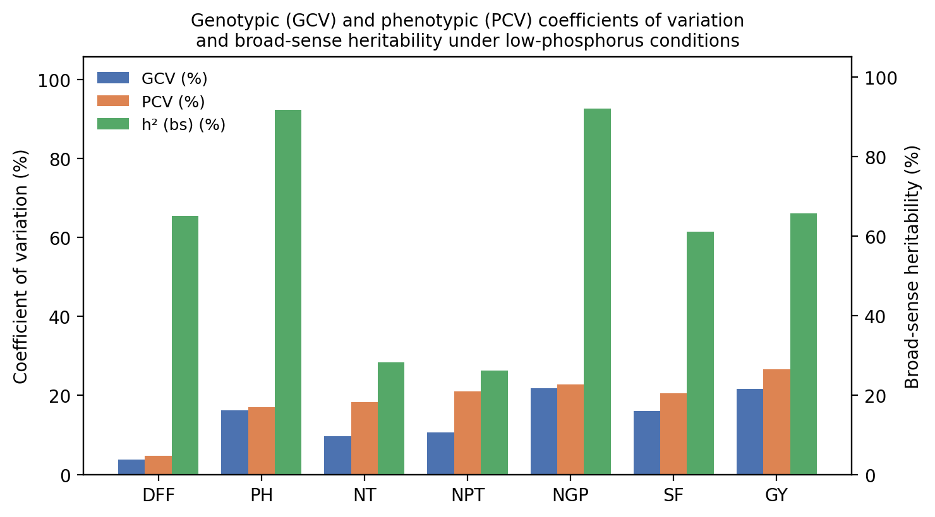
Fig. 1. Genotypic (GCV) and phenotypic (PCV) coefficients of variation and broad-sense heritability (h² bs) for seven traits under low-phosphorus conditions.
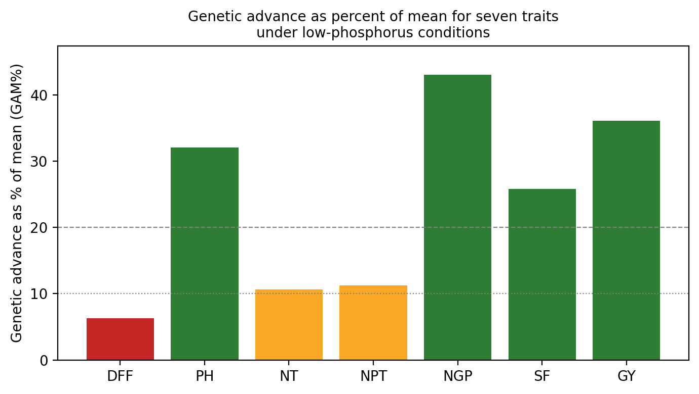
Fig. 2. Genetic advance as per cent of mean (GAM%) for seven traits under low-phosphorus conditions. Dashed lines mark the moderate (10%) and high (20%) GAM thresholds.

3.4 Promising donor entries
Using block-adjusted values for the three heritable, high-GAM traits (PH, NGP, GY), entries IX299-160-2, IX299-87-1, IX299-150 and IX299-177 combined the highest adjusted grain yield with favourable plant height and grains per panicle (Table 4, Fig. 3), and are proposed as candidate donors for phosphorus-use-efficiency breeding. The P-sensitive parent ISM, included as one of the 40 entries, ranked among the lowest-yielding (adjusted GY 5.50 g, close to the trial minimum), which is consistent with its documented phosphorus sensitivity and supports the internal validity of the block adjustment used here.
The four leading entries differ in the specific trait combination underlying their grain yield advantage, and this distinction determines how each is best used in a breeding programme. IX299-160-2 recorded the highest adjusted grain yield (12.80 g) together with a plant height of 95.6 cm and 87.8 grains per panicle, placing it closest to the population mean for height while exceeding the mean for grain number; it is therefore the preferred donor where grain number is the primary improvement target without a substantial change in plant stature. IX299-87-1 recorded a comparable grain yield (12.74 g) at a markedly shorter plant height (80.9 cm) with the highest grain number among the top four entries (88.5), making it the most suitable donor where a reduction in plant height is also desired, for example to improve lodging resistance under phosphorus-stressed conditions. IX299-150 combined a taller plant stature (104.6 cm) with the highest grain number recorded among all entries in this trial (97.8) and ranked third for grain yield (12.01 g); this entry is recommended specifically for crosses aimed at increasing sink size. IX299-177 recorded the lowest plant height among the top four entries (58.9 cm) together with the highest grain number of the four (99.8 grains per panicle) and a grain yield of 12.01 g, representing the most compact plant type among the leading entries and the preferred donor where short stature is the primary breeding objective. All four entries exceeded both parents for grain yield (7.62 g in LR-299 and 5.50 g in ISM) and for grains per panicle (67.2 in LR-299 and 50.2 in ISM), indicating transgressive segregation for these two traits in the ISM × LR-299 cross, consistent with the recombination of favourable alleles from both parents. Plant height did not segregate in the same transgressive direction: only IX299-150 (104.6 cm) exceeded both parents in height, while IX299-87-1 (80.9 cm) and IX299-160-2 (95.6 cm) fell between the two parental values, and IX299-177 (58.9 cm) was shorter than both parents. This indicates that plant height segregated independently of grain yield and grain number in this cross, and that the four donors identified here were selected on the basis of yield and sink-size advantage rather than on any single, shared height class.

3.5 Implications for breeding strategy
The genetic parameters recorded in this trial support a specific selection strategy for this population. Direct phenotypic selection for grain yield under low-phosphorus conditions, supported by indirect selection on plant height and grains per panicle, is the appropriate strategy for this material, because all three traits combine high heritability with high genetic advance and are therefore governed predominantly by additive gene action, which responds efficiently to simple selection procedures such as pedigree or bulk selection. Days to 50 per cent flowering and spikelet fertility are best advanced through index selection combining these traits with grain yield, which makes efficient use of their moderate heritability even where their individual genetic advance is modest. The stable performance recorded for tiller number and productive tiller number across entries is best used as a dependable background trait in this population, with selection pressure concentrated instead on plant height, grains per panicle and grain yield, where it will deliver the greatest genetic gain.
Table 4. Top 10 entries by block-adjusted grain yield under low-phosphorus conditions
Entry | PH (cm) | NGP | GY (g)
160-2 | 95.6 | 87.8 | 12.80
87-1 | 80.9 | 88.5 | 12.74
177 | 58.9 | 99.8 | 12.01
150 | 104.6 | 97.8 | 12.01
100 | 82.6 | 91.5 | 11.85
53 | 89.3 | 65.5 | 11.40
166 | 106.3 | 76.8 | 11.29
111 | 76.3 | 79.5 | 10.95
156 | 111.9 | 72.5 | 10.57
164 | 74.9 | 78.5 | 10.57
Lowest-ranked entries (for comparison):
Entry | PH (cm) | NGP | GY (g)
102-1 | 78.3 | 42.5 | 5.41
20 | 132.2 | 58.3 | 4.97
95 | 101.6 | 76.8 | 4.43
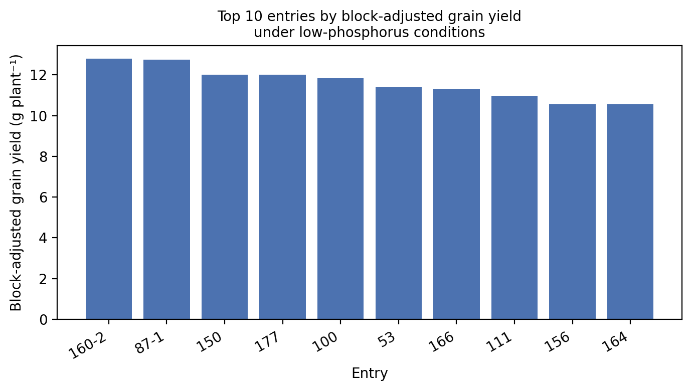
Fig. 3. Block-adjusted grain yield of the top 10 entries under low-phosphorus conditions.
These four entries are to be regarded as preliminary candidates requiring further evaluation, rather than as confirmed donors. A single-season, unreplicated augmented trial is capable of distinguishing superior outliers from the general population, the check-derived error term in the present study being reasonably precise; however, it cannot preclude the possibility of genotype × year or genotype × location interaction specific to this trial. Prior to utilisation of any of these lines as a parent in a phosphorus-use-efficiency breeding programme, re-evaluation under replicated conditions across at least one additional season is recommended, preferably in conjunction with a well-characterised tolerant check such as Kasalath or a Pup1 near-isogenic line, in order to confirm the yield advantage recorded in the present study (Wissuwa & Ae, 2001).

3.6 Scope for further validation
The present study provides a clear first assessment of genetic variability for yield and yield-attributing traits under low-phosphorus conditions in this RIL population, generated from a single season (Kharif 2024) at one location. The check-derived error term used here, built from four replicated check varieties genuinely re-planted and re-measured in each block, gave a reasonably precise basis for identifying genotypic differences in this trial, and the results are well placed to guide the next phase of testing: confirmation of the heritability and genetic advance estimates, and of the donor entries identified, through a replicated multi-season evaluation. Follow-up work separating phosphorus uptake efficiency from internal utilisation efficiency would further strengthen the physiological basis of the field-level yield advantage recorded here for the leading entries.

4. CONCLUSION
In this ISM × LR-299 RIL population evaluated under phosphorus-deficient field conditions, plant height, grains per panicle and grain yield per plant showed significant genotypic variation with high heritability and high genetic advance, establishing them as reliable, directly selectable criteria for phosphorus-use-efficiency breeding. Tiller number and productive tiller number were expressed uniformly across entries in this trial and are best used as stable background traits while selection effort is concentrated on the three traits identified above. Entries IX299-160-2, IX299-87-1, IX299-150 and IX299-177 are proposed as promising donors for further evaluation, on the basis of combining high grain yield with favourable plant height and grain number under phosphorus stress.
Limitations
The experiment was conducted during one season at a single location, limiting assessment of genotype-by-environment interactions. The 40 test entries were evaluated in unreplicated plots, although replicated checks were used to estimate experimental error and adjust for block effects. In addition, phosphorus uptake and internal utilisation efficiency were not measured separately, so the physiological basis of the observed yield differences remains unresolved. Future replicated, multi-season trials incorporating these measurements would strengthen the findings.

COMPETING INTERESTS
Authors have declared that no competing interests exist.

Declaration of AI Use

This manuscript was prepared through the intellectual contributions of the author(s) to the study design, data analysis, interpretation of results, and scholarly content. Grammarly and ChatGPT were used solely to assist with grammatical refinement and reference formatting during manuscript revision. The author(s) accept full responsibility for the accuracy, integrity, and final content of the manuscript.

REFERENCES
Allard, R. W. (1960). Principles of plant breeding. John Wiley & Sons. https://opac.uasd.edu/bib/67462
Basavaraj, P. S., Gireesh, C., Bharamappanavara, M., Manoj, C. A., Ishwaryalakshmi, L. V. G., Senguttuvel, P., Sundaram, R. M., Subbarao, L. V., & Anantha, M. S. (2022). Genetic analysis of introgression lines of Oryza rufipogon for improvement of low phosphorous tolerance in indica rice. Indian Journal of Genetics and Plant Breeding, 82(2), 135–142. https://doi.org/10.31742/IJGPB.82.2.1
Burton, G. W., & DeVane, E. H. (1953). Estimating heritability in tall fescue (Festuca arundinacea) from replicated clonal material. Agronomy Journal, 45(10), 478–481. https://doi.org/10.2134/agronj1953.00021962004500100005x
Comstock, R. E., & Robinson, H. F. (1952). Estimation of average dominance of genes. In J. W. Gowen (Ed.), Heterosis (pp. 494–516). Iowa State College Press.
Dobermann, A., & Fairhurst, T. (2000). Rice: Nutrient disorders and nutrient management. Potash & Phosphate Institute and International Rice Research Institute. https://books.irri.org/9810427425_content.pdf
Falconer, D. S., & Mackay, T. F. C. (1996). Introduction to quantitative genetics (4th ed.). Longman. https://searchworks.stanford.edu/view/3140681
Federer, W. T. (1956). Augmented (or hoonuiaku) designs. Hawaiian Planters' Record, 55, 191–208. https://ecommons.cornell.edu/entities/publication/22e171a6-71d7-422a-9de5-9d7cc372ccd0
Fehr, W. R. (1987). Principles of cultivar development: Vol. 1. Theory and technique. Macmillan Publishing Company. https://agris.fao.org/search/en/providers/122535/records/65ddc61063b8185d9ca4755e
Girma, B. T., Kitil, M. A., Banje, D. G., Biru, H. M., & Serbessa, T. B. (2018). Genetic variability study of yield and yield related traits in rice (Oryza sativa L.) genotypes. Advances in Crop Science and Technology, 6(4), Article 381. https://doi.org/10.4172/2329-8863.1000381
Gomez, K. A., & Gomez, A. A. (1984). Statistical procedures for agricultural research (2nd ed.). John Wiley & Sons. https://agris.fao.org/search/en/records/65ddf0374c5aef494fd7a8f5
Hallauer, A. R., & Miranda Filho, J. B. (1988). Quantitative genetics in maize breeding (2nd ed.). Iowa State University Press. https://agris.fao.org/search/en/providers/122535/records/65de0707b766d82b18fbd3dc
Harisha, T., Shruti, Anantha, M. S., Gireesh, C., Sundaram, R. M., Senguttuvel, P., Mahender Kumar, R., Brajendra, Swamy, A. V. S. R., Dushyantha Kumar, B. M., Sathish, K. M., Usha, T. N., Kalleshwara Swamy, C. M., & Lokesha, R. (2024). Exploring genetic variability for yield and its attributing traits in rice (Oryza sativa L.) under low soil phosphorous condition. Asian Journal of Soil Science and Plant Nutrition, 10(3), 297–303. https://doi.org/10.9734/ajsspn/2024/v10i3340
Holford, I. C. R. (1997). Soil phosphorus: Its measurement, and its uptake by plants. Australian Journal of Soil Research, 35(2), 227–240. https://doi.org/10.1071/S96047
James, M., Tyagi, W., Magudeeswari, P., Neeraja, C. N., & Rai, M. (2024). Genome-wide association-based identification of alleles, genes and haplotypes influencing yield in rice (Oryza sativa L.) under low-phosphorus acidic lowland soils. International Journal of Molecular Sciences, 25(21), Article 11673. https://doi.org/10.3390/ijms252111673
Johnson, H. W., Robinson, H. F., & Comstock, R. E. (1955). Estimates of genetic and environmental variability in soybeans. Agronomy Journal, 47(7), 314–318. https://doi.org/10.2134/agronj1955.00021962004700070009x
Kohli, P. S., Donde, R., Sirohi, U., Singh, B., Anantha, M. S., Bhadana, V. P., Sundaram, R. M., Mangrauthia, S. K., & Giri, J. (2025). Physiological and genetic basis of superior phosphate uptake and utilization efficiency in the rice landrace Wazuhophek. Journal of Experimental Botany, 76(20), 6145–6165. https://doi.org/10.1093/jxb/eraf331
Lu, H., Wang, F., Wang, Y., Lin, R., Wang, Z., & Mao, C. (2023). Molecular mechanisms and genetic improvement of low-phosphorus tolerance in rice. Plant, Cell & Environment, 46(4), 1104–1119. https://doi.org/10.1111/pce.14457
Ojah, H., Talukdar, P., Das, P., Deka, P., & Choudhury, M. (2025). Combining ability and heterosis analysis for some physio-morphological traits in rice (Oryza sativa L.). Journal of Global Agriculture and Ecology, 17(3), 36–47. https://doi.org/10.56557/jogae/2025/v17i39487
Panse, V. G., & Sukhatme, P. V. (1954). Statistical methods for agricultural workers. Indian Council of Agricultural Research. https://agris.fao.org/search/en/providers/122621/records/647761775eb437ddff77fa17
R Core Team. (2023). R: A language and environment for statistical computing. R Foundation for Statistical Computing. https://doi.org/10.32614/R.manuals
Robinson, H. F., Comstock, R. E., & Harvey, P. H. (1949). Estimates of heritability and the degree of dominance in corn. Agronomy Journal, 41(8), 353–359. https://doi.org/10.2134/agronj1949.00021962004100080005x
Singh, B., Gauraha, D., Sao, A., & Nair, S. K. (2021). Assessment of genetic variability, heritability and genetic advance for yield and quality traits in advanced breeding lines of rice (Oryza sativa L.). The Pharma Innovation Journal, 10(8), 1627–1630. https://www.thepharmajournal.com/archives/2021/vol10issue8/PartW/10-8-32-626.pdf
Sivasubramaniam, S., & Madhava Menon, P. (1973). Genotypic and phenotypic variability in rice. Madras Agricultural Journal, 60(9–12), 1093–1096.
Solangi, A. M., Khanzada, H., Wassan, G. M., Rasheed, A., Keerio, A. A., Solangi, M., Khanzada, S., Faheem, M., Bian, J., Pan, X., Han, R. C., He, X., & Wu, Z. (2020). Genetic mapping and identification of new major loci for tolerance to low phosphorus stress in rice. Physiology and Molecular Biology of Plants, 26(9), 1897–1910. https://doi.org/10.1007/s12298-020-00858-3
Wissuwa, M., & Ae, N. (2001). Genotypic variation for tolerance to phosphorus deficiency in rice and the potential for its exploitation in rice improvement. Plant Breeding, 120(1), 43–48. https://doi.org/10.1046/j.1439-0523.2001.00561.x
Wricke, G., & Weber, W. E. (1986). Quantitative genetics and selection in plant breeding. Walter de Gruyter. https://doi.org/10.1515/9783110837520

