Assessment of the Current Operating Status of On-Site Sanitation Facilities: A Case Study of Selected Neighborhoods in Yamoussoukro, Côte d’Ivoire.

.
ABSTRACT

Sanitation remains often overlooked in urban policies and development projects in developing countries such as Côte d’Ivoire. Several factors impede effective sanitation management. Therefore, an assessment of the operating status of sanitation facilities was conducted across the Millionnaire, Assabou, Kokrénou, and Sopim neighbourhoods of Yamoussoukro, and 498 households were surveyed out of 3,672 (14%). Field observations, socioeconomic characteristics, and operating status of the facilities were documented. The findings showed that 31.40% of household members had completed primary school and that monthly household incomes ranged from F CFA 100,000 to F CFA 200,000. Furthermore, the findings indicated that some sanitation facilities were in a state of disrepair. Shower wastewater was discharged directly into the environment in the neighbourhoods of Assabou, Kokrénou, and Sopim. More than 50% of low-income households had damaged latrines and septic tanks, unlike high-income households. The uncontrolled discharge of wastewater into streets and gutters, backflow of water into septic tanks, and insect infestations in latrines, coupled with the dumping of septic sludge in courtyards, contribute significantly to environmental degradation, thereby posing serious health risks to the population. Household reports of malaria, typhoid fever, diarrhoea, dysentery and cholera were discussed in relation to sanitation and hygiene conditions within households. Unsanitary conditions pose a real health risk. It is therefore important to design adequate and appropriate facilities to prevent wastewater from flowing into the streets and raise awareness among households about proper usage.

Keywords: On-site sanitation; Sanitation facility performance; Septic tanks; Latrines; Household wastewater; Faecal sludge; Wastewater disposal; Socioeconomic disparities; Environmental health

1. INTRODUCTION

Sanitation is a major concern for governments worldwide. The global water and sanitation crisis remains pressing, with 2 billion people lacking safely managed drinking water and 3.6 billion people lacking safely managed sanitation (United Nations, 2021).
Sustainable Development Goal 6 (SDG 6) aims to achieve universal and equitable access to safe drinking water, sanitation and hygiene by 2030, particularly for vulnerable populations; billions of people still struggle daily to access even basic services (Le Jallé & Désille, 2008; Briand, 2026).
Between 2000 and 2022, 2.1 billion people gained access to safely managed drinking water, and the number of people lacking even basic drinking water supply services fell from 1.2 billion to 703 million. Two-thirds (1.4 billion) of the people who gained access to safely managed drinking water services lived in urban areas, compared with 704 million in rural areas (UNICEF & WHO, 2023). Approximately 1.4 million people die each year worldwide due to insufficient access to safe drinking water, sanitation, and hygiene, a large proportion of whom are young children who are vulnerable to diarrhoeal diseases (Boinet & Goldberg, 2021). Despite international attention to this issue, nearly one in three people still lacked access to improved sanitation systems in 2015 (UNICEF & WHO, 2023). To this end, the Sustainable Development Goals (SDGs) offer an opportunity to go beyond the ambitions of the Millennium Development Goals (MDGs) by ensuring universal access to improved sanitation. In particular, SDG 6, which aims to ensure access to safe water and sanitation for all, requires governments to ensure that everyone has progressively better access to sanitation, without discrimination (UNESCO, 2019). Recent characterisation of faecal sludge from septic tanks and pit latrines has demonstrated differences associated with the type of on-site sanitation system, supporting the need to assess the operation of facilities rather than their presence alone (Jothinathan & Singh, 2024).
The provision of safe drinking water and improved sanitation services ranks among the major challenges faced by African countries. In sub-Saharan Africa, approximately 55% of the urban population (about 200 million people) lacks adequate sanitation facilities, and more than 400 million people lack basic water supply services, while 700 million people do not have access to decent sanitation facilities. In addition, 750 million people lack access to hygiene services (African Water Facility, 2023). In major African cities, several factors make it difficult to effectively manage urban sanitation and ensure access to safe drinking water. However, inadequate sanitation and hygiene facilitate the transmission of pathogenic germs, and 88% of diarrhoea cases are directly linked to these causes. Furthermore, several studies highlight the negative health, environmental and economic consequences of poor sanitation (Dovonou et al., 2022). A household-based assessment in Addis Ababa also identified inadequate maintenance and unsafe faecal sludge handling practices, indicating that access to toilets does not by itself establish safe sanitation management (Sisay et al., 2024).
In Côte d'Ivoire, access to safe drinking water and sanitation poses significant challenges, with notable disparities among different population groups and geographic areas. According to the 2021 Côte d’Ivoire Demographic and Health Survey (Institut National de la Statistique & ICF, 2023), 81% of the population has access to at least a basic drinking water service, while 3% use a limited service. However, the actual availability of water remains a challenge, as only 72% of households report having sufficient water for their needs. Furthermore, in these cities, access to sanitation is a daily struggle for hundreds of thousands of people. This challenge also affects Yamoussoukro, the political capital. A study by Yapi et al. (2020) reported that, according to ONAD, the rate for on-site sanitation in the municipality of Yamoussoukro was 90 per cent, while only 10 per cent of the population had access to centralised sanitation in 2015. Although these on-site sanitation systems may appear adequate, their operation remains problematic. Indeed, the use of on-site sanitation systems by the city’s residents does little to solve the problem, as evidenced by wastewater stagnating in the streets due to backflows from septic tanks and discharge of dishwater, laundry water, and toilet waste (N’Dri et al., 2023). Research on on-site sanitation in Kiribati identified infrastructure and financial constraints that complicate the management of household sanitation systems (Biko et al., 2025). An investigation of domestic wastewater discharge into the Choba River in Nigeria also documented deterioration in water quality downstream of discharge points (Obunadike et al., 2025). A scoping review further identified affordability as an important consideration in household access to faecal sludge emptying services (Tomoi et al., 2024). Although existing studies describe the prevalence of on-site sanitation and wastewater management problems in Yamoussoukro, the literature discussed above does not provide a combined, neighbourhood-level comparison of the physical condition and operation of latrines and septic tanks across Millionnaire, Assabou, Kokrénou and Sopim. A more specific examination of household socioeconomic conditions, wastewater discharge pathways, emptying practices and visible facility defects is therefore needed to inform maintenance and design recommendations for these neighbourhoods.
In light of these findings, this study seeks to understand why these on-site sanitation facilities are inadequate for reducing social inequalities and health and environmental risks. Thus, the overall objective of this study is to conduct an assessment of the current operation of on-site sanitation facilities in the Millionnaire, Assabou, Kokrénou, and Sopim neighbourhoods of Yamoussoukro. In particular, the study aims to (1) examine the socioeconomic characteristics of households; (2) identify the causes of the malfunctioning of on-site sanitation systems and assess their current operating status; and (3) propose solutions for maintaining and designing on-site sanitation facilities adapted to local conditions.

2. MATERIALS AND METHODS
2.1. Overview of the Study Sites
Yamoussoukro is the political and administrative capital of the Republic of Côte d’Ivoire. It is located approximately 248 km from Abidjan and lies between latitudes 06°33’ and 07°20’ North and longitudes 04°56’ and 05°30’ West. With an area of 3,500 km² (Djagoun et al., 2022), Yamoussoukro is bounded to the north by the departments of Tiébissou and Bouaké, to the east by the department of Dimbokro, to the west by the departments of Bouaflé and Daloa, and to the south by the department of Toumodi. The neighbourhoods included in this study are geolocated in Figure 1.
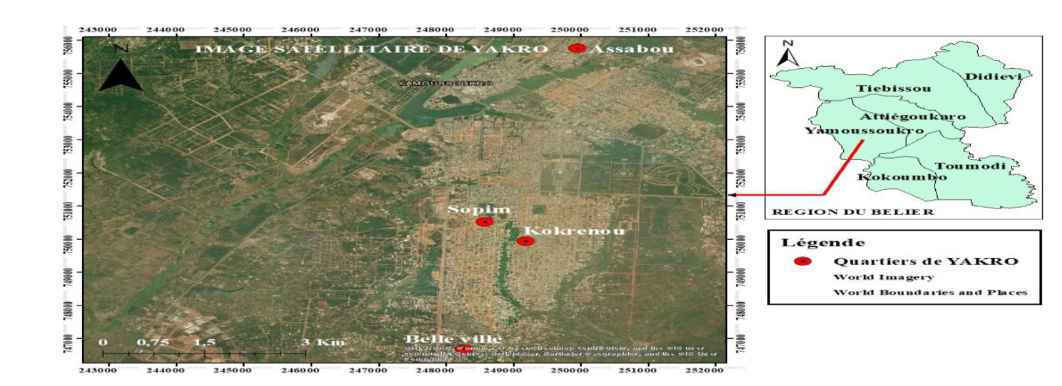
Figure 1: Geolocation of Neighborhoods

2.2. Methodological Approach
For this study, the methodological approach was based primarily on sample design and data collection. To this end, the housing standard was used as a criterion for the surveys. The neighbourhoods were selected based on the distribution of sectors among the different groups of students. Thus, the Millionaire, Assabou, Kokrénou, and Sopim neighbourhoods were classified into three categories based on the types of housing identified: upper, middle and lower class. The Millionaire neighbourhood was classified as upper class, Assabou as lower class, and Kokrénou and Sopim as middle class.
2.3. Sampling Method
The sampling method used to determine the sample size for the survey was based on simple random sampling (Djagoun et al., 2022). According to data from the 2021 General Population Census (RGPH, 2021), the city of Yamoussoukro is reported to have 73,428 households spread across some 20 neighbourhoods. In the absence of survey data on the number of households in the Millionnaire, Assabou, Kokrénou, and Sopim neighbourhoods, which are the focus of this study, the normal distribution was assumed; thus, the distribution of the total number of households across the twenty neighbourhoods gives 3,672 households per neighbourhood. The sample size (n) was calculated by applying Schwartz’s Equation 1 to the 3,672 households.
Accordingly, using Equation 1, the sample size for households was determined according to income level.
$$n=\frac{NP{(t_{p})}^{2}(1-P)}{(P({t_{p})}^{2}(1-P))+(y^{2}(N-1))} (1)$$

where n = sample size; N = 3 672 households = target population; P = 0.4: expected response rate from the population; tp = 1.96: sampling confidence interval, y = 0.04: margin of sampling error.
Substituting the data into Equation 1 yielded a sample size of 498 households. The sample distribution is shown in Table I.
Table I: The sample distribution
Neighborhoods | Types of Housing | Number of households surveyed | Total
Millionnaire | Upper class | 123 | 498
Kokrénou | Middle class | 123 | 498
Sopim | Middle class | 123 | 498
Assabou | Lower class | 129 | 498

2.4. Data Collection and Processing
When the household head or an authorised representative was absent, the household survey was conducted with another resident adult. The survey was conducted in April 2025 using predefined questionnaires. Door-to-door visits were used to collect household responses on access to sanitation. Households were randomly selected (Djagoun et al., 2022) as the assigned survey teams visited each neighbourhood.
The questionnaires were prepared according to the guidelines provided by Djagoun et al. (2022). The data collected covered household characteristics; the household head’s educational attainment, economic activity and monthly income; access to sanitation and the condition of sanitation facilities (showers, latrines and septic tanks); and diseases reported by households in relation to poor sanitation.
Observations and photographs of on-site sanitation practices were recorded during the surveys. Observations focused, among other things, on the location, construction, presence of inert materials, wastewater disposal, and state of sanitation facilities in households and throughout the neighbourhood.
For data processing, household responses and observation forms were used to code responses, particularly textual data, into numerical values to facilitate assessment. The proportions of the various parametres were calculated using Equation 2, and the charts were produced using Excel.
$$F=\frac{X}{Y}×100 (2)$$
where F = frequency (%), X = number of respondents in the category under consideration, and Y = total number of respondents.
3. RESULTS AND DISCUSSION
  - Socioeconomic Characteristics of Households
The analysis of the socioeconomic characteristics of households provided insight into challenges relating to basic social services, which are essential to sanitation service management. These characteristics included the household size, level of education of household heads, and monthly household income.
Regarding household size, the survey findings presented in Figure 2 show that 62.22% of households, or 309 out of 498 households have more than 10 members, while 32% (159 households) have between 5 and 10 members. Households with less than 5 people are in the minority, accounting for 5.78% (28 out of 498 households). Regarding the educational level of household members, the results in Figure 3 show that 13.88% of household members did not attend school, 24.80 % completed secondary school, and 28.92% completed higher education. Primary education was the most frequently reported educational level, accounting for 32.40 %. Furthermore, Figure 4 shows that households with monthly incomes between F CFA 100,000 and F CFA 200,000 are the most common, accounting for 38.84 %. Only 28.10% of respondents have a monthly income of at least F CFA 200,000. However, heads of households with a low monthly income of less than F CFA 100,000 account for 33.06 %.
According to the household socioeconomic data, the household size is one of the key factors determining the effectiveness and lifespan of sanitation facilities. It can influence the volume of wastewater produced by households and lead to premature saturation of septic tanks. Thus, reduced retention time could disrupt the biological treatment process (Laré et al., 2018; Gueye et al., 2026b). However, nearly 94.22 % of households have more than five members; that is, approximately 360 out of 382. In addition to household size, educational attainment could influence the condition or operation of sanitation facilities in cities. The survey findings showed that the majority of households had a low level of education, with 31.40% of respondents having completed only primary school. Education, as an influence on attitudes and opinions, plays a decisive role in behavioural change, particularly among less-educated populations who may be resistant to new ideas (Djagoun et al., 2022). Thus, these findings highlight that education plays a crucial role in the adoption of proper hygiene and sanitation practices and are consistent with Seraj (2008), who asserts that household heads who have completed primary school are more likely to invest in improving their sanitation facilities.
Education is one of the factors associated with the willingness to pay for adequate sanitation services. It raises awareness among individuals about the benefits of sanitation systems. Indeed, Gaffan et al. (2024) have shown that, in Benin today, the construction of latrines by households depends heavily on their financial contributions. However, empirical data show that many households may be unwilling to invest in adequate sanitation services, given the basic characteristics of these households.
Furthermore, inadequate hygiene and sanitation practices in the neighbourhoods of Yamoussoukro covered by this study are not solely due to education but are also linked to civic behaviour or household income.
In terms of monthly household income, the findings showed that the most frequently reported incomes ranged from F CFA 100,000 and F CFA 200,000, accounting for 38.84 per cent of households.
Indeed, in developing countries, socioeconomic factors play a crucial role in the management of the water and sanitation sector (Gueye et al., 2026a).
Furthermore, according to Abgottspon et al. (2025), improving waste management can help enhance public health at the local level and mitigate climate change on a global scale. However, this requires significant funding and sound economic models.
In fact, in the village of Cape Maclear, Malawi, some households were willing to pay an average of $0.90 per month if they did not have to sort their own waste, compared with $0.54 per month if they had to sort it at the collection point. The guesthouses were willing to pay $13.00 per month for the management of their own waste and an additional $4.22 for the collection of public waste.
These socioeconomic challenges arise from financial constraints and limited civic responsibility.

Figure 2: Household size

Figure 3: level of education of family heads

Figure 4: Monthly household income

3.2. Current Operating Status of On-Site Sanitation Facilities
3.2.1. Types of Latrines in Households
The household surveys showed that all households have latrines, with the types varying according to socioeconomic status. Figure 5 shows the proportions of different types of latrines in households. In fact, 28.92% of households use manually flushed latrines, followed by 26.45% of households that have mechanically flushed latrines, whilst 21.31% of households have traditional latrines (Figure 6). Furthermore, 10.74 per cent of responding households use both traditional latrines and manually flushed latrines, whilst 9.10 per cent of households have both traditional latrines and mechanically flushed latrines. Finally, 3.48 per cent of households have Ventilated Improved Pit latrines (VIP).
These findings show that latrine types vary according to household socioeconomic status, with manual-flush latrines being the most common (28.92 per cent). This may reflect the fact that Yamoussoukro is the country’s political capital and efforts are being made to combat open defecation (Kone et al., 2024). Gaffan et al. (2025) showed in their study that the per centage of latrine use ranged from 36.00% to 94.30%.
This finding contrasts with that of Kafando et al. (2025), who reported a shortage of latrines across villages in the rural municipality of Koubri, Burkina Faso. Open defecation is also common, with its associated consequences. Measures are therefore needed to raise community awareness about good hygiene practices and to promote sanitation.

Figure 5: Types of Latrines in households
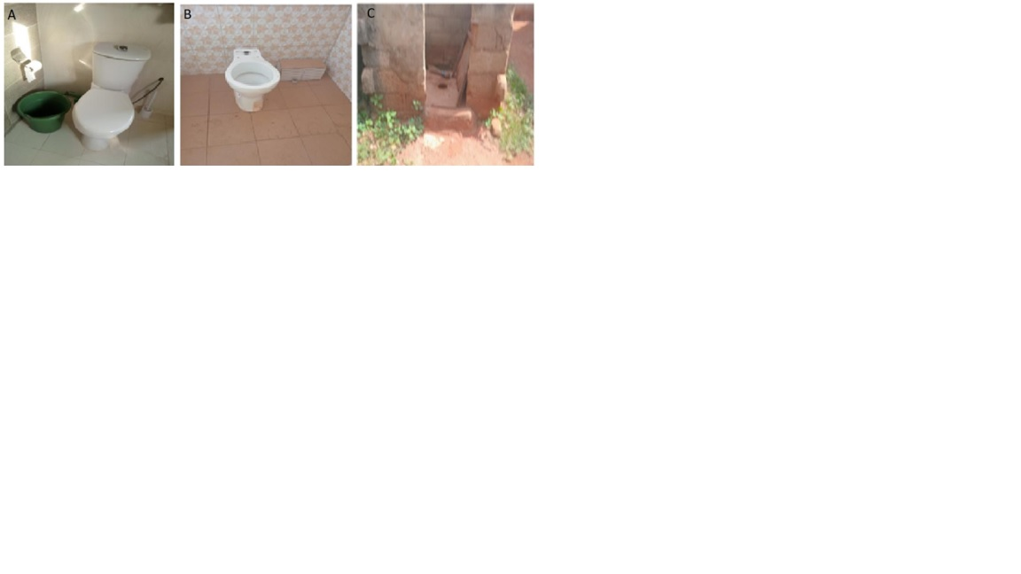
Figures 6: Some photos of different types of latrines: (A) Millionnaire neighborhood, (B) Kokrénou neighborhood, (C) Assabou neighborhood.

3.2.2. Shower Water Disposal Locations
Figure 7 shows household shower-water discharge locations. Specifically, 39.68 per cent of households discharge shower water into septic tanks and 9.92 per cent into soakaways. The remaining households discharge shower water directly into the environment, with 28.01 per cent discharging it into gutters and 22.39 per cent onto the streets. Figure 8 illustrates the various discharge points for shower water.
The findings showed that shower water was discharged into the environment, with 50.40 per cent of the wastewater discharged into gutters and onto public roads in low- and middle-income neighbourhoods. This pattern appears to be associated with household economic status. Stagnant wastewater, described as nutrient-rich and acidic, could contribute to the gradual deterioration of roads, making them difficult to use (Kambiré et al., 2021), and contribute to the spread of certain diseases such as acute respiratory infections (ARI), malaria and diarrhoeal diseases (Coulibaly et al., 2022). According to Boinet and Goldberg (2021), approximately 1.4 million people die each year worldwide due to insufficient access to sanitation and hygiene, a large proportion of whom are young children who are vulnerable to diarrhoeal diseases.
A similar finding was reported by Djagoun et al. (2022) in a study on wastewater management. According to that study, inadequate sanitation facilities in low-income neighbourhoods of Yamoussoukro led households to discharge their wastewater onto the streets. These practices were attributed to the lack of wastewater storage facilities (septic tanks and soakaways), compelling households to discharge their wastewater into the environment.

Figures 7: Shower Drain Location

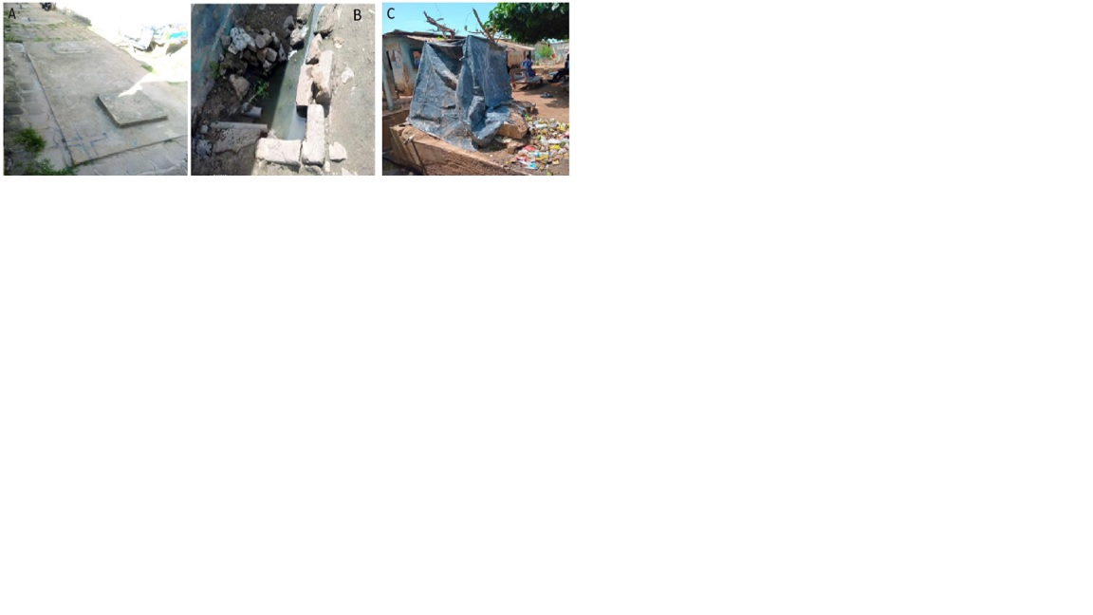
Figure 8: Images of shower drainage locations: (A) septic tank slab in the Millionnaire neighborhood; (B) a gutter in Kokrénou; (C) Shower water draining into a gutter in Assabou.

3.2.3. Type of Emptying
Regarding septic tank emptying methods, the surveys showed that households use two methods: manual and mechanical emptying (Figure 9). A total of 51.25 per cent of households had their septic tanks emptied mechanically, whilst 31.40 per cent used manual emptiers and 17.35 per cent of households had not had their septic tanks emptied.
Regarding household septic tank emptying, the findings indicated that 51.25 per cent of households have their septic tanks emptied using specialised sewage trucks, although the destination of the waste resulting from this process is unknown. Nevertheless, 17.35 per cent of households that use manual emptiers for their septic tank cleaning needs dispose of these by-products haphazardly, into the surrounding environment. Households in Yamoussoukro who use these methods view mechanical emptying as very expensive. This practice represents a potential source of pollution to aquatic environments.
A similar finding was reported by Tia (2018) in a study conducted in the municipality of Port-Bouët. According to that study, when on-site sanitation facilities are full, the sludge is removed without necessarily complying with applicable health regulations. Households call upon traditional emptiers who open the slab covering the pit to discharge the contents into a hole dug elsewhere in the courtyard.

Figure 9: Different types of septic tank emptying
3.2.4. Comparative Study of the State of Facilities per Socioeconomic Status
Figure 10 illustrates the condition of household latrines and septic tanks by socioeconomic status. Images showing the condition of the latrines are presented in Figures 11A, 11B and 11C.
In low-income households (Assabou), 61 per cent of latrines and septic tanks are in poor condition, whilst 39 per cent are in good condition (Figures 10 and 11A). Among middle-income households (Kokrenou and Sopim), the findings show that 44 per cent of latrines and septic tanks are in poor condition and 56 per cent are in good condition (Figures 10 and 11B). In high-income households (Millionnaire), 87.52 per cent of the facilities are in good condition, whilst 12.48 per cent are in poor condition (Figures 10 and 11C).
The comparison of sanitation-facility conditions by socioeconomic status showed that 50 per cent of low-income households have latrines and septic tanks in a state of disrepair. In contrast, only 5.35 per cent of high-income households have facilities in poor condition. Indeed, the findings indicate that the inadequacy or absence of drainage and sewerage systems for surface runoff and wastewater in low-income neighbourhoods may force households to construct septic tanks that, in most cases, fail to meet hygiene standards. Because these tanks are shallow and poorly covered, they allow foul odours and even wastewater from showers to escape (Kambiré et al., 2021).
The study by Coulibaly et al. (2022) showed that 86.88% of households discharged wastewater onto streets and that 67.21% of respondents lived less than 25 metres from wastewater discharge points.
Furthermore, Kambiré et al. (2017) noted that housing type was a significant variable, insofar as the quality of housing may be regarded as an indicator of living standards. Indeed, signs of the malfunctioning of these sanitation systems include the backflow of sewage from septic tanks and stagnation of greywater on properties. The factors contributing to the malfunctioning of these facilities in low-income neighbourhoods are associated with limited financial resources, which forces residents to construct makeshift structures.
The study therefore showed that low- and middle-income households experience problems related to poor hygiene and sanitation. In this regard, such problems are found in 56.40 per cent of low-income households, compared with 43.60 per cent of middle-income households. According to Kramo (2024), 50% of wastewater from dishwashing and laundry was discharged onto streets, 23% onto wasteland, 14% into sewers, 9% into septic tanks and 4% into backyards. For toilet waste, 23% is discharged into latrines inside the home, 61% into the yard, 7% outside the yard and 9% into the street. This environmental degradation is associated with the lack of, or poor design of, sanitation facilities. Overgrowth and stagnant water exacerbate the health risks associated with environmental degradation.

Figure 10: Condition of Latrines and Septic Tanks by Income Level

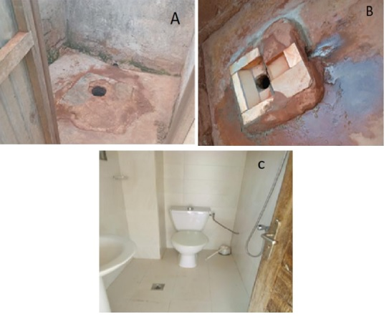

Figure 11: State of latrines and septic tanks according to the socioeconomic status: (A) Low-income households ( Assabou); (B) Middle-income households (Kokrenou et Sopim) and (C) High-income households (Millionaires).

3.2.5. Adverse Environmental and Health Impacts of Sanitation
- Disposal of Sludge
Regarding the disposal of sludge following septic tank emptying, Figure 12 shows that 62.65 per cent of households do not know where the emptied sludge is disposed of; most of these households use mechanical emptying, whilst households using manual emptying report where the emptied sludge is disposed of. Of the households surveyed, 20.48 per cent reported discharging sludge into the natural environment, 14.47 per cent into gutters and 2.40 per cent recycle it on their fields.
The uncontrolled dumping of sewage sludge into the environment presents a potential environmental and health concern. Among other things, this may affect ecosystems because of its concentrated organic and chemical constituents, potentially resulting in the eutrophication of watercourses or contamination of groundwater (N’Gouran et al., 2023; Gueye et al., 2026a).

Figure 12: Disposal of sludge from septic tanks after emptying

- Problems Observed in Operating Sanitation Facilities
During the surveys, observations were recorded on the operation of sanitation facilities and associated problems (stagnant wastewater, insect infestations in latrines and sewage overflow from septic tanks); the findings are presented in Figure 13 with illustrative images shown in Figures 14(A, B) and 15(A–C).
The proportions of insect infestations in latrines in high-, middle- and low-income households were 4.75 per cent, 40.10 per cent and 55.15 per cent respectively. Regarding wastewater stagnation, none was reported in high-income households, compared with 50 per cent in middle- and low-income households. Sewage overflow from septic tanks was not reported in high-income neighbourhoods, whereas 56.40 per cent of low-income households and 43.60 per cent of middle-income households experienced such overflow.

Figure 13: Nuisances Observed by Types of Housing

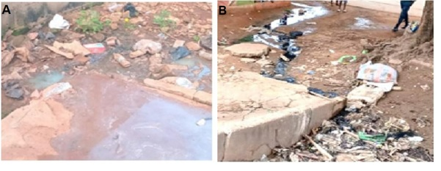
Figure 14: Images of the observed problems: (A) Dishwater in the yard in Sopim and (B) Sewage overflow from septic tanks in Kokrenou

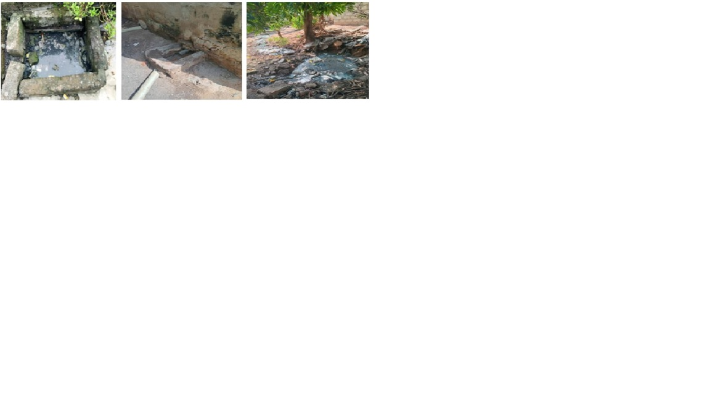
Figure 15: Images of Nuisances Observed in Assabou: (A) Open septic tank; (B) Latrine pit; (C) Shower water flowing into the street.

- Diseases Related to Sanitation and Hygiene
Figure 16 presents the findings on diseases observed in households that are associated with sanitation and hygiene. Malaria was the most frequently reported disease among the surveyed population, accounting for 32.36 per cent, followed by typhoid fever at 28.38 per cent, diarrhoea at 26 per cent, and other diseases at 13.26 per cent, including dysentery (8.11 per cent) and cholera (5.15 per cent).
Regarding diseases reported in the household surveys in relation to sanitation and hygiene, the findings indicate potential health risks associated with unsanitary conditions. Thus, the proportion of households affected by malaria, typhoid fever and diarrhoea stood at 32.36 per cent, 28.38 per cent and 26 per cent respectively, whilst a few cases of dysentery (8.11 per cent) and cholera (5.15 per cent) were also identified. These reported diseases may also be associated with poor living conditions and the sanitation facilities available to residents. Diabia and Bechi (2018) reported that, in the municipality of Bongouanou, the adoption of a good, modern sanitation system can help reduce the risk of diarrhoeal diseases by 29.34 per cent in rural areas and by 35.29 per cent amongst urban dwellers. Furthermore, Koffi and Anoh (2025) reported that malaria and diarrhoea are influenced by the presence of household garbage and wastewater.

Figure 16: Diseases observed in households

- Recommendations
- Involve sanitation experts and specialists in the design and planning of on-site sanitation facilities in households;
- Enforce the sanctions adopted and enacted by the relevant authorities in relation to sanitation regulations;
- Request from real-estate developers proper sanitation plans for their housing estates and construction projects;
- Conduct an in-depth study into the various methods of recycling sludge, wastewater and plastic waste to prevent the proliferation of rubbish in cities;
- Strengthen information and awareness-raising campaigns on good sanitation and hygiene management;
- Build adequate and suitable latrines to prevent sewage from flowing into the streets; and provide septic tanks, soakaways and washbasins to ensure better drainage of laundry water, washing-up water, shower water and human excreta.

5. Conclusion
This study aimed to assess the current operating status of on-site sanitation facilities and propose improvement measures tailored to the Assabou, Sopim, Kokrenou and Millionnaire neighbourhoods in Yamoussoukro. Household socioeconomic characteristics and the operating conditions of these facilities were examined.
The surveys indicated relatively low levels of educational attainment among household members, with 31.40 per cent having completed primary education. Regarding monthly household income, the findings showed that the most commonly reported incomes ranged from F CFA 100,000 to F CFA 200,000, accounting for 38.84 per cent of households.
The findings further indicated that the condition of sanitation facilities in the surveyed neighbourhoods presents environmental concerns, although all households had latrines of different types depending on socioeconomic status, with a higher proportion of manually flushed latrines. Regarding shower-water disposal, the study showed that shower water was frequently discharged directly into the environment, with 50.40 per cent being discharged into gutters and onto public roads in low- and medium-standard neighbourhoods.
A comparison of sanitation-facility conditions by socioeconomic status showed that 50 per cent of low-income households have latrines and septic tanks in a state of disrepair. By contrast, 5.35 per cent of high-income households have facilities in poor condition.
The uncontrolled discharge of wastewater into streets and into the sewer system (gutters), backflow of water into septic tanks, and insect infestations in latrines, coupled with the dumping of septic sludge in courtyards, may contribute to environmental degradation and potential health risks to the population.
Diseases reported during the household surveys indicated potential health concerns associated with poor sanitation and hygiene. Thus, 32.36%, 28.38%, and 26% of households, respectively, reported malaria, typhoid fever, and diarrhoea; in addition, cases of dysentery (8.11%) and cholera (5.15%) were recorded.

Limitations
This assessment was confined to four selected neighbourhoods of Yamoussoukro, so its findings should not be generalised automatically to the entire municipality. Neighbourhood household totals were estimated from city-level census information. The study relied on household questionnaire responses and observations of facility conditions. Its descriptive design cannot establish causal relationships between sanitation practices and illnesses reported by households. Accordingly, the results should be interpreted as evidence of reported practices and observed conditions, rather than as a direct measurement of health effects. Further neighbourhood-level studies could examine the operation and maintenance of these systems in greater detail.

Competing interests
The authors declare that they have no known competing financial interests or personal relationships that could have appeared to influence the work reported in this paper.

Consent
As per international standards or university standards, respondents’ written consent has been collected and preserved by the author(s).

Ethical approval
All authors hereby declare that all experiments have been examined and approved by the appropriate ethics committee and have therefore been performed in accordance with the ethical standards laid down in the 1964 Declaration of Helsinki.

Declaration of AI Use

This manuscript was prepared through the intellectual contributions of the author(s) to the study design, data analysis, interpretation of results, and scholarly content. Grammarly and ChatGPT were used solely to assist with grammatical refinement and reference formatting during manuscript revision. The author(s) accept full responsibility for the accuracy, integrity, and final content of the manuscript.

References
Abgottspon, E., Freihardt, J., Tkaczuk, J., & Tilley, E. (2025). Willingness to pay for and economic feasibility of solid waste management in Cape Maclear, Malawi. Resources, Conservation & Recycling Advances, 27, Article 200281. https://doi.org/10.1016/j.rcradv.2025.200281
African Water Facility. (2023, June 16). USAID commits $3 million to African Water Facility to accelerate preparation of water and sanitation investment projects in Africa. https://www.afdb.org/en/news-and-events/press-releases/usaid-commits-3-million-african-water-facility-accelerate-preparation-water-and-sanitation-investment-projects-africa-62167
Biko, T., Omar, O. O., Nilsson, P., & Biko, T. (2025). On-site sanitation systems in Kiribati: Challenges, opportunities and the path toward circular economy integration. Journal of Geography, Environment and Earth Science International, 29(3), 1–16. https://doi.org/10.9734/jgeesi/2025/v29i3869
Boinet, A., & Goldberg, K. (2021). Water, sanitation, and hygiene barometer (7th ed.). SOLIDARITÉS INTERNATIONAL. https://www.solidarites.org/wp-content/uploads/2021/03/barometre-eau-2021-solidarites-international.pdf
Briand, A. (2026). Rendre visibles les enjeux systémiques de l’eau (One Water) : Les défis de l’évaluation au service de la sécurité humaine. Innovations, 2026(1), 149–174. https://doi.org/10.3917/inno.pr2.0202
Coulibaly, M., Traoré, D., & N’Guessan, S. A. (2022). Cohabitation of populations with household waste: Source of environmental and health risks in the Dioulabougou district in the city of Sinfra (Centre-West of Côte d’Ivoire). International Journal of Environmental and Ecology Research, 4(3), 6–17. https://www.environmentaljournal.in/assets/archives/2022/vol4issue3/4-2-21-377.pdf
Diabia, T. M., & Bechi, G. F. (2018). Recours à l’assainissement traditionnel, source de maladies diarrhéiques dans la commune de Bongouanou (centre-est de la Côte d’Ivoire). Revue Espace, Territoires, Sociétés et Santé, 1(1), 80–94. https://retssa-ci.com/detail_article/27/1
Djagoun, K. A. G., Effebi, K. R., Dahani, D., Kenfack, S., & Abdou, S. (2022). Mode d’approvisionnement en eau et assainissement des ménages dans la commune de Yamoussoukro (Côte d’Ivoire). International Journal of Biological and Chemical Sciences, 16(5), 2265–2280. https://doi.org/10.4314/ijbcs.v16i5.35
Dovonou, F. E., Adjimehossou, F. R., Kindoho, M., Atchichoe, W. N., & Azonhe, T. (2022). Problèmes d’assainissement de base : Contribution à l’éducation à la santé environnementale à Vekky (Sô-Ava). Journal of Applied Biosciences, 174(1), 18069–18092. https://doi.org/10.35759/jabs.174.5
Gaffan, N., Kpozehouen, A., Degbey, C., Glele Ahanhanzo, Y., & Paraïso, M. N. (2024). Understanding households’ willingness to pay for improved sanitation services in Benin: A study protocol. Environmental Health Insights, 18, Article 11786302241228954. https://doi.org/10.1177/11786302241228954
Gaffan, N., Kpozehouen, A., Degbey, C., Glele Ahanhanzo, Y., & Paraïso, M. N. (2025). Household ownership of latrines does not ensure use: A scoping review. BMJ Public Health, 3(2), Article e001527. https://doi.org/10.1136/bmjph-2024-001527
Gueye, A., Lo, M., Tall, N. C. L., Afouda, S. A., Assogba, M. A. I., Igue, J., Chabi, M., Saliou, M., & Ba, C. O. (2026a). Impacts des facteurs socio-culturels, économiques et environnementaux sur la gestion des boues de vidange au Bénin. International Journal of Biological and Chemical Sciences, 20(2), 768–782. https://doi.org/10.4314/ijbcs.v20i2.19
Gueye, A., Lo, M., Tall, N. C. L., Tounkara, S., Cisse, N., Sene, S. O., & Ba, C. O. (2026b). Impact des facteurs socio-économique des ménages sur l’accès à des services d’assainissement autonome sécurisé : Cas de 7 communes de Dakar, Sénégal. International Journal of Biological and Chemical Sciences, 20(2), 916–929. https://doi.org/10.4314/ijbcs.v20i2.30
Institut National de la Statistique, & ICF. (2023). Enquête démographique et de santé de Côte d’Ivoire 2021 : Rapport final. https://www.dhsprogram.com/pubs/pdf/FR385/FR385.pdf
Jothinathan, H., & Singh, A. P. (2024). A comprehensive study on the physicochemical characteristics of faecal sludge from septic tank and single pit latrine facilities in a typical semi-urban Indian town: A case study of Rajasthan, India. Environmental Science: Water Research & Technology, 10, 2906–2928. https://doi.org/10.1039/D4EW00127C
Kafando, B., Sawadogo Ayassou, K. I., & Sana, A. (2025). Availability, use, and management of latrines in the rural municipality of Koubri, Burkina Faso: A persistent challenge in the face of open defecation. Sciences de la Santé, 47(2), 23–44. https://www.revuesciences-techniquesburkina.org/index.php/sciences_de_la_sante/article/view/1532
Kambiré, B., Ymba, M., & Ouattara, S. (2017). Liquid waste management and population vulnerability to disease: The case of Songon-Agban, Abidjan District. Tropicultura (special issue), 271–280. https://hal.science/hal-01802493/document
Kambiré, B., Yassi, A. G., & Lama, K. J. (2021). Dégradation du cadre de vie et risques sanitaires à Bingerville (Côte d’Ivoire). Revue Espace, Territoires, Sociétés et Santé, 4(7), 75–94. https://retssa-ci.com/pages/Numero7/KAMBIRE/TAP-Retssa-Kambir%C3%A9%20et%20al-Juillet-2021.pdf
Koffi, H. Z., & Anoh, P. K. C. (2025). Spatial distribution of environmental diseases: The case of malaria and diarrhea in the city of Oumé (Côte d’Ivoire). Éditions Francophones Universitaires d’Afrique (pp. 91–112). https://edition-efua.acaref.net/wp-content/uploads/sites/6/2025/09/3-Hyacinthe-Zamina-KOFFI.pdf
Kone, K., Kouame, Y. F., Bomisso, T. F., Allouko, J. R., & Bony, K. Y. (2024). Diagnosis of open defecation in Yamoussoukro District (Central Côte d’Ivoire). World Journal of Advanced Research and Reviews, 24(1), 1119–1125. https://doi.org/10.30574/wjarr.2024.24.1.2035
Kramo, Y. V. (2024). Household waste management, real estate practices, and health risks in the city of Beoumi (Central Côte d’Ivoire). Revue de Géographie de l’Université de Ouagadougou, 1(13), 99–118. https://revuegeographieouaga.com/wp-content/uploads/2025/04/06_TAP_RGO_N%C2%B013-v1_-KRAMO.pdf
Laré, A., Briand, A., & Kéré, E. N. (2018). L’accès à l’assainissement dans les quartiers précaires de Ouagadougou. L’Actualité économique, 94(3), 341–362. https://doi.org/10.7202/1068042ar
Le Jallé, C., & Désille, D. (2008). Relever le défi de l’assainissement en Afrique, une composante clé de la gestion des ressources en eau. Programme Solidarité Eau / Partenariat Français pour l’Eau. https://iwra.org/proceedings/congress/resource/abs758_article.pdf
N’Dri, S. K., Eleazaus, A. L. M., & Brou, E. K. (2023). Yamoussoukro : Un système d’aménagement urbain lacunaire aux externalités environnementales et socio-économiques. International Journal of Humanities and Social Science Invention, 12(9), 151–162. https://doi.org/10.35629/7722-1209151162
N’Gouran, K. P., Ouattara, K., Koffi, N’G. A., Kpangui, K. B., & Barima, Y. S. S. (2023). Impact of septic tank sludge on residual floristic diversity at dump sites in Daloa, Central-West, Côte d’Ivoire. Afrique SCIENCE, 23(5), 55–68. https://www.afriquescience.net/admin/postpdfs/98dd10d220bb79bd82dd8728df5a8064.1718281205.pdf
Obunadike, J. C., Okpoji, A. U., Dare, B. E., Obi, J. N., Udo, J. J., Akpan, M. P., & Garuba, M. H. (2025). Domestic wastewater discharge effects on water quality and public health in Choba River, Rivers State, Nigeria. Journal of Applied Physical Science International, 17(2), 37–49. https://doi.org/10.56557/japsi/2025/v17i210117
RGPH. (2021). Recensement général de la population et de l’habitat : Rapport d’analyse monographique du district autonome de Yamoussoukro. Agence Nationale de la Statistique. https://www.anstat.ci/assets/publications/files/File_val_indicateur1767023430.pdf
Seraj, K. F. B. (2008). Willingness to pay for improved sanitation services and its implication on demand responsive approach of BRAC Water, Sanitation and Hygiene Programme (RED Working Paper No. 1). BRAC Research and Evaluation Division. https://www.ircwash.org/sites/default/files/document1682008530.498501.pdf
Sisay, S. F., Gari, S. R., & Ambelu, A. (2024). Fecal sludge management and sanitation safety: An assessment in Addis Ababa, Ethiopia. Environmental Health Insights, 18, Article 11786302241267187. https://doi.org/10.1177/11786302241267187
Tia, L. (2018). Anarchie urbaine et gestion des eaux usées et pluviales à Port-Bouët, Côte d’Ivoire. Revue de Géographie de l’Université de Ouagadougou, 1(7), 109–132. https://revuegeographieouaga.com/wp-content/uploads/2019/11/06_TAP_TIA.pdf
Tomoi, H., MacLeod, C., Moriyasu, T., Simiyu, S., Ross, I., Cumming, O., & Braun, L. (2024). Determinants of willingness to pay for fecal sludge management services and knowledge gaps: A scoping review. Environmental Science & Technology, 58(4), 1908–1920. https://doi.org/10.1021/acs.est.3c06628
UNESCO. (2019). The United Nations world water development report 2019: Leaving no one behind. https://unesdoc.unesco.org/ark:/48223/pf0000367305
UNICEF & WHO. (2023). Progress on household drinking water, sanitation and hygiene 2000–2022: Special focus on gender. UNICEF / WHO Joint Monitoring Programme. https://www.unwater.org/sites/default/files/2023-07/jmp-2023-wash-households-launch-version_0.pdf
United Nations. (2021). The Sustainable Development Goals report 2021. https://unstats.un.org/sdgs/report/2021/goal-06/
Yapi, A. C., Kone, T. B., & Kouadio, I. B. (2020). Assainissement et pathologies infectieuses à Yamoussoukro (Côte d’Ivoire). DaloGéo (2), 328–347. https://revuegeo-univdaloa.net/fr/publication/assainissement-et-pathologies-infectieuses-yamoussoukro-cote-divoire

