Multivariate Dissection of Phenotypic Variation and Genetic Divergence in Advanced Groundnut Lines Under Rainy Season
Abstract
Groundnut (Arachis hypogaea L.) is an important oilseed and legume crop for global food security, yet its genetic advancement remains constrained by a narrow genetic base. Improving pod yield and kernel quality by systematically exploiting available genetic variability is a primary objective in groundnut breeding. In this study, we evaluated 35 groundnut accessions, 30 advanced breeding lines (ICGV series) and five commercial checks during the rainy season of 2024 in an Augmented Randomized Block Design (Augmented RBD) at the Seed Research and Technology Centre (SRTC), PJTAU. A total of 11 quantitative morphological and agronomic traits were recorded and subjected to multivariate analysis. The hierarchical cluster analysis using Euclidean distance and Ward’s minimum variance method (Ward.D2) partitioned the genotypes into four distinct clusters. Cluster II was the largest (n = 22), comprising lines with low average yield (2,589.30 kg ha⁻¹) and seed weight; while cluster III (n = 2) exhibited maximum plant height (56.29 cm) and 100-seed weight (58.80 g), yet fewer pods per plant (8.60), revealing a trade-off between seed size and pod proliferation. Cluster IV (n = 3, including K6, JCG 2141, and G5) demonstrated superior agronomic performance, combining early maturity (110 days) with the highest pod yield (5,215.28 kg ha⁻¹). Maximum inter-cluster distance occurred between Clusters II and III (6.32), followed by Clusters III and IV (6.10), highlighting substantial genetic divergence. Principal Component Analysis (PCA) identified four principal components (λ > 1.0) accounting for 76.81% of total phenotypic variation, with PC1 (33.74%) dominated by 100-seed weight, pod wall thickness, kernel diameter, and pod yield. Crossing genotypes from Cluster IV with Cluster III offers high potential to combine large kernel traits with early maturity and high pod yield, facilitating transgressive segregation in future groundnut improvement programs.
Keywords: Groundnut, Advanced breeding lines, Genetic divergence, Hierarchical clustering, Principal component analysis
1. Introduction
Groundnut (Arachis hypogaea L.), commonly known as peanut, is a self-pollinated allotetraploid (2n = 4x = 40) legume and one of the most widely cultivated oilseed crops in tropical and subtropical regions globally. It ranks fourth among the most economically important oil Crops worldwide and is cultivated across more than 100 countries (Machado et al., 2025). Although native to South America, groundnut is extensively grown throughout the semi-arid tropics of Asia, Africa, and Latin America due to its high adaptability and economic value as a multi-purpose oilseed, food, and fodder crop (FAO, 2024). In India, groundnut occupies a central position in the agricultural economy, spanning an area of 53.51 million hectares with a total production of 120.91 million tonnes and an average productivity of 2,260 kg ha⁻¹ (India Stat, 2026). The seeds are nutritionally rich, containing 40-50% high-quality edible oil, approximately 25% digestible protein, and significant concentrations of essential micronutrients including vitamin E, niacin, calcium, phosphorus, magnesium, zinc, iron, riboflavin, thiamine, and potassium (Savage and Keenan, 1994).
Enhancement of yield potential, alongside the integration of desirable agronomic and end-use kernel quality attributes, constitutes the primary objective of groundnut improvement programs. Maximizing genetic gains for these economically vital characteristics depends largely on the effective utilization of functional genetic variance present within breeding germplasm. However, progress in genetic enhancement remains substantially constrained by the narrow genetic base and limited variation for critical economic traits in the cultivated germplasm pool. This inherent genetic bottleneck is further compounded by pronounced genotype-by-environment (G × E) interactions and yield instabilities driven by the complex interplay of synergistic biotic stresses (e.g., foliar diseases, insect pests) and abiotic constraints (e.g., terminal drought, thermal stress).
To overcome these constraints and design effective breeding strategies, characterization and quantification of existing genetic diversity among advanced breeding lines are essential prerequisites. Selection based solely on yield is often inefficient due to its low heritability; hence, multivariate analytical techniques such as Principal Component Analysis (PCA) and Hierarchical Cluster Analysis provide robust statistical frameworks for evaluating complex germplasm sets. These approaches enable breeders to first dissect multi-trait associations and identify key morpho-agronomic traits contributing to total phenotypic variance. Further, advanced breeding lines can be grouped, and parental lines from diversified groups can be identified for hybridization to attain maximum heterosis.
Multivariate statistical techniques, particularly Principal Component Analysis (PCA) and cluster analysis based on Euclidean distance using Ward’s minimum-variance method (Ward.D2), are widely used to assess genetic divergence and classify germplasm collections. PCA reduces dataset dimensionality by transforming interrelated morpho-agronomic variables into a smaller set of uncorrelated principal components that capture the maximum proportion of total variance, thereby pinpointing the key traits driving phenotypic diversity (Jolliffe & Cadima, 2016). Complementarily, Euclidean distance quantifies dissimilarity among genotypes across multiple traits, whereas Ward's hierarchical clustering groups lines by minimizing intra-cluster variance and maximizing inter-cluster divergence. Integrating PCA with Euclidean distance-based clustering is effective in legume germplasm, thus aiding in understanding the population structure, identifying complementary parental lines, and enhancing selection efficiency in crop improvement programmes (Kumar et al., 2024; Qulmamatova, 2023; Sharifi et al., 2018). Therefore, this study aimed to elucidate the genetic architecture, trait associations, and principal components of the selected advanced groundnut breeding lines under study.
2. Materials and Methods
2.1 Plant Material
The experimental material for this investigation comprised 30 advanced breeding lines designated as ICGV (ICRISAT Groundnut Variety), obtained from the Groundnut Breeding Section at ICRISAT, Hyderabad (Table 1), along with five widely grown commercial cultivars used as checks.
2.2 Experimental Conditions and Field Evaluation
The field trial was conducted during the Kharif (rainy) season of 2024 at the Seed Research and Technology Centre (SRTC), Professor Jayashankar Telangana Agricultural University (PJTAU), Rajendranagar, Hyderabad. The experimental material comprising 30 advanced breeding lines and five commercial checks were evaluated using an Augmented Randomized Block Design (Augmented RBD), where the five check cultivars were replicated randomly across each block to account for soil heterogeneity. Each entry was sown on a well-prepared seedbed in four-row plots of 4 m in length, maintaining a row-to-row spacing of 30 cm and a plant-to-plant distance of 10 cm. Standard crop management practices and need-based plant protection measures were strictly followed to raise a healthy and uniform crop.
Phenotypic data were recorded across key morpho-agronomic and yield-related traits. The traits such as plant height (cm), pod wall thickness (mm), kernel diameter (mm), and number of pods per plant were collected from five representative plants selected randomly from the main row of each experimental plot. Conversely, phenological and plot-level yield traits such as days to 50% flowering, days to maturity, 100-pod weight (g), 100-seed weight (g), and total pod yield per plot (kg) were evaluated on a full-plot basis.
Table 1: List of groundnut advanced breeding lines used in the study
Sr. No. | ICGV Number | Type
1 | ICGV 02266 | Advanced Breeding Line
2 | ICGV 06189 | Advanced Breeding Line
3 | ICGV 06420 | Advanced Breeding Line
4 | ICGV 171002 | Advanced Breeding Line
5 | ICGV 171008 | Advanced Breeding Line
6 | ICGV 171010 | Advanced Breeding Line
7 | ICGV 171015 | Advanced Breeding Line
8 | ICGV 171021 | Advanced Breeding Line
9 | ICGV 171024 | Advanced Breeding Line
10 | ICGV 181065 | Advanced Breeding Line
11 | ICGV 201006 | Advanced Breeding Line
12 | ICGV 201024 | Advanced Breeding Line
13 | ICGV 201041 | Advanced Breeding Line
14 | ICGV 201179 | Advanced Breeding Line
15 | ICGV 201181 | Advanced Breeding Line
16 | ICGV 201235 | Advanced Breeding Line
17 | ICGV 211009 | Advanced Breeding Line
18 | ICGV 211010 | Advanced Breeding Line
19 | ICGV 211020 | Advanced Breeding Line
20 | ICGV 211021 | Advanced Breeding Line
21 | ICGV 211029 | Advanced Breeding Line
22 | ICGV 211033 | Advanced Breeding Line
23 | ICGV 211036 | Advanced Breeding Line
24 | ICGV 211037 | Advanced Breeding Line
25 | ICGV 211040 | Advanced Breeding Line
26 | ICGV 211043 | Advanced Breeding Line
27 | ICGV 211047 | Advanced Breeding Line
28 | ICGV 211062 | Advanced Breeding Line
29 | ICGV 211069 | Advanced Breeding Line
30 | ICGV 211089 | Advanced Breeding Line
31 | K6 | Commercial Check
32 | JCG 2141 | Commercial Check
33 | G5 | Commercial Check
34 | GG40 | Commercial Check
35 | JL24 | Commercial Check

2.3 Statistical Analysis
To evaluate genetic diversity and elucidate multivariate relationships among the groundnut genotypes, all statistical analyses were performed using R software (v4.5.1). First, adjusted mean values for each entry were derived from the augmented design analysis to eliminate block effects. To reduce dataset dimensionality and pinpoint the key morpho-agronomic traits driving overall phenotypic variation, Principal Component Analysis (PCA) was conducted using the prcomp function. Scree plots, eigenvalues, variable contributions, and genotype biplots were generated using the factoextra package (Kassambara & Mundt, 2020).
To further determine genetic relationships and group genotypes based on dissimilarity, hierarchical cluster analysis was performed. Pairwise genetic distances were computed using the Euclidean distance metric, followed by hierarchical agglomerative clustering via Ward’s minimum variance method (Ward.D2). The resulting dendrogram was partitioned into distinct genetic clusters using the cutree function. The circular cluster topology and clade distributions were visualized using the ggtree (Yu et al., 2017) and ggtreeExtra (Xu et al., 2021) packages.
3. Results and Discussion
3.1 Divergence and Clustering Patterns Based on Quantitative Morpho-physiological Traits
Analysis of genetic divergence of thirty-five groundnut accessions was performed through the use of hierarchical clustering. The genotypes were classified into four major clusters that exhibited a high degree of variation with respect to phenological traits, morphological characteristics, and yield components (Table 2). Among these, Cluster II represented the largest cluster with twenty-two accessions. This cluster was characterized by the lowest mean pod yield per hectare (2589.30), lowest hundred seed weight (32.08 g), shortest plant height (42.44 cm), and minimal pod wall thickness (0.72). Cluster I contained eight accessions, displaying the highest hundred pod weight (110.13 g) and a relatively high kernel diameter (10.75), alongside moderate pod yield per hectare (3793.23) and intermediate maturity duration. Cluster III contained two accessions with the lowest days to 50 per cent flowering (27 days), maximum plant height (56.29 cm), highest hundred seed weight (58.80 g), and the thickest pod walls (1.45 mm), despite recording the lowest number of pods per plant (8.60). Cluster IV comprised three accessions (K6, JCG 2141, G5), which showed an overall superior agronomic performance compared to other clusters. Cluster IV had the earliest physiological maturity (110 days) and curing maturity (120 days), with maximum number of pods per plant (58.73) and highest pod yield per plant (2.50) and per hectare (5215.28).
The estimated inter- and intra-cluster distances (Table 3) further assessed the extent of genetic divergence among all identified clusters. The highest inter-cluster distance is between clusters II and III (6.32), followed by clusters III and IV (6.10), indicating that there is a high degree of genetic divergence between these specific groups and possibility of the usage of these genotypes for hybridization to achieve desirable recombinants. However, the lowest inter-cluster distance occurs between clusters I and II (4.98), suggesting phenotypic similarity between their respective genotypes. Phenotypic variation between genotypes within clusters was also substantially different. The lowest intra-cluster distance is noted for cluster III (3.01), closely followed by cluster IV (3.23), suggesting a very high level of similarity among the genotypes found within these groups. Conversely, cluster I shows the highest intra-cluster distance (4.20) of the four clusters, suggesting that genotypes within cluster I show considerably more variability than those in other clusters.
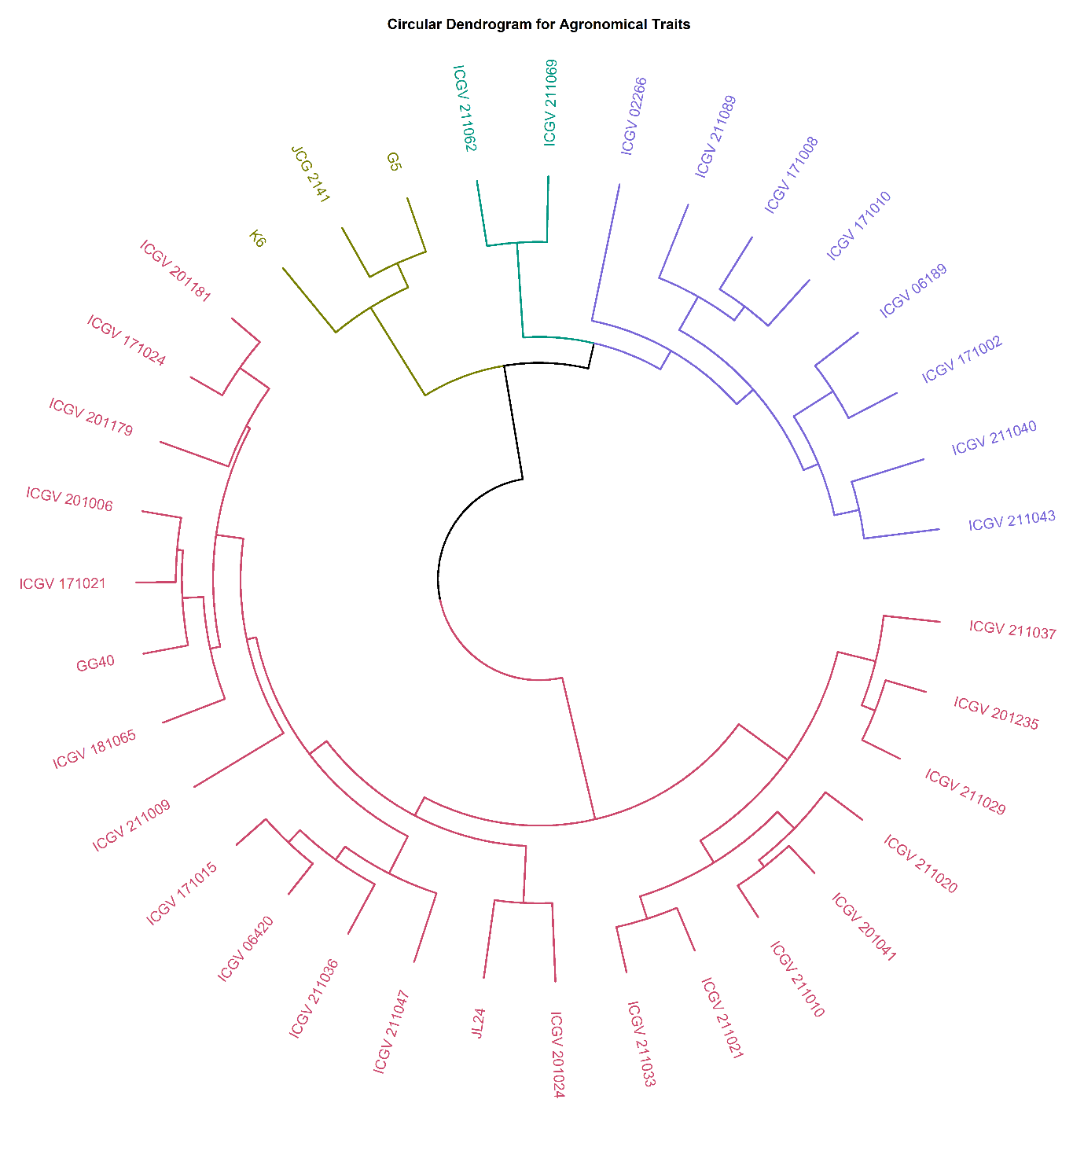
Hierarchical clustering grouped the 35 groundnut accessions into four distinct clusters, revealing clear phenotypic variability within the studied material (Fig. 1). Cluster III reflected a contrasting pattern in which enhanced vegetative growth (maximum plant height) and large seed size (highest hundred seed weight) were associated with a drastically reduced number of pods per plant, indicating a possible physiological trade-off between physical seed dimensions and overall pod proliferation. The distinct clustering pattern became particularly apparent when the genotypes grouped under Cluster IV were considered, as they were characterized by early maturity and superior yield performance, likely reflecting the effects of intensive selection. Additionally, inter-cluster distance analysis provided an important measure of genetic divergence, which can be effectively utilized for identifying suitable parents in hybridization programmes. The highest inter-cluster distance recorded between Cluster II and Cluster III indicated substantial phenotypic divergence between these groups, thereby highlighting their potential usefulness for generating transgressive segregants in later generations following hybridization. The minimal intra-cluster divergence recorded in Clusters III and IV indicated a high level of uniformity, whereas the relatively higher intra-cluster variability within Cluster I highlighted the presence of broader genetic diversity useful for widening the genetic base. Similar clustering patterns were reported in earlier studies on groundnut divergence. Saiteja et al. (2023) grouped 32 genotypes into eight clusters and reported the largest inter-cluster distance between clusters VII and VIII, suggesting crossing of genotypes from these clusters to obtain better segregants for yield and yield parameters. Jain et al. (2024) grouped 31 genotypes into twelve clusters and also reported that inter-cluster distances were higher than intra-cluster distances. They concluded that hybridization between genotypes of distant clusters may create more variability in segregating populations. These are in agreement with the present finding that the highest inter-cluster distance, between Clusters II and III, marks these groups as promising parents for generating transgressive segregants.
Fig. 1 Phylogenetic relationship and phenotypic diversity of groundnut genotypes.

The wide variation among genotypes within individual clusters, as seen here for Cluster I, was also reported by Saiteja et al. (2023), Jain et al. (2024) and Dudhatra et al. (2022). Further, the clusters in Jain et al. (2024) differed in earliness and yield-related traits, and the best cross combinations were identified by considering both cluster distances and cluster means. This is consistent with the present observation that Cluster IV combined early maturity with superior yield performance.
Table 2: Cluster-wise means and distribution of groundnut genotypes across four distinct groups
Cluster | No. of Genotype | Genotypes | PH | NPPP | PYPP | PYH | HSW | DFPF | DTMP | DTMC | HPW | KD | PWT
1 | 8 | ICGV 02266, ICGV 06189, ICGV 171002, ICGV 171008, ICGV 171010, ICGV 211040, ICGV 211043, ICGV 211089 | 44.83 | 32.25 | 1.82 | 3793.23 | 44.95 | 31 | 120 | 128 | 110.13 | 10.75 | 0.91
2 | 22 | ICGV 06420, ICGV 171015, ICGV 171021, ICGV 171024, ICGV 181065, ICGV 201006, ICGV 201024, ICGV 201041, ICGV 201179, ICGV 201181, ICGV 201235, ICGV 211009, ICGV 211010, ICGV 211020, ICGV 211021, ICGV 211029, ICGV 211033, ICGV 211036, ICGV 211037, ICGV 211047, GG40, JL24 | 42.44 | 25.92 | 1.24 | 2589.30 | 32.08 | 32 | 115 | 123 | 96.30 | 8.14 | 0.72
3 | 2 | ICGV 211062, ICGV 211069 | 56.29 | 8.60 | 1.72 | 3581.25 | 58.80 | 27 | 118 | 128 | 92.00 | 9.32 | 1.45
4 | 3 | K6, JCG 2141, G5 | 51.07 | 58.73 | 2.50 | 5215.28 | 36.00 | 31 | 110 | 120 | 104.67 | 8.53 | 0.86

Table 3: Inter-cluster and Intra-cluster Distances
Cluster Distance | I | II | III | IV
I | 4.20
II | 4.98 | 3.47
III | 5.15 | 6.32 | 3.01
IV | 5.07 | 5.25 | 6.10 | 3.23

Table 4: Principal component analysis (PCA) for 11 traits of groundnut genotypes
 | PC1 | PC2 | PC3 | PC4 | PC5 | PC6 | PC7 | PC8 | PC9 | PC10 | PC11
Eigen Value | 3.71 | 2.22 | 1.50 | 1.01 | 0.78 | 0.67 | 0.50 | 0.40 | 0.15 | 0.05 | 0.00
Variance % | 33.74 | 20.22 | 13.66 | 9.18 | 7.09 | 6.14 | 4.52 | 3.61 | 1.38 | 0.46 | 0.00
Cumulative Variance % | 33.74 | 53.96 | 67.62 | 76.81 | 83.89 | 90.03 | 94.54 | 98.15 | 99.54 | 100.00 | 100.00
Traits
PH | 0.51 | 0.29 | -0.38 | -0.33 | 0.02 | 0.53 | -0.31 | -0.09 | -0.08 | -0.01 | 0.00
NPPP | 0.17 | 0.46 | 0.57 | 0.27 | 0.08 | 0.49 | 0.35 | 0.05 | 0.00 | 0.00 | 0.00
PYPP | 0.76 | 0.23 | 0.52 | -0.19 | -0.10 | -0.18 | -0.12 | -0.08 | 0.02 | 0.00 | 0.00
PYH | 0.76 | 0.23 | 0.52 | -0.19 | -0.10 | -0.18 | -0.12 | -0.08 | 0.02 | 0.00 | 0.00
HSW | 0.84 | -0.21 | -0.27 | 0.06 | 0.25 | 0.06 | 0.01 | 0.15 | 0.30 | -0.02 | 0.00
DFPF | -0.57 | -0.11 | 0.50 | 0.03 | 0.43 | 0.05 | -0.37 | 0.30 | -0.02 | -0.01 | 0.00
DTMP | 0.19 | -0.91 | 0.25 | 0.11 | -0.13 | 0.12 | -0.01 | -0.10 | -0.04 | -0.16 | 0.00
DTMC | 0.21 | -0.92 | 0.19 | 0.05 | -0.08 | 0.20 | -0.05 | -0.08 | -0.01 | 0.16 | 0.00
HPW | 0.29 | 0.27 | -0.11 | 0.81 | -0.30 | -0.01 | -0.29 | 0.03 | -0.01 | 0.01 | 0.00
KD | 0.65 | -0.05 | -0.15 | 0.28 | 0.62 | -0.16 | 0.06 | -0.21 | -0.15 | 0.01 | 0.00
PWT | 0.81 | -0.18 | -0.17 | -0.08 | -0.14 | -0.07 | 0.15 | 0.45 | -0.17 | 0.00 | 0.00

(PH- plant height; NPPP- number of pods per plant; PYPP- pod yield per plant; PYH- pod yield per hectare; HSW- hundred seed weight; DFPF- days to fifty percent flowering; DTMP- days to maturity physiological; DTMC- days to maturity curing; HPW- hundred pod weight; KD- kernel diameter; PWT- pod wall thickness)

3.2 Principal Component Analysis and Contribution of Traits to Genetic Variability
Principal Component Analysis (PCA) was employed to further dissect the total variation and identify the primary traits contributing to the observed diversity. The first four significant components, all with eigenvalues greater than one, explained 76.81% of variation in the overall phenotypic diversity (Table 4). The first principal component (PC1) alone accounted for 33.74% of the diversity and was mainly related to hundred seed weight (0.84), pod wall thickness (0.81), pod yield per plant (0.76), pod yield per hectare (0.76), and kernel diameter (0.65). Thus, a significant part of the differences between distinct genotypes in this population is driven by seed dimensions, pod characteristics, and overall yield components. The second component (PC2) contributed 20.22% of variation, featuring strong negative loadings for days to maturity curing (-0.92) and days to maturity physiological (-0.91), alongside a positive loading for the number of pods per plant (0.46). This second principal component appears to demonstrate a biological trend primarily driven by the timing of crop maturity. Lastly, the third (PC3) and fourth components (PC4) contributed an additional 13.66% and 9.18%, respectively. The major indicators in PC3 were the number of pods per plant (0.57), pod yield per hectare (0.52), and pod yield per plant (0.52), while the major contributor in PC4 was hundred-pod weight (0.81).
The PCA biplot (Fig. 2) visually confirmed the divergence of genotypes and illustrated the relationships between different traits. Vectors for pod yield per hectare, pod yield per plant, hundred-seed weight, pod wall thickness, and kernel diameter were clustered closely together along the positive axis of PC1, indicating high positive correlations among these variables. The vector for days to fifty per cent flowering was positioned opposite to major yield and seed traits, indicating that earlier-flowering genotypes tend to exhibit higher productivity characteristics. Additionally, vectors for physiological and curing maturity were strongly aligned along the negative axis of PC2. The study comprised various parameters regarding phenology and yield-attributing traits, leading to a total of four PCs with an eigenvalue of 1 or above due to phenotypic diversity within the data. The analysis showed the predominance of pod, seed, and yield traits in PC1. By identifying these key contributors such as yield, pod characteristics, and phenological timing, the study provides a clear approach for targeting traits for breeders to exploit genetic diversity for crop improvement.
Similar results were reported in various other studies in groundnut conducted earlier. These studies included phenological, yield-attributing and quality traits, and they yielded several PCs with eigenvalues of one and above because of the diversity within the data. Three PCs with eigenvalues above one, together explaining 67.23% of the variability among 46 genotypes, were reported by Vinothini et al. (2023). Ali et al. (2022) obtained five PCs with eigenvalues above one, contributing about 71.83% of the total variation, with PC1 dominated by pod weight per plant, grain weight per plant and number of pods per plant. This is parallel to the predominance of pod, seed and yield traits in PC1 of the present study. Niveditha et al. (2016) reported five PCs with eigenvalues above one, accounting for 71.46% of the total variability, and PC1 was positively associated with pod yield per plant, number of filled pods per plant, kernel yield and days to 50% flowering. Similarly, Sudhir et al. (2010) observed that the first principal component gave high positive weight to pod yield per plant and kernel yield per plant.

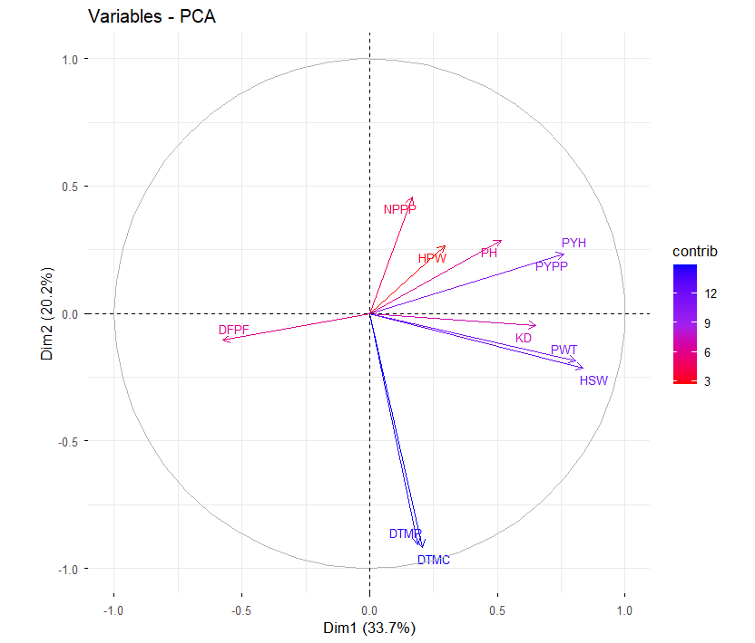

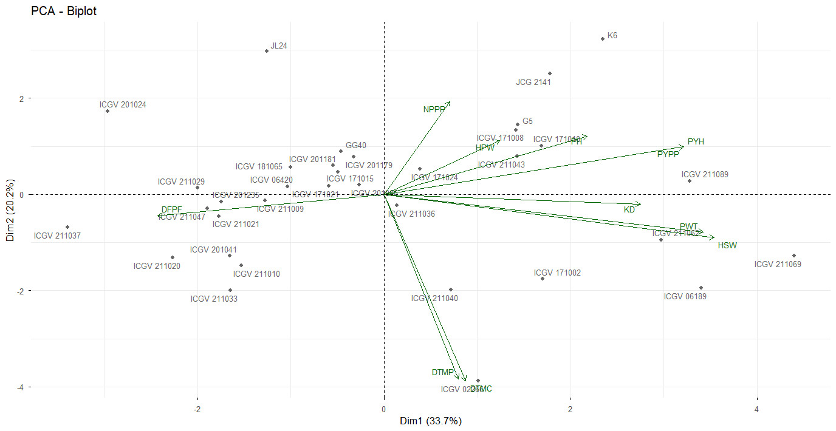

Fig. 2. Biplot showing distribution of traits and genotypes across the principal component

4. Conclusion
The multivariate evaluation of 35 groundnut (Arachis hypogaea L.) genotypes revealed substantial phenotypic and genetic diversity across morpho-agronomic, phenological, and yield attributes. Hierarchical cluster analysis resolved the genotypes into four distinct groups, revealing key physiological trade-offs most notably between vegetative vigour/seed size in Cluster III and overall pod count. Principal Component Analysis demonstrated that 76.81% of the total phenotypic variance was captured by four principal components (λ > 1.0), driven predominantly by seed dimensions, pod wall thickness, kernel diameter, maturity duration, and pod yield.
The high inter-cluster distance observed between Cluster II (low-yielding lines with thin pod walls) and Cluster III (large-seeded, high-vigour lines), as well as between Cluster III and Cluster IV (elite, early-maturing, high-yielding lines comprising K6, JCG 2141, and G5), highlights these contrasting groups as primary candidates to obtain the best recombinants. Crossing genotypes from Cluster IV with those in Cluster III offers strong potential for combining large kernel size with early maturity and high pod proliferation, thereby facilitating the recovery of high-yielding transgressive segregants in future groundnut breeding programs.
Competing Interests
The authors have declared that no competing interests exist.
Declaration of AI Use

This manuscript was prepared through the intellectual contributions of the author(s) to the study design, data analysis, interpretation of results, and scholarly content. Grammarly and ChatGPT were used solely to assist with grammatical refinement and reference formatting during manuscript revision. The author(s) accept full responsibility for the accuracy, integrity, and final content of the manuscript

References
Ali, S., Ahmad, R., Hassan, M.F., Ibrar, D., Iqbal, M.S., Naveed, M.S., Arsalan, M., Rehman, A. and Hussain, T. (2022). Groundnut genotypes’ diversity assessment for yield and oil quality traits through multivariate analysis. SABRAO Journal of Breeding and Genetics, 54(3): 565–573.
Dudhatra, R.S., Viradiya, Y.A., Joshi, K.B., Desai, T.A. and Vaghela, G.K. (2022). Genetic divergence analysis in groundnut (Arachis hypogaea L.) genotypes. Emer Life Science Research, 8(1): 114–118.
FAOSTAT, Statistics FAO (2024). Food and Agriculture Organization of the United Nations. Rome. https://www.fao.org/faostat/en/#data/QCL
India, Stat. (2026). Season-wise Area, Production and Productivity of Groundnut in India. https://www.indiastat.com/data/agriculture
Jain, P., Srevalli Devi, M., John, K. and Arunasri, P. (2024). Genetic divergence studies for yield, yield components and resistance to late leaf spot in groundnut (Arachis hypogaea L.). Andhra Pradesh Journal of Agricultural Sciences, 10(4): 263–268.
Kassambara, A. and Mundt, F. (2020) Factoextra: Extract and Visualize the Results of Multivariate Data Analyses. R Package Version 1.0.7.
https://CRAN.R-project.org/package=factoextra
Kumar A., Kumar H., Singh M. C., Kumar M., Sharma V., Kumar S., & Panwar G.S. (2024). Multivariate Analysis for Elucidating Genetic Diversity of Chickpea (Cicer arietinum L.) Germplasm using Agromorphological Traits. Legume Research, 48(4): 590-596. https://doi.org/10.18805/LR-4956
Machado, N.M., Nunes, Y.C., de Lima, E.P., Chehadi, A.C., Otoboni, A.M., Miola, V.F., Nicolau, C.C., Fiorini, A.M., Oshiiwa, M., Laurindo, L.F., Barbalho, S.M. (20252). Peanuts (Arachis hypogaea L.) in food industry and their benefits for human health- A review of the current literature. Journal of Food Composition and Analysis, 143:107574. https://doi.org/10.1016/j.jfca.2025.107574
Niveditha, P.D., Sudharani, M., Prasanna Rajesh, A. and Nirmala, P.J. (2016). Genetic diversity based on cluster and principal component analysis for yield, yield components and quality traits in peanut stem necrosis tolerant groundnut (Arachis hypogaea L.) genotypes. The Journal of Research ANGRAU, 44(3&4): 6–12.
Qulmamatova, D. E. (2023). Chickpea (Cicer arietinum L.) genotypes evaluation for high yield through multivariate analysis. SABRAO. https://doi.org/10.54910/sabrao2023.55.1.10
Saiteja, R., John, K., Sreevalli Devi, M. and Ramana Murthy, B. (2023). Studies on genetic divergence for yield, yield components and quality traits in groundnut (Arachis hypogaea L.). Andhra Pradesh Journal of Agricultural Sciences, 9(3): 205-209.
Savage, G. P., and Keenan, J. I. (1994). The composition and nutritive value of groundnut kernels. In The groundnut crop: A scientific basis for improvement. Dordrecht: Springer Netherlands, 173-213.
Sharifi, P., Astereki, H., & Pouresmael, M. (2018). Evaluation of variations in chickpea (Cicer arietinum L.) yield and yield components by multivariate technique. Annals of Agrarian Science, 16(2): 136-142. https://doi.org/10.1016/j.aasci.2018.02.003
Sudhir, K.I., Marappa, N. and Govindaraj, M. (2010). Classification of new germplasm and advanced breeding lines of groundnut (Arachis hypogaea L.) through principal component analysis. Legume Research, 33(4).
Vinothini, N., Umadevi, M., Kalaimagal, T., Rajeswari, R. and Shanthi, P. (2023). Assessment of the genetic diversity of groundnut (Arachis hypogaea L.) genotypes for kernel yield. Electronic Journal of Plant Breeding, 14(3): 1167-1173.
Xu, S., Dai, Z., Guo, P., Fu, X., Liu, S., Zhou, L., Tang, W., Feng, T., Chen, M., Zhan, L., Wu, T., Hu, E., Jiang, Y., Bo, X., & Yu, G. (2021). GGTreeExtra: Compact Visualization of richly annotated phylogenetic data. Molecular Biology and Evolution, 38(9): 4039- 4042. https://doi.org/10.1093/molbev/msab166
Yu, G., Smith, D. K., Zhu, H., Guan, Y., & Lam, T. T. (2016). ggtree: an R package for visualization and annotation of phylogenetic trees with their covariates and other associated data. Methods in Ecology and Evolution, 8(1): 28-36. https://doi.org/10.1111/2041-210x.12628

