Leaf Morphological Diversity and Phenotypic Characterization of Jackfruit (Artocarpus heterophyllus Lam.) Genotypes in the Rayalaseema Region of Andhra Pradesh, India

Abstract
The study conducted characterized leaf morphological diversity among 26 Jackfruit (Artocarpus heterophyllus Lam.) genotypes maintained at the College of Horticulture, Anantharajupeta, Andhra Pradesh, India. Quantitative and qualitative leaf traits were evaluated under a randomized block design with three replications. Leaf blade length ranged from 8.92 to 19.98 cm, with the maximum in JAP-1, while leaf blade width ranged from 5.54 to 10.78 cm, with the maximum in Yellow round. Petiole length varied from 1.37 to 3.07 cm, with Eddi pasand recording the highest value. SPAD readings ranged from 47.62 to 99.11, with the highest value in ARPJ-7. Elliptic leaf blades, acuminate apices and entire margins were the predominant qualitative characteristics. Pearson’s correlation analysis revealed a positive association between leaf blade length and width (r = 0.60). The first two principal components explained 71.3% of the total variation, while hierarchical cluster analysis revealed similarities among genotypes based on the measured traits. These findings provide baseline information for characterizing leaf diversity and identifying contrasting genotypes for further evaluation and jackfruit germplasm conservation in the Rayalaseema region of Andhra Pradesh, India.
Keywords: Jackfruit; leaf morphology; phenotypic variation; SPAD readings; correlation analysis; principal component analysis; hierarchical clustering

1. INTRODUCTION
Jackfruit (Artocarpus heterophyllus Lam.), belonging to the family Moraceae, is an important tropical fruit crop valued for its nutritional, economic and ecological significance ref. Considerable variation exists in jackfruit genotypes due to cross pollination and environmental factors, hence characterization jack fruit genotypes in nursery stage is much essential for documenting germplasm diversity, identifying varieties and supporting future crop improvement programmes.
Leaf characteristics are useful morphological descriptors for differentiating genotypes in early crop growth stages may useful for conservation and crop improvement (Ref).
The leaf quantitative traits such as leaf blade length, width and petiole length provide measurable information on leaf dimensions, whereas leaf qualitative traits viz, leaf blade shape, apex, base, margin, colour and petiole shape contribute to genotype identification and morphological classification REF. Evaluating these traits through standardized descriptors to be used for documenting jackfruit diversity (International Plant Genetic Resources Institute, 2000; Nakintu et al., 2023) and it may provide a systematic data for documenting leaf traits among the jackfruit genotypes.
In addition to morphological characteristics, leaf chlorophyll status provides complementary information on plant physiological attributes to compare leaf greenness among genotypes, although they may be influenced by leaf structure, developmental stage and measurement conditions ref. Non-destructive chlorophyll meters have been evaluated for estimating foliar chlorophyll status (Markwell et al., 1995; Richardson et al., 2002).
Jack fruit shows wide diversity and leaf characters due to genetic and environmental factors ref. Hence, systematic characterization of leaf traits among jackfruit genotypes under specific agro-climatic conditions can generate region-specific information for germplasm selection, conservation and further crop improvement. However, the Rayalaseema region of Andhra Pradesh called as hub of horticulture, still no research work has done on jack fruit genotype evaluation based on leaf traits.
In this context, the present study was undertaken to characterize quantitative and qualitative leaf traits and assess the SPAD chlorophyll index among 26 jackfruit (Artocarpus heterophyllus Lam.) genotypes under the Rayalaseema region of Andhra Pradesh, India, with the objective of documenting phenotypic variation and identifying unique leaf characteristics for germplasm characterization and further crop selection and crop improvement.
2. MATERIAL AND METHODS
The field investigation was conducted in the jackfruit germplasm block, Department of Fruit Science, College of Horticulture, Dr. YSR Horticultural University, Anantharajupeta, Andhra Pradesh, India. The experimental site is situated at an altitude of approximately 162 m above mean sea level, at the reported coordinates of 13°95′ N latitude and 79°40′ E longitude, within the southern agro-climatic zone of Andhra Pradesh.
Twenty-six Jackfruit genotypes were selected for systematic evaluation of leaf morphological characteristics with randomized block design (RBD). The leaf morphological observations were recorded using quantitative and qualitative descriptors published by the International Plant Genetic Resources Institute (IPGRI, 2000) and the Protection of Plant Varieties and Farmers Rights Authority (PPV&FRA, 2001) DUS guidelines for jackfruit. SPAD readings were recorded to estimate chlorophyll content and compare the readings among the evaluated jackfruit genotypes.
The quantitative data were analysed using analysis of variance (ANOVA) under a randomized block design (RBD) and the genotype means, standard error of the mean (S. eM), critical difference (C.D.) at the 5% probability level and coefficient of variation (C.V.) were calculated to assess variation among the genotypes. Pearson correlation analysis and principal component analysis (PCA) was done to standardize trait values REF. The hierarchical cluster analysis was performed using Euclidean distance and Ward's method. REF

3. RESULTS AND DISCUSSION
The results of present study showed significant variation in leaf qualitative characteristics such as leaf blade shape, apex shape, base shape, margin and leaf colour (Table 1). Among the 26 genotypes, elliptic shape was the most frequently observed leaf blade shape, while oblong, obovate, narrowly elliptic and broadly elliptic forms were also observed. The leaf apex was predominantly acuminate, although acute and retuse forms were recorded in some genotypes. Leaf base shape varied among oblique, rounded, shortly attenuate and cuneate types.
3.1. Qualitative Leaf Characteristics
Table 1. Qualitative leaf morphological characteristics of 26 jackfruit genotypes
Genotype | Leaf blade shape | Leaf apex | Leaf base | Leaf margin | Leaf colour | Petiole shape
A to Z variety | Narrowly elliptic | Acuminate | Oblique | Entire | Green | Flattened
ARPJ-1 | Elliptic | Acuminate | Rounded | Entire | Dark green | Rounded
ARPJ-2 | Elliptic | Acuminate | Shortly attenuate | Entire | Dark green | Flattened
ARPJ-3 | Elliptic | Acuminate | Oblique | Entire | Dark green | Rounded
ARPJ-4 | Elliptic | Acuminate | Shortly attenuate | Entire | Dark green | Rounded
ARPJ-5 | Elliptic | Acute | Rounded | Entire | Dark green | Rounded
ARPJ-6 | Broadly elliptic | Acuminate | Rounded | Entire | Dark green | Rounded
ARPJ-7 | Narrowly elliptic | Acute | Shortly attenuate | Entire | Dark green | Rounded
Byrachandra | Oblong | Acute | Oblique | Entire | Green | Flattened
Eddi pasand | Oblong | Acuminate | Cuneate | Entire | Green | Rounded
Gumless | Elliptic | Acuminate | Rounded | Entire | Dark green | Flattened
Honey dew | Obovate | Acuminate | Oblique | Entire | Green | Flattened
JAP-1 | Elliptic | Acuminate | Rounded | Entire | Green | Rounded
JAP-2 | Elliptic | Acute | Cuneate | Entire | Dark green | Rounded
Kanavarikka | Elliptic | Acuminate | Oblique | Entire | Dark green | Flattened
Kumbali | Obovate | Acuminate | Oblique | Entire | Green | Flattened
Lalbagh madhura | Elliptic | Acuminate | Rounded | Entire | Dark green | Rounded
Malaysian dwarf | Oblong | Retuse | Rounded | Entire | Green | Rounded
Muttamvarikka | Oblong | Acuminate | Rounded | Entire | Dark green | Rounded
NSP | Elliptic | Acute | Oblique | Entire | Green | Rounded
Palur-1 | Elliptic | Acuminate | Rounded | Entire | Dark green | Rounded
Prashanti | Elliptic | Acuminate | Rounded | Entire | Dark green | Rounded
Ramachandra | Obovate | Acute | Oblique | Entire | Green | Flattened
Roja | Narrowly elliptic | Acuminate | Shortly attenuate | Entire | Dark green | Flattened
Thailand | Elliptic | Acuminate | Rounded | Entire | Light green | Flattened
Yellow round | Obovate | Acute | Rounded | Undulate | Green | Rounded

genotypes exhibited an entire leaf margin, whereas Yellow round showed an undulate margin. Leaf colour varied from green to dark green, with Thailand recorded as light green. These qualitative differences provide additional morphological features for describing and distinguishing the evaluated genotypes. Differences in leaf morphological characteristics among selected genotypes are illustrated in Figure 1

The predominance of elliptic leaf blades and acuminate apices, together with less frequent forms, provides descriptive contrasts among the accessions but does not by itself demonstrate the presence of distinct genetic groups. Related studies have reported considerable variation in jackfruit leaf and other vegetative characters and have used such descriptors to support germplasm characterization (Gwokyalya et al., 2024; Nakintu et al., 2023; Singh et al., 2018). As the expression of leaf form can be influenced by both inherited and environmental factors, repeated observations at comparable developmental stages would help establish which distinctions remain consistent (Gupta et al., 2020).
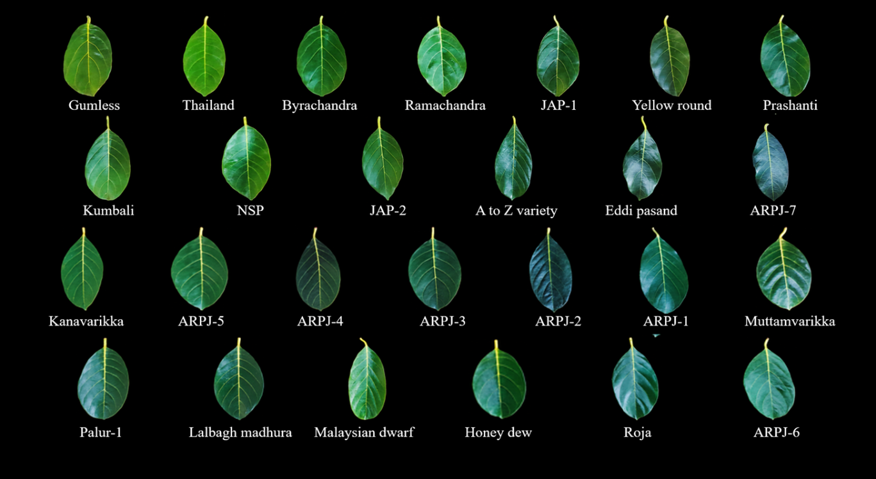Figure 1. Leaf morphological variation among selected jackfruit genotypes.

3.2. Quantitative Leaf Characteristics

Table 2. Quantitative leaf traits and SPAD readings of 26 jackfruit genotypes
Genotype | Leaf blade length (cm) | Leaf blade width (cm) | Petiole length (cm) | Chlorophyll (SPAD )
A to Z variety | 12.86 | 6.18 | 1.57 | 80.95
ARPJ-1 | 14.58 | 7.02 | 1.97 | 69.11
ARPJ-2 | 15.36 | 7.46 | 1.63 | 66.81
ARPJ-3 | 13.66 | 7.88 | 2.27 | 91.69
ARPJ-4 | 11.76 | 6.62 | 2.27 | 94.85
ARPJ-5 | 12.94 | 7.68 | 1.90 | 66.15
ARPJ-6 | 14.10 | 8.72 | 2.33 | 73.97
ARPJ-7 | 15.88 | 6.42 | 2.10 | 99.11
Byrachandra | 14.56 | 8.04 | 2.10 | 63.72
Eddi pasand | 13.94 | 7.28 | 3.07 | 67.23
Gumless | 18.14 | 8.92 | 1.90 | 79.65
Honey dew | 8.92 | 6.00 | 1.57 | 62.25
JAP-1 | 19.98 | 9.58 | 2.07 | 90.77
JAP-2 | 14.44 | 8.14 | 2.67 | 66.51
Kanavarikka | 13.54 | 6.52 | 2.00 | 56.96
Kumbali | 12.42 | 7.28 | 2.27 | 66.43
Lalbagh madhura | 14.48 | 7.60 | 1.77 | 63.74
Malaysian dwarf | 14.42 | 5.88 | 1.70 | 54.51
Muttamvarikka | 18.04 | 9.02 | 1.80 | 61.20
NSP | 13.16 | 7.98 | 2.00 | 56.37
Palur-1 | 15.04 | 7.64 | 1.93 | 82.83
Prashanti | 17.50 | 7.96 | 2.40 | 70.54
Ramachandra | 15.52 | 8.78 | 2.10 | 48.37
Roja | 10.64 | 5.54 | 1.57 | 62.99
Thailand | 11.84 | 6.06 | 1.37 | 47.62
Yellow round | 13.54 | 10.78 | 1.93 | 79.79
Mean | 14.37 | 7.90 | 2.01 | 70.16
Range | 8.92–19.98 | 5.54–10.78 | 1.37–3.07 | 47.62–99.11
S.E. (m.) | 0.73 | 0.39 | 0.07 | 2.52
C.D. (P = 0.05) | 2.07 | 1.10 | 0.19 | 7.17
C.V. (%) | 8.82 | 8.61 | 6.10 | 6.23

Among the all 26 genotypes showed significant variation with respect to

Leaf blade length ranged from 8.92 to 19.98 cm, with a mean of 14.37 cm. JAP-1 recorded the maximum length (19.98 cm), whereas Honey dew recorded the minimum (8.92 cm). Leaf blade width ranged from 5.54 to 10.78 cm, with a mean of 7.90 cm. Yellow round recorded the maximum width (10.78 cm), while Roja recorded the minimum (5.54 cm).Petiole length ranged from 1.37 to 3.07 cm. Eddi pasand recorded the maximum length (3.07 cm), whereas Thailand recorded the minimum (1.37 cm).

SPAD readings ranged from 47.62 to 99.11, with a reported mean of 70.16. ARPJ-7 recorded the highest reading (99.11) and Thailand recorded the lowest reading (47.62). SPAD readings provide relative estimates of leaf greenness and should not be interpreted as direct chlorophyll concentrations unless calibrated against direct chlorophyll measurements.

The observed differences in leaf dimensions are broadly consistent with reports of morphological variability in jackfruit collections from Uttarakhand and Tripura, although differences in plant age, site conditions and sampling methods limit direct numerical comparisons (Roy et al., 2021; Singh et al., 2018). Evaluating blade length and width jointly is relevant because individual dimensions do not fully capture leaf form, as emphasised in morphometric studies of leaf size and shape (Chuanromanee et al., 2019). The SPAD differences should likewise be treated as relative greenness indices: the relationship between meter readings and extracted chlorophyll can depend on leaf structure and calibration (Markwell et al., 1995; Richardson et al., 2002). Consequently, the present SPAD rankings cannot, on their own, establish differences in absolute pigment concentration or photosynthetic capacity.
3.3. Implications for morphological characterization
The combined assessment of quantitative and qualitative traits showed variation among the 26 genotypes. JAP-1 had the longest leaf blades, Yellow round had the widest blades, Eddi pasand had the longest petioles, and ARPJ-7 had the highest SPAD reading. These traits may be useful for preliminary phenotypic description, although selection decisions require consideration of the full dataset and additional evidence.
The combination of qualitative descriptors, dimensions and SPAD readings provides a preliminary profile of contrasting jackfruit accessions, consistent with the use of multiple morphological descriptors in germplasm studies (Nakintu et al., 2023; Singh et al., 2018). Nevertheless, similarity in observable traits should not be equated with genetic identity: jackfruit investigations using molecular markers have shown that morphological and genetic relationships can differ (Gwokyalya et al., 2024; Shyamalamma et al., 2008). The present observations are therefore most appropriately used to prioritise genotypes for further evaluation rather than to make definitive claims about genetic superiority.
3.4. Correlation Analysis
Correlation analysis showed positive relationships among the four quantitative traits (Figure 2). The strongest positive correlation was between leaf blade length and leaf blade width (r = 0.60). Petiole length was positively correlated with leaf blade width (r = 0.30), SPAD reading (r = 0.25) and leaf blade length (r = 0.22). SPAD reading was positively correlated with leaf blade length (r = 0.25) and width (r = 0.18). These coefficients describe associations and do not establish causal relationships.
The moderate association between blade length and width is compatible with partial covariation in leaf size; it does not imply that the two measurements are interchangeable. Leaf morphometric research has highlighted the value of analysing related size and shape measurements together, while also recognising variation associated with growing conditions (Chuanromanee et al., 2019; Gupta et al., 2020). In a separate jackfruit study, correlation analysis was combined with multivariate approaches to characterise morphological differences, underscoring the descriptive value of interpreting several traits jointly (Ullah et al., 2025). The current coefficients therefore warrant cautious interpretation, particularly in the absence of multi-environment observations.
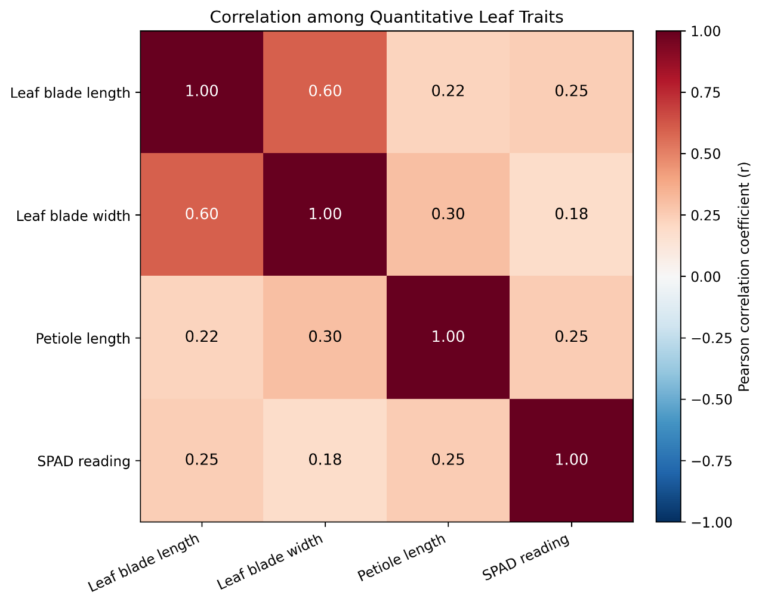

Figure 2. Pearson correlation matrix showing the relationships among four quantitative leaf traits of 26 jackfruit genotypes
3.5. Principal Component Analysis (PCA)
Principal component analysis (PCA) summarized variation among the 26 genotypes based on the four quantitative traits. The first principal component explained 48.3% of the total variation and the second explained 23.0%; together, they accounted for 71.3%. Leaf blade length and width were oriented towards the positive sides of both components, whereas petiole length and SPAD reading were oriented towards the positive side of the first component and negative side of the second. JAP-1 was positioned towards the positive extreme of the first component, while ARPJ-4 was located towards the negative extreme of the second.
The first two components retain a substantial proportion of the measured variation, but the remaining 28.7% is not displayed in the two-dimensional biplot. Comparable jackfruit research has used PCA to summarise multivariate phenotypic patterns and to identify accessions differing in measured characteristics (Karunakaran et al., 2025; Ullah et al., 2025). Nevertheless, separation on an ordination plot represents phenotypic contrast within the variables analysed rather than independent confirmation of genetic distinctness, a distinction reinforced by work comparing morphological and molecular information in jackfruit (Gwokyalya et al., 2024). The PCA interpretation should also be considered in relation to the standardisation of leaf dimensions and SPAD readings, which have different measurement scales.
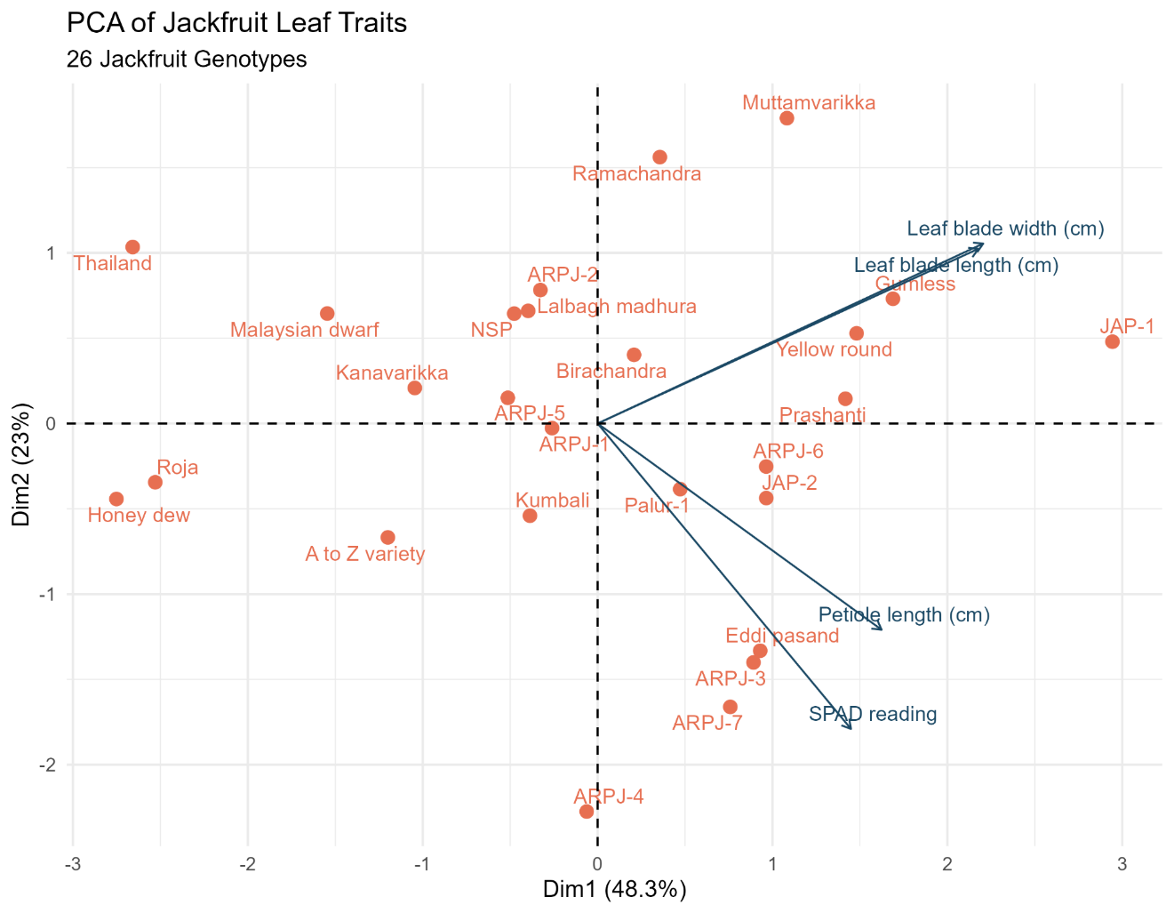
Figure 3. Principal component analysis (PCA) biplot showing the relationships among 26 jackfruit genotypes based on four quantitative leaf traits

3.6. Hierarchical Cluster Analysis
The dendrogram showed differences in similarity among genotypes, Thailand, Honey dew and Roja formed a closely associated group; ARPJ-2 and Lalbagh madhura were also closely associated. ARPJ-3 and Palur-1, ARPJ-6 and JAP-2, and Byrachandra, ARPJ-5 and NSP showed close clustering relationships. Genotypes joined at shorter Euclidean distances were more similar for the measured traits than those joined at larger distances. The clustering pattern complemented the PCA summary of phenotypic variation.
The short branch distances in the dendrogram indicate similarity under the four standardised traits examined, not verified pedigree relationships. Jackfruit studies have applied hierarchical clustering to morphological descriptors and molecular-marker profiles, illustrating that the resulting groupings depend on the underlying character set and analytical method (Shyamalamma et al., 2008; Ullah et al., 2025). Moreover, research comparing morphological and molecular distances in jackfruit found limited correspondence between the two in the populations examined (Gwokyalya et al., 2024). The groups identified here are therefore useful for organising subsequent assessments, but additional traits, environments and, where feasible, molecular data would be required to assess the stability and genetic basis of these associations.
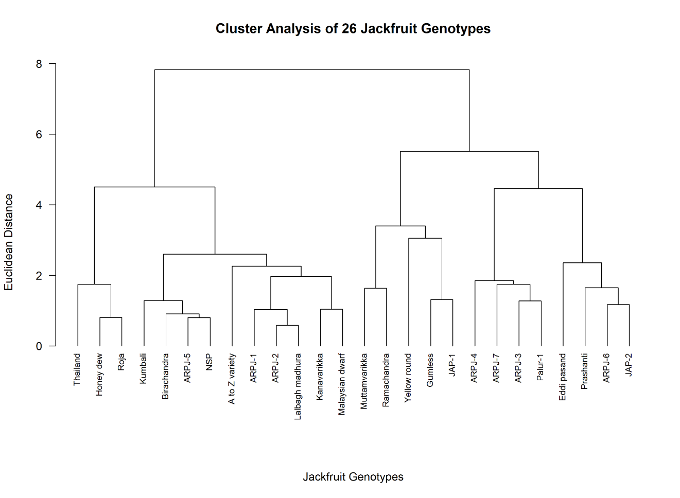
Figure 4. Hierarchical cluster analysis of 26 jackfruit genotypes based on standardized leaf traits using Euclidean distance and Ward’s method.

4. CONCLUSION
The study revealed notable variation in quantitative and qualitative leaf traits among 26 jackfruit genotypes evaluated under the Rayalaseema region of Andhra Pradesh, India. The genotype, JAP-1 recorded the maximum leaf blade length (19.98 cm), Yellow round the widest blades (10.78 cm), Eddi pasand the longest petioles (3.07 cm), and ARPJ-7 the highest SPAD reading (99.11). Wide variation was also observed in leaf blade shape, apex, base, margin, colour and petiole shape. Leaf blade length and width showed the strongest positive correlation. Cluster analysis also showed differences among the genotypes based on quantitative traits. These findings provide baseline information for leaf-trait characterization and documentation of jackfruit germplasm in Rayalaseema region of A.P..

Declaration of AI Use

This manuscript was prepared through the intellectual contributions of the author(s) to the study design, data analysis, interpretation of results, and scholarly content. Grammarly and ChatGPT were used solely to assist with grammatical refinement and reference formatting during manuscript revision. The author(s) accept full responsibility for the accuracy, integrity, and final content of the manuscript.

Competing Interests
The authors declare that no competing interests exist
References
Chuanromanee, T. S., Cohen, J. I., & Ryan, G. L. (2019). Morphological analysis of size and shape (MASS): An integrative software program for morphometric analyses of leaves. Applications in Plant Sciences, 7(9), Article e11288. https://doi.org/10.1002/aps3.11288
Gupta, S., Rosenthal, D. M., Stinchcombe, J. R., & Baucom, R. S. (2020). The remarkable morphological diversity of leaf shape in sweet potato (Ipomoea batatas): The influence of genetics, environment, and G × E. New Phytologist, 225(5), 2183–2195. https://doi.org/10.1111/nph.16286
Gwokyalya, R., Nanteza, A., Wagaba, H., Kayondo, S. I., Kazigaba, D., et al. (2024). Morphological and genetic characterization of jackfruit (Artocarpus heterophyllus) in the Kayunga and Luwero districts of Uganda. BMC Plant Biology, 24, Article 355. https://doi.org/10.1186/s12870-024-05064-x
International Plant Genetic Resources Institute. (2000). Descriptors for jackfruit (Artocarpus heterophyllus). IPGRI. https://alliancebioversityciat.org/publications-data/descriptors-jackfruit-artocarpus-heterophyllus
Karunakaran, G., Dinesh, M. R., Ravishankar, K. V., Prakash, K., Kanupriya, C., Singh, P., Arivalagan, M., & Ruchitha, T. (2025). Characterization of jackfruit Artocarpus heterophyllus Lam. for economic traits in dry zones of Karnataka, India. Scientific Reports, 15, Article 6830. https://doi.org/10.1038/s41598-025-91810-6
Markwell, J., Osterman, J. C., & Mitchell, J. L. (1995). Calibration of the Minolta SPAD-502 leaf chlorophyll meter. Photosynthesis Research, 46, 467–472. https://doi.org/10.1007/BF00032301
Nakintu, J., Andama, M., Albrecht, C., Wangalwa, R., Lejju, J. B., & Olet, E. A. (2023). Morphological traits of jackfruit (Artocarpus heterophyllus Lam.): Indicators of diversity, selection and germplasm dispersion in Uganda. Scientific African, 22, Article e01900. https://doi.org/10.1016/j.sciaf.2023.e01900
Protection of Plant Varieties and Farmers’ Rights Authority. (n.d.). Guidelines for the conduct of test for distinctiveness, uniformity and stability on jackfruit (Artocarpus heterophyllus Lam.). Government of India. https://plantauthority.gov.in/sites/default/files/draftjackfruitguideline.pdf
Richardson, A. D., Duigan, S. P., & Berlyn, G. P. (2002). An evaluation of noninvasive methods to estimate foliar chlorophyll content. New Phytologist, 153(1), 185–194. https://doi.org/10.1046/j.0028-646X.2001.00289.x
Roy, A., Banerjee, R., & Pratibha. (2021). Effect of jackfruit (Artocarpus heterophyllus Lam.) germplasms on the morphological characters under Terai conditions of Uttarakhand. Bhartiya Krishi Anusandhan Patrika, 36(3), 186–191. https://doi.org/10.18805/BKAP354

Shyamalamma, S., Chandra, S. B. C., Hegde, M., & Naryanswamy, P. (2008). Evaluation of genetic diversity in jackfruit (Artocarpus heterophyllus Lam.) based on amplified fragment length polymorphism markers. Genetics and Molecular Research, 7(3), 645–656. https://doi.org/10.4238/vol7-3gmr457
Singh, A. K., Gohain, I., & Shyamalamma, S. (2018). Morphological variability in jackfruit grown under agro-forestry system of Tripura. Indian Journal of Horticulture, 75(3), 376–383. https://doi.org/10.5958/0974-0112.2018.00065.8
Ullah, L. R., Purnama, P. R., & Wisanti. (2025). Morphological characterization and clustering analysis of three local jackfruit cultivars (Artocarpus heterophyllus) in Lamongan District, East Java, Indonesia. Biodiversitas, 26(4), 1920–1928. https://doi.org/10.13057/biodiv/d260441

