Assessment of the Current Operating Status of On-Site Sanitation Facilities: A Case Study of Selected Neighborhoods in Yamoussoukro, Côte d’Ivoire.

.
ABSTRACT

Sanitation remains largely an overshadowed issue in urban policies and development projects in developing countries such as Côte d’Ivoire. Several factors impede effective sanitation management. Therefore, an assessment of the operating status of sanitation facilities was conducted across the Millionnaire, Assabou, Kokrénou, and Sopim neighborhoods of Yamoussoukro, and 498 households were surveyed out of 3,672, or 14 %. Field observations, socioeconomic characteristics, and operating status of the facilities were documented. The findings showed that 31.40% of household members had completed primary school and that monthly household incomes ranged from F CFA 100,000 to F CFA 200,000. Furthermore, according to the findings, the sanitation facilities were in a state of disrepair. With regard to the discharge points for wastewater from showers, this water is discharged directly into the environment in the neighborhoods of Assabou, Kokrénou, and Sopim. More than 50% of low-income households had damaged latrines and septic tanks, unlike high-income households. The uncontrolled discharge of wastewater into streets and gutters, backflow of water into septic tanks, and insect infestations in latrines, coupled with the dumping of septic sludge in courtyards, contribute significantly to environmental degradation, thereby posing serious health risks to the population. Diseases reported in households, such as malaria, typhoid fever, cases of diarrhea, and a few cases of dysentery and cholera, are believed to be linked to sanitation and hygiene conditions within households. Unsanitary conditions pose a real health risk. It is therefore imperative to design adequate and appropriate facilities to prevent wastewater from flowing into the streets and raise awareness among households about proper usage.

Keywords: On-site sanitation facilities, households in Yamoussoukro, health risk, malfunction.

1. INTRODUCTION

Sanitation is a major concern for governments around the world. Global joint programs have revealed that 4.5 billion people worldwide lack adequate sanitation (OMS & UNICEF, 2017). As a response to this problem, sanitation was identified in 2002 at the World Summit on Sustainable Development in Johannesburg as one of the targets of Millennium Development Goal 7 (OMS, 2002; Tezanou, 2010; Le Jallé & Désillé, 2008). However, as the deadline for the Millennium Development Goals approached, between 2000 and 2022, 2.1 billion people gained access to safely managed drinking water, and the number of people lacking even basic drinking water supply services fell from 1.2 billion to 703 million. Two-thirds (1.4 billion) of the people who gained access to safely managed services lived in urban areas, compared with 704 million in rural areas (UNICEF/WHO, 2023). Approximately 1.4 million people die each year worldwide due to insufficient access to safe drinking water, sanitation, and hygiene, a large proportion of whom are young children who are vulnerable to diarrheal diseases (BOINET & GOLDBERG, 2021; WHO, 2023). Despite international attention being paid to this issue, nearly one in three people still lacked access to improved sanitation systems in 2015 (UNICEF/WHO, 2023). To this end, the Sustainable Development Goals (SDGs) offer an opportunity to go beyond the ambitions of the Millennium Development Goals (MDGs) by ensuring universal access to improved sanitation. Indeed, Target 6 of the Sustainable Development Goals, which aims to ensure access to safe water and sanitation for all, requires governments to ensure that everyone has progressively better access to sanitation, without discrimination (UNESCO, 2019).
In Africa, the state of sanitation infrastructure is the same: nearly a quarter of 612 million people out of approximately 2.5 billion worldwide, live without improved sanitation facilities. The provision of safe drinking water and improved sanitation services ranks among the major challenges faced by African countries (WHO & UNICEF, 2013). In major African cities, several factors make it difficult to effectively manage urban sanitation and ensure access to safe drinking water. However, inadequate sanitation and hygiene facilitate the transmission of pathogenic germs, and 88% of diarrhea cases are directly linked to these causes. Furthermore, several studies highlight the negative consequences of poor sanitation, in terms of health, environment, and economy (Dovonou et al., 2022).
In Côte d'Ivoire, access to safe drinking water and sanitation poses significant challenges, with notable disparities among different population groups and geographic areas. According to data from the 2023 DHS, 81% of the population has access to at least one basic drinking water service, while 3% use a limited service. However, the actual availability of water remains a challenge, as only 72% of households report having enough water for their consumption. Furthermore, in these cities, access to sanitation is a daily struggle for hundreds of thousands of people. The same is true for the municipality of Yamoussoukro, the political capital. Furthermore, a study by Yapi et al. (2020) showed that, according to ONAD, the rate for on-site sanitation in the municipality of Yamoussoukro stood at 90 percent, while only 10 percent of the population had access to centralized sanitation in 2015. Unfortunately, these on-site sanitation systems may appear to be adequate, yet they are, in fact, inadequate. Indeed, the use of on-site sanitation systems by the city’s residents does little to solve the problem, as we observe wastewater stagnating in the streets due to backflows from septic tanks and discharge of dishwater, laundry water, and toilet waste (Wandan et al., 2014; N’Dri et al., 2023).
In light of the aforementioned findings, the research question of this study is to understand why these on-site sanitation facilities are inappropriate for reducing social inequalities along with health and environmental risks. Thus, the overall objective of this study is to conduct an assessment of the current operation of on-site sanitation facilities in the Millionnaire, Assabou, Kokrénou, and Sopim neighborhoods of Yamoussoukro. In particular, the study will (1) examine the socioeconomic characteristics of households; (2) identify the causes of the malfunctioning of on-site sanitation systems and assess their current operating status; and (3) propose solutions for maintaining and designing on-site sanitation facilities adapted to local conditions.

2. material and methods
2.1. Overview of the Study Sites
Yamoussoukro is the political and administrative capital of the Republic of Côte d’Ivoire. It is located approximately 248 km from Abidjan and lies between latitudes 06°33’ and 07°20’ North and longitudes 04°56’ and 05°30’ West. With an area of 3,500 Km² (Akmel, 2013), Yamoussoukro is bounded to the north by the departments of Tiébissou and Bouaké, to the east by the department of Dimbokro, to the west by the departments of Bouaflé and Daloa, and to the south by the department of Toumodi. The neighborhoods included in this study are geolocated in Figure 1.
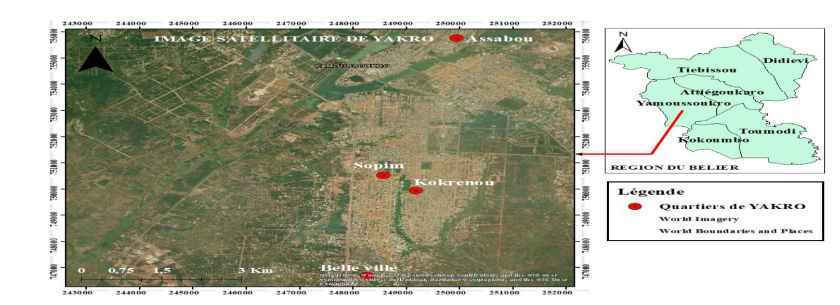
Figure 1: Geolocation of Neighborhoods

2.2. Methodological Approach
For this study, the methodological approach was based primarily on sample design and data collection. To this end, the type of housing standard was used as the criterion for surveys. The neighborhoods were selected based on the distribution of sectors among the different groups of students. Thus, the Millionaire, Assabou, Kokrénou, and Sopim neighborhoods were classified into three categories based on the types of housing identified, namely: upper class, middle class, and lower class. The Millionaire neighborhood was classified as upper class, Assabou as lower class, and Kokrénou and Sopim as middle class.
2.3. Sampling Method
The sampling method used to determine the sample size for the survey was based on simple random sampling (Djagoun et al., 2022). In fact, according to data from the 2021 General Population Census (RGPH, 2021), the city of Yamoussoukro is reported to have 73,428 households spread across some 20 neighborhoods. In the absence of survey data on the number of households in the Millionnaire, Assabou, Kokrénou, and Sopim neighborhoods, which are the focus of this study, the normal distribution was assumed; thus, the distribution of the total number of households across the twenty neighborhoods yields 3,672 households per neighborhood. The sample size (n) is calculated by applying Schwartz’s Equation 1 to the 3,672 households.
Therefore, based on Equation 1, the sample size for households was determined according to income level.
$$n=\frac{NP{(t_{p})}^{2}(1-P)}{(P({t_{p})}^{2}(1-P))+(y^{2}(N-1))} (1)$$

Where: n = sample size; N = 3 672 households = target population; P = 0.4: expected response rate from the population, tp = 1.96: sampling confidence interval, y = 0.04: sampling error margin.
The sample size obtained by substituting data into Equation 1 is 498 households. The sample distribution is shown in Table I.
Table I: The sample distribution
Neighborhoods | Types of Housing | Number of households surveyed | Total
Millionnaire | Upper class | 123 | 498
Kokrénou | Middle class | 123 | 498
Sopim | Middle class | 123 | 498
Assabou | Lower class | 129 | 498

2.4. Data Collection and Processing
Household surveys were conducted in the presence of an adult residing in the household when the family head or anyone authorized to represent him or her was absent. The survey phase took place in April 2025, using predefined questionnaires. Since the data collection method used was door-to-door, it involved visiting households to gather opinions on access to sanitation based on the questionnaires. Households were randomly selected (Djagoun et al., 2022) as survey teams assigned to this task visited every neighborhood.
The questionnaires were prepared according to the guidelines provided by Bigumandondera (2014) and Djagoun et al. (2022). Thus, the data collected provided information on the household; socioeconomic characteristics of the household, to determine the family head’s level of education, economic activity, and monthly income; information on access to sanitation and state of sanitation facilities (shower, latrines, septic tank); and information on diseases observed in households linked to poor sanitation.
Observations were made and photos were taken during surveys on on-site sanitation practices. Observations focused, among other things, on the location, construction, presence of inert materials, wastewater disposal, and state of sanitation facilities in households and throughout the neighborhood.
Regarding data processing, household responses and observation grid forms allowed us to convert responses (especially textual data) into numerical values to facilitate assessment and gather information relevant to our study. The proportions of the various parameters were calculated using Equation 2, and the charts were created using Excel.
$$F=\frac{X}{Y}×100 (2)$$
Where: F: Frequency (%); X: Number of respondents in the category under consideration; and Y: Total number of respondents.
3. results and discussion
  - Socioeconomic Characteristics of Households
The analysis of the socioeconomic characteristics of households provided a better understanding of challenges related to basic social services, given that they are an essential component of sanitation service management. These characteristics included the household size, level of education of family heads, and monthly household income.
As regards the household size, the survey findings presented in Figure 2 show that 62.22 % of households or 309 out of 498 households have more than 10 members, while 32 % (159 households) have between 5 and 10 members. Households with less than 5 people are in the minority, accounting for 5.78 % (28 out of 498 households). As regards the educational level of households, the results in Figure 3 show that 13.88% of household members did not attend school, 24.80 % completed secondary school, and 28.92% completed higher education. The most common educational level is primary school, accounting for 32.40 %. Furthermore, data on monthly household income presented in Figure 4 show that households with monthly incomes between F CFA 100,000 and F CFA 200,000 are the most common, accounting for 38.84 %. Only 28.10 % of respondents have a monthly income above or equal to F CFA 200,000. However, heads of households with a low monthly income of less than F CFA 100,000 account for 33.06 %.
In fact, according to data on the socioeconomic characteristics of households, the household size is one of the key factors determining the effectiveness and lifespan of sanitation facilities. It can influence the volume of wastewater produced by households and lead to premature saturation of septic tanks. Thus, a reduction in retention time could disrupt the biological treatment process (Laré et al., 2018; Gueye, 2026a). However, nearly 94.22 % of households have more than 5 members that is, approximately 360 out of 382. In addition to the large number of people in households, the population’s level of education could influence the state or functioning of sanitation facilities in cities. The findings of the survey showed that the majority of households had a low level of education, with 31.40% of respondents having completed only primary school. Education, as a key influencer of attitudes and opinions, plays a decisive role in behavioral change, particularly among less-educated populations who may be resistant to new ideas (Djagoun et al., 2022). Thus, these findings highlight that education plays a crucial role in the adoption of proper hygiene and sanitation practices and are consistent with the work of Seraj (2008), who asserts that household heads who have completed primary school are more likely to invest in improving their sanitation facilities. The work of Whittington et al. (1993) confirms that education influences the willingness to invest in sanitation improvements in Africa, as it helps individuals understand the benefits of sanitation systems.
Furthermore, improper hygiene and sanitation practices in the neighborhoods of Yamoussoukro covered by this study are not solely due to education but are also linked to the population’s lack of civic-mindedness or, perhaps, their income level.
In terms of monthly household income, the findings revealed that the highest incomes were between F CFA 100,000 and F CFA 200,000, accounting for 38.84 percent of households.
Indeed, in developing countries, socioeconomic factors play a crucial role in the management of the water and sanitation sector (Jaglin, 2001).
Furthermore, Collignon and Vezina (2000) noted that in African cities, a user spent between F CFA two thousand seven hundred eighty-one (F CFA 2,781) and F CFA eleven thousand two hundred twenty-three (F CFA 11,223) per year to obtain drinking water. As for sanitation, they spent between F CFA one thousand one hundred thirteen (F CFA 1,113) and F CFA eleven thousand one hundred thirteen (F CFA 11,113). Socioeconomic problems stem, firstly, from financial constraints and, secondly, from a lack of civic responsibility among the population.

Figure 2: Household size

Figure 3: level of education of family heads

Figure 4: Monthly household income

3.2. Current Operating Status of On-Site Sanitation Facilities
3.2.1. Types of Latrines in Households
Following household surveys, findings revealed that all households have latrines, with different types depending on their socioeconomic status. Figure 5 shows the proportions of different types of latrines in households. In fact, 28.92% of households use manually flushed latrines, followed by 26.45% of households that have mechanically flushed latrines, whilst 21.31% of households have traditional latrines (Figure 6). Furthermore, 10.74 per cent of responding households use both traditional latrines and manually flushed latrines, whilst 9.10 per cent of households have both traditional latrines and mechanically flushed latrines. Finally, 3.48 per cent of households have Ventilated Improved Pit latrines (VIP).
This shows that all households have different types of latrines depending on their socioeconomic status, with manual-flush latrines being the most common (28.92 per cent). This could be explained by the fact that Yamoussoukro is the country’s political capital and efforts are being made to combat open defecation (Kone et al., 2024).
This finding contrasts with that presented by Coulibaly (2016) in the developing neighborhoods of Daloa. In these developing neighborhoods, approximately two per cent (1.9 per cent) do not have a latrine (toilet).

Figure 5: Types of Latrines in households
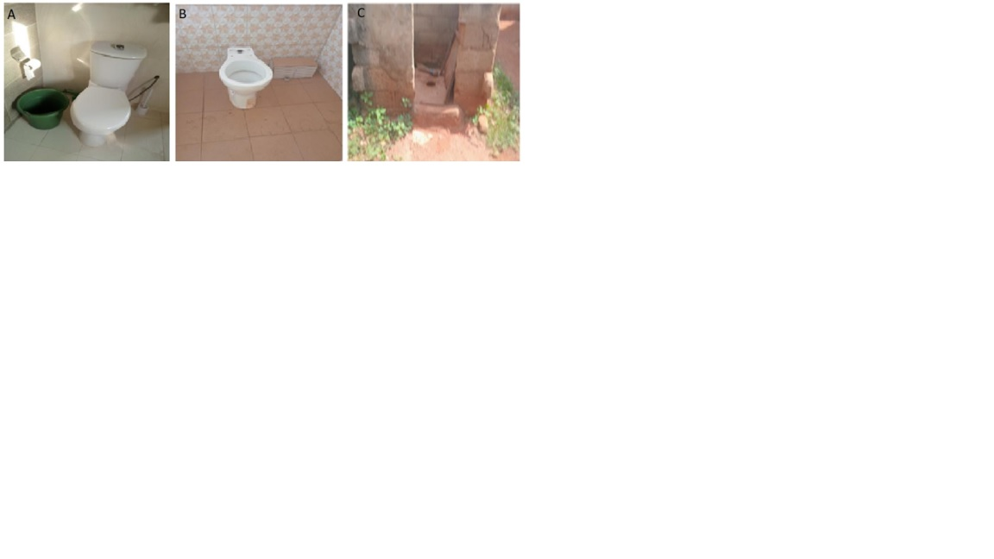
Figures 6: Some photos of different types of latrines: (A) Millionnaire neighborhood, (B) Kokrénou neighborhood, (C) Assabou neighborhood.

3.2.2. Shower Water Disposal Locations
Figure 7 shows where shower water is discharged in households. In fact, 39.68 per cent of households discharge shower water into septic tanks and 9.92 per cent into soakaways. The remaining households discharge shower water directly into the environment, with 28.01 per cent discharging it into gutters and 22.39 per cent onto the streets. Figure 8 illustrates the various discharge points for shower water.
The findings on the disposal locations of shower water showed that it was discharged into the environment, with 50.40 per cent of the wastewater discharged into gutters and onto public roads in low- and middle-income neighborhoods. This situation appears to be linked to households’ economic status. This stagnant water which is rich in nutrients and highly acidic, could, on the one hand, lead to the gradual deterioration of roads, making them difficult to use (Khemici, 2014), and, on the other hand, contribute to the spread of certain diseases such as acute respiratory infections (ARI), malaria and diarrhoeal diseases (Ta Bi et al., 2019).
Studies conducted by Bechi (2013) in Tiassalé showed that public roads were places where the majority of households discharged domestic wastewater. This same finding was also reported by Wandan et al. (2014) in a study on wastewater management. According to this author, the lack of sanitation facilities in the low-income neighborhoods of Yamoussoukro compelled households to discharge their wastewater onto the streets. These practices are due to the lack of wastewater storage facilities (septic tanks and soakaways), compelling households to discharge their wastewater into the environment.

Figures 7: Shower Drain Location

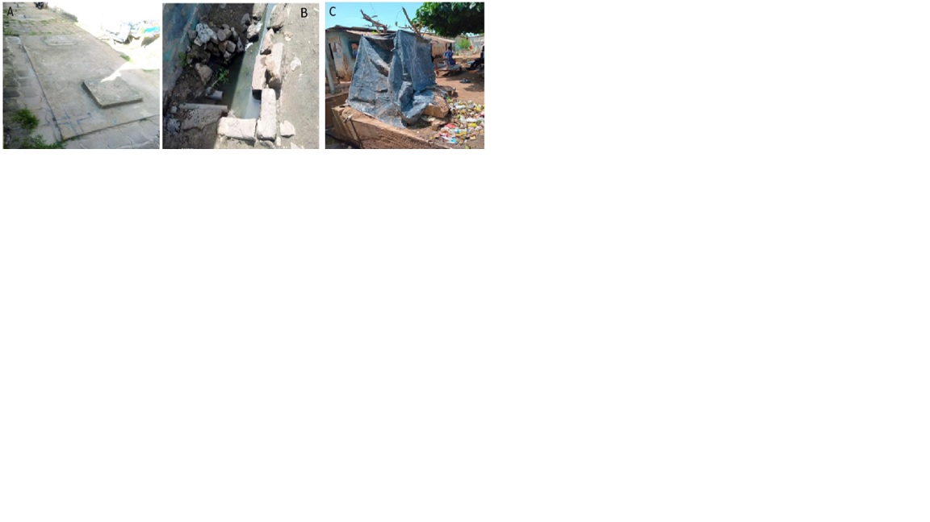
Figure 8: Images of shower drainage locations: (A) septic tank slab in the Millionnaire neighborhood; (B) a gutter in Kokrénou; (C) Shower water draining into a gutter in Assabou.

3.2.3. Type of Emptying
As regards the different types of septic tank emptying, surveys show that households use two methods: manual and mechanical emptying (Figure 9). A large proportion, 51.25 per cent of households have their septic tanks emptied mechanically, whilst 31.40 per cent use manual emptiers and 17.35 per cent of households did not have their septic tanks emptied.
As regards the emptying of septic tanks by households, the findings indicated that 51.25 per cent of households have their septic tanks emptied using specialized sewage trucks, whilst the destination of the waste resulting from this process is unknown. Nevertheless, 17.35 per cent of households that use manual emptiers for their septic tank cleaning needs dispose of these by-products haphazardly, that is to say, into the environment. Households in Yamoussoukro who use these methods view mechanical emptying as very expensive. This practice constitutes a potential source of pollution to aquatic environments.
This finding was reported by Tia et al. (2018) during their studies in the municipality of Port Bouët. According to this author, when on-site sanitation facilities are full, the sludge is removed regardless of the health regulations in force. Households call upon traditional emptiers who open the slab covering the pit to discharge the contents into a hole dug elsewhere in the courtyard.

Figure 9: Different types of septic tank emptying
3.2.4. Comparative Study of the State of Facilities per Socioeconomic Status
Figure 10 illustrates the findings on the state of latrines and septic tanks in households according to the socioeconomic status. Images showing the state of the latrines are shown in Figures 11A, 11B and 11C.
In this regard, in low-income households (Assabou), 61 per cent of latrines and septic tanks are in poor condition, whilst 39 per cent are in good condition (Figures 10 and 11A). As regards middle-income households (Kokrenou and Sopim), the findings show that 44 per cent of latrines and septic tanks are in poor condition and 56 per cent are in good condition (Figures 10 and 11B). As for the condition of septic tanks and latrines in high-income households (millionaires), 87.52 per cent of the facilities are in good condition, whilst 12.48 per cent are in poor condition (Figures 10 and 11C).
Following a comparative study of the operating status of sanitation facilities based on socioeconomic status, findings revealed that 50 per cent of low-income households have latrines and septic tanks in a state of disrepair. By contrast, only 5.35 per cent of high-income households have facilities in poor condition. Indeed, it was found that the inadequacy or even absence of drainage and sewerage systems for surface runoff and wastewater in low-income neighborhoods may force households to construct septic tanks which, in most cases, fail to meet hygiene standards. As these tanks are not only shallow but also poorly covered, they allow foul odours and even waste water from showers to escape. Fofana (2017) study showed that in the informal settlement of Andokoi in the municipality of Yopougon, sanitation systems suffer from numerous malfunctions. Furthermore, the study by Ossey (2017) noted that the housing type variable proved to be significant, insofar as the quality of housing can be regarded as an indicator of living standards. Indeed, signs of the malfunctioning of these sanitation systems include the backflow of sewage from septic tanks and stagnation of greywater on properties. The factors contributing to the malfunctioning of these facilities in low-income neighborhoods relate to a lack of financial resources, which forces residents to construct makeshift structures.
This study has therefore highlighted that low- and middle-income households are living with problems related to poor hygiene and sanitation. In this regard, such problems are found in 56.40 per cent of low-income households, compared with 43.60 per cent of middle-income households. According to Awomon et al. (2018), more than 91.43 per cent of households live within 5 metres of wastewater from showers, washing-up, laundry and septic tanks in the informal settlement of Ayakro in the municipality of Yopougon. This environmental degradation is caused by the lack of, or poor design of, sanitation facilities.

Figure 10: Condition of Latrines and Septic Tanks by Income Level

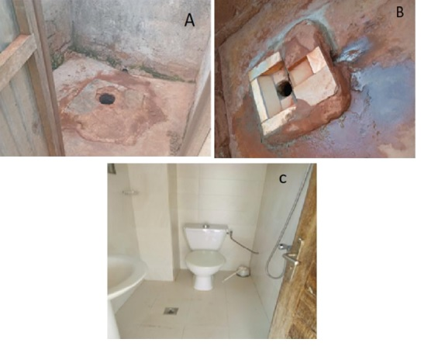

Figure 11: State of latrines and septic tanks according to the socioeconomic status: (A) Low-income households ( Assabou); (B) Middle-income households (Kokrenou et Sopim) and (C) High-income households (Millionaires).

3.2.5. Adverse Environmental and Health Impacts of Sanitation
- Disposal of Sludge
As regards the disposal of sludge from septic tanks after emptying, Figure 12 shows that 62.65 per cent of households do not know where the emptied sludge is disposed of; most of these households are those that have their septic tanks emptied mechanically, whilst households whose septic tanks are emptied manually do indicate where the emptied sludge is disposed of. Thus, 20.48 per cent discharge it into the natural environment, 14.47 per cent into gutters and 2.40 per cent recycle it on their fields.
The uncontrolled dumping of sewage sludge into the environment constitutes a major environmental and health crisis. Among other things, this leads to the destruction of the environment and ecosystems due to the highly concentrated organic and chemical substances they contain, resulting in the eutrophication of watercourses or contamination of groundwater (N’Gouran et al., 2023; Gueye et al., 2026b).

Figure 12: Disposal of sludge from septic tanks after emptying

- Problems Observed in Operating Sanitation Facilities
During surveys, observations were made about the operation of sanitation facilities and related nuisances (stagnant wastewater, insect infestations in latrines and sewage overflow from septic tanks); the findings are presented in Figure 13 with illustrative images shown in Figures 14A, B and Figure 15(A, B, C).
Thus, the prevalence of insect infestations in latrines in high-, middle- and low-income households was 4.75 per cent, 40.10 per cent and 55.15 per cent respectively. As regards wastewater stagnation, there is no stagnant water in high-income households, compared with 50 per cent in middle- and low-income households. As for sewage overflow from septic tanks, there is none in high-income neighborhoods, compared with 56.40 per cent of households in low-income neighborhoods and 43.60 per cent in middle-income neighborhoods experiencing such overflow.

Figure 13: Nuisances Observed by Types of Housing

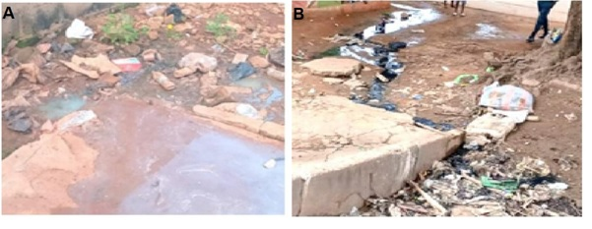
Figure 14: Images of the observed problems: (A) Dishwater in the yard in Sopim and (B) Sewage overflow from septic tanks in Kokrenou

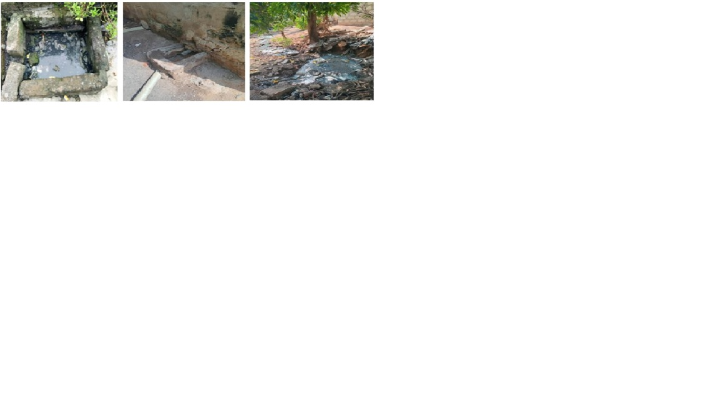
Figure 15: Images of Nuisances Observed in Assabou: (A) Open septic tank; (B) Latrine pit; (C) Shower water flowing into the street.

- Diseases Related to Sanitation and Hygiene
Figure 16 presents the findings on diseases observed in households that are associated with sanitation and hygiene. Indeed, malaria is the most common disease amongst the population, accounting for 32.36 per cent, followed by typhoid fever at 28.38 per cent, diarrhoea at 26 per cent, and finally other diseases at 13.26 per cent, including dysentery (8.11 per cent) and cholera (5.15 per cent).
With regard to the diseases identified following household surveys that are associated with sanitation and hygiene, the findings revealed that unsanitary conditions pose a serious health risk. Thus, the proportion of households affected by malaria, typhoid fever and diarrhoea stood at 32.36 per cent, 28.38 per cent and 26 per cent respectively, whilst a few cases of dysentery (8.11 per cent) and cholera (5.15 per cent) were also identified. Indeed, these hygiene-related diseases are, as a result, also linked to the precarious living conditions and toilets available to the population. According to Diabia & Bechi (2018) in their studies in the municipality of Bongouanou, it was demonstrated that the adoption of a good, modern sanitation system can help reduce the risk of diarrhoeal diseases by 29.34 per cent in rural areas and by 35.29 per cent amongst urban dwellers. Furthermore, Koffi & Anoh (2025) demonstrated that malaria and diarrhoea are influenced by the presence of household garbage and wastewater.

Figure 16: Diseases observed in households

- Recommendations
- Involve sanitation experts and specialists in the design and planning of on-site sanitation facilities in households;
- Enforce the sanctions adopted and enacted by the relevant authorities in relation to sanitation regulations;
- Request from real-estate developers proper sanitation plans for their housing estates and construction projects;
- Conduct an in-depth study into the various methods of recycling sludge, wastewater and plastic waste to prevent the proliferation of rubbish in cities;
- Strengthen information and awareness-raising campaigns on good sanitation and hygiene management;
- Build adequate and suitable latrines to prevent sewage from flowing into the streets; also provide septic tanks, soakaways and washbasins to ensure better drainage of laundry water, washing-up water, shower water and human excreta.

5. Conclusion
The aim of this study was to assess the current operating status of on-site sanitation facilities and propose improvement measures tailored to the Assabou, Sopim, Kokrenou and Millionnaire neighborhoods in Yamoussoukro. The socioeconomic characteristics and operating status of these facilities were therefore monitored.
Surveys showed that most household members had a low level of education, with 31.40 per cent having completed primary education. As regards monthly household income, the findings revealed that the highest incomes were between F CFA 100,000 and F CFA 200,000, accounting for 38.84 per cent of households.
It also emerged that the state of the sanitation facilities in the neighborhoods covered by this study poses a serious environmental problem, despite the fact that all households have latrines; however, these vary in type depending on socioeconomic status, with a higher proportion of manually flushed latrines. As regards the disposal of wastewater from showers, the study showed that such water was often discharged directly into the environment, with 50.40 per cent being discharged into gutters and onto public roads in low- and medium-standard neighborhoods.
Following a comparative study of the operating status of sanitation facilities based on socioeconomic status, findings revealed that 50 per cent of low-income households have latrines and septic tanks in a state of disrepair. By contrast, only 5.35 per cent of high-income households have facilities in poor condition.
The uncontrolled discharge of wastewater into streets and into the sewer system (gutters), backflow of water into septic tanks, and insect infestations in latrines, coupled with the dumping of septic sludge in courtyards, contribute significantly to environmental degradation, thereby posing serious health risks to the population.
The diseases identified following household surveys related to sanitation and hygiene revealed that unsanitary conditions pose a serious health risk. Thus, 32.36%, 28.38%, and 26% of households, respectively, suffered from malaria, typhoid fever, and diarrhea; in addition, a few cases of dysentery (8.11%) and cholera (5.15%) were recorded.

Competing interests
The authors declare that they have no known competing financial interests or personal relationships that could have appeared to influence the work reported in this paper.
Consent (where ever applicable)
The study was approved by all authors and tacitly or explicitly by the responsible authorities where the work was carried out.
Ethical approval (where ever applicable)
All authors hereby declare that all experiments have been examined and approved by the appropriate ethics committee and have therefore been performed in accordance with the ethical standards laid down in the 1964 Declaration of Helsinki.
Declaration of AI Use

This manuscript was prepared through the intellectual contributions of the author(s) to the study design, data analysis, interpretation of results, and scholarly content. Grammarly and ChatGPT were used solely to assist with grammatical refinement and reference formatting during manuscript revision. The author(s) accept full responsibility for the accuracy, integrity, and final content of the manuscript.

References

Akmel J. M. (2013). Study on the Implementation of a Tourism Economic Information Network for the City of Yamoussoukro. Final Thesis, Bachelor of Science in Tourism Engineering, ECEPC at INP-HB, Yamoussoukro, Côte d’Ivoire, 45 p.

Awomon A. D. F., Coulibaly M., Ymba M. (2018). “Drinking Water Supply and the Vulnerability of Populations in Informal Settlements to Waterborne Diseases: The Cases of Ayakro and Jude-Mondon (Yopougon, Côte d’Ivoire).” Proceedings of the Symposium on Spaces, Societies, and Development in Sub-Saharan Africa, University of Lomé (Togo), pp. 522-546.

Bechi G. F. (2013). Wastewater Management in Ivorian Forest Towns: Risks of Marginalization. Leïdi Laboratory Journal of Geography, 11 : 118.

Bigumandondera P. (2014). A Study of On-Site Sanitation in Sub-Saharan Africa: Application to the City of Bujumbura. Doctoral dissertation, University of Liège, Belgium, 240 p.

BOINET A. & GOLDBERG K. (2021). Water, Sanitation, and Hygiene Barometer, 7th Edition: An Overview of a Vital Resource, Challenges and Solutions, SOLIDARITÉS INTERNATIONAL–PEFC, 25p.
https://www.solidarites.org/wp-content/uploads/2021/03/barometre-eau-2021-solidarites-international.pdf

Collignon B. and Vezina M. (2000). Independent Operators of Drinking Water Supply and Sanitation in African Urban Areas. Water and Sanitation Program. Summary Report on 10 Case Studies in Africa. UNDP-World Bank, Washington, 92p.

Coulibaly M. (2016). Environmental Degradation and Health in Daloa, Single-Volume Doctoral Dissertation, Institute of Tropical Geography, Félix Houphouët-Boigny University, Abidjan, Côte d’Ivoire, 348p.

Dovonou , F. E. ., Adjimehossou , F. R. ., Kindoho, M. ., Atchichoe, W. N. . ., & Azonhe , T. . (2022). Basic Sanitation Issues: A Contribution to Environmental Health Education in Vekky (Sô-Ava). Journal of Applied Biosciences, 174(1), 18069–18092. https://doi.org/10.35759/jabs.174.5

Fofana M. (2017). Assessment of the Operation of the Domestic Wastewater Treatment System in the Andokoi Neighborhood, Yopougon, Abidjan. Knowledge and Expertise, 9-16.

Diabia, T. M., & Bechi, G. F. (2018). Use of Traditional Sanitation Systems as a Source of Diarrheal Diseases in the Municipality of Bongouanou (Central-Eastern Côte d’Ivoire). *Journal of Space, Territories, Societies, and Health.*. Institute of Tropical Geography. Félix Houphouët-Boigny University. Abidjan. Côte d’Ivoire, Vol.1, N°1, pp. 80-94.

Djagoun K. A. G., Effebi K. R., Dahani D., Kenfack S., Abdou S. (2022). Household Water Supply and Sanitation Practices in the Municipality of Yamoussoukro (Ivory Coast). International Journal of Biological and Chemical Science Int. J. Biol. Chem. Sci. 16(5): 2265-2280,
DOI: https://dx.doi.org/10.4314/ijbcs.v16i5.35

Jaglin S. (2001). Drinking Water in Developing Cities: Market-Based Models vs. Poverty. Tiers Monde Journal, XLII, 166 : 273-303.

RGPH (2021). General Population and Housing Census: Monographic Analysis Report: Yamoussoukro Autonomous District. National Statistics Agency, Côte d’Ivoire, World Bank, BIRD-IDA, 1- 133.
https://www.anstat.ci/assets/publications/files/File_val_indicateur1767023430.pdf

Gueye A., Cisse N., Lo M., Tall N. C. L., Tounkara S., Sene S. O. and Ba C. O. (2026a). Impact of Household Socioeconomic Factors on Access to Safe On-Site Sanitation Services: A Study of 7 Municipalities in Dakar, Senegal. Int. J. Biol. Chem. Sci. 20(2): 916-929.
DOI : https://dx.doi.org/10.4314/ijbcs.v20i2.30.

Gueye A., LO M., Tall N. C. L., Afouda S. A., Assogba M. A. I., Igue J., Chabi M., Saliou M. and Ba C. O. (2026b). Impacts des facteurs socio-culturels, économiques et environnementaux sur la gestion des boues de vidange au Bénin. Int. J. Biol. Chem. Sci. 20(2): 768-782.

Koffi H. Z., & Anoh P. KC. (2025). Spatial Distribution of Environmental Diseases: The Case of Malaria and Diarrhea in the City of Oumé (Côte d’Ivoire). Editions Francophones Universitaires d’Afrique, 91 - 112.

Kone K., Kouame Y. F., Bomisso T. F., Allouko J. R. and Bony K. Y. (2024). Diagnosis of open defecation in Yamoussoukro District (Central Côte d’Ivoire). World Journal of Advanced Research and Reviews, 24(01), 1119–1125.

Khemici Y. (2014). Study of the Physicochemical and Bacteriological Quality of Wastewater Treated Using a Plant Bed. Professional Master’s Thesis, School of Technical Sciences, Kasdi Merbah-Ouargla University, Algeria, 56 p.

Laré A., Briand A. & Kéré E. N. (2018). “Access to Sanitation in the Slums of Ouagadougou,” Economic News, Canadian Economic Association, vol. 94(3), 341-362.

N’Dri S. K., Eleazaus A. L. M., Brou E. K. (2023). Yamoussoukro: Lacunal Urban Development With Environmental And Socio-Economic Externalities. International Journal of Humanities and Social Science Invention, Volume 12 Issue 9, PP. 151-162.
DOI: 10.35629/7722-1209151162

N’Gouran K. P., Ouattara K., Koffi N’G. A., Kpangui K. B. and Barima Y. S. S. (2023). Impact of Septic Tank Sludge on Residual Floristic Diversity at Dump Sites in Daloa, Central-West, Côte d’Ivoire. Afrique SCIENCE 23(5): 55 – 68.

LE Jallé C. & Désille D (2008). « “Addressing the Challenge of Sanitation in Africa: A Key Component of Water Resources Management,” Solidarité Eau Program (pS-Eau) for the French Water Partnership (PFE), a platform for French water sector stakeholders active internationally www.partenariat-francais-eau.fr et www.pseau.org, 13 p.

UNESCO (2019). United Nations World Water Development Report 2019: Leaving No One Behind. United Nations Educational, Scientific and Cultural Organization (UNESCO), 7 Place de Fontenoy, 75352 Paris 07-SP, France, on behalf of UN-Water, 213p. ISBN : 978-92-3-200168-9
https://unesdoc.unesco.org/ark:/48223/pf0000367305
OMS (2002). World Summit on Sustainable Development. Report of the World Summit on Sustainable Development, Johannesburg, South Africa, August 26–September 4, 2002. United Nations publication, New York, A/CONF.199/20, Numéro: F.02. 198p.
https://edd.enseigne.ac-lyon.fr/spip/IMG/pdf/rapport_sommet_onu_johannesbourg.pdf

OMS & UNICEF (2017). Progress on Drinking Water, Sanitation, and Hygiene: 2017 Update and SDG Baselines. Geneva, Switzerland: World Health Organization and the United Nations Children’s Fund (UNICEF).116 p. ISBN 978-92-4-251289-2
https://www.unicef.org/media/49061/file/Progress_on_Drinking_Water_Sanitation_and_Hygiene_2017-ENG.pdf

Ossey A. F. (2017). Vulnerability of Communities Living Along the Shores of Abidjan’s Bays to Waterborne Diseases: The Case of Biétry Bay and Banco Bay. Master’s Thesis in Geography, UFHB University of Abidjan-Cocody, Abidjan, Côte d’Ivoire, 291 p.

Seraj K. F. B (2008). Willingness to Pay for Improved Sanitation Services and its Implication on Demand Responsive Approach of BRAC Water, Sanitation and Hygiene Programme. BRAC /Research and Evaluation Division (RED) Working, 20 : 1-16.

Tezanou K. B. M. (2010). Access to Drinking Water and Sanitation in Cameroon: Current Situation, Constraints, Issues, and Challenges for Achieving MDG 7. Journal of Economics and Management, 9(1), 111-124. https://journals.univ-tlemcen.dz/REM/index.php/REM/article/view/336

Ta Bi B. C, Kenfack S, Gnagne T, Soro G. (2019). Water Conservation in Toilets: A Feasible Approach to Reducing the Drinking Water Shortage in the City of Abidjan (Côte d’Ivoire). Int. J. Biol. Chem. Sci., 13(5) : 91-104.
DOI: https://dx.doi.org/10.4314/ijbcs.v13i5.7S

Tia L. (2018). Urban Anarchy and Wastewater and Stormwater Management in Port-Bouet, Ivory Coast, Journal of Geography of the University of Ouagadougou, N° 07, Vol. 1, 109 – 132.

UNICEF/WHO (2023). Joint Monitoring Program (JMP) for Water Supply and Sanitation, Progress on household drinking water, sanitation and hygiene 2000–2022 : special focus on gender. UN-Water. 1 – 172.
ISBN (UNICEF): 978-92-806-5476-9 / ISBN (WHO) 978-92-4-007692-1
https://www.unwater.org/sites/default/files/2023-07/jmp-2023-wash-households-launch-version_0.pdf

WHO & UNICEF (2013). Progress on Sanitation and Drinking-Water. Geneva, WHO Library Cataloguing-in-Publication Data, 40 p. ISBN 978 92 4 150539 0. JMP web site: www.wssinfo.org.
https://reliefweb.int/report/world/progress-sanitation-and-drinking-water-2013-update/

Wandan E. N., Ngoran N. J., Kouadio K. B. (2014). Perceptions of Environmental Problems in the Municipality of Yamoussoukro, Ivory Coast. European Scientific Journal, 8(10) :1857- 7881.
https://doi.org/10.19044/esj.2014.v10n8p%25p

Whittington D., Lauria D.T., Choe K., Hugues J.A., Swrana V. & Wright A.M. (1993). Houseold Sanitation in Kumassi, Ghana : à description of current practices, attitudes, and perceptions. World Development, 21, 733-748.

Yapi Atse Calvin, Kone Tanyo Boniface et Issa Kouadio Bonaventure (2020). « Assainissement et pathologies infectieuses à Yamoussoukro (Côte d’Ivoire) », In DaloGéo, revue scientifique spécialisée en Géographie, Université Jean Lorougnon Guédé, N°002, pp. 328-347.

