Original Research Article

Effect of Rationing on Oreochromis niloticus (Linnaeus, 1758) Tilapia Larvae Reared in Happas (Dabou, Ivory Coast)

Abstract
The inability to control feeding rates remains one of the major concerns for some Ivorian fish farmers. This study, conducted from March 10 to April 14, 2025, aimed to evaluate the effect of feeding rates on the growth and survival of Oreochromis niloticus larvae. Thus, three rationing rates (10%, 20%, 30%) were tested on three batches (each treated in triplicate) of 25 larvae reared in happas. At the start of the study, the larvae weighed 30.67 ± 7.40 mg and measured 12.63 ± 0.57 mm in length. They were fed a commercial feed (containing 47% protein). To monitor changes in zootechnical parameters, ten larvae per happa were randomly selected, weighed, and measured each week. Deaths were counted and recorded. The physicochemical parameters of the water were measured daily using a multiparameter meter. At the end of the study, the larvae fed at a rate of 20% showed the best growth (average weight: 1745.33 ± 297.71 mg; average length: 45.00 ± 2.50 mm). Furthermore, the highest survival rate (100%) was recorded in the 20% feeding rate group. Overall, the 20% feeding rate yielded the best performance. Looking ahead, it would be interesting to extend the experiment through to the grow-out phase while incorporating an economic analysis.
Keywords: Feeding rate, Oreochromis niloticus, Growth, Happas, Dabou

1. Introduction
In Côte d’Ivoire, the demand for fishery resources is estimated at 650,000 metric tons per year (Wognin et al., 2023), while national production barely reaches 100,000 metric tons, of which 94,500 metric tons come from fisheries and only 4,500 metric tons from aquaculture (Tré Bi et al., 2023).
To increase domestic production, the Ivorian government is seeking to encourage the development of aquaculture, particularly fish farming, which offers a sustainable alternative to meet the ever-growing domestic demand for fish. Accordingly, the government has implemented several initiatives, including the National Policy for the Development of Livestock, Fisheries, and Aquaculture (MIRAH, 2022). This policy aims to remove existing barriers and ensure national self-sufficiency in fish. Research institutions such as the Center for Oceanographic Research (CRO), the National Center for Agronomic Research (CNRA), and universities have been established and tasked with identifying and studying the most promising local aquaculture species. Among these species, the tilapia Oreochromis niloticus stands out as a fish with high aquaculture potential. According to Yao et al. (2017), Kremen et al. (2020), and El-Sayed et al. (2021), O. niloticus exhibits numerous characteristics of interest for fish farming. It is undemanding in terms of feed and grows rapidly.
However, the intensification of tilapia farming requires not only high-quality feed but also sufficient quantities of it. Numerous studies have shown that the quantity and quality of feed provided are critical factors during the farming process. An insufficient feed ration reduces fish performance, while an excess leads to feed waste and even pollution of the rearing water. Furthermore, research by Aworunsebe et al. (2024) has shown that feed costs account for between 60 and 70 percent of the production cost of farmed fish. This means adjusting the amount of feed to the fish’s needs, their size, water temperature, and the type of farming system. Recent studies have indicated that moderate rationing can maintain or even improve growth while optimizing the feed conversion ratio (Ayoola et al., 2023).
Today, it is therefore necessary to determine the optimal rationing rate for efficient growth and sustainable fish farming management. In this context, different rationing rates were tested in happas on larvae of the tilapia Oreochromis niloticus. The objective of this study was to determine the ration that yields the best growth and survival results.
2. Materials and Methods
2.1. Study Area and Period
The study was conducted at the Layo Experimental Aquaculture Station (Figure 1), from March 10 to April 14, 2025 , over a period of 35 days. The study area is located on the northern shore of the Ebrié Lagoon, approximately 40 km west of Abidjan on the Abidjan-Dabou axis.
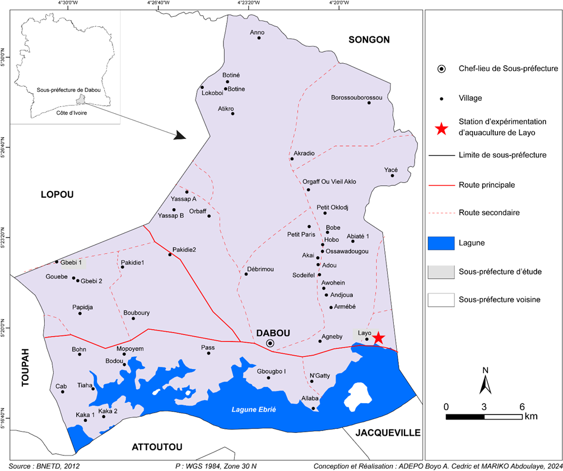
Figure 1: Geographic location of the study area.
2.2. Materials
2.2.1. Biological Material
To conduct the experiment, 225 individuals with an initial average weight of 30.67 ± 7.40 mg and an initial average length of 12.63 ± 0.57 mm were distributed among the happas. The larvae were fed three different feeding rates (10%, 20%, 30%), prepared using a commercial feed containing 47% protein.
2.2.2. Technical Equipment
The technical equipment consisted primarily of: a HANNA multi-parameter for determining several physicochemical parameters of the rearing water; a Fisher Scientific precision scale with a maximum capacity of 620 g and a precision of 0.001 g, for weighing the fry during sampling; an OHAUS digital kitchen scale with a maximum capacity of 2,000 g and an accuracy of 0.0 g, for weighing the daily feed ration; a 50-cm ichtyometer for measuring fish size during sampling ; a hand net with a 6-mm mesh for collecting juvenile fish for sampling; plastic buckets and basins for transporting fish during sampling, and plastic bowls for serving the daily feed ration.
2.2.3. Rearing Infrastructure
Nine (9) identical happas made of 1.5-mm-mesh netting (Figure 2) were used to set up the experimental plots. Each happa had a capacity of 50 liters. They were arranged in three rows of three happas in a previously prepared fish pond. Each row was supported by eight Chinese bamboo stakes, each three meters long. The happas were suspended in the water from the bamboo stakes approximately 20 cm above the sediment.
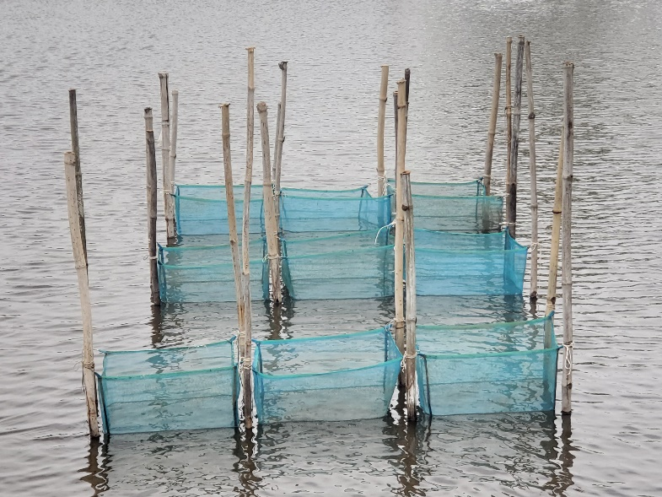
Figure 2: Experimental happas installed.
2.3. Methods
2.3.1. Composition of the experimental groups
Three experimental groups were established based on the rationing rate. Before the fish were distributed among the happas, 30 individuals were selected, weighed, and measured individually to determine the average initial weight and average initial length. The experimental groups, each set up in triplicate, consisted of Group 1 (fed a ration of 10% of the biomass); Group 2 (fed a ration of 20% of the biomass); and Group 3 (fed a ration of 30% of the biomass).
2.3.2. Rearings
The established groups (1, 2, and 3) received feed rations comprising 10%, 20%, and 30%, respectively, of the biomass of the larvae in each group. The daily feed ration was distributed manually at the following times each day: 8:30 a.m., 12:30 p.m., and 4:30 p.m. Each week, sampling was conducted to monitor larval growth and survival rates. To do this, 10 fish were randomly selected from each happa, weighed, and measured individually using a precision scale and an ichtyometer. After the measurements, all fish in each happa were counted to determine biomass and adjust the daily feed ration. At the end of the trial, all fish were weighed, measured individually, and counted by batch.
In addition, the water temperature, dissolved oxygen level, and pH were measured in the pond starting at 7:00 a.m., before feeding. To perform these measurements, the probe of the measuring device (a HANNA-type multiparameter meter) was submerged directly into the water, and the measured parameter values were automatically displayed on the screen.
2.3.3. Calculated Zootechnical Parameters
Several zootechnical parameters were determined during this experiment. These included:
- Weight growth (Pm) and Length growth s (Lm), whose formulas are:
Pm (𝑔) = Sum of the weights of the individuals weighed / Total number of subjects weighed
Lm (cm) = Sum of the lengths of the weighed individuals / Total number of weighed subjects
- Average Daily Gain (ADG), calculated using the formula:
ADG (g/day) = (Average final weight - Average initial weight) / Rearing period
- Coefficient of Variation (CV) by the formula:
CV (%) = (Standard Deviation / Average) × 100. When the CV is less than 2%, the population is considered highly homogeneous; when the CV is between 2% and 30%, the population is considered homogeneous; and if the CV is greater than 30%, the population is considered heterogeneous.
- The condition factor K , which is calculated using the formula:
K = (P / L³) × 100; where P = total weight of the fish in grams and L = total length of the fish in centimeters.
- The survival rate (SR) . It is calculated using the following formula:
SR (%) = (Number of fish remaining / Initial number of fish) × 100

2.3.4. Statistical Analyses
The data were first subjected to a descriptive analysis using Excel 2016. This allowed us to calculate the averages and standard deviations and to present the data in graphical form. The results were presented as average ± standard deviation.
To compare results across the different groups, an analysis of variance (one-way ANOVA) was performed using Statistica 7.1 software. The threshold for statistical significance was set at 5% (α = 0.05). When a significant difference was observed following the ANOVA, post hoc comparisons were performed using Tukey’s HSD test.

3. Results
3.1. Physicochemical Parameters of the Rearing Water
Changes in the water’s physicochemical parameters are shown in Table 1. The dissolved oxygen level and pH showed slight fluctuations relative to temperature. The temperature ranged from 27.20 to 29.20°C, with an average of 28.80 ± 0.76°C. With regard to dissolved oxygen levels, the recorded values ranged from 5.50 mg/L to 6.70 mg/L, yielding an average of 6.06 ± 0.31 mg/L. Regarding pH, the recorded values ranged from 6.58 to 7.60, with an average of 7.1 ± 0.33 . The observed values were consistent with the recommended standards for O. niloticus.
Table 1: Variation in the physicochemical parameters of the water during the experiment.
Periods | Temperature (°C) | Dissolved oxygen (mg/l) | pH
Week 1 | 27.40 | 5.50 | 6.80
Week 2 | 28.10 | 6.20 | 6.58
Week 3 | 27.20 | 6.70 | 7.18
Week 4 | 29.10 | 5.90 | 7.35
Week 5 | 29.20 | 6.00 | 7.6
Averages | 28.80 ± 0.76 | 6.06 ± 0.31 | 7.1 ± 0.33

3.2. Zootechnical Performance
3.2.1. Weight- al growth of the fish
From the start to the end of the experiment, average weights ranged from 30.66 ± 7.39 mg to 1,574.15 ± 381.57 mg, 1,745.33 ± 297.71 mg, and 1,712.00 ± 250.70 mg, respectively, for ration levels of 10%, 20%, and 30% (Figure 3). During the first two weeks, weight gain remained low regardless of the treatment group. However, it increased rapidly in each group from week 2 to week 5. Larvae fed the 20% and 30% diets showed nearly identical growth rates. Ultimately, the highest average weight was observed in individuals fed the 20% diet. In contrast, those fed the 10% diet showed relatively slow growth. The fish in group 3 exhibited intermediate growth. At the end of the trial, the weight gain of the group receiving the 10% diet was significantly different (p < 0.05) from that of the other two groups.

Figure 3: Changes in the average weights of O. niloticus larvae as a function of feeding rate and rearing duration.
3.2.2. Length growth of the fish
From week 0 to week 2, the length of the larvae increased from 12.63 ± 0.57 to 25.26 ± 1.96 mm, to 26.66 ± 1.90 mm, and to 26.30 ± 2.25 mm, respectively, for the 10%, 20%, and 30% feeding rates (Figure 4). At the end of the experiment, the greatest total length (45.00 ± 2.50 mm) was observed in group 2, while the larvae fed the 10% diet had the lowest value (43.60 ± 3.31 mm). Those fed the 30% diet recorded an intermediate total length (44.75 ± 3.32 mm), with no significant difference (p > 0.05) between the groups.

Figure 4: Growth of O. niloticus larvae as a function of feeding rate and time.
3.2.3. Average Daily Gain (ADG)
The ADGs determined are shown in Table 2. The lowest values for this parameter were obtained in the second week for the 10% diet (16.57 ± 1.36 mg/day) and in the first week for the other two (18.57 ± 0.95 mg/day for the 20% diet and 18.05 ± 1.00 mg/day for the 30% diet). In contrast, the highest values were recorded during the fourth week of age for all diets. They were 66.00 ± 5.94 mg/day for the 10% diet; 70.33 ± 11.97 mg/day for the 20% diet; and 67.81 ± 7.03 mg/day for the 30% diet. At the end of the trial, the average daily intake (ADI) was 44.09 ± 1.70 mg/day for batch 1, 48.99 ± 2.91 mg/day for batch 2, and 48.04 ± 1.43 mg/day for batch 3. There is a significant difference (p < 0.05) between group 1 and the other two groups (groups 2 and 3).

Table 2: Average Daily Feed Intake (ADFI) of Oreochromis niloticus tilapia larvae by diet
Period | 10% Diet | 20% Diet | 30% Diet
Week 1 | 18.14 ±0.76 | 18.14 ±0.77 | 18.14 ±0.78
Week 2 | 16.57 ± 1.36ª | 23.48 ± 2.01^{b} | 20.62 ± 3.76^{b}
Week 3 | 39.62 ± 3.73ª | 42.43 ± 2.11^{b} | 45.52 ± 4.12^{ab}
Week 4 | 66.00 ± 5.94ª | 70.33 ± 11.97^{b} | 67.81 ± 7.03^{b}
Week 5 | 44.11 ± 1.70ª | 48.99 ± 2.91^{b} | 48.04 ± 1.43^{b}
Average | 36.89 ± 2.70ª | 40.76 ± 3.99^{b} | 40.01 ± 3.45^{b}

ADG values with the same letters in the same row are not significantly different (p > 0.05).

3.2.4. Coefficient of Variation (CV) , and Condition Coefficient (K)

The CVs for average weight were 24.62 ± 3.91, 16.17 ± 6.63, and 13.70 ± 7.73%, respectively, for larvae fed 10%, 20%, and 30% of the biomass. For average total length, the CVs were 7.83 ± 1.42% for batch 1, 5.48 ± 1.61% for batch 2, and 4.52 ± 2.04% for batch 3. The CVs for the average weight and average total length of the larvae ranged from 2% to 30%, regardless of the rationing rate.
Regarding the Condition Factor (K), the recorded values were 1.89 ± 0.03%, 1.91 ± 0.02%, and 1.90 ± 0.01% for the larvae in batches 1, 2, and 3, respectively. These values were not significantly different (p > 0.05).

3.2.5. Survival Rate
The survival rate of Oreochromis niloticus larvae was determined for each diet at the end of the experiment. The highest value for this parameter (100.00 ± 0.00%) was recorded in larvae fed the 20% diet, while those fed the 10% and 30% diets showed the same survival rate (98.67 ± 2.31%). There were no significant differences (p > 0.05) among the different treatment groups.
4. Discussion
The average values for temperature (28.80 ± 0.76°C), dissolved oxygen (6.06 ± 0.31 mg/L), and pH (7.1 ± 0.33) were within the recommended range for good growth of farmed fish (Ross, 2000). This range is 27 to 29°C for temperature, 6.5 to 9 for pH, and greater than 3 mg/L for dissolved oxygen. Our results were consistent with those of N’dri et al. (2025a), who, in their trial with Coptodon guineensis juveniles in happas, obtained values of 28.13 ± 0.31°C for temperature, 6.30 ± 0.26 mg/L for dissolved oxygen, and 7.03 ± 0.21 for pH. Similarly, N’dri et al. (2025b) observed average values of 28.35 ± 1.20°C, 7.46 ± 0.93 mg/L, and 6.94 ± 0.77 for temperature, dissolved oxygen, and pH, respectively, during their study of Sarotherodon melanotheron tilapia in happas. The favorable values of the physicochemical parameters could be explained by the fact that the fish were raised in a suitable environment.
With regard to weight gain, larval growth was slow for all three diets during the first two weeks. This slow larval growth at the start of the experiment is thought to be due to the fact that the larvae had not yet acclimated to the rearing conditions. According to Legendre et al. (1992), this situation can be explained by the preferential allocation of most of their energy toward the development of various organs. From the second week until the end of the experiment, growth was more pronounced. This rapid growth is thought to be linked to the fact that the larvae readily accepted and utilized the feed provided. However, the growth of larvae fed the 10% biomass diet remained below that of the other two diets until the end of the experiment. This result could be explained by the fact that this diet remains insufficient to support good larval growth. Thus, excessive dietary restriction can limit the growth potential of larvae. This observation is consistent with the conclusions of Nairuti et al. (2021), who observed reduced growth performance in tilapia fed less nutritious diets. Furthermore, although the 30% diet produced good results, the 20% diet yielded the highest growth. This observation is comparable to that of N’dri et al. (2025a).
Regarding ADG, a gradual increase in recorded values was observed, with the exception of week 5. The results showed better performance among the fish in the group fed the 20% diet. Our results are consistent with the observations of Shoko et al. (2016), Gangbé et al. (2022), and N’dri et al. (2025a), who demonstrated that juvenile fish exhibit better growth and a higher ADG with a moderate feeding rate, compared to rates that are too low or too high.
Regarding larval survival, the results showed that the highest survival rate (100%) in the group fed at 20% of biomass could be explained by the fact that this feeding rate provides more favorable nutritional and environmental conditions for larval survival, potentially reducing feeding competition and metabolic stress. This finding is consistent with the work of El-Sayed (2021), who emphasizes that a moderate feeding rate promotes growth in tilapia larvae. A low feed rate, such as 10%, can lead to undernutrition and dominance conflicts, whereas an excessive rate, such as 30%, can degrade water quality, increase metabolic waste, and cause stress, although in this study, water quality parameters remained within acceptable limits.

Conclusion
The purpose of this study was to evaluate the effect of rationing on the growth and survival of Oreochromis niloticus larvae. The rationing levels tested had a positive effect on the growth and survival of Oreochromis niloticus larvae. However, the 20% ration showed the best growth performance (final average weight: 1745.33 ± 297.71 mg; ADG: 40.76 ± 3.99 g/day) and survival (100.00 ± 0.00%). Looking ahead, it would be interesting to test these diets on other fish species through the grow-out phase and in other aquaculture facilities to better evaluate the results.
Declaration of AI Use

This manuscript was prepared through the intellectual contributions of the author(s) to the study design, data analysis, interpretation of results, and scholarly content. Grammarly and ChatGPT were used solely to assist with grammatical refinement and reference formatting during manuscript revision. The author(s) accept full responsibility for the accuracy, integrity, and final content of the manuscript.
Conflict of Interest
The authors declare that they have no competing interests.

Références
Aworunsebe, A. F., Adesina, B. T., Adebayo, O. T. (2024). Growth performance of
Oreochromis niloticus under different feeding strategies in semi-intensive systems. BMC Veterinary Research, 20 (1) : 112.
Ayoola, S. O., Ofojekwu, P. C., Alatise, M. O. (2023). Effects of feed rationing on nutrient
retention and growth in Oreochromis niloticus. Aquaculture Reports, 30 : 101567.
El-Sayed AFM, Abdel-Tawwab M, Ali SA. (2021). Tilapia aquaculture: State of the art and future perspectives. Aquaculture Research, 52 (2) : 1111-1124.
Gangbé, L., Dessouassi, E., Houndonougbo, P. K., Brahim, A. A., Djimènou, D.,
Agadjihouedé, H. (2022). Trophic regime of the giant freshwater shrimp Macrobrachium vollenhoveni (Herklots, 1857) in the lower Oueme valley in Southern Benin. International Journal of Biological Sciences, 4 (1) : 37-45.
Kremen, K., Anvo, M. P. M., Kouadio, K. E., Kouassi, N. C., Assemien, Diarrassouba, O. S.
(2020). Utilisation des blocs alimentaires dans le grossissement du tilapia Oreochromis niloticus en étang. Journal of Applied Biosciences, 153 (1) : 15821-15828.
Legendre, M., Teugels, G. G., Cauty, C., Jalabert, B. (1992). A comparative study on
morphology, growth rate and reproduction of Clarias gariepinus, Héterobranchus longifilus and their reciprocal hybrids (Pisces, Clariidae). J. Fish BioZ., 40 : 59-79.
MIRAH. (2022). Rapport de la nouvelle stratégie de la Politique Nationale de
Développement de l’Elevage la Pêche et l’Aquaculture, 2022-2026, 178 p.
Nairuti, D. K., Munguti, J. M., Waibbacher, H., Zollitsch, W. (2021). Growth performance
and survival rate of Nile tilapia (Oreochromis niloticus L.) reared on diets containing black soldier fly (Hermitia illucens L.) larval meal. Journal of land management, Food and Environnement, 72 (1) : 9-19.
N’dri, K. M., Alla, Y. L., Amon, Y. N., Setin, K. D., Tano, K., Diomande, D. (2025a).
Influence of Feeding Intensity on Growth Parameters and Survival of Coptodon Guineensis Günther, 1862 Juveniles Raised at the Layo Aquaculture Experimental Station, Ivory Coast. Journal of Advances in Biology & Biotechnology 28 (3) : 97-106. DOI : https://doi.org/10.9734/jabb/2025/v28i32073
N’dri, K. M., Gogbe, Z. M., Amon, Y. N., Alla, Y. L., Koné, M., Yao, K. (2025b). Rearing
juvenile tilapia sarotherodon melanotheron (rüppell, 1852) in happas at layo (Côte d'Ivoire). International Journal of Current Research., 17 (08) : 34304-34309. DOI : https://doi.org/10.24941/ijcr.49322.08.2025
Ross LG. 2000. Environmental physiology and energetics. In Tilapias: Biology and
Exploitation, Beveridge MCM, McAndrew BJ (eds). Springer Netherlands (Fish and Fisheries Series): Netherlands. 89-128 pp.
Shoko, A. P., Limbu, S. M., Mzighani, S. I. (2016). Effects of physicochemical parameters on
tilapia growth and survival. Journal of Aquaculture Research and Development, 47 (5) : 321-330.
Tré Bi, T. C. O., Anvo, M. P. M., Doumbia, L., Kouassi, N. C. (2023). Evaluation of the zoo
technical performance during the grow-out phase of an improved strain of Oreochromis niloticus reared in ponds in the Ivorian environment. International Journal of Innovation and Applied Studies, 39 (2) : 965-972.
Wognin, G. M. T., Anvo, M. P. M., Kanh, K. H. M., Diarrassouba, A. O., Kouassi, N. C.
(2023). Caractérisation Zootechnique des Populations Sauvages de Heterobranchus Longifilis des Bassins Versants de Cavally et de Bandama (Côte d’Ivoire). European Scientific Journal, 19 (9) : 174-188.
Yao, A. H., Koumi, A. R., Atse, B. C., Kouamelan, E. P. (2017). Etat des connaissances sur
la pisciculture en Côte d’Ivoire. Agronomie Africaine, 29 (3) : 227-24.

