Original Research Article
Green Synthesis of Silver Nanoparticles Using Aqueous and Ethanolic Root Extracts of Cyperus scariosus Their Characterization and Evaluation of Their Anthelmintic Activity

.
ABSTRACT

Helminthiasis is a widespread disease affecting over a billion people globally. Current treatment measures for helminthiasis rely predominantly on antibiotics; however, growing anthelmintic drug resistance necessitates the inclusion of alternative treatment measures. Thus, this study pursued a sustainable nanotechnology approach through the green synthesis of silver nanoparticles (AgNPs) using aqueous and ethanolic root extracts of Cyperus scariosus.
The extracts were evaluated for their phytochemical profiles and utilised for the synthesis of AgNPs. The synthesised AgNPs were characterised by UV-visible (UV-Vis) spectroscopy, Fourier transform infrared (FTIR) spectroscopy, transmission electron microscopy (TEM), field-emission scanning electron microscopy (FESEM), and energy-dispersive X-ray (EDX) spectroscopy. Both plant extracts, the synthesised AgNPs, and the standard drug Albendazole were evaluated for their comparative anthelmintic potential against the earthworms Eisenia fetida.
Phytochemical screening revealed tannins, saponins, terpenoids, steroids, and phenols in the aqueous extract, vis-a-vis alkaloids, tannins, terpenoids, steroids, and phenols in the ethanolic extract. UV-Vis spectroscopy confirmed AgNP formation, with surface plasmon resonance peaks obtained at 450 nm for aqueous AgNPs and 416 nm for ethanolic AgNPs. FTIR analysis exhibited eight peaks for aqueous AgNPs and five for ethanolic AgNPs, indicating the presence of varied functional groups. TEM analysis revealed quasi-spherical nanoparticles, with the well-dispersed aqueous AgNPs averaging ~91 nm and the less-dispersed ethanolic AgNPs averaging ~24 nm. FESEM confirmed the surface morphology, and EDX confirmed the silver content of both AgNP preparations, with 47.72 weight % silver in aqueous AgNPs and 34.91 weight % in ethanolic AgNPs. The anthelmintic assay showed potent dose-dependent effects for both aqueous and ethanolic AgNPs, surpassing the respective plant extracts and the standard drug Albendazole.
Thus, Cyperus scariosus root extracts (aqueous and ethanolic) serve as promising biogenic agents for AgNP synthesis, with the synthesised AgNPs showing potent therapeutic potential in anthelmintic applications.

Keywords: Green synthesis; silver nanoparticles; Cyperus scariosus; root extracts; phytochemical screening; UV–Vis spectroscopy; FTIR; TEM; FESEM–EDX; anthelmintic activity; Eisenia fetida

1. INTRODUCTION
Nanotechnology has evolved as one of the most transformative fields of science, with its unique ability to operate at molecular and atomic levels opening new opportunities across disciplines such as agriculture, energy, and especially biomedicine (Khan et al., 2019; Manjunatha et al., 2016). A major advancement in this field is the synthesis of nanoparticles, whose extremely small size and high surface-area-to-volume ratio lead to a significant enhancement of their chemical reactivity, as evidenced by their strong antimicrobial properties and improved interactions with microbial membranes (Khan et al., 2019).
In recent years, metallic nanoparticles have drawn considerable attention; gold, copper, zinc, platinum, and silver are some of the commonly used metals for the synthesis of nanoparticles (Jamkhande et al., 2019). Amongst them, silver nanoparticles (AgNPs) are the most favoured owing to their high stability, cost-effectiveness, and well-established antimicrobial, antifungal, anti-angiogenic, anticancer, and catalytic properties at the nanoscale (Ahmed et al., 2016; Keat et al., 2015). AgNPs have also been extensively used in biomedical applications such as bone healing, as vaccine adjuvants, and in dental care. Their mechanism of action involves the production of reactive oxygen species (ROS), DNA damage, and enzyme inactivation, which contribute to their antimicrobial and anti-cancer properties (Xu et al., 2020).
Silver nanoparticles can be synthesised via physical, chemical, and biological methods. While physical and chemical methods can produce highly pure and uniformly sized particles and are time-saving, high-yielding, and reliable, they often involve complex procedures and instruments, release toxic reagents, and raise environmental concerns (Xu et al., 2020). In contrast, green synthesis, a biological method, is commonly utilised for the synthesis of silver nanoparticles because it is simple, reliable, cost-effective, and environmentally friendly. A range of biological agents, such as bacteria, fungi, and plant extracts, are used for the biosynthesis of silver nanoparticles (Siddiqi et al., 2018). Amongst the aforementioned agents, plant extracts derived from the seeds, leaves, flowers, and roots of medicinal plants are highly favoured because of their rich phytochemical content and ease of availability (Majumdar & Kar, 2023; Shkryl et al., 2018). Recent reviews continue to support plant-mediated AgNP synthesis as a green route in which plant-derived biomolecules can contribute to nanoparticle reduction, capping, and stabilisation while retaining relevance for biological applications (Thomas et al., 2024; Eker et al., 2025). Recent plant-based studies have similarly demonstrated successful AgNP synthesis and characterisation using medicinal-plant extracts, further supporting the suitability of phytochemical-rich extracts for biogenic AgNP production (Lakshmanan et al., 2023; Nandhini et al., 2026).
Cyperus scariosus, commonly known as Nagarmotha (Hindi) and Nutgrass (English), is a medicinal plant that belongs to the Cyperaceae family and is native to India, thriving in tropical and subtropical regions, particularly in the state of Madhya Pradesh. The well-established bio-efficacy of C. scariosus, along with its rich phytochemical profile, including flavonoids, terpenoids, essential oils, and saponins, makes it an effective stabilising agent and a suitable candidate for the green synthesis of AgNPs (Gandhi et al., 2024). It is a perennial herb that is well recognised in Ayurveda for treating issues related to digestion, inflammation, and skin disorders (Gandhi et al., 2024; Bolatkyzy et al., 2025).
However, not all disorders are treated with Ayurvedic medicines. Helminthiasis is an infection caused by parasitic worms known as helminths and affects a large number of people in developing countries, especially children, causing morbidity. The worms have developed resistance to some of the available drugs, and limited attention has been given to using medicinal plants as an alternative form of treatment for the infection (Idris et al., 2019). Moreover, the utilisation of C. scariosus in the green synthesis of silver nanoparticles and its anthelmintic potential remain underexplored.
Thus, this study focused on the preparation and phytochemical analysis of aqueous and ethanolic root extracts of C. scariosus, followed by their utilisation for the synthesis of silver nanoparticles. Characterisation of the synthesised AgNPs was carried out using UV-Vis spectroscopy, FTIR, TEM, FESEM, and EDX analysis. Additionally, the anthelmintic activity of both the synthesised AgNPs and the aforementioned root extracts was evaluated against the earthworms - Eisenia fetida using Albendazole as a positive control to assess their relative efficacy.
2. material and methods

2.1 Materials used
Commercially available root powder of C. scariosus, of the Yuvika brand and made by Ishan Herbaceuticals, was used for the preparation of the aqueous and ethanolic extracts. A 100 gm quantity of powder was finely sieved and stored in an airtight container at room temperature in a dry, contamination-free environment. All chemicals used in the experiments were of analytical grade.
2.2 Preparation of Plant Extracts
Aqueous and ethanolic root extracts of C. scariosus were prepared following the method described by Jindapunnapat et al. (2018), with some modifications. A 40 gm quantity of C. scariosus root powder was dissolved separately in 200 mL of distilled water and 80 % ethanol in separate conical flasks. The mixtures were incubated at 37 °C for 24 hours in a shaker incubator (NEOLAB) at 150 rpm. After incubation, the solutions were filtered through muslin cloth and Whatman No. 1 filter paper. Concentration of the filtrates was carried out using a rotary evaporator (SUPERFIT) at 90°C for the aqueous extract and 70 °C for the ethanolic extract until approximately 40 mL remained. The samples were then centrifuged (using Plasto Crafts Superspin R – V/F_{M}) at 5,000 rpm for 15-20 minutes at 30 °C, and the supernatants were collected. The extracts were kept in sterile centrifuge tubes at 4 °C for further use.
2.3 Phytochemical screening of plant extracts
The aqueous and ethanolic root extracts of C. scariosus were subjected to qualitative phytochemical screening to identify various bioactive compounds present in them. All the tests were performed in triplicate using standard methods.
The presence of alkaloids and steroids was detected following Auwal et al. (2014), and tannins were detected following Iqbal et al. (2015), while saponins were assessed using the methods described by both Auwal et al. (2014) and Iqbal et al. (2015). The method of Melaku and Amare (2020) was used to check for the presence of flavonoids. Phenols and terpenoids were detected using the methods of Yadav ^{and} Agarwala (2011) and Dubale et al. (2023), respectively.
2.4 Biosynthesis of Silver Nanoparticles
The biosynthesis of silver nanoparticles (AgNPs) using aqueous and ethanolic root extracts of C. scariosus was performed following Khanal et al. (2022), with slight modifications. For both aqueous and ethanolic extracts, 5 mL of the respective root extract was added dropwise to 45 mL of 6 mM AgNO₃ solution in separate flasks, with constant stirring on a REMI magnetic stirrer at room temperature. The flasks were kept in a shaker incubator (NEOLAB) for 4 hours, during which a gradual colour change to reddish brown was observed, indicating the primary confirmation of AgNP synthesis.
2.5 Characterization of AgNPs
2.5.1 UV-Vis spectroscopy
The absorbance of the synthesised AgNPs was measured using a BioEra UV-visible spectrophotometer over a wavelength range of 300 to 700 nm (Khanal et al., 2022). Distilled water was used to set the blank.
2.5.2 FTIR spectroscopy
The infrared spectra of the green-synthesised AgNPs were recorded for the identification of functional groups using a Shimadzu FTIR 8400S with IR Solutions software, with registered amplitude waves ranging from 500 to 3500 cm⁻¹.
2.5.3 TEM analysis
Transmission electron microscopy (TEM) was performed using a Tecnai G2 Spirit Biotwin (Netherlands) to study the shape and size of the synthesised AgNPs. A small amount (0.5 µL) of the sample was diluted in 4.0 mL of distilled water, and 0.2 µL of this solution was drop-cast onto a carbon-coated copper grid (200 mesh). Following this, the grid was air-dried at room temperature. Imaging was performed at 100 kV using a tungsten filament and an Olympus Veleta CCD camera. Tecnai imaging and analysis software was used to capture and analyse the images, with magnification up to 350,000X for clear observation (Nijhawan et al., 2024).
2.5.4 FESEM and EDX analysis
The surface morphology of the synthesised silver nanoparticles was observed using FESEM (Quanta 200). The liquid samples were first sonicated for uniform particle dispersion. Carbon conductive tape was attached to an aluminium stub, and a small volume of the sample was drop-cast and spread evenly on the tape. The stub was then air-dried at room temperature and mounted in the field-emission scanning electron microscope chamber for imaging under high-vacuum conditions (Malik & Madan, 2020). Nanoparticles were checked for their elemental composition using EDX, which was attached to the FESEM imaging system. Quantitative information on the different elements present in the sample was obtained using EDX.
2.6 In vitro Anthelmintic Activity
The anthelmintic assay method was adopted from Ikbal et al. (2020), with slight modifications. Adult earthworms (E. fetida) brought from Konkan Krishi Vikas Pratishthan Nursery, Navi Mumbai, were used as model organisms for evaluating the anthelmintic activity of both the aqueous and ethanolic root extracts and the silver nanoparticles synthesised using the aforementioned extracts. Worms were washed with distilled water to remove faecal matter, mud, adherent dirt, and other impurities. Healthy worms of approximately 4-6 cm in length were used for the assay. They were divided into 10 groups, with 6 worms in each group (n=6). Each earthworm was kept in a separate Petri plate. Albendazole was used as the positive control and normal saline as the negative control. The experimental design was as follows:
Group 1 (negative control) was treated with 20 mL of normal saline.
Group 2 was treated with 20 mL of aqueous root extract (100 μg/mL). Distilled water was used for dilution and preparation of all the working solutions.
Group 3 was treated with 20 mL of aqueous root extract (200 μg/mL).
Group 4 was treated with 20 mL of ethanolic root extract (100 μg/mL).
Group 5 was treated with 20 mL of ethanolic root extract (200 μg/mL).
Group 6 (positive control) was treated with 20 mL of Albendazole (200 μg/mL) prepared in normal saline.
Group 7 was treated with 20 mL of colloidal solution of aqueous AgNPs (100 μg/mL).
Group 8 was treated with 20 mL of colloidal solution of aqueous AgNPs (200 μg/mL).
Group 9 was treated with 20 mL of colloidal solution of ethanolic AgNPs (100 μg/mL).
Group 10 was treated with 20 mL of colloidal solution of ethanolic AgNPs (200 μg/mL).
Treated earthworms were observed continuously for four hours to note the times of paralysis and death. Worms were considered paralysed when no movement or only slight movement was observed after shaking. Death was ascertained when worms showed no movement at all after vigorous shaking and slight pricking with a needle.
Statistical analysis - Results are expressed as mean ± SEM (n = 6 worms per group). Groups in which no worm was paralysed or died within the 240 min observation window (saline and all four crude extract groups) yielded right-censored values (> 240 min) and were reported descriptively rather than analysed. Comparisons were therefore restricted to groups with uncensored data: five for time to paralysis and four for time to death, as albendazole produced no deaths within 240 min. Normality was determined by the Shapiro–Wilk test (P > .05 for all groups); Levene's test indicated unequal variances for both endpoints (P < .05). Group means were consequently compared by Welch's heteroscedastic one-way ANOVA followed by the Games–Howell post-hoc test, with effect size expressed as eta-squared (η²). Two-tailed P < .05 was considered significant. Analyses were performed in R version 4.3.3.

3. results and discussion

3.1 Qualitative Phytochemical Analysis
The phytochemical composition of both root extracts (aqueous and ethanolic) of C. scariosus was evaluated to check for the presence of functional biometabolites. These secondary metabolites play a crucial role in nanoparticle formation by acting as natural reducing, chelating, and capping agents; therefore, preliminary phytochemical screening is essential for evaluating the pharmacological constituents (Villagrán et al., 2024). The aforementioned solvents were selected based on their polarity range, allowing maximum extraction of both polar and semi-polar phytochemical compounds (Kumar et al., 2023).
As depicted in Table 1, tannins, saponins, terpenoids, steroids, and phenols were present in the aqueous extract of C. scariosus, while alkaloids and flavonoids were absent. Conversely, the ethanolic extract showed the presence of alkaloids, tannins, terpenoids, steroids, and phenols, with the absence of flavonoids and saponins. The phytochemical profile indicates that C. scariosus possesses significant bioactive potential. These findings align with those reported for aqueous and ethanolic extracts of Cyperus species in previous studies (Ngoc & Minh, 2021; Gomathi & Maneemegalai, 2023).
Table 1: Qualitative phytochemical screening of aqueous and ethanolic root extracts of C. scariosus
Serial no. | Extract | Phytochemicals
Serial no. | Extract | Alkaloids | Tannins | Flavonoids | Saponins | Terpenoids | Steroids | Phenols
1. | Aqueous root extract | -ve | +ve | -ve | +ve | +ve | +ve | +ve
2. | Ethanol root extract | +ve | +ve | -ve | -ve | +ve | +ve | +ve
‘+ve’ indicates present and ‘-ve’ indicates absent
3.2 Synthesis of Silver Nanoparticles and their characterization
3.2.1 UV-Vis Spectroscopy
Qualitative phytochemical analysis showed promising results that led to the use of both root extracts (aqueous and ethanolic) of C. scariosus for the green synthesis of silver nanoparticles. The synthesis of silver nanoparticles was visually confirmed by a colour change in the reaction mixture from pale to dark brown, indicating the reduction of Ag⁺ (ions) to Ag⁰ (atoms) by the phytochemicals present in the respective extracts (Figs. 1 a-d). This colour change in the AgNO₃ solution was due to the excitation of surface plasmon vibration, a characteristic size feature of nanoparticles (Bhokare & Warthe, 2020).
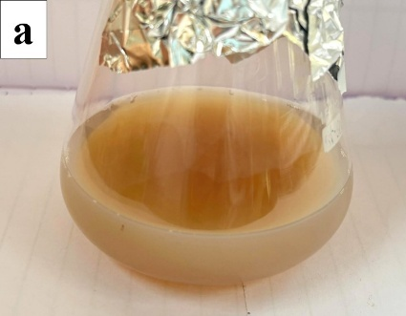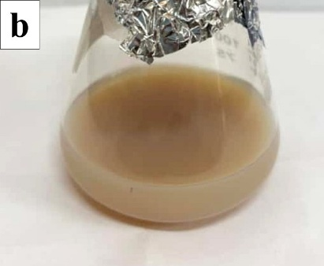

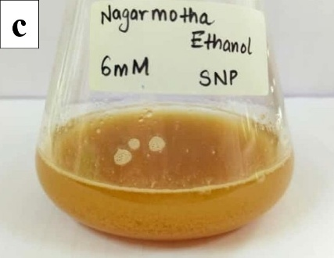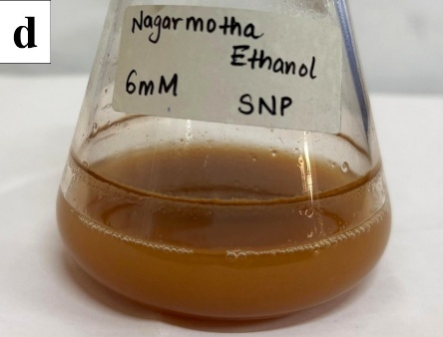
Fig. 1: Colour change of reaction mixture during synthesis of (a, b) Aqueous AgNP, (c, d) Ethanolic AgNP of C. scariosus

The 6 mM AgNO₃ solution did not produce any surface plasmon resonance (SPR) peak (Figs. 2, 3). On the contrary, the aqueous AgNPs displayed an SPR peak at 450 nm (Fig. 2), while the ethanolic AgNPs displayed an absorption peak at 416 nm (Fig. 3). The aforementioned results confirm the successful synthesis of silver nanoparticles, as both fall within the defined SPR range for AgNPs (Njagi et al., 2011). The peak obtained for the aqueous extract is consistent with that reported for AgNPs synthesised using an aqueous extract of Mikania cordata leaves (Khatun et al., 2023). Similarly, the peak obtained for the ethanolic extract is close to that obtained for AgNPs synthesised using ethanolic Areca catechu seed extract (Apriani et al., 2022), thereby validating our results.
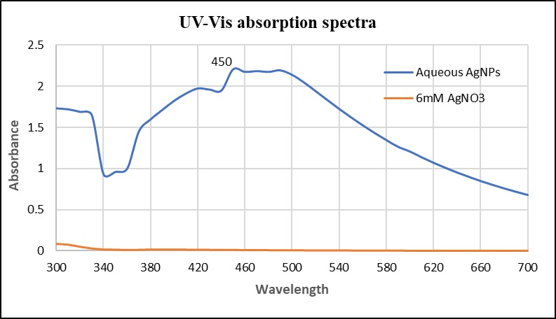
Fig. 2: Ultraviolet-visible spectrum of silver nanoparticles synthesized using aqueous root extract of C. scariosus
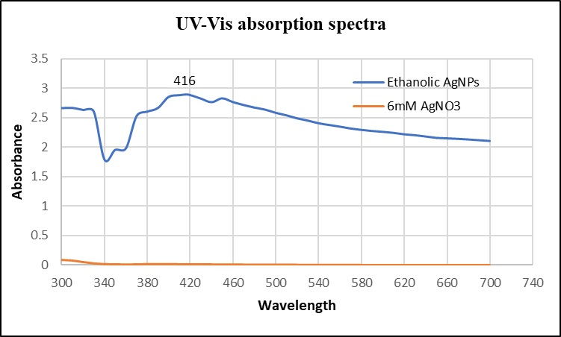
Fig. 3: Ultraviolet-visible spectrum of silver nanoparticles synthesized using ethanolic root extract of C. scariosus
3.2.2 FTIR spectroscopy
FTIR captures the vibrations of chemical bonds through the absorption of infrared radiation and acts as a spectral fingerprint of the functional groups involved in nanoparticle synthesis (Pasieczna-Patkowska et al., 2025). In this study, FTIR was used to reveal the molecular interactions leading to the bioreduction and surface capping of the AgNPs synthesised using aqueous and ethanolic root extracts of C. scariosus, as illustrated in Fig. 4 and Fig. 5, respectively.
The FTIR spectra recorded by the aqueous AgNPs showed peaks at 3333.24 cm⁻¹, 2926.75 cm⁻¹, 2359.08 cm⁻¹, 1637.38 cm⁻¹, 1349.27 cm⁻¹, 1250.86 cm⁻¹, 1085.41 cm⁻¹, and 944.20 cm⁻¹ (Fig. 4). The strong absorption band at 3333.24 cm⁻¹ corresponds to the O–H stretching of alcohols and phenols (Quero et al., 2025); further, the peaks at 2926.75 cm⁻¹ and 2359.08 cm⁻¹ suggest C–H stretching of methylene groups (Quero et al., 2025) and O=C=O stretching, respectively (George et al., 2021). The sharp peak at 1637.38 cm⁻¹ suggests C=C stretching due to the presence of alkenes (Rahman & Prasanna, 2018), while the peak at 1250.86 cm⁻¹ indicates C–O of ethers (Majumdar & Kar, 2023). The peaks at 1349.27 cm⁻¹ and 1085.41 cm⁻¹ correspond to esters and amines (C–N), respectively, while the peak at 944.20 cm⁻¹ confirms aromatic =C–H bending (Afreen et al., 2020; El-Rafie & Hamed, 2014).
In contrast, the FTIR spectra recorded by the ethanolic AgNPs showed peaks at 3299.01 cm⁻¹, 2363.36 cm⁻¹, 2331.98 cm⁻¹, 1635.95 cm⁻¹, and 1045.47 cm⁻¹ (Fig. 5). The broad band at 3299.01 cm⁻¹ showed a peak that suggests O–H stretching of alcohols and phenols. The peaks at 2363.36 and 2331.98 cm⁻¹ displayed O=C=O stretching (Ahmad et al., 2023). A sharp peak at 1635.95 cm⁻¹ corresponds to C=C stretching, indicating alkenes (Rahman & Prasanna, 2018). The peak at 1045.47 cm⁻¹ shows S=O bending of sulfoxides (Iskakova et al., 2025).
Overall, the aqueous AgNPs exhibited eight FTIR peaks, similar to those reported in the FTIR analysis of AgNPs synthesised from aqueous Pogonatherum crinitum extract (Shrestha et al., 2025). The ethanolic AgNPs showed five peaks. This finding is in line with results obtained from AgNP synthesis using ethanolic Eleutherine americana extract, which displayed five major FTIR peaks (Manullang et al., 2021). This variation in the number of peaks likely stems from the higher polarity of distilled water, facilitating the extraction of a more diverse array of functional groups, as noted in previous studies (Kelkawi et al., 2017).
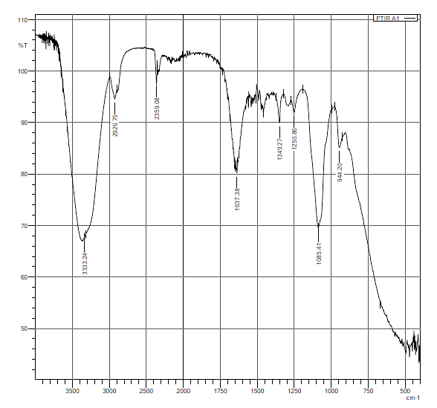
Fig. 4. FTIR spectrum of AgNPs synthesized using aqueous root extract of C. scariosus
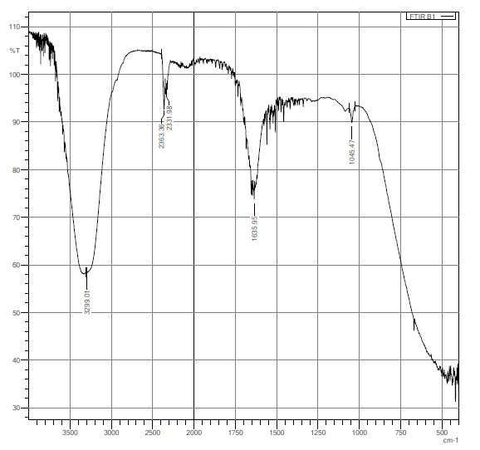
Fig. 5. FTIR spectrum of AgNPs synthesized using ethanolic root extract of C. scariosus
3.2.3 TEM
Transmission electron microscopy (TEM) provides a unique perspective on the size, shape, and distribution of nanoparticles (Zhang & Wang, 2023). AgNPs synthesised from aqueous and ethanolic root extracts of C. scariosus were therefore analysed by TEM.
TEM analysis revealed that the aqueous AgNPs were well dispersed and quasi-spherical to polyhedral in shape, with an average particle size of 90.7 nm (range: 9 to 200 nm). The size distribution pattern indicated a bimodal nature, with populations of smaller spherical nanoparticles and larger polyhedral ones. The particles displayed clear faceting and twinning planes, confirming their crystalline nature (Figs. 6 – a, b). In contrast, ethanolic AgNPs were spherical to quasi-spherical, with an average size of 23.9 nm (range: 17 to 32 nm). These nanoparticles were relatively less uniform and exhibited mild aggregation at some locations compared with the aqueous extract (Figs. 6 - c, d).
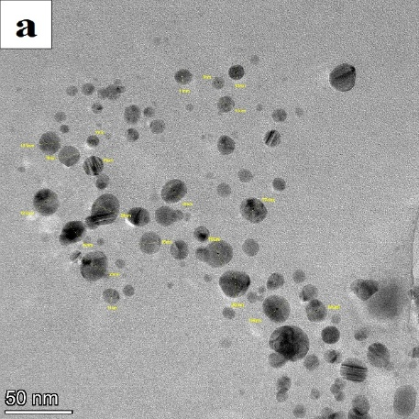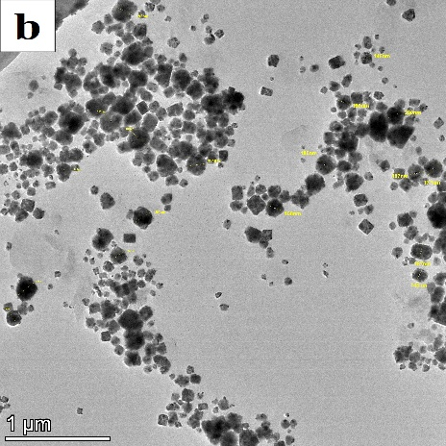
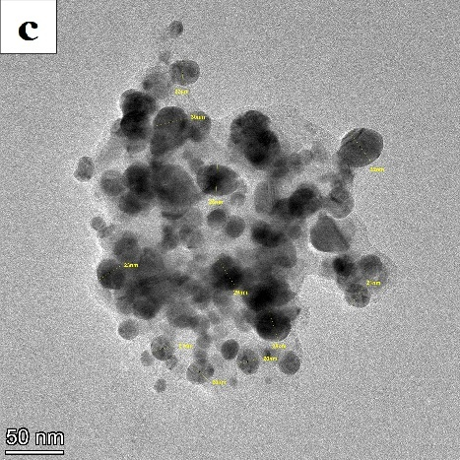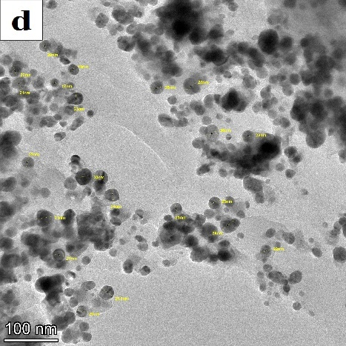
Fig.6 TEM images of AgNPs synthesized using aqueous root extract of C. scariosus (a) at 50nm magnification (top left) and (b) at 1µm magnification (top right).
TEM images of AgNPs synthesized using ethanolic root extract of C. scariosus (c) at 50nm magnification (bottom left) and (d) at 100nm magnification (bottom right).
These variations can be attributed to solvent polarity. Highly polar distilled water extracts a broader range of hydrophilic phytochemicals that act as strong reducing and stabilising agents, resulting in well-dispersed, crystalline nanoparticles. Ethanol, being less polar, extracts a different set of bioactive compounds, producing comparatively smaller and quasi-spherical nanoparticles with mild aggregation. Both outcomes are advantageous—aqueous extracts favour stability and defined morphology, while ethanolic extracts yield smaller nanoparticles with potentially enhanced bioactivity (Sasikala et al., 2015; Kota et al., 2017). Thus, TEM analysis confirms that both extracts of C. scariosus effectively mediate the green synthesis of AgNPs, each offering unique and complementary benefits.
3.2.4 FESEM and EDX analysis
FESEM provided a high-resolution view of the surface morphology of the biosynthesised silver nanoparticles, while EDX analysis confirmed the elemental presence of silver amongst other elements, thereby validating the successful green synthesis of silver nanoparticles using the aqueous and ethanolic root extracts of C. scariosus, as illustrated in Figs. (7, 8).
The FESEM analysis of the aqueous AgNPs revealed that they were smooth, spherical, and well dispersed, with some agglomeration (Figs. 7 - a, b). Our results align with those obtained in the synthesis of silver nanoparticles from Pedalium murex leaf extract (Anandalakshmi et al., 2016). The surface morphology of the ethanolic AgNPs exhibited well-dispersed, quasi-spherical nanoparticles with evidence of agglomeration (Figs. 7 - c, d). The rough surface texture and irregular clustering suggest the presence of bioorganic compounds from the plant extract acting as stabilising agents. These findings are in line with results observed for silver nanoparticles synthesised using gum kondagogu, displaying similar agglomeration of AgNPs (Rastogi et al., 2015).
The EDX analysis of the aqueous AgNPs showed a strong signal at 3 keV, confirming the successful formation of AgNPs with 47.72 weight % silver. Other detected elements included Carbon (16.41 %), Oxygen (15.86 %), Nitrogen (6.11 %), Chlorine (12.91 %), and Potassium (1.71 %) by weight (Figs. 8 - a, c). These biomolecules act as reducing and stabilising agents, likely derived from plant phytochemicals. A similar elemental composition has been reported for AgNPs synthesised using aqueous extracts of Brillantaisia patula, Crossopteryx febrifuga, and Senna siamea, where EDX analysis of the AgNP sample showed 47.14 weight % Ag (Kambale et al., 2020).
The EDX analysis of ethanolic AgNPs also showed a strong Ag peak at ~3 keV, with 34.91 weight % silver, confirming silver nanoparticle formation. Elements such as Carbon (23.91 weight %), Oxygen (23.48 weight %), Chlorine (14.81 weight %), Sodium (2.58 weight %), and Potassium (2.30 weight %) suggest phytochemical capping by C. scariosus extract (Figs. 8 - b, d). Similar findings of organic elements associated with plant-derived AgNPs have been reported in earlier studies (Iravani, 2011; Mittal et al., 2013).

Fig. 7 FESEM images of AgNPs synthesized using aqueous root extract of C. scariosus (a) at 500 nm magnification (top left) and (b) at 2 μm magnification (top right).
FESEM images of AgNPs synthesized using ethanolic root extract of C. scariosus (c) at 500nm magnification (bottom left) and (d) at 1 μm magnification (bottom right).
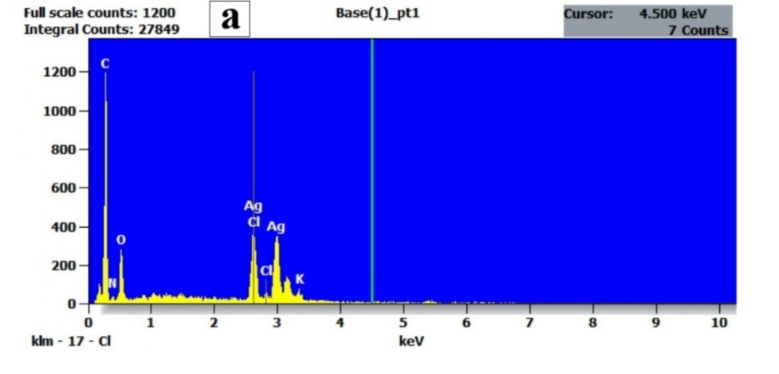
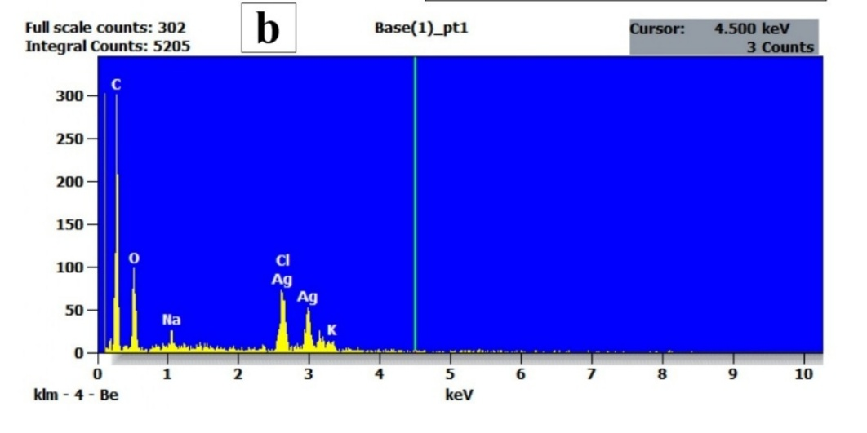
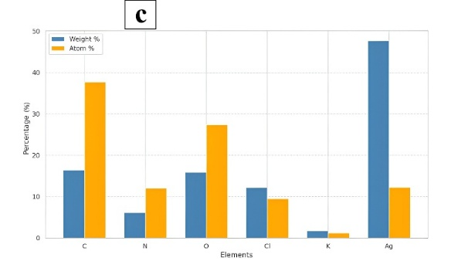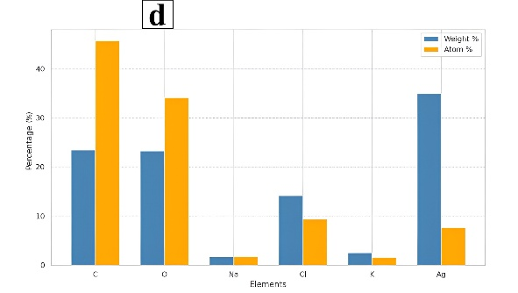
Fig. 8 EDX Spectrum of AgNPs synthesized using (a) aqueous root extract of C. scariosus (row 1) (b) ethanolic root extract of C. scariosus (row 2)
EDX analysis histogram of AgNPs synthesized using (c) aqueous root extract of C. scariosus (Lower left) (d) ethanolic root extract of C. scariosus (Lower right)
3.3 In vitro Anthelmintic Activity
E. fetida is a widely accepted model for preliminary anthelmintic screening, owing to the anatomical and physiological similarity between its cuticle and the body wall of intestinal helminths infecting humans (Bazan et al., 2020). Normal saline produced no discernible effect over the four-hour observation period; the aqueous and ethanolic C. scariosus root extracts also caused no paralysis or death at 100 or 200 µg/mL (Table 2). All four AgNP formulations, in contrast, produced rapid dose-dependent paralysis followed by death, indicating that the activity arises from the nanoparticulate silver rather than the phytoconstituents alone, with the plant metabolites serving as reducing and capping agents (Rashid et al., 2016; Majumdar & Kar, 2023). Greater anthelmintic potential of synthesised AgNPs than of the parent leaf extract has been reported for Viscum orientale (Kumar et al., 2023), which supports our results.

Table 2: Anthelmintic activity of aqueous and ethanolic plant extracts, aqueous AgNPs, and ethanolic AgNPs.
Treatment Groups | Time of Paralysis  (in minutes) | Time of Death  (in minutes)
Negative control – Normal Saline | >240.00 † | >240.00 †
Aqueous extract (100 µg/mL) | >240.00 † | >240.00 †
Aqueous extract (200 µg/mL)  Ethanolic extract (100 µg/mL)  Ethanolic extract (200 µg/mL)  Positive control - Albendazole (200 µg/mL) | >240.00 †  >240.00 †  >240.00 †  71.51 ± 3.61 ᵃ | >240.00 †  >240.00 †  >240.00 †  >240.00 †
A-AgNps (100 µg/mL) | 39.98 ± 1.60 ᵇ*** | 86.13 ± 2.95 ᵃ
A-AgNPs (200 µg/mL) | 31.79 ± 0.65 ᶜ*** | 76.44 ± 0.52 ᵇ*
E-AgNPs (100 µg/mL) | 45.8 ± 1.13 ᵈ*** | 56.78 ± 0.54 ᶜ***
E-AgNPs (200 µg/mL) | 35.51 ± 0.50 ᵉ*** | 55.95 ± 0.64 ᶜ***
*A-AgNPs- Aqueous Silver Nanoparticles, *E-AgNPs- Ethanolic Silver Nanoparticles.
n = 6 worms per group. † Censored observation; Welch's ANOVA - paralysis: F (4, 11.81) = 47.12, P < .001, η² = 0.92; death: F (3, 10.71) = 284.65, P < .001, η² = 0.93.
Within each column, means not sharing a common superscript letter (a–e) differ significantly at P < .05 by the Games–Howell post-hoc test. For time to paralysis, all ten pairwise comparisons were significant (P ranging from < .001 to .049), hence each group carries a distinct letter. For time to death, ethanolic AgNPs at 100 and 200 µg/mL did not differ from each other (P = .53) and therefore share the letter ᶜ.
Asterisks denote significance versus the corresponding reference group: for time to paralysis, versus albendazole 200 µg/mL; for time to death, versus aqueous AgNPs 100 µg/mL (the least active group with measurable lethality, since albendazole produced no deaths). *P < .05, **P < .01, ***P < .001.

Every AgNP treatment paralysed the worms faster than albendazole at the same concentration (P < .001), with aqueous AgNPs at 200 µg/mL being the most rapid (31.79 ± 0.65 versus 71.51 ± 3.61 min, exhibiting a 55.5 % reduction); paralysis time fell by roughly 20 % between 100 and 200 µg/mL for both preparations (P ≤ .002) (Table 2), consistent with the greater surface area and oxidative Ag⁺ release available at higher particle loads (Ivask et al., 2014; Dakal et al., 2016). Albendazole paralysed but did not kill the worms within 240 min, consistent with its slower β-tubulin-mediated depletion of glycogen and ATP reserves (Lacey, 1990).
The two endpoints ranked the formulations differently, which is the most informative finding of the study. Although aqueous AgNPs paralysed the worms faster, ethanolic AgNPs were more lethal, killing them some 20 min sooner at 200 µg/mL (55.95 ± 0.64 versus 76.44 ± 0.52 min; P < .001) and shortening the paralysis-to-death interval from about 45 min to about 20 min (Table 2). This suggests that rapid neuromuscular blockade and slower Ag⁺-mediated cytotoxicity contribute unequally to the two preparations. The absence of any further gain between 100 and 200 µg/mL for the ethanolic AgNPs (P = .53) indicates that a ceiling of lethal efficacy had already been reached at the lower concentration.
Visual observations during the four-hour period supported a cytotoxic rather than a purely paralytic mode of killing, with bleeding from the anterior region, body paleness, and white secretions observed with both AgNP preparations. Comparable surface disruption has been demonstrated microscopically in Toxocara vitulorum (Bahaaeldine et al., 2022) and in cestode tegument (Majumdar & Kar, 2023). Likewise, the reactive oxygen species generation reported in Haemonchus contortus (Kaiaty et al., 2023) links oxidative stress to cellular breakdown; these signs imply that membrane disruption and Ag⁺ binding to essential thiol groups are implicated in both (Dakal et al., 2016; Bruna et al., 2021). The treatment group accounted for the great majority of variance in both endpoints (η² = 0.92 and 0.93). Overall, both the aqueous and ethanolic AgNPs can be considered promising anthelmintic agents.

4. CONCLUSION
This study explored the potential of aqueous and ethanolic root extracts of C. scariosus as biogenic agents for the synthesis of silver nanoparticles. The diverse phytochemical profile of the aforesaid plant extracts indicated their potential as reducing, capping, and chelating agents for the synthesis of silver nanoparticles. The results of silver nanoparticle characterisation affirm the successful synthesis of silver nanoparticles with desired characteristics, such as a befitting surface plasmon resonance range, the presence of varied functional groups, and appropriate size, shape, and elemental composition. The potent anthelmintic potential exhibited by the AgNPs from both root extracts of C. scariosus (aqueous and ethanolic), which exceeded the potential of their respective plant extracts and the standard drug Albendazole, highlights their potential in therapeutic applications. Although further research involving validation in a parasitic nematode model and mammalian cytotoxicity testing is required, this study provides a strong foundation for such work.
Limitation
This study used Eisenia fetida as a preliminary non-parasitic model, with only six worms per group, two test concentrations, and a 240-min observation period. Paralysis and death were determined by direct observation, which may introduce observer-related variability. The aqueous and ethanolic AgNPs also differed in particle size and dispersion, potentially influencing their comparative activity. Moreover, mammalian cytotoxicity and in vivo efficacy were not evaluated. Future studies should include larger samples, additional concentrations, parasitic nematode models, longer observation periods, standardised blinded assessments, and comprehensive toxicity testing.
Declaration of AI Use

This manuscript was prepared through the intellectual contributions of the author(s) to the study design, data analysis, interpretation of results, and scholarly content. Grammarly and ChatGPT were used solely to assist with grammatical refinement and reference formatting. The author(s) accept full responsibility for the accuracy, integrity, and final content of the manuscript.

COMPETING INTEREST
The authors declare that they have no conflicts of interest.
REFERENCES
Afreen, A., Ahmed, R., Mehboob, S., Tariq, M., Alghamdi, H. A., Zahid, A. A., Ali, I., Malik, K., & Hasan, A. (2020). Phytochemical-assisted biosynthesis of silver nanoparticles from Ajuga bracteosa for biomedical applications. Materials Research Express, 7(7), 075404. https://doi.org/10.1088/2053-1591/aba5d0
Ahmad, K., Asif, H. M., Afzal, T., Khan, M. A., Younus, M., Khurshid, U., Safdar, M., Saifulah, S., Ahmad, B., Sufyan, A., Ansari, S. A., Alkahtani, H. M., & Ansari, I. A. (2023). Green synthesis and characterization of silver nanoparticles through the Piper cubeba ethanolic extract and their enzyme inhibitory activities. Frontiers in Chemistry, 11, 1065986. https://doi.org/10.3389/fchem.2023.1065986
Ahmed, S., Ahmad, M., Swami, B. L., & Ikram, S. (2016). A review on plants extract mediated synthesis of silver nanoparticles for antimicrobial applications: A green expertise. Journal of Advanced Research, 7(1), 17–28. https://doi.org/10.1016/j.jare.2015.02.007
Anandalakshmi, K., Venugobal, J., & Ramasamy, V. (2016). Characterization of silver nanoparticles by green synthesis method using Pedalium murex leaf extract and their antibacterial activity. Applied Nanoscience, 6, 399–408. https://doi.org/10.1007/s13204-015-0449-z
Apriani, E. F., Mardiyanto, M., & Hendrawan, A. (2022). Optimization of green synthesis of silver nanoparticles from Areca catechu L. seed extract with variations of silver nitrate and extract concentrations using simplex lattice design method. Farmacia, 70(5), 917–924. https://doi.org/10.31925/farmacia.2022.5.18
Auwal, M. S., Saka, S., Mairiga, I. A., Sanda, K. A., Shuaibu, A., & Ibrahim, A. (2014). Preliminary phytochemical and elemental analysis of aqueous and fractionated pod extracts of Acacia nilotica (Thorn mimosa). Veterinary Research Forum, 5(2), 95–100. https://pubmed.ncbi.nlm.nih.gov/25568701/
Bahaaeldine, M. A., Garhy, E. M., Fahmy, S. R., & Mohamed, A. S. (2022). In vitro anti-Toxocara vitulorum effect of silver nanoparticles. Journal of Parasitic Diseases, 46(2), 409–420. https://doi.org/10.1007/s12639-021-01464-0
Bazan, D., Lopez, E., Caceres, A., Degen, R., & Alvarenga, N. (2020). In vitro anthelmintic activity of methanol extracts and fractions of two Amphilophium species against Eisenia fetida. Journal of Applied Biology & Biotechnology, 8(2), 98–102. https://doi.org/10.7324/JABB.2020.80216
Bhokare, D. D., & Warthe, K. (2020). Biosynthesis of silver nano particles using plant extract. International Journal of Emerging Technologies and Innovative Research, 7(2), 640–643. https://www.jetir.org/view?paper=JETIRDI06125
Bolatkyzy, N., Shepilov, D., Turmanov, R., Berillo, D., Vassilina, T., Ibragimova, N., Berganayeva, G., & Dyusebaeva, M. (2025). Medicinal plants for skin disorders: Phytochemistry and pharmacological insights. Molecules, 30(15), 3281. https://doi.org/10.3390/molecules30153281
Bruna, T., Maldonado-Bravo, F., Jara, P., & Caro, N. (2021). Silver nanoparticles and their antibacterial applications. International Journal of Molecular Sciences, 22(13), 7202. https://doi.org/10.3390/ijms22137202
Dakal, T. C., Kumar, A., Majumdar, R. S., & Yadav, V. (2016). Mechanistic basis of antimicrobial actions of silver nanoparticles. Frontiers in Microbiology, 7, 1831. https://doi.org/10.3389/fmicb.2016.01831
Dubale, S., Kebebe, D., Zeynudin, A., Abdissa, N., & Suleman, S. (2023). Phytochemical screening and antimicrobial activity evaluation of selected medicinal plants in Ethiopia. Journal of Experimental Pharmacology, 15, 51–62. https://doi.org/10.2147/JEP.S379805
Eker, F., Akdaşçi, E., Duman, H., Bechelany, M., & Karav, S. (2025). Green synthesis of silver nanoparticles using plant extracts: A comprehensive review of physicochemical properties and multifunctional applications. International Journal of Molecular Sciences, 26(13), 6222. https://doi.org/10.3390/ijms26136222
El-Rafie, M., & Hamed, M. A. (2014). Antioxidant and anti-inflammatory activities of silver nanoparticles biosynthesized from aqueous leaves extracts of four Terminalia species. Advances in Natural Sciences: Nanoscience and Nanotechnology, 5(3), 035008. https://doi.org/10.1088/2043-6262/5/3/035008
Gandhi, Y., Kumar, V., Singh, G., Prasad, S. B., Mishra, S. K., Soni, H., Rawat, H., Singh, S., Charde, V., Gupta, A., Dhanjal, D. S., Jha, S. K., Tandon, S., Bhagwat, P., Arya, J. C., Ramamurthy, P. C., Acharya, R., Narasimhaji, C. V., Singh, A., . . . Webster, T. J. (2024). Chemoprofiling and medicinal potential of underutilized leaves of Cyperus scariosus. Scientific Reports, 14, 7263. https://doi.org/10.1038/s41598-024-58041-7
George, A. Z., Anil, K., Jude, C. A. L., Srinivasan, & Rajan, S. S. R. (2021). A study on the cytotoxicity of Plectranthus amboinicus and Bacopa monnieri stem extracts on lung cancer cell line. Current Trends in Biotechnology and Pharmacy, 15(5), 395–400. https://doi.org/10.5530/ctbp.2021.3s.31
Gomathi, S., & Maneemegalai, S. (2023). Phytochemical analysis and in vitro anti-oxidant activities of medicinal plants Cyperus rotundus, Tinospora cordifolia and their formulation. Oriental Journal of Chemistry, 39(3), 712–720. https://doi.org/10.13005/ojc/390322
Idris, O. A., Wintola, O. A., & Afolayan, A. (2019). Helminthiases; prevalence, transmission, host-parasite interactions, resistance to common synthetic drugs and treatment. Heliyon, 5(1), e01161. https://doi.org/10.1016/j.heliyon.2019.e01161
Ikbal, A. M. A., Rajkhowa, A., Singh, P. C., Choudhury, P. D., & Sahu, R. K. (2020). Assessment of phytochemical and anthelmintic activity of some selected ethnomedicinal plants from Barak Valley Region of Assam. Biomedical and Pharmacology Journal, 13(4), 1825–1831. https://doi.org/10.13005/bpj/2057
Iqbal, E., Salim, K. A., & Lim, L. B. L. (2015). Phytochemical screening, total phenolics and antioxidant activities of bark and leaf extracts of Goniothalamus velutinus (Airy Shaw) from Brunei Darussalam. Journal of King Saud University – Science, 27(3), 224–232. https://doi.org/10.1016/j.jksus.2015.02.003
Iravani, S. (2011). Green synthesis of metal nanoparticles using plants. Green Chemistry, 13(10), 2638–2650. https://doi.org/10.1039/c1gc15386b
Iskakova, Z., Kozhantayeva, A., Temirbekova, A., Mukhtubayeva, S., Bissenova, G., Tekebayeva, Z., Almagambetov, K., Tashenov, Y., & Sarmurzina, Z. (2025). Green synthesis of silver nanoparticles using Circaea lutetiana ethanolic extract: Phytochemical profiling, characterization, and antimicrobial evaluation. International Journal of Molecular Sciences, 26(12), 5505. https://doi.org/10.3390/ijms26125505
Ivask, A., Kurvet, I., Kasemets, K., Blinova, I., Aruoja, V., Suppi, S., Vija, H., Käkinen, A., Titma, T., Heinlaan, M., Visnapuu, M., Koller, D., Kisand, V., & Kahru, A. (2014). Size-dependent toxicity of silver nanoparticles to bacteria, yeast, algae, crustaceans and mammalian cells in vitro. PLOS ONE, 9(7), e102108. https://doi.org/10.1371/journal.pone.0102108
Jamkhande, P. G., Ghule, N. W., Bamer, A. H., & Kalaskar, M. G. (2019). Metal nanoparticles synthesis: An overview on methods of preparation, advantages and disadvantages, and applications. Journal of Drug Delivery Science and Technology, 53, 101174. https://doi.org/10.1016/j.jddst.2019.101174
Jindapunnapat, K., Reetz, N. D., MacDonald, M. H., Bhagavathy, G., Chinnasri, B., Soonthornchareonnon, N., Sasnarukkit, A., Chauhan, K. R., Chitwood, D. J., & Meyer, S. L. F. (2018). Activity of vetiver extracts and essential oil against Meloidogyne incognita. Journal of Nematology, 50(2), 147–162. https://doi.org/10.21307/jofnem-2018-008
Kaiaty, A. M., Salib, F. A., El-Gameel, S. M., Massieh, E. S. A., Hussien, A. M., & Kamel, M. S. (2023). Emerging alternatives to traditional anthelmintics: The in vitro antiparasitic activity of silver and selenium nanoparticles, and pomegranate (Punica granatum) peel extract against Haemonchus contortus. Tropical Animal Health and Production, 55(5), 317. https://doi.org/10.1007/s11250-023-03722-0
Kambale, E. K., Nkanga, C. I., Mutonkole, B. I., Bapolisi, A. M., Tassa, D. O., Liesse, J.-M. I., Krause, R. W. M., & Memvanga, P. B. (2020). Green synthesis of antimicrobial silver nanoparticles using aqueous leaf extracts from three Congolese plant species (Brillantaisia patula, Crossopteryx febrifuga and Senna siamea). Heliyon, 6, e04493. https://doi.org/10.1016/j.heliyon.2020.e04493
Keat, C. L., Aziz, A., Eid, A. M., & Elmarzugi, N. A. (2015). Biosynthesis of nanoparticles and silver nanoparticles. Bioresources and Bioprocessing, 2, 47. https://doi.org/10.1186/s40643-015-0076-2
Kelkawi, A. H. A., Kajani, A. A., & Bordbar, A. K. (2017). Green synthesis of silver nanoparticles using Mentha pulegium and investigation of their antibacterial, antifungal and anticancer activity. IET Nanobiotechnology, 11(4), 370–376. https://doi.org/10.1049/iet-nbt.2016.0103
Khan, I., Saeed, K., & Khan, I. (2019). Nanoparticles: Properties, applications and toxicities. Arabian Journal of Chemistry, 12(7), 908–931. https://doi.org/10.1016/j.arabjc.2017.05.011
Khanal, L. N., Sharma, K. R., Paudyal, H., Parajuli, K., Dahal, B., Ganga, G. C., Pokharel, Y. R., & Kalauni, S. K. (2022). Green synthesis of silver nanoparticles from root extracts of Rubus ellipticus Sm. and comparison of antioxidant and antibacterial activity. Journal of Nanomaterials, 2022, 1832587. https://doi.org/10.1155/2022/1832587
Khatun, M., Khatun, Z., Karim, M. R., Habib, M. R., Rahman, M. H., & Aziz, M. A. (2023). Green synthesis of silver nanoparticles using extracts of Mikania cordata leaves and evaluation of their antioxidant, antimicrobial and cytotoxic properties. Food Chemistry Advances, 3, 100386. https://doi.org/10.1016/j.focha.2023.100386
Kota, S., Dumpala, P., Anantha, R. K., Verma, M. K., & Kandepu, S. (2017). Evaluation of therapeutic potential of the silver/silver chloride nanoparticles synthesized with the aqueous leaf extract of Rumex acetosa. Scientific Reports, 7(1), 11566. https://doi.org/10.1038/s41598-017-11853-2
Kumar, D. G., Achar, R. R., Kumar, J. R., Amala, G., Gopalakrishnan, V. K., Pradeep, S., Shati, A. A., Alfaifi, M. Y., Elbehairi, S. E. I., Silina, E., Stupin, V., Manturova, N., Shivamallu, C., & Kollur, S. P. (2023). Assessment of antimicrobial and anthelmintic activity of silver nanoparticles bio-synthesized from Viscum orientale leaf extract. BMC Complementary Medicine and Therapies, 23, 167. https://doi.org/10.1186/s12906-023-03982-1
Lacey, E. (1990). Mode of action of benzimidazoles. Parasitology Today, 6(4), 112–115. https://doi.org/10.1016/0169-4758(90)90227-U
Lakshmanan, R., Paulraj, P., Iyappan, P., Chandramohan, M., & Naji, E. A. (2023). Green synthesis of silver nanoparticle using aqueous leaf extract of Barleria noctiflora and its bioactive efficacy. Uttar Pradesh Journal of Zoology, 44(23), 37–45. https://doi.org/10.56557/upjoz/2023/v44i233761
Majumdar, R., & Kar, P. K. (2023). Biosynthesis, characterization and anthelmintic activity of silver nanoparticles of Clerodendrum infortunatum isolate. Scientific Reports, 13, 7415. https://doi.org/10.1038/s41598-023-34221-9
Malik, T., & Madan, V. K. (2020). Rapid and green synthesis of metallic/bimetallic nanoparticles using aqueous plant extract of Triphala with their excellent bio-efficacies. Journal of Pharmacognosy and Phytochemistry, 9(3), 939–949. https://www.phytojournal.com/archives/2020.v9.i3.11408/rapid-and-green-synthesis-of-metallicbimetallic-nanoparticles-using-aqueous-plant-extract-of-triphala-with-their-excellent-bio-efficacies
Manjunatha, S. B., Biradar, D. P., & Aladakatti, Y. R. (2016). Nanotechnology and its applications in agriculture: A review. Journal of Farm Sciences, 29(1), 1–13.
Manullang, J. R., Nugroho, R. A., Rohmah, M., Rudianto, & Qorysuchi, A. (2021). Plant-extract-mediated biosynthesis of silver nanoparticles using Eleutherine americana bulb extract and its characterization. Nusantara Bioscience, 13(2), 247–254. https://doi.org/10.13057/nusbiosci/n130216
Melaku, C. B., & Amare, G. G. (2020). Evaluation of antidiabetic and antioxidant potential of hydromethanolic seed extract of Datura stramonium Linn (Solanaceae). Journal of Experimental Pharmacology, 12, 181–189. https://doi.org/10.2147/JEP.S258522
Mittal, A. K., Chisti, Y., & Banerjee, U. C. (2013). Synthesis of metallic nanoparticles using plant extracts. Biotechnology Advances, 31(2), 346–356. https://doi.org/10.1016/j.biotechadv.2013.01.003
Nandhini, S. N., Rajendran, K., Seeniponnalagu, S., Tamilselvi, N., & Anusuya, S. (2026). Bioinspired silver nanoparticles synthesized from Typha domingensis leaves: Integrating phytochemical composition, molecular docking and anti-inflammatory evaluation. Asian Journal of Research in Biochemistry, 16(4), 117–133. https://doi.org/10.9734/ajrb/2026/v16i4505
Ngoc, Q. N., & Minh, T. N. (2021). Cyperus rotundus Cyperaceae: A study of phytochemistry, total polyphenol content, flavonoid content, and antioxidant activity. E3S Web of Conferences, 332, 06003. https://doi.org/10.1051/e3sconf/202133206003
Nijhawan, H. P., Prabhakar, B., & Yadav, K. S. (2024). Central composite design augmented quality-by-design-based systematic formulation of erlotinib hydrochloride-loaded chitosan-poly(lactic-co-glycolic acid) nanoparticles. Therapeutic Delivery, 15(6), 427–447. https://doi.org/10.1080/20415990.2024.2342771
Njagi, E. C., Huang, H., Stafford, L., Genuino, H., Galindo, H. M., Collins, J. B., Hoag, G. E., & Suib, S. L. (2011). Biosynthesis of iron and silver nanoparticles at room temperature using aqueous sorghum bran extracts. Langmuir, 27(1), 264–271. https://doi.org/10.1021/la103190n
Pasieczna-Patkowska, S., Cichy, M., & Flieger, J. (2025). Application of Fourier transform infrared (FTIR) spectroscopy in characterization of green synthesized nanoparticles. Molecules, 30(3), 684. https://doi.org/10.3390/molecules30030684
Quero, R. E., Lucas, K., Higgins, J., & Mojica, E. R. E. (2025). ATR-FTIR characterization and multivariate analysis classification of different commercial propolis extracts. Measurement: Food, 18, 100224. https://doi.org/10.1016/j.meafoo.2025.100224
Rahman, A., & Prasanna, A. (2018). Characterization of silver nanoparticles biosynthesized using Ficus religiosa plant leaf extract. International Research Journal of Engineering and Technology, 5(12), 1449–1452. https://www.irjet.net/archives/V5/i12/IRJET-V5I12272.pdf
Rashid, M. M. O., Ferdous, J., Banik, S., Islam, M. R., Uddin, A. H. M. M., & Robel, F. N. (2016). Anthelmintic activity of silver-extract nanoparticles synthesized from the combination of silver nanoparticles and M. charantia fruit extract. BMC Complementary and Alternative Medicine, 16, 242. https://doi.org/10.1186/s12906-016-1219-5
Rastogi, L., Kora, A. J., & Sashidhar, R. B. (2015). Antibacterial effects of gum kondagogu reduced/stabilized silver nanoparticles in combination with various antibiotics: A mechanistic approach. Applied Nanoscience, 5(5), 535–543. https://doi.org/10.1007/s13204-014-0347-9
Sasikala, A., Rao, M. L., & Savithramma, N. (2015). Synthesis of silver nanoparticles from stem bark of Cochlospermum religiosum (L.) Alston: An important medicinal plant and evaluation of their antimicrobial efficacy. Applied Nanoscience, 5, 827–835. https://doi.org/10.1007/s13204-014-0380-8
Shkryl, Y. N., Veremeichik, G. N., Kamenev, D. G., Gorpenchenko, T. Y., Yugay, Y. A., Mashtalyar, D. V., Nepomnyaschiy, A. V., Avramenko, T. V., Karabtsov, A. A., Ivanov, V. V., Bulgakov, V. P., Gnedenkov, S. V., Kulchin, Y. N., & Zhuravlev, Y. N. (2018). Green synthesis of silver nanoparticles using transgenic Nicotiana tabacum callus culture expressing silicatein gene from marine sponge Latrunculia oparinae. Artificial Cells, Nanomedicine, and Biotechnology, 46(8), 1646–1658. https://doi.org/10.1080/21691401.2017.1388248
Shrestha, D. K., Magar, A. B., Pathak, I., Parajuli, N., Sharma, S., & Sharma, K. R. (2025). Comparative analysis of biological activities of green-synthesized silver and zinc oxide nanoparticles using Pogonatherum crinitum extracts. Arabian Journal of Chemistry, 18(5), 1882024. https://doi.org/10.25259/AJC_188_2024
Siddiqi, K. S., Husen, A., & Rao, R. A. K. (2018). A review on biosynthesis of silver nanoparticles and their biocidal properties. Journal of Nanobiotechnology, 16(1), 14. https://doi.org/10.1186/s12951-018-0334-5
Thomas, S., Gonsalves, R. A., Jose, J., Zyoud, S. H., Prasad, A. R., & Garvasis, J. (2024). Plant-based synthesis, characterization approaches, applications and toxicity of silver nanoparticles: A comprehensive review. Journal of Biotechnology, 394, 135–149. https://doi.org/10.1016/j.jbiotec.2024.08.009
Villagrán, Z., Anaya-Esparza, L. M., Velázquez-Carriles, C. A., Silva-Jara, J. M., Ruvalcaba-Gómez, J. M., Aurora-Vigo, E. F., Rodríguez-Lafitte, E., Rodríguez-Barajas, N., Balderas-León, I., & Martínez-Esquivias, F. (2024). Plant-based extracts as reducing, capping, and stabilizing agents for the green synthesis of inorganic nanoparticles. Resources, 13(6), 70. https://doi.org/10.3390/resources13060070
Xu, L., Wang, Y. Y., Huang, J., Chen, C. Y., Wang, Z. X., & Xie, H. (2020). Silver nanoparticles: Synthesis, medical applications and biosafety. Theranostics, 10(20), 8996–9031. https://doi.org/10.7150/thno.45413
Yadav, R., & Agarwala, M. (2011). Phytochemical analysis of some medicinal plants. Journal of Phytology, 3(12), 10–14. https://updatepublishing.com/journal/index.php/jp/article/view/2737
Zhang, S., & Wang, C. (2023). Precise analysis of nanoparticle size distribution in TEM image. Methods and Protocols, 6(4), 63. https://doi.org/10.3390/mps6040063

