Combined Effect of Hydro-Priming and Seed Storage Duration on Germination,
Growth, and Tolerance to Water Deficit in Maize (Zea mays L.)

Abstract
Maize (Zea mays L.) is the world’s leading cereal crop. In Côte d’Ivoire, maize is a strategic crop for food security and rural economies. Despite its importance, this crop is highly sensitive to early water stress. In the face of climate change, which poses a major constraint on cereal production, improving plant tolerance to water deficit through environmentally sustainable techniques such as seed hydro-priming is a key challenge. Against this background, the present study aimed to evaluate the effectiveness of hydro-priming maize seeds in improving germination performance and seedling growth under different levels of water availability. Maize seeds underwent hydro-priming pre-treatment followed by different storage periods (0, 1, 2 and 4 weeks) and were then assessed under four water regimes corresponding to 100 per cent, 50 per cent, 25 per cent and 12.5 per cent of field capacity. A completely randomised experimental design was adopted to analyse the combined effects of pre-treatment and water stress on germination and growth parameters. Seedling performance was assessed in terms of emergence rate, germination rate, plant height, number of leaves, leaf area, collar diameter and biomass. The results showed that hydro-priming significantly improved seedling establishment compared with untreated seeds, particularly under severe water-deficit conditions. Hydro-primed seeds stored for a short period (1 to 2 weeks) performed best, with an improvement in germination rate of up to approximately 79 per cent under general conditions and values exceeding 90 per cent under certain water-deficit regimes. The treatment also promoted a significant increase in growth parameters such as biomass, leaf development and root architecture. These results demonstrated that hydro-priming is a promising agroecological strategy for enhancing maize resilience to water stress induced by climate change.
Keywords: Zea mays L., hydro-priming, seeds, germination, plant growth, seedling growth, seed vigour.
INTRODUCTION
Maize (Zea mays L.) is the world’s leading cereal crop, with global production estimated at over one billion tonnes (Food and Agriculture Organization of the United Nations [FAO], 2024). It is a strategic crop because of its major role in human nutrition, animal feed and the agri-food industries (Erenstein et al., 2022). In Côte d’Ivoire, national production is estimated at over 1.6 million tonnes (FAO, 2024) and comes from several agroecological zones (Deffan et al., 2015). However, despite its importance, maize cultivation remains severely limited by several abiotic constraints, including water stress, which is currently one of the most pressing concerns. Insufficient water availability reduces the water-holding capacity of plant tissues. This situation limits water uptake by seeds, disrupts the metabolic processes associated with germination and can lead to uneven stand emergence (Kaya et al., 2006; Janmohammadi et al., 2008). In the long term, these disruptions affect vegetative growth and crop productivity. Against the current background of climate variability, identifying sustainable strategies to improve maize resilience to water stress is therefore a major scientific and agronomic challenge.
Among the approaches developed to improve plant tolerance to abiotic stresses, pre-germination treatment of seeds by hydro-priming appears to be a promising strategy. This technique involves the controlled hydration of seeds, enabling the activation of metabolic processes linked to germination without allowing the radicle to emerge (Forti et al., 2021). Unlike simple imbibition, hydro-priming physiologically prepares the seed for faster and more uniform germination. These adaptations enable seedlings from primed seeds to maintain better metabolic activity and more efficient growth when water conditions become unfavourable. Several studies have thus shown that hydro-priming improves seedling vigour, emergence synchronisation and tolerance to water stress in several crop species, including maize (Marthandan et al., 2020; Aswathi et al., 2022). Recent evidence from maize indicates that seed priming can improve crop establishment and performance under water-limited conditions, although the response depends on the priming treatment and experimental context (Shabir et al., 2026). Maize seed quality is also influenced by storage conditions and storage duration, highlighting the importance of considering post-treatment storage when evaluating seed-management strategies (Mebratu et al., 2026). For maize inbred lines, priming responses vary with both the priming agent and treatment duration, and hydro-priming has been identified as a practical option for improving germination-related performance (Bekele et al., 2024). More recent work under drought conditions has likewise shown genotype-dependent improvements in maize germination performance following seed priming (Wazeer et al., 2025). However, the combined influence of hydro-priming and post-treatment seed storage duration on maize germination and early seedling growth across contrasting water regimes remains insufficiently resolved in the context addressed by this study. Evaluating whether the benefits of hydro-priming are retained after short storage periods before sowing is therefore necessary to clarify its practical usefulness under water-limited conditions. Accordingly, the overall objective of this study was to evaluate the effect of hydro-priming maize seeds on the resilience of young seedlings subjected to different levels of water deficit following various storage periods.
More specifically, the objectives were:
- to evaluate the combined effect of hydro-priming and seed storage duration on germination and emergence parameters.
- to characterize the morphological and biometric responses of seedlings derived from seeds that had undergone hydro-priming and were subjected to different water regimes.

1. MATERIAL
The plant material used consisted of maize seeds (Zea mays L.) obtained commercially (Figure 1)
2. Description of the Study Area
The experiments were conducted at the Scientific and Innovation Center of Félix HOUPHOUËT-BOIGNY University in Bingerville (Figure 2). Located 12 km from the city of Abidjan, the economic capital of Côte d’Ivoire, the site lies between 5°21’ north latitude and –3°54’ west longitude (Union des Villes et Communes de Côte d’Ivoire, 2020).
Bingerville has a sub-equatorial climate with a bimodal pattern, characterised by four seasons: two dry seasons and two rainy seasons. The average temperature ranges from 25 to 30°C. Rainfall and average temperature for the period 1919–2020 were assessed and are shown in Figure 3. The climate is therefore hot and humid, with evergreen rainforest vegetation characterised by the presence of giant trees with unique structures (buttresses, roots, palettes and stilts).
The topography is shaped by a geological substrate consisting of schist and granite. The soil is classified within the ferralsol family. It is a deep and highly desaturated soil. It consists mainly of sand in the coastal plain and, on the plateau, of sand at the surface and clay at depth (Koutoua, 2019).

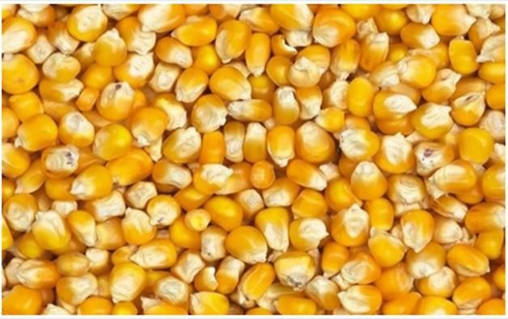

Figure 1: Corn kernels (Zea mays L.), yellow variety.

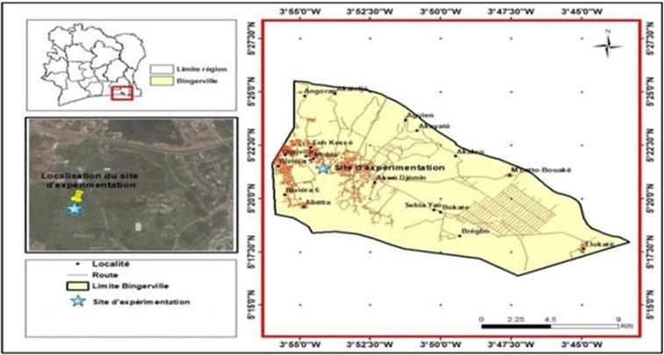

Figure 2: Map of the municipality of Bingerville showing the study site.

Figure 3: Rainfall and temperature records for the study area

2. METHODS
2.1. Experimental Design
The experimental design was a completely randomised block design with two factors: water regime and seed storage duration. Each experimental unit (field capacity × storage duration) was repeated four times (Figure 4).
2.2. Conducting the Experiment
2.2.1. Determination of Field Capacity and Water Status
The collected substrate was sieved and placed in an oven for 24 hours at 105°C. Disposable 200 ml pots were perforated at the bottom to allow water to drain. The pots were then filled with soil that had been dried beforehand and weighed to determine the mass of each pot containing dry soil (P2). Water was added until saturation, after which the soil was left to drain for 48 hours. The mass of the pots containing the drained soil was then determined using a balance (P3). The respective masses of the dry soil and the drained soil were calculated using the following formulae.
Dry soil weight (PS) = P2 - P1 (1); Drained soil weight (PE) = P3 - P1 (2)

To calculate the volume of water retained in the drained soil (VEC), the following formula was adopted:
VEC (ml) = (PE – PS) X 1 ml/g

This water volume (VEC) corresponds to 100% of field capacity. This value is divided by 2, 4, and 8 to obtain water regimes of 50%, 25%, and 12.5%, respectively. Thus, the plants were subjected to the following stresses:
-T1: The soil is irrigated to 100% of its field capacity, representing normal irrigation conditions;
-T2: The soil is maintained at 50% of its field capacity, representing a fairly moderate water deficit;
-T3: The soil is maintained at 25% of its field capacity, representing a moderate water deficit;
-T4: The soil is maintained at 12.5% of field capacity, representing severe water deficit conditions.

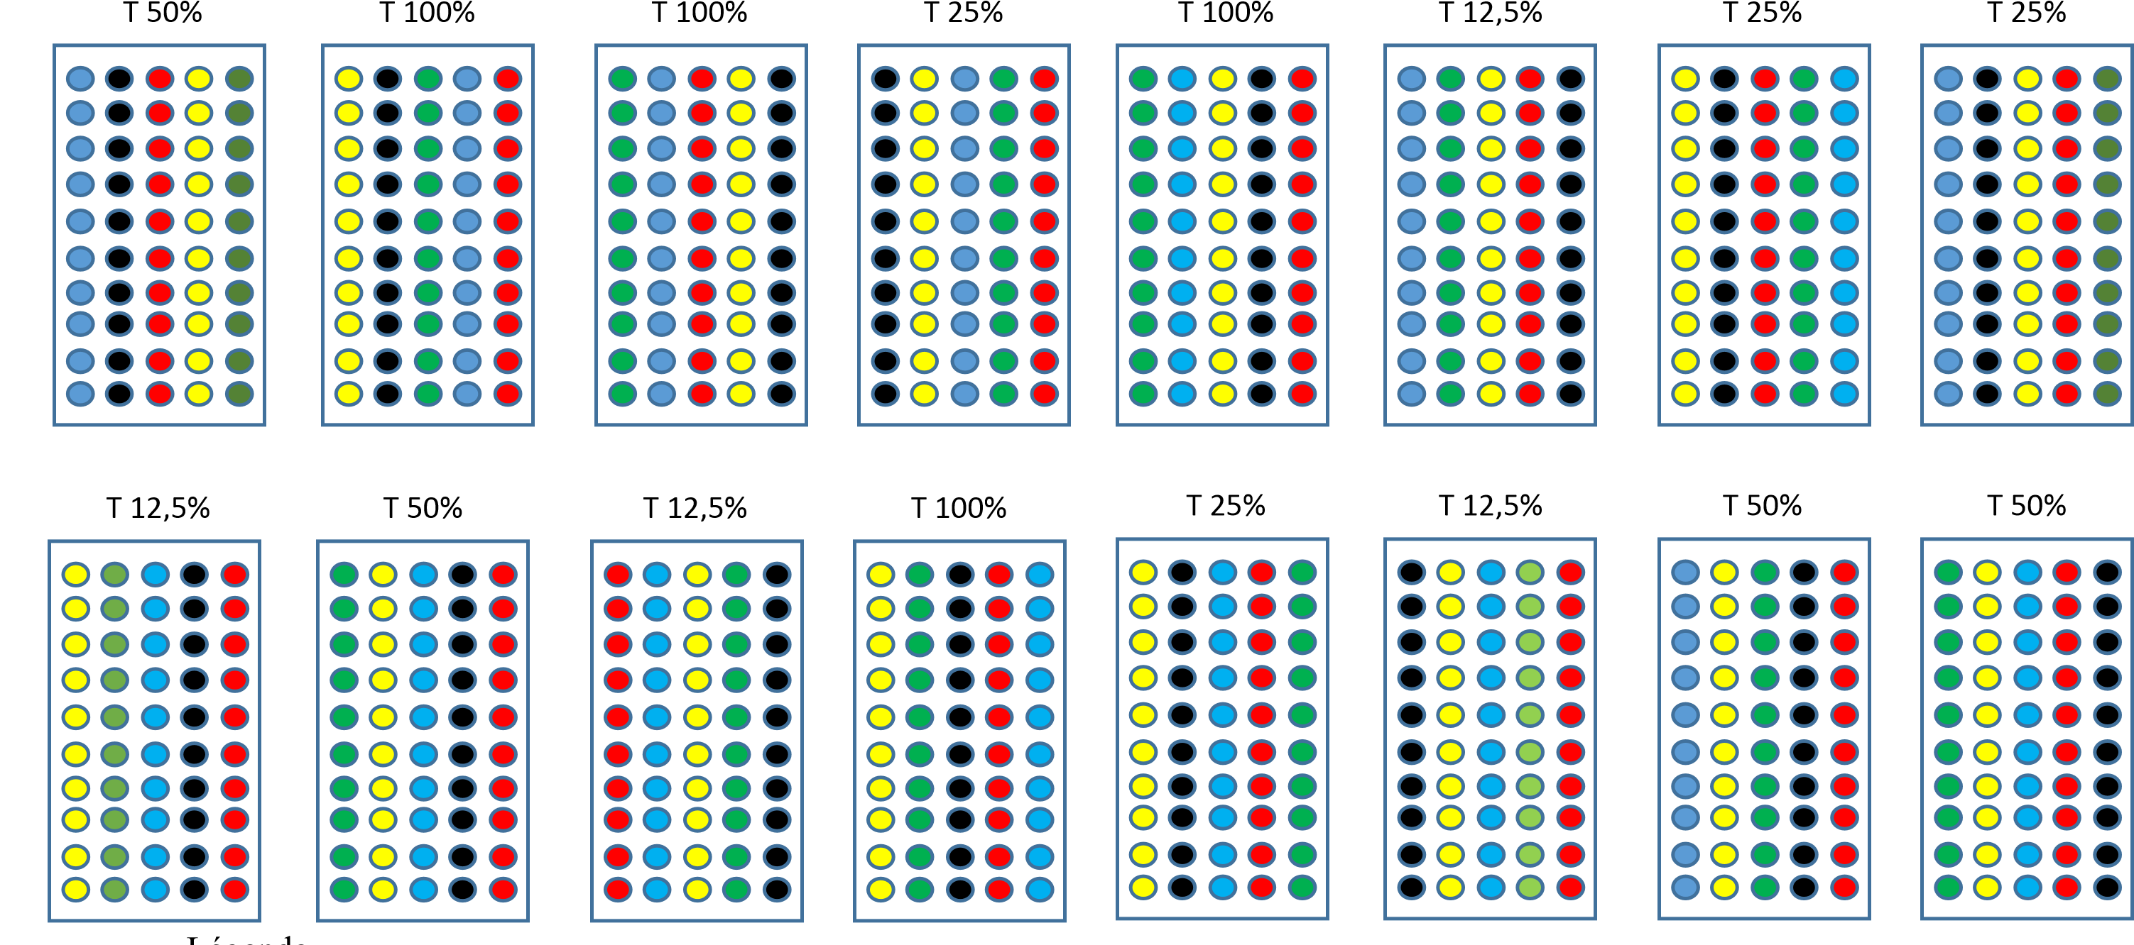
Figure 4: Completely randomized experimental design with 4 replicates
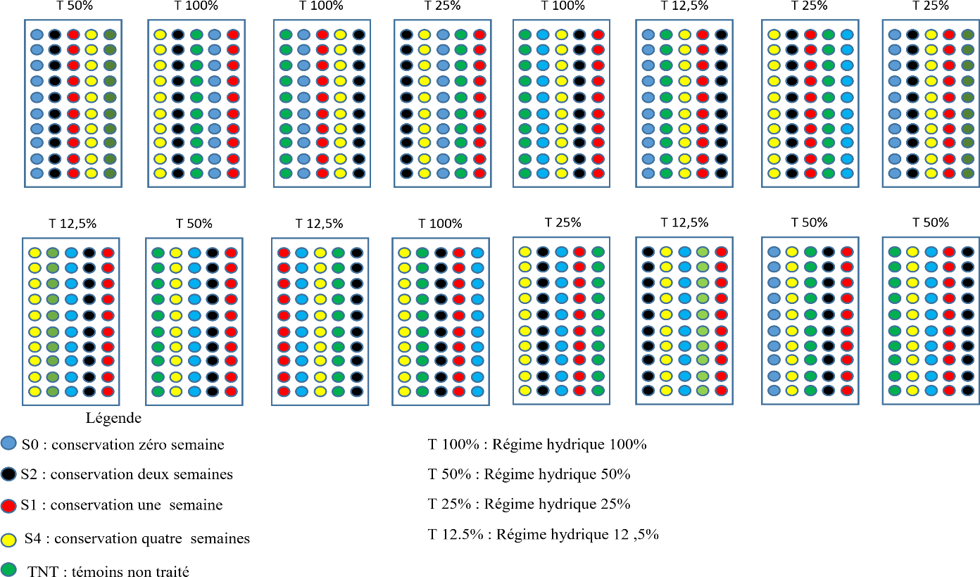
T100%: 100% water regime
T50%: 50% water regime
T25%: 25% water regime
T12.5%: 12.5% water regime
S0: 0-week retention
S2: 2-week retention
S1: 1-week retention
S4: 4-week retention
TNT: Untreated control

2.2.2. Hydro-priming and grain storage at different times
Pre-germination involved a set of seven Petri dishes and 175 corn kernels. The kernels underwent the same treatment as before (disinfection). Twenty-five kernels were placed in each Petri dish, which had been pre-soaked with 6 ml of distilled water.
The boxes were placed in a room at a temperature of 25°C. The kernels were dried for three days at a temperature of 25°C until they returned to their initial weight. After drying, the treated grains were wrapped in aluminium foil to create samples aged zero (S0), one (S1), two (S2) and four (S4) weeks.
A fifth batch of grains was used in this experiment. These were untreated grains that served as the control (TNT).
2.2.3. Determination of the Average Time to Radicle Emergence
The average germination time corresponds to the precise moment of radicle emergence. To determine this, four batches of 25 seeds each were disinfected in 1% sodium hypochlorite for 5 minutes. Next, the seeds were thoroughly rinsed with distilled water and then placed in four Petri dishes lined with a double layer of paper towels that had been pre-soaked with 6 ml of distilled water. The Petri dishes were incubated at room temperature. In each Petri dish, the time elapsed between the day the seeds were sown and the emergence of the radicle was recorded. The average germination time (AGT) was calculated for each Petri dish using the formula proposed by Côme (1970):
∑𝐧. 𝐣𝐧
𝐓𝐌𝐆 = 𝐗 𝟏𝟎𝟎
𝐍

n: number of seeds that germinated per day
j: number hours after sowing
N: total number of seeds that germinated
2.2.4. Potting
The seeds were sown in pots filled with potting compost. One seed per pot was sown at a depth of 1 cm.
2.2.5. Crop Care After Seeding
The plants were watered according to different irrigation regimes (100%, 50%, 25%, and 12.5%) starting on the first day after seeding.
2.2.6. Determination of Germination Parameters
The following parameters were determined:
The emergence time is the time at which seedling emergence is observed. It is the time that elapses between sowing and the emergence of seedlings from the soil.
To determine the daily emergence percentage, the number of seedlings that emerged each day at the same time was recorded until the last day on which no further seedling emergence was observed.
The daily emergence rate was calculated as the ratio of the number of seedlings that emerged each day to the total number of seeds sown.
The emergence rate was calculated using the following formula:
Total number of emerged seedlings
Emergence rate = 𝐗 𝟏𝟎𝟎
Total number of seeds sown

2.3. Statistical Analyses
STATISTICA version 7.1 was used to analyse the data collected. Analysis of variance (ANOVA) was used to assess the effects of each water regime and storage time on the parameters. When the null hypothesis (H0) was rejected, the Newman-Keuls multiple-comparison test was carried out at a 5 per cent significance level (α = 0.05) to rank the means.

3. RESULTS
3.1. Determination of the average germination time (time required for the radicle to emerge)
The average time for the radicle to emerge ranged from 16 hours to 33 hours depending on the grain lots, with an estimated average of 29.25 hours (Table 1).
A duration shorter than 29.25 hours was therefore selected, and 27 hours was used as the time required for hydro-priming the corn seeds.
Table 2: Average germination time for grains from four lots of corn.
Lots | Average germination time (hours)
Lot 1 | 31
Lot 2 | 30
Lot 3 | 20
Lot 4 | 28
Average | 29,25

3.2. Effect of Storage Time of Hydro-Primed Seeds and Water Regimes on Germination
In this study, a seed was considered to have germinated when a plant emerged from the growing medium (soil) (Figure 5).
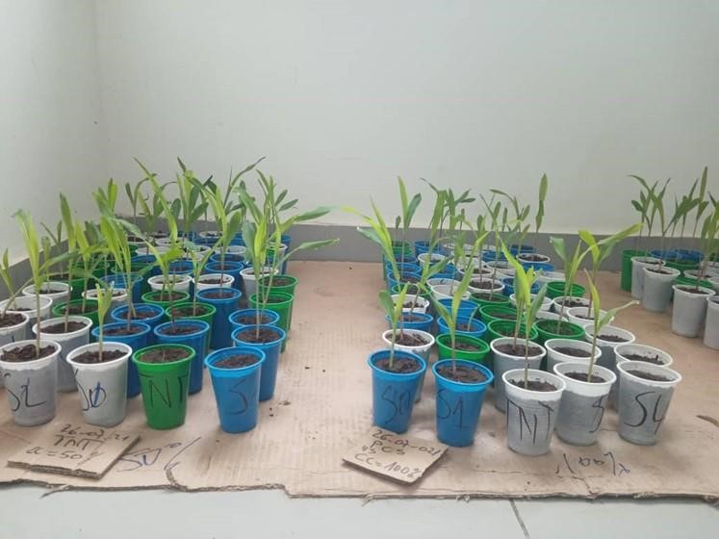
Figure 5: Corn plants that have emerged from the growing medium one week after sowing.

3.2.1. Effect of Seed Storage Time After Hydro-Priming on the Germination Rate
Figure 6 shows the germination rates as a function of storage time for seeds that underwent the hydro-priming process. Analysis of this figure revealed a germination rate exceeding 70% for all treatments. The lowest germination rate (72.5%) was observed in the control treatment, while seeds treated and stored for one week (S1) and two weeks (S2) showed the highest germination rate (79.37%). However, no statistically significant difference was observed among the germination rates.
3.2.2. Effect of Water Regime on the Germination Rate of Corn Seeds After Hydro-Priming
The results of this study showed that the water regime influenced the germination of corn seeds (Figure 7). The T4 treatment recorded the highest germination rate, at 93%. However, the germination rate for the T4 treatment differed significantly from those of the T2 (84.00%) and T1 (42.00%) treatments. The T1 treatment had the lowest germination rate (42%).
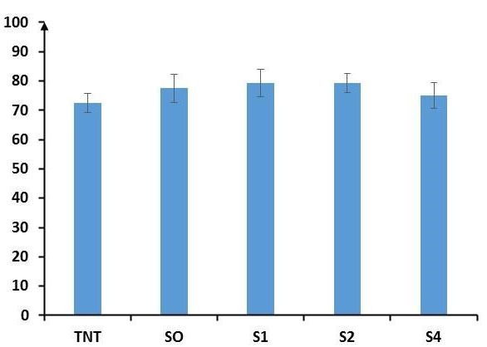
Germination percentage (%)

Storage time
Figure 6: Germination percentage of corn kernels at different storage times.
S0: Pre-germinated and unstored kernels; S1: Pre-germinated kernels stored for one week; S2: Pre-germinated kernels stored for two weeks; S4: Pre-germinated kernels stored for four weeks; TNT: Untreated kernels (control).

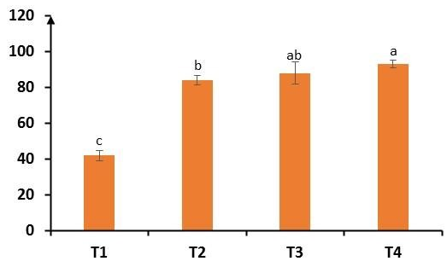
Germination percentage (%)
water balance

Figure 7: Germination percentage of corn kernels under different water regimes.
T1: 100% of field capacity, T2: 50% of field capacity, T3: 25% of field capacity, T4: 12.5% of field capacity.

3.3. Effect of water regimes on the growth parameters of seedlings derived from grains that underwent hydro-priming and were stored for different periods of time.
3.3.1. Growth of the aboveground parts of corn seedlings
The growth parameters evaluated were plant height (PH), collar diameter (CD), number of leaves (NL), leaf area (LA), fresh above-ground biomass (FAB) and dry above-ground biomass (DAB). Analysis of the study results presented in Table II showed that plant height varied among treatments depending on the water regime. Furthermore, regardless of the water regime, plants grown from pre-germinated, non-stored seeds (S0) were the tallest.
Regarding the number of leaves and collar diameter, analysis of the table showed that the values for these two parameters were lower under the T4 water regime.
Leaf area was greatest under the T1 water regime (59.83 cm² obtained with S0), followed by the T2 water regime. In contrast, the T4 water regime had the smallest leaf areas, at 24.25 cm² (S0).
For dry above-ground biomass (DAGB), the lowest biomass values were obtained under the T3 irrigation regime, where values did not exceed 0.33 g (S0), whereas under T1 the lowest value was 0.24 g (S2).
Table 2: Growth of maize plants subjected to different water regimes combined with storage time.
CC | TC | HP (cm) | NF | DC (cm) | SF (cm²) | BAF (cm) | BAS (g)
T1 | SO | 14,54±0,74a | 6,4±0,16ab | 3,39±0,12a | 59,83±4,58a | 2,74±0,15a | 0,55±0,15a
T1 | S1 | 14,44±0,49a | 6,4±0,16ab | 2,95±0,26a | 54,64±3,68a | 2,66±0,17ab | 0,43±0,02b
T1 | S2 | 14,41±0,73a | 6,4±0,16ab | 2,92±0,1ab | 53,88±4,32ab | 2,23±0,2abc | 0,24±0,12b
T1 | S4 | 13,11±0,66a | 6,2±0,2abc | 2,88±0,14a | 49,85±3,4b | 2,33±0,21ab | 0,66±0,18a
T1 | TN | 14,75±0,7a | 6,6±0,22a | 3,04±0,15a | 55,95±5,45a | 2,67±0,17ab | 0,36±0,07b
T2 | SO | 14,34±0,45a | 6,5±0,17a | 2,9±0,13ab | 55,38±3,03a | 1,92±0,17bc | 0,31±0,11b
T2 | SI | 13,82±0,37a | 6,2±0,2abc | 3, 03±17ab | 52,8±4,43a | 2,06±0,21ab | 0,28±0,07b
T2 | S2 | 12,67±0,49a | 6,4±0,16ab | 3,07±0,08a | 42,99±3,04b | 2,08±0,13ab | 0,87±0,18a
T2 | S4 | 12,5±0,44ab | 6,3±0,21ab | 2,96±0,15a | 40,79±3,38b | 2,02±0,1abc | 0,57±0,11a
T2 | TN | 12,92±0,95a | 6,3±0,15ab | 2,92±0,07a | 41,13±1,46b | 1,85±0,14cd | 0,24±0,04b
T3 | SO | 14,4±0,41ab | 6,2±0,25ab | 2,81±0,12a | 84,38±37,4a | 2,21±0,24ab | 0,33±0,08b
T3 | SI | 14,11±0,59a | 6,5±0,17a | 2,92±0,08a | 48,83±5,34b | 1,82±0,16cd | 0,19±0,02c
T3 | S2 | 13,77±0,41a | 5,9±0,1abc | 2,8±0,09ab | 41,54±3,67c | 1,47±0,2de | 0,17±0,01c
T3 | S4 | 12,99±0,47a | 6±0,15abc | 2,68±0,11b | 38,48±2,28d | 1,6±0,20cde | 0,16±0,02c
T3 | TN | 12,84±0,44a | 5,9±0,18ab | 2,81±0,01a | 40,23±2,75c | 1,38±0,14ef | 0,15±0,02c
T4 | SO | 11,89±0,7bc | 4,9±0,18e | 2,38±0,12c | 24,25±2,63b | 0,82±0,13f | 0,19±0,05c
T4 | SI | 11,87±0,66b | 5,4±0,16de | 2,5±0,09bc | 34,18±1,71a | 1,32±0,17ef | 0,14±0,01c
T4 | S2 | 11,39±0,73c | 5,5±0,17de | 2,73±0,08b | 34,76±2,35a | 1,30±0,19ef | 0,30±0,12b
T4 | S4 | 11,85±0,49b | 5,6±0,16de | 2,61±0,07b | 32,17±3,27b | 1,27±0,11ef | 0,37±0,05b
T4 | TN | 10,18±0,74d | 5,4±0,27de | 2,61±0,21b | 32,34±5,13b | 1,27±0,29ef | 0,13±0,02c
p |  | 0,05 | 0,09 | 0,22 | 0,11 | 0,01 | 0,0003
HP: plant height; NF: number of leaves; DC: collar diameter; SF: leaf area; BAF: fresh aboveground biomass; BAS: dry aboveground biomass. T1: 100% of field capacity, T2: 50% of field capacity, T3: 25% of field capacity, T4: 12.5% of field capacity. TC: Storage time; CC: Field capacity. S0: Pre-germinated and unstored seeds; S1: Pre-germinated seeds stored for one week; S2: Pre-germinated seeds stored for two weeks. S4: Pre-germinated seeds stored for four weeks; TNT: Untreated seeds (control). ±: Standard error.
3.3.2. Growth of the underground parts of corn seedlings
The results showed that the number of roots (NR) decreased with water availability. This number ranged from 4.5 to 12, and the lowest number of roots was recorded under the 12.5% water-availability treatment (T4) with the untreated control seeds (TNT). Seeds that were treated but not stored (S0) and those that were treated and stored for one week (S1), when watered under the 100% irrigation regime (T1), had the highest number of roots (12).
Results similar to those for root number (RN) were observed for root length (RL). Root length (RL) was shorter under the T4 water regime. Under this T4 regime, the plants grown from S0 seeds had the shortest root length (RL) (Table III).
For fresh aboveground biomass (FAB), the results showed that it was highest (2.18 g) in treatment T1 with seeds S2 and S4 and was identical to that of the TNT control. The lowest fresh biomass values were observed in treatments T3S2 (0.43 g) and T4 TNT (0.49 g).
The analysis showed that under the T3 water regime, S0 recorded a significantly higher value, followed by S1, S2 and S4, compared with TNT, which had a low value. The results showed a higher LR for TNT, followed by S1, S0, S2 and S4. For BSF, S0, S1, S2 and S4 had statistically higher values, while TNT had a low value; the same observation was made for BSS. Under the T4 water regime, S0 exhibited a high number of roots as well as other growth parameters (LR, BSF and BSS). S1 and S2 recorded statistically identical values, followed by S4, with TNT showing the lowest value (Table 3).
Table 3: Comparison of the means of growth parameters measured on the underground parts of corn plants subjected to different water regimes combined with storage time.
CC (%) | TC | NR | LR | BSF | BSS
T1 | SO | 12±0,38a | 35,76±3,72a | 1,01±0,13bcd | 0,26±0,05cd
T1 | SI | 12±1,06a | 35,65±4,08a | 1,19±0,13bc | 0,38±0,05bcd
T1 | S2 | 11±0,97ab | 34,17±2,6a | 2,04±0,12a | 0,64±0,08b
T1 | S4 | 9,56±0,65abcd | 34,83±5,24a | 2,18±0,3a | 0,99±0,23a
T1 | TNT | 10,8±0,53abc | 38,68±2,67a | 2,18±0,33a | 0,289±0,07cd
T2 | SO | 8,6±0,65bcd | 27,82±2,49a | 0,81±0,11bcd | 0,26±0,05cd
T2 | SI | 8,6±0,65bcd | 31,22±2,56a | 0,89±0,12bcd | 0,35±0,07bcd
T2 | S2 | 8±0,87bcde | 35,8±4,16a | 0,98±0,12bcd | 0,34±0,07bcd
T2 | S4 | 8,3±1,16bcd | 34,57±4,36a | 1,34±0,19b | 0,53±0,12bc
T2 | TNT | 7,8±0,88bcde | 28,51±1,95a | 1,10±0,28bcd | 0,47±0,15bcd
T3 | SO | 8,1±0,59bcde | 32,36±2,46 | 0,65±0,07bcd | 0,2±0,03cd
T3 | SI | 7,7±0,82bcde | 34,18±2,65a | 0,73±0,14bcd | 0,26±0,06cd
T3 | S2 | 7,4±1,05bcde | 28,91±3,83a | 0,43±0,7d | 0,12±0,02d
T3 | S4 | 7,5±0,52bcde | 26,47±3,44a | 0,8±0,11bcd | 0,3±0,05cd
T3 | TNT | 7±0,7cde | 35,58±1,46a | 0,48±0,06cd | 0,13±0,02d
T4 | SO | 8±1,06bcde | 27,58±2,40a | 0,51±0,09cd | 0,1±0,02d
T4 | SI | 7,4±0,72bcde | 29,64±1,61a | 0,54±0,12cd | 0,14±0,02d
T4 | S2 | 7,3±0,79bcde | 29,09±1,51a | 0,57±0,09cd | 0,15±0,02d
T4 | S4 | 5,9±0,69de | 30,25±2,94a | 0,55±0,08cd | 0,16±0,03d
T4 | TNT | 4,5±0,65e | 29,78±4,58a | 0,49±0,06cd | 0,14±0,02d
P |  | 0,1 | 0,53 | 0,0001 | 0,0002

NR: number of roots; MRL: mean root length; FSB: fresh below-ground biomass; DSB: dry below-ground biomass; T1: 100% field capacity; T2: 50% field capacity; T3: 25% field capacity; T4: 12.5% ​​field capacity. ST: Storage time. FC: Field capacity. S0: Pre-germinated, non-stored grains; S1: Pre-germinated grains stored for one week; S2: Pre-germinated grains stored for two weeks; S4: Pre-germinated grains stored for four weeks; TNT: Untreated grains (Control). ±: Standard error.

3.3.3. Effect of Different Storage Durations on the Growth Parameters of Seedlings
Seeds that had undergone hydro-priming and were stored for different periods were germinated and watered according to different irrigation regimes during the growth phase. The mean values of the growth parameters measured for the aboveground and underground parts are presented in Table 4. Certain growth parameters, such as plant height, total number of leaves, collar diameter, leaf area, number of roots, average root length, fresh above-ground biomass, fresh below-ground biomass, dry aboveground biomass and dry belowground biomass, were assessed during the experiment; the results are summarised in Table 4.
In general, the watering regime influenced the growth of all plant organs. Plant heights ranged from 11.44 to 14.25 cm. The tallest plants, which were statistically indistinguishable, were obtained under watering regimes T1, T2 and T3. The shortest plants were those watered with 12.5 ml of water. Regarding the number of leaves and collar diameter, analysis of the table showed that the values for these two parameters were higher and statistically equivalent under the T1 (6.40; 3.04) and T2 (6.34; 2.98) irrigation regimes. The lowest values were observed under the T3 regime (6.10; 2.80), followed by T4 (6.10; 2.56). The same observation was made for dry above-ground biomass (DAGB). However, for this parameter, the T3 and T4 water regimes exhibited statistically equivalent DAGB values.
Leaf area was highest under the T1 (54.83 cm²), T2 (46.62 cm²) and T3 (50.69 cm²) water regimes. These values were statistically indistinguishable at the 5% significance level. The smallest leaf area was observed under the T4 regime (31.54 cm²).
Fresh aboveground biomass (FAB) decreased with water stress; that is, FAB decreased as the amount of water supplied to the plant decreased.

Table 4: Comparision of the mean values of growth parameters measured on corn seedlings subjected to different water regimes
CC | HP NF DC (cm) SF (cm2) BAF (g) B AS(g) NR LR (cm) BSF (g) BS S (g)
T1 | 14,25±0,30a 6,40±0,08a 3,04±0,08a 54,83±1,92a 2,53±0,08a 0,45±0,06a 11,1±0,37a 35,84±1,61a 1,72±0,12a 0,51±0,06a
T2 | 13,25±0,27b 6,34±0,08a 2,98±0,05a 46,62±1,64a 1,99±0,07b 0,45±0,06a 8,24±0,37b 31,58±1,47ab 1,02±0,08b 0,39±0,04b
T3 | 13,62±,23ab 6,10±0,08b 2,80±0,04b 50,69±7,72a 1,7±0,1c 0,20±0,02b 7,54±0,33bc 31,50±1,33ab 0,62±0,05c 0,20±0,02c
T4 | 11,44±0,25c 6,10±0,09c 2,56±0,06c 31,54±1,49b 1,20±0,09d 0,23±0,03b 6,62±0,39c 29,271±,22b 0,53±0,04c 0,14±0,01c

NT: control; HP: seedling height; NF: number of leaves; DC: collar diameter; SF: leaf area; BAF: fresh above-ground biomass; BAS: dry above-ground biomass; NR: number of roots; LR: root length; BSF: fresh below-ground biomass; BSS: dry below-ground biomass; CC: field capacity; T1: 100%; T2: 50%; T3: 25%; T4: 12.5%; S0: Pre-germinated seeds not stored; S1: Pre-germinated seeds stored for one week; S2: Pre-germinated seeds stored for two weeks. S4: Pre-germinated grains stored for four weeks; TNT: Untreated grains (control); ±: Standard error.

4. DISCUSSION
Plant production and the establishment of healthy crops depend heavily on seed germination, which is a crucial stage in the life cycle of higher plants (Puglia, 2024).
According to this study, regardless of the type of water regime, hydro-priming improved the germination performance of corn. This could be explained by the fact that hydro-priming triggers and regulates pre-germination processes and also induces strong activation of certain genes responsible for water-stress tolerance. These results are consistent with those reported by Paparella et al. (2015). Their findings showed that hydro-priming triggers and regulates pre-germination metabolic processes, such as DNA repair, protein synthesis, activation of antioxidant enzymes and modulation of gene expression involved in the response to water stress, thereby improving germination vigour and seedling tolerance to water-deficient conditions. Aswathi et al. (2022) and Mir et al. (2021) also observed that priming improves the performance and vigour of corn, wheat and cowpea under stressful conditions. However, what is entirely new in this study compared with all previous studies is the storage of treated seeds and the application of the treatment in the field. Our results demonstrated the effect of storage time on the germination period, germination rate and number of seedlings emerging from hydro-primed seeds. The pre-treated seeds stored for different periods exhibited good germination capacity under moisture regimes of 50%, 25% and 12.5%. Thus, under water-stress conditions, untreated grains (TNT) had insufficient germination capacity and emergence rates. This result is consistent with those of Dezfuli et al. (2008), Qadir (2021) and Adinde et al. (2020), who noted that emergence rates vary significantly depending on the duration of pre-soaking, confirming that an optimal duration is essential for maximising seedling establishment. Ahammad et al. (2014) showed that, in corn, a treatment involving an 18-hour soak followed by surface drying yielded the best results in terms of germination percentage, germination index and reduction in average germination time. Thus, the treated and stored grains had significantly better germination performance than the controls under water regimes of 50%, 25% and 12.5%. These results show that pre-treated seeds do not require a large amount of water for seedling emergence. These results are consistent with those of El-Sanatawy et al. (2021), who demonstrated that hydro-priming improves maize seed germination, seedling vigour, yield and productivity under water stress. In particular, the authors reported a 20% and 22.7% increase in yield under moderate and severe water stress, respectively, compared with non-primed seeds. Furthermore, according to Tanwar et al. (2021, 2023), pre-soaking for 8 to 12 hours significantly improves the germination rate and vigour indices of wheat seeds. The results obtained for growth parameters show that pre-germination treatments lead to faster and more uniform germination and better seedling growth under adverse conditions. Indeed, the beneficial effects of hydro-priming are generally more pronounced when seeds are subjected to adverse environmental conditions (water stress, salinity or extreme temperatures) than under optimal germination conditions (Paparella et al., 2015; Ibrahim, 2016).
It was also demonstrated that seeds stored under conditions S0 and S1 exhibited more efficient plant growth than the control (TNT). Furthermore, hydro-priming combined with specific water regimes significantly improved these parameters. The greatest plant height, leaf area and above-ground biomass were obtained under water regime T4, followed by T3 and T2. Under our experimental conditions, the storage times of pre-germinated seeds clearly showed improved plant growth in terms of height, number of leaves, leaf area and collar diameter when the seeds were pre-treated and stored for zero weeks (S0), one week (S1) and two weeks (S2). Thus, hydro-priming may be useful for mitigating the adverse effects of drought and improving germination in a water-stressed environment. These results are similar to those of Marthandan et al. (2020), who demonstrated that hydro-priming is a simple and effective strategy for mitigating the adverse effects of drought. Choi et al. (2024, 2025), through their research on rice, also observed improved seedling performance under water-stress conditions due to hydro-priming. In particular, hydro-primed rice seeds exhibited increased shoot length, root length and dry matter content in both shoots and roots compared with unprimed seeds. Hydro-priming promotes early growth, improves root development and enhances water uptake. The authors demonstrated that hydro-priming improves germination and promotes seedling growth under water stress, particularly through increased α-amylase activity and soluble sugar content.
5. CONCLUSION
Abiotic factors are among the major challenges facing crop production. This phenomenon is also driven by climate change. Numerous studies are being conducted in this area to mitigate the effects of abiotic stress. Hydro-priming is used to break dormancy and improve seed vigour. Hydro-priming also plays a key role in helping plants adapt to water stress. This study was initiated to assess the effects of hydro-priming maize seeds on germination and growth under stressful conditions. On completion of this study, it can be concluded that hydro-priming of maize seeds improved the germination performance, growth and development of seedlings derived from seeds treated and stored for different durations (S0, S1, S2, S4) under water regimes of 25 per cent and 12.5 per cent compared with the control group. However, it is best to pre-treat the seeds and store them only for a short period (one to two weeks), as this yields the best results. Thus, hydro-priming could be a highly effective method for improving crop production, particularly under adverse water-stress conditions. It is a simple and inexpensive technique that avoids the use of chemicals that could be harmful to the environment and human health. All the different grains that were pre-treated and stored for a short period showed tolerance to water stress. The research conducted on hydro-priming indicates that it is a promising agroecological strategy for enhancing maize resilience to water stress induced by climate change. This research could be extended to other cereal crops such as sorghum and rice.

Limitation
This study has certain limitations that must be taken into account when interpreting the results. The experiment focused primarily on the early stages of maize development, which does not allow a definitive determination of the effect of hydro-priming on final yield. Furthermore, controlled experimental conditions may differ from actual field conditions, which are characterised by simultaneous variations in multiple environmental factors.
Future research should include a field trial in which the plants are monitored through to final production to assess the beneficial effect of hydro-priming on productivity and yield under water-stress conditions.

Declaration of AI Use

This manuscript was prepared through the intellectual contributions of the author(s) to the study design, data analysis, interpretation of results, and scholarly content. Grammarly and ChatGPT were used solely to assist with grammatical refinement and reference formatting during manuscript revision. The author(s) accept full responsibility for the accuracy, integrity, and final content of the manuscript.

REFERENCES
Adinde, J. O., Omeje, T. E., Uche, O. J., & Agu, C. J. (2020). Impact of hydropriming duration on seed germination and emergence indices of sweet basil (Ocimum basilicum). Journal of Agricultural Science and Practice, 5(1), 1–7. https://doi.org/10.31248/JASP2019.177
Ahammad, K. U., Rahman, M. M., & Ali, M. R. (2014). Effect of hydropriming method on maize (Zea mays) seedling emergence. Bangladesh Journal of Agricultural Research, 39(1), 143–150. https://doi.org/10.3329/bjar.v39i1.20164
Aswathi, K. P. R., Kalaji, H. M., & Puthur, J. T. (2022). Seed priming of plants aiding in drought stress tolerance and faster recovery: A review. Plant Growth Regulation, 97, 235–253. https://doi.org/10.1007/s10725-021-00755-z
Choi, J.-Y., Ju, Y.-H., Nakamichi, A., Cho, S.-W., Woo, S.-H., & Sakagami, J.-I. (2024). Effect of seed hydropriming on the elongation of plumule and radicle during the germination process and changes in enzyme activity under water-deficient conditions. Plants, 13(24), 3537. https://doi.org/10.3390/plants13243537
Choi, J.-Y., Ju, Y.-H., Cho, S.-W., Chun, J.-B., Woo, S.-H., & Sakagami, J.-I. (2025). Interactive effects of seed priming and genetic diversity on rice germination and early growth under drought stress. All Life, 18(1), 2527623. https://doi.org/10.1080/26895293.2025.2527623
Côme, D. (1970). Les obstacles à la germination. Masson. https://catalogue.bnf.fr/ark:/12148/cb353886553
Deffan, K. P., Akanvou, L., Akanvou, R., Nemlin, G. J., & Kouamé, P. L. (2015). Évaluation morphologique et nutritionnelle de variétés locales et améliorées de maïs (Zea mays L.) produites en Côte d’Ivoire. Afrique Science, 11(3), 181–196.
Dezfuli, P. M., Sharif-Zadeh, F., & Janmohammadi, M. (2008). Influence of priming techniques on seed germination behavior of maize inbred lines (Zea mays L.). ARPN Journal of Agricultural and Biological Science, 3(3), 22–25.
Union des Villes et Communes de Côte d’Ivoire. (2020, June 10). Communes.
El-Sanatawy, A. M., El-Kholy, A. S. M., Ali, M. M. A., Awad, M. F., & Mansour, E. (2021). Maize seedling establishment, grain yield and crop water productivity response to seed priming and irrigation management in a Mediterranean arid environment. Agronomy, 11(4), 756. https://doi.org/10.3390/agronomy11040756
Erenstein, O., Jaleta, M., Sonder, K., Mottaleb, K., & Prasanna, B. M. (2022). Global maize production, consumption and trade: Trends and R&D implications. Food Security, 14(5), 1295–1319. https://doi.org/10.1007/s12571-022-01288-7
Food and Agriculture Organization of the United Nations. (2024). FAOSTAT: Crops and livestock products [Data set]. https://www.fao.org/faostat/en/#data/QCL
Forti, C., Ottobrino, V., Doria, E., Bassolino, L., Toppino, L., Rotino, G. L., Pagano, A., Macovei, A., & Balestrazzi, A. (2021). Hydropriming applied on fast germinating Solanum villosum Miller seeds: Impact on pre-germinative metabolism. Frontiers in Plant Science, 12, 639336. https://doi.org/10.3389/fpls.2021.639336
Ibrahim, E. A. (2016). Seed priming to alleviate salinity stress in germinating seeds. Journal of Plant Physiology, 192, 38–46. https://doi.org/10.1016/j.jplph.2015.12.011
Janmohammadi, M., Moradi Dezfuli, P., & Sharifzadeh, F. (2008). Seed invigoration techniques to improve germination and early growth of inbred line of maize under salinity and drought stress. General and Applied Plant Physiology, 34(3–4), 215–226.
Kaya, M. D., Okçu, G., Atak, M., Çıkılı, Y., & Kolsarıcı, Ö. (2006). Seed treatments to overcome salt and drought stress during germination in sunflower (Helianthus annuus L.). European Journal of Agronomy, 24(4), 291–295. https://doi.org/10.1016/j.eja.2005.08.001
Koutoua, A. J.-P. (2019). Planification urbaine et développement du Grand Abidjan: Cas des villes d’Anyama, de Bingerville et de Grand-Bassam [Doctoral dissertation, Université Félix Houphouët-Boigny Abidjan-Cocody]. HAL.
Marthandan, V., Geetha, R., Kumutha, K., Renganathan, V. G., Karthikeyan, A., & Ramalingam, J. (2020). Seed priming: A feasible strategy to enhance drought tolerance in crop plants. International Journal of Molecular Sciences, 21(21), 8258. https://doi.org/10.3390/ijms21218258
Mir, H. R., Yadav, S., & Yadav, S. (2021). Hydropriming associated physiological and biochemical changes responsible for the enhanced planting value of maize hybrid and its parental line seeds. Turkish Journal of Agriculture and Forestry, 45(3), 335–348. https://doi.org/10.3906/tar-2006-77
Paparella, S., Araújo, S. S., Rossi, G., Wijayasinghe, M., Carbonera, D., & Balestrazzi, A. (2015). Seed priming: State of the art and new perspectives. Plant Cell Reports, 34(8), 1281–1293. https://doi.org/10.1007/s00299-015-1784-y
Puglia, G. D. (2024). Reactive oxygen and nitrogen species (RONS) signalling in seed dormancy release, perception of environmental cues, and heat stress response. Plant Growth Regulation, 103, 9–32. https://doi.org/10.1007/s10725-023-01094-x
Qadir, S. A. (2021). Influence of different seed priming techniques on the growth and vigor of two (Triticum aestivum L.) bread wheat genotypes. Plant Archives, 21(Supplement 1), 1751–1756. https://doi.org/10.51470/PLANTARCHIVES.2021.v21.S1.278
Tanwar, H., Mor, V. S., Sharma, S., Khan, M., Bhuker, A., Singh, V., Yadav, J., Sangwan, S., Singh, J., Yashveer, S., & Singh, K. (2021). Optimization of ‘on farm’ hydropriming conditions in wheat: Soaking time and water volume have interactive effects on seed performance [Preprint]. Research Square. https://doi.org/10.21203/rs.3.rs-1097189/v1
Tanwar, H., Mor, V. S., Sharma, S., Khan, M., Bhuker, A., Singh, V., Yadav, J., Sangwan, S., Singh, J., Yashveer, S., & Singh, K. (2023). Optimization of ‘on farm’ hydropriming conditions in wheat: Soaking time and water volume have interactive effects on seed performance. PLOS ONE, 18(1), e0280962. https://doi.org/10.1371/journal.pone.0280962

Shabir, H., Bordolui, S. K., & Murmu, K. (2026). Influence of seed priming with seaweed-based biostimulant on growth and yield of maize under water stress conditions in West Bengal, India. Asian Journal of Soil Science and Plant Nutrition, 12(3), 140–149. https://doi.org/10.9734/ajsspn/2026/v12i3710
Mebratu, T., Adamu, E., & Zenebe, M. (2026). Effects of different storage materials in maize (Zea mays L.) seed quality at Hawassa Agricultural Research Center, Sidama Regional State of Ethiopia. Asian Journal of Research and Review in Agriculture, 8(1), 239–247. https://doi.org/10.56557/ajrra/2026/v8i1209
Bekele, G., Ashagre, H., & Gudeta, B. (2024). Evaluation of priming techniques for enhancement of maize inbred line seed germination parameters. International Journal of Agronomy, 2024, 9940768. https://doi.org/10.1155/ioa/9940768
Wazeer, H., Zeidan, A., Allevi, J., Pagano, A., Dueñas, C., Jr., Marocco, A., Stagnati, L., Doria, E., & Macovei, A. (2025). Seed priming with plant waste extracts enhances maize drought tolerance in a genotype-specific manner. Frontiers in Plant Science, 16, 1717255. https://doi.org/10.3389/fpls.2025.1717255

