Evaluation of Turnip (Brassica napus) Production on Different Substrates in Côte d’Ivoire

.
ABSTRACT
Turnip (Brassica napus) production in Côte d’Ivoire is constrained by limited cultivable land, while reliance on chemical fertilisers raises environmental concerns. This study evaluated locally available soil–compost substrates for turnip production under soilless conditions at the École Normale Supérieure d’Abidjan from June to December 2025. Five substrate treatments were assessed: 100% soil (S1), 100% compost (S2), 75% compost + 25% soil (S3), 50% compost + 50% soil (S4), and 25% compost + 75% soil (S5). Seeds of the hybrid turnip variety MAXIMUS were sown in pots arranged under a shade structure, with watering applied as required. Germination rate, leaf production, plant height, and yield were evaluated. Germination was most rapid on S4, while substrates containing compost generally supported greater vegetative growth than the soil-only control. The highest number of leaves was recorded on S4 and S5. Plant height was greatest on the 100% compost substrate. Yield was highest on S4, reaching 1,820 kg/ha, whereas the soil-only control produced the lowest yield at 383 kg/ha. Overall, the 50% compost + 50% soil mixture provided the most favourable balance between vegetative development and yield. These findings support the use of a locally formulated soil–compost substrate for turnip production under the conditions of this experiment.
Keywords: Brassica napus, turnip, soilless cultivation, compost, soil–compost substrate, growing medium, germination, vegetative growth, yield
1. INTRODUCTION

Food sufficiency is one of the major concerns of developing countries, including Côte d’Ivoire. Vegetable crops such as turnips contribute significantly to supplying urban markets with essential food items (Olahan, 2010). However, vegetable production by farmers remains insufficient due to a lack of cultivated soil, which is linked, among other factors, to rapid urbanisation and numerous land conflicts in Côte d’Ivoire (Kouakou et al., 2010; Useni et al., 2012). Faced with this situation, farmers generally resort to the heavy use of chemicals to increase crop yields (Dembélé et al., 2008; Gala Bi et al., 2011). This agricultural technique results in environmental pollution and the degradation of agricultural products, which often affects consumers’ health (Koutros et al., 2009). There are industrial substrates with high potential for increasing crop yields. However, their cost remains quite high, which means that most farmers in developing countries, who have limited resources, cannot obtain them (Elabed et al., 2018). The use of local substrates within easy reach of farmers would facilitate the cultivation of vegetable crops in proximity to cities (Çelebi, 2019). The use of various substrates in food crop production in soilless conditions thus appears to be an innovative technique worth exploring. Substrates composed of sawdust and potting soil have promoted better growth and development of tomato plants in Gabon (Nzengue et al., 2024). Compost used as a cultivation substrate in plastic pots has improved the yield of peanuts and millet (Mamane et al., 2026). The use of various local materials could help develop a suitable substrate for growing turnips. Recent work has shown that locally sourced compost-based mixtures can be formulated with physicochemical properties suitable for soilless horticulture (Fall et al., 2026). Organic substrate alternatives have also been evaluated for vegetable seedling production, indicating that locally available materials can support more sustainable nursery systems (Rahaman et al., 2026). Research in other horticultural crops further shows that crop responses to compost-containing growing media depend on the composition and proportion of substrate components (Adamczewska-Sowińska et al., 2024). In turnip, compost-containing nutrient strategies have likewise been investigated as approaches to support crop performance while reducing reliance on solely inorganic inputs (Machado et al., 2025). However, evidence remains limited on the performance of locally formulated soil-compost substrates specifically for turnip production under soilless conditions in Côte d’Ivoire. Thus, the objective of this study is to determine a formulation for a local substrate for turnip production under soilless conditions.

2. material and methods

2.1 Material

2.1.1 Plant material
The plant material used consisted of seeds from a hybrid turnip variety named MAXIMUS. These seeds were commercially obtained from Technisem (Fig.1).
2.1.2 Cultivation substrates
In this study, the substrates considered were soil, compost, and a mixture of soil and compost in various proportions.

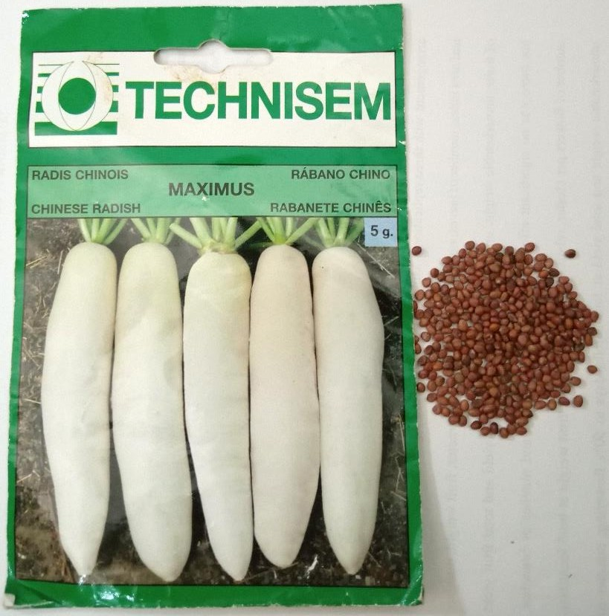.
Fig.1. Maximus turnip seeds

2.2. Methods
2.2.1 Experimental setups
The chosen experimental setup consisted of a completely randomised block with three replicates. Each replicate of the experimental setup consisted of three (3) rows, each containing 30 pots for the substrate combinations, at a rate of six pots per treatment. This resulted in a total of 54 pots for each treatment. Five treatments were considered in this experiment:
- Treatment S1 consisting of 100% soil (control)
- Treatment S2 consisting of 100% compost
- Treatment S3 consisting of a mixture of 75% compost and 25% soil
- Treatment S4 consisting of a mixture of 50% compost and 50% soil
- Treatment S5 consisting of a mixture of 25% compost and 75% soil
2.2.2 Preparation of Growing Media
The collected substrates were prepared seven days before the experiment. The soil was collected from the experiment site. The compost was prepared from a mixture of plant debris from the site and organic waste collected at the ENS market near the experimental site. After the various mixtures were combined, the substrates were heat-sterilised by heating them in aluminium barrels. After cooling, the substrates were packaged in sterile bags according to the different treatments.
2.2.3 Sowing the Seeds
Five-litre plastic pots with holes in the sides were filled with substrate. Then, 1 cm holes were made in each pot, and two seeds were placed in each hole and covered with substrate.
2.2.4 Monitoring and Maintenance of the Turnip Crop
2.2.4.1 Watering
This involved providing the amount of water necessary for proper plant growth during periods of low rainfall. The turnips were watered manually twice daily when rainfall became irregular.
2.2.4.2 Weed Control
Weed control involved limiting weed growth to reduce its negative impact on the crop. Weed control was carried out manually.
2.2.4.3 Pest Control
Mechanical control measures were implemented against caterpillars found on the turnips after symptoms were observed on the plants. The caterpillars were regularly removed from the plants by hand.
2.2.5 Harvesting
The turnips were harvested by hand at maturity, after two months of growth, by carefully digging up the plants from each substrate.
2.2.6 Data Collection
2.2.6.1 Turnip Germination Rate
The germination rate is the ratio of the number of seeds that germinated to the total number of seeds sown, expressed as a percentage.
Number of seeds germinated
Germination rate (%) = x 100
Total number of seeds sown
2.2.6.2 Leaf Production in Turnips
Leaf production is the total number of leaves produced per plant. Ten turnip plants were randomly selected from each experimental unit for each substrate, and the number of leaves produced was recorded.
2.2.6.3 Height of Turnip Plants
Plant height was measured on ten plants randomly selected from each experimental unit for each substrate, using a graduated ruler to measure the stem length from the collar to the tip of the tallest leaf.
2.2.6.4 Weight of Turnip Vegetables
At harvest, 10 plants were randomly selected from each substrate; the tuberous roots were then removed and weighed using a precision scale. Subsequently, yield, expressed as the total weight of turnip vegetables, was estimated per hectare for each substrate. Yield was calculated using the following equation:
Total weight of harvested vegetables (kg)
Yield (kg/ha) =
Area (ha)
3. results and discussion
3. 1 Results
3. 1. 2 Germination of Turnip Seeds
The germination rate of turnip seeds on the tested substrates is shown in Fig. 2. Seed germination began three days after sowing and was complete by the sixth day of cultivation. The germination rate was higher on substrate S4, composed of 50% compost and 50% soil, than on the other substrates from the onset of germination. With this substrate, the maximum germination rate was attained after six days of cultivation. The lowest germination rate was recorded for the compost substrate (S2) and the mixture of 75% compost and 25% soil (S5).

Fig. 2. Germination rates of turnip seeds on substrates
S1: substrate consisting of 100% soil, S2: substrate consisting of 100% compost, S3: substrate consisting of a mixture of 75% compost and 25% soil, S4: substrate consisting of a mixture of 50% compost and 50% soil, S5: substrate consisting of a mixture of 25% compost and 75% soil.

3. 1. 3 Turnip Growth on Various Substrates
The turnip plants performed well during cultivation. Furthermore, no mortality was recorded on the substrates (Fig. 3).

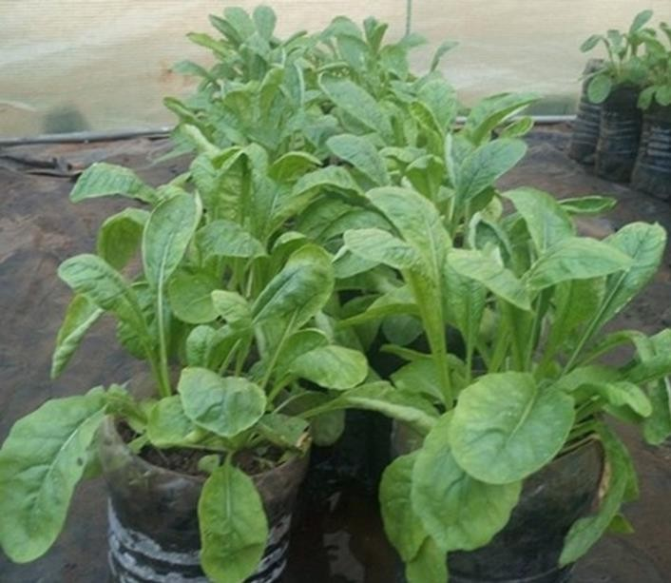
Fig. 3. Turnip plants growing on various substrates

3. 1. 3. 1. Evolution of the Number of Leaves
On the tenth day of cultivation, the plants produced the same number of leaves (4 leaves) on all substrates considered (Fig. 4). From that time, the number of leaves produced by the turnip plants increased gradually until it attained its maximum value on the 31st day of the experiment. The highest number of leaves was observed on the substrates consisting of a mixture of 50% compost and 50% soil (S4) and 25% compost and 75% soil (S5), with 13 and 12 leaves, respectively, as opposed to 10 leaves for the other substrates.

Fig. 4. Number of leaves produced during the growth of turnips on the substrates
S1: substrate consisting of 100% soil, S2: substrate consisting of 100% compost, S3: substrate consisting of a mixture of 75% compost and 25% soil, S4: substrate consisting of a mixture of 50% compost and 50% soil, S5: substrate consisting of a mixture of 25% compost and 75% soil.

3. 1. 3. 2. Plant Height
After 31 days of growth on the substrates, when no variation in plant size was observed, plant heights were measured and recorded. The results are presented in Fig. 5. The height of the plants grown on substrates containing compost was higher than that of the control (100% soil). The greatest height was observed on substrate S2, which consisted exclusively of compost.

Fig. 5. Height of turnips grown on various substrates
S1: substrate consisting of 100% soil, S2: substrate consisting of 100% compost, S3: substrate consisting of a mixture of 75% compost and 25% soil, S4: substrate consisting of a mixture of 50% compost and 50% soil, S5: substrate consisting of a mixture of 25% compost and 75% soil.

3. 1. 4. Turnip Yield
At the end of the growing season, the turnips were harvested, and yield, expressed as vegetable weight, was estimated for each substrate. The experimental results are shown in Fig. 6. The yield at harvest was significantly higher on the substrate consisting of a mixture of compost and soil. The highest yield was recorded on substrate S4, which consisted of 50% compost and 50% soil (1,820 kg/ha). The lowest yield was recorded on the control substrate, which consisted of 100% soil (383 kg/ha).

Fig. 6. Yield of turnips grown on various substrates
S1: substrate consisting of 100% soil, S2: substrate consisting of 100% compost, S3: substrate consisting of a mixture of 75% compost and 25% soil, S4: substrate consisting of a mixture of 50% compost and 50% soil, S5: substrate consisting of a mixture of 25% compost and 75% soil.
3.2. Discussion
Turnip seeds germinated faster in the substrate consisting of 50% compost and 50% soil. This could be explained by the aeration and water retention promoted by the mixture. The availability of sufficient water and oxygen rapidly initiates the seed germination process in plants (Kouadio et al., 2020). The softening of the seed coat following water absorption facilitated the entry of oxygen into the seed, which triggered the resumption of metabolic activity necessary for embryo development, as suggested by Ahoton et al. (2009). The embryo’s intense metabolic activity generally leads to seed germination. Catusse et al. (2008) demonstrated that seed germination is controlled by the embryo’s metabolic activities. Turnip plants produced a high number of leaves on substrates containing 25% and 50% compost. Incorporating compost into the soil at a moderate level certainly improved organ development in the plants compared to the control (soil alone). The positive impact of compost on leaf growth and turnip yield is attributable to improvements in the soil’s physicochemical properties, the nutrient diffusion rate, and its water-holding capacity (Diakhaté et al., 2018). Furthermore, substrates containing a mixture of compost and soil improve the biological properties and the crumbly structure of the soil (Konaté et al., 2018). The substantial amount of organic substance in compost stimulates the activity of microorganisms, thereby improving soil bioavailability (Takeda et al., 2009). Several other authors, such as Ihihi et al. (2014) and Ouedraogo (2016), cited by N’Ganzoua et al. (2023), have demonstrated that composting organic waste provides an alternative to the limited availability of cultivated soil. It offers the advantage of not only limiting pathogens but also improving fertility and accelerating the availability of the nutrients it contains to plants. The resulting mineralisation of organic material has enriched the soil with nutrients that plants can directly assimilate to build their various organs (Temgoua et al., 2012; Etsè et al., 2014). The development of aerial organs such as leaves has promoted optimal photosynthetic activity, which is necessary for the production of metabolic substances. The accumulation of these substances as reserves is beneficial for tuber formation in root vegetables. Mamane et al. (2026) demonstrated that the use of compost as a cultivation substrate in plastic pots significantly improves yields of millet and peanuts.
In this study, when compost was used in excess or served as the sole substrate, plant height was very high, but leaf production and root tuberisation were inhibited. The compost’s excessive organic content, particularly nitrogen, caused significant stem elongation at the expense of other plant parts (Diakhaté et al., 2018).

4. Conclusion
This study evaluated locally formulated soil–compost substrates for turnip production under soilless conditions in Côte d’Ivoire. Substrate composition influenced germination, vegetative growth, and yield. The 50% compost + 50% soil treatment (S4) showed the most favourable overall performance, combining rapid germination, high leaf production, and the highest recorded yield of 1,820 kg/ha. By comparison, the 100% soil control produced the lowest yield, at 383 kg/ha. The 25% compost + 75% soil treatment also supported high leaf production, whereas the 100% compost treatment produced the greatest plant height but did not provide the best yield. These results show that increasing compost content does not necessarily improve all growth and yield parameters simultaneously. Among the substrates tested, an equal mixture of compost and soil was the most suitable for turnip cultivation under the conditions of this experiment. Further work should evaluate different turnip varieties and include chemical characterisation of the substrates before broader recommendations are made for soilless turnip production.

Limitations
The study was conducted at a single site using one hybrid turnip variety and a limited set of soil–compost ratios. Chemical characterisation of the tested substrates was not reported, which limits interpretation of the mechanisms underlying differences in growth and yield. The findings therefore apply primarily to the experimental conditions used in this study. Further studies across additional varieties, sites, and seasons, with detailed substrate characterisation, are needed before broader recommendations are made.

Competing interests

The authors of this manuscript have declared that they have no conflicts of interest.

COMPETING INTERESTS DISCLAIMER:
Authors have declared that they have no known competing financial interests OR non-financial interests OR personal relationships that could have appeared to influence the work reported in this paper.

Declaration of AI Use

This manuscript was prepared through the intellectual contributions of the author(s) to the study design, data analysis, interpretation of results, and scholarly content. Grammarly and ChatGPT were used solely to assist with grammatical refinement and reference formatting during manuscript revision. The author(s) accept full responsibility for the accuracy, integrity, and final content of the manuscript.

References

Adamczewska-Sowińska, K., Sowiński, J., Jamroz, E., & Bekier, J. (2024). The effect of peat replacement in horticulture media by willow (Salix viminalis L.) biomass compost for cucumber transplant production. Frontiers in Plant Science, 15, 1348073. https://doi.org/10.3389/fpls.2024.1348073
Ahoton, L. E., Adjakpa, J. B., M’po, I. M., & Akpo, E. L. (2009). Effet des prétraitements des semences sur la germination de Prosopis africana (Guill., Perrot. et Rich.) Taub. (Césalpiniacées). Tropicultura, 27(4), 233–238. https://agris.fao.org/search/en/providers/122436/records/67598ef4c7a957febdfc2815
Catusse, J., Strub, J.-M., Job, C., Van Dorsselaer, A., & Job, D. (2008). Germination des graines et contrôle du métabolisme. Journal de la Société de Biologie, 202(3), 223–229. https://doi.org/10.1051/jbio:2008024
Çelebi, M. (2019). Effects of different growing media on the yield in tomato, cucumber and pepper, and on seedling in tomato. Tekirdağ Ziraat Fakültesi Dergisi, 16(2), 112–120. https://doi.org/10.33462/jotaf.332857
Dembélé, A., Oumarou, B., Traore, S. K., Mamadou, K., Coulibaly, D. T., & Abba, T. (2008). The chemical control of the pests in the truck farming and the quality of vegetables in African urban cities: The health hazards and security of consumers. European Journal of Scientific Research, 20(4), 836–843.
Diakhaté, K., Toure, M. A., & Diatta, S. (2018). Effet du compost de JACADUR sur la fertilité du sol et la production du navet (Raphanus sativus). Journal of Chemical, Biological and Physical Sciences, 9(1), 68–81. https://doi.org/10.24214/jcbps.B.9.1.06881
Elabed, N., Msilini, I., Belkadhi, M. S., & Hadded, M. (2018). Effect of different substrates on growth, yield and quality of tomato by the use of geothermal water in the South of Tunisia. GPH-International Journal of Agriculture and Research, 1(1), 14–30. https://gphjournal.org/index.php/ar/article/view/56
Etsè, A., Sanonka, T., Kokou, S., Magnoudéwa, B. B., Kokou, D., Koffi, K. A., Gado, T., & Gnon, B. (2014). Étude de la disponibilité du phosphore assimilable des composts de déchets urbains dans deux sols différents. European Scientific Journal, ESJ, 10(6), 156–167. https://eujournal.org/index.php/esj/article/view/2747
Fall, M., Sarr, S. M., & Gueye, N. (2026). Evaluation of the physicochemical properties of innovative substrates based on rice husk biochar and compost inoculated with Trichoderma for soilless horticulture. Asian Journal of Biotechnology and Bioresource Technology, 12(1), 1–12. https://doi.org/10.9734/ajb2t/2026/v12i1273
Gala Bi, T. J., Camara, M., Yao-Kouamé, A., & Keli, Z. J. (2011). Rentabilité des engrais minéraux en riziculture pluviale de plateau: Cas de la zone de Gagnoa dans le centre ouest de la Côte d’Ivoire. Journal of Applied Biosciences, 46, 3153–3162. https://www.m.elewa.org/JABS/2011/46/12.pdf
Ihihi, A., Kitane, M., Lakhtib, I., Bahloul, A., Benqlilou, C., & El Kacemi, K. (2014). Fabrication d’un nouveau compost équilibré à partir de la partie fermentescible des ordures ménagères et de la fiente de poulet. Scientical Editions Mersenne, 1(1), Article 312.
Konaté, Z., Abobi, H. D. A., Soko, F. D., & Yao-Kouamé, A. (2018). Effets de la fertilisation des sols à l’aide des déchets ménagers solides compostés dans les décharges sur le rendement et la qualité chimique de la laitue (Lactuca sativa L.). International Journal of Biological and Chemical Sciences, 12(4), 1611–1625. https://doi.org/10.4314/ijbcs.v12i4.9
Kouadio, K., Sanogo, S., Kouassi, E. K., & Doffou, C. S. (2020). Effet des durées de conservation et du traitement à l’eau sur la germination des graines de Tieghemella heckelii Pierre ex A. Chev. (Sapotaceae) en Côte d’Ivoire. International Journal of Biological and Chemical Sciences, 14(8), 2880–2892. https://doi.org/10.4314/ijbcs.v14i8.18
Kouakou, Y. E., Koné, B., Bonfoh, B., Kientga, S. M., N’Go, Y. A., Savane, I., & Cissé, G. (2010). L’étalement urbain au péril des activités agro-pastorales à Abidjan. VertigO, 10(2). https://doi.org/10.4000/vertigo.10066
Koutros, S., Lynch, C. F., Ma, X., Lee, W. J., Hoppin, J. A., Christensen, C. H., Andreotti, G., Beane Freeman, L., Rusiecki, J. A., Hou, L., Sandler, D. P., & Alavanja, M. C. R. (2009). Heterocyclic aromatic amine pesticide use and human cancer risk: Results from the U.S. Agricultural Health Study. International Journal of Cancer, 124(5), 1206–1212. https://doi.org/10.1002/ijc.24020
Machado, R. M. A., Alves-Pereira, I., Velez, D., Grilo, A., Veríssimo, I., & Ferreira, R. (2025). Exploring sustainable fertilization strategies involving biochar, compost, and inorganic nitrogen: Impact on nutrient uptake, yield, phytochemical accumulation, and antioxidant responses in turnips. Plants, 14(4), 529. https://doi.org/10.3390/plants14040529
Mamane Abdou, I., Mella Mamane, T., Jamilou Salissou, I., Mohamed Adou, S. A., Hassane Bissala, Y., & Zanguina, A. (2026). Effet des différentes doses de compost sur la croissance et le rendement des plants de mil Pennisetum glaucum (L.) R. Br. et de l’arachide (Arachis hypogaea L.). Journal of Applied Biosciences, 217, 24106–24121. https://doi.org/10.35759/JABs.217.6
N’Ganzoua, K. R., Alla, K. T., Zadi, F., & Bakayoko, S. (2023). Effet comparé du temps de compostage sur la fertilité chimique de deux fumures organiques couramment utilisées en maraîchage à Daloa-Côte d’Ivoire. ESI Preprints, 21, 107. https://doi.org/10.19044/esipreprint.9.2023.p107
Nzengue, E., Gnacadja, K. C., Mombo, S., Moundounga Mavouroulou, Q., Mandjedi-Mandjedi, C.-M., Ndiade Bourobou, D., Biroungou, C., Zinga Koumba, C. R., Lépengué, A. N., & Mavoungou, J. F. (2024). Étude de l’impact des substrats locaux sur la germination et la croissance des plants de tomate de la variété BENTO 02 en pépinière au Gabon. Journal of Animal & Plant Sciences, 60(2), 11004–11014. https://doi.org/10.35759/JAnmPlSci.v60-2.1
Olahan, A. (2010). Agriculture urbaine et stratégies de survie des ménages pauvres dans le complexe spatial du district d’Abidjan. VertigO, 10(2). https://doi.org/10.4000/vertigo.10005
Ouedraogo, R. (2016). Evaluation des effets de la fiente de volaille, du fumier de vache et du fumier de porc sur le flétrissement bactérien de la tomate [Mémoire de fin de cycle, Diplôme d’Ingénieur du Développement Rural, Université Polytechnique de Bobo-Dioulasso, Institut du Développement Rural]. https://beep.ird.fr/collect/upb/index/assoc/IDR-2016-OUE-EVA/IDR-2016-OUE-EVA.pdf
Rahaman, M. A., Rahman, M. M., Hasan, S. M. R., Nawmi, U. R., Hasan, M. M., Islam, M. O., Sanzid, F., Islam, A. M. R., Sorwar, S. S. R. M. M. A., & Ahmmed, A. N. F. (2026). Evaluation of sustainable agroecological practices based on the application of organic substrates (cocodust) in vegetable seedlings at the nursery level in the producing areas of Bangladesh. Asian Journal of Agriculture and Allied Sciences, 9(1), 1–13. https://doi.org/10.56557/ajaas/2026/v9i178
Takeda, M., Nakamoto, T., Miyazawa, K., Murayama, T., & Okada, H. (2009). Phosphorus availability and soil biological activity in an Andosol under compost application and winter cover cropping. Applied Soil Ecology, 42(2), 86–95. https://doi.org/10.1016/j.apsoil.2009.02.003
Temgoua, E., Ntangmo Tsafack, H., Njine, T., & Serve, M.-A. (2012). Vegetable production systems of swamp zone in urban environment in West Cameroon: Case of Dschang city. Universal Journal of Environmental Research and Technology, 2(2), 83–92. https://www.environmentaljournal.org/2-2/ujert-2-2-9.pdf
Useni, S. Y., Baboy, L. L., Nyembo, K. L., & Mpundu, M. M. (2012). Effets des apports combinés de biodéchets et de fertilisants inorganiques sur le rendement de trois variétés de Zea mays L. cultivées dans la région de Lubumbashi. Journal of Applied Biosciences, 54, 3935–3943. https://m.elewa.org/JABS/2012/54/10.pdf

