Systematic Review
Urban Wastewater and River Health in Bangladesh: A Systematic Evidence Map Revealing a Dhaka Bias and a Neglected Barnoi River

ABSTRACT
Background: Urban and industrial wastewater discharge has contributed to river pollution in Bangladesh, raising concerns about water quality and ecosystem health. However, existing research remains unevenly distributed across geographical regions and environmental compartments, particularly in rivers associated with secondary cities.
Objective: To map primary field studies of effluent-affected rivers by region, sampled compartment and pollutant group, with particular attention to the Barnoi River near Rajshahi.
Study Design: Systematic evidence map, reported in line with PRISMA 2020 and ROSES.

Methodology: DOAJ and PubMed were searched, and 547 unique records were screened against predefined criteria; of these, 204 primary field studies were included and coded by region, compartment sampled and pollutant group; 21 reviews were kept for comparison. The completeness of reporting on sampling design and analysis in each abstract was appraised with a seven-item checklist; this is a reporting appraisal, not a validated risk-of-bias assessment.
Results: Rivers of the Dhaka region accounted for 90 studies (44%), and Dhaka, Chattogram and Khulna together for 72%; Rajshahi and the north-west accounted for 12 (6%). Water was sampled in 70% of studies and sediment in 31%, but fish in 20%, other aquatic life in 6%, soil or crops in 5% and people in 2%. Metals dominated (63%), and microplastic studies rose from none before 2020 to 34. Of the 189 studies with an abstract (15 had none and could not be appraised), reporting completeness was high in 30%, moderate in 50% and low in 21%; only 14% of these abstracts reported the number of samples. The Barnoi River, which has received the wastewater of Rajshahi since 2008, had three studies against 42 naming the Buriganga, and none examined its sediment, plankton, bottom-dwelling animals, riverbank soil, crops or riverside communities.
Conclusion: Current knowledge describes the water chemistry of a few industrial rivers near the capital far better than the ecological and human consequences of effluent elsewhere. Baseline studies that follow effluent from the drain to the community in secondary cities, with fuller reporting of sampling design, are the clearest priority. Because only two databases were searched and coding was based on titles and abstracts, the counts are minimum values.
Keywords: River pollution, urban effluent, systematic map, reporting completeness, heavy metals, microplastics, Barnoi River, Bangladesh
ABBREVIATIONS
AMR, antimicrobial resistance; DOAJ, Directory of Open Access Journals; PRISMA, Preferred Reporting Items for Systematic Reviews and Meta-Analyses; ROSES, RepOrting standards for Systematic Evidence Syntheses.
1. INTRODUCTION
Almost every city and industrial zone in Bangladesh stands beside a river, and most of the wastewater these places produce reaches the river without treatment. Sewage from households, effluent from tanneries, textile dyeing units and other factories, and runoff from streets and markets all enter the same channels. Reviews published over the last decade describe the outcome in detail: the rivers around Dhaka and other large cities carry heavy loads of organic matter, nutrients and metals; these pollutants build up in riverbed sediment, in fish and in crops irrigated with river water; and the people who use the water or eat the produce are exposed to them (e.g., Akram et al., 2024; Hasi et al., 2025; Hossain et al., 2025b; Islam, 2026; Pandit et al., 2025; see Appendix Table A1). More recent reviews add microplastics to the list (Afroze et al., 2026; Al-Emran et al., 2025; Chakraborty et al., 2026; Chowdhury et al., 2021; Das et al., 2025). An assessment of the Karnaphuli River used a water-quality index based on physicochemical and metal measurements to describe river-water conditions (Mukut et al., 2023).
These reviews answer one question: how polluted are the rivers? They collect reported concentrations, compare them with national and international guideline values and estimate the risk to ecosystems and to health. A second question has received much less attention: where has the research been done, and what exactly has it measured? This second question matters for two practical reasons.
The first reason is that effluent is not the same everywhere. The rivers of Dhaka receive discharges from tanneries, textile factories and many other industries together with the sewage of a megacity. A smaller city may have little heavy industry and may discharge mainly household wastewater through open drains. The mixture of pollutants, and therefore the damage it does, is likely to differ. Results from one kind of river cannot simply be assumed to hold for the other.
The second reason is that pollution moves. Effluent enters the water; part of it settles into the sediment; fish and smaller organisms take it up or lose the oxygen they need; farmers draw the water onto riverbank fields, where pollutants reach soil and crops; and at the end of this chain are the people who fish, farm, bathe and live beside the river. We call each step in this chain a compartment. A body of research that measures only the first one or two compartments can say that pollutants are present, but it cannot say what they have done to the river's life or to the people who depend on it. A Buriganga River investigation measured metals in water, sediment and fish, whereas a separate study of the Gorai River focused on sediment contamination (Roy et al., 2025; Santa et al., 2026). A review of Indian urban rivers also treated sediment contamination and responses of aquatic organisms as related but distinct aspects of effluent impact (Pandey & Kerketta, 2026).
A systematic evidence map is designed for exactly this kind of question. A conventional review combines the results of studies to reach a conclusion about an effect. A map undertakes a simpler, preliminary task: it finds the available studies in a transparent, repeatable way, describes each one with a small set of codes, and shows where studies are plentiful and where they are missing (James et al., 2016). The result resembles a census of the research rather than a verdict on the rivers. To our knowledge, no such map has been published for effluent research on the rivers of Bangladesh. A recent review of microplastic studies in the Karnaphuli River identified differences in sampling designs and analytical reporting that limit comparisons across the available evidence (Wahab & Mollah, 2026).
We chose the Barnoi because it has received untreated municipal wastewater from Rajshahi City through purpose-built canals since December 2008 (Galib et al., 2018), and because a mass death of fish in the river was reported in September 2026 (Dhaka Tribune, 2026).
Table 1 explains the main terms used in the paper.
Although pollutant concentrations have been reviewed, the distribution of primary field studies across regions and environmental compartments has not been systematically mapped for effluent-affected rivers in Bangladesh. The corresponding gaps for secondary-city rivers, particularly the Barnoi, therefore remain difficult to distinguish from the better-studied urban-industrial river systems.
We therefore set out to answer three questions. (1) How is primary research on effluent-affected rivers in Bangladesh distributed among cities and regions? (2) Which compartments and which groups of pollutants has this research examined? (3) What is known about a secondary city, taking Rajshahi and the Barnoi River as a worked example?
Table 1. Terms used in this paper.
Term | Meaning as used here
Effluent | Liquid waste discharged to a drain, canal or river: household sewage, industrial wastewater, or a mixture of the two.
Compartment | A part of the environment in which pollutants can be measured: water, sediment, fish, other aquatic life, soil and crops, or people.
Primary study | A study that reports new field data, as distinct from a review of earlier studies.
Systematic evidence map | A catalogue of the studies on a topic, built by a documented search and coded so that well-studied and neglected areas can be seen.
Secondary city | A divisional or district city outside the three largest urban-industrial centres (Dhaka, Chattogram and Khulna).
Other aquatic life | Plankton, bottom-dwelling invertebrates, shellfish, aquatic plants and aquatic mammals, that is, river organisms other than fish.

2. MATERIALS AND METHODS
2.1 Design and Review Question
This study is a systematic evidence map. We followed published guidance for systematic mapping in environmental science (James et al., 2016) and report the work in line with the ROSES reporting standards for systematic maps and, where they apply to a map, the PRISMA 2020 statement and its extension for scoping reviews (Haddaway et al., 2018; Page et al., 2021; Tricco et al., 2018). No protocol was registered before the work began. Systematic maps are often registered in advance, for example with the Open Science Framework, and without registration readers cannot confirm that the methods were fixed before screening started. To make up for this, the search strings, eligibility criteria, coding rules, appraisal checklist and the decision for every record are published in full (Tables 2 and 3; Supplementary Table S1), so that every step can be checked and repeated.
The question was defined by four components. The setting was any river in Bangladesh, or any canal or drain connected to a river. The exposure was urban, municipal or industrial effluent. The outcome was any field measurement in any compartment listed in Table 1. The study type was primary field research published as a journal article in English. Results were not pooled in a meta-analysis, because the studies measure different pollutants in different compartments, with different units and designs. PRISMA 2020 asks for an appraisal of the included studies; because no validated risk-of-bias tool exists for field studies of river pollution, we instead appraised the reporting completeness of every study (Section 2.6).
2.2 Information Sources and Search Strategy
We searched two databases. The Directory of Open Access Journals (DOAJ) was chosen because it indexes many journals published in Bangladesh and neighbouring countries that the large commercial indexes do not cover. PubMed was chosen because it covers the international environmental and public-health journals in which much of this literature appears. Both databases are free to use, so any reader can repeat the searches exactly without a subscription, and both provide abstracts with their records, which the coding in Section 2.5 required. DOAJ was searched in all fields with three sets of keywords and without a date limit. PubMed was searched in titles and abstracts for the years 2000 to 2026. The exact search strings and the number of records each returned are given in Table 2. The searches were run on 6 October 2026. Scopus and Web of Science were not searched; the consequences are discussed in Section 4.6.
Table 2. Databases, search strings and number of records retrieved.
Database | Search string | Records
DOAJ | Bangladesh AND (river OR rivers) AND (effluent OR effluents OR wastewater OR sewage) | 75
DOAJ | Bangladesh AND (river OR rivers) AND ("heavy metals" OR "heavy metal" OR "trace metals") | 100
DOAJ | Bangladesh AND (river OR rivers) AND (pollution OR polluted OR contamination OR "water quality") | 274
PubMed | Bangladesh[tiab] AND (river*[tiab] OR canal*[tiab]) AND (effluent*[tiab] OR wastewater[tiab] OR sewage[tiab] OR pollut*[tiab] OR contaminat*[tiab] OR "water quality"[tiab] OR "heavy metal*"[tiab] OR microplastic*[tiab]); publication years 2000 to 2026 | 321
Total |  | 770

2.3 Eligibility Criteria
Table 3 lists the criteria used to decide whether a record belonged in the map. The exclusion criteria were applied in the order shown, and each excluded record was given one reason. Published reviews were not counted as evidence, because they report no new field data, but we kept a list of them for comparison (Section 4.5). Retracted articles and retraction notices were removed.
Table 3. Eligibility criteria.
Included | Excluded (in this order)
Study area in Bangladesh | 1. Study area outside Bangladesh
A river, or a canal or drain connected to a river, that receives urban, municipal or industrial effluent; or riverside land and communities exposed to such water | 2. Not a river system: groundwater, ponds, wetlands, farms, open coast or sea
New field data on water, sediment, aquatic organisms, soil, crops or people | 3. Subject is not pollution or its effects (for example hydrology, fish biology, climate or policy)
Journal article in English | 4. No new field data: laboratory treatment trials, modelling without new sampling, methods papers and commentaries
 | 5. No link to an urban, municipal or industrial source in the abstract: rural, estuarine and coastal baseline studies
 | 6. Retracted article or retraction notice

2.4 Screening
Records from the two databases were combined, and duplicates were removed by matching DOIs and titles. Each remaining record was then screened on its title and abstract using the criteria in Table 3. Where the abstract did not settle the decision, it was read a second time against the criteria; full texts were not obtained at this stage. Screening was supported by an AI language model (Claude; Anthropic; Claude Opus 5.5 model, accessed through the Claude desktop application), which proposed a decision and a reason for every record. The model was given the eligibility criteria of Table 3, and later the coding and appraisal rules, as written instructions together with the title and abstract of each record. The same tool applied the keyword rules used for coding (Section 2.5) and for the reporting-completeness appraisal (Section 2.6). Its output was treated as a proposal, not a final decision.
Two authors (N.H. and M.I.H.) then checked all records proposed for inclusion, all reviews that were set aside and a random sample of 110 excluded records (34% of exclusions); differences were settled by discussion. Excluded records outside this sample rest on the model's proposal checked against the stated criteria, which is noted as a limitation in Section 4.6. The decision and the reason for every one of the 547 screened records are given in Supplementary Table S1.
During this process, one article and one review were found to have been retracted, together with one retraction notice, and all three were removed.
2.5 Coding of Included Studies
Each included study was described with three codes. The first was the region, determined from the city, district and river names in the title and abstract. We used eight groups: the Dhaka region (Dhaka, Gazipur, Narayanganj and Savar); Chattogram and the south-east; Khulna and the south-west; Rajshahi and the north-west; Sylhet; Barishal and the south; other cities (Mymensingh, Tangail and Cumilla); and studies that covered several regions. Studies whose abstract named no place were recorded as not stated.
The second code was the compartment sampled: water (including effluent itself), sediment, fish, other aquatic life, soil, crops or riverside plants, and people. The last category was used only when a study collected information directly from people, for example through a questionnaire, a valuation survey or a livelihood survey; health risks calculated from pollutant concentrations were not counted as data from people. A study could be given more than one compartment code.
The third code was the pollutant group: metals and metalloids; physico-chemical and organic-load measures such as dissolved oxygen, biochemical oxygen demand and nutrients; microplastics; microbial contamination, including antimicrobial resistance; and organic micropollutants such as pesticides, hydrocarbons, pharmaceuticals and industrial chemicals. These groups overlap, and a study could fall into several. We also recorded whether the abstract named industrial, municipal or tannery sources.
Coding was done with keyword rules applied to the title and abstract. The result for each study was then inspected, and codes were corrected where a rule had misread the text, for example where a place name appeared only as a comparison. The complete coded list, with the decision for every screened record, is provided as Supplementary Table S1.
2.6 Appraisal of Reporting Completeness
PRISMA 2020 asks reviewers to assess the risk of bias in the studies they include (Page et al., 2021). No validated risk-of-bias tool exists for field studies of river pollution, and a true assessment of risk of bias would need the full methods of each study. We therefore appraised a narrower property, reporting completeness: whether the title and abstract report the features a reader needs in order to judge whether field measurements can be trusted and compared. A study that leaves a feature out of its abstract may still have reported it, and done it well, in the full text, so a low rating indicates incomplete reporting in the abstract, not a biased study. The items were: (D1) whether the sampling sites were specified; (D2) whether the number of samples was reported; (D3) whether the sampling time or season was stated; (D4) whether the analytical method was named; (D5) whether results were compared with a guideline, background value, pollution index or reference site; (D6) whether statistical or source-apportionment analysis was used; and (D7) whether quantitative results were reported. Each item was rated as reported, not reported or unclear, the last when no abstract was available.
A study was rated as having high reporting completeness when at least five items were reported, moderate completeness when three or four were reported, and low completeness when two or fewer were reported. Studies without an abstract were recorded as not assessable and are left out of all percentages for this appraisal. Ratings were made from titles and abstracts with predefined keyword rules, in the same way as the coding, and are given for every study in Supplementary Table S1. Because abstracts leave out much of what a methods section contains, the appraisal is likely to understate how completely the studies are reported in their full texts. Ratings were not used to exclude or weight studies.
Two authors (N.H. and M.I.H.) checked the ratings for a random sample of 40 studies against the full texts.
2.7 Analysis and Presentation
The analysis was descriptive. We counted studies by region, by year of publication, by compartment and by pollutant group, and cross-tabulated region by compartment and by pollutant group. To see whether the pattern has changed, we compared three periods: up to 2019, 2020 to 2022, and 2023 to 2026. We also counted how many studies named each major river. Percentages are of the 204 included studies unless stated otherwise; the appraisal in Section 3.9 uses the 189 studies with an abstract. Because a study can have several codes, percentages for compartments and pollutant groups add up to more than 100.
2.8 The Rajshahi Case
For Rajshahi, we added a targeted web search for studies of the Barnoi River, whose name is also spelled Barnai and Baranai, and of the drains of the city. The sources found in this way are described in Section 3.8. They are not included in the counts of the map, so that the map remains the product of one repeatable search.
3. RESULTS
3.1 Search and Selection
The searches returned 770 records: 449 from DOAJ and 321 from PubMed (Figure 1). Removing 223 duplicates left 547 unique records. Of these, 322 were excluded: 41 described places outside Bangladesh, 67 did not concern a river system, 94 were not about pollution or its effects, 45 reported no new field data, and 72 gave no link to an urban or industrial source; 3 were retracted items. A further 21 records were published reviews. The remaining 204 primary studies make up the evidence map. They were published in 89 different journals, and 26 of them were found in both databases.
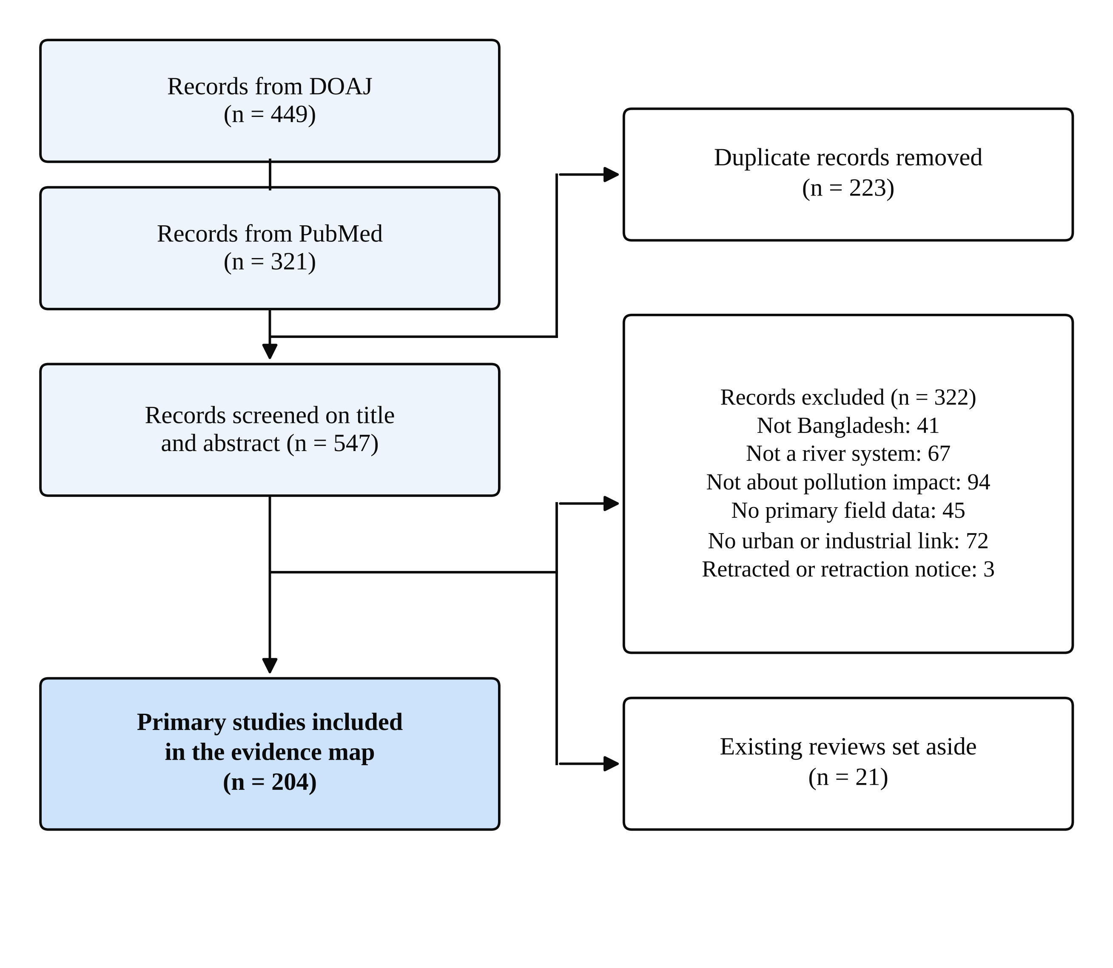
Figure 1. Flow of records through identification, screening and inclusion.
3.2 Growth of the Literature
The earliest study in the map dates from 2001, and only 14 studies were published before 2015 (e.g., Begum et al., 2013; Islam et al., 2014; Nawaz et al., 2014; Rahman et al., 2012; Siddique & Aktar, 2012; see Appendix Table A1). Output then rose steeply. A total of 169 studies (83%) appeared from 2020 onwards, and more than half of all studies (117 of 204) were published in 2023 or later (Figure 2). This is a young literature: most of what is known has been reported in the last six years.
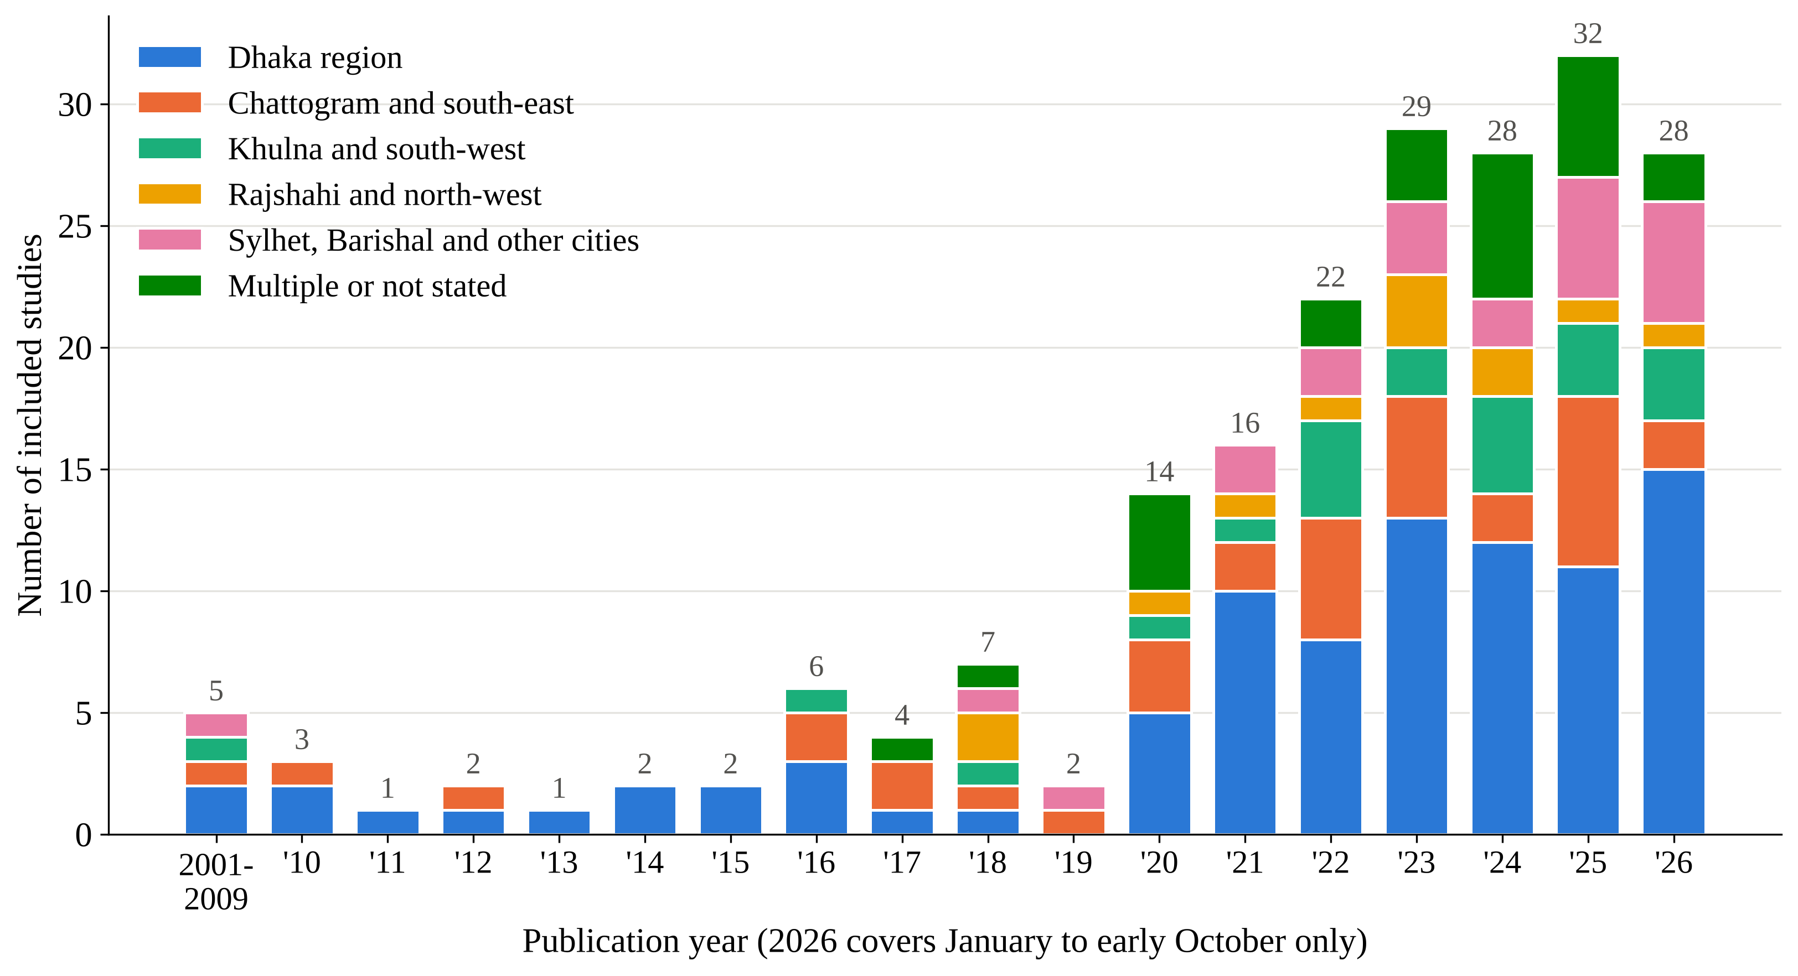
Figure 2. Included studies by publication year and region. The count for 2026 covers January to early October only.
3.3 Where the Research Has Been Done
Research is concentrated on the capital. Rivers of the Dhaka region account for 90 of the 204 studies (44%) (Figure 3). Chattogram and the south-east follow with 35 studies (17%), and Khulna and the south-west with 21 (10%). These three urban-industrial centres together hold 72% of the evidence; representative studies are cited here (e.g., Bhuiyan et al., 2026; Faruk et al., 2026; Haque et al., 2026; Salsabil et al., 2026; Sultana et al., 2026b; see Appendix Table A1).
The other regions of the country are less extensively studied. Rajshahi and the north-west have 12 studies (6%) (e.g., Haque et al., 2024; Hossain et al., 2023; Islam et al., 2025a; Mona et al., 2026; Mortuza, 2024; see Appendix Table A1). Sylhet has 8, nearly all on the Surma River (e.g., Anam et al., 2025; Hossain et al., 2026a; Izlal et al., 2024; Jahan et al., 2024; Rahman et al., 2025; see Appendix Table A1). Barishal and the south have 5 (e.g., Mitu et al., 2026; Oyshi et al., 2026; see Appendix Table A1), and Mymensingh, Tangail and Cumilla together have 9 (e.g., Rahman et al., 2026; Siddiqa et al., 2025; see Appendix Table A1). Four studies compared several regions, and for 20 the abstract did not name the place where samples were taken (e.g., Ahmed et al., 2026; Haque et al., 2025; Mojumder et al., 2026; Parvez et al., 2025; Siddique et al., 2025; see Appendix Table A1).
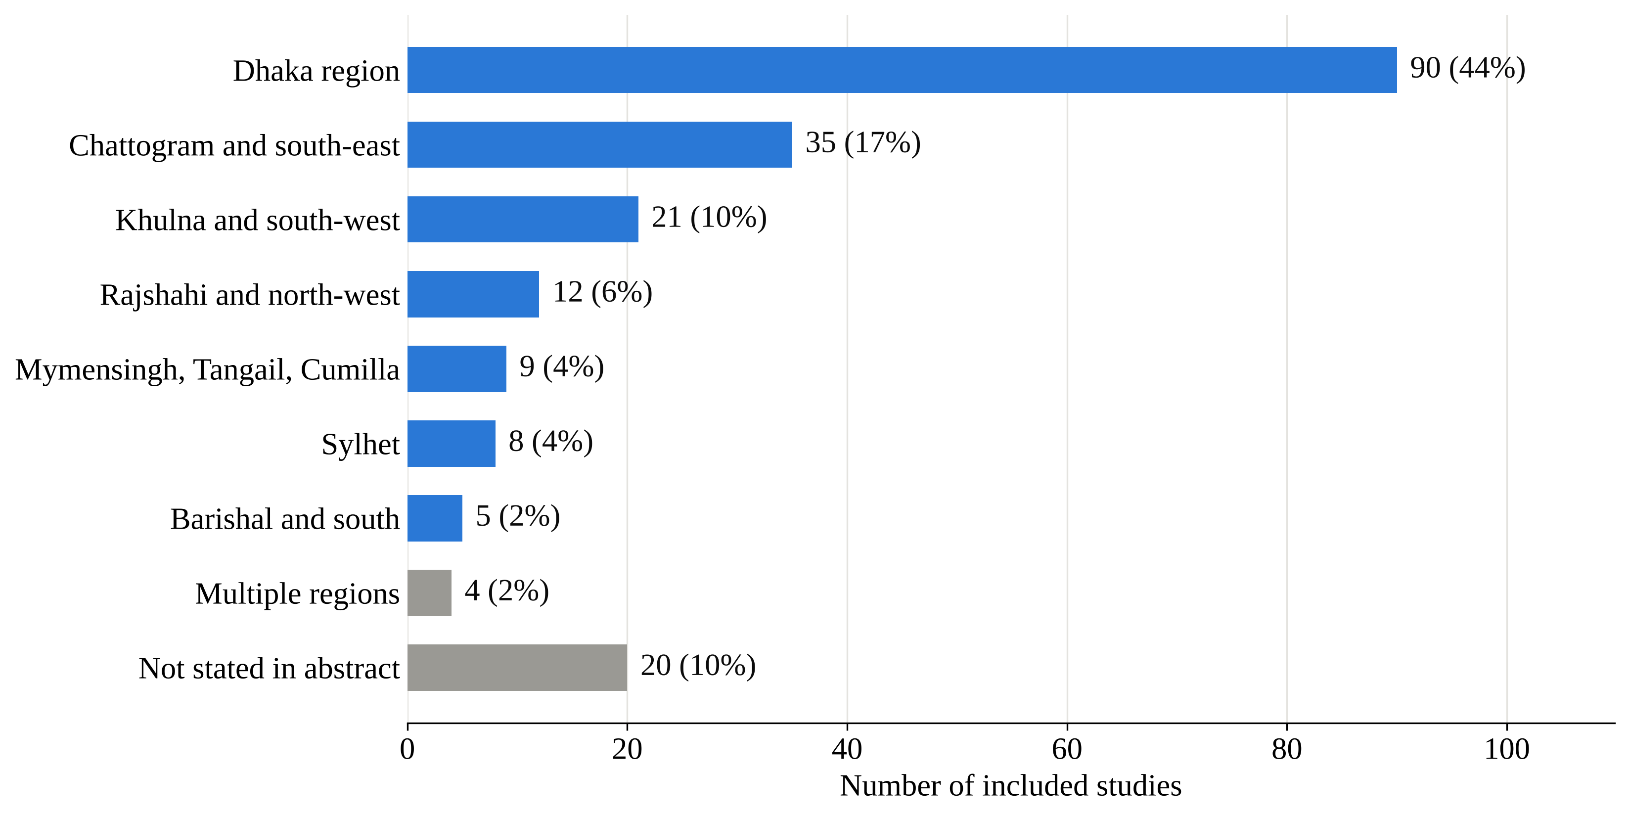
Figure 3. Number and share of included studies by region.
The same concentration appears when studies are counted by river (Table 4). The Buriganga is named in 42 studies, more than any other river, and five rivers around Dhaka (the Buriganga, Turag, Dhaleshwari, Shitalakshya and Balu) are named in 84 studies, or 41% of the map. Outside Dhaka only the Karnaphuli is named in more than twenty.
Table 4. Rivers named most often in the title or abstract of included studies.
River | City or region | Studies
Buriganga | Dhaka | 42
Turag | Dhaka, Gazipur | 25
Karnaphuli | Chattogram | 23
Dhaleshwari | Dhaka (Savar) | 19
Shitalakshya | Dhaka, Narayanganj | 16
Balu | Dhaka | 10
Halda | Chattogram | 10
Rupsha | Khulna | 10
Pasur | Khulna region (Mongla) | 9
Surma | Sylhet | 7
Bhairab | Khulna | 6
Karatoya | North-west | 4
Barnoi | Rajshahi | 3
A study that names several rivers is counted under each.
The growth of the literature has not altered this balance. The Dhaka region supplied 16 of 35 studies up to 2019 (46%), 23 of 52 in 2020 to 2022 (44%) and 51 of 117 in 2023 to 2026 (44%). The number of studies has more than tripled, but the share of the capital has stayed almost exactly the same.
3.4 What Has Been Sampled
The evidence becomes thinner at each step along the path that pollutants follow (Figure 4). Water was sampled in 143 studies (70%) and sediment in 64 (31%). Fish were examined in 40 (20%), typically to measure the metals or microplastics in their tissue. Only 13 studies (6%) examined other aquatic life (e.g., Hossain et al., 2026a; see Appendix Table A1), 10 (5%) examined soil, crops or riverside plants (e.g., Sultana et al., 2026a; see Appendix Table A1), and 4 (2%) collected information from people (e.g., Sheikh et al., 2026; see Appendix Table A1).
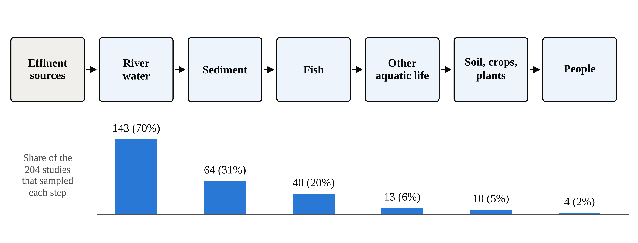
Figure 4. Number and share of included studies that sampled each step of the pathway from effluent to people. A study can appear at more than one step.
Most studies examined only one compartment: 148 (73%) sampled a single compartment, 43 sampled two, and 13 (6%) sampled three or more. Studies that follow a pollutant from water through sediment into living organisms at the same sites are therefore unusual.
The thinning differs between regions (Figure 5a, Table 5). In the Dhaka region, 9 studies examined soil, crops or plants and 3 collected information from people. Outside Dhaka, the only soil study came from Khulna, and the only study of people came from the southern coastal region (Sheikh et al., 2026). No included study from Chattogram, the north-west, Sylhet or the other cities examined soil or crops, and none from Chattogram, Khulna or the north-west collected information from people.
Table 5. Included studies by region and by compartment sampled.
Region | Studies | Water | Sediment | Fish | Other aquatic life | Soil, crops, plants | People
Dhaka region | 90 (44%) | 65 | 21 | 16 | 3 | 9 | 3
Chattogram and south-east | 35 (17%) | 23 | 15 | 4 | 4 | 0 | 0
Khulna and south-west | 21 (10%) | 14 | 11 | 7 | 0 | 1 | 0
Rajshahi and north-west | 12 (6%) | 8 | 6 | 3 | 1 | 0 | 0
Sylhet | 8 (4%) | 6 | 3 | 2 | 3 | 0 | 0
Barishal and south | 5 (2%) | 4 | 0 | 1 | 0 | 0 | 1
Mymensingh, Tangail, Cumilla | 9 (4%) | 6 | 2 | 4 | 0 | 0 | 0
Multiple regions | 4 (2%) | 1 | 2 | 2 | 0 | 0 | 0
Not stated in abstract | 20 (10%) | 16 | 4 | 1 | 2 | 0 | 0
All regions | 204 (100%) | 143 | 64 | 40 | 13 | 10 | 4
A study can be counted under more than one compartment.
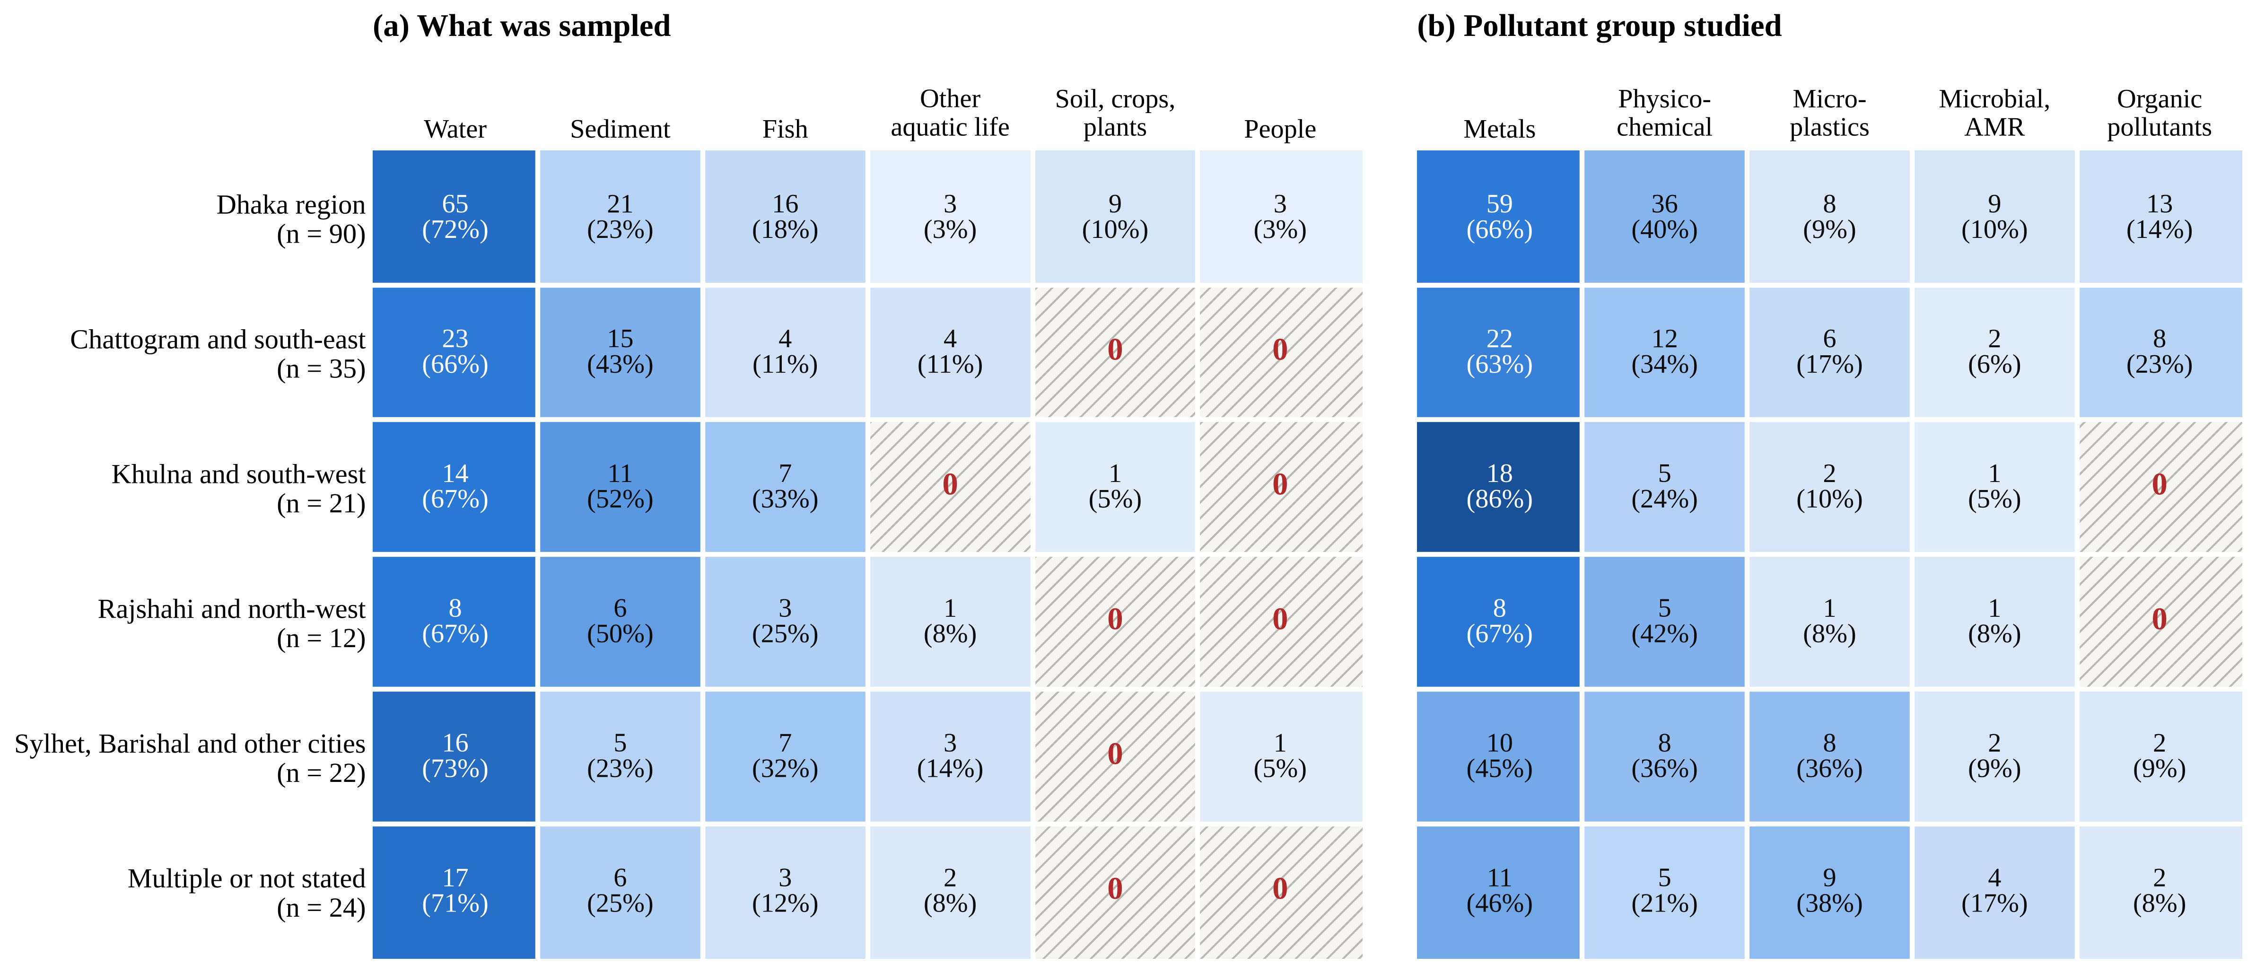
Figure 5. Evidence grid by region: (a) compartment sampled and (b) pollutant group studied. Each cell shows the number of studies and their share of the studies in that region. Hatched cells mark combinations for which no study was found.
3.5 Which Pollutants Have Been Studied
Metals and metalloids are the predominant subject of the literature. They are reported in 128 studies (63%), usually together with pollution indices and calculated health-risk values. Physico-chemical and organic-load measures appear in 71 studies (35%). Microbial contamination and antimicrobial resistance are addressed in 19 studies (9%) (e.g., Bhuiyan et al., 2026; Haque et al., 2026; see Appendix Table A1), and organic micropollutants in 25 (12%) (e.g., Hossain et al., 2026b; Tasneem et al., 2026; see Appendix Table A1). The last group is varied: it includes pesticides, polycyclic aromatic hydrocarbons, polychlorinated biphenyls, pharmaceuticals, antibiotics, bisphenols and per- and polyfluoroalkyl substances.
The fastest change is in microplastics (Figure 6). No included study of microplastics was published before 2020; there were 3 in 2020 to 2022 and 31 in 2023 to 2026, when they made up 26% of all studies (e.g., Faruk et al., 2026; Hossain et al., 2026a; Mojumder et al., 2026; Oyshi et al., 2026; Salsabil et al., 2026; see Appendix Table A1). Metals remained the largest group in every period, reported in 71%, 69% and 57% of studies in the three periods.
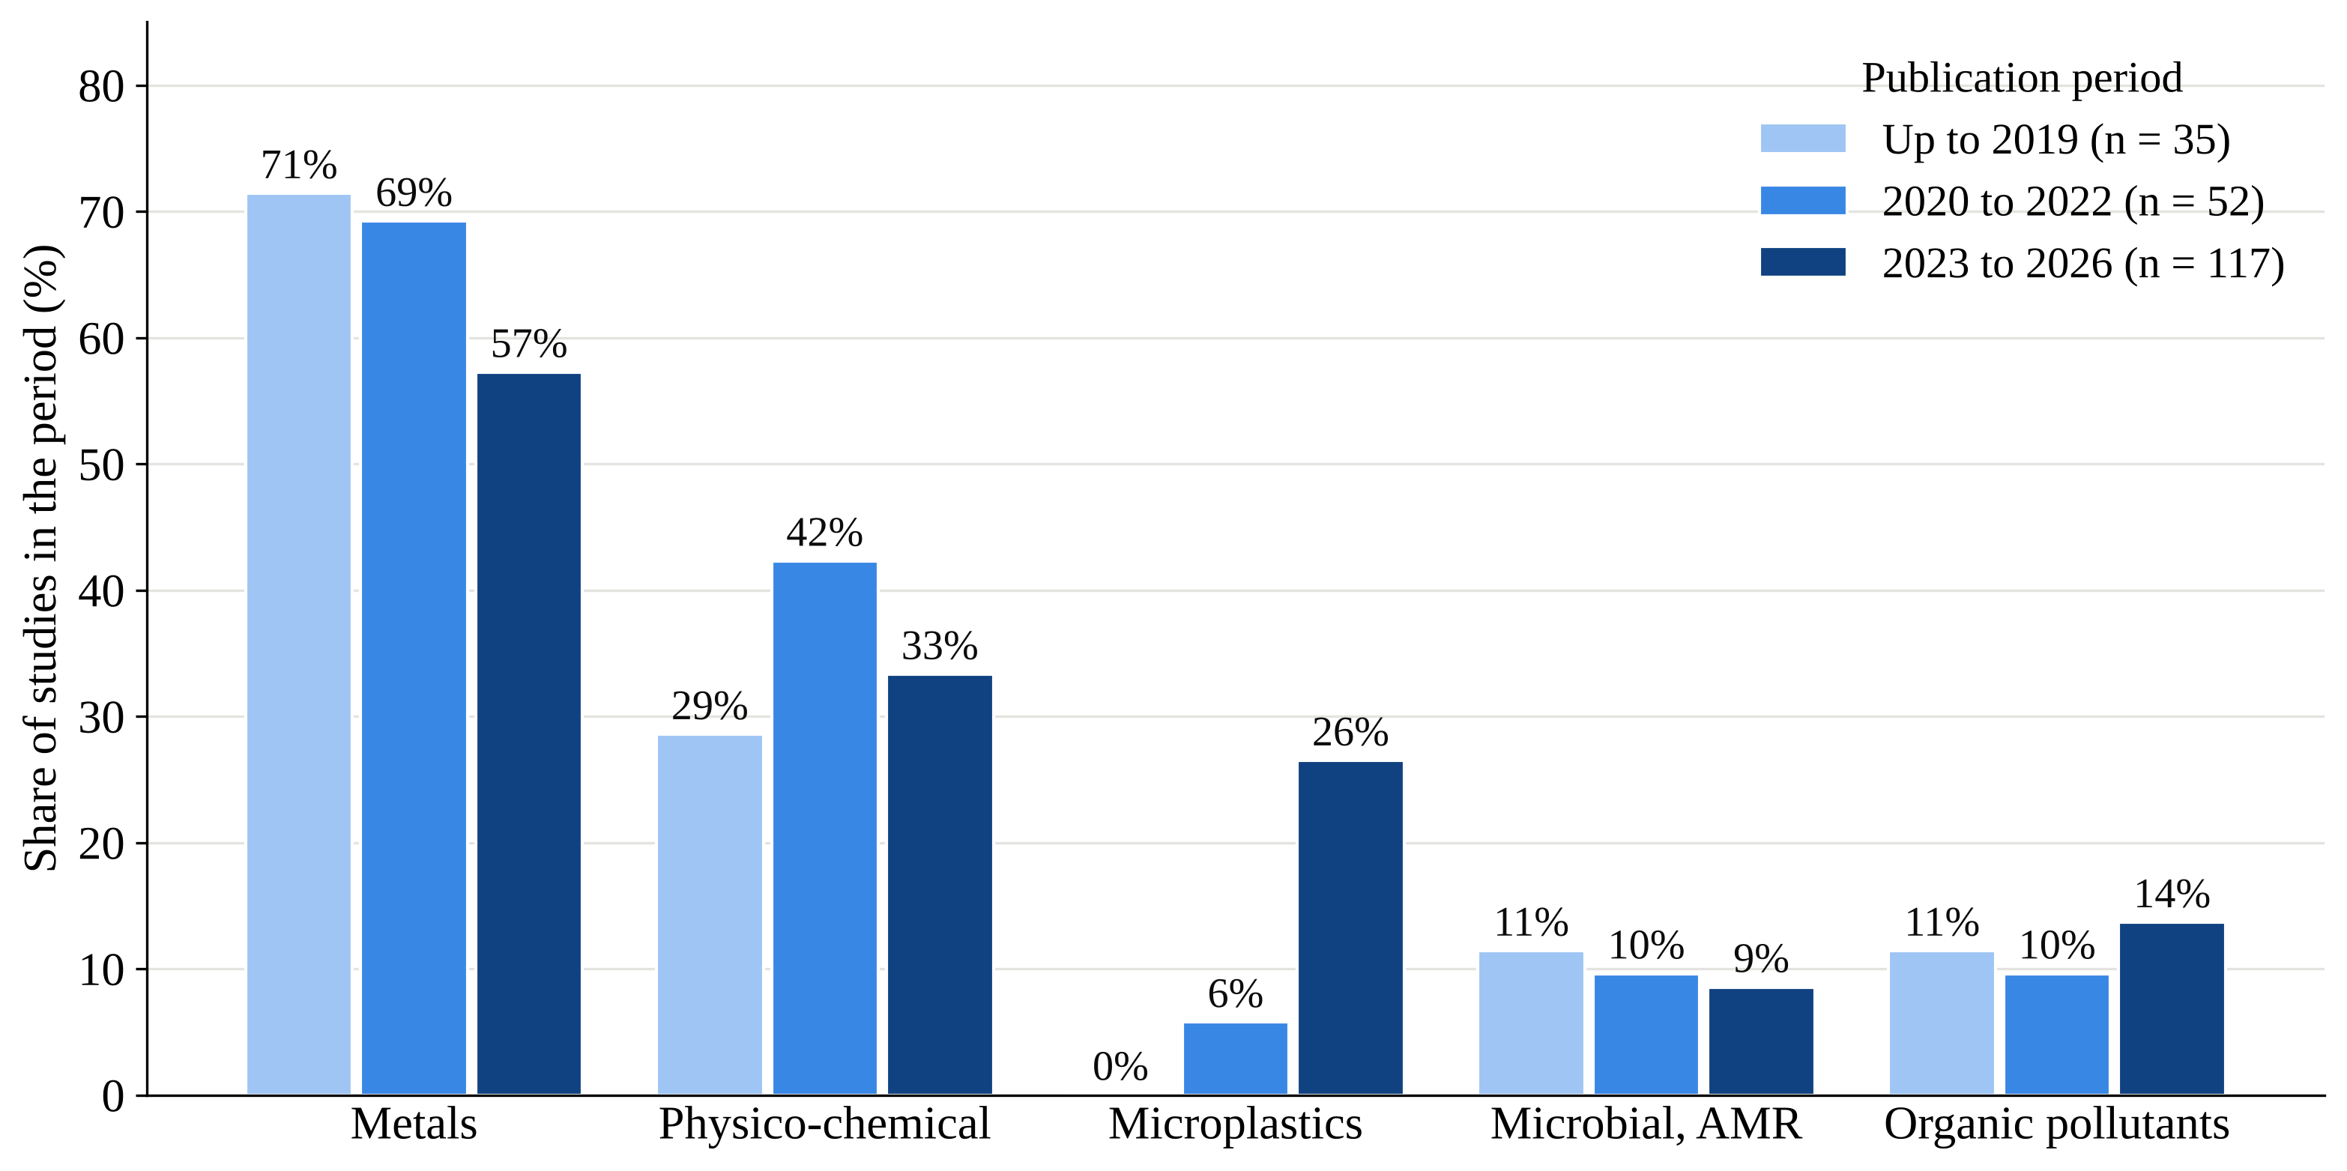
Figure 6. Share of included studies that examined each pollutant group in three periods. A study can be counted in more than one group.
New topics have followed the old geography. About half of the studies of organic micropollutants and of microbial contamination come from the Dhaka region, and no included study from Khulna or the north-west measured organic micropollutants (Figure 5b). Microplastics are the partial exception: the Surma and the Karnaphuli have each been studied several times.
Abstracts name industrial sources far more often than household ones: 103 studies refer to industry and 42 to municipal or domestic wastewater. Tanneries alone are named in 24 studies, of which 23 are from the Dhaka region (e.g., Aurnab et al., 2024; Hasan et al., 2021; Khan et al., 2026; Mohinuzzaman et al., 2025; Pervez et al., 2026; see Appendix Table A1). One survey of outfalls around Dhaka attributed about 60% of the waste load to industrial sources and about 30% to municipal sources (Majed & Islam, 2022). Studies of rivers whose main burden is household wastewater are rare.
3.6 What the Studies Report, Region by Region
A map does not weigh results, but a brief account of the studies’ findings helps to show the character of the evidence in each region.
Dhaka region. The earliest study in the map, published in 2001, already linked severe surface-water pollution in Dhaka to unplanned urban and industrial growth and to inadequate sewerage and treatment (Karn & Harada, 2001). Later studies have repeatedly classified the water of the rivers around the city as poor or unfit for use, and one long-term analysis found that water quality fell while built-up land around a peripheral river increased by 288% in thirty years (Miah et al., 2025). The tannery cluster has been followed closely: studies describe chromium-rich sediment near the outfall (Khan et al., 2026), the need to improve the central effluent treatment plant (Hasan et al., 2020) and the redistribution of toxic elements after the tanneries were moved from the city to Savar (Kurniasari et al., 2022). Recent studies extend the record to antibiotics at concentrations above resistance thresholds in the Buriganga (Salma et al., 2025), polychlorinated biphenyls in Turag sediment (Chowdhury et al., 2022), drug-resistant bacteria near pollution sources (Sharif et al., 2024) and microplastics in riverbed sediment (Islam et al., 2023b).
Chattogram and the south-east. Work here centres on the Karnaphuli, which passes the port city and its industrial zones, and on the Halda, the country's main natural breeding ground for carp. A sediment-core study concluded that human inputs of metals to the Karnaphuli estuary have risen since about 2000 with the growth of the city (Wang et al., 2016). Studies of the Halda report raised metal levels in sediment during the monsoon and in water afterwards (Bhuyan & Bakar, 2017) and a greater calculated risk for children who eat its fish and shellfish (Ahmed et al., 2020). Newer contaminants are beginning to be measured, including rare earth elements (Farjana et al., 2025), microplastics (Fatema et al., 2023) and, in the Bakkhali River, per- and polyfluoroalkyl substances (Choudhury et al., 2026).
Khulna and the south-west. Studies of the Rupsha, Bhairab, Mayur and Pasur are dominated by metals in water, sediment and fish. Source-apportionment work attributes a large share of the risk in sediment to industrial emissions (Proshad et al., 2022b), and water-quality variation in an urban river has been related to urban and industrial effluent and to farm runoff (Shammi et al., 2023). One study examined microbial contamination of surface water used by farmers at the edge of the city and recommended treatment of wastewater before disposal and protection for the farmers (Haldar et al., 2022).
Other regions. In Sylhet, the Surma has become a focus of microplastic research (Izlal et al., 2024; Jahan et al., 2024; Rahman et al., 2025), and an earlier study recorded ammonia above the national effluent standard in fertiliser-factory wastewater entering the Kushiyara (Alam & Hossain, 2009). In Barishal, metals in fish from the Kirtankhola were attributed to human sources (Ali et al., 2022), while basic water-quality measures affected by vessel waste stayed within limits (Mitu et al., 2026). In Mymensingh, pharmaceuticals were detected in river water at levels of low to medium ecological risk (Hossain et al., 2018), metals in fish from the Old Brahmaputra carried a calculated cancer risk from arsenic (Shorna et al., 2021), and genetically identical drug-resistant bacteria were recovered from hospital effluent and from the river downstream (Rahman et al., 2026). The north-west is described in Section 3.8.
3.7 Evidence on Biological and Human Effects
It is one thing to show that a pollutant is present in a fish and another to show that pollution has changed the life of a river. Evidence of the second kind is limited. A before-and-after comparison on the Barnoi documented a fall in the number and variety of fish downstream of a municipal discharge (Galib et al., 2018). Studies on the Turag and the Karatoya related the composition of phytoplankton to water quality and nutrient enrichment (Haque et al., 2021; Khatun & Alam, 2020). Tissue damage in the liver and kidney of fish was reported from the Surma (Karim et al., 2022; Zaman et al., 2023), altered immune and enzyme responses in tilapia from the Buriganga (Hossain et al., 2021), impaired growth and reproduction of a snakehead in metal-contaminated rivers (Parvez et al., 2025), and biomarker responses in fish caged below a paper mill on the Karnaphuli (Al-Arabi et al., 2005). The uptake of pollutants has also been examined in clams, mussels, crabs, aquatic insects and tubificid worms (Anam et al., 2025; Haque et al., 2025; Hossain et al., 2024; Hossain et al., 2026a).
Evidence beyond the river channel is thinner still. A small group of studies, mostly conducted near the tannery and industrial areas of Dhaka and Gazipur, measured metals in riverside soil, plants and food (e.g., Chowdhury et al., 2026; Islam et al., 2026a; Mondol et al., 2026; Roy et al., 2026; Sultana et al., 2026a; see Appendix Table A1). One of these estimated the weekly intake of metals from food grown or sold beside the Buriganga and found it below the provisional tolerable limits (Islam et al., 2014). Farmers on the bank of the Turag reported that industrial effluent had harmed their soil, water and rice harvest (Afrad et al., 2020). An early economic study valued the benefits of cleaning up the Buriganga at 18.6 million US dollars a year (Alam & Marinova, 2003), and a recent study linked waste dumping in a coastal canal to poor water quality and to health hazards for the local community (Sheikh et al., 2026). No included study measured health outcomes in a riverside population.
3.8 The Rajshahi Case
Of the 12 studies from the north-west, three concern the Barnoi River, two the Padma at Rajshahi, one the sediments of the Ganges in the north-west, three the Karatoya, and one each the Ichamati, the Punarbhaba and the Teesta (e.g., Haque et al., 2024; Hossain et al., 2023; Islam et al., 2025a; Mona et al., 2026; Mortuza, 2024; see Appendix Table A1). The Karatoya studies report phytoplankton groups shaped by nutrient enrichment, sediment with a high pollution load of which about 30% was attributed to industry, and metal levels in water that improved during the COVID-19 lockdown (Haque et al., 2021; Jawad-Ul-Haque et al., 2023; Proshad et al., 2022a). For comparison, the Buriganga alone is named in 42 studies, about 14 times as many as the Barnoi.
Rajshahi has no sewerage system. Surface drains carry untreated wastewater to canals and wetlands north of the city (Clemett et al., n.d.), and two canals built by the city corporation have discharged this wastewater to the Barnoi since December 2008 (Galib et al., 2018). The three Barnoi studies each address a different link in the chain. The first compared fish at six sites in 2006 and in 2016 and found that, downstream of the discharge, abundance had fallen by more than 47% and the number of species by more than 35%, with lower dissolved oxygen, pH and water clarity (Galib et al., 2018). The second monitored the water for a year, from July 2019 to June 2020, and found that chromium, arsenic, lead and cadmium exceeded recommended values although the general physico-chemical measures did not (Haque et al., 2024). The third counted microplastics in river water and in the gut of three fish species at five sites (Mona et al., 2026). On the Padma beside the city, one study reported physico-chemical and bacteriological water quality (Haque et al., 2018), and another reported metals in water, sediment and fish at levels below international limits (Mortuza, 2024).
The supplementary search identified three additional studies of the city itself. Irrigation water at 20 sites exceeded the limit of the Food and Agriculture Organization for manganese in 80% of samples and for cadmium in 55% (Shahriar et al., 2023). Wastewater from open drains at 12 locations contained zinc, manganese, lead, chromium, copper and cadmium, in that order of abundance (Shahriar et al., 2025). An older survey found raised biochemical and chemical oxygen demand in the Padma beside the city (Rasul & Jahan, 2010). None of these studies measures how much of what is in the drains reaches the Barnoi.
Table 6 sets this evidence against the steps of the pathway. For the Barnoi and the land irrigated with its water, we found no study of sediment, of plankton or bottom-dwelling invertebrates, of riverbank soil, of the uptake of metals by crops, or of the health and livelihoods of riverside communities. When hundreds of fish died in the river in September 2026, residents and officials suggested causes that ranged from the retting of jute to discharges from the city and from industry (Dhaka Tribune, 2026). There was no published monitoring record against which any of these explanations could be tested.
Table 6. Evidence found for the Barnoi River and for the effluent of Rajshahi city, by step of the pathway.
Step of the pathway | Evidence found | What is missing
Effluent sources | Metals in drain wastewater and in irrigation water within the city; a background report on drainage | An estimate of the effluent load that reaches the river; a link between drain and river measurements
River water | One year of physico-chemical and metal data (2019 to 2020); basic measures in the fish study | A profile of organic load and nutrients above and below the discharge points; records covering several years
Sediment | None found | Any study
Fish | A fall in abundance and number of species between 2006 and 2016; microplastics in the gut of three species | Metals in fish tissue
Other aquatic life | None found | Plankton and bottom-dwelling invertebrates; any biological index of river condition
Riverbank soil and crops | Irrigation water quality within the city only | Soil quality; uptake of metals by crops
People | Health-risk values calculated from water data; a news report of skin irritation | A survey of health, water use or livelihoods
"None found" refers to the database and supplementary searches described in Sections 2.2 and 2.8.
3.9 Reporting Completeness of the Included Studies
Abstracts were available for 189 of the 204 studies; the remaining 15 could not be assessed, so all percentages in this section are of the 189 appraised studies (Figure 7). Most studies compared their results with a guideline, background value or pollution index (D5, 88%) and about seven in ten used statistical or source analysis (D6, 70%). Basic sampling design was reported much less often: the number of samples was stated in only 14% of abstracts, the sampling sites in 43% and the sampling time or season in 44%. Overall, 56 studies (30%) showed high reporting completeness, 94 (50%) moderate and 39 (21%) low. Together with the 15 studies that could not be assessed, these account for all 204 included studies.
Reporting has improved over time. Of the appraised studies published up to 2019, 55% showed low completeness, against 13% of those published from 2023 onwards. Although few in number, studies from Rajshahi and the north-west were reported as fully as those from other regions: none of the 10 that could be assessed showed low completeness. In practice, these ratings mean that most published values can be placed on a river but not always in a season, and that the precision of individual estimates often cannot be judged from the abstract alone.
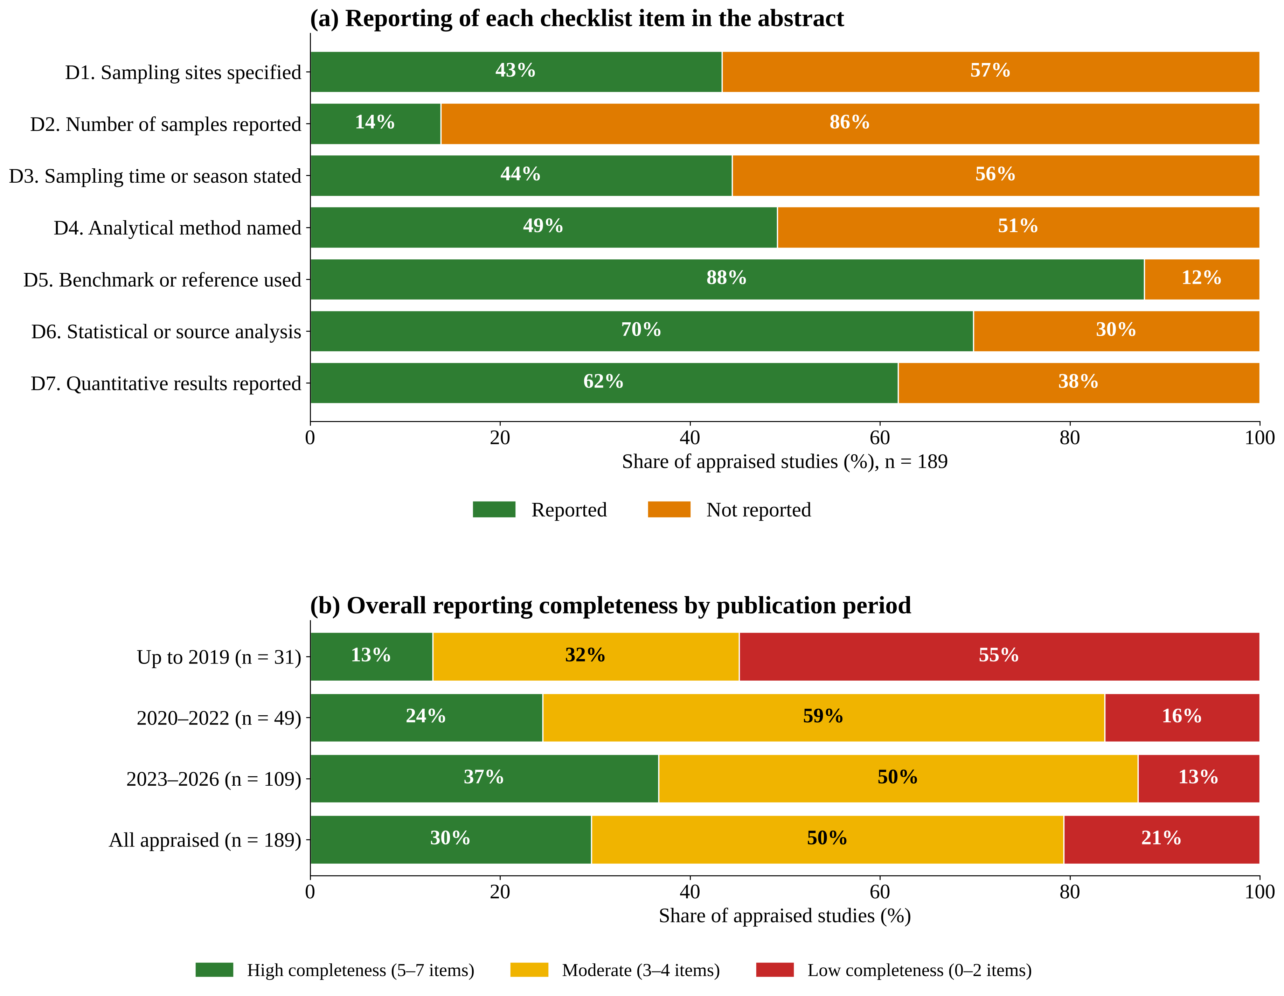
Figure 7. Reporting completeness of the included studies, judged from titles and abstracts (n = 189 appraised studies; 15 studies without an abstract are not shown): (a) share of studies whose abstract reported each checklist item; (b) overall rating by publication period. High completeness: five or more items reported; moderate: three or four; low: two or fewer. Percentages may not add to 100 because of rounding.
4. DISCUSSION
4.1 Main Findings
Three findings stand out. First, research on effluent-affected rivers in Bangladesh is concentrated in space: 44% of studies concern the Dhaka region, and 72% concern Dhaka, Chattogram and Khulna. Second, it is concentrated in what it measures: seven studies in ten sampled water and about a third sampled sediment, but one in twenty examined soil or crops and one in fifty collected information from people. Third, the two patterns reinforce each other. The compartments that are rarely studied anywhere are almost never studied outside the capital, so that for a secondary city such as Rajshahi the ecological, agricultural and human consequences of effluent are close to undocumented.
4.2 A Literature Centred on the Capital
The predominance of studies from Dhaka is understandable. A likely reason is that its rivers are the most visibly degraded in the country and lie closest to the institutions that carry out most of this research; a river near the laboratory is far easier to sample repeatedly than a distant one. Yet the tripling of research output since 2020 has not spread the effort more widely. The share of the Dhaka region was 46% before 2020 and 44% in 2023 to 2026.
The consequence is that the national picture of effluent impact is largely a picture of industrial rivers. Tannery and textile discharges, which dominate the Dhaka literature, are not the main source in a city such as Rajshahi, where the effluent is household wastewater carried by open drains (Clemett et al., n.d.; Galib et al., 2018). In rivers of that kind, organic load, nutrients, disease-causing organisms and loss of oxygen may matter more than the metal indices on which most studies concentrate. The Barnoi fish study suggests that municipal wastewater alone can cause severe ecological change (Galib et al., 2018). A monitoring programme or a regulation designed from the Dhaka evidence may therefore measure the wrong things in much of the country.
4.3 Evidence Thins Where Consequences Begin
The second pattern concerns what is measured. Water and sediment are the easiest compartments to sample and analyse, and the literature reflects this. Risk to health is almost always inferred, by applying standard formulas to measured concentrations, and almost never observed in people. The same is true of ecological effect. Fish are analysed as carriers of pollutants far more often than fish communities, plankton or bottom-dwelling invertebrates are analysed as indicators of the condition of a river. Standard tools of biological assessment therefore remain largely untested in these rivers.
This matters because the questions that communities and decision-makers ask lie at the far end of the pathway. Is the fish safe to eat? Are the rice and vegetables grown with this water safe? Why have the fish gone? Are people who bathe and work in the river becoming ill? Calculated risk values give a first indication, but they rest on assumptions about how much water people drink and how much fish they eat, and they cannot replace direct evidence. For the north-west the two gaps coincide: 8 studies sampled water, 6 sediment, 3 fish and 1 other aquatic life, and none examined soil, crops or people.
4.4 New Pollutants, Old Geography
The rapid increase in microplastic research shows that the field can respond quickly to a new concern: from no studies before 2020 to 34 by late 2026. It also shows how new topics tend to be pursued. Microplastics, antibiotics, resistant bacteria and industrial chemicals have mostly been measured in the rivers that were already the best studied. This is reasonable for a first survey, since heavily polluted rivers are where a new contaminant is most likely to be found. But it means that each new topic adds another layer to the knowledge of a few rivers, while the basic description of many others has not begun.
4.5 How This Map Relates to Existing Reviews
The search identified 21 published reviews (e.g., Afroze et al., 2026; Chakraborty et al., 2026; Das et al., 2025; Hasi et al., 2025; Islam, 2026; see Appendix Table A1). Judged from their titles and abstracts, they fall into three groups: reviews of metals in water, sediment, fish and food (e.g., Hasi et al., 2025; see Appendix Table A1); reviews of plastics and microplastics (e.g., Chakraborty et al., 2026; see Appendix Table A1); and general accounts of river pollution, water quality and water security (e.g., Islam, 2026; see Appendix Table A1). Their purpose is to summarise how much contamination has been reported and what risk it carries. The present map asks a different question and so complements them: it measures how the underlying studies are distributed, by region and by compartment, on a defined set of records that others can check and extend.
4.6 Strengths and Limitations
The main strength of the map is that it is transparent and repeatable. The search strings, the decision for every record and the codes for every included study are published with the paper, so that any reader can check a decision or update the map. The limitations are as follows.
Coverage. Only DOAJ and PubMed were searched. Studies indexed only in Scopus or Web of Science, and studies in local journals covered by neither database, are missing. The counts therefore represent minimum values. We see no clear reason why the missing studies would favour one region, but studies in local journals may be more likely to concern local rivers, so the share of secondary cities could be somewhat higher than reported here.
Depth. Screening, coding and the appraisal of reporting completeness were based on titles and abstracts, and excluded records were checked on a random sample rather than in full. Approximately two-thirds of the exclusions therefore rest on the AI-proposed decision and the stated criteria, without an individual check by an author. A study may have sampled a compartment that its abstract does not mention, and for 20 studies the region could not be determined. Pollutant groups and sources were coded with keyword rules, which are transparent but approximate.
Scope. The map counts studies and does not combine their results. Its appraisal rests on abstracts, so it measures the completeness of reporting rather than the risk of bias or the quality of the field and laboratory work itself. A region with few studies is not necessarily less polluted, and a river with many studies is not necessarily well understood. Statements that no study was found refer to these searches only. Theses and reports held in university libraries, where work on local rivers is often to be found, were not searched. Finally, no protocol was registered in advance (Section 2.1).
4.7 What Should Be Done Next
The gaps point to practical priorities for researchers, the agencies that fund them and the city and environmental authorities that need the results. Table 7 lists six. None requires advanced equipment; several can be done with the methods already in routine use in the country's universities, applied in new places and joined together at the same sites. For the Barnoi all six are open, and the fish kill of 2026 shows the cost of having no monitoring record when something goes wrong.
Table 7. Research priorities for rivers that receive the effluent of secondary cities.
Priority | What it involves | Why it matters
1. Baseline studies across compartments | Sample water, sediment and living organisms together, above and below discharge points, in more than one season | Shows how far pollution travels along the pathway; most existing studies cover one compartment
2. Biological assessment | Survey plankton, bottom-dwelling invertebrates and fish communities, and apply standard biological indices | Measures the condition of the river itself, not only the presence of pollutants
3. Soil and crops | Measure pollutants in riverbank soil and in crops irrigated with river or drain water | Wastewater is used for irrigation around Rajshahi (Clemett et al., n.d.; Shahriar et al., 2023), yet no crop study was found outside Dhaka
4. People | Survey health, water use and livelihoods in riverside communities | Replaces calculated risk with observed evidence
5. Effluent load | Measure the volume and composition of what the drains deliver to the river | Connects the source to the effect and shows where treatment would help most
6. Repeated measurement | Return to the same sites over years, or compare before and after a change | Allows change to be attributed to effluent, as the Barnoi fish study did (Galib et al., 2018)

5. CONCLUSIONS
Research on effluent-affected rivers in Bangladesh has grown quickly, but it is narrow in two ways. It is narrow in place: the Dhaka region accounts for 44% of the 204 studies we mapped, and Dhaka, Chattogram and Khulna together for 72%. It is narrow in subject: the chemistry of water and sediment, above all for metals, is well described, while aquatic communities, riverbank soil, crops and people are not. Outside the capital, these later steps of the pathway are almost unstudied. These patterns describe the records found by two database searches, and the counts should be read as minimum values.
The Barnoi River at Rajshahi, with three studies and no information on its sediment, its smaller aquatic life, its riverbank soil and crops or its riverside communities, is typical of the rivers that receive the wastewater of secondary cities. For such rivers, the most useful next step is not another index of metal pollution but a baseline study that follows effluent from the drain to the community. Research of that kind, in a handful of secondary cities, would fill the largest gaps that this map has identified.
SUPPLEMENTARY MATERIAL
Supplementary Table S1 (Excel workbook) gives the search log, the screening decision for every record, the codes and reporting-completeness ratings for every included study, and the list of published reviews.

Declaration of AI Use
The authors designed the study, set the search, eligibility, coding and appraisal criteria, checked the screening and coding decisions, and interpreted the results. Claude Opus 5.5 (Anthropic) was used as a supporting tool to apply these predefined criteria to titles and abstracts (Sections 2.4 to 2.6) and to assist with drafting and language editing under the authors' direction. Grammarly was used for grammar checking. All AI outputs were reviewed by the authors, who accept full responsibility for the accuracy, integrity and final content of the manuscript.

COMPETING INTERESTS
Authors have declared that no competing interests exist.
CONSENT
Not applicable.
ETHICAL APPROVAL
Not applicable. This study used only published literature.
REFERENCES
Afrad, M. S. I., Monir, M. B., Haque, M. E., Barau, A. A., & Haque, M. M. (2020). Impact of industrial effluent on water, soil and Rice production in Bangladesh: a case of Turag River Bank. Journal of Environmental Health Science & Engineering, 18(2), 825–834. https://doi.org/10.1007/s40201-020-00506-8
Afroze, C. A., Ahmed, M. N., Azam, M. N. K., Jahan, R., & Rahman, H. (2026). Microplastics pollution in Bangladesh: a decade of challenges, impacts, and pathways to sustainability. Integrated Environmental Assessment and Management, 22(1), 98–115. https://doi.org/10.1093/inteam/vjaf108
Ahmed, M. J., Haque, M. R., Ahsan, A., Siraj, S., Bhuiyan, M. H. R., Bhattacharjee, S. C., & Islam, S. (2010). Physicochemical assessment of surface and groundwater quality of the greater Chittagong region of Bangladesh. Pakistan Journal of Analytical & Environmental Chemistry, 11(2), 1–11. https://pjaec.pk/index.php/pjaec/article/view/410
Ahmed, A. S. S., Hossain, M. B., Semme, S. A., Babu, S. M. O. F., Hossain, K., & Moniruzzaman, M. (2020). Accumulation of trace elements in selected fish and shellfish species from the largest natural carp fish breeding basin in Asia: a probabilistic human health risk implication. Environmental Science and Pollution Research, 27(30), 37852–37865. https://doi.org/10.1007/s11356-020-09766-1
Ahmed, I., Monwar, M. M., Al Amran, M. I. U., Iqbal, M. M., Isha, I. S., Billah, M. M., Islam, M. R., Al Mamun, A., & Bhuiyan, M. K. A. (2025). Are industrial footprints driving potentially toxic element contamination in the Karnaphuli River Estuary? Journal of Trace Elements and Minerals, 12, Article 100220. https://doi.org/10.1016/j.jtemin.2025.100220
Ahmed, N. S., Hasan, M. M., Riya, K. K., Ahmed, F., Arai, T., Kamaruddin, N. A., & Hossain, M. B. (2026). Co-contamination and combined effects of microplastic and microbial load on water quality and public health risks in industrial and urban canals of coastal Bangladesh. Environmental Health Insights, 20, 11786302261461120. https://doi.org/10.1177/11786302261461120
Akram, W., Niyommaneerat, W., Phetrak, A., & Kittipongvises, S. (2024). A review on water security in Dhaka City, Bangladesh: Calling for ensuring sustainability. Applied Environmental Research, 46(2), Article 024. https://doi.org/10.35762/AER.2024024
Akter, S., Islam, M. S., Kabir, M. H., Hoque, M. M. M., Khatun, S., Ahammed, M. S., & Khan, M. B. (2026). Appraisal of water quality and heavy metal concentration from the urban Balu River in Dhaka City, Bangladesh. International Journal of Agricultural Research, Innovation and Technology, 15(2), 85–97. https://doi.org/10.3329/ijarit.v15i2.87890
Al-Arabi, S. A. M., Adolfsson-Erici, M., Waagbø, R., Ali, M. S., & Goksøyr, A. (2005). Contaminant accumulation and biomarker responses in caged fish exposed to effluents from anthropogenic sources in the Karnaphuly River, Bangladesh. Environmental Toxicology and Chemistry, 24(8), 1968–78. https://doi.org/10.1897/04-383r.1
Al-Emran, M., Sarker, A., Adib, S. S., Nayem, M. J., Sultana, T., Sadat, M. A., & Shahjahan, M. (2025). Microplastics pollution in aquatic ecosystems of Bangladesh: A critical review on research trends and future perspectives. Science of the Total Environment, 1002, Article 180620. https://doi.org/10.1016/j.scitotenv.2025.180620
Alam, R., & Hossain, M. D. (2009). Wastewater quality of natural gas fertilizer factory, Fenchuganj and water quality of Kushiara River at the down stream. Environmental Monitoring and Assessment, 154(1-4), 127–33. https://doi.org/10.1007/s10661-008-0383-6
Alam, M. K., & Marinova, D. (2003). Measuring the total value of a river cleanup. Water Science & Technology, 48(7), 149–156. https://doi.org/10.2166/wst.2003.0435
Alam, M. A., Sowrav, S. F. F., Rahman, M. S., Chowdhury, A. M. S., & Choudhury, T. R. (2025). Potential pollution sources of heavy metals and nutrient variability in water of Sandwip Island, Patenga Coast, and Karnaphuli River. Cleaner Water, 4, 100145. https://doi.org/10.1016/j.clwat.2025.100145
Ali, M. M., Ali, M. L., Rakib, M. R. J., Islam, M. S., Bhuyan, M. S., Senapathi, V., Chung, S. Y., Roy, P. D., Sekar, S., Islam, A. R. M. T., & Rahman, M. Z. (2022). Seasonal behavior and accumulation of some toxic metals in commercial fishes from Kirtankhola tidal river of Bangladesh: A health risk taxation. Chemosphere, 301, Article 134660. https://doi.org/10.1016/j.chemosphere.2022.134660
Anam, U., Chakraborty, A., Saifullah, M. K., Gupta, T., Reza, M. S., Khatun, M. A., Mim, F., Moniruzzaman, M., Munshi, M. K., Hossain, M. A., & Iqbal, M. M. (2025). Tubificid worms reveal hidden pollutants in tropical upstream freshwater ecosystem. Chemical Engineering Journal Advances, 24, Article 100928. https://doi.org/10.1016/j.ceja.2025.100928
Arias-Barreiro, C. R., Nishizaki, H., Okubo, K., Aoyama, I., & Mori, I. C. (2010). Ecotoxicological characterization of tannery wastewater in Dhaka, Bangladesh. Journal of Environmental Biology, 31(4), 471–475. https://pubmed.ncbi.nlm.nih.gov/21186722/
Aurnab, I. T., Uddin, M. J., & Kabir, A. (2024). Risk assessment of four toxic heavy metals in terrestrial and aquatic ecosystems around BSCIC tannery industrial estate of Savar, Dhaka, Bangladesh. Environmental Science and Pollution Research, 31(23), 34124–34143. https://doi.org/10.1007/s11356-024-33503-7
Baki, M. A., Bhouiyan, N. A., Islam, M. S., Alam, S. M. I., Shil, S., & Hossain, M. M. (2017). Present Status of Ganges River Dolphins Platanista gangetica gangetica (Roxburgh, 1801) in the Turag River, Dhaka, Bangladesh. International Journal of Zoology, 2017, 1–7. https://doi.org/10.1155/2017/8964821
Begum, A., Mustafa, A. I., Amin, M. N., Chowdhury, T. R., Quraishi, S. B., & Banu, N. (2013). Levels of heavy metals in tissues of shingi fish (Heteropneustes fossilis) from Buriganga River, Bangladesh. Environmental Monitoring and Assessment, 185(7), 5461–9. https://doi.org/10.1007/s10661-012-2959-4
Bhuiyan, M. A. H., Suruvi, N. I., Dampare, S. B., Islam, M. A., Quraishi, S. B., Ganyaglo, S., et al. (2011). Investigation of the possible sources of heavy metal contamination in lagoon and canal water in the tannery industrial area in Dhaka, Bangladesh. Environmental Monitoring and Assessment, 175(1-4), 633–49. https://doi.org/10.1007/s10661-010-1557-6
Bhuiyan, M. M. K., Roy, H., Saidur Rahman, K., Nath Roy, B., Bhuyan, M. A. A. K., Jahedi, M. R. M., et al. (2026). Development of a PCA-derived water quality index model for monitoring the urban river systems in Dhaka City, Bangladesh. City and Environment Interactions, 29, 100276. https://doi.org/10.1016/j.cacint.2025.100276
Bhuyan, M. S., & Bakar, M. A. (2017). Seasonal variation of heavy metals in water and sediments in the Halda River, Chittagong, Bangladesh. Environmental Science and Pollution Research, 24(35), 27587–27600. https://doi.org/10.1007/s11356-017-0204-y
Bhuyan, M. S., Bakar, M. A., Rashed-Un-Nabi, M., Senapathi, V., Chung, S. Y., & Islam, M. S. (2019). Monitoring and assessment of heavy metal contamination in surface water and sediment of the Old Brahmaputra River, Bangladesh. Applied Water Science, 9(5), 125. https://doi.org/10.1007/s13201-019-1004-y
Bilal, H., Li, X., Iqbal, M. S., Mu, Y., Tulcan, R. X. S., & Ghufran, M. A. (2023). Surface water quality, public health, and ecological risks in Bangladesh-a systematic review and meta-analysis over the last two decades. Environmental Science and Pollution Research, 30(40), 91710–91728. https://doi.org/10.1007/s11356-023-28879-x
Chakraborty, D., Asif, M. A. U., Faria, M., Aziz, M. A., & Pal, S. K. (2026). Microplastic pollution across Bangladesh: A review of current evidence and research gaps. Next Sustainability, 8, 100527. https://doi.org/10.1016/j.nxsust.2026.100527
Choudhury, T. R., Alam, M. A., Sowrav, S. F. F., Koly, F. A., & Chowdhury, A. M. S. (2026). Tracing the sources and environmental distribution of PFAS and heavy metals in the Bakkhali River and coastal zone of Cox's Bazar, Bangladesh. Journal of Contaminant Hydrology, 282, 105026. https://doi.org/10.1016/j.jconhyd.2026.105026
Chowdhury, G. W., Koldewey, H. J., Duncan, E., Napper, I. E., Niloy, M. N. H., Nelms, S. E., et al. (2021). Plastic pollution in aquatic systems in Bangladesh: A review of current knowledge. Science of the Total Environment, 761, 143285. https://doi.org/10.1016/j.scitotenv.2020.143285
Chowdhury, N. J., Shammi, M., Rahman, M. M., Akbor, M. A., & Uddin, M. K. (2022). Seasonal distributions and risk assessment of polychlorinated biphenyls (PCBs) in the surficial sediments from the Turag River, Dhaka, Bangladesh. Environmental Science and Pollution Research, 29(30), 45848–45859. https://doi.org/10.1007/s11356-022-19176-0
Chowdhury, J. H., Sarker, N. R., Hossain, M. J., Saha, B., Chakroborty, S., Alam, R., et al. (2026). Investigating the risk of heavy metal contamination in an industrial and a non-industrial zone in Gazipur district, Bangladesh. Discover Public Health, 23(1), 1140. https://doi.org/10.1186/s12982-026-02545-2
Clemett, A., Ara, S., Amin, M. M., & Akan, M. M. R. (n.d.). Summary assessment: Background information for Rajshahi City, Bangladesh. International Water Management Institute. https://waspa.iwmi.org/wp-content/uploads/sites/30/2018/11/rajshahi-summary-background-final.pdf
Das, R. K., Marma, M., Mizan, A., Chen, G., & Alam, M. S. (2025). Heavy Metals and Microplastics as Emerging Contaminants in Bangladesh's River Systems: Evidence from Urban-Industrial Corridors. Toxics, 13(9). https://doi.org/10.3390/toxics13090803
Dhaka Tribune. (2026, September 6). Mass fish deaths in Barnai River raise pollution concerns. Dhaka Tribune. https://www.dhakatribune.com/bangladesh/nation/419240/mass-fish-deaths-in-barnai-river-raise-pollution
Farjana, S. J., Sarker, B. S., Hossain, M. K., Riya, K. K., Rahman, M. A., Al Jubaer, A., et al. (2025). Rare earth elements in a highly industrialized South Asian estuary: Enrichment patterns, geochemical behaviors, contamination status and multi-index risk evaluation. Science of the Total Environment, 1002, 180628. https://doi.org/10.1016/j.scitotenv.2025.180628
Faruk, O., Rana, M. R. K., Fatema, B., Paul, J. C., & Islam, M. R. (2025). Insight into antibiotic and heavy metal resistance gene diversity in two ecologically important rivers of Bangladesh: a metagenomics analysis. Annals of Microbiology, 75(1), 25. https://doi.org/10.1186/s13213-025-01820-y
Faruk, M. O., Chowdhury, K. M. A., Albin, E. H. C., Capuano, T. A., Shreya, S. S., Lubna, L. S., et al. (2026). Anthropogenic influences on seasonal microplastic dispersion in the Pasur River of Bangladesh based on field observations and numerical simulation. Discover Environment, 4(1), 111. https://doi.org/10.1007/s44274-026-00632-4
Fatema, K., Rahman, T., Islam, M. J., Sumon, K. A., Uddin, M. H., Hasan, S. J., et al. (2023). Microplastics pollution in the river Karnaphuli: a preliminary study on a tidal confluence river in the southeast coast of Bangladesh. Environmental Science and Pollution Research, 30(13), 38853–38868. https://doi.org/10.1007/s11356-022-24998-z
Ferdous, S. R., Amin, A., Hasan, J., Alam, M. S., & Shahjahan, M. (2023). Prevalence of microplastics in commonly consumed fish species of the river Old Brahmaputra, Bangladesh. Environmental Science and Pollution Research, 30(36), 85639–85654. https://doi.org/10.1007/s11356-023-28514-9
Galib, S. M., Mohsin, A. B. M., Parvez, M. T., Lucas, M. C., Chaki, N., Arnob, S. S., Hossain, M. I., & Islam, M. N. (2018). Municipal wastewater can result in a dramatic decline in freshwater fishes: a lesson from a developing country. Knowledge & Management of Aquatic Ecosystems, 419, Article 37. https://doi.org/10.1051/kmae/2018025
Haddaway, N. R., Macura, B., Whaley, P., & Pullin, A. S. (2018). ROSES RepOrting standards for Systematic Evidence Syntheses: pro forma, flow-diagram and descriptive summary of the plan and conduct of environmental systematic reviews and systematic maps. Environmental Evidence, 7(1), 7. https://doi.org/10.1186/s13750-018-0121-7
Haldar, K., Kujawa-Roeleveld, K., Hofstra, N., Datta, D. K., & Rijnaarts, H. (2022). Microbial contamination in surface water and potential health risks for peri-urban farmers of the Bengal delta. International Journal of Hygiene and Environmental Health, 244, 114002. https://doi.org/10.1016/j.ijheh.2022.114002
Haque, M. A., Jewel, M. A. S., & Sultana, M. P. (2018). Assessment of physicochemical and bacteriological parameters in surface water of Padma River, Bangladesh. Applied Water Science, 9(1), 10. https://doi.org/10.1007/s13201-018-0885-5
Haque, M. A., Jewel, M. A. S., Akhi, M. M., Atique, U., Paul, A. K., Iqbal, S., et al. (2021). Seasonal dynamics of phytoplankton community and functional groups in a tropical river. Environmental Monitoring and Assessment, 193(11), 704. https://doi.org/10.1007/s10661-021-09500-5
Haque, M. R., Ali, M. M., Ahmed, W., Siddique, M. A. B., Akbor, M. A., Islam, M. S., et al. (2023). Assessment of microplastics pollution in aquatic species (fish, crab, and snail), water, and sediment from the Buriganga River, Bangladesh: An ecological risk appraisals. Science of the Total Environment, 857(Pt 1), 159344. https://doi.org/10.1016/j.scitotenv.2022.159344
Haque, M. A., Khatun, B., Jewel, M. A. S., Ara, J., Islam Kazal, M. S., & Hasan, J. (2024). Assessment of water quality and heavy metal indices in a tropical freshwater river for aquatic life and public health standard. Ecological Indicators, 169, 112862. https://doi.org/10.1016/j.ecolind.2024.112862
Haque, M. R., Ahmed, W., Rahman, M. A., Md Zulfiker Rahman, K., & Rahman, M. M. (2025). Aquatic insects as mediator for microplastics pollution in a river ecosystem of Bangladesh. Scientific Reports, 15(1), 15635. https://doi.org/10.1038/s41598-025-88024-1
Haque, M. E., Rahman, M. S., Sultana, M., & Begum, A. (2026). Seasonal Restructuring of Microbial Communities and Resistomes in the Shitalakshya River, Bangladesh Revealed by Shotgun Metagenomics. MicrobiologyOpen, 15(4), e70359. https://doi.org/10.1002/mbo3.70359
Hasan, M. M., Ahmed, M. S., & Adnan, R. (2020). Assessment of physico-chemical characteristics of river water emphasizing tannery industrial park: a case study of Dhaleshwari River, Bangladesh. Environmental Monitoring and Assessment, 192(12), 807. https://doi.org/10.1007/s10661-020-08750-z
Hasan, S. M. M., Akber, M. A., Bahar, M. M., Islam, M. A., Akbor, M. A., Siddique, M. A. B., et al. (2021). Chromium Contamination from Tanning Industries and Phytoremediation Potential of Native Plants: A Study of Savar Tannery Industrial Estate in Dhaka, Bangladesh. Bulletin of Environmental Contamination and Toxicology, 106(6), 1024–1032. https://doi.org/10.1007/s00128-021-03262-z
Hasan, M., Hosna, A. U., Sheikh, M. S., Khan, T. A., Hasan, M. T., Islam, M. H., et al. (2026). Water quality assessment in a dense urban landscape using Statistical Analysis (SA), Artificial Intelligence (AI) and Geographic Information System (GIS). Environmental Monitoring and Assessment, 198(10). https://doi.org/10.1007/s10661-026-15907-9
Hasi, S. A., Jyoti, S. A., Joardar, J. C., & Halder, M. (2025). Heavy metals in the soil, water, plants, and river sediments of Bangladesh: A synthesis. Waste Management Bulletin, 3(4), 100266. https://doi.org/10.1016/j.wmb.2025.100266
Hossain, A., Nakamichi, S., Habibullah-Al-Mamun, M., Tani, K., Masunaga, S., & Matsuda, H. (2018). Occurrence and ecological risk of pharmaceuticals in river surface water of Bangladesh. Environmental Research, 165, 258–266. https://doi.org/10.1016/j.envres.2018.04.030
Hossain, S., Latifa, G. A., Prianqa, & Al Nayeem, A. (2019). Review of Cadmium Pollution in Bangladesh. Journal of Health & Pollution, 9(23), 190913. https://doi.org/10.5696/2156-9614-9.23.190913
Hossain, Z., Hossain, M. S., Ema, N. S., & Omri, A. (2021). Heavy metal toxicity in Buriganga river alters the immunology of Nile tilapia (Oreochromis niloticus L). Heliyon, 7(11), e08285. https://doi.org/10.1016/j.heliyon.2021.e08285
Hossain, M. J., AftabUddin, S., Akhter, F., Nusrat, N., Rahaman, A., Sikder, M. N. A., et al. (2022). Surface water, sediment, and biota: The first multi-compartment analysis of microplastics in the Karnafully river, Bangladesh. Marine Pollution Bulletin, 180, 113820. https://doi.org/10.1016/j.marpolbul.2022.113820
Hossain, S., Khan, R., Anik, A. H., Siddique, M. A. B., Tamim, U., Islam, A. R. M. T., et al. (2023). Natural and anthropogenic contributions to the elemental compositions and subsequent ecological consequences of a transboundary river's sediments (Punarbhaba, Bangladesh). Environmental Research, 216(Pt 1), 114444. https://doi.org/10.1016/j.envres.2022.114444
Hossain, M. M., Jahan, I., Al Nahian, A., Johannesson, K. H., Maxwell, S. J., & Zhu, D. (2025a). Distribution of potentially toxic elements in sediments of the municipal river channel (Balu), Dhaka, Bangladesh: Ecological and health risks assessment. Journal of Contaminant Hydrology, 269, 104492. https://doi.org/10.1016/j.jconhyd.2024.104492
Hossain, M. M., Jahan, I., Dar, M. A., Dhanavade, M. J., Mamtaz, A. F. B., Maxwell, S. J., Han, S., & Zhu, D. (2025b). A review of potentially toxic elements in sediment, water, and aquatic species from the river ecosystems. Toxics, 13(1), Article 26. https://doi.org/10.3390/toxics13010026
Hossain, M. M., Wang, S., Liang, Z., Geng, A., Jahan, I., Tripty, S. J., Maxwell, S. J., Hossain, I., Sethupathy, S., & Zhu, D. (2024). Potentially toxic elements (PTEs) in the invasive Asian clam (Corbicula fluminea) from polluted urban river areas of Bangladesh and evaluation of human health risk. Environmental Monitoring and Assessment, 196(12), Article 1178. https://doi.org/10.1007/s10661-024-13322-6
Hossain, M. A., Anam, U., Chakraborty, A., Islam, R., & Iqbal, M. M. (2026a). Mussel and crab as bioindicators for assessing microplastic contamination in a tropical freshwater urban river. Cleaner Water, 7, 100296. https://doi.org/10.1016/j.clwat.2026.100296
Hossain, M. S., Debi, S., Islam, R., Ahmed, M., & Siddique, M. A. M. (2026b). Prevalence of pharmaceutical compounds and heavy metals in municipal wastewater and river waters of Gazipur District of Bangladesh: ecological risk assessment. Heliyon, 12(3), e44578. https://doi.org/10.1016/j.heliyon.2026.e44578
Hossen, M. A., & Mostafa, M. G. (2023). Assessment of heavy metal pollution in surface water of Bangladesh. Environmental Challenges, 13, 100783. https://doi.org/10.1016/j.envc.2023.100783
Islam, F. A. S. (2026). Integrated pollution regimes and water resource sustainability across Bangladeshi rivers and aquifers. Cleaner Water, 8, 100309. https://doi.org/10.1016/j.clwat.2026.100309
Islam, G. M. R., Khan, F. E., Hoque, M. M., & Jolly, Y. N. (2014). Consumption of unsafe food in the adjacent area of Hazaribag tannery campus and Buriganga River embankments of Bangladesh: heavy metal contamination. Environmental Monitoring and Assessment, 186(11), 7233–44. https://doi.org/10.1007/s10661-014-3923-2
Islam, M. M., Karim, M. R., Zheng, X., & Li, X. (2018). Heavy Metal and Metalloid Pollution of Soil, Water and Foods in Bangladesh: A Critical Review. International Journal of Environmental Research and Public Health, 15(12). https://doi.org/10.3390/ijerph15122825
Islam, T. T., Chakma, S. K., Akter, L., Mondol, A. S., & Bari, F. S. (2023a). A cross sectional study on consumption pattern and heavy metal content in Buriganga River fish. Heliyon, 9(12), e22714. https://doi.org/10.1016/j.heliyon.2023.e22714
Islam, M. S., Karim, M. R., Islam, M. T., Oishi, H. T., Tasnim, Z., Das, H., et al. (2023b). Abundance, characteristics, and ecological risks of microplastics in the riverbed sediments around Dhaka city. Science of the Total Environment, 877, 162866. https://doi.org/10.1016/j.scitotenv.2023.162866
Islam, A. R. M. T., Rabbi, A. H. M. F., Anik, A. H., Khan, R., Masud, M. A. A., Nedjoud, G., et al. (2025a). Source distribution, ecological risks, and controlling factors of heavy metals in river sediments: Receptor model-based study in a transboundary river basin. International Journal of Sediment Research, 40(1), 45–61. https://doi.org/10.1016/j.ijsrc.2024.10.001
Islam, M. M., Moniruzzaman, M., Shoeb, M., Rouf Mamun, M. I., & Ankhy, R. S. (2025b). Spatiotemporal dynamics, quality appraisal and source apportionment of water quality parameters in Shitalakshya River, Bangladesh. Heliyon, 11(13), e43627. https://doi.org/10.1016/j.heliyon.2025.e43627
Islam, M. S., Al-Bakky, A., Islam, A. R. M. T., Ismail, Z., Siddique, M. A. B., Antu, U. B., et al. (2026a). Ecological risk and source apportionment of heavy metals in riparian soil and sediment of an urban river in a developing country. Scientific Reports, 16(1), 4856. https://doi.org/10.1038/s41598-026-35479-5
Islam, M. M., Shoeb, M., & Mamun, M. I. R. (2026b). Spatiotemporal Distribution, Risk, and Source Identification of Organochlorine Pesticides in the Surface Water of Shitalakshya River, Bangladesh. Journal of Toxicology, 2026, 9611223. https://doi.org/10.1155/jt/9611223
Izlal, S., Ruhad, F. M., Islam, T., Rahman, M. H., & Tania, H. A. (2024). Characterization and spatial distribution of microplastics in Surma river, Bangladesh: Assessing water and sediment dynamics. Water Environment Research, 96(9), e11130. https://doi.org/10.1002/wer.11130
Jahan, I., Chowdhury, G., Baquero, A. O., Couetard, N., Hossain, M. A., Mian, S., et al. (2024). Microplastics pollution in the Surma River, Bangladesh: A rising hazard to upstream water quality and aquatic life. Journal of Environmental Management, 360, 121117. https://doi.org/10.1016/j.jenvman.2024.121117
James, K. L., Randall, N. P., & Haddaway, N. R. (2016). A methodology for systematic mapping in environmental sciences. Environmental Evidence, 5(1), 7. https://doi.org/10.1186/s13750-016-0059-6
Jawad-Ul-Haque, Siddique, M. A. B., Islam, M. S., Ali, M. M., Tokatli, C., Islam, A., et al. (2023). Effects of COVID-19 era on a subtropical river basin in Bangladesh: Heavy metal(loid)s distribution, sources and probable human health risks. Science of the Total Environment, 857(Pt 1), 159383. https://doi.org/10.1016/j.scitotenv.2022.159383
Jewel, M. A. S., Zinat, A., Khatun, B., Akter, S., Chandra Barman, A., Satter, A., et al. (2024). Ecological and public health risk assessment of potentially toxic elements in the surface sediments of the Pasur river estuary, Bangladesh. Heliyon, 10(8), e29278. https://doi.org/10.1016/j.heliyon.2024.e29278
Jui, M., Miah, M. S., Islam, M. H., Sarwar, M. I., Moniruzzaman, M., Ankhy, R. S., et al. (2025). Microplastic pollution in the water and sediment of the Karnaphuli River, Bangladesh: An ecological risk assessment. Marine Pollution Bulletin, 216, 117948. https://doi.org/10.1016/j.marpolbul.2025.117948
Kamal, D., Khan, A. N., Rahman, M. A., & Ahamed, F. (2007). Study on the physico chemical properties of water of Mouri River, Khulna, Bangladesh. Pakistan Journal of Biological Sciences : PJBS, 10(5), 710–7. https://doi.org/10.3923/pjbs.2007.710.717
Karim, M. A., Rohani, M. F., Hasan, A. K. M. M., Farhad, F. B., Alam, M. M. M., Khalil, S. M. I., et al. (2022). Health status monitoring of Mystus cavasius through histological aberrations of liver and kidney due to the deterioration of water Physico-chemical parameters in Surma River. Environmental Chemistry and Ecotoxicology, 4, 148–154. https://doi.org/10.1016/j.enceco.2022.04.001
Karim, A., Moula, M. T., Nath, R. K., Rashel, M. R., Chowdhury, M. M., Mansur, A., et al. (2026). Assessment of water quality of the Halda River using multiple WQI approaches: Implications for Riverine Ecosystem and Sustainable Management. PLOS ONE, 21(6), e0350672. https://doi.org/10.1371/journal.pone.0350672
Karn, S. K., & Harada, H. (2001). Surface water pollution in three urban territories of Nepal, India, and Bangladesh. Environmental Management, 28(4), 483–96. https://doi.org/10.1007/s002670010238
Khan, R., Das Shuvo, S., Basir, M. S., Siddique, M. A. B., Mallick, J., Hang, H. T., et al. (2026). Chromium as a severe anthropogenic geochemical anomaly in river sediments near a tannery outfall: spatial attenuation, source apportionment and ecological risk screening. Environmental Geochemistry and Health, 48(14). https://doi.org/10.1007/s10653-026-03457-5
Khatun, M., & Alam, A. K. M. R. (2020). Phytoplankton assemblage with relation to water quality in Turag River of Bangladesh. Caspian Journal of Environmental Sciences, 18(1), 31–45. https://doi.org/10.22124/cjes.2020.3977
Kibria, G., Hossain, M. M., Mallick, D., Lau, T. C., & Wu, R. (2016). Trace/heavy metal pollution monitoring in estuary and coastal area of Bay of Bengal, Bangladesh and implicated impacts. Marine Pollution Bulletin, 105(1), 393–402. https://doi.org/10.1016/j.marpolbul.2016.02.021
Kudrat-E-Khuda, Riaduzzaman, M., Akter, T., & Akther, S. (2023). Negative Effects of the Urban River Pollution on the Environment and Human Health in Bangladesh. Nature Environment and Pollution Technology, 22(3), 1081–1096. https://doi.org/10.46488/NEPT.2023.v22i03.001
Kurniasari, F., Tazaki, A., Hashimoto, K., Yuan, T., Al Hossain, M. M. A., Akhand, A. A., et al. (2022). Redistribution of potentially toxic elements in the hydrosphere after the relocation of a group of tanneries. Chemosphere, 303(Pt 2), 135098. https://doi.org/10.1016/j.chemosphere.2022.135098
Lipy, E. P., Rahman, M. T., Islam, S., Raknuzzaman, M., Islam, M. M., Akhter, S., et al. (2025). Occurrence of heavy metals in fish species, water and sediments of the Pasur River in Bangladesh along with assessments of ecological and human health risks. Discover Environment, 3(1), 49. https://doi.org/10.1007/s44274-025-00238-2
Majed, N., & Islam, M. A. S. (2022). Contaminant Discharge From Outfalls and Subsequent Aquatic Ecological Risks in the River Systems in Dhaka City: Extent of Waste Load Contribution in Pollution. Frontiers in Public Health, 10, 880399. https://doi.org/10.3389/fpubh.2022.880399
Majumder, A. K., Al Nayeem, A., Islam, M., Akter, M. M., & Carter, W. S. (2021). Critical Review of Lead Pollution in Bangladesh. Journal of Health & Pollution, 11(31), 210902. https://doi.org/10.5696/2156-9614-11.31.210902
Masum, M. M. H., Islam, M. B., Anowar, M. R., Arsh, K., & Alam, S. (2025a). Assessment of textile industry effluents and their impact on local water bodies in an urban setting of Bangladesh. Discover Environment, 3(1), 59. https://doi.org/10.1007/s44274-025-00245-3
Masum, M. M. H., Islam, M. B., Hoque, A., & Hossen, M. A. (2025b). Impacts of firefighting effluents from a sugar refinery fire on river water quality in Bangladesh. Cleaner Water, 4, 100150. https://doi.org/10.1016/j.clwat.2025.100150
Miah, M. H., Chand, D. S., & Malhi, G. S. (2022). Selected river pollution in Bangladesh based on industrial growth and economic perspective: a review. Environmental Monitoring and Assessment, 195(1), 98. https://doi.org/10.1007/s10661-022-10663-y
Miah, O., Anik, A. H., Sorker, R., Parvin, F., Shammi, M., & Tareq, S. M. (2025). Impacts of rapid urbanization on long-term water quality of the peripheral River of Dhaka, Bangladesh. Water Environment Research, 97(1), e70000. https://doi.org/10.1002/wer.70000
Mitu, E. K., Munna, M. N. H., Khatun, S., Zimi, S. S., Haque, H. A., & Lal, R. (2026). Impacts of vessel-generated waste on seasonal dynamics of water quality in the Kirtonkhola River, Bangladesh. Open Life Sciences, 21(1), 20251380. https://doi.org/10.1515/biol-2025-1380
Mohinuzzaman, M., Mowa, J., Kabir, M. M., Chowdhury, M. A. Z., Nesha, M., Mostofa, K. M. G., et al. (2025). Water quality and fluorescent dissolved organic matter dynamics of Dhaleshwari River. Frontiers in Water, 7, 1507254. https://doi.org/10.3389/frwa.2025.1507254
Mojumder, S., Lipi, J. A., Ali, Y., Sultana, S., Banik, P., Jolly, Y. N., et al. (2026). Microplastic Contamination in a Freshwater-Dominated Subtropical Estuary: Multi-Approach Assessment of Spatial Dynamics, Sources and Ecological Hazard. Air, Soil and Water Research, 19, 11786221261429893. https://doi.org/10.1177/11786221261429893
Mukut, S., Rahaman, M. M., Azim, M. R., Hossain, M. M., & Uddin, M. H. (2023). Water quality assessment of Karnaphuli River of Bangladesh using CCME-WQI method. Asian Journal of Environment & Ecology, 20(1), 6–15. https://doi.org/10.9734/ajee/2023/v20i1429
Mona, R. T., Jewel, M. A. S., Rahman, M. M., & Haque, M. A. (2026). Selective ingestion drives divergence between environmental and gut microplastics in riverine fishes. Environmental Monitoring and Assessment, 198(7). https://doi.org/10.1007/s10661-026-15590-w
Mondol, M. M. H., Eresh, M. A. I., Borhan, S. A., Akter, L., Hridoy, M. S. K., Billah, S. M., et al. (2026). Evaluation of pollution indices for cadmium, lead, and chromium in water and soil around three rivers in the southwest region of Bangladesh. South African Journal of Chemical Engineering, 57, 100888. https://doi.org/10.1016/j.sajce.2026.100888
Mortuza, M. G. (2024). Impact of anthropogenic activities on the accumulation of heavy metals in water, sediments and some commercially important fish of the Padma River, Bangladesh. Fisheries and Aquatic Sciences, 27(2), 66–75. https://doi.org/10.47853/fas.2024.e8
Musa, M. A., Abdullah-Al-Mamun, Nasrin, S., Jakia, T., Sikdar, K., Alam Siddik, M. N., et al. (2025). Heavy metals in water, sediment and fish species of the Bhairab River in southwest Bangladesh and their health implications. Waste Management Bulletin, 3(3), 100237. https://doi.org/10.1016/j.wmb.2025.100237
Nasiruddin, M., Islam, A. R. M. T., Siddique, M. A. B., Hasanuzaman, M., Hassan, M. M., Akbor, M. A., et al. (2023). Distribution, sources, and pollution levels of toxic metal(loid)s in an urban river (Ichamati), Bangladesh using SOM and PMF modeling with GIS tool. Environmental Science and Pollution Research, 30(8), 20934–20958. https://doi.org/10.1007/s11356-022-23617-1
Nawaz, M. S., Ferdousi, F. K., Rahman, M. A., & Alam, A. M. S. (2014). Reversed Phase SPE and GC-MS Study of Polycyclic Aromatic Hydrocarbons in Water Samples from the River Buriganga, Bangladesh. International Scholarly Research Notices, 2014, 234092. https://doi.org/10.1155/2014/234092
Neelotpol, S., Raj, A., Nabila, A. A., Kamal, L., Noha, S. M., & Moniruzzaman, M. (2026). Heavy metal pollution and health risk assessment in surface waters impacted by pharmaceutical effluents in Gazipur and Narayanganj, Bangladesh. Scientific Reports, 16(1). https://doi.org/10.1038/s41598-026-39794-9
Oyshi, I. Z., Shamsuzzoha, M., Rasheduzzaman, M., Islam, M. T., Hoque, M. S., Chakma, S., et al. (2026). Assessment of microplastics on the coastal urban waterways in a developing country: a spectrometric study. Scientific Reports, 16(1), 25362. https://doi.org/10.1038/s41598-026-56280-4
Page, M. J., McKenzie, J. E., Bossuyt, P. M., Boutron, I., Hoffmann, T. C., Mulrow, C. D., Shamseer, L., Tetzlaff, J. M., Akl, E. A., Brennan, S. E., Chou, R., Glanville, J., Grimshaw, J. M., Hróbjartsson, A., Lalu, M. M., Li, T., Loder, E. W., Mayo-Wilson, E., McDonald, S.,... Moher, D. (2021). The PRISMA 2020 statement: An updated guideline for reporting systematic reviews. BMJ, 372, Article n71. https://doi.org/10.1136/bmj.n71
Pandey, A., & Kerketta, N. S. (2026). Industrial effluents and biodiversity collapse: A review of Subarnarekha River pollution in Jamshedpur and Indian urban rivers. Uttar Pradesh Journal of Zoology, 47(2), 219–235. https://doi.org/10.56557/upjoz/2026/v47i25479
Pandit, D., Haque, M. M., Bhuyan, M. S., Harun-Al-Rashid, A., Barman, P. P., Roy, R., et al. (2025). A comprehensive scenario of heavy metals pollution in the rivers of Bangladesh during the last two decades. Environmental Science and Pollution Research, 32(16), 10240–10257. https://doi.org/10.1007/s11356-024-34225-6
Parvez, I., Ahmed, S., Tasnim, N., Pervin, R., Alam, M. A., Khan, M. N., et al. (2025). Heavy metal contamination in freshwater habitats impairs the growth and reproductive health of wild spotted snakehead Channa punctata (Channidae) in Bangladesh. Heliyon, 11(4), e42543. https://doi.org/10.1016/j.heliyon.2025.e42543
Pervez, M. E., Ahmmed, M. S., Rana, M. S., Ahmed, S., Ferdousi, F. K., Zhao, S., et al. (2026). Assessment of heavy metal contamination and ecological risks in sediments of the Buriganga River, Dhaka, Bangladesh. Environmental Monitoring and Assessment, 198(2), 173. https://doi.org/10.1007/s10661-026-15032-7
Proshad, R., Zhang, D., Idris, A. M., Islam, M. S., Kormoker, T., Sarker, M. N. I., et al. (2021). Comprehensive evaluation of chemical properties and toxic metals in the surface water of Louhajang River, Bangladesh. Environmental Science and Pollution Research, 28(35), 49191–49205. https://doi.org/10.1007/s11356-021-14160-6
Proshad, R., Kormoker, T., Abdullah Al, M., Islam, M. S., Khadka, S., & Idris, A. M. (2022a). Receptor model-based source apportionment and ecological risk of metals in sediments of an urban river in Bangladesh. Journal of Hazardous Materials, 423(Pt A), 127030. https://doi.org/10.1016/j.jhazmat.2021.127030
Proshad, R., Uddin, M., Idris, A. M., & Al, M. A. (2022b). Receptor model-oriented sources and risks evaluation of metals in sediments of an industrial affected riverine system in Bangladesh. Science of the Total Environment, 838(Pt 1), 156029. https://doi.org/10.1016/j.scitotenv.2022.156029
Proshad, R., Dey, H. C., Khan, M. S. U., Baroi, A., Kumar, S., & Idris, A. M. (2023). Source-oriented risks apportionment of toxic metals in river sediments of Bangladesh: a national wide application of PMF model and pollution indices. Environmental Geochemistry and Health, 45(9), 6769–6792. https://doi.org/10.1007/s10653-022-01455-x
Rahman, M. A., & Bakri, D. A. (2010). A study on selected water quality parameters along the River Buriganga, Bangladesh. Iranica Journal of Energy and Environment, 1(2), 81–92. https://ijee.net/article_64282.html
Rahman, M. S., Molla, A. H., Saha, N., & Rahman, A. (2012). Study on heavy metals levels and its risk assessment in some edible fishes from Bangshi River, Savar, Dhaka, Bangladesh. Food Chemistry, 134(4), 1847–54. https://doi.org/10.1016/j.foodchem.2012.03.099
Rahman, M. H., Izlal, S., Islam, T., Ruhad, F. M., Jahin, A., Islam, M. R., et al. (2025). Occurrence and risk assessment of microplastics in surface water, sediment, and biota of Surma River, Bangladesh. Journal of Contaminant Hydrology, 273, 104620. https://doi.org/10.1016/j.jconhyd.2025.104620
Rahman, A., Roy, S., Afreen, N., Alam, M. G. S., Sadekuzzaman, M., Kalam, A., Talukdar, F., Alam, M. B., Alam, M. S., Yesmin, S. M. S., Larsen, A. R., Cavaco, L. M., Petersen, A., Hoque, K. I., Amin, M. B., Hasan, R., Lindahl, J., Delamare-Deboutteville, J., & Moodley, A. (2026). Environmental dissemination of multidrug-resistant Escherichia coli across one health interfaces in Mymensingh, Bangladesh. npj Antimicrobials and Resistance, 4, Article 27. https://doi.org/10.1038/s44259-026-00202-x
Rakib, M. R. J., Rahman, M. A., Onyena, A. P., Kumar, R., Sarker, A., Hossain, M. B., et al. (2022). A comprehensive review of heavy metal pollution in the coastal areas of Bangladesh: abundance, bioaccumulation, health implications, and challenges. Environmental Science and Pollution Research, 29(45), 67532–67558. https://doi.org/10.1007/s11356-022-22122-9
Rakib, M. R. J., Al Nahian, S., Madadi, R., Haider, S. M. B., De-la-Torre, G. E., Walker, T. R., et al. (2023). Spatiotemporal trends and characteristics of microplastic contamination in a large river-dominated estuary. Environmental Science: Processes & Impacts, 25(5), 929–940. https://doi.org/10.1039/d3em00014a
Rakib, M. R. J., Sarker, A., Nahida, Z. T., Islam, A. R. M. T., Mia, M. Y., Rahman, M. N., et al. (2024). A critical review on heavy metal contamination in aquatic food webs by edible fish species: a special case concerning Bangladesh. Environmental Monitoring and Assessment, 196(12), 1175. https://doi.org/10.1007/s10661-024-13347-x
Rasul, M. T., & Jahan, M. S. (2010). Quality of Ground and Surface Water of Rajshahi City Area for Sustainable Drinking Water Source. Journal of Scientific Research, 2(3), 577–586. https://doi.org/10.3329/jsr.v2i3.4093
Riad, S., Abbas Alam, M., Uddin, F. J., Tawhid Al Jomar, M., Sarwaruddin Chowdhury, A. M., Chowdhury, T. I., et al. (2025). Toxic metal Accumulation in Edible Fishes and Associated Human Health Risks: Evidence from Southeastern Coastal Region of Bangladesh. Journal of Food Protection, 88(11), 100636. https://doi.org/10.1016/j.jfp.2025.100636
Roy, D., Shahriar, A., Sarker, S., Begum, M. H., Khan, W., Gope, S. R., Sultana, S., Akhter, J., Mia, R., Asaduzzaman, M., Rana, M. M., Mahmud, M. S., Samad, A., & Quraishi, S. B. (2025). Toxic metal pollution and associated ecological and health risks in water, sediment, and fish in a major urban river in Bangladesh: Implications for toxicological surveillance. Journal of Food Composition and Analysis, 148, 108635. https://doi.org/10.1016/j.jfca.2025.108635
Roy, A., Hossain, M. S., Sarker, P., Liu, X., Ahmed, F. F., Shaibur, M. R., et al. (2026). Heavy Metal Pollution and Ecological Risk Assessment of the Soil and Grass from Major Riverside Areas in Megacity Dhaka, Bangladesh. Pollution, 12(3), 751–768. https://doi.org/10.22059/poll.2026.398978.3034
Ruma, A. F., Jolly, Y. N., Samad, M. A., & Mohiuddin, A. S. M. (2025). Integrated analysis of heavy metal pollution and physicochemical parameters in Dhaka’s industrial-affected rivers highlighting ecological and human health risks. Cleaner Water, 4, 100167. https://doi.org/10.1016/j.clwat.2025.100167
Sahen, M. S., Naim, M. A. H. K., Hosen, M. S., Pranta, M. A., Hasan, M., Rahman, M. M., et al. (2025). Multi-compartmental risk assessment of heavy metal contamination in soil, plants, and wastewater: A model from Industrial Gazipur, Bangladesh. Environmental Monitoring and Assessment, 197(4), 397. https://doi.org/10.1007/s10661-025-13818-9
Sakib, S., Kundu, G. K., Islam, M. S. M. M., Akhter, R., Moniruzzaman, M., Saha, B., et al. (2025). Heavy Metal Accumulation in Fish, Sediment and Water from Three Riverine Ecosystems in the South-western Bangladesh and Nexus to Human Health. Biological Trace Element Research, 203(4), 1839–1858. https://doi.org/10.1007/s12011-024-04321-2
Salma, U., Nishimura, Y., Tokumura, M., Hossain, A., Watanabe, K., Noro, K., et al. (2025). Occurrence, seasonal variation, and environmental risk of multiclass antibiotics in the urban surface water of the Buriganga River, Bangladesh. Chemosphere, 370, 143956. https://doi.org/10.1016/j.chemosphere.2024.143956
Salsabil, N., Tauhiduzzaman, M., Chakraborty, T. K., & Ghosh, G. C. (2026). Co-occurrence and ecological risk assessment of microplastics and heavy metals in hyporheic-zone sediments of the Bhairab-Rupsha River, Bangladesh. Emerging Contaminants, 12(1), 100629. https://doi.org/10.1016/j.emcon.2026.100629
Santa, S. S., Hossain, M. K., Moniruzzaman, M., Ghosh, A., Hossain, R., Hossain, M. B., Khan, M. H. R., & Arai, T. (2026). Baseline assessment of sedimentary heavy metals and ecological risks in the high-siltation Gorai River, Bangladesh. Scientific Reports, 16, 20262. https://doi.org/10.1038/s41598-026-48853-0
Sayed Jewel, M. A., Haque, M. A., Amin, R., Hasan, J., Alam, L., Mondal, S., et al. (2020). Heavy Metal Contamination and Human Health Risk Associated with Sediment of Ganges River (Northwestern Bangladesh). Nature Environment and Pollution Technology, 19(02), 783–790. https://doi.org/10.46488/nept.2020.v19i02.035
Shahriar, S. M. S., Munshi, M., Zakir, H. M., Islam, M. J., Mollah, M. M. A., & Salam, S. M. A. (2023). Assessment of Heavy Metal Pollution in Irrigation Water of Rajshahi City, Bangladesh. Environmental and Earth Sciences Research Journal, 10(3), 100–110. https://doi.org/10.18280/eesrj.100303
Shahriar, S. M. S., Kulsum, U., Hasan, M. M., Hossain, M. S., Hasan, T., & M A Salam, S. (2025). Analyzing the Risk of Heavy Metal Pollution in Wastewater from the Open Drainage System in Rajshahi City, Bangladesh. Journal of Engineering Science, 16(1), 47–60. https://doi.org/10.3329/jes.v16i1.82666
Shammi, R. S., Hossain, M. S., Kabir, M. H., Islam, M. S., Taj, M. T. I., Islam, M. S., et al. (2023). Hydrochemical appraisal of surface water from a subtropical urban river in southwestern Bangladesh using indices, GIS, and multivariate statistical analysis. Environmental Science and Pollution Research, 30(2), 3467–3489. https://doi.org/10.1007/s11356-022-22384-3
Shammi, R. S., Islam, M. S., Kabir, M. H., Hoque, M. M. M., & Tusher, T. R. (2025). Heavy metal(loid) pollution in the Laukhati River water of Bangladesh: Environmental implications for the Patuakhali coastal region. Cleaner Water, 4, 100170. https://doi.org/10.1016/j.clwat.2025.100170
Sharif, D. I., Amin, F., Mehbub, M. H., & Ratul, R. I. (2024). Distribution and antibiotic resistance patterns of Pseudomonas aeruginosa across different point sources of pollution in the Buriganga River, Bangladesh. Journal of Water and Health, 22(12), 2358–2369. https://doi.org/10.2166/wh.2024.270
Sheikh, S., Aktar, S., Debnath, P., Roy, T. K., Ismail, Z., & Islam, M. S. (2026). Impacts of waste dumping on canal water quality and community livelihoods in coastal Bangladesh. Scientific Reports. https://doi.org/10.1038/s41598-026-61346-4
Shorna, S., Shawkat, S., Hossain, A., Quraishi, S. B., Ullah, A. K. M. A., Hosen, M. M., et al. (2021). Accumulation of Trace Metals in Indigenous Fish Species from the Old Brahmaputra River in Bangladesh and Human Health Risk Implications. Biological Trace Element Research, 199(9), 3478–3488. https://doi.org/10.1007/s12011-020-02450-y
Siddiqa, S., Gautam, S., Eti, S. A., Khatun, F., Rahman, M. M., Solayman, H. M., et al. (2025). Characterization, distribution, and risk assessment of microplastic in fish and sediment from the longest river of Bangladesh. Water Environment Research, 97(2), e70029. https://doi.org/10.1002/wer.70029
Siddique, M. A. M., & Aktar, M. (2012). Heavy metals in salt marsh sediments of Porteresia bed along the Karnafully river coast, Chittagong. Soil and Water Research, 7(3), 117–123. https://doi.org/10.17221/7/2012-swr
Siddique, M. A. M., Naher, S., Islam, N., Hossen, M. Y., Tabassum, S., Uddin, A., et al. (2025). Potential Ecological Risk and Characterization of Floating Microplastics in the Surface Water of a Highly Urbanized Large River in Southeast Asia. Scientifica, 2025, 3043345. https://doi.org/10.1155/sci5/3043345
Sultana, S., Islam, M. S., Kabir, M. H., Sarker, R., Tusher, T. R., Hoque, M. M. M., et al. (2025). Spatiotemporal discrepancies and risk assessment of toxic heavy metals in surface water of Shitalakhya River around Narayanganj port in Bangladesh. International Journal of Agricultural Research, Innovation and Technology, 14(2), 74–84. https://doi.org/10.3329/ijarit.v14i2.79403
Sultana, S., Saha, A., Ferdoush, F., Ferdousi, B. N., & Shahruzzaman, M. (2026a). Assessment of heavy metal contamination and ecological risk due to remobilization in water, bank sediments, and adjacent soils of the Buriganga River, Bangladesh. Hydrology Research, 57(5), 100022. https://doi.org/10.1016/j.hydrch.2026.100022
Sultana, S., Nur E Alam, M., Salam, M. A., Islam, M. S., Khan, S. R., Maksud, M. A., et al. (2026b). Seasonal hydrochemical dynamics and index-based ecological risk assessment of heavy metal pollution in the Turag river, Bangladesh. Cleaner Water, 6, 100232. https://doi.org/10.1016/j.clwat.2026.100232
Tamim, A. R., Al Harun, M. A. Y., Islam, M. A., Bahar, M. M., Islam, M. S., & Hasan, M. (2025). Microplastic contamination in vertical water columns and fish: a comparative study between the Buriganga River and the Bay of Bengal in Bangladesh. Environmental Monitoring and Assessment, 197(8), 851. https://doi.org/10.1007/s10661-025-14328-4
Tanjin, F., Rahman, M. M., Jolly, Y. N., Riya, K. K., Akter, S., Albeshr, M. F., et al. (2024). Accumulation and Phytoremediation Potentiality of Trace and Heavy Metals in Some Selected Aquatic Plants from a Highly Urbanized Subtropical Estuary. Journal of Marine Science and Engineering, 12(7), 1131. https://doi.org/10.3390/jmse12071131
Tasneem, A., Akbor, M. A., & Rahman, M. M. (2026). Profiling of bisphenol a substitutes in the Buriganga River, Dhaka: A Polluted urban water system context. Emerging Contaminants, 12(2), 100652. https://doi.org/10.1016/j.emcon.2026.100652
Tricco, A. C., Lillie, E., Zarin, W., O'Brien, K. K., Colquhoun, H., Levac, D., et al. (2018). PRISMA Extension for Scoping Reviews (PRISMA-ScR): Checklist and Explanation. Annals of Internal Medicine, 169(7), 467–473. https://doi.org/10.7326/m18-0850
Uddin, M. J., & Jeong, Y. K. (2021). Urban river pollution in Bangladesh during last 40 years: potential public health and ecological risk, present policy, and future prospects toward smart water management. Heliyon, 7(2), e06107. https://doi.org/10.1016/j.heliyon.2021.e06107
Wahab, M., & Mollah, A. H. (2026). Microplastic contamination in the Karnaphuli River, Bangladesh: A PRISMA-guided critical appraisal of evidence reliability, source-attribution uncertainty, and receptor pathways. Environmental Science and Pollution Research. https://doi.org/10.1007/s11356-026-38317-3
Wang, A. J., Kawser, A., Xu, Y. H., Ye, X., Rani, S., & Chen, K. L. (2016). Heavy metal accumulation during the last 30 years in the Karnaphuli River estuary, Chittagong, Bangladesh. SpringerPlus, 5(1), 2079. https://doi.org/10.1186/s40064-016-3749-1
Yasmin, F., Hossain, T., Shahrukh, S., Hossain, M. E., & Sultana, G. N. N. (2023). Evaluation of seasonal changes in physicochemical and bacteriological parameters of Gomti River in Bangladesh. Environmental and Sustainability Indicators, 17, 100224. https://doi.org/10.1016/j.indic.2023.100224
Zaman, M., Ibrahim Khalil, S., Rahman, M., Hossain, A., Al Mamun, M., Rahman, M., et al. (2023). Evaluation of Histopathological Alterations in the Liver and Kidney of Olive Barb (Puntius sarana, Hamilton 1822) as an Indicator of the Surma River’s Pollution. Aquatic Sciences and Engineering, 38(2), 81–88. https://doi.org/10.26650/ase20221208209
APPENDIX
Table A1. Complete lists of included studies and reviews behind the grouped citations in the text.
Group | Studies
Dhaka region | Afrad et al., 2020; Akter et al., 2026; Alam & Marinova, 2003; Arias-Barreiro et al., 2010; Aurnab et al., 2024; Baki et al., 2017; Begum et al., 2013; Bhuiyan et al., 2011; Bhuiyan et al., 2026; Chowdhury et al., 2026; Faruk et al., 2025; Haque et al., 2023; Haque et al., 2026; Hasan et al., 2021; Hasan et al., 2026; Hossain et al., 2025a; Hossain et al., 2026b; Islam et al., 2014; Islam et al., 2023a; Islam et al., 2025b; Islam et al., 2026a; Islam et al., 2026b; Karn & Harada, 2001; Khan et al., 2026; Khatun & Alam, 2020; Miah et al., 2025; Mohinuzzaman et al., 2025; Nawaz et al., 2014; Neelotpol et al., 2026; Pervez et al., 2026; Rahman & Bakri, 2010; Rahman et al., 2012; Roy et al., 2026; Ruma et al., 2025; Sahen et al., 2025; Salma et al., 2025; Sultana et al., 2025; Sultana et al., 2026a; Sultana et al., 2026b; Tamim et al., 2025; Tasneem et al., 2026
Chattogram and south-east | Ahmed et al., 2010; Ahmed et al., 2025; Al-Arabi et al., 2005; Alam et al., 2025; Choudhury et al., 2026; Hossain et al., 2022; Jui et al., 2025; Karim et al., 2026; Kibria et al., 2016; Masum et al., 2025a; Masum et al., 2025b; Rakib et al., 2023; Riad et al., 2025; Siddique & Aktar, 2012; Tanjin et al., 2024
Khulna and south-west | Faruk et al., 2026; Jewel et al., 2024; Kamal et al., 2007; Lipy et al., 2025; Mondol et al., 2026; Musa et al., 2025; Sakib et al., 2025; Salsabil et al., 2026
Rajshahi and north-west | Galib et al., 2018; Haque et al., 2018; Haque et al., 2021; Haque et al., 2024; Hossain et al., 2023; Islam et al., 2025a; Jawad-Ul-Haque et al., 2023; Mona et al., 2026; Mortuza, 2024; Nasiruddin et al., 2023; Proshad et al., 2022a; Sayed Jewel et al., 2020
Sylhet | Alam & Hossain, 2009; Anam et al., 2025; Hossain et al., 2026a; Izlal et al., 2024; Jahan et al., 2024; Karim et al., 2022; Rahman et al., 2025; Zaman et al., 2023
Barishal and south | Ali et al., 2022; Mitu et al., 2026; Oyshi et al., 2026; Shammi et al., 2025; Sheikh et al., 2026
Other cities | Bhuyan et al., 2019; Ferdous et al., 2023; Hossain et al., 2018; Proshad et al., 2021; Rahman et al., 2026; Shorna et al., 2021; Siddiqa et al., 2025; Yasmin et al., 2023
Several regions or not stated | Ahmed et al., 2026; Haque et al., 2025; Hossain et al., 2024; Mojumder et al., 2026; Parvez et al., 2025; Siddique et al., 2025
Other aquatic life sampled | Anam et al., 2025; Baki et al., 2017; Haque et al., 2021; Haque et al., 2023; Haque et al., 2025; Hossain et al., 2022; Hossain et al., 2024; Hossain et al., 2026a; Khatun & Alam, 2020; Kibria et al., 2016; Rahman et al., 2025; Rakib et al., 2023; Tanjin et al., 2024
Soil, crops or riverside plants sampled | Afrad et al., 2020; Aurnab et al., 2024; Chowdhury et al., 2026; Hasan et al., 2021; Islam et al., 2014; Islam et al., 2026a; Mondol et al., 2026; Roy et al., 2026; Sahen et al., 2025; Sultana et al., 2026a
Information collected from people | Afrad et al., 2020; Alam & Marinova, 2003; Islam et al., 2023a; Sheikh et al., 2026
Microplastics | Ahmed et al., 2026; Anam et al., 2025; Faruk et al., 2026; Ferdous et al., 2023; Haque et al., 2023; Haque et al., 2025; Hossain et al., 2022; Hossain et al., 2026a; Izlal et al., 2024; Jahan et al., 2024; Jui et al., 2025; Mojumder et al., 2026; Mona et al., 2026; Oyshi et al., 2026; Rahman et al., 2025; Rakib et al., 2023; Salsabil et al., 2026; Siddiqa et al., 2025; Siddique et al., 2025; Tamim et al., 2025
Microbial contamination and antimicrobial resistance | Ahmed et al., 2026; Arias-Barreiro et al., 2010; Bhuiyan et al., 2026; Faruk et al., 2025; Haque et al., 2018; Haque et al., 2026; Karn & Harada, 2001; Rahman et al., 2026; Salma et al., 2025; Yasmin et al., 2023
Organic micropollutants | Al-Arabi et al., 2005; Bhuiyan et al., 2011; Choudhury et al., 2026; Haque et al., 2023; Hossain et al., 2018; Hossain et al., 2022; Hossain et al., 2026b; Islam et al., 2026b; Jahan et al., 2024; Jui et al., 2025; Nawaz et al., 2014; Neelotpol et al., 2026; Rakib et al., 2023; Tasneem et al., 2026
Tannery effluent | Arias-Barreiro et al., 2010; Aurnab et al., 2024; Bhuiyan et al., 2011; Hasan et al., 2021; Islam et al., 2014; Khan et al., 2026; Mohinuzzaman et al., 2025; Pervez et al., 2026
Published before 2015 | Ahmed et al., 2010; Al-Arabi et al., 2005; Alam & Hossain, 2009; Alam & Marinova, 2003; Arias-Barreiro et al., 2010; Begum et al., 2013; Bhuiyan et al., 2011; Islam et al., 2014; Kamal et al., 2007; Karn & Harada, 2001; Nawaz et al., 2014; Rahman & Bakri, 2010; Rahman et al., 2012; Siddique & Aktar, 2012
Existing reviews: metals | Hasi et al., 2025; Hossain et al., 2019; Hossain et al., 2025b; Hossen & Mostafa, 2023; Islam et al., 2018; Majumder et al., 2021; Pandit et al., 2025; Proshad et al., 2023; Rakib et al., 2022; Rakib et al., 2024
Existing reviews: microplastics | Afroze et al., 2026; Al-Emran et al., 2025; Chakraborty et al., 2026; Chowdhury et al., 2021; Das et al., 2025
Existing reviews: general | Akram et al., 2024; Bilal et al., 2023; Islam, 2026; Kudrat-E-Khuda et al., 2023; Miah et al., 2022; Uddin & Jeong, 2021
A study can appear in more than one group. Groups follow the codes described in Section 2.5.

