Spatiotemporal Monitoring of Heavy Metal Attenuation and Ecological Risk Dynamics in Oil-Degraded Soils of Eleme, Niger Delta, Nigeria

Abstract

This study aims to address this gap by using spatiotemporal mapping and monitoring of heavy-metal concentrations and assessing their corresponding pollution levels and ecological risks to evaluate the environmental quality of oil-degraded sites. This study investigates the presence of metals, their pollution levels, and the associated ecological risks at an oil-spill site in Eleme, Nigeria. Twenty-six soil samples were analysed, comprising twenty-two from the spill site and four from reference sites. The concentrations of cadmium (Cd), chromium (Cr), copper (Cu), iron (Fe), nickel (Ni), lead (Pb), and zinc (Zn) were determined during two sampling phases at a six-month interval. The geoaccumulation index (Igeo) showed values < 2 after the first sampling phase, indicating moderate contamination, and values < 1 after the second phase, signifying uncontaminated levels. The metal pollution index (MPI) decreased from 1.01 to 0.59, indicating a significant reduction in pollution associated with post-remediation activities such as metal immobilisation and leaching, as well as environmental processes such as rainfall, weathering, and groundwater movement. The contamination factor (CF) primarily indicated low contamination for most heavy metals across the samples, except Cd, which remained persistent, while the potential ecological risk index (PERI) revealed a shift from moderate to low ecological risk. The findings showed progressive contaminant reduction and improved environmental quality, with heavy-metal concentrations spatially concentrated in the southern parts of the site and significant second-phase reductions, particularly for Cr and Pb, which fell within permissible limits of the U.S. Environmental Protection Agency (USEPA). However, Cd, Zn, and Fe remained persistent in certain areas, reflecting ongoing attenuation dynamics that may affect heavy-metal behaviour and mobility and highlighting the need for targeted remedial efforts and public health protection.

Keywords: Spatiotemporal monitoring; Heavy metals; Soil contamination; Oil spill; Natural attenuation; Geoaccumulation index; Metal pollution index; Ecological risk; Geospatial analysis;

1. Introduction

The exploration and mining of crude oil in the Niger Delta, along with the transportation and processing of oil through extensive networks of pipelines, have caused significant environmental degradation within the region (George et al., 2023; Onomhoale et al., 2025b). The primary source of this environmental damage is petroleum hydrocarbon contamination from pipeline leaks and spills, which is exacerbated by pipeline corrosion and sabotage (Ahmed et al., 2019; Onwuka et al., 2021). These spills have significantly polluted soils and groundwater systems, adversely affecting environmental quality, public health, and economic stability and contributing to social displacement (Bello et al., 2019; Jimoh et al., 2020; Ahmed et al., 2024d). The urgency of identifying and assessing these contaminated sites cannot be overemphasised. Effective monitoring and remedial approaches are required to reduce contaminants, enhance the restoration of impacted soils, and ensure the efficiency and sustainability of clean-up efforts (Aparicio et al., 2022; Onomhoale et al., 2025a). The capacity to monitor soil health is critical to ensuring ecosystem functionality, as soil directly supports a range of vital environmental processes (USDA, 2001; USEPA, 2011). Recent field evidence from the Niger Delta further indicates that oil-pipeline spills can alter soil-fertility indicators, reinforcing the need for site-specific monitoring during remediation and recovery (Owordi et al., 2025).

Spatiotemporal heavy-metal assessment involves monitoring contaminant concentrations and distributions and mapping reductions at impacted sites across geographic space and time (Mohamed et al., 2024; Muhammad et al., 2024), which influence risks to human health and the environment (Seifu & Elias, 2019). The choice of parameters for monitoring varies depending on the type and chemical concentration of contaminants, such as heavy metals (Dhaliwal et al., 2020). Soil geochemistry is crucial for understanding contaminant behaviour and fate within soils (Singh & Steinnes, 2020). Detailed chemical analyses of soil samples offer valuable insights into the composition, speciation, and transformation of hydrocarbon contaminants and associated inorganic pollutants such as heavy metals (Lehmann et al., 2020; Kara, 2024). Oil spills can lead to significant accumulation of heavy metals in soils, which may be essential or harmful to organisms. Heavy metals such as zinc (Zn), nickel (Ni), copper (Cu), and iron (Fe) are required in trace amounts by organisms, whereas heavy metals such as lead (Pb), cadmium (Cd), and mercury (Hg) are highly toxic and provide no benefit to organisms (Aparicio et al., 2022). Growing concern regarding the toxicity and accumulation of heavy metals within environmental systems emphasises the need for effective attenuation evaluation, especially in areas impacted by oil spills (Imasuen et al., 2014; Jayakumar et al., 2021). Recent remote-sensing assessments across the Niger Delta have also demonstrated the value of geospatial methods for delineating contaminated land and tracking oil-spill-related environmental degradation at broad spatial scales (Adebangbe et al., 2025).

Assessing environmental quality and human health involves analysing various ecosystem parameters, including chemical factors such as heavy-metal concentrations, which are vital indicators for evaluating ecological conditions (Khatri & Tyagi, 2015). Heavy metals such as cadmium (Cd) are highly toxic and can accumulate in geosystems, posing significant risks to human and environmental health (Khan et al., 2017). Prolonged cadmium exposure can lead to severe health issues, such as kidney, lung, and bone damage (Mishra et al., 2019). In plants, cadmium accumulation can interfere with nutrient uptake, hamper growth, and threaten food safety (Shammas et al., 2020). Similarly, Pb has been widely regarded as a hazard to human health, particularly to children's nervous systems, cardiovascular health, and cognitive development (Imasuen et al., 2014). Environmental exposure to lead can also harm animal life and contribute to bioaccumulation in the food chain (Ukaogo et al., 2020). Essential trace elements, such as Cu and Zn, require careful monitoring, as elevated levels can damage ecosystems (Omokpariola et al., 2022). Elevated Ni levels in environmental systems can impair the growth and development of organisms and pose risks to human health when accumulated in the food chain (Lee et al., 2024). Chronic exposure to high nickel concentrations can result in liver damage, respiratory issues, and skin irritation (Chinedu & Chukwuemeka, 2018). Chromium (Cr), particularly hexavalent chromium (Cr(VI)), is another hazardous metal that can cause severe environmental and health impacts. Long-term exposure to chromium has been linked to respiratory disorders, kidney damage, and various cancers (USDA, 2000). Iron (Fe) is a critical nutrient for organisms, but it can become problematic when present in excess. Elevated iron concentrations can lead to eutrophication of water bodies, fostering algal growth that depletes oxygen levels and disrupts aquatic ecosystems (Desaules, 2012). Excessive iron can also affect plant and animal health by altering the soil's nutrient balance (Rajendran et al., 2022). Seasonal assessment of groundwater and surface water in a crude-oil-contaminated Niger Delta community further showed that contaminant profiles varied between wet and dry seasons, supporting repeated temporal monitoring of oil-impacted environments (Akinpelumi et al., 2025).

To assess contamination levels, various pollution indices are used to quantify the extent of pollution and ecological disruption caused by heavy metals in the environment (Onyele & Anyanwu, 2018). These indices include the Geoaccumulation Index (I_{geo}), Contamination Factor (CF), and Metal Pollution Index (MPI) (Kolawole et al., 2023). The I_{geo} measures the degree of environmental contamination by comparing the current concentrations of heavy metals with their natural background levels, with higher values indicating more severe contamination (Müller, 1969). The MPI integrates the concentrations of multiple heavy metals to generate a comprehensive measure of pollution, while the CF assesses the degree of contamination by calculating the ratio of metal concentration to a reference value (Ahmed et al., 2024a). Higher index values imply greater pollution severity, usually linked to anthropogenic activities such as mining, industrial emissions, and oil spills (Jimoh et al., 2020). In combination with pollution indicators, risk assessments are crucial for evaluating the potential impacts of contamination on the environment and human health (Ordinioha & Brisibe, 2013). The Potential Ecological Risk Index (PERI) is a vital tool for assessing the ecological risks of heavy metals by providing an integrated measure of the potential harm caused by specific metals based on their toxicity and environmental concentrations (Bello et al., 2019; Ahmed et al., 2024e). MPI and PERI are important for assessing ecological risks and environmental contamination levels. Monitoring these environmental-quality indicators is crucial for evaluating overall ecosystem health, as they provide integrated measures of contamination levels (Rahman et al., 2019; Ahmed et al., 2024a). Elevated PERI and HPI values typically imply that higher metal concentrations have detrimental environmental effects, including soil degradation and biodiversity disruption (Jimoh et al., 2020; Ahmed et al., 2024b). Accumulation of these metals in organisms can pose considerable risks to human and animal health where populations rely on these ecosystems for sustenance (Kacholi & Sahu, 2018). Likewise, lower values of these indices suggest reduced contamination levels, contributing to healthier and more sustainable ecosystems (Li et al., 2012). A recent assessment of oil-producing areas in southern Nigeria likewise showed that the combined use of contamination factors, geoaccumulation indices, and ecological risk indices can distinguish overall risk conditions from localised cadmium enrichment and thereby support monitoring priorities (Ubong et al., 2026).

Understanding and managing pollution indices, potential risks, contaminant levels, and their distributions across geographic locations over specific periods are crucial for the sustainable environmental management of oil-impacted sites (Mohamed et al., 2024). By tracking pollution levels and assessing associated risks, the current health and quality of a site can be determined, making it possible to implement targeted strategies to mitigate the harmful effects of heavy-metal pollution (Nieder et al., 2018), thereby ensuring the protection and restoration of ecosystems and the well-being of human populations that depend on these ecosystems for water, food, and other resources (Perera et al., 2024). These indices and assessments are particularly relevant for regions such as the Niger Delta, where oil spills and industrial activities have led to widespread pollution of water, soil, and the food chain (Muhammad et al., 2024). Eleme Local Government Area (LGA), in the Niger Delta, has been particularly affected by oil spills, resulting in extensive soil contamination (Ahmed et al., 2024e; Onomhoale et al., 2025a). The inorganic residues, particularly heavy metals, left behind by these spills pose significant risks to environmental health and human well-being. The challenge of effectively mapping and monitoring these contaminants, even after treatment, remains a critical concern (George et al., 2023; Muhammad et al., 2024). This study aims to address this gap by using spatiotemporal mapping and monitoring of heavy-metal concentrations and assessing their corresponding pollution levels and ecological risks to evaluate the environmental quality of oil-degraded sites.

2. Materials and Methods

2.1 Fieldwork and Laboratory Analysis

2.1.1 Field Description and Sampling
The study commenced with a reconnaissance survey to understand the layout of the study area and identify critical sites for data collection. The study activities included grading the site for soil collection, using simple hand augers to conduct geochemical soil sampling, and preparing and analysing samples in the laboratory. The Eleme L.G.A. of Rivers State, Nigeria, is the study area; it lies roughly at Latitude 4º 46'29.60'' N and Longitude 7º 07'35.46'' E, as shown in Fig. 1. Eleme occupies around 230 km² and is an important town because of extensive oil and gas industry activities, including the Onne Oil and Gas Free Zone and the Nigerian National Petroleum Corporation (NNPC) refinery (Amadi, 2020). Agriculture has been a primary occupation in Eleme, and farming and fishing form the basis of local livelihoods. The main crops cultivated in the area include yams, cassava, and pumpkin, underscoring the critical need for healthy and uncontaminated soils to prevent food-borne diseases (Ngulube, 2011).

Table 1. Samples identification and description.
S/No. | Stations | Depth (0.2m) | Latitude (N) | Longitude (E)
SN 1 | CT-1 | Control | 4º46'33.49" | 7º 7'36.06"
SN 2 | CT-2 | Control | 4º46'34.86" | 7º 7'38.48"
SN 3 | CT-3 | Control | 4º46'34.83" | 7º 7'37.67"
SN 4 | CT-4 | Control | 4º46'33.18" | 7º 7'39.30"
SN 5 | PR-1 | First  Sampling  Phase | 4°46'19.68" | 7° 7'37.71"
SN 6 | PR-2 | First  Sampling  Phase | 4°46'18.77" | 7° 7'35.69"
SN 7 | PR-3 | First  Sampling  Phase | 4°46'19.45" | 7° 7'36.56"
SN 8 | PR-4 | First  Sampling  Phase | 4°46'20.11" | 7° 7'37.32"
SN 9 | PR-5 | First  Sampling  Phase | 4°46'19.17" | 7° 7'35.32"
SN 10 | PR-6 | First  Sampling  Phase | 4°46'18.92" | 7° 7'36.30"
SN 11 | PR-7 | First  Sampling  Phase | 4°46'19.56" | 7° 7'37.12"
SN 12 | PR-8 | First  Sampling  Phase | 4°46'20.17" | 7° 7'37.84"
SN 13 | PR-9 | First  Sampling  Phase | 4°46'18.69" | 7° 7'35.17"
SN 14 | PR-10 | First  Sampling  Phase | 4°46'19.30" | 7° 7'35.88"
SN 15 | PR-11 | First  Sampling  Phase | 4°46'19.95" | 7° 7'36.67"
SN 16 | PR-12 | Second  Sampling  Phase | 4°46'19.68" | 7° 7'37.71"
SN 17 | PR-13 | Second  Sampling  Phase | 4°46'18.77" | 7° 7'35.69"
SN 18 | PR-14 | Second  Sampling  Phase | 4°46'19.45" | 7° 7'36.56"
SN 19 | PR-15 | Second  Sampling  Phase | 4°46'20.11" | 7° 7'37.32"
SN 20 | PR-16 | Second  Sampling  Phase | 4°46'19.17" | 7° 7'35.32"
SN 21 | PR-17 | Second  Sampling  Phase | 4°46'18.92" | 7° 7'36.30"
SN 22 | PR-18 | Second  Sampling  Phase | 4°46'19.56" | 7° 7'37.12"
SN 23 | PR-19 | Second  Sampling  Phase | 4°46'20.17" | 7° 7'37.84"
SN 24 | PR-20 | Second  Sampling  Phase | 4°46'18.69" | 7° 7'35.17"
SN 25 | PR-21 | Second  Sampling  Phase | 4°46'19.30" | 7° 7'35.88"
SN 26 | PR-22 | Second  Sampling  Phase | 4°46'19.95" | 7° 7'36.67"

Twenty-six soil samples were randomly collected, with twenty-two samples from the study site and four controls from an uncontaminated location (Table 1). For the first and second phases of the survey and sampling, eleven experimental soil samples were obtained at 0.2 m depth, and two reference soil samples were used to benchmark the monitoring of residual heavy-metal concentrations introduced by the oil spill and to assess their alteration and reduction dynamics over six months (Tomei & Daugulis, 2013). Consistent sampling locations across both phases ensured accurate monitoring of the site, which was carried out under comparable meteorological conditions from October to March, predominantly during the alternating wet and dry seasons (Ahmed et al., 2024e; Onomhoale et al., 2025b), to obtain reliable outcomes. Systematic random sampling, with coordinates and carefully recorded sampling stations, ensured an even distribution and provided a representative analysis of the study area (IAEA, 2004). The samples were stored in airtight plastic bags, preserved in ice-packed coolers away from direct sunlight, and transported immediately after collection to the laboratory for analysis (Ahmed et al., 2024a).

Fig. 1. Map of Nigeria, showing Rivers State and Eleme L.G.A.

2.1.2 Mapping and Geospatial Analysis
The study was conducted in the Alode community of Eleme L.G.A., focusing on a right-of-way spill site along the compromised 24-inch petroleum flow-line owned by the Nigerian Pipeline Storage Company (NPSC) (Fig. 2). Using ArcGIS 10.4 and Surfer 24, geographical digitisation was used to map the region, and geospatial analysis was used to plot the spatial distribution of metal levels (Cd, Cu, Cr, Fe, Ni, Zn, and Pb) across sampling stations within the study site (Ahmed et al., 2024c).

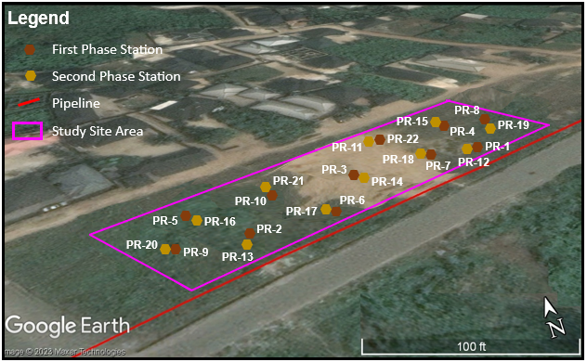
Fig. 2. Map showing the study site and sample stations.

Sample-point coordinates allowed precise analysis, with software algorithms generating graphical outputs, including contour maps and distribution curves, to visualise spatiotemporal variations in heavy metals over time (Ahmed & Taiwo, 2023). Consistent sampling locations across the first and second phases enabled reliable tracking of concentration changes, thereby providing sufficient information on contaminant-attenuation progress and site pollution status.

2.1.3 Laboratory Analysis
The sampled soil specimens were subjected to laboratory analysis to determine the concentrations of selected heavy metals, namely cadmium (Cd), iron (Fe), copper (Cu), zinc (Zn), lead (Pb), chromium (Cr), and nickel (Ni). Prior to analysis, the soil samples were thoroughly homogenized and prepared for digestion using aqua regia following the procedure described by USEPA (1996). A 1.0 g portion of each homogenized soil sample was placed in a 250 mL conical flask, and 10 mL of aqua regia was added. The mixture was thoroughly mixed and heated on a hot plate to facilitate digestion and reduce the volume of the digest to approximately 7–12 mL. Following digestion, the digest was allowed to cool and was filtered through Whatman filter paper to remove residual particulate matter. The filtrate was subsequently transferred into a 50 mL volumetric flask and made up to volume with distilled or deionized water. The prepared digests were then transferred into clean, labelled plastic containers and stored for subsequent analysis using Atomic Absorption Spectrophotometry (AAS) (Fishman & Downs, 1966).
For the AAS determination, the prepared digests were thoroughly homogenized before aspiration into the instrument. The sample solution was introduced into the flame, where the dissolved metal ions were atomized. The atoms absorbed radiation at wavelengths characteristic of the respective elements, and the resulting absorbance was measured by the detector. The concentrations of the target metals were determined from the corresponding calibration standards. Element-specific hollow-cathode lamps and appropriate flame conditions were employed for the determination of the individual metals, using either an air–acetylene or nitrous oxide–acetylene flame as required. The concentrations obtained from the AAS analysis were subsequently recorded and used to assess the levels and spatial distribution of the selected heavy metals in the sampled soils (Fishman & Downs, 1966).

  - Pollution Assessments, Ecological Risks and Contaminants Reduction

2.2.1 Geoaccumulation Index (Igeo)
This index evaluates the contamination level of a sample and quantifies the degree of contamination. Its calculation is guided by Equation 1, as proposed by Müller (1969).

$Igeo={Log}_{2}(C_{n}/1.5B_{n})$----------------------------------(1)

Where: C_{n} represents the measured heavy-metal levels, while B_{n} denotes the background geochemical composition for average crustal shale (Müller, 1969), with the factor of 1.5 incorporated in the equation to account for differences in background values caused by geogenic influences and lithological variations. This corresponds to baseline levels of the same metal, which can be obtained from the literature or determined from texturally comparable natural sediments. For this study, reference concentration levels were derived from selected credible sources, including the research by Turekian and Wedepohl (1961) on the distribution of elements in primary zones of the Earth's crust. The index of geoaccumulation classifies contamination into seven distinct categories, ranging from unpolluted to extremely polluted, as described by Müller (1969) and Guan et al. (2014) (Table 2).

Table 2. Index standards, Identification, and description for geoaccumulation (Müller, 1969)
Igeo | Class |  | Contamination level
I_{geo} ≤ 0, | Class 0 |  | Uncontaminated
0 < I_{geo} ≤ 1 | Class 1 |  | Uncontaminated to Moderately Contaminated
1 < I_{geo} ≤ 2 | Class 2 |  | Moderately Contaminated
2 < I_{geo}≤ 3 | Class 3 |  | Moderately to Heavily Contaminated
3 < I_{geo} ≤ 4 | Class 4 |  | Heavily Contaminated
4 < I_{geo} ≤ 5 | Class 5 |  | Heavily to Extremely Contaminated
I_{geo} > 5 | Class 6 |  | Extremely Contaminated

2.2.2 Contamination Factor (CF)
The Contamination Factor (CF) was derived from Equation 2, outlined by Hakanson (1980).

$Contamination Factor=\frac{Concentration of heavy metal in sediment (C_{n})}{Background value of heavy metal (B_{n})}$ ------------------------------(2)

Where: C_{n} represents the metal level in the study area, while Bn represents the ambient or background metal level. The adopted reference for this calculation corresponds to the target or standard values presented in Table 3 (Hakanson, 1980).

Table 3. Description and identification of contamination factor (CF) (Hakanson, 1980)
Value | Soil Quality
CF < 1 | Low contamination factor indicating low contamination
1 ≤ CF < 3 | Moderate contamination factor
3 ≤ CF < 6 | Considerable contamination factor
6 ≤ CF | Very high contamination factor

2.2.3 Metal Pollution Index (MPI)
The Metal Pollution Index ($MPI)$ represents the correlation between the concentration of heavy metals in the soil samples and the corresponding baseline values. It is computed following Equation 3 and is categorised into five distinct groups or classes, as outlined in Table 4 (Hakanson, 1980).

$MPI=\sum_{1}^{i}{\frac{Mean concentration of metal in sample}{Concentration of metal in control}}$ ----------------------------------------(3)

Where (i) is the number of heavy metals studied.

Table 4. Description and Identification of metal pollution index (MPI) (Hakanson, 1980).
Values | Soil Quality
MPI< 1 | Unpolluted
1 <MPI< 2 | Slightly Polluted
2<MPI< 3 | Moderately Polluted
3< MPI <5 | Severely Polluted
6< MPI < 10 | Heavily Polluted

2.2.4 Potential Ecological Risk Index (PERI)
The Potential Ecological Risk Index (PERI), introduced by Hakanson (1980), is designed to evaluate the ecological and environmental risk posed by heavy metals contamination in the study area soils sampled. The calculation of PERI incorporates the contamination degree ($CD)$, the potential ecological risk factor ($E_{R}^{i})$, and the toxic-response factor ($TR)$. Using this approach, the ecological risk index for a single element ($E_{R}^{i})$and the overall index of ecological risk ($RI)$ are determined through Equations 4, 5, and 6, as described by Hakanson (1980).

${C_{f}}_{= {C_{D}^{i}}/{C_{R}^{i}} }^{i}$ ------------------------------------------(4)
$E_{R}^{i}=T_{R}^{i}×C_{f}^{i}$ -------------------------------------------(5)
$RI=\sum_{i=1}^{i}{E_{R}^{i}}$ -------------------------------------------(6)

Where: $C_{D}^{i}$ denotes the concentration of respective heavy metal measured at specific sample locations, while $C_{R }^{i}$ denotes the reference or baseline levels of the respective metals.

Equation 6 defines the pollution factor for a single element. The PERI for a singular element ($E_{R}^{i})$and the comprehensive PERI ($RI)$are calculated using associated toxic response factors ($T_{R}^{i}$). The toxic reaction indicators for various metals are as follows: Zn = 1, Fe = 1, Cr = 2, Cu = 5, Pb = 5, Ni = 5, and Cd = 30 (Hakanson, 1980; Huang et al., 2020). Metals such as Fe, with an $E_{R}^{i}$value ≤ 1, are excluded from the $RI$calculations (Gbadamosi, 2018; Pobi et al., 2019). The levels of ecological risk are categorized into five distinct classes distinguished in relation to pre-industrial baseline levels (Pobi et al., 2019). These background values ($C_{R}^{i}$) establish the standards for evaluating prospective soil risks, with specific concentrations provided for Cd (0.2), Pb (20), Cu (32), and Zn (129), as summarized in Table 5 (Pobi et al., 2019).

Table 5. Description and identification of individual potential risks (Eir) (Pobi et al., 2019)
Value | Soil Quality
E^{i}_{R} ≤ 40 | low ecological risk
40 < E^{i}_{R} ≤ 80 | moderate ecological risk
80 < E^{i}_{R} ≤ 160 | considerable ecological risk
160 < E^{i}_{R} ≤ 320 | high ecological risk
E^{i}_{R} > 320 | very high ecological risk

The PERI ($RI)$ is categorised into four distinct groups, with corresponding values from below 150 to above 600, as outlined in Table 6 (Pobi et al., 2019).

Table 6. Description and Identification of potential ecological risk index (RI) (Pobi et al., 2019).
Value | Soil Quality
RI ≤ 150 | Low Ecological Risk
150 < RI ≤ 300 | Moderate Ecological Risk
300 < RI ≤ 600 | Considerable Ecological Risk
RI > 600 | Very High Ecological Risk

2.2.5 Contaminants Reduction Assessment
This study assessed contaminant reduction using a straightforward temporal heavy-metal percentage-reduction method (Altan et al., 2011). The spatiotemporal changes for each heavy metal were determined based on the alterations or reductions observed across corresponding sample points between the first and second sampling phases (Altan et al., 2011). The assessment compares the initial average contamination levels in the first phase with the final average contamination levels observed in the second phase to determine the overall percentage reduction in residual heavy-metal contamination (Mohamed et al., 2024). It was calculated using Equation 7.

$Percentage Reduction=\frac{ Initial Average Concentrations - Final Average Concentrations}{Initial Average Concentration} X 100$ --------------(7)

3. Results and Discussion

3.1 Heavy Metal Flux and Spatiotemporal Distribution

3.1.1 Chromium
Chromium (Cr) levels showed substantial reductions between the first and second sampling phases, as seen in Fig. 3. PR-1 had an initial concentration of 4.51 mg/kg, which decreased to 1.22 mg/kg in PR-12 in the second phase. This reduction represents a decrease of approximately 73%, indicating strong attenuation (Mohamed et al., 2024). Similarly, PR-2 decreased from 4.86 mg/kg in the first phase to 0.87 mg/kg at the corresponding second-phase sample point, PR-13, showing a reduction of nearly 82%. Other sample points, such as PR-9 (5.98 mg/kg), also exhibited significant reductions, with PR-20 (its second-phase counterpart) showing a much lower concentration of 0.98 mg/kg. The declines in Cr levels at these points brought concentrations closer to those in control samples, such as CT-3 (0.49 mg/kg) and CT-4 (0.61 mg/kg), suggesting substantial Cr displacement (Diagne et al., 2015). However, some sample points in the second phase, such as PR-15 (2.12 mg/kg) and PR-22 (1.02 mg/kg), still had slightly elevated Cr levels compared with control samples, implying the need for more time or enhanced natural attenuation to fully meet USDA (2000) soil-quality standards across the site.

Fig. 3. Plot of chromium concentrations for the first and second sampling phases

The spatiotemporal distribution of chromium (Cr) is illustrated in Fig. 4(a) and (b), revealing a considerable spread across the southern part of the study site. Notably, Cr concentrations increased in this region during the second sampling phase, suggesting that factors contributing to Cr accumulation were more prevalent during this period (Kara, 2024). The increase could be attributed to localised contamination sources or geochemical interactions that mobilised Cr (Diagne et al., 2015). While Cr concentrations decreased in some locations, the spatial analysis indicates that some southern regions require additional intervention to control Cr levels effectively and prevent further spread (George et al., 2023).

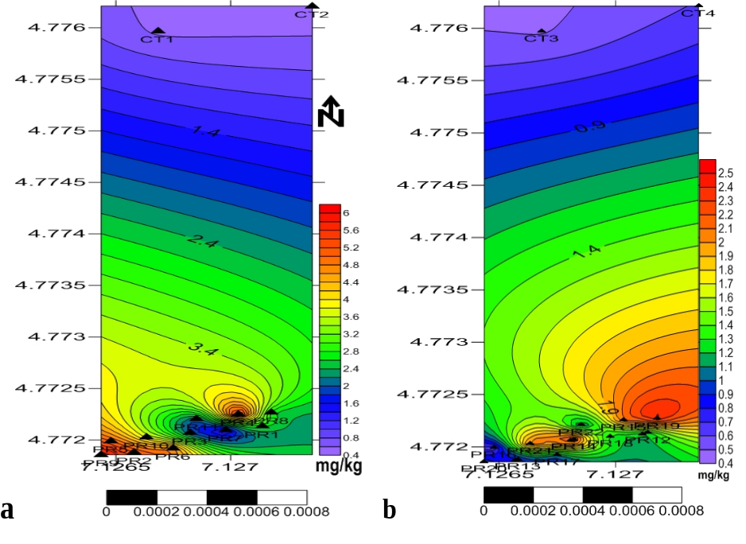
Fig. 4. Spatiotemporal distribution of chromium for the first and second sampling phases

3.1.2 Cadmium
Cadmium (Cd) concentrations decreased noticeably between corresponding sample points, as shown in Fig. 5. PR-1 initially had a Cd concentration of 0.58 mg/kg, which later dropped to 0.31 mg/kg in PR-12 in the second sampling phase, marking a reduction of nearly 47%. However, PR-2, which started at a higher concentration of 1.13 mg/kg, only showed a slight decrease to 1.06 mg/kg in PR-13, indicating limited attenuation for Cd (Diagne et al., 2015).

Fig. 5. Plot of cadmium concentrations for the first and second sampling phases

Other points, such as PR-4 (1.42 mg/kg), showed a more substantial decline, dropping to 0.92 mg/kg in PR-15. Despite relative decreases in Cd levels in some areas, they did not uniformly reach control-sample levels (e.g., CT-3 at 0.25 mg/kg). While the overall findings for Cd levels across most corresponding points reflect positive declines, the data suggest that specific sample areas, such as PR-13, may require further efforts to fully comply with the environmental standards of the U.S. Department of Agriculture, Soil Quality Institute (USDA, 2000), and the U.S. Environmental Protection Agency (USEPA, 2011).
The spatiotemporal distribution of cadmium (Cd), illustrated in Fig. 6(a) and (b), is primarily observed at specific locations within the southern region of the site. In both sampling phases, Cd extended towards the northern parts, although at lower concentrations. This distribution pattern suggests localised Cd levels in the south, with diffusion towards the north possibly due to subsurface migration or environmental factors such as rainfall and groundwater flow (Ahmed et al., 2024a). The spatial reduction in Cd from the first to the second phase reflects positive attenuation that limited its spread (Mohamed et al., 2024); however, further monitoring of the southern zone is recommended for full Cd mitigation.

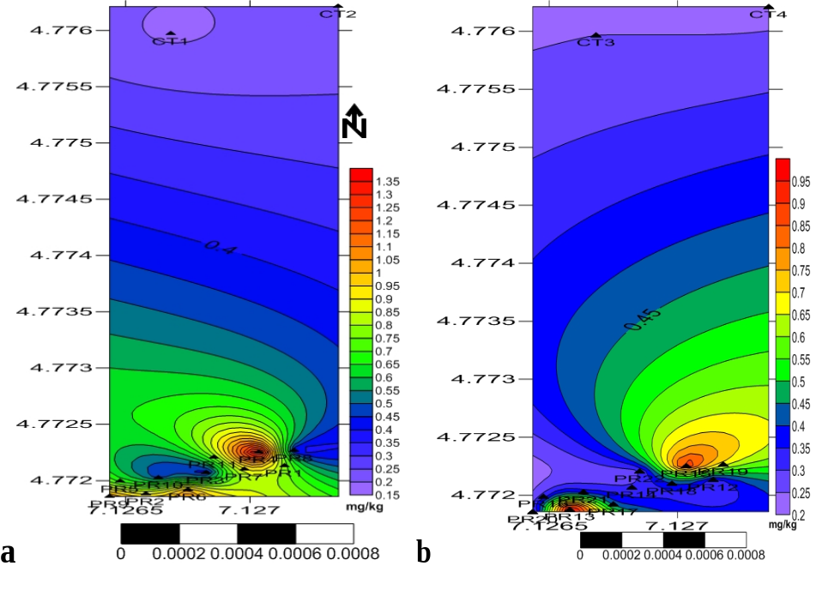
Fig. 6. Spatiotemporal distribution of cadmium for the first and second sampling phases

3.1.3 Copper
In the case of copper (Cu), concentrations showed variable results across the site, as depicted in Fig. 7. The first-phase sample PR-1 had a Cu concentration of 3.85 mg/kg, which decreased to 2.23 mg/kg in PR-12 in the second phase, demonstrating a substantial reduction, although the value remained slightly higher than the control level at CT-3 (1.65 mg/kg).

Fig. 7. Plot of copper concentrations for the first and second sampling phases

Similarly, PR-11 decreased from 3.19 mg/kg in the first phase to 2.19 mg/kg in PR-22. In addition, some sample points, such as PR-17 (2.66 mg/kg) and PR-13 (2.12 mg/kg), showed only moderate reductions and remained slightly elevated compared with control samples. While the general trend indicates a decrease in Cu levels, the magnitude of the decline varied among sample points. The continued elevation in certain areas suggests that further targeted efforts may be beneficial for achieving uniform compliance with USDA (2000) soil-quality standards for Cu.
The spatiotemporal distribution of copper (Cu), depicted in Fig. 8(a) and (b), reveals higher intensities predominantly within the southern part of the study area, with lower levels spreading towards the southeastern and southwestern areas. In the first sampling phase, elevated Cu concentrations were mainly in the southeastern region, whereas in the second phase, they shifted towards the southwest. This shift may indicate the influence of soil and surface-water (rain) dynamics on Cu distribution (Hazarika et al., 2024). Despite reductions in Cu levels in some areas, high Cu concentrations in the south indicate specific hotspots of concern.

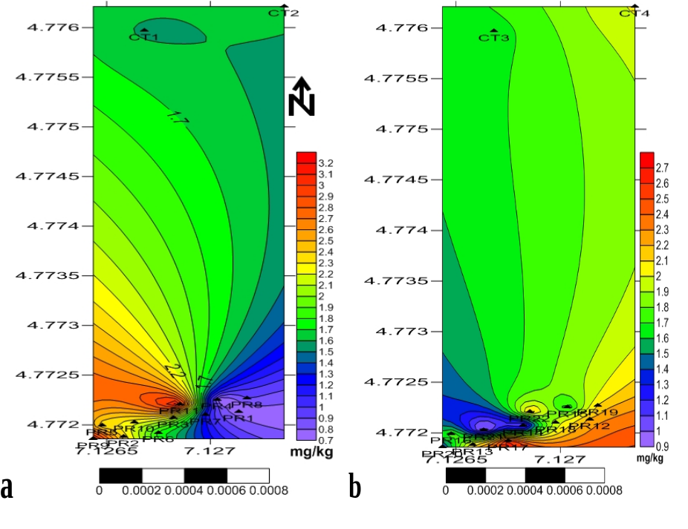
Fig. 8. Spatiotemporal distribution of copper for the first and second sampling phases

3.1.4 Nickel
Nickel (Ni) concentrations showed notable reductions across corresponding sample points, as shown in Fig. 9. PR-1 had an initial Ni level of 2.05 mg/kg, which dropped to 0.55 mg/kg in PR-12, representing a decrease of 73%. Similarly, PR-4 decreased from 0.97 mg/kg to 0.42 mg/kg at its corresponding point, PR-15. These reductions brought Ni concentrations close to control values, such as CT-3 at 0.45 mg/kg, indicating effective attenuation across most of the site (Diagne et al., 2015). Moreover, PR-7 (1.15 mg/kg) in the first phase decreased significantly to 0.36 mg/kg at PR-18 in the second phase, nearing control levels. The consistent decrease across all corresponding points demonstrates that Ni levels satisfy USEPA (2011) guidelines and supports improvement in the site's overall health and quality.

Fig. 9. Plot of nickel concentrations for the first and second sampling phases

The spatiotemporal distribution of nickel (Ni), presented in Fig. 10(a) and (b), shows a marked reduction in Ni levels in the southernmost parts. High Ni concentrations in the first sampling phase were concentrated in the south, but these levels diminished significantly by the second phase. Both phases displayed lower Ni levels across the northernmost parts of the area, indicating a stable but low-level presence in these regions (Liu et al., 2023). This spatial reduction highlights the role of high metal mobility in reducing Ni contamination, particularly in the south (Guan et al., 2014).

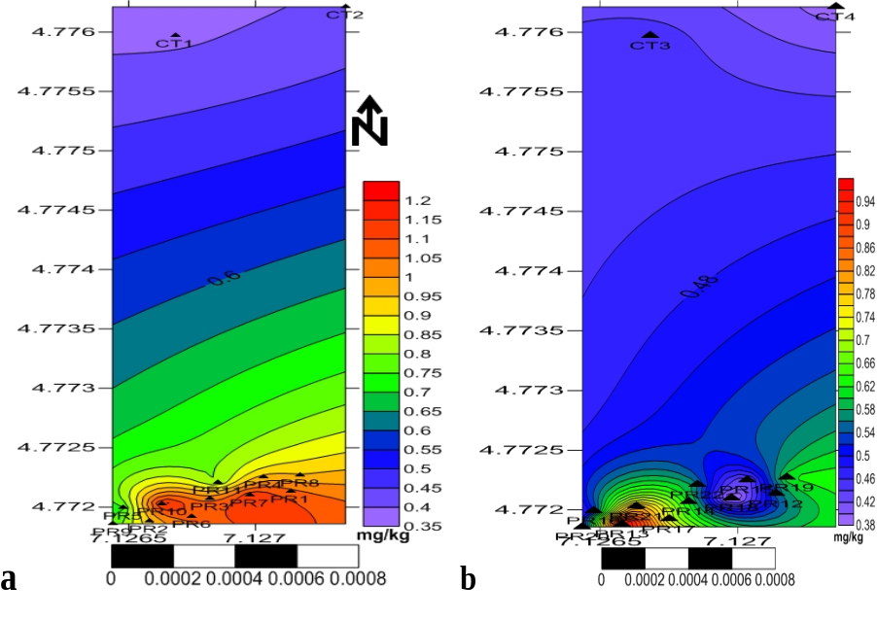
Fig. 10. Spatiotemporal distribution of nickel for the first and second sampling phases

3.1.5 Lead
Lead (Pb) levels presented in Fig. 11 showed substantial reductions across corresponding sample stations. PR-1 in the first phase had a Pb concentration of 1.75 mg/kg, which dropped to 0.62 mg/kg in PR-12 in the second phase. PR-9 showed an exceptionally high initial level of 3.79 mg/kg, which decreased dramatically to 0.59 mg/kg in PR-20, suggesting substantial reduction in Pb contamination (Sánchez-Castro et al., 2023), with most second-phase values aligning closely with control samples such as CT-3 at 0.49 mg/kg. The uniformity of Pb reductions across the site indicates substantial declines, with Pb levels falling within safe limits according to USDA (2000) standards.

Fig. 11. Plot of lead concentrations for the first and second sampling phases

The spatiotemporal distribution of lead (Pb), illustrated in Fig. 12(a) and (b), reflects a significant decrease from the first to the second sampling phase, as initial Pb levels were 3.8 mg/kg but dropped to 0.64 mg/kg after the second phase. Low Pb levels were uniformly distributed in the northern parts of the area, with substantial reductions across the site demonstrating high flux in Pb contamination (Mohamed et al., 2024), particularly in the southern zones, where concentrations initially peaked. The spatiotemporal data suggest that further intervention may not be necessary, as Pb levels are now within acceptable limits permitted under USDA (2000) and USEPA (2011) standards.

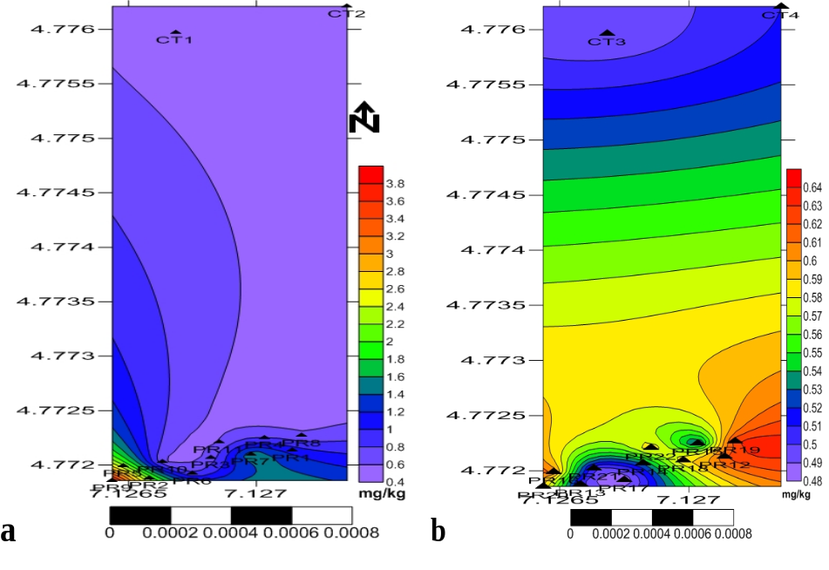
Fig. 12. Spatiotemporal distribution of lead for the first and second sampling phases

3.1.6 Zinc
Zinc (Zn) concentrations decreased across corresponding points. However, the degree of reduction varied, as illustrated in Fig. 13. PR-1 had a Zn concentration of 6.86 mg/kg, which was reduced to 3.93 mg/kg in PR-12, approaching but remaining slightly higher than the value at control CT-3 (2.91 mg/kg). Likewise, PR-9 declined from 7.95 mg/kg to 4.26 mg/kg in PR-20, exhibiting positive flux (Diagne et al., 2015) but not fully reaching background levels. Some points, such as PR-22 (4.74 mg/kg), retained slightly elevated Zn levels in the second phase, necessitating continued attenuation in these areas to ensure compliance with environmental standards (George et al., 2023).

Fig. 13. Plot of zinc concentrations for the first and second sampling phases

The spatiotemporal distribution of zinc (Zn), presented in Fig. 14(a) and (b), shows low levels in the northern parts of the site, with higher concentrations in isolated pockets in the south during both sampling phases. This distribution pattern suggests that Zn contamination is localised rather than widespread (Hazarika et al., 2024). Although there was a general reduction in Zn levels from the first to the second phase, certain pockets in the south retained elevated concentrations, likely due to persistent contamination sources (George et al., 2023). Targeted attenuation is required in these isolated areas to prevent potential risks to soil and groundwater quality in surrounding zones.

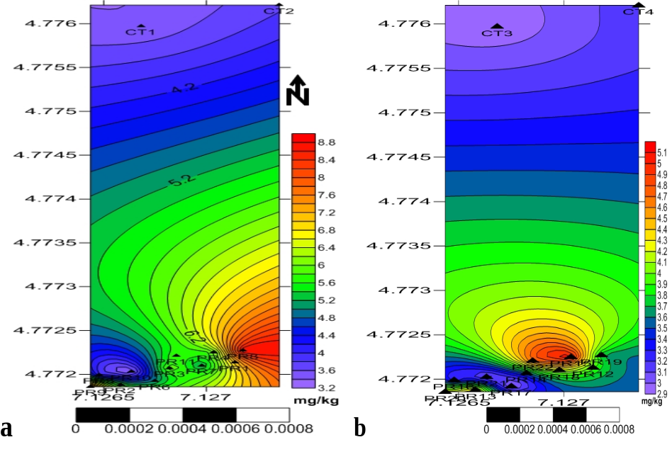
Fig. 14. Spatiotemporal distribution of zinc for the first and second sampling phases

3.1.7 Iron
Iron (Fe) concentrations demonstrated variable reductions across corresponding points, as shown in Fig. 15. PR-1 started with a concentration of 6.93 mg/kg and decreased to 6.40 mg/kg in PR-12, a moderate reduction that still exceeded control levels such as CT-3 (4.16 mg/kg). However, more substantial reductions were observed at PR-8, where Fe levels decreased from 9.65 mg/kg in the first phase to 3.69 mg/kg in PR-19 in the second phase, approaching control values. Some sample points, such as PR-17 (5.10 mg/kg), still exhibited Fe concentrations above control values in the second phase and beyond the USEPA (2011) environmental standards. The mixed results suggest that, although there was an overall reduction in Fe, targeted efforts are needed to achieve uniform compliance (Aloa et al., 2024).

Fig. 15. Plot of iron concentrations for the first and second sampling phases

The spatiotemporal pattern indicates that Fe contamination was predominantly distributed across the southern part of the study site (Hazarika et al., 2024), with medium concentrations in the northern part during the first phase, as shown in Fig. 16(a). On the second-phase map, these medium Fe levels in the north were reduced to lower concentrations, as illustrated in Fig. 16(b). These trends suggest high flux in the southern and northern parts of the site (Mohamed et al., 2024). However, because Fe concentrations in the south are still greater than those in the north, additional reductions are needed to balance the distribution and achieve uniform environmental quality (Ghrefat et al., 2021).

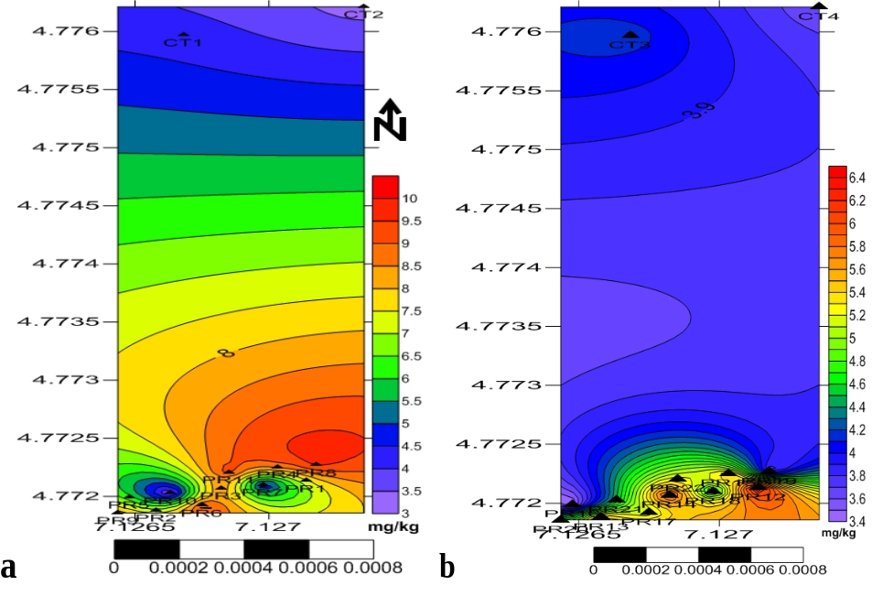
Fig. 16. Spatiotemporal distribution of iron for the first and second sampling phases

3.2 Pollution Trends and Ecological Risk Shifts

3.2.1 Geoaccumulation Index (I_{geo})
The Index of Geoaccumulation (I_{geo}), introduced by Müller (1969), was originally developed to provide a quantitative assessment of metal concentrations in marine sediments. It has since gained widespread use for estimating metal pollution in estuarine, riverine, and lacustrine sediments, generating significant interest in environmental science (Ergin et al., 1991). This study assessed the extent and degree of pollution in soil samples using background concentration values provided by Turekian and Wedepohl (1961).

Table 7. Geoaccumulation Index values
Station | Cr | Cd | Cu | Ni | Pb | Zn | Fe
First sampling phase
PR-1 | -4.904 | 0.366 | -4.066 | -5.637 | -4.1 | -4.377 | -13.303
PR-2 | -4.796 | 1.328 | -6.941 | -6.941 | -4.85 | -4.307 | -13.252
PR-3 | -6.121 | -0.206 | -4.914 | -6.63 | -5.442 | -4.551 | -13.005
PR-4 | -4.561 | 1.658 | -6.547 | -6.716 | -5.247 | -4.604 | -12.987
PR-5 | -4.752 | 0.617 | -4.797 | -7.107 | -3.718 | -5.151 | -13.455
PR-6 | -4.832 | 1.181 | -5.196 | -6.588 | -5.193 | -4.836 | -12.89
PR-7 | -6.766 | 0.984 | -5.822 | -6.471 | -4.238 | -4.813 | -14.022
PR-8 | -5.693 | -0.244 | -6.132 | -6.746 | -5.551 | -4.008 | -12.826
PR-9 | -4.497 | 1.237 | -4.369 | -7.068 | -2.985 | -4.164 | -13.047
PR-10 | -5.178 | 0.063 | -4.854 | -6.434 | -5.62 | -5.424 | -14.396
PR-11 | -6.041 | 0.737 | -4.338 | -7.013 | -5.668 | -4.616 | -12.877
CT-1 | -7.913 | -1.244 | -5.351 | -8.031 | -5.966 | -5.377 | -14.002
CT-2 | -8.136 | -0.968 | -5.289 | -7.959 | -6.027 | -5.244 | -14.382
Mean | -6.32 | 0.08 | -5.17 | -7.1 | -5.15 | -4.81 | -13.65
I_{geo} Class | Class 1 | Class 1 & 2 | Class 1 | Class 1 | Class 1 | Class 1 | Class 1
Second sampling phase
PR-12 | -6.79 | -0.538 | -4.854 | -7.535 | -5.597 | -5.18 | -13.418
PR-13 | -7.278 | 1.236 | -4.927 | -6.658 | -5.907 | -5.014 | -13.642
PR-14 | -5.844 | -0.538 | -6.026 | -7.362 | -5.823 | -5.331 | -13.506
PR-15 | -5.993 | 1.032 | -5.324 | -7.924 | -5.85 | -4.801 | -13.661
PR-16 | -7.79 | -0.492 | -5.179 | -7.644 | -5.62 | -5.468 | -14.343
PR-17 | -7.02 | -0.1 | -4.6 | -7.167 | -5.966 | -5.604 | -13.746
PR-18 | -6.778 | -0.206 | -5.04 | -8.146 | -5.668 | -5.098 | -13.917
PR-19 | -5.808 | 0.596 | -4.927 | -7.362 | -5.573 | -5.271 | -14.213
PR-20 | -7.106 | -0.791 | -5.611 | -7.702 | -5.668 | -5.064 | -13.873
PR-21 | -5.993 | -0.282 | -6.212 | -6.994 | -5.907 | -5.546 | -13.936
PR-22 | -7.048 | -0.685 | -4.88 | -7.484 | -5.668 | -4.91 | -13.704
CT-3 | -8.106 | -0.848 | -5.289 | -7.824 | -5.936 | -5.614 | -14.04
CT-4 | -7.79 | -0.968 | -4.997 | -8.031 | -5.878 | -5.49 | -14.248
Mean | -6.87262 | -0.19877 | -5.22046 | -7.52562 | -5.77392 | -5.26085 | -13.8652
I_{geo} Class | Class 0 | Class 0 & 1 | Class 0 | Class 0 | Class 0 | Class 0 | Class 0

The accumulation index for the study area is presented in Table 7. According to the first sampling-phase values, all studied heavy metals (Cr, Cu, Fe, Ni, Pb, Zn) fall into class one, except Cd, which falls under class zero at stations PR-3, PR-8, and the control samples; class one at PR-1, PR-5, PR-7, PR-10, and PR-11; and class two at locations PR-2, PR-4, PR-6, and PR-9, as depicted in Fig. 17a. For the second phase, as shown in Fig. 17b, Cd falls under class one at station PR-19, class two at PR-13 and PR-15, and class zero at the other stations, including the control samples (Table 7). These classifications range from uncontaminated to moderately contaminated (class 1) and moderately contaminated (class 2). The effect of attenuation over time can be seen in the reduced number of locations contaminated with Cd. However, the persistent concentration of Cd remaining in the environment indicates that efforts should be made to monitor the factors contributing to the persistence of Cd (Aloa et al., 2024) or those responsible for the low concentration found at PR-13 and PR-15.

Fig. 17a. Geoaccumulation index (I_{geo}) of the first sampling phase

Fig. 17b. Geo-accumulation index of the second sampling phase
3.2.2 Contamination Factor (CF)
This pollution index is commonly applied to assess the anthropogenic contribution of heavy-metal contaminants to sediments (George et al., 2023). The results from the first-phase exercise conducted at the site for metallic contaminants such as Cd, Cr, Cu, Fe, Ni, Pb, and Zn indicate that all parameters, including the control samples for Cd, fall under the low-contamination category. However, cadmium is classified as moderately contaminated at all stations except PR-2, PR-4, PR-6, and PR-9, which fall under the considerable-contamination category (Hakanson, 1980), as presented in Table 8. The mean Cd value is 2.359 mg/kg, while the minimum value is 0.633 mg/kg and the maximum is 4.733 mg/kg, with a total of 30.667 g/kg across all samples.
Table 8. Contamination factor values
Station | Cr | Cd | Cu | Ni | Pb | Zn | Fe
First sampling phase
PR-1 | 0.05 | 1.933 | 0.09 | 0.03 | 0.088 | 0.072 | 0.0
PR-2 | 0.054 | 3.767 | 0.074 | 0.012 | 0.052 | 0.076 | 0.0
PR-3 | 0.022 | 1.3 | 0.05 | 0.015 | 0.035 | 0.064 | 0.0
PR-4 | 0.064 | 4.733 | 0.016 | 0.014 | 0.04 | 0.062 | 0.0
PR-5 | 0.056 | 2.3 | 0.054 | 0.011 | 0.114 | 0.042 | 0.0
PR-6 | 0.053 | 3.4 | 0.041 | 0.016 | 0.041 | 0.053 | 0.0
PR-7 | 0.014 | 2.967 | 0.027 | 0.017 | 0.08 | 0.053 | 0.0
PR-8 | 0.029 | 1.267 | 0.021 | 0.014 | 0.032 | 0.093 | 0.0
PR-9 | 0.067 | 3.533 | 0.073 | 0.011 | 0.19 | 0.084 | 0.0
PR-10 | 0.041 | 1.567 | 0.052 | 0.017 | 0.031 | 0.035 | 0.0
PR-11 | 0.023 | 2.5 | 0.074 | 0.012 | 0.03 | 0.061 | 0.0
CT-1 | 0.006 | 0.633 | 0.037 | 0.006 | 0.024 | 0.036 | 0.0
CT-2 | 0.005 | 0.767 | 0.038 | 0.006 | 0.023 | 0.04 | 0.0
Sum | 0.484 | 30.667 | 0.647 | 0.181 | 0.78 | 0.771 | 0.0
Class | Low | Low to Consid. | Low | Low | Low | Low | Low

Second sampling phase
PR-12 | 0.014 | 1.033 | 0.052 | 0.008 | 0.031 | 0.041 | 0.0
PR-13 | 0.01 | 3.353 | 0.049 | 0.015 | 0.025 | 0.046 | 0.0
PR-14 | 0.026 | 1.033 | 0.023 | 0.009 | 0.027 | 0.037 | 0.0
PR-15 | 0.024 | 3.067 | 0.037 | 0.006 | 0.026 | 0.054 | 0.0
PR-16 | 0.007 | 1.067 | 0.041 | 0.008 | 0.031 | 0.034 | 0.0
PR-17 | 0.011 | 1.4 | 0.062 | 0.01 | 0.024 | 0.031 | 0.0
PR-18 | 0.014 | 1.3 | 0.046 | 0.005 | 0.03 | 0.044 | 0.0
PR-19 | 0.027 | 2.267 | 0.049 | 0.009 | 0.032 | 0.039 | 0.0
PR-20 | 0.011 | 0.867 | 0.031 | 0.007 | 0.03 | 0.045 | 0.0
PR-21 | 0.024 | 1.233 | 0.02 | 0.012 | 0.025 | 0.032 | 0.0
PR-22 | 0.011 | 0.933 | 0.051 | 0.008 | 0.03 | 0.05 | 0.0
CT-3 | 0.005 | 0.833 | 0.038 | 0.007 | 0.025 | 0.031 | 0.0
CT-4 | 0.007 | 0.767 | 0.047 | 0.006 | 0.026 | 0.033 | 0.0
Sum | 0.191 | 19.153 | 0.546 | 0.11 | 0.362 | 0.517 | 0.0
Class | Low | Low to Mod. | Low | Low | Low | Low | Low

Fig. 18a. Contamination factor for the first sampling phase
All other parameters retained their low-contamination status during the second phase. At the same time, Cd concentrations decreased to low-contamination levels at most locations but remained moderately contaminated at PR-13 and PR-15. Fig. 18a and 18b illustrate the reduction in Cd concentration across all locations; however, despite these decreases, Cd remains persistent in the environment.

Fig. 18b. Contamination factor for the second sampling phase

3.2.3 Metal Pollution Index (MPI)

The MPI was used to evaluate metal contamination in the soil samples retrieved from the study area, with the results presented in Table 9. In the first sampling phase, analysis of the metals (Cd, Cr, Cu, Fe, Ni, Pb, and Zn) yielded an index of 1.007. This indicated ongoing metal contamination in the study area (Diagne et al., 2015). However, after the second sampling phase, the index value dropped to 0.587, indicating a reduction in contamination levels and suggesting that the environment had become less polluted. Specifically, the concentration of cadmium decreased from 30.667 in the first sampling phase to 19.153 in the second sampling phase, demonstrating a significant reduction in contamination.

Table 9. Metal pollution index
Sample | Cr | Cd | Cu | Ni | Pb | Zn | Fe
First sampling phase
(∑Cf) | 0.484 | 30.667 | 0.647 | 0.181 | 0.78 | 0.771 | 0.00
MPI = (Cf₁*Cf₂*Cf₃*…..Cf_{n})^{1/n} |  |  |  |  | = 1.007

Second sampling phase
(∑Cf) | 0.191 | 19.153 | 0.546 | 0.110 | 0.362 | 0.517 | 0.00
MPI = (Cf₁*Cf₂*Cf₃*…..Cf_{n})^{1/n} |  |  |  |  | = 0.587

3.2.4 Potential Ecological Risk Index (PERI)
The ecological risk assessment of the metals Cd, Cr, Cu, Fe, Ni, Pb, and Zn was conducted at the study site following the first phase of activity. The results are summarized in Table 10. The findings indicate that, with the exception of Cd, all metals have $E_{R}^{i}$and $RI$ values below 40 and 150, respectively. These values classify them within Group A of the ecological risk standard level, as defined by Li et al. (2012). The ecological risk values for Cd are less than 40 in samples PR-3 and PR-8 and the control samples CT-1 and CT-2, indicating low ecological risk. This risk level corresponds to the (Hakanson, 1980) classification, which is a low ecological risk (i.e., when E^{i}_{R} < 40) shown in Tables 10. Sample PR-1, PR-5, PR-10, and PR-11 have values falling between 40 and 80 and are categorized under moderate ecological risk, while sample PR-9, PR-7, PR-6, PR-4, and PR-2 have values falling between 80 and 160, which indicates considerable ecological risk in the index table.

Table 10. Potential ecological risk index
Station | Cr | Cd | Cu | Ni | Pb | Zn | Fe | ∑RI
First sampling phase
PR-1 | 0.1 | 58 | 0.45 | 0.15 | 0.44 | 0.07 | 0.0 | 59.21
PR-2 | 0.1 | 113 | 0.4 | 0.1 | 0.3 | 0.1 | 0.0 | 113.9
PR-3 | 0.04 | 39 | 0.25 | 0.08 | 0.17 | 0.06 | 0.0 | 39.6
PR-4 | 0.13 | 142 | 0.08 | 0.07 | 0.2 | 0.06 | 0.0 | 142.54
PR-5 | 0.11 | 69 | 0.27 | 0.05 | 0.57 | 0.04 | 0.0 | 70.05
PR-6 | 0.11 | 102 | 0.2 | 0.08 | 0.21 | 0.05 | 0.0 | 102.65
PR-7 | 0.03 | 89 | 0.13 | 0.08 | 0.4 | 0.05 | 0.0 | 89.7
PR-8 | 0.06 | 38 | 0.11 | 0.07 | 0.16 | 0.09 | 0.0 | 38.49
PR-9 | 0.13 | 106 | 0.36 | 0.06 | 0.95 | 0.08 | 0.0 | 107.58
PR-10 | 0.08 | 47 | 0.26 | 0.09 | 0.15 | 0.03 | 0.0 | 47.62
PR-11 | 0.05 | 75 | 0.37 | 0.06 | 0.15 | 0.06 | 0.0 | 75.68
CT-1 | 0.01 | 19 | 0.18 | 0.03 | 0.12 | 0.04 | 0.0 | 19.38
CT-2 | 0.01 | 23 | 0.19 | 0.03 | 0.12 | 0.04 | 0.0 | 23.39
Mean | 0.07 | 70.77 | 0.25 | 0.07 | 0.3 | 0.06 | 0.0 | 71.52
Class | Low  Ecol. Risk | Low-Consid. Risk | Low  Ecol.  Risk | Low  Ecol.  Risk | Low  Ecol.  Risk | Low  Ecol.  Risk | Low  Ecol.  Risk | Low-  Consid.  Risk

Second sampling phase
PR-12 | 0.03 | 31 | 0.26 | 0.04 | 0.16 | 0.04 | 0.0 | 31.52
PR-13 | 0.02 | 106 | 0.25 | 0.07 | 0.13 | 0.05 | 0.0 | 106.51
PR-14 | 0.05 | 31 | 0.12 | 0.05 | 0.13 | 0.04 | 0.0 | 31.38
PR-15 | 0.05 | 92 | 0.19 | 0.03 | 0.13 | 0.05 | 0.0 | 92.45
PR-16 | 0.01 | 32 | 0.21 | 0.04 | 0.15 | 0.03 | 0.0 | 32.44
PR-17 | 0.02 | 42 | 0.31 | 0.05 | 0.12 | 0.03 | 0.0 | 42.54
PR-18 | 0.03 | 39 | 0.23 | 0.03 | 0.15 | 0.04 | 0.0 | 39.47
PR-19 | 0.05 | 68 | 0.25 | 0.05 | 0.16 | 0.04 | 0.0 | 68.54
PR-20 | 0.02 | 26 | 0.15 | 0.04 | 0.15 | 0.04 | 0.0 | 26.4
PR-21 | 0.05 | 37 | 0.1 | 0.06 | 0.13 | 0.03 | 0.0 | 37.36
PR-22 | 0.02 | 28 | 0.25 | 0.04 | 0.15 | 0.05 | 0.0 | 28.52
CT-3 | 0.01 | 25 | 0.19 | 0.03 | 0.12 | 0.03 | 0.0 | 25.39
CT-4 | 0.01 | 23 | 0.23 | 0.03 | 0.13 | 0.03 | 0.0 | 23.44
Mean | 0.03 | 48.36 | 0.21 | 0.04 | 0.14 | 0.04 | 0.0 | 48.83
Class | Low  Ecol. Risk | Low- Consid. Risk | Low  Ecol. Risk | Low  Ecol. Risk | Low  Ecol.  Risk | Low  Ecol.  Risk | Low  Ecol.  Risk | Low  Ecol.  Risk

However, the ecological risk index results for the heavy metals at the study site after the second sampling phase exercise revealed that all the metals studied except for Cd exhibits values of $E_{R}^{i}$and $RI$ < 40 and 150, respectively. They fall in Group A of the ecological risk standard level (Pobi et al., 2019). The values for ecological risks of Cd in these stations PR-12, 14, 16, 18, 20, 21, and 22, and control CT-3 and 4 were assessed under low ecological risk as their concentrations were less than 40 (Table 10). Sample PR-17 falls under moderate risk (40-80), and sample PR-13 has the value falling under considerable risk (80< E^{i}_{R} < 160). The mean concentration value of Cd was reduced to 48.36 compared to 70.77 in the first sampling phase exercise, and a range from 23 to 106 compared with 19 to 142 in the second phase exercise. The second sampling phase exercise was observed to have reduced the risks of Cd within the environment in most locations.

3.3 Environmental Quality Assessment
Spatiotemporal heavy-metal monitoring through comparative analysis across corresponding sample stations between the first and second sampling phases demonstrates significant reductions in metal concentrations over the six-month period. Nickel (Ni), chromium (Cr), and lead (Pb) showed the most substantial improvements, with concentrations at many corresponding points approaching or matching control-sample levels, reflecting effective attenuation aligned with USEPA (2011) and USDA (2000) standards. Cadmium (Cd), zinc (Zn), and iron (Fe) levels, although generally lower, still showed residual contamination in some areas, including PR-13 for Cd, PR-22 for Zn, and PR-17 for Fe, suggesting the need for targeted efforts or more time in these zones (Mohamed et al., 2024). The high levels of Fe, likely influenced by geogenic factors and exacerbated by low pH (Kara, 2024), may raise concerns about long-term neurological effects and oxidative damage from human and animal consumption of plants within the area due to contaminant bioaccumulation (Bello et al., 2019). The distribution of contaminants reveals that, while natural attenuation reduced the concentrations of several metals across the study site, the southern parts parallel to the right-of-way spill source consistently show higher contamination levels, indicating possible recontamination from the sabotaged pipeline (Ahmed et al., 2024e).
Cr, Cd, Cu, and Fe concentrations remain elevated in isolated pockets in the south, indicating the need for continued monitoring in these zones (Hazarika et al., 2024). Conversely, Ni and Pb showed more uniform reductions across the site, with concentrations aligning closely with background levels by the second sampling phase. According to Table 11, the initial average Cr concentration was roughly 4.4 mg/kg in the first sampling phase but dropped to about 1.5 mg/kg in the second sampling phase, achieving approximately 65.9% contaminant reduction. Despite this significant reduction, certain areas in the southern part of the site still show elevated levels, indicating the need for localised intervention (George et al., 2023). For Cd, the initial average level was around 0.92 mg/kg in the first sampling phase, which decreased to 0.55 mg/kg in the second sampling phase, resulting in a 40.2% reduction. This moderate effectiveness suggests that specific zones with residual contamination may require additional time for further decline or enhanced natural attenuation (Aparicio et al., 2022). Cu had an initial average concentration of roughly 2.5 mg/kg in the first phase, which was reduced to about 1.6 mg/kg in the second phase, indicating a 36.0% reduction. This moderate effectiveness suggests that, while attenuation has been beneficial, more time or further efforts may be necessary (Dhaliwal et al., 2020), particularly in southern areas. This emphasises the importance of addressing the environmental and health implications of site contamination (Aloa et al., 2024); hence, minimising exposure to Ni, Pb, Zn, and Fe remains crucial because of their potentially harmful impacts (USEPA, 2011).

Table 11. Contaminants Percentage Reduction
Heavy Metal | Initial Average Concentration (mg/kg) | Final Average Concentration (mg/kg) | Percentage  Reduction (%)
Chromium (Cr) | 4.4 | 1.5 | 65.9%
Cadmium (Cd) | 0.92 | 0.55 | 40.2%
Copper (Cu) | 2.5 | 1.6 | 36.0%
Nickel (Ni) | 1.2 | 0.6 | 50.0%
Lead (Pb) | 1.8 | 0.6 | 66.7%
Zinc (Zn) | 5.8 | 3.8 | 34.5%
Iron (Fe) | 7.0 | 4.7 | 32.9%

Ni concentrations decreased from an initial average of around 1.2 mg/kg in the first phase to 0.6 mg/kg in the second sampling phase, achieving about a 50.0% reduction. This indicates good attenuation progress, with most locations nearing background levels (Imasuen et al., 2014). Pb levels initially averaged around 1.8 mg/kg in the first sampling phase and dropped to about 0.6 mg/kg in the second sampling phase, resulting in a 66.7% reduction. This substantial decrease brought Pb concentrations near control levels, highlighting the progress of natural attenuation over time (Aparicio et al., 2022). For Zn, the initial average concentration of 5.8 mg/kg in the first sampling phase was reduced to about 3.8 mg/kg in the second sampling phase, indicating a 34.5% reduction. While natural attenuation has been beneficial, some hotspots may require additional contaminant mitigation (Mohamed et al., 2024). Iron (Fe) had an initial average level of 7.0 mg/kg in the first phase, which decreased to about 4.7 mg/kg in the second, reflecting a 32.9% reduction. Despite only partial reductions, elevated Fe levels in the southern part reflect ongoing iron mobility and suggest the need for more time to meet environmental standards across the entire site (Sánchez-Castro et al., 2023). Overall, the findings indicate positive progress in contaminant attenuation, with most sample points showing compliance with environmental standards for most heavy metals.
The environmental quality observed from the pollution evaluation shows that Geoaccumulation Index (I_{geo}) values for most heavy metals by the second sampling phase fell into the Class 0 category, suggesting that the soils were primarily uncontaminated, except for Cd, which persisted in Class 1 as moderately contaminated. This persistence of Cd contamination indicates the complexity of fully attenuating this metal, possibly due to site-specific factors such as soil pH and organic matter content (Dhaliwal et al., 2020; Rajendran et al., 2022). Supporting the I_{geo} findings, the Contamination Factor (CF) values also revealed that most metals exhibited low contamination levels after the first sampling, with only a few stations showing moderate contamination for Cd. The second phase showed a continued drop in Cd, shifting these areas from moderate to low contamination levels and reflecting that attenuation was active overall (Diagne et al., 2015). The Metal Pollution Index (MPI), which integrates the contamination factors of all studied metals, decreased from 1.007 after the first sampling phase to 0.587 after the second. This reduction reflects an overall improvement in environmental quality (Mohamed et al., 2024), indicating that attenuation has effectively reduced metal pollution in the study area. Despite the decrease in overall contamination, the persistence of metals, especially Cd, shows the need for continuous monitoring and possible clean-up strategies to address these sources effectively (George et al., 2023). The Potential Ecological Risk Index (PERI) analysis showed a substantial reduction in ecological risk between the first and second sampling phases (Bello et al., 2019). Initially, some locations exhibited considerable ecological risk due to Cd, but this risk was reduced in the second phase, with only a few locations still posing a moderate risk. This reduction in ecological risk underscores the benefit of active contaminant-mass reduction over time in mitigating potential environmental harm (George et al., 2023; Ahmed et al., 2024a).

4. Conclusion
This study highlights the challenges of soil contamination in the Niger Delta, particularly in Eleme, where oil spills have led to significant heavy-metal pollution. The spatiotemporal monitoring approach employed in this research provided valuable insights into contaminant attenuation over time. The results show that the first sampling phase revealed elevated heavy-metal concentrations, including cadmium, chromium, and lead. In the second sampling phase, concentrations of the metal contaminants showed mixed results, with declines in some metals but persistent levels in others, reflecting ongoing variations in metal mobility. The findings demonstrate that, while natural attenuation has partially reduced the concentrations of most heavy metals, cadmium remains particularly persistent. This persistent contamination emphasises the need for ongoing monitoring and potentially more intensive strategies to fully mitigate the health and environmental risks of heavy metals in the study area. Natural attenuation reduced heavy-metal contamination across the site, with an overall decline of roughly 33%–67%, depending on the individual metal. Pb and Cr showed the most substantial declines, indicating a lower requirement for further mitigation actions to reach control-sample levels. Conversely, Zn and Fe exhibited slower attenuation rates, indicating the need for continued treatment in specific areas, particularly in the southern part of the site parallel to the pipeline. This implies that sensitive areas bordering the pipeline spill source require more effective in-situ clean-up strategies, such as remediation by enhanced natural attenuation (RENA) and targeted bioventing, to prevent recontamination. To achieve complete clean-up and restoration to background levels, the study suggests that an additional 6–18 months of ongoing effort may be required, depending on the specific metal, its spatial concentration, and other atmospheric and geological dynamics such as rainfall and horizontal and vertical groundwater fluctuations. Consistent monitoring and targeted interventions in hotspots will be important for sustaining attenuation progress, ensuring compliance with environmental standards, and enhancing environmental quality.
While the study provides robust insights into heavy-metal attenuation and ecological-risk dynamics, it was conducted over two sampling phases within a six-month interval, offering a focused medium-term assessment of contaminant behaviour. Sampling targeted surface soils (0.2 m depth) across twenty-six strategically distributed locations, providing representative site coverage for the study objectives. The analysis emphasised total heavy-metal concentrations and established pollution indices, which effectively captured contamination trends and ecological-risk shifts. Future investigations may further enhance understanding through extended temporal monitoring, inclusion of metal speciation and bioavailability assessment, and additional statistical evaluations such as ANOVA or distance-based concentration modelling. Graphical representation could also be refined using advanced plotting tools such as Origin software to allow axis-break specifications where required, and inclusion of a dedicated PERI distribution figure may strengthen visual risk interpretation. Additionally, integrating hydrogeological modelling tools such as MODFLOW in future studies would provide complementary insight into subsurface-flow dynamics and contaminant-transport pathways, thereby supporting predictive environmental management. Future research incorporating these complementary approaches would further strengthen long-term monitoring frameworks and sustainable remediation planning for oil-impacted environments in the Niger Delta.
Limitation

The study was limited to two sampling phases separated by six months and to surface-soil sampling at 0.2 m depth. The assessment focused on total concentrations of seven heavy metals and established pollution and ecological-risk indices. Consequently, the results describe medium-term spatial and temporal changes within the sampled locations but do not characterise longer-term variability, metal speciation, bioavailability, or deeper subsurface transport. Extended monitoring and complementary analyses would strengthen interpretation of the persistence and mobility of residual contaminants.

Competing interests: The authors declare no competing interests.

Declaration of AI Use
This manuscript was prepared through the intellectual contributions of the author(s) to the study design, data analysis, interpretation of results, and scholarly content. Grammarly and ChatGPT were used solely to assist with grammatical refinement and reference formatting during manuscript revision. The author(s) accept full responsibility for the accuracy, integrity, and final content of the manuscript.

References
Adebangbe, S. A., Dixon, D. P., & Barrett, B. (2025). Evaluating contaminated land and the environmental impact of oil spills in the Niger Delta region: A remote sensing-based approach. Environmental Monitoring and Assessment, 197, Article 1149. https://doi.org/10.1007/s10661-025-14584-4
Ahmed, N. O., Okujagu, D. C., & Ekedede, C. P. (2019). Geochemical assessment of hydrocarbon contaminated site in Central Niger Delta, Nigeria. International Journal of Research, 6(6), 505–520.
Ahmed, N. O., Fagorite, V. I., Chikwado, A. G., Apata, D. M., Yunusa, L. J., Itiveh, E. S., & Biliaminu, Z. B. (2024a). Pollution assessment and index properties of Okpulor soils, Rivers State, Nigeria: Geochemical characterization, geotechnical and geoenvironmental implications. Discover Environment, 2, Article 60. https://doi.org/10.1007/s44274-024-00094-6
Ahmed, N. O., Nik Daud, N. N., & Okunlola, I. A. (2024b). An investigation of the environmental quality through anthropogenic metal analysis in targeted Niger Delta aquatic systems, Nigeria. In Geography, earth science and environment: Research highlights (Vol. 2, pp. 91–115). BP International. https://doi.org/10.9734/bpi/geserh/v2/3212
Ahmed, N. O., Nik Daud, N. N., & Okunlola, I. A. (2024c). Geoelectrical soil mapping for subsurface hydrocarbon contaminant characterization and remediation site zoning at Alode, Central Niger Delta, Nigeria. Physics and Chemistry of the Earth, Parts A/B/C, 136, Article 103726. https://doi.org/10.1016/j.pce.2024.103726
Ahmed, N. O., Obafemi, A. A., & Udom, G. J. (2024d). Geospatial variability and distribution of total petroleum hydrocarbons (TPH) in soot-contaminated rain and rivers at Oyigbo, Niger Delta, Nigeria. Journal of Geography, Environment and Earth Science International, 28(3), 1–30. https://doi.org/10.9734/jgeesi/2024/v28i3753
Ahmed, N. O., Udom, G. J., & Obafemi, A. A. (2024e). Chemophysical and metallic characterization of surface water and precipitation for environmental quality assessment in Oyigbo L.G.A., Rivers State, Nigeria. Journal of Global Ecology and Environment, 20(1), 28–57. https://doi.org/10.56557/jogee/2024/v20i18562
Ahmed, N. O., & Taiwo, O. S. (2023). Spatio-temporal analysis of Ilorin Airport on the land-use of Ilorin metropolis, Southwestern Nigeria. Journal of Applied Geospatial Information, 7(2), 948–955. https://doi.org/10.30871/jagi.v7i2.5693
Akinpelumi, V. K., Ezejiofor, A. N., Abdulai, P. M., Rovira, J., Frazzoli, C., & Orisakwe, O. E. (2025). Seasonal variations of physicochemical parameters, arsenic, heavy metals, and PAHs in groundwater and surface water in crude oil contaminated community of Niger Delta, Nigeria: A comparative chemometric and human health risk assessment analyses. Water Environment Research, 97(12), Article e70220. https://doi.org/10.1002/wer.70220
Aloa, B. M., Ateba, J. F. B., Gondji, D. S., Sabouang, J. F., Shouop, C. J. G., Ema’a, J. M. E., & Ben-Bolie, G. H. (2024). Assessment of contamination levels, potential ecological and human health risks due to trace elements pollution in the vicinity of the Lolodorf uranium deposit, Southern Cameroon. Environmental Monitoring and Assessment, 196, Article 1147. https://doi.org/10.1007/s10661-024-13218-5
Altan, M., Ayyildiz, Ö., Malkoç, S., Yazici, B., & Koparal, S. (2011). Heavy metal distribution map in soil by using GIS techniques. Journal of Environmental Science and Engineering, 5(1), 15–20. https://www.davidpublisher.com/Public/uploads/Contribute/5535cb13ab1cb.pdf
Amadi, J. E. (2020). Application of electrical resistivity method in groundwater exploration [Preprint]. SSRN. https://doi.org/10.2139/ssrn.3505105
Aparicio, J. D., Raimondo, E. E., Saez, J. M., Costa-Gutierrez, S. B., Álvarez, A., Benimeli, C. S., & Polti, M. A. (2022). The current approach to soil remediation: A review of physicochemical and biological technologies, and the potential of their strategic combination. Journal of Environmental Chemical Engineering, 10(2), Article 107141. https://doi.org/10.1016/j.jece.2022.107141
Bello, S., Nasiru, R., Garba, N. N., & Adeyemo, D. J. (2019). Carcinogenic and non-carcinogenic health risk assessment of heavy metals exposure from Shanono and Bagwai artisanal gold mines, Kano State, Nigeria. Scientific African, 6, Article e00197. https://doi.org/10.1016/j.sciaf.2019.e00197
Chinedu, E., & Chukwuemeka, C. K. (2018). Oil spillage and heavy metals toxicity risk in the Niger Delta, Nigeria. Journal of Health and Pollution, 8(19), Article 180905. https://doi.org/10.5696/2156-9614-8.19.180905
Desaules, A. (2012). Critical evaluation of soil contamination assessment methods for trace metals. Science of the Total Environment, 426, 120–131. https://doi.org/10.1016/j.scitotenv.2012.03.035
Dhaliwal, S. S., Singh, J., Taneja, P. K., & Mandal, A. (2020). Remediation techniques for removal of heavy metals from the soil contaminated through different sources: A review. Environmental Science and Pollution Research, 27, 1319–1333. https://doi.org/10.1007/s11356-019-06967-1
Diagne, N., Ngom, M., Djighaly, P. I., Ngom, D., Ndour, B., Cissokho, M., Faye, M. N., Sarr, A., Sy, M. O., Laplaze, L., & Champion, A. (2015). Remediation of heavy metal-contaminated soils and enhancement of their fertility with actinorhizal plants. In I. Sherameti & A. Varma (Eds.), Heavy metal contamination of soils: Monitoring and remediation (Soil Biology, Vol. 44, pp. 375–394). Springer International Publishing. https://doi.org/10.1007/978-3-319-14526-6_19
Ergin, M., Saydam, C., Baştürk, Ö., Erdem, E., & Yörük, R. (1991). Heavy metal concentrations in surface sediments from the two coastal inlets (Golden Horn Estuary and İzmit Bay) of the northeastern Sea of Marmara. Chemical Geology, 91(3), 269–285. https://doi.org/10.1016/0009-2541(91)90004-B
Fishman, M. J., & Downs, S. C. (1966). Methods for analysis of selected metals in water by atomic absorption (Water-Supply Paper 1540-C). U.S. Geological Survey. https://doi.org/10.3133/wsp1540C
Gbadamosi, M. R., Afolabi, T. A., Ogunneye, A. L., Ogunbanjo, O. O., Omotola, E. O., Kadiri, T. M., Akinsipo, O. B., & Jegede, D. O. (2018). Distribution of radionuclides and heavy metals in the bituminous sand deposit in Ogun State, Nigeria: A multi-dimensional pollution, health and radiological risk assessment. Journal of Geochemical Exploration, 190, 187–199. https://doi.org/10.1016/j.gexplo.2018.03.006
George, S. D., Ahmed, N. O., Yunusa, L. J., Senbore, S., & Yomi-Agbajor, E. B. (2023). Ecological and human health impacts of oil spill-induced heavy metal contamination in the Niger Delta environment, Nigeria: Post-remedial assessment, risks, and mitigation strategies. International Journal of Ecology and Environmental Sciences, 5(3), 24–42.
Ghrefat, H., Zaman, H., Batayneh, A., El Waheidi, M. M., Qaysi, S., Al-Taani, A., Jallouli, C., & Badhris, O. (2021). Assessment of heavy metal contamination in the soils of the Gulf of Aqaba (Northwestern Saudi Arabia): Integration of geochemical, remote sensing, GIS, and statistical data. Journal of Coastal Research, 37(4), 864–872. https://doi.org/10.2112/JCOASTRES-D-20-00137.1
Guan, Y., Shao, C., & Ju, M. (2014). Heavy metal contamination assessment and partition for industrial and mining gathering areas. International Journal of Environmental Research and Public Health, 11(7), 7286–7303. https://doi.org/10.3390/ijerph110707286
Håkanson, L. (1980). An ecological risk index for aquatic pollution control: A sedimentological approach. Water Research, 14(8), 975–1001. https://doi.org/10.1016/0043-1354(80)90143-8
Hazarika, P. P., Medhi, B. K., Thakuria, R. K., Kondareddy, A. N., & Das, S. (2024). Geospatial analysis of heavy metal contamination in soil and groundwater: A case study. In Remote sensing of soils: Mapping, monitoring, and measurement (Chap. 18, pp. 295–306). Elsevier. https://doi.org/10.1016/B978-0-443-18773-5.00035-1
Huang, L., Rad, S., Xu, L., Gui, L., Song, X., Li, Y., Wu, Z., & Chen, Z. (2020). Heavy metals distribution, sources, and ecological risk assessment in Huixian Wetland, South China. Water, 12(2), Article 431. https://doi.org/10.3390/w12020431
Shammas, N. K., Wang, L. K., & Wang, M.-H. S. (2020). Sources, chemistry and control of acid rain in the environment. In Y.-T. Hung, L. K. Wang, & N. K. Shammas (Eds.), Handbook of environment and waste management: Acid rain and greenhouse gas pollution control (Vol. 3, pp. 1–26). World Scientific. https://doi.org/10.1142/9789811207136_0001
Imasuen, O. I., Galasi, D. T., & Omorogieva, O. M. (2014). Impact assessment and bioremediation of oil contaminated soil: A case study of Koko and Ajoki communities, Niger Delta Nigeria. Journal of Applied Sciences and Environmental Management, 18(1), 55–60. https://doi.org/10.4314/jasem.v18i1.8
International Atomic Energy Agency. (2004). Soil sampling for environmental contaminants (IAEA-TECDOC-1415). https://www.iaea.org/publications/7113/soil-sampling-for-environmental-contaminants
Jayakumar, M., Surendran, U., Raja, P., Kumar, A., & Senapathi, V. (2021). A review of heavy metals accumulation pathways, sources and management in soils. Arabian Journal of Geosciences, 14, Article 2156. https://doi.org/10.1007/s12517-021-08543-9
Jimoh, A., Agbaji, E. B., Ajibola, V. O., & Funtua, M. A. (2020). Application of pollution load indices, enrichment factors, contamination factor and health risk assessment of heavy metals pollution of soils of welding workshops at Old Panteka market, Kaduna-Nigeria. Open Journal of Analytical and Bioanalytical Chemistry, 4(1), 11–19. https://doi.org/10.17352/ojabc.000019
Kacholi, D. S., & Sahu, M. (2018). Levels and health risk assessment of heavy metals in soil, water, and vegetables of Dar es Salaam, Tanzania. Journal of Chemistry, 2018, Article 1402674. https://doi.org/10.1155/2018/1402674
Kara, Z. (2024). Assessment of heavy metal pollution in soil-parent material relationship across ecosystems. Environmental Monitoring and Assessment, 196, Article 1131. https://doi.org/10.1007/s10661-024-13312-8
Khan, M. A., Khan, S., Khan, A., & Alam, M. (2017). Soil contamination with cadmium, consequences and remediation using organic amendments. Science of the Total Environment, 601–602, 1591–1605. https://doi.org/10.1016/j.scitotenv.2017.06.030
Khatri, N., & Tyagi, S. (2015). Influences of natural and anthropogenic factors on surface and groundwater quality in rural and urban areas. Frontiers in Life Science, 8(1), 23–39. https://doi.org/10.1080/21553769.2014.933716
Kolawole, T. O., Oyelami, C. A., Olajide-Kayode, J. O., Jimoh, M. T., Fomba, K. W., Anifowose, A. J., & Akinde, S. B. (2023). Contamination and risk surveillance of potentially toxic elements in different land-use urban soils of Osogbo, Southwestern Nigeria. Environmental Geochemistry and Health, 45(7), 4603–4629. https://doi.org/10.1007/s10653-023-01518-7
Lee, H., Sam, K., Coulon, F., De Gisi, S., Notarnicola, M., & Labianca, C. (2024). Recent developments and prospects of sustainable remediation treatments for major contaminants in soil: A review. Science of the Total Environment, 912, Article 168769. https://doi.org/10.1016/j.scitotenv.2023.168769
Lehmann, J., Bossio, D. A., Kögel-Knabner, I., & Rillig, M. C. (2020). The concept and future prospects of soil health. Nature Reviews Earth & Environment, 1(10), 544–553. https://doi.org/10.1038/s43017-020-0080-8
Li, R. Z., Pan, C. R., Xu, J. J., Ding, G. Z., & Zou, Y. (2012). Application of potential ecological risk assessment model based on Monte Carlo simulation. Research of Environmental Sciences, 25(12), 1336–1343. ONLINE version not available
Liu, Q., Du, B., He, L., Zeng, Y., Tian, Y., Zhang, Z., Wang, R., & Shi, T. (2023). Digital soil mapping of heavy metals using multiple geospatial data: Feature identification and deep neural network. Ecological Indicators, 154, Article 110863. https://doi.org/10.1016/j.ecolind.2023.110863
Mishra, S., Bharagava, R. N., More, N., Yadav, A., Zainith, S., Mani, S., & Chowdhary, P. (2019). Heavy metal contamination: An alarming threat to environment and human health. In Environmental biotechnology: For sustainable future (pp. 103–125). Springer. https://doi.org/10.1007/978-981-10-7284-0_5
Mohamed, E. S., Jalhoum, M. E. M., Hendawy, E., El-Adly, A. M., Nawar, S., Rebouh, N. Y., Saleh, A., & Shokr, M. S. (2024). Geospatial evaluation and bio-remediation of heavy metal-contaminated soils in arid zones. Frontiers in Environmental Science, 12, Article 1381409. https://doi.org/10.3389/fenvs.2024.1381409
Muhammad, S., Ahmed, T., Ullah, R., Tokatli, C., & Ahmad, A. (2024). Spatial distribution of heavy metal contamination and risk indices of surface sediments in high-altitude lakes. Environmental Monitoring and Assessment, 196, Article 1188. https://doi.org/10.1007/s10661-024-13361-z
Müller, G. (1969). Index of geoaccumulation in sediments of the Rhine River. GeoJournal, 2, 108–118. ONLINE version not available
Nieder, R., Benbi, D. K., & Reichl, F. X. (2018). Soil-borne particles and their impact on environment and human health. In Soil components and human health (pp. 99–177). Springer. https://doi.org/10.1007/978-94-024-1222-2_3
Ngulube, I. E. (2011). The Eleme orthography. In O.-M. Ndimele & T. Enyia (Eds.), Orthographies of Nigerian languages: Manual X (pp. 36–59). Nigerian Educational Research and Development Council. https://rsust.academia.edu/IsaacNgulube
Omokpariola, D. O., Nduka, J. K., Kelle, H. I., Mgbemena, N. M., & Iduseri, E. O. (2022). Chemometrics, health risk assessment and probable sources of soluble total petroleum hydrocarbons in atmospheric rainwater, Rivers State, Nigeria. Scientific Reports, 12, Article 11829. https://doi.org/10.1038/s41598-022-15677-7
Onomhoale, N. A., Nik Daud, N. N., Okunlola, I. A., Idrus, S., & Roslan, S. N. A. (2025a). Time-lapse geoenvironmental hydrocarbon attenuation in Nigeria: Integrated geoelectrical, geochemical and geotechnical site characterization. Journal of Environmental & Earth Sciences, 7(8), 408–436. https://doi.org/10.30564/jees.v7i8.11042
Onomhoale, N. A., Yunusa, L. J., Senbore, S., Apata, M. D., Ojogbo, P., & Itiveh, E. S. (2025b). Hydrochemical dispersion and geospatial correlation for source identification, transport, and fate of aerial petro-pollutants in the Niger Delta, Nigeria. Journal of Geoscience and Environment Protection, 13(4), 113–140. https://doi.org/10.4236/gep.2025.134007
Onwuka, C., Eboatu, A. N., Ajiwe, V. I. E., & Morah, E. J. (2021). Pollution studies on soils from crude oil producing areas of Rivers State, Niger Delta region, Nigeria. Open Access Library Journal, 8, Article e7583. https://doi.org/10.4236/oalib.1107583
Onyele, O. G., & Anyanwu, E. D. (2018). Human health risk assessment of some heavy metals in a rural spring, southeastern Nigeria. African Journal of Environment and Natural Science Research, 1(1), 15–23. https://abjournals.org/ajensr/1/1/human-health-risk-assessment-of-some-heavy-metals-in-a-rural-spring-southeastern-nigeria
Ordinioha, B., & Brisibe, S. (2013). The human health implications of crude oil spills in the Niger Delta, Nigeria: An interpretation of published studies. Nigerian Medical Journal, 54(1), 10–16. https://doi.org/10.4103/0300-1652.108887
Owordi, J. C., Osuji, L. C., & Onojake, M. C. (2025). Soil fertility after an oil pipeline spill in Niger Delta, Nigeria. Asian Journal of Current Research, 10(2), 153–165. https://doi.org/10.56557/ajocr/2025/v10i29302
Perera, R. A., Perera, R. T., Liyanage, U. P., Premaratne, J., & Liyanage, J. A. (2024). Chemometric assessment of bioaccumulation and contamination pathways for toxic metals in diet and environment: Implications for chronic kidney disease of unknown etiology (CKDu) in Sri Lankan agricultural regions. Environmental Monitoring and Assessment, 196, Article 1179. https://doi.org/10.1007/s10661-024-13316-4
Pobi, K. K., Satpati, S., Dutta, S., Nayek, S., Saha, R. N., & Gupta, S. (2019). Sources evaluation and ecological risk assessment of heavy metals accumulated within a natural stream of Durgapur industrial zone, India, by using multivariate analysis and pollution indices. Applied Water Science, 9, Article 58. https://doi.org/10.1007/s13201-019-0946-4
Rahman, S. M., Khan, M. D. H., Jolly, Y. N., Kabir, J., Akter, S., & Salam, A. (2019). Assessing risk to human health for heavy metal contamination through street dust in the Southeast Asian megacity: Dhaka, Bangladesh. Science of the Total Environment, 660, 1610–1622. https://doi.org/10.1016/j.scitotenv.2018.12.425
Rajendran, S., Priya, T. A. K., Khoo, K. S., Hoang, T. K., Ng, H. S., Munawaroh, H. S. H., Karaman, C., Orooji, Y., & Show, P. L. (2022). A critical review on various remediation approaches for heavy metal contaminants removal from contaminated soils. Chemosphere, 287, Article 132369. https://doi.org/10.1016/j.chemosphere.2021.132369
Sánchez-Castro, I., Molina, L., Prieto-Fernández, M.-Á., & Segura, A. (2023). Past, present and future trends in the remediation of heavy-metal contaminated soil: Remediation techniques applied in real soil-contamination events. Heliyon, 9(6), Article e16692. https://doi.org/10.1016/j.heliyon.2023.e16692
Seifu, W., & Elias, E. (2019). Soil quality attributes and their role in sustainable agriculture: A review. International Journal of Plant & Soil Science, 26(3), 1–26. https://doi.org/10.9734/IJPSS/2018/41589
Singh, B. R., & Steinnes, E. (2020). Soil and water contamination by heavy metals. In R. Lal & B. A. Stewart (Eds.), Soil processes and water quality (pp. 233–271). CRC Press. https://doi.org/10.1201/9781003070184-6
Tomei, M. C., & Daugulis, A. J. (2013). Ex situ bioremediation of contaminated soils: An overview of conventional and innovative technologies. Critical Reviews in Environmental Science and Technology, 43(20), 2107–2139. https://doi.org/10.1080/10643389.2012.672056
Turekian, K. K., & Wedepohl, K. H. (1961). Distribution of the elements in some major units of the earth's crust. Geological Society of America Bulletin, 72(2), 175–192. https://doi.org/10.1130/0016-7606(1961)72[175:DOTEIS]2.0.CO;2
Ubong, U. U., Akpan, A. D., & Isotuk, U. G. (2026). Ecological risk assessment of heavy metals in soils and surface waters of oil-producing areas in Akwa Ibom State, Nigeria. Asian Journal of Physical and Chemical Sciences, 14(3), 111–125. https://doi.org/10.9734/ajopacs/2026/v14i3333
Ukaogo, P. O., Ewuzie, U., & Onwuka, C. V. (2020). Environmental pollution: Causes, effects, and the remedies. In P. Chowdhary, A. Raj, D. Verma, & Y. Akhter (Eds.), Microorganisms for sustainable environment and health (pp. 419–429). Elsevier. https://doi.org/10.1016/B978-0-12-819001-2.00021-8
United States Department of Agriculture, Natural Resources Conservation Service, Soil Quality Institute. (2000). Heavy metal soil contamination (Soil Quality—Urban Technical Note No. 3). https://directives.nrcs.usda.gov/sites/default/files2/1719602876/Soil%20Quality%20-%20Urban%20190-03%2C%20Heavy%20Metal%20Soil%20Contamination.pdf
United States Department of Agriculture, Natural Resources Conservation Service, Soil Quality Institute. (2001). Guidelines for soil quality assessment in conservation planning. https://directives.nrcs.usda.gov/sites/default/files2/1719841599/Soil%20Quality%20-%20General%20190-01%2C%20Guidelines%20for%20Soil%20Quality%20Assessment%20in%20Conservation%20Planning.pdf
United States Environmental Protection Agency. (1996). Method 3050B: Acid digestion of sediments, sludges, and soils (Revision 2). https://www.epa.gov/sites/default/files/2015-06/documents/epa-3050b.pdf
United States Environmental Protection Agency. (2011). Regional screening levels for chemical contaminants at Superfund sites. https://19january2021snapshot.epa.gov/risk/regional-screening-levels-rsls-whats-new_.html

