From Marshlands to Livelihood Shifts: A 30-Year Socio-Ecological Analysis of Coastal Adaptation in Côte d'Ivoire
- Original Research Article
Abstract:
This study assessed the socio-economic effects of climate variability and community-led adaptation along the southeastern coastal zone of Côte d’Ivoire, from Abidjan to Aboisso. It combined a household survey of 280 participants with a diachronic land-use and land-cover analysis based on Landsat imagery from 1986, 2000, and 2016. Climate-change awareness was reported by 99.6% of respondents, while 81.4% associated climate variability with declining crop yields, product quality, and household income. The survey identified multiple responses to climatic and livelihood pressures, including soil fertilisation, introduction of new crops, improved crop varieties, staggered sowing, localised reforestation, and livelihood diversification. Some households moved partly or completely away from primary crop production towards poultry farming, commerce, transport, and migration. Remote-sensing analysis showed marked landscape restructuring over the 30-year period. Built-up areas increased by 7.71%, dense forest declined by 9.38%, and marshlands decreased from 2.69% of the study area in 1986 to 0.00% by 2000. Former marshland areas were subsequently used for rice cultivation, indicating a shift towards lowland farming under changing environmental and livelihood conditions. The findings show that local adaptation is expressed through interconnected agricultural, socio-economic, and land-use adjustments. However, these responses should be interpreted in relation to both climatic variability and concurrent anthropogenic pressures.
Keywords: climate variability; land-use change; livelihood shifts; socio-ecological adaptation; coastal Côte d'Ivoire.

1. Introduction
Agriculture serves as the backbone of the Ivorian economy, contributing 22% of GDP, sustaining two-thirds of household incomes, and generating approximately 75% of non-oil export revenues (Kpan, 2017). Because this agricultural model relies heavily on rainfall and stable atmospheric conditions, it is highly vulnerable to climate change (Oga et al., 2016).
While the scientific community has extensively documented the macro-level repercussions of climate change on human livelihoods, granular empirical data regarding smallholder perceptions and localised vulnerabilities in rural coastal areas—particularly in southeastern Côte d'Ivoire—remain sparse. This study fills this gap by assessing the adverse effects of climate variability on rural livelihoods from Abidjan to Aboisso and characterising the endogenous adaptation strategies developed by local populations to build climate resilience.
Recent peer-reviewed work reinforces the sensitivity of West African rain-fed agriculture to warming, rainfall variability, and climate extremes, while also emphasising locally specific adaptation pathways (Sultan & Gaetani, 2016; Yapo et al., 2019). In Côte d'Ivoire, farmer-based evidence similarly documents perceived shifts in temperature and rainfall and the use of altered planting calendars, crop varieties, and livelihood diversification as responses to climatic stress (Kone et al., 2022). These findings provide a comparative basis for examining whether comparable socio-ecological responses are evident in the southeastern coastal corridor.
Recent evidence from Côte d’Ivoire indicates that smallholder adaptation decisions are associated with access to agricultural information, cooperative participation, insurance, education, and household resources, while rice farmers in Yamoussoukro report responses that include improved cultivation practices, stress-tolerant varieties, irrigation adjustments, and changes in cropping calendars (Djezou & N’Goran, 2024; N’Guessan et al., 2025).
Across West Africa, the benefits of climate-smart agricultural technologies for smallholder welfare appear to depend on combinations of practices and enabling institutional conditions, while broader African evidence shows that climate shocks can cause substantial farm-level production losses (Bello et al., 2024; Wollburg et al., 2024).
Comparable evidence from Nigeria and Ghana also links climate variability with pressures on agricultural productivity and food security, reinforcing the relevance of climate information and livelihood-support measures for smallholder adaptation (Ikenga, 2025).
However, the literature still provides limited place-specific evidence that jointly relates farmers’ perceptions and livelihood responses to observed long-term land-use transitions in the southeastern coastal corridor of Côte d’Ivoire. In particular, the interaction between household adaptation choices and the conversion of marshland and other land-cover classes remains insufficiently documented at the local scale.
Accordingly, this study aims to assess the socio-economic effects of climate variability on rural livelihoods along the Abidjan–Aboisso corridor and to characterise the community-led adaptation strategies and associated land-use changes observed over the 1986–2016 period.
2. Materials and Methods
2.1 Study Area
The study area is located along the southeastern coast of Côte d'Ivoire, extending from Gonzagueville (Port-Bouët, Abidjan) to Aboisso. It covers 5,056 km² between longitudes 3°00' and 4°00' W and latitudes 5°00' and 5°30' N (Figure 1). Geologically, the region comprises 90% sedimentary basin formations in the south and 10% crystalline basement rock in the north and northeast (Aké, 2010). The local Attiean climate is characterised by four distinct seasons: a major rainy season (April–July), a minor dry season (August–September), an irregular minor rainy season (October–November), and a major dry season (December–March). The landscape is highly hydrographic, encompassing major lagoons (Ebrié, Aby, Adjin, Potou, Ono) and rivers (Comoé, Bia, La Mé, Soumié, Gbangbo, Djibi) (Kpan, 2017).
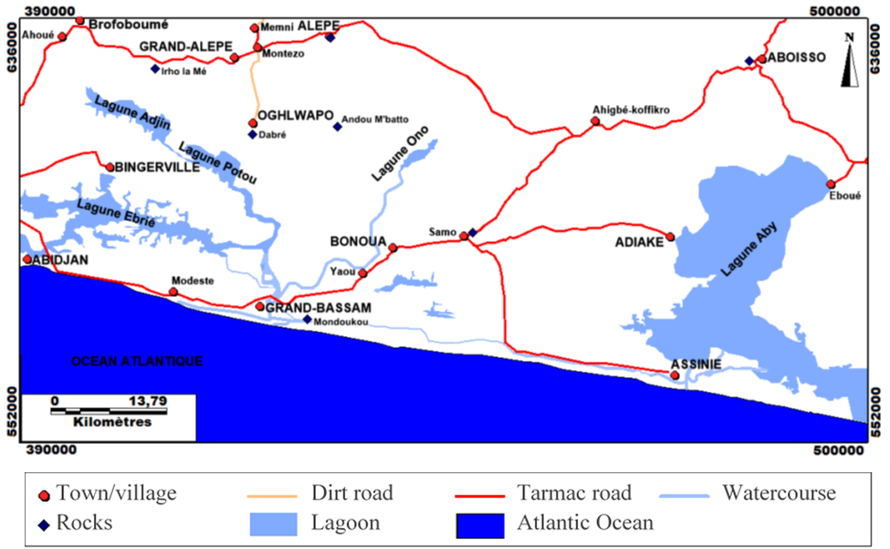

Figure 1: Map of the Study area
2.2 Data Collection and Sampling
Socio-economic data were gathered through a structured questionnaire containing 70 items. The questionnaire was administered by 10 trained enumerators to 280 participants (minimum age: 30 years) across the focal localities of Ahigbé-Koffikro and Samo along the Bonoua–Aboisso highway axis. The survey instrument was structured into four thematic modules: (1) respondent demographics and baseline characteristics; (2) climate change awareness and perceptions; (3) socio-economic and financial consequences of climate anomalies; and (4) local adaptive actions and coping mechanisms.
2.3 Remote Sensing and Statistical Analysis
To quantify environmental changes, Landsat TM (1986) and ETM+ (2000, 2016) satellite images (Path = 195; Row = 056) were acquired to generate diachronic land-use maps (Figure 2). Spatial data processing and supervised classifications were performed using ENVI 4.3 software. Descriptive and inferential statistical analyses of the socio-economic survey data were conducted using IBM SPSS Statistics 20.
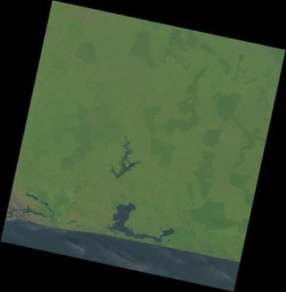
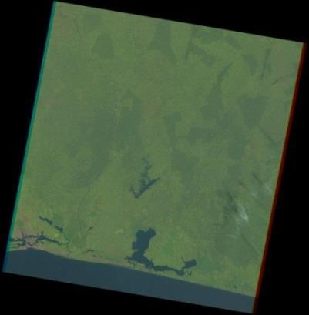
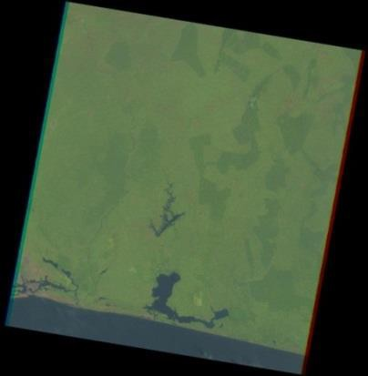

1986 2000 2016
Figure 2: Landsat 5 TM satellite images (1986) and Landsat 7 and 8 ETM+ satellite images (2000 and 2016)
Land use and land cover (LULC) changes were detected using the post-classification diachronic comparison method (Mas, 2000; Lu et al., 2004; Hoang et al., 2008), which has proven effective in Côte d’Ivoire (Soro, 2010, 2014). This method classifies a single scene acquired at different dates through three main steps: geometric correction, image enhancement, and classification. For geometric correction, NASA pre-processed and orthorectified the Landsat TM and ETM+ images using the UTM WGS84 Zone 30 North system before publishing them on USGS Earth Explorer (usgs.gov). For image-contrast enhancement, the study area is fully covered by path/row scene 195-056 (longitudes 4°15'–2°30' W, latitudes 5°00'–6°00' N) for the years 1986, 2000, and 2016. Principal Component Analysis (PCA) and the Normalized Difference Vegetation Index (NDVI) maximised the soil-vegetation contrast. The Red-Green-Blue (RGB) colour space was selected over Intensity-Hue-Saturation (IHS) and Martin Taylor (MT) models (Kouamé, 1999) because of its superior capacity to distinguish features such as forests, water, and built-up areas. Consequently, a 3, 4, 5 band combination (Red: Band 3, Green: Band 4, Blue: Band 5) was selected because it optimally differentiates LULC classes for TM and ETM+ sensors (Soro, 2010, 2014). The classification process involved selecting training areas followed by a priori supervised classification. Training areas were selected based on fieldwork, cartographic reference data, and visual interpretation (Soro, 2014). Training samples were selected to identify six LULC classes: water bodies (lagoons, lakes, and the Comoé River); built-up areas (appearing pink or red on the 3, 4, 5 composite); bare soil (surfaces dominated by soil reflectance, including coastal savannas, rocky outcrops, and quarries); cropland (pineapple, cassava, rice, and banana plantations); dense forest (classified and gallery forests delineated based on ground truth); and marshlands or wetlands (flooded and flood-prone areas).
While unsupervised classification automatically clusters radiometrically similar pixels, supervised classification assigns pixels to the nearest training samples using a Bayesian distance metric (Kouassi, 2007). The Maximum Likelihood algorithm was applied and has consistently yielded strong results in similar regional studies (e.g., Kouassi, 2007; Hoang et al., 2008; Soro, 2010, 2014). This algorithm categorises pixels based on the representative spectral signatures of the training areas. Classifications were validated using a confusion matrix, the Kappa index, and extensive ground-truth data from fieldwork, sampling campaigns, and socio-economic surveys conducted between December 2013 and September 2014. Training classes are considered reliable when their internal correlation in the confusion matrix reaches or exceeds 70% (Soro, 2014). The Kappa index (k) validates vegetation classification accuracy (Pontius, 2000) using Equation 1:
$$k=\frac{P_{0}-P_{c}}{P_{p}-P_{c}}$$
Where P0 is the observed overall accuracy, PC is the expected chance-agreement probability, and Pp is the perfect classification percentage (100%). According to Landis and Koch (1977), Kappa values range from slight agreement (0–0.20) to almost perfect agreement (0.81–1). To analyse the LULC dynamics and vegetation degradation under anthropogenic pressure, the average annual rate of spatial expansion (E) was calculated alongside absolute variations using the formula in Equation 2 from Mama and Oloukoi (2003):
$$E=\frac{V_{I2}-V_{I1}}{100×P}$$
Where Vi2 is the statistical value of stratum i for the target year, Vi1 is the value for the baseline year, and P is the duration of the period in years.

3. Results
3.1 Population Perceptions of Climate Impacts
The survey sample had an age range of 30 to 84 years, with a mean age of 49 years. Climate change awareness was near-universal, with 99.6% of respondents reporting observable shifts over the past decade. Gender-disaggregated perceptual data showed that 41.4% of men perceived an increase in rainfall intensity, while 26.8% observed a delayed onset of the rainy season.
Agriculture was the primary livelihood, engaging 57.5% of the population in Ahigbé-Koffikro and 55.5% in Samo. This was supplemented by commerce (25.0% in Samo; 16.2% in Ahigbé-Koffikro), civil service/salaried employment, and transport. Rubber (Hevea brasiliensis) and cassava were the dominant crops. Large-scale agro-industrial oil palm plantations (operated by PALMCI and PALMAFRIQUE) employed 25% of respondents in Ahigbé-Koffikro. Historically dominant crops such as pineapple had fallen to fourth place, while coffee and cocoa production showed significant declines.
Overall, 81.4% of farmers reported substantial declines in crop yields and product quality, leading directly to decreased household incomes. Conversely, a small minority (7.2%) noted a temporary yield increase attributed to heavy rainfall in 2014, while salaried workers reported stable economic conditions.
The very high level of climate-change awareness observed here is consistent with evidence from other West African farming systems showing that farmers often perceive changes in rainfall timing, rainfall amount, and temperature that broadly correspond with instrumental climate records (Ayanlade et al., 2017; Kone et al., 2022). Such perceptions are analytically important because they can shape the selection and timing of farm-level adaptation measures, particularly in rain-fed systems where seasonal uncertainty directly affects crop establishment and yield formation (Sultan & Gaetani, 2016).
3.2 Environmental and Ecosystem Shifts
Respondents noted severe ecological disruptions linked to shifts in precipitation and rising temperatures, notably the localised disappearance of flora and fauna. Specific losses included coffee trees and Thaumatococcus daniellii (locally used for text wrapping), alongside declines in pangolin and locust populations. Concurrently, climate-driven ecosystem degradation accelerated coastal erosion and damaged rural access roads. Although mean annual rainfall remained high (~1,600 mm), the primary agricultural constraint was the increasing unpredictability and disruption of traditional crop seasons.
The reported ecological changes should be interpreted as the combined outcome of climatic stress and land-use pressure rather than as evidence of a single causal driver. Climate-model analyses project increasing warm extremes in Côte d'Ivoire, while remote-sensing studies elsewhere in the country document substantial forest conversion and land degradation associated with agricultural expansion and population pressure (Yapo et al., 2019; Kouassi et al., 2021). In the Abidjan lagoonal environment, long-term urban reclamation and wetland transformation further illustrate how anthropogenic modification can intensify the vulnerability of low-lying coastal ecosystems (Sultan & Gaetani, 2016).
3.3 Agro-Ecological and Autonomous Adaptation Strategies
Faced with economic strain, 32.7% of households transitioned out of primary crop production. Diversification pathways (Table 1) included poultry farming, urban transport, and commercial reorientation. Within agriculture, farmers systematically shifted away from water-sensitive crops (pineapple, coffee, cocoa, maize, and coconut) towards drought-resistant or water-efficient alternatives such as rubber, oil palm, and cassava.
The portfolio of responses identified in the survey is consistent with adaptation pathways reported in West African smallholder systems, where shifting sowing dates, adopting more suitable varieties, diversifying crops or income sources, and adjusting land-management practices are recurrent responses to climate variability (Sultan & Gaetani, 2016; Kone et al., 2022). The observed movement toward lowland or wetland rice production also has a regional analogue: evidence from Côte d'Ivoire and Ghana indicates that adoption of inland-valley farming is shaped by household resources, farm size, competing perennial crops, and access to local institutions and services (Alemayehu & Van der Werf, 2026). Accordingly, the strategies recorded here are better viewed as context-dependent livelihood adjustments than as uniformly effective adaptations.
Table 1. Local adaptation methods disaggregated by gender.
Adaptation Method | Male (%) | Female (%) | Total Share (%)
Soil Fertilisation Techniques | 20.8 | 9.3 | 30.1
Introduction of New Crops | 11.5 | 1.6 | 13.1
Livelihood Diversification | 7.1 | 0.0 | 7.1
Improved Crop Varieties | 4.4 | 0.5 | 4.9
Staggered Sowing / Multiple Re-seedings | 1.1 | 0.0 | 1.1
Localised Reforestation | 0.5 | 0.0 | 0.5
No Adaptation Action | 22.4 | 15.8 | 38.3
Other Strategies | 4.4 | 0.5 | 4.9

3.4 Diachronic Land-Use Change Analysis (1986–2016)
Supervised classification of satellite imagery demonstrated major spatial rearrangements over the 30-year study period. The overall classification accuracy was highly robust, yielding global accuracies of 99.35% (1986) and 98.92% (2000), with corresponding Kappa coefficients of 0.99 and 0.98. Table 2 presents the evolution of land-cover classes from 1986 to 2016.
Table 2. Evolution of land cover classes from 1986 to 2016.
Land Cover Class | 1986 Surface (%) | 2000 Surface (%) | 2016 Surface (%) | Net Change (%)
Agricultural Zones | 38.01 | 41.02 | 38.40 | +0.39
Water Bodies | 31.11 | 30.99 | 30.82 | -0.29
Built-up / Settlements | 11.09 | 12.25 | 18.80 | +7.71
Dense Forest | 16.94 | 14.86 | 7.56 | -9.38
Bare Soil | 0.16 | 0.88 | 4.42 | +4.26
Marshlands / Wetlands | 2.69 | 0.00 | 0.00 | -2.69
Key spatial dynamics reveal that built-up areas expanded by 7.71%, driven by demographic growth and urbanisation. Conversely, dense forests decreased by 9.38%, signalling severe deforestation. The diachronic land-use analysis highlights a major spatial rearrangement characterised by the complete disappearance of the marshland class, which declined from 2.69% of the total study area in 1986 (Figure 3) to 0.00% by 2000 (Figure 4). This marked regression of surface wetlands is attributed to the combined effects of climatic and anthropogenic factors. On the one hand, the region experienced prolonged and sub-continuous droughts between 1971 and 2000, which triggered the progressive drying of low-lying wetland basins.
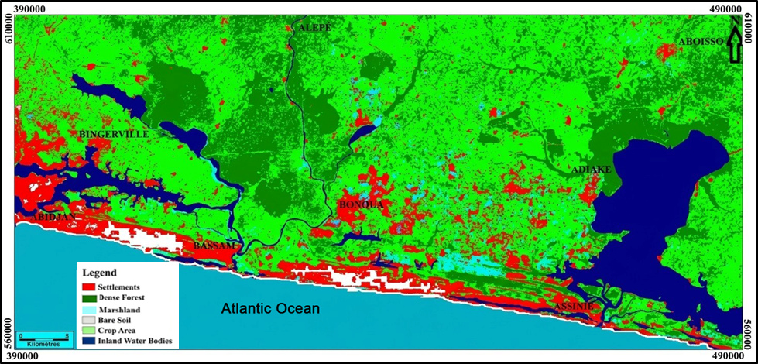
Figure 3: Land use and land cover map of the southeastern coastal zone in 1986: baseline status of forest and marshland ecosystems.
On the other hand, to cope with moisture deficits on the uplands, local populations deployed an autonomous adaptation strategy by opportunistically converting these dried marshland beds into rice paddies (Figure 5). This spatial dynamic highlights a structural shift towards wetland farming, transforming a vulnerable natural ecosystem into a livelihood resource to mitigate declining yields in traditional rain-fed agriculture.
The direction of land-cover change is broadly consistent with longer-term evidence from Côte d'Ivoire, where Landsat-based studies have documented forest loss, agricultural expansion, and settlement growth over recent decades (Kouassi et al., 2021; Kouame et al., 2019). Around Abidjan, progressive reclamation and occupation of lagoonal and marshy margins have likewise reduced aquatic and wetland space, demonstrating that urban growth can directly reconfigure coastal land-water boundaries (Sultan & Gaetani, 2016). The conversion of former marshlands into rice fields in the present study is also compatible with the wider importance of lowland rice systems in Côte d'Ivoire, although such conversion should not be interpreted as exclusively climate-driven because agricultural demand, land availability, and institutional factors can also influence lowland adoption (Komatsu et al., 2022; Alemayehu & Van der Werf, 2026).

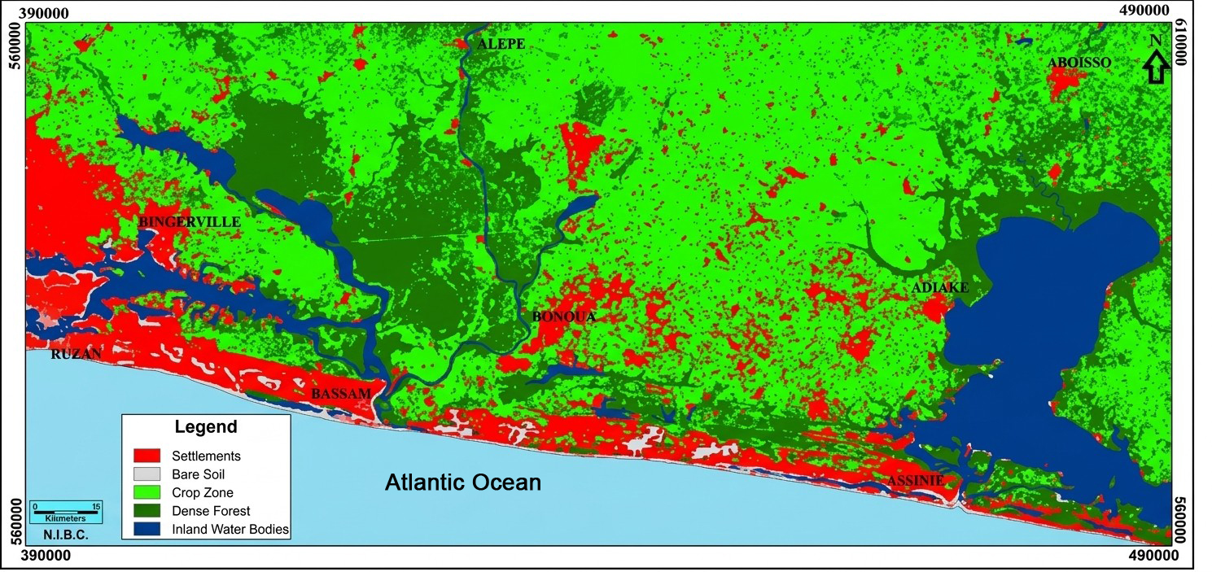
Figure 4: Land use and land cover map in 2000: markers of the initial agricultural transition phase and complete marshland loss.
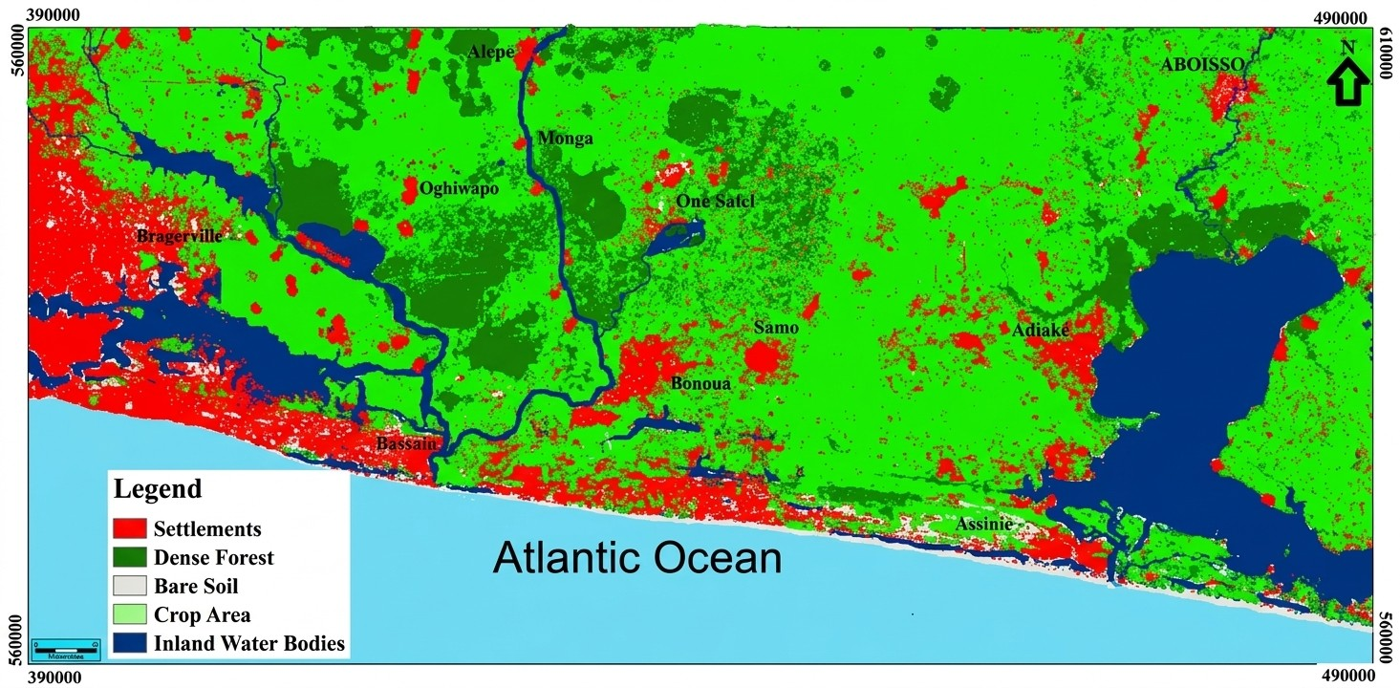
Figure 5: Land use and land cover map in 2016: intensification of anthropogenic pressure and urban expansion.

4. Discussion
The strong alignment between local climate-change perceptions in the Abidjan–Aboisso corridor and actual meteorological anomalies corroborates regional findings across West Africa (Al Hamndou & Requier-Desjardins, 2008; Balme, 2005; Soro, 2010; Soro, 2014). For instance, smallholder observations mirror findings from Dimbokro, Côte d'Ivoire, and rural Burkina Faso, where over 76% of farmers reported highly disrupted rainfall patterns (Diomandé, 2013; Ouédraogo et al., 2010; Yapi, 2014). The perceived decline in crop yields is directly explained by the shortening of the bioclimatic growing period, which fails to cover the full physiological growth cycle of traditional crops.
To preserve yields, the observed adoption of chemical and organic fertilisers and early-maturing, short-cycle crop varieties matches documented trends in the regional climate-adaptation literature (Global Water Partnership, 2010; UNDP, 2009). The systematic expansion of agricultural land into former marshlands underscores a structural transition towards opportunistic wetland farming as an autonomous defence against upland moisture deficits (Dioum, 2010; Dugué, 2012; Mbaye et al., 2011; Ouaga, 2009; Tidjani & Akponikpe, 2012).
Taken together, the results support a socio-ecological interpretation in which perceived climatic disruption, livelihood adjustment, and land-cover change interact rather than operate independently. Studies comparing farmer perceptions with meteorological records show that local observations can capture meaningful shifts in rainfall and temperature, but the strength and direction of perceived impacts remain context-specific (Ayanlade et al., 2017; Kone et al., 2022). This cautions against attributing every observed livelihood or ecological change solely to climate variability and supports consideration of demographic, land-use, and market pressures alongside climatic factors.
From an agricultural perspective, the observed emphasis on crop substitution, improved varieties, sowing adjustments, and lowland rice expansion is consistent with the broader adaptation literature for West Africa (Sultan & Gaetani, 2016). Modelling work indicates that higher temperatures can shorten rice growth duration and reduce yields in African rice systems, while evidence from Côte d'Ivoire shows that recent growth in lowland rice production has been driven substantially by expansion of cropped area as well as yield improvement (Van Oort & Zwart, 2018; Komatsu et al., 2022). The marshland-to-rice transition identified by the present land-use analysis can therefore be interpreted as one component of a wider livelihood response, but its ecological trade-offs warrant careful consideration where wetland functions are being replaced by agriculture.
Evidence from inland-valley farming in Côte d'Ivoire and Ghana further shows that household resource endowments and competing land uses influence whether farmers adopt lowland rice production, reinforcing that adaptive capacity is socially differentiated rather than uniform across households (Alemayehu & Van der Werf, 2026).
5. Conclusion
The study demonstrates that households along the southeastern coastal corridor of Côte d’Ivoire have responded to climate variability through a combination of agricultural adjustment, livelihood diversification, and land-use change. Most respondents recognised changes in climatic conditions, and a large proportion reported declining crop yields, product quality, and household income. Adaptation measures included soil fertilisation, introduction of new crops, improved varieties, staggered sowing, localised reforestation, and shifts towards alternative income-generating activities. The land-cover analysis also documented substantial spatial change between 1986 and 2016, including expansion of built-up areas, reduction of dense forest, and the disappearance of the mapped marshland class after 1986. The conversion of former marshland areas to rice cultivation illustrates how livelihood responses can become embedded in landscape change. These findings indicate that adaptation in the study area is not a single agricultural response but a broader socio-ecological process shaped by climatic stress, land availability, livelihood needs, and other anthropogenic pressures.

Limitation:
This study is limited by its reliance on household perceptions to characterise several climate-related livelihood effects and by the temporal spacing of the three satellite-image observations used for land-cover analysis. The survey represents selected localities along the Abidjan–Aboisso corridor and therefore should not be interpreted as statistically representative of all coastal communities in Côte d’Ivoire. In addition, observed land-cover transitions cannot be attributed exclusively to climate variability because demographic, agricultural, market, and other anthropogenic pressures may have contributed concurrently.

DECLARATION OF AI USE

This manuscript was prepared through the intellectual contributions of the author(s) to the study design, data analysis, interpretation of results, and scholarly content. Grammarly and ChatGPT were used solely to assist with grammatical refinement and reference formatting during manuscript revision. The author(s) accept full responsibility for the accuracy, integrity, and final content of the manuscript.

COMPETING INTERESTS DISCLAIMER:
Authors have declared that they have no known competing financial interests OR non-financial interests OR personal relationships that could have appeared to influence the work reported in this paper.

References

Ake, G. E. (2010). Impacts de la variabilité climatique et des pressions anthropiques sur les ressources hydriques de la région de Bonoua (Sud-Est de la Côte d’Ivoire) [Doctoral dissertation, University of Cocody-Abidjan].
Al Hamndou, D., & Requier-Desjardins, M. (2008). Variabilité climatique, désertification et biodiversité en Afrique : S’adapter, une approche intégrée. VertigO – La revue électronique en sciences de l’environnement, 8(1). https://doi.org/10.4000/vertigo.5356
Alemayehu, T., & Van der Werf, E. (2026). Adoption of inland valley farming and rice production practices: Evidence from smallholder farmers in Côte d’Ivoire and Ghana. Agricultural and Resource Economics Review, 55(1), 145–165. https://doi.org/10.1017/age.2025.10018
Ayanlade, A., Radeny, M., & Morton, J. F. (2017). Comparing smallholder farmers’ perception of climate change with meteorological data: A case study from southwestern Nigeria. Weather and Climate Extremes, 15, 24–33. https://doi.org/10.1016/j.wace.2016.12.001
Balme, M., Galle, S., & Lebel, T. (2005). Démarrage de la saison des pluies au Sahel : Variabilité aux échelles hydrologique et agronomique, analysée à partir des données EPSAT-Niger. Sécheresse, 16(1), 15–22.
Bello, L. O., Awotide, B. A., & Sakurai, T. (2024). Climate change adaptation and smallholder farmers welfare: Empirical evidence from the Sahelian Region of West Africa. Land Use Policy, 142, 107181. https://doi.org/10.1016/j.landusepol.2024.107181
Diomandé, M. (2013). Impact du changement de pluviosité sur les systèmes de production agricoles en zone de contact forêt-savane de Côte d’Ivoire [Doctoral dissertation, Félix Houphouët-Boigny University].
Dioum, A. (2010). Stratégies endogènes d’adaptation aux changements climatiques : Recul des cultures sous pluie et extension de l’arboriculture associée dans la communauté rurale de Taïba Ndiaye [Master’s thesis, École Nationale d’Économie Appliquée, Dakar].
Djezou, W. B., & N’Goran, F. (2024). Climate change adaptation mechanisms for smallholder farmers in Côte d’Ivoire. Asian Journal of Agricultural Extension, Economics & Sociology, 42(11), 263–283. https://doi.org/10.9734/ajaees/2024/v42i112612
Dugué, M.-J. (2012). Caractérisation des stratégies d’adaptation au changement climatique en agriculture paysanne. Agronomes et Vétérinaires Sans Frontières.
Sultan, B., & Gaetani, M. (2016). Agriculture in West Africa in the twenty-first century: Climate change and impacts scenarios, and potential for adaptation. Frontiers in Plant Science, 7, 1262. https://doi.org/10.3389/fpls.2016.01262
Hoang, K. H., Bernier, M., & Villeneuve, J.-P. (2008). Les changements de l’occupation du sol dans le bassin versant de la rivière Câu (Viêt-Nam) : Essai sur une approche diachronique. Télédétection, 8(4), 227–236.
Ikenga, U. V. (2025). Economic impact of climate change on agriculture and food security: A comparative study of smallholder farmers in Nigeria and Ghana. Asian Journal of Research and Review in Agriculture, 7(1), 39–51. https://doi.org/10.56557/ajrra/2025/v7i1153
Komatsu, S., Saito, K., & Sakurai, T. (2022). Changes in production, yields, and the cropped area of lowland rice over the last 20 years and factors affecting their variations in Côte d’Ivoire. Field Crops Research, 277, 108424. https://doi.org/10.1016/j.fcr.2021.108424
Kone, I., Agyare, W. A., Gaiser, T., Owusu-Prempeh, N., Kouadio, K.-K. H., Kouadio, E. N., & Amponsah, W. (2022). Local cotton farmers’ perceptions of climate change events and adaptations strategies in cotton basin of Cote d’Ivoire. Journal of Sustainable Development, 15(3), 108–124. https://doi.org/10.5539/jsd.v15n3p108
Kouamé, K. F. (1999). Hydrogéologie des aquifères discontinus de la région semi-montagneuse de Man-Danané (Ouest de la Côte d’Ivoire) : Apport des données des images satellitaires et des méthodes statistique et fractale à l’élaboration d’un système d’information hydrogéologique à référence spatiale [Doctoral dissertation, Université de Cocody].
Kouame, Y. M., Obahoundje, S., Diedhiou, A., François, B., Amoussou, E., Anquetin, S., Didi, R. S., Kouassi, L. K., Bi, V. H. N., Soro, E. G., & Yao, E. K. (2019). Climate, land use and land cover changes in the Bandama Basin (Côte d’Ivoire, West Africa) and incidences on hydropower production of the Kossou Dam. Land, 8(7), 103. https://doi.org/10.3390/land8070103
Kouassi, A. M. (2007). Caractérisation d’une modification éventuelle de la relation pluie-débit et ses impacts sur les ressources en eau en Afrique de l’Ouest : Cas du bassin versant du N’zi (Bandama) en Côte d’Ivoire [Doctoral dissertation, Université de Cocody].
Kouassi, J.-L., Gyau, A., Diby, L., Bene, Y., & Kouamé, C. (2021). Assessing land use and land cover change and farmers’ perceptions of deforestation and land degradation in south-west Côte d’Ivoire, West Africa. Land, 10(4), 429. https://doi.org/10.3390/land10040429
Kpan, O. J. G. (2017). Incidence de la variabilité climatique sur les ressources en eau, le développement agricole et la santé des populations dans le Sud-Est de la Côte d’Ivoire et prospectives : Cas de la zone littorale d’Abidjan à Aboisso [Doctoral dissertation, Félix Houphouët-Boigny University]. https://uemoa.switch-maker.net/sites/default/files/bibliotheque/compendium-des-travaux-de-recherche-soutenus-par-le-projet-dappui-lenseignement-superieur-paes-dans.pdf
Landis, J. R., & Koch, G. G. (1977). The measurement of observer agreement for categorical data. Biometrics, 33(1), 159–174. https://doi.org/10.2307/2529310
Lu, D., Mausel, P., Brondízio, E., & Moran, E. (2004). Change detection techniques. International Journal of Remote Sensing, 25(12), 2365–2401. https://doi.org/10.1080/0143116031000139863
Mama, V. J., & Oloukoi, J. (2003). Évaluation de la précision des traitements analogiques des images satellitaires dans l’étude de la dynamique de l’occupation du sol. Télédétection, 3(5), 429–441.
Mas, J.-F. (2000). Une revue des méthodes et des techniques de télédétection du changement. Canadian Journal of Remote Sensing, 26(4), 349–362. https://doi.org/10.1080/07038992.2000.10874785
Mbaye, I., Sané, T., & Dièye, E. B. (2011). Changement climatique, perceptions et stratégies des populations de la ville de Ziguinchor au Sénégal. In Actes du colloque « Renforcer la résilience au changement climatique des villes : Du diagnostic spatialisé aux mesures d’adaptation », Université Paul Verlaine-Metz, France.
N’Guessan, K. J.-Y., Adahi, B. M., Konan-Waidhet, A. B., Kouassi, B. S. A., Seri, J. A. E., Kra, L. J., Satoh, M., & Assidjo, N. E. (2025). A vulnerability assessment of rice farmers to climate change in Yamoussoukro, central Côte d’Ivoire. Environmental Development, 56, 101311. https://doi.org/10.1016/j.envdev.2025.101311
Oga, Y. M. S., Adja, M., Yapi, A. F., Kpan, J. G., Baka, D., Yao, K. T., & Biemi, J. (2016). Projection de la variabilité climatique à l’horizon 2050 dans la zone côtière au Sud-Est de la Côte d’Ivoire (d’Abidjan à Aboisso). Larhyss Journal, 25, 67–81. https://univ-biskra.dz/sites/lab/Larhyss/images/pdf/JOURNAL%C2%B025/4.Oga%26al.pdf
Ouaga, H. N. (2009). Vulnérabilité, impacts et stratégies d’adaptation des populations locales à la variabilité et aux changements climatiques [Regional report]. AGRHYMET Regional Centre.
Ouédraogo, M., Dembélé, Y., & Somé, L. (2010). Perceptions et stratégies d’adaptation aux changements des précipitations : Cas des paysans du Burkina Faso. Sécheresse, 21(2), 87–96. https://doi.org/10.1684/sec.2010.0244
Pontius, R. G., Jr. (2000). Quantification error versus location error in comparison of categorical maps. Photogrammetric Engineering & Remote Sensing, 66(8), 1011–1016. https://commons.clarku.edu/faculty_geography/794/
Soro, G. (2010). Évaluation quantitative et qualitative des ressources en eau souterraines dans la région des lacs (Centre de la Côte d’Ivoire) [Doctoral dissertation, University of Cocody-Abidjan].
Soro, T. (2014). Évolution des ressources en eau du bassin versant du Haut Bandama à Tortiya (Nord de la Côte d’Ivoire) dans un contexte de variabilité et de changement climatiques [Doctoral dissertation, Félix Houphouët-Boigny University].
Sultan, B., & Gaetani, M. (2016). Agriculture in West Africa in the twenty-first century: Climate change and impacts scenarios, and potential for adaptation. Frontiers in Plant Science, 7, 1262. https://doi.org/10.3389/fpls.2016.01262
Tidjani, M. A., & Akponikpe, P. B. I. (2012). Évaluation des stratégies paysannes d’adaptation aux changements climatiques : Cas de la production du maïs au Nord-Bénin. African Crop Science Journal, 20(Supplement 2), 425–441. https://doi.org/10.4314/acsj.v20i2
United Nations Development Programme. (2009). Programme d’appui à la réduction de la pauvreté et à la réalisation des OMD (PARP/OMD), 2009–2013.
Van Oort, P. A. J., & Zwart, S. J. (2018). Impacts of climate change on rice production in Africa and causes of simulated yield changes. Global Change Biology, 24(3), 1029–1045. https://doi.org/10.1111/gcb.13967
Wollburg, P., Markhof, Y., Bentze, T., & Ponzini, G. (2024). Substantial impacts of climate shocks in African smallholder agriculture. Nature Sustainability, 7(11), 1525–1534. https://doi.org/10.1038/s41893-024-01411-w
Yapi, A. F. (2014). Étude de la variabilité climatique et son impact sur les ressources en eau de la zone côtière de la Côte d’Ivoire (d’Abidjan à Aboisso) [Master’s thesis, Félix Houphouët-Boigny University]. https://uemoa.switch-maker.net/sites/default/files/bibliotheque/compendium-des-travaux-de-recherche-soutenus-par-le-projet-dappui-lenseignement-superieur-paes-dans.pdf
Yapo, A. L. M., Diawara, A., Yoroba, F., Kouassi, B. K., Sylla, M. B., Kouadio, K., Odoulami, R. C., & Tiémoko, D. T. (2019). Twenty-first century projected changes in extreme temperature over Côte d’Ivoire (West Africa). International Journal of Geophysics, 2019, Article 5610328. https://doi.org/10.1155/2019/5610328

