Original Research Article

‘Sustainable Coffee Seedling Production through Rhizophagus intraradices Inoculation and Organic Substrate Management in Motozintla, Chiapas

ABSTRACT

Aims: We evaluated the morphological and physiological response of coffee plants (Coffea arabica) grown with organic substrates in combination with the mycorrhizal fungus Rhizophagus intraradices under conditions in Motozintla, Chiapas.
Study design: The experiment followed a completely randomized design with five treatments and ten replicates.
Place and Duration of Study: The study was carried out under open-air conditions in Motozintla, Chiapas, Mexico, between July and October 2025.
Methodology: Five substrate combinations were compared: soil + mycorrhiza + vermicompost (T1), soil + mycorrhiza + poultry manure (T2), soil + mycorrhiza + mango sawdust (T3), soil + mycorrhiza + fermented coffee pulp (T4), and soil + mycorrhiza as the control (T5). Leaf length, leaf diameter, stem diameter, leaf area, fresh weight, dry weight, and root length were evaluated between 21 and 210 days after sowing.
Results: For most of the variables measured, treatments that included an organic substrate showed better responses than the control. T4 had the greatest leaf length, leaf area (>330 cm²), and biomass accumulation (12 g fresh weight and 4.0 g dry weight). T1, in contrast, recorded the highest leaf diameter, stem diameter, and root length (>21 cm). Leaf area and biomass in T2 and T3 remained below the values observed in the control.
Conclusion: The response to R. intraradices varied with the quality of the organic matter added to the substrate. Among the materials tested, fermented coffee pulp and vermicompost provided the most favorable conditions for coffee seedling production.

Keywords: coffee seedlings, organic substrates; arbuscular mycorrhiza; Rhizophagus intraradices,; vermicompost; organic substrates; nursery.

1. INTRODUCTION

Coffee has a long history as both a crop and a beverage, shaped by trade routes and by its movement through Arab, Turkish, and later European societies (Herrera & Cortina, 2013). The crop originated in Ethiopia, and its early cultivation and spread through Yemen and the Arab world have been well documented (Herrera & Cortina, 2013). Today, coffee remains an important crop for the economy and livelihoods of producing regions in Latin America, Africa, and Asia (Coutiño-Puchuli et al., 2017).

In Mexico, close to 700,000 ha are planted with coffee, and Chiapas contributes 40.7% of national production (Servicio de Información Agroalimentaria y Pesquera [SIAP], 2018). Rural populations that depend heavily on agriculture are especially exposed to changes in temperature and rainfall because these changes alter agroclimatic conditions and planting calendars (GTZ GmbH & Cafédirect, 2010). In coffee, climate and crop management also affect flowering and fruit development (Fournier & Di Stéfano, 2004). Nursery studies have reported positive responses of coffee seedlings to arbuscular mycorrhizae and other beneficial microorganisms (Aguirre-Medina et al., 2011; Hernández-Acosta et al., 2020). Against this background, combining coffee-processing by-products or other organic fertilizers with arbuscular mycorrhizae may offer a practical option for improving seedling growth under the conditions of Motozintla, Chiapas.
The objective of this study was to evaluate the morphological and physiological growth of Coffea arabica seedlings grown with Rhizophagus intraradices in combination with vermicompost, poultry manure, mango sawdust, or fermented coffee pulp under nursery conditions in Motozintla, Chiapas. Specifically, the study examined morphological growth responses and assessed leaf area, fresh and dry biomass, and root development across the substrate combinations.

2. METHODOLOGY
2.1. Geographic location and site conditions
The experiment was conducted outdoors in the Nueva Esperanza neighborhood, San José Ixtepec ejido, in the municipality of Motozintla, Chiapas (15° 22' N, 92° 15' W; 1,528 m above sea level). The area is predominantly warm and humid, with annual precipitation of approximately 1,000-5,000 mm and temperatures ranging from 12 to 26 °C.

2.2. Experimental design and biological material
The soil mixture used consisted of 50% sand and 50% soil taken from the orchard where the work was conducted. Two grams of *Rhizophagus intraradices* were added per plant; this product contains 40 to 50 spores per gram, along with fungal propagules that facilitate plant colonization.

A completely randomized design was used, with five treatments and ten plants assigned to each treatment during the July-October 2025 experimental period. Germinated Marsellesa coffee plants were grown with different organic materials, including vermicompost, mango sawdust, poultry manure, and fermented coffee pulp, together with mycorrhiza and soil containing organic matter. The treatments were: (1) soil + mycorrhiza + vermicompost; (2) soil + mycorrhiza + poultry manure; (3) soil + mycorrhiza + mango sawdust; (4) soil + mycorrhiza + fermented coffee pulp; and (5) soil + mycorrhiza as the control. All treatments were maintained under the soaking condition (C/R).

2.3. Variables evaluated and statistical analysis
Leaf length, leaf diameter, and stem diameter were recorded at 21, 42, 63, 84, 105, 126, 147, 168, 189, and 210 days after sowing (DAS). Although ten plants per treatment were established at the beginning of the experiment, eight complete observations per treatment were available at each sampling date for the descriptive analysis of these growth variables. For every treatment and sampling date, the results were summarized as the mean ± standard error (SE).
Leaf area, fresh weight, dry weight, and root length required destructive sampling and were therefore measured in two plants per treatment. Given this small number of experimental units, these variables were treated descriptively. The individual observations are shown together with the mean ± SE.
The dataset was organized in Microsoft Excel and processed in Python. Growth over time was plotted as treatment means with SE at each sampling date. Leaf area and root length were shown as point-and-error plots, while the fresh- and dry-weight components (stem, leaves, root, and total biomass) were displayed as grouped point plots. Inferential tests were not applied to the destructive variables because only two plants were available per treatment (n = 2). These responses were therefore interpreted descriptively, and P values are not reported.

Limitations
This study has some limitations that should be considered when interpreting the results. Because all treatments received Rhizophagus intraradices, the absence of a non-mycorrhizal control does not allow the effects of mycorrhizal inoculation to be distinguished from those of the organic amendments. In addition, leaf area, fresh weight, dry weight, and root length were measured in only two plants per treatment (n = 2); these observations were therefore interpreted descriptively and do not support robust statistical comparisons. The experiment was also conducted over a limited period and at a single location, so the results should be applied cautiously beyond the nursery conditions of Motozintla, Chiapas. Further studies with a non-mycorrhizal control, larger sample sizes for destructive measurements, and trials across multiple locations and growing seasons would help assess the consistency of these responses.

3. RESULTS AND DISCUSSION

3.1. Morphological variables
3.1.1. Leaf length
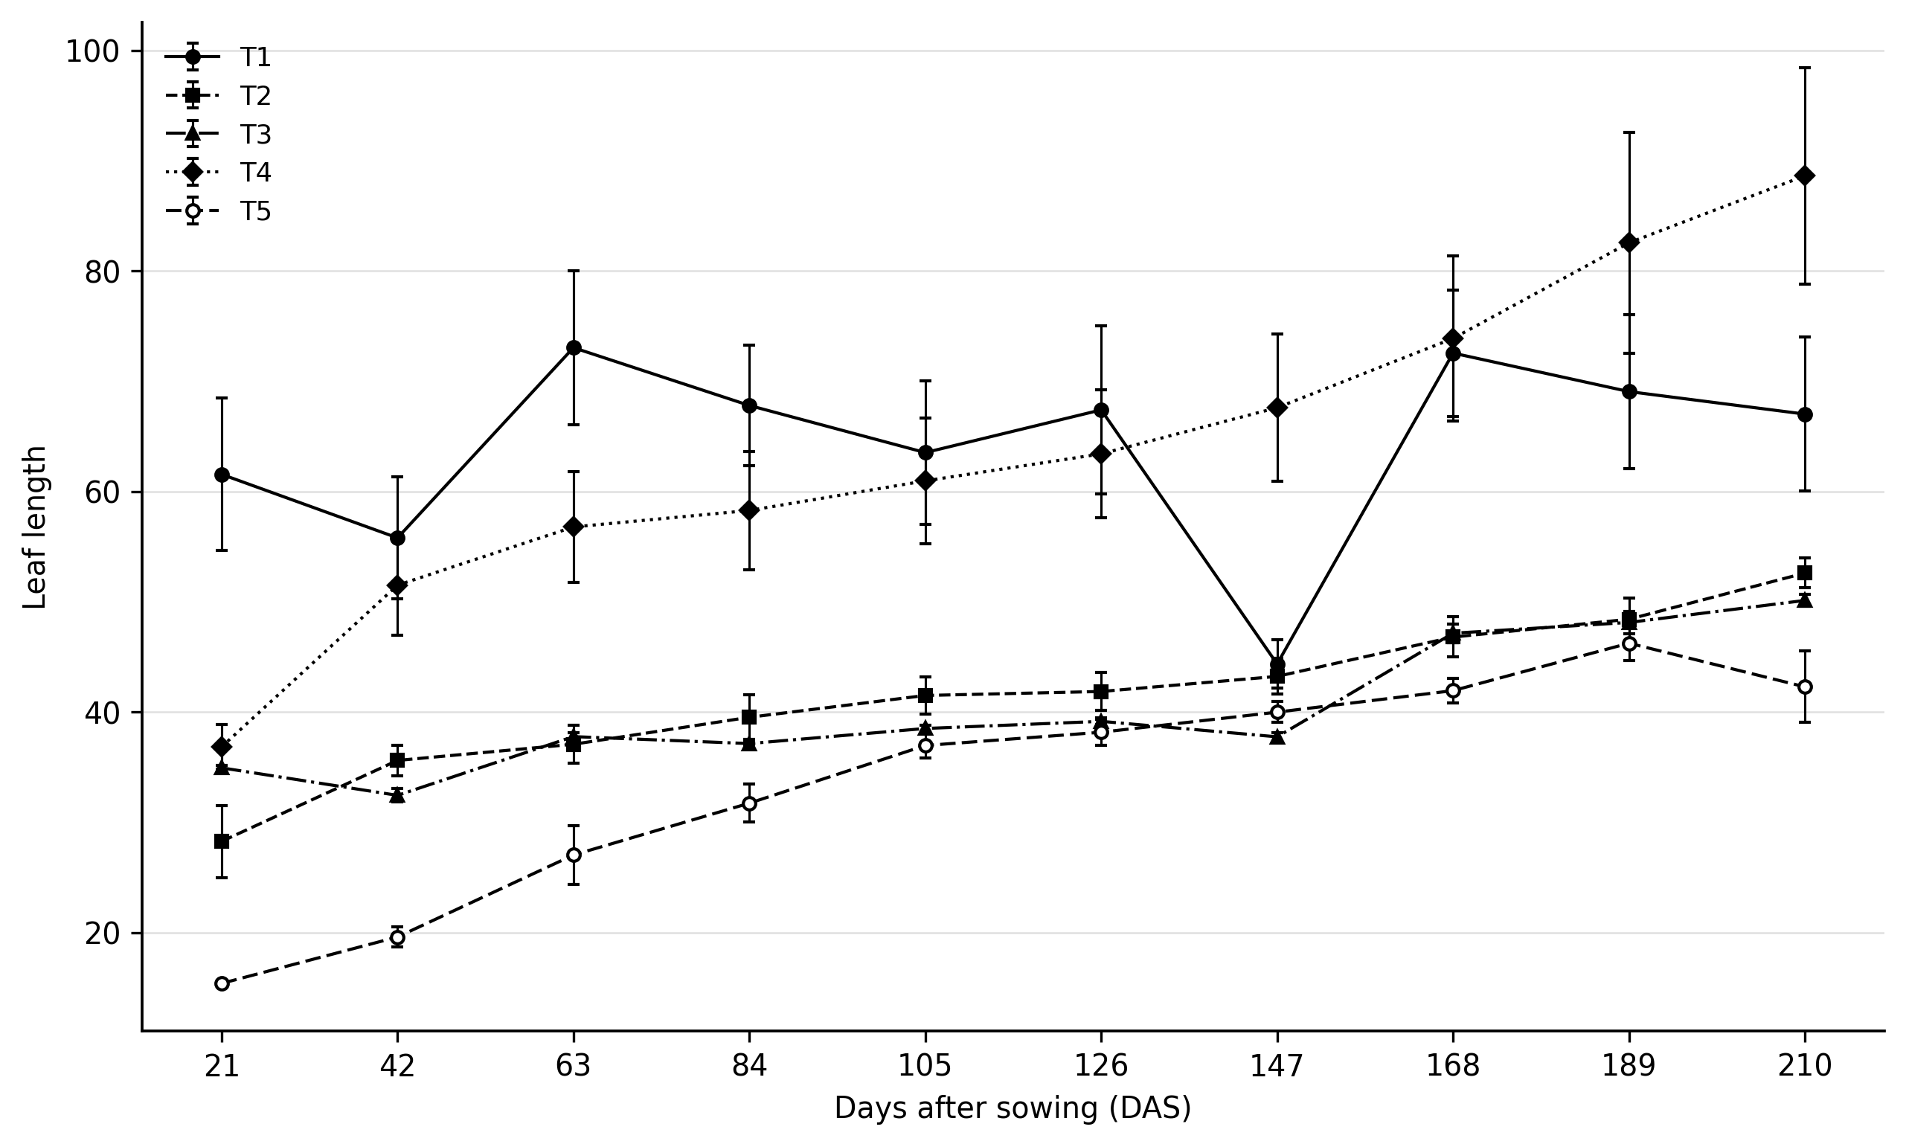
Fig. 1. Leaf length growth of coffee plants under five organic substrates (1. soil + mycorrhiza + vermicompost; 2. soil + mycorrhiza + poultry manure; 3. soil + mycorrhiza + mango sawdust; 4. soil + mycorrhiza + fermented coffee pulp; 5. control: soil + mycorrhiza), all with soaking (C/R), from 21 to 210 days after sowing (DAS).

Treatment differences were evident from the early measurements (Figure 1). Plants in the organic-substrate treatments generally had greater leaf length than the control. T1 (vermicompost) showed the strongest increase during the first 60 days, but its values became more variable later in the experiment. T4 (fermented coffee pulp) increased more clearly after 147 DAS and finished with the greatest leaf length, at approximately 90 units. T2 (poultry manure) and T3 (mango sawdust) increased more gradually, whereas T5 remained below the treatments that received an organic substrate.

The response observed in T4 agrees with previous work showing that coffee-processing residues can have agronomic value when they are reused as organic materials (Murthy & Naidu, 2012; Pandey et al., 2000). In this treatment, the presence of R. intraradices may also have contributed to nutrient acquisition, as arbuscular mycorrhizae have been reported to support nutrient uptake and seedling development in coffee (Hernández-Acosta et al., 2020). The early increase in T1, followed by a period of stabilization, is also compatible with the improved nutrient supply reported for vermicompost and other organic amendments in coffee nurseries (Aguilar Jiménez et al., 2016; Canseco Martínez et al., 2020). By comparison, the weaker response in T3 is consistent with the temporary nutrient immobilization that can occur in sawdust-based substrates (Pineda Pineda et al., 2019; Sery et al., 2025).

3.1.2. Stem diameter
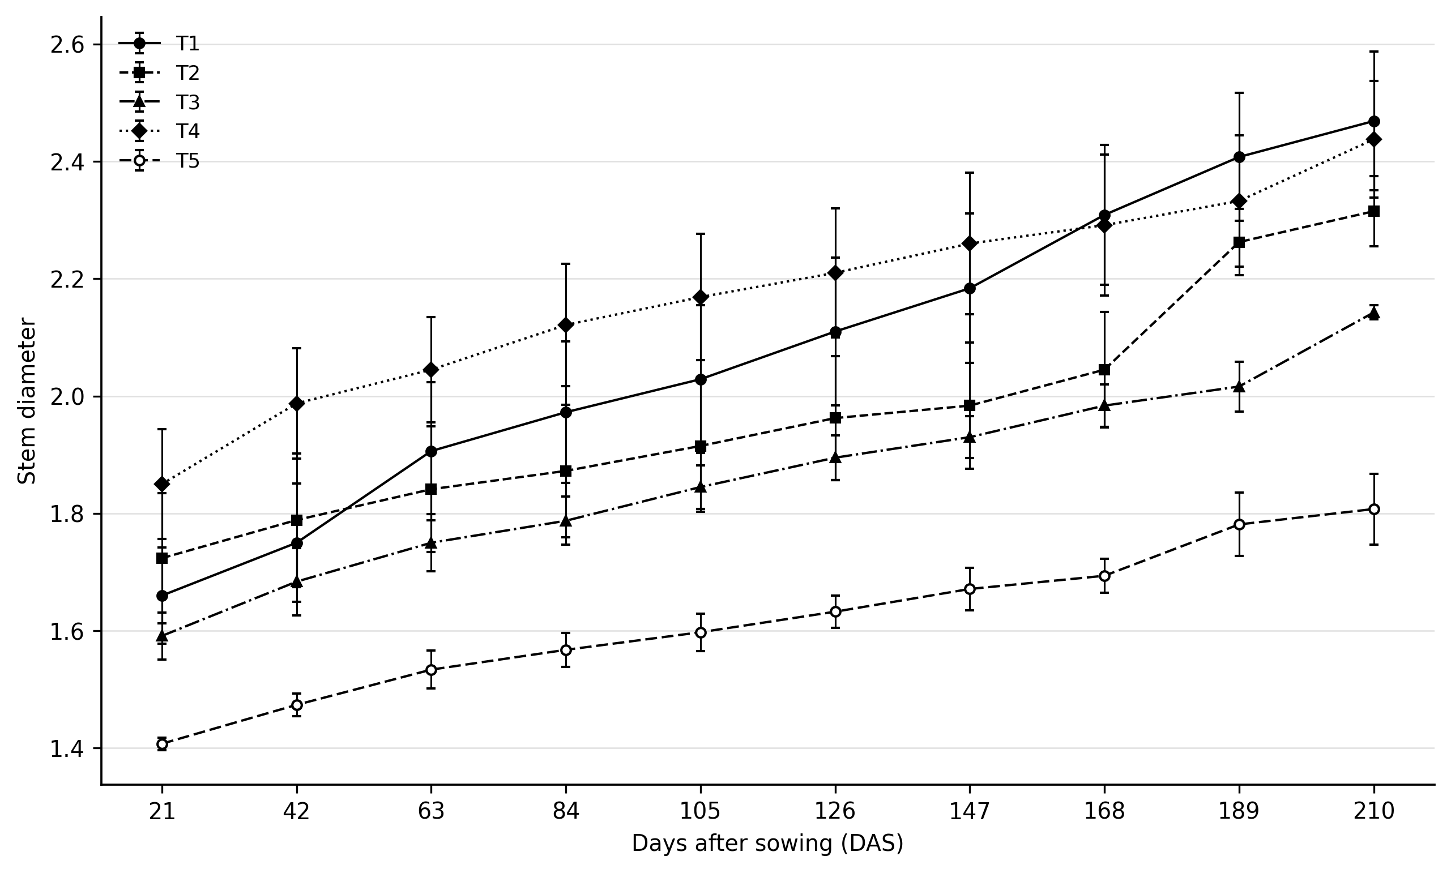

Fig. 2. Stem diameter growth by treatment in coffee plants (1. soil + mycorrhiza + vermicompost; 2. soil + mycorrhiza + poultry manure; 3. soil + mycorrhiza + mango sawdust; 4. soil + mycorrhiza + fermented coffee pulp; 5. control: soil + mycorrhiza), all with soaking (C/R), from 21 to 210 days after sowing (DAS).

Stem diameter increased throughout the experiment in all five treatments. T4 (coffee pulp) began with the largest diameter and remained above the other treatments for much of the evaluation period. Toward the end, however, T1 (vermicompost) increased more rapidly and slightly surpassed T4 at about 200 DAS. T2 (poultry manure) showed an intermediate pattern, with a more noticeable increase after 160 DAS. T3 (sawdust) increased at a moderate rate, while T5 (control) consistently showed the smallest values. By the final evaluation, the difference between T1 and T5 was approximately 0.6 mm.
The patterns in T1 and T4 suggest that stabilized organic materials supported stem development. Stem diameter is commonly used as an indicator of vigor and nutritional response in young coffee plants (Sadeghian, 2021). The late increase in T1 may also be related to the physiological effects of humic substances found in vermicompost (Canellas et al., 2002). In the poultry-manure treatment, the response is likely to depend on the degree of stabilization and mineralization of the material, since both processes affect nutrient availability and possible phytotoxicity (Bernal et al., 2009). The difference between the amended treatments and the control is also consistent with reports of improved coffee seedling growth after the use of organic fertilizers in nursery conditions (Canseco Martínez et al., 2020).

3.1.3. Leaf diameter
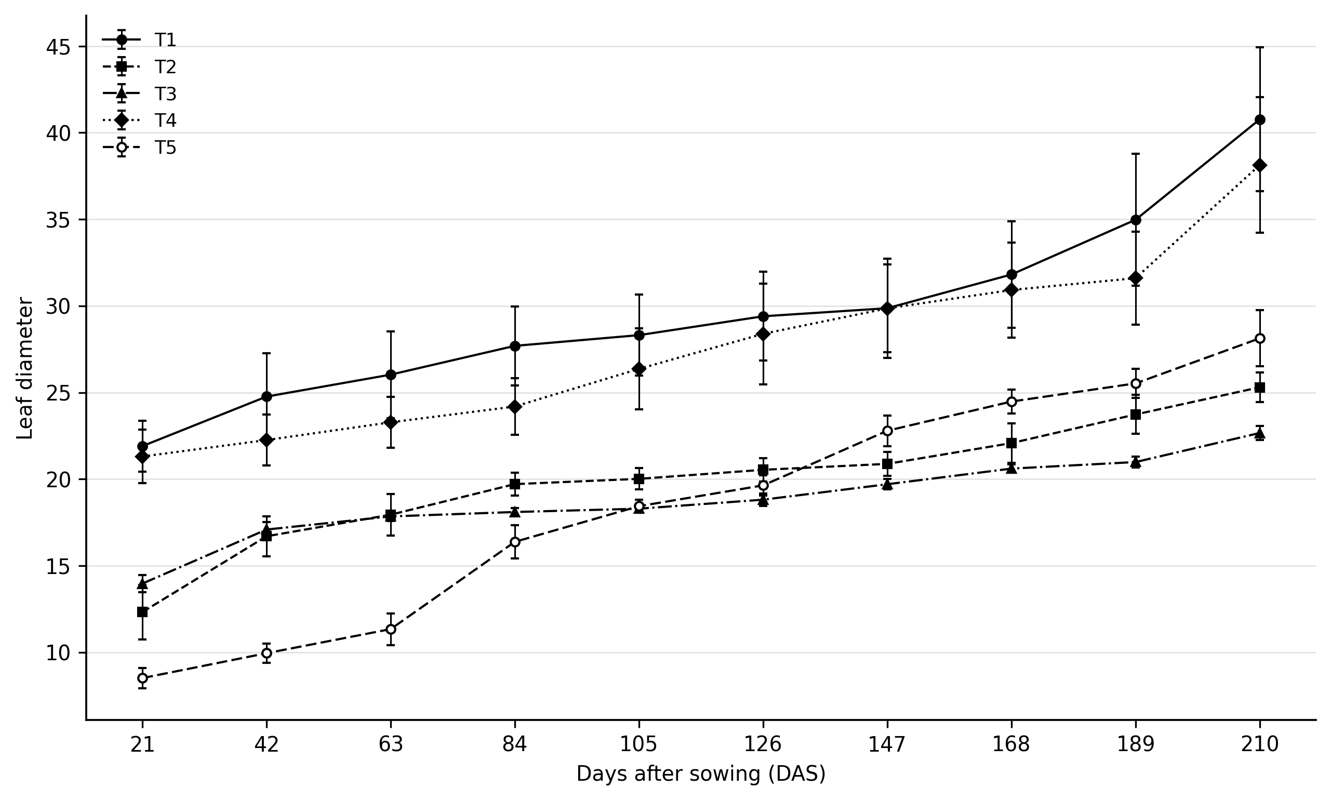
Fig. 3. Leaf diameter growth by treatment in coffee plants (1. soil + mycorrhiza + vermicompost; 2. soil + mycorrhiza + poultry manure; 3. soil + mycorrhiza + mango sawdust; 4. soil + mycorrhiza + fermented coffee pulp; 5. control: soil + mycorrhiza), all with soaking (C/R), from 21 to 210 days after sowing (DAS).
Leaf diameter followed a different pattern from leaf length. T1 (vermicompost) remained above the other treatments during most of the cycle and finished with the largest leaf diameter (>40 units at 210 DAS). T4 (coffee pulp) was second, reaching a value close to 38. The control (T5) started with relatively low values but, after approximately 110 DAS, it exceeded both T2 and T3. At the final evaluation, poultry manure (T2) and mango sawdust (T3) had the lowest values.
The larger leaves observed in T1 may be linked to humic substances and other beneficial effects associated with vermicompost (Canellas et al., 2002; Aguilar Jiménez et al., 2016). The response in T4 is likewise consistent with the use of coffee-processing residues as organic amendments and nutrient sources (Murthy & Naidu, 2012; Pandey et al., 2000). The lower values in T3 fit the pattern expected when nutrients are temporarily immobilized in sawdust-based substrates (Pineda Pineda et al., 2019). More broadly, the results are in line with studies showing that arbuscular mycorrhizal inoculation can modify coffee seedling growth, although the size of the response depends on the growing conditions and the inputs used with the inoculum (Hernández-Acosta et al., 2020; Del Aguila et al., 2018; Ibarra-Puón et al., 2014; Gomes Júnior et al., 2025; González-Osorio et al., 2025; Sara et al., 2025).

3.2. Physiological variables
3.2.1. Leaf area
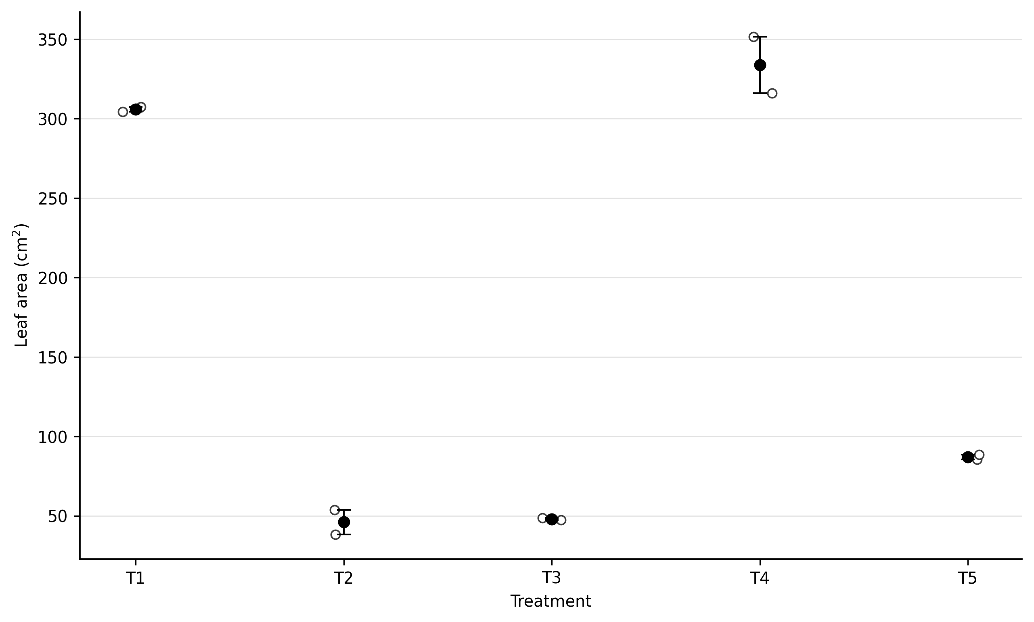
Fig. 4. Total leaf area (cm²) by treatment in coffee plants (1. soil + mycorrhiza + vermicompost; 2. soil + mycorrhiza + poultry manure; 3. soil + mycorrhiza + mango sawdust; 4. soil + mycorrhiza + fermented coffee pulp; 5. control: soil + mycorrhiza), all with soaking (C/R), from 21 to 210 days after sowing (DAS).

Leaf area clearly separated the treatments. T4 (fermented coffee pulp) had the largest values, exceeding 330 cm², and showed relatively little variation between the two plants evaluated. T1 (vermicompost) followed, with values above 300 units. T5 (control) was intermediate to low, at about 90 units, whereas T2 (poultry manure) and T3 (mango sawdust) remained below 50 units and were lower than the control.
The high leaf area in T4 and T1 is comparable with the improved vegetative development reported for coffee seedlings grown with organic fertilizers or mycorrhizal inoculation (Aguilar Jiménez et al., 2016; Del Aguila et al., 2018). The low values in T2 and T3 point instead to limitations in nutrient availability. In sawdust substrates, nutrients—especially nitrogen—can be temporarily immobilized (Pineda Pineda et al., 2019). Manure that has not been sufficiently stabilized may also contain salts or ammoniacal compounds that can produce phytotoxic effects (Bernal et al., 2009). These limitations are relevant because nutrient availability strongly affects root architecture and overall plant growth (López-Bucio et al., 2003).

3.2.2. Fresh weight composition
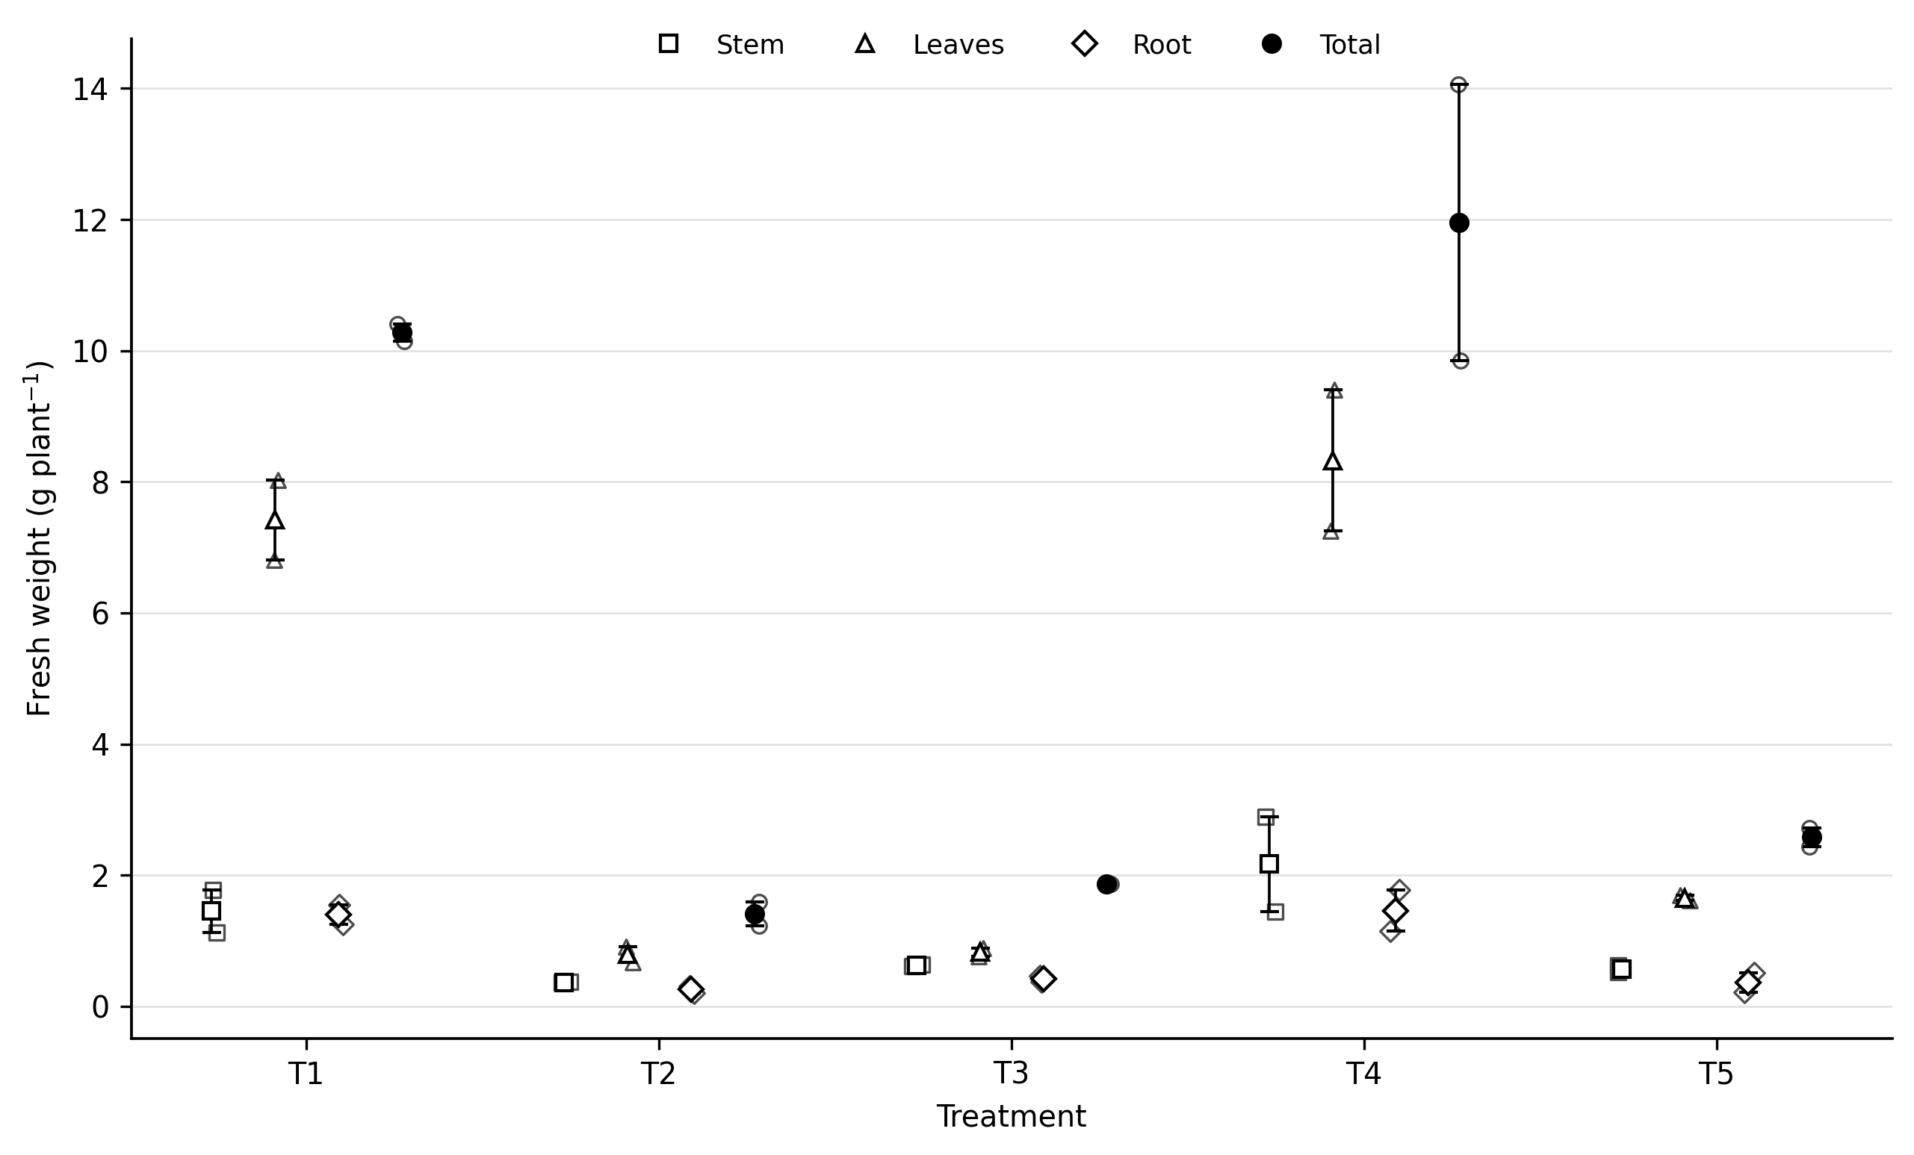
Fig. 5. Fresh weight composition (stem, leaves, and root) by treatment in coffee plants (1. soil + mycorrhiza + vermicompost; 2. soil + mycorrhiza + poultry manure; 3. soil + mycorrhiza + mango sawdust; 4. soil + mycorrhiza + fermented coffee pulp; 5. control: soil + mycorrhiza), all with soaking (C/R), from 21 to 210 days after sowing (DAS).

Fresh biomass was greatest in T4, which reached approximately 12 g per plant; most of this biomass was in the leaves. T1 followed with about 10 g per plant. The control (T5) was only slightly above 2.5 g, while T3 (sawdust) and T2 (poultry manure) both remained below 2 g.
The larger biomass values in T4 and T1 reflect the better overall growth of plants in these treatments. Mycorrhizal inoculation has previously been associated with increased growth and dry matter production in coffee nursery plants (Ibarra-Puón et al., 2014). The predominance of leaf biomass in T4 and T1 is also consistent with biomass-allocation patterns described for actively growing young plants (Poorter et al., 2012). Conversely, the low biomass recorded in T2 and T3 indicates restricted growth and a different allocation of resources under less favorable conditions (Poorter et al., 2012; Canseco Martínez et al., 2020).

3.2.3. Dry weight
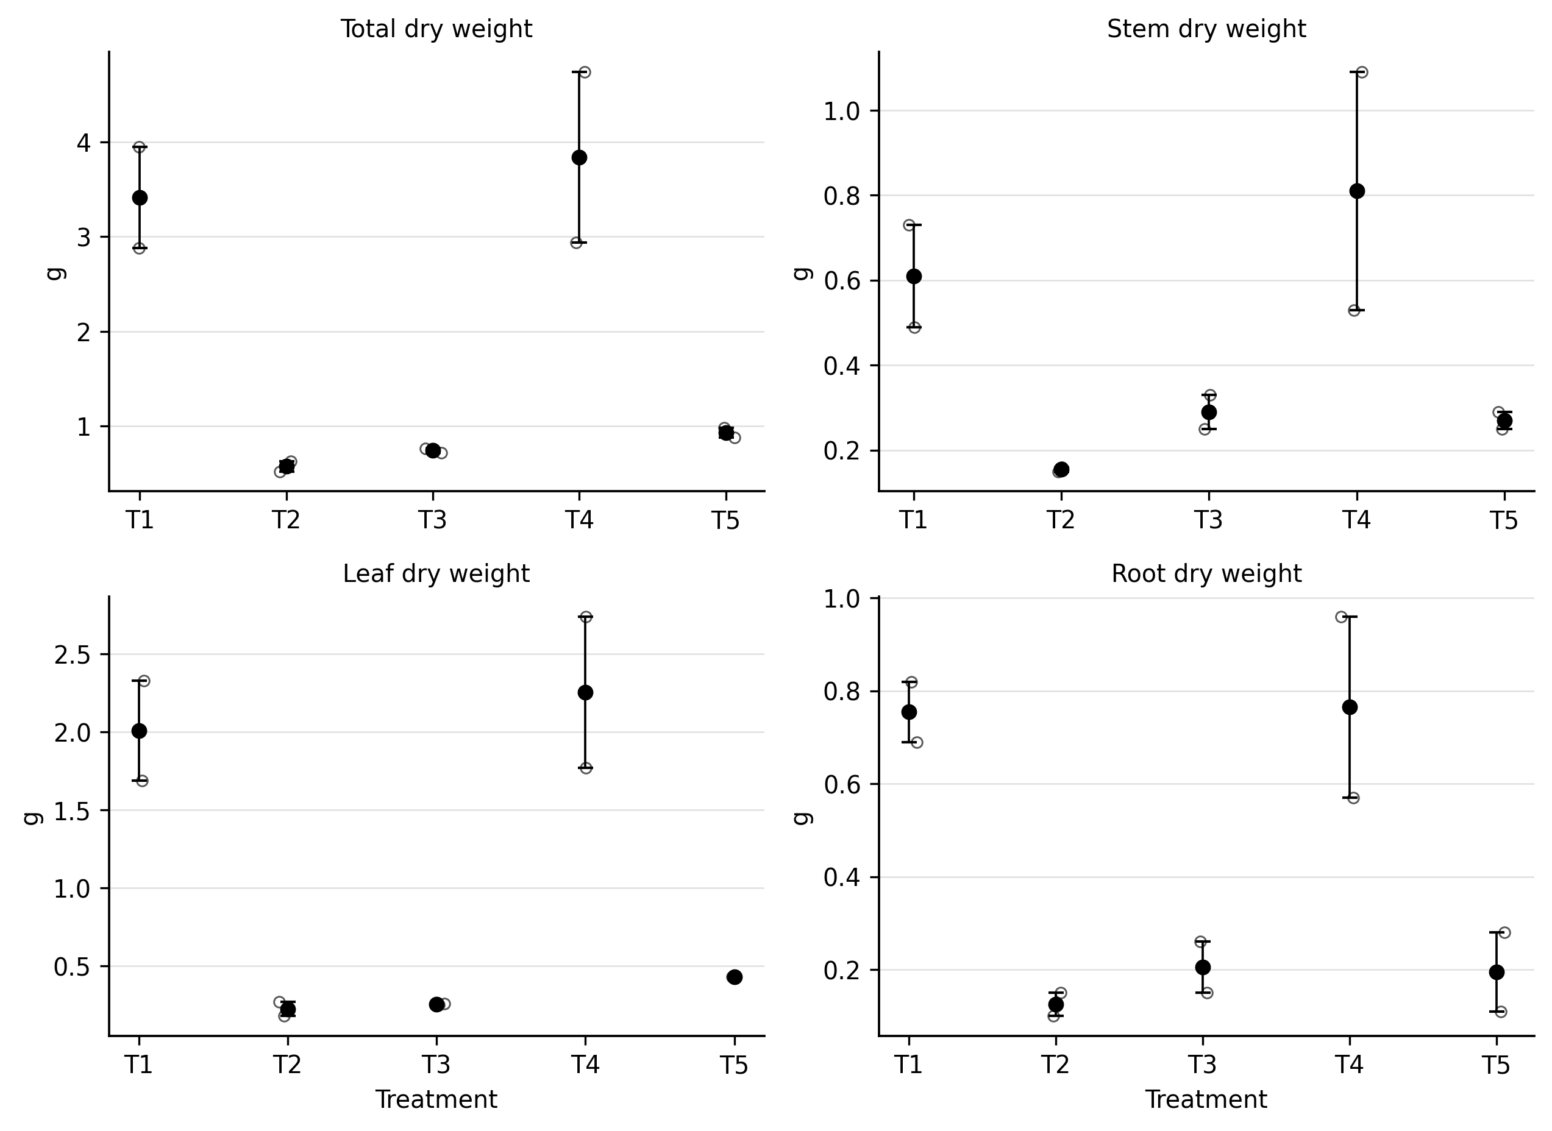
Fig. 6. Dry weight composition (stem, leaves, and root) by treatment in coffee plants (1. soil + mycorrhiza + vermicompost; 2. soil + mycorrhiza + poultry manure; 3. soil + mycorrhiza + mango sawdust; 4. soil + mycorrhiza + fermented coffee pulp; 5. control: soil + mycorrhiza), all with soaking (C/R), from 21 to 210 days after sowing (DAS).

Dry-weight results followed the same general pattern. T4 had the highest values, with total dry weight close to 4.0 g, followed by T1 at approximately 3.4 g. These two treatments also had the largest root dry-weight values, at about 0.8 g. Total dry weight in T2 (poultry manure), T3 (sawdust), and T5 (control) remained below 1.0 g.

The greater dry matter accumulation in T4 is consistent with previous evidence that suitable nursery conditions and mycorrhizal inoculation can increase biomass production in coffee seedlings (Ibarra-Puón et al., 2014). The lower dry-weight values of T2 and T3 show that biomass accumulation was more limited in these treatments. Such differences are biologically plausible because biomass allocation changes with environmental conditions and resource availability (Poorter et al., 2012).

3.2.4. Root length

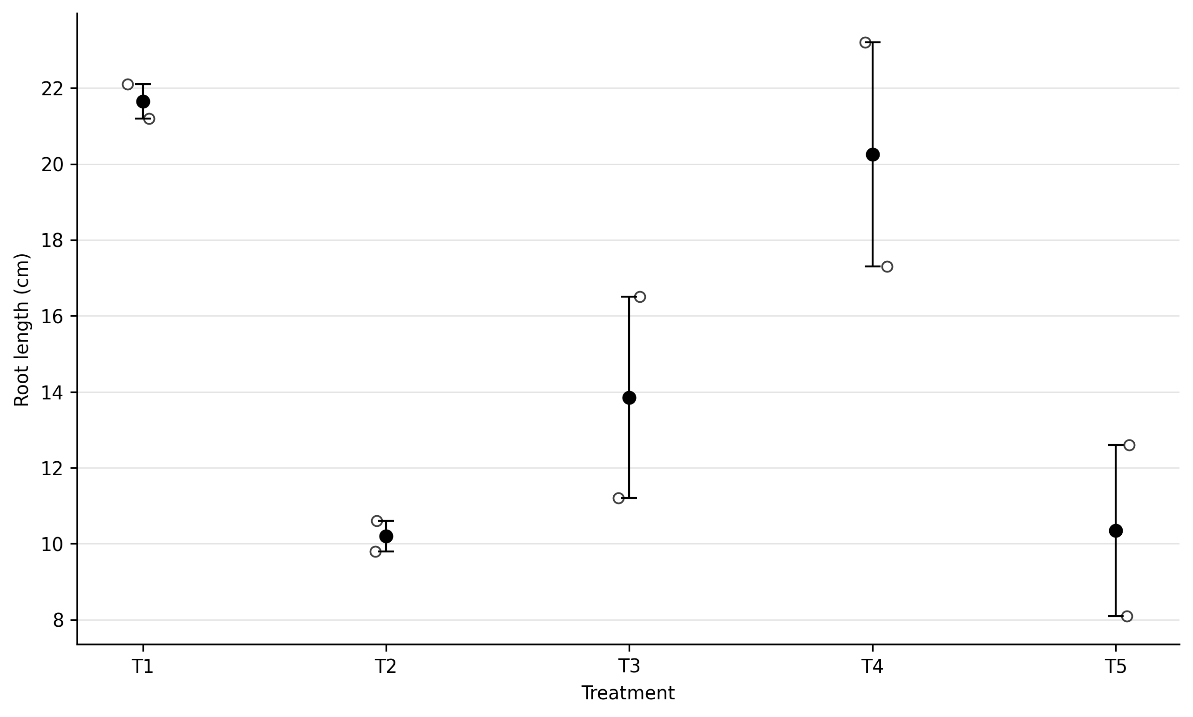

Fig. 7. Root length (cm) by treatment in coffee plants (1. soil + mycorrhiza + vermicompost; 2. soil + mycorrhiza + poultry manure; 3. soil + mycorrhiza + mango sawdust; 4. soil + mycorrhiza + fermented coffee pulp; 5. control: soil + mycorrhiza), all with soaking (C/R), from 21 to 210 days after sowing (DAS).

Root length was greatest in T1 (vermicompost), where values were above 21 cm. T4 (coffee pulp) was close behind, at approximately 20 cm. T3 (mango sawdust) had an intermediate root length of about 14 cm, which was greater than the values recorded for T2 and T5. The shortest roots were observed in poultry manure (T2) and the control (T5), both at around 10 cm.
The stronger root development in T1 and T4 may be related, at least in part, to the physical characteristics of the growing media. Porosity, bulk density, and other substrate properties can influence the space and resistance encountered by developing roots (Monsalve Camacho et al., 2021). In T3, the relatively greater root elongation despite low biomass may indicate a response to limited nutrient availability. The reduced root growth in T2 may also be related to the degree of stabilization of the manure and to possible phytotoxic effects associated with incompletely stabilized material (Bernal et al., 2009).

4. CONCLUSION

Overall, the response to Rhizophagus intraradices was closely linked to the organic substrate with which it was applied. Fermented coffee pulp (T4) and vermicompost (T1) produced the most favorable morphological and physiological responses. Mango sawdust and poultry manure were less effective under the conditions of this study, a pattern consistent with nutrient immobilization in sawdust and the possible effects of salts in manure-based materials. The control also showed that mycorrhiza alone was not enough to produce the same level of plant development achieved with the better-performing organic substrates.
The conclusion should state that fermented coffee pulp and vermicompost produced the most favorable observed responses under the conditions tested, without claiming a statistically demonstrated interaction.

COMPETING INTERESTS
The authors have declared that no competing interests exist.

Declaration of AI Use

This manuscript was prepared through the intellectual contributions of the author(s) to the study design, data analysis, interpretation of results, and scholarly content. Grammarly and ChatGPT were used solely to assist with grammatical refinement and reference formatting during manuscript revision. The author(s) accept full responsibility for the accuracy, integrity, and final content of the manuscript.

REFERENCES
Aguilar Jiménez, C. E., Alvarado Cruz, I., Martínez Aguilar, F. B., Galdámez Galdámez, J., Gutiérrez Martínez, A., & Morales Cabrera, J. A. (2016). Evaluación de tres abonos orgánicos en el cultivo de café (Coffea arabica L.) en etapa de vivero. Siembra,( Evaluation of three organic fertilizers in coffee (*Coffea arabica* L.) cultivation at the nursery stage. Sowing.) 3(1), 11–20. https://doi.org/10.29166/siembra.v3i1.211
Aguirre-Medina, J. F., Moroyoqui-Ovilla, D. M., Mendoza-López, A., Cadena-Iñiguez, J., Avendaño-Arrazate, C. H., & Aguirre-Cadena, J. F. (2011). Hongo endomicorrízico y bacteria fijadora de nitrógeno inoculadas a Coffea arabica en vivero. Agronomía Mesoamericana, (Endomycorrhizal fungus and nitrogen-fixing bacteria inoculated into *Coffea arabica* in the nursery. Agronomía Mesoamericana)22(1), 71–80. https://doi.org/10.15517/am.v22i1.8668
Bernal, M. P., Alburquerque, J. A., & Moral, R. (2009). Composting of animal manures and chemical criteria for compost maturity assessment: A review. Bioresource Technology, 100(22), 5444–5453. https://doi.org/10.1016/j.biortech.2008.11.027
Canellas, L. P., Olivares, F. L., Okorokova-Façanha, A. L., & Façanha, A. R. (2002). Humic acids isolated from earthworm compost enhance root elongation, lateral root emergence, and plasma membrane H+-ATPase activity in maize roots. Plant Physiology, 130(4), 1951–1957. https://doi.org/10.1104/pp.007088
Canseco Martínez, D. A., Villegas Aparicio, Y., Castañeda Hidalgo, E., Carrillo Rodríguez, J. C., Robles, C., & Santiago Martínez, G. M. (2020). Respuesta de Coffea arabica L. a la aplicación de abonos orgánicos y biofertilizantes. Revista Mexicana de Ciencias Agrícolas,( Robles, C., & Santiago Martínez, G. M. (2020). Response of Coffea arabica L. to the application of organic fertilizers and biofertilizers. Mexican Journal of Agricultural Sciences,) 11(6), 1285–1298. https://doi.org/10.29312/remexca.v11i6.2612
Coutiño-Puchuli, V., Santoyo-Cortés, V. H., Flores-Verduzco, J. J., & Muñoz-Rodríguez, M. (2017). Análisis comparativo de dos organizaciones de pequeños productores de café de Oaxaca, México. Transitare,( Comparative analysis of two small coffee producer organizations in Oaxaca, Mexico. Transitare) 3(2), 41–57. https://transitare.anahuacoaxaca.edu.mx/index.php/Transitare/article/download/55/31
Del Aguila, K. M., Vallejos-Torres, G., Arévalo, L. A., & Becerra, A. G. (2018). Inoculación de consorcios micorrícicos arbusculares en Coffea arabica, variedad Caturra en la región San Martín. Información Tecnológica,( Inoculation of arbuscular mycorrhizal consortia in *Coffea arabica* (Caturra variety) in the San Martín region. Información Tecnológica,) 29(1), 137–146. https://doi.org/10.4067/S0718-07642018000100137
González-Osorio, H., Sadeghian, S., & Mira, B. E. (2025). Contribution of mycorrhiza and phosphate-solubilizing fungi in coffee seedling growth in four soils with different fertility conditions. Bragantia, 84, e20240171. https://doi.org/10.1590/1678-4499.20240171
Gomes Júnior, C. C., de Souza, R. P. B., Menezes, K. M. S., de Souza, A. H., Tomazeli-Silva, A., Valadares, S. V., Martins, S. C. V., Cardoso, A. A., da Silva, M. C. S., & DaMatta, F. M. (2025). Boosting coffee seedling performance through arbuscular mycorrhizal association. Mycorrhiza, 35(6), Article 69. https://doi.org/10.1007/s00572-025-01245-0
Deutsche Gesellschaft für Technische Zusammenarbeit (GTZ) GmbH & Cafédirect. (2010). Cambio climático y café: Capacitación para productores y organizaciones cafetaleras(Climate Change and Coffee: Training for Producers and Coffee Organizations) (Proyecto AdapCC). https://www.adapcc.org/es/infoteca/
Fournier, L. A., & Di Stéfano, J. F. (2004). Variaciones climáticas entre 1988 y 2001, y sus posibles efectos sobre la fenología de varias especies leñosas y el manejo de un cafetal con sombra en Ciudad Colón de Mora, Costa Rica. Agronomía Costarricense, (Climatic variations between 1988 and 2001 and their potential effects on the phenology of several woody species and the management of a shaded coffee plantation in Ciudad Colón de Mora, Costa Rica. Agronomía Costarricense)28(1), 101–120. https://doi.org/10.15517/rac.v28i1.61290
Hernández-Acosta, E., Trejo-Aguilar, D., Rivera-Fernández, A., & Ferrera-Cerrato, R. (2020). La micorriza arbuscular como biofertilizante en cultivo de café. Terra Latinoamericana, (Trejo-Aguilar, D., Rivera-Fernández, A., & Ferrera-Cerrato, R. (2020). Arbuscular mycorrhiza as a biofertilizer in coffee cultivation. Terra Latinoamericana,)38(3), 613–628. https://doi.org/10.28940/terra.v38i3.659
Herrera, J. C., & Cortina, H. A. (2013). Taxonomía y clasificación del café. In Federación Nacional de Cafeteros de Colombia, Manual del cafetero colombiano: Investigación y tecnología para la sostenibilidad de la caficultura (Taxonomy and classification of coffee. In National Federation of Coffee Growers of Colombia, Colombian Coffee Grower's Manual: Research and technology for the sustainability of coffee growing.)(Vol. 1, pp. 117–121). Cenicafé. https://doi.org/10.38141/cenbook-0026_07
Ibarra-Puón, J. C., Aguirre-Medina, J. F., Ley-De Coss, A., Cadena-Iñiguez, J., & Zavala-Mata, G. A. (2014). Coffea canephora (Pierre) ex Froehner inoculado con micorriza y bacteria fijadora de nitrógeno en vivero. Revista Chapingo Serie Horticultura, 20(2), 201–213. https://doi.org/10.5154/r.rchsh.2013.09.027
López-Bucio, J., Cruz-Ramírez, A., & Herrera-Estrella, L. (2003). The role of nutrient availability in regulating root architecture. Current Opinion in Plant Biology, 6(3), 280–287. https://doi.org/10.1016/S1369-5266(03)00035-9
Monsalve Camacho, O. I., Henao Toro, M. C., & Gutiérrez Díaz, J. S. (2021). Caracterización de materiales con uso potencial como sustratos en sistemas de cultivo sin suelo. Ciencia y Tecnología Agropecuaria,( Characterization of materials with potential use as substrates in soilless cultivation systems. Agricultural Science and Technology.) 22(1), e1977. https://doi.org/10.21930/rcta.vol22_num1_art:1977
Murthy, P. S., & Naidu, M. M. (2012). Sustainable management of coffee industry by-products and value addition—A review. Resources, Conservation and Recycling, 66, 45–58. https://doi.org/10.1016/j.resconrec.2012.06.005
Pandey, A., Soccol, C. R., Nigam, P., Brand, D., Mohan, R., & Roussos, S. (2000). Biotechnological potential of coffee pulp and coffee husk for bioprocesses. Biochemical Engineering Journal, 6(2), 153–162. https://doi.org/10.1016/S1369-703X(00)00084-X
Pineda Pineda, J., Sánchez del Castillo, F., Moreno Pérez, E. del C., Valdez Aguilar, L. A., Castillo González, A. M., Ramírez Arias, A., et al. (2019). Inmovilización y retención nutrimental en aserrín de pino como sustrato agrícola. Terra Latinoamericana,( Nutrient immobilization and retention in pine sawdust as an agricultural substrate. Terra Latinoamericana,) 37(3), 261–271. https://doi.org/10.28940/terra.v37i3.448
Poorter, H., Niklas, K. J., Reich, P. B., Oleksyn, J., Poot, P., & Mommer, L. (2012). Biomass allocation to leaves, stems and roots: Meta-analyses of interspecific variation and environmental control. New Phytologist, 193(1), 30–50. https://doi.org/10.1111/j.1469-8137.2011.03952.x
Sadeghian, S. (2021). Nutrición de cafetales. In Centro Nacional de Investigaciones de Café, Guía +Agronomía +Productividad +Calidad (Coffee plantation nutrition. In National Coffee Research Center, Guide: Agronomy + Productivity + Quality.)(3rd ed., pp. 101–115). Cenicafé. https://doi.org/10.38141/10791/0014_7
Sery, D. J. M., Tokpa, L. Z., Gba, K., Ohoueu, E. J. B., Seri, T. C. O., & Konan, A. (2025). Coffee pulp and husk residue compost improve the growth of Robusta coffee (Coffea canephora) seedlings in the nursery. Indian Journal of Agricultural Research, 59(5), 791–796. https://doi.org/10.18805/IJARe.AF-891
Sara, D. S., Tridakusumah, A. C., Joy, B., Sofyan, E. T., & Suriadikusumah, A. (2025). Integrasi kompos kulit kopi dan biochar untuk meningkatkan kualitas bibit kopi Arabika. Soilrens, 23(2). https://doi.org/10.24198/soilrens.v23i2.69715
Servicio de Información Agroalimentaria y Pesquera. (2018). Anuario estadístico de la producción agrícola [Cierre agrícola]. SAGARPA. (Statistical Yearbook of Agricultural Production [Agricultural Year-End]. SAGARPA)https://nube.agricultura.gob.mx/cierre_agricola/

