Reflex Supraventricular Tachycardia and Chest Pain Following the First Dose of Fixed-Dose Perindopril/Amlodipine in an Older Patient With Hypertension and Type 2 Diabetes Mellitus: A Case Report
Abstract
Background: Fixed-dose combinations (FDCs) of an angiotensin-converting enzyme (ACE) inhibitor and a dihydropyridine calcium-channel blocker (CCB) are recommended as initial therapy for most patients with arterial hypertension and are generally well tolerated. Reflex tachycardia has not previously been reported with the perindopril/amlodipine combination.
Case presentation: A 70-year-old Caucasian man with arterial hypertension and type 2 diabetes mellitus developed chest pain 1 hour after the first dose of AlmirinComb 4/5 mg (perindopril 4 mg/amlodipine 5 mg). The prehospital ECG showed supraventricular tachycardia (SVT), which was terminated with adenosine (6 mg, then 12 mg); conversion to sinus rhythm was accompanied by transient inferior ST denivelation, and the chest pain resolved immediately. On arrival at the hospital, he was pain-free, haemodynamically stable (blood pressure 162/90 mmHg, heart rate 82 beats/min), and in normal sinus rhythm without ST-segment changes; serial high-sensitivity troponin I values remained within the normal range. Cardiology consultation attributed the event to reflex tachycardia. According to the World Health Organization-Uppsala Monitoring Centre (WHO-UMC) causality assessment system, the reaction was classified as probable. He was discharged on nebivolol with scheduled ambulatory follow-up (Holter-ECG, exercise testing, and echocardiography).
Conclusion: This case suggests that a first dose of an ACE inhibitor/dihydropyridine FDC may rarely trigger a reflex-mediated supraventricular tachyarrhythmia with chest pain in an older patient at high cardiovascular risk. Blood pressure and heart rate monitoring after the first dose, patient education regarding symptoms, and prompt pharmacovigilance reporting are advisable.
Keywords: perindopril; amlodipine; fixed-dose combination; supraventricular tachycardia; reflex tachycardia; adverse drug reaction; arterial hypertension; type 2 diabetes mellitus; pharmacovigilance

Introduction
Arterial hypertension is the leading modifiable risk factor for cardiovascular morbidity and mortality worldwide, affecting an estimated 1.28 billion adults between 30 and 79 years of age (Mancia et al., 2023). Current guidelines recommend starting treatment with a two-drug combination comprising an ACE inhibitor or angiotensin receptor blocker together with a CCB or a thiazide/thiazide-like diuretic for most patients, preferably as a single-pill fixed-dose combination to improve adherence and the speed and quality of blood pressure control (Mancia et al., 2023; Williams et al., 2018). The 2024 ESC Guidelines provide an updated framework for the pharmacological management of elevated blood pressure and hypertension, including contemporary treatment targets and antihypertensive medication strategies (McEvoy et al., 2024). A recent American Heart Association scientific statement further supports single-pill combination therapy as a practical option for simplifying multidrug antihypertensive treatment and improving blood pressure management when clinically appropriate (King et al., 2026).
The combination of perindopril and amlodipine is among the most extensively validated ACE inhibitor/CCB pairings. In the Anglo-Scandinavian Cardiac Outcomes Trial-Blood Pressure Lowering Arm (ASCOT-BPLA), an amlodipine-based regimen with perindopril added as required was superior to an atenolol-thiazide regimen in reducing cardiovascular events, mortality, and new-onset diabetes (Dahlöf et al., 2005). Perindopril-based therapy in patients with type 2 diabetes reduced macrovascular and microvascular outcomes in the ADVANCE trial (Patel et al., 2007). The single-pill perindopril/amlodipine combination lowers blood pressure more effectively than either component alone or placebo, with good tolerability, and has been reviewed favourably as a first-step treatment (Laurent et al., 2015; Mancia et al., 2015; Shirley & McCormack, 2015). Recent pharmacovigilance work in cardiovascular drug therapy has also emphasised active surveillance and structured assessment of suspected adverse drug reactions during treatment (Mansoori et al., 2024).
Despite this favourable efficacy-safety profile, any potent vasodilator combination can produce an acute fall in blood pressure with compensatory sympathetic activation. First-dose hypotension is a recognised phenomenon with ACE inhibitors in older patients, and short-acting dihydropyridines are classically associated with reflex tachycardia and palpitations. However, according to Micromedex, reflex tachycardia had not previously been reported with perindopril or amlodipine. Recent pharmacovigilance literature also highlights systematic safety surveillance and the use of real-world data to support the detection of adverse drug reactions that may otherwise remain under-recognised (Onyebuchi et al., 2026). A specific evidence gap therefore remains regarding whether first-dose perindopril/amlodipine can precipitate reflex-mediated supraventricular tachycardia in susceptible older patients. This paper describes a case of a 70-year-old man with hypertension and type 2 diabetes who presented with chest pain and ECG-documented supraventricular tachycardia 1 hour after his first dose of fixed-dose perindopril/amlodipine, reviews plausible mechanisms, and discusses the implications for first-dose monitoring in older, high-risk patients.

Case Presentation
A 70-year-old Caucasian man with a history of arterial hypertension and type 2 diabetes mellitus was brought to the Emergency Department (ED) of the University Hospital Centre by the T1 field emergency medicine team (physician, registered nurse, and driver) because of an episode of chest pain that developed 1 hour after taking the first dose of AlmirinComb 4/5 mg (containing perindopril 4 mg and amlodipine 5 mg). He took the drug at around 9 a.m. and developed chest pain at around 10 a.m. During transport to the hospital, the first ECG (Figure 1) showed supraventricular tachycardia, and the physician administered adenosine 6 mg followed by adenosine 12 mg, after which conversion to sinus rhythm occurred (Figure 2) with inferior ST denivelations. Immediately after conversion to sinus rhythm, the patient's chest pain resolved. A dose of 300 mg of Andol was also administered before arrival at the hospital. At the initial physical examination in the ED, the patient was free of chest pain, and the third ECG showed normal sinus rhythm without ST deviations (Figure 3). His vital signs were BP 162/90 mmHg, heart rate 82 bpm, oxygen saturation 96% on room air, respiratory rate 16/min, and temperature 36.5 °C. The physical examination findings were within normal limits. His laboratory test results were within normal limits: erythrocytes 5.27 ×10¹²/L, haemoglobin 163 g/L, haematocrit 0.485 L/L, MCV 92 fL, MCH 30.9 pg, MCHC 336 g/L, RDW 13.1%, leucocytes 4.9 ×10⁹/L, PT 1.18, INR 0.93, aPTT 25.9 s, glucose 7.2 mmol/L, BUN 5.8 mmol/L, creatinine 99 µmol/L, potassium 4 mmol/L, sodium 140 mmol/L, and CRP less than 1 mg/L. The first high-sensitivity troponin I measurement, obtained at 11:28 a.m., was 5.7 ng/L, and the second, obtained at 12:39 p.m., was 10.7 ng/L. The patient was monitored and observed, during which two additional ECGs were obtained (Figures 4 and 5), showing normal sinus rhythm without any ST-segment dynamics. The chest X-ray was normal (Figure 6). The cardiologist was consulted and concluded that the chest pain was associated with tachycardia, which was probably reflex tachycardia due to AlmirinComb. The patient was discharged on a new treatment regimen: nebivolol 5 mg once daily in the morning, nitroglycerine in case of chest pain or very high BP values (180/110 mmHg), and Andol 100 mg once daily until the next ambulatory cardiology follow-up. Holter-ECG, ergometry, and echocardiography were recommended, with additional laboratory tests (HbA1c, glucose, hepatogram, and lipidogram) as part of further outpatient evaluation. The suspected adverse effect was reported to the national reporting system (HALMED).

Discussion
The temporal sequence in this case is the cornerstone of the causal interpretation: first-ever exposure to combined perindopril/amlodipine, symptom onset within approximately 1 hour, an ECG-documented regular narrow-complex tachycardia, termination by intravenous adenosine boluses (6 mg followed by 12 mg), and immediate relief of chest pain upon restoration of sinus rhythm. Adenosine remains the drug of choice for the acute termination of haemodynamically stable narrow-complex SVT when vagal manoeuvres fail, and its efficacy here indicates an atrioventricular (AV) node-dependent re-entrant mechanism (AV nodal re-entrant tachycardia or AV re-entrant tachycardia) (Brugada et al., 2020; Page et al., 2016).
The chest pain and transient inferior ST deviations observed immediately after conversion are best explained as rate-related phenomena rather than acute coronary syndrome: the pain abated when sinus rhythm was restored, serial high-sensitivity troponin I values remained within the normal range of the assay, and all subsequent ECGs were free of ST-segment dynamics. Rapid regular tachycardia increases myocardial oxygen demand and shortens diastolic coronary perfusion, which can produce demand ischaemia, chest pain, and repolarisation abnormalities even in the absence of obstructive coronary disease. A coronary vasospastic mechanism cannot be definitively excluded, but the absence of ST-segment elevation, the immediate and complete resolution, and the uneventful subsequent course make it unlikely; scheduled ergometry and echocardiography will further assess residual ischaemic risk.
From a pharmacological standpoint, the event is mechanistically plausible. Dihydropyridines such as amlodipine lower blood pressure through arterial vasodilatation; the acute fall in blood pressure unloads the arterial baroreceptors and provokes a reflex increase in sympathetic outflow with vagal withdrawal, which manifests as tachycardia, palpitations, and flushing. This reflex response is most pronounced with short-acting dihydropyridines and is usually attenuated with amlodipine because of its long elimination half-life and gradual onset of effect, which is precisely why amlodipine is considered largely free of reflex tachycardia (Abernethy & Schwartz, 1999). Nevertheless, a first dose of a two-drug vasodilator combination may lower blood pressure more steeply than either drug alone. ACE inhibitors are a recognised cause of first-dose hypotension in older patients, in whom reduced renal clearance, impaired cardiovascular reflexes, and comorbid heart failure or renal impairment increase susceptibility (Tomlinson, 1996). Ageing and type 2 diabetes further blunt baroreflex sensitivity, so a brisk first-dose pressure fall may generate an exaggerated and insufficiently buffered sympathetic surge, a setting in which an AV node-dependent re-entrant circuit can be triggered and sustained. The absence of hypotension on arrival in the ED does not argue against this mechanism because the haemodynamic perturbation is transient and the patient had already converted to sinus rhythm by the time of hospital measurement.
It is also noteworthy that ACE inhibitors attenuate dihydropyridine-induced ankle oedema by reducing precapillary hydrostatic pressure, a complementary pharmacodynamic interaction that underlies the rationale for the fixed combination (Abernethy & Schwartz, 1999). The same additive vasodilator effect, however, may translate into a larger initial blood pressure drop in susceptible individuals, as this case illustrates. Fixed-dose perindopril/amlodipine has otherwise shown a reassuring safety profile in randomised first-step and comparative trials, in which adverse events were mostly mild (cough, peripheral oedema, flushing, dizziness, and hypotension) and comparable to those of the component drugs (Laurent et al., 2015; Mancia et al., 2015; Shirley & McCormack, 2015).
Causality assessment supports a drug-related event. Using the WHO-UMC system, the reasonable temporal relationship, the clinically reasonable response to withdrawal (no recurrence after the combination was stopped), the lack of a more plausible alternative explanation, and the objective ECG documentation fulfil the criteria for a "probable/likely" classification without the need for rechallenge, which would have been ethically unjustified (World Health Organization-Uppsala Monitoring Centre, 2013). Application of the Naranjo algorithm yields a score of 4 (possible) if de novo paroxysmal SVT is accepted as an alternative cause and 6 (probable) if alternative causes are judged unlikely; the WHO-UMC "probable" classification adopted by the treating team therefore lies at the upper bound of the structured assessments (Naranjo et al., 1981). Paroxysmal SVT can occur spontaneously in older adults; however, the close temporal association with the first dose, the absence of any previous episode, and the immediate symptom resolution upon conversion argue in favour of a drug-triggered reflex mechanism.
Several patient-related factors plausibly increased susceptibility: advanced age (70 years), type 2 diabetes with probable subclinical autonomic dysfunction, first exposure to both agents simultaneously, and uncontrolled hypertension at baseline. These are precisely the patients in whom guidance advises lower initial doses, cautious up-titration, and early blood pressure (and, in practice, heart rate) monitoring after starting or changing ACE inhibitor-based therapy (Specialist Pharmacy Service, 2026; Tomlinson, 1996).
The management in this case followed current recommendations: prehospital recognition and pharmacological cardioversion of stable narrow-complex SVT with adenosine (Brugada et al., 2020; Page et al., 2016), exclusion of acute coronary syndrome with serial ECGs and troponin measurements, and discontinuation of the implicated combination. The choice of nebivolol for subsequent antihypertensive therapy is rational: it is a highly β₁-selective blocker with nitric oxide-mediated vasodilatory properties, a favourable metabolic profile in patients with type 2 diabetes, and direct protection against reflex sympathetic tachycardia if vasodilator therapy is reintroduced, while nitroglycerine was sensibly reserved for acute symptom relief.
Limitation
This report has limitations inherent to a single case: no electrophysiological study was performed, the in-hospital observation window was short, rechallenge was appropriately omitted, and a spontaneous first episode of paroxysmal SVT coinciding with the first drug dose cannot be excluded with absolute certainty. Nonetheless, case reports remain a signal-generating tool in pharmacovigilance, particularly for rare or unexpected reactions that randomised trials, which systematically exclude the frailest, highest-risk patients, are underpowered to detect.
Conclusion
This case suggests that, although previously unreported, the fixed-dose combination of perindopril and amlodipine may be associated with supraventricular tachycardia, most plausibly reflex-mediated, in patients at higher cardiovascular risk, such as older individuals with type 2 diabetes and arterial hypertension. According to the WHO-UMC Causality Assessment System, this adverse reaction may be classified as probable. Clinicians should consider monitoring blood pressure and heart rate after the first dose of ACE inhibitor/dihydropyridine combinations in older, high-risk patients, educate patients to seek immediate care for palpitations or chest pain after treatment initiation, and report suspected adverse drug reactions to their national pharmacovigilance centre to allow signal confirmation or refutation.
Declarations
Consent: Written informed consent was obtained from the patient for publication of this case report and any accompanying images.
Reporting guideline: This report was prepared in accordance with the CAse REport (CARE) guidelines (Gagnier et al., 2014).
Conflicts of interest: The authors declare no competing interests.
Declaration of AI Use

This manuscript was prepared through the intellectual contributions of the author(s) to the study design, data analysis, interpretation of results, and scholarly content. Grammarly and ChatGPT were used solely to assist with grammatical refinement and reference formatting during manuscript revision. The author(s) accept full responsibility for the accuracy, integrity, and final content of the manuscript.

References
Abernethy, D. R., & Schwartz, J. B. (1999). Calcium-antagonist drugs. The New England Journal of Medicine, 341(19), 1447–1457. https://doi.org/10.1056/NEJM199911043411907
Brugada, J., Katritsis, D. G., Arbelo, E., Arribas, F., Bax, J. J., Blomström-Lundqvist, C., Calkins, H., Corrado, D., Deftereos, S. G., Diller, G.-P., Gomez-Doblas, J. J., Gorenek, B., Grace, A., Ho, S. Y., Kaski, J.-C., Kuck, K.-H., Lambiase, P. D., Sacher, F., Sarquella-Brugada, G., . . . ESC Scientific Document Group. (2020). 2019 ESC guidelines for the management of patients with supraventricular tachycardia: The Task Force for the management of patients with supraventricular tachycardia of the European Society of Cardiology (ESC). European Heart Journal, 41(5), 655–720. https://doi.org/10.1093/eurheartj/ehz467
Dahlöf, B., Sever, P. S., Poulter, N. R., Wedel, H., Beevers, D. G., Caulfield, M., Collins, R., Kjeldsen, S. E., Kristinsson, A., McInnes, G. T., Mehlsen, J., Nieminen, M., O'Brien, E., Ostergren, J., & ASCOT Investigators. (2005). Prevention of cardiovascular events with an antihypertensive regimen of amlodipine adding perindopril as required versus atenolol adding bendroflumethiazide as required, in the Anglo-Scandinavian Cardiac Outcomes Trial-Blood Pressure Lowering Arm (ASCOT-BPLA): A multicentre randomised controlled trial. The Lancet, 366(9489), 895–906. https://doi.org/10.1016/S0140-6736(05)67185-1
Gagnier, J. J., Kienle, G., Altman, D. G., Moher, D., Sox, H., Riley, D., & CARE Group. (2014). The CARE guidelines: Consensus-based clinical case report guideline development. Journal of Clinical Epidemiology, 67(1), 46–51. https://doi.org/10.1016/j.jclinepi.2013.08.003
King, J. B., An, J., Bellows, B. K., Cohen, J. B., Commodore-Mensah, Y., Ghazi, L., Langford, A. T., & Brook, R. D. (2026). Single-pill combination therapy for the management of hypertension: A scientific statement from the American Heart Association. Hypertension, 83(3), 887–901. https://doi.org/10.1161/HYP.0000000000000258
Laurent, S., Parati, G., Chazova, I., Sirenko, Y., Erglis, A., Laucevicius, A., & Farsang, C. (2015). Randomized evaluation of a novel, fixed-dose combination of perindopril 3.5 mg/amlodipine 2.5 mg as a first-step treatment in hypertension. Journal of Hypertension, 33(3), 653–662. https://doi.org/10.1097/HJH.0000000000000440
Mancia, G., Asmar, R., Amodeo, C., Mourad, J.-J., Taddei, S., Alcocer Gamba, M. A., Chazova, I. E., & Puig, J. G. (2015). Comparison of single-pill strategies first line in hypertension: Perindopril/amlodipine versus valsartan/amlodipine. Journal of Hypertension, 33(2), 401–411. https://doi.org/10.1097/HJH.0000000000000409
Mancia, G., Kreutz, R., Brunström, M., Burnier, M., Grassi, G., Januszewicz, A., Muiesan, M. L., Tsioufis, K., Agabiti-Rosei, E., Algharably, E. A. E., Azizi, M., Benetos, A., Borghi, C., Hitij, J. B., Cifkova, R., Coca, A., Cornelissen, V., Cruickshank, J. K., Cunha, P. G., . . . Kjeldsen, S. E. (2023). 2023 ESH guidelines for the management of arterial hypertension: The Task Force for the management of arterial hypertension of the European Society of Hypertension. Endorsed by the International Society of Hypertension (ISH) and the European Renal Association (ERA). Journal of Hypertension, 41(12), 1874–2071. https://doi.org/10.1097/HJH.0000000000003480
Mansoori, I., Kumar, P., Rai, G., & Dave, S. (2024). Adverse drug reactions and safety profiles in cardiovascular drug therapy: A pharmacovigilance analysis. Journal of Pharmaceutical Research International, 36(11), 198–207. https://doi.org/10.9734/jpri/2024/v36i117612
McEvoy, J. W., McCarthy, C. P., Bruno, R. M., Brouwers, S., Canavan, M. D., Ceconi, C., Christodorescu, R. M., Daskalopoulou, S. S., Ferro, C. J., Gerdts, E., Hanssen, H., Harris, J., Lauder, L., McManus, R. J., Molloy, G. J., Rahimi, K., Regitz-Zagrosek, V., Rossi, G. P., Sandset, E. C., . . . ESC Scientific Document Group. (2024). 2024 ESC guidelines for the management of elevated blood pressure and hypertension. European Heart Journal, 45(38), 3912–4018. https://doi.org/10.1093/eurheartj/ehae178
Naranjo, C. A., Busto, U., Sellers, E. M., Sandor, P., Ruiz, I., Roberts, E. A., Janecek, E., Domecq, C., & Greenblatt, D. J. (1981). A method for estimating the probability of adverse drug reactions. Clinical Pharmacology & Therapeutics, 30(2), 239–245. https://doi.org/10.1038/clpt.1981.154
Onyebuchi, O. R., Akanbi, O. O., Olowookere, A. K., Baiden, I., Ngwoke, F. C., Onodje, L., Akinlolu, O., Eboh, N. A., & Okoye, U. L. (2026). Use of artificial intelligence and machine learning in rapid drug discovery and pharmacovigilance. Journal of International Research in Medical and Pharmaceutical Sciences, 21(2), 183–200. https://doi.org/10.56557/jirmeps/2026/v21i210521
Page, R. L., Joglar, J. A., Caldwell, M. A., Calkins, H., Conti, J. B., Deal, B. J., Estes, N. A. M., III, Field, M. E., Goldberger, Z. D., Hammill, S. C., Indik, J. H., Lindsay, B. D., Olshansky, B., Russo, A. M., Shen, W.-K., Tracy, C. M., & Al-Khatib, S. M. (2016). 2015 ACC/AHA/HRS guideline for the management of adult patients with supraventricular tachycardia: A report of the American College of Cardiology/American Heart Association Task Force on Clinical Practice Guidelines and the Heart Rhythm Society. Heart Rhythm, 13(4), e136–e221. https://doi.org/10.1016/j.hrthm.2015.09.019
Patel, A., ADVANCE Collaborative Group, MacMahon, S., Chalmers, J., Neal, B., Woodward, M., Billot, L., Harrap, S., Poulter, N., Marre, M., Cooper, M., Glasziou, P., Grobbee, D. E., Hamet, P., Heller, S., Liu, L. S., Mancia, G., Mogensen, C. E., Pan, C. Y., . . . Williams, B. (2007). Effects of a fixed combination of perindopril and indapamide on macrovascular and microvascular outcomes in patients with type 2 diabetes mellitus (the ADVANCE trial): A randomised controlled trial. The Lancet, 370(9590), 829–840. https://doi.org/10.1016/S0140-6736(07)61303-8
Shirley, M., & McCormack, P. L. (2015). Perindopril/amlodipine (Prestalia®): A review in hypertension. American Journal of Cardiovascular Drugs, 15(5), 363–370. https://doi.org/10.1007/s40256-015-0144-1
Specialist Pharmacy Service. (2026, August 12). ACE inhibitors and angiotensin II receptor blockers monitoring. NHS Specialist Pharmacy Service. https://sps.nhs.uk/monitorings/ace-inhibitors-and-angiotensin-ii-receptor-blockers-monitoring/
Tomlinson, B. (1996). Optimal dosage of ACE inhibitors in older patients. Drugs & Aging, 9(4), 262–273. https://doi.org/10.2165/00002512-199609040-00004
Williams, B., Mancia, G., Spiering, W., Agabiti Rosei, E., Azizi, M., Burnier, M., Clement, D. L., Coca, A., de Simone, G., Dominiczak, A., Kahan, T., Mahfoud, F., Redon, J., Ruilope, L., Zanchetti, A., Kerins, M., Kjeldsen, S. E., Kreutz, R., Laurent, S., . . . ESC Scientific Document Group. (2018). 2018 ESC/ESH guidelines for the management of arterial hypertension. European Heart Journal, 39(33), 3021–3104. https://doi.org/10.1093/eurheartj/ehy339
World Health Organization–Uppsala Monitoring Centre. (2013, June 5). The use of the WHO-UMC system for standardised case causality assessment. World Health Organization. https://www.who.int/publications/m/item/WHO-causality-assessment

Figure 1. SVT (around 10:30 a.m.)
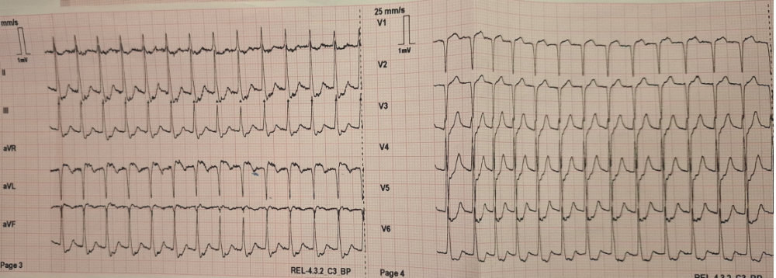

Figure 2. Sinus rythm after conversion with adenosine.
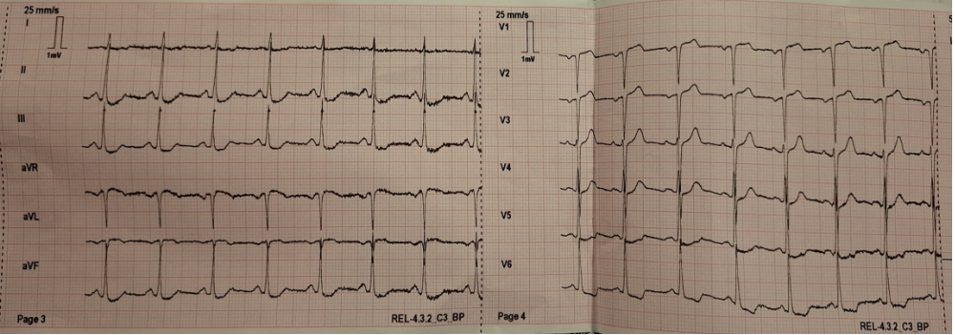

Figure 3. Sinus rythm in ED department: no ST-denivelations.
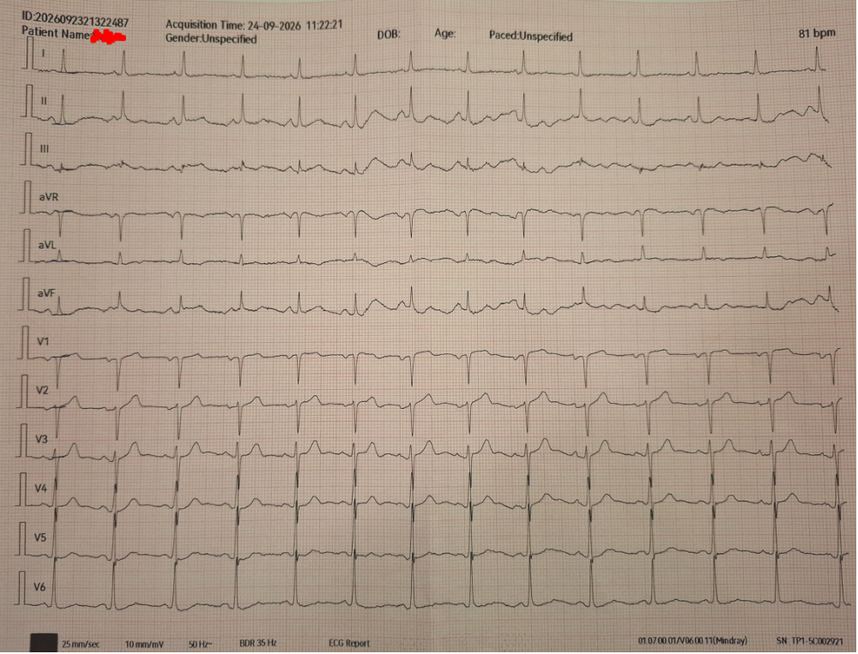

Figure 4. Follow up ECG
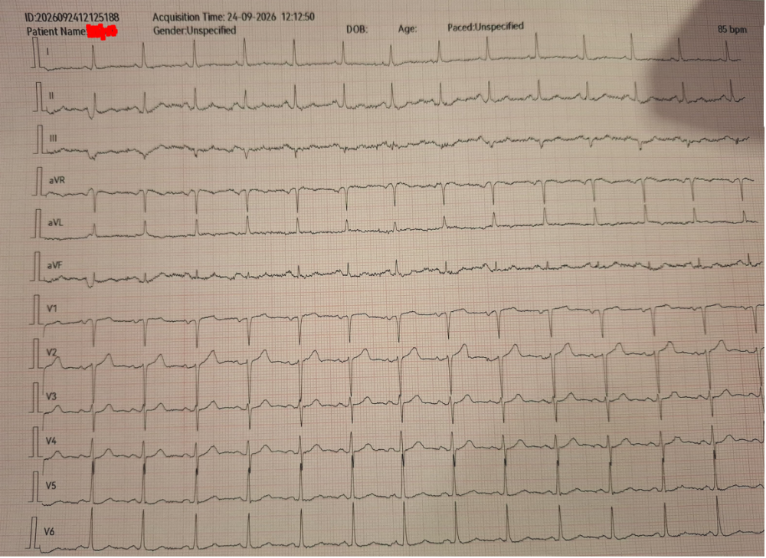

Figure 5. Follow-up ECG before discharge from hospital.
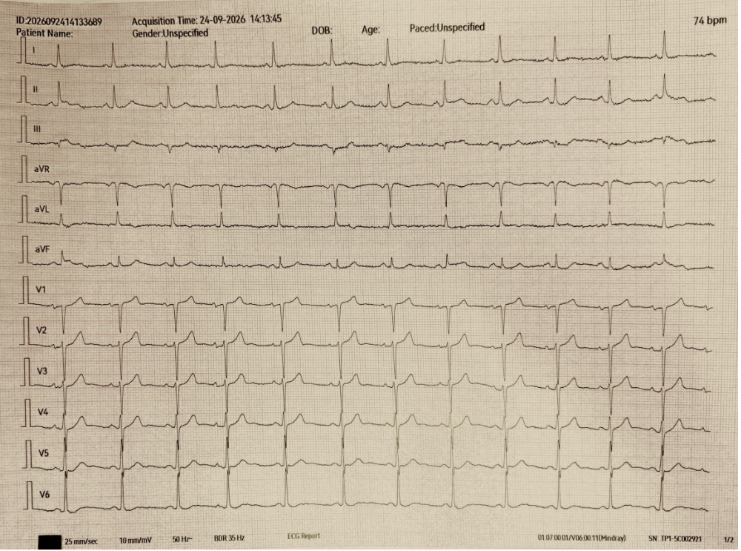

Figure 6. Chest X-ray
