E=ffectiveness of a Planned Teaching Programme on Knowledge Regarding the Influence of Television on Behavioural Changes among High School Students in Jaipur: A Pre-Experimental Study

ABSTRACT
Background: Television and other screen-based media can influence adolescent knowledge, attitudes, emotions, daily routines, and behaviour. School-based health education may improve students’ awareness of these effects. Objective: To assess baseline knowledge regarding the influence of television on behavioural changes among high school students and evaluate the effectiveness of a planned teaching programme. Methods: A quantitative evaluative, pre-experimental one-group pre-test–post-test design was used. Sixty high school students in Jaipur were selected by purposive sampling. Knowledge was measured with a 25-item self-structured multiple-choice questionnaire. The tool underwent expert content validation and showed split-half reliability of 0.82. A planned teaching programme was delivered after the pre-test, and the post-test was conducted five days later. Data were analysed using frequency, percentage, mean, standard deviation, a paired t-test and a chi-square test. Results: Before the intervention, 70.0% of students had poor knowledge and 30.0% had average knowledge; none had good knowledge. After the intervention, 73.3% had good knowledge, 26.7% had average knowledge, and none remained in the poor category. Mean knowledge score increased from 11.82 ± 2.63 to 19.82 ± 2.11. The paired t-value was -20.40 (df = 59; p < 0.05), indicating a statistically significant improvement. Among the demographic variables examined, only self-reported health disturbances related to television viewing showed a significant association with pre-test knowledge (χ² = 11.85, df = 1, p < 0.05). Conclusion: The planned teaching programme was effective in improving high school students’ knowledge regarding the influence of television on behavioural changes. School and community health nurses may use structured media-literacy education as part of adolescent health-promotion activities.
Keywords: high school students; television; behaviour; knowledge; planned teaching programme; adolescent health; nursing education

1. INTRODUCTION
Television remains an important source of information, education, entertainment, and social learning for children and adolescents. At the same time, heavy or poorly supervised screen exposure has been associated with behavioural concerns, reduced physical activity, sleep problems, academic difficulties, emotional symptoms, and exposure to violent or otherwise inappropriate content. The effects vary according to age, developmental stage, duration of exposure, programme content, and family supervision (American Academy of Child and Adolescent Psychiatry, 2025; Eric, 2021; Kostyrka-Allchorne et al., 2017; Muppalla et al., 2023; Musau et al., 2017; Nirusha et al., 2017).
A recent literature review indicated that associations between screen use and adolescent well-being vary with the type of content, patterns of use, and family and social context (de Souza et al., 2025).
In a study using objective measures of screen exposure, screen use once in bed was associated with shorter sleep duration, whereas use during the two hours before bedtime was not associated with most sleep measures (Brosnan et al., 2024).
Adolescents are especially responsive to observed behaviour and media messages. Social-learning perspectives suggest that behaviours portrayed by influential models can be observed, encoded, and reproduced, particularly when they appear rewarded or socially acceptable (Anderson et al., 2003; Bandura et al., 1961). In addition, school-age children increasingly use multiple digital media platforms, which can amplify exposure beyond traditional television (Kostyrka-Allchorne et al., 2017; Liu et al., 2022; Nakshine et al., 2022; Santi et al., 2022).
Indian studies have reported high levels of screen exposure among children and adolescents and have highlighted associations with developmental delay, limited physical activity, sleep problems, eye symptoms, headache, and behavioural or psychosocial difficulties (Guo et al., 2021; Hu et al., 2023; Jain et al., 2023; Kaur et al., 2021; Liu et al., 2022; Meena et al., 2020; Nakshine et al., 2022; Varadarajan et al., 2021; Xiang et al., 2022). Although television may provide educational and prosocial benefits, students need the knowledge and skills to recognise harmful content, regulate viewing time, and make healthier media choices (Reid Chassiakos et al., 2016; TOI Lifestyle Desk, 2024).
A descriptive survey of parents in Nigeria identified gaps in awareness of the health effects of prolonged screen exposure and in attitudes towards limiting children’s screen time (Ukwuani et al., 2026).
Planned teaching programmes are a practical nursing strategy for school health promotion. A systematic review of school-based interventions found that reductions in screen time were modest compared with reductions in problematic digital technology use, supporting the need to define intervention outcomes precisely (Žmavc et al., 2025). However, the cited background evidence does not establish baseline knowledge of television-related behavioural influences among students in the selected Jaipur school or short-term changes in knowledge following a planned teaching programme. The present study therefore evaluated whether a structured educational intervention could improve high school students’ knowledge regarding the influence of television on behavioural changes.
2. AIM AND OBJECTIVES
The aim of the study was to evaluate students’ knowledge regarding the influence of television on behavioural changes and determine the effectiveness of a planned teaching programme in improving that knowledge.
- To assess pre-test knowledge regarding the influence of television on behavioural changes among high school students.
- To assess post-test knowledge regarding the influence of television on behavioural changes among high school students.
- To compare pre-test and post-test knowledge scores.
- To evaluate the effectiveness of the planned teaching programme.
- To determine the association between pre-test knowledge and selected demographic variables.

3. CONCEPTUAL FRAMEWORK
The study was guided by Ludwig von Bertalanffy’s General System Model. Baseline characteristics and pre-test knowledge were treated as input; the planned teaching programme represented the throughput process; post-test knowledge represented output; and the findings provided feedback regarding the effectiveness of the educational intervention.
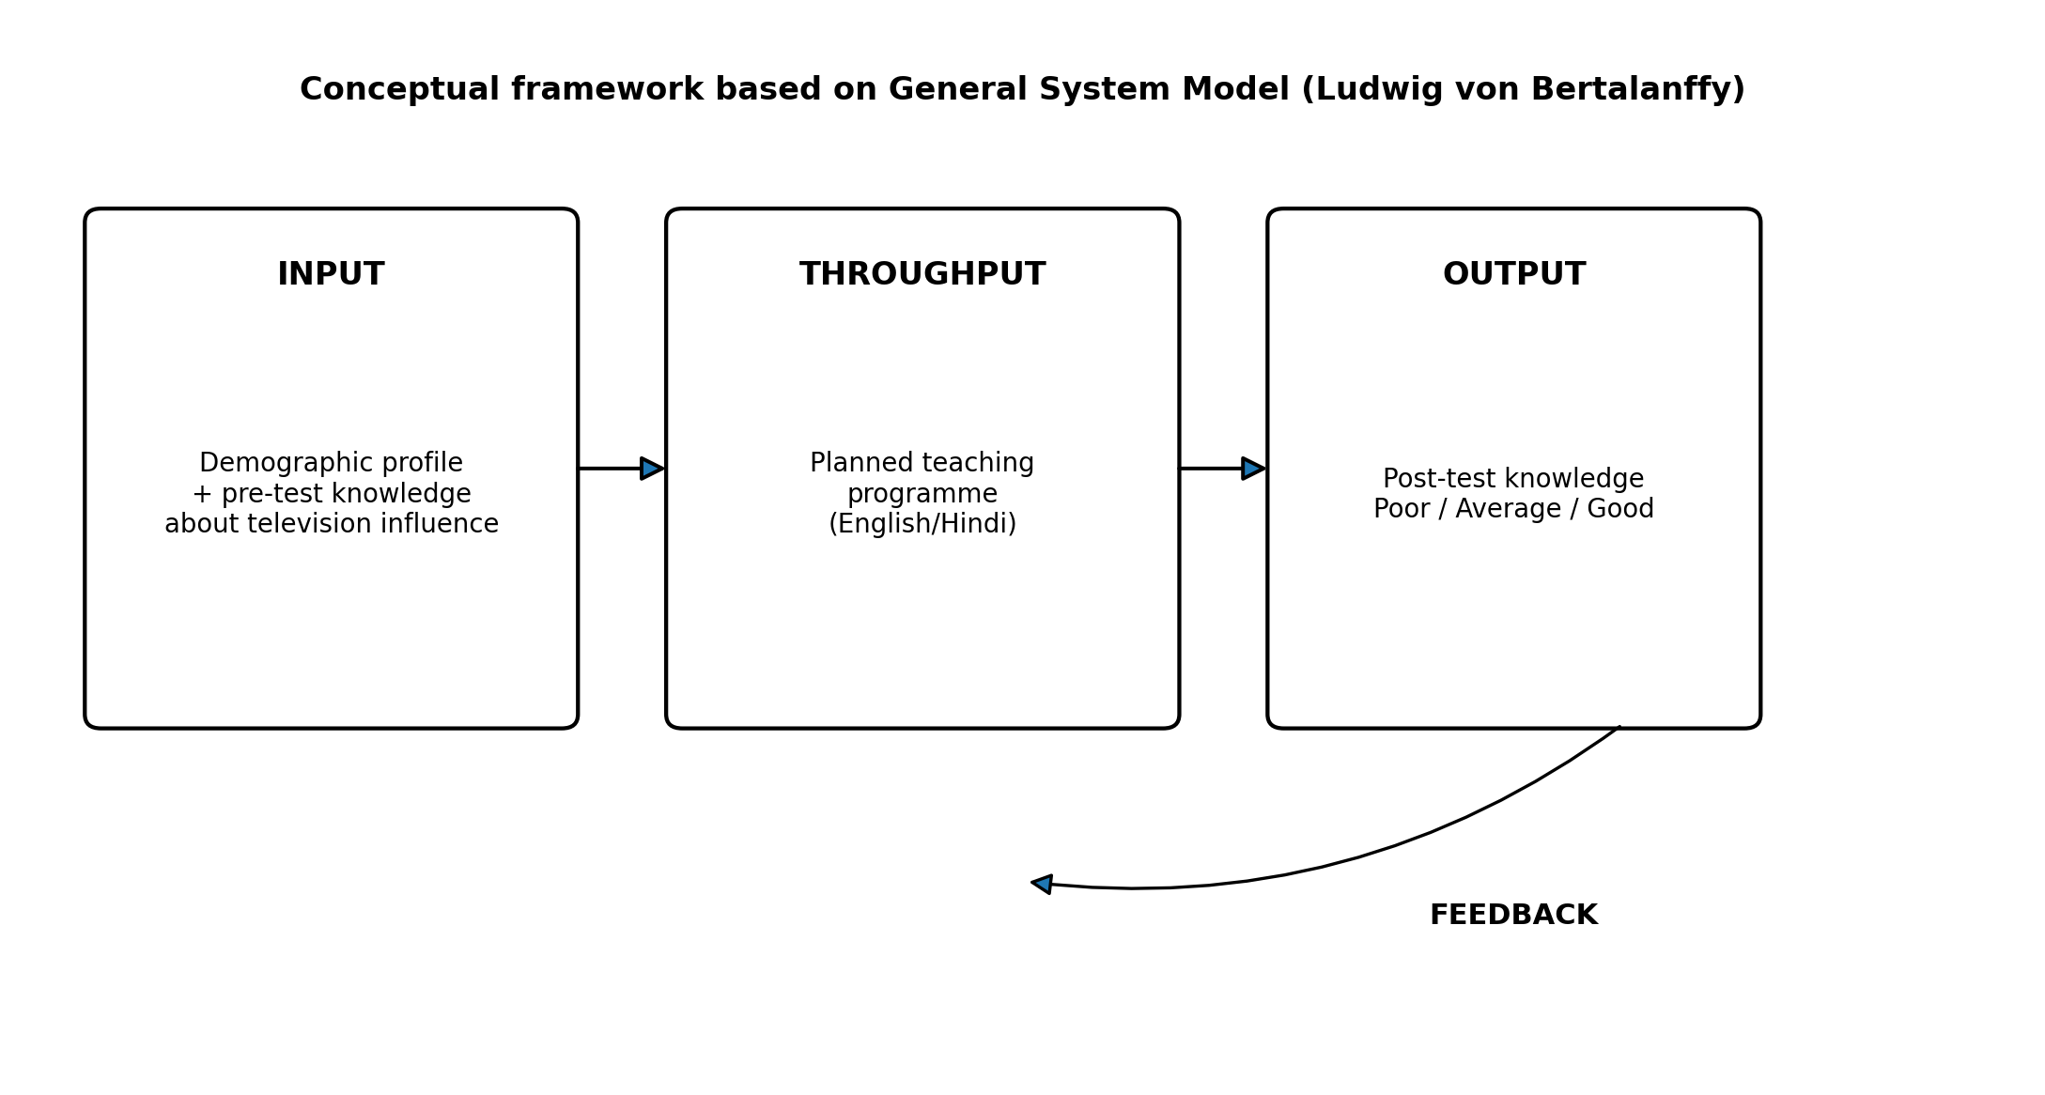
Figure 1. Conceptual framework based on the General System Model.

4. MATERIALS AND METHODS

4.1 Research approach and design
A quantitative evaluative approach was adopted. The study used a pre-experimental one-group pre-test–post-test design (O1–X–O2), with manipulation of the independent variable but no randomisation and no control group (Polit & Beck, 2004).
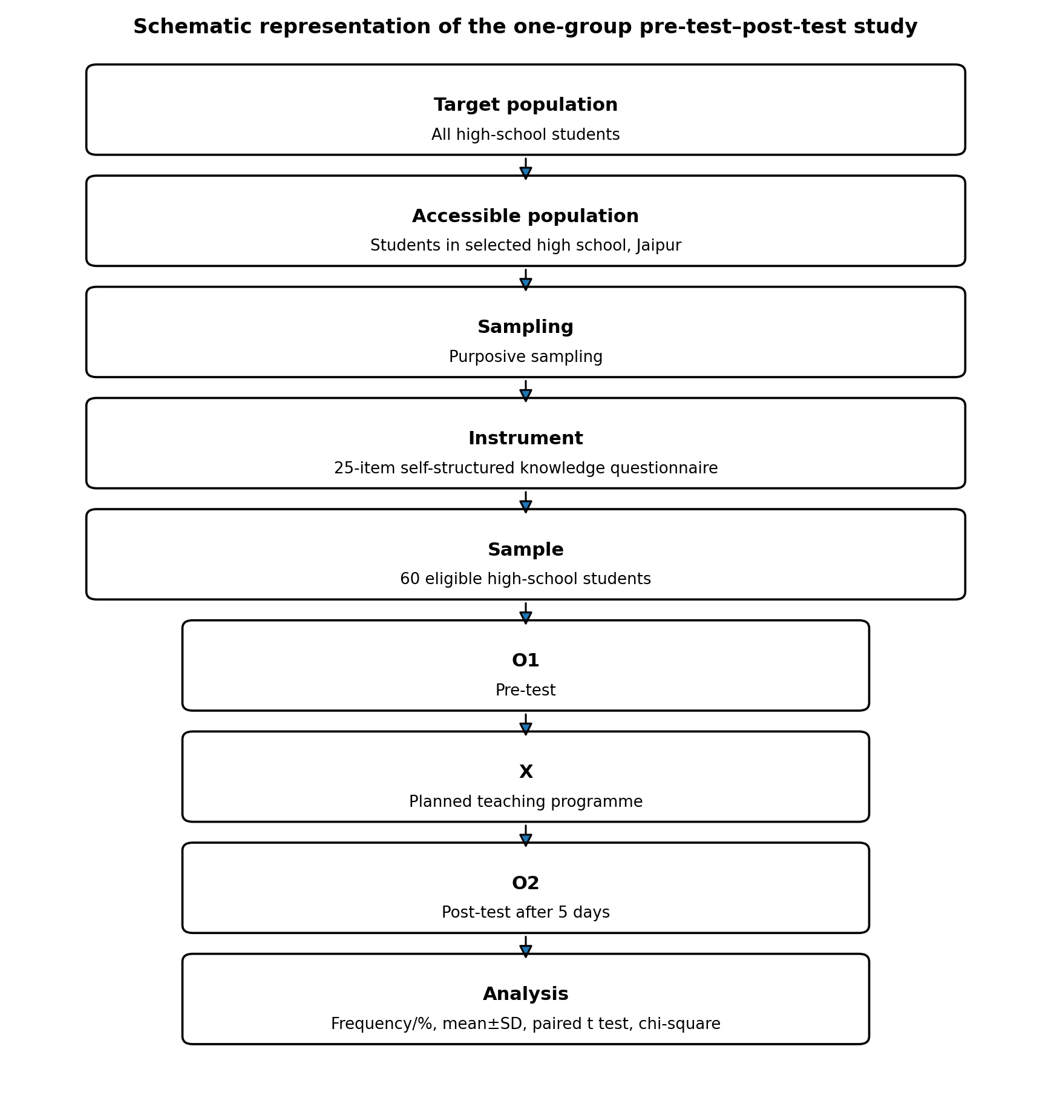
Figure 2. Schematic representation of the research design and study flow.

4.2 Setting, population, sample, and sampling
The study was conducted in a selected high school in Jaipur, Rajasthan. The target population comprised high school students, and the accessible population comprised students attending the selected school. A sample of 60 students was selected using purposive sampling. The dissertation abstract identifies participants as being 14–18 years of age and of both sexes. Participants were required to be regular students, willing to participate, available during data collection, and able to understand English or Hindi.

4.3 Variables
The independent variable was the planned teaching programme regarding the influence of television on behavioural changes. The dependent variable was students’ knowledge regarding the influence of television on behavioural changes. Demographic and television-viewing characteristics were treated as background variables.

4.4 Instrument
Data were collected using a self-structured tool consisting of demographic/television-viewing items and a 25-item multiple-choice knowledge questionnaire. Each correct response was awarded one mark, whereas each incorrect response was awarded zero, giving a possible total score of 0–25. The outcome analysis categorised knowledge as poor (0–13), average (14–18), or good (19–25). Content validity was established through review by five experts from Child Health Nursing. Split-half reliability, calculated using Karl Pearson’s correlation method during tool testing, was reported as 0.82.

4.5 Planned teaching programme
The planned teaching programme was developed from the study objectives, a review of the literature, expert consultation, and the investigator’s experience. It was prepared in English and Hindi and focused on the influence of television on behaviour, beneficial and harmful effects of television exposure, and strategies to reduce negative effects. The teaching content was reviewed by experts and modified according to their suggestions.

4.6 Pilot study
A pilot study was conducted from 22 October 2024 to 9 November 2024 at Government Senior Secondary School, Khowarani Ji, Jamwaramgarh, Jaipur, with six students (10% of the main sample). Purposive sampling was used. Participants completed the pre-test, received the planned teaching programme, and completed a post-test on the seventh day. The pilot study indicated that the procedures were feasible.

4.7 Data collection procedure
Formal permission was obtained from the principal of the selected high school. The main study was conducted from 16 April 2025 to 10 May 2025. The investigator explained the purpose of the study, obtained written consent, assured confidentiality, and administered the pre-test. The planned teaching programme was delivered on the same day. The same knowledge questionnaire was used for the post-test five days later.

4.8 Statistical analysis
Demographic data were summarised using frequencies and percentages. Mean and standard deviation were used for knowledge scores. A paired t-test evaluated the difference between pre-test and post-test scores. Chi-square tests examined associations between pre-test knowledge grade and selected demographic variables. Statistical significance was considered at p < 0.05.
5. RESULTS AND DISCUSSION

5.1 Participant characteristics and television-viewing profile
Variable | Category | n (%)
Age | <16 years | 45 (75.0)
Age | 17 years | 14 (23.3)
Age | >17 years | 1 (1.7)
Gender | Male | 34 (56.7)
 | Female | 26 (43.3)
 | Transgender | 0 (0.0)
Residence | Urban | 33 (55.0)
 | Semi-urban | 20 (33.3)
 | Rural | 7 (11.7)
Monthly family income | <₹10,000 | 5 (8.3)
 | ₹10,000–20,000 | 21 (35.0)
 | ₹21,000–31,000 | 23 (38.3)
 | >₹31,000 | 11 (18.3)
TV viewing per day | <1 hour | 4 (6.7)
 | 1–3 hours | 29 (48.3)
 | 4–6 hours | 22 (36.7)
 | >6 hours | 5 (8.3)
Programme usually watched | News | 1 (1.7)
 | Movies | 38 (63.3)
 | Comedies | 15 (25.0)
 | Reality shows | 5 (8.3)
 | Cartoons/anime | 1 (1.7)
 | Other | 0 (0.0)
Viewing companion | Alone | 23 (38.3)
 | Family | 32 (53.3)
 | Friends | 5 (8.3)
Missed daily activities due to TV | Yes | 31 (51.7)
 | No | 29 (48.3)
Negative emotions after TV | Yes | 40 (66.7)
 | No | 20 (33.3)
Health disturbances related to TV | Yes | 18 (30.0)
 | No | 42 (70.0)
Believes TV influences behaviour | Yes | 15 (25.0)
 | No | 45 (75.0)
Table 1. Demographic characteristics and television-viewing profile (N=60).
The sample was predominantly younger than 16 years (75.0%), male (56.7%), and urban (55.0%). Nearly half watched television for 1–3 hours daily (48.3%), and movies were the most commonly watched programme type (63.3%). More than half watched with family (53.3%). In total, 51.7% reported missing daily activities because of television, 66.7% reported negative emotions such as anxiety or fear after viewing, and 30.0% reported health disturbances related to television viewing. Despite these experiences, 75.0% did not believe that television influenced their behaviour.

5.2 Pre-test and post-test knowledge grade
Knowledge grade | Pre-test n (%) | Post-test n (%)
Poor (0–13) | 42 (70.0) | 0 (0.0)
Average (14–18) | 18 (30.0) | 16 (26.7)
Good (19–25) | 0 (0.0) | 44 (73.3)
Total | 60 (100.0) | 60 (100.0)
Table 2. Comparison of pre-test and post-test knowledge grades.
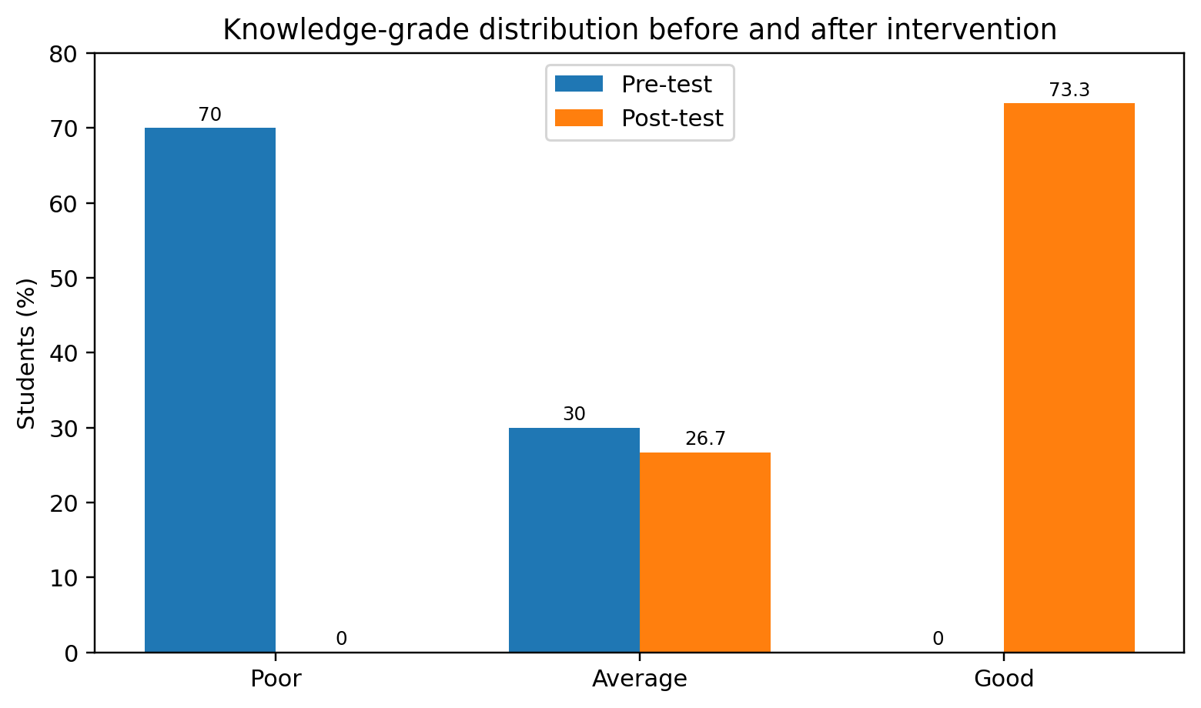
Figure 3. Knowledge-grade distribution before and after the planned teaching programme.
At baseline, 70.0% of students were in the poor-knowledge category and 30.0% were in the average category; no student had good knowledge. After the intervention, no student remained in the poor category, 26.7% had average knowledge, and 73.3% had good knowledge.
5.3 Effectiveness of the planned teaching programme
Assessment | Mean ± SD | t | df | p value | Inference
Pre-test | 11.82 ± 2.63 | -20.40 | 59 | <0.05 | Significant
Post-test | 19.82 ± 2.11
Table 3. Pre-test and post-test knowledge scores.
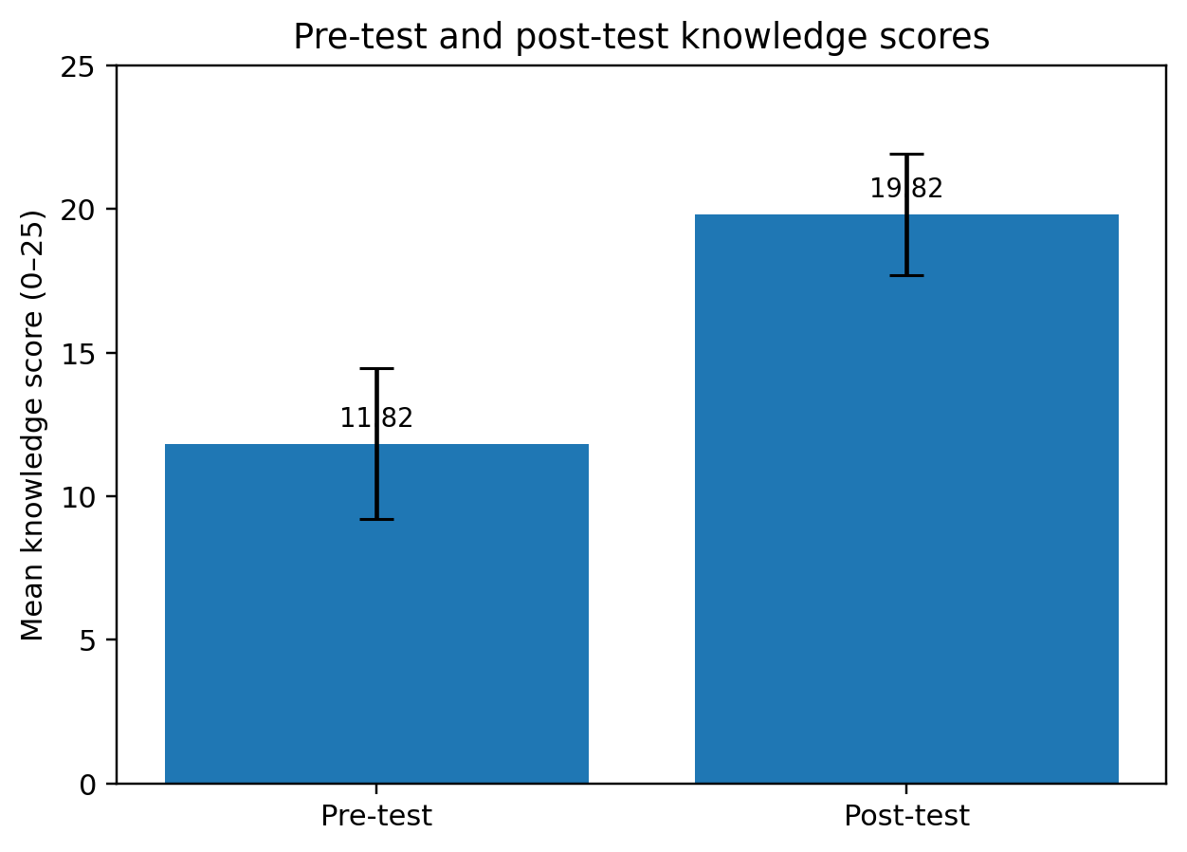
Figure 4. Mean knowledge score before and after the intervention (error bars show SD).
The mean knowledge score increased by 8.00 points, from 11.82 ± 2.63 in the pre-test to 19.82 ± 2.11 in the post-test. The paired t-test was statistically significant (t = −20.40, df = 59, p < 0.05), indicating a substantial improvement in knowledge following the planned teaching programme.
5.4 Association of pre-test knowledge with selected variables
Variable | χ² | df | p value | Inference
Age | 0.46 | 2 | >0.05 | NS
Gender | 3.31 | 1 | >0.05 | NS
Area of residence | 5.39 | 2 | >0.05 | NS
Monthly family income | 5.68 | 3 | >0.05 | NS
TV viewing hours/day | 3.13 | 3 | >0.05 | NS
Type of TV programme | 5.70 | 4 | >0.05 | NS
Viewing companion | 2.43 | 2 | >0.05 | NS
Missed daily activities | 1.68 | 1 | >0.05 | NS
Negative emotions after TV | 1.42 | 1 | >0.05 | NS
Health disturbances related to TV | 11.85 | 1 | <0.05 | Significant
Belief that TV influences behaviour | 0.10 | 1 | >0.05 | NS
Table 4. Association between pre-test knowledge grade and selected demographic/television-viewing variables.
Pre-test knowledge was not significantly associated with age, gender, residence, family income, daily viewing duration, type of programme, viewing companion, missed daily activities, negative emotions after viewing, or belief that television influences behaviour. A significant association was reported only for health disturbances related to television viewing (χ² = 11.85, df = 1, p < 0.05).
The study showed a marked improvement in students’ knowledge after a planned teaching intervention. The shift from 70.0% poor knowledge at baseline to 73.3% good knowledge after teaching, together with an increase in mean score from 11.82 to 19.82, indicates that a short, structured educational programme can substantially improve awareness of television-related behavioural influences.
The baseline viewing pattern is notable. Almost half of participants watched television for 1–3 hours each day, more than one-third watched 4–6 hours, and entertainment-oriented content—especially movies and comedies—dominated viewing. Previous Indian and international literature has similarly described extensive screen exposure among children and adolescents and linked it with sleep disturbance, reduced physical activity, psychosocial problems, poorer academic outcomes, and other health concerns (Guo et al., 2021; Hu et al., 2023; Jain et al., 2023; Liu et al., 2022; Meena et al., 2020; Nakshine et al., 2022; Varadarajan et al., 2021; Wiguna et al., 2024; Xiang et al., 2022).
Two-thirds of participants reported negative emotions after television viewing and nearly one-third reported health disturbances, yet three-quarters did not perceive television as influencing their behaviour. This gap between experienced effects and perceived behavioural influence supports the need for media-literacy education that helps students recognise less obvious emotional, social, and behavioural consequences of media exposure.
The significant paired t-test supports the effectiveness of the intervention, alongside studies evaluating structured teaching and digital health education in relation to knowledge and screen-use outcomes among adolescents and families (dos Santos et al., 2023; Jones et al., 2021; Parveen & Tyagi, 2022; Raj et al., 2023; Settipalle & Bhavya, 2024). Although the present study measured knowledge rather than long-term behaviour, improved knowledge is a necessary foundation for informed decision-making and self-regulation.
Only health disturbances related to television viewing were significantly associated with baseline knowledge. Other demographic factors were not associated with pre-test knowledge, suggesting that the educational need was broad across subgroups. However, because the design lacked randomisation and a control group, causal inference should be made cautiously.
7. NURSING IMPLICATIONS

7.1 Nursing practice
- School and community health nurses can incorporate media-literacy counselling into adolescent health promotion.
- Nurses can counsel students and families regarding balanced viewing, content selection, sleep hygiene, physical activity, and recognition of emotional or health effects related to prolonged viewing.
- Students who report distress, sleep problems, headaches, eye strain, or interference with daily activities can be identified early and referred when necessary.

7.2 Nursing education
- Nursing curricula can include the health and behavioural effects of screen exposure and practical methods for designing school-based teaching interventions.
- Student nurses can use similar programmes during community and school-health postings to build health-education and evaluation skills.

7.3 Nursing research and administration
- Further studies can evaluate long-term behavioural outcomes, parent-involved interventions, peer-led education, and digital teaching formats.
- Nursing administrators can support school-health programmes, educational materials, interdisciplinary collaboration, and policies that promote healthy media use.

8. LIMITATIONS
- The study used a pre-experimental one-group design without a control group or randomisation.
- The sample was limited to 60 students from a selected high school in Jaipur, limiting generalisability.
- Purposive sampling may introduce selection bias.
- The outcome focused on knowledge immediately after a short follow-up rather than sustained behaviour change.
- Some methodological details in the dissertation require clarification before journal submission, including formal ethics committee approval information and the final author-approved knowledge grading scheme.

9. RECOMMENDATIONS
- Conduct controlled or randomised studies with larger, multi-school samples.
- Use longer follow-up periods to determine whether knowledge gains translate into reduced screen time or healthier viewing behaviours.
- Compare interactive workshops, peer education, digital modules, and parent–student interventions.
- Include qualitative interviews or focus groups to explore students’ perceptions and barriers to healthy screen use.
- Develop and validate standardised culturally appropriate tools measuring knowledge, attitudes, media literacy, and behavioural outcomes.
- Evaluate cost-effectiveness when implementing school-based media-literacy programmes at scale.

10. CONCLUSION

The study identified a notable increase in knowledge regarding the influence of television on behavioural changes among the participating high school students following a planned teaching programme. Before the intervention, 70.0% of students were classified as having poor knowledge, whereas 73.3% were classified as having good knowledge at the post-test conducted five days later. The mean knowledge score increased from 11.82 to 19.82 out of 25, and the paired t-test indicated a statistically significant difference between assessments. Among the demographic and television-viewing characteristics evaluated, only self-reported health disturbances related to television viewing showed a statistically significant association with baseline knowledge. These findings suggest that a structured teaching programme may be a practical approach for improving short-term awareness of television-related behavioural influences in school settings. However, the one-group design, purposive selection of students from a single school and brief follow-up mean that the findings cannot establish causation or demonstrate sustained behavioural change. Further controlled studies with broader samples and longer follow-up periods would help clarify whether knowledge gains persist and influence television-viewing practices.

11. DECLARATIONS
Consent
Written consent was obtained from participants, and confidentiality was assured.

Ethics Approval
The dissertation reports that formal permission was obtained from the principal of the selected high school.

Declaration of AI Use

This manuscript was prepared through the intellectual contributions of the author(s) to the study design, data analysis, interpretation of results, and scholarly content. Grammarly and ChatGPT were used solely to assist with grammatical refinement and reference formatting during manuscript revision. The author(s) accept full responsibility for the accuracy, integrity, and final content of the manuscript.

12. REFERENCES

American Academy of Child and Adolescent Psychiatry. (2025). Screen violence and children. https://www.aacap.org/AACAP/Families_and_Youth/Facts_for_Families/FFF-Guide/Screen_Violence_Children-013.aspx
Anderson, C. A., Berkowitz, L., Donnerstein, E., Huesmann, L. R., Johnson, J. D., Linz, D., Malamuth, N. M., & Wartella, E. (2003). The influence of media violence on youth. Psychological Science in the Public Interest, 4(3), 81–110. https://doi.org/10.1111/j.1529-1006.2003.pspi_1433.x
Bandura, A., Ross, D., & Ross, S. A. (1961). Transmission of aggression through imitation of aggressive models. The Journal of Abnormal and Social Psychology, 63(3), 575–582. https://doi.org/10.1037/h0045925
Brosnan, B., Haszard, J. J., Meredith-Jones, K. A., Wickham, S.-R., Galland, B. C., & Taylor, R. W. (2024). Screen use at bedtime and sleep duration and quality among youths. JAMA Pediatrics, 178(11), 1147–1154. https://doi.org/10.1001/jamapediatrics.2024.2914
de Souza, A. C. A., Valadares, A. E. M., Gomes, G. C., de Barros, G. C. G., do Espírito Santo, L. M., de Azevedo, N. M., Nunes, P. A. S., Carneiro, S. F., Nascimento, S., Cruz, T. C., & Vasconcellos Neto, J. R. T. (2025). Screen time and its impacts on youth health and brain development. Asian Journal of Education and Social Studies, 51(9), 1206–1220. https://doi.org/10.9734/ajess/2025/v51i92450
dos Santos, P. C., Bandeira, A. S., da Costa, B. G. G., de Sousa, A. C. C., & Silva, K. S. (2023). From awareness to action: Effects of a school-based intervention on TV viewing behavior stages and screen time guidelines knowledge in Brazilian adolescents. Revista Brasileira de Atividade Física & Saúde, 28, Article e0314. https://doi.org/10.12820/rbafs.28e0314
Eric, O. (2021). The negative effects of new screens on the cognitive functions of young children require new recommendations. Italian Journal of Pediatrics, 47, Article 223. https://doi.org/10.1186/s13052-021-01174-6
Guo, Y.-F., Liao, M.-Q., Cai, W.-L., Yu, X.-X., Li, S.-N., Ke, X.-Y., Tan, S.-X., Luo, Z.-Y., Cui, Y.-F., Wang, Q., Gao, X.-P., Liu, J., Liu, Y.-H., Zhu, S., & Zeng, F.-F. (2021). Physical activity, screen exposure and sleep among students during the pandemic of COVID-19. Scientific Reports, 11, Article 8529. https://doi.org/10.1038/s41598-021-88071-4
Hu, Z., Bi, S., Wang, W., Liu, C., & Li, L. (2023). Association of screen exposure with psychosocial problems in primary school students. Frontiers in Pediatrics, 10, Article 961137. https://doi.org/10.3389/fped.2022.961137
Jain, S., Shrivastava, S., Mathur, A., Pathak, D., & Pathak, A. (2023). Prevalence and determinants of excessive screen viewing time in children aged 3–15 years and its effects on physical activity, sleep, eye symptoms and headache. International Journal of Environmental Research and Public Health, 20(4), Article 3449. https://doi.org/10.3390/ijerph20043449
Jones, A., Armstrong, B., Weaver, R. G., Parker, H., von Klinggraeff, L., & Beets, M. W. (2021). Identifying effective intervention strategies to reduce children's screen time: A systematic review and meta-analysis. International Journal of Behavioral Nutrition and Physical Activity, 18, Article 126. https://doi.org/10.1186/s12966-021-01189-6
Kaur, N., Gupta, M., Kiran, T., Malhi, P., & Grover, S. (2021). Development and evaluation of the digital-screen exposure questionnaire (DSEQ) for young children. PLOS ONE, 16(6), Article e0253313. https://doi.org/10.1371/journal.pone.0253313
Kostyrka-Allchorne, K., Cooper, N. R., & Simpson, A. (2017). The relationship between television exposure and children's cognition and behaviour: A systematic review. Developmental Review, 44, 19–58. https://doi.org/10.1016/j.dr.2016.12.002
Liu, J., Riesch, S., Tien, J., Lipman, T., Pinto-Martin, J., & O'Sullivan, A. (2022). Screen media overuse and associated physical, cognitive, and emotional/behavioral outcomes in children and adolescents: An integrative review. Journal of Pediatric Health Care, 36(2), 99–109. https://doi.org/10.1016/j.pedhc.2021.06.003
Meena, P., Gupta, P., & Shah, D. (2020). Screen time in Indian children by 15–18 months of age. Indian Pediatrics, 57(11), 1033–1036. https://doi.org/10.1007/s13312-020-2031-3
Muppalla, S. K., Vuppalapati, S., Reddy Pulliahgaru, A., & Sreenivasulu, H. (2023). Effects of excessive screen time on child development: An updated review and strategies for management. Cureus, 15(6), Article e40608. https://doi.org/10.7759/cureus.40608
Musau, L. M., Okoth, U., & Matula, P. (2017). Impact of students' exposure to electronic media facilities in their homes on parental involvement in management of students' discipline in public day secondary schools in Kenya. European Scientific Journal, 13(31), 202–221. https://doi.org/10.19044/esj.2017.v13n31p202
Nakshine, V. S., Thute, P., Khatib, M. N., & Sarkar, B. (2022). Increased screen time as a cause of declining physical, psychological health, and sleep patterns: A literary review. Cureus, 14(10), Article e30051. https://doi.org/10.7759/cureus.30051
Nirusha, K., Daniel, V. S., & Bhanu Priya, U. (2017). A descriptive study to assess the impact of television watching on behavior among school going children in selected schools at Guntur, Andhra Pradesh, India. International Journal of Science and Research, 6(10), 2067–2070. https://www.ijsr.net/getabstract.php?paperid=ART20177737
Parveen, N., & Tyagi, Z. A. (2022). Effectiveness of structured teaching programme on knowledge regarding harmful effect of long screen viewing habits among adolescents. International Journal of Science and Research, 11(3), 880–884. https://doi.org/10.21275/MR22316000348
Polit, D. F., & Beck, C. T. (2004). Nursing research: Principles and methods (7th ed.). Lippincott Williams & Wilkins. https://iucat.iu.edu/iuk/5476481
Raj, D., Ahmad, N., Mohd Zulkefli, N. A., & Lim, P. Y. (2023). Stop and Play digital health education intervention for reducing excessive screen time among preschoolers from low socioeconomic families: Cluster randomized controlled trial. Journal of Medical Internet Research, 25, Article e40955. https://doi.org/10.2196/40955
Reid Chassiakos, Y. L., Radesky, J., Christakis, D., Moreno, M. A., & Cross, C. (2016). Children and adolescents and digital media. Pediatrics, 138(5), Article e20162593. https://doi.org/10.1542/peds.2016-2593
Santi, Ramli, H., & Sumiati. (2022). The implications of screentime for children's health in online learning at 59 Siguntu Elementary School, Palopo City. Jurnal Life Birth, 6(3), 119–132. https://doi.org/10.37362/jlb.v6i3.944
Settipalle, N. A., & Bhavya, Y. (2024). A study to assess the effectiveness of structured teaching programme regarding influence of mass media on adolescence behavior among their parents in selected rural areas at Kolar. International Journal of Current Science, 14(1), 322–495. https://rjpn.org/ijcspub/viewpaperforall.php?paper=IJCSPTH00036
TOI Lifestyle Desk. (2024, March 2). Impact of excessive screen time on children's exam performance. The Times of India.
Ukwuani, M. C., Kanikwu, P. N., & Oladipo, G. S. (2026). Parental awareness and attitude towards health effects of prolonged screen time on children in Enugu, Nigeria. Asian Journal of Research in Medicine and Medical Science, 8(1), 256–265. https://doi.org/10.56557/ajrmms/2026/v8i1110
Varadarajan, S., Govindarajan Venguidesvarane, A., Ramaswamy, K. N., Rajamohan, M., Krupa, M., & Winfred Christadoss, S. B. (2021). Prevalence of excessive screen time and its association with developmental delay in children aged <5 years: A population-based cross-sectional study in India. PLOS ONE, 16(7), Article e0254102. https://doi.org/10.1371/journal.pone.0254102
Wiguna, T., Minayati, K., Kaligis, F., Teh, S. D., Sourander, A., Dirjayanto, V. J., Krishnandita, M., Meriem, N., & Gilbert, S. (2024). The influence of screen time on behaviour and emotional problems among adolescents: A comparison study of the pre-, peak, and post-peak periods of COVID-19. Heliyon, 10(1), Article e23325. https://doi.org/10.1016/j.heliyon.2023.e23325
Xiang, H., Lin, L., Chen, W., Li, C., Liu, X., Li, J., Ren, Y., & Guo, V. Y. (2022). Associations of excessive screen time and early screen exposure with health-related quality of life and behavioral problems among children attending preschools. BMC Public Health, 22, Article 2440. https://doi.org/10.1186/s12889-022-14910-2
Žmavc, M., Horvat, J., Židan, M., & Selak, Š. (2025). The effectiveness of school-based interventions to reduce problematic digital technology use and screen time: A systematic review and meta-analysis. Journal of Behavioral Addictions, 14(2), 571–589. https://doi.org/10.1556/2006.2025.00043

