Climate Variability and Agricultural Adaptations in Northern Côte d'Ivoire: Restructuring Crop Calendars in the Korhogo Department (North of Côte d’Ivoire)

ABSTRACT
Background: Seasonal rainfall variability affects crop timing in the Korhogo department of northern Côte d’Ivoire, where agriculture depends substantially on rainfall. Objective: This study examined hydroclimatic variability during 1982–2022 and developed revised agricultural calendars for rice, maize, cotton and cashew. Methods: Daily rainfall and temperature records from the Korhogo Airport station were examined alongside agronomic technical sheets. Annual variability was assessed with the Nicholson precipitation index and a second-order Hanning filter. Rainfall breakpoints were evaluated using Pettitt’s test and Hubert’s segmentation, while rainfall and dry-spell criteria were applied to identify seasonal onset and cessation. Crop operations were subsequently aligned with the identified seasonal pattern and crop-specific requirements. Results: The analyses identified a major rainfall regime breakpoint in 2000 and a shift in the onset of the rainy season from April to May. Decadal mean rainfall declined to 1,179.4 mm during 2002–2011 before recovering to 1,505.595 mm during 2012–2021. The revised schedules placed upland rice sowing between May and mid-June, lowland rice between 15 June and 15 August, maize between 15 June and 15 July, and cotton between 20 May and 30 June. Cashew transplanting was scheduled for July–September. Conclusion: The proposed calendars reflect the observed rainfall timing and may inform crop scheduling in Korhogo. Their suitability under farm conditions remains to be evaluated.
Keywords: Crop calendars, Climate variability, Rainfall disruption, Crop production systems, Korhogo Department.

1. INTRODUCTION
Climate change and variability have become a central concern for scientists and policy-makers worldwide due to their immediate and long-term consequences on both the environment and human societies (Kpan, 2017; Intergovernmental Panel on Climate Change [IPCC], 2023). In West Africa, and particularly in Côte d'Ivoire, these dynamics are reflected in substantial changes in climatic and hydroclimatic conditions (Kouassi et al., 2008; Savané et al., 2001; Yapi, 2021). The manifestations of this crisis typically include a decline in rainfall amounts, an increase in average temperatures, and a profound disruption of rainfall seasonality. The reduction of wet seasons and the erratic occurrence of extreme weather events disrupt the socio-economic balance of populations whose development depends closely on water resources (Food and Agriculture Organization of the United Nations [FAO], 2017; Goula et al., 2007; Kpan, 2017).
A study in the Bagoué region of northern Côte d’Ivoire also documented changes in rainfall and temperature, providing additional regional context for examining local hydroclimatic variability (Diabate & Dibi-Anoh, 2024). At the Kolda station in Senegal, an analysis using complementary change-point methods identified shifts in the rainfall regime, illustrating the relevance of station-level investigations of rainfall variability (Traore et al., 2026).
In Côte d’Ivoire, climate variability is currently considered one of the most serious threats to sustainable development (Adja, 2009; Sultan & Gaetani, 2016). Agriculture, a macroeconomic and subsistence pillar of the country, stands out as the sector particularly vulnerable to these changes (World Bank Group, 2023). In the Korhogo department, located in northern Côte d'Ivoire, this vulnerability is exacerbated by the fact that 75% of agricultural activity remains strictly dependent on rainfall. The rainfall delays and deficits recorded in recent decades lead to critical direct consequences, notably frequent sowing failures, declining crop yields and substantial harvest losses, exposing local populations to poverty and food insecurity (Kouakou, 2011; Soro et al., 2013).
Using rainfall observations and crop simulations in Senegal, Joseph et al. (2023) examined the implications of different definitions of rainy-season onset for maize sowing dates. Agoungbome et al. (2024) assessed alternative sowing strategies for rainfed agriculture in West Africa, with particular attention to the risks associated with variability at the beginning of the rainy season. Jayasankar and Misra (2025) analysed variations in rainy-season onset across West Africa and their relationship with rainy-season duration and rainfall, highlighting the potential relevance of monitoring onset dates for seasonal planning.
Given the need to minimise these agricultural losses and support the resilience of farmers against a disrupted seasonality, it is imperative to adjust cultivation practices. Adapting crop calendars is an important strategy for optimising agricultural practices according to the new hydroclimatic realities of the region. The present study was undertaken in this context.
Although these studies provide evidence on rainfall variability and the timing of agricultural operations, they do not directly establish crop-specific cultivation calendars for the Korhogo department. In this context, an assessment combining the local hydroclimatic record with the cultivation requirements of rice, maize, cotton, and cashew is needed to inform the timing of land preparation, sowing, and harvesting.
The main objective of this work is to design agricultural calendars adapted to the new climate profile of the area to help farmers secure their production cycles. Specifically, the aims are, first, to characterise the trajectory of climate variability in the Korhogo department during 1982–2022 and, second, to determine optimal periods for land clearing, ploughing, sowing, and harvesting for four strategic crops: cotton, maize, rice, and cashew.
2. MATERIALS AND METHODS
2.1. Geographical Setting, Data and Equipment
Located in northern Côte d’Ivoire, the town of Korhogo is situated approximately 564 km from Abidjan (the economic capital) and 320 km from Yamoussoukro (the political capital). It serves as the administrative centre for both the Poro Region and the Savanes District. The Korhogo department encompasses an area of 12,640.4 km² with an estimated population of 440,926 inhabitants (Institut National de la Statistique, 2022). It shares administrative boundaries with the departments of M’Bengue to the north, Sinematiali and Ferkessédougou to the east, Dikodougou and Niakaramadougou to the south, and Boundiali and Dianra to the west.
The regional vegetation consists primarily of shrub savanna interspersed with small, dense forest patches locally referred to as “sacred groves”. Korhogo experiences a Sudano-Guinean climate characterised by two distinct seasons (Soro et al., 2013). Topographically, the region is a vast, rolling plateau with elevations ranging from 300 to 400 metres above sea level (Fig. 1). The local hydrographic network is dominated by the Bandama River and its main tributaries, including the Lofigou and Solomougou rivers.
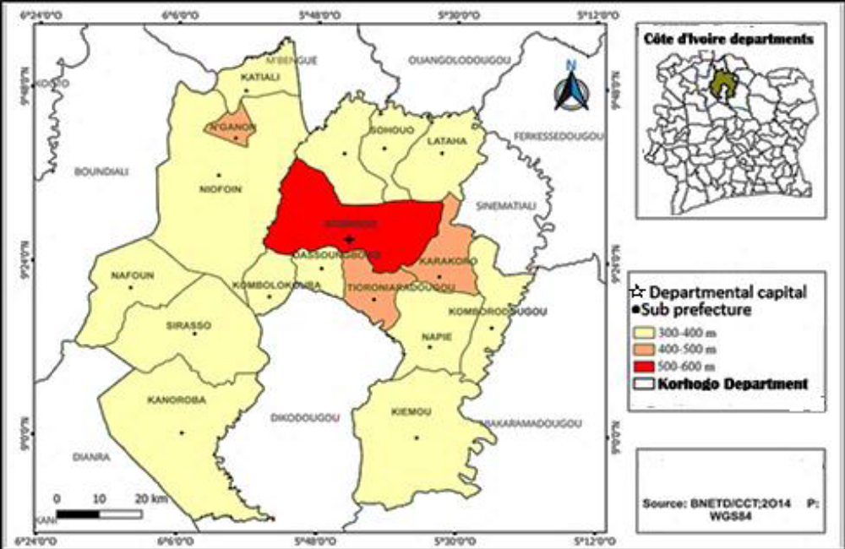
Fig. 1. Map of the study area
The study draws on two complementary types of data:
- Climate data: Time series of daily rainfall and temperatures covering 1982–2022, provided by Société d’Exploitation et de Développement Aéroportuaire, Aéronautique et Météorologique (SODEXAM) from the agro-meteorological station at Korhogo-Airport.
- Agronomic data: Technical sheets published by the Centre National de Recherche Agronomique (CNRA), specifying crop evapotranspiration, agro-climatic cycles, and the requirements of varieties recommended in the region.
Data processing and analysis were performed using Excel (arithmetic calculations and charting), Khronostat 1.00 statistical software (developed by the IRD for detecting changes and breakpoints), and ArcGIS 10.1 for cartographic representations.
2.2. Methodology
2.2.1. Characterization of Climate Variability
The Nicholson precipitation index (Nicholson, 1993) was used to identify annual rainfall deficits or surpluses. It is calculated using the following formula:
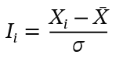
Where Ii represents the index of year i, Xi the rainfall of year i, X_mean the mean of the time series, and sigma its standard deviation.
The second-order Hanning low-pass filter was applied to smooth the chronological series, reduce high-frequency seasonal variations, and highlight long-term climate trends using centred weighted moving averages.
To detect climatic breakpoints, the non-parametric Pettitt test was used to identify the main breakpoint (the date of the most significant change) within the time series at a 5% significance level. Hubert’s segmentation method was also used to detect possible additional breakpoints by dividing the series into segments with significantly distinct means.
2.2.2. Establishment of Adapted Crop Calendars
- Determination of Season Onset and End Dates (Sivakumar (1988) criteria):
The onset of the rainy season corresponds to the date when a minimum cumulative rainfall of 20 mm occurs over three consecutive days, without any dry spell exceeding seven days occurring within the following 30 days. The end of the rainy season is defined as the first day of a period of at least 20 consecutive days without any rainfall greater than or equal to 5 mm.
- Design of Adapted Calendars
The specific physiological requirements of the four crops (overall water requirements, critical temperatures, sunshine duration) were compared with the newly established seasonality to chronologically reposition land clearing, ploughing, sowing, and harvesting operations (Djaha et al., 2008; Ezan et al., 1998; Kockmann, 2009; Koffi, 2005).

3. RESULTS AND DISCUSSION
3.1. Climate Diagnosis Results and Rainfall Disruption
The thermal and hydroclimatic analysis indicates substantial changes of the Sudanese climate in the Korhogo department during 1982–2022.
3.1.1. Decadal Evolution and Nicholson Precipitation Indices
The evaluation of decadal rainfall averages reveals a bell-shaped trajectory characterised by a marked dry phase followed by a subsequent recovery in rainfall (Fig. 2):
- The 1982-1991 decade was the wettest with an average of 1595.54 mm.
- A decline occurred during the 1992-2001 decade (1405.94 mm).
- The 2002-2011 decade recorded the lowest mean rainfall with a minimum of 1179.4 mm.
- Finally, the 2012-2021 decade showed a rainfall recovery, reaching 1505.595 mm.

Fig. 2. Trends in the ten-year average rainfall

The application of Hanning’s second-order low-pass filter and Nicholson indices enabled the segmentation of the time series into five climatic periods (Fig. 3):
- Three wet periods: 1982-1990 (mean of 1611.05 mm, a surplus of +188.03 mm relative to the interannual mean of 1423.02 mm), 1997-2000 (+206.63 mm), and 2015-2022 (+123.90 mm).
- Two dry periods: 1991-1996 (deficit of -119.9 mm) and the prolonged dry period of 2001-2014, which records the largest deficit in the series at -199.46 mm.
Frequency analysis shows that the proportion of dry years at the Korhogo-Airport station was 51.21%, compared with 48.78% of wet years.
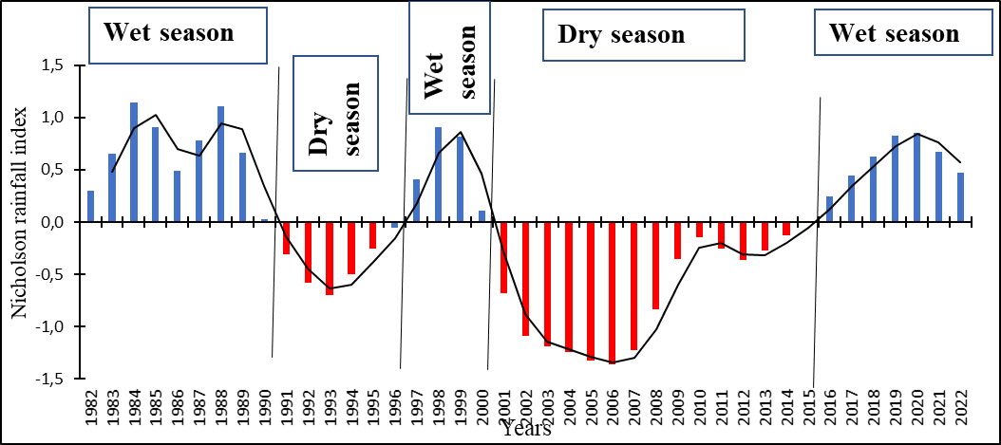

Fig. 3. Variation in the Nicholson rainfall index in the Korhogo department from (1982 to 2022)
3.1.2. Statistical Detection of Rainfall Ruptures
The non-parametric Pettitt test detected a major rainfall rupture in 2000 with a significance level greater than 99% (Fig. 4). This rupture separates the time series into two distinct climatic regimes:
1. Pre-breakpoint period (1982-2000): Mean annual precipitation was 1430.47 mm, including the maximum recorded in the series (2143.81 mm recorded in 1988).
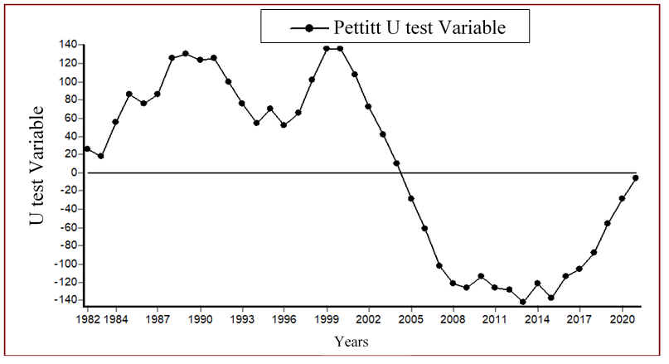
2. Post-rupture period (2001-2022): Average rainfall dropped to 1341.14 mm, recording the absolute historical minimum of the time series (1015.74 mm in 2007).

Figure 4: Variation in Pettitt’s U-values test at the Korhogo Airport rain gauge station

Hubert's segmentation method corroborates the main rupture in 2000 and identifies two secondary ruptures in 2008 and 2022 (Table 1), indicating the temporal variability of rainfall.
Table 1: Hubert's segmentation method (Significance level of the Scheffé test at 1%)
Start | End | Average | Standard deviation
1982  2001  2009 | 2000  2008  2022 | 1517,832  1104,937  1476,121 | 281,994  68,247  164,927

3.1.3. Temporal Shift of the Rainy Season
The direct agronomic consequence of this rupture is reflected in changes in seasonality. Before 2000, the rainy season typically began in April, with a monthly average above the reported threshold of the series (126.89 mm).
After 2000, April rainfall declined and fell below the new reference monthly average (112.09 mm). The onset of the rainy season therefore shifted from April to May, restricting the growing season from May to October and necessitating a revision of sowing periods.
3.2. Restructuring of Crop Calendars by Crop
To counter sowing losses and the collapse of yields caused by this seasonal shortening, new crop calendars, modelled on post-rupture water availability, have been validated for four key crops.
3.2.1. Upland and Lowland Rice Cultivation
Rice requires warm conditions and high sunlight and a monthly water input of 100 mm (upland) to 200 mm (lowland).
- Proposed itinerary: Land clearing is scheduled from March to May, followed by deep ploughing (manual or mechanized) from May to July to promote root development and bury organic matter.
- Sowing and harvesting: For upland rice, sowing must be completed between May and mid-June. In lowlands, the proposed window extends from June 15 to August 15, allowing the period of greatest foliage development to coincide with the peak rainfall period of August-September (when mean rainfall reaches 243.45 mm and 227.07 mm). Harvesting begins from September onwards for short-cycle varieties.
Table 2 summarises the rice cultivation schedule.
Table 2: Agricultural calendar for rice in the Korhogo department
 | Jan | Feb | Mar | Apr | May | June | July | Aug | Sept | Oct | Nov | Dec
Land clearing
Hilling
Sowing
Weeding
Harvest

3.2.2. Maize Cultivation
Maize requires a well-structured soil and a well-distributed total of 450 mm of water to guarantee an optimal yield of 10 t/ha.
- Proposed itinerary: Plot preparation and clearing extend from April to June, and ploughing is carried out from June to July to a depth of 15 to 30 cm.
- Sowing and harvesting: Sowing is scheduled between June 15 and July 15, after ensuring a rainfall event of at least 20 mm. Maintenance weeding is scheduled 15 to 30 days after emergence to limit weed competition. Harvesting occurs from September onwards depending on the length of the varietal cycle (Table 3).
Table 3: Agricultural calendar for maize in the Korhogo department
 | Jan | Feb | Mar | Apr | May | June | July | Aug | Sept | Oct | Nov | Dec
Land clearing
Hilling
Sowing
Weeding
Harvest

3.2.3. Cotton Cultivation
Cotton is sensitive to waterlogging but requires at least 700 mm of water over a vegetative cycle of 150 to 170 days. It requires high temperatures (around 30°C) early in the cycle and a marked dry period towards the end of the growing cycle.
- Proposed itinerary: The revised calendar schedules land clearing in March-April and ploughing from April to June.
- Sowing and harvesting: Sowing occurs from May 20 to June 30 on moist soil with the application of pre-emergence herbicides. Maintenance is performed through successive weedings at days 20 and 60. Harvesting takes place in stages (in at least two passes) starting in November, taking advantage of the onset of the dry season and the harmattan to preserve fibre quality (Table 4).
Table 4: Agricultural calendar for cotton plant in the Korhogo department
 | Jan | Feb | Mar | Apr | May | June | July | Aug | Sept | Oct | Nov | Dec
Land clearing
Hilling
Sowing
Weeding
Harvest

3.2.4. Cashew Cultivation
The cashew tree, a perennial woody species is resistant to drought but requires deep and well-drained soils.
- Proposed itinerary: Land preparation takes place in the first quarter (January to March). Hole digging (50 cm in diameter by 80 cm in depth) is planned from April to June. The holes are left open for 15 days and then refilled with organic basal fertiliser 45 days before transplanting.
- Planting: Transplanting of vigorous young seedlings from the nursery is carried out during the third quarter, from July to September, when the soil has substantial soil-water reserves that favour root establishment before the November dry season (Table 5).
Table 5. Agricultural calendar for cashew tree in the Korhogo department
Years | 1st year |  |  |  | 2nd year |  |  |  | 3rd year
Quarters | J-M | A-J | J-S | O-D | J-M | A-J | J-S | O-D | J-M | A-J | J-S | O-D
Land clearing
Hilling
Sowing
Weeding
Harvest

3.3. Discussion
Hydro-climatic Variability and Rainfall Decline
For several decades, the Korhogo Department has faced significant disruptions in agricultural calendars. Graphical representations and statistical methods—including Nicholson's rainfall index, Pettitt's test, and Hubert's segmentation—indicate a decline in rainfall across the region. Specifically, Nicholson's indices and the Hanning low-pass filter highlight a major climatic shift (rupture pluviométrique) around 2000 at the Korhogo-Airport meteorological station. This climatic breakpoint is characterised by a severe reduction in annual precipitation.
The decline in rainfall and seasonal shift observed at the Korhogo-Airport station are consistent with West African hydroclimatic literature. Numerous authors date the onset of the major West African rainfall deficit to around 1969–1970 (Diomandé, 2013; Kouakou, 2011; Kpan, 2017; Sultan & Gaetani, 2016; Yapi, 2021).
These findings align with previous hydroclimatic studies conducted in northern Côte d'Ivoire. For instance, Brou et al. (2005), Adja (2009), and Soro et al. (2013) also identified a steady decline in precipitation in the northern region, tracing the onset of this rainfall deficit back to the 1960s.
Such rainfall fluctuations vary across different bioclimatic zones of the country. In the southern and eastern regions, Kpan (2017) dated this climatic shift around 1982 in the Aboisso and Adiaké region. In the East, Kouakou (2011) reported that annual rainfall decreased from 1400 mm to 1150 mm between 1970 and 1990. In the V-Baoulé and central regions, Diomandé (2013) identified a decline in rainfall in the N’Zi river basin starting in 1968. In the western and central-western regions, Savané et al. (2001) reported declining rainfall from 1967 in the far west, within a broader trend beginning in the 1961–1970 decade. Furthermore, the south-western, central and central-western regions recorded even more severe rainfall deficits during the 1960s and 1970s (Diomandé, 2013; Kpan, 2017).
In Korhogo, the later shift identified in 2000 confirms the persistence and northern extent of this climate instability (Adja, 2009). The shift of the onset of rains to May reduces farmers’ flexibility and supports reconsidering traditional April sowing because seedlings may be exposed to dry spells after emergence.
Agricultural calendars vary substantially among crops due to specific agro-climatic requirements and local sociotechnical conditions (Allen et al., 1998). In the Korhogo Department, Cotton, maize, rice and cashew play strategic roles in these production systems (Lebailly et al., 2012). This section contrasts the cropping cycles of these major commodities and compares them with broader West African agricultural contexts.
Crop | Sowing / Flowering Period | Harvesting Period | Regional Comparison & Agro-climatic Drivers
Cotton (Gossypium hirsutum) | May – June | November – December | Driven by the onset of the first rains (Ochou et al., 2006). Consistent with the cotton campaign in Bobo-Dioulasso, Burkina Faso (Ouedraogo et al., 2008; Traore, 2020).
Maize (Zea mays) | First cycle: April – June  Second cycle: August – September | First: July – August Second: November – December | This bimodal distribution mirrors maize (Nouvelle-Calédonie, 2015; Battude, 2017) adaptation strategies in the savanna transition zones of Ghana and Benin (RONGEAD, 2014; Zougmoré et al., 2016)
Rice (Oryza sativa) | Upland: Mid-May – July  Lowland: July | Upland: October – November  Lowland: December | Reflects diversified cropping systems (upland, irrigated, and lowland). Aligns with cycles reported in Gagnoa and Korhogo (Diarra & Tagbo, 2020; Kouassi, 2019).
Cashew (Anacardium occidentale) | Flowering: November – January | February – May | Perennial crop. The dry season promotes optimal flowering, making it highly suitable for northern Côte d'Ivoire. Identical cycles are observed in Benin and Senegal (Djaha et al., 2008).

These cropping cycles reflect different forms of adaptation to the Sudano-Guinean climate of Korhogo. While this crop diversity represents a major agronomic asset, optimizing farming sequences remains important for mitigating the impacts of ongoing climate variability.
The calendars restructured during this study demonstrate that the synchronisation of the physiological needs of crops (water requirements of rice in August, need for dry conditions for cotton in November) with the post-2000 climate profile offers a potential adaptation strategy..
The findings of the present study highlight the importance of integrating long-term climatic assessments with crop-specific adaptation strategies to strengthen agricultural resilience under changing hydroclimatic conditions. The observed rainfall regime shift and delayed onset of the rainy season in the Korhogo department demonstrate how changes in rainfall distribution can influence sowing decisions, crop water availability, and the synchronisation of crop growth stages with favourable climatic conditions. Similar research perspectives are reflected in Velusamy et al. (2024), who investigated the impacts of climate change on tomato water requirements and yield across different agro-climatic zones of Tamil Nadu, emphasizing the relevance of regional climate conditions in crop-water planning. Furthermore, district-level forecast diagnostics and advisory risk profiling for maize in Telangana demonstrate the value of integrating forecast evaluation with agricultural risk characterization to support climate-smart planning (Velusamy et al., 2026a). The importance of spatially differentiated adaptation is also consistent with research on district-level climate variability, yield resilience, and risk categorization of sugarcane in semi-arid Telangana (Velusamy et al., 2026c), as well as multi-model agro-climatic hazard profiling of rice and wheat under the SSP2-4.5 scenario (Velusamy et al., 2026b). Beyond crop production, the assessment of cotton pest outbreak risks using entropy, Gini coefficients, and machine-learning approaches illustrates the broader need to consider climate-related agricultural risks through complementary analytical frameworks (Velusamy et al., 2026e). In addition, research on ENSO–monsoon teleconnections using spectral, coherence, and wavelet analyses provides a wider climatic perspective for understanding rainfall variability and its potential implications for agricultural decision-making (Velusamy et al., 2026d). Collectively, these studies support the broader relevance of combining climate diagnostics, crop-specific assessment, risk characterization, and agricultural advisory approaches. In this context, the revised crop calendars proposed for Korhogo provide a practical adaptation pathway that could be further strengthened through seasonal forecast information, local agrometeorological services, and subsequent field-based evaluation of crop establishment and productivity.
Limitations of this study
This study was carried out in the Korhogo department, which covers an area of 12,640.4 km². Because of data availability, the analysis was restricted to the Korhogo Airport station. Additional stations within the department would improve spatial coverage

4. CONCLUSION AND PERSPECTIVES
The present study characterised the trajectory of climate variability in the Korhogo department over the 41-year period (1982-2022) and examined its agronomic implications on major crops in this northern region. Combined statistical analyses (Nicholson indices, Hanning filter, Pettitt and Hubert tests) indicate local hydroclimatic changes, marked by a major rainfall breakpoint in 2000. This breakpoint was associated with a significant decline in interannual precipitation and a notable temporal shift in the onset of the rainy season, from April to May.
Faced with this shortening of the active cultural window, the adaptation of agricultural practices is an important consideration for the food and economic security of the region. The crop revised calendars developed in this study provide a proposed management approach for rice, maize, cotton, and cashew. By better aligning the critical physiological phases of plants with the observed rainfall seasonality (sowing windows centred between mid-May and mid-July depending on the crops), these calendars may help reduce the risk of sowing failure and support crop production.
For future implementation, the use of these calendars would benefit from strengthening local agro-meteorological services and disseminating these findings to local farmers' organizations. Furthermore, given continuing interannual variability, future research should include field evaluation of these revised calendars with the use of short-cycle and drought-tolerant varieties to consolidate the overall resilience of farming systems in northern Côte d'Ivoire.

Competing Interests
Authors have declared that they have no known competing financial interests OR non-financial interests OR personal relationships that could have appeared to influence the work reported in this paper
Declaration of AI Use

This manuscript was prepared through the intellectual contributions of the author(s) to the study design, data analysis, interpretation of results, and scholarly content. Grammarly and ChatGPT were used solely to assist with grammatical refinement and reference formatting during manuscript revision. The author(s) accept full responsibility for the accuracy, integrity, and final content of the manuscript.

REFERENCES

Adja, M. G. (2009). Étude de l’état hydrique saisonnier du bassin versant de la Bagoé dans un contexte de variabilité climatique : Départements de Boundiali et Tengrela (milieux soudano-sahéliens au nord-ouest de la Côte d’Ivoire) [Doctoral dissertation, Université de Cocody].
Agoungbome, S. M. D., ten Veldhuis, M.-C., & van de Giesen, N. (2024). Safe sowing windows for smallholder farmers in West Africa in the context of climate variability. Climate, 12(3), Article 44. https://doi.org/10.3390/cli12030044
Allen, R. G., Pereira, L. S., Raes, D., & Smith, M. (1998). Crop evapotranspiration: Guidelines for computing crop water requirements (FAO Irrigation and Drainage Paper No. 56). Food and Agriculture Organization of the United Nations. https://www.fao.org/4/X0490E/X0490E00.htm
Battude, M. (2017). Estimation des rendements, des besoins et consommations en eau du maïs dans le Sud-Ouest de la France : Apport de la télédétection à hautes résolutions spatiale et temporelle [Doctoral dissertation, Université Toulouse III–Paul Sabatier]. https://www.researchgate.net/publication/316998956
Brou, Y. T., Akindès, F., & Bigot, S. (2005). La variabilité climatique en Côte d’Ivoire : Entre perceptions sociales et réponses agricoles. Cahiers Agricultures, 14(6), 533–540. https://revues.cirad.fr/index.php/cahiers-agricultures/article/view/30548
Diabate, W., & Dibi-Anoh, A. P. (2024). Effects of climate variability on bushfire regimes in the Bagoué region, Côte d’Ivoire. International Journal of Plant & Soil Science, 36(8), 65–79. https://doi.org/10.9734/ijpss/2024/v36i84836
Diarra, A., & Tagbo, M.-P. R. (2020). Variabilité climatique et production de riz pluvial en zone humide : Cas de la sous-préfecture de Gagnoa (Côte d’Ivoire). Regard Sud, 45–60. https://regardsuds.org/variabilite-climatique-et-production-de-riz-pluvial-en-zone-humide-cas-de-la-sous-prefecture-de-gagnoa-cote-divoire-2/
Diomandé, M. (2013). Impact du changement de pluviosité sur les systèmes de production agricoles en zone de contact forêt-savane de Côte d’Ivoire [Doctoral dissertation, Université Félix Houphouët-Boigny].
Djaha, A., N’Da, A. A., N’Klo, H., Edo, K., & N’Guessan, A. (2008). Bien cultiver l’anacardier en Côte d’Ivoire. Centre National de Recherche Agronomique. https://cnra.ci/download/bien-cultiver-lanacardier-en-cote-divoire/
Ezan, M., Hala, N. K., Kessé, F., Koto, E., Kouadio, N., Kouassi, A., Martin, T., N’Guessan, E., Ochou, G. O., Ouraga, Y., Touré, Y., & Viot, C. (1998). Culture du coton : Manuel technique. CIRAD-CA. https://www.researchgate.net/publication/384691571_Culture_du_Coton_Manuel_Technique
Food and Agriculture Organization of the United Nations. (2017). FAO strategy on climate change. https://www.fao.org/fileadmin/user_upload/webcasting/documents/FAO_Strategy_On_Climate_Change.pdf
Goula, B. T. A., Konan, B., Brou, Y. T., Savané, I., Fadika, V., & Srohourou, B. (2007). Estimation des pluies exceptionnelles journalières en zone tropicale : Cas de la Côte d’Ivoire par comparaison des lois lognormale et de Gumbel. Hydrological Sciences Journal, 52(1), 49–67. https://doi.org/10.1623/hysj.52.1.49
Institut National de la Statistique. (2022). Recensement général de la population et de l’habitat de la Côte d’Ivoire, 2021 : Résultats globaux définitifs. https://www.ins.ci/RGPH2021/RESULTATS%20DEFINITIFSRP21.pdf
Intergovernmental Panel on Climate Change. (2023). Climate change 2023: Synthesis report. Contribution of Working Groups I, II and III to the Sixth Assessment Report of the Intergovernmental Panel on Climate Change (H. Lee & J. Romero, Eds.). https://doi.org/10.59327/IPCC/AR6-9789291691647
Jayasankar, C. B., & Misra, V. (2025). Seasonal outlook on the West African rainy season: Monitoring onset date variations using GPM IMERG satellite-based precipitation data. Journal of Hydrometeorology, 26(4), 401–414. https://doi.org/10.1175/JHM-D-24-0067.1
Joseph, J. E., Akinseye, F. M., Worou, O. N., Faye, A., Konte, O., Whitbread, A. M., & Rötter, R. P. (2023). Assessment of the relations between crop yield variability and the onset and intensity of the West African monsoon. Agricultural and Forest Meteorology, 333, Article 109431. https://doi.org/10.1016/j.agrformet.2023.109431
Kockmann, S. (2009). Mise en place d’une filière biologique de noix de cajou dans le Nord de la Côte d’Ivoire [Final-year thesis, ISARA-Lyon].
Koffi, Y. J. J. (2005). Impacts socio-économique et écologique de la culture de l’anacarde dans la région du Zanzan (Nord-est de la Côte d’Ivoire) [Diplôme d’études approfondies thesis, Université de Cocody]. https://doi.org/10.57054/codesria.pub.1426
Kouakou, K. E. (2011). Impacts de la variabilité climatique et du changement climatique sur les ressources en eau en Afrique de l’Ouest : Cas du bassin versant de la Comoé [Doctoral dissertation, Université de Cocody].
Kouassi, A. M., Kouamé, K. F., Goula, B. T. A., Lasm, T., Paturel, J. E., & Biémi, J. (2008). Influence de la variabilité climatique et de la modification de l’occupation du sol sur la relation pluie-débit à partir d’une modélisation globale du bassin versant du N’zi (Bandama) en Côte d’Ivoire. Revue Ivoirienne des Sciences et Technologie, 11, 207–229. https://revist.net/REVIST_11/REVIST_11_15.pdf
Kouassi, B. A. C. D. (2019). Analyse des déterminants du choix et de l’adoption de variétés améliorées de riz : Cas des zones de Gagnoa et de Korhogo en Côte d’Ivoire [Final-year engineering thesis, Institut National Polytechnique Félix Houphouët-Boigny].
Kpan, O. J. G. (2017). Incidence de la variabilité climatique sur les ressources en eau, le développement agricole et la santé des populations dans le Sud-Est de la Côte d’Ivoire et prospectives : Cas de la zone littorale d’Abidjan à Aboisso [Doctoral dissertation, Université Félix Houphouët-Boigny].
Lebailly, P., Lynn, S., & Seri, H. (2012). Étude pour la préparation d’une stratégie pour le développement de la filière anacarde en Côte d’Ivoire : Rapport diagnostic. Université de Liège. https://orbi.uliege.be/handle/2268/131064
Nicholson, S. E. (1993). An overview of African rainfall fluctuations of the last decade. Journal of Climate, 6(7), 1463–1466. https://doi.org/10.1175/1520-0442%281993%29006%3C1463%3AAOOARF%3E2.0.CO%3B2
Nouvelle-Calédonie. (2015). L’irrigation du maïs : Méthodes de pilotage de l’irrigation en Nouvelle-Calédonie [Technical fact sheet].
Ochou, O. G., N’Guessan, E., Koto, E., Kouadio, N. N., Ouraga, Y., Téhia, K. E., & Touré, Y. (2006). Bien produire du coton en Côte d’Ivoire [Technical fact sheet]. Centre National de Recherche Agronomique. https://cnra.ci/download/bien-produire-du-coton-en-cote-divoire/
Ouedraogo, A., Yombi, L., Doumbia, S., Eyhorn, F., & Dischl, R. (2008). Guide de production du coton biologique et équitable : Un manuel de référence pour l’Afrique de l’Ouest. Helvetas.
RONGEAD. (2014). Diagnostic de la filière maïs en Côte d’Ivoire : Projet « Redynamiser les productions, l’accès au marché et le conseil agricole pour les filières vivrières et commerciales du Nord de la Côte d’Ivoire ». RONGEAD, ONG CHIGATA et Ministère de l’Agriculture. https://www.fao.org/sustainable-food-value-chains/library/details/fr/c/428798/
Savané, I., Coulibaly, K. M., & Gioan, P. (2001). Variabilité climatique et ressources en eaux souterraines dans la région semi-montagneuse de Man. Sécheresse, 12(4), 231–237.
Sivakumar, M. V. K. (1988). Predicting rainy season potential from the onset of rains in southern Sahelian and Sudanian climatic zones of West Africa. Agricultural and Forest Meteorology, 42(4), 295–305. https://doi.org/10.1016/0168-1923(88)90039-1
Soro, T. D., Kouakou, B. D., Kouassi, E. A., Soro, G., Kouassi, A. M., Kouadio, K. E., Oga Yéi, M.-S., & Soro, N. (2013). Hydroclimatologie et dynamique de l’occupation du sol du bassin versant du Haut Bandama à Tortiya (Nord de la Côte d’Ivoire). VertigO, 13(3). https://doi.org/10.4000/vertigo.14468
Sultan, B., & Gaetani, M. (2016). Agriculture in West Africa in the twenty-first century: Climate change and impacts scenarios, and potential for adaptation. Frontiers in Plant Science, 7, Article 1262. https://doi.org/10.3389/fpls.2016.01262
Traore, B. (2020). Incidence d’une irrigation d’appoint sur l’état sanitaire et le rendement du cotonnier (Gossypium hirsutum L., 1763) au Nord de la Côte d’Ivoire, dans le contexte du changement climatique [Doctoral dissertation, Institut National Polytechnique Félix Houphouët-Boigny]. https://cea-valopro.inphb.ci/publicationthese
Traore, V. B., Thiam, O. N., Ndiaye, M. L., & Sow, M. L. (2026). Shifts detection in rainfall regime as an indicator of climate variability at the Kolda station. Journal of Global Ecology and Environment, 22(3), 363–381. https://doi.org/10.56557/jogee/2026/v22i311021
Velusamy, G., Akasapu, D. R., Kopparthi, N., & Goroshi, S. (2026a). A multi-metric diagnostic framework for district-level climate risk advisory in maize cultivation: A Telangana case study. Theoretical and Applied Climatology, 157(6), Article 381. https://doi.org/10.1007/s00704-026-06301-z
Velusamy, G., Akasapu, D. R., Kopparthi, N., & Goroshi, S. (2026d). Multi-scale diagnostics of ENSO–monsoon teleconnections: Spectral, coherence, and wavelet insights from Indian rainfall and temperature variability. Atmospheric Research, 342, Article 109178. https://doi.org/10.1016/j.atmosres.2026.109178
Velusamy, G., Geethalakshmi, V., Bhuvaneswari, K., Kowshika, N., Vinothkumar, V., Nithila, S., & Marimuthu, M. (2024). Impact of climate change on water requirement and yield of tomato over different agro-climatic zones of Tamil Nadu. Current Science, 127(11), 1330–1334. https://doi.org/10.18520/cs/v127/i11/1330-1334
Velusamy, G., Goroshi, S., Akasapu, D. R., & Kopparthi, N. (2026b). Agro-climatic hazard profiling of rice and wheat under SSP245 using a spatial multi-model framework in India. Agricultural Research. https://doi.org/10.1007/s40003-026-01046-7
Velusamy, G., Goroshi, S., Akasapu, D. R., & Kopparthi, N. (2026c). District-level climate variability, yield resilience, and risk categorization of sugarcane in semi-arid Telangana. International Journal of Climatology, 46(10), Article e70448. https://doi.org/10.1002/joc.70448
Velusamy, G., Goroshi, S., Akasapu, D. R., Kopparthi, N., Almazroui, M., & Elhag, M. (2026e). Stochastic risk assessment of cotton pest outbreaks in tropical India: Entropy, Gini coefficients, and machine learning for sustainable agroecosystem management. Sustainability, 18(11), Article 5673. https://doi.org/10.3390/su18115673
World Bank Group. (2023). Côte d’Ivoire country climate and development report. https://documents1.worldbank.org/curated/en/099110523091011137/pdf/P179533045a3100290a928090650b4eca0e.pdf
Yapi, A. F. (2021). Évaluation du risque potentiel de sécheresse et prévision par la méthode des indices climatiques : Apport du générateur stochastique de temps mono site (WeaGETS) dans la région de la Marahoué (Centre-Ouest de la Côte d’Ivoire) [Doctoral dissertation, Université Félix Houphouët-Boigny]. https://biblio.uvci.edu.ci/records/j09z9-2t182
Zougmoré, R., Partey, S., Ouédraogo, M., Omitoyin, B., Thomas, T., Ayantunde, A., Ericksen, P., Said, M., & Jalloh, A. (2016). Toward climate-smart agriculture in West Africa: A review of climate change impacts, adaptation strategies and policy developments for the livestock, fishery and crop production sectors. Agriculture & Food Security, 5, Article 26. https://doi.org/10.1186/s40066-016-0075-3

