Environmental Patterns, Diversity, and Phytoplankton Composition in Urban Lakes of Yamoussoukro, Côte d'Ivoire

Abstract
Urban lakes are exposed to environmental pressures that can influence phytoplankton communities and water quality. This study assessed the taxonomic composition, richness, abundance, diversity and relationships with physicochemical variables in eight urban lakes of Yamoussoukro, Côte d’Ivoire. Physicochemical measurements and phytoplankton samples were collected at 28 stations during 12 bimonthly campaigns between December 2015 and October 2017. Taxa were identified by light microscopy, and community patterns were examined using diversity indices, principal component analysis (PCA) and redundancy analysis (RDA). A total of 191 phytoplankton taxa belonging to 61 genera and five major phyla were recorded. Chlorophyta (69 taxa) and Euglenophyta (61 taxa) jointly accounted for 68.06% of taxonomic richness. Lake 5 exhibited the highest richness (103 taxa), whereas Lake 7 had the lowest (11 taxa). Rarefied richness, Shannon diversity and Pielou evenness were generally higher in Lakes 5, 6 and 8 and lower in Lake 7. Jaccard coefficients indicated limited compositional similarity between many lake pairs. Phytoplankton abundance, biomass and chlorophyll-a concentrations varied among lakes. The first two PCA axes accounted for 60.5% of physicochemical variability, while the first two RDA axes accounted for 65% of the reported variance. These analyses associated spatial differences in phytoplankton composition with gradients in nutrients, conductivity and dissolved oxygen. Overall, the findings indicate pronounced spatial heterogeneity among the studied lakes and support comparative phytoplankton assessments as a component of urban-lake monitoring.
Keywords: Phytoplankton; Taxonomic diversity; Urban lakes; Water quality; Yamoussoukro
1.Introduction
Urban lakes are important ecosystems that support drainage regulation, recreational activities and a variety of water uses. Nevertheless, their vulnerability to domestic, agricultural, and industrial inputs is exacerbated by their proximity to residential areas and human activities. These pressures have the potential to modify the physicochemical characteristics of water, increase organic matter and nutrient loads, and contribute to aquatic ecosystem degradation and eutrophication (Zheng et al., 2024; Guo et al., 2023; Peng et al., 2021). Recent research on a eutrophic urban lake has likewise documented spatial differences in plankton communities alongside variation in physicochemical conditions (Jena et al., 2026). The municipal lakes of Yamoussoukro, which were constructed in the late 1970s, are subject to a variety of pressures associated with activities within their catchments and along their shores. The ecological conditions of these water bodies may be affected by the transport of refuse and sediment by runoff, as well as domestic, agricultural, and industrial discharges. Their hydrological, physicochemical, microbiological, and faunal characteristics have been the subject of previous research (N’Guessan et al., 2011; Kouakou et al., 2014; Nangoh et al., 2019). Research on other freshwater systems also suggests that water quality and surrounding land use may jointly help explain differences in phytoplankton composition and diversity (Ye et al., 2025). In this context, phytoplankton communities provide a useful basis for evaluating the ecological state of aquatic ecosystems. Variations in phytoplankton composition and abundance are valuable indicators of environmental conditions due to their sensitivity to environmental change and their important role in aquatic food webs (Zheng et al., 2024; Peng et al., 2021). Seasonal observations from another freshwater lake further illustrate the relevance of examining changes in phytoplankton diversity over time (Pratap et al., 2025). Consequently, the assessment of taxonomic composition, richness, abundance, and diversity can provide additional information on spatial and temporal variation in community structure. Assessments of lake phytoplankton have also linked community structure with measured environmental gradients (Wang et al., 2024). Nutrient–chlorophyll relationships may additionally depend on water transparency and other lake characteristics, underscoring the value of considering these variables together (Naderian et al., 2025). Nevertheless, available information on the structure and diversity of phytoplankton communities in the urban lakes of Yamoussoukro remains limited. In particular, a comparative assessment integrating phytoplankton diversity with measured physicochemical gradients across the urban lakes remains insufficiently documented. This study aimed to evaluate variation in the taxonomic composition and diversity of phytoplankton communities in the urban lakes of Yamoussoukro in relation to the physicochemical characteristics of the water. We assessed phytoplankton taxonomic composition, richness, abundance, diversity and evenness and compared these measures with physicochemical characteristics.
2. Materials and Methods
2.1. Study area and sampling design
This investigation focused on the lakes of Yamoussoukro, located between latitudes 6°40' N and 7°12' N and longitudes 5°24' W and 5° W (Fig.1). The study was conducted in the urban lake system of Yamoussoukro, central Côte d’Ivoire. Eight lakes (Lakes 0, 1, 5, 6, 7, 8, 9 and 10) were selected based on accessibility, lake area, and the presence of potential pollution sources. A total of 28 sampling stations were distributed across the eight lakes to account for the spatial characteristics of each water body. Lakes 2, 3 and 4 were excluded because they were located within the security perimeter of the presidential area and were inaccessible. Sampling was conducted bimonthly from December 2015 to October 2017, resulting in 12 sampling campaigns. At each station, physicochemical measurements and phytoplankton samples were collected during each sampling campaign.

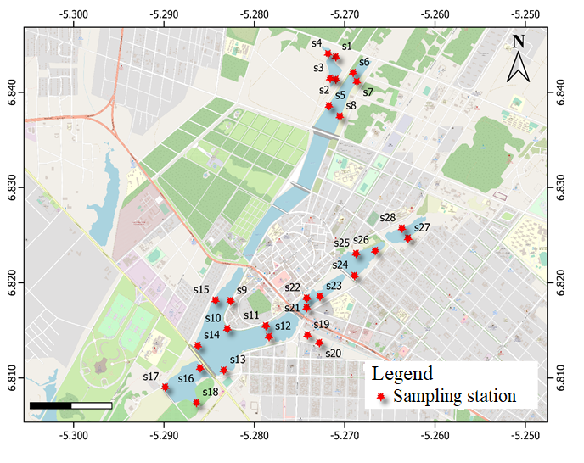
Fig.1. Location of the twenty-eight (28) sampling stations on the eight lakes surveyed
2.2. Physicochemical measurements
HACH Q40d multiparameter probes were used to measure water temperature, pH, electrical conductivity, and dissolved oxygen in situ at a depth of approximately 10 cm below the water surface between 8:00 and 12:00. A Secchi disc was used to measure water transparency. To minimise disturbance of the water column, physicochemical measurements were taken before phytoplankton sampling. Water samples were collected in 1-litre vials, stored in a cooler, and transported to the laboratory for nutrient analysis. Spectrophotometric methods were used to determine the concentrations of ammonium, nitrite, nitrate, phosphate, and total phosphorus in accordance with the ISO standards reported in the original methodology.
2.3. Phytoplankton sampling and identification
Two types of phytoplankton samples were collected at each site. For qualitative analysis, 20 L of water was collected using a bucket and concentrated using a plankton net (mesh size 20 µm) . For quantitative analysis, water was collected directly from the upper water layer. All samples were preserved with formalin at a final concentration of 5%. Conventional taxonomic references and identification keys for the main phytoplankton groups were used to identify phytoplankton taxa under a light microscope. Identification was conducted at the species or infraspecific level whenever feasible. In accordance with the modified Utermöhl method (Utermöhl, 1958) and NF EN 15204 (European Committee for Standardization, 2006), quantitative analysis was conducted on 25 mL subsamples. The samples were allowed to settle in a 25 mL sedimentation chamber for 4 hours. An inverted microscope was used to count cells, colonies, and filaments that were ≥2 µm in size at ×40 magnification. Phytoplankton density was expressed as the number of cells per unit volume.
2.4. Community structure and diversity indices
Phytoplankton community structure was characterised by taxonomic richness, relative abundance, occurrence frequency, Shannon diversity, Pielou evenness, and Jaccard similarity. The frequency of occurrence of each taxon was calculated as the percentage of samples in which it was present. Taxa were subsequently grouped according to their frequency of occurrence. The Shannon-Weaver diversity index (H′) was used to estimate species diversity by analysing the relative abundance of taxa. The evenness index of Pielou (J′) was calculated as the ratio of observed diversity to the maximum theoretical diversity. The Jaccard similarity index was used to determine the degree of similarity in phytoplankton composition between lakes. It was based on the number of species shared between two communities.
2.5. Statistical analyses
The normality of biological and physicochemical variables was assessed using the Shapiro–Wilk test, at a 5% significance level. Differences among lakes and sampling periods were examined using the Kruskal-Wallis test. Pairwise comparisons with the Mann–Whitney U test were used to investigate significant differences. To provide an overview of the key physicochemical gradients and to evaluate correlations between sampling stations and environmental variables, Principal Component Analysis (PCA) was performed. Hierarchical cluster analysis was employed to identify groups of comparable stations using Ward’s method and Euclidean distance. Relationships between phytoplankton composition and environmental variables were explored using redundancy analysis (RDA). The analysis considered the main phytoplankton taxa and significant environmental factors (temperature, transparency, conductivity, pH, dissolved oxygen, nitrate, orthophosphate and ammonium). Statistical significance was evaluated using a Monte Carlo permutation test (499 permutations).
3. Results
3.1. Physicochemical characteristics of the lakes
The physicochemical properties exhibited minimal variation across different stations within the same lake (Kruskal–Wallis test, p > 0.05) (Table 1). Consequently, these physicochemical variables were summarised by lake to examine differences among lakes. Table 1 presents the differences among lakes in the physicochemical variables examined. Water temperature varied from 27°C in lake 0 to 31°C in lake 9. Water pH varied between 6.5 (lake 0) and 8.1 (lake 9), while transparency ranged from 20 cm in lake 0 to 30 cm in lake 10. These variables did not exhibit significant differences (Kruskal–Wallis test, p > 0.05). Conductivity and dissolved oxygen differed significantly (p < 0.05). Conductivity measurements varied from 308 µS/cm (lake 10) to 902 µS/cm (lake 7). The Mann–Whitney test (p < 0.05) indicated that the conductivity in lake 7 was significantly higher than in the other lakes. The highest concentrations of dissolved oxygen were 5.1 mg/L in lake 5, 4.7mg/L in lake 8, and 6.8mg/L in lake 9, distinguishing them from the other lakes. Nitrite concentrations varied from 0.02 mg/L in lakes 0, 5, 6, 8, 9, and 10 to 0.1 mg/L in lake 7. Significant differences (p < 0.05) among the lakes were identified, with Lakes 1 and 7 differing significantly from the remaining lakes. Nitrate concentrations during the study ranged from 2.81 mg/L (lake 0) to 21 mg/L (lake 7). Nitrate concentrations in Lake 7 were significantly higher than those in the other lakes (Mann-Whitney test, p < 0.05). Phosphate concentrations varied between 0.04 mg/L (lake 9) and 0.34 mg/L (lake 5), with lakes 5 and 8 exhibiting statistically significant differences compared to the other lakes (Mann–Whitney test, p < 0.05). Ammonium concentrations fluctuated between 0.03 mg/L in lake 10 and 1.45 mg/L in lake 5, whereas total phosphorus levels spanned from 0.15 mg/L in lake 10 to 0.73 mg/L in lake 8. Both variables differed significantly among lakes (Mann Whitney test, p < 0.05).
The first two axes of principal component analysis (PCA) explained 60.5% of the total physicochemical variability, with 33.7% and 26.8% of the variance explained, respectively (Fig.2). Lakes 5 and 8 were associated with comparatively high phosphate, total phosphorus, dissolved oxygen, transparency and pH values. Lakes 6 and 7 were mainly associated with high concentrations of nitrate, nitrite and conductivity, while Lakes 0, 1, 9 and 10 were characterised by relatively lower values of these variables.

Table 1. Variation of environmental parameters measured among the lakes
 |  | Lake 0 |  |  |  | Lake 1 |  |  |  | Lake 5 |  |  |  | Lake 6 |  |  |  | Lake7 |  |  | Lake 8 |  |  |  | Lake 9 |  |  |  |  | Lake 10
 | Min |  | Med | Max | Min |  | Med | Max | Min |  | Med | Max | Min |  | Med | Max | Min |  | Med | Max |  | Min | Med | Max |  | Min | Med | Max | Min |  | Med | Max
Temperature  (°C) | 27.1 |  | 27a | 28 | 27.2 |  | 27.5a | 27.8 | 28.5 |  | 29a | 29.4 | 27.4 |  | 28a | 28 | 28.5 |  | 29a | 29 |  | 26.8 | 28.4a | 29.6 |  | 29 | 31a | 32 | 27.5 |  | 28a | 29.7
Dissolved oxygen (mg/L) | 1.05 |  | 2.56a | 4.27 | 1.1 |  | 1.82a | 2.5 | 1.93 |  | 5.1b | 7.3 | 1.2 |  | 1.3a | 1.4 | 2.6 |  | 2.9a | 3.4 |  | 2.4 | 4.7b | 6.8 |  | 4.2 | 6.8b | 10.6 | 1.6 |  | 2.5a | 3.8
pH | 6.7 |  | 6.8a | 6.9 | 6.3 |  | 6.5a | 6.7 | 7.0 |  | 7.3a | 7.6 | 6.5 |  | 6.9a | 7.1 | 7 |  | 7.4a | 7.7 |  | 7.4 | 7.8a | 8.3 |  | 8.1 | 8.1a | 8.24 | 7.7 |  | 7.9a | 8
Conductivity  (µS/cm) | 271 |  | 341a | 459 | 249 |  | 315a | 359 | 402 |  | 430a | 454 | 335 |  | 413a | 438 | 828 |  | 902b | 987 |  | 390 | 434a | 488 |  | 317 | 339a | 353 | 286 |  | 308a | 329
Transparency (cm) | 15.2 |  | 20a | 22.3 | 18.5 |  | 22a | 24.4 | 19.2 |  | 25a | 30.5 | 17.5 |  | 22.2a | 29 | 20 |  | 21a | 22.7 |  | 22.4 | 25a | 29 |  | 25 | 27a | 30 | 27 |  | 30a | 33.6
Nitrate (mg/L) | 2.3 |  | 2.81a | 3.3 | 3.3 |  | 4.11a | 4.8 | 4.5 |  | 10.7a | 17.9 | 14.4 |  | 16.2b | 17.9 | 19.3 |  | 21b | 23.5 |  | 7.5 | 10.4a | 12.2 |  | 6.8 | 7.3a | 7.7 | 6.8 |  | 7.2a | 7.6
Nitrite (mg/L) | 0.06 |  | 0.06a | 0.08 | 0.02 |  | 0.02b | 0.02 | 0.02 |  | 0.02b | 0.03 | 0.01 |  | 0.02b | 0.04 | 0.08 |  | 0.1a | 0.14 |  | 0.02 | 0.02b | 0.03 |  | 0.01 | 0.01b | 0.02 | 0.01 |  | 0.02b | 0.03
Ammonium (mg/L) | 0.01 |  | 0,07a | 0.13 | 0.28 |  | 0.4a | 0.49 | 0.8 |  | 1.45b | 1.89 | 0.75 |  | 1.07b | 1.39 | 0.65 |  | 0.77b | 0.85 |  | 0.73 | 0.81b | 0.85 |  | 0.02 | 0.08a | 0.11 | 0.02 |  | 0.03a | 0.05
Phosphate (mg/L) | 0.03 |  | 0.05a | 0.06 | 0.08 |  | 0.08a | 0.11 | 0.21 |  | 0.34b | 0.43 | 0.09 |  | 0.10a | 0.12 | 0.07 |  | 0.09a | 0.1 |  | 0.18 | 0,2b | 0.22 |  | 0.01 | 0.04a | 0.07 | 0.03 |  | 0,05a | 0.08
Total phosphorus (mg/L) | 0.3 |  | 0.32a | 0.33 | 0.35 |  | 0.39a | 0.4 | 0.44 |  | 0.46b | 0.49 | 039 |  | 0.47b | 0.53 | 0.21 |  | 0.26c | 0.28 |  | 0.68 | 0.73b | 0.76 |  | 0.17 | 0.18c | 0.19 | 0.13 |  | 0.15c | 0.18
Different lettres (a, b and c) on two lakes refers significant difference between them (Mann-Whitney test, p<0.05); min = minimum value, med = median value and max = maximum value

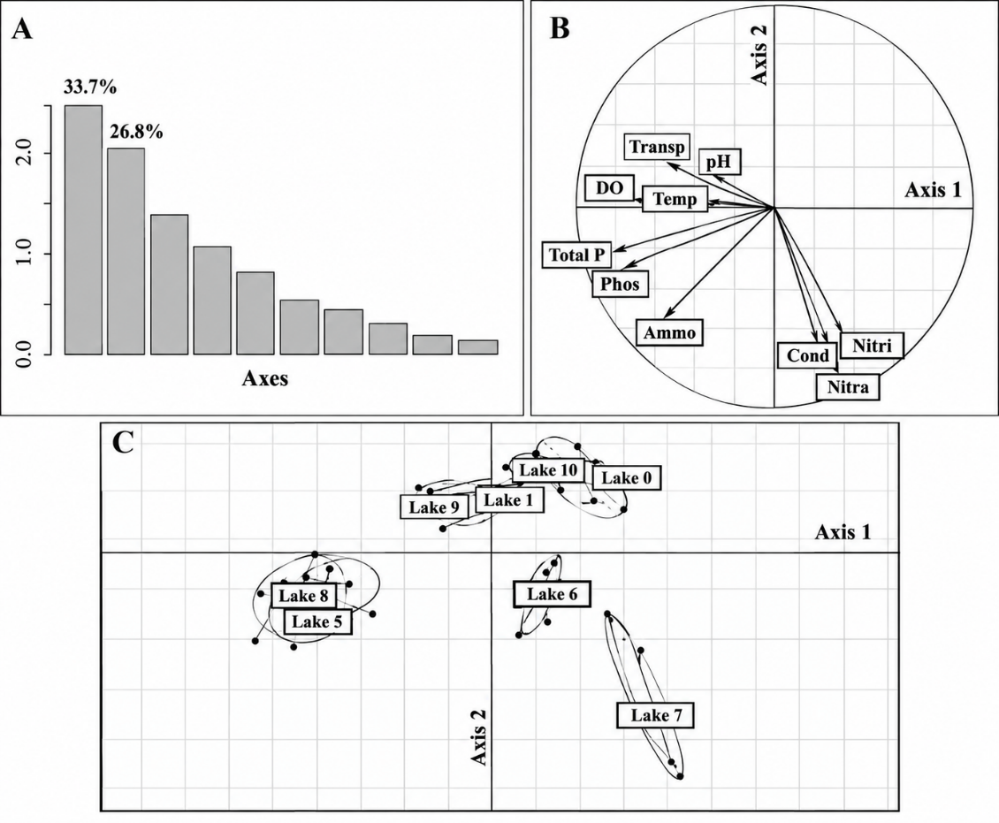

Fig. 2. Ordination of the physicochemical variables of the eight lakes using Principal Component Analysis (PCA), A = scree plot of eigenvalues; B=correlation circle; C=factor map; transp = transparency; DO = dissolved oxygen; Temp = temperature; phos = phosphates; ammo = ammonium; nitra = nitrates; nitri = nitrites; cond = conductivity; photo = total phosphorus.
3.2. Taxonomic composition and richness of phytoplankton
3.2.1. Taxonomic composition
A total of 191 phytoplankton taxa, belonging to 61 genera, 31 families, 15 orders and 8 classes, were identified in the eight urban lakes. The community comprised five major phyla: Chlorophyta, Euglenophyta, Cyanobacteria, Bacillariophyta and Dinophyta.
Chlorophyta were the most diverse group, with 69 taxa, followed by Euglenophyta with 61 taxa. Together, these two groups accounted for 68.06% of the total taxonomic richness. Cyanobacteria comprised 33 taxa, Bacillariophyta 26 taxa and Dinophyta two taxa. Within Chlorophyta, the most diverse genera were Scenedesmus (8 taxa), Monoraphidium and Desmodesmus (6 taxa each), and Tetraedron (5 taxa). Euglenophyta were mainly represented by Trachelomonas (24 taxa), Phacus (16 taxa) and Lepocinclis (7 taxa). Among Cyanobacteria, Oscillatoria (7 taxa) and Pseudanabaena (5 taxa) were the most diverse genera. Bacillariophyta were mainly represented by Gomphonema (7 taxa) and Pinnularia (6 taxa), while Dinophyta comprised one taxon each from Peridinium and Glenodiniopsis. Taxonomic richness varied markedly among lakes. Lake 5 had the highest richness, with 103 taxa, followed by Lake 8 (66), Lake 6 (53), Lake 9 (49), Lake 1 (48), Lake 0 (40) and Lake 10 (28). Lake 7 had the lowest richness, with only 11 taxa. The relative contribution of the major taxonomic groups also differed among lakes. Euglenophyta dominated the communities of Lakes 0, 1 and 6, whereas Chlorophyta were dominant in Lakes 5, 8 and 10. Bacillariophyta were predominant in Lake 7.
3.2.2. Taxa occurrence
The occurrence analysis showed that accessory taxa predominated in Lakes 1, 8 and 9, representing 43.7%, 51.5% and 44.9% of the taxa, respectively. Accidental taxa predominated in Lakes 0, 5, 6 and 10, accounting for 37.5%, 45.6%, 54.5% and 50.0%, respectively. Lake 7 was characterised by similar proportions of constant and accessory taxa (45.4% each) (Table 2). Euglenophyta represented all constant taxa in Lake 1 and 50% of the constant taxa in Lake 6. They also accounted for 66.7% and 61.5% of constant taxa in Lakes 0 and 8, respectively. Trachelomonas volvocina had a frequency of occurrence of 100% in all eight lakes. Chlorophyta predominated among constant taxa in Lake 5 and co-dominated with Bacillariophyta in Lake 9, whereas Bacillariophyta predominated among constant taxa in Lake 10 (Table 3).
Table 2: Proportions of constant, accessory, and accidental taxa in the different lakes of Yamoussoukro surveyed
LAKES | CONSTANT  TAXA (%) | ACCESSORY  TAXA (%) | ACCIDENTAL  TAXA (%)
Lake 0 | 27.5 | 35.0 | 37.5
Lake 1 | 16.6 | 43.7 | 39.6
Lake 5 | 16.5 | 37.8 | 45.6
Lake 6 | 14.5 | 30.9 | 54.5
Lake 7 | 45.4 | 45.4 | 09.0
Lake 8 | 16.6 | 51.5 | 31.2
Lake 9 | 14.3 | 44.9 | 40.8
Lake 10 | 14.3 | 35.7 | 50.0
Table 3: Proportions of phytoplankton phyla among the constant taxa identified in the lakes of Yamoussoukro surveyed
Proportions of constant taxa (%)
Phyla | Lake 0 | Lake 1 | Lake 5 | Lake 6 | Lake 7 | Lake 8 | Lake 9 | Lake 10
Cyanobacteria | 0 | 0 | 21.4 | 8.3 | 66.7 | 7.6 | 0 | 0
Euglenophyta | 66.7 | 100 | 28.6 | 50 | 0 | 61.5 | 14.3 | 25
Chlorophyta | 25 | 0 | 35.7 | 0 | 0 | 30.8 | 42.8 | 0
Bacillariophyta | 8.3 | 0 | 14.3 | 41.7 | 33.3 | 0 | 42.8 | 75
Dinophyta | 0 | 0 | 0 | 0 | 0 | 0 | 0 | 0
3.2.3. Taxonomic richness
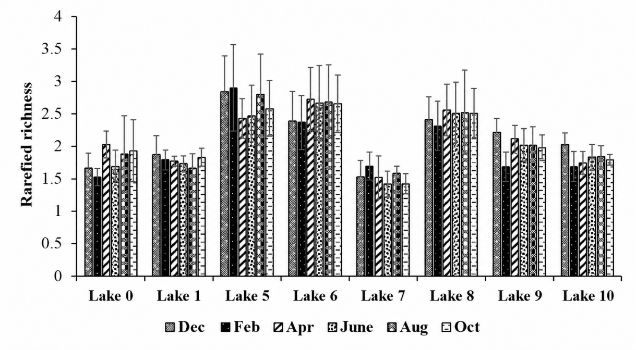
Rarefied richness differed significantly among lakes (Mann–Whitney test, p < 0.05), with higher values in Lakes 5, 6 and 8 and the lowest values in Lake 7 (Fig. 3). Median rarefied richness ranged from 1.50 to 2.02 in Lake 0 and from 1.66 to 1.86 in Lake 1. In Lakes 5 and 6, values ranged from 2.42 to 2.90 and from 2.36 to 2.72, respectively. Lake 7 showed the lowest values, ranging from 1.42 to 1.69. No significant temporal variation in rarefied richness was observed within individual lakes (Kruskal–Wallis test, p > 0.05).

Fig. 3. Spatio-temporal variations in the rarefied richness of phytoplankton recorded in the lakes of Yamoussoukro.
3.3. Phytoplankton diversity and community similarity
3.3.1. Shannon diversity and Pielou evenness

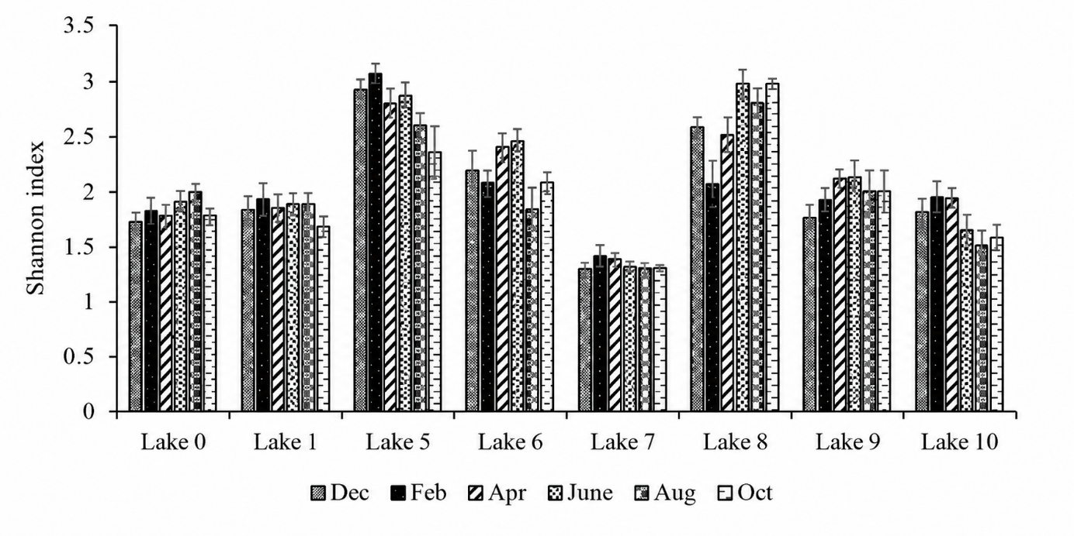
The Shannon diversity index differed significantly among the lakes and ranged from 1.3 to 3.0 (Kruskal-Wallis test, p < 0.05). Values were highest in Lakes 5, 6 and 8, whereas Lake 7 had significantly lower values (Mann-Whitney test, p < 0.05) (Fig.4). Shannon diversity in Lake 5 varied from 2.36 in October to 3.00 in February. The values in Lake 6 ranged from 1.84 to 2.47, while those in Lake 8 ranged from 2.10 to 2.98. Lake 7 exhibited the lowest values, ranging from 1.30 in December to 1.42 in February. No significant changes over time were observed within individual lakes (p > 0.05). Pielou evenness also differed significantly among lakes (p<0.05). The highest values were observed in Lakes 5, 6 and 8, whereas the lowest values were observed in Lake 7 (Fig. 5). Pielou evenness in Lake 5 ranged from 0.63 to 0.73, whereas values in Lake 6 ranged from 0.56 to 0.71 and Lake 8 ranged from 0.68 to 0.75. The values for Lake 7 ranged from 0.31 to 0.33. No statistically significant variation was observed within individual lakes over time (p > 0.05).
Fig.4.Spatio-temporal variations in the Shannon index in the lakes of Yamoussoukro surveyed, Dec: December, Feb: February, Apr: April, Aug: August, Oct: October

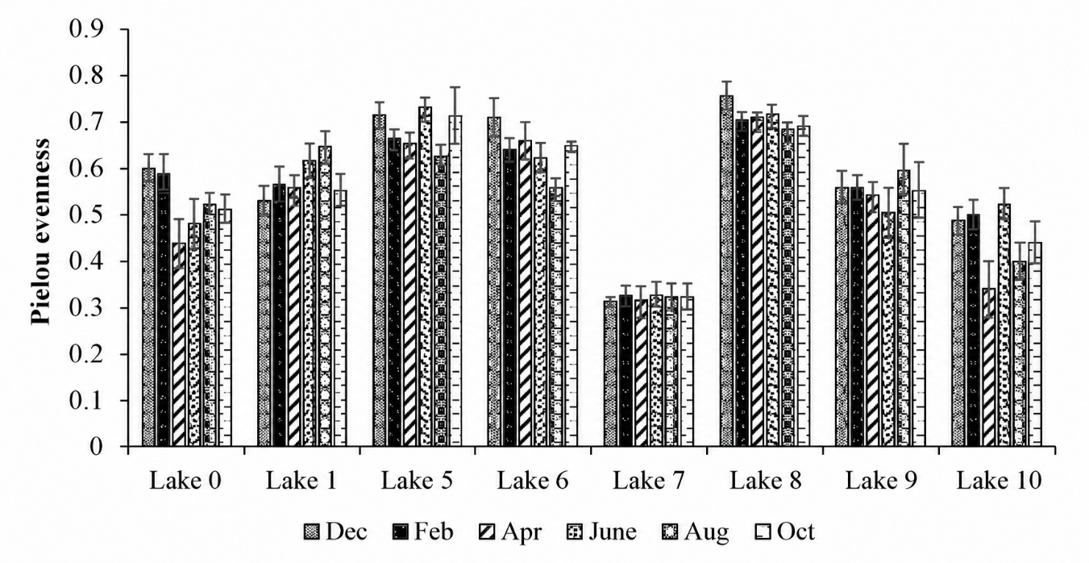

Fig.5. Spatio-temporal variations in the Pielou evenness index in the lakes of Yamoussoukro surveyed, Dec: December, Feb: February, Apr: April, Aug: August, Oct: October

3.3.2. Jaccard similarity
Most lakes exhibited relatively low overlap in phytoplankton composition, as indicated by Jaccard similarity coefficients (Table 4). Similarity was highest between Lakes 5 and 8 (CJ = 0.50), followed by Lakes 0 and 1 (CJ = 0.45). Similarity values were very low for several pairs of lakes, such as Lakes 0 and 7 (CJ =0.06) and Lakes 1 and 8 (CJ = 0.06). Overall, the lake communities shared relatively few taxa.

Table 4: Jaccard similarity index of phytoplankton communities in the surveyed lakes of Yamoussoukro.
 | Lake0 | Lake1 | Lake5 | Lake 6 | Lake7 | Lake 8 | Lake9 | Lake10
Lake 0 |  | 0.45 | 0.26 | 0.24 | 0.06 | 0.19 | 0.11 | 0.25
Lake1 |  |  | 0.21 | 0.36 | 0.08 | 0.08 | 0.06 | 0.29
Lake 5 |  |  |  | 0.20 | 0.14 | 0.50 | 0.18 | 0.2
Lake 6 |  |  |  |  | 0.14 | 0.15 | 0.15 | 0.21
Lake 7 |  |  |  |  |  | 0.10 | 0.11 | 0.17
Lake 8 |  |  |  |  |  |  | 0.40 | 0.2
Lake 9 |  |  |  |  |  |  |  | 0.20
Lake10

3.4. Phytoplankton abundance and biomass
3.4.1. Phytoplankton abundance
The contributions of the main taxonomic groups to phytoplankton density varied considerably among lakes (Fig. 6). Cyanobacteria constituted the dominant phylum in Lakes 5, 7, 8, and 9, contributing between 42.6% and 92.8% to the communities. Chlorophyta ranged from 0 to 39%, Euglenophyta from 2.43 to 14.5%, and Bacillariophyta from 0.86 to 13.8%. Euglenophyta predominated in Lakes 0, 1 and 6, with 47.5-83.89% of total abundance, whereas Chlorophyta accounted for 3.81 to 42.36%. Cyanobacteria, Bacillariophyta, and Dinophyta comprised 0-11.82% of the total abundance in these lakes. Chlorophyta accounted for 42.33% of the biomass in Lake 10, followed by Euglenophyta at 23.23%, Bacillariophyta at 21.42%, and Cyanobacteria at 13%.

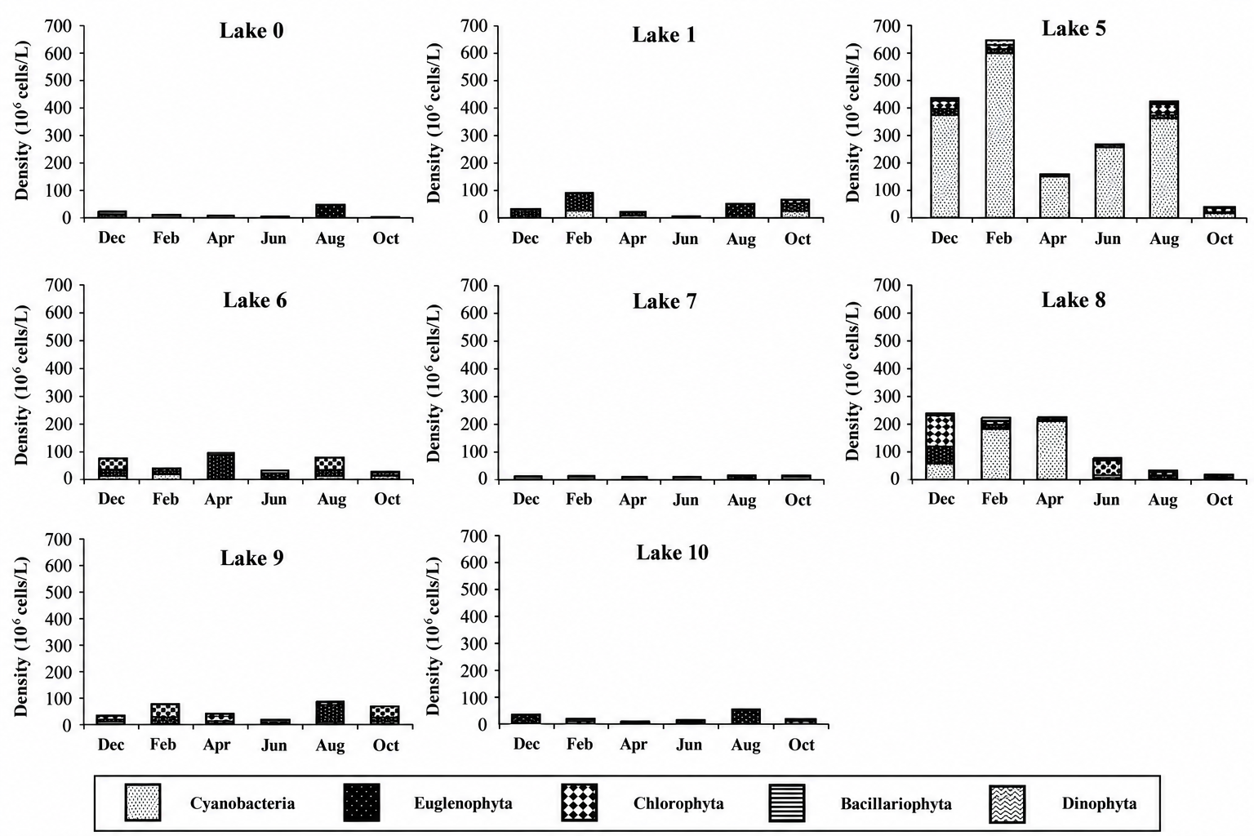

Fig. 6.Spatio-temporal variations in phytoplankton density by taxonomic group in the lakes of Yamoussoukro surveyed.
3.4.2. Phytoplankton biomass
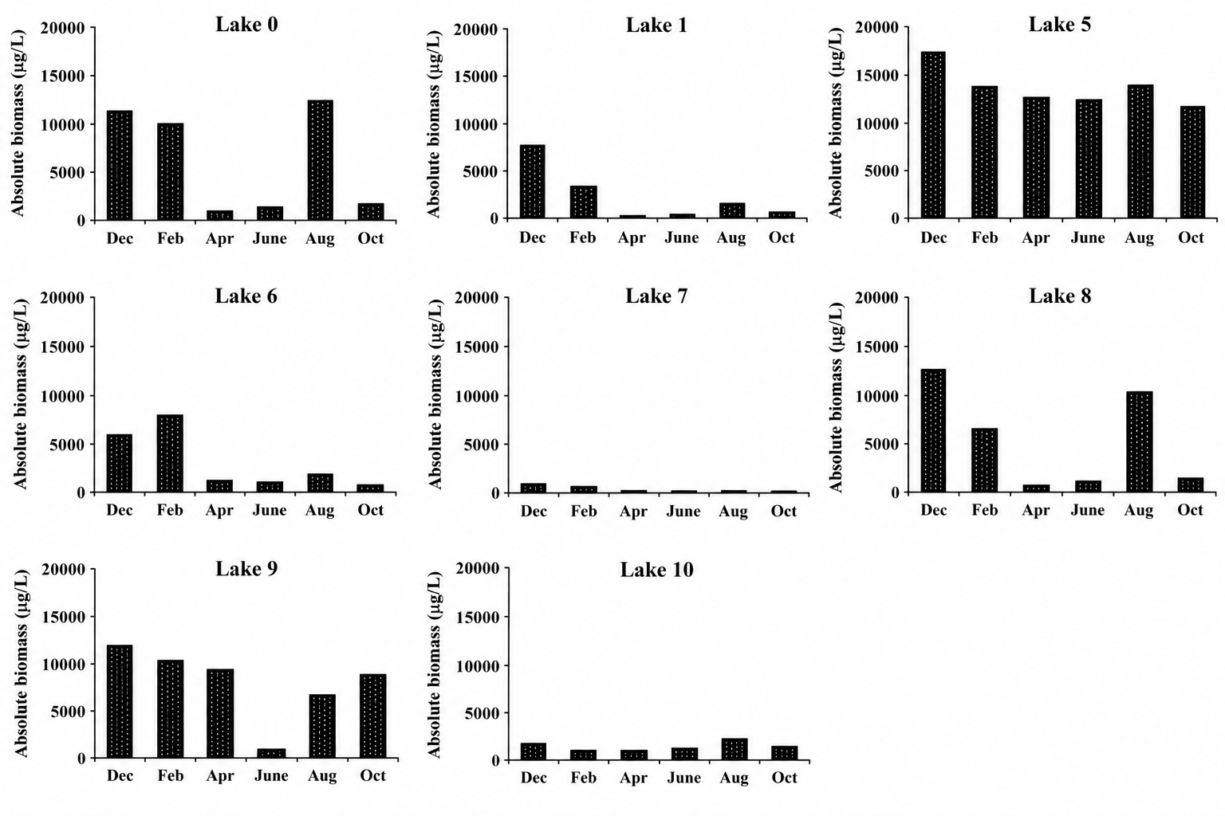
Phytoplankton biomass, assessed using biovolume, exhibited significant spatial and temporal variability (Fig. 7). Lake 5 had the highest biomass, followed by Lakes 1, 8 and 9, whereas Lake 7 had the lowest biomass. The lowest biomass values were recorded in June for Lake 0, in April for Lakes 1 and 5, and in October for Lake 6. Peak biomass values occurred in August in Lake 0, in February in Lakes 1 and 6, and in December in Lake 5. Cyanobacteria contributed substantially to the biomass maxima, representing more than 60% in Lake 0, 49% in Lake 1, and 54% in Lake 5. Euglenophyta contributed approximately 45% to the biomass increase in Lake 6 during February. Peak biomass values were recorded in June (Lake 7), December (Lake 8), October (Lake 9), and February (Lake 10) in Lakes 7–10. The lowest values were recorded in Lake 7 in August, in Lakes 8 and 9 in June, and in Lake 10 in April. Cyanobacteria constituted almost 60% of the biomass during the sampling period in Lake 7. Euglenophyta contributed substantially to the biomass of Lakes 9 and 10, accounting for approximately 50% and 81%, respectively during their respective biomass maxima.

Fig. 7. Spatio-temporal changes in phytoplankton absolute biomass in the lakes of Yamoussoukro studied Dec: December, Feb: February, Apr: April, Aug: August, Oct: October

3.5. Chlorophyll-a concentration
Chlorophyll-a concentrations exhibited significant temporal and spatial variability among the eight lakes (Fig. 8). Higher levels were recorded in Lakes 5 and 8, whereas lower levels were recorded in Lake 7 (Mann-Whitney test, p < 0.05). Chlorophyll-a concentrations in Lake 0 ranged from 33.35 µg L⁻¹ in October to 65.0 µg L⁻¹ in December. Concentrations in Lake 1 ranged from 56.5 µg L⁻¹ in October to 65.5 µg L⁻¹ in April. Concentrations in Lakes 5 and 6 were significantly higher, varying from 166.9 to 228 µg L⁻¹ and 97.9 to 145.3 µg L⁻¹, respectively. Lake 7 exhibited the lowest chlorophyll-a concentrations, ranging from 9.8 µg L⁻¹ in February and 12.4 µg L⁻¹ in April, whereas Lake 8 exhibited higher concentrations, ranging from 154 to 210 µg L⁻¹. The concentrations in Lakes 9 and 10 were 92.7-126 μg L⁻¹ and 27.5-39.2 μg L⁻¹, respectively. The spatial distribution of chlorophyll-a was consistent with phytoplankton density and biomass, with the highest concentrations in Lakes 5, 6, 8 and 9, whereas Lake 7 recorded the lowest concentrations.
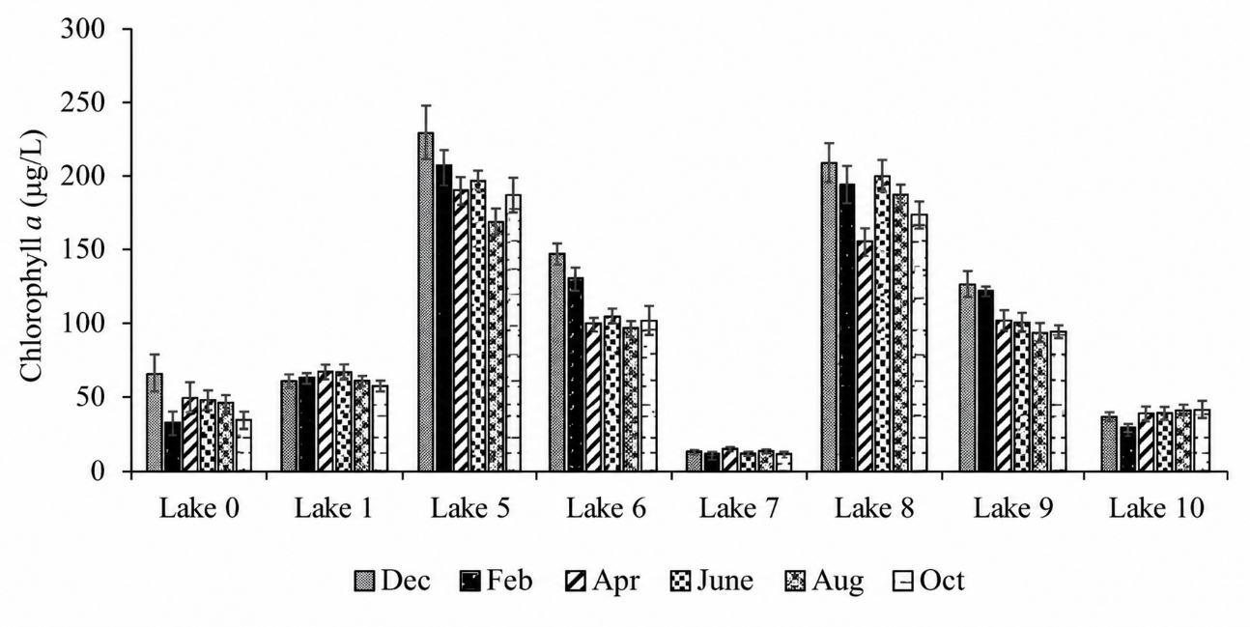

Fig. 8. Spatio-temporal variations in chlorophyll-a concentrations in the lakes of Yamoussoukro surveyed, Dec: December, Feb: February, Apr: April, Aug: August, Oct: October

3.6. Relationships between phytoplankton communities and physicochemical variables
Redundancy analysis (RDA) was conducted to examine the relationships between predominant phytoplankton taxa and physicochemical variables. The analysis considered taxa representing more than 2% of community abundance and 10 environmental factors: temperature, pH, nitrate, phosphate, ammonium, dissolved oxygen, conductivity, nitrite, total phosphorus, and transparency (Fig.9). The first two RDA axes accounted for 65% of the variance (40% for axis 1 and 25% for axis 2). Axis 1 was positively correlated with nitrate, conductivity, ammonium, and phosphate, and showed a modest negative correlation with temperature. Euglena gracilis, Oscillatoria tenuis, and Oscillatoria limosa were positively correlated with conductivity, nitrate and ammonium, particularly in Lake 7 during August and April. Axis 2 was mainly associated with total phosphorus and dissolved oxygen levels. Higher values of these variables were mainly associated with Lakes 8 and 5. Thus, the RDA indicated a distinct spatial pattern of phytoplankton communities in relation to nutrient enrichment, conductivity, and oxygen gradients.

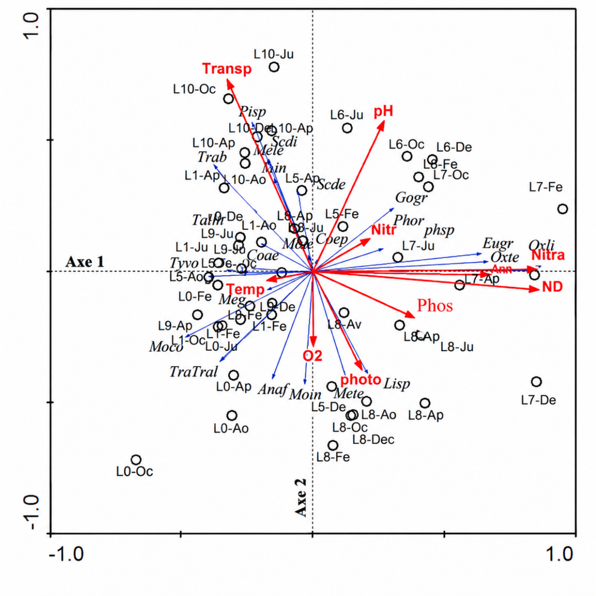

Fig.9. RDA ordination of phytoplankton taxa and physicochemical characteristics on the first two axs in the lakes of Yamoussoukro. Taxon abbreviations: see Table IV; T: temperature; CND: conductivity; O₂: dissolved oxygen; Nitra: nitrates; Ammo: ammonium; Transp: transparancy; phosphates; Phos: Photo: total phosphorous; Nitr: nitrites; L0: Lake 0; L1: Lake 1; L5: Lake 5; L6: Lake 6; L7: Lake 7; L8: Lake 8; L9: Lake 9; L10: Lake 10; De: December; Fe: February Av: April Ju: June Aou: August Oc: October

4. Discussion
Considerable phytoplankton taxonomic richness was observed in the urban lakes of Yamoussoukro, with 191 taxa identified. Lake 5 had the highest taxonomic richness, whereas Lake 7 had the lowest. The high taxonomic richness observed in Lake 5 may be attributed to its diverse ecological niches. This lake exhibited relatively high concentrations of the main nutrients associated with eutrophication, including nitrogen and phosphate. The low richness of Lake 7 may be related to its effluent-like water conditions. Additionally, aquatic vegetation covers more than 80% of this water body, which may limit the development of phytoplankton. Aquatic vegetation can inhibit algal growth by reducing the penetration of solar radiation into the water (Peng et al., 2022). Chlorophyta and Euglenophyta were the most taxonomically diverse groups in the Yamoussoukro lakes, collectively comprising more than 68% of the recorded taxa. Additionally, the dominance of these two major groups has been documented in the tropical reservoir of Adzopé (Nangoh et al., 2019), in small reservoirs of the central and northern Côte d'Ivoire (Nangoh et al., 2019), in Lake Guiers, Senegal (Peng et al., 2021), and in the lakes of the floodplains of Brazil (Peng et al., 2021). The ecological flexibility and widespread occurrence of Chlorophyta may account for their predominance. The prevalence of Euglenophyta may be associated with organic matter in domestic effluents and runoff from agricultural areas. The most representative Euglenophyta genera were Euglena, Phacus and Trachelomonas. Recent evidence confirms that euglenophytes are frequently associated with nutrient-rich and organically enriched freshwater environments (Sultana et al., 2024). Euglenophyta were dominant in several lakes, and Trachelomonas volvocina occurred in all lakes at a frequency of 100%. This high frequency of occurrence may be related to the nutrient-rich conditions of these lakes. Euglenophyta can thrive in waters rich in organic matter, and their blooms can have a detrimental impact on water quality (Sultana et al., 2024). The Shannon–Weaver index, Pielou evenness and rarefied richness were significantly higher in Lakes 5, 6 and 8. Consequently, the phytoplankton communities in these lakes were more diverse and evenly distributed. These lakes may therefore provide relatively favourable environmental conditions for a diverse range of taxa. In contrast, these indicators were significantly lower in Lake 7. The phytoplankton community in this lake was less evenly distributed and less diverse, which may indicate environmental stress. This pattern may be associated with the elevated concentrations of nitrates and conductivity encountered in this lake. Patterns of phytoplankton abundance were generally consistent with those of biomass and chlorophyll-a. This was reflected in the elevated chlorophyll-a concentrations and phytoplankton abundance in Lakes 5, 6, 8 and 9. The high phytoplankton biomass values may be attributed to the presence of species such as Eudorina elegans, Pandorina morum, Oedogonium sp., and Mougeotia sp., which can be relatively less abundant but contribute substantial biomass. The high abundance and biomass values observed in these lakes may be attributed to the periodic removal of floating aquatic vegetation. The removal of floating aquatic vegetation may enhance the penetration of light, which may increase algal photosynthetic activity. The lakes in the city centre also receive nutrients from agricultural and domestic wastewater. Lakes 5 and 8 are situated in densely urbanised areas, where various commercial activities, including restaurants, maquis and hotels, have developed along their shores. These enterprises discharge effluents, food waste, and other waste into the lakes on a daily basis, particularly in Lake 5, a large body of water that is connected to a significant population. In addition, several areas surrounding the lake have become informal disposal sites for domestic waste and locations of unregulated open-air sanitation. The Regional Hospital Centre (CHR) discharges its effluents into Lake 5. Organic trace elements, inorganic nutrients, temperature and light are factors regulating phytoplankton growth and succession (Dokulil & Qian, 2021). Trachelomonas, Euglena, Microcystis, Gomphonema, Oscillatoria, Monoraphidium, Merismopedia, Scenedesmus, Phacus, Aphanocapsa, and Ulnaria were among the most abundant taxa in the collected phytoplankton. These taxa are considered prominent in eutrophic waters (Zheng et al., 2024; Guo et al., 2023; Sultana et al., 2024). Consequently, the occurrence of these taxa is consistent with nutrient enrichment and organic inputs, although their interpretation should be supported by the measured physicochemical variables (Zheng et al., 2024; Sultana et al., 2024). These taxa may serve as bioindicators of eutrophic conditions (Sultana et al., 2024). N’Guessan et al. (2011) estimated that the Yamoussoukro lake system receives approximately 38,300 m³ of wastewater annually. Generally, the warmer months (December, February, and August) were characterised by high abundance and biomass (phytoplankton and chlorophyll-a) values. The water bodies were relatively stable during these periods, which may have facilitated biological processes, such as the complete reproductive and developmental cycles of algae (Pulsifer & Laws, 2021). These periods were also characterised by higher temperatures. Because enzymatic reactions are temperature-dependent, temperature is an important environmental factor influencing phytoplankton physiology (Pulsifer & Laws, 2021). Microalgal photosynthetic activity increases with temperature up to an optimum, beyond which photosynthetic capacity declines (Dokulil & Qian, 2021). Temporal changes in phytoplankton communities were less clearly distinguished among the lakes, as evidenced by the application of RDA to the entire dataset of physicochemical parameters and the high relative densities of phytoplankton taxa in the various lakes. This may be because most physicochemical variables did not differ significantly among months, limiting their ability to distinguish samples by sampling month.
Conclusion
This study evaluated the taxonomic composition, diversity, and spatial and temporal dynamics of the phytoplankton communities in the urban lakes of Yamoussoukro. A total of 191 taxa were recorded, with Chlorophyta and Euglenophyta being the most diverse groups. Taxonomic richness, diversity, evenness, abundance, biomass and chlorophyll-a concentrations varied significantly among lakes. Lake 5 exhibited the highest taxonomic richness and phytoplankton biomass, while Lake 7 exhibited the lowest richness, diversity, biomass, and chlorophyll-a concentrations. As indicated by low Jaccard similarity coefficients, the phytoplankton composition varied significantly among these lakes. The main physicochemical gradients identified by PCA were associated with nutrients, conductivity, dissolved oxygen, phosphorus, and transparency. RDA showed that phytoplankton composition was particularly associated with nutrient and conductivity gradients. Temporal variation was less pronounced than spatial variation. Overall, phytoplankton communities provided information relevant to evaluating the ecological condition of the urban lakes of Yamoussoukro. Continued monitoring is recommended to support water-quality assessment and sustainable lake management.

Limitations
The findings describe eight accessible lakes during the sampling period from December 2015 to October 2017; consequently, they should not be interpreted as a direct characterisation of excluded lakes or current conditions. The observed relationships between phytoplankton communities and physicochemical variables are correlational and do not, by themselves, establish causality. Interpretation should therefore remain focused on the measured variables, observed taxa and sampled periods. Continued observations could help determine whether the reported spatial patterns persist over time.

Declaration of AI Use

This manuscript was prepared through the intellectual contributions of the author(s) to the study design, data analysis, interpretation of results, and scholarly content. Grammarly and ChatGPT were used solely to assist with grammatical refinement and reference formatting during manuscript revision. The author(s) accept full responsibility for the accuracy, integrity, and final content of the manuscript.

REFERENCES
Dokulil, M. T., & Qian, K. (2021). Photosynthesis, carbon acquisition and primary productivity of phytoplankton: A review dedicated to Colin Reynolds. Hydrobiologia, 848(1), 77–94. https://doi.org/10.1007/s10750-020-04321-y
European Committee for Standardization. (2006). Water quality—Guidance standard on the enumeration of phytoplankton using inverted microscopy (Utermöhl technique) (EN 15204:2006). https://www.nen.nl/en/nen-en-15204-2006-en-109691
Guo, W., Li, Z., Li, C., Liu, B., & Shi, W. (2023). Drainage ratio controls phytoplankton abundance in urban lakes. Water, 15(4), Article 683. https://doi.org/10.3390/w15040683
Jena, H. P., Yadav, M. K., & Saxena, S. (2026). Ecological assessment of qualitative and quantitative plankton diversity in eutrophic urban water bodies: A case study of Lower Lake, Bhopal. Annual Research & Review in Biology, 41(10), 88–98. https://doi.org/10.9734/arrb/2026/v41i102463
Kouakou, K. A., Aw, S., Adamou, M. M., Siaka, S., & Savane, I. (2014). Caractérisation des sédiments du système lacustre de Yamoussoukro (Côte d’Ivoire) et spéciation de leurs phosphores. Journal of Materials and Environmental Science, 5(4), 1013–1020. https://www.jmaterenvironsci.com/Document/vol5/vol5_N4/125-JMES-664-2014-kouakou.pdf
N’Guessan, K. A., Konan, F. K., Bony, K. Y., Edia, O. E., Gnagne, T., Traoré, K. S., & Houenou, P. V. (2011). Prospects for rehabilitation of man-made lake system of Yamoussoukro (Ivory Coast). Procedia Environmental Sciences, 9, 140–147. https://doi.org/10.1016/j.proenv.2011.11.022
Naderian, D., Noori, R., Kim, D., Jun, C., Bateni, S. M., Woolway, R. I., Sharma, S., Shi, K., Qin, B., Zhang, Y., Jeppesen, E., & Maberly, S. C. (2025). Environmental controls on the conversion of nutrients to chlorophyll in lakes. Water Research, 274, Article 123094. https://doi.org/10.1016/j.watres.2025.123094
Nangoh, K. M., Adon, M. P., Edia, O. E., Niamien-Ebrottié, J. E., & Ouattara, A. (2019). Phytoplankton composition of the urban man-made lakes of Yamoussoukro (Côte d’Ivoire). Journal of Applied Biosciences, 140(1), 14281–14292. https://doi.org/10.4314/jab.v140i1.7
Peng, X., Zhang, L., Li, Y., Lin, Q., He, C., Huang, S., Li, H., Zhang, X., Liu, B., Ge, F., Zhou, Q., Zhang, Y., & Wu, Z. (2021). The changing characteristics of phytoplankton community and biomass in subtropical shallow lakes: Coupling effects of land use patterns and lake morphology. Water Research, 200, Article 117235. https://doi.org/10.1016/j.watres.2021.117235
Peng, X., Lin, Q., Liu, B., Huang, S., Yan, W., Zhang, L., Ge, F., Zhang, Y., & Wu, Z. (2022). Effect of submerged plant coverage on phytoplankton community dynamics and photosynthetic activity in situ. Journal of Environmental Management, 301, Article 113822. https://doi.org/10.1016/j.jenvman.2021.113822
Pratap, G. V., Rao, T. B., Lakshman, P., & Keerthana, B. (2025). Seasonal dynamics and diversity analysis of phytoplankton in Lakshmipuram Lake, Anakapalli District, Andhra Pradesh, India. Uttar Pradesh Journal of Zoology, 46(10), 323–331. https://doi.org/10.56557/upjoz/2025/v46i104991
Pulsifer, J., & Laws, E. (2021). Temperature dependence of freshwater phytoplankton growth rates and zooplankton grazing rates. Water, 13(11), Article 1591. https://doi.org/10.3390/w13111591
Sultana, S., Khan, S., Shaika, N. A., Hena, S. M., Mahmud, Y., & Haque, M. M. (2024). Ecology of freshwater harmful euglenophytes: A review. Heliyon, 10(8), Article e29625. https://doi.org/10.1016/j.heliyon.2024.e29625
Utermöhl, H. (1958). Zur Vervollkommnung der quantitativen Phytoplankton-Methodik. SIL Communications, 1953–1996, 9(1), 1–38. https://doi.org/10.1080/05384680.1958.11904091
Wang, W., Huang, H., He, Z., Zhang, G., Lv, J., Liu, Q., Nan, F., Liu, X., Xie, S., & Feng, J. (2024). Unveiling phytoplankton diversity: Taxonomy, functional groups, and environmental drivers in North China lakes. Ecology and Evolution, 14(12), Article e70656. https://doi.org/10.1002/ece3.70656
Ye, S., Xu, S., Ren, M., Chang, C., Hu, E., & Li, M. (2025). Land use types, basin characteristics and water quality together shape riverine phytoplankton community composition and diversity. Journal of Environmental Management, 376, Article 124496. https://doi.org/10.1016/j.jenvman.2025.124496
Zheng, Y., Yu, J., Wang, Q., Yao, X., Yue, Q., & Xu, S. (2024). What drives the changing characteristics of phytoplankton in urban lakes: Climate, hydrology, or human disturbance? Journal of Environmental Management, 351, Article 119966. https://doi.org/10.1016/j.jenvman.2023.119966

