Explainable Multimodal Artificial Intelligence for Precision Laboratory Diagnosis: Integrating Biomarkers, Molecular Profiles, Immunological Signatures, and Clinical Data

Abstract
Background. Precision laboratory diagnosis increasingly relies on the interpretation of heterogeneous biological and clinical information. Conventional workflows tend to examine biomarkers, molecular measurements, immunological findings, and clinical characteristics along partly separate analytical pathways. Artificial intelligence (AI) can uncover complex relationships in high-dimensional biomedical data, yet many such systems remain hard to interpret at the point of clinical use. Explainable artificial intelligence (XAI) renders algorithmic outputs more transparent by identifying the features, modalities, and interactions that shape a prediction. Objective. This manuscript proposes an explainable multimodal AI framework for precision laboratory diagnosis, termed XMAI-PLD, which unites conventional laboratory biomarkers, molecular profiles, immunological signatures, and clinical data within a single analytical architecture. The framework is designed to support, rather than supplant, laboratory expertise and clinical judgement. Framework. The architecture comprises seven interconnected layers: data acquisition; quality control and harmonisation; modality-specific representation; multimodal fusion; diagnostic inference; explainability and uncertainty assessment; and laboratory–clinical decision support. Biomarker measurements contribute quantitative biochemical information, molecular profiles characterise genomic or molecular alterations, immunological signatures capture host-response patterns, and clinical variables supply patient-level context. Each stream is processed separately before being integrated through multimodal learning, and explanations are generated at the modality and feature levels to reveal the principal drivers of each output. Clinical and laboratory relevance. The framework addresses the shortcomings of isolated single-modality models, namely incomplete biological representation, heterogeneous data structures, missing information, analytical variability, and limited interpretability. Its proposed outputs comprise diagnostic probabilities, contributing features, modality-level evidence, uncertainty estimates, and cases flagged for human review. Particular emphasis falls on analytical validity, calibration, external validation, data provenance, subgroup assessment, cybersecurity, privacy, and human oversight. Conclusion. Explainable multimodal AI offers a promising route towards a more integrated diagnostic representation of laboratory and clinical evidence. Its worth will hinge not only on predictive performance but also on analytical robustness, reproducibility, interpretability, calibration, clinical usefulness, and sustained human oversight. Prospective, multicentre evaluation is required before such systems enter routine diagnostic practice.
Keywords: Explainable artificial intelligence; multimodal artificial intelligence; precision laboratory diagnosis; biomarkers; molecular profiling; immunological signatures; clinical data integration; uncertainty estimation; human–AI interaction; clinical decision support

1. Introduction
Laboratory medicine is moving away from the reading of individual tests and towards the integrated analysis of biochemical, molecular, immunological, pathological, and clinical information. Modern diagnostic laboratories generate large volumes of heterogeneous data through automated chemistry and haematology platforms, immunoassays, molecular diagnostics, genomic technologies, microbiological testing, digital pathology, and further analytical systems. Such results are interpreted against a clinical background that includes demographic characteristics, symptoms, medical history, medications, physiological measurements, imaging findings, and longitudinal disease trajectories [1].
This growth in diagnostic information is both an opportunity and a challenge. Several data streams may carry complementary signals about one biological process, yet they differ markedly in scale, structure, temporal resolution, analytical behaviour, and clinical meaning. A molecular profile may describe a disease-associated alteration at the genomic or transcriptomic level, whereas an immunological signature may mirror the host response. A biochemical marker may point to tissue injury or physiological dysfunction, while clinical variables define the patient-specific setting in which every measurement must be read. Examining each source in isolation can therefore hide relationships that appear only when several modalities are viewed together[2-3].
AI is being explored with growing intensity in laboratory medicine and neighbouring diagnostic disciplines. These methods can interrogate complex datasets, detect nonlinear relationships, assist classification, streamline workflows, and refine quantitative interpretation. Translation into practice nevertheless remains constrained by data quality, generalisability, transparency, validation, and the need for human review. Published reviews of AI in the clinical laboratory likewise underline the distance between rapidly evolving computational methods and their established clinical implementation[4]. Recent evaluation of multimodal AI in medical diagnostics shows that model performance should be considered together with response behaviour and the continued value of collective human judgement [57].
Interpretability of complex machine-learning systems is a central concern. High-performing models can yield clinically relevant predictions without any intelligible account of how those predictions arose, a weakness that is acute in laboratory diagnosis, where conclusions are expected to trace back to measurable biological or clinical evidence. XAI has consequently attracted attention as a means of improving transparency by naming the variables, features, patterns, or data modalities associated with a model output. In pathology and allied diagnostic fields, XAI has been proposed as a remedy for the black-box nature of AI and as an aid to interpreting intricate clinical, histological, and molecular information[5]. Clinician-facing evaluation of XAI further indicates that explanations can affect users differently, underscoring the need to assess trust, reliance, and performance empirically rather than assuming that explanation alone improves decisions [58].
Multimodal AI extends this idea by combining several forms of information within one analytical system. Such models may draw on structured numerical data, molecular measurements, images, text, temporal observations, and other sources. Integration should not, however, be reduced to the simple concatenation of every available variable: each modality has its own biological and analytical character and must be pre-processed, represented, quality-controlled, and validated before fusion. Recent work on explainable multimodal and longitudinal AI stresses the need to coordinate outputs and explanations across data sources instead of treating each modality as a separate prediction problem[6]. A recent critical review of explainable multimodal medical imaging likewise cautions that the value of explanations for clinician trust and diagnostic accuracy depends on the task, explanation format, and correctness of the underlying prediction [59].
The approach is especially pertinent to precision diagnostics, because a laboratory result seldom stands apart from the patient who produced it. Interpreting a biomarker depends on clinical context, a molecular alteration can carry different implications across diseases, and immunological measurements vary with disease stage, treatment, timing, and host characteristics. An integrated computational system could capture these dependencies more systematically while preserving an explicit link between a prediction and the evidence beneath it[7]. Disease-focused precision-care literature similarly emphasises multimodal modelling, uncertainty estimation, multicentre validation, and human-centred implementation when AI is applied to heterogeneous clinical and biomarker data [60].
This manuscript accordingly proposes the Explainable Multimodal Artificial Intelligence for Precision Laboratory Diagnosis (XMAI-PLD) framework. It brings together four principal evidence domains (biomarkers, molecular profiles, immunological signatures, and clinical data) and treats explainability, uncertainty assessment, calibration, and human oversight as integral design elements rather than later additions[8]. Although the manuscript addresses multimodal AI, XAI, and precision diagnostics, a laboratory-centred framework that jointly organises biomarker, molecular, immunological, and clinical evidence while treating explainability, uncertainty, calibration, and human oversight as integrated elements of one diagnostic pathway remains insufficiently specified in the context considered here.
Objective. The objective of this manuscript is to present the XMAI-PLD framework for integrating biomarkers, molecular profiles, immunological signatures, and clinical data within an explainable, uncertainty-aware architecture for precision laboratory diagnosis that supports laboratory and clinical judgement.

2. Rationale for Multimodal Laboratory Diagnosis

2.1 Limitations of single-modality interpretation
Single-modality diagnostic models are built around one principal information source, such as biochemical measurements, genomic variants, immunological markers, or clinical variables. They can serve well when the diagnostic target is strongly represented in the chosen modality. Disease biology, however, seldom confines itself to a single information domain[9-10].
A biomarker may signal tissue injury without disclosing its cause. A molecular alteration may offer mechanistic insight yet say little about current disease activity. An antibody or cytokine profile may demonstrate a host response without pinpointing its biological origin. Clinical variables furnish essential context but may lack molecular specificity. Any one modality may thus capture merely a fragment of the disease process and overlook complementary evidence, whereas multimodal integration allows these partially overlapping views to be combined[11-12].

2.2 Complementary diagnostic information
The four principal domains of the proposed framework are summarised in Table 1. Multimodal integration does not presume that every modality contributes equally to every diagnostic question[13]. Instead, the model should learn how each evidence stream bears on a particular prediction and should make it possible to recognise which modalities are informative, weak, discordant, or unavailable[14-15].
Table 1. Data modalities in the XMAI-PLD framework
Data modality | Primary information represented | Examples of information types | Potential diagnostic contribution
Biomarkers | Quantitative biological or biochemical state | Enzymes, proteins, metabolites, routine laboratory parameters | Evidence of physiological disturbance or tissue injury
Molecular profiles | Molecular alterations and biological mechanisms | DNA/RNA alterations, expression profiles, molecular signatures | Disease-associated molecular characterization
Immunological signatures | Host immune response | Antibodies, immune-cell characteristics, inflammatory mediators | Evidence of immune activation or response
Clinical data | Patient-specific context | Symptoms, history, demographic variables, treatment, disease course | Contextual interpretation of laboratory evidence

3. The XMAI-PLD Framework
The framework comprises seven sequential yet interconnected layers (Figure 1; Table 2): data acquisition; quality control and harmonisation; modality-specific representation; multimodal fusion; diagnostic inference; explainability and uncertainty; and laboratory–clinical decision support[16]. A single principle underpins the design: the diagnostic prediction and its supporting evidence should remain linked throughout the analytical pathway.
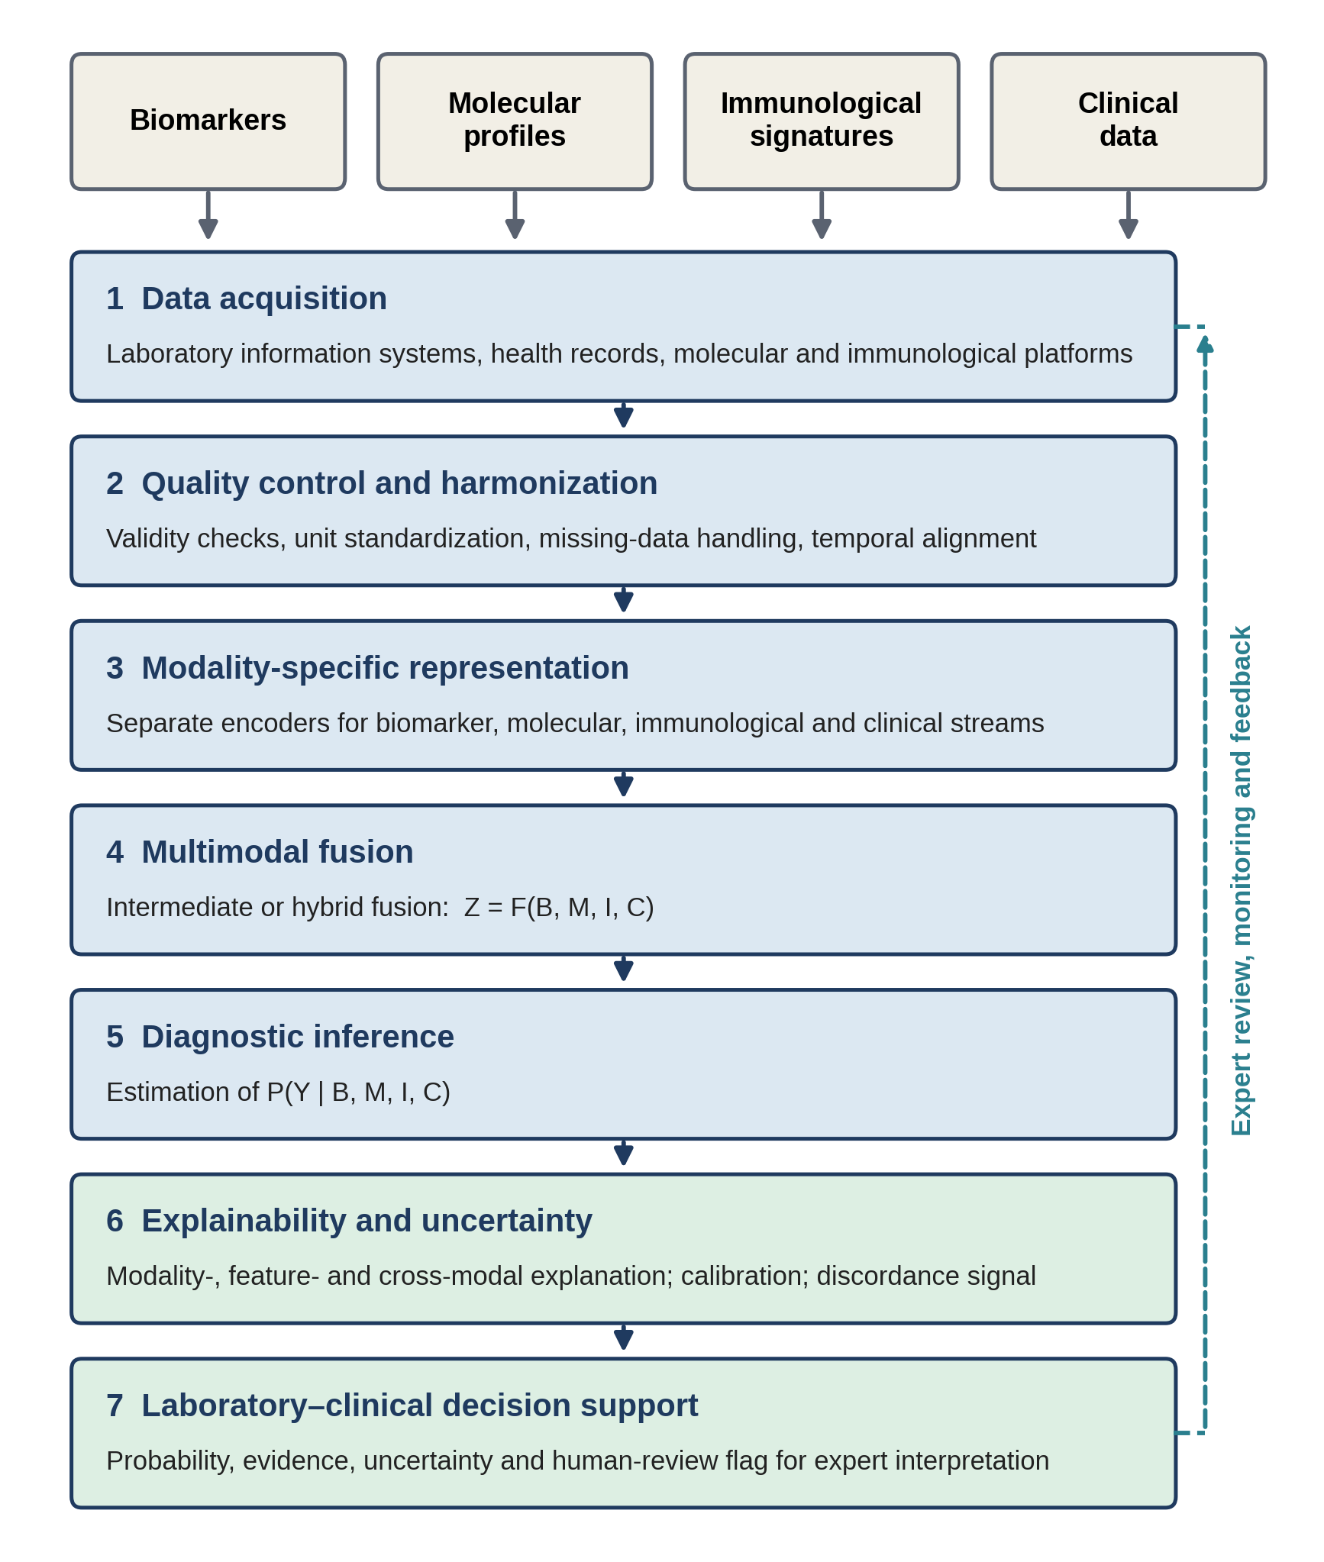
Figure 1. Layered architecture of the XMAI-PLD framework. Four evidence domains enter a seven-layer pipeline; the dashed arrow denotes expert review, monitoring, and feedback.
Table 2. The seven layers of the XMAI-PLD framework
Layer | Principal function | Key requirements
1. Data acquisition | Capture information from laboratory information systems, health records, and molecular and immunological platforms | Patient and specimen linkage; collection timing; assay metadata; data provenance[17]
2. Quality control and harmonization | Prepare reliable, compatible inputs before fusion | Validity checks; normalization; standardized terminology and units; missing-data handling; patient-level data separation; prevention of data leakage[18]
3. Modality-specific representation | Convert each stream into a suitable computational form | Biologically interpretable features; dimensionality reduction for molecular data; longitudinal representation of immune responses[19]
4. Multimodal fusion | Integrate the modality-specific representations | Intermediate or hybrid fusion; learning of cross-modal interactions[20]
5. Diagnostic inference | Estimate the diagnostic target from the joint evidence | Probability estimation, P(Y | B, M, I, C)
6. Explainability and uncertainty | Link each prediction to its evidence and quantify reliability | Modality-, feature-, and cross-modal explanation; calibration; discordance signal[21]
7. Laboratory–clinical decision support | Deliver outputs for expert interpretation | Probability, contributing evidence, uncertainty, and human-review flag; human oversight[22]

4. Data Acquisition, Quality Control, and Harmonisation

4.1 Data acquisition
The first layer captures information from laboratory information systems, electronic health records, molecular diagnostic platforms, immunological assays, and other validated clinical sources. Acquisition should preserve patient-level linkage, specimen identity, collection and processing times, assay and platform details, units and reference intervals, analytical quality indicators, molecular and immunological assay characteristics, clinical timing, treatment status where relevant, and data provenance[23].
Temporal information deserves particular care. Laboratory and immunological values may shift during disease progression or treatment, so each measurement should stay tied to the moment at which it was obtained rather than being handled as contemporaneous with all others[24].

4.2 Quality control and harmonisation
Multimodal diagnostic systems depend heavily on the quality and compatibility of their inputs. Laboratory data may contain missing values, analytical outliers, batch effects, instrument-related variation, discrepant units or reference ranges, and changes in testing platform. Molecular data can be extremely high-dimensional and prone to technical variation; immunological measurements may fluctuate in time and between individuals; and clinical records may suffer from incomplete documentation, inconsistent terminology, or irregular measurement frequency. Quality control should therefore precede fusion[25].
The key processes are (i) identification of invalid or technically unreliable measurements; (ii) normalisation of compatible numerical variables; (iii) standardisation of terminology and units; (iv) documentation of assay and platform differences; (v) handling of missing data; (vi) temporal alignment of repeated observations; (vii) detection of anomalous observations; (viii) preservation of specimen-level provenance; and (ix) patient-level separation of training, validation, and test data[26].
Data leakage warrants special vigilance: information generated after the diagnostic decision, or otherwise unavailable at the intended moment of prediction, must not enter model development.

5. Modality-Specific Representation
Before integration, each information stream should be converted into a computational representation suited to its nature (Table 3).
For biomarkers, feature engineering should remain biologically interpretable wherever possible. A model that highlights a combination of laboratory abnormalities offers a more meaningful explanation when those variables can be traced to their original measurements. Molecular datasets are often very high-dimensional relative to cohort size, so dimensionality reduction, feature selection, representation learning, or biologically informed aggregation may be needed; the aim is to retain clinically relevant information while limiting the instability caused by redundant or poorly measured variables. Because immune responses are dynamic, a longitudinal representation may be valuable: where repeated observations exist, the model can encode temporal relationships among measurements instead of relying on a single time point. Clinical variables form the contextual layer and should not be regarded as merely supplementary, since in many diagnostic situations clinical context determines how laboratory and molecular findings are understood[27].
Table 3. Modality-specific representation strategies
Modality | Typical content | Representation considerations
Biomarkers | Routine laboratory parameters, disease-associated proteins, enzymes, metabolites | Absolute and normalized values, longitudinal change, relationships between markers; interpretable engineered features traceable to original measurements
Molecular profiles | Genomic, transcriptomic, epigenetic, proteomic, or other profiles | Dimensionality reduction, feature selection, representation learning, or biologically informed aggregation; limitation of instability from redundant or poorly measured variables
Immunological signatures | Antibody responses, antigen-specific measurements, inflammatory mediators, immune-cell characteristics | Longitudinal representation of temporal relationships where repeated observations are available
Clinical data | Demographics, symptoms, history, comorbidities, medications, disease stage, treatment, physiological measurements | Contextual layer that shapes the reading of laboratory and molecular findings; restricted to information available within the intended diagnostic pathway

6. Multimodal Fusion Strategy
Multimodal fusion is the central computational component of the framework. Three broad strategies can be considered (Table 4). For precision laboratory diagnosis, intermediate or hybrid fusion is conceptually the most suitable, because it permits modality-specific representation while allowing the model to learn interactions between modalities.
Table 4. Multimodal fusion strategies
Strategy | Description | Considerations
Early fusion | Features from different modalities are combined before model training | Yields a unified feature space but is sensitive to differences in scale, dimensionality, missingness, and modality-specific structure
Intermediate fusion | Each modality is encoded separately, and the learned representations are then integrated | Each source retains its own characteristics before cross-modal learning; conceptually the most suitable option (alone or in hybrid form)
Late fusion | Independent modality-specific predictions are generated and subsequently combined | Useful when modalities differ substantially in structure or are intermittently unavailable

The integrated representation can be expressed conceptually as
Z = F(B, M, I, C)
where B denotes the biomarker representation, M the molecular representation, I the immunological representation, C the clinical representation, F the multimodal fusion function, and Z the integrated patient-level diagnostic representation. The diagnostic model then estimates
P(Y | B, M, I, C)
where Y is the diagnostic target. This formulation stresses that the final prediction arises from the joint evidence and not from any single laboratory measurement.

7. Explainability Architecture
Explainability should be built into the diagnostic framework instead of being applied only after model development. The proposed architecture offers three levels of explanation (Table 5).
At the modality level, the model indicates the relative contribution of each information domain. A diagnostic output might show, for instance, that a prediction was driven mainly by molecular evidence, supported by a matching immunological pattern, with clinical information adding contextual support. Such information can help laboratory professionals judge whether a prediction is biologically coherent. At the feature level, individual variables contributing to the output are identified. Feature attribution should be read as evidence of a feature’s contribution to the model, not automatically as proof of biological causation. At the cross-modal level, interactions between modalities are examined: a model may recognise, for example, that a particular biomarker becomes diagnostically informative only in the presence of a specific molecular or immunological pattern. This level carries special weight in precision diagnostics, because clinically meaningful interpretation often rests on combinations of findings rather than isolated measurements[28-29].
Table 5. Three levels of explanation in the XMAI-PLD framework
Level | Question addressed | Illustration | Interpretive note
Modality-level | How much does each information domain contribute to the prediction? | Prediction driven mainly by molecular evidence, supported by an immunological pattern, with clinical context as additional support | Helps judge biological coherence[30]
Feature-level | Which individual variables contribute to the output? | Specific biomarkers, molecular features, immune-response measurements, clinical variables, temporal changes, feature interactions | Attribution is not proof of causation[31]
Cross-modal | How do modalities interact to shape the output? | A biomarker that is informative only alongside a specific molecular or immunological pattern | Reflects combinations of findings rather than isolated measurements[32]

8. Diagnostic Output
The system should deliver more than a categorical label. A clinically meaningful output contains the components listed in Table 6, thereby turning the system from a bare prediction generator into an interpretable decision-support tool.
Table 6. Components of the proposed diagnostic output
Output component | Purpose
Diagnostic classification | Indicates the predicted diagnostic category[33]
Probability or risk estimate | Communicates model confidence quantitatively[34]
Modality contribution | Shows which information domains influenced the prediction[35]
Feature contribution | Identifies the individual variables that mattered most[36]
Uncertainty estimate | Flags predictions that call for caution[37]
Data completeness | Indicates whether important modalities were missing[38]
Discordance signal | Reveals conflicting evidence between modalities[39]
Human-review flag | Marks cases requiring expert assessment[40]

9. Handling Missing and Discordant Modalities
A major practical difficulty is that complete multimodal data are not available for every patient. One patient may have conventional laboratory results but no molecular testing; another may have molecular information without a full immunological profile. A deployable system should therefore handle absent modalities explicitly instead of assuming complete datasets. Candidate strategies include modality masking, missing-data modelling, modality-specific fallback pathways, and uncertainty-aware inference[41].
Discordant information should likewise be preserved rather than automatically resolved. A molecular profile may support one diagnostic interpretation while the immunological profile offers weaker or conflicting evidence. Such discordance may stem from analytical error, differences in timing, biological heterogeneity, or a genuinely uncertain clinical state. The framework therefore treats discordance as an informative signal that can prompt additional testing or expert review[42].

10. Uncertainty, Calibration, and Reliability
Predictive accuracy alone does not suffice for clinical deployment. A model may discriminate well yet produce poorly calibrated probabilities, and in a diagnostic setting the gap between a high-confidence and a low-confidence prediction carries real clinical weight. The framework therefore incorporates probability calibration, uncertainty estimation, confidence intervals where appropriate, sensitivity analyses, subgroup evaluation, external validation, robustness testing, and post-deployment monitoring[43].
Cases with substantial uncertainty should not be forced into a definitive category. Uncertainty should instead form part of the output and prompt escalation to laboratory or clinical review. This stance is consistent with contemporary guidance that calls for trustworthy, robust, traceable, usable, fair, and explainable AI across the entire healthcare AI lifecycle[44].

11. Laboratory–Clinical Human–AI Interaction
The system is conceived as a decision-support architecture and not an autonomous replacement for diagnostic judgement. A possible workflow is shown in Figure 2. The laboratory professional remains accountable for evaluating analytical validity and specimen-related factors, while the clinician remains accountable for integrating laboratory evidence with the wider clinical presentation[45]. This division of responsibility matters because an AI system may detect statistical relationships that are unsuitable for a particular patient, or may encounter circumstances that differ from those in its development environment.
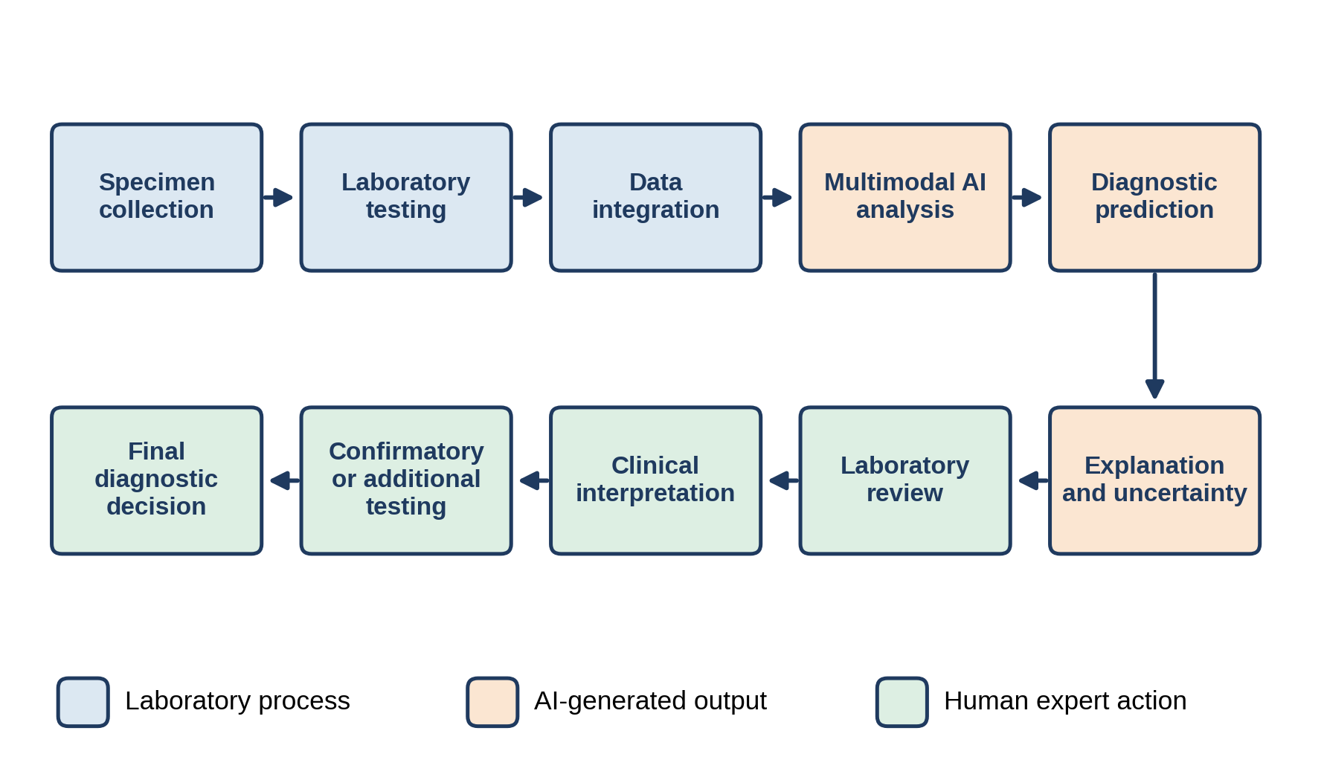
Figure 2. Proposed laboratory–clinical human–AI workflow. Colours distinguish laboratory processes, AI-generated outputs, and human expert actions.
Human oversight should therefore encompass review of unusual predictions, assessment of discordant evidence, confirmation of analytical validity, scrutiny of high-uncertainty cases, appraisal of clinically implausible outputs, documentation of overrides, and continuous monitoring of system performance. The World Health Organization has called for transparency, accountability, human oversight, safety, and sound governance in the development and deployment of AI for health[46].

12. Potential Applications Across Laboratory Medicine
In principle, the framework could be adapted to several diagnostic domains (Table 7). In infectious disease, molecular detection, antigen or antibody measurements, inflammatory biomarkers, and clinical features may provide temporally complementary evidence, and a multimodal system could organise these signals by their contribution to a prediction while representing uncertainty and discordance explicitly[47]. In oncology, diagnosis and characterisation increasingly combine molecular alterations, tissue biomarkers, immunological information, routine laboratory parameters, and clinical variables; multimodal AI with explainability has already been investigated there using clinical, imaging-derived, and molecular information, showing that heterogeneous evidence can be integrated.
Table 7. Potential application domains for the XMAI-PLD framework
Domain | Complementary evidence | Anticipated role of the framework
Infectious disease | Molecular detection, antigen or antibody measurements, inflammatory biomarkers, clinical features | Organize temporally complementary signals; represent uncertainty and discordance explicitly
Oncology | Molecular alterations, tissue biomarkers, immunological information, routine laboratory parameters, clinical variables | Integrate heterogeneous evidence with explainability
Autoimmune and inflammatory disorders | Clinical manifestations, immunological markers, inflammatory biomarkers, molecular signatures | Provide a structured approach to partially overlapping information sources
Haematological disorders | Complete blood counts, morphology, immunophenotyping, molecular abnormalities, cytogenetics, clinical findings | Help organize complementary evidence streams
Endocrine and metabolic disorders | Biochemical biomarkers, hormonal profiles, molecular characteristics, clinical findings, longitudinal measurements | Combine complementary information over time

These examples are potential application domains only. They do not imply that the framework has been clinically validated in any of these settings.

13. Validation Framework
Rigorous validation is essential before clinical implementation, and it should proceed through the successive stages summarised in Table 8. Analytical validation comes first and must show that input data are correctly processed and represented. Internal validation assesses performance on appropriately separated development and validation datasets. External validation, using data from other institutions, laboratory platforms, populations, and clinical settings, is needed to gauge generalisability, since a model that performs well only within its development environment may not perform equivalently elsewhere. Retrospective performance does not establish clinical effectiveness, so prospective studies must determine how the system behaves within real laboratory workflows and how laboratory professionals and clinicians engage with its outputs. Finally, evaluation should reach beyond discrimination metrics to ask whether AI-supported interpretation improves relevant diagnostic processes without introducing unacceptable risks, delays, or inappropriate reliance on automated outputs[48].
Table 8. Staged validation framework
Stage | Objective | Principal considerations
Analytical validation | Confirm that inputs are correctly processed and represented | Data quality, reproducibility, preprocessing, measurement compatibility, data provenance
Internal validation | Assess performance on separated development and validation data | Patient-level separation when several specimens or repeated observations exist
External validation | Establish generalizability | Data from different institutions, laboratory platforms, populations, and clinical settings
Prospective validation | Examine behaviour within real laboratory workflows | Interaction of laboratory professionals and clinicians with outputs; retrospective results do not establish effectiveness
Clinical utility | Determine whether AI-supported interpretation improves diagnostic processes | Benefit beyond discrimination metrics; risks, delays, and inappropriate reliance on automation

For reporting, TRIPOD+AI provides updated guidance for AI-based clinical prediction models, while CONSORT-AI and SPIRIT-AI address the reporting and prospective evaluation of AI interventions [49].

14. Evaluation of Explainability
Explainability should itself be evaluated, not presumed useful merely because an algorithm produces attribution plots or scores. We propose assessing explanations along four dimensions: fidelity, stability, clinical plausibility, and usability (Table 9). An explanation that is visually appealing yet unstable, misleading, or hard to interpret may have little clinical value.
Table 9. Dimensions for evaluating explanations
Dimension | Guiding question
Fidelity | Does the explanation accurately represent the information used by the model?
Stability | Does the explanation stay reasonably consistent when small, clinically irrelevant changes are introduced?
Clinical plausibility | Are the identified contributing features consistent with established laboratory and biological knowledge?
Usability | Can laboratory professionals and clinicians understand the explanation and use it appropriately?

15. Bias, Fairness, and Generalisability
Multimodal diagnostic systems can inherit biases from their underlying data. Sources of variation include demographic differences, healthcare access, disease prevalence, laboratory platforms, analytical procedures, institutional testing patterns, sample composition, missing-data mechanisms, clinical documentation practices, and differences in treatment pathways. A model may therefore appear accurate overall while performing unevenly in clinically important subgroups[50].
Subgroup evaluation should be built into model development and external validation, and any performance differences uncovered should be investigated rather than masked by aggregate metrics. Fairness reaches beyond algorithmic performance to data acquisition, access, deployment, and monitoring. Contemporary international guidance on trustworthy healthcare AI emphasises fairness, universality, traceability, usability, robustness, and explainability throughout the AI lifecycle[51].

16. Privacy, Security, and Data Governance
Laboratory and clinical datasets hold sensitive patient information, and combining several sources yields a fuller portrait of the individual, so multimodal systems may heighten privacy concerns. Data governance should therefore address lawful and ethical data access, de-identification or suitable pseudonymization, access controls, secure storage, audit trails, data provenance, model version control, cybersecurity, responsible secondary use, and monitoring for unintended data exposure. Governance belongs in the design of the system from the outset and should not be left as a final deployment requirement.

17. Implementation Pathway and Conceptual Model

17.1 Translational pathway
The proposed translational pathway comprises eleven steps, from definition of the diagnostic problem to continuous performance monitoring (Table 10).
Table 10. Proposed translational pathway
Step | Action
1. Define the diagnostic problem | Specify the disease, diagnostic target, intended users, clinical setting, and decision point
2. Define the required modalities | Identify the appropriate biomarkers, molecular profiles, immunological measurements, and clinical variables
3. Establish laboratory data quality | Standardize measurements, document analytical characteristics, and establish data provenance
4. Develop modality-specific representations | Process each domain with methods suited to its biological and analytical structure
5. Perform multimodal fusion | Integrate the representations using an appropriately selected fusion architecture
6. Generate diagnostic inference | Produce a diagnostic classification or probability estimate
7. Generate explanations | Report modality-level and feature-level contributions
8. Estimate uncertainty | Identify low-confidence and discordant cases
9. Conduct human review | Laboratory and clinical professionals evaluate the prediction, explanation, analytical validity, and clinical context
10. Confirm and document | Perform additional testing or expert adjudication where required
11. Monitor performance | Evaluate calibration, drift, subgroup performance, errors, and clinical utility on a continuing basis

17.2 Overall conceptual model
The overall framework is depicted in Figure 3. It emphasises a closed analytical loop in which model outputs, expert review, diagnostic discordance, and subsequent performance monitoring all feed into responsible system evaluation.
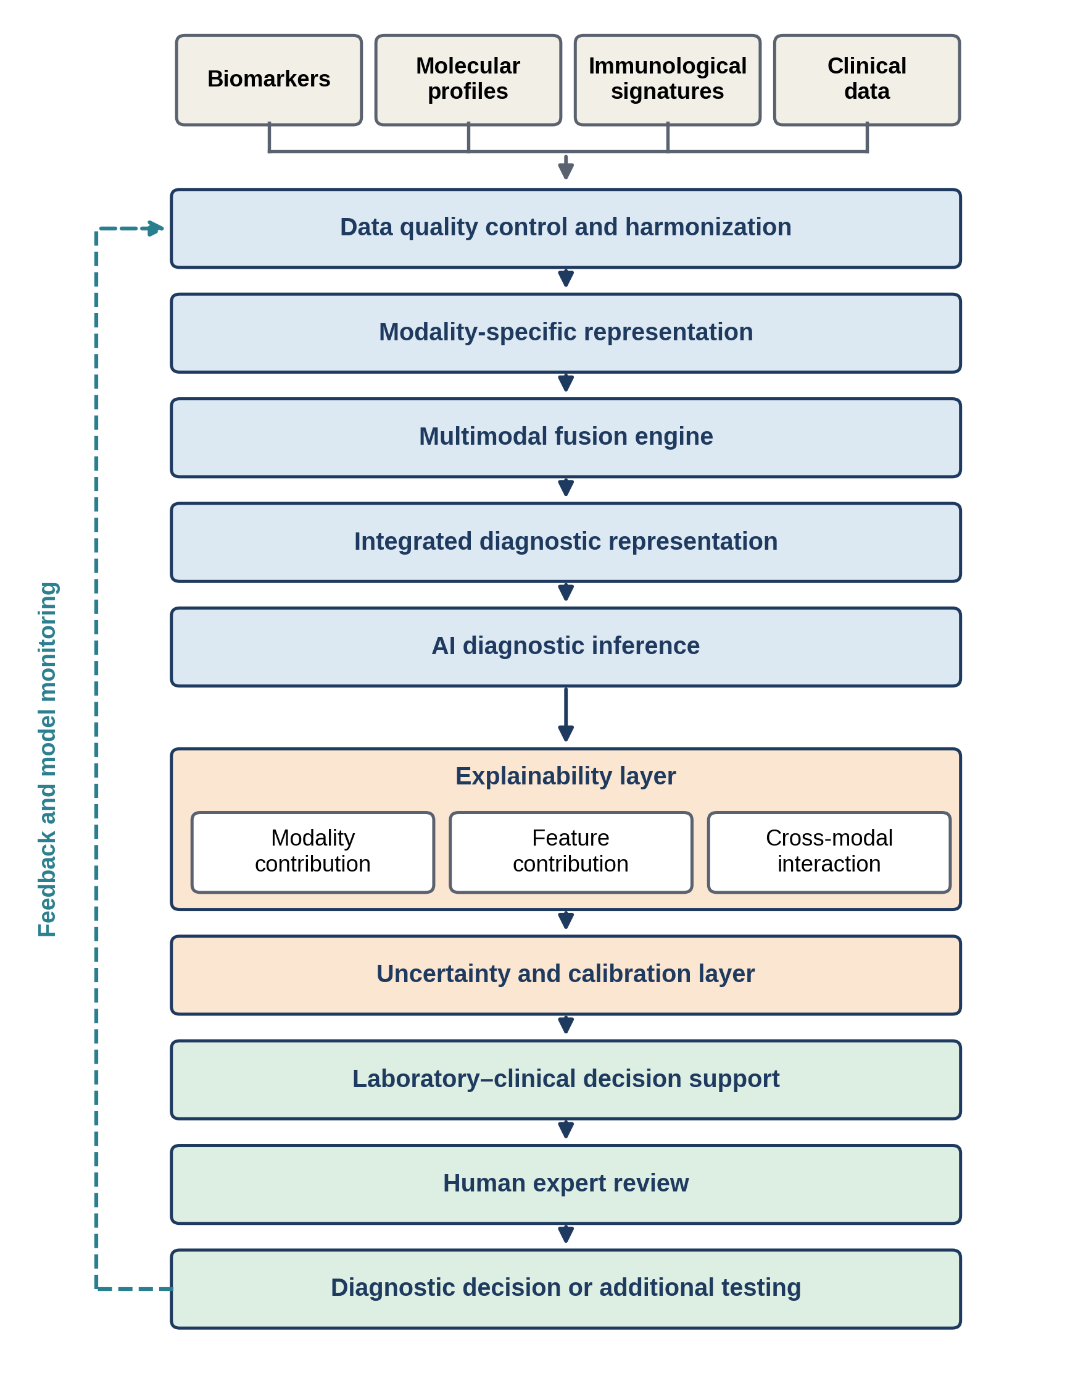
Figure 3. Conceptual model of the XMAI-PLD framework, showing parallel explanation outputs and the closed loop of feedback and model monitoring.

18. Discussion
The central proposition of this framework is that precision laboratory diagnosis can benefit from an architecture that integrates complementary forms of evidence while remaining interpretable. Conventional laboratory interpretation often requires professionals to synthesise information from different analytical platforms and clinical records; multimodal AI offers a computational means of representing such heterogeneous data within a common diagnostic frame. The proposed architecture departs conceptually from single-modality prediction models in three respects. First, it treats laboratory diagnosis as a problem of multimodal evidence integration. Second, it regards explainability as part of the diagnostic workflow instead of an optional post-processing step. Third, it builds uncertainty, discordance, and human review into the output. This distinction matters because predictive performance does not necessarily establish clinical usefulness. A model may classify many cases correctly yet reveal little about why an individual prediction was made; conversely, an explanation may identify important features without guaranteeing that the model is clinically reliable. Prediction, explanation, calibration, and clinical utility should therefore be evaluated as related but distinct properties. Recent research illustrates the feasibility of coupling multimodal clinical information with explainability: in oncology, real-world data comprising clinical, imaging-derived, and molecular information have been analysed with explainable AI approaches to identify patient-level contributions from heterogeneous variables. Carrying this concept into laboratory medicine, however, demands careful attention to analytical variability, specimen characteristics, assay platforms, temporal relationships, reference intervals, and laboratory workflow[52]. Explainability is particularly relevant here because laboratory professionals routinely judge whether a result is analytically and biologically plausible. A multimodal system should accordingly produce outputs that can be interrogated against measurable laboratory evidence: an unexplained diagnostic probability is likely to be less useful than one accompanied by its principal contributing biomarkers, molecular signals, immunological findings, relevant clinical variables, and an uncertainty estimate. Explanations should not, however, be mistaken for causal mechanisms. Feature attribution describes how information contributed to a model prediction; it does not independently establish biological causality, a distinction that is essential when computational associations are translated into laboratory or clinical interpretation. The framework also acknowledges that missing data are intrinsic to real-world laboratory practice, because not every patient undergoes every available test. A system demanding complete multimodal information may have limited practical applicability, which is why explicit handling of absent modalities and transparent identification of incomplete evidence are important for deployment[53]. Model drift is a further concern. Laboratory technologies, testing platforms, patient populations, clinical guidelines, and disease prevalence all change over time, so a model developed under one set of analytical conditions may need continued monitoring. Trustworthy AI guidance increasingly stresses lifecycle-based evaluation, from design and validation through deployment and monitoring. The proposed framework should therefore be viewed as a foundation for future empirical studies and not as evidence of clinical effectiveness. Its components require evaluation in disease-specific datasets and clinical environments, and such studies should establish analytical validity, diagnostic performance, calibration, robustness, explainability, subgroup performance, external generalisability, and clinical utility[54].

19. Strengths and Limitations

19.1 Strengths
The framework offers five conceptual strengths. It recognises that precision diagnosis may require several biological and clinical information domains rather than reliance on isolated measurements. It embeds explainability directly in the architecture, so that outputs stay connected to their supporting evidence. It treats uncertainty and discordance as clinically relevant outputs rather than as mere model failures. It stresses human–AI collaboration over autonomous replacement of laboratory and clinical expertise. Lastly, it folds validation, governance, fairness, privacy, and lifecycle monitoring into the implementation pathway [55].

19.2 Limitations
The framework is conceptual and provides no empirical evidence of diagnostic performance. It does not specify a patient cohort, disease population, laboratory platform, algorithmic architecture, or prospective clinical dataset. Different diseases may call for different combinations of modalities, so the four-domain structure should not be regarded as universally applicable. The computational methods chosen for fusion and explanation may also influence the resulting predictions and interpretations, and comparative evaluation of alternative architectures will therefore be necessary. Finally, explainability neither eliminates model bias nor guarantees clinical correctness: transparent models can still err, and explanations can be misread if their limits are not clearly communicated[56].

20. Future Research Directions
Future investigations should progress from conceptual architecture to disease-specific empirical validation. Priority areas include (i) development of standardised multimodal laboratory datasets; (ii) prospective collection of temporally aligned laboratory and clinical data; (iii) evaluation of missing-modality strategies; (iv) comparison of early, intermediate, and late fusion architectures; (v) assessment of multimodal calibration; (vi) evaluation of explanation fidelity and stability; (vii) external multicentre validation; (viii) subgroup and fairness assessment; (ix) prospective laboratory workflow studies; (x) evaluation of human–AI interaction; (xi) monitoring of model drift after deployment; and (xii) assessment of clinical utility and patient-safety outcomes.
Reporting should follow guidance matched to the study design: TRIPOD+AI for clinical prediction models and CONSORT-AI and SPIRIT-AI for AI interventions and their prospective evaluation.

21. Conclusion
Explainable multimodal AI offers a conceptual pathway for integrating biomarkers, molecular profiles, immunological signatures, and clinical data within a unified framework for precision laboratory diagnosis. Instead of treating laboratory measurements as isolated observations, the XMAI-PLD architecture portrays diagnosis as a process of evidence integration, in which complementary modalities are individually characterised, jointly analysed, and explicitly linked to the resulting prediction. It places explainability, uncertainty, calibration, data quality, human oversight, and governance alongside predictive modelling. This is especially pertinent to laboratory medicine, where diagnostic decisions require traceable analytical evidence and contextual clinical interpretation. The framework is not meant to replace laboratory professionals or clinicians. Its role is to organise heterogeneous evidence, surface potentially informative relationships, communicate uncertainty, and support expert interpretation. Its clinical value must be established through analytical, external, prospective, and clinical-utility validation.

Declaration of AI Use

This manuscript was prepared through the intellectual contributions of the author(s) to the study design, data analysis, interpretation of results, and scholarly content. Grammarly and ChatGPT were used solely to assist with grammatical refinement and reference formatting during manuscript revision. The author(s) accept full responsibility for the accuracy, integrity, and final content of the manuscript.

References:
Srivastava, K., & Srivastava, R. (2026). Explainable deep learning approaches and clinical insights for cancer biomarker identification. Frontiers in Oncology, 16, 1810793. https://doi.org/10.3389/fonc.2026.1810793
Kleczyk, E. J. (2025). Artificial intelligence in diagnostic medicine: Advances in image analysis, predictive modeling, and multi-modal data integration [Manuscript]. ResearchGate.
Khan, S. N., Danishuddin, Khan, M. W. A., Guarnera, L., & Akhtar, S. M. F. (2026). Multi-modal AI in precision medicine: Integrating genomics, imaging, and EHR data for clinical insights. Frontiers in Artificial Intelligence, 8, 1743921. https://doi.org/10.3389/frai.2025.1743921
Arif, N., Shafiq, H., Noor, M., Shahbaz, T., Khan, A., Noor, H., Ahmed, K., Farrukh, E., & Butt, M. A. (2026). Artificial intelligence in cardiovascular diagnostics: Integration of laboratory biomarkers, medical imaging, and molecular data. Pakistan Journal of Medical & Cardiological Review, 5(2), 5665–5695. https://doi.org/10.66021/pakmcr1251
Dejen, G. M. (2026). Multimodal artificial intelligence in medical biotechnology: Integrating genomics, imaging, and clinical data for precision therapeutics. Precision Medical Sciences, 1–28. https://doi.org/10.1002/prm2.70047
Yadav, V., Nagrik, S. U., Gajanan, B., & Rastogi, V. (2026). Artificial intelligence–integrated cancer ecosystems: Multimodal digital biomarkers for precision, personalized, and preventive oncology. International Journal of Emerging Research in Applied Medical Sciences, 2(6), 43–58. https://doi.org/10.65477/2026.v.2i.6.05
Dinc, R., & Ardic, N. (2026). Artificial intelligence in biomarker discovery for diseases: Diagnostic and therapeutic prospects. Signal Transduction and Targeted Therapy, 11(1), 407. https://doi.org/10.1038/s41392-026-02946-4
Liu, N., Han, G., Gu, Q., Zhang, Y., & Chen, M. (2026). A new era of precision diagnosis and treatment for lung cancer: Artificial intelligence-driven multimodal data integration and clinical applications. Cell Death & Disease, 17(1), 534. https://doi.org/10.1038/s41419-026-08769-z
Arif, N., Shafiq, H., Noor, M., Shahbaz, T., Khan, A., Noor, H., Ahmed, K., Farrukh, E., & Butt, M. A. (2026). Artificial intelligence in cardiovascular diagnostics: Integration of laboratory biomarkers, medical imaging, and molecular data. Pakistan Journal of Medical & Cardiological Review, 5(2), 5665–5695. https://doi.org/10.66021/pakmcr1251
Hasnain, M., Hameed, S., Azim, K., & Waseem, M. (2026). Explainable AI for multi-omics in precision medicine: A systematic review. Exploration of Digital Health Technologies, 4(1), 1011102. https://doi.org/10.37349/edht.2026.1011102
Toshpolatov, B., Camalov, F., Eyvazova, K., Latifova, L., Abdiyeva, S., Umirqulova, F., Karimova, I., Baratova, M., Raupova, N., & Shausmanova, R. (2026). Integrating artificial intelligence with biological and multimodal data for predicting, diagnosing and managing inflammatory diseases: A comprehensive review. Advances in Biology & Earth Sciences, 11(Special Issue), 311–329. https://doi.org/10.62476/abes.11si311
Loukopoulou, C., Koliarakis, I., & Tsiaoussis, J. (2026). Next-generation biomarkers and artificial intelligence in colorectal cancer: From multi-omic data integration to clinical application. Cancers, 18(18), 3052. https://doi.org/10.3390/cancers18183052
Alshorman, J., Mehran, M. J., Bahrami, Y., Mohammadzadeh, S., Barzigar, R., Morshedi, M., Haider, K. H., Tembo, K. M., Rong, S.-J., Jadgal, N., Altahla, R., Bolideei, M., & Wang, Y. (2026). Artificial intelligence in immunotherapy: Revolutionizing diagnostic and therapeutic applications in cancer and autoimmune diseases. Clinical and Experimental Medicine, 26(1), 185. https://doi.org/10.1007/s10238-026-02107-5
Kakkar, A., Singh, H., Anand, A., Mishra, A. K., Chopra, S., Chopra, H., & Greig, N. H. (2026). Artificial intelligence and multi-omics integration advances precision diagnosis and personalized therapy for Alzheimer’s disease. Discover Artificial Intelligence. https://doi.org/10.1007/s44163-026-01850-8
Sharma, R., Joshi, S., Yadav, V., Nagrik, S. U., Gajanan, B., & Rastogi, V. (2026). Artificial intelligence, digital biomarkers, and precision oncology: Emerging technologies for early detection and personalized intervention. International Journal of Emerging Research in Applied Medical Sciences, 2(6), 59–67. https://doi.org/10.65477/2026.v.2i.6.06
Singh, A. P., Siddiqui, J., & Singh, V. (2026). Advanced tissue processing: Automation and emerging technologies. Indian Journal of Pathology: Research and Practice, 15(1), 21–38. https://doi.org/10.21088/ijprp.2278.148X.15126.3
Singh, R., Verma, K., Kumar, N., & Singh, A. P. (2026). Beyond the H&E slide: Uncovering hidden histopathological signatures with spatial omics and artificial intelligence. Journal of Basic and Applied Research International, 32(5), 75–91. https://doi.org/10.56557/jobari/2026/v32i511115
Verma, K., Kumar, N., Singh, R., & Singh, A. P. (2026). Path Lab-AI: An autonomous framework for error-free histopathology slide interpretation. Research & Reviews: A Journal of Bioinformatics, 13(1), 19–30. https://journals.stmjournals.com/rrjobi/article=2026/view=239689
Singh, A. P., Siddiqui, J., & Singh, V. (2026). Safety and ethics in the histopathology laboratory. Indian Journal of Pathology: Research and Practice, 15(1), 49–63. https://doi.org/10.21088/ijprp.2278.148X.15126.5
Chungkham, A., Nassor, I. H. S., Charles, N. L., & Singh, A. P. (2025). Quality control and troubleshooting in histopathology laboratories. Asian Journal of Current Research, 10(4), 378–393. https://doi.org/10.56557/ajocr/2025/v10i410053
Jain, K., Devi, R., Singh, A. P., Agrawal, S., Yadav, A. K., Kumari, R., Jain, A. K., & Jain, S. (2025). Artificial intelligence reimagining pre-service teacher training: A comprehensive study of blended learning models in developing and developed contexts. TPM – Testing, Psychometrics, Methodology in Applied Psychology, 32(S9), 1530–1544. https://doi.org/10.5281/zenodo.17963149
Anwer, M., Bhaliya, K., & Wei, M. Q. (2026). Decoding cancer with artificial intelligence: Transforming research, diagnosis, and therapy with future insights. Translational Oncology, 72, 103006. https://doi.org/10.1016/j.tranon.2026.103006
Sah, A. K., Gupta, R., Mishra, P. S., Sharma, N., Kumar, R., Patel, S., & Elshikh, R. H. (2026). The roles of machine learning and artificial intelligence in the prediction of autoimmune disease. In Applications of artificial intelligence in healthcare (pp. 249–264). Academic Press. https://doi.org/10.1016/B978-0-443-43934-6.00015-8
Moar, K., Pant, A., & Maurya, P. K. (2026). Artificial intelligence, machine learning, and multi-omics: The future of cancer and precision oncology. Indian Journal of Clinical Biochemistry, 1–18. https://doi.org/10.1007/s12291-026-01425-5
Yadav, V. (2026). The rise of predictive oncology: Artificial intelligence, digital biomarkers, and personalized cancer care. International Journal of Emerging Research in Applied Medical Sciences, 2(6), 22–31. https://doi.org/10.65477/2026.v.2i.6.03
Nkansah, E., Oladosu, M. A., Abah, M. A., & Oladosu, O. A. (2026). Artificial intelligence-driven multi-omics diagnostic pipelines for infectious, neurodegenerative, and metabolic diseases: From biomarker discovery to precision medicine and digital twin healthcare. International Journal of Preventive Medicine and Health, 6(5), 26–33. https://doi.org/10.54105/ijpmh.E1162.06050726
Christodoulou, R. C., Papageorgiou, P. S., Eller, D., Vassiliou, E., Papageorgiou, S. G., Solomou, E. E., & Georgiou, M. F. (2026). Multimodal artificial intelligence in glioma management: Integrating neuroimaging and hematologic biomarkers for precision oncology. Frontiers in Oncology, 16, 1812518. https://doi.org/10.3389/fonc.2026.1812518
Goswami, P. K., & Chatterjee, S. (2026). Biological multi-omics approaches to next-generation biomarkers in immune-related disorders and malignancies: An overview. Clinical and Translational Oncology, 28(5), 1570–1585. https://doi.org/10.1007/s12094-025-04128-0
Horestani, M. K. (2026). Artificial intelligence-driven multimodal prediction of disease severity and biologic therapy response in inflammatory bowel disease using integrated clinical endoscopic and biomarker data. Scientific Journal of Research Studies in Future Basic Sciences and Medical Sciences, 4(1), 128–157. https://journalhi.com/sci/article/view/400
Xie, Y., Wang, Z., Zeng, Z., Xin, T., Yuan, S., Qin, F., & Chen, Z. (2026). Applications of artificial intelligence in cancer diagnosis and treatment. Cancer Medicine, 15(8), e72143. https://doi.org/10.1002/cam4.72143
Tayebi, T., David, M. A., & Tayebi, M. (2026). Machine learning and multimodal biomarker discovery in Alzheimer’s disease. Brain Sciences, 16(9), 969. https://doi.org/10.3390/brainsci16090969
Hulwan, A. B. (2026). Integrating AI and multiomics for breakthroughs in cancer studies. In Psychopathology early prediction and classification: A deep generative AI approach (pp. 349–367). Wiley. https://doi.org/10.1002/9781394336760.ch16
Davronova, G. B., Eshniyazova, G., Ataeva, M. S., & Nasirov, S. K. (2026). Next-generation precision medicine: Integrating artificial intelligence, genomics, and real-world clinical data for disease prediction and personalized therapy optimization. International Journal of Special Education, 41(5s), 330–347. https://www.internationalsped.com/index.php/ijse/article/view/2977
Wang, X., He, J., Ding, G., Tang, Y., & Wang, Q. (2026). Artificial intelligence–enabled multi-omics for predicting immune checkpoint inhibitor response and resistance. Journal of Multidisciplinary Healthcare, 19, 572089. https://doi.org/10.2147/JMDH.S572089
Suresh, S., Parvathy, A. S., Raj, M., G. S., K., Priya, M. L., Biswas, R., Ramaiah, S., & Anbarasu, A. (2026). Multimodal artificial intelligence and machine learning in oncology: From data integration to precision cancer care. Frontiers in Digital Health, 8, 1872286. https://doi.org/10.3389/fdgth.2026.1872286
Mondal, O., Khatun, M., Lawarde, A., Sajitha Lulu, S., Sundararajan, V., Salumets, A., & Modhukur, V. (2026). Integrating artificial intelligence and multi-omics data for precision oncology in endometrial cancer: A narrative review. Functional & Integrative Genomics, 26(1), 168. https://doi.org/10.1007/s10142-026-01957-2
Shinde, A. D., Taware, V. P., & Nagrik, S. U. (2026). Multimodal artificial intelligence in oncology: Integrating radiomics, pathomics, and genomics. International Journal of Emerging Research in Applied Medical Sciences, 2(6), 1–10. https://doi.org/10.65477/2026.v.2i.6.01
Zhang, M., Chu, J., Wang, Z., Wang, Y., Huang, L., & Qian, M. (2026). Artificial intelligence–driven multimodal fusion for precision diagnosis and personalized management of breast cancer. Oncology Reviews, 20, 1849152. https://doi.org/10.3389/or.2026.1849152
Blaga, A. M., Mihuț, R. O., Treteanu, A. R., Andronic, O., Busnatu, Ș. S., Dima, S., & Rădoi, V. E. (2026). Artificial intelligence and genomic data analysis: New frontiers in precision medicine. International Journal of Molecular Sciences, 27(15), 6755. https://doi.org/10.3390/ijms27156755
Liu, F., Beck, S., Yang, L., Luo, H., & Zhang, K. (2026). Advancing AI for multi-omics and clinical data integration in basic and translational cancer research. Nature Reviews Cancer, 26(7), 497–512. https://doi.org/10.1038/s41568-026-00922-2
Atti, H. B., Porika, S., Sreepada, D., Rayilla, D., Samudrala, M., Raju, R. N., Andy, A., Budhewar, A., Dwivedi, A., & Singh, A. (2026). Integrating multi-omics data using AI: Foundations for systems pharmacology and precision care. In Revolutionizing drug research and personalized medicine through AI and machine learning (pp. 397–430). IGI Global Scientific Publishing. https://doi.org/10.4018/979-8-3373-6400-1.ch014
Liu, F., Beck, S., Yang, L., Luo, H., & Zhang, K. (2026). Advancing AI for multi-omics and clinical data integration in basic and translational cancer research. Nature Reviews Cancer, 26(7), 497–512. https://doi.org/10.1038/s41568-026-00922-2
Siddiqui, M. R. (2026). Machine learning for multi-omics biomarker discovery in lung, kidney, and head and neck cancers. Biosciences Reports, 3(01), 147–172. https://biosciencesreports.com/index.php/BR/article/view/29
Horestani, M. K. (2026). Artificial intelligence-driven multimodal prediction of disease severity and biologic therapy response in inflammatory bowel disease using integrated clinical endoscopic and biomarker data. Scientific Journal of Research Studies in Future Basic Sciences and Medical Sciences, 4(1), 128–157. https://journalhi.com/sci/article/view/400
Tayebi, T., David, M. A., & Tayebi, M. (2026). Machine learning and multimodal biomarker discovery in Alzheimer’s disease. Brain Sciences, 16(9), 969. https://doi.org/10.3390/brainsci16090969
Davronova, G. B., Eshniyazova, G., Ataeva, M. S., & Nasirov, S. K. (2026). Next-generation precision medicine: Integrating artificial intelligence, genomics, and real-world clinical data for disease prediction and personalized therapy optimization. International Journal of Special Education, 41(5s), 330–347. https://www.internationalsped.com/index.php/ijse/article/view/2977
Chera, A., Chirilaș, A. M., El-Sabeh, A., Crețu Stancu, M., & Bucur, O. (2026). AI-assisted multimodal data integration for precision oncology. Frontiers in Artificial Intelligence, 9, 1917442. https://doi.org/10.3389/frai.2026.1917442
Wang, X., He, J., Ding, G., Tang, Y., & Wang, Q. (2026). Artificial intelligence–enabled multi-omics for predicting immune checkpoint inhibitor response and resistance. Journal of Multidisciplinary Healthcare, 19, 572089. https://doi.org/10.2147/JMDH.S572089
Suresh, S., Parvathy, A. S., Raj, M., G. S., K., Priya, M. L., Biswas, R., Ramaiah, S., & Anbarasu, A. (2026). Multimodal artificial intelligence and machine learning in oncology: From data integration to precision cancer care. Frontiers in Digital Health, 8, 1872286. https://doi.org/10.3389/fdgth.2026.1872286
Mondal, O., Khatun, M., Lawarde, A., Sajitha Lulu, S., Sundararajan, V., Salumets, A., & Modhukur, V. (2026). Integrating artificial intelligence and multi-omics data for precision oncology in endometrial cancer: A narrative review. Functional & Integrative Genomics, 26(1), 168. https://doi.org/10.1007/s10142-026-01957-2
Shinde, A. D., Taware, V. P., & Nagrik, S. U. (2026). Multimodal artificial intelligence in oncology: Integrating radiomics, pathomics, and genomics. International Journal of Emerging Research in Applied Medical Sciences, 2(6), 1–10. https://doi.org/10.65477/2026.v.2i.6.01
Liu, F., Beck, S., Yang, L., Luo, H., & Zhang, K. (2026). Advancing AI for multi-omics and clinical data integration in basic and translational cancer research. Nature Reviews Cancer, 26(7), 497–512. https://doi.org/10.1038/s41568-026-00922-2
Saha, P., Yasmin, A., Jha, R., Passi, A., Kaur, M., Jindal, S., Monga, V., & Goyal, K. (2026). Integrative approaches in lung cancer diagnosis: Bridging molecular biomarkers and AI-driven imaging. Biomarkers, 31(4), 295–325. https://doi.org/10.1080/1354750X.2026.2644329
Chakrabarti, T., Mansour, A. G., Wu, X., Arias-Romero, J., Mambetsariev, I., Chang, N., Delos Santos, S., Mirzapoiazova, T., Fricke, J., Kim, J., Afkhami, M., Lall, C., Khan, A. M., Reyes, A., Lee, M., Bruno, D. S., Ladbury, C., Amini, A., & Salgia, R. (2026). Multimodal artificial intelligence in lung cancer: From data integration to precision oncology. Cancers, 18(18), 2953. https://doi.org/10.3390/cancers18182953
Kara, K., & Gunel, T. (2026). Translational bioinformatics and multi-omics integration for AI-driven biomarker discovery in precision oncology. Acta Infologica, 10(1), 1–20. https://doi.org/10.26650/acin.1799569
Addissouky, T. A., Moemen, Y. S., Ibrahim, M., Khalil, F. O., Ali, H., El-Tantawy, A. I., Elarabany, N. F., Afifi, A. A. M., & El Sayed, I. E. T. (2026). Precision medicine in thyroid disorders enabled by integrated multi-omics and artificial intelligence technologies. SN Comprehensive Clinical Medicine, 8(1), 466. https://doi.org/10.1007/s42399-026-02690-4
Kaczmarczyk, R., Wilhelm, T. I., Martin, R., & Roos, J. (2024). Evaluating multimodal AI in medical diagnostics. npj Digital Medicine, 7, 205. https://doi.org/10.1038/s41746-024-01208-3
Nicolson, A., Bradburn, E., Gal, Y., Papageorghiou, A. T., & Noble, J. A. (2025). The human factor in explainable artificial intelligence: Clinician variability in trust, reliance, and performance. npj Digital Medicine, 8, 658. https://doi.org/10.1038/s41746-025-02023-0
Okoroafor, O., Ibrahim, M. S., Ibecheozor, C., Ukatu, C. E., & Arhin, E. (2026). Explainable artificial intelligence, clinician trust and diagnostic accuracy in multi-modal medical imaging: A critical narrative review. Journal of Advances in Medical and Pharmaceutical Sciences, 28(8), 111–134. https://doi.org/10.9734/jamps/2026/v28i8884
Onyebuchi, O. R., Olawuyi, M. A., Ikpokpo, N., Alabi, D., & Chioma, O. O. (2026). Artificial intelligence for physiologically informed precision care in sickle cell disease: Diagnosis, risk prediction, personalised treatment and equitable implementation. Journal of Medicine and Health Research, 11(2), 348–372. https://doi.org/10.56557/jomahr/2026/v11i211065

