Entomological Infestation and Evolution of Peanut Losses During Storage in Northern Côte d’Ivoire

Abstract

Peanut (Arachis hypogaea L.) is an important food commodity in Côte d’Ivoire, and its storage helps ensure its availability beyond the harvest period. However, stored peanuts are exposed to various insect infestations that may result in quantitative and qualitative losses. This study aimed to identify the main insect pests associated with stored peanuts in the Korhogo Department and to assess the evolution of infestation and losses during storage. A survey was conducted with 120 participants in the sector, including 90 producers and 30 traders, distributed across three villages and three markets. Shelled and unshelled peanut samples were then monitored for 90 days in an insectarium. Adult insects were collected at the beginning of storage and again after 45 and 90 days. A total of seven species belonging to two orders and seven families were identified: Caryedon serratus, Rhyzopertha dominica, Sitophilus zeamais, Tribolium castaneum, Cathartus quadricollis, Carpophilus dimidiatus, and Sitotroga cerealella. C. serratus was predominant, with a relative abundance of 93.02%, followed by T. castaneum (4.84%) and R. dominica (1.41%). The infestation rate, initially ranging from 6.90 to 10.74% in the unshelled samples and from 7.00 to 10.22% in the samples collected from the markets, reached 59.73–76.71% and 43.72–76.73%, respectively, after 90 days. Weight losses reached 20.91% of the samples studied. Diversity indices varied among sites, with the highest Shannon values recorded at Drogo (0.470) and the large Market (0.503). These results highlight the importance of C. serratus in the deterioration of stored peanuts and highlight the need to improve storage practices and develop integrated management strategies adapted to local conditions.

Keywords: Arachis hypogaea; Caryedon serratus; groundnut; stored-product insects; infestation dynamics; post-harvest losses; weight loss; species richness
1. Introduction

Peanut (Arachis hypogaea L.) is a legume native to South America and widely cultivated in tropical, subtropical, and warm temperate regions (Desmae et al., 2019). It is an important food and oil crop in many African countries. Globally, it is among the major food and oil crops (Desmae et al., 2019). In Côte d’Ivoire, peanut production mainly contributes to the food supply and supplies various marketing and processing channels. A large proportion of the production is intended for local consumption, particularly in the form of peanut paste. The seeds also have important nutritional value due to their high lipid, protein and carbohydrate content. After harvest, storage is crucial for maintaining the availability of this food throughout the year. However, peanuts can be attacked by several insects during storage, resulting in quantitative and qualitative losses. These losses may result in weight reduction, deterioration of market quality, decreased germination capacity and alteration of the nutritional value of stored products. Stored-product pests therefore represent a major constraint to food preservation (Guèye et al., 2011; Morrison et al., 2019). A study of peanut storage facilities in Georgia, USA, examined associations among insect infestation, storage conditions, peanut quality and aflatoxin contamination (Mbata et al., 2024). In several West African countries, losses caused by insects in stored food products can be substantial (Guèye et al., 2011). Peanuts are particularly susceptible to attacks by Caryedon serratus, which is considered one of their major storage pests. Studies in Africa have documented the importance of this species in stored peanuts (Matokot et al., 1987; Ouedraogo et al., 2016). A laboratory study in Burkina Faso evaluated essential oils from several plants, including Hyptis suaveolens, against adults and eggs of Caryedon serratus (Ouedraogo et al., 2016). More recent experimental research examined alternative approaches to limiting C. serratus damage in stored groundnuts (Singh et al., 2025). A review of stored-grain pest management also examined botanical products as potential components of integrated protection and identified challenges associated with their wider application (Yogapriya et al., 2026). Despite the importance of peanuts in the food systems of northern Côte d’Ivoire, recent data on insects associated with stored peanuts remain limited in this area. Korhogo Department is an important area for the production and marketing of food crops. Knowledge of the pests present in stored products and their dynamics is therefore a prerequisite for implementing appropriate management methods. In particular, combined evidence on local storage practices, insect assemblages and changes in infestation and weight losses during storage remains limited for producer and market peanut stocks in Korhogo. The current study aims to identify insect pests of stored peanuts in the Korhogo Department and to assess the evolution of infestation and losses during storage. More specifically, the study aimed (i) to characterise storage practices and control methods used by producers and traders, (ii) to identify insects associated with stored peanuts and investigate their abundance and distribution, and (iii) to estimate damage and weight losses over 90 days of storage.

2. Material and methods

2.1. Study area
The study was conducted in Korhogo Department in northern Côte d’Ivoire, approximately 600 km north of Abidjan (Figure 1). It is the capital of the Poro Region and the Savane’s District. It covers an area of approximately 12,500 km². The area has a dry tropical climate of the Sudano-Sahelian type. Two main seasons characterize this climate: a rainy season, generally occurring from May to October, and a dry season from November to April. Annual rainfall ranges from 1,100 to 1,600 mm. The region is mainly drained by the Bandama River and several of its tributaries (Jourda et al., 2006).
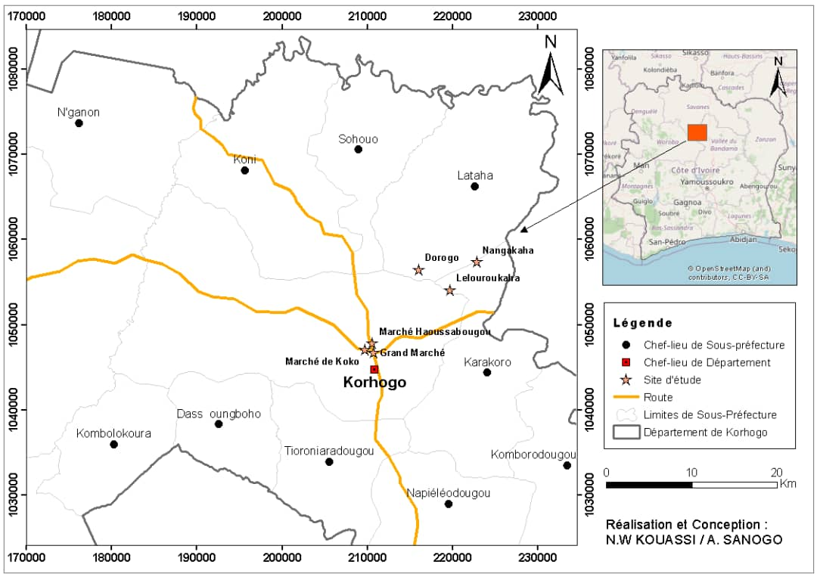

Figure 1: Location of the study area (map: Kouassi and Sanogo, 2026)

2.2. Survey of producers and traders
The survey was conducted in three villages, Nangakaha, Drogo and Lailouroukaha, as well as in three markets in the municipality of Korhogo: the city’s main market, Koko market and Haoussabougou market. A total of 120 people were surveyed, including 30 producers per village and 10 traders per market. The questionnaire focused mainly on the socio-demographic characteristics of the respondents, peanut storage methods, and the methods used to control pests.

2.3. Peanut sampling and storage
Peanut samples were collected from producers and traders. In the insectarium, 200 g of shelled peanuts and 200 g of unshelled peanuts were taken from each sample. The samples were subjected to an initial sieving to collect the adult insects already present. The samples were then placed in labelled jars and covered with muslin cloth, allowing air circulation while preventing insects from entering or leaving. The collected insects were preserved in vials containing 70% alcohol. Two further sieving operations were carried out after 45 and 90 days of storage. This procedure made it possible to monitor the evolution of infestation during storage.

2.4. Insect identification
The collected insects were observed using a stereomicroscope or a trinocular microscope. They were identified on the basis of morphological characteristics using the identification keys of Delobel and Tran (1993) and the catalogue of Fandohan et al. (2005). The individuals were classified by order, family, and species. The number of individuals belonging to each species was recorded to determine their relative abundance.

2.5. Assessment of infestation and weight losses
Losses were assessed at the beginning of storage and then after 45 and 90 days. For each sample, healthy peanuts were separated from peanuts showing signs of infestation, and both fractions were weighed. The infestation rate was calculated from the ratio between the number of infested grains and the total number of grains examined: PA (%) = [Nga / (Nga + Ngs)] × 100 where Nga represents the number of infested grains and Ngs the number of healthy grains. Weight loss was determined from the weights of the infested and healthy fractions: PB (%) = [Pga / (Pga + Pgs)] × 100 where Pga corresponds to the weight of infested grains and Pgs to the weight of healthy grains.

2.6. Diversity analysis
Species richness corresponded to the total number of species observed at each site. The relative abundance (Ar) of each species was calculated as the number of individuals of that species relative to the total number of individuals collected. According to the criteria used, a species was considered very abundant when Ar > 10%, abundant when 5% ≤ Ar < 10%, fairly abundant when 1% ≤ Ar < 5%, and less abundant when Ar < 1%. The occurrence frequency was also calculated. A species was considered constant when 50% ≤ C < 100%, frequent when 25% ≤ C < 50%, accessory when 5% ≤ C < 25%, and rare when C < 5%. The Shannon index and evenness were used to characterise the structure of insect communities.

2.7. Statistical analysis
Data entry, table preparation, and calculation of ecological indices were performed using R Studio and Excel 2019. The normality of the data was assessed using the Shapiro-Wilk test. As the data were not normally distributed, non-parametric tests were used to compare the variables studied. A principal component analysis (PCA) was also performed to examine species distribution and their association with the different study sites.

3. Results

3.1. Characteristics of Producers and Traders
In the villages, 53.33% of respondents were women and 46.67% were men, whereas in the markets, all respondents were women (100%). In both the villages and the markets, the most represented age group was 25–40 years (Figure 2).

Number of people
Market
Age range

Figure 2: Age range of the surveyed population

Most of the respondents had no formal education (73.33% in the markets and 82.22% in the villages) (Figure 3).

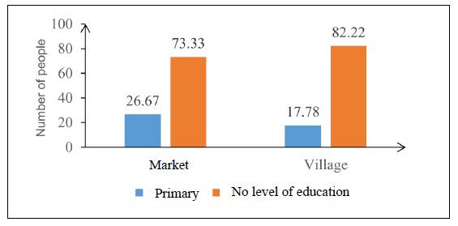
Figure 3: Educational level of the respondents

3.2. Storage methods and control methods
In the villages, peanuts were entirely stored in bags. Most of the producers surveyed (98.88%) stored stocks from different harvests in the same storage location, while keeping the different crops in separate bags. Maize, rice, and cowpea were also stored in the same locations as peanuts. At the village level, 76.67% of the respondents stored their stocks in houses, compared with 23.33% who stored them in warehouses. In the markets, peanuts were displayed in basins during the day and then stored in bags inside warehouses after sales. Insects were identified as the main storage pests by 95.55% of respondents in the villages and 76.67% in the markets. The other respondents mainly considered rodents to be the organisms responsible for the damage. All producers interviewed in the villages reported the use of chemical products against pests. Some also used Hyptis suaveolens, a plant locally considered to have insecticidal or repellent effects. In the markets, sorting and winnowing were the main control methods reported.

3.3. Taxonomic richness of insect pests
A total of seven species belonging to two orders and seven families were identified in the peanut samples. Species richness was seven at Nangakaha and Drogo, five at Lailouroukaha, four at Haoussabougou market, three at Koko market, and four at the large market.

Table 1. Insect pests identified in stored peanut stocks
Orders | Families | Species | V1 | V2 | V3 | M1 | M1 | M3
Coleoptera | Tenebrionidae | Tribolium castaneum | * | * | * | * | * | *
Coleoptera | Silvaniidae | Cathartus quadricollis | * | * | * | * | * | *
Coleoptera | Nitidulidae, | Carpophilus dimidiatus | * | *
Coleoptera | Chrysomelidae | Caryedon serratus | * | * | * | * | * | *
Coleoptera | Curculionidae | Sitophilus zeamais | * | * | *
Coleoptera | Bostrichidae | Rhyzopertha dominica | * | * | * | *
Lepidoptera | Gelechiidae | Sitotroga cerealella | * | * |  |  |  | *
Richness | 7 | 7 | 7 | 7 | 5 | 4 | 3 | 4
V1: Nangakaha, V2: Drogo, V3: Lailouroukaha, M1: large market, M2: market of Koko, M3: market of Haoussabougou

3.4. Relative abundance of insect pest species
The species Caryedon serratus was by far the dominant species across all samples, with a relative abundance of 93.02%. It was followed by Tribolium castaneum with 4.84% and Rhyzopertha dominica with 1.41%. The other species had markedly lower relative abundances: Sitophilus zeamais (0.40%), Cathartus quadricollis (0.19%), Carpophilus dimidiatus (0.11%), and Sitotroga cerealella (0.03%) (Figure 4).

Figure 4: Relative abundance (Ar) of insect pests across all study sites

The highest proportion of insects recorded across sites was at Haoussabougou (23.11%), followed by the large market (19.18%) and Nangakaha (18.89%). Lailouroukaha accounted for 15.73%, Koko for 12.58%, and Drogo for 10.51%. The differences in relative abundance between the sites were not statistically significant according to the statistical analysis (Figure 5).

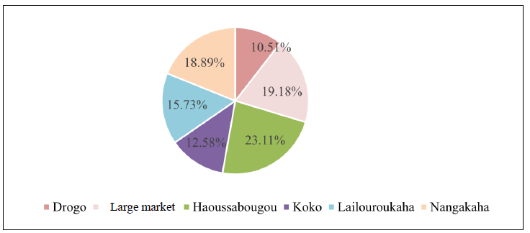

Figure 5: Relative abundance of insect pests according to the study sites

3.5. Dynamics of insects in samples from markets

Five species were identified in the samples collected from the markets during the monitoring period: T. castaneum, C. serratus, C. quadricollis, R. dominica and S. cerealella. At the beginning of storage, three species were recorded: C. serratus, C. quadricollis and T. castaneum. Their relative abundances were 53.99%, 7.35% and 38.66%, respectively. After 45 days, R. dominica appeared with a relative abundance of 0.16%. Species richness then reached four species. At the same time, the relative abundance of C. serratus increased to 76.40%, whereas that of T. castaneum decreased to 22.48% and that of C. quadricollis to 0.95%. After 90 days, R. dominica was no longer detected in the samples and S. cerealella was observed. C. serratus then reached a relative abundance of 92.48%, compared with 6.15% for T. castaneum and 1.23% for C. quadricollis. The frequency of occurrence of C. serratus also increased during storage. It reached 75% after 45 days and 76% after 90 days. T. castaneum showed frequencies of 72% and 70%, respectively, in the same periods.

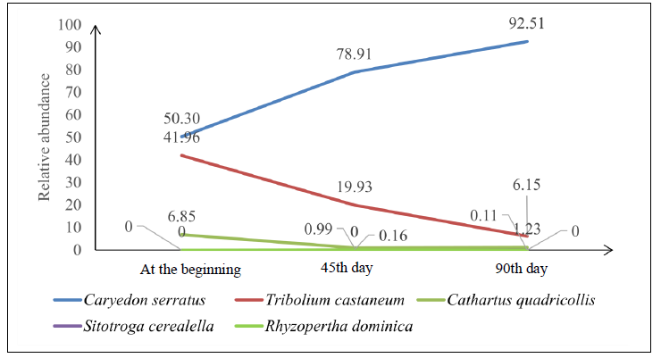
Figure 6: Curve showing the variation in species richness as a function of storage duration for samples from the markets

3.6. Dynamics of insects in samples from the villages
At the beginning of storage, five species were recorded in the samples from the villages. C. serratus, T. castaneum and C. quadricollis were the most abundant species, with 66.47%, 20.35% and 10.18%, respectively. C. dimidiatus and S. zeamais had lower relative abundances of 1.80% and 1.20%, respectively. After 45 days, species richness reached six species. C. serratus remained dominant, with a relative abundance of 78.11%. T. castaneum and C. quadricollis accounted for 12.23% and 5.56%, respectively. The frequency of occurrence of C. serratus reached 97% after 45 days, while that of T. castaneum was 93%. After 90 days, C. serratus remained the most frequently observed species, with a frequency of occurrence of 100%. T. castaneum and R. dominica had frequencies of 90% and 53.33%, respectively. S. cerealella and C. dimidiatus occurred much less frequently.

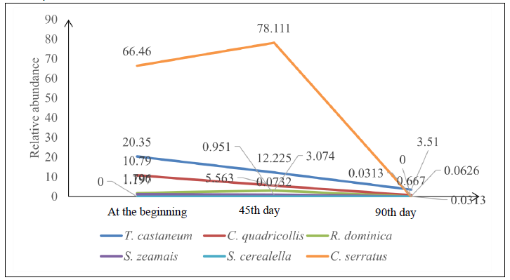

Figure 7: Curve showing the variation in species richness as a function of storage duration for samples collected from the villages

3.7. Nature and evolution of damage

Peanut samples showed several types of deterioration during storage. The damage observed included perforations in the grains and pods, weight reduction, and a decrease in market quality. A loss of germination capacity was also reported.
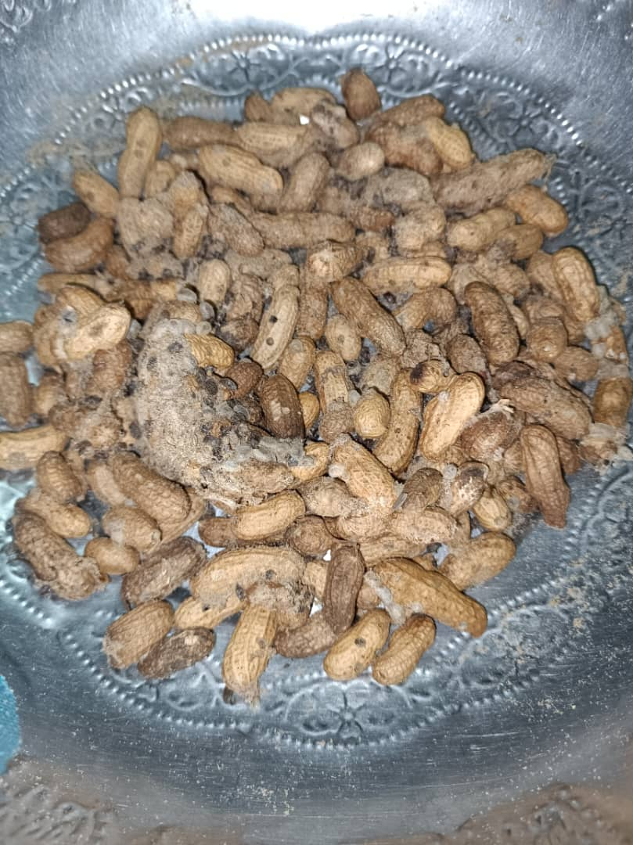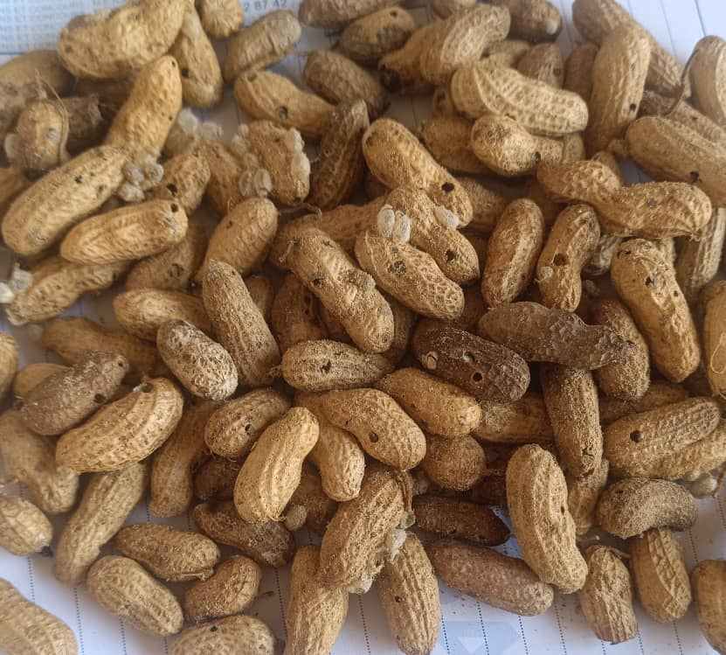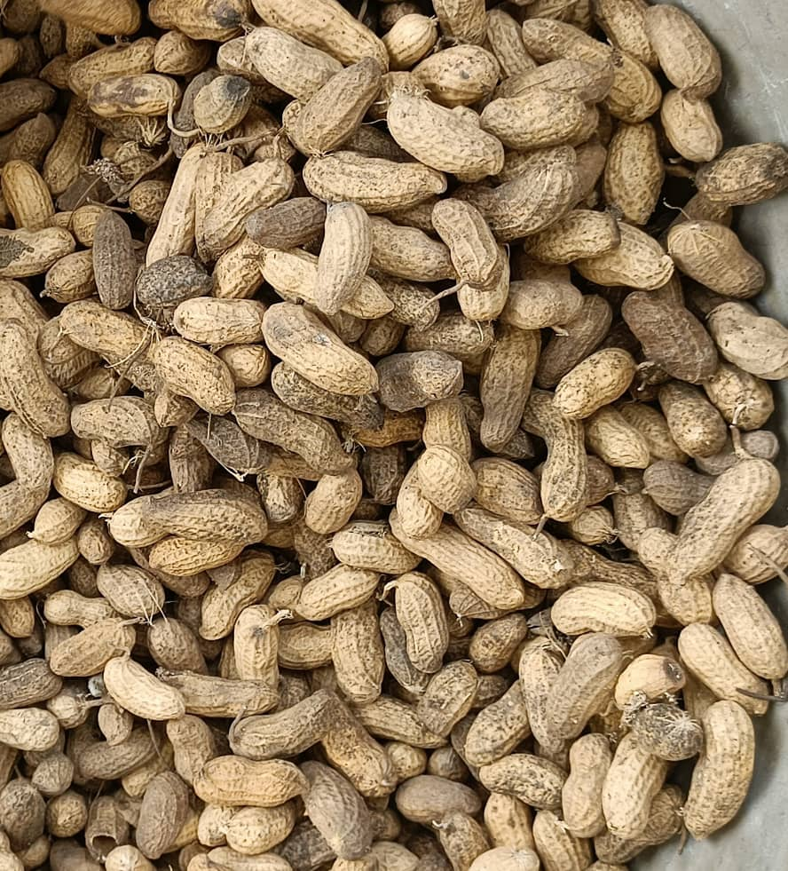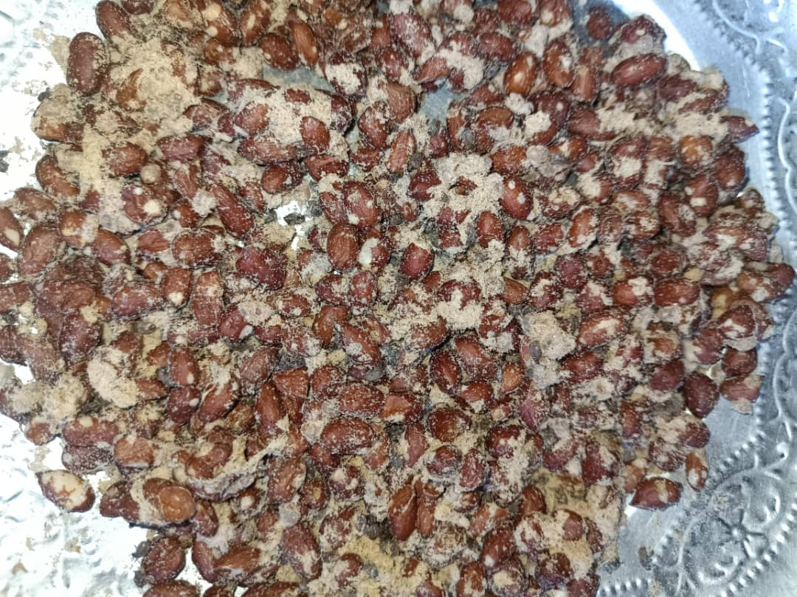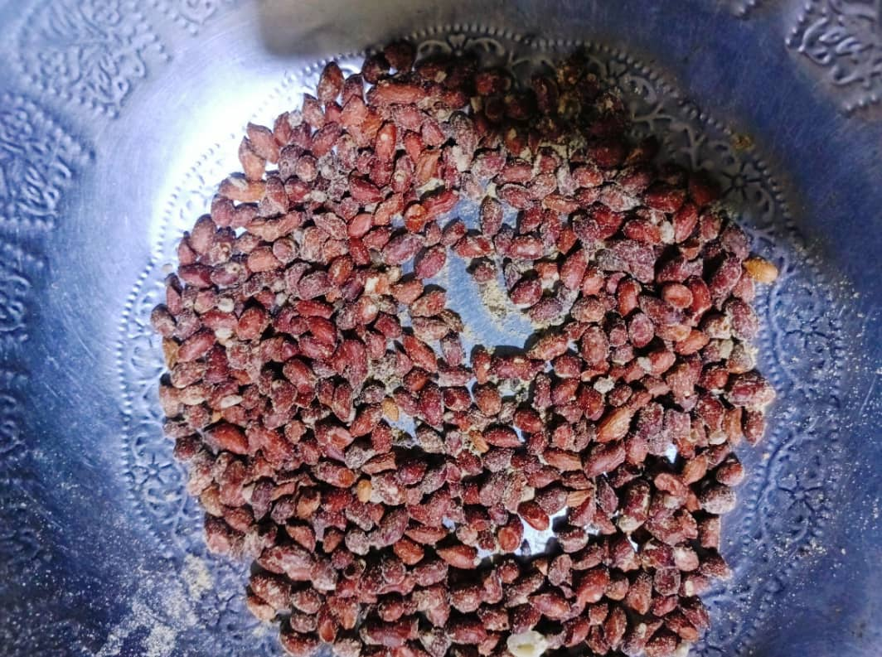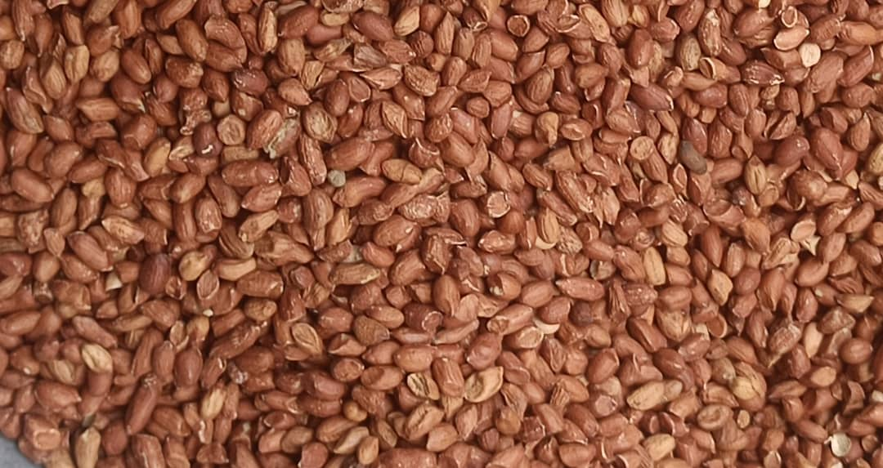
A
B
C
D
E
F

Village: (A: 0-day, B: 45 days, C: 90 days); Market: (D: 0-day, E: 45 days, F: 90 days)

Figure 8: Nature of Damage Caused by Insects to Groundnuts

At the beginning of storage, the infestation rate of unshelled peanuts ranged from 6.90 to 10.74%. In the shelled samples collected from the markets, it ranged from 7.00 to 10.22%. After 45 days, the infestation rate reached 10.09 to 28.71% in unshelled peanuts and 20.53 to 33.51% in the seeds collected from the markets. After 90 days, the infestation rate reached 59.73 to 76.71% in the unshelled samples and 43.72 to 76.73% in the shelled samples.

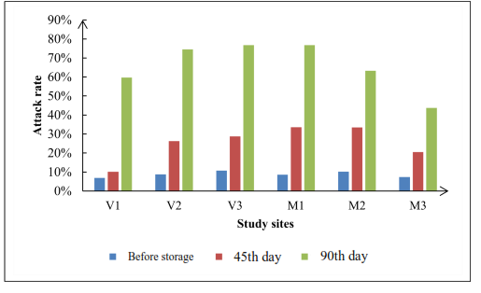

V1 : Nangakaha, V2 : Drogo, V3 : Lailouroukaha, M1 : large market, M2 : market of Koko, M3 : market of Haoussabougou
Figure 9: Insect pest infestation rate on peanut samples
prélevés

Weight losses also increased during storage. At the beginning of storage, they ranged from 3.24 to 6.01% in samples from the villages and from 0.74 to 2.37% in samples from the markets. After 45 days, they reached 5.28 to 7.86% in the villages and 3.14 to 10.78% in the markets. After 90 days, weight losses ranged from 13.22 to 19.51% in samples from the villages and from 13.67 to 20.91% in samples from the markets, depending on the sites and storage conditions.

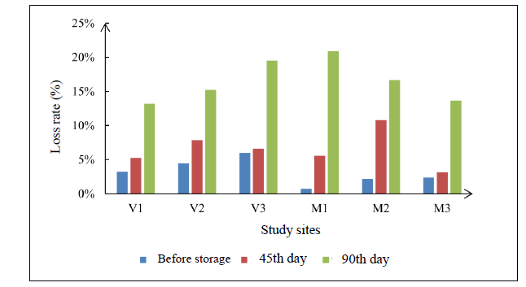
Figure 10: Weight loss rate of the collected peanut samples
V1: Nangakaha, V2: Drogo, V3: Lailouroukaha, M1: large market, M2: market of Koko, M3: market of Haoussabougou

3.8. Diversity indices
The Shannon index ranged from 0.220 to 0.503. The highest value was observed at the large market (0.503), followed by the village of Drogo (0.470). The lowest values were recorded at Koko (0.220) and Haoussabougou (0.234). Species richness ranged from three to six species depending on the sites. Drogo and Nangakaha each recorded six species, whereas the large market had only three species. The large Market recorded the highest evenness (0.458), while Nangakaha had the lowest value (0.140), indicating the strong dominance of certain species at this site.

Table 2: Diversity indices of insect pests according to the sites
Site | Shannon | Specific richness | Pielou’s species evenness
Drogo | 0.470 | 6 | 0.262
Large market | 0.503 | 3 | 0.458
Haoussabougou | 0.234 | 4 | 0.169
Koko | 0.220 | 4 | 0.159
Lailouroukaha | 0.294 | 5 | 0.183
Nangakaha | 0.251 | 6 | 0.140

3.9. Distribution of insect pest species
Principal component analysis showed that the first two axes explained 29.9% and 19.2% of the total variance, respectively. The representation highlighted the structure of the insect communities across sites and the presence of certain species associated with several environments. The proximity observed between certain species, particularly S. zeamais and C. serratus, suggested an association in the samples studied. However, this proximity should be interpreted as an association in the abundance patterns and not as direct evidence of niche sharing.
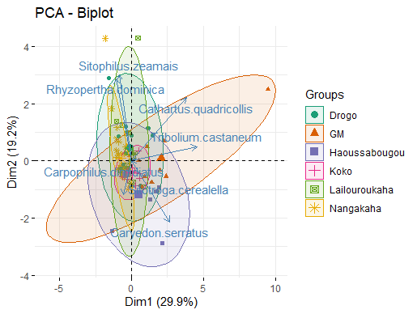
Figure 11: Distribution of insect pests across all study sites

4. Discussion

The study identified seven species of insect pests associated with stored peanuts in the Korhogo Department. This taxonomic richness confirms that peanut stocks constitute a favourable habitat for several groups of insects. Regional studies have documented a broad assemblage of insects associated with stored cereals and legumes in West Africa (Guèye et al., 2011). The strong dominance of Caryedon serratus, which accounted for 93.02% of the individuals collected, constitutes a principal finding of the study. This predominance is consistent with observations made in other peanut-producing countries. C. serratus is considered a primary pest of peanuts, capable of initiating infestation even before storage. Adults can lay eggs on the pods, and the larvae subsequently develop inside the seeds. This ability contributes to the persistence of infestation during storage. High levels of infestation by this species have also been reported in Burkina Faso and Senegal. The importance of C. serratus partly explains the rapid increase in the infestation rate observed during the 90 days of storage. Eggs or larvae present in the pods at the time of storage can continue their development and give rise to new adults. Sorting and sieving operations therefore do not necessarily eliminate all immature stages. This dynamic could explain the increase from relatively low infestation rates at the beginning of storage to levels exceeding 75% after 90 days. The infestation levels observed are comparable to those reported in some previous studies on the peanut bruchid. Matokot et al. (1987) reported losses sometimes exceeding 60% of the dry seed weight after several generations of the pest in Congo. A review of stored-product pests in West Africa likewise emphasised the importance of preventive control of insect populations (Guèye et al., 2011). The increase in weight losses accompanied the increase in the infestation rate. The values recorded after 90 days, close to or exceeding 15% at several sites and reaching approximately 20%, show that infestation is not limited to visible deterioration of the products. Attacks can directly reduce the marketable mass. They may also lead to a decline in market value and a reduction in germination capacity. Stored-product insects may also contribute to contamination and deterioration of product quality (Guchi et al., 2014; Mbata et al., 2024). The storage practices observed also constitute an important factor to consider. In the villages, peanuts are predominantly stored in bags placed inside houses, and stocks from different harvests are kept in the same location. This storage method may favour the persistence of insect populations and their transfer from one stock to another. The presence of insects in stored products therefore requires not only curative treatments but also preventive measures involving storage facility hygiene, cleaning of bags, and regular monitoring of stocks (Arthur, 2000; Morrison et al., 2019). The widespread use of chemical products by producers reflects the importance given to pest control. However, their use should be regulated to limit risks associated with residues and improper application practices. Integrated pest management approaches are particularly relevant in this regard because they allow different control methods to be combined according to the level of infestation and the characteristics of the stock (Hagstrum & Athanassiou, 2019; Tapondjou et al., 2002). In markets, sorting and winnowing are the main practices reported. These methods can remove some of the infested products while maintaining the visual quality of marketed peanuts. The local use of Hyptis suaveolens also deserves particular attention. Producers reported using this plant for insecticidal or repellent effects. Although its essential oil has been tested against C. serratus under laboratory conditions (Ouedraogo et al., 2016), effectiveness under local storage conditions should be evaluated before any large-scale recommendation. Botanical treatments have also been investigated against other stored-legume pests (Dabiré et al., 2008). The differences in diversity observed among sites are mainly related to species richness and the dominance of C. serratus. The large Market had the highest Shannon index despite relatively low species richness, which can be explained by a more balanced distribution of individuals among the species present. Conversely, the low evenness values observed at some sites indicate a high concentration of individuals in one or a few species, mainly C. serratus. The results therefore show that the issue of pests in stored peanuts in Korhogo is not limited to the presence of a diverse assemblage of species. It is mainly characterized by the dominance of a primary pest, C. serratus, whose populations can increase considerably during storage. The management of this species should therefore be a priority in local strategies aimed at reducing post-harvest losses.

5. Conclusion
This study enabled the identification of the insect pests associated with stored peanuts in the Korhogo Department. Seven species belonging to two orders and seven families were identified: Caryedon serratus, Tribolium castaneum, Rhyzopertha dominica, Sitophilus zeamais, Cathartus quadricollis, Carpophilus dimidiatus and Sitotroga cerealella. The insect community was dominated by C. serratus, whose relative abundance reached 93.02%. Monitoring of the samples over 90 days showed a substantial increase in the infestation rate, with values reaching up to 76.71% in unshelled peanuts and 76.73% in shelled samples. Weight losses reached approximately 20% in the most severely affected situations. These results highlight the importance of insect pests in peanut storage in Korhogo and, particularly, the dominant role of C. serratus. Training producers and female traders in good storage practices, improving the hygiene of storage facilities, and regularly monitoring stored products are important measures for limiting losses. Further studies should focus on the biology and ecology of C. serratus under the conditions of northern Côte d’Ivoire, as well as on the evaluation of integrated management methods combining hermetic storage, biopesticides and, where necessary and legally authorized, appropriate chemical treatments.

Limitations
The study covered only three villages and three markets in Korhogo Department, and samples were observed for 90 days under insectarium conditions. Consequently, the findings may not represent longer storage periods or other production areas. Storage practices were obtained through respondent surveys, and the study did not experimentally compare the effectiveness of control methods. Associations between insect abundance and losses should therefore not be interpreted as evidence of causation. Additional field-based and longer-term studies are needed to assess the consistency of these patterns.

Conflict of Interest
The authors declare that they have no conflict of interest in relation to the present study.
Declaration of AI Use

This manuscript was prepared through the intellectual contributions of the author(s) to the study design, data analysis, interpretation of results, and scholarly content. Grammarly and ChatGPT were used solely to assist with grammatical refinement and reference formatting during manuscript revision. The author(s) accept full responsibility for the accuracy, integrity, and final content of the manuscript.

References

Arthur, F. H. (2000). Impact of accumulated food on survival of Tribolium castaneum on concrete treated with cyfluthrin wettable powder. Journal of Stored Products Research, 36(1), 15–23. https://doi.org/10.1016/S0022-474X(99)00022-3
Dabiré, C. L. B., Ba, M. N., & Sanon, A. (2008). Effects of crushed fresh Cleome viscosa L. (Capparaceae) plants on the cowpea storage pest, Callosobruchus maculatus Fab. (Coleoptera: Bruchidae). International Journal of Pest Management, 54(4), 319–326. https://doi.org/10.1080/09670870802266953
Delobel, A., & Tran, M. (1993). Les coléoptères des denrées alimentaires entreposées dans les régions chaudes. ORSTOM (Faune tropicale, 32). https://www.documentation.ird.fr/hor/fdi%3A39066
Desmae, H., Janila, P., Okori, P., Pandey, M. K., Motagi, B. N., Monyo, E., Mponda, O., Okello, D., Sako, D., Echeckwu, C., Oteng-Frimpong, R., Miningou, A., Ojiewo, C., & Varshney, R. K. (2019). Genetics, genomics and breeding of groundnut (Arachis hypogaea L.). Plant Breeding, 138(4), 425–444. https://doi.org/10.1111/pbr.12645
Fandohan, P., Goergen, G., Hell, K., & Lamboni, Y. (2005). Petit manuel d’identification des principaux ravageurs des denrées stockées en Afrique de l’Ouest. INRAB & IITA. https://www.researchgate.net/publication/320474955
Guchi, E., Ayalew, A., Dejene, M., Ketema, M., Asalf, B., & Fininsa, C. (2014). Occurrence of Aspergillus species in groundnut (Arachis hypogaea L.) along the value chain in different agro-ecological zones of Eastern Ethiopia. Journal of Applied & Environmental Microbiology, 2(6), 309–317. https://doi.org/10.12691/jaem-2-6-7
Guèye, M. T., Seck, D., Wathelet, J.-P., & Lognay, G. (2011). Lutte contre les ravageurs des stocks de céréales et de légumineuses au Sénégal et en Afrique occidentale : synthèse bibliographique. Biotechnologie, Agronomie, Société et Environnement, 15(1), 183–194. https://popups.uliege.be/1780-4507/index.php?id=7108
Hagstrum, D. W., & Athanassiou, C. G. (2019). Improving stored product insect pest management: From theory to practice. Insects, 10(10), 332. https://doi.org/10.3390/insects10100332
Jourda, J. P., Saley, M. B., Djagoua, É. V., Kouamé, K. J., Biémi, J., & Razack, M. (2006). Utilisation des données ETM+ de Landsat et d’un SIG pour l’évaluation du potentiel en eau souterraine dans le milieu fissuré précambrien de la région de Korhogo (nord de la Côte d’Ivoire) : approche par analyse multicritère et test de validation. Télédétection, 5(4), 339–357.
Matokot, L., Mapangou-Divassa, S., & Delobel, A. (1987). Évolution des populations de Caryedon serratus (Ol.) (Coleoptera : Bruchidae) dans les stocks d’arachide au Congo. L’Agronomie tropicale, 42(1), 69–74. https://horizon.documentation.ird.fr/exl-doc/pleins_textes/pleins_textes_5/b_fdi_18-19/24002.pdf
Mbata, G. N., Danso, J. K., & Holton, R. L. (2024). Peanut aflatoxin: Impact of postharvest insect infestation and storage systems. Insects, 15(11), 836. https://doi.org/10.3390/insects15110836
Morrison, W. R., III, Bruce, A., Wilkins, R. V., Albin, C. E., & Arthur, F. H. (2019). Sanitation improves stored product insect pest management. Insects, 10(3), 77. https://doi.org/10.3390/insects10030077
Ouedraogo, I., Nebie, C. R., Dakouo, D., & Guenda, W. (2016). Insecticide activity of essential oils on the development of eggs and adult of Caryedon serratus Olivier (Coleoptera: Chrysomelidae), pest of stored groundnut. Journal of Agriculture and Ecology Research International, 9(2), 1–10. https://doi.org/10.9734/JAERI/2016/26435
Singh, R., Mishra, P. R., Sharma, K. R., Mangaraj, S., Singh, S. K., & Singh, A. K. (2025). Entomotoxic efficacy of nanoparticles and elevated levels of CO₂ against groundnut bruchid, Caryedon serratus (Olivier, 1790) (Coleoptera: Chrysomelidae) in stored groundnut. Journal of Stored Products Research, 114, 102758. https://doi.org/10.1016/j.jspr.2025.102758
Tapondjou, L. A., Adler, C., Bouda, H., & Fontem, D. A. (2002). Efficacy of powder and essential oil from Chenopodium ambrosioides leaves as post-harvest grain protectants against six stored-product beetles. Journal of Stored Products Research, 38(4), 395–402. https://doi.org/10.1016/S0022-474X(01)00044-3
Yogapriya, A., Karuppusamy, K., Senthilkumar, E., Annanithi, A., Balaji, A., & Elango, G. (2026). Eco-friendly management of storage grain pests: A review. Uttar Pradesh Journal of Zoology, 47(6), 144–159. https://doi.org/10.56557/upjoz/2026/v47i65568

