Original Research Article
Root colonisation and growth responses of African eggplant (Solanum aethiopicum L.) to indigenous and commercial arbuscular mycorrhizal fungal inoculants

.
ABSTRACT

Background: African eggplant (Solanum aethiopicum L.) is an important vegetable crop in sub-Saharan Africa, but its productivity is constrained by declining soil fertility and increasing reliance on chemical inputs. Arbuscular mycorrhizal fungi (AMF) represent a potential sustainable biofertilisation strategy, although the effectiveness of commercial and indigenous inocula may vary depending on environmental conditions and plant–fungus interactions.
Aims: This study evaluated the ability of one commercial and two indigenous AMF inocula originating from cassava- and maize-associated rhizospheres to colonise S. aethiopicum roots and influence plant growth.
Study design: Greenhouse experiment conducted in Daloa, Côte d’Ivoire.
Place and Duration of Study: Jean LOROUGNON GUEDE University, Department of Plant Biology, from April to June 2024.
Methodology: A completely randomised design with four treatments and seven replicates was used: a commercial inoculant (CoM), an indigenous cassava-derived inoculum (CaM), an indigenous maize-derived inoculum (MaM), and a non-inoculated control. Mycorrhizal colonisation frequency and intensity were assessed 40 days after transplanting, while plant growth and biomass production were monitored for 60 days. Results: All three inocula established mycorrhizal colonisation, with colonisation frequencies exceeding 50%, whereas no colonisation was detected in the non-inoculated control. However, colonisation intensity remained low, and no significant differences were observed among the commercial and indigenous inocula. Similarly, no statistically significant treatment differences were detected in plant height, collar diameter, number of leaves, flower-bud production, or fresh aboveground and belowground biomass.
Conclusion: These findings indicate that the indigenous inocula evaluated were capable of colonising S. aethiopicum roots at levels comparable to the commercial inoculant. Under the controlled greenhouse conditions and regular irrigation regime used in this study, AMF inoculation did not result in detectable improvements in eggplant growth. Longer-term experiments using larger root-zone volumes and contrasting water conditions, together with field trials, are needed to determine the agronomic potential of these indigenous inocula for sustainable biofertilisation of African eggplant in Côte d’Ivoire.

Keywords: Sustainable agriculture, Biofertilizer, Arbuscular mycorrhizae, Mycorrhizal colonization

1. INTRODUCTION

African eggplant (Solanum aethiopicum L.) is one of the most widely cultivated indigenous vegetables in sub-Saharan Africa and constitutes an essential component of local food systems. The crop is valued for its edible fruits and leaves, which provide dietary fibre, vitamins, minerals, and bioactive compounds with recognised nutritional and health-promoting properties (Choi & Choi, 2024). In addition to its contribution to household nutrition, African eggplant has an important economic role in smallholder farming systems, providing a source of income through commercial production and contributing to farmers’ livelihoods (Kasharu et al., 2019; Mvungi et al., 2025). Consequently, improving the cultivation of this indigenous vegetable is considered an important strategy for strengthening food security, improving nutrition, and supporting rural livelihoods while promoting sustainable agricultural development.

Despite its importance, S. aethiopicum cultivation faces several constraints, including declining soil fertility, inadequate nutrient management, and increasing pest and disease pressures. In Côte d’Ivoire, farmers frequently rely on chemical pesticides and mineral fertilisers to address these constraints. Although mineral fertilisation can rapidly improve crop performance and chemical pesticides can protect crops, their long-term sustainability is increasingly questioned because of rising input costs and adverse environmental impacts. These limitations have stimulated growing interest in environmentally friendly alternatives capable of sustaining crop growth while restoring soil biological functions. Recent reviews also identify AMF-based biofertilisation as a biological approach for supporting nutrient acquisition and soil functions within more sustainable production systems (Gayathry et al., 2024).

Among the biological approaches proposed for sustainable agriculture, arbuscular mycorrhizal fungi (AMF) have attracted considerable attention because of their capacity to simultaneously influence plant nutrition, growth, and stress resilience. AMF establish mutualistic associations with approximately 80% of terrestrial plant species, in which carbon compounds supplied by the host plant support fungal growth, while the extraradical mycelial network enhances the acquisition of mineral nutrients and water (Zhang et al., 2024). Meta-analytical evidence indicates that AMF inoculation can substantially improve plant biomass and nitrogen and phosphorus nutrition, although the magnitude of these effects depends on plant, fungal, and environmental factors (Wu et al., 2024). Beyond nutritional benefits, AMF can improve soil structure and water-use efficiency and enhance plant tolerance to drought, salinity, and temperature stress through coordinated physiological, biochemical, and molecular responses (Nie et al., 2024). They may also contribute to plant protection against soil-borne pathogens by stimulating host defence mechanisms and modifying the rhizosphere environment (Nie et al., 2024). A recent global field synthesis likewise showed that AMF effects on root colonisation and crop performance vary with fungal identity, crop group, climate, and soil conditions (Li et al., 2025).
These multiple ecosystem services have positioned AMF as key components of sustainable agriculture and have contributed to the development of numerous industries producing commercial mycorrhizal inoculants worldwide (Vosátka et al., 2012). However, the effectiveness of mycorrhizal inoculation may vary depending on the origin of the fungal inoculum. In particular, indigenous AMF isolates may be better adapted to local soil and environmental conditions than exotic or commercial strains, potentially influencing their ability to establish symbiosis with host plants and to promote plant growth (Berruti et al., 2016). Although considerable progress has been made in understanding AMF–plant interactions, important knowledge gaps remain for indigenous vegetable production systems in West Africa. Furthermore, information on the agronomic performance of locally produced AMF inocula remains limited (Kouadio et al., 2017; Séry et al., 2016), despite their potential advantages in terms of adaptation to local soils, lower production costs, and wider accessibility for smallholder farmers. Therefore, comparing commercial inoculants with indigenous inocula is important for determining whether locally sourced AMF can provide an effective alternative to commercially available products. Recent studies using native AMF in vegetable and cereal systems further indicate that inoculation outcomes can depend on host–fungus interactions and the growing environment (Gebreslassie et al., 2024; Marrassini et al., 2024). Variation in AMF diversity and root colonisation among crop hosts also supports crop-specific evaluation of locally sourced inocula (Nengi-Benwari et al., 2025).
The present study was designed to assess the effects of one commercial and two locally produced AMF inocula on Solanum aethiopicum root mycorrhizal colonisation and growth under greenhouse conditions in Daloa, Côte d’Ivoire. By comparing commercial and indigenous inocula under standardised conditions, this study provides new evidence regarding the context-dependent effectiveness of AMF inoculation and contributes to the development of sustainable biofertilisation strategies for African eggplant cultivation in West Africa.

2. MATERIAL AND METHODS

2.1 Plant material

The eggplant seeds used in the experiment belonged to the BELLO variety. BELLO is an African eggplant cultivar belonging to the Solanaceae family, characterised by a mild flavour and early maturity, with the first harvest occurring approximately 60 days after planting. The seeds were purchased from Semivoire, a commercial seed supplier.

2.2 Arbuscular mycorrhizal fungi inocula
The fungal material used consisted of three mycorrhizal inocula belonging to two categories: commercial and indigenous inocula. The indigenous AMF inocula consisted of mixtures of soil, AMF spores, and root fragments collected from cassava and maize fields. The commercial inoculant was supplied by the Quebec-based company Premier Tech Biotechnologies (PTB), which is recognised as one of the world’s leading producers and suppliers of mycorrhizal inoculants. Indigenous AMF inocula contained one spore per gram of soil in addition to colonised root fragments and other propagules present in the field-derived inoculum. In contrast, the commercial inoculum contained 500 AMF spores per gram. Thus, the inocula differed substantially in their counted spore doses and in their composition, and the comparison should not be interpreted as an equivalent spore-dose comparison.

2.3 Experimental design, culture conditions and data collection
To establish the nursery, eggplant seeds of the ‘Bello’ cultivar obtained from Semivoire were sown in perforated plastic trays to allow excess irrigation water to drain. The trays were filled with previously sterilised potting soil. The seedlings were watered once every two days with 1 L per pot. After reaching the four-leaf stage, each plant was transplanted into a 3-L pot containing a substrate consisting of a mixture of sand and potting soil (1:2, v/v). The relatively low-nutrient substrate was intended to avoid excessive nutrient availability that could potentially limit AMF colonisation. The substrate was previously sterilised by autoclaving at 121 °C for 15 min, twice at a 24-h interval.

Seedlings were inoculated with AMF at the time of transplanting. The indigenous AMF inocula were applied at a rate of 200 g per plant and contained 200 counted AMF spores per plant, in addition to colonised root fragments and other propagules present in the field-derived inoculum. The indigenous inocula were mixtures of soil, AMF spores, and root fragments. For the commercial inoculant, 15 g plant⁻¹ (the manufacturer’s recommended rate) was applied, corresponding to 7,500 AMF spores and propagules per plant. The inocula were placed in the planting holes in close proximity to the roots, following the application instructions provided for the commercial mycorrhizal inoculant supplied by Premier Tech Biotechnologies (PTB).

For this experiment, a completely randomised design was used, with seven replicates and four treatments: the commercial mycorrhizal inoculant (CoM), the indigenous mycorrhizal inoculum from a cassava field (CaM), the indigenous mycorrhizal inoculum from a maize field (MaM), and an uninoculated control.

Following transplanting, the plants were irrigated once every two days and maintained under greenhouse conditions for 60 days until flowering. Agronomic data, such as plant height, collar diameter, and number of leaves, were recorded at seven-day intervals. At the end of the experiment, the number of flower buds and fresh aboveground and belowground biomass were also recorded. Mycorrhizal colonisation frequency and intensity were assessed 40 days after transplanting. Fine fresh roots were collected from cultivation pots. Roots were cleared and stained prior to microscopic observation, following the method described by Phillips and Hayman (1970). The roots were first immersed in a 10% KOH solution and heated in a water bath at 90 °C for 30 min. They were then thoroughly rinsed with running water, drained, and treated with 1% HCl at 80 °C for 15 min in a water bath. After a second thorough rinse, the roots were immersed in a 0.05% trypan blue solution and heated at 80 °C for 30 min in a water bath. The roots were finally rinsed with water and mounted on microscope slides in 50% glycerol for microscopic observation. The degree of mycorrhizal colonisation was assessed according to the method of Trouvelot et al. (1986), based on mycorrhizal frequency and mycorrhizal intensity. The microscopic preparations were examined at least 24 h after mounting. Mycorrhizal colonisation frequency and intensity were then calculated.

2.4 Statistical analysis
Statistical analyses were performed using Statistica software, version 7.1. The effects of the treatments on mycorrhizal colonisation parameters were assessed using a one-way analysis of variance (ANOVA). The assumptions of normality of the model residuals and homogeneity of variances were assessed before analysis. When the ANOVA indicated a significant treatment effect, means were compared using Fisher’s least significant difference (LSD) test at the 5% significance level. For plant growth parameters measured repeatedly over time, a repeated-measures ANOVA was performed using inoculation treatment as the between-subject factor and the successive measurement dates as repeated measures. Multivariate tests were used to assess the effect of inoculation treatment across the repeated measurements. Statistical significance was set at P = .05.

3. RESULTS AND DISCUSSION

3.1 Mycorrhizal colonisation frequency and intensity
Significant differences were observed among treatments in terms of mycorrhizal colonisation frequency and intensity (Figure 1). Complete absence of mycorrhizal colonisation was observed in the roots of non-inoculated plants. In contrast, all inoculated plants were successfully colonised by AMF 40 days after transplanting, with mycorrhizal colonisation frequencies exceeding 50% across all inoculated treatments (Figure 1). Fisher’s LSD post hoc test showed no significant differences among the three inoculated treatments, indicating that the significant overall treatment effect was primarily attributable to the absence of mycorrhizal colonisation in the non-inoculated control (Figure 1). A similar pattern was observed for mycorrhizal colonisation intensity, with no significant differences among the inoculated treatments. However, colonisation intensity was generally low.

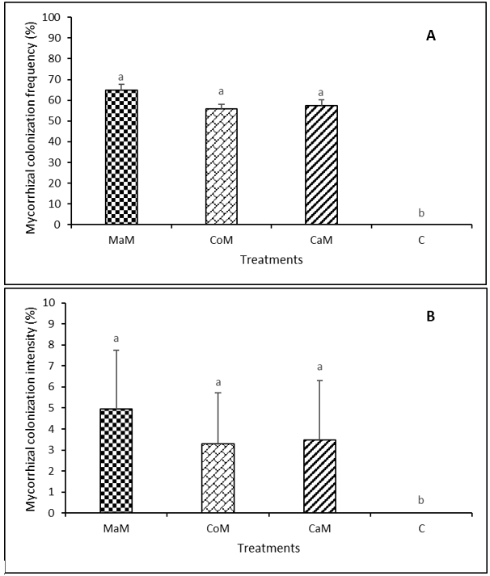
Fig. 1: Mycorrhizal colonization frequency (A). and intensity (B)
Bar graphs following the same letter in each graph are not significantly different at the 5% significance level. MaM: Maize mycorrhizal inoculum; CoM: Commercial mycorrhizal inoculant; CaM: Cassava mycorrhizal inoculum; C: Control with no mycorrhizal inoculum

3.2 Plant height, collar diameter and number of leaves
The multivariate repeated-measures analysis showed no significant effect of inoculation treatment on growth parameters across the measurement dates (P = 0.93).
No significant differences among treatments were observed for plant height, collar diameter, or number of leaves throughout the experimental period (Figure 2). The mean height of plants inoculated with the commercial inoculant CoM increased from 13.71 ± 2.49 cm during the first week of measurements to 36.29 ± 6.76 cm during the final week of measurements (Figure 2A). For plants inoculated with the indigenous inocula CaM and MaM, mean plant height increased from 13.81 ± 1.73 cm and 13.00 ± 2.49 cm, respectively, during the first week of measurements to 30.63 ± 6.88 cm and 34.13 ± 8.17 cm, respectively, during the final week of measurements (Figure 2A). Non-inoculated plants increased from 13.43 ± 1.59 cm during the first week of measurements to 34.00 ± 5.53 cm during the final week of measurements (Figure 2A).

The collar diameter of plants inoculated with the commercial inoculant CoM increased from 3.67 ± 0.67 mm during the first week of measurements to 5.59 ± 0.61 mm during the final week of measurements (Figure 2B). For plants inoculated with the indigenous inocula CaM and MaM, collar diameter increased from 3.15 ± 0.36 mm and 3.55 ± 0.28 mm, respectively, during the first week of measurements to 5.43 ± 0.47 mm and 5.73 ± 0.36 mm, respectively, during the final week of measurements (Figure 2B). Non-inoculated plants increased from 3.20 ± 0.37 mm during the first week of measurements to 5.87 ± 0.61 mm during the final week of measurements (Figure 2B).

The number of leaves of plants inoculated with the commercial inoculant CoM increased from 6.00 ± 0.73 during the first week of measurements to 17.00 ± 5.36 during the final week of measurements (Figure 2C). For plants inoculated with the indigenous inocula CaM and MaM, the mean number of leaves increased from 5.00 ± 0.66 and 5.00 ± 0.60, respectively, during the first week of measurements to 16.00 ± 1.79 and 16.00 ± 2.38, respectively, during the final week of measurements (Figure 2C). Non-inoculated plants increased from 5.00 ± 0.64 during the first week of measurements to 15.00 ± 1.68 during the final week of measurements (Figure 2C).
No statistically significant differences were detected in growth parameters among treatments throughout the experimental period (Figure 2).

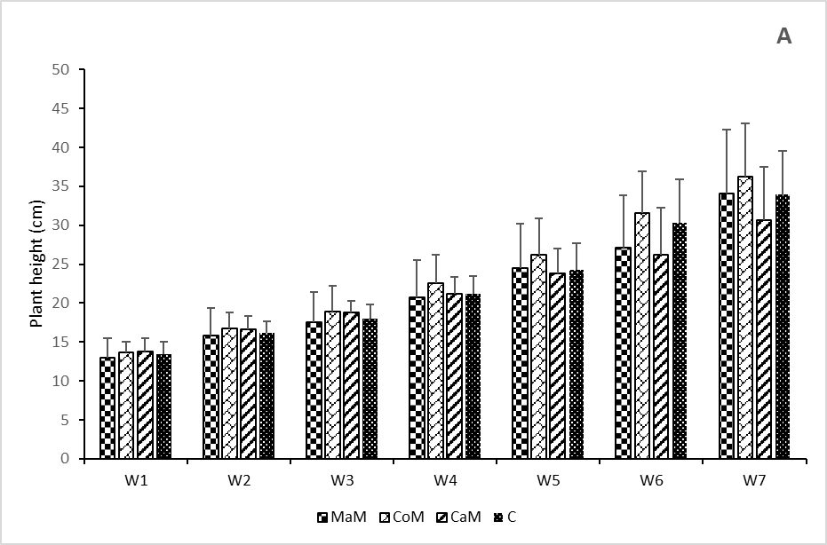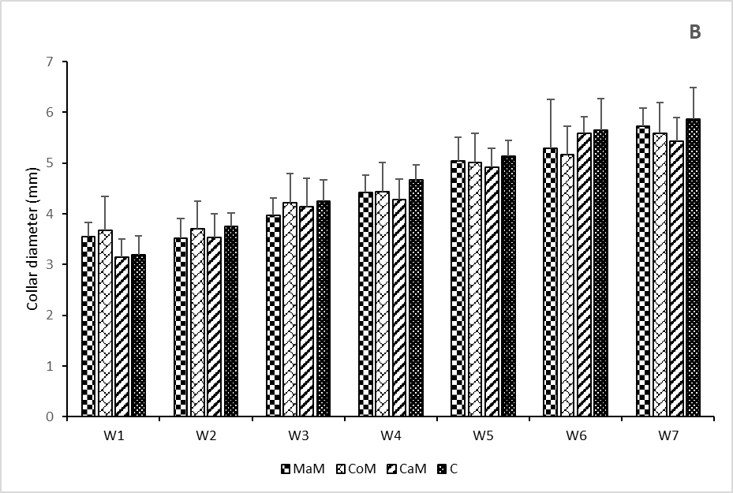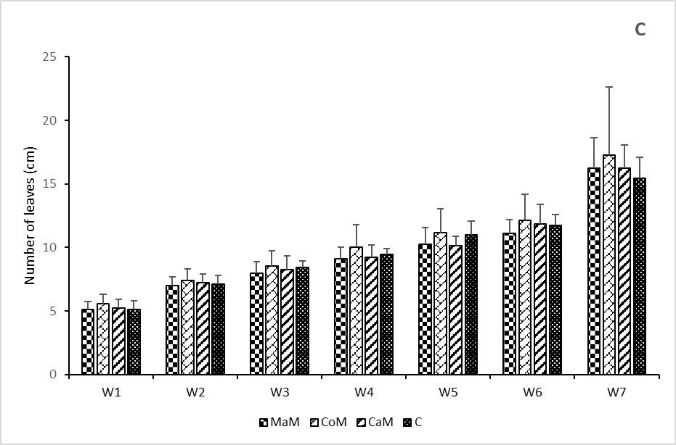
Fig. 2: Plant height, collar diameter and number of leaves over time under the different inoculation treatments.
Values are presented as means ± ecart-type. No significant differences among inoculation treatments were detected by repeated-measures ANOVA (P > 0.05). MaM: Maize mycorrhizal inoculum; CoM: Commercial mycorrhizal inoculant; CaM: Cassava mycorrhizal inoculum; C: Control with no mycorrhizal inoculum

3.3 Flower bud production and fresh biomass
No significant differences were observed among treatments in the number of flower buds produced by the plants (Figure 3A).
Plants inoculated with the commercial inoculant CoM produced 7 ± 2.50 flower buds. Plants inoculated with the indigenous inocula CaM and MaM produced 6 ± 2.34 and 7 ± 1.76 flower buds, respectively (Figure 3A), whereas non-inoculated plants produced 8 ± 1.60 flower buds (Figure 3A).
No significant differences were observed among treatments in fresh aboveground and belowground biomass (Figure 3B). The fresh aboveground biomass of plants inoculated with CoM, CaM, and MaM was 22.65 ± 6.89 g, 26.23 ± 6.77 g, and 29.57 ± 3.74 g, respectively (Figure 3B), compared with 23.02 ± 3.38 g for the non-inoculated control plants (Figure 3B). Similarly, the fresh root biomass of plants inoculated with CoM, CaM, and MaM was 5.46 ± 2.48 g, 4.95 ± 1.26 g, and 8.89 ± 1.24 g, respectively, compared with 8.86 ± 1.02 g for the non-inoculated control plants (Figure 3B).

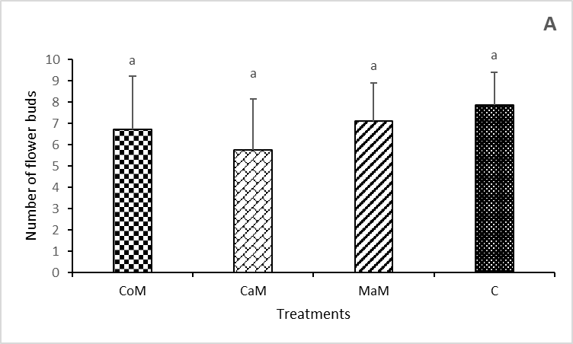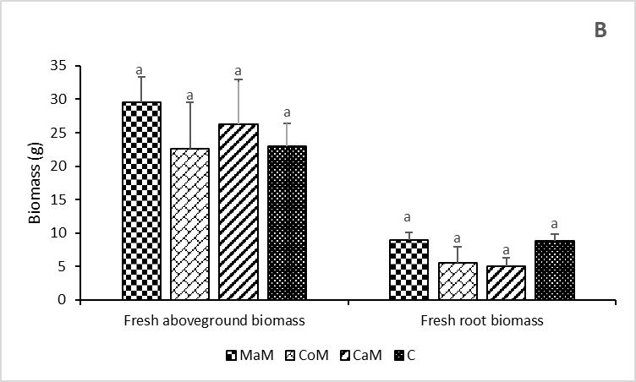
Fig. 3: Flower bud production and fresh biomass
Bar graphs following the same letter in each histogram group are not significantly different at the 5% significance level. MaM: Maize mycorrhizal inoculum; CoM: Commercial mycorrhizal inoculant; CaM: Cassava mycorrhizal inoculum; C: Control with no mycorrhizal inoculum

4. DISCUSSION
The assessment of mycorrhizal colonisation revealed that the roots of inoculated plants were successfully colonised by AMF. More than 50% of the inoculated plants exhibited mycorrhizal colonisation, whereas no colonisation was detected in the non-inoculated control. However, colonisation intensity remained low, and no significant differences were observed among the commercial and indigenous inocula. These results indicate that all three inocula were capable of establishing an association with S. aethiopicum under the experimental conditions, but that the extent of intraradical fungal development remained limited.
The difference between relatively high colonisation frequency and low colonisation intensity suggests that the establishment of the symbiosis did not necessarily translate into extensive fungal development within the root cortex. The effectiveness of AMF inoculation depends not only on the presence of viable propagules but also on the compatibility between the fungal community and the host plant and on the density and infectivity of the inoculum (Basiru & Hijri, 2022).
The duration of the experiment may also have influenced the extent of colonisation. Root colonisation by AMF is a dynamic process that develops progressively following contact between the host root and fungal propagules (Corona Ramírez et al., 2023). The 40-day assessment therefore provided a snapshot of the colonisation process rather than a measure of its maximum potential. Nevertheless, the relatively short experimental period should not be considered the only explanation for the low colonisation intensity, since the development of AMF colonisation is also strongly influenced by plant–fungus compatibility and environmental conditions. Further experiments involving earlier and later assessments of root colonisation would therefore be useful to determine whether the low intensity observed in the present study reflected delayed colonisation or intrinsically limited fungal development.
The absence of significant differences in colonisation intensity among the three inocula is also noteworthy. Although indigenous AMF are frequently considered to be better adapted to local soil and climatic conditions than non-local fungal material (Berruti et al., 2016), such adaptation does not necessarily result in greater root colonisation or plant growth under all experimental conditions. In the present study, the indigenous inocula performed similarly to the commercial inoculant with respect to both colonisation frequency and intensity. This suggests that the indigenous inocula contained AMF capable of recognising and colonising S. aethiopicum roots, but the experiment did not demonstrate a superior colonisation capacity of indigenous inocula under the conditions tested.
The lack of significant effects of AMF inoculation on plant growth should therefore be interpreted in light of the limited extent of root colonisation. No significant differences were observed among treatments for plant height, collar diameter, number of leaves, flower-bud production, or fresh aboveground and belowground biomass. A similar absence of growth stimulation has been reported in some AMF inoculation experiments, particularly when root colonisation remains limited (Plenchette et al., 2000). The establishment of mycorrhizal structures alone does not necessarily result in a measurable growth response, as the magnitude of the plant benefit depends on the functional contribution of the fungal symbiosis under the prevailing environmental conditions.
The controlled conditions of the present experiment may also have reduced the potential benefits of mycorrhization. Plants were maintained under greenhouse conditions and regularly irrigated, thereby reducing water limitation and other environmental stresses that can enhance the relative contribution of AMF to plant nutrient and water acquisition. Previous studies have shown that the benefits of AMF can become more pronounced under conditions of drought or other abiotic stresses (Chandrasekaran, 2022). The absence of a growth response in the present experiment should not be interpreted as evidence that the inocula are agronomically ineffective, but rather as an indication that their potential benefits were not expressed under the specific experimental conditions used.
Finally, the relatively small root-zone volume may have imposed an additional constraint on plant development and potentially on the expression of the mycorrhizal symbiosis. Eggplant is sensitive to root-zone volume (Djidji & Fondio, 2013), and previous work has shown that root restriction can reduce several growth parameters (Kurunç & Ünlükara, 2009). The 3-L pots used in the present study provided a considerably smaller rooting volume than the containers used in some previous experiments with African eggplant, such as the 47-cm-long and 50-cm-diameter containers reported by Bolou-Bi et al. (2023). Under such conditions, root development may have been restricted before the plants reached their full productive potential, potentially limiting both the development of the fungal symbiosis and its contribution to plant growth.

5. CONCLUSION

This study evaluated, under controlled greenhouse conditions in Daloa, Côte d’Ivoire, the ability of one commercial and two indigenous AMF inocula originating from cassava- and maize-associated rhizospheres to colonise the roots of Solanum aethiopicum and enhance plant growth. The results showed that all three inocula established mycorrhizal associations with eggplant, with colonisation frequencies exceeding 50% in inoculated plants, whereas no mycorrhizal colonisation was detected in the non-inoculated control. However, colonisation intensity remained low, and no significant differences were observed among the commercial and indigenous inocula. The absence of a measurable agronomic response may have been related, at least partly, to the low intensity of root colonisation. In fact, root colonisation occurred, but the degree of intraradical fungal development was low and was not accompanied by detectable plant-growth promotion under the experimental conditions. The relatively short experimental period, regular irrigation under greenhouse conditions, and restricted root-zone volume may also have limited the development and functional expression of the mycorrhizal symbiosis. Overall, the results indicate that the indigenous inocula evaluated in this study were capable of colonising S. aethiopicum roots at levels comparable to those achieved with the commercial inoculant. However, their agronomic potential cannot be established on the basis of root colonisation under the conditions tested. The findings therefore highlight the importance of considering both the establishment of mycorrhizal symbiosis and its functional expression in the host plant when evaluating AMF inocula.

Limitations
The experiment was conducted for 60 days under greenhouse conditions with regular irrigation and a restricted 3-L root-zone volume. Root colonisation was assessed at a single time point, 40 days after transplanting, and colonisation intensity remained low. In addition, the indigenous and commercial inocula differed substantially in counted spore dose and inoculum composition. These factors limit direct interpretation of inoculum performance and the extent to which the observed responses can be generalised to longer-term or field conditions.

Competing interests

Authors have declared that no competing interests exist.

Declaration of AI Use

This manuscript was prepared through the intellectual contributions of the author(s) to the study design, data analysis, interpretation of results, and scholarly content. Grammarly and ChatGPT were used solely to assist with grammatical refinement and reference formatting during manuscript revision. The author(s) accept full responsibility for the accuracy, integrity, and final content of the manuscript.

References

Basiru, S., & Hijri, M. (2022). The potential applications of commercial arbuscular mycorrhizal fungal inoculants and their ecological consequences. Microorganisms, 10(10), 1897. https://doi.org/10.3390/microorganisms10101897
Berruti, A., Lumini, E., Balestrini, R., & Bianciotto, V. (2016). Arbuscular mycorrhizal fungi as natural biofertilizers: Let’s benefit from past successes. Frontiers in Microbiology, 6, 1559. https://doi.org/10.3389/fmicb.2015.01559
Bolou-Bi, E. B., Chérif, M., Gnimassoun, E.-G. K., & Adjalla, L. A. (2023). Effect of vermicompost associated with mycorhizal fungi on the growth of eggplant in organic greenhouse agriculture. Tropical and Subtropical Agroecosystems, 26(1), Article 007. https://doi.org/10.56369/tsaes.4180
Chandrasekaran, M. (2022). Arbuscular mycorrhizal fungi mediated enhanced biomass, root morphological traits and nutrient uptake under drought stress: A meta-analysis. Journal of Fungi, 8(7), 660. https://doi.org/10.3390/jof8070660
Choi, S. M., & Choi, C.-I. (2024). Nutritional composition, phytochemical profiles, and pharmacological effects of Ethiopian eggplant (Solanum aethiopicum L.). Nutrients, 16(23), 4228. https://doi.org/10.3390/nu16234228
Corona Ramírez, A., Symanczik, S., Gallusser, T., & Bodenhausen, N. (2023). Quantification of arbuscular mycorrhizal fungi root colonization in wheat, tomato, and leek using absolute qPCR. Mycorrhiza, 33(5–6), 387–397. https://doi.org/10.1007/s00572-023-01122-8
Djidji, A. H., & Fondio, L. (2013). Bien cultiver l’aubergine en Côte d’Ivoire [Fiche technique]. Centre National de Recherche Agronomique. https://cnra.ci/download/bien-cultiver-laubergine-en-cote-divoire/
Gayathry, G., Natarajan, K., Jayalakshmi, T., Vinu Radha, R., Sugumaran, M. P., Sunitha, R., & Kumutha, K. (2024). Mycorrhizae: A rhizolive symbiotic fungi in organic agriculture. Archives of Current Research International, 24(9), 183–193. https://doi.org/10.9734/acri/2024/v24i9881
Gebreslassie, S., Jida, M., Puente, M. L., Covacevich, F., & Belay, Z. (2024). Inoculation of native arbuscular mycorrhizae and Bacillus subtilis can improve growth in vegetable crops. International Journal of Microbiology, 2024, 9226715. https://doi.org/10.1155/2024/9226715
Kasharu, A. K., Kizito, E. B., Masanza, M., Jjagwe, J., & Namutebi, A. (2019). Quantifying physical and economic losses of African indigenous vegetable Solanum aethiopicum along the commercial supply value chain. Journal of Economics and Sustainable Development, 10(2), 67–77. https://doi.org/10.7176/JESD/10-2-08
Kouadio, A. N. M.-S., Nandjui, J., Krou, S. M., Séry, D. J.-M., Nelson, P. N., & Zézé, A. (2017). A native arbuscular mycorrhizal fungus inoculant outcompetes an exotic commercial species under two contrasting yam field conditions. Rhizosphere, 4, 112–118. https://doi.org/10.1016/j.rhisph.2017.10.001
Kurunç, A., & Ünlükara, A. (2009). Growth, yield, and water use of okra (Abelmoschus esculentus) and eggplant (Solanum melongena) as influenced by rooting volume. New Zealand Journal of Crop and Horticultural Science, 37(3), 201–210. https://doi.org/10.1080/01140670909510265
Li, X., Wu, Y., Huang, C., Rahman, M. A., Argaman, E., & Xiao, Y. (2025). Inoculation with arbuscular mycorrhizal fungi in the field promotes plant colonization rate and yield. European Journal of Agronomy, 164, 127503. https://doi.org/10.1016/j.eja.2024.127503
Marrassini, V., Ercoli, L., Piazza, G., & Pellegrino, E. (2024). Plant genotype and inoculation with indigenous arbuscular mycorrhizal (AM) fungi modulate wheat productivity and quality of processed products through changes in the frequency of root AM fungal taxa. Field Crops Research, 315, 109456. https://doi.org/10.1016/j.fcr.2024.109456
Mvungi, H.-H. A., Wanyama, R., Dinssa, F. F., Ngoteya, G., Sigalla, J., Minja, R., Bishop, G., & Schreinemachers, P. (2025). Production of African eggplant in Tanzania: Varieties, practices, profitability, and constraints. Frontiers in Sustainable Food Systems, 9, 1461851. https://doi.org/10.3389/fsufs.2025.1461851
Nengi-Benwari, A. O., Williams, K. F., & Onwudiwe, H. A. (2025). Arbuscular mycorrhizal fungi: Diversity and colonization in leguminous and non-leguminous crops. Asian Journal of Microbiology and Biotechnology, 10(1), 26–34. https://doi.org/10.56557/ajmab/2025/v10i19167
Nie, W., He, Q., Guo, H., Zhang, W., Ma, L., Li, J., & Wen, D. (2024). Arbuscular mycorrhizal fungi: Boosting crop resilience to environmental stresses. Microorganisms, 12(12), 2448. https://doi.org/10.3390/microorganisms12122448
Phillips, J. M., & Hayman, D. S. (1970). Improved procedures for clearing roots and staining parasitic and vesicular-arbuscular mycorrhizal fungi for rapid assessment of infection. Transactions of the British Mycological Society, 55(1), 158–161, IN16–IN18. https://doi.org/10.1016/S0007-1536(70)80110-3
Plenchette, C., Bois, J.-F., Duponnois, R., & Cadet, P. (2000). La mycorhization (Glomus aggregatum) du mil (Pennisetum glaucum). Étude et Gestion des Sols, 7(4), 379–384. https://www.afes.fr/wp-content/uploads/2023/04/EGS_7_4_plenchette.pdf
Séry, D. J.-M., Kouadjo, Z. G. C., Voko, B. R. R., & Zézé, A. (2016). Selecting native arbuscular mycorrhizal fungi to promote cassava growth and increase yield under field conditions. Frontiers in Microbiology, 7, 2063. https://doi.org/10.3389/fmicb.2016.02063
Trouvelot, A., Kough, J. L., & Gianinazzi-Pearson, V. (1986). Mesure du taux de mycorhization VA d’un système radiculaire: Recherche de méthodes d’estimation ayant une signification fonctionnelle. In V. Gianinazzi-Pearson & S. Gianinazzi (Eds.), Physiological and genetical aspects of mycorrhizae: Proceedings of the 1st European Symposium on Mycorrhizae, Dijon, 1–5 July 1985 (pp. 217–221). INRA.
Vosátka, M., Látr, A., Gianinazzi, S., & Albrechtová, J. (2012). Development of arbuscular mycorrhizal biotechnology and industry: Current achievements and bottlenecks. Symbiosis, 58(1–3), 29–37. https://doi.org/10.1007/s13199-012-0208-9
Wu, Y., Chen, C., & Wang, G. (2024). Inoculation with arbuscular mycorrhizal fungi improves plant biomass and nitrogen and phosphorus nutrients: A meta-analysis. BMC Plant Biology, 24(1), 960. https://doi.org/10.1186/s12870-024-05638-9
Zhang, J., Zhao, R., Li, X., & Zhang, J. (2024). Potential of arbuscular mycorrhizal fungi for soil health: A review. Pedosphere, 34(2), 279–288. https://doi.org/10.1016/j.pedsph.2024.02.002

