Reproductive biology of Oreochromis niloticus (Linnaeus, 1758)
in the Zienkôlô dam lake (Korhogo, Côte d’Ivoire)

Abstract
The reproductive biology of Oreochromis niloticus was investigated in the Zienkôlô dam lake, northern Côte d’Ivoire, from December 2024 to November 2025. Reproductive parameters of O. niloticus were determined with the aim of ensuring rational and sustainable management of the resource. A total of 351 specimens, comprising 129 females and 222 males and ranging from 6.5 to 22.5 cm in total length, were examined. The various specimens were collected monthly using gillnets. Sex ratio, size at first sexual maturity, gonadosomatic index, hepatosomatic index, condition factor, and monthly changes in sexual maturity stages were assessed. Males were numerically dominant, with an overall male-to-female ratio of approximately 1:0.58, which differed significantly from the theoretical 1:1 ratio (χ² = 24.64; p < 0.05). The estimated size at first sexual maturity was 11.81 cm total length for females and 14 cm for males, indicating that females attained maturity at a smaller size. The condition factor varied between 1.52 ± 0.02 and 2.07 ± 0.17. Analysis of female maturity stages and monthly gonadosomatic index variation indicated reproductive activity throughout the annual sampling period. Gonadosomatic index values showed prominent peaks in May and October, suggesting periods of increased reproductive activity. Hepatosomatic index variation generally followed the reproductive cycle, while the condition factor varied across months. These findings provide baseline information on the reproductive characteristics of O. niloticus in the Zienkôlô dam lake and may contribute to future evaluation and management of the local fish population.
Keywords : Nile tilapia; Oreochromis niloticus; reproductive biology; sex ratio; sexual maturity; gonadosomatic index; hepatosomatic index

1. Introduction
The Zienkôlô dam lake is one of the 270 dam lakes built in Côte d’Ivoire since 1970. These various lakes were constructed to address the need to combat the effects of drought and to support agro-pastoral activities (Aka-Koffi, 2003; Le Guen, 2002). These artificial reservoirs now serve as potential fishing grounds, provide drinking water, and contribute to the hydrological regulation of the territories (Cecchi, 2007). Since its creation, very few studies have been conducted on this lake. Fishing takes place there, and the catch supplies the markets of the city of Korhogo. Among the species caught in this dam lake is the cichlid Oreochromis niloticus (Linnaeus, 1758). This species is of significant economic interest. However, there are almost no studies of its biology and ecology. The sustainable exploitation of fishery resources requires a sound understanding of their biology, specifically the growth and reproduction of individuals within a population. Certain reproductive parameters such as size at first sexual maturity, variation in the gonadosomatic index, and fecundity allow for a better characterisation of reproduction by indicating the spawning period and strategy (Heins et al., 2004). Size at first sexual maturity in fish plays a key role in determining minimum catch sizes and regulating fishing net mesh sizes (Chikou, 2006). Recent studies of O. niloticus have assessed sex ratio, gonadosomatic index, fecundity, size at first sexual maturity, and breeding-season patterns to characterise reproductive dynamics in different aquatic systems (Abdalla et al., 2024; Belay et al., 2025; Hu et al., 2026). Population-level assessments have also examined sex-ratio and condition-factor patterns in O. niloticus, providing baseline information relevant to fisheries management (Nkanta et al., 2025). Reproductive assessment in Nile tilapia can also incorporate maturity-stage evaluation and gonadosomatic index measurements (Setthawong et al., 2024). Despite the fishery importance of O. niloticus in the Zienkôlô dam lake, site-specific information on its reproductive parameters remains limited. It is within this context that the present study was conducted, aiming to determine certain reproductive parameters of Oreochromis niloticus in the Zienkôlô dam lake.
2. Materials and Methods
2.1 Study Area
The Zienkôlô dam lake (Figure 1) is an artificial body of water created in the 1970s in northern Côte d’Ivoire to support agricultural activities during periods of drought (Le Guen, 2002). It is located in the village of Zienkôlô, in northern Côte d’Ivoire, in the Korhogo Department (Poro Region). The lake is located approximately between 9°29′16″ N and 5°49′35″ W, in the midst of a Sudanian landscape characterised by an alternation between a long dry season and a short rainy season.
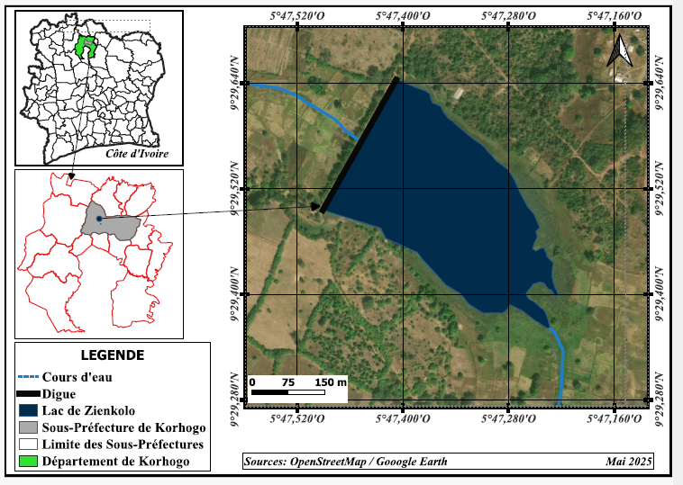
Figure 1 : Zienkôlô Dam lake (located approximately between 9°29′16″ N and 5°49′35″ W)
2.3 Sampling and measurement of reproductive parameters
Monthly sampling was conducted from December 2024 to November 2025. The various specimens obtained through artisanal fishing were caught using gillnets and cast nets. A total of 351 specimens were examined and identified using the identification key of Paugy et al. (2003). For each specimen, standard length and total length were measured to the nearest millimetre using an ichthyometer. Total weight and eviscerated weight were determined to the nearest gram, and gonad and liver weights to the nearest decigram, using an electronic balance. Sex and the macroscopic stage of sexual maturity were determined using Fontana’s (1969) identification key.
Reproductive parameters, specifically sex ratio (SR), size at first sexual maturity (L50), gonadosomatic index (GSI), hepatosomatic index (HSI), and condition factor (K), were then determined.

Sex ratio (SR)
The sex of each specimen was determined by dissecting the abdominal region (Fermon, 1996).
The sex ratio makes it possible to assess the demographic structure and reproductive biomass of a given stock. It defines the relative proportion of the sexes (male and female) within a population. The sex ratio provides information on the balance of sexes within a population (Kartas & Quignard, 1984). It is expressed as follows:
$SR=\frac{M}{F}$
SR: sex ratio; M: number of males; F: number of females;
A condition factor of less than 1 indicates that the species is in poor condition, whereas a condition factor greater than 1 shows that the species is adapting well to the physicochemical and biological conditions of its habitat (Alhassan et al., 2015).
Regarding the monthly variations in sexual maturity stages, the proportion of each maturity stage within the samples was determined each month.
- Size at first sexual maturity (L50)
The size at first sexual maturity makes it possible to estimate the fraction of the stock that is harvested before reproducing at least once and, therefore, will not contribute to stock renewal (Domain et al., 2000). It is also defined as the size at which 50% of the individuals in a population are sexually mature during the breeding season.
The L50 was determined by grouping the sampled individuals by sex and size class.
Next, the proportion of mature individuals in each size class was determined.
All individuals with gonads at stage III or higher were considered mature.
Size-proportion pairs for mature individuals were fitted to a sigmoid-type logistic curve (Amenzoui, 2010), the mathematical expression of which is as follows:
P = 1 / (1+e^{-(a+b*Lt)}) ;
L₅₀ = - $\frac{a}{b}$;
P = Proportion of mature individuals by size class
Lt = Total length
a and b = constants.
- Gonadosomatic index (GSI)
The gonadosomatic index (GSI) is the primary weight-based criterion for characterising the developmental stages of sexual maturation in fish. A relatively high GSI value reflects an advanced stage of gonadal maturation, whereas relatively low values ​​indicate a state of sexual quiescence or immaturity (Boussou, 2013). Thus, the gonadosomatic index makes it possible to determine spawning periods during a species' sexual cycle (Monteiro, 2003). Its mathematical formula is as follows:
$GSI=\frac{Pg}{Pev}x100$ ;
Pg: gonad weight in g;
Pev: eviscerated fish weight in g.
- Hepatosomatic index (HSI)
In fish, oogenesis and spermatogenesis require a significant amount of energy, which is stored primarily in the liver in the form of lipids. Variations in liver weight are influenced by the reproductive status of the fish (Konan, 2013). The HSI was calculated as follows:
$RHS=\frac{Pf}{Pev}x100$;
Pf: liver weight in g;
Pev: gutted fish weight in g.
- Condition factor (K)
The condition factor (K) reflects the fish's body condition in relation to the influence of ecological and physiological factors. It provides information on the storage of reserves required for gametogenesis (Fehri-Bedoui et al., 2002).
$$k=\frac{P}{{Lt}^{3}}x 100$$
P: weight of the fish in g
Lt: total length of the fish in cm.

The chi-square (χ²) test was used to compare the sex ratios for the different months and seasons with the theoretical sex ratio (1:1).
Sizes at first maturity were compared by sex using Statistica version 7.1 software.

3. Results
3.1 Sex ratio
222 males and 129 females were identified out of a total of 351 specimens examined. In terms of numbers, males were more numerous than females. The sex ratio (males : females) of this population was 1:0.74, i.e., 0.74 females per male (Table 1). This sex ratio was significantly different from the theoretical 1:1 sex ratio (χ² = 24.64; p < 0.05). When monthly variation was considered, the sex ratio was male-biased throughout the year, except in March (χ² = 3.66; p > 0.05). Seasonal variation in the sex ratio indicated a predominance of males across all seasons. There was a significant difference between the number of females and the number of males in both the dry season (χ² = 8.53; p < 0.05) and the rainy season (χ² = 17.55; p < 0.05).
Table 1: Monthly and seasonal variations of sex proportion and sex ratio of O. niloticus caught in Lake Zienkolo, Côte d’Ivoire.
* : significant difference.
Month | Number of Females | Number of males | Total | Sex-ratio M:F | X²
December 2024 | 14 | 23 | 37 | 1 : 0.6 | 2.19
January 2025 | 9 | 14 | 23 | 1 :0.64 | 1.08
February 2025 | 25 | 23 | 48 | 1 :1.08 | 0.08
March 2025 | 22 | 11 | 33 | 1 : 2 | 3.66
April 2025 | 6 | 31 | 37 | 1 : 0.19 | 16.89*
May 2025 | 13 | 36 | 49 | 1 :0.36 | 10.79*
June 2025 | 22 | 47 | 69 | 1 :0.46 | 9.05*
July 2025 | 2 | 11 | 13 | 1 :0.18 | 6.23*
August 2025 | 4 | 14 | 18 | 1 :0.28 | 5.55
September 2025 | 2 | 3 | 5 | 1 :0.66 | 0.2
October 2025 | 10 | 9 | 19 | 1 :1.11 | 0.05
November 2025 | 3 | 5 | 8 | 1 :0.6 | 0.5
TOTAL | 129 | 222 | 351 | 1 :0.74 | 24.64*
Dry season | 78 | 119 | 197 | 1 :0.5 | 8.53*
Rainy season | 51 | 103 | 154 | 1 :0.5 | 17.55*

3.2 Size at first sexual maturity
The size at first sexual maturity observed in O. niloticus was 11.81 cm for females (Figure 2) and 14 cm for males (Figure 3). Females reached sexual maturity at a smaller size than males. This size difference was not statistically significant (χ² = 0.16; p > 0.05). The smallest mature individuals recorded measured 11 cm for females and 13.5 cm for males.

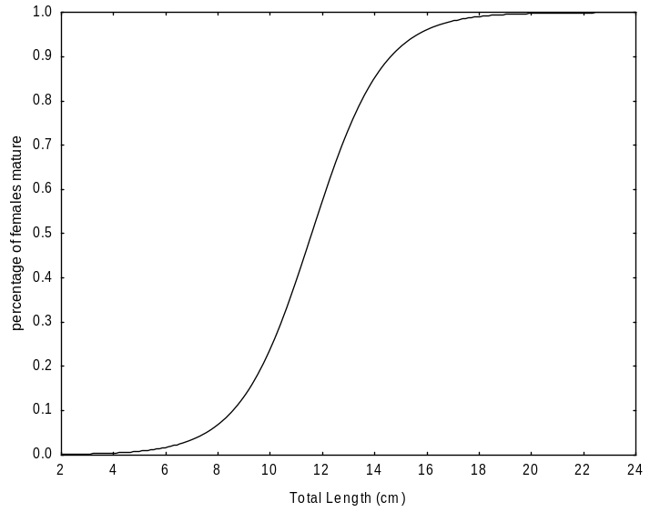

TL=11.81cm

Figure 2: Progression of sexual maturity in relation to length (Lt) in female O. niloticus from the Zienkôlô dam lake.
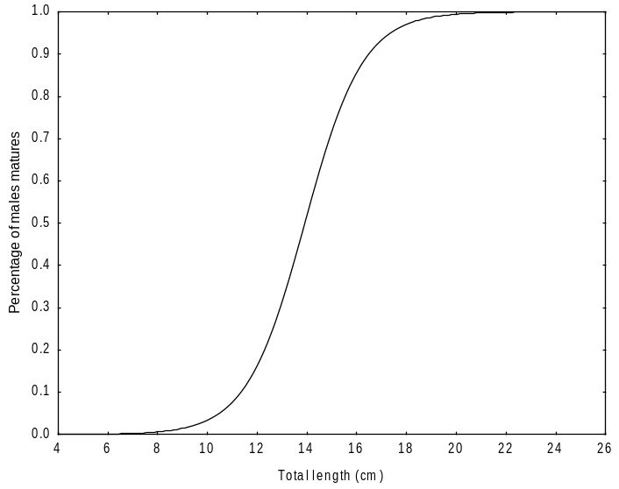

TL=14 cm

Figure 3: Progression of sexual maturity in relation to length (Lt) in male O. niloticus from the Zienkôlô reservoir.

3.3 Monthly variation in sexual maturity stages
Six stages of sexual maturity were observed in females in varying proportions throughout the year (Figure 4). Stage I females were present in the samples during December, January, February, and November. Stage II females were present in the samples in December, January, February, June, October, and November. Stage III was absent from the samples in May, July, August, November, and December. Stage IV individuals were also absent from the catches during July, September, November, and December. Stage V females appeared in the catches only from February to June and in August, whereas stage VI individuals were encountered from February to August.

Figure 4: Changes in sexual maturity stages of female O. niloticus from the Zienkôlô dam Lake.
3.3 Gonadosomatic index (GSI) and reproductive period
The variation curve of the gonadosomatic index (GSI) followed a saw-tooth pattern and exhibited two peaks (Figure 5). The highest GSI values were observed in May (3.88 ± 1.48) and October (3.36 ± 8.18).
These monthly variations revealed that Oreochromis niloticus in the Zienkôlô dam lake generally reproduces during the months of May and October, with greater intensity during the main rainy season, specifically in May. The minimum GSI values were observed in December (0.14 ± 0.08) and November (0.25 ± 0.22).

Figure 5: Monthly variations in the gonadosomatic index (GSI) of female O. niloticus from the Zienkôlô dam lake.
3.4 Hepatosomatic Index (HSI)
The monthly variation in the HSI was similar to that of the GSI. The HSI curve followed a sawtooth pattern and moved in the same direction as the GSI curve (Figure 6). The HSI reached its maximum values in May and October, with values of 1.6 ± 0.66 and 1.8 ± 0.59, respectively. The minimum HSI value was recorded in June (0.7 ± 0.17).

Figure 6: Monthly variations in the gonadosomatic index (GSI) of female O. niloticus from the Zienkôlô dam lake.
3.5 Condition factor (k)
Figure 7 illustrates the variation in the condition factor of female O. niloticus. The maximum value of the condition factor (k) was observed in December (2.07 ± 0.17), while the lowest values ​​were recorded in June (1.78 ± 0.18), July (1.52 ± 0.02), and October (1.7 ± 0.25).

Figure 7: Condition factor (K) of female O. niloticus from the Zienkôlô reservoir.
4. Discussion
The sex ratio of the entire Oreochromis niloticus population is 1:0.74. This result indicates a predominance of males over females. Seasonal variation reveals a predominance of males in both the dry and rainy seasons. This result could be explained by the fact that several factors such as differential growth, movement associated with foraging, and sex-specific mortality rates influence the sex ratio in fish (Sylla et al., 2008). The male-biased sex ratio in cichlid populations of the African Great Lakes could also be explained by faster male growth rates compared with those of females (Atsé et al., 2009). The male-biased sex ratio could also be explained by the fact that, as O. niloticus is a mouth-brooding species, the lack of food during the breeding season may force the breeding adults to remain largely sedentary in areas where capture is difficult. Some authors, such as Djadji et al. (2013) and Poulet (2004), also note that a predominance of one sex is a phenomenon frequently encountered in many teleost fish species. The result obtained in the present study is consistent with that obtained by Akonkwa et al. (2016) in Lake Kivu, Congo. These authors found a sex ratio (1.67:1) biased towards males in the same species. Kidari (2023) also observed a male predominance in O. niloticus, with 61.36% of the population being male, in the Tlemcen region of Algeria.
The size at first sexual maturity (L50) of Oreochromis niloticus in the Zienkôlô reservoir lake is 14 cm (total length) for males and 11.81 cm (total length) for females. This result indicates that females reach sexual maturity before males. Differences in size at maturity among individuals may depend on several factors, such as anthropogenic activities (overfishing), biological and/or ecological environmental factors, and energy allocation for gamete production (Koné et al., 2011). Similar results were obtained by Dhraïef et al. (2010) in the geothermal waters of southern Tunisia. The determined size at first sexual maturity (Lm50) was 11.3 cm for females and 12.3 cm for males. These authors observed that female O. niloticus reached sexual maturity at a smaller size than males. In contrast to the present study, Akonkwa et al. (2016) found that male O. niloticus reached the size at first maturity before females in Lake Kivu, Congo. The size at first sexual maturity was 13.7 cm for males and 15.8 cm for females. Atsé et al. (2009) reported that males of the Cichlidae Tylochromis jentinki reached sexual maturity earlier than females in the Ébrié Lagoon (Côte d’Ivoire). The sizes at first sexual maturity were estimated at 11.8 cm and 12.6 cm for males and females, respectively. The variability in size at first sexual maturity from one biogeographic zone to another could depend on food availability as well as the physicochemical conditions of the environment. This difference in size can also be explained by the ability of the breeding individuals to adapt to environmental factors, namely temperature, salinity, and food resources (Poulet, 2004).
Monthly analysis of the gonadosomatic index (GSI) and sexual maturity stages made it possible to examine the reproductive patterns of Oreochromis niloticus throughout the year. O. niloticus in the Zienkôlô dam lake exhibited year-round reproduction. The highest mean GSI values were observed in May and October, at 3.88 ± 1.48 and 3.36 ± 8.18, respectively. Similar patterns were reported by Atsé et al. (2009) in the Cichlidae Tylochromis jentinki in Ébrié Lagoon (Côte d’Ivoire). These authors observed that the spawning period of T. jentinki extends throughout the year, with a more pronounced peak from October to November, during which the highest proportions of females at stages 4 and 5 were recorded. A second, low-amplitude peak occurred in April.
Comparison of the monthly variation curves for the GSI and HSI showed that these two indices varied synchronously. The peak of the GSI coincided with that of the HSI. The increase in liver weight was associated with increased reproductive activity. This pattern suggests that O. niloticus is a fatty fish. It stores energy reserves in the muscles, in the perivisceral mesenteries, and under the skin. These reserves are then transferred to the liver and gonads to meet energy requirements during the reproductive period, which accounts for the low condition factor value observed during this time (Djadji et al., 2013).
5. Conclusion
The study indicates that Oreochromis niloticus in the Zienkôlô dam lake maintains reproductive activity throughout the year, with comparatively greater activity observed in May and October. The estimated size at first sexual maturity was 11.81 cm total length for females and 14 cm for males. Males were more abundant than females in the overall sample. Monthly variations in gonadosomatic index, hepatosomatic index, maturity stages, and condition factor demonstrated temporal changes associated with reproduction. These results provide baseline information on the reproductive biology of O. niloticus in this reservoir and may support future investigations of population dynamics and fishery management. Management recommendations concerning capture size or fishing-gear selectivity should, however, be based on additional gear-selectivity and population-level evidence.
Limitations
This study was limited to a single reservoir and one annual sampling period, which may restrict the generalisability of the findings to other populations or years. Specimens were obtained from artisanal catches using gillnets and cast nets, and gear selectivity may have influenced the observed size and sex composition. Monthly sample sizes also varied considerably, which may affect comparisons among months. Sexual maturity was assessed macroscopically, and environmental variables were not incorporated into the analyses. Future studies should include multi-year sampling, more standardised monthly sampling, and environmental measurements.
Declaration of AI Use
This manuscript was prepared through the intellectual contributions of the author(s) to the study design, data analysis, interpretation of results, and scholarly content. Grammarly and ChatGPT were used solely to assist with grammatical refinement and reference formatting during manuscript revision. The author(s) accept full responsibility for the accuracy, integrity, and final content of the manuscript.
Competing Interests
Authors have declared that no competing interests exist.
References
Abdalla, M. Y. M., Abd Elhalim, A. E. I., Shuaib, M. E. K., Hamid, A. M., Sati, N. A., Elhassan, M. M., & Adam, A. E.-B. (2024). A study of age, sex ratio, gonado-somatic index, fecundity, and breeding season, of Nile tilapia (Oreochromis niloticus Linnaeus, 1758) from Khashm El-Girba Reservoir and Atbara River, Eastern Sudan. Asian Journal of Research in Zoology, 7(3), 28–46. https://doi.org/10.9734/ajriz/2024/v7i3154
Aka-Koffi, N. M. (2003). Zooplancton des petits lacs de barrage du nord et du centre de la Côte d’Ivoire : Communautés, biomasses, relations trophiques et impact de la prédation par les larves de Chaoborus et des poissons [Doctoral dissertation, Université d’Abobo-Adjamé, Côte d’Ivoire].
Akonkwa, B., Ahouansou Montcho, S., Muderhwa, N., & Lalèyè, P. (2016). Quelques aspects de la reproduction des poissons du lac Kivu. Afrique Science, 12(4), 240–255.
Alhassan, E. H., Akongyuure, D. N., & Asumang, F. (2015). Determination of morphometric relationship and condition factors of four cichlids from Golinga Reservoir in Northern Region of Ghana. OnLine Journal of Biological Sciences, 15(3), 201–206. https://doi.org/10.3844/ojbsci.2015.201.206
Amenzoui, K. (2010). Variabilité des caractéristiques biologiques de la sardine, Sardina pilchardus (Walbaum, 1792), exploitée au niveau des zones de Safi, Agadir et Laâyoune (côtes atlantiques marocaines) [Doctoral dissertation, Université Mohammed V–Agdal, Faculté des Sciences, Rabat]. https://doi.org/10.83129/toubkal-14625
Atsé, B. C., Konan, K. J., & Kouassi, N. G. J. (2009). Biologie de la reproduction du Cichlidae Tylochromis jentinki dans la lagune Ébrié (Côte d’Ivoire). Cybium, 33(1), 11–19. https://doi.org/10.26028/cybium/2009-331-002
Belay, T., Dadebo, E., Tilahun, G., & Aemro, D. (2025). Reproductive biology and feeding habits of the Nile tilapia Oreochromis niloticus (Linnaeus, 1758) (Pisces, Cichlidae) in Lake Hawassa, Ethiopia. Fisheries and Aquatic Sciences, 28(6), 357–371. https://doi.org/10.47853/FAS.2025.e31
Boussou, K. C. (2013). Variations morphométriques, biologie et écologie du Cichlidae Chromidotilapia guntheri (Sauvage, 1882) dans des hydrosystèmes de l’Est et du Sud de la Côte d’Ivoire [Doctoral dissertation, Université Nangui Abrogoua, Côte d’Ivoire].
Cecchi, P. (Ed.). (2007). L’eau en partage : Les petits barrages de Côte d’Ivoire. IRD Éditions. https://doi.org/10.4000/books.irdeditions.5558
Chikou, A. (2006). Étude de la démographie et de l’exploitation halieutique de six espèces de poissons-chats (Teleostei, Siluriformes) dans le delta de l’Ouémé au Bénin [Doctoral dissertation, Université de Liège].
Dhraïef, M. N., Azaza, M. S., & Kraïem, M. M. (2010). Étude de la reproduction du tilapia du Nil Oreochromis niloticus (L.) en captivité dans les eaux géothermales du Sud tunisien. Bulletin de l’Institut National des Sciences et Technologies de la Mer de Salammbô, 37, 89–96.
Djadji, E. L. G., Atsé, B. C., Sylla, S., Konan, K. J., & Kouassi, N. G. J. (2013). Reproduction du Mugilidae Mugil cephalus Linné, 1758 dans deux complexes lagunaires (lagunes Ébrié et de Grand-Lahou) de la Côte d’Ivoire. International Journal of Biological and Chemical Sciences, 7(4), 1701–1716. https://doi.org/10.4314/ijbcs.v7i4.25
Domain, F., Chavance, P., & Bah, A. (2000). Notes sur la reproduction des espèces démersales du peuplement côtier. In F. Domain, P. Chavance, & A. Diallo (Eds.), La pêche côtière en Guinée : Ressources et exploitation (pp. 159–171). IRD Éditions/CNSHB.
Fehri-Bedoui, R., Gharbi, H., & El Abed, A. (2002). Période de reproduction et maturité sexuelle de Liza aurata (poisson, Mugilidae) des côtes Est et Sud tunisiennes. Bulletin de l’Institut National des Sciences et Technologies de la Mer de Salammbô, 29, 11–15.
Fermon, Y. (1996). Les Haplochromis spp. (Teleostei, Cichlidae) des zones rocheuses du Mwanza Gulf, lac Victoria, Tanzanie : Structure des communautés et écomorphologie [Doctoral dissertation, Muséum national d’Histoire naturelle].
Fontana, A. (1969). Étude de la maturité sexuelle des sardinelles Sardinella eba (Val.) et Sardinella aurita C. et V. de la région de Pointe-Noire. Cahiers ORSTOM, Série Océanographie, 7(2), 101–114.
Heins, D. C., Baker, J. A., & Guill, J. M. (2004). Seasonal and interannual components of intrapopulation variation in clutch size and egg size of a darter. Ecology of Freshwater Fish, 13(4), 258–265. https://doi.org/10.1111/j.1600-0633.2004.00064.x
Hu, Z., Dong, L., Li, K., Zhai, D., Chen, Y., Liu, H., Xiong, F., Duan, X., & Liu, M. (2026). Reproductive traits revealing the invasion and coexistence of two tilapia species in the Jinghong Reservoir of the Lower Lancang River, Southwest China. Animals, 16(13), 2055. https://doi.org/10.3390/ani16132055
Kartas, F., & Quignard, J.-P. (1984). La fécondité des poissons téléostéens. Masson.
Kidari, R. (2023). Relation taille-poids chez le Tilapia d’élevage Oreochromis niloticus (Linnaeus, 1758) dans la région de Tlemcen [Master’s thesis, Université Aboubekr Belkaid–Tlemcen].
Konan, K. S. (2013). Biologie et pêche des poissons capitaines : Polydactylus quadrifilis, Galeoides decadactylus et Pentanemus quinquarius de la pêcherie artisanale maritime de Grand-Lahou, Côte d’Ivoire [Doctoral dissertation, Université Nangui Abrogoua, Côte d’Ivoire].
Koné, N., Berté, S., Kraidy, A. L. B., Kouamélan, E. P., & Koné, T. (2011). Biologie de la reproduction du Clupeidae Pellonula leonensis (Boulenger, 1916) dans le lac de barrage de Kossou (Côte d’Ivoire). Journal of Applied Biosciences, 41, 2797–2807.
Le Guen, T. (2002). Les barrages du Nord de la Côte-d’Ivoire : Développement socio-économique et état sanitaire des populations [Doctoral dissertation, Université de Bretagne Occidentale].
Monteiro, A. (2003). Biologie et pêche des aiguilles Hemiramphus brasiliensis (Linnaeus, 1758) et Hyporhamphus unifasciatus (Ranzani, 1842) (Poissons–Téléostéens–Hemiramphidae) dans la région Nord-Est du Brésil [Doctoral dissertation, Université de Bretagne Occidentale].
Nkanta, G. U., Akpan, U. E., Ubong, O. N., Abiaobo, N. O., Akpan, I. I., & Ukpatu, J. E. (2025). Aspects of fish biology: Sexual dimorphism of mouth brooder (Nile tilapia) Oreochromis niloticus Cichlidae at the Qua Iboe River Estuary Ibeno Local Government Area of Akwa Ibom State, Nigeria. Asian Journal of Current Research, 10(4), 353–361. https://doi.org/10.56557/ajocr/2025/v10i49991
Paugy, D., Lévêque, C., & Teugels, G. G. (Eds.). (2003). Poissons d’eaux douces et saumâtres de l’Afrique de l’Ouest / The fresh and brackish water fishes of West Africa (Vols. 1–2). IRD Éditions, Muséum national d’Histoire naturelle, & Musée royal de l’Afrique centrale.
Poulet, N. (2004). Le sandre (Sander lucioperca [L.]) : Biologie, comportement et dynamique des populations en Camargue (Bouches-du-Rhône, France) [Doctoral dissertation, Université Paul Sabatier–Toulouse III].
Setthawong, P., Khemthong, M., Lertwanakarn, T., & Surachetpong, W. (2024). Ultrasonography for non-invasive sex identification and reproductive assessment in Nile tilapia (Oreochromis niloticus). Frontiers in Veterinary Science, 11, 1467158. https://doi.org/10.3389/fvets.2024.1467158
Sylla, S., Atsé, B. C., & Kouassi, N. G. J. (2008). Régime alimentaire de Trachinotus teraia (Carangidae) dans la lagune Ébrié (Côte d’Ivoire). Cybium, 32(1), 81–87. https://doi.org/10.26028/cybium/2008-321-008

