Reproductive biology of Oreochromis niloticus (Linnaeus, 1758)
in the Zienkôlô dam lake (Korhogo, Côte d’Ivoire)

Abstract
The reproductive biology of Oreochromis niloticus was investigated in the Zienkôlô dam lake, northern Côte d’Ivoire, from December 2024 to November 2025. A total of 351 specimens, comprising 129 females and 222 males and ranging from 6.5 to 22.5 cm in total length, were examined. Sex ratio, size at first sexual maturity, gonadosomatic index (GSI), hepatosomatic index (HSI), condition factor (K), and monthly changes in female sexual maturity stages were assessed. Males were more numerous than females, with an overall male-to-female ratio of approximately 1:0.58, and the sex distribution differed significantly from the theoretical 1:1 ratio (χ² = 24.64; p < 0.05). The estimated size at first sexual maturity was 11.81 cm total length for females and 14 cm for males, indicating that females attained maturity at a smaller size. Six stages of female sexual maturity were observed during the annual sampling period. Monthly variation in maturity stages and GSI indicated reproductive activity throughout the year. Mean GSI values showed pronounced peaks in May (3.88 ± 1.48) and October (3.36 ± 8.18), while the lowest values occurred in December and November. HSI varied broadly in parallel with GSI, whereas the condition factor varied among months. These findings provide baseline information on the reproductive characteristics of O. niloticus in the Zienkôlô dam lake for subsequent population assessment and fisheries management.
Keywords : Cichlidae, Oreochromis niloticus, reproduction, Zienkôlô Dam Lake
1. Introduction
The Zienkôlô dam lake is one of the 270 dam lakes built in Côte d’Ivoire since 1970. These various lakes were constructed to address the need to combat the effects of drought and to support agro-pastoral activities (Le Guen, 2002; Aka-Koffi, 2003). These artificial reservoirs now serve as potential fishing grounds, provide drinking water, and contribute to the hydrological regulation of the territories (Cecchi, 2007). Since its creation, very few studies have been conducted on this lake. Fishing takes place there, and the catch supplies the markets of the city of Korhogo. Among the species caught in this dam lake is the cichlid Oreochromis niloticus (Linnaeus, 1758). This species is of significant economic interest. However, almost no studies have examined its biology and ecology. The sustainable exploitation of fishery resources requires a sound understanding of their biology, specifically the growth and reproduction of individuals within a population. Certain reproductive parameters, such as size at first sexual maturity, variation in the gonadosomatic index, and fecundity, allow reproduction to be better characterised by indicating the spawning period and strategy (Abdalla et al., 2024). Size at first sexual maturity in fish plays a key role in determining minimum catch sizes and regulating fishing-net mesh sizes (Chikou, 2006). Recent studies on Nile tilapia in African inland waters have similarly used sex ratio, gonadosomatic index, fecundity, and breeding season to describe reproductive patterns relevant to fisheries management (Abdalla et al., 2024; Wagaw et al., 2024). Likewise, size at first maturity and condition-related metrics have been used to assess O. niloticus populations across contrasting lake environments (Mutie et al., 2024; Nkanta et al., 2025). Recent lake-based studies have also reported population-specific reproductive patterns for O. niloticus, supporting the value of site-specific reproductive information (Handago et al., 2024). Within this context, the present study aimed to determine certain reproductive parameters of Oreochromis niloticus in the Zienkôlô dam lake.
2. Materials and Methods
2.1 Study Area
The Zienkôlô dam lake (Figure 1) is an artificial body of water created in the 1970s in northern Côte d’Ivoire to support agricultural activities during periods of drought (Le Guen, 2002). It is located in the village of Zienkôlô, in northern Côte d’Ivoire, in the Korhogo Department (Poro Region). The lake is located approximately at 9°29′16″ N and 5°49′35″ W, within a Sudanian landscape characterised by an alternation between a long dry season and a short rainy season.
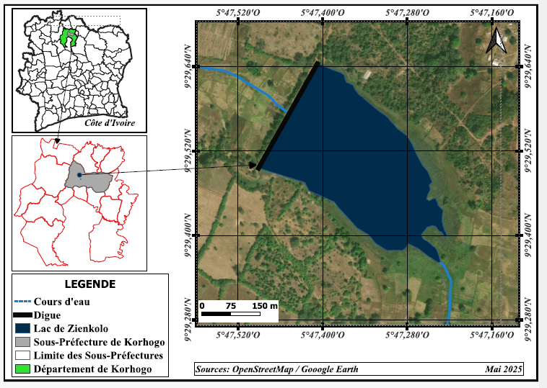
Figure 1 : Overview of the study area

2.3 Sampling and measurement of reproductive parameters
Monthly sampling was conducted from December 2024 to November 2025. The specimens obtained through artisanal fishing were caught using gillnets and cast nets. A total of 351 specimens were examined and identified using the identification key of Lévêque et al. (1992). For each specimen, the following were recorded: standard length and total length to the nearest millimetre; total weight and gutted weight to the nearest gram; gonad and liver weights to the nearest decigram; and sex and macroscopic sexual maturity stage, based on Fontana (1969). Reproductive parameters, specifically sex ratio (SR), size at first sexual maturity (L50), gonadosomatic index (GSI), hepatosomatic index (HSI), and condition factor (K), were then determined. The chi-squared (χ²) test was used to compare the sex ratios for the different months and seasons with the theoretical sex ratio (1:1).
Sizes at first maturity were compared between sexes using Statistica version 7.1 software.
- Sex ratio (SR)
The sex ratio makes it possible to assess the demographic structure and reproductive biomass of a given stock. It defines the relative proportion of the sexes (male and female) within a population. The sex ratio provides information on the balance of sexes within a population (Kartas & Quignard, 1984). It is expressed as follows:
$SR=\frac{M}{F}$
SR: sex ratio; M: number of males; F: number of females;
- Size at first sexual maturity (L50)
The size at first sexual maturity makes it possible to estimate the fraction of the stock that is harvested before reproducing at least once and that, therefore, will not contribute to stock renewal (Domain et al., 2000). It is also defined as the size at which 50% of individuals in a population are sexually mature during the breeding season.
The L50 was determined by grouping the sampled individuals by sex and size class.
Next, the proportion of mature individuals in each size class was determined.
All individuals with gonads at stage III or higher were considered mature.
Size-proportion pairs for mature individuals were fitted to a sigmoid-type logistic curve (Amenzoui, 2010), the mathematical expression of which is as follows:
P = 1 / (1+e^{-(a+b*Lt)}) ;
L₅₀ = - $\frac{a}{b}$;
P = Proportion of mature individuals by size class
Lt = Total length
a and b = constants.
- Gonadosomatic index (GSI)
The gonadosomatic index (GSI) is the primary weight-based criterion for characterising the developmental stages of sexual maturation in fish. A relatively high GSI value reflects an advanced stage of gonadal maturation, whereas relatively low values indicate a state of sexual quiescence or immaturity (Boussou, 2013). Thus, the gonadosomatic index can be used to determine spawning periods during a species' sexual cycle (Boussou, 2013). Its mathematical formula is as follows:
$GSI=\frac{Pg}{Pev}x100$ ;
Pg: gonad weight in g;
Pev: eviscerated fish weight in g.
- Hepatosomatic index (HSI)
In fish, oogenesis and spermatogenesis require a significant amount of energy, which fish store primarily in the liver in the form of lipids. Variations in liver weight are influenced by the reproductive status of the fish (Konan, 2013). The HSI is calculated as follows:
$RHS=\frac{Pf}{Pev}x100$;
Pf: liver weight in g;
Pev: gutted fish weight in g.
- Condition factor (K)
The condition factor (K) reflects the fish's body condition in relation to the influence of ecological and physiological factors. It provides information on the storage of reserves required for gametogenesis (Fehri-Bedoui et al., 2002).
$$k=\frac{P}{{Lt}^{3}}x 100$$
P: weight of the fish in g
Lt: total length of the fish in cm.
3. Results and Discussion
3.1 Sex ratio
Of the 351 specimens examined, 222 males and 129 females were identified. Males were more numerous than females. The sex ratio (males:females) of this population was 1:0.74, i.e., 0.74 females per male (Table 1). This sex ratio was significantly different from the theoretical 1:1 sex ratio (χ² = 24.64; p < 0.05). With regard to monthly variation, the sex ratio was male-biased throughout the year, except in March (χ² = 3.66; p > 0.05). Seasonal variation in the sex ratio indicated a predominance of males in both seasons. There was a significant difference between the numbers of females and males in both the dry season (χ² = 8.53; p < 0.05) and the rainy season (χ² = 17.55; p < 0.05).
Table 1: Monthly and seasonal variations of sex proportion and sex ratio of O. niloticus caught in Lake Zienkolo, Côte d’Ivoire.
* : significant difference.
Month | Number of Females | Number of males | Total | Sex-ratio M:F | X²
December 2024 | 14 | 23 | 37 | 1 : 0.6 | 2.19
January 2025 | 9 | 14 | 23 | 1 :0.64 | 1.08
February 2025 | 25 | 23 | 48 | 1 :1.08 | 0.08
March 2025 | 22 | 11 | 33 | 1 : 2 | 3.66
April 2025 | 6 | 31 | 37 | 1 : 0.19 | 16.89*
May 2025 | 13 | 36 | 49 | 1 :0.36 | 10.79*
June 2025 | 22 | 47 | 69 | 1 :0.46 | 9.05*
July 2025 | 2 | 11 | 13 | 1 :0.18 | 6.23*
August 2025 | 4 | 14 | 18 | 1 :0.28 | 5.55
September 2025 | 2 | 3 | 5 | 1 :0.66 | 0.2
October 2025 | 10 | 9 | 19 | 1 :1.11 | 0.05
November 2025 | 3 | 5 | 8 | 1 :0.6 | 0.5
TOTAL | 129 | 222 | 351 | 1 :0.74 | 24.64*
Dry season | 78 | 119 | 197 | 1 :0.5 | 8.53*
Rainy season | 51 | 103 | 154 | 1 :0.5 | 17.55*
The sex ratio of the entire Oreochromis niloticus population was 1:0.74. This result indicated a predominance of males over females. Seasonal variation revealed a predominance of males in both the dry and rainy seasons. This result could be explained by the fact that several factors, such as differential growth, movement associated with foraging, and sex-specific mortality rates, influence the sex ratio in fish (Sylla et al., 2008). The male-biased sex ratio in Cichlid populations of the African Great Lakes could also be explained by their faster growth rate compared with females (Atsé et al., 2009). The male-biased sex ratio could also be explained by the fact that, as O. niloticus is a mouth-brooding species, the lack of food during the breeding season may force breeding adults to remain largely sedentary in areas where capture is difficult. Djadji et al. (2013) and Poulet (2004) also noted that the predominance of one sex is a phenomenon frequently encountered in many teleost fish species. The result obtained in the present study is consistent with that obtained by Akonkwa et al. (2016) in Lake Kivu, Congo. These authors found a sex ratio (1.67:1) biased towards males in the same species. Kidari (2023) also observed a male predominance in O. niloticus, with 61.36% of the population being male, in the Tlemcen region of Algeria.
3.2 Size at first sexual maturity and monthly variation in sexual maturity stages
The size at first sexual maturity observed in O. niloticus was 11.81 cm for females (Figure 2) and 14 cm for males (Figure 3). Females reached sexual maturity at a smaller size than males.
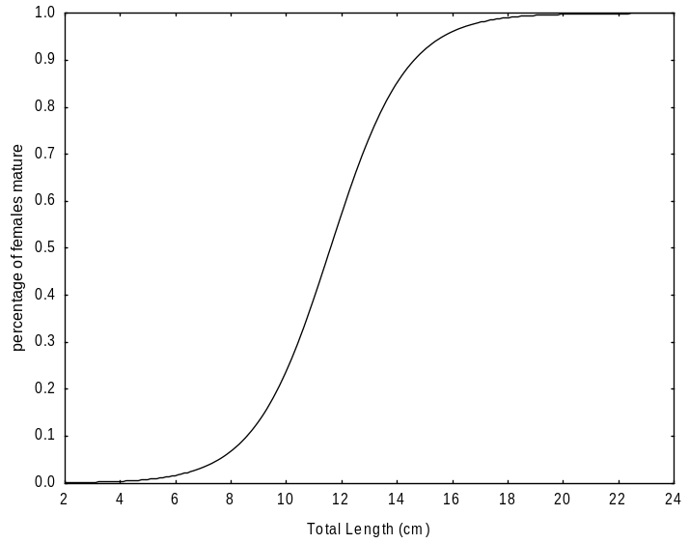

This size difference was not statistically significant (χ² = 0.16; p > 0.05). The smallest mature individuals recorded measured 11 cm for females and 13.5 cm for males.

LT=11.81cm

Figure 2: Progression of sexual maturity in relation to length (Lt) in female O. niloticus from the Zienkôlô dam lake.
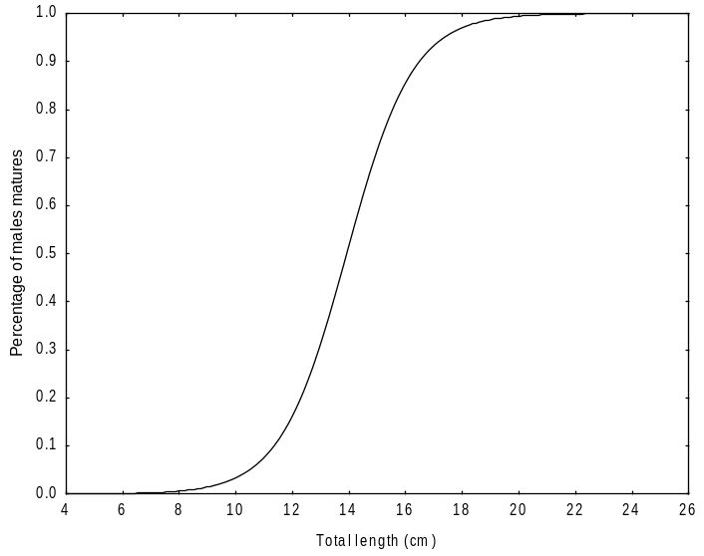

LT=14 cm

Figure 3: Progression of sexual maturity in relation to length (Lt) in male O. niloticus from the Zienkôlô reservoir.

Six stages of sexual maturity were observed in females in varying proportions throughout the year (Figure 4). Stage I females were present in the samples during December, January, February, and November. Stage II females were present in the samples in December, January, February, June, October, and November. Stage III was absent from the samples in May, July, August, November, and December. Stage IV individuals were also absent from the catches during July, September, November, and December. Stage V females appeared in the catches only from February to June and in August, whereas Stage VI individuals were encountered from February to August.

Figure 4: Changes in sexual maturity stages of female O. niloticus from the Zienkôlô dam Lake.
The size at first sexual maturity (L50) of Oreochromis niloticus in the Zienkôlô reservoir lake was 14 cm (total length) for males and 11.81 cm (total length) for females. This result indicated that females reached sexual maturity before males. Differences in size at maturity among individuals may depend on several factors, such as anthropogenic activities (overfishing), biological and/or ecological environmental factors, and energy allocation for gamete production (Koné et al., 2011). Similar results were obtained by Dhraïef et al. (2010) in the geothermal waters of southern Tunisia. The determined size at first sexual maturity (Lm50) was 11.3 cm for females and 12.5 cm for males. These authors observed that female O. niloticus reached sexual maturity at a smaller size than males. In contrast, Akonkwa et al. (2016) found that male O. niloticus reached the size at first maturity before females in Lake Kivu, Congo. The size at first sexual maturity was 13.7 cm for males and 15.8 cm for females. Atsé et al. (2009) reported that males of the Cichlidae Tylochromis jentinki reached sexual maturity earlier than females in the Ébrié Lagoon (Côte d’Ivoire). The sizes at first sexual maturity were estimated at 11.8 cm and 12.6 cm for males and females, respectively. The variability in size at first sexual maturity from one biogeographic zone to another could depend on food availability as well as the physicochemical conditions of the environment. This difference in size can also be explained by the ability of breeding individuals to adapt to environmental factors, namely temperature, salinity, and food resources (Poulet, 2004).
3.3 Gonadosomatic index (GSI) and reproductive period
The variation curve of the gonadosomatic index (GSI) followed a sawtooth pattern and exhibited two peaks (Figure 5). The highest GSI values were observed in May (3.88 ± 1.48) and October (3.36 ± 8.18).
These monthly variations indicated that Oreochromis niloticus in the Zienkôlô dam lake generally reproduced during May and October, with greater intensity during the main rainy season, specifically in May. The minimum GSI values were observed in December (0.14 ± 0.08) and November (0.25 ± 0.22).

Figure 5: Monthly variations in the gonadosomatic index (GSI) of female O. niloticus from the Zienkôlô dam lake.
Monthly analysis of the gonadosomatic index (GSI) and sexual maturity stages made it possible to examine the reproductive patterns of Oreochromis niloticus throughout the year. O. niloticus in the Zienkôlô dam lake exhibited year-round reproduction. The highest mean GSI values were observed in May and October, with respective values of 3.88 ± 1.48 and 3.36 ± 8.18. Similar results were observed by Atsé et al. (2009) in the Cichlidae Tylochromis jentinki in Ébrié Lagoon (Côte d’Ivoire). These authors observed that the spawning period of T. jentinki extended throughout the year, with a more pronounced peak from October to November, the period during which the highest proportions of females at Stages IV and V were recorded. A second peak of lower amplitude occurred in April.
3.4 Hepatosomatic index (HSI) and condition factor (K)
The monthly variation in the HSI was similar to that of the GSI. The HSI curve followed a sawtooth pattern and varied in the same direction as the GSI curve (Figure 6). The HSI reached its maximum values in May and October, at 1.6 ± 0.66 and 1.8 ± 0.59, respectively. The minimum HSI value was recorded in June (0.7 ± 0.17).

Figure 6: Monthly variations in the gonadosomatic index (GSI) of female O. niloticus from the Zienkôlô dam lake.

Figure 7 illustrates the variation in the condition factor of female O. niloticus. The maximum value of the condition factor (K) was observed in December (2.07 ± 0.17), while the lowest values were recorded in June (1.78 ± 0.18), July (1.52 ± 0.02), and October (1.7 ± 0.25).

Figure 7: Condition factor (K) of female O. niloticus from the Zienkôlô reservoir.
Comparison of the monthly variation curves for the GSI and HSI showed that these two indices varied synchronously. The peak of the GSI coincided with that of the HSI. The increase in liver weight was linked to the increase in reproductive activity. This result indicates that O. niloticus is a fatty fish. It stores energy reserves in the muscles, perivisceral mesenteries, and under the skin. These reserves are then transferred to the liver and gonads to meet energy requirements during the reproductive period, which accounts for the low condition factor observed during this period (Djadji et al., 2013).
4. Conclusion
This study characterised key reproductive features of Oreochromis niloticus in the Zienkôlô dam lake over an annual sampling cycle. The sampled population contained more males than females, and the overall sex distribution differed significantly from the theoretical 1:1 ratio. Females attained the estimated size at first sexual maturity at 11.81 cm total length, whereas males attained maturity at 14 cm. Monthly changes in female maturity stages and the gonadosomatic index indicated reproductive activity throughout the year, with comparatively greater activity in May and October. The hepatosomatic index showed a broadly similar temporal pattern, while the condition factor varied among months. Together, these observations provide baseline information on the temporal reproductive pattern and maturity characteristics of Nile tilapia in this reservoir. The findings may support subsequent assessments of population dynamics and local fishery management. However, recommendations concerning minimum capture size or fishing-gear selectivity should be based on additional population-level and gear-selectivity evidence rather than on the present reproductive observations alone.
Limitations
Sampling covered a single annual cycle, and specimens were obtained through artisanal fishing using gillnets and cast nets. Accordingly, the findings describe the reproductive characteristics of the sampled population and period rather than long-term interannual variability. The study focused on sex ratio, size at first maturity, GSI, HSI, maturity stages, and condition factor; therefore, additional population-level and gear-selectivity evidence would be required before specific management thresholds are established.

Declaration of AI Use

This manuscript was prepared through the intellectual contributions of the author(s) to the study design, data analysis, interpretation of results, and scholarly content. Grammarly and ChatGPT were used solely to assist with grammatical refinement and reference formatting during manuscript revision. The author(s) accept full responsibility for the accuracy, integrity, and final content of the manuscript.

Competing Interests
Authors have declared that no competing interests exist.
References
Abdalla, M. Y. M., Abd Elhalim, A. E. I., Shuaib, M. E. K., Hamid, A. M., Sati, N. A., Elhassan, M. M., & Adam, A. E.-B. (2024). A study of age, sex ratio, gonadosomatic index, fecundity, and breeding season of Nile tilapia (Oreochromis niloticus Linnaeus, 1758) from Khashm El-Girba Reservoir and Atbara River, Eastern Sudan. Asian Journal of Research in Zoology, 7(3), 28–46. https://doi.org/10.9734/ajriz/2024/v7i3154
Aka-Koffi, N. M. (2003). Zooplancton des petits lacs de barrage du nord et du centre de la Côte d’Ivoire: Communautés, biomasses, relations trophiques et impact de la prédation par les larves de chaoborus et des poissons [Zooplankton of small reservoir lakes in northern and central Côte d’Ivoire: Communities, biomass, trophic relationships, and the impact of predation by Chaoborus larvae and fish] [Doctoral dissertation, Université d’Abobo-Adjamé].
Akonkwa, B., Ahouansou Montcho, S., Muderhwa, N., & Lalèyè, P. (2016). Quelques aspects de la reproduction des poissons du lac Kivu [Some aspects of fish reproduction in Lake Kivu]. Afrique Science, 12(4), 240–255.
Amenzoui, K. (2010). Variabilité des caractéristiques biologiques de la sardine, Sardina pilchardus (Walbaum, 1792) exploitée au niveau des zones de Safi, Agadir et Laâyoune (côtes atlantiques marocaines) [Variability of the biological characteristics of the sardine, Sardina pilchardus (Walbaum, 1792), exploited in the Safi, Agadir, and Laâyoune zones (Moroccan Atlantic coast)] [Doctoral dissertation, Université Mohammed V–Agdal]. https://doi.org/10.83129/toubkal-14625
Atsé, B. C., Konan, K. J., & Kouassi, N. J. (2009). Biologie de la reproduction du Cichlidae Tylochromis jentinki dans la lagune Ébrié (Côte d’Ivoire). Cybium, 33(1), 11–19. https://doi.org/10.26028/cybium/2009-331-002
Boussou, K. C. (2013). Variations morphométriques, biologie et écologie du Cichlidae Chromidotilapia guntheri (Sauvage, 1882) dans des hydrosystèmes de l’Est et du Sud de la Côte d’Ivoire [Doctoral dissertation, Université Nangui Abrogoua].
Cecchi, P. (Ed.). (2007). L’eau en partage: Les petits barrages de Côte d’Ivoire. IRD Éditions. https://doi.org/10.4000/books.irdeditions.5558
Chikou, A. (2006). Étude de la démographie et de l’exploitation halieutique de six espèces de poissons-chats (Teleostei, Siluriformes) dans le delta de l’Ouémé au Bénin [Doctoral dissertation, Université de Liège]. https://orbi.uliege.be/handle/2268/315042
Dhraïef, M. N., Azaza, M. S., & Kraïem, M. M. (2010). Étude de la reproduction du tilapia du Nil Oreochromis niloticus (L.) en captivité dans les eaux géothermales du sud tunisien. Bulletin de l’Institut National des Sciences et Technologies de la Mer, 37, 89–96.
Djadji, E. L. G., Atsé, B. C., Sylla, S., Konan, J. K., & Kouassi, J. N. (2013). Reproduction du Mugilidae Mugil cephalus Linné, 1758 dans deux complexes lagunaires (lagunes Ébrié et de Grand-Lahou) de la Côte d’Ivoire. International Journal of Biological and Chemical Sciences, 7(4), 1701–1716. https://doi.org/10.4314/ijbcs.v7i4.25
Domain, F., Chavance, P., & Bah, A. (2000). Notes sur la reproduction des espèces démersales du peuplement côtier guinéen [Notes on the reproduction of demersal species in the Guinean coastal fish assemblage]. In F. Domain, P. Chavance, & A. Diallo (Eds.), La pêche côtière en Guinée: Ressources et exploitation (pp. 159–171). CNSHB; IRD.
Fehri-Bedoui, R., Gharbi, H., & El Abed, A. (2002). Période de reproduction et maturité sexuelle de Liza aurata (poisson, Mugilidae) des côtes Est et Sud tunisiennes [Reproductive period and sexual maturity of Liza aurata (Mugilidae) off the east and south coasts of Tunisia]. Bulletin de l’Institut National des Sciences et Technologies de la Mer, 29, 11–15.
Fontana, A. (1969). Étude de la maturité sexuelle des sardinelles Sardinella eba et Sardinella aurita de la région de Pointe-Noire [Study of the sexual maturity of the sardinellas Sardinella eba and Sardinella aurita in the Pointe-Noire region]. Cahiers ORSTOM, Série Océanographique, 7(2), 101–114.
Handago, T., Dadebo, E., & Tilahun, G. (2024). Reproductive biology and feeding habits of Nile tilapia Oreochromis niloticus (Linnaeus, 1758) (Pisces: Cichlidae) in Lake Boyo, Ethiopia. Ethiopian Journal of Science and Technology, 17(1), 81–97. https://doi.org/10.4314/ejst.v17i1.5
Kartas, F., & Quignard, J. P. (1984). La fécondité des poissons téléostéens [Fecundity of teleost fish]. Masson.
Kidari, R. (2023). Relation taille-poids chez le Tilapia d’élevage Oreochromis niloticus (Linnaeus, 1758) dans la région de Tlemcen [Length-weight relationship of farmed tilapia Oreochromis niloticus (Linnaeus, 1758) in the Tlemcen region] [Master’s thesis, Université Aboubekr Belkaid–Tlemcen].
Konan, K. S. (2013). Biologie et pêche des poissons capitaines Polydactylus quadrifilis, Galeoides decadactylus et Pentanemus quinquarius de la pêcherie artisanale maritime de Grand-Lahou, Côte d’Ivoire [Biology and fishery of threadfins Polydactylus quadrifilis, Galeoides decadactylus, and Pentanemus quinquarius in the artisanal marine fishery of Grand-Lahou, Côte d’Ivoire] [Doctoral dissertation, Université Nangui Abrogoua].
Koné, N., Berté, S., Kraidy, A. L. B., Kouamélan, E. P., & Koné, T. (2011). Biologie de la reproduction du Clupeidae Pellonula leonensis (Boulenger, 1916) dans le lac de barrage de Kossou (Côte d’Ivoire) [Reproductive biology of the clupeid Pellonula leonensis (Boulenger, 1916) in the Kossou reservoir (Côte d’Ivoire)]. Journal of Applied Biosciences, 41, 2797–2807.
Le Guen, T. (2002). Les barrages du Nord de la Côte-d’Ivoire: Développement socio-économique et état sanitaire des populations [Dams in northern Côte d’Ivoire: Socio-economic development and the health status of the population] [Doctoral dissertation, Université de Bretagne Occidentale].
Lévêque, C., Paugy, D., & Teugels, G. G. (Eds.). (1992). Faune des poissons d’eaux douces et saumâtres de l’Afrique de l’Ouest (Vols. 1–2). ORSTOM; Musée Royal de l’Afrique Centrale.
Mutie, A., Morara, G. N., Waithaka, E., Obegi, B., & Loki, P. (2024). Length–weight relationship, condition factor and maturity characteristics of an invasive Oreochromis niloticus (Cichlidae) in an alkaline-saline Lake Nakuru, Kenya. Lakes & Reservoirs: Research & Management, 29, e12462. https://doi.org/10.1111/lre.12462
Nkanta, G. U., Akpan, U. E., Ubong, O. N., Abiaobo, N. O., Akpan, I. I., & Ukpatu, J. E. (2025). Aspects of fish biology: Sexual dimorphism of mouth brooder (Nile tilapia) Oreochromis niloticus Cichlidae at the Qua Iboe River Estuary, Ibeno Local Government Area of Akwa Ibom State, Nigeria. Asian Journal of Current Research, 10(4), 353–361. https://doi.org/10.56557/ajocr/2025/v10i49991
Poulet, N. (2004). Le sandre (Sander lucioperca L.): Biologie, comportement et dynamique des populations en Camargue (Bouches-du-Rhône, France) [Biology, behaviour, and population dynamics in the Camargue (Bouches-du-Rhône, France)] [Doctoral dissertation, Université Toulouse III–Paul Sabatier].
Sylla, S., Atsé, B. C., & Kouassi, N. J. (2008). Régime alimentaire de Trachinotus teraia (Carangidae) dans la lagune Ébrié (Côte d’Ivoire) [Diet of Trachinotus teraia (Carangidae) in the Ébrié Lagoon (Côte d’Ivoire)]. Cybium, 32(1), 81–87. https://doi.org/10.26028/cybium/2008-321-008
Wagaw, S., Sisay, A., Bazezew, A., Enawgaw, Y., & Wosnie, A. (2024). Biological aspects of Oreochromis niloticus (Linnaeus, 1758) in Geray Reservoir (Ethiopia) for effective sustainable fisheries. Fisheries and Aquatic Sciences, 27(2), 100–110. https://doi.org/10.47853/FAS.2024.e11

