Original Research Article

Formulation and Evaluation of Mucoadhesive Buccal Patch of Clomipramine Hydrochloride for Enhanced Buccal Drug Delivery

ABSTRACT
Background: Mucoadhesive buccal patches are being investigated as alternatives to conventional oral dosage forms for drugs affected by hepatic first-pass metabolism.
Objective: This study aimed to formulate and evaluate clomipramine hydrochloride buccal patches using hydroxypropyl methylcellulose (HPMC E15) and Carbopol 940.
Methods: Six formulations (F1–F6) containing 15 mg of clomipramine hydrochloride were prepared by solvent casting with varying polymer proportions and glycerin as a plasticiser. The patches were characterised for physical appearance, weight uniformity, thickness, folding endurance, surface pH, drug content, flatness, swelling, moisture uptake and loss, and in vitro drug release in phosphate buffer (pH 6.8). Release kinetics, surface morphology, and short-term stability were also assessed.
Results: The optimised formulation, F3, contained 750 mg of HPMC E15 and 250 mg of Carbopol 940. It showed a surface pH of 6.52, folding endurance exceeding 300 folds, drug content of 98.26%, and a swelling index of 537.13%. Cumulative drug release reached 82.52% after 6 hours. Among the kinetic models examined, the Higuchi model provided the best fit (R² = 0.9894). Following 30 days of room-temperature storage, no visible changes in appearance were reported, and drug content was 97.52%.
Conclusion: F3 demonstrated favourable formulation characteristics and sustained in vitro release over the study period. Further permeation and in vivo studies are required to establish buccal absorption and therapeutic performance.
Keywords: Clomipramine HCl; buccal patch; mucoadhesion; HPMC E15; Carbopol 940; sustained release; Higuchi model.
1. INTRODUCTION
Buccal drug delivery offers a convenient alternative to oral administration and may reduce gastrointestinal degradation and hepatic first-pass metabolism. The buccal mucosa is well vascularised, allowing drug absorption into the systemic circulation. Mucoadhesive polymers help retain a formulation at the absorption site, supporting sustained release and potentially improved bioavailability. Recent reviews identify polymer selection, film design, and the relationship between drug release and mucosal permeation as important considerations in the development of buccal films (Joshi et al., 2026; Nair et al., 2023).
Among buccal dosage forms, patches are flexible, provide a measured dose, and may offer longer residence times than gels, which can be washed away by saliva. They commonly contain a drug-loaded mucoadhesive layer and may include a backing layer to control drug release. Previous research on solvent-cast buccal films has assessed physical properties alongside in vitro drug release to characterise formulation performance (Mahapatra et al., 2020). Systematic formulation research has also identified polymer and plasticiser properties, casting volume, and drying conditions as important variables in buccal-film development (Hassan et al., 2023).
Clomipramine hydrochloride is a tricyclic antidepressant used to treat obsessive-compulsive disorder, panic disorder, major depressive disorder, and chronic pain. It is also used to treat premature ejaculation. These applications make mucoadhesive buccal patches a potentially useful approach to local or systemic drug delivery. A recent critical review further emphasises that mucoadhesion measurements require cautious interpretation and that formulation-level observations alone do not demonstrate improved clinical absorption (Semwal et al., 2026). Within the scope of the present investigation, a formulation-level comparison of HPMC E15–Carbopol 940 ratios was needed to relate patch characteristics to in vitro drug-release behaviour.
Accordingly, this study aimed to prepare clomipramine hydrochloride mucoadhesive buccal patches by solvent casting with different proportions of HPMC E15 and Carbopol 940 and to evaluate their physicochemical properties, in vitro drug release, release kinetics, and short-term stability.
2. MATERIALS AND METHODS
2.1 Procurement of Drug and Excipient
Clomipramine HCl was provided by Shubham Pharmachem Pvt. Ltd., Mumbai; HPMC E15 and Carbopol 940 were obtained from Jain Industrial Chemicals, Chennai; Tween 80 was obtained from Ocean Chemicals Pvt. Ltd.; and ethanol, glycerin, sucrose, and vanillin were obtained from chemical laboratories.
2.2 Characterization of Drug
2.2.1 Organoleptic Properties
The colour, odour, appearance, and taste of the drug were recorded using descriptive terminology.
2.2.2 Solubility Study
The solubility characteristics of a drug in an aqueous system are important because a degree of water solubility is required to elicit a therapeutic response. The solubility of the drug was recorded using descriptive terminology.
2.2.3 Determination of Melting point
A small amount of the drug was placed in a capillary tube sealed at one end. The capillary tube was placed in the melting-point apparatus, and the temperature at which the drug melted was recorded.
2.2.4 Drug-Excipient Compatibility Study
The drug and excipients selected for the formulation were evaluated for physical and chemical compatibility.
2.2.4.1 Chemical Compatibility Study
FTIR spectrophotometric analysis was performed to investigate compatibility between the drug and the excipients. The Bruker attenuated total reflection alpha technique was used for the analysis. Spectra of the pure drug, the physical mixture of the optimised blank, and CLOMOPT were recorded at 25.0 ± 0.5 °C by placing the samples on a zinc solenoid crystal plate over the wavenumber range of 4000 to 400 cm -1 and comparing them with the reference Pharmacopoeia.
2.2.5 Determination of λ max
A quantity of 10 mg of clomipramine HCl was weighed and transferred to a 10 mL volumetric flask. The drug was dissolved, and the volume was made up to 10 mL with phosphate buffer (pH 6.8) to obtain a 1000 µg/mL stock solution (stock solution I). A 1 mL aliquot of this stock solution was diluted to 10 mL with phosphate buffer (pH 6.8) to obtain a 100 µg/mL solution (stock solution II). From stock solution II, 1 mL was pipetted into a 10 mL volumetric flask, and the volume was made up to 10 mL using phosphate buffer (pH 6.8) to obtain a concentration of 10 µg/mL. This solution was scanned at 254 nm using a UV–visible spectrophotometer to determine the absorption maximum (λ max).

2.2.6 Standard Curve for Clomipramine HCl
2.2.6.1 Preparation of Phosphate buffer pH 6.8
Phosphate buffer (pH 6.8) was prepared by dissolving 28.80 g of disodium hydrogen phosphate and 11.45 g of potassium dihydrogen phosphate in sufficient water. The solution was mixed thoroughly, and the final volume was made up to 1000 mL with distilled water.
2.2.6.2 Preparation of Stock solution
A quantity of 10 mg of clomipramine HCl was weighed and transferred to a 100 mL volumetric flask. The drug was dissolved in phosphate buffer (pH 6.8), and the volume was made up to 100 mL with the same buffer to obtain a stock solution of 100 µg/mL. Aliquots of 5, 10, 15, 20, and 25 mL of the stock solution were transferred to separate 100 mL volumetric flasks. Each was made up to volume with phosphate buffer (pH 6.8). The absorbance of these solutions was measured at 254 nm against a blank.
2.3 Formulation of Mucoadhesive Buccal Patch of Clomipramine HCl
Mucoadhesive buccal patches containing clomipramine HCl were prepared by the solvent-casting method.
2.3.1 Preparation Process
Patches were prepared by the solvent-casting method using different proportions of HPMC E15 and Carbopol 940. Glycerol was used as a plasticiser. Carbopol 940 (250 mg) was dispersed in water while stirring at 300 rpm for 10 minutes and was allowed to hydrate for 2 hours. HPMC E15 (750 mg) was dissolved in a 2:1 water–ethanol mixture while stirring at 400 rpm for 20 minutes and was then set aside for 30 minutes. The hydrated Carbopol was incorporated into the HPMC solution and stirred at 400 rpm for 20 minutes, followed by a 30-minute resting period. Clomipramine hydrochloride (15 mg) was dissolved in 1 mL of water and added to the polymer blend while stirring at 300 rpm for 15 minutes. Glycerin (0.20 g) and Tween 80 (0.15 g) were added separately with stirring. Sucrose (0.05 g) and vanillin (0.05 g) were dissolved in 2 mL of water and incorporated into the mixture. The final solution was allowed to rest for 60 minutes to remove air bubbles. The solution was poured into Petri dishes and dried at room temperature for 3 days. The dried films were cut into 2 × 2 cm patches and stored in airtight zip-lock covers.

Table 1: Formulation of Mucoadhesive Buccal Patch of Clomipramine HCl
Formulation | F1 | F2 | F3 | F4 | F5 | F6
Clomipramine HCl (mg) | 15 | 15 | 15 | 15 | 15 | 15
HPMC E15 (mg) | 1000 | 500 | 750 | 850 | 670 | 950
Carbopol 940 (mg) | - | 500 | 250 | 150 | 330 | 50
Glycerin (g) | 0.20 | 0.20 | 0.20 | 0.20 | 0.20 | 0.20
Ethanol (ml) | 5 | 5 | 5 | 5 | 5 | 5
Tween 80 (g) | 0.15 | 0.15 | 0.15 | 0.15 | 0.15 | 0.15
Distilled water (ml) | q. s | q. s | q. s | q. s | q. s | q. s
Sucrose (g) | 0.05 | 0.05 | 0.05 | 0.05 | 0.05 | 0.05
Vanillin (g) | 0.05 | 0.05 | 0.05 | 0.05 | 0.05 | 0.05

2.4 Characterization of Mucoadhesive Buccal Patch of Clomipramine HCl
2.4.1 Physical Appearance
All formulated clomipramine HCl patches were examined for surface texture, colour, flexibility, and smoothness.
2.4.2 Weight Uniformity
Individual patches measuring 2 × 2 cm2 were cut and weighed using a balance, and the average weight variation was calculated.
2.4.3 Thickness
Patch thickness was measured using a screw gauge with a least count of 0.002 mm.
2.4.4 Folding Endurance
Folding endurance was determined by repeatedly folding a patch at the same point until it broke or had been folded 300 times, the latter being considered satisfactory for good film properties.
2.4.5 Surface pH
For this test, each patch was kept in contact with 5 mL of distilled water for 60 minutes at room temperature.
The pH was then measured using a pH meter. The procedure was performed in triplicate, and the mean value was calculated.
2.4.6 Drug Content Uniformity
Drug-content uniformity was determined by dissolving a patch (2 × 2 cm) through homogenisation in 50 mL of isotonic phosphate buffer (pH 6.8) for 2 hours, with occasional shaking.
A 4 mL aliquot was withdrawn and diluted to 10 mL with phosphate buffer (pH 6.8). The resulting solution was filtered through Whatman filter paper, and the drug content was determined using a UV spectrophotometer at 254 nm.
2.4.7 Swelling Index
A 2 × 2 cm2 patch was weighed on a pre-weighed microscope slide. Phosphate buffer (50 mL, pH 6.8) was added to a Petri dish containing the patch on the microscope slide. At regular intervals over 60 minutes, the slide was removed and weighed. The difference in weight indicated the increase due to buffer absorption, and patch swelling was calculated using the following equation:
Swelling Index = (W2-W1/ W1) x 100%
Here, W1 is the weight of the buccal patch before immersion in phosphate buffer (pH 6.8), and W2 is its weight after immersion and blotting with filter paper.
2.4.8 Flatness
To determine patch flatness, one strip was cut from the centre and two strips from each side of the patch. The length of each strip was measured, and any variation in length was recorded. These data were used to determine percentage constriction, and the results were expressed as percentage flatness. A constriction of 0% indicates 100% flatness. It was calculated using the following formula:
% constriction = L1- L2/ L1 × 100
Here, L1 is the initial strip length (cm), and L2 is the final strip length (cm).
2.4.9 Moisture Absorption Studies
Patches were selected from each batch and weighed accurately (W1 mg). These patches were kept in dessicator at room temperature for 24 hours. Then patches were taken out and exposed to 84% relative humidity using a saturate solution of Potassium chloride in another dessicator. Exposure was continued until a constant weight (W2 mg) was obtained. The percent moisture uptake was calculated using following formula: % Moisture uptake = (W2- W1)/ W2 × 100
2.4.10 Moisture Loss Studies
For this test, one patch from each batch was selected and weighed accurately (W1 mg). The patches were kept in a desiccator containing calcium chloride at room temperature for 24 hours. After this period, they were weighed again until a constant weight (W2 mg) was obtained. Percentage moisture content was calculated using the following formula:
% Moisture content = (W1- W2)/ W1 × 100
2.4.11 In- Vitro Drug Release
Drug release from the buccal patches was studied using USP dissolution apparatus type II, maintained at 37 ± 0.5 °C and stirred at 50 rpm. Each 2 × 2 cm² patch was fixed to a coverslip with cyanoacrylate adhesive. The mucoadhesive layer was kept in contact with the dissolution medium, while the backing layer was fixed to the slip. The coverslip was immersed in 500 mL of phosphate buffer (pH 6.8) to prevent floating and allow the patch to settle. Aliquots of 5 mL were withdrawn at 15, 30, 60, 120, 180, 240, 300, and 360 minutes. Equal volumes of fresh buffer at the same temperature were added to maintain sink conditions. Drug concentration was analysed using UV–visible spectrophotometry at λ max (254 nm).
2.4.12 Release Kinetic Study
To analyse drug-release behaviour, the dissolution profiles of all batches were fitted to zero-order, first-order, Higuchi, Hixson–Crowell, and Korsmeyer–Peppas kinetic models.
2.4.13 Scanning Electron Microscopy (SEM)
Patch morphology was analysed using SEM. The selected sample was mounted on brass stubs with double-sided adhesive and sputter-coated with gold–palladium for 30 seconds under argon. The coated stub was then placed in the SEM chamber for examination.
2.4.14 Stability Studies
Stability testing was performed in accordance with ICH guidelines to evaluate the stability of the drug and formulation under environmental conditions. Buccal patches were wrapped in aluminium foil and stored at room temperature for one month. After storage, they were examined for appearance, thickness, and drug content.
3. RESULTS AND DISCUSSION
3.1 Characterization of Drug
3.1.1 Organoleptic Properties
Clomipramine HCl was observed to be a white, odourless, crystalline powder.
Organoleptic observation provides a preliminary indication of identity and quality but is not sufficiently specific to establish drug identity. Accordingly, this observation is best interpreted alongside instrumental characterisation and validated analytical procedures reported for clomipramine (Ali et al., 2016; Ghumman et al., 2023; Rahman & Afaq, 2010).
3.1.2 Determination of Melting Point
The observed melting point of clomipramine HCl was 192 ºC, which agreed with the standard range of 192–196 ºC.

A measured melting point close to 192 °C supports the characterisation of the sample as crystalline clomipramine hydrochloride; nevertheless, thermal behaviour can vary with solid-state form and experimental conditions. Agreement with the reported melting point should therefore complement spectroscopic and thermal characterisation rather than serve as an independent identity test (Ghumman et al., 2023; Patel & Karvekar, 2019; Rahman & Afaq, 2010).
3.1.3 Solubility Studies
Clomipramine HCl was freely soluble in distilled water, ethanol, methanol, chloroform, and 0.1N HCl and was soluble in acetone.
The broad solubility observed in aqueous and organic media is consistent with the amphiphilic solution behaviour of clomipramine hydrochloride. Because ionisation, pH, and medium composition can alter apparent solubility and molecular association, these qualitative findings should be interpreted as medium-specific rather than as intrinsic solubility constants (Ali et al., 2016; Naqvi et al., 2010; Rahman & Afaq, 2010).
3.1.4 Drug-Excipient Compatibility Study
3.1.4.1 Chemical Compatibility Study
A)
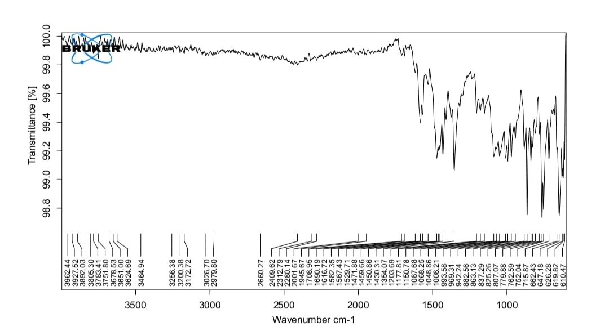
B)
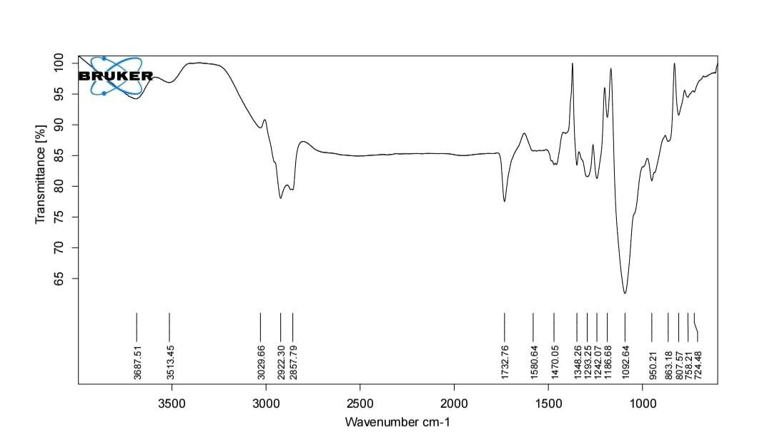
Fig. 1: A) FT-IR Spectrum of Clomipramine HCl and B) Clomipramine HCl, Tween 80, HPMC E15, Carbopol 940

Table 2: FT-IR spectral interpretation of Clomipramine HCl and Clomipramine HCl,
S. No. | Wave Number (cm⁻¹) | Types of Vibrations
1. | 1580.64 - 1582.86 | C=C Stretching
2. | 950.21 - 1087.68 | C-Cl Stretching
3. | 1203.69 - 2922.30 | C-N Stretching
4. | 2857.79 - 2979.80 | C-H Stretching
5. | 1092.64 - 2660.27 | N-H Stretching
Tween 80, HPMC E15, Carbopol 940

Retention of the principal drug-related FTIR bands in the multicomponent spectrum, without conspicuous new bands or major shifts, supports the absence of a detectable strong chemical interaction under the tested conditions. Similar applications of FTIR as a compatibility-screening method have been reported in clomipramine and buccal-film formulations, although complementary thermal or solid-state methods may be useful when subtle interactions are suspected (Ghumman et al., 2023; Nair et al., 2021; Salehi & Boddohi, 2017).
3.1.5 Determination of λmax for Clomipramine HCl by using Uv Spectroscopy
A)
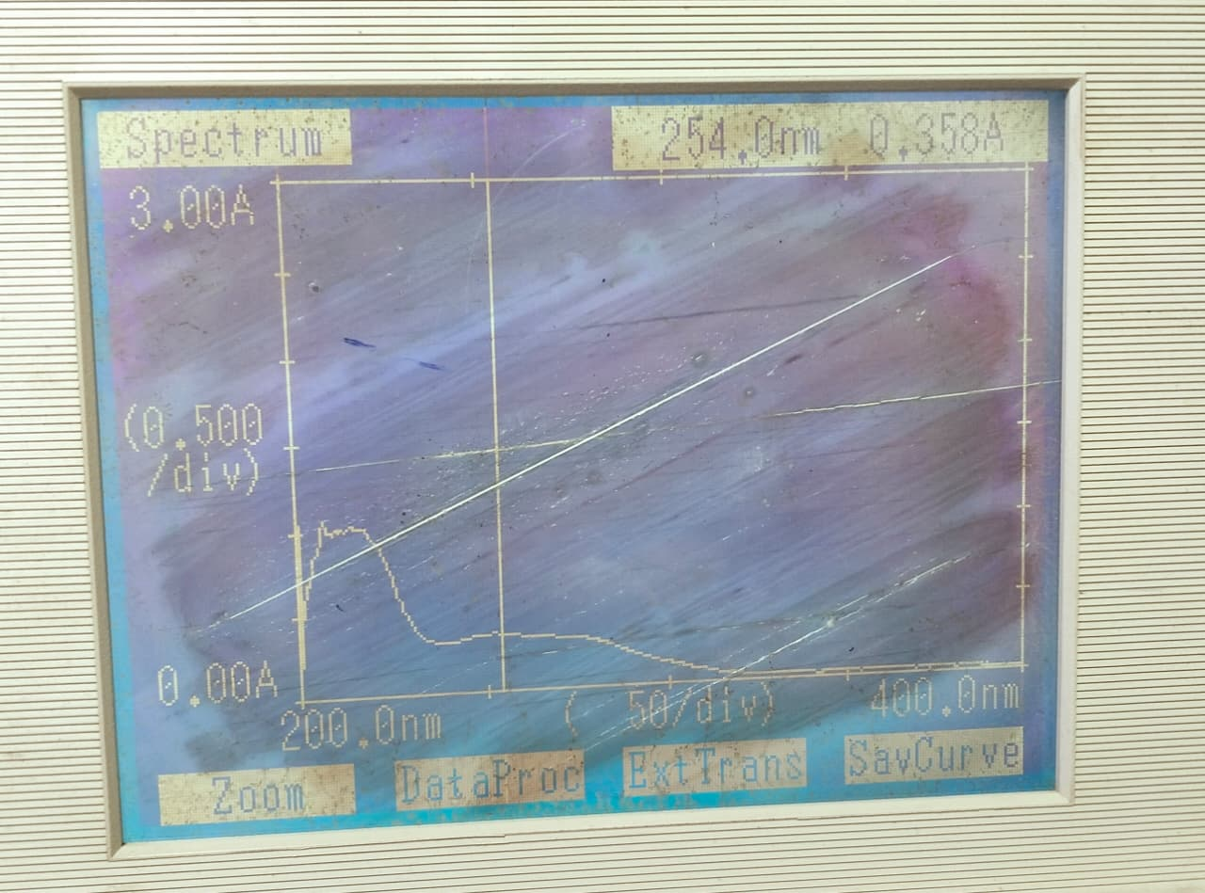
B)
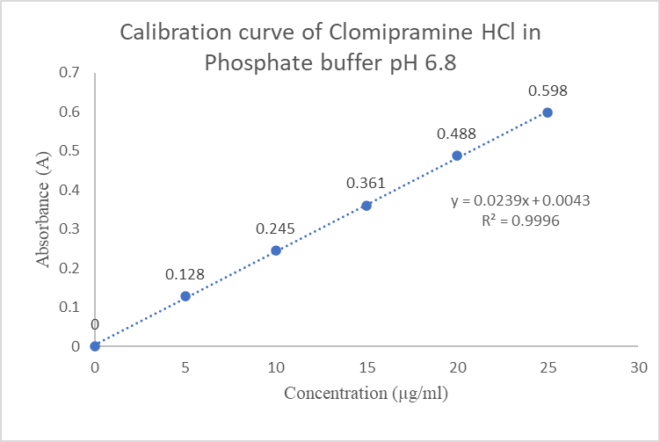
Fig. 2: A) UV Spectrum and B) Calibration curve of Clomipramine HCl using Phosphate Buffer pH 6.8

The use of 254 nm for clomipramine quantification has precedent in ultraviolet-detection methods, although the optimal analytical wavelength depends on the solvent, matrix, and assay configuration. The recorded spectrum therefore provides method-specific justification for using 254 nm in the present phosphate-buffer assay (Aymard et al., 1997; Palego et al., 2000; Tanaka et al., 1997).
3.1.6 Standard Calibration Curve of Clomipramine HCl using Phosphate Buffer pH 6.8
The absorbance of drug solutions with concentrations ranging from 5 to 25 µg/mL was measured at 254 nm against a blank.
Table 3: Data for Calibration curve of Clomipramine HCl using Phosphate Buffer pH 6.8
S. No | Concentration (µg/ml) | Absorbance (A)
1. | 0 | 0
2. | 5 | 0.128
3. | 10 | 0.245
4. | 15 | 0.361
5. | 20 | 0.488
6. | 25 | 0.598

Inference
The solutions showed linearity (R² = 0.9996) over the concentration range of 5–25 µg/mL and obeyed the Beer–Lambert law.
The high coefficient of determination (R² = 0.9996) indicates a strong linear concentration–response relationship over the tested range of 5–25 µg/mL. Such linearity is important for quantitative drug-content and release measurements, although complete analytical validation also requires consideration of accuracy, precision, selectivity, and sensitivity (Ali et al., 2016; Michael et al., 2023; Rahman & Afaq, 2010).
3.2 Characterization of Mucoadhesive Buccal Patch of Clomipramine HCl
3.2.1 Physical Appearance
These parameters were assessed by visual inspection and by touching the patches.
A smooth, flexible appearance is desirable for buccal patches because visible defects may reflect non-uniform casting or an unsuitable polymer–plasticiser balance and may affect handling during application. Comparable visual and tactile criteria are routinely used in the evaluation of solvent-cast mucoadhesive patches (Adhikari et al., 2010; Hassan et al., 2023; Salehi & Boddohi, 2017).
3.2.2 Weight Uniformity
Three individual patches from each batch were weighed using a digital balance, and the average weight was calculated.
Limited variation in patch weight is important because mass uniformity indirectly reflects the reproducibility of casting and may influence dose uniformity when the drug is dispersed throughout the polymeric matrix. Weight uniformity is therefore commonly evaluated alongside thickness and drug-content uniformity in buccal-patch development (Adhikari et al., 2010; Ikram et al., 2015; Ramachandran et al., 2018).
3.2.3 Thickness
Patch thickness was measured using a vernier calliper with a least count of 0.002 mm. The thickness ranged from 0.14 to 0.20 mm, as shown in Table 4.
The observed thickness range is consistent with the thin-film characteristics expected of buccal dosage forms and should be considered alongside mechanical flexibility and drug loading. Polymer quantity and composition can alter film thickness and consequently influence hydration and release behaviour; the relatively narrow range therefore supports reasonable manufacturing consistency among the batches (Habib et al., 2010; Hassan et al., 2023; Morales & McConville, 2011).
3.2.4 Folding Endurance
Folding endurance was measured manually for a patch from each batch. No cracks were observed, even after the patch had been folded at the same point more than 300 times.
Folding endurance exceeding 300 folds indicates that the patches tolerated repeated mechanical deformation without visible cracking, which is favourable for handling and use in the dynamic oral environment. Similar testing is widely used as a practical indicator of film flexibility and integrity in mucoadhesive buccal systems (Asif et al., 2015; Habib et al., 2010; Vasantha et al., 2011).
3.2.5 Surface pH
The surface pH of each buccal patch was determined to evaluate its suitability for drug permeation and mucoadhesion.
The pH values of all formulations were within the salivary pH range.

Surface pH values close to the physiological salivary range are desirable because marked acidity or alkalinity may increase the risk of local irritation and may influence polymer hydration and mucoadhesion. The observed values therefore support further buccal evaluation of the formulations, although direct mucosal-tolerance studies would be required for confirmation (Adhikari et al., 2010; Habib et al., 2010; Salehi & Boddohi, 2017).
3.2.6 Drug Content Uniformity
UV–visible spectrophotometry was used to determine drug-content uniformity in the mucoadhesive buccal patches. Drug content ranged from 89% to 98% among the formulations, as shown in Table 4.
Table 4: Physical Parameters of Mucoadhesive Buccal Patch
Formulation Code | Weight Uniformiy (g) | Thickness (mm) | Folding Endurance | Surface pH | % Drug Content
F1 | 0.0396 | 0.16 | >300 | 6.75 | 89.14
F2 | 0.0403 | 0.18 | >300 | 6.28 | 92.10
F3 | 0.0513 | 0.18 | >300 | 6.52 | 98.26
F4 | 0.05 | 0.14 | >300 | 6.67 | 96.54
F5 | 0.0553 | 0.2 | >300 | 6.56 | 95.06
F6 | 0.0486 | 0.16 | >300 | 6.43 | 93.83

The range of drug-content values indicates formulation-dependent differences in recovery, with F3 showing the highest measured content. High and reproducible drug-content uniformity is important in matrix-type buccal films because variability may directly affect dose uniformity and complicate comparisons of release profiles (Ikram et al., 2015; Ramachandran et al., 2018; Salehi & Boddohi, 2017).
3.2.7 Flatness
Flatness is an important characteristic of mucoadhesive buccal patches because the patch should have a smooth, uniform surface and retain its dimensions without appreciable constriction over time. Flatness was assessed to determine whether the prepared patches met these requirements. All formulations showed identical strip lengths before and after cutting, indicating 100% flatness and 0% constriction.
Complete flatness without measurable constriction indicates good dimensional stability following film formation. Dimensional stability is relevant because curling or contraction may reduce the effective mucosal contact area and complicate reproducible application, whereas controlled film structure and mechanical integrity support consistent buccal performance (Morales & McConville, 2011; Nair et al., 2021; Salehi & Boddohi, 2017).
3.2.8 Swelling Index
The swelling index of each patch was determined from the increase in weight after a predetermined period. F3 exhibited a swelling index of 537.13%, attributed to the balanced HPMC E15–Carbopol 940 ratio.
The substantial swelling observed across the formulations indicates hydration of the hydrophilic polymer matrices. Hydration is required to mobilise polymer chains and expose functional groups involved in mucoadhesion; however, excessive swelling may weaken matrix integrity. The intermediate swelling observed for F3 may therefore represent a balance between hydration and structural retention rather than simply the maximum swelling response (Andrews et al., 2009; Muzib & Kumari, 2011; Smart, 2005).
3.2.9 Moisture Absorption Studies
Moisture absorption increased patch weight, with formulations containing more Carbopol 940 showing greater uptake because of its hygroscopic nature.
Patches containing more HPMC E15 showed less weight gain and maintained better structural stability.
The higher moisture uptake observed in Carbopol-rich films is consistent with the strong hydrophilicity of carbomer-containing matrices, whereas lower uptake may favour dimensional and mechanical stability during storage. Nevertheless, moisture sorption requires control because excessive uptake may soften films and alter drug release, while very low moisture content may promote brittleness (Adhikari et al., 2010; Ikram et al., 2015; Vasantha et al., 2011).
3.2.10 Moisture Loss Studies
The moisture-loss study showed a decrease in patch weight, with formulations containing more HPMC E15 losing more weight because of their lower hygroscopicity. Carbopol 940-based patches retained more moisture and consequently showed comparatively less weight loss.
Table 5: Characterization of Mucoadhesive Buccal Patch
Formulation Code | Swelling Index (%) | % Moisture Uptake | % Moisture Loss
F1 | 464.89 | 9.17 | 9.95
F2 | 627.75 | 11.62 | 10.84
F3 | 537. 13 | 11.39 | 10.48
F4 | 544.07 | 11.34 | 10.31
F5 | 579.99 | 11.52 | 10.66
F6 | 458.36 | 9.15 | 10.20

The moisture-loss values indicate that all formulations retained a measurable fraction of bound or absorbed water under desiccating conditions. This balance is important because residual moisture may contribute to flexibility, whereas excessive drying may increase brittleness and excessive retained moisture may compromise physical stability (Adhikari et al., 2010; Ikram et al., 2015; Vasantha et al., 2011).
3.2.11 In-Vitro Drug Release
Table 6: Cumulative % drug release
Time (Hrs) | Cumulative % Drug Release
Time (Hrs) | F1 | F2 | F3 | F4 | F5 | F6
0 | 0 | 0 | 0 | 0 | 0 | 0
0.25 | 19.9 | 20.32 | 21.43 | 21.01 | 20.46 | 20.73
0.50 | 26.03 | 25.34 | 27.15 | 25.76 | 25.89 | 26.17
1 | 28.96 | 28.27 | 29.38 | 29.24 | 28.41 | 29.80
2 | 32.59 | 34.82 | 45.14 | 38.86 | 37.47 | 38.17
3 | 44.03 | 44.72 | 54.48 | 45.42 | 44.72 | 44.30
4 | 52.25 | 52.67 | 63.97 | 55.04 | 54.63 | 53.65
5 | 62.85 | 63.55 | 72.06 | 63.13 | 62.44 | 62.16
6 | 79.87 | 80.29 | 82.52 | 81.96 | 81.68 | 81.40

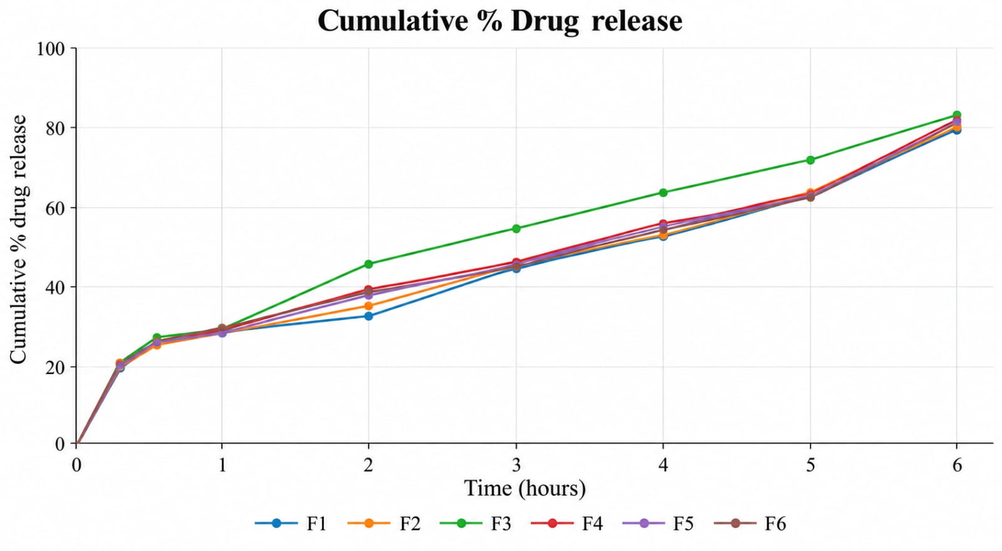
Fig. 3: Comparative in-vitro drug release of formulations F1-F6

All formulations showed progressive drug release over 6 hours, with F3 reaching the highest cumulative value (82.52%) at the final sampling point. Separation of the profiles after approximately 2 hours suggests that polymer composition increasingly influenced diffusion and matrix relaxation as hydration progressed. This pattern is consistent with HPMC-based buccal matrices, in which polymer viscosity and swelling regulate sustained release (Lodhi et al., 2013; Muzib & Kumari, 2011; Semalty et al., 2008).
3.2.12 Release Kinetic of F3
Table 7: Release kinetics of F3
Time (Hrs) | Cum. % drug release | Cum. % drug remaining | Log Cum. % drug remaining | √Time | Log  Time | Log Cum. % drug release | Cube root log Cum. % drug remaining
0 | 0 | 100 | 2 | 0 | - | - | 4.642
0.25 | 21.43 | 78.57 | 1.895 | 0.l5 | -0.602 | 1.331 | 4.289
0.50 | 27.15 | 72.85 | 1.862 | 0.707 | -0.301 | 1.434 | 4.191
1 | 29.38 | 70.62 | 1.849 | 1 | 0 | 1.468 | 4.123
2 | 45.47 | 54.53 | 1.737 | 1.414 | 0.301 | 1.658 | 3.8
3 | 54.48 | 45.52 | 1.658 | 1.732 | 0.477 | 1.736 | 3.583
4 | 63.97 | 36.03 | 1.557 | 2 | 0.602 | 1.806 | 3.301
5 | 72.06 | 27.94 | 1.446 | 2.236 | 0.699 | 1.858 | 3.03
6 | 82.52 | 17.48 | 1.242 | 2.449 | 0.788 | 1.917 | 2.596

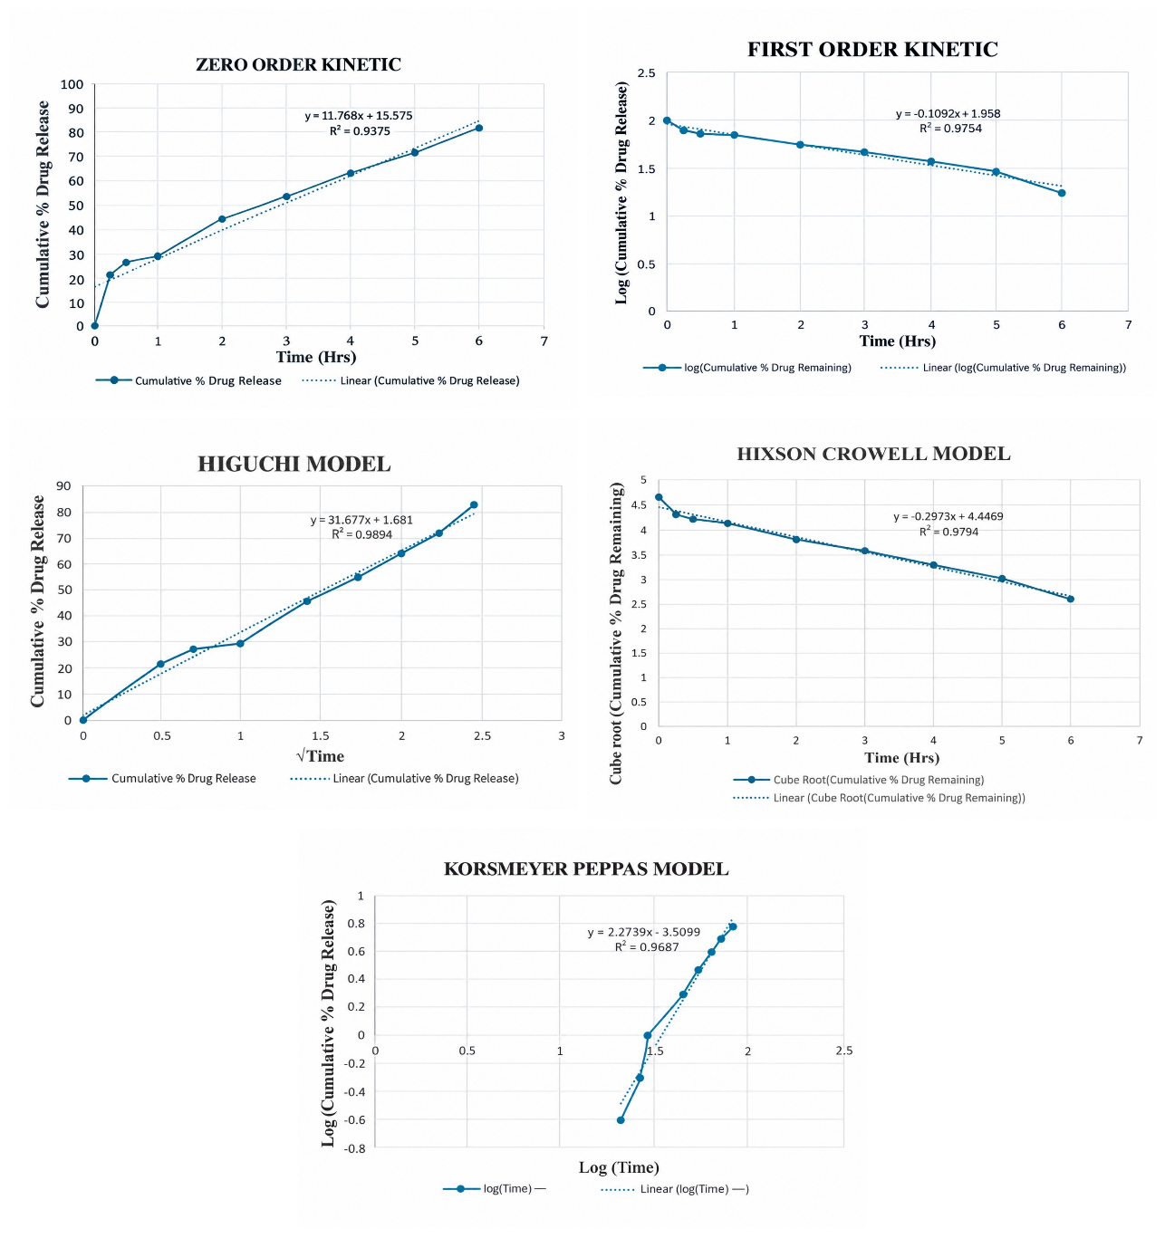
Fig.4: Release kinetics of F4 formulation: A) zero-order, B) first-order, C) Higuchi, D) Korsmeyer–Peppas and (E) Hixson–Crowell plots
Inference:
The drug-release kinetics of the optimised mucoadhesive buccal patch (F3) were analysed using several kinetic models. The Higuchi model provided the best fit (R² = 0.9894), indicating release associated with matrix hydration and gradual dissolution.
The superior fit to the Higuchi model supports a predominantly diffusion-associated release process from a hydrated matrix, although the model fit alone does not exclude concurrent swelling or erosion. Similar mucoadhesive films have exhibited Higuchi-type or mixed diffusion–relaxation behaviour, indicating that mechanistic interpretation should consider both kinetic modelling and polymer hydration characteristics (Muzib & Kumari, 2011; Semalty et al., 2008; Vasantha et al., 2011).
3.2.13 Scanning Electron Microscopy (SEM) Analysis
The formulated buccal patches were examined by scanning electron microscopy to characterise their surface morphology.
Fig. 5: SEM image of F3 formulation
SEM provides a qualitative assessment of surface topography and may reveal pores, cracks, drug crystals, or heterogeneity that could influence hydration and release. In comparable buccal-film studies, relatively uniform surfaces and few visible defects have been interpreted as evidence of satisfactory dispersion within the polymeric matrix, although SEM should be considered complementary to physicochemical and release data (Kumar et al., 2013; Nair et al., 2021; Salehi & Boddohi, 2017).
3.2.14 Stability Studies of F3
Formulation F3 was subjected to stability studies in accordance with ICH guidelines, and the results are shown in Table 8.
Table 8: Stability studies of F3
Stability conditions (F3) | Physical Appearance |  | Thickness (mm) |  | Drug content (%)
Stability conditions (F3) | Initial | Final  (30 days) | Initial | Final  (30 days) | Initial | Final  (30 days)
At room temp. | NC | NC | 0.14 | 0.14 | 98.26 | 97.52

*NC-No change

The absence of visible changes and the small reduction in drug content from 98.26% to 97.52% over 30 days suggest short-term physical and chemical stability under the room-temperature conditions tested. However, this finding is preliminary because a 30-day study cannot replace longer-term, controlled stability testing under defined temperature and humidity conditions. Extended studies are required to establish shelf life and packaging requirements (Adhikari et al., 2010; Kumar et al., 2013; Vasantha et al., 2011).
4. CONCLUSION
The present study aimed to formulate and evaluate mucoadhesive buccal patches containing clomipramine HCl for sustained drug delivery. Preformulation studies characterised the physicochemical properties of the drug and its suitability for formulation. FTIR analysis indicated no significant interaction between the drug and the selected excipients.
The UV method showed maximum absorbance at 254 nm and good linearity (R² = 0.9996). Six patch formulations (F1–F6) were prepared by solvent casting using HPMC E15 and Carbopol 940. The patches exhibited smooth, homogeneous surfaces, good flexibility, and surface pH values suitable for further buccal evaluation. Drug content ranged from 89.14% to 98.26%, with F3 exhibiting the highest value. All formulations showed 100% flatness, while swelling indices ranged from 458.36% to 627.75%. F3 had a swelling index of 537.13% and achieved cumulative drug release of 82.52% after 6 hours. The optimised F3 formulation contained 15 mg clomipramine HCl, 750 mg HPMC E15, and 250 mg Carbopol 940. It showed a thickness of 0.14 mm, a surface pH of 6.52, and folding endurance exceeding 300 folds. Drug release increased gradually over 6 hours, indicating a sustained-release profile. Of the tested kinetic models, the Higuchi model provided the best fit (R² = 0.9894). After 30 days at room temperature, F3 showed no visible change in appearance or recorded change in thickness, with drug content decreasing to 97.52%. Overall, F3 was selected as the optimised formulation based on its physicochemical characteristics and drug-release performance.
Future Scope
- Ex vivo permeation studies could be conducted.
- In vivo evaluation is required.
- Long-term stability studies are required.
Limitations
The findings are based on physicochemical characterisation and in vitro release testing of the prepared patches. Buccal-mucosal permeation, direct mucoadhesive strength, residence time, and in vivo performance were not established in the reported study. Stability observations were limited to 30 days at room temperature and therefore do not determine long-term shelf life. The different F3 thickness values reported in the manuscript and the discrepancy in its two-hour release values require verification against the original records before the findings are finalised.

COMPETING INTERESTS
Authors have declared that no competing interests exist.

Declaration of AI Use

This manuscript was prepared through the intellectual contributions of the author(s) to the study design, data analysis, interpretation of results, and scholarly content. Grammarly and ChatGPT were used solely to assist with grammatical refinement and reference formatting during manuscript revision. The author(s) accept full responsibility for the accuracy, integrity, and final content of the manuscript.

REFERENCE
Adhikari, S. N. R., Nayak, B. S., Nayak, A. K., & Mohanty, B. (2010). Formulation and evaluation of buccal patches for delivery of atenolol. AAPS PharmSciTech, 11(3), 1038–1044. https://doi.org/10.1208/s12249-010-9459-z
Ali, E. A., Adawy, A. M., El-Shahat, M. F., & Amin, A. S. (2016). Simple spectrophotometric methods for determination of fluoxetine and clomipramine hydrochlorides in dosage forms and in some post-mortem biological fluids samples. Egyptian Journal of Forensic Sciences, 6(4), 370–380. https://doi.org/10.1016/j.ejfs.2016.05.007
Andrews, G. P., Laverty, T. P., & Jones, D. S. (2009). Mucoadhesive polymeric platforms for controlled drug delivery. European Journal of Pharmaceutics and Biopharmaceutics, 71(3), 505–518. https://doi.org/10.1016/j.ejpb.2008.09.028
Asif, H. M., Rao, T. R., Ayesha, N., Anjum, M., & Rahman, M. A. (2015). Design and evaluation of mucoadhesive buccal patches of venlafaxine. British Journal of Pharmaceutical Research, 6(2), 96–106. https://doi.org/10.9734/BJPR/2015/12637
Aymard, G., Livi, P., Pham, Y. T., & Diquet, B. (1997). Sensitive and rapid method for the simultaneous quantification of five antidepressants with their respective metabolites in plasma using high-performance liquid chromatography with diode-array detection. Journal of Chromatography B: Biomedical Sciences and Applications, 700(1–2), 183–189. https://doi.org/10.1016/S0378-4347(97)00327-7
Ghumman, S. A., Hameed, H., Noreen, S., Al-Hussain, S. A., Kausar, R., Irfan, A., Shabbir, R., Rana, M., Amanat, A., & Zaki, M. E. A. (2023). In vitro/in vivo evaluation of clomipramine orodispersible tablets for the treatment of depression and obsessive-compulsive disorder. Pharmaceuticals, 16(2), Article 265. https://doi.org/10.3390/ph16020265
Habib, F., Abdel Azeem, M., Fetih, G., & Safwat, M. (2010). Mucoadhesive buccal patches of lornoxicam: I. Development and in-vitro characterization. Bulletin of Pharmaceutical Sciences. Assiut University, 33(1), 59–68. https://doi.org/10.21608/bfsa.2010.147025
Hassan, A. A. A., Kristó, K., Ibrahim, Y. H.-E. Y., Regdon, G., Jr., & Sovány, T. (2023). Quality by design-guided systematic development and optimization of mucoadhesive buccal films. Pharmaceutics, 15(10), Article 2375. https://doi.org/10.3390/pharmaceutics15102375
Ikram, M., Gilhotra, N., & Gilhotra, R. M. (2015). Formulation and optimization of mucoadhesive buccal patches of losartan potassium by using response surface methodology. Advanced Biomedical Research, 4, Article 239. https://doi.org/10.4103/2277-9175.168606
Joshi, Y. N., Akhzarmehr, A., & Omidian, H. (2026). Buccal film drug delivery: Linking formulation design with pharmacokinetic control and clinical translation. Journal of Pharmaceutical Sciences, 115(9), Article 104411. https://doi.org/10.1016/j.xphs.2026.104411
Kumar, A., Bali, V., Kumar, M., & Pathak, K. (2013). Comparative evaluation of porous versus nonporous mucoadhesive films as buccal delivery system of glibenclamide. AAPS PharmSciTech, 14(4), 1321–1332. https://doi.org/10.1208/s12249-013-0014-6
Lodhi, M., Dubey, A., Narayan, R., Prabhu, P., & Priya, S. (2013). Formulation and evaluation of buccal film of ivabradine hydrochloride for the treatment of stable angina pectoris. International Journal of Pharmaceutical Investigation, 3(1), 47–53. https://doi.org/10.4103/2230-973X.108963
Mahapatra, A. P. K., Nagvenkar, S. P., & Gude, R. (2020). Formulation and physicochemical characterization of buccal mucoadhesive films containing alfuzocin hydrochloride. Journal of Advances in Medical and Pharmaceutical Sciences, 22(2), 9–20. https://doi.org/10.9734/jamps/2020/v22i230155
Michael, A. M., Mahmoud, A. M., & Fahmy, N. M. (2023). Determination of clomipramine using eco-friendly solid-contact ionophore-doped potentiometric sensor. BMC Chemistry, 17, Article 27. https://doi.org/10.1186/s13065-023-00938-x
Morales, J. O., & McConville, J. T. (2011). Manufacture and characterization of mucoadhesive buccal films. European Journal of Pharmaceutics and Biopharmaceutics, 77(2), 187–199. https://doi.org/10.1016/j.ejpb.2010.11.023
Muzib, Y. I., & Kumari, K. S. (2011). Mucoadhesive buccal films of glibenclamide: Development and evaluation. International Journal of Pharmaceutical Investigation, 1(1), 42–47. https://doi.org/10.4103/2230-973X.76728
Nair, A. B., Shah, J., Jacob, S., Al-Dhubiab, B. E., Patel, V., Sreeharsha, N., & Shinu, P. (2021). Development of mucoadhesive buccal film for rizatriptan: In vitro and in vivo evaluation. Pharmaceutics, 13(5), Article 728. https://doi.org/10.3390/pharmaceutics13050728
Nair, V. V., Cabrera, P., Ramírez-Lecaros, C., Jara, M. O., Brayden, D. J., & Morales, J. O. (2023). Buccal delivery of small molecules and biologics: Of mucoadhesive polymers, films, and nanoparticles – An update. International Journal of Pharmaceutics, 636, Article 122789. https://doi.org/10.1016/j.ijpharm.2023.122789
Naqvi, A. Z., Al-Ahmadi, M. D. A., Akram, M., & Kabir-ud-Din. (2010). Surfactants and ureas affect the cloud point of amphiphilic drug, clomipramine hydrochloride. Colloids and Surfaces B: Biointerfaces, 81(1), 152–157. https://doi.org/10.1016/j.colsurfb.2010.07.003
Palego, L., Marazziti, D., Biondi, L., Giannaccini, G., Sarno, N., Armani, A., Lucacchini, A., Cassano, G. B., & Dell'Osso, L. (2000). Simultaneous plasma level analysis of clomipramine, N-desmethylclomipramine, and fluvoxamine by reversed-phase liquid chromatography. Therapeutic Drug Monitoring, 22(2), 190–194. https://doi.org/10.1097/00007691-200004000-00009
Patel, K. A., & Karvekar, M. D. (2019). A study on synthesis and characterization of various polymorphic forms of trimipramine maleate and clomipramine hydrochloride. Journal of Pharmaceutical Research, 18(3), 1–7. https://doi.org/10.18579/jopcr/v18.3.patel
Rahman, N., & Afaq, N. (2010). Optimization and validation of spectrofluorimetric method for the determination of clomipramine hydrochloride via ion-pair complexation with alizarin red S. Analytical Methods, 2, 513–518. https://doi.org/10.1039/C0AY00017E
Ramachandran, C., Nair, S. G., Kumar, G. S., & Viswanad, V. (2018). Formulation and evaluation of mucoadhesive buccal patch containing imipramine hydrochloride. International Journal of Research in Pharmaceutical Sciences, 9(4), 1409–1422. https://doi.org/10.26452/ijrps.v9i4.1695
Salehi, S., & Boddohi, S. (2017). New formulation and approach for mucoadhesive buccal film of rizatriptan benzoate. Progress in Biomaterials, 6, 175–187. https://doi.org/10.1007/s40204-017-0077-7
Semalty, M., Semalty, A., & Kumar, G. (2008). Formulation and characterization of mucoadhesive buccal films of glipizide. Indian Journal of Pharmaceutical Sciences, 70(1), 43–48. https://doi.org/10.4103/0250-474X.40330
Semwal, A., Agrahari, M., Joshi, V., Koul, R., & Trivedi, R. K. (2026). Mucoadhesive drug delivery systems: A critical appraisal of adhesion mechanisms, formulation strategies and translational prospects. Asian Journal of Microbiology and Biotechnology, 11(2), 142–171. https://doi.org/10.56557/ajmab/2026/v11i210910
Smart, J. D. (2005). The basics and underlying mechanisms of mucoadhesion. Advanced Drug Delivery Reviews, 57(11), 1556–1568. https://doi.org/10.1016/j.addr.2005.07.001
Tanaka, E., Terada, M., Nakamura, T., Misawa, S., & Wakasugi, C. (1997). Forensic analysis of eleven cyclic antidepressants in human biological samples using a new reversed-phase chromatographic column of 2 µm porous microspherical silica gel. Journal of Chromatography B: Biomedical Sciences and Applications, 692(2), 405–412. https://doi.org/10.1016/S0378-4347(96)00510-5
Vasantha, P. V., Puratchikody, A., Mathew, S. T., & Balaraman, A. K. (2011). Development and characterization of Eudragit based mucoadhesive buccal patches of salbutamol sulfate. Saudi Pharmaceutical Journal, 19(4), 207–214. https://doi.org/10.1016/j.jsps.2011.07.003

