Original Research Article
Exploring the Potential of Heliotropium indicum Aqueous and Ethanolic Leaf Extracts as Novel Antioxidant and Anti-inflammatory Agents: A Comparative In vitro Study

Abstract
Heliotropium indicum is used in traditional medicine, although direct comparative evidence on the antioxidant and anti-inflammatory activities of aqueous and ethanolic leaf extracts remains limited. This study compared the in vitro antioxidant and anti-inflammatory activities of these extracts. Aqueous and ethanolic leaf extracts were prepared by maceration. Antioxidant activity was assessed using total antioxidant capacity, 2,2-diphenyl-1-picrylhydrazyl radical scavenging, nitric oxide scavenging and hydroxyl radical scavenging assays. Anti-inflammatory activity was evaluated through inhibition of albumin denaturation, heat-induced human red blood cell haemolysis and trypsin activity. Extract responses were examined at concentrations ranging from 15.625 to 1000 µg/mL, and half-maximal inhibitory concentrations (IC₅₀) were compared. Both extracts showed concentration-dependent responses across the assays. The ethanolic extract had lower IC₅₀ values than the aqueous extract for DPPH scavenging (178.93 ± 1.14 versus 226.80 ± 11.87 µg/mL), nitric oxide scavenging (390.83 ± 25.75 versus 744.59 ± 3.79 µg/mL) and hydroxyl radical scavenging (267.13 ± 27.97 versus 679.29 ± 22.91 µg/mL). It also had lower IC₅₀ values for albumin denaturation (217.60 ± 2.09 versus 440.13 ± 6.43 µg/mL), membrane stabilisation (223.29 ± 6.91 versus 343.89 ± 1.79 µg/mL) and antiprotease activity (66.88 ± 1.34 versus 207.36 ± 27.47 µg/mL). Under the reported experimental conditions, the ethanolic extract demonstrated greater in vitro activity than the aqueous extract. Further investigation is required to establish its biological relevance beyond these assays.
Keywords: Heliotropium indicum; Aqueous extract; Ethanol extract; Antioxidants, Anti-inflammatory

1. Introduction
Oxidative stress and inflammation are closely interconnected biological processes that contribute to the initiation and progression of numerous acute and chronic disorders (Altanam et al., 2025; Awhin et al., 2025; Manful et al., 2025a). Oxidative stress occurs when the generation of reactive oxygen species (ROS) and reactive nitrogen species exceeds the capacity of endogenous antioxidant systems to neutralise them, resulting in oxidative damage to cellular lipids, proteins and nucleic acids (Ajoh et al., 2025; Qin et al., 2026). Although ROS are essential for normal cellular signalling and host defence, their excessive accumulation can activate redox-sensitive inflammatory pathways and promote the production of pro-inflammatory mediators (Manful et al., 2025b). Conversely, inflammatory responses can further enhance oxidative stress through the activation of immune cells and increased generation of reactive species, thereby establishing a self-perpetuating relationship between oxidative damage and inflammation (Altanam et al., 2025; Bellanti et al., 2025). Consequently, the identification of natural products capable of attenuating oxidative stress and inflammatory responses remains an important area of pharmacological research (Jia et al., 2018).
Medicinal plants represent a valuable source of structurally diverse secondary metabolites with antioxidant and anti-inflammatory properties. Phenolic compounds, flavonoids, terpenoids, tannins, and other valuable phytochemicals have been reported to exhibit free-radical-scavenging, metal-chelating and inflammation-modulating activities through several complementary mechanisms (Latif & Nawaz, 2026; Sun & Shahrajabian, 2023). The antioxidant activity of plant extracts is commonly investigated using in vitro assays such as 2,2-diphenyl-1-picrylhydrazyl (DPPH) radical scavenging, nitric oxide (NO) scavenging and related reducing or radical-scavenging methods (Chaves et al., 2020; Enyi et al., 2026). Similarly, in vitro models including inhibition of protein denaturation, membrane stabilisation and inhibition of enzymes or mediators associated with inflammation have been employed as preliminary approaches for evaluating anti-inflammatory potential (Hasan et al., 2024; Sabalingam, 2025). These assays serve as fast, cost-effective preliminary screening tools to identify bioactive plant extracts or compounds with antioxidant and anti-inflammatory potentials (Cerulli et al., 2021; Sultana et al., 2026).
Amos-Tautua et al. (2025) reported differences in phenolic content and antioxidant activity between methanolic and n-hexane Spondias mombin leaf extracts. In another study, Asadu et al. (2026) used human red blood cell membrane stabilisation to assess the in vitro anti-inflammatory activity of combined ethanolic leaf extracts of Ficus capensis and Mentha spicata.
Heliotropium indicum L., known as Indian heliotrope, is a medicinal herb belonging to the Boraginaceae family that is widely distributed in tropical and subtropical regions. The plant has a history of use in traditional medicine for managing conditions associated with inflammation, pain, wounds and other ailments (Roy, 2015; Sarkar et al., 2021). Experimental studies have also suggested antioxidant, antimicrobial, anti-inflammatory and other pharmacological properties of extracts or isolated constituents of the plant (Sarkar et al., 2021). Phytochemical investigations of H. indicum have demonstrated the presence of several classes of bioactive constituents, including phenolic compounds, flavonoids, glycosides, tannins, terpenoids and alkaloids, which may contribute to its reported biological activities (Ajoh et al., 2026; Shoily et al., 2026).
A study of Solanum nigrum leaf extracts demonstrated that solvent selection affects phytochemical composition and in vitro antioxidant responses (Lim & Lim, 2025). Pavithra et al. (2025) likewise investigated solvent-derived Suaeda maritima extracts using antioxidant and protein-denaturation assays. Research on Lagenaria siceraria fruit extracts has also reported solvent-associated variation in extraction yield and DPPH scavenging activity (Mulay et al., 2026).
Despite the traditional use and reported pharmacological potential of H. indicum, comparative information on the in vitro antioxidant and anti-inflammatory activities of its aqueous and ethanolic leaf extracts remains limited. Direct comparison of these preparations is important because differences in solvent composition may translate into differences in extraction efficiency and bioactivity. Hence, the present study was designed to comparatively evaluate the in vitro antioxidant and anti-inflammatory activities of aqueous and ethanolic leaf extracts of H. indicum. By comparing the two extraction systems using standardized experimental approaches, the study seeks to determine whether the choice of solvent influences the biological activity of the leaf extracts and to provide preliminary evidence supporting the potential use of H. indicum as a source of antioxidant and anti-inflammatory agents.

2. Materials and Methods
2.1 Collection and Authentication of Plant
Fresh plants of Heliotropium indicum were harvested from uncultivated land in Ughelli, Delta State, Nigeria. The plant was authenticated by Professor Adewale Akinnibosun of the Herbarium Unit, Department of Plant Biology and Biotechnology, Faculty of Life Sciences, University of Benin, Benin City, Edo State, Nigeria with an assigned voucher number of UBH-H533.
2.2 Preparation of Heliotropium indicum Aqueous and Ethanolic Extracts
The leaves of the H. indicum plant were plucked and rinsed thoroughly. The leaves were then air-dried in the shade at room temperature for 14 days. The dried leaves were pulverized into fine powder and used for the preparation of H. indicum aqueous and ethanolic extracts. The aqueous and ethanolic extracts were prepared using the maceration technique. Following extraction, the extracts were freeze-dried at the Department of Pharmacognosy, Faculty of Pharmacy, Delta State University, Abraka. The obtained freeze-dried samples were then stored in a refrigerator until further analyses.
2.3 In vitro antioxidant activity of H. indicum aqueous and ethanolic extracts
2.3.1 Total antioxidant capacity
The total antioxidant capacity of H. indicum aqueous and ethanolic extracts was determined using the phosphomolybdate assay as previously described by Prieto et al. (1999) with slight modifications. The assay is based on the reduction of the phosphomolybdate ion (MoVI) resulting in the formation of a green phosphate (MoV) complex in the presence of an antioxidant, which is measured spectrophotometrically. Different dilutions (15.625, 31.25, 62.50, 125.00, 250.00, 500.00 and 1000 μg/ml) of H. indicum extracts (aqueous and ethanolic), as well as the standard (ascorbic acid) were prepared and a 0.1 ml aliquot of each sample was added to a separate test tube except the blank tube (control). Each concentration was tested in triplicate. To each tube, 1 mL of phosphomolybdenum reagent (comprising 0.6 M sulfuric acid, 28 mM sodium phosphate, and 4 mM ammonium molybdate) was added. After incubation for 90 minutes at 95 ◦C in a water bath and cooling of the samples to room temperature, their absorbance values at 695 nm were recorded. The total antioxidant activity (phosphomolybdate inhibitory) of the plant extracts was calculated using the equation:
TAC (% inhibition) = [(Abs. of control − Abs. of sample)/(Abs. of control] × 100
The percentage inhibition was plotted against concentration to determine the concentration of the extracts at which 50% inhibition was observed (IC₅₀) in comparison to the standard.
2.3.2 2,2-Diphenyl-1-picrylhydrazyl (DPPH) assay
The DPPH free radical scavenging activity of the aqueous and ethanolic extracts of H. indicum was determined according to the method by Liyana-Pathirana and Shahidi (2005) with slight modifications. One millilitre of 0.135 mM DPPH prepared in methanol was mixed with 1 ml of the extracts (aqueous and ethanolic) and standard (ascorbic acid) ranging from 15.625 to 1000 μg/ml. The reaction mixtures were thoroughly vortexed and then left in the dark at room temperature for 30 minutes. Thereafter, the absorbances were measured spectrophotometrically at 517 nm. The DPPH scavenging activity of the plant extracts and standard was calculated using the equation:
DPPH scavenging activity (%) = [(Abs. control – Abs. sample)]/(Abs. control)] × 100
where Abs. control is the absorbance of DPPH + methanol and
Abs. sample is the absorbance of DPPH radical + sample (i.e., extracts or standard).
The percentage inhibition was plotted against concentration to determine the concentration of the extracts at which 50% inhibition was observed (IC₅₀) in comparison to the standard.
2.3.3 Nitric oxide scavenging assay
The method described by Oyedemi et al. (2010), with slight modifications, was used to determine the nitric oxide radical scavenging activity of H. indicum in this assay. It relies on the fact that sodium nitroprusside in aqueous solution at physiological pH spontaneously generates nitric oxide which interacts with oxygen to produce nitrite ions that are determined using Griess reagents. Two millilitres of 10 mM sodium nitroprusside dissolved in 0.5 ml phosphate buffer saline (pH 7.4) was mixed with 0.5 ml of the plant extracts at various concentrations (15.625 to 1000 μg/ml). The mixture was incubated at 25 °C. After 150 minutes, 0.5 ml of incubated solution was withdrawn and mixed with 0.5 ml of Griess reagent [1.0 ml sulfanilic acid reagent (0.33% in 20% glacial acetic acid at room temperature for 5 minutes) with 1 ml of naphthylethylenediamine dichloride (0.1% w/v)]. The mixture was incubated at room temperature for 30 minutes. Thereafter, the absorbance was measured at 540 nm. The amount of nitric oxide radicals inhibited by the extracts was calculated using the following equation:
% inhibition of NO = [(Abs control – Abs sample)]/(Abs control)] × 100
where Abs control is the absorbance of NO radicals + methanol and
Abs sample is the absorbance of NO radical + extract or standard.
The percentage inhibition was plotted against concentration to determine the concentration of the extracts at which 50% inhibition was observed (IC₅₀).
2.3.4 Hydroxyl radical scavenging assay
The hydroxyl radical scavenging activity of H. indicum aqueous and ethanolic extracts was determined using the Fenton reaction-based deoxyribose degradation assay as previously described by Gutteridge (1984) with slight modifications. In this method, generation of hydroxyl radicals (•OH) occurs through the reaction of Fe³⁺–EDTA, ascorbic acid and hydrogen peroxide, which subsequently degrade deoxyribose into products that react with thiobarbituric acid (TBA) to form a pink chromogen measurable at 532 nm. The reaction mixture contained, in a final volume of 1 ml, 2-deoxy-2-ribose (2.8 mM); KH₂PO₄-KOH buffer (20 mM, pH 7.4); FeCl₃ (100 μM); EDTA (100 μM); H₂O₂ (1.0 mM); ascorbic acid (100 μM) and various concentrations (15.625 to 1000 μg/ml) of the extracts. The reaction mixture was incubated for 1 hour at 37 °C and, after incubation, 0.5 ml of the reaction mixture was mixed with 1 ml 2.8% TCA, after which 1 ml 1% aqueous TBA was added to it. The solution was then incubated at 90 °C for 15 minutes to allow colour development. After incubation, the solution was cooled down and the absorbance was measured at 532 nm against an appropriate blank solution. All tests were performed in triplicate. Percentage inhibition was evaluated by the following equation:
% inhibition= [(A₀-A₁) / A₀] × 100
where: A₀ is the absorbance of the control and
A₁ was the absorbance in the presence of the samples.
2.4 In vitro anti-inflammatory activity of H. indicum aqueous and ethanolic extracts
2.4.1 Albumin denaturation assay
The method previously described by Chandra et al. (2012) was used with slight modifications. 0.2 ml of 1% egg albumin solution, 2 ml of the sample extract (aqueous and ethanolic of H. indicum) or standard (Diclofenac sodium) at varying concentrations (15.625 to 1000 μg/ml), and 2.8 ml of phosphate-buffered saline (pH 7.4) were mixed to form a reaction mixture with a total volume of 5 ml. For the control, a total volume of 5 ml was also created by combining 2 ml of distilled water, 0.2 ml of 1% egg albumin solution, and 2.8 ml of phosphate-buffered saline. The reaction mixtures were incubated at 37 °C for 30 minutes and then heated at 70 °C for 15 minutes in a water bath. After cooling, the absorbances were measured at 280 nm. The percentage inhibition of albumin denaturation was determined using the equation:
% inhibition = [(Abs control – Abs sample)]/(Abs control)] × 100
The 50% inhibitory concentrations (IC₅₀) of the extracts and standard were determined by plotting percentage inhibition against concentration.
2.4.2 Membrane Stabilisation against Heat-Induced Haemolysis
This was carried out according to the method previously described by Shinde et al. (1999) with slight modifications. Human blood was obtained by venipuncture from a healthy volunteer, collected into heparinised tubes and centrifuged at 2000 rpm for 10 minutes at 4°C. After removing the plasma, red blood cells (RBCs) were washed three times using phosphate buffer saline (PBS) (0.9% NaCl). The reaction mixture (2.0 ml) consisted of 1.0 ml of 10% human red blood cell (HRBC) and 1.0 ml of various concentrations of the aqueous and ethanolic H. indicum extracts (15.625, 31.25, 62.50, 125.00, 250.00, 500.00 and 1000 μg/ml) which were added to each test tube and mixed gently. The standard consisted of 1.0 ml of HRBC and 1.0 ml of various concentrations of diclofenac sodium (15.625, 31.25, 62.50, 125.00, 250.00, 500.00 and 1000 μg/ml). The control consisted of 1.0 ml of 10% erythrocyte suspension and 1.0 ml of normal saline alone. The experiment was performed in triplicate. The resulting solutions were heated at 56 °C for 30 minutes, cooled to room temperature and then centrifuged at 2000 rpm for 10 minutes. The supernatants were collected, and the absorbance of each solution was measured at 560 nm. The percentage inhibition of haemolysis was calculated using the equation:
% inhibition = [(Abs control – Abs sample)]/(Abs control)] × 100
The 50% inhibitory concentrations for heat-induced haemolysis (IC₅₀) of the extracts and standard were determined by plotting percentage inhibition against concentration.
2.4.3 Antiprotease activity assay
The antiprotease activity of the extracts was carried out according to the method described by Oyedapo and Famurewa (1995) and Sakat et al. (2010), with slight modifications. The final reaction mixture in each test tube consisted of 1 ml 25mM Tris-HCl buffer (pH 7.4), 250 μL of trypsin and 1 ml of sample extracts and standard (diclofenac sodium) at varying concentrations (15.625, 31.25, 62.50, 125.00, 250.00, 500.00 and 1000 μg/ml). The mixture was then incubated for a period of 5 minutes at 37 °C. Thereafter, 1.0 ml of 0.8% (w/v) casein was added, and the mixture was incubated for another 20 minutes. Following incubation, 2 ml of 70% perchloric acid was added to each test tube to arrest the reaction. The cloudy suspension obtained was centrifuged and the absorbance of the supernatant was read at 210 nm against the buffer as blank (control). The experiment was repeated in triplicate and percentage inhibition of protease activity was calculated using the equation:
% inhibition = [(Abs control – Abs sample)]/(Abs control)] × 100
The IC₅₀ of the extracts and standard were determined by plotting percentage inhibition against concentration.
2.5 Statistical Analysis
GraphPad Prism version 10 was used for statistical analysis. Results were expressed as mean ± SD of triplicate determinations. Concentration-response curves were plotted and IC₅₀ values were extrapolated using the Fit Spline/LOWESS analytical tool. Student’s t-test was used to compare the mean IC₅₀ values for nitric oxide and hydroxyl radical scavenging assays. One-way analysis of variance (ANOVA), followed by Tukey’s post hoc analysis, was used to analyse differences in group means for the other assays. A p-value of less than 0.05 was considered statistically significant.

3. Results
3.1 In vitro antioxidant activity of H. indicum aqueous and ethanolic extracts
3.1.1 Total antioxidant capacity (TAC)
The comparative total antioxidant capacity (TAC) of the aqueous and ethanolic leaf extracts of Heliotropium indicum was determined using the phosphomolybdate inhibition assay, and the half-maximal inhibitory concentration (IC₅₀) was extrapolated from the concentration-response curve as shown in Figures 1 and 2:
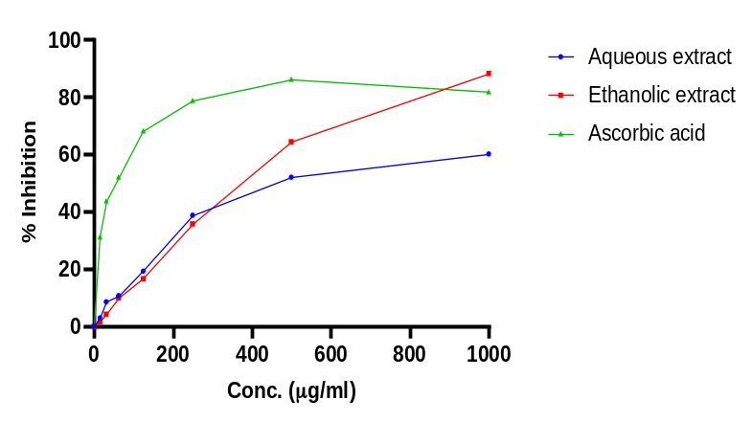
Figure 1: Concentration-response curve of phosphomolybdate inhibition by H. indicum extracts
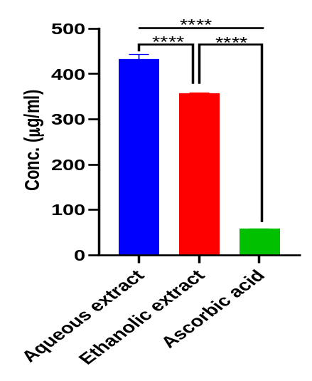
**** = Statistically significant
Figure 2: Bars showing TAC IC₅₀ values of H. indicum extracts
The results of this study revealed that the aqueous and ethanolic extracts of H. indicum, as well as the standard (ascorbic acid) all showed concentration-dependent phosphomolybdate inhibitory activity. Furthermore, the ethanolic extract of H. indicum possessed significantly higher total antioxidant capacity (phosphomolybdate inhibitory activity) as evidenced by the significantly (p < 0.05) lower IC₅₀ values (356.82 ± 1.66 µg/ml) compared with that of the aqueous extract (432.14 ± 11.14 µg/ml). The TAC of the standard, ascorbic acid, was significantly (p < 0.05) higher than both extracts (IC₅₀ = 58.17 ± 1.10 µg/ml).
3.1.2 2,2-Diphenyl-1-picrylhydrazyl (DPPH) assay
The comparative DPPH inhibitory activity of the aqueous and ethanolic leaf extracts of Heliotropium indicum was determined and the half-maximal inhibitory concentration (IC₅₀) was extrapolated from the concentration-response curve as shown in Figures 3 and 4:
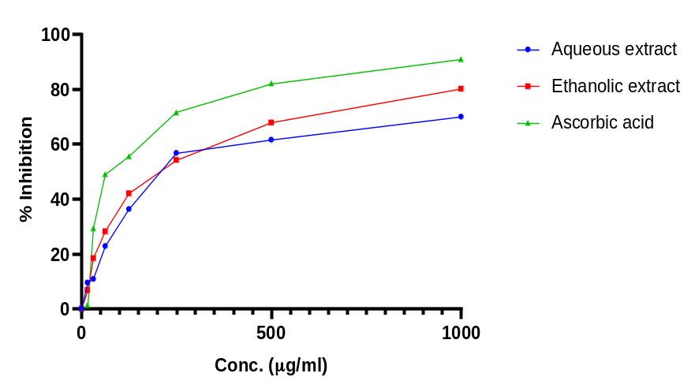
Figure 3: Concentration-response curve of DPPH inhibition by H. indicum extracts
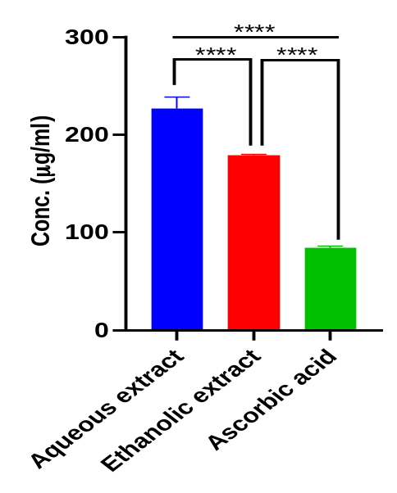
**** = Statistically significant
Figure 4: Bars showing DPPH IC₅₀ values of H. indicum extracts
The results of this study revealed that the aqueous and ethanolic extracts of H. indicum, as well as the standard (ascorbic acid) all showed concentration-dependent DPPH inhibitory activity. Furthermore, the ethanolic extract of H. indicum possessed significantly (p < 0.05) better DPPH inhibitory activity (IC₅₀ = 178.93 ± 1.14 µg/ml) compared with that of the aqueous extract (IC₅₀ = 226.80 ± 11.87 µg/ml). The DPPH inhibitory activity of the standard, ascorbic acid, was significantly (p < 0.05) higher than both extracts (IC₅₀ = 84.13 ± 1.74 µg/ml).

3.1.3 Nitric oxide scavenging (NOS) assay
The comparative nitric oxide scavenging activity of the aqueous and ethanolic leaf extracts of Heliotropium indicum was determined and the half-maximal inhibitory concentration (IC₅₀) was extrapolated from the concentration-response curve as shown in Figures 5 and 6:
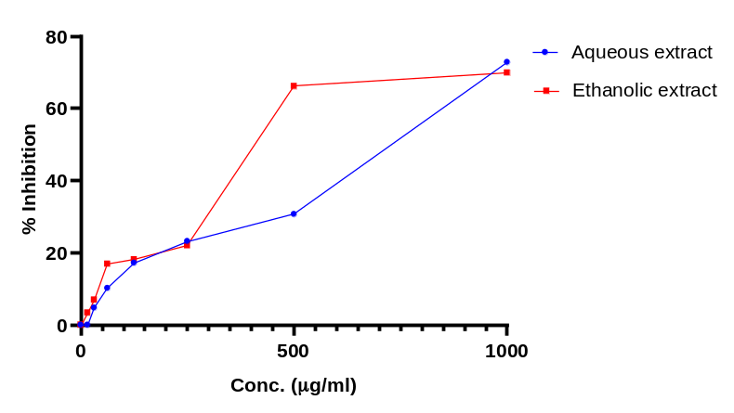
Figure 5: Concentration-response curve of nitric oxide (NO) inhibition by H. indicum extracts
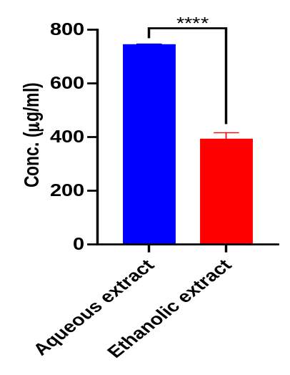
**** = Statistically significant
Figure 6: Bars showing NOS IC₅₀ values of H. indicum extracts
The results of this study revealed that the aqueous and ethanolic extracts of H. indicum both showed concentration-dependent nitric oxide inhibitory activity. Furthermore, the ethanolic extract of Heliotropium indicum possessed significantly (p < 0.05) better NO scavenging activity (IC₅₀ = 390.83 ± 25.75 µg/ml) than the aqueous extract of Heliotropium indicum (IC₅₀ = 744.59 ± 3.79 µg/ml).

3.1.4 Hydroxyl radical scavenging (HRS) activity
The comparative hydroxyl radical scavenging activity of the aqueous and ethanolic leaf extracts of Heliotropium indicum was determined and the half-maximal inhibitory concentration (IC₅₀) was extrapolated from the concentration-response curve as shown in Figures 7 and 8:
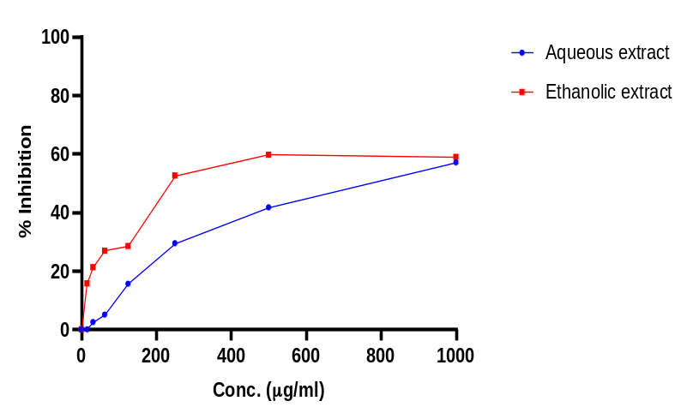
Figure 7: Concentration-response curve of hydroxyl radical inhibition by H. indicum extracts
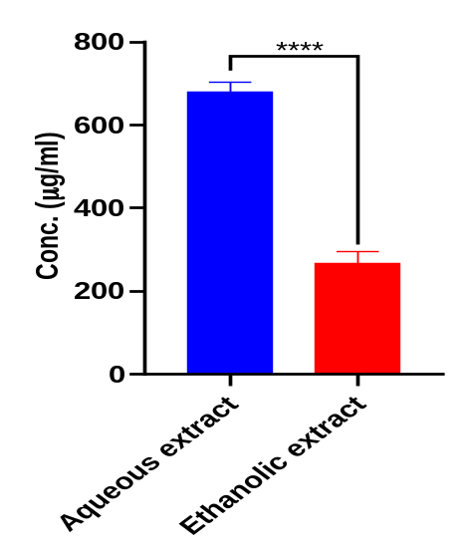
**** = Statistically significant
Figure 8: Bars showing HRS IC₅₀ values of extracts
The results of this study revealed that the aqueous and ethanolic extracts of H. indicum both showed concentration-dependent hydroxyl radical scavenging activity. Furthermore, the ethanolic extract of Heliotropium indicum possessed significantly (p < 0.05) better hydroxyl radical scavenging activity (IC₅₀ = 267.13 ± 27.97 µg/ml) than the aqueous extract of Heliotropium indicum (IC₅₀ = 679.29 ± 22.91 µg/ml).

Table 1: Summary of IC₅₀ values across in vitro antioxidant assays
Extract/Standard | IC₅₀ values (µg/ml)
 | TAC | DPPH | Nitric oxide | Hydroxyl radical
Aqueous H. indicum | 432.14 ± 11.14 | 226.80 ± 11.87 | 744.59 ± 3.79 | 679.29 ± 22.91
Ethanolic H. indicum | 356.82 ± 1.66 | 178.93 ± 1.14 | 390.83 ± 25.75 | 267.13 ± 27.97
Ascorbic acid | 58.17 ± 1.10 | 84.13 ± 1.74 | - | -

On the whole, the results obtained from the in vitro antioxidant assays (TAC, DPPH, NOS, HRS) revealed that the ethanolic extract of H. indicum possessed significantly better antioxidant potential than the aqueous extract as evidenced by the significantly lower IC₅₀ values across assays. This suggests that the ethanolic extract had better potential in treating oxidative stress-related diseases than the aqueous extract.
3.2 In vitro anti-inflammatory activity of H. indicum aqueous and ethanolic extracts
3.2.1 Albumin denaturation assay
The comparative albumin denaturation inhibitory activity of the aqueous and ethanolic leaf extracts of Heliotropium indicum was determined and the half-maximal inhibitory concentration (IC₅₀) was extrapolated from the concentration-response curve as shown in Figures 9 and 10:
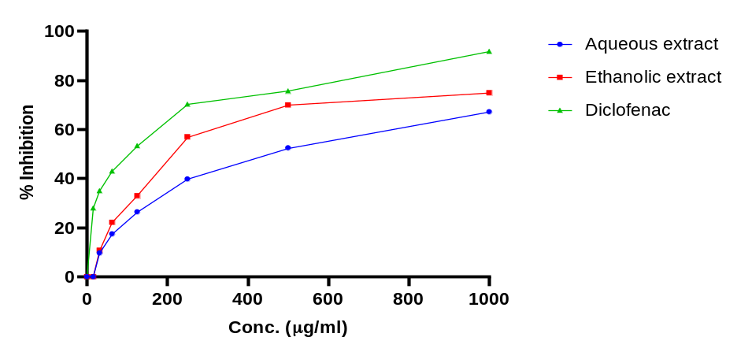
Figure 9: Percentage albumin denaturation inhibitory activity of H. indicum extracts
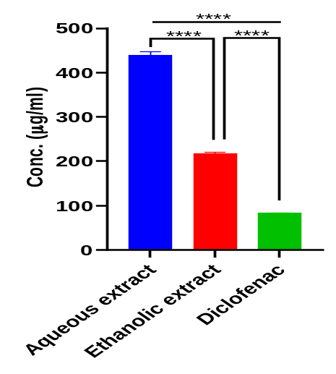
**** = Statistically significant
Figure 10: Bars showing albumin denaturation IC₅₀ values for H. indicum extracts
The results of this study revealed that the aqueous and ethanolic extracts of H. indicum, as well as the standard (diclofenac) all showed concentration-dependent inhibition of albumin denaturation. Furthermore, the study revealed that the ethanolic extract of H. indicum significantly (p < 0.05) inhibited the denaturation of egg yolk albumin (IC₅₀ = 217.60 ± 2.09 µg/ml) more effectively than the aqueous extract of Heliotropium indicum (IC₅₀ = 440.13 ± 6.43 µg/ml). The albumin denaturation inhibitory activity of the standard, diclofenac, was significantly (p < 0.05) higher than both extracts (IC₅₀ = 83.52 ± 0. 31 µg/ml).
3.2.2 Membrane Stabilisation
The comparative RBC membrane stabilisation (inhibition of heat-induced haemolysis) activity of the aqueous and ethanolic leaf extracts of Heliotropium indicum was determined and the half-maximal inhibitory concentration (IC₅₀) was extrapolated from the concentration-response curve as shown in Figures 11 and 12:
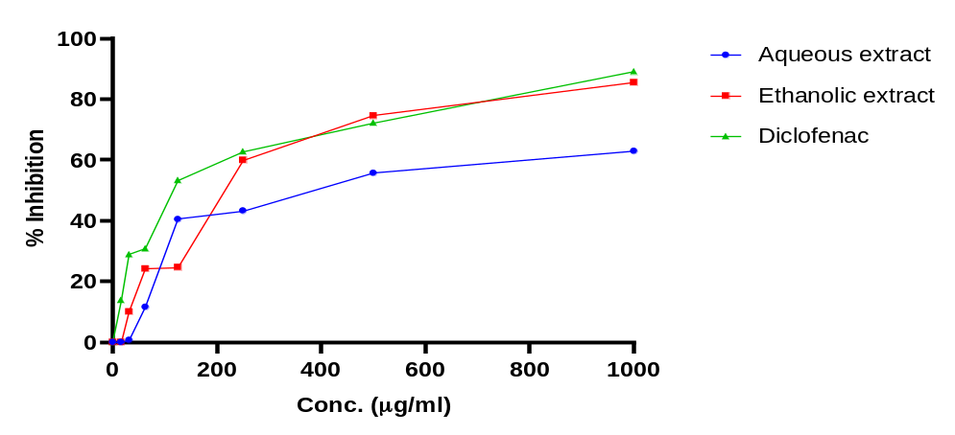
Figure 11: Percentage HRBC membrane stabilization (inhibition of heat-induced hemolysis) activity of H. indicum extracts
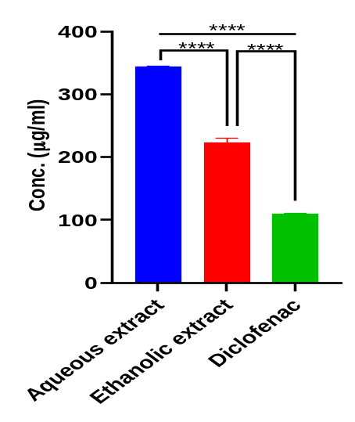
**** = Statistically significant
Figure 12: Bars showing IC₅₀ values for H. indicum extracts
The results of this study revealed that the aqueous and ethanolic extracts of H. indicum, as well as the standard (diclofenac) all showed concentration-dependent inhibition of heat-induced HRBC haemolysis. Furthermore, the study revealed that the ethanolic extract of H. indicum inhibited heat-induced haemolysis of human red blood cells significantly (p < 0.05) more effectively (IC₅₀ = 223.29 ± 6.91 µg/ml) in comparison to the aqueous extract of H. indicum (IC₅₀ = 343.89 ± 1.79 µg/ml), thereby stabilising the RBC membrane more effectively than the aqueous extract in this study. The RBC membrane stabilisation activity of the standard, diclofenac, was significantly (p < 0.05) higher than both the aqueous and ethanolic extracts (IC₅₀ = 109.81 ± 0.43 µg/ml).
3.2.3 Antiprotease activity
The comparative antiprotease (inhibition of trypsin) activity of the aqueous and ethanolic leaf extracts of Heliotropium indicum was determined and the half-maximal inhibitory concentration (IC₅₀) was extrapolated from the concentration-response curve as shown in Figures 13 and 14:
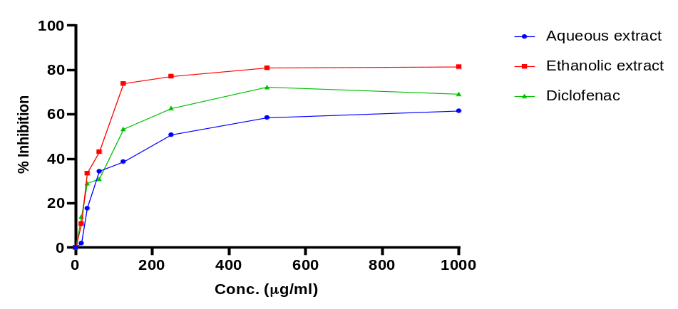
Figure 13: Percentage antiprotease activity of H. indicum extracts
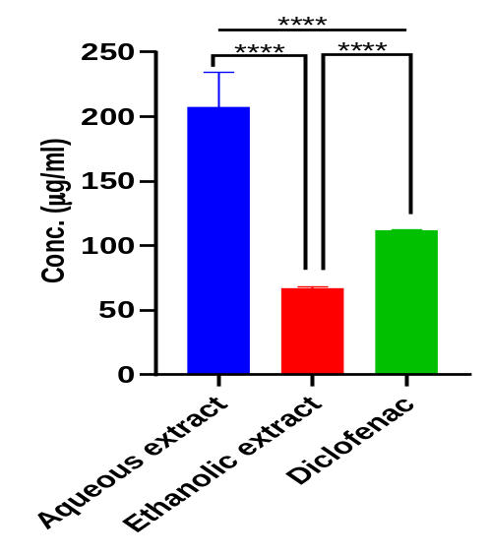
**** = Statistically significant
Figure 14: Bars showing Antiprotease IC₅₀ values for H. indicum extracts
The results of this study revealed that the aqueous and ethanolic extracts of H. indicum, as well as the standard (diclofenac) all showed concentration-dependent inhibition of trypsin activity. Furthermore, the study revealed that the ethanolic extract of H. indicum had significantly (p < 0.05) better antiprotease activity (IC₅₀ = 66.88 ± 1.34 µg/ml) compared with both the aqueous extract of H. indicum (IC₅₀ = 207.36 ± 27.47 µg/ml), and the standard, diclofenac (IC₅₀ = 111.70 ± 0.41 µg/ml).
Table 2: Summary of IC₅₀ values across in vitro anti-inflammatory assays
Extract/Standard | IC₅₀ values (µg/ml)
 | Albumin denaturation | Membrane stabilization | Antiprotease
Aqueous H. indicum | 440.13 ± 6.43 | 343.89 ± 1.79 | 207.36 ± 27.47
Ethanolic H. indicum | 217.60 ± 2.09 | 223.29 ± 6.91 | 66.88 ± 1.34
Diclofenac | 83.52 ± 0. 31 | 109.81 ± 0.43 | 111.70 ± 0.41
On the whole, the results obtained from the in vitro anti-inflammatory assays (albumin denaturation, membrane stabilisation, antiprotease) revealed that the ethanolic extract of H. indicum possessed significantly better anti-inflammatory potential than the aqueous extract, and exhibited activity closer to that of the standard anti-inflammatory drug, diclofenac, than did the aqueous extract.

4. Discussion
The search for novel antioxidant and anti-inflammatory agents is one of the most critical frontiers in modern medicine and pharmacology. While many treatments exist, the rising burden of chronic diseases and the limitations of current drugs make the search for new agents essential (Awhin et al., 2023; Kulkarni et al., 2025). H. indicum is widely used in traditional medicine, but the comparative in vitro antioxidant and anti-inflammatory activities of its aqueous and ethanolic extracts remain unclear. The in vitro antioxidant activity of the aqueous and ethanolic leaf extracts of H. indicum was carried out using standard assays (total antioxidant capacity (TAC), 2,2-Diphenyl-1-picrylhydrazyl (DPPH), nitric oxide scavenging (NOS) and hydroxyl radical scavenging (HRS) assays), while the in vitro anti-inflammatory activity of the aqueous and ethanolic extracts was carried out using albumin denaturation, membrane stabilisation and antiprotease activity assays.
The total antioxidant capacity (TAC) assay was evaluated by determining the phosphomolybdate inhibitory activity of the extracts. The TAC by the phosphomolybdenum method is a widely used quantitative spectrophotometric assay to evaluate the antioxidant potential of sample extracts (Prieto et al., 1999; Maswada, 2013). This is characterised by the ability of antioxidants to reduce molybdenum (VI) to molybdenum (V) and form a green phosphomolybdenum complex (Adekola et al., 2022). Both the aqueous and ethanolic extracts showed concentration-dependent phosphomolybdate inhibitory activity in the present study, with the ethanolic extract showing better activity than the aqueous extract, suggesting that the ethanolic extract could possess a better TAC than the aqueous extract.
The DPPH assay is an inexpensive and precise assay that is popularly used in screening substances for their antioxidant potential (Bouhlali et al., 2016). The DPPH radical is a violet-coloured stable free radical with a characteristic absorbance at 517 nm that changes to pale yellow colour upon reduction due to electron or hydrogen transfer (Pavithra & Vadivukkarasi, 2015). In the present study, the ethanolic and aqueous H. indicum extract scavenged DPPH radicals in a concentration-dependent manner, with the ethanolic extract showing significantly better DPPH scavenging activity than the aqueous extract, although both were still significantly outperformed by the standard, ascorbic acid. This suggests that the ethanolic extract could possess significantly better radical scavenging activity than the aqueous extract.
Hydroxyl radicals are short-lived and highly reactive radicals with the capacity to damage important macromolecules like nucleic acids and proteins (Hayyan et al., 2016). Their high reactivity could damage cells and their components, making their removal a necessity (Dizdaroglu & Jaruga, 2012). Plants with considerable hydroxyl radical scavenging activity are good antioxidants. The ethanolic and aqueous extracts of H. indicum in the present study showed considerable concentration-dependent hydroxyl radical scavenging activity. Also, the ethanolic extract showed better scavenging activity than the aqueous extract, suggesting better antioxidant activity of the ethanolic extract.
Nitric oxide (NO) is an important molecule that can react easily with the superoxide anion to produce peroxynitrite (ONOO⁻), a powerful oxidising molecule leading to cellular damage (Andrabi et al., 2023). Plants with in vitro nitric oxide terminating ability are important sources of antioxidants (Rao et al., 2013). The ethanolic and aqueous leaf extracts of H. indicum showed considerable concentration-dependent nitric oxide scavenging activity in this study, with the ethanolic extract showing better activity than the aqueous extract.
Generally, the extracts had appreciable antioxidant activity in the in vitro investigations, with the ethanolic extract showing better activity across assays than the aqueous extract. Initial phytochemical analyses had revealed higher total phenolic and flavonoid content in the ethanolic extract than the aqueous extract (Ajoh et al., 2026), which could explain the noticed superior antioxidant activity of the ethanolic extract. The in vitro antioxidant activity of H. indicum extracts could be due to the presence of various phenols and flavonoids in the plant. The antioxidant activity of phenolic compounds from plants is attributable to their redox properties, allowing them to act as hydrogen donors, reducing agents, metal chelators and singlet oxygen quenchers (Lisjak et al., 2026).
Protein denaturation is a well-documented cause of inflammation (Kamala Lakshmi & Valarmathi, 2020). The ability of extracts and compounds to inhibit heat-induced albumin denaturation is used to screen for the anti-inflammatory property of such extracts and compounds (Williams et al., 2008). In the present study, the ethanolic and aqueous H. indicum extracts both inhibited albumin denaturation in a concentration-dependent manner, with the ethanolic extract showing significantly better inhibition of albumin denaturation than the aqueous extract, although both were still significantly outperformed by the standard anti-inflammatory drug, diclofenac, suggesting that the ethanolic extract could represent a better anti-inflammatory agent than the aqueous extract.
The human red blood cell membrane stabilisation assay is used to investigate the anti-inflammatory potential of compounds based on the resemblance between the RBC membrane and the lysosomal membrane (Righi et al., 2021). Following tissue injury or infection, activated neutrophils are known to release their lysosomal contents, which leads to tissue inflammation (Riaz & Sohn, 2023; Torfs et al., 2026). Considering the resemblance between the lysosomal membrane and the HRBC membrane, the ability of extracts or compounds to stabilise HRBC membrane suggests that they could potentially stabilise lysosomal membranes, preserve their structural integrity, and consequently inhibit inflammation (Righi et al., 2021). The ethanolic and aqueous H. indicum extracts both showed concentration-dependent inhibition of heat-induced HRBC haemolysis. Also, the ethanolic extract showed significantly better HRBC membrane stabilisation than the aqueous extract, although both were still significantly outperformed by the standard anti-inflammatory drug, diclofenac, suggesting that the ethanolic extract could represent a better anti-inflammatory agent than the aqueous extract.
Proteases contribute to the damage of tissues, facilitate the migration of cells to inflammatory areas and break down components of the extracellular matrix, which are all important aspects of the inflammatory process (Berdyshev et al., 2022; Sabalingam, 2025). Compounds that are protease inhibitors are therefore potential anti-inflammatory agents. In the present study, the ethanolic and aqueous H. indicum extracts both showed concentration-dependent protease (trypsin) inhibition. The ethanolic extract also showed better inhibitory activity than the aqueous extract. Interestingly, the ethanolic extract even showed better activity than diclofenac, a standard anti-inflammatory drug. The observed trypsin inhibition could have resulted from molecular interactions whereby bioactive compounds from the extract interfere with substrate binding by binding to amino acids at the enzyme’s active site (Kamboj et al., 2025).
The observed anti-inflammatory activity of H. indicum extracts in the present study could be associated with the presence of bioactive compounds with known anti-inflammatory activity in these extracts (Ajoh et al., 2026). Furthermore, secondary metabolites such as flavonoids, phenolics, alkaloids and terpenoids present in the extracts (Ajoh et al., 2026; Shoily et al., 2026) have been shown to possess anti-inflammatory activity in previous studies (Bhambhani et al., 2021; Gallily et al., 2018; Liu et al., 2018; Weremczuk-Jeżyna et al., 2023). Further exploration and potential use of H. indicum extracts should be preceded by detailed toxicity assessment considering the genus-specific toxicity risk of pyrrolizidine alkaloids (Lu et al., 2024).

5. Conclusion
This comparative study demonstrated concentration-dependent antioxidant and anti-inflammatory activity in aqueous and ethanolic leaf extracts of Heliotropium indicum under the in vitro conditions examined. The ethanolic extract consistently showed lower IC₅₀ values than the aqueous extract in the total antioxidant capacity, DPPH radical scavenging, nitric oxide scavenging and hydroxyl radical scavenging assays. The same pattern was observed in the albumin denaturation, membrane stabilisation and antiprotease assays. Ascorbic acid showed greater activity than both extracts in the antioxidant assays for which the standard was reported. Diclofenac also showed greater activity than both extracts in the albumin denaturation and membrane stabilisation assays; however, the ethanolic extract showed a lower IC₅₀ value than diclofenac in the antiprotease assay. These findings indicate that extraction solvent was associated with measurable differences in the observed assay responses and identify the ethanolic leaf extract as the more active preparation within the scope of this study. Nevertheless, the observed effects remain preliminary and should not be interpreted as evidence of therapeutic efficacy. Further mechanistic, toxicological and in vivo investigations are warranted before any potential medical application is considered.

Limitations
The findings of the present study are based solely on in vitro assays and, therefore, while they provide preliminary information on the extracts’ potential, they cannot be directly extrapolated to in vivo or clinical effects.

Declaration of AI Use
This manuscript was prepared through the intellectual contributions of the author(s) to the study design, data analysis, interpretation of results, and scholarly content. Grammarly and ChatGPT were used solely to assist with grammatical refinement and reference formatting during manuscript revision. The author(s) accept full responsibility for the accuracy, integrity, and final content of the manuscript.

Competing Interests
Authors declare that no competing interests exist.

References
Adekola, M. B., Areola, J. O., Fagbohun, O. F., Asaolu, F. T., Ogundepo, G. E., Fajobi, A. O., & Babalola, O. O. (2022). In vitro antioxidant and anti-inflammatory activities of ethanol stem-bark extract of Blighia sapida K.D. Koenig. Journal of Pharmaceutical Analysis, 12(2), 350–354. https://doi.org/10.1016/j.jpha.2021.04.002
Ajoh, A. I., Ikewuchi, J. C., Awhin, E. P., & Monanu, M. O. (2026). Phytochemical screening and gas chromatography-mass spectrometry (GC-MS) analysis of bioactive compounds in Heliotropium indicum aqueous and ethanolic leaf extracts. Asian Plant Research Journal, 14(5), 148–167. https://doi.org/10.9734/aprj/2026/v14i5403
Altanam, S. Y., Darwish, N., & Bakillah, A. (2025). Exploring the interplay of antioxidants, inflammation, and oxidative stress: Mechanisms, therapeutic potential, and clinical implications. Diseases, 13(9), 309. https://doi.org/10.3390/diseases13090309
Amos-Tautua, B. M., Ajoko, I. T., & Ebong, C. U. (2025). Phytocompounds profiling and assessment of the antioxidant and anti-inflammatory efficacies of Spondias mombin (Linn) leaf extracts. South Asian Research Journal of Natural Products, 8(1), 1–20. https://doi.org/10.9734/sarjnp/2025/v8i1159
Andrabi, S. M., Sharma, N. S., Karan, A., Shahriar, S. M. S., Cordon, B., Ma, B., & Xie, J. (2023). Nitric oxide: Physiological functions, delivery, and biomedical applications. Advanced Science, 10(30), 2303259. https://doi.org/10.1002/advs.202303259
Asadu, C. L., Ubenyi, S. M., & Mba, E. C. (2026). Synergistic in-vitro anti-inflammatory and anti-platelet activities of combined ethanol leaf extract of Ficus capensis and Mentha spicata with phytochemical characterization. Journal of Biochemistry International, 13(1), 54–62. https://doi.org/10.56557/jobi/2026/v13i110335
Awhin, E. P., Ajoh, A. I., & Unuajowohfia, O. S. (2025). Nephroprotective effect of D-ribose-L-cysteine (DRLC) on renal oxidative stress and proinflammatory markers in lead acetate-treated mice. Tropical Journal of Chemistry, 1(1), 26–30. https://doi.org/10.71148/tjoc/v1i1.4
Awhin, P. E., Ajoh, A. I., Erutere, B., & Dennis-Eboh, U. (2023). Effects of methanol leaf extract of Dryopteris filix-mas on catalase activity and malondialdehyde levels in the brain of adult male Wistar rats. Sokoto Journal of Medical Laboratory Science, 8(1), 56–59. https://doi.org/10.4314/sokjmls.v8i1.7
Bellanti, F., Coda, A. R. D., Trecca, M. I., Lo Buglio, A., Serviddio, G., & Vendemiale, G. (2025). Redox imbalance in inflammation: The interplay of oxidative and reductive stress. Antioxidants, 14(6), 656. https://doi.org/10.3390/antiox14060656
Berdyshev, I. M., Karaseva, M. A., & Demidyuk, I. V. (2022). Assay for protealysin-like protease inhibitor activity. Bio-protocol, 12(19), e4528. https://doi.org/10.21769/BioProtoc.4528
Bhambhani, S., Kondhare, K. R., & Giri, A. P. (2021). Diversity in chemical structures and biological properties of plant alkaloids. Molecules, 26(11), 3374. https://doi.org/10.3390/molecules26113374
Bouhlali, E. D. T., Sellam, K., Bammou, M., Alem, C., & Filali-Zehzouti, Y. (2016). In vitro antioxidant and anti-inflammatory properties of selected Moroccan medicinal plants. Journal of Applied Pharmaceutical Science, 6(5), 156–162. https://doi.org/10.7324/JAPS.2016.60525
Cerulli, A., Napolitano, A., Hošek, J., Masullo, M., Pizza, C., & Piacente, S. (2021). Antioxidant and in vitro preliminary anti-inflammatory activity of Castanea sativa (Italian cultivar “Marrone di Roccadaspide” PGI) burs, leaves, and chestnuts extracts and their metabolite profiles by LC-ESI/LTQOrbitrap/MS/MS. Antioxidants, 10(2), 278. https://doi.org/10.3390/antiox10020278
Chandra, S., Chatterjee, P., Dey, P., & Bhattacharya, S. (2012). Evaluation of in vitro anti-inflammatory activity of coffee against the denaturation of protein. Asian Pacific Journal of Tropical Biomedicine, 2(1, Suppl.), S178–S180. https://doi.org/10.1016/S2221-1691(12)60154-3
Chaves, N., Santiago, A., & Alías, J. C. (2020). Quantification of the antioxidant activity of plant extracts: Analysis of sensitivity and hierarchization based on the method used. Antioxidants, 9(1), 76. https://doi.org/10.3390/antiox9010076
Dizdaroglu, M., & Jaruga, P. (2012). Mechanisms of free radical-induced damage to DNA. Free Radical Research, 46(4), 382–419. https://doi.org/10.3109/10715762.2011.653969
Enyi, K. C., Opajobi, A. O., Ajoh, A. I., Dunkwu, C. C., Orororo, O. C., Okwurinka, K., Mordi, J., & Onyesom, I. (2026). In vitro antioxidant activities and in vivo modulation of testicular oxidative stress markers by verminoside and specioside isolated from Spathodea campanulata. Emerging Frontiers in Translational Biomedicine and Health Sciences, 2(1), 61–70. https://doi.org/10.66779/e2cf8021
Gallily, R., Yekhtin, Z., & Hanuš, L. O. (2018). The anti-inflammatory properties of terpenoids from Cannabis. Cannabis and Cannabinoid Research, 3(1), 282–290. https://doi.org/10.1089/can.2018.0014
Gutteridge, J. M. C. (1984). Reactivity of hydroxyl and hydroxyl-like radicals discriminated by release of thiobarbituric acid-reactive material from deoxy sugars, nucleosides and benzoate. Biochemical Journal, 224(3), 761–767. https://doi.org/10.1042/bj2240761
Hasan, M. M., Islam, M. E., Hossain, M. S., Akter, M., Rahman, M. A. A., Kazi, M., Khan, S., & Parvin, M. S. (2024). Unveiling the therapeutic potential: Evaluation of anti-inflammatory and antineoplastic activity of Magnolia champaca Linn’s stem bark isolate through molecular docking insights. Heliyon, 10(1), e22972. https://doi.org/10.1016/j.heliyon.2023.e22972
Hayyan, M., Hashim, M. A., & AlNashef, I. M. (2016). Superoxide ion: Generation and chemical implications. Chemical Reviews, 116(5), 3029–3085. https://doi.org/10.1021/acs.chemrev.5b00407
Jia, Z., Anandh Babu, P. V., Chen, W., & Sun, X. (2018). Natural products targeting on oxidative stress and inflammation: Mechanisms, therapies, and safety assessment. Oxidative Medicine and Cellular Longevity, 2018, 6576093. https://doi.org/10.1155/2018/6576093
Kamala Lakshmi, B., & Valarmathi, S. (2020). In vitro anti-inflammatory activity of aqueous extract of Albizia lebbeck leaf (L.). The Journal of Phytopharmacology, 9(5), 356–360. https://doi.org/10.31254/phyto.2020.9511
Kamboj, N., Kumar, R., Kumar, N., Pal, M., & Gautam, P. (2025). Antibacterial and antiprotease activities of fermented barnyard millet (Echinochloa frumentacea) protein hydrolysate. Food Chemistry: X, 27, 102511. https://doi.org/10.1016/j.fochx.2025.102511
Kulkarni, A., Kulkarni, C. C., Pradeep, S. R., Poyya, J., Kudva, A. K., Radhakrishnan, V., & Khandagale, A. S. (2025). Role of anti-inflammatory and antioxidant properties of natural products in curing cardiovascular diseases. Current Issues in Molecular Biology, 47(11), 955. https://doi.org/10.3390/cimb47110955
Latif, R., & Nawaz, T. (2026). Medicinal plants and human health: A comprehensive review of bioactive compounds, therapeutic effects, and applications. Phytochemistry Reviews, 25, 2299–2342. https://doi.org/10.1007/s11101-025-10194-7
Lim, H. S., & Lim, H.-B. (2025). Effects of solvents on phytochemical composition and biological activity of Solanum nigrum leaf extracts. Chemistry & Biodiversity, 22(10), e03393. https://doi.org/10.1002/cbdv.202403393
Lisjak, M., Špoljarević, M., Ravlić, J., Lončarić, Z., & Galić, L. (2026). Phenolic compounds and antioxidant activity: Analytical methods and current knowledge—A review. Methods and Protocols, 9(2), 60. https://doi.org/10.3390/mps9020060
Liu, H., Ma, S., Xia, H., Lou, H., Zhu, F., & Sun, L. (2018). Anti-inflammatory activities and potential mechanisms of phenolic acids isolated from Salvia miltiorrhiza f. alba roots in THP-1 macrophages. Journal of Ethnopharmacology, 222, 201–207. https://doi.org/10.1016/j.jep.2018.05.008
Liyana-Pathirana, C. M., & Shahidi, F. (2005). Antioxidant activity of commercial soft and hard wheat (Triticum aestivum L.) as affected by gastric pH conditions. Journal of Agricultural and Food Chemistry, 53(7), 2433–2440. https://doi.org/10.1021/jf049320i
Lu, Y. S., Qiu, J., Mu, X. Y., Qian, Y. Z., & Chen, L. (2024). Levels, toxic effects, and risk assessment of pyrrolizidine alkaloids in foods: A review. Foods, 13(4), 536. https://doi.org/10.3390/foods13040536
Manful, C. F., Fordjour, E., Ikumoinein, E., Abbey, L., & Thomas, R. (2025a). Therapeutic strategies targeting oxidative stress and inflammation: A narrative review. BioChem, 5(4), 35. https://doi.org/10.3390/biochem5040035
Manful, C. F., Fordjour, E., Subramaniam, D., Sey, A. A., Abbey, L., & Thomas, R. (2025b). Antioxidants and reactive oxygen species: Shaping human health and disease outcomes. International Journal of Molecular Sciences, 26(15), 7520. https://doi.org/10.3390/ijms26157520
Maswada, H. F. (2013). Assessment of total antioxidant capacity and antiradical scavenging activity of three Egyptian wild plants. Journal of Medical Sciences, 13(7), 546–554. https://doi.org/10.3923/jms.2013.546.554
Mulay, V., Mukherjee, S., & Desikan, R. (2026). Integrated phytochemical, antioxidant, and anti-inflammatory assessment of Lagenaria siceraria fruit extracts through in silico and in vitro exploration. Natural Product Research, 1–7. https://doi.org/10.1080/14786419.2026.2630364
Oyedemi, S. O., Bradley, G., & Afolayan, A. J. (2010). In vitro and in vivo antioxidant activities of aqueous extract of Strychnos henningsii Gilg. African Journal of Pharmacy and Pharmacology, 4(2), 70–78. https://doi.org/10.5897/AJPP.9000176
Oyedapo, O. O., & Famurewa, A. J. (1995). Antiprotease and membrane stabilizing activities of extracts of Fagara zanthoxyloides, Olax subscorpioides, and Tetrapleura tetraptera. International Journal of Pharmacognosy, 33(1), 65–69. https://doi.org/10.3109/13880209509088150
Pavithra, K., & Vadivukkarasi, S. (2015). Evaluation of free radical scavenging activity of various extracts of leaves from Kedrostis foetidissima (Jacq.) Cogn. Food Science and Human Wellness, 4(1), 42–46. https://doi.org/10.1016/j.fshw.2015.02.001
Pavithra, R., Khan, M. R., & Khan, M. S. (2025). In vitro evaluation of phytochemical, antioxidant, anti-inflammatory and anticancer properties of Suaeda maritima. Discover Applied Sciences, 7, 594. https://doi.org/10.1007/s42452-025-06912-7
Prieto, P., Pineda, M., & Aguilar, M. (1999). Spectrophotometric quantitation of antioxidant capacity through the formation of a phosphomolybdenum complex: Specific application to the determination of vitamin E. Analytical Biochemistry, 269(2), 337–341. https://doi.org/10.1006/abio.1999.4019
Qin, Y., Qian, C., Li, W., Wang, Q., Sheng, Q., Chen, Z., Zhang, W., Li, W., Ge, G., Yan, Z., & Geng, D. (2026). Oxidative stress: Molecular mechanisms, diseases, and therapeutic targets. MedComm, 7(2), e70600. https://doi.org/10.1002/mco2.70600
Rao, S. B., Jayanthi, M., Yogeetha, R., Ramakrishnaiah, H., & Nataraj, J. (2013). Free radical scavenging activity and reducing power of Gnidia glauca (Fresen.) Gilg. Journal of Applied Pharmaceutical Science, 3(6), 203–207. https://doi.org/10.7324/JAPS.2013.3634
Riaz, B., & Sohn, S. (2023). Neutrophils in inflammatory diseases: Unraveling the impact of their derived molecules and heterogeneity. Cells, 12(22), 2621. https://doi.org/10.3390/cells12222621
Righi, N., Boumerfeg, S., Deghima, A., Fernandes, P. A. R., Coelho, E., Baali, F., Cardoso, S. M., Coimbra, M. A., & Baghiani, A. (2021). Phenolic profile, safety assessment, and anti-inflammatory activity of Salvia verbenaca L. Journal of Ethnopharmacology, 272, 113940. https://doi.org/10.1016/j.jep.2021.113940
Roy, A. (2015). Pharmacological activities of Indian heliotrope (Heliotropium indicum L.): A review. Journal of Pharmacognosy and Phytochemistry, 4(3), 101–104. https://www.phytojournal.com/archives/2015.v4.i3.629/pharmacological-activities-of-indian-heliotrope-heliotropium-indicum-l-a-review
Sabalingam, S. (2025). In vitro approaches to evaluate the anti-inflammatory potential of phytochemicals: A review. Journal of Drug Delivery and Therapeutics, 15(1), 187–192. https://doi.org/10.22270/jddt.v15i1.6956
Sakat, S., Juvekar, A. R., & Gambhire, M. N. (2010). In vitro antioxidant and anti-inflammatory activity of methanol extract of Oxalis corniculata Linn. International Journal of Pharmacy and Pharmaceutical Sciences, 2(1), 146–155. https://innovareacademics.in/journal/ijpps/Vol2Issue1/322.pdf
Sarkar, C., Mondal, M., Khanom, B., Hossain, M. M., Hossain, M. S., Sureda, A., Islam, M. T., Martorell, M., Kumar, M., Sharifi-Rad, J., Al-Harrasi, A., & Al-Rawahi, A. (2021). Heliotropium indicum L.: From farm to a source of bioactive compounds with therapeutic activity. Evidence-Based Complementary and Alternative Medicine, 2021, 9965481. https://doi.org/10.1155/2021/9965481
Shinde, U. A., Phadke, A. S., Nair, A. M., Mungantiwar, A. A., Dikshit, V. J., & Saraf, M. N. (1999). Membrane stabilizing activity—A possible mechanism of action for the anti-inflammatory activity of Cedrus deodara wood oil. Fitoterapia, 70(3), 251–257. https://doi.org/10.1016/S0367-326X(99)00030-1
Shoily, S. A., Parvin, M. S., Kazi, M., Aqib, A. H., Hossain, M. S., Ahmed, R., Rafi, R. H., Barmon, J., Uddin, M. N., & Islam, M. E. (2026). Phytochemical profiling and computational docking studies revealing the potential anticancer and antioxidant properties of Heliotropium indicum L. Scientifica, 2026, 1079290. https://doi.org/10.1155/sci5/1079290
Sultana, T., Uzzaman, M., Patwary, M. K. A., Khan, M. L., Jihad, M., & Fardous, J. (2026). In vitro and in silico evaluation of antioxidant, anti-inflammatory, and antidiabetic activities of Allium schoenoprasum leaf extracts. Discover Chemistry, 3, 415. https://doi.org/10.1007/s44371-026-00869-1
Sun, W., & Shahrajabian, M. H. (2023). Therapeutic potential of phenolic compounds in medicinal plants—Natural health products for human health. Molecules, 28(4), 1845. https://doi.org/10.3390/molecules28041845
Torfs, K., Vermeersch, G., Gouwy, M., Devos, T., Proost, P., & Struyf, S. (2026). Neutrophils as critical orchestrators of chronic inflammation. Cellular & Molecular Immunology, 23(2), 123–149. https://doi.org/10.1038/s41423-025-01380-w
Weremczuk-Jeżyna, I., Gonciarz, W., & Grzegorczyk-Karolak, I. (2023). Antioxidant and anti-inflammatory activities of phenolic acid-rich extract from hairy roots of Dracocephalum moldavica. Molecules, 28(19), 6759. https://doi.org/10.3390/molecules28196759
Williams, L. A. D., O’Connar, A., Latore, L., Dennis, O., Ringer, S., Whittaker, J. A., Conrad, J., Vogler, B., Rosner, H., & Kraus, W. (2008). The in vitro anti-denaturation effects induced by natural products and non-steroidal compounds in heat-treated (immunogenic) bovine serum albumin is proposed as a screening assay for the detection of anti-inflammatory compounds, without the use of animals, in the early stages of the drug discovery process. West Indian Medical Journal, 57(4), 327–331. https://www.mona.uwi.edu/fms/wimj/article/764

