Deep Learning-Based Honey Adulteration Classification: A Comparative Study with Hyperparameter Tuning and Explainable AI
Abstract

Honey adulterated with cheap sugar syrups continues to threaten consumer confidence in one of the most precious natural products globally. However, methods to detect such fraud can be slow, expensive, or destructive. This study developed an explainable deep-learning framework for distinguishing pure from adulterated honey using two complementary and openly available datasets: a large synthetic physicochemical dataset (D1; 247,903 observations, eight variables) and a visible-near-infrared (Vis-NIR) hyperspectral dataset of real honey samples (D2; 8,675 observations, 128 bands). A one-dimensional convolutional neural network (1D-CNN) and a bidirectional long short-term memory network (Bi-LSTM) were independently optimised for each dataset using Optuna and then evaluated on held-out test data using accuracy, precision, recall, F1-score, and ROC-AUC. The 1D-CNN outperformed the Bi-LSTM on both modalities. On D1, it reached 98.49% accuracy, an F1-score of 0.9881, and a ROC-AUC of 0.9994, compared with 92.42%, 0.9417, and 0.9832 for the Bi-LSTM; on D2, it reached 99.08% accuracy and a ROC-AUC of 0.9987, compared with 93.16% and 0.9846. SHAP analysis of the physicochemical model ranked pH and colour score as the dominant predictors, followed by density and water content. Two caveats temper these numbers. D1 is synthetically generated; therefore, the D1 results demonstrate that the framework recovers a known nonlinear decision boundary rather than detecting adulteration in real honey. Moreover, all four models were evaluated using internal validation only. Therefore, the framework is best understood as a reproducible, interpretable template for rapid authenticity screening, which requires external validation on independently collected honey spanning a range of botanical origins, adulterant types, and adulteration levels.
Keywords: Honey Adulteration, 1D CNN, Bidirectional LSTM, Explainable AI

1. Introduction
Honey is a chemically complex food. Its major constituents are carbohydrates, although water, organic acids, proteins, amino acids, minerals, enzymes, phenols, and volatiles all contribute to its functional properties and taste. This value also makes honey vulnerable to economic adulteration, primarily through the addition of inexpensive syrups (Dodd et al., 2025). Such additions not only increase product volume but can also produce a mixture that is difficult to distinguish from honey by taste or appearance (Zhang et al., 2023). Variation in moisture content, pH, and electrical conductivity among honeys of different floral origins and bee species has also been documented, indicating that physicochemical profiles should be interpreted in relation to sample provenance (Sawarkar, 2025).
HFCS, rice syrup, invert sugar, and similar carbohydrate-based sweeteners used to adulterate honey have a chemical composition that is comparable to that of the major sugars found in honey. A single determination of sugar content has limited discriminatory capability (Egido et al., 2024). Chromatography, isotope analysis, spectroscopy, and molecular approaches provide more chemical information than a single measurement but usually involve complex equipment, time-consuming sample preparation, skilled analysts, and costs that may preclude their use in screening procedures. Visible and near-infrared spectroscopy is among the most attractive alternatives.
It requires no sample preparation and responds to overtone and combination vibrations of O-H and C-H bonds, along with the presence of colourants at the shorter wavelengths. However, the problem lies in the fact that the honey matrix produces broad absorption spectra, with substantial overlap among wavelengths, making meaningful interpretation difficult (Prata & da Costa, 2024). Biswas and Chaudhari (2024) raise this issue in their review of honey identification based on the NIR technique, and stress the significance of chemometric modelling alongside the measurement process.
Recent studies have combined ultraviolet–visible–near-infrared measurements with machine learning to classify honey adulteration across multiple honey varieties and adulterant types (Al Noman et al., 2025). Near-infrared spectroscopy coupled with aquaphotomics and chemometric models has also been investigated for classifying and quantifying honey samples mixed with different sugar-based adulterants (Kumar et al., 2025).
Machine learning expands on this by capturing nonlinear relationships between physicochemical or spectral variables that fixed thresholds cannotcapture (Shiet al., 2025). Convolutional deep learning models that use hyperspectral and Raman measurements have produced strong classification results for honey adulteration, thus indicating that convolutional neural network structures can be used for feature extraction from complex analytical data (Ahmed, 2024). A one-dimensional CNN is well suited for spectral analysis since convolution kernels learn local features based on neighbouring variables, and neighbouring wavelengths hold correlated information due to overlapping molecular absorptions (Malek et al., 2018). Bidirectional LSTM networks process the
same data in both forward and backward directions to exploit long-range dependencies (Schuster & Paliwal, 1997). Which model is better suited to honey authentication data can only be determined through empirical comparison, which has rarely been undertaken.
In a separate multispectral analysis of jaggery-syrup-adulterated honey, random forest and artificial neural network models yielded different classification outcomes, further motivating empirical model comparison (Biradar et al., 2026).
Such comparisons make sense only when both architectures are compared under optimised configurations. Performance depends heavily on the learning rate, kernel size, number of filters, dropout, and hidden-unit size, and tuning incurs substantial computational costs. To solve this problem, Optuna uses a sequential model-based optimisation approach that includes the tree-structured Parzen Estimator. This algorithm allows for efficient sampling of regions of the hyperparameter space in which promising models are likely to be found (Akiba et al., 2019).
However, accuracy alone does not explain the reasons for such decisions. Explainable AI addresses this issue. SHAP (SHapley Additive exPlanations) assigns a feature contribution to each prediction, allowing identification of the physicochemical or spectral features that contribute to a fraud alert (Lundberg & Lee, 2017). Traceability is also important for techniques intended for use in regulated settings. SHAP has also been applied to ultraviolet–visible–near-infrared measurements of honey to identify influential wavelengths and explain machine-learning predictions of adulteration levels (Al Noman et al., 2026).
A remaining methodological gap is the limited direct comparison of equally optimised 1D-CNN and Bi-LSTM architectures on both synthetic physicochemical and measured Vis-NIR honey data, with SHAP-based explanation of the physicochemical model. This study addresses that specific comparison rather than establishing externally validated screening performance.
Because such studies remain limited, the present research aimed to (i) construct a framework within which 1D-CNN and Bi-LSTM models were optimised using the same approach and evaluated using physicochemical data and Vis-NIR hyperspectral data, (ii) examine convergence, generalisation, and classification measures, and (iii) interpret the results using SHAP.

2. Materials And Methods

2.1 Study framework
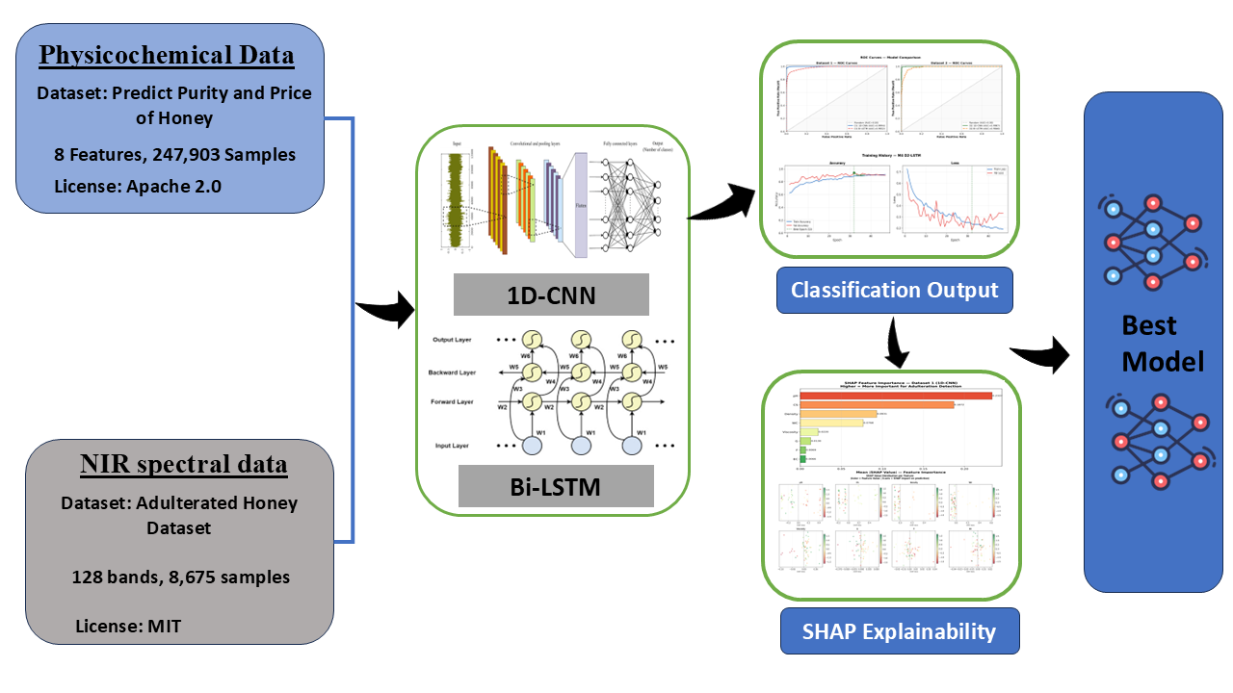
The methodology employed a common pipeline for each dataset, comprising data preparation, exploratory data analysis, preprocessing, model building, hyperparameter tuning, evaluation on a hold-out test set, and explanation of the results. The 1D-CNN and Bi-LSTM models were developed and optimised separately for both datasets, resulting in four models (M1-M4). Subsequently, SHAP was used to analyse the most accurate physicochemical model. The process is depicted in Fig. 1.
Figure 1 . Computational workflow of the proposed framework, from the two input datasets through parallel 1D-CNN and Bi-LSTM development to classification output, SHAP explainability, and model selection.

2.2 Datasets
Two datasets with different characteristics were used to assess architectural performance across distinct data structures, as shown in Table 1. They differ in terms of size, modality, and source: D1 is synthetic and D2 is real.
Table 1. Composition and class balance of the two datasets used in this study
Dataset | Data type | Provenance | Total observations | Pure | Adulterated | Class ratio
D1 | Physicochemical (8 variables) | Synthetic | 247,903 | 159,381 (64.3%) | 88,522 (35.7%) | 1.8:1
D2 | Vis-NIR hyperspectral (128 bands) | Measured | 8,675 | 1,050 (12.1%) | 7,625 (87.9%) | 1:7.3

2.2.1 Physicochemical dataset (D1)

Dataset D1 comprises 247,903 observations obtained from the public Kaggle repository “Predict Purity and Price of Honey” (Varshitha, 2026). In total, 159,381 observations (64.3%) are labelled as pure, whereas 88,522 (35.7%) are labelled as adulterated. The dataset contains eight input variables: colour score (CS), density, water content (WC), pH, electrical conductivity (EC), fructose (F), glucose (G), and viscosity. This dataset was generated synthetically rather than measured experimentally. The variables were simulated across parameter ranges similar to those reported in the honey authenticity literature. The purity label was generated from the continuous purity score (correlation between purity score and binary purity label, r = 0.88) using a threshold procedure. Two implications should be considered when interpreting D1 results. First, the eight predictors are almost independent by definition (all pairwise |r| < 0.01; Fig. 2b), whereas the compositional variables of real honey are correlated. Second, training a classifier on D1 involves learning a synthetic generation function; classifier performance therefore measures decision-boundary recovery rather than the ability to detect adulteration in real honey.

2.2.2 Vis-NIR hyperspectral dataset (D2)
D2 represents the hyperspectral adulterated honey dataset collected at the University of Auckland by Phillips et al.(2021) and can be obtained from a public mirror site. The dataset consists of 8,675 records, which include 1,050 pure (12.1%) and 7,625 adulterated (87.9%). Each record has 128 spectral features extracted over the visible to near-shortwave infrared spectrum range (about 400-1000 nm). The dataset covers twelve honey varieties from seven New Zealand brands and twelve botanical origins, half of which are Mānuka. Adulteration was performed by mixing the honey with sugar at four concentrations: 5%, 10%, 25%, and 50% weight per weight, resulting in the 1:7.3 class imbalance, with one pure observation for approximately 7.3 adulterated observations.
The data are publicly available (Phillips et al., 2021) and were collected using a laboratory Vis-NIR hyperspectral imaging device operating in a wavelength range of about 400–1000 nm (Phillips & Abdulla, 2023). The 128 selected variables are the centres of the bands ranging from 399.40 to 1063.79 nm, spaced apart by approximately 5 nm, as shown in the feature table provided with the data release. The camera type, lighting source, integration settings, and pixel/region-of-interest value specifications are provided in the original data release. As the images were collected by the original investigators rather than the present authors, these specifications are not repeated here.
2.3 Exploratory data analysis

In D1, the class distributions of all eight physicochemical properties were analysed for both pure and adulterated classes, and Pearson correlations were calculated among the predictors and with the binary class variable. In D2, mean spectra were calculated for each class, together with the difference spectra between pure and adulterated samples.

2.4 Data preprocessing
D1 contains eight physicochemical characteristics, which were standardised using the StandardScaler technique with zero mean and unit variance; the StandardScaler was fitted to the entire feature set before splitting the data into training, validation, and testing subsets. No baseline or scatter correction was applied to D2, but a Savitzky–Golay derivative was used; the 128 raw reflectance values were standardised using StandardScaler, as in D1.

In both cases, the features were reshaped into the format required by the convolutional and recurrent layers (three-dimensional tensor of samples x time-steps x channels), with eight physicochemical features and 128 spectral bands each constituting one channel.

2.5 Dataset partitioning

The data for each experiment were randomly partitioned into training, validation, and testing sets. Models were fitted using the training set, hyperparameters were tuned using the validation set, and the test set was used once for final performance estimation. The data were stratifiedand randomly split in a 70/15/15 ratio for training, validation, and testing,respectively, using a fixedrandom seed of 42. This resulted in a split of 173,531 / 37,186 / 37,186 for D1 and 6,071 / 1,302 / 1,302 for D2.

2.6 One-dimensional convolutional neural network
The 1D-CNN model extracts local patterns by sliding learnable filters across neighbouring positions in the input sequence. For spectral data, this means learning relationships among adjacent bands without any prior selection of diagnostic wavelengths; for physicochemical data, it means learning interactions among adjacent variables in the input vector. Convolutional blocks were followed by pooling and fully connected layers that terminated in a sigmoid unit that outputs the probability of the pure class (Li et al., 2022). The number of convolutional blocks, filter counts, kernel sizes, pooling configuration, dense-layer widths, activation functions, and dropout rates were all treated as hyperparameters rather than fixed in advance.

2.7 Bidirectional long short-term memory network
The Bi-LSTM was included as a contrasting architecture. It processes the input sequence in both forward and reverse directions so that the representation at each position reflects context from both sides. This tests whether bidirectional sequential modelling offers any advantage over localised convolutional feature extraction on these data. The number of recurrent layers, hidden-unit counts, dropout, recurrent dropout rates, dense-layer configuration, and activation functions were optimised using the same procedure applied to the 1D-CNN (Tan et al., 2022).

2.8 Automated hyperparameter optimisation
Hyperparameters were optimised separately for each of the four model–dataset combinations using Optuna with the tree-structured Parzen Estimator sampler, which builds a probabilistic model of past trial outcomes and concentrates subsequent sampling where improvement is likely (Akiba et al., 2019). Thirty trials were run sequentially for each combination, with validation accuracy as the objective. The best configuration per combination was then retrained and evaluated once using the test set. Using the same search protocol for both architectures limits differences arising from unequal tuning effort.

2.9 Model training and performance evaluation
Optimised models were trained on the training subset with validation-set monitoring and then evaluated once on the held-out test subset using accuracy, precision, recall, F1-score, and area under the receiver operating characteristic curve (ROC-AUC). Confusion matrices were used to expose class-specific error patterns, and ROC curves were used to assess discrimination across thresholds (Minho et al., 2025). Throughout this study, the positive class was pure honey. Therefore, precision is the proportion of samples predicted to be pure that are genuinely pure, and recall is the proportion of genuinely pure samples identified by the model. This convention determines how classification errors should be interpreted: a false positive means adulterated honey passed as pure, which is a regulatory concern; low precision for the pure class reflects this failure mode. The F1-score is the harmonic mean of the two. Because D2 is strongly imbalanced, accuracy alone would be misleading, and complementary metrics are therefore reported alongside it.

2.10 Model convergence and generalisation
Training and validation accuracy and loss were tracked across epochs to assess convergence and detect overfitting. A widening and sustained gap between training and validation performance was interpreted as evidence of overfitting, and convergence of the two curves was interpreted as more stable behaviour. Final training–validation gaps were compared across the four optimised models (Ji et al., 2025).

2.11 SHAP-based model interpretation
SHAP was applied to the optimised physicochemical 1D-CNN (M1) to quantify the contribution of each variable to the model output. Mean absolute SHAP values were used to rank global feature importance, and the signed values were examined to establish the direction in which particular feature values influenced predictions. SHAP values were computed using the model-agnostic Kernel SHAP explainer (shap.KernelExplainer) wrapped around the trained 1D-CNN (M1). The background distribution comprised the first 150 samples of the D1 training partition, and SHAP values were computed for 60 samples drawn from the D1 test partition. SHAP was not applied to the spectral models because per-band attributions across 128 correlated variables would be difficult to interpret chemically; this is noted as a limitation in Section 4.

2.12 Computational environment
All data handling, model development, optimisation, and evaluation were performed using Python 3.11.9. Model development used TensorFlow/Keras (version 2.11), together with Optuna, SHAP, scikit-learn, NumPy, and pandas. All training was run on a CPU-only Windows workstation with no GPU acceleration.

3. RESULTS AND DISCUSSION

3.1 Dataset characteristics and exploratory analysis
The two datasets present different classification problems, as shown in Table 1. D1 is moderately imbalanced at 1.8:1 in favour of pure samples, while D2 is strongly imbalanced at 1:7.3 in favour of adulterated samples. This asymmetry, combined with the opposite direction of the imbalance in the two datasets, is the reason performance is reported through five complementary metrics and confusion matrices rather than accuracy alone.
Within D1, class separation was clearest for pH, density, and water content, while fructose, glucose, viscosity, and electrical conductivity overlapped almost completely between classes. Correlations with the binary label were uniformly weak: pH was the strongest (r = − 0.30), followed by density (r = −0.08), water content (r = −0.03), and colour score (r = 0.05), with fructose, glucose, and electrical conductivity at effectively zero as illustrated in Figure 2(c). Two observations follow. First, none of these variables alone has sufficient discriminatory capacity to distinguish between the classes, consistent with the multivariate approach of Amiry et al. (2017) and the broader chemometric literature on honey authentication (Tsagkaris et al., 2021). Second, a feature specific to D1 constrains interpretation: the predictors are also uncorrelated with each other (all pairwise |r| < 0.01), a structure arising from independent synthetic sampling that is not representative of real honey, where water content, density, and viscosity are strongly coupled. Conclusions about relative variable importance in D1 should therefore be interpreted cautiously.
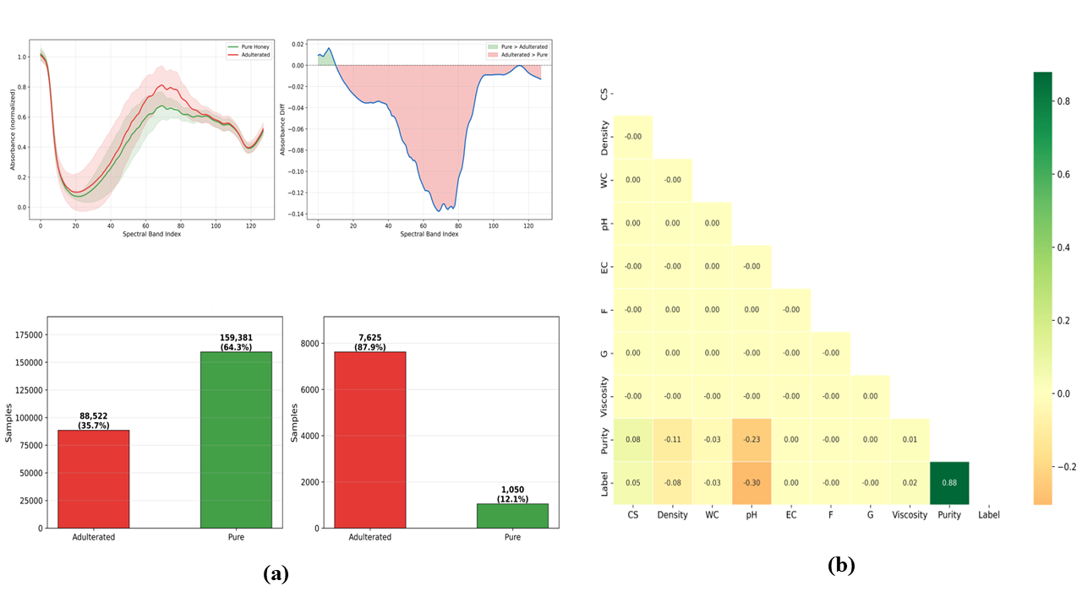
Figure 2 Exploratory analysis of the two datasets: (a) class distribution in D1 and D2; (b) mean Vis-NIR spectra of pure and adulterated honey with the corresponding difference spectrum for D2; (c) Pearson correlation matrix for the D1 predictors, purity score and binary level

3.2 Spectral characteristics and implications for convolutional modelling
The class-mean spectra of D2 differ across much of the measured range rather than at isolated bands, with the largest separation between bands 65 and 80, where the pure-minus-adulterated difference reaches approximately −0.138 as shown in Figure 2(b). Because the measurement covers roughly 400–1000 nm, these differences arise from a combination of colour-bearing constituents in the visible region and higher-order O–H and C–H overtones at the short-wave near-infrared end, both of which shift when a syrup displaces part of the honey matrix. In contrast, Bázár et al. (2016) located HFCS-related changes in water-associated features between 1300 and 1800 nm, a region outside the range measured here. The present spectral evidence is therefore complementary to, rather than a replication of, that work. Within the visible and short-wave NIR range, adulteration-related discrimination has been demonstrated repeatedly for honey (El Hajj & Estephan, 2025; Yang et al., 2020).
The practical implication for modelling is that the class signal is distributed across many correlated bands rather than concentrated at a few diagnostic wavelengths. This pattern is suited to convolutional kernels, which learn local relationships among adjacent bands without requiring prior wavelength selection and may therefore favour the 1D-CNN.

3.3 Optuna-based hyperparameter optimisation
Thirty trials per model were sufficient for the best-so-far curve to plateau in all four cases as illustrated in Figure 3(a). Best validation accuracies were 0.9644 for M1, 0.9209 for M2, 0.9869 for M3 and 0.9124 for M4. These values came from the Optuna trials themselves and were not directly comparable to those of the final retrained models reported in Sections 3.4 and 3.5, which were fitted afresh using the best configuration.
Hyperparameter importance depended strongly on architecture, as shown in Figure 3(b). The learning rate dominated for both physicochemical models, at 0.481 for M1 and 0.672 for M2. For the spectral 1D CNN (M3), kernel size was the leading factor at 0.324, ahead of dropout (0.223), learning rate (0.171), and filter count (0.161). For the spectral Bi-LSTM (M4), sensitivity was distributed across dense-layer size (0.326), dropout (0.280), and recurrent dropout (0.235). These results can be interpreted in relation to model design. Kernel size controls the receptive field across neighbouring bands; thus, the importance of kernel size in M3 suggests that the spectral window considered by the model is an important design parameter for these data. In contrast, the leading hyperparameters for M4 relate to model capacity and regularisation, which is consistent with training a high-capacity recurrent model on a relatively small, imbalanceddataset (LeCunet al., 2015).
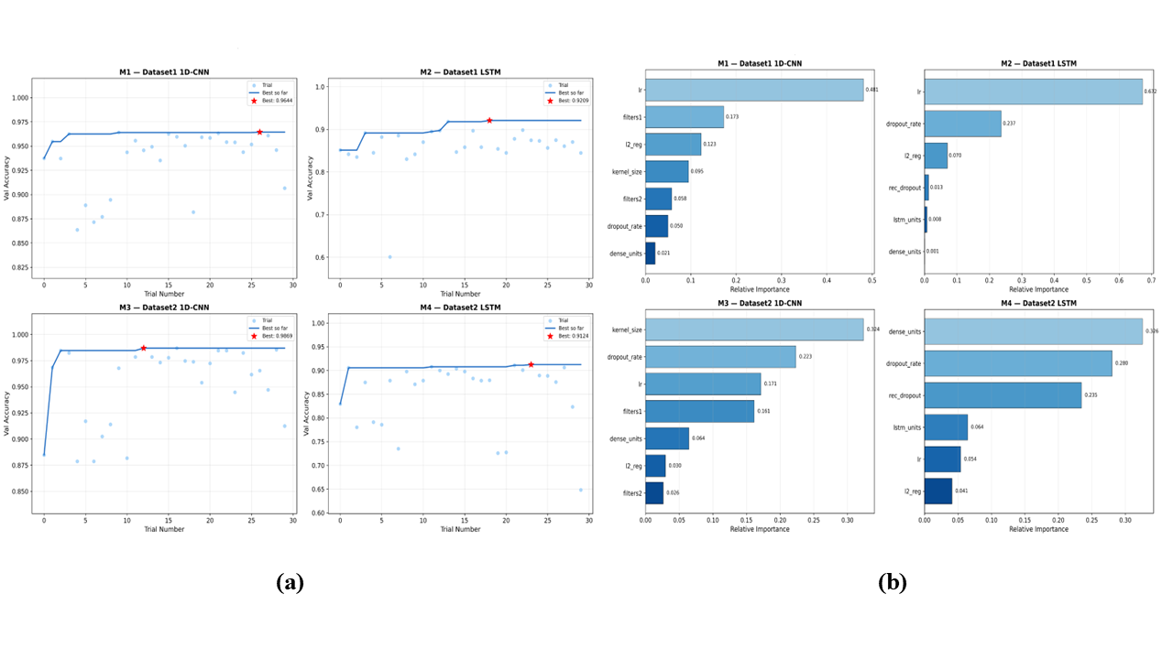
3.4 Model convergence and generalisation
Figure 3 Optuna-based hyperparameter optimisation: (a) validation accuracy across the thirty trials for each model, with the best trial marked; (b) relative importance of the optimised hyperparameters for each of the four models.
Convergence behaviour provided further distinctions between the models beyond their final performance values. M3 showed the most stable convergence, achieving about 0.985 training accuracy and 0.9931 validation accuracy after retraining, with the validation loss dropping below 0.10 without evident divergence. M2 and M4 both showed fluctuations; M4 showed increasing validation loss after approximately epoch 35 while training loss continued to decrease, a pattern consistent with overfitting in overparameterised networks (Goodfellow et al., 2016).
The final training-minus-validation accuracy gaps were −1.5%, −2.8%, −0.8%, and −2.6% for M1 to M4, respectively. The negative values indicate that validation accuracy slightly exceeded training accuracy, which can occur because dropout was active during training but not during evaluation. M3 had the smallest gap and the most consistent curve. All four gaps were relatively small, indicating consistency between training and validation performance under the optimised configurations; however, this establishes only internal validity. External validity requires independently collected samples (Hastie et al., 2009).

3.5 Comparative classification performance
The 1D-CNN outperformed the Bi-LSTM on both modalities and on every metric, as shown in Table 2 and Figure 4. On the physicochemical data, M1 achieved 98.49% accuracy with precision 0.9953, recall 0.9811, F1-score 0.9881, and ROC-AUC 0.9994, against 92.42%, 0.9307, 0.9531, 0.9417, and 0.9832 for M2. On the spectral data, M3 reached 99.08% accuracy with precision 0.9451, recall 0.9810, F1-score 0.9627, and ROC-AUC 0.9987, against 93.16%, 0.6494, 0.9491, 0.7712, and 0.9846 for M4. For M1, the confusion matrix shows 98.1% of pure samples and 99.2% of adulterated samples correctly classified.
An important result in this table concerns the weakest model. M4 combines high recall (0.9491) with low precision (0.6494) on the pure class, meaning that approximately one-third of the samples classified as pure are actually adulterated. This is the more consequential direction of error in a screening context, and this failure is obscured by an overall accuracy of 93.16%: with 87.9% of D2 adulterated, a model can score above 90% while performing poorly on the minority class. This is the standard argument for precision–recall reporting on imbalanced data (Saito & Rehmsmeier, 2015), as illustrated by M4. M3, on the same data and with the same imbalance, maintains a precision of 0.9451; therefore, the difference is associated with the architecture rather than differences in class distribution.
Table 2. Classification performance of the four optimised deep-learning models on the held-out test sets. Metrics are reported with pure honey as the positive class.
Model | Dataset | Modality | Architecture | Accuracy (%) | Precision | Recall | F1-score | ROC-AUC
M1 | D1 | Physicochemical | 1D-CNN | 98.49 | 0.9953 | 0.9811 | 0.9881 | 0.9994
M2 | D1 | Physicochemical | Bi-LSTM | 92.42 | 0.9307 | 0.9531 | 0.9417 | 0.9832
M3 | D2 | Vis-NIR | 1D-CNN | 99.08 | 0.9451 | 0.9810 | 0.9627 | 0.9987
M4 | D2 | Vis-NIR | Bi-LSTM | 93.16 | 0.6494 | 0.9491 | 0.7712 | 0.9846

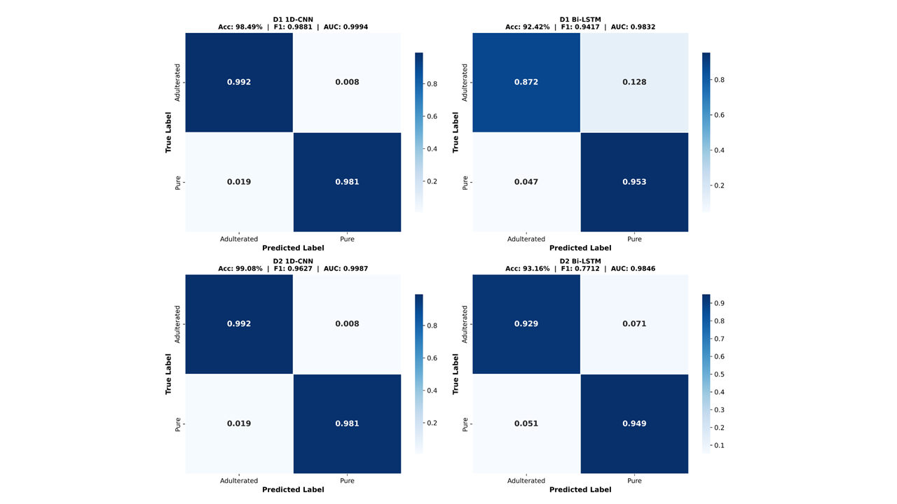
(a)

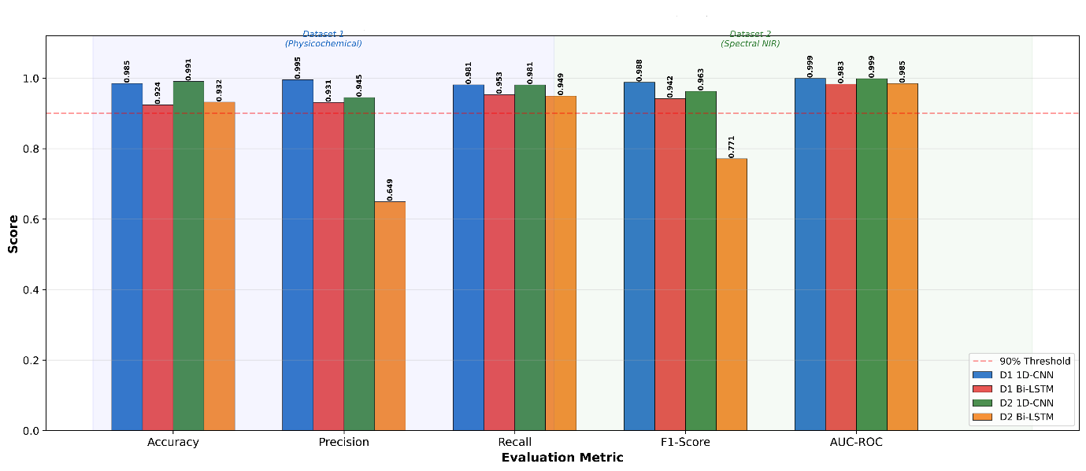
(b)

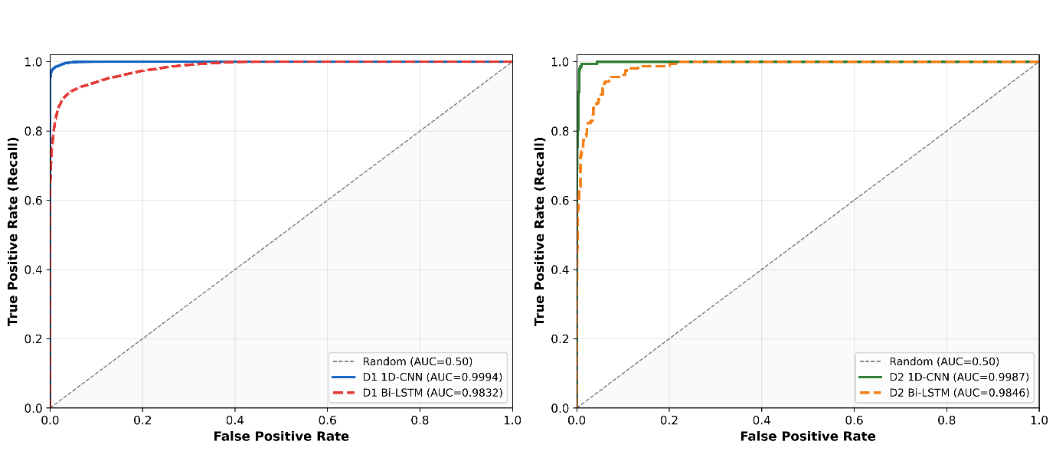
(C)

Figure 4. Comparative classification performance of the four optimised models: (a) normalised confusion matrices; (b) receiver operating characteristic curves; (c) accuracy, precision, recall and F1-score across models.
The consistent advantage of the convolutional architecture indicates that localised feature extraction matches the structure of both inputs better than bidirectional sequence modelling does. For the spectral data, one explanation is that adjacent wavelengths carry correlated, overlapping information, which is what convolutional kernels are designed to exploit, and the importance of kernel size in M3 supports this interpretation. For the physicochemical data, the eight variables have no inherent sequential ordering, so the long-range dependency modelling that justifies a recurrent architecture may offer limited benefit, while additional parameters may increase the risk of overfitting.
These findings are consistent with earlier work. Wu et al. (2022) coupled Raman spectroscopy with convolutional networks to detect and quantify honey adulteration at high accuracy, and Bertotto et al. (2026) reported similar success for FTIR-based deep chemometrics. Direct numerical comparisons across studies nevertheless require caution: sample size, adulterant type and concentration, class balance, preprocessing and validation strategy all vary and may each influence the reported results.

3.6 Discrimination capability and practical interpretation
All four models discriminated well across thresholds, with M1 (AUC 0.9994) and M3 (AUC 0.9987) ahead of M2 (0.9832) and M4 (0.9846). Near-unity AUC values indicate that the score distributions of the two classes overlap only slightly (Fawcett, 2006). Two qualifications are necessary. First, AUC is threshold-independent and therefore insensitive to the precision problem identified in M4; the two must be read together. Second, a high internal AUC does not guarantee comparable performance on honey from other sources, since composition varies with botanical and geographical origin, processing and storage (Tsagkaris et al., 2021). The models reported here should be regarded as promising screening tools pending independent validation.

3.7 SHAP-based interpretation of the physicochemical model
SHAP analysis of M1 ranked the eight predictors by mean absolute SHAP value as follows: pH (0.2337), colour score (0.1872), density (0.0931), water content (0.0768), viscosity (0.0220), glucose (0.0130), fructose (0.0069) and electrical conductivity (0.0066). pH and colour score together account for the majority of the attributed contribution, with density and water content playing secondary roles and the remaining four variables contributing relatively little, as shown in Figure 5(b).
The most interesting feature of this ranking is colour score. Its linear correlation with the label is only r = 0.05, yet it emerges as the second most important predictor, demonstrating that marginal correlation and predictive importance are different quantities, and that a variable can contribute substantially through interactions that a correlation coefficient does not capture (Lundberg & Lee, 2017). The prominence of pH is chemically sensible: honey is characteristically acidic, and syrup addition shifts it away from that range. Density and water content behave as matrix-level indicators, reflecting the altered balance of water and soluble solids that follows dilution with syrup, consistent with the compositional changes reported by Gajek et al. (2026) for sugar-adulterated honey.
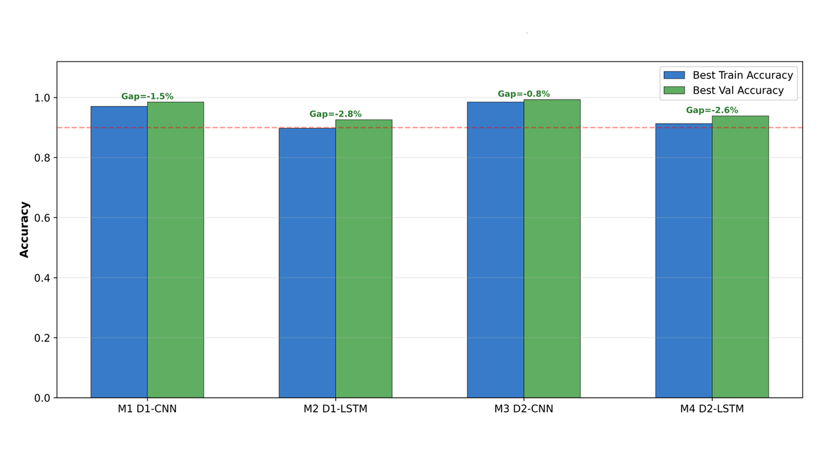
(a)
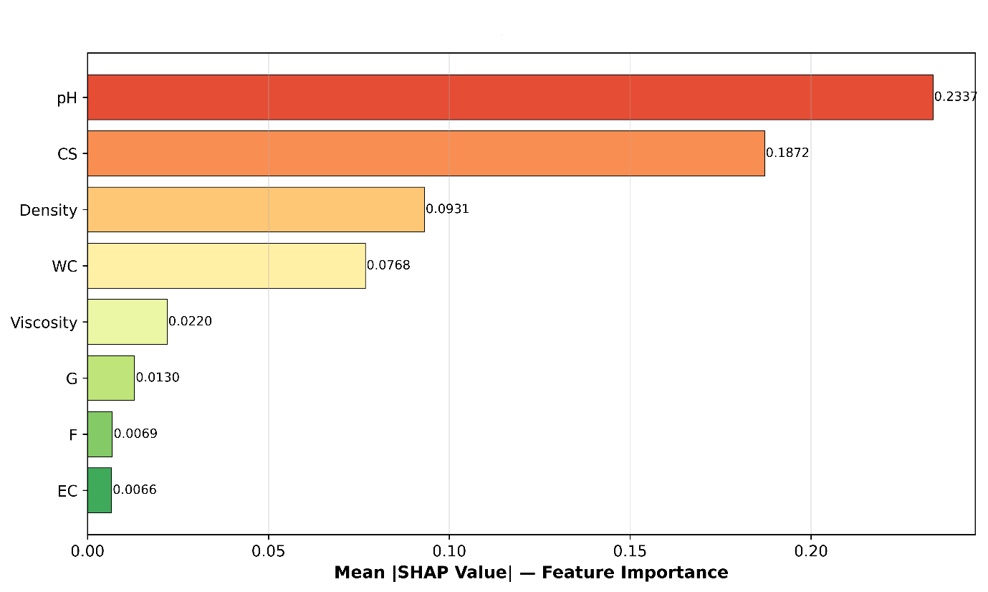
(b)

Fig. 5. Explainability and generalisation analysis: (a) training and validation accuracy trajectories for the optimised models; (b) global SHAP feature importance for the physicochemical 1D-CNN (M1), ordered by mean absolute SHAP value.

3.8 Directional interpretation and its limits
SHAP values of opposite signs indicate how pH values outside the characteristically acidic range shift predictions towards the adulterated class, whereas values within the range favour the pure class. The contributions of density and moisture content were consistent, suggesting that they can be considered markers of compositional change at the matrix level. However, fructose and glucose did not contribute significantly. This does not mean that sugars lack chemical significance; rather, they showed limited discriminatory ability in this dataset because they are major compounds in both honey and syrup used for adulteration, so their concentrations may change little following adulteration. Previous research supports the same conclusion: multivariate profiles are better than compositional variables for honey identification (Amiry et al., 2017; Downey et al., 2003). Chemical abundance and predictive importance are therefore distinct quantities in a nonlinear classifier.

However, one limitation of this interpretation should be acknowledged. Since D1 is artificial, the SHAP ranking reflects the D1 data-generating mechanism, rather than necessarily representing the chemical composition of adulterated honey itself. The high ranking of pH is consistent with established honey chemistry. Although the ranking demonstrates the framework’s capacity to produce interpretable explanations, it does not establishwhich physicochemical factors are most effective for detecting adulteration. Further research is required to establish this.

4. Limitations
Four limitations qualify the conclusions of this study and are presented together to facilitate their consideration.
- Synthetic physicochemical data. D1 is simulated. The results demonstrate that the framework efficiently recovers and coherently explains a known nonlinear decision rule; they do not demonstrate detection performance on real honey.
- Internal validation only. All reported metrics come from held-out partitions of the same datasets used for training. No independent external test set was used, so generalisation across instruments, origins and adulteration protocols remains untested.
- Binary framing. Adulteration was treated as a two-class problem. D2 contains four adulteration levels (5–50% w/w), and a model that distinguishes pure honey from samples adulterated at 50% may perform less well at 5%. Level-resolved performance was not assessed and is an important extension of this work.
- Explainability limited to one modality. SHAP was applied only to the physicochemical model. Band-level attribution for the spectral models was not attempted, although it is computationally feasible, so the chemical basis of the 1D-CNN’s spectral decisions remains uncharacterised.

5. Conclusions
An optimised one-dimensional convolutional neural network classified pure and adulterated honey accurately and interpretably across two very different data modalities, outperforming a bidirectional LSTM optimised under identical conditions in every comparison made. On the Vis-NIR hyperspectral data, the convolutional model achieved 99.08% accuracy with a ROC-AUC of 0.9987, and, more importantly for practical screening, maintained a precision of 0.9451 for the minority pure class, compared with 0.6494 for the recurrent model. SHAP analysis identified pH and colour score as the dominant predictors in the physicochemical model, followed by density and water content, linking model behaviour to compositional changes that are chemically plausible for syrup addition.
The contribution here is a reproducible template rather than an externally validated assay. Automated hyperparameter optimisation supports a consistent architecture comparison, and SHAP supports interpretation of the resulting model, which matters for any method intended for regulatory or commercial use. Realising that potential depends on external validation with independently collected honey spanning botanical and geographical origins, adulterant types, adulteration levels and processing conditions, together with level-resolved rather than purely binary evaluation. Consistent reporting of dataset provenance, spectral acquisition, preprocessing, architecture, optimisation ranges and software versions will be equally important, both for reproducibility and for the regulatory acceptance needed for practical deployment.

Conflict Of Interest
The authors declare no conflicts of interest that could have influenced the work presented in this manuscript.

Data Availability
Two publicly available datasets were used in this study. The physicochemical dataset (D1) was obtained from the Kaggle repository Predict Purity and Price of Honey (Varshitha, 2026) and is distributed under the Apache 2.0 License. The dataset was synthetically generated to represent realistic physicochemical properties of honey. The variables included in the dataset and their corresponding parameter ranges are presented in Section 2.2. This dataset was used for the physicochemical analysis and interpretation carried out in the present study.
The Vis-NIR hyperspectral dataset (D2) was originally collected and reported by Phillips et al. (2021) and is publicly available through the University of Auckland data repository (https://doi.org/10.17608/k6.auckland.16441686.v1). The same dataset is also available through the Kaggle repository Adulterated Honey Dataset under the MIT License. In this study, D2 was used to investigate Vis-NIR hyperspectral characteristics associated with honey adulteration.
Declaration of AI Use

This manuscript was prepared through the intellectual contributions of the author(s) to the study design, data analysis, interpretation of results, and scholarly content. Grammarly and ChatGPT were used solely to assist with grammatical refinement and reference formatting during manuscript revision. The author(s) accept full responsibility for the accuracy, integrity, and final content of the manuscript.

References
Ahmed, E. (2024). Detection of honey adulteration using machine learning. PLOS Digital Health, 3(6), e0000536. https://doi.org/10.1371/journal.pdig.0000536
Akiba, T., Sano, S., Yanase, T., Ohta, T., & Koyama, M. (2019). Optuna: A next-generation hyperparameter optimization framework. In Proceedings of the 25th ACM SIGKDD International Conference on Knowledge Discovery & Data Mining (pp. 2623–2631). Association for Computing Machinery. https://doi.org/10.1145/3292500.3330701
Al Noman, M. A., Nijhum, A. B., Hossain, I., Islam, M. S., Sifat, I. M., Aziz, M. G., & Rahman, A. (2025). Non-destructive adulterants detection in various honey types in Bangladesh using UV–VIS–NIR spectroscopy coupled with machine learning algorithms. LWT, 228, 118125. https://doi.org/10.1016/j.lwt.2025.118125
Al Noman, M. A., Nijhum, A. B., Hossain, I., Aziz, M. G., & Rahman, A. (2026). Quantification of adulteration in Bangladeshi honey varieties using UV–vis–NIR spectroscopy and SHAP-guided machine learning. NFS Journal, 43, 100268. https://doi.org/10.1016/j.nfs.2026.100268
Amiry, S., Esmaiili, M., & Alizadeh, M. (2017). Classification of adulterated honeys by multivariate analysis. Food Chemistry, 224, 390–397. https://doi.org/10.1016/j.foodchem.2016.12.025
Bázár, G., Romvári, R., Szabó, A., Somogyi, T., Éles, V., & Tsenkova, R. (2016). NIR detection of honey adulteration reveals differences in water spectral pattern. Food Chemistry, 194, 873–880. https://doi.org/10.1016/j.foodchem.2015.08.092
Bertotto, M., Krause, W. O., Bertotto, J., Ghidoli, P., Fusca, V., & Bello, M. O. (2026). Deep chemometrics with convolutional neural networks for the detection of honey adulteration using Fourier transform infrared spectroscopy. Spectrochimica Acta Part A: Molecular and Biomolecular Spectroscopy, 355, 127167. https://doi.org/10.1016/j.saa.2025.127167
Biradar, V. M., Hiregoudar, S., Patil, R., & Begum, S. (2026). Detection of jaggery syrup adulteration in Apis mellifera honey using a multispectral sensor coupled with machine learning. European Journal of Nutrition & Food Safety, 18(8), 29–42. https://doi.org/10.9734/ejnfs/2026/v18i82114
Biswas, A., & Chaudhari, S. R. (2024). Exploring the role of NIR spectroscopy in quantifying and verifying honey authenticity: A review. Food Chemistry, 445, 138712. https://doi.org/10.1016/j.foodchem.2024.138712
Dodd, S., Kevei, Z., Karimi, Z., Parmar, B., Franklin, D., Koidis, A., & Anastasiadi, M. (2025). Detection of sugar syrup adulteration in UK honey using DNA barcoding. Food Control, 167, 110772. https://doi.org/10.1016/j.foodcont.2024.110772
Downey, G., Fouratier, V., & Kelly, J. D. (2003). Detection of honey adulteration by addition of fructose and glucose using near infrared transflectance spectroscopy. Journal of Near Infrared Spectroscopy, 11(6), 447–456. https://doi.org/10.1255/jnirs.395
Egido, C., Saurina, J., Sentellas, S., & Núñez, O. (2024). Honey fraud detection based on sugar syrup adulterations by HPLC-UV fingerprinting and chemometrics. Food Chemistry, 436, 137758. https://doi.org/10.1016/j.foodchem.2023.137758
El Hajj, R., & Estephan, N. (2025). Advances in infrared spectroscopy and chemometrics for honey analysis: A comprehensive review. Critical Reviews in Food Science and Nutrition, 65(29), 6371–6384. https://doi.org/10.1080/10408398.2024.2439055
Fawcett, T. (2006). An introduction to ROC analysis. Pattern Recognition Letters, 27(8), 861–874. https://doi.org/10.1016/j.patrec.2005.10.010
Gajek, M., Moj, K., Wysocki, P., Kuśmierek, E., & Szynkowska-Jóźwik, M. I. (2026). Analysis of changes in selected physicochemical parameters and elemental composition of honey as a result of adulteration with sugar additives. Foods, 15(3), 562. https://doi.org/10.3390/foods15030562
Goodfellow, I., Bengio, Y., & Courville, A. (2016). Deep learning. MIT Press. https://mitpress.mit.edu/9780262035613/deep-learning/
Hastie, T., Tibshirani, R., & Friedman, J. (2009). The elements of statistical learning: Data mining, inference, and prediction (2nd ed.). Springer. https://doi.org/10.1007/978-0-387-84858-7
Ji, S., Granato, D., Wang, K., Hao, S., & Xuan, H. (2025). Detecting the authenticity of two monofloral honeys based on the Canny-GoogLeNet deep learning network combined with three-dimensional fluorescence spectroscopy. Food Chemistry, 485, 144509. https://doi.org/10.1016/j.foodchem.2025.144509
Kumar, N., Gupta, K. K., & Panchariya, P. C. (2025). Qualitative and quantitative analysis of Indian honey samples and various adulterants using near infrared spectroscopy with water as a sensing probe (aquaphotomics) and chemometrics. Journal of Food Composition and Analysis, 144, 107735. https://doi.org/10.1016/j.jfca.2025.107735
LeCun, Y., Bengio, Y., & Hinton, G. (2015). Deep learning. Nature, 521(7553), 436–444. https://doi.org/10.1038/nature14539
Li, M., Pan, T., Bai, Y., & Chen, Q. (2022). Development of a calibration model for near infrared spectroscopy using a convolutional neural network. Journal of Near Infrared Spectroscopy, 30(2), 89–96. https://doi.org/10.1177/09670335211057234
Lundberg, S. M., & Lee, S.-I. (2017). A unified approach to interpreting model predictions. In I. Guyon, U. von Luxburg, S. Bengio, H. Wallach, R. Fergus, S. Vishwanathan, & R. Garnett (Eds.), Advances in neural information processing systems (Vol. 30, pp. 4765–4774). Curran Associates, Inc. https://suinlee.cs.washington.edu/publications
Malek, S., Melgani, F., & Bazi, Y. (2018). One-dimensional convolutional neural networks for spectroscopic signal regression. Journal of Chemometrics, 32(5), e2977. https://doi.org/10.1002/cem.2977
Minho, L. A. C., de Lima Conceição, J., Barboza, O. M., de Freitas Santos Junior, A., & dos Santos, W. N. L. (2025). Robust deep heterogeneous ensemble and meta-learning for honey authentication. Food Chemistry, 482, 144001. https://doi.org/10.1016/j.foodchem.2025.144001
Phillips, T., & Abdulla, W. (2023). A new honey adulteration detection approach using hyperspectral imaging and machine learning. European Food Research and Technology, 249(2), 259–272. https://doi.org/10.1007/s00217-022-04113-9
Phillips, T., Coleman, B., Takano, S., & Abdulla, W. (2021). Hyperspectral imaging adulterated honey dataset [Data set]. University of Auckland. https://doi.org/10.17608/k6.auckland.16441686.v1
Prata, J. C., & da Costa, P. M. (2024). Fourier transform infrared spectroscopy use in honey characterization and authentication: A systematic review. ACS Food Science & Technology, 4(8), 1817–1828. https://doi.org/10.1021/acsfoodscitech.4c00377
Saito, T., & Rehmsmeier, M. (2015). The precision-recall plot is more informative than the ROC plot when evaluating binary classifiers on imbalanced datasets. PLOS ONE, 10(3), e0118432. https://doi.org/10.1371/journal.pone.0118432
Sawarkar, A. B. (2025). Comparative physicochemical properties of honey from Apis cerana indica and Apis dorsata across different floral origins in Khandesh, North Maharashtra, India. Uttar Pradesh Journal of Zoology, 46(2), 12–24. https://doi.org/10.56557/upjoz/2025/v46i24759
Schuster, M., & Paliwal, K. K. (1997). Bidirectional recurrent neural networks. IEEE Transactions on Signal Processing, 45(11), 2673–2681. https://doi.org/10.1109/78.650093
Shi, S., Zhang, K., Tian, N., Jin, Z., Liu, K., Huang, L., Tian, X., Cao, C., Zhang, Y., & Jiang, Y. (2025). Spectroscopic techniques combined with chemometrics for rapid detection of food adulteration: Applications, perspectives, and challenges. Food Research International, 211, 116459. https://doi.org/10.1016/j.foodres.2025.116459
Varshitha, D. N., Mulakaluri, S., Anitha Kumari, R. D., Latha, D. U., & Choudhary, S. (2026). Deep learning-based assessment of honey purity using predictive modelling. Asian Journal of Dairy and Food Research. https://doi.org/10.18805/ajdfr.DR-2451
Tan, A., Wang, Y., Zhao, Y., Wang, B., Li, X., & Wang, A. X. (2022). Near infrared spectroscopy quantification based on Bi-LSTM and transfer learning for new scenarios. Spectrochimica Acta Part A: Molecular and Biomolecular Spectroscopy, 283, 121759. https://doi.org/10.1016/j.saa.2022.121759
Tsagkaris, A. S., Koulis, G. A., Danezis, G. P., Martakos, I., Dasenaki, M., Georgiou, C. A., & Thomaidis, N. S. (2021). Honey authenticity: Analytical techniques, state of the art and challenges. RSC Advances, 11(19), 11273–11294. https://doi.org/10.1039/d1ra00069a
Wu, X., Xu, B., Ma, R., Niu, Y., Gao, S., Liu, H., & Zhang, Y. (2022). Identification and quantification of adulterated honey by Raman spectroscopy combined with convolutional neural network and chemometrics. Spectrochimica Acta Part A: Molecular and Biomolecular Spectroscopy, 274, 121133. https://doi.org/10.1016/j.saa.2022.121133
Yang, X., Guang, P., Xu, G., Zhu, S., Chen, Z., & Huang, F. (2020). Manuka honey adulteration detection based on near-infrared spectroscopy combined with aquaphotomics. LWT, 132, 109837. https://doi.org/10.1016/j.lwt.2020.109837
Zhang, X. H., Gu, H. W., Liu, R. J., Qing, X. D., & Nie, J. F. (2023). A comprehensive review of the current trends and recent advancements on the authenticity of honey. Food Chemistry: X, 19, 100850. https://doi.org/10.1016/j.fochx.2023.100850

​

