Preparation and Preliminary Evaluation of Chitosan–Tripolyphosphate–ZnO Bionanocomposite Membranes for Methylene Blue Removal

ABSTRACT
Chitosan-based films provide a biodegradable polymeric platform for the preparation of composite membranes through ionic crosslinking and the incorporation of inorganic materials. In this study, a chitosan–tripolyphosphate–zinc oxide (CTPP-ZnO) bionanocomposite film was prepared using chitosan dissolved in 2% acetic acid, followed by mixing with zinc oxide and crosslinking with sodium tripolyphosphate at approximately pH 5.0. The resulting mixture was cast and oven-dried to obtain a CTPP-ZnO membrane. The crosslinking mechanism is based on electrostatic interactions between protonated amino groups of chitosan and negatively charged phosphate groups of tripolyphosphate, while the β-1,4-glycosidic backbone of chitosan remains the principal structural framework of the polymer. Morphological characteristics of the prepared material were examined using scanning electron microscopy. A preliminary membrane-performance test was also conducted by passing a 4 ppm methylene blue solution through the membrane under a pressure of 10 bar. The observations support the formation of a cross-linked chitosan-based matrix containing zinc oxide and indicate morphological differences between chitosan and the composite film. However, the available measurements do not quantitatively distinguish dye adsorption, pressure-driven separation and photocatalytic degradation. Additional physicochemical, structural and membrane-performance characterisation is therefore required to establish the contribution of zinc oxide and tripolyphosphate to the functional properties of the composite. The study demonstrates a simple preparation approach for a chitosan-based composite film intended for further investigation as a functional membrane material.

Keywords: Chitosan, sodium tripolyphosphate, zinc oxide nanoparticles, bionanocomposite membrane, ionic crosslinking, ionotropic gelation, methylene blue, scanning electron microscopy, dye removal, membrane performance

[1] .INTRODUCTION :

Nowadays, biopolymer-based films are being developed as alternatives to plastic-based films because they are effective, non-toxic, inexpensive, flexible and widely available. A film or membrane is a thin, selective barrier that allows some substances to pass through while retaining others. Such substances may include molecules, ions or other small nanoparticles. Films are often used for purification in processes such as haemodialysis, biodiesel production and bioreactors, with the aim of improving membrane efficiency, continuous operation and energy conservation. Recent studies have investigated the properties of membranes synthesised from biopolymers, for example, membranes made from polysaccharides such as cellulose and chitosan (Aranaz et al., 2021; Sacco et al., 2014). The glucose ring is the basic unit of the backbone of both cellulose and chitosan polysaccharides, which are linked by β-1,4 glycosidic units (Kim et al., 2022). These polymers are insoluble in water and differ structurally in their nitrogen-containing side groups. From a chemical perspective, chitosan is one of the natural polymers and is a deacetylated product of chitin, which is usually sourced from molluscs and shrimp or crab skins (Zhang et al., 2024; Furlani et al., 2019). The reactive groups in chitosan include a primary amino group (C2) and primary and secondary hydroxyl groups (C6, C3). Glycosidic bonds and the acetamide group can also be considered functional groups, which allow numerous reactant-based reactions to produce polymers with new behaviours and properties. Applications of chitosan-based biopolymers include drug-delivery carriers and food preservatives because of their biocompatibility, outstanding antibacterial properties and biomedical applications (Cánepa et al., 2017; Abri et al., 2019; Nguyen et al., 2019; Parchen et al., 2025).
Recent studies continue to use tripolyphosphate as a polyanionic crosslinking component for chitosan-based nanostructures, while chitosan has also been used as a matrix for zinc oxide nanomaterials (Ahamed et al., 2025; Saraswat et al., 2024). In water-treatment-oriented systems, chitosan-ZnO composites have been investigated for dye removal and photocatalytic decolourisation, including methylene blue, supporting the relevance of combining chitosan-based matrices with ZnO for functional membrane and pollutant-removal studies (Subagyo et al., 2024; Karabaş et al., 2025; Adnan et al., 2025).

In this article, we report a bionanocomposite (BNC) material based on β-1,4-chitosan crosslinking with multivalent tripolyphosphate (TPP) anions, forming a coordination complex with embedded zinc oxide (ZnO) nanoparticles in a rapidly developed, eco-friendly chitosan-tripolyphosphate-zinc oxide (CTPP-ZnO) film (Dimkpa et al., 2023; Chalitangkoon et al., 2025). This β-1,4-chitosan-tripolyphosphate-zinc oxide nanocomposite is a highly versatile, eco-friendly material. The role of the β-1,4 bonds in the CTPP-ZnO nanocomposite is to maintain backbone integrity by preserving the rigidity and physicochemical stability of the linear polysaccharide chains, making them well suited for a range of biomedical applications, particularly drug delivery. The powdered form and hexagonal crystal structure of zinc oxide (ZnO) nanoparticles, which can be considered to be composed of two interpenetrating hexagonal close-packed (hcp) cation-anion sublattices (Zn⁺⁺ and O²⁻) (Cotton et al., 1999), are shown in Figure 1; the structure of β-(1-4)-linked chitosan and the tripolyphosphate (CTPP) ion is shown in Figure 2. The crosslink between the two reagents is not harmful to humans. It is a source of film production. It is a source of income. The manuscript provides literature for future scientists in the field of chemical technology.
In the present manuscript, the unresolved point is whether the selected preparation conditions can yield a CTPP-ZnO membrane with observable morphological modification and preliminary suitability for pressure-driven methylene blue testing. Because the available test does not separately quantify adsorption, pressure-driven separation, or photocatalytic degradation, these mechanisms are not treated as established outcomes.
Objective: To prepare a chitosan-tripolyphosphate-zinc oxide (CTPP-ZnO) bionanocomposite membrane by ionic crosslinking, examine its morphology using scanning electron microscopy, and conduct a preliminary membrane-performance test using 4 ppm methylene blue at 10 bar.

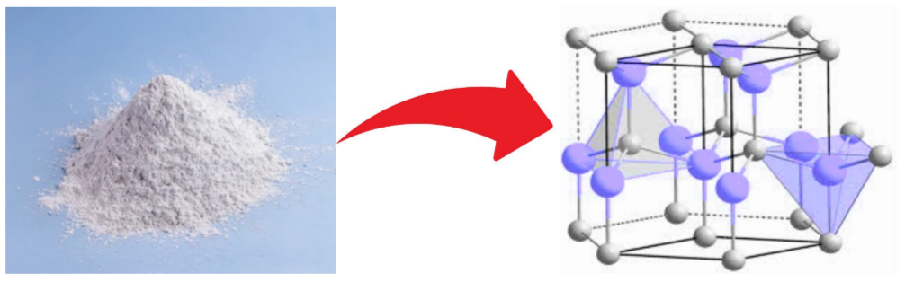

Figure 1. The powdered form and hexagonal crystal structure of zinc oxide (ZnO) nanoparticles
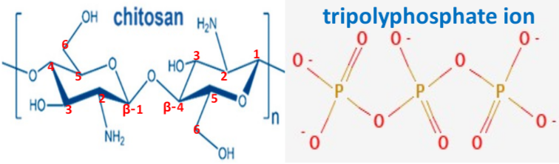

Figure 2. The structure (chair-form) ofβ-(1-4) linkedchitosan molecule and tripolyphosphate (TPP) ion

[2]. Methodology:

In this procedure, all reagents and chemicals required for the preparation of the CTPP-ZnO nanocomposite, namely chitosan, sodium tripolyphosphate (Na₅P₃O₁₀), acetic acid (CH₃COOH) and solid zinc oxide (ZnO) powder, were laboratory-grade analytical reagents and were used without further purification. Typically, a carbonate-free basic NaOH solution was prepared following Vogel's procedure (Vogel, 1989). Reagent-grade solutions, including Na₅P₃O₁₀ (sodium tripolyphosphate) stock solution, CH₃COOH (acetic acid) and purified distilled water, were prepared and used throughout the work. All calibrated and Class A volumetric glassware were used. First, chitosan was dissolved in an aqueous acidic solution, typically 2% acetic acid (CH₃COOH), at a ratio of 1:50, and was then stirred and heated at about 50 to 60°C. After the chitosan solution became homogeneous, it was mixed with ZnO (zinc oxide), and the solution was stirred at 1300 rpm for 30 minutes. Once homogeneous, sodium tripolyphosphate (Na₅P₃O₁₀) solution, used as a crosslinker and prepared in deionised water, was added at approximately pH 5.0 until a clear suspension was obtained. The TPP solution was then added dropwise to the previously prepared chitosan sample solution under vigorous or magnetic stirring at room temperature. Subsequently, 50 mL of the resulting solution was transferred into Teflon moulds and oven-dried at about 60°C until a CTPP-ZnO membrane (film) was obtained. The membrane-performance test was conducted by passing a 4 ppm methylene blue dye solution through the membrane under pressure controlled at 10 bar by a valve.

[3]. RESULTS AND DISCUSSION:

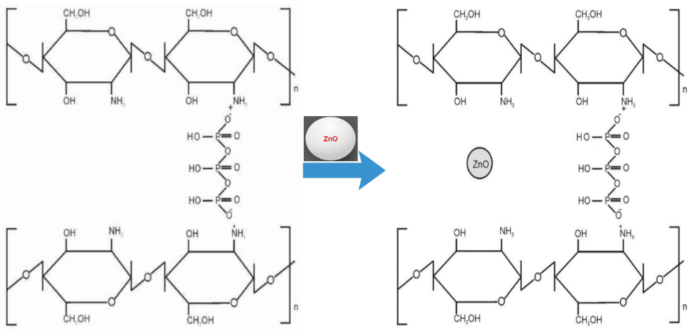

Figure 3. A schematic cross-linked structure of chitosan-tripolyphosphate (CTPP) in CTPP-zinc oxide (ZnO) nanocomposite ecofilm

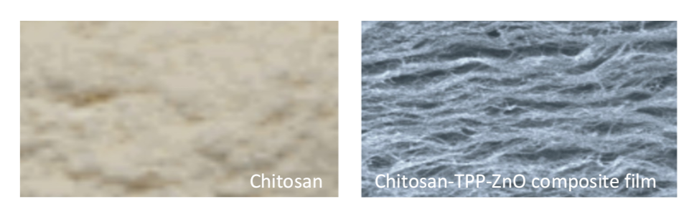

Figure 4. A SEM image of chitosan and chitosan-tripolyphosphate-zinc oxide (CTPP-ZnO)composite film

During the preparation of chitosan-tripolyphosphate (CTPP) films, the dominant polymer solution is chitosan and acetic acid (CH₃COOH), to which sodium tripolyphosphate (Na₅P₃O₁₀) is added at concentrations of 0.5, 1.0 and 1.5% at pH 5.0. Notably, at acidic pH, polymeric chitosan is in cationic form and therefore contains NH₃⁺ groups that can bind to anionic tripolyphosphate (TPP). Here, tripolyphosphate acts as an ionic crosslinker that binds to the positively charged amino groups of chitosan. This ‘ionotropic gelation’ binds the polymer matrix together, enhancing its tensile strength and durability. Figure 3 illustrates the bonding between β-1,4-linked chitosan and TPP with ZnO (zinc oxide) nanoparticles in the CTPP-ZnO film or membrane. During film preparation, chitosan-TPP is mixed with zinc oxide at 1300 rpm until homogeneous and is then oven-dried at 60°C until a CTPP-ZnO hydrogel-type membrane is formed. To improve the stability of the CTPP membrane, one possible method is the interlinking of chitosan with tripolyphosphate (TPP) to form complex polyelectrolyte CTPP-ZnO bionanocomposite films for improved performance (Genedy et al., 2024; Hu et al., 2010). The CTPP-ZnO membrane has electroconductive properties because structural oxygen vacancies and point defects in the ZnO lattice confer n-type semiconducting properties on the hybrid polymer.
An attempt has been made to combine organic and inorganic membranes through ionic crosslinking. These observations are consistent with the established ionotropic-gelation mechanism, in which protonated chitosan amine groups interact electrostatically with multivalent tripolyphosphate phosphate groups; the extent of crosslinking and the resulting network or particle morphology are sensitive to pH, polymer concentration and the chitosan-to-tripolyphosphate ratio (Poureghbal et al., 2022; Alehosseini et al., 2022; Hamidi et al., 2022). Accordingly, the use of pH 5.0 and different tripolyphosphate concentrations in the present formulation is chemically plausible, although the degree of crosslinking would require complementary spectroscopic, swelling or mechanical measurements for quantitative confirmation.

The β-1,4 glycosidic linkage is the primary backbone structure of the linear chitosan polymer and remains intact during ionic crosslinking of chitosan with tripolyphosphate (TPP) during nanocomposite formation. Chemically, chitosan consists of β-1,4 glycosidic linkages involving 2-acetamido-2-deoxy-β-D-glucopyranose residues; these covalent backbone bonds connect the repeating D-glucosamine and N-acetyl-D-glucosamine units within the chitosan polymer chain. The role of the β-1,4 bonds in chitosan-TPP nanocomposites is to maintain backbone integrity by preserving the rigidity and functional and physicochemical stability of the linear polysaccharide chains, making them well suited for a range of biomedical applications, particularly drug delivery. In ionic crosslinking, TPP acts as a polyanion with negatively charged phosphate groups (-P₃O₁₀⁵⁻) that interact electrostatically via ionic gelation with the positively charged protonated amine groups (-NH₃⁺) of the chitosan backbone (Hidaka et al., 2024; Filion et al., 2007). These CTPP-ZnO nanocomposite ecofilms reported in the present study were characterised using SEM (scanning electron microscopy), as shown above in Figure 4.
Previous studies of chitosan/ZnO composite membranes and films have shown that ZnO incorporation can alter surface morphology and that nanoparticle distribution within the chitosan matrix depends on the preparation route and ZnO loading (Li et al., 2010; Qiu et al., 2019; Zhang et al., 2021). Therefore, the morphological contrast shown in Figure 4 is consistent with the formation of a chitosan/ZnO-containing composite; however, SEM alone does not establish the chemical state, crystallinity or spatial uniformity of ZnO, and complementary XRD, EDX or FTIR analysis would strengthen the structural interpretation.

In photocatalytic applications, composite polymers can act as active catalysts for degrading organic pollutants or dyes. Thus, the impregnation of ZnO (zinc oxide) nanoparticles into a chitosan-tripolyphosphate (CTPP) film is expected to degrade pollutants trapped on the membrane surface and improve antifouling performance. The pollutant used in the membrane-performance test is methylene blue dye, and the methylene blue solution is passed through the CTPP-ZnO membrane with reverse-osmosis action. However, during the fixation process, a large amount of dye is lost with wastewater. Another weakness of the chitosan membrane is its instability at acidic pH (pKa value is approximately 6.2 to 6.5). The use of methylene blue dye may also influence the effect of pH on adsorption and photocatalytic degradation activity. Because TPP membranes are hydrophilic in nature, aqueous methylene blue solution diffuses through the CTPP-ZnO membrane and is trapped on the membrane surface. Thus, to improve the stability of the chitosan membrane, one possible method is to interlink chitosan with tripolyphosphates to form complex polyelectrolyte membranes for improved performance (Tang et al., 2024; Cui et al., 2019).

The experimental method is based on electrostatic interactions. The intermolecular bonding between the CTPP membrane and water is considered to involve van der Waals forces. Zinc oxide nanoparticles may be predicted to have the capability to degrade compounds such as methylene blue dye at the membrane surface, where van der Waals interactions are mainly reported together with ionic bonding between negatively charged methylene blue (-SO₃⁻) and positively charged zinc oxide in the Zn(OH)⁺ form. The presence of TPP and ZnO nanoparticles may inhibit water adsorption because they could obstruct the -OH (hydroxyl) and amine functional groups of the membrane. The impregnation of zinc oxide nanoparticles can affect membrane morphology, making the surface rougher, and can also affect the hydrophilicity of the membrane surface. Therefore, for the performance test, methylene blue dye at a concentration of 4 ppm is passed or diffused through the membrane under pressure controlled at 10 bar by a valve. Applications of chitosan-based biopolymers include drug-delivery carriers and food preservatives because of their perfect biocompatibility, outstanding antibacterial properties and other biomedical properties (Canama et al., 2023; Ji et al., 2024; Bui et al., 2025; Wongput et al., 2026).
Extensive research has examined chitosan/ZnO composite membranes for methylene blue adsorption and/or photocatalytic degradation, with performance strongly influenced by irradiation conditions, pH, catalyst loading, initial dye concentration and contact time (Haldorai & Shim, 2013; Zango et al., 2022; Madhan et al., 2021). In the present study, passage of 4 ppm methylene blue through the CTPP-ZnO membrane at 10 bar provides a preliminary indication of membrane performance; however, without paired feed and permeate concentrations, irradiation conditions, flux and rejection or degradation efficiency, adsorption, pressure-driven separation and photocatalysis cannot be quantitatively distinguished. Because it investigates the preparation of a biodegradable film with possible uses in membrane-based environmental clean-up, this manuscript is significant to the scientific community. ZnO nanoparticles, ionic crosslinking and a renewable biopolymer offer a viable framework for creating multipurpose materials for pollutant removal.

[4]. CONCLUSION:

A chitosan–tripolyphosphate–zinc oxide bionanocomposite membrane was prepared through ionic crosslinking of chitosan with tripolyphosphate in the presence of ZnO. The preparation procedure produced a membrane whose SEM appearance differed from that of chitosan, supporting morphological modification of the polymer matrix after composite formation. The proposed crosslinking process is based on electrostatic interaction between protonated amino groups of chitosan and negatively charged phosphate groups of tripolyphosphate, while the β-1,4-glycosidic backbone remains the principal polymer framework. A preliminary membrane-performance test was conducted using 4 ppm methylene blue at 10 bar. This test demonstrates that the prepared material can be subjected to pressure-driven dye testing, but the available data do not provide quantitative adsorption, rejection, flux or photocatalytic degradation efficiencies. Consequently, the individual roles of ZnO incorporation and tripolyphosphate crosslinking cannot yet be resolved. Additional structural and physicochemical characterisation, together with quantitative feed–permeate measurements and defined photocatalytic conditions, is required before specific separation, adsorption, photocatalytic or biomedical applications are established.
Limitations
The study provides only preliminary preparation, SEM observation and a single membrane-performance test using 4 ppm methylene blue at 10 bar. Paired feed and permeate concentrations, membrane flux, rejection efficiency, adsorption capacity and defined irradiation conditions were not reported, preventing quantitative distinction among adsorption, pressure-driven separation and photocatalytic degradation. Structural confirmation was also limited because complementary analyses such as XRD, EDX and FTIR were not presented. Future work should include replicated quantitative performance testing and complementary structural and physicochemical characterisation.
Declaration of AI Use

This manuscript was prepared through the intellectual contributions of the author(s) to the study design, data analysis, interpretation of results, and scholarly content. Grammarly and ChatGPT were used solely to assist with grammatical refinement and reference formatting during manuscript revision. The author(s) accept full responsibility for the accuracy, integrity, and final content of the manuscript.

REFERENCES:
Abri, S., Ghatpande, A. A., Ress, J., Barton, H. A., & Leipzig, N. D. (2019). Polyionic complexed antibacterial heparin–chitosan particles for antibiotic delivery. ACS Applied Bio Materials, 2(12), 5848–5858. https://doi.org/10.1021/acsabm.9b00833
Adnan, M. A. M., Majnis, M. F., Norman, M. A. M., Rahman, M. D. A., Johan, M. R., & Julkapli, N. M. (2025). Visible-light-activated TiO₂/ZnO-chitosan catalyst for photodegradation of methylene blue dye: An experimental and predictive modelling using artificial neural networks. Journal of Water Process Engineering, 77, 108423. https://doi.org/10.1016/j.jwpe.2025.108423
Ahamed, J. S., Balasubramanian, S., & Citarasu, T. (2025). Chitosan-TPP nanoparticles: A potential biocompatible growth promotor diet in fish aquaculture. Uttar Pradesh Journal of Zoology, 46(12), 162–180. https://doi.org/10.56557/upjoz/2025/v46i125053
Alehosseini, E., Shahiri Tabarestani, H., Kharazmi, M. S., & Jafari, S. M. (2022). Physicochemical, thermal, and morphological properties of chitosan nanoparticles produced by ionic gelation. Foods, 11(23), 3841. https://doi.org/10.3390/foods11233841
Aranaz, I., Alcántara, A. R., Civera, M. C., Arias, C., Elorza, B., Heras Caballero, A., & Acosta, N. (2021). Chitosan: An overview of its properties and applications. Polymers, 13(19), 3256. https://doi.org/10.3390/polym13193256
Bui, H. T. T., Dang, L. T. T., Nguyen, H. T., Le, L. T., Tran, H. Q., & Nguyen, T. T. T. (2025). Synergic effect and biosafety of chitosan/zinc complex nanoparticle-based carboxymethyl cellulose coatings for postharvest strawberry preservation. RSC Advances, 15(20), 15539–15549. https://doi.org/10.1039/d5ra00140d
Canama, G. J. C., Delco, M. C. L., Talandron, R. A., & Tan, N. P. (2023). Synthesis of chitosan-silver nanocomposite and its evaluation as an antibacterial coating for mobile phone glass protectors. ACS Omega, 8(20), 17699–17711. https://doi.org/10.1021/acsomega.3c00191
Cánepa, C., Imperiale, J. C., Berini, C. A., Lewicki, M., Sosnik, A., & Biglione, M. M. (2017). Development of a drug delivery system based on chitosan nanoparticles for oral administration of interferon-α. Biomacromolecules, 18(10), 3302–3309. https://doi.org/10.1021/acs.biomac.7b00959
Chalitangkoon, J., Ronte, A., Sintoppun, T., Manapradit, N., & Monvisade, P. (2025). Dual cross-linked chitosan-based films with pH-sensitive coloration and drug release kinetics for smart wound dressings. ACS Omega, 10(8), 7770–7782. https://doi.org/10.1021/acsomega.4c08089
Cotton, F. A., Wilkinson, G., Murillo, C. A., & Bochmann, M. (1999). Advanced inorganic chemistry (6th ed.). John Wiley & Sons. https://www.wiley.com/en-us/Advanced+Inorganic+Chemistry%2C+6th+Edition-p-9780471199571
Cui, L., Liu, W., Liu, H., Qin, Q., Wu, S., He, S., Pang, X., Zhu, C., & Shen, P. (2019). pH-triggered charge-reversal mesoporous silica nanoparticles stabilized by chitosan oligosaccharide/carboxymethyl chitosan hybrids for effective intracellular delivery of doxorubicin. ACS Applied Bio Materials, 2(5), 1907–1919. https://doi.org/10.1021/acsabm.8b00830
Dimkpa, C. O., Deng, C., Wang, Y., Adisa, I. O., Zhou, J., & White, J. C. (2023). Chitosan and zinc oxide nanoparticle-enhanced tripolyphosphate modulate phosphorus leaching in soil. ACS Agricultural Science & Technology, 3(6), 487–498. https://doi.org/10.1021/acsagscitech.3c00054
Filion, D., Lavertu, M., & Buschmann, M. D. (2007). Ionization and solubility of chitosan solutions related to thermosensitive chitosan/glycerol-phosphate systems. Biomacromolecules, 8(10), 3224–3234. https://doi.org/10.1021/bm700520m
Furlani, F., Sacco, P., Decleva, E., Menegazzi, R., Donati, I., Paoletti, S., & Marsich, E. (2019). Chitosan acetylation degree influences the physical properties of polysaccharide nanoparticles: Implication for the innate immune cells response. ACS Applied Materials & Interfaces, 11(10), 9794–9803. https://doi.org/10.1021/acsami.8b21791
Genedy, H. H., Delair, T., Alcouffe, P., Crépet, A., Chatre, E., Alhareth, K., & Montembault, A. (2024). Nanoassemblies of chitosan-based polyelectrolyte complexes as nucleic acid delivery systems. Biomacromolecules, 25(8), 4780–4796. https://doi.org/10.1021/acs.biomac.4c00054
Haldorai, Y., & Shim, J.-J. (2013). Chitosan-zinc oxide hybrid composite for enhanced dye degradation and antibacterial activity. Composite Interfaces, 20(5), 365–377. https://doi.org/10.1080/15685543.2013.806124
Hamidi, F., Azadi Aghdam, M., Johar, F., Mehdinejad, M. H., & Norouzian Baghani, A. (2022). Ionic gelation synthesis, characterization and adsorption studies of cross-linked chitosan-tripolyphosphate (CS-TPP) nanoparticles for removal of As(V) ions from aqueous solution: Kinetic and isotherm studies. Toxin Reviews, 41(3), 795–805. https://doi.org/10.1080/15569543.2021.1933532
Hidaka, M., Kojima, M., Sakai, S., & Delattre, C. (2024). Characterization of chitosan hydrogels obtained through phenol and tripolyphosphate anionic crosslinking. Polymers, 16(9), 1274. https://doi.org/10.3390/polym16091274
Hu, M., Li, Y., Decker, E. A., Xiao, H., & McClements, D. J. (2010). Influence of tripolyphosphate cross-linking on the physical stability and lipase digestibility of chitosan-coated lipid droplets. Journal of Agricultural and Food Chemistry, 58(2), 1283–1289. https://doi.org/10.1021/jf903270y
Ji, Z., Liang, M., Wang, C., Ma, M., Tian, J., Su, Y., Chang, H., & Li, M. (2024). High-efficiency broad-spectrum antibacterial activity of chitosan/zinc ion/polyoxometalate composite films for water treatment. Langmuir, 40(51), 26997–27009. https://doi.org/10.1021/acs.langmuir.4c03784
Karabaş, E., Yurddaskal, M., Bozatlı, S. B., & Yılmaz, T. (2025). Production of zinc oxide (ZnO) doped biodegradable film and investigation of its photocatalytic/antimicrobial properties. Journal of Photochemistry and Photobiology A: Chemistry, 462, 116214. https://doi.org/10.1016/j.jphotochem.2024.116214
Kim, E. S., Baek, Y., Yoo, H.-J., Lee, J.-S., & Lee, H. G. (2022). Chitosan-tripolyphosphate nanoparticles prepared by ionic gelation improve the antioxidant activities of astaxanthin in the in vitro and in vivo model. Antioxidants, 11(3), 479. https://doi.org/10.3390/antiox11030479
Li, L.-H., Deng, J.-C., Deng, H.-R., Liu, Z.-L., & Xin, L. (2010). Synthesis and characterization of chitosan/ZnO nanoparticle composite membranes. Carbohydrate Research, 345(8), 994–998. https://doi.org/10.1016/j.carres.2010.03.019
Madhan, G., Begam, A. A., Varsha, L. V., Ranjithkumar, R., & Bharathi, D. (2021). Facile synthesis and characterization of chitosan/zinc oxide nanocomposite for enhanced antibacterial and photocatalytic activity. International Journal of Biological Macromolecules, 190, 259–269. https://doi.org/10.1016/j.ijbiomac.2021.08.100
Nguyen, M.-A., Wyatt, H., Susser, L., Geoffrion, M., Rasheed, A., Duchez, A.-C., Cottee, M. L., Afolayan, E., Farah, E., Kahiel, Z., Côté, M., Gadde, S., & Rayner, K. J. (2019). Delivery of microRNAs by chitosan nanoparticles to functionally alter macrophage cholesterol efflux in vitro and in vivo. ACS Nano, 13(6), 6491–6505. https://doi.org/10.1021/acsnano.8b09679
Parchen, G. P., Quaillet, M., de Freitas, R. A., & Hillaireau, H. (2025). Chitosan-based nano-objects for drug delivery: A review of their chemical modifications, supramolecular organization and biological fate. RSC Pharmaceutics, 2(6), 1292–1322. https://doi.org/10.1039/d5pm00095e
Poureghbal, Y., Rahimi, M., & Akbari, M. (2022). Ionic gelation of chitosan with sodium tripolyphosphate using a novel combined nebulizer and falling film system. The Canadian Journal of Chemical Engineering, 100(7), 1547–1557. https://doi.org/10.1002/cjce.24234
Qiu, B., Xu, X.-F., Deng, R.-H., Xia, G.-Q., Shang, X.-F., & Zhou, P.-H. (2019). Construction of chitosan/ZnO nanocomposite film by in situ precipitation. International Journal of Biological Macromolecules, 122, 82–87. https://doi.org/10.1016/j.ijbiomac.2018.10.084
Sacco, P., Borgogna, M., Travan, A., Marsich, E., Paoletti, S., Asaro, F., Grassi, M., & Donati, I. (2014). Polysaccharide-based networks from homogeneous chitosan–tripolyphosphate hydrogels: Synthesis and characterization. Biomacromolecules, 15(9), 3396–3405. https://doi.org/10.1021/bm500909n
Saraswat, A., Ram, S., Kumar, R., Singh, V., Singh, V., Salar, A., & Durgude, S. A. (2024). Synthesis and characterization of chitosan encapsulated zinc oxide nanoparticles and its application in maize under zinc deficit soil. International Journal of Plant & Soil Science, 36(3), 393–401. https://doi.org/10.9734/ijpss/2024/v36i34438
Subagyo, R., Saepurahman, S., Zain, E., Hartati, S., Zhang, L., Kurnia, K. A., Arramel, A., Ediati, R., Akhlus, S., & Kusumawati, Y. (2024). Elevating the photodecolorization efficiency for synthetic and actual colored wastewater through the integration of chitosan and zinc oxide layers on a fiberglass flat sheets. Case Studies in Chemical and Environmental Engineering, 10, 100875. https://doi.org/10.1016/j.cscee.2024.100875
Tang, R., Pan, L., Bai, Q., Li, C., Ma, S., Ou, J., & Shen, Y. (2024). Biobased tannic acid-chitosan composite membranes as reusable adsorbents for effective enrichment of phosphopeptides. Langmuir, 40(1), 927–937. https://doi.org/10.1021/acs.langmuir.3c03115
Vogel, A. I. (1989). Vogel's textbook of quantitative chemical analysis (5th ed.). Longman Scientific & Technical. https://search.worldcat.org/title/Vogel%27s-textbook-of-quantitative-chemical-analysis/oclc/19846882
Wongput, S., Liou, J.-W., Yang, C.-H., & Hung, C.-H. (2026). Gelatin-incorporated chitosan-TPP nanocomposites enhanced cumulative and sustained bovine serum albumin release. ACS Omega, 11(3), 4254–4266. https://doi.org/10.1021/acsomega.5c08843
Zango, Z. U., Dennis, J. O., Aljameel, A. I., Usman, F., Ali, M. K. M., Abdulkadir, B. A., Algessair, S., Aldaghri, O. A., & Ibnaouf, K. H. (2022). Effective removal of methylene blue from simulated wastewater using ZnO-chitosan nanocomposites: Optimization, kinetics, and isotherm studies. Molecules, 27(15), 4746. https://doi.org/10.3390/molecules27154746
Zhang, S., Ji, Y., He, Y., Dong, J., Li, H., & Yu, S. (2024). Effect of environmental pH on the mechanics of chitin and chitosan: A single-molecule study. Polymers, 16(7), 995. https://doi.org/10.3390/polym16070995
Zhang, X., Zhang, Z., Wu, W., Yang, J., & Yang, Q. (2021). Preparation and characterization of chitosan/Nano-ZnO composite film with antimicrobial activity. Bioprocess and Biosystems Engineering, 44(6), 1193–1199. https://doi.org/10.1007/s00449-021-02521-x

