Original Research Article

Screening, Optimization, and Characterization of Exopolysaccharides Produced by Yoghurt-Derived Enterococcus Species and Evaluation of Their Antioxidant and Antibacterial Activities

Abstract
Background: Exopolysaccharides (EPS) produced by lactic acid bacteria have potential technological and biological applications, but their properties vary among isolates.
Aim: The present study aimed to produce and characterise exopolysaccharides (EPS) from Enterococcus species GS 12D and evaluate their biological and selected technological potential. The primary objective was to select the most productive EPS-producing strain among the Enterococcus isolates and to optimise, characterise and evaluateits biological properties.
Study design: Screening, growth kinetics and extraction of EPS using MRS medium.
Place and duration of study: Department of Studies in Microbiology, Davangere University, Davangere 577007, India, from 2023 to 2026.
Methodology: Four lactic acid bacteria fromyoghurtwere screened for their exopolysaccharide production capacity on aniline blue agar plates and the growth kinetics of the Enterococcus sp. GS 12D were measuredspectrophotometrically usingNanoDrop 2000 CC at different incubation times, temperatures and with different carbohydrates using MRS broth. The partially purified EPS was then assessed for biological properties including antibacterial and antioxidant activities.
Results: Among the four strains, Enterococcus sp GS 12D was selected, and the production conditions were optimised: 5% (w/v) sucrose,45°C and an incubation period of 96 h. The DPPH radical-scavenging activity at 2 mg/mL was 75 ± 0.12 %. The EPS produced by Enterococcus sp. also exhibited antibacterial activity at 0.1 mg/mL against Staphylococcus aureus ATCC 25923, Listeria monocytogenes ATCC 19115, Salmonella Typhimurium ATCC 14028, Bacillus subtilis ATCC 6051, Clostridium perfringens ATCC 13124, Proteus vulgaris ATCC 13315, Pseudomonas aeruginosa ATCC 27853 and Escherichia coli ATCC 25922, with the highest antibacterial activity observed against Pseudomonas aeruginosa.
Conclusion: Exopolysaccharides (EPSs) are carbohydrate polymers produced by lactic acid bacteria such as Enterococcus species GS 12D. The results indicated that EPS produced by this bacterium may be a promising functional biopolymer for potential applications in the food and pharmaceutical sectors, subject to further validation.
Key words: Enterococcus sp. GS 12D; lactic acid bacteria; yoghurt-derived isolates; exopolysaccharides; EPS screening; sucrose supplementation; growth kinetics; DPPH radical scavenging; antibacterial activity; antibiotic susceptibility.

- Introduction

Polysaccharides are extensively utilised in the food industry as thickening, emulsifying and stabilising agents owing to their ability to modify rheological properties. Recent investigations into exopolysaccharides (EPS) have highlighted their diverse physiological functions and biological activities, including antioxidant, antibacterial, antiviral, antitumour, immunoregulatory, hypoglycaemic, antihypertensive and cholesterol-lowering effects. Furthermore, EPS have been reported to promote the colonisation of probiotics within the host (Tiwari et al., 2021). Studies using EPS-producing lactic acid bacterial cultures in yoghurt have examined their effects on viscosity, texture and whey separation, indicating the relevance of EPS to fermented dairy product properties (Adamu-Governor et al., 2020).
Exopolysaccharides (EPS) are generally high-molecular-weight extracellular carbohydrate biopolymers secreted by various microorganisms, including lactic acid bacteria (LAB). These biopolymers primarily contribute to microbial survival under adverse environmental conditions by providing protection against desiccation, phagocytosis, cell recognition, bacteriophage attack, antibiotics, toxic compounds and osmotic stress. EPS produced by LAB have a broad range of biomedical applications owing to their distinctive structural, physicochemical and functional properties (Kavitake et al., 2023). The health benefits associated with EPS derived from Enterococcus spp. are primarily attributed to their interactions with the gut microbiome, a complex microbial ecosystem that plays a vital role in maintaining metabolic and immune homeostasis in the host (Angelin and Kavitha, 2020; Yang et al., 2023). Furthermore, recent experimental evidence indicates that fermentation conditions and subsequent modifications of LAB-derived EPS can influence their functional activities, as determined through in vitro assessments (Hu et al., 2026).
Lactic acid bacteria (LAB) and Bifidobacterium spp. have been widely recognised as producers of exopolysaccharides (EPS) and are considered particularly suitable for applications in the food industry owing to their generally recognised as safe (GRAS) status (Vasudha M, 2023). LAB constitute one of the most important groups of microorganisms employed in food production and probiotic applications. These bacteria produce structurally distinct EPS in varying quantities, depending on several factors, including strain-specific characteristics, carbon sources and environmental stress conditions. Among LAB, Enterococcus spp. are of particular importance in the fermented food industry and have been reported to exhibit various health-promoting properties under in vitro conditions (Abarquero et al., 2022; Angelin & Kavitha, 2020). Nevertheless, the evaluation of LAB as potential probiotic candidates requires strain-specific scientific evidence, as probiotic benefits cannot be established solely on the basis of bacterial identity or origin (Gill, 2023).
Enterococcus is an important genus within the lactic acid bacteria (LAB) group, characterised by its ability to produce diverse polysaccharides with numerous potential applications. Enterococci are Gram-positive, catalase-negative bacteria capable of homofermentative lactic acid production from glucose during primary metabolism and were formerly classified as group D streptococci (Ryan & Ray, 2004). These bacteria play significant roles in the food, medical and environmental sectors through various mechanisms. Members of this genus have been isolated from diverse sources, including soil, plants, animals, water and fermented foods. Strains belonging to the genus Enterococcus have been reported to possess functional properties that contribute to food preservation and the control of multidrug-resistant pathogens through the production of various metabolites, particularly bacteriocins and exopolysaccharides (EPS) (Kavitake et al., 2023).
Compared with L. plantarum, relatively few studies have investigated the properties of EPS produced by E. faecium strains isolated from infants, fermented milk products, and fresh and processed fish products. Moreover, these investigations have primarily focused on selected physiological and biological characteristics, including antibacterial activity, antibiotic susceptibility and antioxidant properties. The present study investigates the bioactivities of EPS-producing Enterococcus sp. isolated from a fermented food sample and identified as a potential probiotic (Ayyash et al., 2020).
Bacteriocins produced by Enterococcus species are naturally occurring antimicrobial metabolites commonly referred to as enterocins. Similarly, Enterococcus species are known to synthesise various types of EPS exhibiting important functional characteristics with potential applications in the food and healthcare sectors. Over the past decade, EPS derived from LAB have attracted considerable research interest owing to their diverse structural characteristics and bioactive properties, which support their potential applications in the food, pharmaceutical, textile and chemical industries (Kavitake et al., 2023). Furthermore, EPS can enhance the textural and visual characteristics of fermented dairy products by reducing syneresis (whey separation), improving water retention and facilitating the formation of stable gel structures (Abarquero et al., 2022).
Therefore, EPS produced by Enterococcus sp. GS 12D may be investigated for use as natural thickeners or stabilizers for dairy products. EPS isolated from Enterococcus hirae MLG3-25-1 has been evaluated for antimicrobial and antioxidant activities alongside technological properties relevant to food applications (Mohal et al., 2025). A separate investigation of glucan EPS from food-origin Enterococcus hirae examined antioxidant responses through biochemical, cell-based and invertebrate assays (Potunuru et al., 2026). Although EPS-producing enterococci have been studied previously, findings from other isolates do not determine the EPS production conditions or in vitro antibacterial and antioxidant activities of the yoghurt-derived Enterococcus sp. GS 12D examined in the present study.
Study objective
The objective of the present study was to screen four yoghurt-derived lactic acid bacterial isolates for EPS production; investigate the effects of incubation time, temperature and carbohydrate sources on the selected Enterococcus sp. GS 12D isolate; recover its EPS; and examine its in vitro antibacterial and antioxidant activities and the antibiotic susceptibility of the isolate.
- Materials and methods
2.1 Chemicals, reagents and culture media
Culture media were sourced from Hi-Media, India, while biochemical reagents and other chemicals were obtained from Sigma, USA.
  - Bacterial propagation

Four LAB isolates were obtained on de Man, Rogosa and Sharpe (MRS) media from a local yoghurt sample, of which only Enterococcus species GS 12D was used for the present study (identified according to Bergey’s Manual of Systematic Bacteriology (Vasudha et al., 2023). The isolate was preserved under refrigeration until further use. The culture was reactivated in MRS brothat 37°C for 24 h. All chemicals used in this study were purchased from Sigma-Aldrich (St. Louis, USA) unless otherwise specified.

2.3 Screening for EPS production
To evaluate the exopolysaccharide (EPS) production capacity of the isolates, the string test and aniline blue (AB) agar plate method were employed (Tarannum et al., 2024). For the string test, a single colony of each isolate grown on Luria–Bertani (LB) agar supplemented with 5% sucrose was lifted using an inoculating loop. The formation of a string exceeding 5 mm in length was considered a preliminary indication of EPS production. Further screening was performed using AB agar plates prepared by supplementing nutrient agar medium with 5% (w/v) sucrose and 0.005% (w/v) aniline blue. Colonies exhibiting intense blue pigmentation were considered positive for EPS production. Staphylococcus aureus ATCC 6538 was used as the positive control.
Additionally, the isolates were screened for EPS production based on their colony texture on modified de Man, Rogosa and Sharpe (MRS) agar containing 5% (w/v) sucrose in place of glucose. Isolates exhibiting mucoid colonies were considered EPS-producing strains. EPS production was further assessed by determining the turbidity of the culture supernatants obtained from modified MRS broth inoculated with the LAB isolates. Supernatant turbidity was determined by measuring the absorbance at 600 nm, following the method described by Cirrincione et al. (2018). Uninoculated modified MRS broth was used as the blank.

2.4 Growth kinetics and EPS production potential of LAB strain
The bacterial growth rate associated with EPS production was assessed following cultivation of the LAB strain in MRS broth medium containing 5% sucrose. Briefly, the bacterial strain was cultured in both media at 37°C anaerobically while maintaining a static condition for 24, 48, 72, and 96 h. The bacterial growth rate at different hours was determined by measuring the absorbance of the bacterial culture broth spectrophotometrically at OD₆₀₀ nm (Nanodrop 200 cc). Similarly, the influence of temperature and carbohydrate sources on the growth of EPS producing Enterococcus sp GS 12D was determined by culturing the strainat different temperatures(15℃, 24℃, 37℃ and 45℃) and different carbohydrate sources at 5% concentration (glucose, sucrose, lactose and xylose) and the growth rate was measured spectrophotometricallyat OD₆₀₀ nm (Nanodrop 200 cc) (Prashantkumar & Gayathri, 2024).

2.5 EPS extraction and purification
Briefly, the bacterial culture was inoculated at 1% (v/v) into fresh, sterile de Man, Rogosa and Sharpe (MRS) broth supplemented with sucrose at a concentration of 5 g/100 mL in a sterile flask. Fermentation was conducted at 45 °C for 96 h while maintaining the pH at 6. Following fermentation, the bacterial biomass was removed by centrifugation at 4,000 rpm for 15 min at 4 °C. The resulting supernatant was treated with 80% trichloroacetic acid (TCA) to achieve a final TCA concentration of 14% and incubated at room temperature for 1 h. Subsequently, the mixture was centrifuged at 4,000 rpm for 15 min at 4 °C, and the supernatant was collected and mixed with two volumes of chilled absolute ethanol. The mixture was then maintained at 4 °C for 24 h to facilitate EPS precipitation. Following centrifugation at 4,000 rpm for 15 min at 4 °C, the supernatant was discarded, and the resulting precipitate was dissolved in warm deionised water (Tarique et al., 2024).
2.6 Antibiotic susceptibility of EPS producing LAB isolate

The antibiotic susceptibility of the EPS-producing Enterococcus isolate was determinedbased on the Clinical and Laboratory Standards Institute (CLSI) guidelines(Clinical and Laboratory Standards Institute [CLSI], 2017). Briefly,an overnight culture of the EPS-producing isolatewas diluted to prepare cell suspension (10⁷ CFU mL−1) and cultured on MRS agar plates. Antibiotic discs, including ampicillin (10 mcg), azithromycin (15 mcg), rifampicin (5 mcg), erythromycin (15 mcg), ciprofloxacin (5 mcg), ofloxacin (5 mcg), penicillin (10 mcg) and kanamycin (30 mcg) were placed on the agar surfaceand allowed to diffuse for 5 min. The plates were then incubated at 37°C for 24 h, and the diameters (mm) of the inhibition zones were measured and determined as susceptible, S (≥21 mm); intermediate, I (16–20 mm), and resistant, R (≤15 mm) (Soliemani et al., 2022).

2.7 Determination of antimicrobial activity
The antimicrobial activity of exopolysaccharides (EPS) was assessed using the agar well diffusion method against eight pathogenic bacterial strains: Staphylococcus aureus ATCC 25923, Listeria monocytogenes ATCC 19115, Salmonella Typhimurium ATCC 14028, Bacillus subtilis ATCC 6051, Clostridium perfringens ATCC 13124, Proteus vulgaris ATCC 13315, Pseudomonas aeruginosa ATCC 27853 and Escherichia coli ATCC 25922. The bacterial strains were cultured overnight in Luria–Bertani (LB) broth at 37 °C, and the cell densities were subsequently adjusted to 10⁷–10⁸ colony-forming units (CFU)/mL. Thereafter, 100 µL of each bacterial suspension was uniformly spread over the surface of Mueller–Hinton agar plates. Wells of 5 mm diameter were aseptically prepared using a sterile stainless-steel borer, and each well was loaded with 60 µL of EPS solution (0.1 mg/mL). The inoculated plates were then incubated at 37 °C for 48 h. Antimicrobial activity was assessed based on the formation of clear zones of inhibition around the wells (Tarannum et al., 2024; Chakra et al., 2025).

2.8 Scavenging activity of DPPH radical
The 2,2-diphenyl-1-(2,4,6-trinitrophenyl)hydrazyl (DPPH) radical-scavenging activity of the exopolysaccharide (EPS) sample was determined according to the method described by Bomfim et al. (2020), with slight modifications. Briefly, 1 mL of an aqueous EPS solution (2 mg/mL) was prepared, while ascorbic acid at an equivalent concentration was used as the positive control. The respective solutions were subsequently mixed with an ethanolic DPPH radical solution, reported at a concentration of 2 mg/mL (0.05 mmol/L). The mixtures were thoroughly homogenised and incubated at room temperature in the dark for 30 min. Following incubation, the samples were centrifuged at 5,000 × g for 5 min, and the absorbance of the resulting solutions was measured at 517 nm. All measurements were performed in triplicate. The DPPH radical scavenging capacity was defined as:
Scavenging activity (%) = [1− (A_{sample} – A_{blank}) / A_{control}] × 100
where Asample represents the absorbance of the solution with DPPH and EPS; A_{blank} represents the absorbance of the solution with EPS and ethanol (ethanol instead of DPPH) and Acontrol represents the absorbance of the solution with DPPH and water (water instead of EPS).
3.0 Results
3.1 Screening of EPS producing LAB isolate
A total offour LAB strainswere isolated from theyoghurt sample as they showed mucoid colonies on MRS medium. These four isolates were examined for EPS production yield by growing in aniline blue medium supplemented with 5.0% sucrose. Accordingly, one isolate (GS 12D) was selected for further studies as it showed positive resultsin the string test, displayed intense blue colonies on aniline blue agar and was identified using Bergey’s manual of systematic bacteriology.
Crude EPS was isolated from Enterococcus sp GS 12D by trichloroacetic acid and anhydrous ethanol precipitation, yielding 102.7 ± 4.07 mg/L. The isolate was grown in MRS broth for EPS production when supplemented with suitable carbon and nitrogen source. The EPS was extracted using the ethanol precipitation method. The partially purified EPS was further usedfor subsequent characterisation and evaluation of its biological activity.
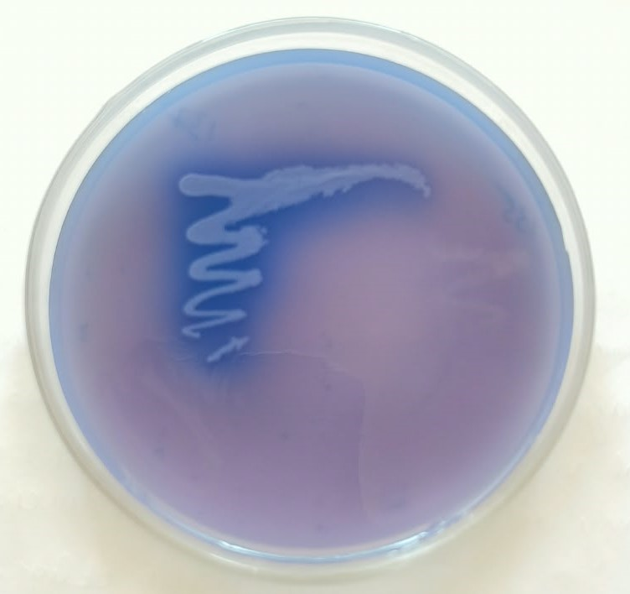
Fig.1. Exopolysaccharide production by Enterococcus sp GS 12D displayed intense blue color on aniline blue agar medium.

3.2 Growth kinetics and EPS production potential
During the 96 h incubation period, bacterial growth increased rapidly, indicating vigorous bacterial multiplication and metabolic activity. The MRS medium supplemented with sucrose supported slightly higher growth, suggesting that it contained nutrients that facilitate bacterial multiplication. A marginal decline in absorbance was reported after 96 h, potentially attributable to the initiation of cell death and autolysis occurring under nutrient depletion (Fig. 2). The strain produced an EPS yield of 102.7 ± 4.07 mg/L in MRS media after 96 h of anaerobic incubation at 45°C compared with the other temperature conditions (15, 24 and 45°C) (Fig. 3.). Similarly, the highest growth was observed for Enterococcus sp GS 12D when sucrose was used as the carbohydrate source followed by glucose and xylose, whereas the lowest growth was observed with lactose (Fig. 4.).

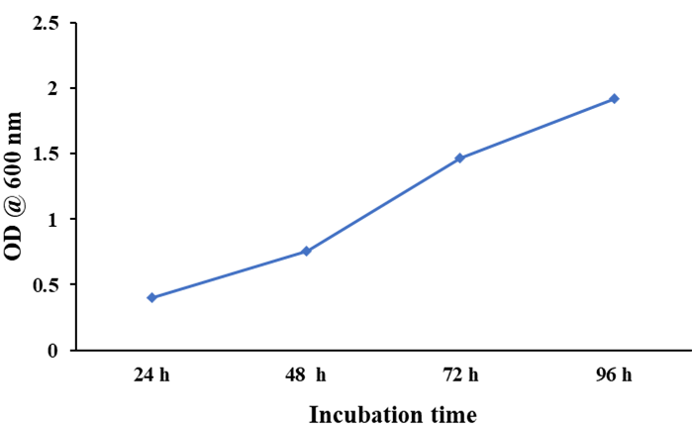
Fig. 2. Effect of incubation time on growth of Enterococcus sp GS 12D and EPS production; highest growth was observed at 96 h of incubation.

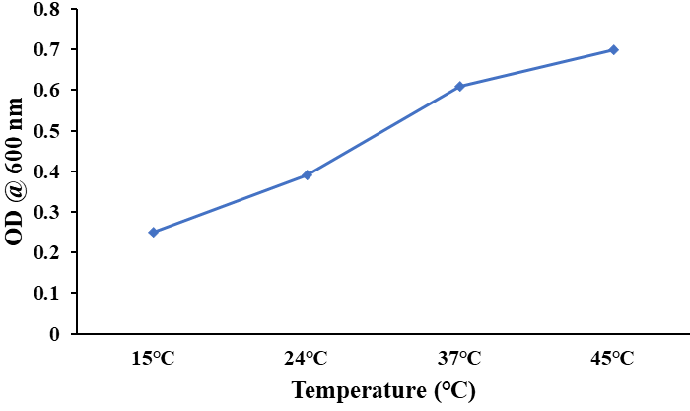
Fig. 3. Effect of different temperature range on growth of Enterococcus sp GS 12D and EPS production; highest growth was observed at 45℃.

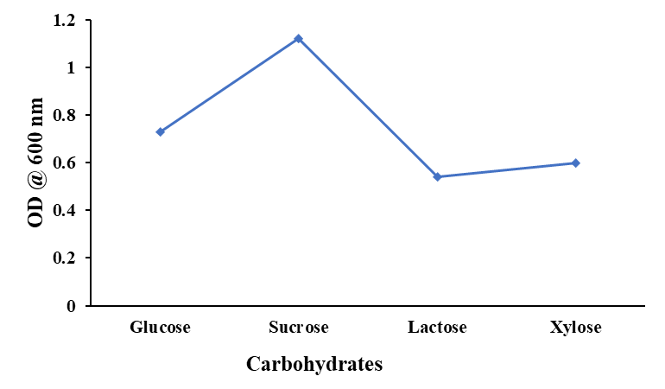
Fig. 4. Effect of different carbohydrate sources on growth of Enterococcus sp GS 12D and EPS production; highest growth was observed in presence of sucrose (5 mg/100 ml).
3.3 Antibiotic sensitivity assay
The antibiotic sensitivity pattern of EPS-producing Enterococcus sp GS 12D was evaluated usingstandard antibiotic discs (Table 1). The Enterococcus sp GS 12D was susceptible to antibiotics including azithromycin, ciprofloxacin, penicillin, erythromycin and kanamycin.However, the strain showed resistance to ampicillin.
Table 1. Antibiotic susceptibility tests for EPS producing Enterococcus sp GS 12D against commonly used antibiotics using disc diffusion assay
Bacterial strain Antibiotics
 | AMP | AZI | CIP | P | E | OF | RF | K
Enterococcus sp GS 12D | R | S | S | S | S | M | M | S

Note: The inhibition zones were measured and determined as susceptible, S (≥21 mm); intermediate, I (16–20 mm), and resistant, R (≤15 mm); AMP = ampicillin; AZI = azithromycin; CIP = ciprofloxacin; P = penicillin; E = erythromycin; OF = ofloxacin; RF = rifampicin; K = kanamycin.

3.4 Antibacterial activity of EPS extract
The antibacterial activity of exopolysaccharides (EPS) extracted from Enterococcus sp. GS 12D was evaluated against a panel of bacterial strains, including Escherichia coli, Salmonella Typhi, Pseudomonas aeruginosa, Clostridium perfringens, Klebsiella pneumoniae, Proteus vulgaris, Bacillus subtilis and Staphylococcus aureus. The results demonstrated broad-spectrum antibacterial activity against both Gram-positive and Gram-negative bacterial strains at a concentration of 0.1 mg/mL (Fig. 5). Antibacterial activity was assessed by measuring the diameters of inhibition zones on agar plates, which revealed varying degrees of susceptibility among the tested bacterial strains. The highest inhibitory activity was observed against P. aeruginosa, followed by S. aureus, E. coli and Listeria monocytogenes. In contrast, no inhibitory activity was detected against C. perfringens.
.

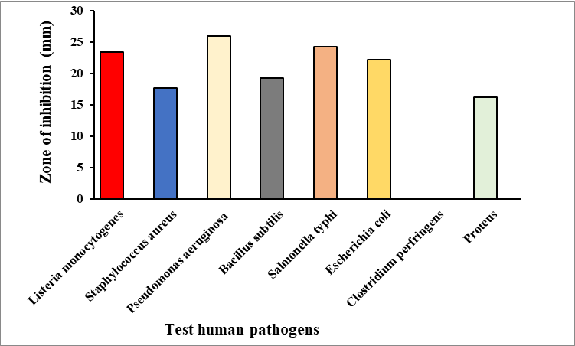
Fig. 5. Antimicrobial activity of selected EPS producing Enterococcus sp GS 12D: Inhibition zones (mm) produced by strain against eight different human pathogens was measured and represented graphically as their mean SD values and significantly the experiments were conducted in triplicates. Highest zone of inhibition was observed for Pseudomonas aeruginosa, where no antibacterial activity was demonstrated against Clostridium perfringens.

3.3 Antioxidant activity
The antioxidant potential of EPS produced by Enterococcus sp. GS 12D was evaluated using various assays, including DPPH and hydroxyl radical-scavenging assays, as well as reducing power determination. The results indicated that the EPS exhibited antioxidant activity, with a DPPH radical-scavenging activity of 75 ± 0.12% (Fig. 6). Furthermore, ascorbic acid, used as the positive standard, exhibited hydroxyl radical-scavenging activity of 70.06 ± 0.02% at a concentration of 100.13 µg/mL, while DPPH with water served as the control in the DPPH assay.

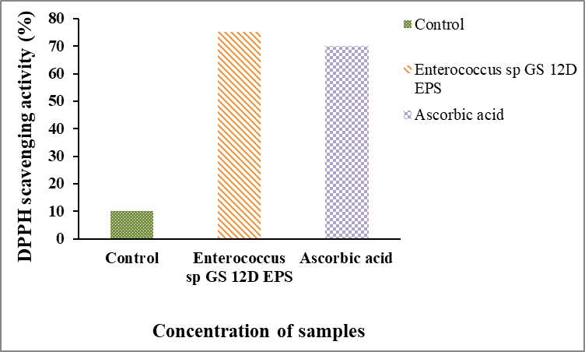
Fig. 6. Antioxidant activity of Enterococcus sp GS 12D EPS was determined using DPPH method and scavenging activity was expressed in %, where, ascorbic acid was used as a positive control and normal sterile water along with DPPH was used as normal control. The experiment was significantly carried out in triplicates and results were expressed as their mean SD values

4.0 Discussion
Microbially derived EPS are environmentally safe, biocompatible, biodegradable, extracellular carbohydrate polymers with potential therapeutic relevance. They have been investigated for diverse health-related properties. EPS possessing antimicrobial and antioxidant properties may offer promising alternatives to synthetic antibiotics and chemical antioxidants by potentially mitigating limitations associated with their use, including antibiotic resistance, adverse effects and disruption of the gut microbiota in the case of antibiotics, as well as potential toxicity, pro-oxidant effects, limited efficacy and reduced stability associated with certain chemical antioxidants. For example, EPS-MS79 produced from Enterococcus faecium has been investigated for potential prebiotic and food-rheological properties (Ayyash et al., 2020). Likewise, the Enterococcus faecium-derived EPS acted as reducing, capping, and stabilizing agents inthe green synthesis of EPS-AgNPs with potential applications in medical and food-packaging industries (Chegini et al., 2024). Exopolysaccharide EPS-F2 produced by Enterococcus faecium has been identified as a potential alternative source of functional additives and ingredients for applications in the food industry (Jiang et al., 2021). In this context, the present study investigated exopolysaccharide (EPS) production by Enterococcus sp. GS 12D, a lactic acid bacterial strain isolated from a locally obtained yoghurt sample. The strain was identified as a potential EPS producer based on its mucoid colony phenotype observed on MRS agar medium supplemented with 5% (w/v) sucrose. Furthermore, the isolate exhibited notable physicochemical and biological characteristics, including EPS production, in vitro antibacterial and antioxidant activities, and a distinct antibiotic susceptibility profile.
To identify the optimal carbon source for bacterial growth and EPS production by Enterococcus sp., four different carbon sources were evaluated at a concentration of 5 g/100 mL in modified MRS broth. The results demonstrated that sucrose supported the highest bacterial growth, followed by glucose, xylose and lactose, suggesting that the nutritional requirements for bacterial growth and EPS production may differ. Consistent with these findings, Rahnama Vosough et al. (2022) reported that sucrose-supplemented medium significantly enhanced EPS production by enterococcal strains, including E. durans K48, E. faecium T52, E. faecium R114 and E. faecium MC-5 (Zanzan et al., 2024). Similarly, E. faecium MC-5 (NCBI accession no. MN542942) was cultured in MRS broth at 37 °C for EPS production. To enhance EPS yield, the medium was supplemented with various carbon and nitrogen sources at a concentration of 2.5% (w/v). The highest EPS production of 8.25 ± 0.16 g/L was recorded in MRS broth supplemented with sucrose (Tilwani et al., 2021). Furthermore, the effects of medium composition and culture conditions on EPS production have been investigated using the Plackett–Burman design (PBD) approach. These findings highlight the importance of optimising nutritional components and cultivation conditions to improve EPS productivity.
In addition to these functional properties, the antibiotic susceptibility profile of Enterococcus sp was evaluated. Enterococcus sp GS 12D showed susceptibility to azithromycin, erythromycin, and ciprofloxacin and intermediate responses to ofloxacin and rifampicin. However, it showed resistance to ampicillin; these observations require further evaluation.
Although the mechanism underlying the observed antibacterial activity of EPS against the tested pathogens was not determined, several mechanisms have been proposed. These include interactions with bacterial cell envelopes and interference with surface receptors, as well as effects associated with secondary metabolites that accumulate in the growth medium(de Brito et al., 2024).
Previous studies have reported antimicrobial activities associated with exopolysaccharides (EPS) and other metabolites produced by Enterococcus spp. Lactic acid bacteria (LAB) are known to produce various antimicrobial compounds, including lactic acid, ethanol, hydrogen peroxide, bacteriocins and short-chain volatile fatty acids. In the present study, EPS produced by Enterococcus sp. GS 12D exhibited pronounced antibacterial activity against Pseudomonas aeruginosa, followed by Escherichia coli, Staphylococcus aureus and Listeria monocytogenes. These findings are broadly consistent with previous studies reporting considerable inhibitory effects of probiotic-derived EPS against both Gram-positive and Gram-negative bacteria. For instance, EPS-MS79 derived from E. faecium exhibited strong inhibitory activity against S. aureus, Salmonella typhimurium, L. monocytogenes and E. coli. Similarly, EPS produced by lactic acid bacteria demonstrated antibacterial activity against E. coli, E. faecalis and L. monocytogenes (Chegini et al., 2024). Enterococcus faecium KT990028 against Escherichia coli ATCC 25922, Pseudomonas aeruginosa ATCC 27853, Listeria monocytogenes ATCC 19117, Staphylococcus aureus ATCC 6538 at 50 mg/ml concentration (de Brito et al., 2024). Proposed antibacterial mechanisms include alterations in cell-wall integrity, interference with nutrient uptake and interactions with bacterial surfaces; these mechanisms were not tested in the present study.
EPS produced by lactic acid bacteria generally exhibit concentration-dependent free-radical-scavenging activity. In the present study, EPS derived from Enterococcus sp. GS 12D demonstrated appreciable radical-scavenging capacity, consistent with previous reports of EPS produced by E. faecalis and E. hirae, which exhibit strong scavenging activities against DPPH, superoxide and hydroxyl radicals. The antioxidant properties of EPS may be attributed to their structural characteristics and monosaccharide composition, which influence their electron-donating capacity and ability to neutralise free radicals. Given the close association between oxidative stress, host homeostasis, intestinal inflammation and epithelial injury, the antioxidant potential of EPS produced by Enterococcus sp. GS 12D at a concentration of 2 mg/mL warrants further investigation to evaluate its possible implications for gut health (Dong et al., 2025). Similarly, EPS produced by E. faecium R114 and E. faecium T52 exhibited antioxidant activities of 58% and 64%, respectively, at a concentration of 25 mg/mL (Rahnama Vosough et al., 2021). Furthermore, EPS MC-5 demonstrated concentration-dependent radical-scavenging activity, reaching a maximum of 73.55% at a concentration of 2000 µg/mL (Tilwani et al., 2021). Collectively, these findings indicate that EPS produced by the isolated bacterial strain possesses in vitro free-radical-scavenging activity at the concentration evaluated.
Moreover, employing LAB-derived EPSs as natural antimicrobial agents offers several advantages over conventional chemical antimicrobials, although their effects on food quality, safety and antimicrobial resistance require further evaluation (Zannini et al., 2016). The EPS-producing Enterococcus faecium BDIFST25003 strain isolated from fermented milk exhibited emulsifying activity against different edible oils and also increased short-chain fatty acid production suggesting potential industrial relevance (Hossain et al., 2026). Likewise, Enterococcus faecalis 84B exhibited good probiotic properties, the strain also demonstrated appreciable antioxidant activity of at a concentration of 5 mg/mL was 81.1 % against DPPH, whereas EPS from the isolate in the present study showed 75 ± 0.12% activity at 2 mg/mL, the EPS-84B also inhibited foodborne pathogens up to 32.6 % (Ali et al., 2023).The EPS-producing strains E. faecium RT94 and E. faecalis RT102 strains isolated from traditional Turkish cheese along with inulin suggesting; they could serve as synergistic synbiotic candidates for the development of probiotic products to manage hypercholesterolemia (Çetin et al., 2026). Exopolysaccharide EPS-NOC219, derived from Enterococcus faecalis NOC219 isolated from yoghurt, exhibited substantial antioxidant activity (55.84%) against DPPH radicals and pronounced antibiofilm activity against the foodborne pathogens Escherichia coli (77.83%) and Listeria monocytogenes (72.14%). These findings suggest that EPS-NOC219, owing to its favourable physicochemical and functional properties, may serve as a promising natural resource for various industrial applications, particularly as a potential food-grade adjunct. Previous investigations have highlighted the diverse functional properties of EPS-producing Enterococcus strains, indicating the need for further exploration of Enterococcus-derived EPS for applications in the food and pharmaceutical industries. Furthermore, EPS produced by lactic acid bacteria (LAB) represent promising candidates for further evaluation in food processing and preservation. The present findings also indicate that EPS derived from Enterococcus sp. GS 12D may offer an environmentally friendly and effective alternative to conventional chemical antimicrobial agents used in the food industry. Nevertheless, the potential of Enterococcus-derived EPS to prevent foodborne illnesses and improve food quality and safety requires further investigation. Additional studies are necessary to optimise EPS-based applications and evaluate their effectiveness under practical food processing conditions.
5.0 Conclusion
The present study demonstrated that Enterococcus sp. GS 12D produces exopolysaccharides (EPS) exhibiting antibacterial and antioxidant properties, suggesting their potential for further investigation in functional food applications. Building on these promising findings, future research should aim to enhance our understanding of Enterococcus sp. GS 12D and its EPS. In particular, in vivo investigations are warranted to assess their biological activities under physiological conditions and to evaluate their safety and efficacy through animal studies and, where appropriate, human clinical trials. Such investigations would provide further insights into the potential contributions of Enterococcus sp. GS 12D and its EPS to human health. The findings also indicate possible applications of this bacterial strain and its EPS across various sectors, particularly in the development of functional foods and pharmaceutical products. Continued research in this area may facilitate the identification of novel applications and potential health benefits while providing the scientific evidence necessary to assess their safety, efficacy and suitability for practical use.

Limitations
The investigation involved four yoghurt-derived lactic acid bacterial isolates, with detailed evaluation restricted to Enterococcus sp. GS 12D. Growth responses were measured mainly by optical density, which does not directly quantify EPS production under every tested condition. The recovered material was described as partially purified, and detailed structural characterisation was not presented. Antioxidant and antibacterial outcomes were obtained from laboratory assays; performance in food matrices or living systems was not assessed. Future studies should include independent production replicates, more extensive EPS characterisation, additional isolates and strain-specific safety assessments.

Declaration of AI Use

This manuscript was prepared through the intellectual contributions of the author(s) to the study design, data analysis, interpretation of results, and scholarly content. No AI tools were used in the manuscript writing.

References

Abarquero, D., Renes, E., Fresno, J. M., & Tornadijo, M. E. (2022). Study of exopolysaccharides from lactic acid bacteria and their industrial applications: A review. International Journal of Food Science & Technology, 57(1), 16–26. https://doi.org/10.1111/ijfs.15227
Adamu-Governor, O. L., Okolie, P. N., Ikegwu, E. M., Obeten, I. H., Abiona, C. O., & Uzochukwu, S. V. A. (2020). Comparative study of commercial starter and gum-producing lactic acid bacteria isolated from palm-sap on yoghurt. Asian Food Science Journal, 19(2), 28–39. https://doi.org/10.9734/afsj/2020/v19i230236
Ali, A. H., Bamigbade, G., Tarique, M., Esposito, G., Obaid, R., Abu-Jdayil, B., & Ayyash, M. (2023). Physicochemical, rheological, and bioactive properties of exopolysaccharide produced by a potential probiotic Enterococcus faecalis 84B. International Journal of Biological Macromolecules, 240, 124425. https://doi.org/10.1016/j.ijbiomac.2023.124425
Angelin, J., & Kavitha, M. (2020). Exopolysaccharides from probiotic bacteria and their health potential. International Journal of Biological Macromolecules, 162, 853–865. https://doi.org/10.1016/j.ijbiomac.2020.06.190
Ayyash, M., Stathopoulos, C., Abu-Jdayil, B., Esposito, G., Baig, M., Turner, M. S., Baba, A. S., Apostolopoulos, V., Al-Nabulsi, A., & Osaili, T. (2020). Exopolysaccharide produced by potential probiotic Enterococcus faecium MS79: Characterization, bioactivities and rheological properties influenced by salt and pH. LWT, 131, 109741. https://doi.org/10.1016/j.lwt.2020.109741
Bomfim, V. B., Lopes Neto, J. H. P., Leite, K. S., de Andrade Vieira, É., Iacomini, M., Silva, C. M., dos Santos, K. M. O., & Cardarelli, H. R. (2020). Partial characterization and antioxidant activity of exopolysaccharides produced by Lactobacillus plantarum CNPC003. LWT, 127, 109349. https://doi.org/10.1016/j.lwt.2020.109349
Çetin, O., Onal Darilmaz, D., & Yildiz, G. G. (2026). Cholesterol-lowering potential of synbiotic combination of inulin and Enterococcus spp. strains via bile salt deconjugation and EPS production. International Journal of Food Science & Technology, 61(1), vvaf225. https://doi.org/10.1093/ijfood/vvaf225
Chakra, P. S., Yalagondanahalli, C. N., & Gayathri, D. (2025). Antibacterial and enzymatic activities of lactic acid bacteria from fermented foods. Journal of Health and Allied Sciences NU, 15(3), 352–359. https://doi.org/10.25259/JHS-2024-7-12-R3-(1478)
Chegini, P., Salimi, F., Pirbodagh, Z. A., & Zare, E. N. (2024). Antilisterial and antioxidant exopolysaccharide from Enterococcus faecium PCH.25 isolated from cow butter: Characterization and probiotic potential. Archives of Microbiology, 206(9), Article 389. https://doi.org/10.1007/s00203-024-04112-2
Cirrincione, S., Breuer, Y., Mangiapane, E., Mazzoli, R., & Pessione, E. (2018). ‘Ropy’ phenotype, exopolysaccharides and metabolism: Study on food isolated potential probiotics LAB. Microbiological Research, 214, 137–145. https://doi.org/10.1016/j.micres.2018.07.004
Clinical and Laboratory Standards Institute. (2017). Performance standards for antimicrobial susceptibility testing (27th ed.; CLSI supplement M100). https://clsi.org/media/1469/m100s27_sample.pdf
de Brito, L. P., da Silva, E. C., Lins, L. F., de Medeiros, R. S., Silva, F. C. O., Pastrana, L., Cavalcanti, I. D. L., Lira-Nogueira, M. C. B., Cavalcanti, M. T. H., & Porto, A. L. F. (2024). Optimization, structural characterization, and biological applications of exopolysaccharide produced by Enterococcus faecium KT990028. International Journal of Biological Macromolecules, 282, 136926. https://doi.org/10.1016/j.ijbiomac.2024.136926
Dong, Z., Li, X., Wu, Y., Wang, Z., Cui, W., Hu, S., Shi, D., Huang, Q., Xiao, Y., Zhou, H., Li, Z., & Zhou, Z. (2025). Gut-protective and multifunctional exopolysaccharide from Enterococcus faecium HDRsEf1: Structural characterization and protective effects against enteropathogenic E. coli-induced intestinal inflammation. Nutrients, 17(23), 3667. https://doi.org/10.3390/nu17233667
Gill, P. K. (2023). Lactic acid bacteria as probiotics: Current status and future prospects. Asian Journal of Microbiology and Biotechnology, 8(2), 120–139. https://doi.org/10.56557/ajmab/2023/v8i28424
Hossain, M. N., Bhowmik, B., Jui, A. H., Islam, S., Kabir, M. H., & Ahmed, M. M. (2026). Probiotic Enterococcus faecium BDIFST25003: A novel exopolysaccharide producing strain with industrial potential. RSC Advances. Advance online publication. https://doi.org/10.1039/d6ra05745d
Hu, T., Yang, D., Mu, Y., Huang, H., Zhu, J., Chai, Y., Wang, C., & Jin, W. (2026). Optimization and chemical modification of exopolysaccharides from lactic acid bacteria: Multi-functional health-promoting properties and structure-activity relationship. Archives of Microbiology, 208, Article 300. https://doi.org/10.1007/s00203-026-04859-w
Jiang, G., Gan, L., Li, X., He, J., Zhang, S., Chen, J., Zhang, R., Xu, Z., & Tian, Y. (2021). Characterization of structural and physicochemical properties of an exopolysaccharide produced by Enterococcus sp. F2 from fermented soya beans. Frontiers in Microbiology, 12, 744007. https://doi.org/10.3389/fmicb.2021.744007
Kavitake, D., Devi, P. B., Delattre, C., Reddy, G. B., & Shetty, P. H. (2023). Exopolysaccharides produced by Enterococcus genus—An overview. International Journal of Biological Macromolecules, 226, 111–120. https://doi.org/10.1016/j.ijbiomac.2022.12.042
Mohal, M. M., Sraboni, F. S., Islam, S., Zaman, S., Uddin, M. S., & Saleh, M. A. (2025). Functional characterization and biotechnological applications of exopolysaccharides produced by newly isolated Enterococcus hirae MLG3-25-1. International Microbiology, 28(4), 851–862. https://doi.org/10.1007/s10123-024-00587-7
Potunuru, U. R., Padmapriya, P., Muthubharathi, B. C., Meenachi, B. A., Goswami, R., Devi, P. B., Mohan, A., Balamurugan, K., Dhayalan, A., Kavitake, D., & Shetty, P. H. (2026). Glucan exopolysaccharide from Enterococcus hirae OL616073 alleviates oxidative stress and extends lifespan in different model systems. Frontiers in Molecular Biosciences, 13, 1901988. https://doi.org/10.3389/fmolb.2026.1901988
Prashantkumar, C. S., & Gayathri, D. (2024). Isolation, diversity and antibacterial efficacy of potential indigenous lactic acid bacteria from North Karnataka, India. Biomedicine, 44(2), 228–235. https://doi.org/10.51248/v44i2.56
Rahnama Vosough, P., Edalatian Dovom, M. R., Habibi Najafi, M. B., Javadmanesh, A., & Mayo, B. (2022). Biodiversity of exopolysaccharide-producing lactic acid bacteria from Iranian traditional Kishk and optimization of EPS yield by Enterococcus spp. Food Bioscience, 49, 101869. https://doi.org/10.1016/j.fbio.2022.101869
Rahnama Vosough, P., Habibi Najafi, M. B., Edalatian Dovom, M. R., Javadmanesh, A., & Mayo, B. (2021). Evaluation of antioxidant, antibacterial and cytotoxicity activities of exopolysaccharide from Enterococcus strains isolated from traditional Iranian Kishk. Journal of Food Measurement and Characterization, 15(6), 5221–5230. https://doi.org/10.1007/s11694-021-01092-5
Ryan, K. J. (2004). Streptococci and enterococci. In K. J. Ryan & C. G. Ray (Eds.), Sherris medical microbiology: An introduction to infectious diseases (4th ed., pp. 273–296). McGraw-Hill. https://www.cur.ac.rw/mis/main/library/documents/book_file/digital-68398393459816.58106940.pdf
Soliemani, O., Salimi, F., & Rezaei, A. (2022). Characterization of exopolysaccharide produced by probiotic Enterococcus durans DU1 and evaluation of its anti-biofilm activity. Archives of Microbiology, 204(7), Article 419. https://doi.org/10.1007/s00203-022-02965-z
Tarannum, N., Ali, F., Khan, M. S., Alhumaidan, O. S., Zawad, A. N. M. S., & Hossain, T. J. (2024). Bioactive exopolysaccharide from Limosilactobacillus fermentum LAB-1: Antioxidant, anti-inflammatory, antibacterial and antibiofilm properties. Bioactive Carbohydrates and Dietary Fibre, 31, 100409. https://doi.org/10.1016/j.bcdf.2024.100409
Tarique, M., Ali, A. H., Kizhakkayil, J., Liu, S. Q., Oz, F., Dertli, E., Kamal-Eldin, A., & Ayyash, M. (2024). Exopolysaccharides from Enterococcus faecium and Streptococcus thermophilus: Bioactivities, gut microbiome effects, and fermented milk rheology. Food Chemistry: X, 21, 101073. https://doi.org/10.1016/j.fochx.2023.101073
Tilwani, Y. M., Lakra, A. K., Domdi, L., Yadav, S., Jha, N., & Arul, V. (2021). Optimization and physicochemical characterization of low molecular levan from Enterococcus faecium MC-5 having potential biological activities. Process Biochemistry, 110, 282–291. https://doi.org/10.1016/j.procbio.2021.08.021
Tiwari, S., Kavitake, D., Devi, P. B., & Shetty, P. H. (2021). Bacterial exopolysaccharides for improvement of technological, functional and rheological properties of yoghurt. International Journal of Biological Macromolecules, 183, 1585–1595. https://doi.org/10.1016/j.ijbiomac.2021.05.140
Vasudha, M., & Devaraja, G. (2023). Metabolism and functional heterogeneity of fermented milk origin lactic acid bacteria for lactose intolerance. Journal of Microbiology, Biotechnology and Food Sciences, 13(3), e9654. https://doi.org/10.55251/jmbfs.9654
Vasudha, M., Prashantkumar, C. S., Bellurkar, M., Kaveeshwar, V., & Gayathri, D. (2023). Probiotic potential of β-galactosidase-producing lactic acid bacteria from fermented milk and their molecular characterization. Biomedical Reports, 18(3), Article 23. https://doi.org/10.3892/br.2023.1605
Yang, Y., Jiang, G., & Tian, Y. (2023). Biological activities and applications of exopolysaccharides produced by lactic acid bacteria: A mini-review. World Journal of Microbiology and Biotechnology, 39(6), Article 155. https://doi.org/10.1007/s11274-023-03610-7
Zannini, E., Waters, D. M., Coffey, A., & Arendt, E. K. (2016). Production, properties, and industrial food application of lactic acid bacteria-derived exopolysaccharides. Applied Microbiology and Biotechnology, 100(3), 1121–1135. https://doi.org/10.1007/s00253-015-7172-2
Zanzan, M., Ezzaky, Y., Achemchem, F., Hamadi, F., Valero, A., & Mamouni, R. (2024). Fermentative optimization and characterization of exopolysaccharides from Enterococcus faecium F58 isolated from traditional fresh goat cheese. Food Science and Biotechnology, 33(5), 1195–1205. https://doi.org/10.1007/s10068-023-01424-9

