A new locality record of the Smooth-coated Otter (Lutrogale perspicillata) from the Sangli stretch of the Krishna River, Maharashtra, India

ABSTRACT
This manuscript reports a locality record of the Smooth-coated Otter (Lutrogale perspicillata) from selected sites along the Krishna River in Sangli District, Maharashtra, India. The study aimed to document the species' occurrence using direct field observation and photographic evidence. River stretches were identified and mapped using Google Earth Pro, and accessible riverbanks were surveyed through visual observation of the river channel, exposed sandbanks and adjacent vegetation. Field notes included the date, approximate time, location, visible animals, behaviour and habitat conditions. A photographic observation was documented near Sangli on 5 September 2026 at approximately 18:00 h. Identification was based on the animal's smooth, dark-brown dorsal coat, lighter ventral surface, elongated body and behaviour in the aquatic environment. The surveyed river sections included riverbanks, sandbars and vegetated areas, while fishing, agriculture and other human activities were noted in parts of the study area. The record provides locality-specific evidence of the species' presence within the Sangli stretch and adds to available information on its occurrence in the Krishna River basin. However, these observations do not establish the number of individuals using the river, the species' wider distribution or its population trajectory. Repeated surveys across sites and seasons are needed to clarify local occurrence and habitat use. Conservation efforts should consider the maintenance of riverbank habitats alongside existing human uses of the river.
Keywords: Lutrogale perspicillata, Smooth-coated Otter, photographic evidence, Krishna River, Sangli, Maharashtra, aquatic biodiversity.
Introduction:
The present study provides photographic evidence of the Smooth-coated Otter (Lutrogale perspicillata) from the Krishna River in Sangli District, Maharashtra. This observation is important because information on the occurrence of otters in many river stretches remains limited (Arivoli & Narasimmarajan, 2021; Raman et al., 2019). Smooth-coated Otters are mainly associated with freshwater habitats where suitable water conditions and sufficient food resources are available (Acharya & Lamsal, 2010; Anoop & Hussain, 2004; Hussain & Choudhury, 1997; Khan et al., 2014). The record from the Krishna River therefore adds useful information to the known distribution of the species in this region. Recent records of Smooth-coated Otters from other parts of Maharashtra illustrate the value of documenting species occurrence at specific localities (Patil & Manjrekar, 2025). Research in wetlands of Gujarat has also examined Smooth-coated Otter occurrence alongside interactions involving local fishing communities (Patel et al., 2026).
The Krishna River provides a range of aquatic and riverbank habitats that can support otters and other wildlife. Areas with relatively shallow water, riverbank vegetation, sandbanks, and suitable feeding grounds may be particularly useful for otters (Anoop & Hussain, 2004; Narasimmarajan et al., 2021; Raha & Hussain, 2016). Fish and other aquatic organisms are important food resources for the species, and their availability may influence where otters occur along the river. The presence of L. perspicillata may therefore indicate that suitable food and habitat resources are still available in parts of the Krishna River. Otters are closely linked with freshwater environments and are considered ecologically important because they depend on healthy aquatic food resources. Their occurrence can provide useful information about the condition of riverine habitats, although the presence of a single species record alone cannot be used to determine the overall health of an ecosystem (Acharya & Rajbhandari, 2011; Khoo et al., 2021). Freshwater ecosystems are increasingly affected by pollution, water extraction, habitat alteration, and other human pressures, which can have direct and indirect effects on aquatic biodiversity (Dudgeon et al., 2006; Vörösmarty et al., 2010).
Research in the Tungabhadra Otter Conservation Reserve reported associations between human disturbance, sprainting-site use, and observed group size, indicating that local riverbank conditions merit consideration in habitat assessments (Moun et al., 2024).
A dietary study of Smooth-coated Otters in an estuarine agroecosystem in Goa documented fish, shrimp, and crabs among prey resources, although these findings do not establish diet composition at Sangli (Dias et al., 2025). A recent review of Indian otters identifies habitat loss and human disturbance among the conservation challenges affecting aquatic and riparian environments (Bharade et al., 2025).
Although the manuscript documents a field observation from the Sangli stretch of the Krishna River, locality-specific evidence remains limited. The present record contributes to this documentation gap but does not establish the distribution, abundance, or population trend of the species along the river.
Objective
To document the occurrence of the Smooth-coated Otter (Lutrogale perspicillata) in the Sangli stretch of the Krishna River, Maharashtra, through direct field observation and photographic evidence.

Materials and Methods

Study Area
The study was carried out along selected stretches of the Krishna River in Sangli (16⁰48’14.15”N, 74⁰34’16.78”E). The river supports a variety of aquatic and terrestrial habitats, including riverbanks, sandbars, rocky areas, agricultural fields, and patches of vegetation. These habitats provide suitable conditions for otters and other wildlife. Selected sites were identified based on local information, previous observations, and the presence of suitable otter habitat.
Materials
Materials used included Google Earth for mapping and analysis of the study area, a field notebook and data sheets for recording observations, a measuring tape for measuring transects and habitat features, a camera or mobile phone for photographic documentation, binoculars for observing otters from a distance, walking shoes and other field equipment for conducting surveys, survey maps for locating the study sites, and a pen and pencil for recording field observations.

Field Survey
The survey was conducted along selected stretches of the Krishna River. The river stretches were first identified and mapped using Google Earth Pro.
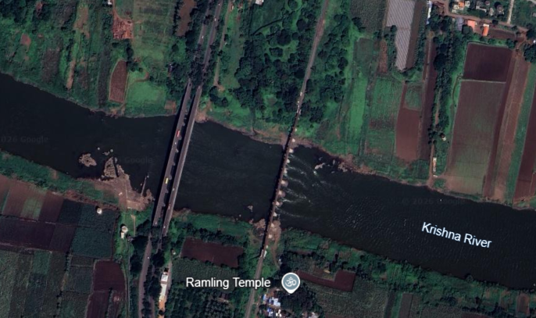
Fig: 1 Map showing Otter Distribution at Krishna River Sangli with Lat/Long – 16⁰48’14.15”N, 74⁰34’16.78”E
Observation
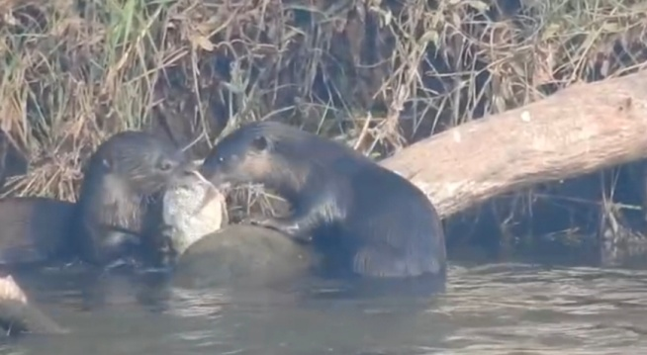 | 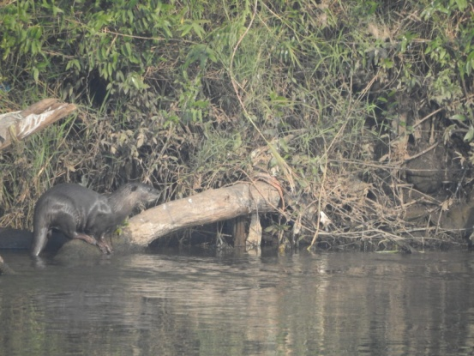
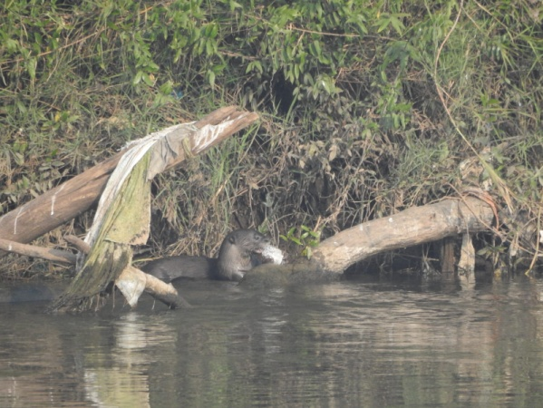 | 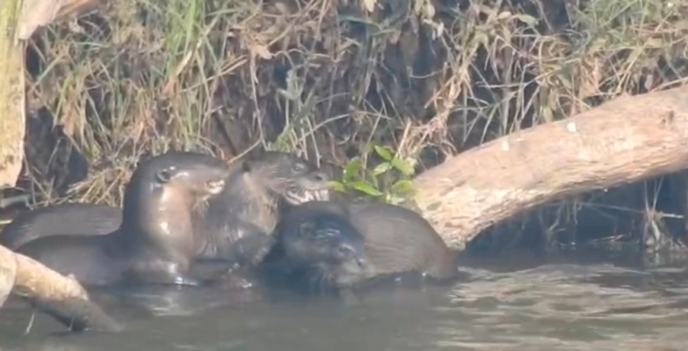
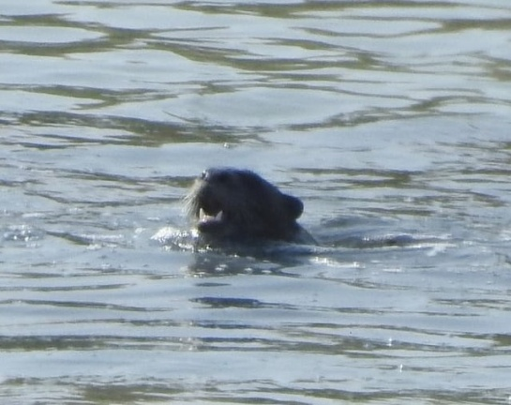 | 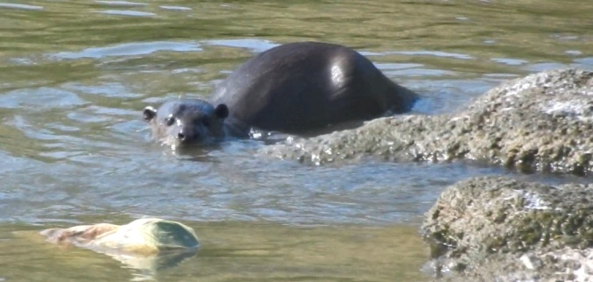
Fig.2 Smooth Coated Otter observed at Krishna River, Sangli
A field observation of the smooth-coated otter (Lutrogale perspicillata) was recorded on 5 September 2026 at approximately 18:00 h along the Krishna River near Sangli, Maharashtra. The individual was observed in the riverine environment during the evening period. Identification was based on its characteristic smooth, dark-brown dorsal pelage, comparatively lighter ventral surface, elongated body, and behaviour associated with the aquatic habitat. The observation was documented photographically and provides additional field evidence for the continued occurrence of Lutrogale perspicillata in the Sangli stretch of the Krishna River.
The occurrence of the smooth-coated otter at Sangli is ecologically relevant because the species is closely associated with freshwater rivers, wetlands, floodplains, and other aquatic habitats where adequate prey and suitable riparian cover are available. The IUCN SSC Otter Specialist Group describes the species as predominantly nocturnal, although it may also be active during daylight when disturbance is limited (Khoo et al., 2021). The species generally requires riverside vegetation and suitable areas for shelter, resting and breeding. The timing of the present observation at approximately 18:00 h is therefore consistent with the species' crepuscular/evening activity pattern. The present observation provides an important new locality record of the Smooth-coated Otter (Lutrogale perspicillata) from the Sangli section of the Krishna River, Maharashtra. Although the species has previously been reported from different parts of the Krishna River system, including riverine habitats associated with sandy banks, riparian vegetation, river islands and other suitable aquatic environments, documented observations from the Sangli stretch remain limited. The present sighting therefore contributes additional evidence of the species’ occurrence in this part of the Krishna River basin. The observation was made in a riverine habitat with suitable vegetation and water resources, which may provide favourable conditions for otter movement and feeding. Recent local reports from the Sangli area have also indicated the presence of a small group of approximately eight to nine Smooth-coated Otters, suggesting that the species may use suitable stretches of the river either individually or in small groups. However, a single observation cannot be used to determine population size, abundance or population trends. Systematic surveys covering different seasons, river stretches and suitable habitats are therefore required to confirm the distribution and status of the species in the Sangli region. The present record highlights the importance of continued field monitoring and conservation of suitable riverine habitats along the Krishna River.

Survey methodology
Field surveys for the smooth-coated otter (Lutrogale perspicillata) were conducted along selected stretches of the Krishna River in Sangli District, Maharashtra. The survey sites were selected on the basis of suitable riverine habitat, including riverbanks, shallow-water areas, sand or mud banks, riparian vegetation and potential resting areas.
During field visits, accessible sections of the riverbank were searched by walking slowly along the river edge and visually scanning the river channel, opposite bank, exposed sandbars and surrounding vegetation. Observations were made during suitable daylight and evening periods. When an otter was observed, the date, approximate time, location, visible number of animals, behaviour and habitat conditions were recorded. Photographs were taken whenever possible to support species identification and document the observation.
The field observations were based on direct visual detection and photographic documentation. The same observation was not counted again when it was clearly part of the same observation event. However, because individual otters were not marked or uniquely identified, it was not possible to determine whether animals observed during different visits represented the same or different individuals.

Results and Discussion
Otters were observed at several suitable places along the study area. Most observations were made near riverbanks, sandbanks, vegetation, and places where food was available. Fish availability and suitable places for resting and grooming appeared to be important for their presence in these areas.
Human activities were present in some parts of the riverbank. Fishing, agriculture, and regular use of the riverbank by local people may affect the areas used by otters. Maintaining natural vegetation along the riverbank and avoiding unnecessary disturbance may help to retain suitable habitats for otters. Local fishermen and residents can also support conservation by reporting otter sightings and informing others about places where otters are regularly seen (Gupta et al., 2020).
The observations from the study indicate that regular monitoring of otters and their habitats along the Krishna River is needed. Conservation measures should protect suitable riverbank habitats while also considering the daily activities and livelihood needs of local people.

Threats to the Otter population

Habitat Loss
Habitat loss is one of the major threats to otters in the study area. Otters need suitable places for resting, breeding, grooming, and defecation. Riverbanks, sandbanks, soil, leaf litter, and areas with vegetation are commonly used for these activities (Nawab & Hussain, 2012). However, many of these habitats are gradually decreasing because of illegal sand mining and the conversion of wetlands and natural areas into agricultural land.
Sand mining is a serious problem for river ecosystems. Excessive removal of sand from the riverbed and riverbanks changes the natural condition of the river, increases water depth in some areas, and damages places used by otters and their prey. It can also reduce the availability of fish and other aquatic organisms on which otters depend. Some parts of the river have already been heavily disturbed due to continuous sand extraction.

Otter–Fisherman Competition
Competition between otters and fishermen can occur in areas where fish are abundant. In some parts of the study area, high fishing activity was observed along with frequent otter activity. This indicates that both otters and fishermen depend on the same fish resources.
Such areas are important for otter conservation, but the livelihood of local fishermen also needs to be considered. Conservation measures should therefore focus on reducing conflicts between otters and fishermen. Sustainable fishing practices and proper management of fishing areas can help both otters and local communities use the river resources.
Otters were recorded from several suitable areas along the study site. Their presence was mainly associated with riverbanks, sandbanks, vegetation, and areas with sufficient food resources. The availability of fish and suitable resting and grooming sites appears to be important for otter occurrence.
The study shows the need for continued monitoring of otters and their habitats along the Krishna River. Conservation efforts should consider both the ecological requirements of otters and the livelihood needs of local people.

Conclusions
The field observations and photographs presented in this study document the occurrence of the Smooth-coated Otter (Lutrogale perspicillata) in the Sangli stretch of the Krishna River, Maharashtra. The observation recorded on 5 September 2026 provides locality-specific evidence of the species' presence in the surveyed riverine environment. Riverbanks, sandbanks and riparian vegetation formed part of the habitat described at the study sites, while fishing, agricultural activities and other forms of human riverbank use were also reported. These observations support the value of continued documentation of otter occurrence along this section of the river but do not, by themselves, establish habitat quality, population abundance or long-term population trends. Although the manuscript refers to observations at more than one suitable location, the available evidence is insufficient for estimating the number of individuals using the wider Sangli stretch. Systematic surveys across different sites and seasons would help clarify the local distribution and persistence of the species. Future conservation attention should therefore consider the maintenance of riverbank vegetation and other suitable aquatic habitats while recognising the livelihood needs of communities that use the Krishna River.
Limitations
The study provides locality-specific observational evidence rather than a quantitative assessment of the species' population. Individual otters were not marked or uniquely identified, limiting the interpretation of observations made on different occasions. The available records do not support estimates of abundance, population trends or the extent of habitat use along the wider river stretch. Further observations across seasons and sites would be needed to assess the consistency of occurrence and to inform more detailed local conservation assessments.

Declaration of AI Use

This manuscript was prepared through the intellectual contributions of the author(s) to the study design, data analysis, interpretation of results, and scholarly content. Grammarly and ChatGPT were used solely to assist with grammatical refinement and reference formatting during manuscript revision. The author(s) accept full responsibility for the accuracy, integrity, and final content of the manuscript.
Reference
Acharya, P. M., & Lamsal, P. (2010). A survey for smooth-coated otter Lutrogale perspicillata on the River Narayani, Chitwan National Park, Nepal. Hystrix, the Italian Journal of Mammalogy, 21(2), 203–207. https://doi.org/10.4404/hystrix-21.2-4464
Acharya, P. M., & Rajbhandari, S. L. (2011). Status of otters in Nepal [Country report submitted to the IUCN/SSC Asian Secretariat, Sri Lanka].
Anoop, K. R., & Hussain, S. A. (2004). Factors affecting habitat selection by smooth-coated otters (Lutra perspicillata) in Kerala, India. Journal of Zoology, 263(4), 417–423. https://doi.org/10.1017/S0952836904005461
Arivoli, K., & Narasimmarajan, K. (2021). First record of an elusive predator: The smooth-coated otter (Lutrogale perspicillata) from Vaduvoor Bird Sanctuary, Thiruvarur District, Tamil Nadu, southern India. IUCN Otter Specialist Group Bulletin, 38(2), 79–84. https://www.iucnosgbull.org/Volume38/Arivoli_Narasimmarajan_2021.html
Bharade, R., Podhade, D., Jadav, K., Mishra, A., Lade, D., Sinha, Y., & Sagar, Y. (2025). Otters of India: Conservation challenges and veterinary perspectives. Uttar Pradesh Journal of Zoology, 46(23), 116–128. https://doi.org/10.56557/upjoz/2025/v46i235387
Dias, S. J., Borker, N. S., Yadav, A. K., D’Costa, J., Borker, A. S., & Porob, P. C. (2025). Seasonal diet of the smooth-coated otter (Lutrogale perspicillata) in traditional brackish-water agroecosystems of Goa, India. Aquatic Ecology, 59, 1299–1318. https://doi.org/10.1007/s10452-025-10226-6
Dudgeon, D., Arthington, A. H., Gessner, M. O., Kawabata, Z.-I., Knowler, D. J., Lévêque, C., Naiman, R. J., Prieur-Richard, A.-H., Soto, D., Stiassny, M. L. J., & Sullivan, C. A. (2006). Freshwater biodiversity: Importance, threats, status and conservation challenges. Biological Reviews, 81(2), 163–182. https://doi.org/10.1017/S1464793105006950
Gupta, N., Tiwari, V., Everard, M., Savage, M., Hussain, S. A., Chadwick, M. A., Johnson, J. A., Nawab, A., & Belwal, V. K. (2020). Assessing the distribution pattern of otters in four rivers of the Indian Himalayan biodiversity hotspot. Aquatic Conservation: Marine and Freshwater Ecosystems, 30(3), 601–610. https://doi.org/10.1002/aqc.3284
Hussain, S. A., & Choudhury, B. C. (1997). Distribution and status of the smooth-coated otter Lutra perspicillata in National Chambal Sanctuary, India. Biological Conservation, 80(2), 199–206. https://doi.org/10.1016/S0006-3207(96)00033-X
Khan, M. S., Dimri, N. K., Nawab, A., Ilyas, O., & Gautam, P. (2014). Habitat use pattern and conservation status of smooth-coated otters Lutrogale perspicillata in the Upper Ganges Basin, India. Animal Biodiversity and Conservation, 37(1), 69–76. https://doi.org/10.32800/abc.2014.37.0069
Khoo, M., Basak, S., Sivasothi, N., de Silva, P. K., & Reza Lubis, I. (2021). Lutrogale perspicillata. The IUCN Red List of Threatened Species 2021, e.T12427A164579961. https://doi.org/10.2305/IUCN.UK.2021-3.RLTS.T12427A164579961.en
Moun, A., Kumar, P. R., Priya, M. M., Ramesh, T., & Kalle, R. (2024). Multi-scale habitat influences sprainting and group size of a freshwater-obligate smooth-coated otter (Lutrogale perspicillata) in Tungabhadra Otter Conservation Reserve, India. Ecological Processes, 13, Article 12. https://doi.org/10.1186/s13717-024-00492-x
Narasimmarajan, K., Hayward, M. W., & Mathai, M. T. (2021). Assessing the occurrence and resource use pattern of smooth-coated otters Lutrogale perspicillata Geoffroy (Carnivora, Mustelidae) in the Moyar River of the Western Ghats biodiversity hotspot. IUCN Otter Specialist Group Bulletin, 38(1), 43–58. https://www.iucnosgbull.org/Volume38/Narasimmarajan_et_al_2021.html
Nawab, A., & Hussain, S. A. (2012). Factors affecting the occurrence of smooth-coated otter in aquatic systems of the Upper Gangetic Plains, India. Aquatic Conservation: Marine and Freshwater Ecosystems, 22(5), 616–625. https://doi.org/10.1002/aqc.2253
Patel, S., Solanki, H., & Patel, B. (2026). Seasonal occurrence and human-otter conflict of Lutra perspicillata in the wetlands of Navsari, Gujarat, India: Towards a community-based conservation strategy. Journal of Advances in Biology & Biotechnology, 29(5), 970–978. https://doi.org/10.9734/jabb/2026/v29i53970
Patil, S. R., & Manjrekar, M. (2025). Distribution of smooth-coated otters (Mammalia: Carnivora: Mustelidae: Lutrogale perspicillata) in the coastal mangroves of Maharashtra: A case study of Savitri River and Kalinje Mangrove Ecosystem. Journal of Threatened Taxa, 17(12), 28066–28075. https://doi.org/10.11609/jott.10066.17.12.28066-28075
Raha, A., & Hussain, S. A. (2016). Factors affecting habitat selection by three sympatric otter species in the southern Western Ghats, India. Acta Ecologica Sinica, 36(1), 45–49. https://doi.org/10.1016/j.chnaes.2015.12.002
Raman, K., Sivangnanaboopathidossvimal, Kishorekumar, S., Krishnakumar, B. M., & Selvan, K. M. (2019). Occurrence of smooth-coated otter Lutrogale perspicillata in Sankaraparani River, Puducherry, India. IUCN Otter Specialist Group Bulletin, 36(1), 28–33. https://www.iucnosgbull.org/Volume36/Raman_et_al_2019%20.html
Vörösmarty, C. J., McIntyre, P. B., Gessner, M. O., Dudgeon, D., Prusevich, A., Green, P., Glidden, S., Bunn, S. E., Sullivan, C. A., Reidy Liermann, C., & Davies, P. M. (2010). Global threats to human water security and river biodiversity. Nature, 467(7315), 555–561. https://doi.org/10.1038/nature09440

