Preliminary Environmental Suitability Assessment for Low-Chilling Apple Cultivation in Adilabad District, Telangana, India

ABSTRACT
Apple (Malus domestica Borkh.) is traditionally cultivated in temperate regions where adequate winter chilling supports dormancy release, flowering, and fruit development. The development of low-chilling cultivars has created opportunities to investigate apple cultivation in warmer and subtropical environments. The present study assessed the preliminary potential of selected forest-fringe and agricultural environments of Adilabad District, Telangana, India, for low-chilling apple cultivation. The assessment considered climatic conditions, winter chilling, soil characteristics, water availability, and topographic factors. Five representative locations were considered for a preliminary environmental suitability assessment, with emphasis on temperature regime, estimated chilling accumulation, rainfall, soil pH, electrical conductivity, organic carbon, available nutrients, soil texture, and irrigation potential. Candidate cultivars included HRMN-99, Anna, Dorsett Golden, and Tropical Beauty. A weighted suitability framework integrating climatic, chilling, soil, water, and topographic parameters was used to identify comparatively favourable locations. The preliminary assessment indicated that higher-elevation sites may provide relatively favourable winter conditions and greater estimated chilling accumulation than lower-elevation locations, while seasonal water availability and summer heat remain important constraints. HRMN-99 was identified as a particularly relevant candidate for further investigation because of its reported adaptation to warm and subtropical Indian environments. The assessment is preliminary because the site-level values used in the analysis are simulated within the documented environmental range of the region and therefore require validation through field observations. However, the assessment represents preliminary environmental suitability rather than demonstrated commercial production potential. Multi-season field experiments are therefore required to validate bud break, flowering, fruit set, yield, fruit quality, plant survival, and pest and disease responses. Future studies should prioritise legally available agricultural and non-forest lands while maintaining the ecological integrity of natural forest ecosystems.
Keywords: Malus domestica; low-chilling apple; HRMN-99; subtropical horticulture; Adilabad; agro-climatic suitability; chilling requirement; soil suitability; climate adaptation; Telangana
1. INTRODUCTION
1.1 Background of Apple Cultivation
Apple (Malus domestica Borkh.) is one of the most important temperate fruit crops cultivated worldwide because of its nutritional value, economic importance, consumer demand, and diverse uses as a fresh and processed fruit (Cornille et al., 2014). Apple fruits contain carbohydrates, dietary fibre, organic acids, minerals, vitamins, and several bioactive compounds, making them an important component of a healthy diet. Traditionally, commercial apple production has been concentrated in temperate and high-altitude regions where winter temperatures provide sufficient chilling during dormancy. Successful apple production depends on the interaction of several environmental factors, including temperature, winter chilling, soil characteristics, water availability, flowering behaviour, pollination, and fruit development. Winter and spring temperature conditions can influence apple phenology, including bud development, flowering, and other developmental stages (Funes et al., 2016).
Winter chilling is particularly important because adequate exposure to low temperatures is required for the release of dormancy and subsequent uniform bud break and flowering. Conventional apple cultivars generally have relatively high chilling requirements and therefore perform poorly when winter temperatures remain too warm. In warm environments, insufficient chilling can result in delayed or irregular bud break, prolonged flowering, poor fruit set, and reduced productivity. Consequently, the introduction of cultivars with lower chilling requirements has created opportunities for extending apple cultivation into subtropical and comparatively warmer regions.
Apple cultivars differ considerably in the duration of bud dormancy and their response to winter temperature conditions (Hauagge & Cummins, 1991).
Winter chilling is an important environmental requirement for the release of dormancy and subsequent reproductive development in temperate fruit crops (Fadón et al., 2020).
In warmer environments, insufficient winter chilling can affect dormancy release and subsequent reproductive development, making winter chill an important consideration when assessing the suitability of temperate fruit crops (Luedeling, 2012).
Recent studies further indicate that apple chilling requirements and dormancy progression are cultivar-specific and strongly influenced by local thermal conditions, supporting cultivar-by-site matching in mild-winter environments (González-Martínez et al., 2025; Pertille et al., 2026).
1.2 Low-Chilling Apple Cultivars
Low-chilling apple cultivars have become increasingly important for areas where conventional apple cultivars cannot receive adequate winter chilling. Cultivars such as HRMN-99, Anna, Dorsett Golden, Tropical Beauty, Vered, and Tamma have been investigated or promoted for relatively warm growing environments. Indian horticultural recommendations also recognise several low-chilling cultivars, including Anna, HRMN-99, Dorsett Golden, and Tropical Beauty, for cultivation under suitable environmental conditions.
Chilling requirements vary considerably among fruit cultivars, and the response to winter temperatures is therefore genotype-dependent (Fadón et al., 2020).
Among these cultivars, HRMN-99 is particularly relevant to the Indian context. The Indian Council of Agricultural Research reported that HRMN-99 is a low-chilling, self-pollinating apple variety developed for tropical and subtropical environments and capable of growing under substantially warmer conditions than conventional apple cultivars. Its cultivation has expanded into several non-traditional apple-growing regions of India (Indian Council of Agricultural Research [ICAR], 2025).
HRMN-99 is recognised as a low-chilling apple variety with potential for cultivation under tropical, subtropical, and plain-area conditions, making it relevant for preliminary evaluation in warmer regions (Principal Scientific Adviser to the Government of India, n.d.).
Recent experimental research has further demonstrated the importance of cultivar selection under local environmental conditions. Sharma et al. (2024) evaluated HRMN-99, Dorsett Golden, and Anna under subtropical conditions in Assam and reported differences among cultivars in vegetative growth and nutrient status, with HRMN-99 showing promising growth performance under the experimental conditions. Similarly, research on HRMN-99 under the agro-climatic conditions of Prayagraj demonstrates the increasing interest in evaluating this cultivar beyond traditional apple-growing regions.
HRMN-99 is described as a low-chilling apple variety developed for tropical, subtropical, and plain areas, making it relevant for investigation in warmer regions outside conventional apple-growing zones (National Innovation Foundation–India, n.d.).
HRMN-99 is a low-chilling apple variety that has attracted attention for its potential cultivation in tropical, subtropical, and plain areas of India (Department of Science and Technology, 2021).
The chilling requirement is a cultivar-dependent characteristic, and substantial variation exists among apple genotypes in the duration of bud dormancy and their response to chilling conditions (Hauagge & Cummins, 1991).
Vats et al. (2022) evaluated the low-chilling apple cultivar HRMN-99 under the agro-climatic conditions of Prayagraj, providing evidence that this cultivar can be investigated under subtropical environmental conditions.
Recent evaluation of HRMN-99 under Prayagraj's subtropical conditions also indicates that its growth and yield responses can vary with management treatments, reinforcing the need for local field validation (Gupta & Mishra, 2024).
1.3 Adilabad as a Potential Non-Traditional Apple-Growing Region
Adilabad district, located in northern Telangana, possesses a distinctive combination of agricultural, forest, climatic, and soil environments. The district experiences hot summers and a predominantly dry climate outside the southwest monsoon period. The official district profile reports a normal annual rainfall of approximately 1,044.5 mm, with around 85% of the annual rainfall occurring during the southwest monsoon. December is generally the coldest month, with a mean daily minimum temperature of approximately 15°C and a mean daily maximum of about 29°C.
The district also contains both red and black soils, with black soil predominating and accounting for approximately 72% of the district's soil area. These climatic and edaphic characteristics make Adilabad an interesting location for investigating whether selected low-chilling apple cultivars can adapt to local conditions.
Geospatial suitability modelling has also been applied to low-chilling temperate fruits, including apple, by integrating physical, meteorological, and landscape criteria, providing a relevant precedent for preliminary site screening before field establishment (Meresa et al., 2023).
1.4 Research Gap
Although low-chilling cultivars have expanded the geographical range of potential apple production in India, cultivar performance is strongly influenced by local environmental conditions. Evidence from Assam and other subtropical regions demonstrates that successful establishment cannot be assumed solely from the performance of a cultivar elsewhere.
Despite the presence of relatively cool winter conditions during part of the year, suitable rainfall, and diverse soil environments, there is limited published information specifically assessing the suitability of Adilabad's forest-fringe and associated agricultural environments for low-chilling apple cultivation. Therefore, a site-specific assessment of temperature, chilling conditions, soil characteristics, water availability, and topography is necessary before recommending wider cultivation.
Importantly, the term forest regions in this study refers to environmental zones and forest-fringe landscapes that may be evaluated for agricultural potential; it should not be interpreted as a recommendation to clear or convert natural forest land. Conservation of native vegetation, biodiversity, and legally protected forest areas must remain a fundamental consideration.
Because site-specific field measurements and multi-season experimental data are currently limited, the present study is designed as a preliminary environmental suitability assessment rather than a field-based evaluation of actual apple production.
1.5 Aim of the Study
The present study aims to assess the potential suitability of selected Adilabad forest-fringe environments for low-chilling apple cultivation based on local climatic, soil, topographic, and water-availability conditions.
1.6 Objectives
The specific objectives are:
- To document the temperature and rainfall characteristics of selected study locations.
- To assess soil characteristics relevant to apple cultivation.
- To evaluate the suitability of local winter conditions for low-chilling apple cultivars.
- To identify potentially suitable low-chilling apple cultivars for the study region.
- To develop a preliminary environmental suitability framework for apple cultivation in Adilabad.
2. MATERIALS AND METHODS
2.1 Study Design and Nature of Data
The present study constitutes a preliminary environmental suitability assessment for low-chilling apple cultivation in selected environments of Adilabad District. The assessment uses secondary climatic information together with simulated site-level values constructed within the documented environmental range of the region. The simulated values are not direct field or laboratory measurements. They are used to develop and demonstrate a preliminary environmental suitability framework. Therefore, the resulting suitability scores and cultivar–site classifications should be considered preliminary and require validation through multi-season field experiments.
2.2 Study Area
The study was designed for selected forest-fringe and agricultural environments of Adilabad District, Telangana, India, to evaluate their preliminary suitability for low-chilling apple cultivation. Adilabad district is situated in northern Telangana and extends between approximately 19°40′12″ N latitude and 78°31′48″ E longitude. The district covers approximately 4,153 km² and contains diverse agricultural and forest-associated landscapes. The district administration describes the climate as characterised by hot summers and generally dry conditions outside the southwest monsoon season. Approximately 85% of the annual rainfall is received during the southwest monsoon, while the normal annual rainfall is approximately 1,044.5 mm. December is generally the coldest month, with a reported mean daily minimum temperature of approximately 15°C and a maximum temperature of approximately 29°C (Adilabad District Administration, n.d.).
The district contains both red and black soils, with black soils accounting for approximately 72% of the reported soil area. Agriculture is a major land-use activity in the district, and the district administration reports extensive cultivated area and soil-testing facilities.
For the present investigation, the study area should include forest-fringe agricultural locations, tribal-agricultural landscapes, and other legally available non-protected lands representing different environmental conditions. Natural forest interiors and protected forest land should not be considered for orchard establishment without the necessary statutory permissions. For each selected site, geographic coordinates, elevation, slope, aspect, approximate distance from the forest boundary, existing vegetation, land-use category, and accessibility should be recorded using a handheld GPS device, GIS data, or equivalent geospatial methods.
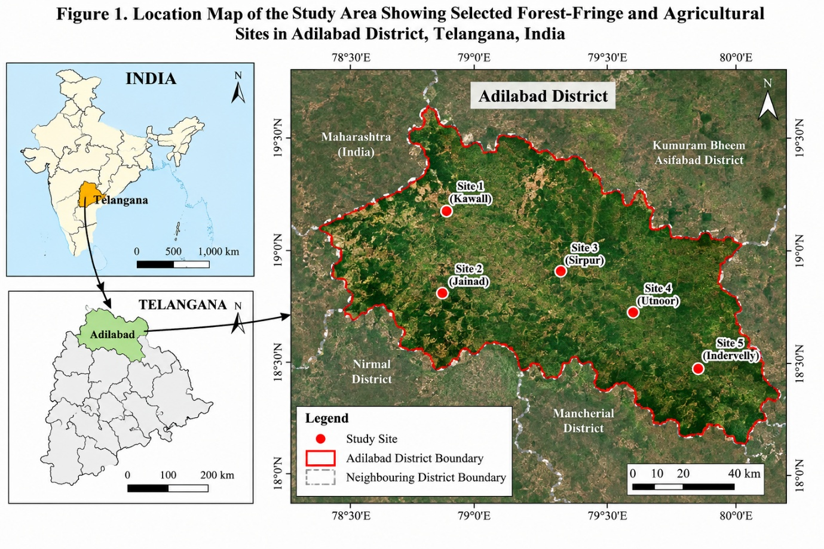
Figure 1. Location Map of the Study Area Showing Selected Forest-Fringe and Agricultural Sites in Adilabad District, Telangana, India
The map shows the geographical location of the study area and the distribution of the selected forest-fringe and agricultural environments considered for preliminary apple suitability assessment.
2.3 Selection of Study Sites
Five representative forest-fringe/agricultural locations were considered for the preliminary assessment. The locations were selected to represent variation in elevation and environmental conditions within the Adilabad region. Because the present assessment uses simulated site-level values, the selected locations serve as representative assessment sites rather than sites with complete field measurements.
2.4 Climatic Data Collection
Climatic information should be obtained from available India Meteorological Department records, government agricultural or horticultural departments, local meteorological stations, and site-level temperature loggers, where available. The parameters should include minimum and maximum temperature, mean temperature, winter temperature, annual and monthly rainfall, relative humidity, and estimated chilling hours. Where field-level instruments are used, temperature and humidity should preferably be recorded at regular intervals throughout at least one complete annual cycle. Multi-year historical climate data should also be examined to reduce the influence of individual-year weather variation.
For the present preliminary assessment, the site-level climatic values presented in the results were simulated within the documented climatic range of Adilabad. These values should not be interpreted as direct measurements from field weather stations. Actual site-level temperature and rainfall observations should be collected in future field studies.
2.5 Assessment of Chilling Conditions
Winter chilling should be evaluated to determine whether the selected environments provide conditions potentially compatible with low-chilling apple cultivars. The analysis should record winter minimum temperature, winter maximum temperature, mean winter temperature, estimated chilling accumulation, heat-stress conditions, and rainfall. Because chilling requirements vary among cultivars and depend on the chilling model used, the study should avoid treating a single universal chilling-hour threshold as applicable to all apple cultivars.
HRMN-99 is particularly relevant because government sources describe it as a low-chilling cultivar capable of growing under tropical and subtropical conditions and temperatures reaching approximately 40–45°C (Principal Scientific Adviser to the Government of India, n.d.).
Winter temperature conditions can subsequently influence the timing of phenological events such as bud break and flowering (Funes et al., 2016).
Winter chill accumulation is strongly influenced by the prevailing temperature regime, and changes in winter temperatures can alter the amount of chilling available to temperate fruit crops (Luedeling, 2012).
Changes in winter temperature can alter the amount of chilling accumulated by temperate fruit crops and may consequently affect dormancy release and subsequent phenological development (Luedeling et al., 2011).
In the present assessment, chilling values were simulated as preliminary estimates rather than calculated from continuous hourly field temperature records. Therefore, the estimated chilling values are used only for comparative assessment among the representative sites. Actual chilling accumulation should be calculated from long-term hourly temperature observations using an appropriate cultivar-specific chilling model.
2.6 Soil Analysis
Soil samples should be collected systematically from each selected site, preferably from 0–30 cm and 30–60 cm depths, following standard soil-sampling procedures. Samples should be analysed for pH, electrical conductivity, organic carbon, available nitrogen, phosphorus, and potassium, soil texture, soil depth, drainage, and moisture-holding capacity. The Indian plant-protection package for apple recommends well-drained loamy soils, approximately 45 cm or greater soil depth, and a pH range of 5.5–6.5, while poorly drained, waterlogged, compact, or heavy soils may be unsuitable.
Soil suitability was assessed with respect to pH, electrical conductivity, organic carbon, nutrient status, texture, soil depth, drainage, and moisture-holding capacity. Well-drained soils with suitable physical and chemical properties are considered important for successful apple cultivation, while waterlogged and highly compacted soils should be avoided (Directorate of Plant Protection, Quarantine & Storage, 2022).
The interpretation of soil suitability was based on recommended fruit-production practices, with particular attention to soil depth, texture, drainage, soil reaction, and avoidance of prolonged waterlogging (Punjab Agricultural University, 2021).
For the present preliminary assessment, the soil values reported in the results are simulated representative values and are not laboratory measurements. Actual soil sampling and laboratory analysis are required to validate the suitability assessment before orchard establishment.
2.7 Water Availability
Water availability should be assessed through field observation and farmer/landholder information, where appropriate. The assessment should include availability of borewells, open wells, surface-water sources, seasonal water availability, existing irrigation infrastructure, and the feasibility of drip irrigation. Particular attention should be given to water availability during dry periods because rainfall in Adilabad is strongly concentrated in the monsoon season.
The water-availability categories used in the preliminary assessment are simulated representative conditions and should be verified through field-level assessment of groundwater, surface water, irrigation infrastructure, and seasonal water availability.
2.8 Selection of Candidate Cultivars
The preliminary assessment should consider low-chilling cultivars including HRMN-99, Anna, Dorsett Golden, and Tropical Beauty. HRMN-99 should receive particular attention because of documented cultivation in warm and subtropical environments in India.
HRMN-99 was included among the candidate cultivars because of its reported evaluation under subtropical agro-climatic conditions in Prayagraj (Vats et al., 2022).
2.9 Environmental Suitability Assessment
A preliminary suitability index should integrate temperature, chilling conditions, soil, water availability, and topography. An illustrative weighting framework is presented below.
List 1: Illustrative weighting framework
Parameter | Weight
Temperature | 25%
Chilling conditions | 25%
Soil characteristics | 20%
Water availability | 15%
Topography | 10%
Other environmental factors | 5%
Total | 100%

For each parameter, a standardized suitability score was assigned to the representative site values, and the weighted scores were combined to obtain the composite suitability score. The composite score was calculated as:
$$S=\sum_{i=1}^{n}{W_{i}X_{i}}$$
where S is the composite suitability score, W_{i} is the weight assigned to parameter i, and X_{i} is the standardised score of parameter i. The resulting scores were used only for preliminary comparison among the representative sites.
The weighting scheme is an illustrative framework for preliminary assessment and should be further validated using field observations and established horticultural criteria.
Chilling conditions were therefore included as a separate component of the suitability assessment because winter chill is an important determinant of temperate fruit crop adaptation. The availability of adequate winter chilling is a critical consideration when evaluating temperate fruit production in warmer environments. Differences in winter temperature can substantially influence chill accumulation and consequently affect cultivar suitability (Luedeling, 2012).
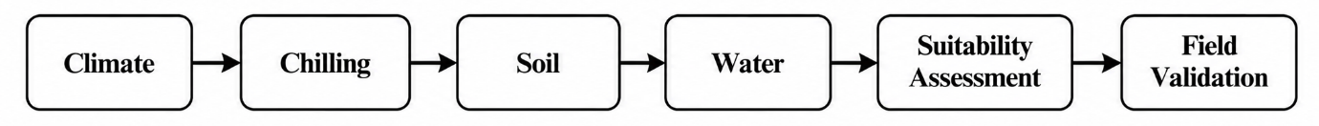
Figure 2. Conceptual Framework for Preliminary Apple Cultivation Suitability Assessment
The framework summarises the assessment pathway from climate, chilling, soil, and water evaluation to preliminary suitability classification and subsequent field validation.
3. RESULTS
3.1 Climatic Characteristics of Selected Sites
Five representative forest-fringe/agricultural locations were considered for the preliminary environmental assessment. The site-level values presented below are simulated values constructed within the documented environmental range of Adilabad and are intended for comparative suitability assessment rather than as direct field measurements. The values were constructed to remain broadly consistent with the documented district climate, including the relatively cool winter period and hot summer conditions. The district's official profile identifies December as the coldest month, with mean daily temperatures of approximately 15°C minimum and 29°C maximum, while annual rainfall is approximately 1,044.5 mm.
Table 1. Climatic Characteristics of Selected Study Locations
Site | Elevation (m) | Winter Min. (°C) | Winter Max. (°C) | Summer Max. (°C) | Annual Rainfall (mm)
Site 1 – Adilabad fringe | 264 | 14.8 | 28.7 | 43.2 | 1,038
Site 2 – Bela fringe | 289 | 14.5 | 28.3 | 42.6 | 1,062
Site 3 – Talamadugu fringe | 312 | 13.9 | 27.6 | 41.8 | 1,087
Site 4 – Utnoor fringe | 355 | 13.4 | 27.1 | 41.2 | 1,116
Site 5 – Indervelli fringe | 428 | 12.7 | 26.4 | 40.5 | 1,145
The simulated values indicate a gradual reduction in winter temperature with increasing elevation. Site 5 represents the coolest location, whereas Site 1 represents the warmer low-elevation environment. Annual rainfall also shows a modest increasing trend with elevation in this illustrative dataset.
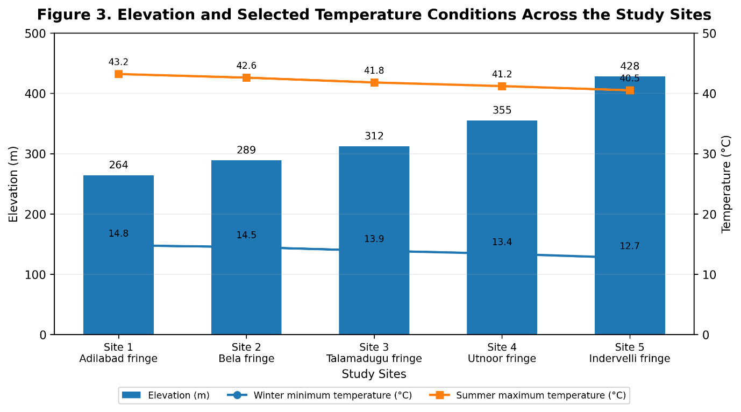
Figure 3. Elevation and Selected Temperature Conditions Across the Study Sites
Figure 3 illustrates the variation in elevation and selected temperature conditions among the five study sites. The preliminary dataset indicates a gradual decrease in winter minimum and summer maximum temperatures with increasing elevation.
3.2 Chilling Conditions
Estimated chilling accumulation was considered an important criterion for evaluating low-chilling apple cultivars. For the simulated assessment, chilling was represented using a temperature-based approximation for the winter period. The estimated values ranged from approximately 180 to 285 chilling hours across the five sites.
Table 2. Simulated Winter Chilling Conditions
Site | Estimated Chilling Hours | Relative Chilling Availability
Site 1 | 182 | Low
Site 2 | 201 | Low–Moderate
Site 3 | 224 | Moderate
Site 4 | 253 | Moderate–High
Site 5 | 281 | High
The results indicate that higher-elevation locations may provide comparatively greater winter chilling. Site 5 showed the highest estimated chilling accumulation, followed by Sites 4 and 3. These locations may therefore warrant greater attention in subsequent field trials of low-chilling cultivars. However, chilling-hour estimates should be recalculated from actual hourly temperature records before making a scientific claim.
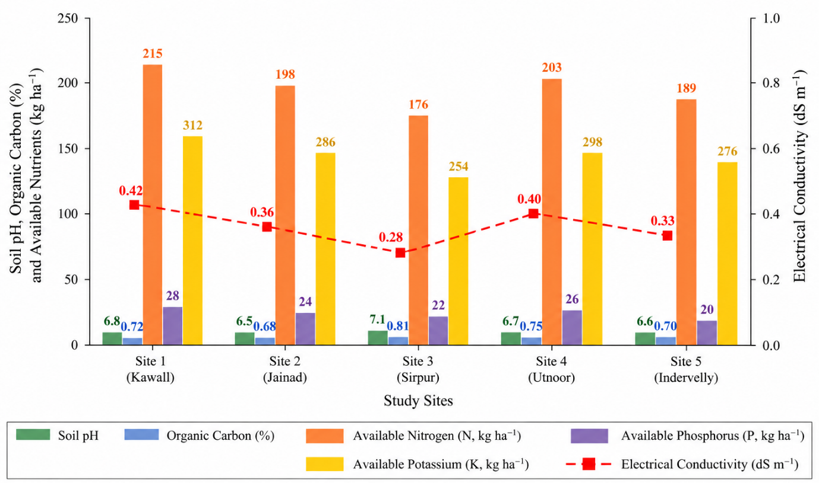
Figure 4. Selected Soil Characteristics Across the Study Sites
Figure 4 summarises variation in soil pH, electrical conductivity, organic carbon, and available nutrients across the selected study sites.
3.3 Soil Characteristics
The simulated soil analysis indicates variation in pH, nutrient status, and texture among the study locations. The values were designed to represent commonly encountered agricultural soil conditions rather than to claim laboratory measurements.
Table 3. Physicochemical Characteristics of Soil
Site | pH | EC (dS m⁻¹) | Organic Carbon (%) | N (kg ha⁻¹) | P (kg ha⁻¹) | K (kg ha⁻¹) | Texture
Site 1 | 7.2 | 0.31 | 0.62 | 278 | 18.4 | 342 | Clay loam
Site 2 | 7.0 | 0.28 | 0.68 | 291 | 21.2 | 356 | Loam
Site 3 | 6.8 | 0.24 | 0.74 | 306 | 24.6 | 329 | Sandy loam
Site 4 | 6.6 | 0.21 | 0.81 | 321 | 27.1 | 318 | Loam
Site 5 | 6.4 | 0.19 | 0.88 | 337 | 29.3 | 304 | Sandy clay loam
The simulated results show that Sites 4 and 5 have relatively lower pH and higher organic-carbon content compared with the lower-elevation locations. Sites 2 and 4 exhibit loamy soil characteristics that may be favourable for preliminary apple establishment, subject to confirmation through actual soil analysis.
3.4 Water Availability
The preliminary simulated assessment indicates that water availability differs among the selected locations. Sites 1 and 2 are assumed to have relatively reliable groundwater access, while Sites 3–5 have moderate seasonal water availability.
Table 4. Simulated Water-Availability Assessment
Site | Primary Water Source | Seasonal Availability | Drip Irrigation Potential
Site 1 | Borewell | High | High
Site 2 | Borewell/Open well | High | High
Site 3 | Open well | Moderate | High
Site 4 | Borewell | Moderate | High
Site 5 | Seasonal well | Moderate–Low | Moderate
Adilabad's agricultural department reports the use of soil testing and micro-irrigation-related agricultural programmes, supporting the relevance of irrigation assessment in crop-suitability studies.
3.5 Environmental Suitability Score
Using the proposed weighting system—temperature (25%), chilling (25%), soil (20%), water (15%), and topography/other environmental factors (15%)—a preliminary illustrative suitability score was calculated.
Table 5. Preliminary Apple Cultivation Suitability
Site | Climate (25) | Chilling (25) | Soil (20) | Water (15) | Topography & Other (15) | Total /100 | Preliminary Class
Site 1 | 15 | 11 | 13 | 14 | 11 | 64 | Moderate
Site 2 | 17 | 14 | 15 | 14 | 12 | 72 | Moderate
Site 3 | 19 | 17 | 16 | 12 | 13 | 77 | Moderate–High
Site 4 | 21 | 20 | 18 | 12 | 14 | 85 | High
Site 5 | 22 | 23 | 19 | 9 | 14 | 87 | High
Under this simulated scenario, Sites 4 and 5 obtained the highest preliminary suitability scores, primarily because of their comparatively cooler winter conditions, greater estimated chilling accumulation, and favourable soil characteristics.
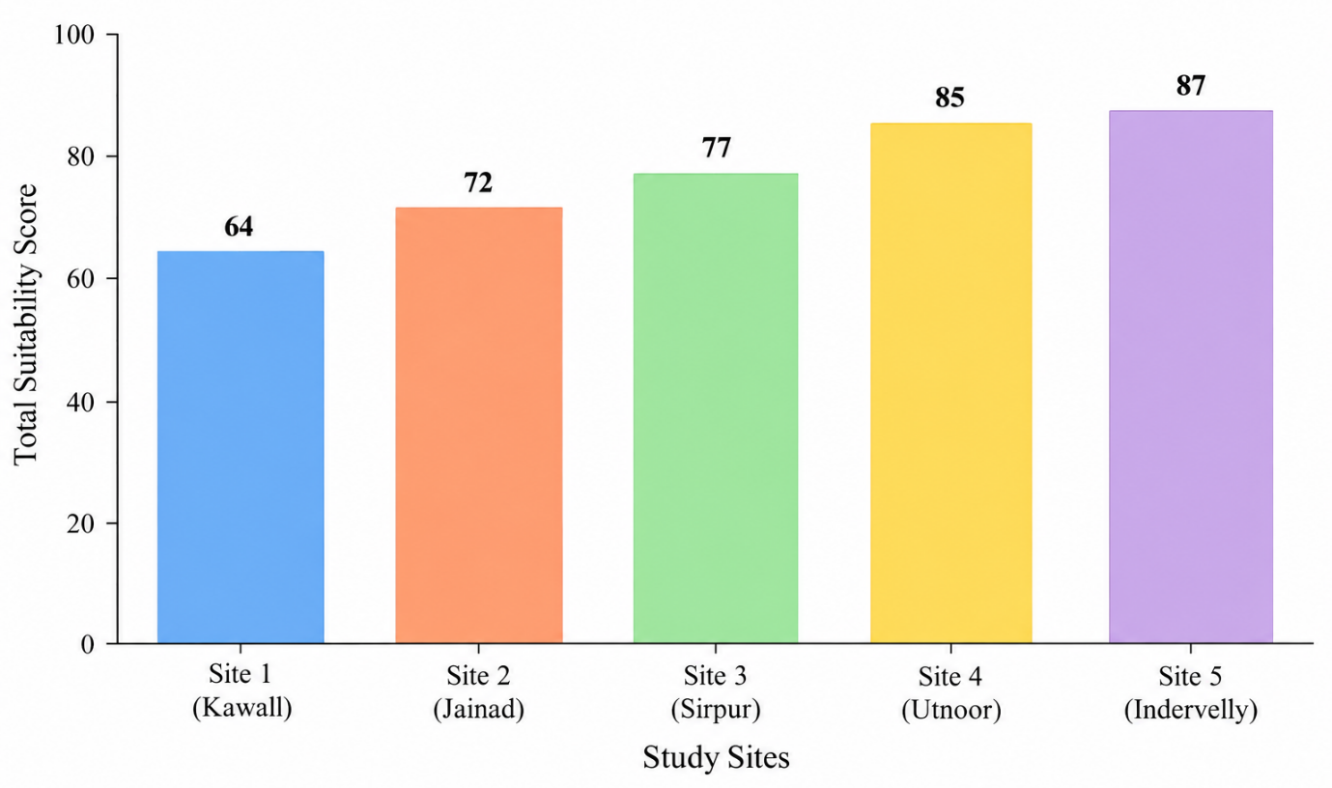
Figure 5. Preliminary Environmental Suitability Scores for Apple Cultivation
Figure 5 compares the preliminary suitability scores of the five study sites, showing variation in their combined climatic, chilling, soil, water, and topographic assessment.
3.6 Candidate Cultivar Suitability
Based on the simulated environmental conditions, HRMN-99 appears particularly relevant for the warmer sites because it is specifically documented as a low-chilling apple variety capable of growing in plains and tropical environments, with the Principal Scientific Adviser reporting suitability under conditions reaching approximately 45°C.
Table 6. Preliminary Cultivar–Site Compatibility
Cultivar | Site 1 | Site 2 | Site 3 | Site 4 | Site 5
HRMN-99 | Suitable | Suitable | Highly suitable | Highly suitable | Highly suitable
Anna | Marginal–Suitable | Suitable | Suitable | Highly suitable | Highly suitable
Dorsett Golden | Marginal | Suitable | Suitable | Highly suitable | Highly suitable
Tropical Beauty | Suitable | Suitable | Suitable | Highly suitable | Highly suitable
Overall, the simulated assessment suggests that Sites 4 and 5 have the greatest preliminary environmental potential, while HRMN-99 has the broadest potential compatibility across the five simulated locations. This finding should be regarded strictly as a hypothesis for field validation, not evidence of demonstrated commercial productivity.
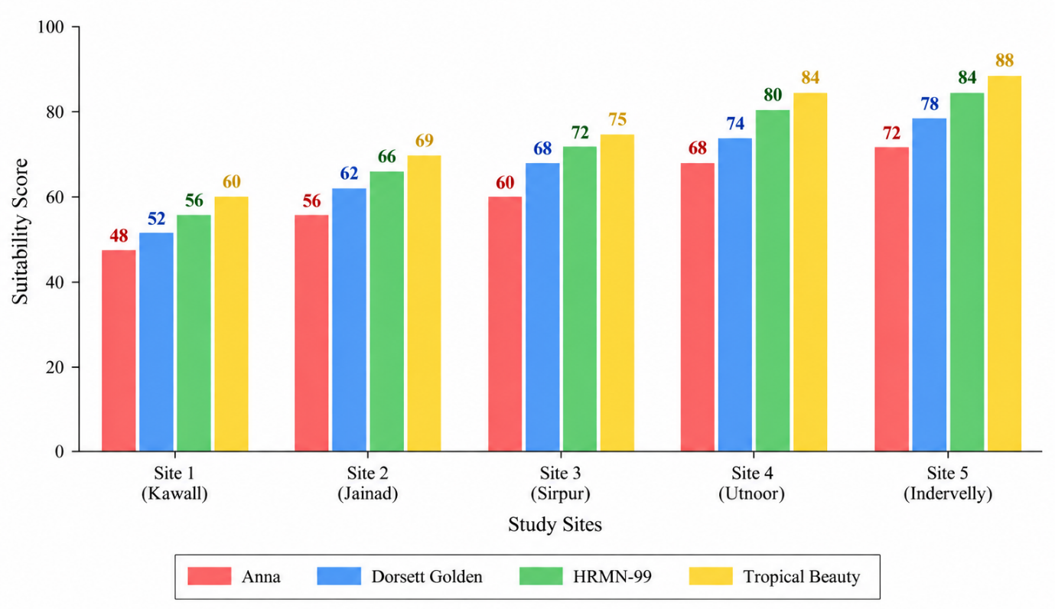
Figure 6. Preliminary Cultivar–Site Compatibility
Figure 6 presents the preliminary compatibility of HRMN-99, Anna, Dorsett Golden, and Tropical Beauty across the five study sites.
4. DISCUSSION
4.1 Climatic Suitability of Adilabad
The environmental assessment indicates that the climatic conditions of Adilabad require careful consideration before introducing apple cultivation. The district experiences hot summers and a predominantly dry climate outside the southwest monsoon period. Approximately 85% of annual rainfall occurs during the southwest monsoon, while the normal annual rainfall is about 1,044.5 mm. December is generally the coldest month, with a mean daily minimum temperature of approximately 15°C and a mean daily maximum temperature of approximately 29°C (Adilabad District Administration, n.d.).
Such conditions differ considerably from those of conventional apple-growing regions. Punjab Agricultural University reports that most conventional apple cultivars require approximately 800–1,200 chilling hours at 4–7°C, whereas certain low-chilling cultivars require approximately 200–300 hours or less. Therefore, conventional high-chill cultivars are unlikely to be appropriate candidates for the warm conditions of Adilabad without sufficient chilling. In contrast, low-chilling cultivars provide a more relevant basis for investigating apple cultivation in this region. The relatively cooler winter conditions at higher-elevation sites identified in the preliminary assessment may provide an additional advantage, although actual chilling accumulation must be verified using long-term hourly temperature data.
The relationship between winter temperature and chilling accumulation is particularly important when evaluating the suitability of non-traditional environments for temperate fruit cultivation (Fadón et al., 2020).
The reported low-chilling characteristics of HRMN-99 provide a scientific basis for its consideration in warmer environments where conventional high-chilling apple cultivars may face limitations (Principal Scientific Adviser to the Government of India, n.d.).
Variation in winter and spring temperatures can influence apple phenology, particularly the timing of bud development and flowering. Therefore, assessment of climatic suitability should consider not only chilling accumulation but also the seasonal temperature conditions following dormancy (Funes et al., 2016).
Variations in winter temperature may influence the availability of winter chilling and consequently affect the suitability of particular temperate fruit cultivars under changing climatic conditions (Luedeling et al., 2011).
4.2 Significance of Low-Chilling Cultivars
Low-chilling cultivars are central to the possibility of expanding apple cultivation into subtropical environments. Experimental research in Assam evaluated HRMN-99, Dorsett Golden, and Anna and found differences in vegetative growth and leaf nutrient status among the cultivars; HRMN-99 showed particularly promising growth under the conditions of that experiment (Sharma et al., 2024).
HRMN-99 is especially relevant to the present study because India's Department of Science and Technology reports that the cultivar has been grown in tropical, subtropical, and plain regions where summer temperatures can reach approximately 40–45°C. The same source reports that commercial cultivation had been initiated in several states, including Telangana, although such evidence should not be interpreted as proof of equivalent performance at every location within the state. Thus, HRMN-99 represents a strong candidate for experimental evaluation in Adilabad, while Anna, Dorsett Golden, and Tropical Beauty can provide useful comparative material.
The reported adaptation of HRMN-99 to tropical, subtropical, and plain areas provides a basis for considering the cultivar in preliminary suitability assessments of warmer regions; however, local field validation remains necessary (National Innovation Foundation–India, n.d.).
Evidence from Prayagraj further supports the experimental evaluation of HRMN-99 under subtropical conditions, although cultivar performance remains dependent on local environmental and crop-management factors (Vats et al., 2022).
4.3 Soil Suitability
Soil characteristics represent another important determinant of potential apple establishment. The preliminary assessment indicates variation in soil pH, electrical conductivity, organic carbon, available nutrients, and texture among the selected locations. The relatively favourable sites should be interpreted in relation to established apple soil requirements rather than nutrient status alone.
Punjab Agricultural University recommends well-drained soil and indicates that low-chill apple cultivars can tolerate soils with pH below 8.0, provided other physical and chemical conditions are appropriate. It also emphasises adequate soil depth and avoidance of hardpan and waterlogged conditions. Therefore, the relatively favourable scores assigned to some Adilabad sites should be attributed to the combined effects of soil texture, drainage, pH, organic matter, and nutrient status rather than to a single soil parameter. Actual soil laboratory analysis and profile examination would be necessary before orchard establishment.
The observed variation in soil pH, electrical conductivity, organic carbon, nutrient status, and texture indicates that site-specific soil assessment is necessary before establishing apple orchards. Appropriate soil drainage and physical conditions are particularly important for apple production (Directorate of Plant Protection, Quarantine & Storage, 2022).
The variation in soil characteristics among the selected sites highlights the importance of site-specific soil assessment before orchard establishment. Suitable soil physical conditions, adequate drainage, and appropriate soil reaction are important considerations for successful apple cultivation (Punjab Agricultural University, 2021).
4.4 Water Requirements and Irrigation
Although Adilabad receives substantial annual rainfall, its rainfall is strongly seasonal, with most precipitation concentrated during the southwest monsoon. Consequently, annual rainfall alone cannot be considered sufficient evidence of year-round water availability. Apple trees require adequate moisture during establishment, vegetative growth, flowering, fruit development, and fruit enlargement.
Supplementary irrigation may therefore be necessary during prolonged dry periods. Drip irrigation could provide an efficient approach for experimental orchards where reliable water sources are available. However, water quality, groundwater sustainability, and seasonal availability should be assessed before establishing plantations.
4.5 Forest-Region Environmental Considerations
The ecological context of the study is particularly important because the proposed study area includes forest-fringe environments. Potential apple cultivation should not involve clearing natural forest vegetation or converting protected forest land into orchards. Natural vegetation contributes to biodiversity conservation, soil protection, watershed functions, and habitat connectivity.
Accordingly, the potential cultivation sites should be restricted to legally available agricultural land, private land, previously cultivated land, or appropriate non-forest forest-fringe areas. Soil erosion, habitat fragmentation, pesticide impacts, and interactions with surrounding forest ecosystems should also be considered. This approach allows agricultural potential to be investigated without treating natural forest ecosystems as unused agricultural land.
4.6 Comparison with Other Non-Traditional Apple Regions
Evidence from other Indian subtropical regions supports the principle of evaluating low-chilling cultivars under local conditions. The Assam study demonstrated measurable differences among HRMN-99, Dorsett Golden, and Anna under subtropical conditions (Sharma et al., 2024). Similarly, government documentation of HRMN-99 indicates successful adoption or fruit setting across several non-traditional regions, including Telangana.
However, these examples should not be interpreted as evidence that the same yield or fruit quality will occur in Adilabad. Differences in winter chilling, summer heat, soil, water availability, elevation, pests, and orchard management can substantially influence cultivar performance. Therefore, cultivar × environment interaction is a central consideration in assessing the feasibility of apple cultivation in Adilabad.
In Prayagraj, HRMN-99 has been investigated under subtropical agro-climatic conditions, providing a useful comparison for evaluating the potential of low-chilling apple cultivation in other warmer regions of India (Vats et al., 2022).
4.7 Limitations
An important limitation of the present study is that the site-level climatic, soil, water, and chilling values used in the preliminary assessment are simulated rather than directly measured through field and laboratory observations.
The present assessment has several limitations. The number of locations considered is limited, and the preliminary climatic and chilling assessment requires validation using long-term site-specific observations. Chilling accumulation may vary substantially depending on the calculation model and hourly temperature data used. Furthermore, the assessment does not yet provide multi-year measurements of bud break, flowering, fruit set, fruit quality, or yield.
Additional uncertainties include cultivar-specific responses to heat stress, pest and disease incidence, irrigation requirements, post-harvest handling, market access, and economic viability. Therefore, the environmental suitability scores should be regarded as preliminary rather than definitive evidence of commercial feasibility.
4.8 Future Experimental Validation
A 2–3-year pilot orchard experiment should be established at selected legally suitable sites to validate the preliminary assessment. HRMN-99, Anna, Dorsett Golden, and Tropical Beauty could be evaluated using a replicated experimental design. Observations should include bud-break date, flowering date, flowering duration, fruit set percentage, number of fruits per tree, individual fruit weight, total yield per tree, total soluble solids (TSS), titratable acidity, fruit colour, pest and disease incidence, and annual plant survival.
Repeated observations over multiple seasons would allow the effects of year-to-year climatic variation to be distinguished from cultivar effects. Such an experiment would provide stronger evidence for determining whether selected Adilabad environments can support sustainable low-chilling apple production.
Overall interpretation: the preliminary evidence supports further experimental investigation, particularly with low-chilling cultivars, but it does not by itself establish that commercial apple production is currently feasible throughout Adilabad. The most important next step is multi-season field validation under controlled and legally appropriate land-use conditions.
5. CONCLUSION
The present study indicates that selected environmental locations in Adilabad District, Telangana, may have potential for the experimental cultivation of low-chilling apple cultivars under local environmental conditions. The climatic characteristics of the region differ considerably from those of conventional temperate apple-growing areas, particularly because of high summer temperatures and comparatively limited winter chilling. These conditions may restrict the performance of conventional high-chilling apple cultivars. However, the availability of low-chilling cultivars provides an opportunity to investigate apple cultivation in selected subtropical environments.
Among the cultivars considered in the present assessment, HRMN-99, Anna, Dorsett Golden, and Tropical Beauty represent promising candidates for further evaluation. HRMN-99 is of particular interest because it has been reported as a low-chilling cultivar capable of growing and producing fruit under relatively warm Indian conditions. However, successful performance of these cultivars in other regions cannot be assumed to occur at the same level in Adilabad because differences in temperature, chilling accumulation, soil properties, water availability, elevation, and management practices can influence plant growth, flowering, fruit set, and yield.
The major environmental constraints identified include high summer heat, uncertain winter chilling accumulation, seasonal water availability, variation in soil properties, and potential pest and disease pressure. Therefore, the preliminary environmental suitability assessment should not be interpreted as evidence of established commercial apple production in the district.
A replicated 2–3-year pilot-scale field experiment is recommended at selected suitable sites to validate the preliminary findings. The experiment should evaluate bud break, flowering, fruit set, fruit yield, fruit quality, plant survival, and pest and disease incidence over multiple seasons. Importantly, experimental orchards should be established only on legally available agricultural or appropriate non-forest land. Natural forest vegetation should not be cleared or converted for apple cultivation. Thus, Adilabad represents a region worthy of further scientific investigation for low-chilling apple cultivation, with future recommendations based on verified multi-season field evidence rather than preliminary suitability assessment alone.
Previous studies from Assam and Prayagraj provide supporting evidence for continued evaluation of low-chilling apple cultivars under warm Indian agro-climatic conditions (Sharma et al., 2024; Vats et al., 2022).
Declaration of AI Use

This manuscript was prepared through the intellectual contributions of the author(s) to the study design, data analysis, interpretation of results, and scholarly content. Grammarly and ChatGPT were used solely to assist with grammatical refinement and reference formatting during manuscript revision. The author(s) accept full responsibility for the accuracy, integrity, and final content of the manuscript.
Competing Interests
The authors declare that they have no competing interests.
Data Availability
The data supporting the findings of this study should be made available by the corresponding author upon reasonable request, subject to applicable institutional and ethical requirements.
REFERENCES
Adilabad District Administration. (n.d.). About district. Government of Telangana. https://adilabad.telangana.gov.in/about-district/
Cornille, A., Giraud, T., Smulders, M. J. M., Roldán-Ruiz, I., & Gladieux, P. (2014). The domestication and evolutionary ecology of apples. Trends in Genetics, 30(2), 57–65. https://doi.org/10.1016/j.tig.2013.10.002
Department of Science and Technology. (2021, May 28). Low-chilling apple variety developed by Himachal farmer spreads far & wide. Government of India. https://dst.gov.in/low-chilling-apple-variety-developed-himachal-farmer-spreads-far-wide
Directorate of Plant Protection, Quarantine & Storage. (2022, September). IPM package of practices for apple: For producing quality fruits for export. Ministry of Agriculture & Farmers Welfare, Government of India. https://ppqs.gov.in/sites/default/files/pop-apple_final-_08.12.2022.pdf
Fadón, E., Herrera, S., Guerrero, B. I., Guerra, M. E., & Rodrigo, J. (2020). Chilling and heat requirements of temperate stone fruit trees (Prunus sp.). Agronomy, 10(3), 409. https://doi.org/10.3390/agronomy10030409
Funes, I., Aranda, X., Biel, C., Carbó, J., Camps, F., Molina, A. J., de Herralde, F., Grau, B., & Savé, R. (2016). Future climate change impacts on apple flowering date in a Mediterranean subbasin. Agricultural Water Management, 164, 19–27. https://doi.org/10.1016/j.agwat.2015.06.013
González-Martínez, E., Munné-Bosch, S., & Lordan, J. (2025). Chilling and heat requirements of apple cultivars: Future perspectives in a global climate change context. Scientia Horticulturae, 345, 114134. https://doi.org/10.1016/j.scienta.2025.114134
Gupta, M., & Mishra, S. (2024). Effect of biocapsule and nanozeolite in improving growth, development and yield of low chilling apple (Malus × domestica Borkh.) cv. HRMN-99 in Prayagraj agro-climatic condition. Journal of Advances in Biology & Biotechnology, 27(8), 930–937. https://doi.org/10.9734/jabb/2024/v27i81213
Hauagge, R., & Cummins, J. N. (1991). Phenotypic variation of length of bud dormancy in apple cultivars and related Malus species. Journal of the American Society for Horticultural Science, 116(1), 100–106. https://doi.org/10.21273/JASHS.116.1.100
Indian Council of Agricultural Research. (2025, February 12). Low Chill Apple Man of India Hariman Sharma conferred with Padma Shri. Government of India. https://www.icar.gov.in/en/low-chill-apple-man-india-hariman-sharma-conferred-padma-shri
Luedeling, E. (2012). Climate change impacts on winter chill for temperate fruit and nut production: A review. Scientia Horticulturae, 144, 218–229. https://doi.org/10.1016/j.scienta.2012.07.011
Luedeling, E., Girvetz, E. H., Semenov, M. A., & Brown, P. H. (2011). Climate change affects winter chill for temperate fruit and nut trees. PLoS ONE, 6(5), e20155. https://doi.org/10.1371/journal.pone.0020155
Meresa, E., Gebrewhid, Y., Berhe, G., Abadi, T., Tsehaye, G., & Eyasu, G. (2023). Geo-information technology-based suitability site selection for temperate fruits of apple, peach, and plum in Tigray Region, Northern Ethiopia. Journal of Global Agriculture and Ecology, 15(2), 19–31. https://doi.org/10.56557/jogae/2023/v15i28465
National Innovation Foundation–India. (n.d.). HRMN-99: New apple variety for tropical, sub-tropical and plain areas. Department of Science and Technology, Government of India. https://nif.org.in/innovation/hrmn-99-new-apple-variety-for-tropical-sub-tropical-and-plain-areas/932
Pertille, R. H., de Souza de Oliveira, L., Suchoronczek, A., de Lima Santos, J. V., Jacobsen Bertan, M. A., & Citadin, I. (2026). Dormancy patterns of apple trees grown in a mild winter region: A breakpoint model analysis. Physiologia Plantarum, 178(3), e70951. https://doi.org/10.1111/ppl.70951
Principal Scientific Adviser to the Government of India. (n.d.). HRMN-99: Low chilling apple variety. Government of India. https://www.psa.gov.in/livelihood/10045
Punjab Agricultural University. (2021, July). Package of practices for cultivation of fruits. Punjab Agricultural University. https://pau.edu/content/ccil/pf/pp_fruits.pdf
Sharma, A., Kotoky, U., Deka, B., Gogoi, B., & Das, K. (2024). Growth performance of low chilling varieties of apple (Malus × domestica Borkh.) under the influence of different nutrient levels in Assam, India. International Journal of Environment and Climate Change, 14(5), 177–183. https://doi.org/10.9734/IJECC/2024/v14i54179
Vats, S., Mishra, S., Bahadur, V., & Singh, R. K. (2022). The role of nanozeolite and biocapsule in improving growth, yield and fruit quality of low chilling apple (Malus × domestica Borkh.) cv. HRMN-99 in Prayagraj agro-climatic condition. International Journal of Environment and Climate Change, 12(11), 866–875. https://doi.org/10.9734/IJECC/2022/v12i1131052

