Original Research Article

OPTIMIZING AGRICULTURAL WASTE BASED SUBSTRATES FOR ENHANCED GROWTH AND PRODUCTIVITY OF OYSTER MUSHROOM (PLEUROTUS OSTREATUS)’
Abstract
The effectiveness of several agricultural substrates for oyster mushroom (Pleurotus ostreatus) production was investigated. The experiment comprised five treatments, with three replicates, using two base substrates: banana leaves and sawdust. It was arranged in a completely randomised design. Lime and water were added to each farm substrate or treatment, which comprised combinations of different agricultural wastes. Some substrates were also prepared from a single agricultural waste combined with water and lime. Trt5 (75% banana leaves: 25% sawdust) was the most effective of the five treatments, producing the highest total yield of 1092.69 g per 2 kg of dry substrate. Sawdust (Trt1) produced the lowest yield (657 g), possibly owing to the presence of several phenolic compounds. Compared with the other substrates, banana leaves required less time for mycelial colonisation, fruiting and harvesting, whereas sawdust required more time. Trt2 (100% banana leaves) produced the largest cap diameter (7.85 cm) and stipe girth (4.03 cm). Trt5, which combined sawdust and banana leaves, had the highest reported biological efficiency (127.35%), whereas Trt1 (100% sawdust) had the lowest (65.83%). In conclusion, the substrate containing 75% banana leaves and 25% sawdust produced the highest yield of P. ostreatus, followed by Trt2, which consisted entirely of banana leaves.
Key words: farm substrates, fruiting, mycelium colonization, Pleurotus ostreatus, Yield.
1. Introduction
The adverse effects of climate change are endangering global food production. Sub-Saharan Africa must therefore increase agricultural output to feed its growing population sustainably and ensure food security and safety (Mutetwa et al., 2019). Sub-Saharan African countries must adopt scientific, technological and economic strategies to address food security (Nyaera et al., 2019). Mushroom production is one approach to improving food security and nutrition. According to Adebayo et al. (2021), mushrooms are fleshy, spore-bearing fruiting bodies of fungi; they lack chlorophyll and cannot perform photosynthesis (Chang & Wasser, 2017; Ofoedum et al., 2024). According to Semwal et al. (2014) and Chukwu et al. (2022), biological decomposition processes provide them with energy. The term 'mushroom' refers to fungi with a stem (stipe), a cap (pileus), a hymenium (lamellae) and spores on the underside of the cap (Masarirambi et al., 2011). Mushroom multiplication and survival are influenced by numerous factors, which may act independently or in combination. Chemical, physical and biological factors associated with mushroom production include chemical composition, the carbon (C)-to-nitrogen (N) ratio, N sources, surfactants, minerals, pH, water activity, moisture, particle size, inoculum quantity, antimicrobial agents and interactions between microorganisms (Eira & Facil Viçosa, 2003).
Light intensity, humidity, temperature and the composition of the air surrounding the substrate, including the proportions of carbon dioxide and oxygen, are important environmental factors affecting oyster mushroom yield and quality (Hoa et al., 2015). According to Alemu and Fisseha (2015), oyster mushrooms (Pleurotus sp.) are the second most popular mushrooms worldwide because of their flavour and ease of cultivation, which requires relatively few financial and material resources. In addition to having low fat and cholesterol contents, these mushrooms are rich in protein, vitamins and minerals (Girmay et al., 2016). Owing to their protein, mineral, vitamin, antioxidant and phytochemical contents and their low fat and carbohydrate contents, they may be used as functional foods and contribute to the nutritional value of meals when used as food additives (Allam & Mohamed, 2023).
It can be cultivated on substrates rich in hemicellulose, lignin and cellulose, such as waste paper, leaves, wheat straw, rice straw, sawdust, sugarcane bagasse and corncobs. Using biological wastes for mushroom production is an important means of transforming inedible biowaste into a source of nutrients. Thus, mushroom cultivation is regarded as an effective approach to biowaste management (Tsegaye, 2017). Many of these lignocellulosic wastes are burned or allowed to accumulate on the ground, contributing to groundwater contamination, environmental pollution and hygiene problems. Recycling organic waste through appropriate biotechnological techniques reduces waste accumulation and environmental contamination.
Comparative cultivation studies of Pleurotus ostreatus (Mubasshira et al., 2020) and other cultivated oyster mushrooms (Margaret et al., 2023) have reported differences in growth or yield among agricultural residues.
Recent studies evaluating tea-waste blends and locally available agro-industrial by-products have also examined the effects of substrate composition on the yield and biological efficiency of P. ostreatus (Ahmed et al., 2024; Desisa et al., 2024). Miśkiewicz et al. (2025) further reported variation in substrate colonisation and the timing of the first harvest among agro-food waste formulations.
Although various agricultural residues have been evaluated for oyster mushroom cultivation, a comparison of banana leaves and sawdust at the proportions investigated in this study is needed to assess their relative effects on growth stages, fruiting-body characteristics and yield under the study conditions.
To promote appropriate biowaste management techniques, this study evaluated the yield and growth performance of oyster mushrooms (Pleurotus ostreatus) cultivated using different proportions of banana leaves and sawdust.

- MATERIALS AND METHODS
2.1 Collection and preparation of Substrates
P. ostreatus spawn was obtained from the Federal University of Technology, Owerri (FUTO), Department of Biological Sciences, Imo State, Nigeria. Banana leaves still attached to the trees were collected from a farm in Owerri, and sawdust was collected from the Mbieri timber market. The investigation was conducted in the Department of Microbiology Laboratory at FUTO, Owerri, Imo State, Nigeria. The clean banana leaves were collected two weeks before spawning, cut into uniform lengths and air-dried for two weeks, while the sawdust was left to decompose for an additional week (Nwoko et al., 2024; Odeyemi et al., 2026).
The treatments included three replicates of each of the following substrates: 100% sawdust (Trt1), 100% banana leaves (Trt2), 50% sawdust and 50% banana leaves (Trt3), 75% sawdust and 25% banana leaves (Trt4), and 25% sawdust and 75% banana leaves (Trt5), as shown in Table 1. These substrates were submerged in water for eight hours, after which the excess water was allowed to drain. The substrates were amended with 4% CaSO₄ and 2% (w/w) CaCO_{3.} Following the methods of Okwulehie and Okwujiako (2008), Nwuka et al. (2026) and Besufekad et al. (2020), each substrate was then pasteurised separately with steam in a metal drum at 96°C for three to four hours and allowed to cool to room temperature (20–25°C). Plates 1 and 2 show freshly harvested and dried mushrooms, respectively.
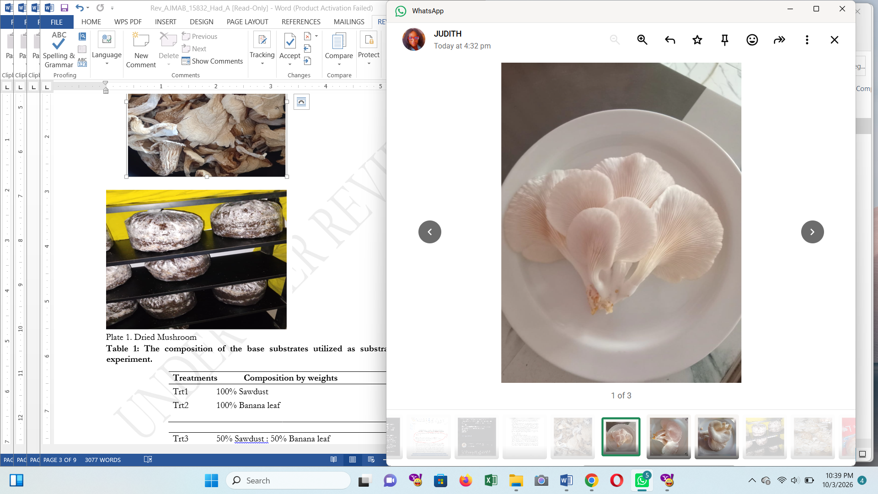Plate 1. Freshly harvested Muchroom. Plate 2. Dried Mushroom

Table 1: The composition of the base substrates utilized as substrate material in this experiment.
Treatments Composition by weights
Trt1 100% Sawdust
Trt2 100% Banana leaf

Trt3 50% Sawdust : 50% Banana leaf
Trt4 75% Sawdust : 25% Banana leaf
Trt5 25% Sawdust : 75% Banana leaf

2.2 Harvesting and spawning
A 70 g quantity of P. ostreatus spawn was used to inoculate each substrate treatment (2 kg) in a clear plastic bag. Ten holes were made in each bag to ensure adequate aeration. The bags were then tied and incubated in the dark in a well-ventilated room. After spawning, the bags were placed 20 cm apart in a cropping room with a light intensity of 450–500 lux, a temperature of 25–32°C and a relative humidity of 70–85%. Fruiting began soon after mycelial growth had fully colonised the substrate. At the primordium stage, the plastic bags were cut open to permit oxygen entry. The mushrooms were harvested while young, firm and fleshy, removed from the residues and weighed on the same day. Three flushes were harvested by carefully removing the mushrooms from the residues; harvesting continued while the mycelia remained firm and white (see Plates 3 and 4).
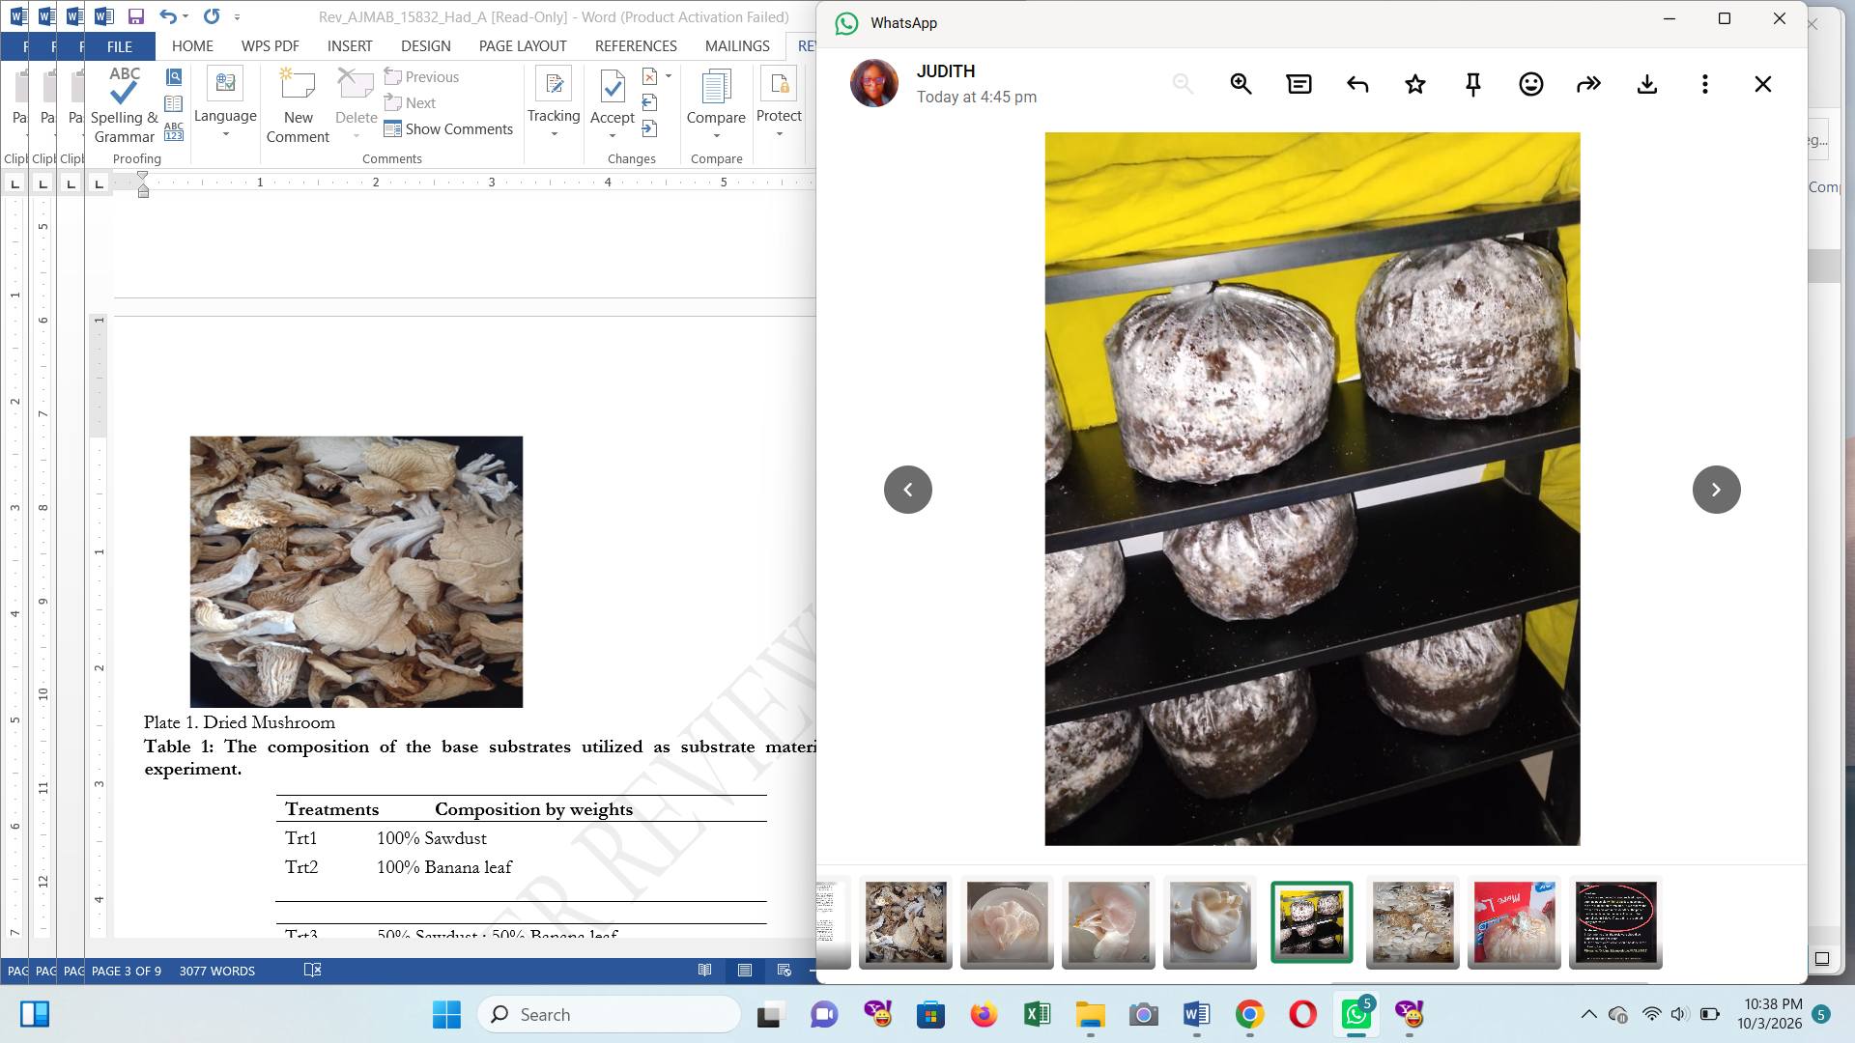Plate 3. Mycelial colonisation

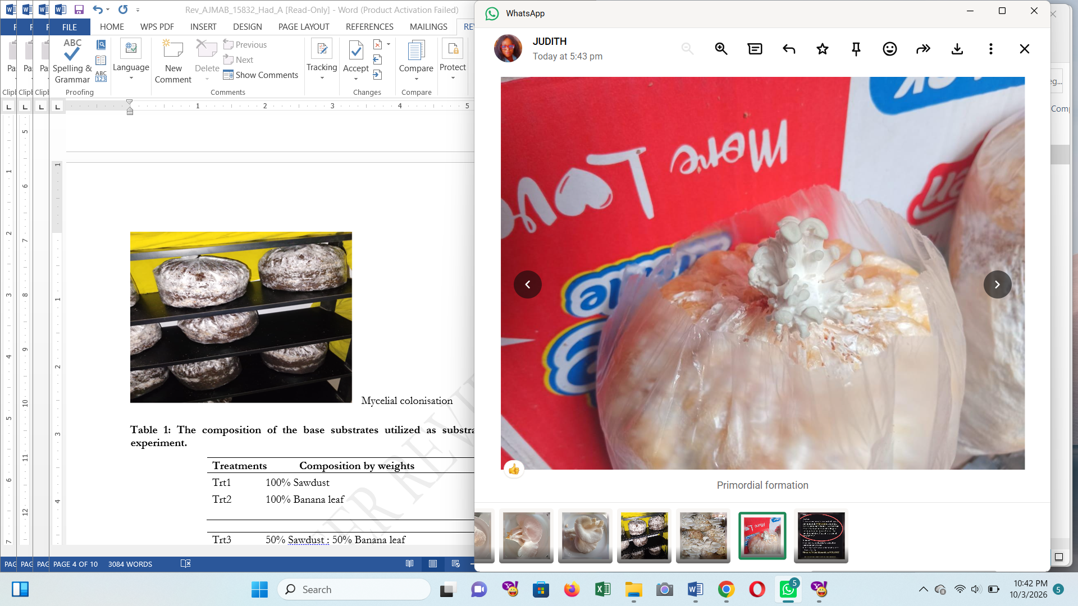Plate 4. Primordial formation
2.3. Data Gathering
The numbers of days required for mycelial colonisation, primordium development and the first harvest were recorded. A ruler was used to measure stipe girth (SG) and cap diameter for each treatment during each harvesting cycle. The total yield of fresh mushrooms was also calculated. Biological efficiency (BE) (%) was calculated as the weight of freshly harvested mushrooms (g) divided by the dry residual weight (g), multiplied by 100.

2.4 Data analysis
The data were analysed using SPSS version 25.0. Differences between treatments were assessed using analysis of variance (ANOVA), and mean growth-stage and yield characteristics were compared using Duncan's multiple range test (DMRT) at a significance level of P ≤ 0.05 and a 95% confidence interval.

3.0 Results and discussion
3.1. The impact of agricultural residues on mycelial colonization, primordial development, and the initial harvest of P. ostreatus
Table 3 indicates significant differences (ρ < 0.05) in the morphological characteristics of mushrooms grown on different residues. Following incubation, the initial harvest, primordium development and mycelial colonisation were completed within 18–31, 22–33 and 28–38 days, respectively. Morphological characteristics differed when Trt2 and Trt5 were used. P. ostreatus cultivated on Trt2 and Trt5 reached primordium development, mycelial colonisation and the first fruiting-body harvest earlier than mushrooms in the other treatments. Mushrooms cultivated solely on Trt1 exhibited a significant (ρ < 0.05) delay in morphological development.
3.2. The impact of agricultural wastes on P. ostreatusfruiting bodies.

Table 2. Yields and Biological efficiency (%) of Pleurotus ostreatus as affected by different agricultural residues

Treatment | 1st flush |  | 2nd flush | 3rd flush | Total yield (g/bag) | Biological efficiency (%) | biggest stipe girth (4.03 cm),
Trt1  Trt2  Trt3  Trt4  Trt5 |  | 349.52^{c}±0.40  463.25ª±0.05  349.25^{c}±0.05  331.50^{d}±0.05  430.39^{b}±0.01 | 203.90e±0.05  302.08^{d}±0.01  311.01^{c}±0.01  318.18^{b}±0.01  390.80ª±0.05 | 104.24e±0.01  121.41^{d}±0.10  203.90^{c}±0.05  134.49^{b}±0.01  271.50ª±0.05 | 657.66e±0.06  886.82^{b}±0.15  864.16^{c}±0.011 784.18^{d}±0.06  1092.69ª±0.11 | 65.83e±0.01  110.80^{b}±0.02  96.58^{c}±0.02  81.45^{d}±0.01  127.35ª±0.02 | which varied from 3.11 to 4.03 cm.

The values are means ± standard deviation of three replicates determinations. The “a,b,c,…” means with the different superscripts along the same columns are significantly different (p<0.05)

According to Table 3, the largest cap diameter was 7.85 cm for Trt2, followed by 5.8 cm for Trt1 and 5.21 cm for Trt4. The study reported no statistically significant difference in stipe girth among the substrate treatments. The mean stipe circumference across the treatments examined was 3.40 cm.

Table 3: The effects of the different substrates on the mycelia colonization duration, Primodial formation, and first harvesting duration, Stipe girth and Cap diameter of Pleurotus mushroom

Morphological traits (day)

Treatment | Mycelial colonization | Primordial formation | First harvest | Cap diameter (cm) | Stipe Girth (cm)
Trt1 | 31.00ª±1.00 | 33.67ª±0.58 | 38.33ª±0.58 | 5.80ª±1.55 | 3.44ª±0.24
Trt2 | 18.67^{d}±0.58 | 22.33^{d}±0.58 | 25.33^{d}±0.58 | 7.85ª± 2.85 | 4.03^{b}± 0.49
Trt3 | 25.33^{b}±0.58 | 28.33^{b}±0.58 | 31.00^{b}±1.00 | 5.30ª±0.87 | 3.11ª± 0.17
Trt4 | 21.33^{c}±0.58 | 26.33^{c}±0.58 | 29.33^{bc}±0.58 | 5.21ª±0.54 | 3.17ª±0.21
Trt5 | 20.33^{c}±0.58 | 25.00^{c}±1.73 | 28.67^{c}±2.08 | 5.41ª±1.20 | 3.24ª±0.25

The values are means ± standard deviation of three replicates determinations. The “a,b,c,…” means with the different superscripts along the same columns are significantly different (p<0.05)
3.3 Effect of agricultural residues on yield of P. ostreatus
Yield is one of the primary objectives of mushroom cultivation. The yield of P. ostreatus cultivated on different locally available agricultural residues varied significantly (p < 0.05) (Table 2). Mushrooms were harvested in three flushes. The first flush produced the highest mean yield (384.78 g/bag), followed by the second flush (305.19 g/bag), with a further decline in the third flush (167.13 g/bag). As shown in Table 2, the total yield ranged from 657.66 to 1092.69 g/bag. Trt5 produced the highest total yield (1092.69 g/bag), followed by Trt2 (886.82 g/bag), Trt3 (864.16 g/bag), Trt4 (784.18 g/bag) and Trt1 (657.66 g/bag). Trt5 produced the highest yield in most flushes, resulting in a greater overall yield than the other substrates. Trt5 had the highest reported biological efficiency (127.35%), followed by Trt2 (110.80%), whereas Trt1 had the lowest (65.83%). Biological efficiency also varied significantly among the treatments.

4.0 Discussion
Owing to their nutritional composition and reported therapeutic properties, mushrooms are becoming an increasingly important component of diets worldwide. This study compared the performance of five substrates prepared from two base materials, banana leaves and sawdust, for the cultivation of oyster mushrooms (Pleurotus ostreatus), focusing on spawn development, harvesting and yield. Mushroom yield and fruiting-body morphology varied substantially according to the physicochemical composition of the growing substrate (p < 0.05). Substrate selection is therefore important for enhancing oyster mushroom growth, development and yield.
The results indicated that the type of agricultural waste used to prepare the substrate, whether a single material or a combination of two different materials, influenced variation in pileus diameter and stipe girth among oyster mushrooms. Substrates prepared from different agricultural wastes produced mushrooms of different sizes, whereas substrates prepared from the same type of waste produced mushrooms of similar sizes. Mushrooms cultivated on a substrate containing 25% sawdust and 75% banana leaves (Trt5) had the highest fresh weight, followed by those cultivated on 100% banana leaves (Trt2). The greater water-holding capacity of banana leaves compared with sawdust may explain these findings.
Compared with the other farm substrates, Trt2 (100% banana leaves) performed best in terms of mycelial colonisation, primordium development, time to first harvest, pileus width and stipe girth. Mondal et al. (2010) reported similar findings, suggesting that higher mycelial growth rates in banana leaves and sawdust may result from appropriate levels of alpha-cellulose, hemicellulose and lignin. Greater mycelial growth in these substrates may also be associated with a suitable C:N ratio, which may, in turn, increase yield. Lower yields on sawdust may be associated with reduced mycelial growth rates, possibly owing to the presence of different polyphenolic compounds, low cellulose content and poor moisture-holding capacity (Ofoedum et al., 2026; Uzoukwu et al., 2025).
The lowest mycelial growth rate may be associated with the presence of various polyphenolic compounds in sawdust (Chang & Quimio, 1982). Mamiro and Mamiro (2011) reported a similar finding, suggesting that the higher water-holding capacity of banana leaves may explain their greater yield compared with rice straw. Stipe length, pileus breadth and total yield may differ depending on whether substrates are prepared from a single agricultural waste or a combination of two different agricultural wastes. Chukwurah et al. (2013) reported a similar finding. Stalk height, stalk diameter and cap size are also influenced by environmental factors such as temperature, humidity, fresh air and substrate compaction (Hoa et al., 2015; Ofoedum et al., 2023).

5. Conclusion and Recommendations
The findings indicate that a substrate consisting of 75% banana leaves and 25% sawdust (Trt5) was more effective than the other treatments for producing Pleurotus ostreatus mushrooms during the summer, followed by 100% banana leaves (Trt2). Substrate mixing may help optimise compositional characteristics, including substrate structure, water-holding capacity, porosity that supports gas exchange and water penetration, and a suitable C:N ratio, thereby improving substrate efficiency. It is therefore important to determine the nitrogen content of each raw agro-industrial by-product before selecting appropriate substrate combinations and proportions for mushroom production. These findings may contribute to the sustainable management of banana waste by banana growers. Further research could investigate substrates other than those assessed in this experiment and evaluate alternative mixing ratios.

Limitation:
The investigation was restricted to five treatment combinations derived from banana leaves and sawdust and was conducted under the stated cultivation conditions. Each treatment had three replicates, and observations focused on growth-stage timing, fruiting-body dimensions, fresh yield and biological efficiency. Substrate chemical composition and nitrogen content were not reported, so the proposed mechanisms underlying yield differences could not be directly evaluated. The findings therefore describe the performance of the tested mixtures and should not be assumed to apply to other residues, proportions or cultivation environments without further assessment.

Declaration of AI Use

This manuscript was prepared through the intellectual contributions of the author(s) to the study design, data analysis, interpretation of results, and scholarly content. Grammarly and ChatGPT were used solely to assist with grammatical refinement and reference formatting during manuscript revision. The author(s) accept full responsibility for the accuracy, integrity, and final content of the manuscript.

References
Adebayo, E. A., Elkanah, F. A., Afolabi, F. J., Ogundun, O. S., Alabi, T. F., & Oduoye, O. T. (2021). Molecular characterization of most cultivated Pleurotus species in sub-western region Nigeria with development of cost effective cultivation protocol on palm oil waste. Heliyon, 7(2), Article e06215. https://doi.org/10.1016/j.heliyon.2021.e06215
Ahmed, R., Niloy, M. A. H. M., Islam, M. S., Reza, M. S., Yesmin, S., Rasul, S. B., & Khandakar, J. (2024). Optimizing tea waste as a sustainable substrate for oyster mushroom (Pleurotus ostreatus) cultivation: A comprehensive study on biological efficiency and nutritional aspect. Frontiers in Sustainable Food Systems, 7, Article 1308053. https://doi.org/10.3389/fsufs.2023.1308053
Allam, S. F. M., & Mohamed, M. O. (2023). Nutritional value, antioxidant activity and sensory evaluation of edible mushroom (Pleurotus ostreatus) as a supplementation to create healthier meat products. Research Journal of Specific Education, (73), 55–79. https://doi.org/10.21608/mbse.2023.178035.1278
Alemu, F., & Fisseha, M. (2015). Cultivation of Pleurotus ostreatus mushroom on Ficus vasta leaves (solid waste of plant) at Dilla University, Ethiopia. International Journal of Applied Science-Research and Review, 2(1), 6–19. https://www.primescholars.com/abstract/cultivation-of-pleurotus-ostreatus-mushroom-on-ficus-vastaleaves-solid-waste-of-plant-at-dilla-university-ethiopia-95351.html
Hoa, H. T., Wang, C.-L., & Wang, C.-H. (2015). The effects of different substrates on the growth, yield, and nutritional composition of two oyster mushrooms (Pleurotus ostreatus and Pleurotus cystidiosus). Mycobiology, 43(4), 423–434. https://doi.org/10.5941/MYCO.2015.43.4.423
Besufekad, Y., Mekonnen, A., Girma, B., Daniel, R., Tassema, G., Melkamu, J., Asefa, M., Fikiru, T., & Denboba, L. (2020). Selection of appropriate substrate for production of oyster mushroom (Pleurotus ostreatus). Journal of Yeast and Fungal Research, 11(1), 15–25. https://doi.org/10.5897/JYFR2019.0187
Chang, S. T., & Quimio, T. H. (Eds.). (1982). Tropical mushrooms: Biological nature and cultivation methods. Chinese University Press. https://cup.cuhk.edu.hk/index.php?product_id=890&route=product%2Fproduct
Chang, S. T., & Wasser, S. P. (2017). The cultivation and environmental impact of mushrooms. In Oxford research encyclopedia of environmental science. Oxford University Press. https://doi.org/10.1093/acrefore/9780199389414.013.231
Chukwu, S. C., Ibeji, C. A., Ogbu, C., Oselebe, H. O., Okporie, E. O., Rafii, M. Y., & Oladosu, Y. (2022). Primordial initiation, yield and yield component traits of two genotypes of oyster mushroom (Pleurotus spp.) as affected by various rates of lime. Scientific Reports, 12, Article 19054. https://doi.org/10.1038/s41598-022-16833-9
Chukwurah, N. F., Eze, S. C., Chiejina, N. V., Onyeonagu, C. C., Okezie, C. E. A., Ugwuoke, K. I., Ugwu, F. S. O., Aruah, C. B., Akobueze, E. U., & Nkwonta, C. G. (2013). Correlation of stipe length, pileus width and stipe girth of oyster mushroom (Pleurotus ostreatus) grown in different farm substrates. Journal of Agricultural Biotechnology and Sustainable Development, 5(3), 54–60. https://doi.org/10.5897/JABSD2013.0197
Desisa, B., Muleta, D., Dejene, T., Jida, M., Goshu, A., Negi, T., & Martin-Pinto, P. (2024). Utilization of local agro-industrial by-products based substrates to enhance production and dietary value of mushroom (P. ostreatus) in Ethiopia. World Journal of Microbiology and Biotechnology, 40, Article 277. https://doi.org/10.1007/s11274-024-04062-3
Eira, A. F. da. (2003). Cultivo do cogumelo medicinal: Agaricus blazei (Murrill) ss. Heinemann ou Agaricus brasiliensis (Wasser et al.). Aprenda Fácil Editora. https://binagri.agro.gov.br/cgi-bin/koha/opac-search.pl?q=su%3A%22Cogumelo+Comestivel%22
Girmay, Z., Gorems, W., Birhanu, G., & Zewdie, S. (2016). Growth and yield performance of Pleurotus ostreatus (Jacq. Fr.) Kumm (oyster mushroom) on different substrates. AMB Express, 6, Article 87. https://doi.org/10.1186/s13568-016-0265-1
Mamiro, D. P., & Mamiro, P. S. (2011). Yield and mushroom size of Pleurotus ostreatus grown on rice straw basal substrate mixed and supplemented with various crop residues. Journal of Animal & Plant Sciences, 10(1), 1211–1218. https://www.suaire.sua.ac.tz/items/dfb71794-5229-4d79-8f57-20c7902f708e
Margaret, I. V., Jeya Praba, L., & Sathiya, G. (2023). A comparative study on the growth of oyster mushroom in different substrates. Uttar Pradesh Journal of Zoology, 44(1), 74–80. https://doi.org/10.56557/upjoz/2023/v44i13393
Masarirambi, M. T., Mamba, M. B., & Earnshaw, D. M. (2011). Effects of various substrates on growth and yield of oyster mushroom (Pleurotus ostreatus). Asian Journal of Agricultural Sciences, 3(4), 275–280. ONLINE version not available
Miśkiewicz, K., Gendaszewska, D., Sieczyńska, K., & Gutarowska, B. (2025). Agri-food wastes as substrates for oyster mushroom (Pleurotus ostreatus) cultivation and their agricultural potential. Scientific Reports, 15, Article 42617. https://doi.org/10.1038/s41598-025-26843-y
Mondal, S. R., Rehana, M. J., Noman, M. S., & Adhikary, S. K. (2010). Comparative study on growth and yield performance of oyster mushroom (Pleurotus florida) on different substrates. Journal of the Bangladesh Agricultural University, 8(2), 213–220. https://doi.org/10.3329/jbau.v8i2.7928
Mubasshira, M., Aminuzzaman, F. M., Sultana, N., & Tanni, J. F. (2020). Impact of different substrates and mother cultures on yield and yield attributes of oyster mushroom (Pleurotus ostreatus). Asian Food Science Journal, 19(3), 25–38. https://doi.org/10.9734/afsj/2020/v19i330241
Mutetwa, M., Nyaera, K., Masaka, T., & Mtaita, T. A. (2019). Effect of bio-priming seeds with microbial-based biofertilizers on growth of maize seedlings. International Journal of Research and Review, 6(10), 281–288. https://www.ijrrjournal.com/IJRR_Vol.6_Issue.10_Oct2019/IJRR0040.pdf
Nwoko, M., Kenne, M. T., Maduegbunam, U., Enweani, I., Buga, M. L., Ibrahime, H., Sokomba, E., & Iwu, M. (2024). Elucidation of fruit body and lovastatin yield dynamics of oyster mushroom components cultivated on two lignocellulosic substrates. Trends in Applied Sciences Research, 19(1), 83–92. https://doi.org/10.3923/tasr.2024.83.92
Nwuka, M. U., Nwosu, J. N., Ogueke, C. C., Kabuo, N. O., & Ofoedum, A. F. (2026). Composition, nutraceutical potentials and utilization of Avacado (Percea americana) seeds in the development of a functional beverage (tea): A review. Journal of Food and Biotechnology, 7(1), 1–12. https://doi.org/10.51470/FAB.2026.7.1.01
Nyaera, K., Mtaita, T. A., Mutetwa, M., & Masaka, T. (2019). Influence of maize seed inoculation with microbial biofertilizers on morphological and physiological parameters of maize. International Journal of Science and Healthcare Research, 4(4), 31–37. https://ijshr.com/IJSHR_Vol.4_Issue.4_Oct2019/IJSHR_Abstract.007.html
Odeyemi, T. A., Owuamanam, C. I., Ofoedum, A. F., Ugwoezuonu, J. N., Elemuo, G. K., Iroagba, L. N., Okezie, F. P., & Eze, O. J. (2026). Characterization of cellulose and assessment of plant extracts for antioxidant-based edible film. Journal of Food and Biotechnology, 7(1), 48–57. https://doi.org/10.51470/FAB.2026.7.1.48
Ofoedum, A. F., Odimegwu, E. N., Uzoukwu, A. E., Alagbaoso, S. O., Elemuo, G. K., Iroagba, L. N., Anaeke, E. J., Okezie, F. P., & Udemba, C. O. (2026). Functional foods and nutraceuticals: A review. Journal of Food and Biotechnology, 7(1), 34–47. https://doi.org/10.51470/FAB.2026.7.1.34
Ofoedum, A. F., Owuamanam, C. I., Ndukauba, O. E., Iroagba, L. N., Ugwoezuonu, J. N., Abbah, E. C., & Anaeke, E. J. (2023). Phytochemicals from selected tropical spices and agro-food wastes. Utilization and applications in health sectors: A review. European Journal of Theoretical and Applied Sciences, 1(5), 681–696. https://doi.org/10.59324/ejtas.2023.1(5).58
Ofoedum, A. F., Uyanwa, N. C., Chikelu, E. C., Iroagba, L. N., Ugwoezuonu, J. N., Anaeke, E. J., Odeyemi, T. A., Okezie, F. P., & Nwuka, M. U. (2024). Primary and secondary metabolites as products of microbial metabolism: Uses and application in foods, pharmaceutical and allied industries. A review. European Journal of Applied Science, Engineering and Technology, 2(2), 4–16. https://doi.org/10.59324/ejaset.2024.2(2).01
Okwulehie, I. C., & Okwujiako, I. A. (2008). The use of local Nigerian substrates for the production of Pleurotus ostreatus var. florida Eger. sporophores. Dynamic Biochemistry, Process Biotechnology and Molecular Biology, 2(1), 38–40. https://globalsciencebooks.info/Online/GSBOnline/images/0812/DBPBMB_2%281%29/DBPBMB_2%281%2938-40o.pdf
Semwal, K. C., Lemma, H., Dhyani, A., Equar, G., & Amhare, S. (2014). Mushroom: Nature’s treasure in Ethiopia. Momona Ethiopian Journal of Science, 6(2), 138–147. https://doi.org/10.4314/mejs.v6i2.109715
Tsegaye, Z., & Tefera, G. (2017). Cultivation of oyster mushroom (Pleurotus ostreatus Kumm, 1871) using agro-industrial residues. Journal of Applied Microbiological Research, 1(1), 15–20. https://www.innovationinfo.org/journal-of-applied-microbiological-research/article/Cultivation-of-Oyster-Mushroom-Pleurotusostreatus-Kumm-1871-using-Agro-Industrial-Residues
Uzoukwu, A. E., Uzomah, A., Akunna, I. C., Nnorom, O. O., Udemba, C. O., Emena, E. E., Odimegwu, E. N., Njoku, N. E., & Ofoedum, A. F. (2025). Valorization of plantain and banana biomass for production of sodium carboxymethyl cellulose. Asian Journal of Dairy and Food Research. Advance online publication. https://doi.org/10.18805/ajdfr.DRF-592

