Original Research Article
Phenotypic Detection of Multidrug-Resistant Klebsiella Species Isolated from Clinical Samples at LAUTECH Teaching Hospital, Ogbomoso, Southwest Nigeria

Abstract
Background: Klebsiella species are opportunistic Gram-negative pathogens and important causes of nosocomial infections, while multidrug-resistant (MDR) strains are an increasing global public health concern. This study determined the prevalence and phenotypic antibiotic susceptibility profile of Klebsiella species isolated from clinical samples at Ladoke Akintola University of Technology (LAUTECH) Teaching Hospital, Ogbomoso, Nigeria.
Methods: In this cross-sectional study conducted between January and March 2022, 65 Klebsiella isolates recovered from clinical specimens (urine, wound swab, sputum, eye swab, bone biopsy, and ear swab) were identified using standard cultural, morphological, and biochemical methods. Antibiotic susceptibility to 14 antibiotics across eight classes was determined by the Kirby-Bauer disc diffusion method and interpreted using CLSI M100 (2022) zone-diameter breakpoints. Isolates resistant to at least one agent in three or more antimicrobial categories were classified as multidrug-resistant (MDR). Data were analysed using SPSS version 19.0; associations between categorical variables were assessed with the Pearson chi-square test, supplemented by Fisher's exact test where expected cell counts were small (α = 0.05).
Results: Klebsiella pneumoniae was the most frequently isolated species (23/65, 35.4%), followed by K. oxytoca (33.8%), K. aerogenes (23.1%), K. rhinoscleromatis (4.6%), and K. ozaenae (3.1%). Isolates showed the highest resistance to ampicillin (72.3%) and amoxicillin (43.1%), and the highest susceptibility to imipenem (83.1%) and gentamicin (64.6%); however, 23.1% of isolates were resistant to meropenem. Overall, 13 of 65 isolates (20.0%) met the criteria for multidrug resistance. MDR status was not significantly associated with species, specimen type, age group, or gender (p > 0.05). Species distribution did not differ by age or gender but differed significantly by specimen type (Fisher's exact p = 0.005), with K. oxytoca predominating in urine.
Conclusion: One in five Klebsiella isolates was multidrug-resistant, with the highest resistance to penicillins and cephalosporins. Imipenem and the aminoglycosides retained the highest in vitro activity, although the meropenem resistance observed warrants confirmation and monitoring. Routine phenotypic susceptibility surveillance, antibiotic stewardship, and confirmatory molecular characterisation of species identity and resistance determinants are recommended.
Keywords: Klebsiella species; multidrug resistance; antibiotic susceptibility; nosocomial infection; Nigeria

1. Introduction
The genus Klebsiella, a member of the family Enterobacteriaceae (order Enterobacterales), comprises Gram-negative, non-motile, encapsulated, lactose-fermenting, facultatively anaerobic bacilli (Dong et al., 2022). The most clinically important members are K. pneumoniae, including its subspecies K. pneumoniae subsp. pneumoniae, subsp. ozaenae, and subsp. rhinoscleromatis, and the K. oxytoca complex (Dong et al., 2022; Yang et al., 2022), organisms that colonise the human gastrointestinal tract as commensals but act as opportunistic pathogens in susceptible hosts (Podschun & Ullmann, 1998). Klebsiella species are a leading cause of healthcare-associated pneumonia, urinary tract infection, bloodstream infection, wound and surgical-site infection, and meningitis, particularly among patients requiring invasive devices and those receiving prolonged antimicrobial therapy (Dong et al., 2022; Miller & Arias, 2024). Hypervirulent K. pneumoniae clones, once considered largely antibiotic-susceptible, have increasingly converged with multidrug-resistant lineages, giving rise to strains that combine high pathogenicity with extensive antimicrobial resistance (Arcari & Carattoli, 2023). Recent clinical surveillance has continued to identify multidrug-resistant K. pneumoniae in both hospital- and community-acquired infections, supporting the need for setting-specific resistance surveillance (Monteiro et al., 2025; Akintoyese et al., 2026).
Antimicrobial resistance within the Enterobacterales, including Klebsiella, has risen markedly over the past two decades, driven by the acquisition of extended-spectrum β-lactamases (ESBLs), AmpC enzymes, and carbapenemases, together with efflux-pump-mediated and mutational resistance mechanisms (Simner et al., 2024). The resulting reduction in effective therapeutic options is associated with higher treatment costs, longer hospital stays, and increased mortality; globally, bacterial antimicrobial resistance was associated with an estimated 4.95 million deaths in 2019, of which 1.27 million were directly attributable to resistance (Antimicrobial Resistance Collaborators, 2022). Multidrug-resistant (MDR) Klebsiella pneumoniae, together with Enterococcus faecium, Staphylococcus aureus, Acinetobacter baumannii, Pseudomonas aeruginosa, and Enterobacter species, constitutes the clinically important "ESKAPE" group of pathogens that effectively evade the action of most available antibacterial agents (Miller & Arias, 2024; Ashurst & Dawson, 2023). Reflecting the severity of this threat, carbapenem-resistant K. pneumoniae was ranked among the very highest-priority pathogens in the World Health Organization's most recent Bacterial Priority Pathogens List, on the basis of its mortality burden, transmissibility, and the limited antibacterial pipeline currently available to treat it (Sati et al., 2025). Molecular studies have also detected β-lactamase and carbapenemase determinants in multidrug-resistant K. pneumoniae from clinical isolates in Africa and Asia, highlighting the complementary role of molecular characterisation alongside phenotypic susceptibility testing (Mansagna et al., 2026; Excel et al., 2023; Halder et al., 2025).
Reliable local data on the prevalence and antibiotic susceptibility profile of Klebsiella species are essential for guiding empirical therapy and infection-control practice, particularly in resource-limited settings where such surveillance is often sparse. However, institution-specific information on the distribution and phenotypic antimicrobial resistance of clinical Klebsiella isolates at LAUTECH Teaching Hospital, Ogbomoso, is limited. This study was therefore designed to phenotypically detect and characterise the antibiotic susceptibility profile of multidrug-resistant Klebsiella species isolated from clinical samples, with the specific objectives of (i) isolating and identifying Klebsiella species from clinical samples, (ii) determining their susceptibility profile against a panel of routinely used antibiotics, and (iii) establishing the prevalence of multidrug resistance among the isolates.

2. Materials and Methods

2.1 Study design, area, and duration
This was a hospital-based, cross-sectional study conducted over three months (January to March 2022) in the Department of Medical Microbiology and Parasitology, Ladoke Akintola University of Technology (LAUTECH) Teaching Hospital, Ogbomoso North Local Government Area, Oyo State, Nigeria (approximately 8°09′N, 4°15′E). Ethical approval was obtained from the Ethical Review Committee of LAUTECH Teaching Hospital. The study used only bacterial isolates recovered from specimens submitted for routine diagnostic care, and no additional specimens were collected from patients. All data were anonymised before analysis.

2.2 Specimen collection and bacterial identification
Sixty-five Gram-negative clinical isolates were recovered from routine diagnostic specimens (urine, wound swabs, sputum, eye swabs, bone biopsy, and ear swabs) submitted to the laboratory. All isolates were sub-cultured on MacConkey agar, a selective and differential medium that inhibits Gram-positive organisms via crystal violet and bile salts and detects lactose fermentation via the neutral red indicator (Jung & Hoilat, 2024), and incubated aerobically at 37°C for 18-24 hours. Presumptive Klebsiella colonies (mucoid, lactose-fermenting) were confirmed to species level using standard morphological, Gram-staining, and biochemical criteria, comprising citrate utilisation, urease, catalase, indole, carbohydrate fermentation, methyl red (MR), and Voges-Proskauer (VP) tests (Cheesbrough, 2006; Ochei & Kolhatkar, 2008).
Species were assigned from the combined reaction pattern. Indole production separated K. oxytoca (indole-positive) from the indole-negative species. Among indole-negative isolates, K. pneumoniae was identified as MR-negative, VP-positive, citrate-positive, and urease-positive; K. aerogenes (formerly Enterobacter aerogenes) as MR-negative, VP-positive, citrate-positive, and urease-negative; and the K. pneumoniae subspecies ozaenae and rhinoscleromatis as MR-positive and VP-negative, with K. rhinoscleromatis further distinguished by negative citrate and urease reactions and K. ozaenae by variable citrate and urease reactions (Cheesbrough, 2006; Dong et al., 2022). Because conventional biochemical tests cannot reliably discriminate closely related members of the K. pneumoniae and K. oxytoca species complexes, the species designations reported here should be regarded as presumptive.

2.3 Antibiotic susceptibility testing
Antibiotic susceptibility was determined by the Kirby-Bauer disc diffusion method. A bacterial suspension adjusted to the 0.5 McFarland turbidity standard (approximately 1.5 × 10⁸ CFU/mL) was used to inoculate Mueller-Hinton agar to confluence. Antibiotic discs were applied and plates incubated at 37°C for 16-18 hours, after which zones of inhibition were measured to the nearest millimetre and interpreted as sensitive, intermediate, or resistant according to the zone-diameter breakpoints for Enterobacterales in CLSI M100, 32nd edition (Clinical and Laboratory Standards Institute [CLSI], 2022). The disc content and interpretive criteria applied to each agent are given in Table 1. Fourteen antibiotics spanning eight classes were tested: penicillins/β-lactamase-inhibitor combinations (Augmentin [amoxicillin-clavulanate], ampicillin, amoxicillin), aminoglycosides (amikacin, gentamicin), a macrolide (azithromycin), cephalosporins (cefotaxime, ceftazidime), a phenicol (chloramphenicol), a nitrofuran (nitrofurantoin), fluoroquinolones (nalidixic acid, ciprofloxacin), and carbapenems (imipenem, meropenem). Confirmatory testing for extended-spectrum β-lactamase, AmpC, or carbapenemase production (Simner et al., 2024) was outside the scope of the present phenotypic survey. Isolates showing resistance to at least one agent in three or more of the antimicrobial categories tested were classified as multidrug-resistant (MDR), following the consensus definition of Magiorakos et al. (2012). For this classification, the eight antibiotic classes listed above were treated as antimicrobial categories and only resistant results were counted; intermediate results were not. Ampicillin was not counted, because Klebsiella species are intrinsically resistant to it. As Magiorakos et al. (2012) define MDR on the basis of non-susceptibility (resistant or intermediate) across a wider set of categories, the MDR prevalence reported here is conservative.
Table 1. Disc contents and CLSI zone-diameter interpretive criteria used for antimicrobial susceptibility testing
Class | Antibiotic | Disc content (µg) | S (mm) | I (mm) | R (mm)
Penicillins/BLI | Amoxicillin-clavulanate (Augmentin) | 20/10 | ≥ 18 | 14–17 | ≤ 13
 | Ampicillin | 10 | ≥ 17 | 14–16 | ≤ 13
 | Amoxicillinᵃ | 10 | ≥ 17 | 14–16 | ≤ 13
Aminoglycosides | Amikacin | 30 | ≥ 17 | 15–16 | ≤ 14
 | Gentamicin | 10 | ≥ 15 | 13–14 | ≤ 12
Macrolide | Azithromycinᵇ | 15 | ≥ 16 | 11–15 | ≤ 10
Cephalosporins | Cefotaxime | 30 | ≥ 26 | 23–25 | ≤ 22
 | Ceftazidime | 30 | ≥ 21 | 18–20 | ≤ 17
Phenicol | Chloramphenicol | 30 | ≥ 18 | 13–17 | ≤ 12
Nitrofuran | Nitrofurantoinᶜ | 300 | ≥ 17 | 15–16 | ≤ 14
Quinolones | Nalidixic acidᶜ | 30 | ≥ 19 | 14–18 | ≤ 13
 | Ciprofloxacin | 5 | ≥ 26 | 22–25 | ≤ 21
Carbapenems | Imipenem | 10 | ≥ 23 | 20–22 | ≤ 19
 | Meropenem | 10 | ≥ 23 | 20–22 | ≤ 19
S, susceptible; I, intermediate; R, resistant; BLI, β-lactamase inhibitor. Criteria are those for Enterobacterales in CLSI M100, 32nd edition (CLSI, 2022). ᵃCLSI provides no disc-diffusion criteria for amoxicillin against Enterobacterales; ampicillin criteria were applied as a surrogate. ᵇCLSI provides no azithromycin criteria for Klebsiella; the criteria for Shigella spp. were applied provisionally. ᶜApplicable to urinary isolates only.

2.4 Statistical analysis
Data were entered into Microsoft Excel and analysed using IBM SPSS Statistics version 19.0. Categorical variables were summarised as frequencies and percentages, and age was additionally summarised as mean ± standard deviation. The Pearson chi-square test was used to test for association between Klebsiella species distribution or MDR status and demographic/specimen variables, with statistical significance set at p < 0.05. Because more than 20% of cells had an expected count below 5 in every contingency table except MDR status by gender, Fisher's exact test (Freeman-Halton extension for tables larger than 2 × 2; Monte Carlo estimate from 100,000 samples where full enumeration was impractical) was also applied. Fisher's exact p-values are reported alongside the chi-square statistics and were used for inference in these cases. Given the small numbers in several subgroups, these comparisons are exploratory.

3. Results

3.1 Demographic and specimen characteristics
A total of 65 Klebsiella isolates from 65 subjects were analysed (Table 2). The mean age of subjects was 43.5 ± 21.5 years; the largest age group was 21-40 years (33.8%), followed by 41-60 years (26.2%), 61-80 years (24.6%), and 1-20 years (15.4%). Slightly more isolates came from female (53.8%) than male (46.2%) subjects. Urine was the most common specimen type (38.5%), followed by wound swab (30.8%) and sputum (26.2%); eye swab, bone biopsy, and ear swab each contributed one isolate (1.5% each).
Table 2. Demographic and specimen characteristics of subjects
Variable | Category | n | % | Mean ± SD
Age (years) | 1-20 | 10 | 15.4 | 43.5 ± 21.5
 | 21-40 | 22 | 33.8
 | 41-60 | 17 | 26.2
 | 61-80 | 16 | 24.6
Gender | Male | 30 | 46.2
 | Female | 35 | 53.8
Specimen type | Urine | 25 | 38.5
 | Wound swab | 20 | 30.8
 | Sputum | 17 | 26.2
 | Eye swab | 1 | 1.5
 | Bone biopsy | 1 | 1.5
 | Ear swab | 1 | 1.5

3.2 Distribution of Klebsiella species
Klebsiella pneumoniae was the most prevalent species (35.4%), followed by K. oxytoca (33.8%), K. aerogenes (23.1%), K. rhinoscleromatis (4.6%), and K. ozaenae (3.1%) (Table 3).

Table 3. Prevalence of Klebsiella species isolated (N = 65)
Species | n | %
K. pneumoniae | 23 | 35.4
K. oxytoca | 22 | 33.8
K. aerogenes | 15 | 23.1
K. rhinoscleromatis | 3 | 4.6
K. ozaenae | 2 | 3.1
Total | 65 | 100.0

3.3 Species distribution by demographic and specimen variables
Species distribution did not differ significantly by age group (χ² = 14.567, df = 12, p = 0.266; Fisher's exact p = 0.302) or gender (χ² = 2.925, df = 4, p = 0.571; Fisher's exact p = 0.652) (Tables 4 and 5; Figures 1 and 2), but differed significantly by specimen type (χ² = 27.910, df = 20, p = 0.112; Fisher's exact p = 0.005) (Table 6; Figure 3). Because 80% of cells in this table had expected counts below 5, inference was based on Fisher's exact test; the association remained significant when the analysis was restricted to urine, wound swab, and sputum specimens (Fisher's exact p = 0.003). K. aerogenes and K. oxytoca were most frequent among subjects aged 21-40 years; K. pneumoniae was most frequent among those aged 41-60 years. K. pneumoniae, K. oxytoca, and K. rhinoscleromatis were more frequent among female subjects, while K. aerogenes was more frequent among males. By specimen type, K. oxytoca was predominantly recovered from urine (16/22), K. pneumoniae from wound swabs (10/23), and K. aerogenes from sputum (7/15).
Table 4. Distribution of Klebsiella species by patient age group
Species | 1-20y n(%) | 21-40y n(%) | 41-60y n(%) | 61-80y n(%) | Total n(%)
K. aerogenes | 1 (1.5) | 8 (12.3) | 3 (4.6) | 3 (4.6) | 15 (23.1)
K. ozaenae | 0 (0.0) | 2 (3.1) | 0 (0.0) | 0 (0.0) | 2 (3.1)
K. pneumoniae | 4 (6.2) | 4 (6.2) | 8 (12.3) | 7 (10.8) | 23 (35.4)
K. oxytoca | 4 (6.2) | 8 (12.3) | 4 (6.2) | 6 (9.2) | 22 (33.8)
K. rhinoscleromatis | 1 (1.5) | 0 (0.0) | 2 (3.1) | 0 (0.0) | 3 (4.6)
Total | 10 (15.4) | 22 (33.8) | 17 (26.2) | 16 (24.6) | 65 (100.0)
χ² = 14.567, df = 12, p = 0.266; Fisher's exact p = 0.302 (not significant).
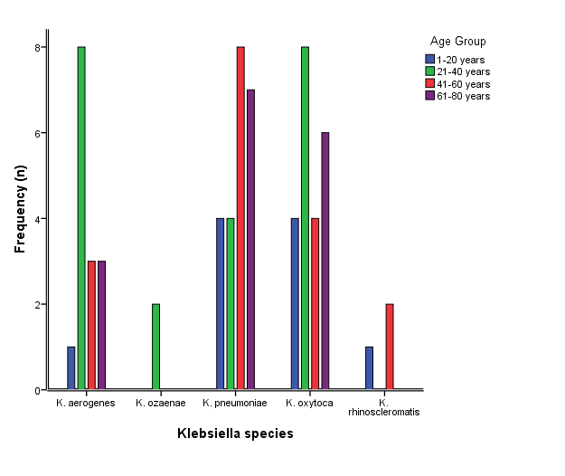
Figure 1. Distribution of Klebsiella species by patient age group.
Table 5. Distribution of Klebsiella species by patient gender
Species | Male n(%) | Female n(%) | Total n(%)
K. aerogenes | 8 (12.3) | 7 (10.8) | 15 (23.1)
K. ozaenae | 1 (1.5) | 1 (1.5) | 2 (3.1)
K. pneumoniae | 11 (16.9) | 12 (18.5) | 23 (35.4)
K. oxytoca | 10 (15.4) | 12 (18.5) | 22 (33.8)
K. rhinoscleromatis | 0 (0.0) | 3 (4.6) | 3 (4.6)
χ² = 2.925, df = 4, p = 0.571; Fisher's exact p = 0.652 (not significant).
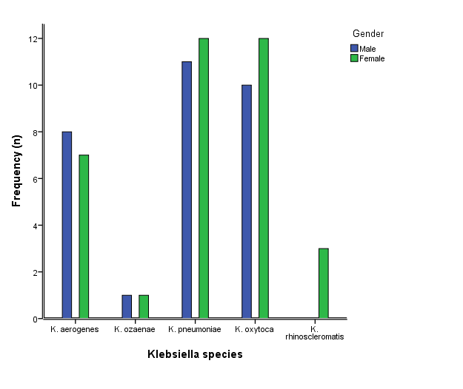
Figure 2. Distribution of Klebsiella species by patient gender.
Table 6. Distribution of Klebsiella species by specimen type
Species | Urine | Wound | Sputum | Eye | Bone | Ear
K. aerogenes | 2 | 5 | 7 | 0 | 0 | 1
K. ozaenae | 1 | 0 | 1 | 0 | 0 | 0
K. pneumoniae | 6 | 10 | 5 | 1 | 1 | 0
K. oxytoca | 16 | 3 | 3 | 0 | 0 | 0
K. rhinoscleromatis | 0 | 2 | 1 | 0 | 0 | 0
χ² = 27.910, df = 20, p = 0.112; Fisher's exact p = 0.005 (significant). 80% of cells had expected counts below 5; inference is based on Fisher's exact test.
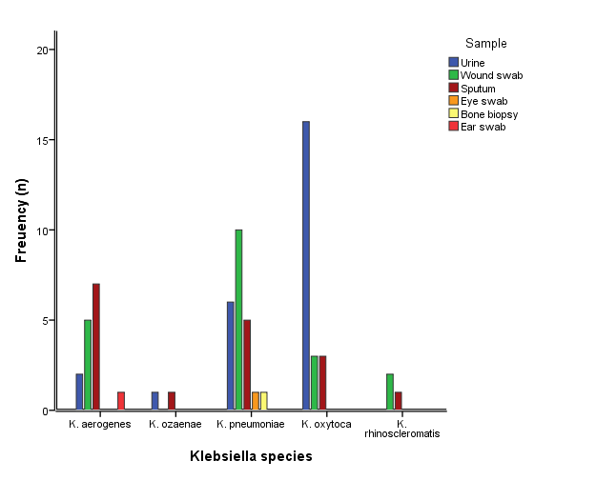
Figure 3. Distribution of Klebsiella species by specimen type.

3.4 Antibiotic susceptibility profile
Isolates showed the highest resistance to ampicillin (72.3%), amoxicillin (43.1%), and ceftazidime (40.0%), and the highest susceptibility to imipenem (83.1%), followed by gentamicin and azithromycin (64.6% each) and meropenem (61.5%) (Table 7). Resistance to meropenem (23.1%) was nearly twice that to imipenem (12.3%). Species-specific profiles (Figure 4A-C) showed that K. aerogenes, K. pneumoniae, and K. oxytoca were each most resistant to penicillins and cephalosporins, and most susceptible to carbapenems, aminoglycosides, and azithromycin.

Table 7. Antibiotic susceptibility profile of Klebsiella isolates
Class | Antibiotic | Sensitive n(%) | Intermediate n(%) | Resistant n(%)
Penicillins/BLI | Augmentin | 37 (56.9) | 6 (9.2) | 22 (33.8)
 | Ampicillin | 10 (15.4) | 8 (12.3) | 47 (72.3)
 | Amoxicillin | 29 (44.6) | 8 (12.3) | 28 (43.1)
Aminoglycosides | Amikacin | 35 (53.8) | 14 (21.5) | 16 (24.6)
 | Gentamicin | 42 (64.6) | 6 (9.2) | 17 (26.2)
Macrolide | Azithromycin | 42 (64.6) | 16 (24.6) | 7 (10.8)
Cephalosporins | Cefotaxime | 31 (47.7) | 11 (16.9) | 23 (35.4)
 | Ceftazidime | 22 (33.8) | 17 (26.2) | 26 (40.0)
Phenicol | Chloramphenicol | 37 (56.9) | 15 (23.1) | 13 (20.0)
Nitrofuran | Nitrofurantoin | 29 (44.6) | 13 (20.0) | 23 (35.4)
Fluoroquinolones | Nalidixic acid | 29 (44.6) | 18 (27.7) | 18 (27.7)
 | Ciprofloxacin | 32 (49.2) | 15 (23.1) | 18 (27.7)
Carbapenems | Imipenem | 54 (83.1) | 3 (4.6) | 8 (12.3)
 | Meropenem | 40 (61.5) | 10 (15.4) | 15 (23.1)
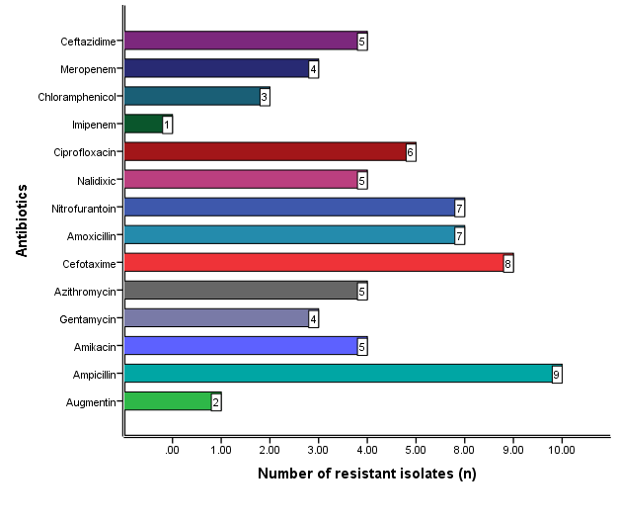
Figure 4A. Number of resistant isolates by antibiotic — K. aerogenes.
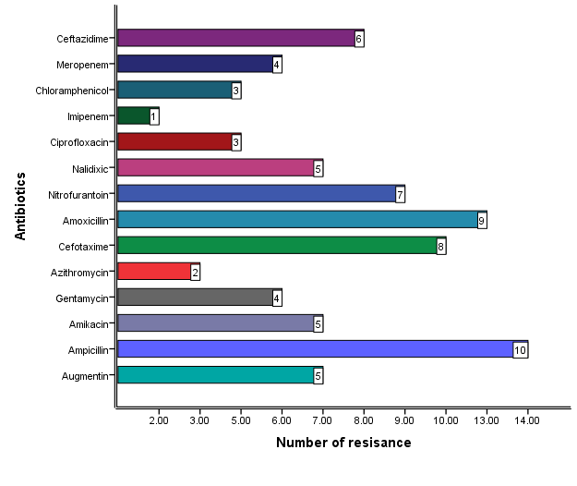
Figure 4B. Number of resistant isolates by antibiotic — K. pneumoniae.
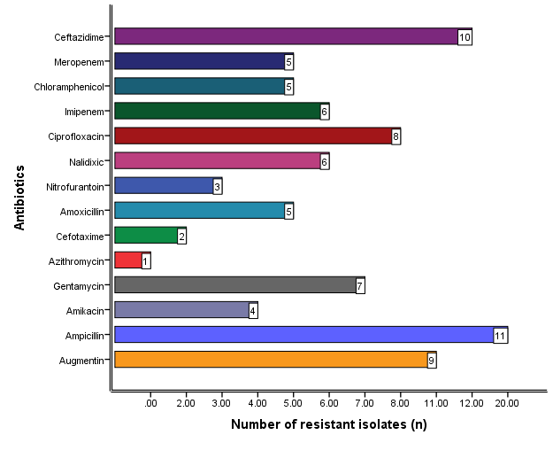
Figure 4C. Number of resistant isolates by antibiotic — K. oxytoca.

3.5 Prevalence and distribution of multidrug resistance
Thirteen of the 65 isolates (20.0%) met criteria for multidrug resistance (Table 8; Figure 5). MDR was not significantly associated with species (χ² = 2.756, df = 4, p = 0.599; Fisher's exact p = 0.763; Table 9, Figure 6), specimen type (χ² = 7.180, df = 5, p = 0.208; Fisher's exact p = 0.225; Table 10), age group (χ² = 4.340, df = 3, p = 0.227; Fisher's exact p = 0.250), or gender (χ² = 0.387, df = 1, p = 0.534; Fisher's exact p = 0.757) (Table 11).
Table 8. Overall prevalence of multidrug resistance (MDR)
Phenotype | n | %
MDR | 13 | 20.0
Non-MDR | 52 | 80.0
Total | 65 | 100.0
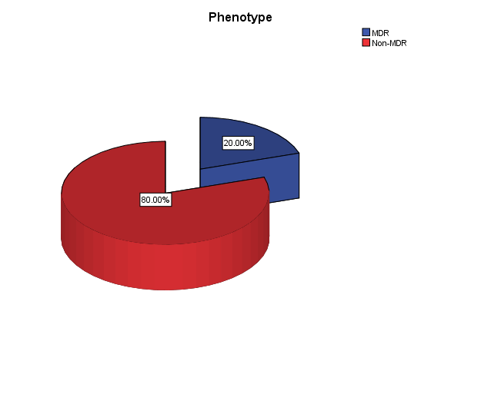
Figure 5. Overall prevalence of multidrug-resistant (MDR) Klebsiella isolates.
Table 9. Distribution of MDR status by Klebsiella species
Species | MDR n(%) | Non-MDR n(%)
K. aerogenes | 4 (6.2) | 11 (16.9)
K. ozaenae | 0 (0.0) | 2 (3.1)
K. pneumoniae | 6 (9.2) | 17 (26.2)
K. oxytoca | 3 (4.6) | 19 (29.2)
K. rhinoscleromatis | 0 (0.0) | 3 (4.6)
χ² = 2.756, df = 4, p = 0.599; Fisher's exact p = 0.763 (not significant).
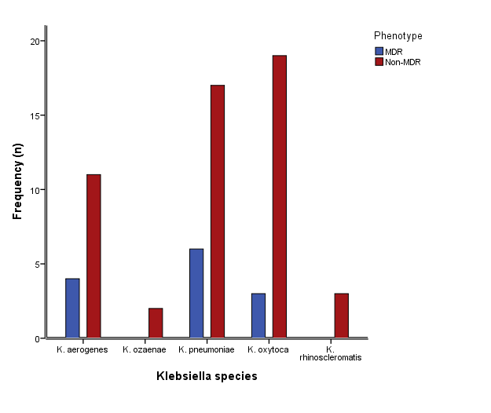
Figure 6. Distribution of MDR and non-MDR isolates by Klebsiella species.
Table 10. Distribution of MDR status by specimen type
Specimen | MDR n(%) | Non-MDR n(%)
Urine | 6 (9.2) | 19 (29.2)
Wound swab | 5 (7.7) | 15 (23.1)
Sputum | 1 (1.5) | 16 (24.6)
Eye swab | 1 (1.5) | 0 (0.0)
Bone biopsy | 0 (0.0) | 1 (1.5)
Ear swab | 0 (0.0) | 1 (1.5)
χ² = 7.180, df = 5, p = 0.208; Fisher's exact p = 0.225 (not significant). Several cells have expected counts below 5; Fisher's exact test was therefore used for inference.
Table 11. Distribution of MDR status by age group and gender
Variable | Category | MDR n(%) | Non-MDR n(%) | Total
Age (years) | 1-20 | 2 (3.1) | 8 (12.3) | 10
 | 21-40 | 3 (4.6) | 19 (29.2) | 22
 | 41-60 | 2 (3.1) | 15 (23.1) | 17
 | 61-80 | 6 (9.2) | 10 (15.4) | 16
Gender | Male | 5 (7.7) | 25 (38.5) | 30
 | Female | 8 (12.3) | 27 (41.5) | 35
Age: χ² = 4.340, df = 3, p = 0.227; Fisher's exact p = 0.250. Gender: χ² = 0.387, df = 1, p = 0.534; Fisher's exact p = 0.757 (neither significant).

4. Discussion
Antimicrobial resistance is now recognised as one of the most pressing threats to global health security: bacterial antimicrobial resistance was associated with an estimated 4.95 million deaths in 2019, of which 1.27 million deaths were directly attributable to resistant infections (Antimicrobial Resistance Collaborators, 2022). Klebsiella pneumoniae sits at the centre of this threat. As a core member of the ESKAPE group of pathogens (Enterococcus faecium, Staphylococcus aureus, Klebsiella pneumoniae, Acinetobacter baumannii, Pseudomonas aeruginosa, and Enterobacter species), it is characterised by its capacity to "escape" the action of antimicrobial agents through the accumulation of diverse resistance determinants (Miller & Arias, 2024). Its clinical importance is compounded by its versatility as both a gastrointestinal commensal and an opportunistic pathogen capable of causing pneumonia, urinary tract infection, bacteraemia, wound and surgical-site infection, and meningitis in hospitalised and immunocompromised patients (Dong et al., 2022). The findings of the present study, drawn from a tertiary hospital in southwestern Nigeria, contribute region-specific evidence of the kind needed to track this evolving threat and to inform empirical prescribing at the point of care.
Klebsiella pneumoniae was the predominant species recovered in this study, accounting for just over one-third of all isolates, followed closely by K. oxytoca and, at a lower frequency, K. aerogenes. This ranking mirrors the pattern reported across most clinical surveillance studies, in which K. pneumoniae and the K. oxytoca complex together account for the majority of clinically significant Klebsiella isolates, while the K. pneumoniae subspecies ozaenae and rhinoscleromatis are encountered comparatively rarely and are more typically associated with chronic granulomatous infection of the respiratory tract than with acute nosocomial disease (Dong et al., 2022). The prevalence of K. pneumoniae recorded here (35.4%) is broadly consistent with recent Nigerian hospital-based data: Akinyemi et al. (2021) identified K. pneumoniae in 34% of patients with suspected Gram-negative infection across four public hospitals in Lagos, and a more recent Lagos-based survey likewise reported Klebsiella species among the predominant Gram-negative organisms recovered from hospitalised patients (Abegunrin et al., 2026), whereas Ahmed Hasan et al. (2021) reported a considerably lower prevalence (7.6%) among clinical isolates in Kirkuk, Iraq. A systematic review and meta-analysis of extended-spectrum β-lactamase-producing K. pneumoniae across Nigeria similarly documents substantial variation in reported prevalence between states and institutions (Ezeh et al., 2024), underscoring the value of institution-level surveillance of the kind reported here. Such cross-study variability is unsurprising: prevalence estimates for a genus as ecologically versatile as Klebsiella are shaped by an interacting set of local variables, including the case-mix and severity of the patient population sampled, the dominant specimen types submitted for culture, and prevailing infection-control and prescribing practices, since members of the K. oxytoca complex in particular are also readily recovered from soil, water, and aquatic animals as well as from clinical specimens (Sun et al., 2024; Yang et al., 2022).
Species distribution did not differ significantly by patient age or gender in this cohort, indicating that Klebsiella acquisition was not confined to a particular demographic subgroup at the population level studied. Several descriptive patterns are nonetheless consistent with the wider literature, although the small subgroup sizes mean that they should be regarded as exploratory. K. pneumoniae and K. oxytoca were more frequently isolated from female patients, in keeping with the female predominance previously reported by Ahmed Hasan et al. (2021), most plausibly reflecting the higher burden of urinary sampling among female patients rather than a true sex-linked susceptibility. In contrast, species distribution differed significantly by specimen type. This association was driven mainly by K. oxytoca, which was recovered predominantly from urinary specimens, consistent with its established role as a common uropathogen. K. pneumoniae was most often recovered from wound swabs and K. aerogenes from sputum, consistent with their recognised roles in surgical-site and respiratory tract infection (Dong et al., 2022; Lam et al., 2021). The broad spread of isolates across the 21-60-year age range, rather than any single peak, is consistent with the role of Klebsiella as an opportunistic pathogen that exploits a wide spectrum of underlying vulnerability, from surgical wounds and indwelling devices to chronic respiratory and urinary tract disease, rather than depending on a single age-defined risk factor.
The antibiotic susceptibility data show that resistance was concentrated against the penicillins and, to a lesser extent, the cephalosporins, whereas imipenem, the aminoglycosides, and azithromycin retained comparatively higher in vitro activity. Ampicillin resistance exceeded 70%, and resistance to amoxicillin and ceftazidime reached 43.1% and 40.0%, respectively. Klebsiella species carry a chromosomally encoded β-lactamase (SHV-type in K. pneumoniae and OXY-type in K. oxytoca), and K. aerogenes carries a chromosomal AmpC enzyme, which confer intrinsic resistance to ampicillin and amoxicillin; CLSI accordingly lists ampicillin among the agents to which Klebsiella species are intrinsically resistant, and acquisition of extended-spectrum β-lactamases and AmpC-type enzymes further compromises later-generation cephalosporins (Dong et al., 2022; CLSI, 2022). The susceptible results recorded for ampicillin (15.4%) and amoxicillin (44.6%) are therefore unexpected and should be interpreted with caution. Plausible explanations include low-level expression of the chromosomal enzyme producing zone diameters within the susceptible range under disc-diffusion conditions, the absence of CLSI disc breakpoints for amoxicillin against Enterobacterales, technical factors such as inoculum density and disc potency, and possible misidentification of some isolates by conventional biochemical methods. Irrespective of the in vitro result, ampicillin and amoxicillin should not be considered reliable agents against Klebsiella. Azithromycin results should likewise be interpreted cautiously, because CLSI provides no interpretive criteria for this agent against Klebsiella. Biofilm formation represents a further, non-enzymatic mechanism through which Klebsiella isolates evade antibiotic action and host clearance, and is increasingly recognised as a contributor to persistent, recurrent, and device-associated infection (Li et al., 2024). The high susceptibility to imipenem (83.1%) indicates that carbapenems retain useful activity in this setting; however, the 23.1% meropenem resistance and the discordance between imipenem and meropenem results warrant confirmation by minimum inhibitory concentration (MIC) testing and phenotypic or molecular carbapenemase detection, given the well-documented capacity of carbapenemase-producing Klebsiella to disseminate rapidly once established within a healthcare facility (Simner et al., 2024). This overall pattern, better-preserved carbapenem and aminoglycoside activity alongside eroding penicillin and cephalosporin efficacy, mirrors the profile reported in other recent Nigerian and sub-Saharan African studies, including Akinyemi et al. (2021) in Lagos and Awoke et al. (2021) in Addis Ababa. These in vitro data can contribute to a local antibiogram, but they should not be translated directly into empirical treatment recommendations; empirical therapy should be guided by institutional antibiograms, the site and severity of infection, patient-level factors, and culture results, with carbapenem use restricted to preserve their activity.
Using the internationally accepted threshold of resistance to at least one agent in three or more antimicrobial categories (Magiorakos et al., 2012), one in five Klebsiella isolates (20.0%) in this study met the criteria for multidrug resistance. This figure, while clinically significant, is markedly lower than the MDR rates reported in other recent African and Middle Eastern hospital-based studies, including 62.8% among K. pneumoniae isolates in Lagos, Nigeria (Akinyemi et al., 2021), 90% among ESBL-producing K. pneumoniae isolates from the Ashanti Region of Ghana (Baidoo et al., 2025), 98.5% in a tertiary hospital in Addis Ababa, Ethiopia (Awoke et al., 2021), and 100% among isolates from Kirkuk, Iraq (Ahmed Hasan et al., 2021). Such disparities most plausibly reflect differences in local antibiotic stewardship, infection-control infrastructure, and the proportion of isolates drawn from high-acuity units such as intensive care, together with methodological differences: the present study counted only resistant (not intermediate) results, tested a limited antibiotic panel, and included all Klebsiella species rather than K. pneumoniae or ESBL producers alone, all of which would tend to yield a lower MDR estimate. They underscore why MDR surveillance is best interpreted at the level of the individual institution rather than extrapolated wholesale from the wider literature. Within this cohort, K. pneumoniae contributed the largest absolute share of MDR isolates, and MDR was numerically, though not statistically significantly, more common among older patients (61-80 years) than in younger age groups, a pattern broadly consistent with the recognised vulnerability of older, often more comorbid and more frequently instrumented or hospitalised patients to colonisation and infection with resistant nosocomial organisms. No significant association was observed between MDR status and species, specimen type, age group, or gender; however, the small number of MDR isolates in each subgroup limited statistical power, so the absence of association should not be taken as evidence that no such relationship exists. If confirmed in larger studies, this finding would suggest that multidrug resistance should be considered across the full spectrum of patients from whom Klebsiella is isolated.
Collectively, these findings reinforce the broader consensus that the drivers of antimicrobial resistance in Klebsiella are multifactorial and mutually reinforcing: unrestricted over-the-counter access to antibiotics, empirical and often unnecessarily broad-spectrum prescribing, inconsistent infection-prevention practice, and the ready dissemination of resistance genes via mobile genetic elements within the hospital environment all converge to sustain and amplify resistant clones once they emerge (Miller & Arias, 2024; Babatunde et al., 2026). The clinical consequences are a narrowing of the effective antibiotic armamentarium, longer hospital stays, higher treatment costs, and increased mortality risk among patients with Klebsiella infection (Antimicrobial Resistance Collaborators, 2022). The comparatively preserved in vitro activity of imipenem and the aminoglycosides in this setting is worth protecting. Preserving it will require deliberate antimicrobial stewardship of the kind increasingly documented across low- and lower-middle-income countries (Babatunde et al., 2026), routine local susceptibility surveillance to detect early signals of emerging carbapenem resistance, and strengthened infection-prevention measures to limit nosocomial spread of resistant clones. Taken together, these data provide locally generated baseline evidence that can inform the institutional antibiogram and stewardship planning, while underscoring the continued need for systematic resistance surveillance in this and similar healthcare settings.

4.1 Limitations of the study
This study was conducted at a single centre over three months with 65 isolates, and several subgroups contained very few isolates, which limited statistical power and the generalisability of the findings. Species were identified by conventional biochemical tests only, which cannot reliably distinguish closely related members of the K. pneumoniae and K. oxytoca complexes, and no confirmation by MALDI-TOF mass spectrometry or molecular methods was performed. Susceptibility was determined by disc diffusion without MIC determination; CLSI provides no interpretive criteria for amoxicillin or azithromycin against Klebsiella, and nitrofurantoin and nalidixic acid results are relevant only to urinary isolates. Resistance mechanisms (ESBL, AmpC, and carbapenemase production) were not characterised phenotypically or genotypically, so the basis of the observed resistance, including carbapenem resistance, could not be established. Finally, clinical data such as ward of admission, prior antibiotic exposure, community or hospital acquisition, and distinction between infection and colonisation were not available, precluding analysis of risk factors for MDR.

5. Conclusion
One-fifth of Klebsiella isolates recovered from clinical samples at this tertiary hospital were multidrug-resistant, with resistance concentrated against penicillins and cephalosporins and comparatively preserved in vitro susceptibility to imipenem and the aminoglycosides. These findings show that multidrug-resistant Klebsiella species are present among clinical isolates in the study area and are consistent with the wider literature describing Klebsiella pneumoniae as an increasingly resistant nosocomial pathogen. The meropenem resistance observed in almost a quarter of isolates warrants confirmation and close monitoring. Continued susceptibility surveillance, molecular confirmation of species identity and resistance mechanisms, and larger multicentre studies that include clinical data are needed before these findings are used to guide empirical therapy. Antibiotic stewardship programmes should be strengthened to optimise and monitor antibiotic use in this setting, alongside closer collaboration between clinical microbiologists and treating physicians.

Declaration of AI Use
This manuscript was prepared through the intellectual contributions of the author(s) to the study design, data analysis, interpretation of results, and scholarly content. Grammarly and ChatGPT were used solely to assist with grammatical refinement and reference formatting during manuscript revision. The author(s) accept full responsibility for the accuracy, integrity, and final content of the manuscript.

References
Abegunrin, R. O., Amisu, K. O., Al-Huchaimi, S. N., Ajoseh, S. O., Salami, W. O., Lawal-Sanni, A. O., Saki, M., & Akinyemi, K. O. (2026). Evaluation of occurrence, antimicrobial resistance rates, and antibiotic resistance determinants in Klebsiella pneumoniae from hospitalised patients in Lagos, Nigeria. BMC Microbiology, 26, Article 471. https://doi.org/10.1186/s12866-026-04918-8
Ahmed Hasan, S., Fakhraddin Raheem, T., & Mohammed Abdulla, H. (2021). Phenotypic, antibiotyping, and molecular detection of Klebsiella pneumoniae isolates from clinical specimens in Kirkuk, Iraq. Archives of Razi Institute, 76(4), 1061–1067. https://doi.org/10.22092/ari.2021.355770.1721
Akintoyese, T. O., Alao, J. O., Oladipo, E. K., Oyedemi, O. T., & Oyawoye, O. M. (2026). Antimicrobial resistance and virulence in Klebsiella pneumoniae: A four-month study in Osogbo, Nigeria. Antimicrobial Stewardship & Healthcare Epidemiology, 5(1), e64. https://doi.org/10.1017/ash.2025.21
Akinyemi, K. O., Abegunrin, R. O., Iwalokun, B. A., Fakorede, C. O., Makarewicz, O., Neubauer, H., Pletz, M. W., & Wareth, G. (2021). The emergence of Klebsiella pneumoniae with reduced susceptibility against third generation cephalosporins and carbapenems in Lagos hospitals, Nigeria. Antibiotics, 10(2), 142. https://doi.org/10.3390/antibiotics10020142
Antimicrobial Resistance Collaborators. (2022). Global burden of bacterial antimicrobial resistance in 2019: A systematic analysis. The Lancet, 399(10325), 629–655. https://doi.org/10.1016/S0140-6736(21)02724-0
Arcari, G., & Carattoli, A. (2023). Global spread and evolutionary convergence of multidrug-resistant and hypervirulent Klebsiella pneumoniae high-risk clones. Pathogens and Global Health, 117(4), 328–341. https://doi.org/10.1080/20477724.2022.2121362
Ashurst, J. V., & Dawson, A. (2023). Klebsiella pneumonia. In StatPearls. StatPearls Publishing. https://www.ncbi.nlm.nih.gov/books/NBK519004/
Awoke, T., Teka, B., Seman, A., Sebre, S., Yeshitela, B., Aseffa, A., Mihret, A., & Abebe, T. (2021). High prevalence of multidrug-resistant Klebsiella pneumoniae in a tertiary care hospital in Ethiopia. Antibiotics, 10(8), 1007. https://doi.org/10.3390/antibiotics10081007
Babatunde, A. O., Ibrahim, A. D., Egbewande, O. M., Olabode, W., Aroyehun, N., Tieosapjaroen, W., Babatunde, Y., & Kpokiri, E. (2026). Antimicrobial stewardship interventions currently implemented at primary healthcare settings across low- and lower-middle-income countries (LLMICs). International Health, 18(4), 557–569. https://doi.org/10.1093/inthealth/ihaf136
Baidoo, E. A., Boamah, V. E., Odoi, H., Boakye, Y. D., & Agyare, C. (2025). Low prevalence but high resistance of extended spectrum beta-lactamase producing Klebsiella pneumoniae isolated from hospitals in the Ashanti Region of Ghana. African Health Sciences, 25(2), 20–29. https://doi.org/10.4314/ahs.v25i2.4
Cheesbrough, M. (2006). District laboratory practice in tropical countries, part 2 (2nd ed.). Cambridge University Press. https://doi.org/10.1017/CBO9780511543470
Clinical and Laboratory Standards Institute. (2022). Performance standards for antimicrobial susceptibility testing (32nd ed.; CLSI supplement M100).
Dong, N., Yang, X., Chan, E. W.-C., Zhang, R., & Chen, S. (2022). Klebsiella species: Taxonomy, hypervirulence and multidrug resistance. eBioMedicine, 79, 103998. https://doi.org/10.1016/j.ebiom.2022.103998
Excel, D. K., Ofoegbu, N. J., Tatfeng, Y. M., Njoku, J. O., Okoro, C. I., Ohalette, C. N., & Nnodim, J. (2023). Klebsiella pneumonia carbapenemase and New Delhi Mettallo-1 genes: Molecular characterization and detection from clinical isolates in Madonna University Teaching Hospital Elele. Asian Journal of Research in Biology, 6(1), 1–14. https://doi.org/10.56557/ajrib/2023/v6i131
Ezeh, C. K., Digwo, D. C., Okeke, I. A., Elebe, P. C., & Ezeh, E. O. (2024). A systematic review and meta-analysis on the prevalence of extended-spectrum beta-lactamase-producing Klebsiella pneumonia in Nigeria. African Health Sciences, 24(3), 30–40. https://doi.org/10.4314/ahs.v24i3.5
Halder, G., Chaudhuri, B. N., Veeraraghavan, B., Denny, P., Dutta, P., Chakraborty, M., Khan, U. R., Ganguly, S. S., Mandal, S., Upadhyaya, Y. P., Biswas, B., Chakraborty, A., Maiti, S., Mondal, H., Pal, S., & Dutta, S. (2025). Antimicrobial resistance and phylogenetic lineages of KPC-2-producing blood-borne Klebsiella pneumoniae subsp. pneumoniae from Kolkata, India during 2015–2024: Emergence of Klebsiella pneumoniae subsp. pneumoniae with blaKPC-2, blaNDM, and blaOXA-48-like triple carbapenemases. Microbiology Spectrum, 13, e00126-25. https://doi.org/10.1128/spectrum.00126-25
Jung, B., & Hoilat, G. J. (2024). MacConkey medium. In StatPearls. StatPearls Publishing. https://www.ncbi.nlm.nih.gov/books/NBK557394/
Lam, M. M. C., Wick, R. R., Watts, S. C., Cerdeira, L. T., Wyres, K. L., & Holt, K. E. (2021). A genomic surveillance framework and genotyping tool for Klebsiella pneumoniae and its related species complex. Nature Communications, 12(1), 4188. https://doi.org/10.1038/s41467-021-24448-3
Li, L., Gao, X., Li, M., Liu, Y., Ma, J., Wang, X., Yu, Z., Cheng, W., Zhang, W., Sun, H., Song, X., & Wang, Z. (2024). Relationship between biofilm formation and antibiotic resistance of Klebsiella pneumoniae and updates on antibiofilm therapeutic strategies. Frontiers in Cellular and Infection Microbiology, 14, 1324895. https://doi.org/10.3389/fcimb.2024.1324895
Magiorakos, A. P., Srinivasan, A., Carey, R. B., Carmeli, Y., Falagas, M. E., Giske, C. G., Harbarth, S., Hindler, J. F., Kahlmeter, G., Olsson-Liljequist, B., Paterson, D. L., Rice, L. B., Stelling, J., Struelens, M. J., Vatopoulos, A., Weber, J. T., & Monnet, D. L. (2012). Multidrug-resistant, extensively drug-resistant and pandrug-resistant bacteria: An international expert proposal for interim standard definitions for acquired resistance. Clinical Microbiology and Infection, 18(3), 268–281. https://doi.org/10.1111/j.1469-0691.2011.03570.x
Mansagna, C. A., Baguy, O. M., Koné, M., Coulibaly, I., Tiékoura, K. B., Kipré, G. B., Konan, K. F., Toty, A. A., & Guessennd, N. K. (2026). Prevalence of beta-lactam resistance genes (Bla genes) in multidrug-resistant strains of Escherichia coli and Klebsiella pneumoniae isolated from infections at a university hospital in Abidjan, Ivory Coast. Microbiology Research Journal International, 36(6), 95–104. https://doi.org/10.9734/mrji/2026/v36i61756
Miller, W. R., & Arias, C. A. (2024). ESKAPE pathogens: Antimicrobial resistance, epidemiology, clinical impact and therapeutics. Nature Reviews Microbiology, 22(10), 598–616. https://doi.org/10.1038/s41579-024-01054-w
Monteiro, A. de S. S., Silva, M. de O., Galvão, V. S., Bomfim, A. P., Araújo, L. G. de, Silva, C. M. P., Barberino, M. G., Gouveia, E. L., Cordeiro, S. M., & Reis, J. N. (2025). High proportions of multidrug-resistant Klebsiella pneumoniae isolates in community-acquired infections, Brazil. Scientific Reports, 15, 9698. https://doi.org/10.1038/s41598-025-92549-w
Ochei, J., & Kolhatkar, A. (2008). Medical laboratory science: Theory and practice. Tata McGraw-Hill.
Podschun, R., & Ullmann, U. (1998). Klebsiella spp. as nosocomial pathogens: Epidemiology, taxonomy, typing methods, and pathogenicity factors. Clinical Microbiology Reviews, 11(4), 589–603. https://doi.org/10.1128/CMR.11.4.589
Sati, H., Carrara, E., Savoldi, A., Hansen, P., Garlasco, J., Campagnaro, E., Boccia, S., Castillo-Polo, J. A., Magrini, E., Garcia-Vello, P., Wool, E., Gigante, V., Duffy, E., Cassini, A., Huttner, B., Ramon Pardo, P., Naghavi, M., Mirzayev, F., Zignol, M., … WHO Bacterial Priority Pathogens List Advisory Group. (2025). The WHO Bacterial Priority Pathogens List 2024: A prioritisation study to guide research, development, and public health strategies against antimicrobial resistance. The Lancet Infectious Diseases, 25(9), 1033–1043. https://doi.org/10.1016/S1473-3099(25)00118-5
Simner, P. J., Pitout, J. D. D., & Dingle, T. C. (2024). Laboratory detection of carbapenemases among Gram-negative organisms. Clinical Microbiology Reviews, 37(4), e00054-22. https://doi.org/10.1128/cmr.00054-22
Sun, S., Gu, T., Ou, Y., Wang, Y., Xie, L., & Chen, L. (2024). Environmental compatibility and genome flexibility of Klebsiella oxytoca isolated from eight species of aquatic animals. Diversity, 16(1), 30. https://doi.org/10.3390/d16010030
Yang, J., Long, H., Hu, Y., Feng, Y., McNally, A., & Zong, Z. (2022). Klebsiella oxytoca complex: Update on taxonomy, antimicrobial resistance, and virulence. Clinical Microbiology Reviews, 35(1), e00006-21. https://doi.org/10.1128/CMR.00006-21

