Characterization of endogenous arbuscular mycorrhizal fungi associated with Xanthosomas sagittifolium (L.) Schott (macabo) in agroecological zone 5 of Cameroon

ABSTRACT
While Xanthosomas sagittifolium is known for its high content of carbohydrates, sugars, vitamins, potassium, calcium, iron, and antioxidants, and serves as a staple food for many populations in sub-Saharan Africa, its production remains threatened by the effects of climates changes, including drought, decline soil fertility, plants diseases intensification like root rot. In any case, a strategy to promote this crop focused on arbuscular mycorrhizal fungi appears relevant ; In fact, these microorganisms are known for their ability to enhance plant resilience to environmental stresses, boost crop yields in low fertil soil while protecting plants from pathogen attacks. Meanwhile, the performancy of these beneficial microorganisms is influence by environnemental factors, indicating that the application of exotics strains may appear ineffective. It is therefore important to explore the diversity of endogenous mycorrhizal fungi adapted to local environmental conditions and specific to the rhizosphere of this crop. In this study, the frequency and intensity of mycorrhization, as well as the species diversity of these microorganisms associated with this plant, were assessed in agroecological zone 5 of Cameroon. Analysis of the results indicates the presence of 11 different species: Sclerocystis sp., Glomus ambisporum, Funneliformis sp., Glomus sp. 1, Acaulospora sp., Scutellospora sp., Racocetra sp., Claroideoglomus sp., Diversispora sp., Paraglomus sp., and Glomus sp. 2. However, Glomus ambisporum is the most abundant species in the study area, in contrast to Paraglomus sp., which is rarer. These results therefore provide valuable preliminary information for the formulation of a mycorrhizal biofertilizer suitable for cassava cultivation in agroecological zone 5 of Cameroon.
Keywords : Xanthosomas sagittifolium, mycorrhiza, characterization, zone 5 of Cameroon

INTRODUCTION
In agroecological zone 5 of Cameroon, where soil and climatic conditions are both varied and complex (Nkamleu and Kegne, 2008), understanding the interactions between arbuscular mycorrhizal fungi and plant roots is essential. Indeed, these fungi actively colonize plant roots and promote nutrient uptake, improve resistance to environmental stress, and stimulate growth and productivity (Abdoul et al., 2020 ; Smith and Qiu, 2021). Furthermore, macabo (Xanthosoma sagittifolium (L.) Schott), which is an essential food crop in this region (Akimoladun et al., 2018), is particularly dependent on arbuscular mycorrhizal fungi for its water and mineral nutrition and its resistance to pathogens (Djeuani et al., 2017 ; Djeuani et al., 2018). At the same time, most research on mycorrhizal symbiosis is limited to the use of imported exotic strains, which often prove ineffective because they are not adapted to local environmental conditions (Tobolbaï et al., 2021 ; Tobolbaï et al., 2023). This study therefore explores the abundance of these fungi in symbiosis with the macabo in the study area.

Materials and Methods Study Site
The study was conducted on plants of two macabo cultivars (white and red) grown in fields at nine locations in Cameroon’s agroecological zone 5. This zone has a tropical climate, with a dry season in winter and a rainy season in summer.

Localities Geographic coordinates of the sampled sites (fields)

Akonolinga 3° 46’42’’N, 12°15’00’’E
Mbankomo 3°47’31’’N, 11°24’13’’ E
Bafia 4°44’33’’N, 11°13’29’’E
Ndji 5°22’0’’N, 12°10’60’’E Mbalmayo 3°31’12’’N, 11°30’44’’E
Kribi 2°55’48’’4 N, 9°54’40’’19 E
Domé 4° 13’59’’N, 13°27’25’’ E
Biloné 4°1053’’N, 11°30’37’’E
Maka-Oum 2°56’00’’N, 9°54’00’’E

Collection of soil and root samples
Soil samples were collected from macabo plantations. In each selected plot, 12 plants were chosen at random. Sampling involved clearing debris from the surface of the rhizosphere, and the entire rhizosphere of the plants was collected (soil and roots), with at least 2 kg of soil

collected from each plant. The soil from within each plot was mixed to form composite samples, wrapped in aluminum foil, and placed in clean plastic bags. At the same time, the finest root fragments were preserved in 60% ethanol for laboratory analysis.

Physicochemical analysis of soil samples
The physicochemical properties of the soils were analyzed at the Soil Analysis and Environmental Chemistry Laboratory at the University of Dschang. These analyses, conducted according to standard methods, provide information on texture (clay, silt, sand), pH, available phosphorus, total nitrogen, organic matter, organic carbon, and exchangeable cations (calcium, magnesium, potassium, sodium); cation exchange capacity...

Assessment of the mycorrhizal status of the study plants
Since arbuscular mycorrhizal symbiosis is invisible to the naked eye, the roots were stained to make it visible. In this regard, the roots were stained using the method of Kormanik and McGraw (1982), which is as follows: bleaching of the roots with potassium hydroxide (KOH 2.5%) for 5 min at 90°C in a water bath ; acidification with 2% HCl for 30 min at 25°C ; staining with funschine (0.01%) for 15 min in a water bath at 80°C. Parameters such as mycorrhization frequency (F%) and mycorrhization intensity (I%) were subsequently evaluated using the method of Trouvelot et al. (1986). This method consists of : 30 root fragments were mounted on 3 slides at a rate of 10 per slide. Each slide was observed under a microscope at 10x magnification, and the presence or absence of structures characteristic of mycorrhizal fungi was noted; the data obtained were used to determine mycorrhizal status.

Mycorrhization frequency (F%)
The mycorrhization rate is defined as the percentage of root fragments that showed at least some evidence of mycorrhization out of all the fragments examined. It is determined using the method described by Sghir et al., 2013 :
𝑭(%) = 𝒏𝟎 x100
𝑵
Where “N” is the number of fragments observed and “n0” is the number of these fragments
showing signs of mycorrhization.

Mycorrhization intensity (I%)
This parameter provides information on the extent to which the root system is colonized by structures characteristic of mycorrhizal fungi. It is determined using the formula developed by Sghir et al. (2013) and employs a root colonization rating scale ranging from 0 to 5.
The formula used was : 𝐈% = (𝟗𝟓𝐧𝟓 + 𝟕𝟎𝐧𝟒 + 𝟑𝟎𝐧𝟑 + 𝟓𝐧𝟐 + 𝐧𝟏)
𝐍

Where n₅, n₄, …, n₁ denote the numbers of fragments labeled 5, 4, 3, 2, 1, and 0, respectively.

Extraction of mycorrhizal fungal spores
After confirming the presence of mycorrhizal symbiosis, the spores were extracted using the method described by Schenk (1982), which was carried out as follows: 100g of soil sample were homogenized in 300mL of tap water ; the supernatant was collected after decanting through a series of four sieves stacked in descending order: 2 mm, 300 µm, 200 µm, 100 µm, and 50 µm. The procedure was repeated three times. The residue from each sieve was collected in Petri dishes and observed under a stereo microscope.

Counting of isolated spores
Spore counting was performed using the method described by Ngonkeu (2003). This involved collecting the residue from each sieve into a grid-lined Petri dish. The grid used for counting consists of 10 squares arranged in two rows of 5 squares, each measuring 2.5 cm², for a total area of 69.4 cm². Assuming that “n” is the number of spores in the 2.5 cm² area, the total number “N” of spores for the entire dish is obtained by performing the calculation :
69.4 × n / 2.5 = N, or 27.76 × n.

Morphological and anatomical characterization of the isolated spores
The morphological characterization of the spores was based on criteria such as size, color, the presence or absence of a suspensor hyphae, suspensor bulbs, spore sacs, and the germination loop (Morton, 1988). The spores were then mounted and crushed in two different reagents: Melzer’s reagent and polyvinyl alcohol-lactic acid-glycerol reagent. These reagents penetrate the spores and reveal their internal structures, as well as the number and arrangement of the spore walls. These features were examined and described. The information obtained, combined with the morphological description, data from the International Collection of Mycorrhizal Fungi website (invam.caf.wvu.edu), and the initial descriptions of the strains, allows for the identification of the mycorrhizal fungus.

Statistical Analysis
The collected data were entered and analyzed descriptively using Excel 2013.
R software version 4.2.2 was used to perform statistical analysis of the data at a significance level of P < 0.05.

RESULTS

Physicochemical properties of soil samples

An analysis of Table 2, based on the texture triangle, shows that the soils under study have a silty-clay texture, with the exception of those at Mbankomo, which were found to be compost, and those at Koevom, which have a silty-clay-sandy texture.
The pH ranges from 5.9 (Akonolinga) to 7.6 (Domé); the KCl pH ranges from 5.3 (Akonolinga) to 6.8 (Biloné). Given that the ideal pH for microbial growth ranges from 6.5 to 7.5, the pH of some soils is unfavorable for microbial development. This parameter influences the availability of nutrients in the soil.
The C/N ratio is a parameter that indicates the degree of mineralization of organic matter. Analysis of the recorded data (Table 1) shows that only 5 of the 9 soils have a ratio suitable for good microbial activity (10–12) (Maka-Oum, Nkoe-Mvom, Ndji, Mbankomo, Akonolinga, Mbalmayo). This parameter for the soils in the other locations is not conducive to microbial activity.
Regarding phosphorus content, whose very high levels are likely to compromise mycorrhizal symbiosis, the soils of Domé (97.47 mg/kg) have the highest levels, followed by Akonolinga (78.59 mg/kg), in contrast to Mbankomo (0.16 mg/kg) and Biloné (7.16 mg/kg), where levels are the lowest.

Table 1. Physical Analysis of Soils

Sample Code | Dombe | Maka- Oum | NkoeMvom | Bilone | Ndji | Mbankomo | Akonolinga | Mbalmayo | Bafia
Sand | 40 | 45 | 45 | 40 | 43.5 |  | 40 | 40.5 | 40
Silt | 29 | 24 | 21.5 | 27.5 | 24.5 |  | 26.5 | 20.5 | 28.5
Clay | 31 | 31 | 33.5 | 32.5 | 32 |  | 33.5 | 34 | 31.5
Texture class | Silt-clay | Silt-clay | Silt-clay-sand | Silt-Clay | Silt-Clay | Compost | Silt-Clay | Silt-Clay | Silt-Clay
Table 2. Chemical Analysis of Soil

Organics maters | Dombe | Maka-Oum | NkoeMvom | Bilone | Ndji | Mbankomo | Akonolinga | Mbalmayo | Bafia
Water-pH | 7,6 | 6,9 | 7,1 | 7,5 | 6,9 | 7,1 | 5,9 | 7,2 | 7,1
KCL-pH | 6,3 | 6,5 | 6,6 | 6,8 | 6,2 | 6,5 | 5,3 | 6,7 | 6,4
OC (%) | 1,54 | 1,43 | 1,26 | 2,27 | 2,78 | 4,5 | 2,67 | 2,11 | 1,77
OM% | 2.66 | 2.47 | 2.18 | 3.92 | 4.79 | 3,5 | 4.60 | 3.63 | 3.05
N% | 0.64 | 0.32 | 0.30 | 0.68 | 0.36 | 3.72 | 4,02 | 2,5 | 0.19
C/N | 3.49 | 10.78 | 12.66 | 5.63 | 12.40 | 12.10 | 12,7 | 11,5 | 9.16
OCa% | 3.52 | 1.36 | 2.75 | 2.32 | 1.31 | 0.43 | 1.01 | 3.81 | 2.45
OMg% | 1.58 | 1.46 | 0.88 | 1.52 | 1.26 | 0.06 | 0.14 | 1.12 | 0.7
K2O% | 0.38 | 0.73 | 0.73 | 0.38 | 0.73 | 1.20 | 1.12 | 0.38 | 0.73
Na (meq/100g) | 0.01 | 0.01 | 0.01 | 0.01 | 0.01 | 0,001 | 0.03 | 0.01 | 0.01
S(meq/100g) | 5049 | 3.56 | 4.37 | 4.23 | 3.31 | 3,2 | 2.29 | 5.32 | 3.90
PH CEC 7(méq/100g) | 13.2 | 11.41 | 12.52 | 11.75 | 12.42 | 12,80 | 11.25 | 11.34 | 11.27
V% | 41.59 | 31.24 | 34.92 | 36.00 | 26.66 | 22,3 | 20.4 | 46.94 | 34.59
P(mg/kg) P2O5% | 97.47 | 22.96 | 51.22 | 7.16 | 64.46 | 0.16 | 78.59 | 26.22 | 21.41
Sand (S%), clay (A%), and silt (L%) content; pH in aqueous media (pH - H₂O), organic carbon (CO), total nitrogen (N); Exchangeable bases (Ca²⁺, Mg²⁺, K⁺, and Na⁺);
Cation exchange capacity (CEC); Available phosphorus content (P Bray II); Sum of exchangeable bases (SBE);

Site 1: Mbalmayo Site 5: Bafia Site: Makaoum; Site 2: Mbankomo Site 6: CRA; Site 3: Akonolinga Site 7: Bilone; Site 4: Ndji Site 8: Dombe; Saturation rate (V).

Assessment of mycorrhizal status in the cultivars under study
A plant’s mycorrhizal status refers to its ability to establish and maintain a symbiotic relationship with mycorrhizal fungi. The aim here is to assess the rate (frequency) and intensity of this mycorrhization. Thus, in general and for both cultivars, this mycorrhizal status varies from one location to another (Table 3) . In all cases, the Mbalmayo plants show a greater ability to maintain the mycorrhizal symbiosis (F (%): 93.3%; M (%): 0.5%; m (%): 1.26%; v (%): 2.5%; V (%): 0.0295. %); conversely, the Nkoemvom seedlings show the lowest ability (F (%): 33.3%; M (%): 0.1%; m (%): 0.3003%; v (%): 0.8% ; V (%): 0.0008%).
Table 3. Mycorrhizal status

Localities | F (%) | M (%) | m (%) | v (%) | V (%)
Dombe | 50,0 | 0,23 | 0,46 | 0,7 | 0,0016
Maka-Oum | 40,0 | 0,16 | 0,4 | 0,2 | 0,0003
NkoeMvom | 33,3 | 0,1 | 0,3003 | 0,8 | 0,0008
Bilone | 93,3 | 0,26 | 0,2787 | 6,8 | 0,0177
Ndji | 83,3 | 0,38 | 0,4562 | 2 | 0,0076
Mbankom | 73,3 | 0,49 | 0,6685 | 3,5 | 0,0172
Akonolinga | 90,0 | 0,3 | 0,3333 | 2,3 | 0,0069
Mbalmayo | 93,3 | 1,18 | 1,2647 | 2,5 | 0,0295
Bafia | 90,1 | 0,50 | 1,02 | 1,8 | 0,022
F (%) = mycorrhization frequency ; I (%) = root colonization intensity ; i (%) = colonization intensity in root systems; v (%) = vesicular intensity of the mycorrhizal portion ; V (%) = vesicular intensity in root systems.
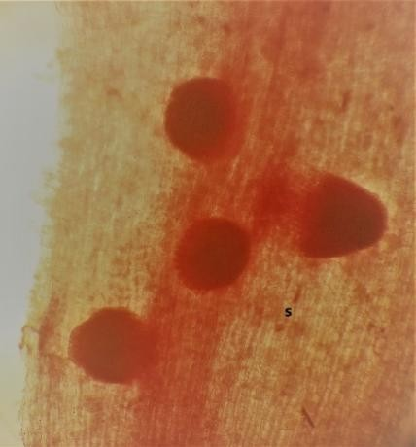
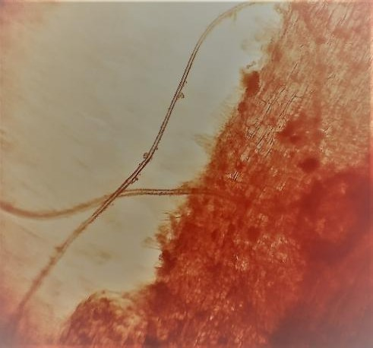
a) Vesicule

b)Suspending hyphae
Figure 1. Root fragments showing mycorrhizal structures

Spore Counting
Spore counting is used to determine spore density and concentration in the soil. Figure 2 shows that, within the same field and under the same conditions, soil spore density varies significantly (p≤0,05) depending on the macabo variety; the most striking differences are observed in Dombé (270 spores/100 g of soil for the red variety versus 100 spores/100 g of soil for the white variety) and Bafia (59 spores/100 g of soil for the red variety versus 150 spores/100 g of soil for the white variety). Overall, the lowest density was recorded in Mbalmayo (47 spores/100 g of soil for the red variety) and the highest in Dombé for the red variety at 270 spores/100 g of soil.
Localities
Red variety
White variety
Bilone ndji rouge Mbankomo akonolinga Mbalmayo Bafia
Dombe Maka-oum CRA
50
0
b
a
a
d
c
b
100
c
c
e
ef
b
d
d
f
d
e d
250
200
150
b
350
300
Spore count/100g of soil

Figure 2. Spore count
Relative abundance of AMF spores by collection site
Figure 3 shows the consortia (mixtures) of spores freshly extracted from the rhizosphere soils of each macabo variety at each location. These spores varied in size and color. The colors observed included: black, yellow, brown, black-brown; dark yellow ; white ; and hyaline. However, black was slightly predominant, followed by yellow, whereas white was less common. At the same time, five size ranges were observed : very small (≤50 µm) ; small (50–100 µm) ; medium (100–200 µm)
; large (200–300 µm) ; very large (≥300 µm). These sizes were determined based on the mesh sizes of the sieves used (50 µm, 100 µm, 200 µm, 300 µm, 2 mm). Medium-sized spores predominate, while large spores are the least abundant. Overall, the spore consortium in the red variety of Dji (Figure 3.9) exhibits higher phenotypic diversity. Conversely, the lowest phenotypic diversity is observed in the white variety of Bafia (Figure 3.18).

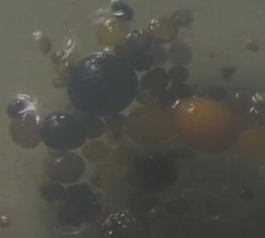
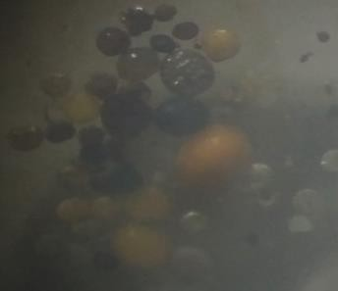
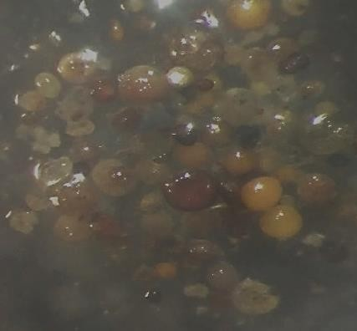
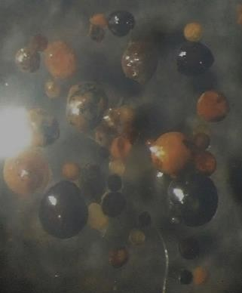
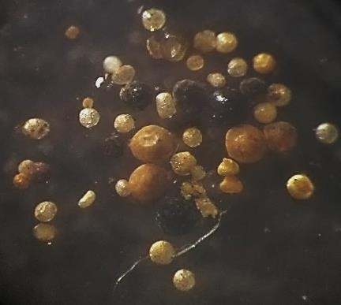
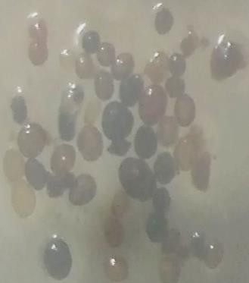
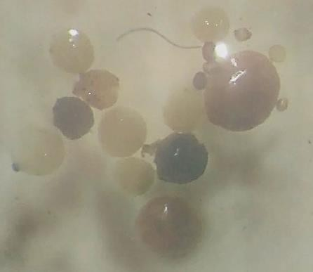
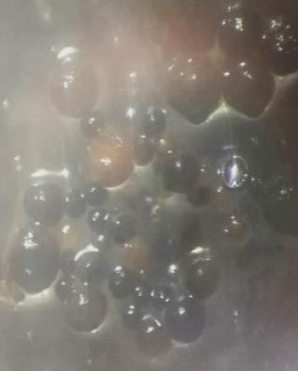
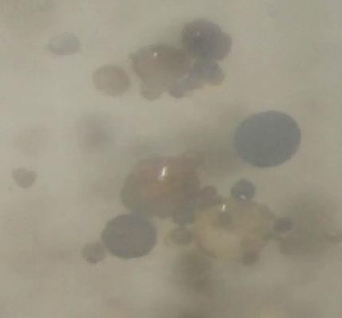
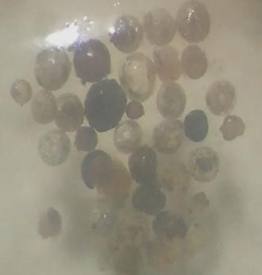
1
2
3
4
7
8
6
11
12
16

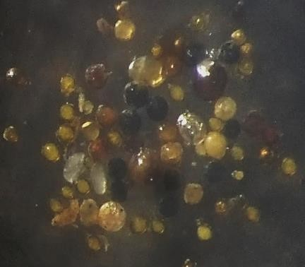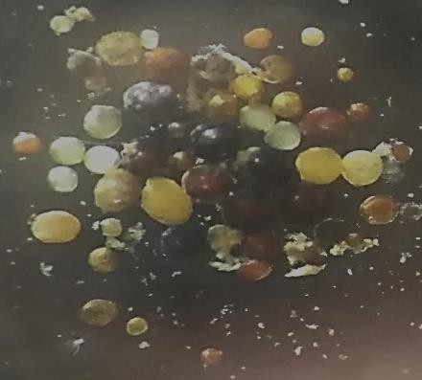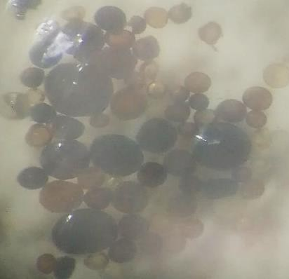
5
9
10
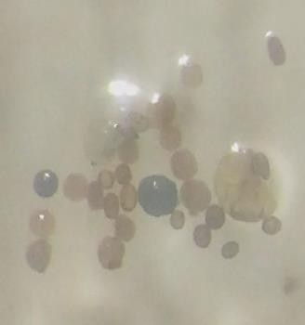
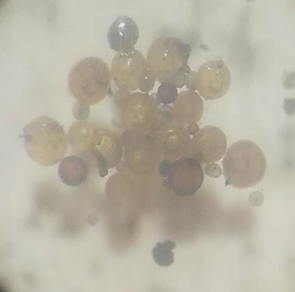
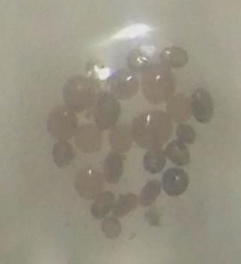
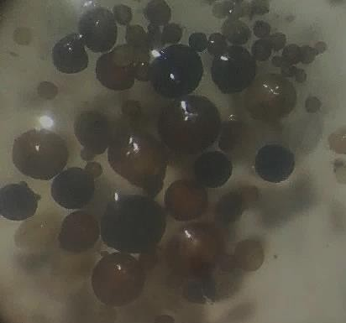
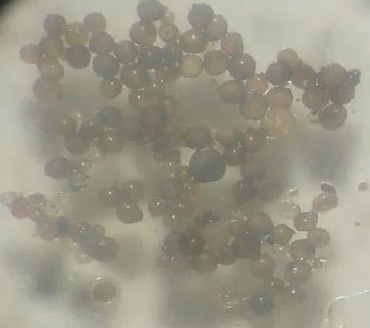
13
14
15
17
18

Figure 3. Freshly extracted spores
Dombe : 1. Red variety, 2. White variety ; Maka-Oum : 3. Red variety, 4. White variety ; NkoeMvom : 5. Red variety, 6. White variety ; Bilone : 7. Red variety, 8. White variety ; Ndji : 9. Red variety, 10. White variety ;

Mbankom : 11. red variety, 12. White variety ; Akonolinga : 13. Red variety, 14. White variety ; Mbalmayo : 15. Red variety, 16. White variety ; Bafia : 17. Red variety, 18. White variety.

Anatomical description of the isolated spores

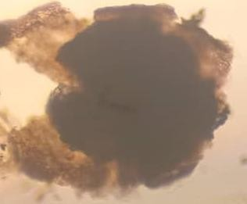
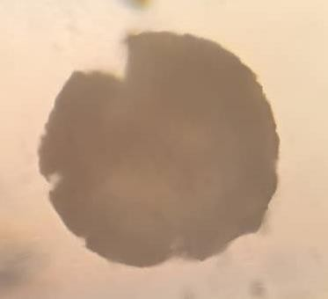
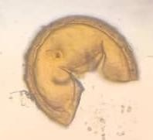

a
b
1
2
4
a
3
c
b
a

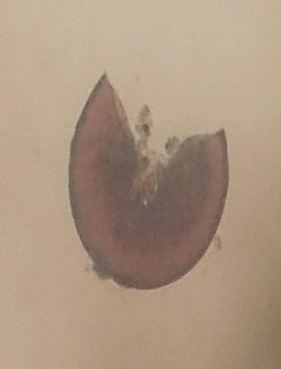
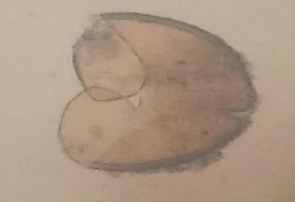
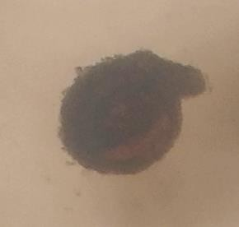

a
b
a
5
b
6
a
8
a
7

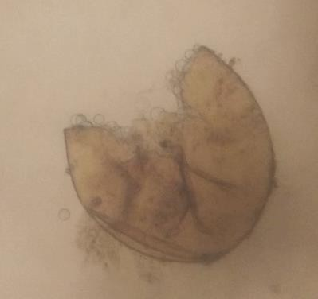

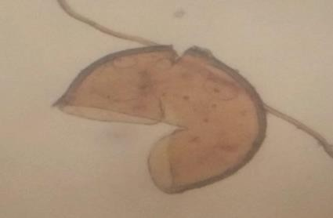
b
a
9
a
10
a
11
- : Sclerocystis sp. The fresh spore is reddish-brown in color, with a size exceeding 300 µm. After staining: a. Thick outer wall consisting of several adherent layers that are breaking down
; b. Inner part of the spore that has absorbed Melzer’s reagent and taken on a dark color.

- : Glomus ambisporum. It measures approximately 100 µm in diameter and has a characteristic black-brown color. The spore does not react to either Melzer’s reagent or the polyvinyl alcohol- lactic acid-glycerol reagent.
- : Funneliformis sp. The spore is dark yellow in color and measures between 150 and 250 µm. It is ovoid in shape, ruptures easily under pressure, and has an outer layer that appears to consist of at least two fused layers.
- : Glomus sp. 1. It is yellow in color and measures between 100 and 200 µm. a. The outermost layer of the spore degrades due to environmental factors; b. the second layer of the spore appears fragile and may degrade like the first layer; c. the third layer appears stable and constitutes the actual spore wall. The interior of the spore appears very dense and colorless;

- Acaulospora sp.; the spore is yellow-brown in color and ranges in size from 100 to 150 µm.
a. Attachment point of the suspending hypha, which was likely lost during the isolation procedure; b. outer coat of the spore.
- Scutellospora sp. Before treatment with reagents, the spore is yellow in color and measures between 100 and 200 µm. a. The outer layer of the spore breaks down ; b. The second layer appears to consist of at least two layers; the spore splits open, revealing a characteristic opening;
- Racocetra sp. Before mounting in the reagents, the spores are black or blackish-brown in color, with sizes that can exceed 450 µm. The spore wall appears to consist of several laminar layers. The spore does not break under pressure and therefore exhibits a certain degree of elasticity.
- Claroideoglomus sp. When freshly extracted, the spores are yellow in color and measure between 100 and 150 µm. a. A prominent suspension point is observed. The spore does not appear to react to either of the two reagents applied.
- Diversispora sp. ; when freshly isolated, the spores are brown in color; with a size greater than 100 µm. a. The outermost wall breaks down ; b. Under pressure, folds form on the surface of the spore.
- Paraglomus sp. Before treatment with chemical reagents, the spores are white in color. Their size is around 100 µm. a. The outer wall of the spore appears to consist of two laminar layers fused together. Under pressure, the spore breaks open to reveal a V-shaped opening. Its inner portion does not absorb Melszer’s reagent.
- Glomus sp. 2. Fresh spores are white in color and have an average size of 200 µm. a. The single spore wall consists of several layers. It breaks under pressure, forming a large opening.

Distribution of isolated mycorrhizal fungal specimens within the study area.
Table 4 shows that the recorded mycorrhizal fungal specimens are not evenly distributed throughout the study area. In fact, regardless of the varieties of the study plant and across all locations, Glomus ambisporum is hyperabundant, followed by Scutellospora sp., Racocetra sp., and Sclerocystis sp., which are abundant in the area. In contrast, Paraglomus sp. was found to be less abundant.

Table 4. Distribution of mycorrhizal fungi specimens in the study area

Red macabo variety

Mycorrhizal fungi specimens | Site 1 | Site 2 | Site 3 |  | Site 4 | Site 5 |  | Site 6 |  | Site 7 |  | Site 8 | Site 9
Sclerocystis sp | ++ | + | + |  | ++ | + |  | + |  | ++ |  | + | +
Glomus ambisporum. | ++++ | ++++ | ++++ |  | ++++ | ++++ |  | ++++ |  | ++++ |  | ++++ | ++++
Funneliformis sp | - | - | ++ |  | - | - |  | ++ |  | - |  | - | ++
Glomus sp1 | ++ | - | ++ |  | ++ | - |  | ++ |  | ++ |  | - | ++
Acaulospora sp ; | + | + | + |  | + | + |  | + |  | + |  | + | +
Scutellospora sp. | ++ | ++ | ++ |  | ++ | ++ |  | ++ |  | ++ |  | ++ | ++
Racocetra sp | ++ | ++ | + |  | + | ++ |  | ++ |  | ++ |  | + | ++
Claroideoglomus sp | + | + | + |  | + | + |  | ++ |  | + |  | + | ++
Diversispora sp | - | + | + |  | - | - |  | + |  | + |  | + | -
Paraglomus sp. | - | - | - |  | + | - |  | - |  | + |  | - | -
Glomus sp2. | ++ | + | ++ |  | ++ | + |  | + |  | ++ |  | + | +
White macobo variety
Mycorrhizal fungi specimens | Site A | Site B | Site C |  | Site D | Site E |  | Site F |  | Site G |  | Site H | Site I
Sclerocystis sp | + | +++ | + |  | + | +++ |  | + |  | +++ |  | + | ++
Glomus ambisporum. | +++ | ++++ | ++++ |  | +++ | ++++ |  | +++ |  | ++++ |  | ++++ | ++++
Funneliformis sp | + | + | ++ |  | - - + |  |  |  |  |  | - - ++
Glomus sp1 | ++ | - | ++ |  | ++ - ++ |  |  |  |  | ++ | - ++
Acaulospora sp ; | - | - | + |  | + | + |  | - |  | - |  | - | +
Scutellospora sp. | + | + |  | ++ | ++ | + |  | ++ |  |  | ++ | + | ++
Racocetra sp | ++ | +++ | + |  | + | + |  | ++ |  | + |  | ++ | +
Claroideoglomus sp | + | ++ |  | + | + |  | + |  | + |  | + | +++ | +
Diversispora sp | + | + |  | + | - |  | + |  | + |  | - | - | -
Paraglomus sp. | - | + |  | - | - |  | - |  | - |  | - | + | -
Glomus sp2. | + | ++ |  | + | ++ |  | + |  | + |  | + | ++ | ++

Site 1= White variety ; Site A= red variety =≥ Site 1 : Dombe ; Site 2 : Maka-Oum ; Site 3 : NkoeMvom ; Site 4 : Bilone ; Site 5 : Ndji ; Site 6 : Mbankom ; Site 7 : Akonolinga ; Site 8 : Mbalmayo ; Site 9 : Bafia ;
- : absent ; + : present; ++ : abundant; +++ : very abundant; ++++ : extremely abundant.

DISCUSSION
Analysis of the soils’ physicochemical properties revealed that their texture ranges from silty-clay to silty-clay-sandy, and the water pH fluctuates between 6.5 and 7.5, while the KCl pH ranges from 6.2 to 6.8. These textures and pH levels are suitable for macabo cultivation, as they promote soil aeration and drainage (Boakye et al., 2018). Furthermore, Aguegia et al. (2000) show that the growth and tuberization of macabo require light soils that are rich in organic matter, well-aerated, well-drained, and loose, with a pH between 5.5 and 6.5.
Regarding the C/N ratio, the recorded data show two categories of soil : those with a low level of organic matter mineralization (3.49–9.16) and those with a high degree of mineralization

(10.78–12.70). In fact, this parameter indicates the rate at which microorganisms break down organic matter, and a fertile soil should have a C/N ratio between 10 and 12.
Regarding phosphorus content, the recorded data show high values ranging from 51.22% to 97.47%. This could be due to agricultural practices in which farmers overuse synthetic chemical fertilizers. It has been demonstrated that high phosphorus levels in the soil inhibit mycorrhizal symbiosis (Tobolbaï, 2018). Indeed, phosphorus is the nutrient that the plant partner receives from the fungus. Thus, when this element is already present in high concentrations in the soil, the host plant ceases to maintain the symbiosis.
With regard to mycorrhizal status, it was observed that most recorded mycorrhization rates exceeded 50%, with some values reaching 90% ; this indicates that the study plants have a very high level of mycorrhization. These observations are consistent with those of Djeuani et al. (2017) and Djeuani et al. (2018), who demonstrated that X. sagittifolium is a highly mycorrhizal plant. At the same time, spore density (number of spores per 100 g of soil) and other mycorrhizal parameters vary depending on the location and the variety of the study plant. This could be explained by variations in the physicochemical properties of the soils between localities and the genomics of the host plants. These results are similar to those of Tobolbaï et al. (2018) and Tobolbaï et al. (2021), who demonstrated that the physicochemical properties of soils influence.
Characterization of the isolated spores indicates the presence of at least eleven different species of mycorrhizal fungi, with Glomus ambisporum being the most abundant. This suggests that G. ambisporum is a ubiquitous species capable of adapting to a wide range of environmental conditions. Tobolbaï et al. (2023) reported a similar finding while studying mycorrhizal fungi associated with the rhizosphere of maize in the Adamaoua region of Cameroon, where they found that Septoglomus constrictum was the most abundant species.

CONCLUSION
The overall objective of this study was to determine the abundance of arbuscular mycorrhizal fungi (AMF) associated with the rhizosphere of macabo (Xanthosoma sagittifolium L. Schott) in agroecological zone 5 of Cameroon. The study soils are generally favorable for macabo cultivation, and this plant is strongly mycorrhizal in the various localities. Analysis of fungal spores revealed the presence of at least 11 species of mycorrhizal fungi, including Sclerocystis sp., Glomus ambisporum, Funneliformis sp., Glomus sp. 1, Acaulospora sp.; Scutellospora sp., Racocetra sp., Claroideoglomus sp., Diversispora sp., and Paraglomus

sp. However, Glomus ambisporum is the most abundant and ubiquitous species in the study area, unlike Paraglomus sp., which is rarer.
Taken together, these results can serve as a starting point for the formulation of a mycorrhizal biofertilizer locally adapted to the cultivation of X. sagittifolium.
Disclaimer (Artificial intelligence)
Author(s) hereby declare that NO generative AI technologies such as Large Language Models (ChatGPT, COPILOT, etc.) and text-to-image generators have been used during the writing or editing of this manuscript.

REFERENCES
Aguegia FDA, Mboua JC, Mouen M, Ndzana X, Tchuango M, Zok S. 2000. Les plantes à racines et à tubercules en Afrique : une contribution au developpement des technologies de récolte et après récolte. (eds) GTZ Gmbt. 385p.
Djeuani AC, Mbouobda HD, Niemenak N. 2017. Improvement of cocoyam (Xanthosoma sagittifolium L. Schott) minitubers production under treatment of Glomus intraradices and Gigaspora margarita and thier impact on some secondary metabolite contents. Journal of plant science and research, 4 (2) : 2017.
Djeuani AC, Mbouobda HD, Omokolo ND. 2018. Effect of arbuscular mycorrhizal fungi on the dynamics of hydrogen peroxide, the activities of catalase, ascorbate peroxidase and Guaïcol peroxidase the activities of catalase, ascorbate peroxidase and Guaïcol peroxidase in Xanthosoma sagittifolium L. Schott rhizome and root during growth. Journal of Biodiversity and Environmental Sciences, Vol. 12, No. 5, p. 1-15, 2018 http://www.innspub.net.
Gerdemann JW, Nicolson TH. 1963. Spores of mycorrhizal Endogene species ectracted from oil by wet-sieving and decanting, Transactionn of the British Mycological Society, 46
:235-244.
Gerdemann JW, Trappe JM. 1974. Endogonceae in the Pacific Northwest. Mycologia, 5 : 1- 76.
INVAM., 2023. International culture collection of VA Mycorrhizal fungi, consulté le 26 janvier 2023. http/www.invam.caf.wvu.edu. 76
Kormanik PP, McGraw AC. 1982. Quantification of vesicular-arbuscular myccorhizal in plant roots. In Schenck, NC(Ed). Methods and principles of mycorrhizal research. Américan phytophatological society, pp, 37-45.
Morton JB, Benny GL. 1990. Revised classification of arbuscular mycorrhizal fungi (Zygomycetes): a new order, Glomales, two new suborders, Glomineae and Gigasporineae, and two families, Acaulosporaceae and Gigasporaceae, with an emendation of Glomaceae. Mycotaxon, 37 : 471-491.

Ngonkeu MEL. 2003. Biodiversité et potentiel des mycorhizes à arbuscules de quelques zones agroécologiques du Cameroun. Thèse de doctorat 3e Cycle, Université de Yaoundé I, Cameroun 258p.
Sghir F, Chliyeh M, Kachkouch W, Khouader M, Touhami A, Benkirane R. 2013. Mycorrhizal status of olea europea spp.oleaster in Morocco. Journal of applied Biosciences.61 :4478-4489
Tobolbaï R. 2018. Diversité et taxonomie des champignons endomycorhiziens associés à Vigna unguiculata, Glycine max et Zea mays cultivés le Grand-Nord Cameroun : Production et application d’inoculum en champ. Thèse de Doctorat PhD. Faculté de Science, Université de Ngaoundéré, Cameroun. 173p.
Tobolbai1 R, Adamou S, Ngakou1 A. 2018. Morphological and structural diversities of indigenous endomycorrhiza communities associated to maize [Zea mays (L.)] in Northern Cameroonian soils. Journal of Animal & Plant Sciences, 38 (1) : 6057-6073.
Tobolbaï R, Ngakou A, Toukam TS, Adamou S. 2021. Potential of endogenous arbuscular mycorrhizae fungi to improve soybean (Glycine max L.) production in northern regions of Cameroon. Journal of Applied Biosciences, 163 : 16846 – 168461.
Tobolbaï R, Ngakou A, Adamou S, Toukam Takoukam S. 2023. Status of endogenous endomycorrhizal fungi associated with cowpea (Vigna unguiculata L.) in the Sudano- Sahelian zone of Cameroon, Int. J. Biol. Chem. Sci. 17(6) : 2141-2157 ;
Trouvelot A, Kough JL, Gianazzi-Pearson V. 1986. Mesure du taux de mycorhization VA d’un système radicualire. Recherche de méthodes d’estimation ayant une signification fonctionnelle. In : Gianazzi-Pearson V, Gianazzi S (eds) physiological and genetical aspects of mycorhizea. INRA, Paris, pp 217-221.

