Climate Variability and Agricultural Adaptations in Northern Côte d'Ivoire: Restructuring Crop Calendars in the Korhogo Department (North of Côte d’Ivoire)

ABSTRACT
Background: The Korhogo department, located in northern Côte d’Ivoire, faces significant climate variability that severely disrupts traditional agricultural cycles. Objective: This study aimed to characterize the regional hydroclimatic evolution over the 1982–2022 period and to develop restructured, climate-adapted crop calendars for rice, maize, cotton, and cashew. Methods: The methodology was based on analyzing SODEXAM climate data using the Nicholson precipitation index, Hanning’s low-pass filter, and statistical shift-detection tests (Pettitt’s test and Hubert’s segmentation). Sivakumar’s criteria were applied to identify rainfall season dynamics. Results: The statistical analyses revealed a major rainfall disruption in the year 2000 (probability > 99%), separating a wet pre-disruption period (1430.47 mm/year) from a dry post-disruption period (1341.14 mm/year). This shift caused a clear delay in the onset of the rainy season, moving from April to May. Conclusion: To mitigate crop and sowing losses, new agricultural calendars were validated: shifting upland rice sowing to May–June, maize to mid-June–mid-July, cotton to late May–June, and cashew planting to July–September. Adopting these revised technical pathways is essential to optimize agricultural production under ongoing climate change.
Keywords: Crop calendars, Climate variability, Rainfall disruption, Crop speculations, Korhogo Department.

1. INTRODUCTION
Climate change and variability have recently moved to the center of concerns for scientists and policymakers worldwide due to their immediate and long-term consequences on both the environment and human societies (Kpan, 2017; IPCC, 2023). In West Africa, and particularly in Côte d'Ivoire, these dynamics manifest as a significant modification of global climatic and hydroclimatic conditions (Kouassi et al, 2008; Savané et al, 2001; Yapi, 2021). The manifestations of this crisis typically include a decline in rainfall amounts, an increase in average temperatures, and a profound disruption of rainfall seasonality. The reduction of wet seasons and the erratic occurrence of extreme weather events heavily disrupt the socio-economic balance of populations whose development depends closely on water resources (FAO, 2017; Goula et al, 2007; Kpan, 2017).
In the Ivorian context, climate variability is currently considered one of the most serious threats to sustainable development (Adja, 2009; Sultan and Gaetani 2016). Agriculture, a macro-economic and subsistence pillar of the country, stands out as the sector most vulnerable to these mutations (CIRAD, 2020). In the Korhogo department, located in northern Côte d'Ivoire, this vulnerability is exacerbated by the fact that 75% of agricultural activity remains strictly dependent on rainfall. The rainfall delays and deficits recorded in recent decades lead to critical direct consequences, notably frequent sowing failures, collapsing crop yields, and substantial harvest losses, exposing local populations to poverty and food insecurity (Kouakou, 2011; Soro et al, 2013).
Faced with the urgent need to minimize these agricultural losses and support the resilience of farmers against a disrupted seasonality, it is imperative to adjust technical itineraries. Adapting crop calendars is an essential strategy to optimize agricultural practices according to the new hydroclimatic realities of the region. It is within this perspective that the present study was initiated.
The main objective of this work is to design agricultural calendars adapted to the new climate profile of the area to help farmers secure their production cycles. Specifically, the aims are, on the one hand, to accurately characterize the trajectory of climate variability in the Korhogo department over the 1982-2022 period, and on the other hand, to determine optimal periods for land clearing, plowing, sowing, and harvesting for four strategic crops: cotton, maize, rice, and cashew.
2. MATERIALS AND METHODS
2.1. Geographical Setting, Data and Equipment
Located in northern Côte d’Ivoire, the town of Korhogo is situated approximately 564 km from Abidjan (the economic capital) and 320 km from Yamoussoukro (the political capital). It serves as the administrative centre for both the Poro Region and the Savanes District. The Korhogo department encompasses an area of 12,640.4 km² with an estimated population of 440,926 inhabitants (Institut National de la Statistique, 2022). It shares administrative boundaries with the departments of M’Bengue to the north, Sinematiali and Ferkessédougou to the east, Dikodougou and Niakaramadougou to the south, and Boundiali and Dianra to the west.
The regional vegetation consists primarily of shrub savanna interspersed with small, dense forest patches locally referred to as "sacred groves". Korhogo experiences a Sudano-Guinean climate characterised by two distinct seasons (Soro et al., 2013). Topographically, the region is a vast, rolling plateau with elevations ranging between 300 and 400 metres above sea level (Fig. 1). The local hydrographic network is dominated by the Bandama River and its main tributaries, including the Lofigou and Solomougou rivers.
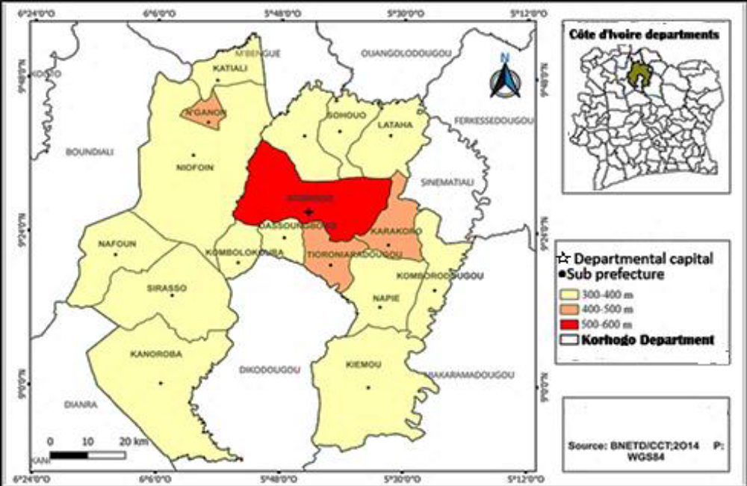
Fig. 1. Map of the study area
The study relies on two complementary types of data:
- Climate Data: Chronological series of daily rainfall and temperatures covering the 1982-2022 period, provided by Société d’Exploitation et de Développement Aéroportuaire, Aéronautique et Météorologique (SODEXAM) from the agro-meteorological station at Korhogo-Airport.
- Agronomic Data: Technical sheets published by the Centre National de Recherche Agronomique (CNRA), specifying crop evapotranspiration, agro-climatic cycles, and the requirements of varieties recommended in the region.
Data processing and analysis were performed using Excel (arithmetic calculations and charting), Khronostat 1.00 statistical software (property of the IRD, dedicated to shift and rupture detection tests), and Arcgis 10.1 for cartographic representations.
2.2. Methodology
2.2.1. Characterization of Climate Variability
Nicholson Precipitation Index (1993) has been used to identify the deficit or surplus nature of annual rainfall. It is calculated using the following formula:
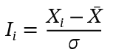
Where Ii represents the index of year i, Xi the rainfall of year i, X_mean the mean of the time series, and sigma its standard deviation.
Hanning Second-Order Low-Pass Filter was applied to smooth the chronological series, eliminate highly frequent seasonal variations, and highlight long-term climate trends using centered moving weight equations.
For Climate Rupture Detection Tests, the non-parametric Pettitt test was deployed to identify the main rupture (the most significant trend shift date) within the time series at a 5% significance level. In addition, Hubert's segmentation method was used to detect potential secondary or tertiary ruptures by dividing the series into segments with significantly distinct means.
2.2.2. Establishment of Adapted Crop Calendars
- Determination of Season Onset and End Dates (Sivakumar and Wilhite (2002) Criteria):
The onset of the rainy season corresponds to the date on which a minimum cumulative rainfall of 20 mm is recorded over 3 consecutive days, without any dry spell exceeding 7 days occurring within the following 30 days. The end of the rainy season is defined as the first day of a period of at least 20 consecutive days without any rainfall greater than or equal to 5 mm.
- Design of Adapted Calendars
The specific physiological requirements of the four crops (global water requirements, critical temperatures, sunshine duration) were crossed with the newly established seasonality to chronologically reposition land clearing, plowing, sowing, and harvesting operations (Djaha et al, 2008; Ezan et al, 1998; Kockmann, 2009; Koffi, 2016).

3. RESULTS AND DISCUSSION
3.1. Climate Diagnosis Results and Rainfall Disruption
The thermal and hydroclimatic analysis highlights a major transformation of the Sudanese climate in the Korhogo department over the 1982-2022 period.
3.1.1. Decadal Evolution and Nicholson Precipitation Indices
The evaluation of decadal rainfall averages reveals a bell-shaped trajectory characterized by a critical drying phase followed by a recent return of rainfall (Fig. 2):
- The 1982-1991 decade stands as the wettest with an average of 1595.54 mm.
- A first drop in amplitude occurs during the 1992-2001 decade (1405.94 mm).
- The 2002-2011 decade marks the peak of the drought with a minimum of 1179.4 mm.
- Finally, the 2012-2021 decade initiates a notable rainfall recovery reaching 1505.595 mm.

Fig. 2. Trends in the ten-year average rainfall

Applying Hanning's second-order low-pass filter and Nicholson indices allows for precise segmentation of the time series into five distinct climatic periods (Fig. 3):
- Three wet periods: 1982-1990 (mean of 1611.05 mm, a surplus of +188.03 mm relative to the interannual average of 1423.02 mm), 1997-2000 (+206.63 mm), and 2015-2022 (+123.90 mm).
- Two dry periods: 1991-1996 (deficit of -119.9 mm) and the long dry period of 2001-2014, which records the most severe deficit of the series at -199.46 mm.
Frequency analysis shows that the overall percentage of dry years at the Korhogo-Airport station reaches 51.21% compared to 48.78% of wet years.
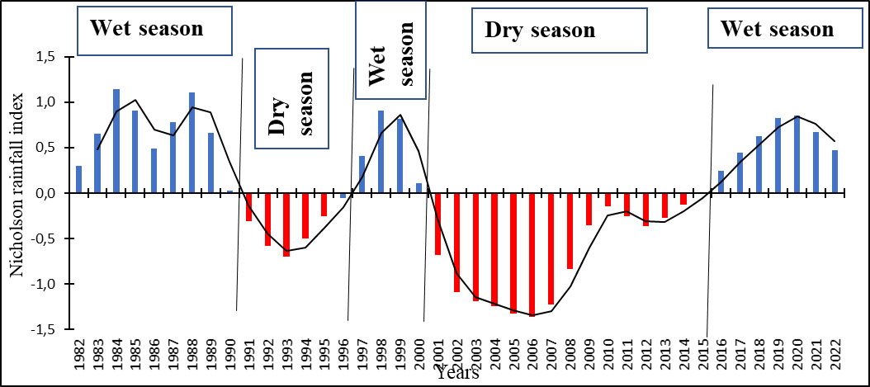

Fig. 3. Variation in the Nicholson rainfall index in the Korhogo department from (1982 to 2022)
3.1.2. Statistical Detection of Rainfall Ruptures
The non-parametric Pettitt test detected a major rainfall rupture in the year 2000 with a significance level greater than 99%. This rupture separates the time series into two distinct climatic regimes:
1. Pre-rupture period (1982-2000): Interannual mean precipitation stood at 1430.47 mm, including the historical maximum of the series (2143.81 mm recorded in 1988).
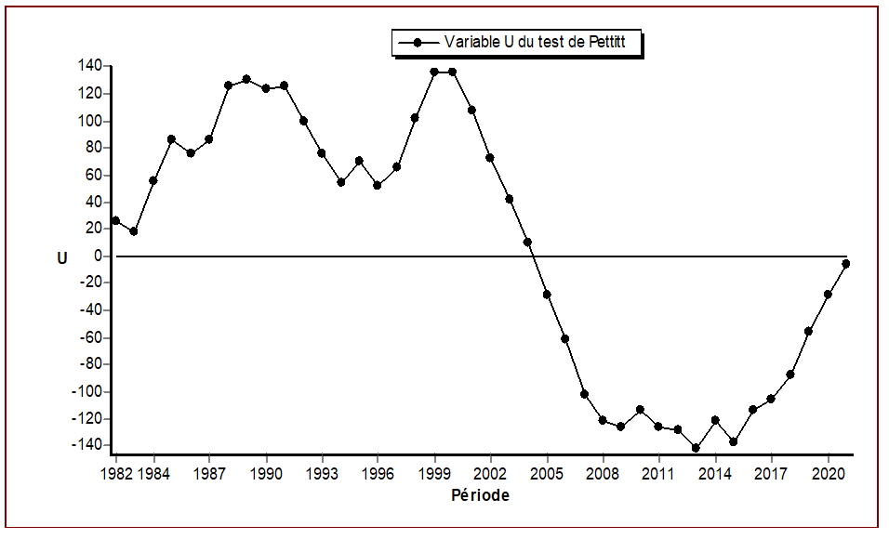
2. Post-rupture period (2001-2022): Average rainfall dropped to 1341.14 mm, recording the absolute historical minimum of the time series (1015.74 mm in 2007).

Figure 9: Variation in Pettitt’s U-values test at the Korhogo Airport rain gauge station

Hubert's segmentation method corroborates the main rupture of the year 2000 and identifies two secondary ruptures in 2008 and 2022 (Table 1), validating the strong temporal instability of rainfall.
Table 1: Hubert's segmentation method (Significance level of the Scheffé test at 1%)
Start | End | Average | Standard deviation
1982  2001  2009 | 2000  2008  2022 | 1517,832  1104,937  1476,121 | 281,994  68,247  164,927

3.1.3. Temporal Shift of the Rainy Season
The direct agronomic consequence of this rupture lies in the modification of seasonality. Before 2000, the rainy season reliably settled as early as April, displaying a monthly average above the critical threshold of the series (126.89 mm).
After 2000, April rainfall collapsed and fell below the new reference monthly average (112.09 mm). The effective start of the rainy season thus shifted from April to May, restricting the active cultural window from May to October and imposing an immediate revision of sowing periods.
3.2. Restructuring of Crop Calendars by Speculation
To counter sowing losses and the collapse of yields caused by this seasonal shortening, new crop calendars, modeled on post-rupture water availability, have been validated for four key crops.
3.2.1. Upland and Lowland Rice Cultivation
Rice requires a warm, highly sunny environment and a monthly water supply of 100 mm (upland) to 200 mm (lowland).
- Proposed itinerary: Land clearing is positioned from March to May, followed by deep plowing (manual or mechanized) from May to July to promote root development and bury organic matter.
- Sowing and Harvesting: For upland rice, sowing must be completed between May and mid-June. In lowlands, the optimal window extends from June 15 to August 15, allowing the maximum foliar growth phase to coincide with the peak rainfall period of August-September (where average rainfall reaches 243.45 mm and 227.07 mm). Harvesting takes place from September onwards for short-cycle varieties.
Table 2 summarize rice cultivation itinerary.
Table 2: Agricultural calendar for rice in the Korhogo department
 | Jan | Feb | Mar | Apr | May | June | July | Aug | Sept | Oct | Nov | Dec
Land clearing
Hilling
Sowing
Weeding
Harvest

3.2.2. Maize Cultivation
Maize requires a well-structured soil and a well-distributed total of 450 mm of water to guarantee an optimal yield of 10 t/ha.
- Proposed itinerary: Preparation and cleaning of plots span from April to June, and plowing is carried out in June-July to a depth of 15 to 30 cm.
- Sowing and Harvesting: Sowing must imperatively be set between June 15 and July 15, after ensuring a useful rain of at least 20 mm. Maintenance weeding is positioned strictly 15 to 30 days after emergence to limit weed competition. Harvesting occurs from September onwards depending on the earliness of the varietal cycle (Table 3).
Table 3: Agricultural calendar for maize in the Korhogo department
 | Jan | Feb | Mar | Apr | May | June | July | Aug | Sept | Oct | Nov | Dec
Land clearing
Hilling
Sowing
Weeding
Harvest

3.2.3. Cotton Cultivation
The cotton plant fears waterlogging but requires at least 700 mm of water over a vegetative cycle of 150 to 170 days. It requires high heat (around 30°C) early in the cycle and a marked dry period at the end of the run.
- Proposed itinerary: The readjusted calendar fixes land clearing in March-April and plowing from April to June.
- Sowing and Harvesting: Sowing occurs from May 20 to June 30 on moist soil with the application of pre-emergence herbicides. Maintenance is performed through successive weedings at the 20th and 60th days. Harvesting is carried out fractionally (in at least two passes) starting in November, taking advantage of the onset of the dry season and the harmattan to preserve fiber quality (Table 4).
Table 4: Agricultural calendar for cotton plant in the Korhogo department
 | Jan | Feb | Mar | Apr | May | June | July | Aug | Sept | Oct | Nov | Dec
Land clearing
Hilling
Sowing
Weeding
Harvest

3.2.4. Cashew Cultivation
The cashew tree, a perennial woody species resistant to drought, nevertheless requires deep and perfectly drained soils.
- Proposed itinerary: Land preparation takes place during the first quarter (January to March). Hole digging (50 cm in diameter by 80 cm in depth) is planned from April to June. Allowing holes to air for 15 days, followed by refilling with organic basal fertilizer (45 days before transplanting), is required.
- Planting: Transplanting of vigorous young seedlings from the nursery is carried out in the heart of the third quarter, from July to September, when the soil has a maximum water reserve guaranteeing perfect root recovery before the November dry season (Table 5).
Table 5. Agricultural calendar for cashew tree in the Korhogo department
Years | 1st year |  |  |  | 2nd year |  |  |  | 3rd year
Quarters | J-M | A-J | J-S | O-D | J-M | A-J | J-S | O-D | J-M | A-J | J-S | O-D
Land clearing
Hilling
Sowing
Weeding
Harvest

3.3. Discussion
Hydro-climatic Variability and Rainfall Decline
For several decades, the Korhogo Department has faced significant disruptions in agricultural calendars. Graphical representations and statistical methods—including Nicholson's rainfall index, Pettitt's test, and Hubert's segmentation—reveal a pronounced downward trend in rainfall across the region. Specifically, Nicholson's indices and the Hanning low-pass filter highlight a major climate shift (rupture pluviométrique) starting in 2000 at the Korhogo-Airport meteorological station. This climatic breakpoint is characterized by a severe reduction in annual precipitation.
The generalized rainfall decline and temporal shift of seasons observed at the Korhogo-Airport station are in perfect alignment with West African hydroclimatic literature. Numerous authors place the beginnings of the major West African rainfall deficit as early as the 1969-1970 decade (Diomandé, 2013; Kouakou, 2011; Kpan, 2017; Sultan and Gaetani, 2016; Yapi. 2021).
These findings align with prior hydro-climatic studies conducted in northern Côte d'Ivoire. For instance, Brou et al (2005), Adja (2009) , and Soro et al. (2013) also identified a steady decline in precipitation in the northern region, tracing the onset of this rainfall deficit back to the 1960s.
Such rainfall fluctuations vary across different bioclimatic zones of the country. In Southern and Eastern Regions, Kpan (2017) situated this climatic shift around 1982 in the Aboisso and Adiaké region. In the East, Kouakou (2011) reported that annual rainfall amplitudes regressed from 1400 mm to 1150 mm between 1970 and 1990. For the V-Baoulé and Central Regions, Diomandé (2013) identified a rainfall regression in the N’Zi river basin starting in 1968. In Western and Central-Western Regions: Savané et al. (2001noted a decline starting in 1967 in the far west) established that the downward trend began during the 1961–1970 decade. Furthermore, the Southwestern, Central, and Central-Western regions recorded even more severe rainfall deficits during the 1960s and 1970s (Diomandé, 2013; Kpan, 2017).
In Korhogo, the later shift validated in the year 2000 confirms the persistence and northern progression of this climate instability (Adja, 2009). The shift of the onset of rains to May drastically reduces farmers' room for maneuver and scientifically justifies the abandonment of traditional early sowing practices in April, under penalty of seeing seedlings destroyed by post-emergence dry spells.
Agricultural calendars vary substantially among crops due to specific agro-climatic requirements and local socio-technical dynamics (Allenet al, 1998). In the Korhogo Department, Cotton, maize, rice, and cashew nuts play strategic roles in these production systems. This section contrasts the cropping cycles of these major commodities and compares them with broader West African agricultural contexts.
Crop | Sowing / Flowering Period | Harvesting Period | Regional Comparison & Agro-climatic Drivers
Cotton (Gossypium hirsutum) | May – June | November – December | Driven by the onset of the first rains (CNRA, 2010). Consistent with the cotton campaign in Bobo-Dioulasso, Burkina Faso (Ouedraogo, 2012; Traore., (2020).).
Maize (Zea mays) | First cycle: April – June  Second cycle: August – September | First: July – August Second: November – December | This bimodal distribution mirrors maize (Nouvelle-Calédonie. 2015; Battude. 2017) adaptation strategies in the savanna transition zones of Ghana and Benin (RONGEAD, 2014; Zougmoré et al., 2016;)
Rice (Oryza sativa) | Upland: Mid-May – July  Lowland: July | Upland: October – November  Lowland: December | Reflects diversified cropping systems (upland, irrigated, and lowland). Aligns with cycles reported in Gagnoa and Korhogo (Diarra and Tagbo, 2020; Kouassi, 2019).
Cashew (Anacardium occidentale) | Flowering: November – January | February – May | Perennial crop. The dry season promotes optimal flowering, making it highly suitable for northern Côte d'Ivoire. Identical cycles are observed in Benin and Senegal (CNRA, 2010).

These cropping cycles reflect a highly differentiated adaptation to the Sudano-Guinean climate of Korhogo. While this crop diversity represents a major agronomic asset, optimizing farming sequences remains critical to mitigating the impacts of ongoing climate variability.
The calendars restructured during this study demonstrate that a rigorous synchronization of the physiological needs of crops (water requirements of rice in August, need for dry conditions for cotton in November) with the post-2000 climate profile is an immediate and highly resilient adaptation solution).
The findings of the present study highlight the importance of integrating long-term climate diagnostics with crop-specific adaptation strategies to strengthen agricultural resilience under changing hydroclimatic conditions. The observed rainfall regime shift and delayed onset of the rainy season in the Korhogo department demonstrate how changes in rainfall distribution can influence sowing decisions, crop water availability, and the synchronization of crop growth stages with favourable climatic conditions. Similar research perspectives are reflected in Guhan et al. (2024), who investigated the impacts of climate change on tomato water requirements and yield across different agro-climatic zones of Tamil Nadu, emphasizing the relevance of regional climate conditions in crop-water planning. Furthermore, district-level forecast diagnostics and advisory risk profiling for maize in Telangana demonstrate the value of integrating forecast evaluation with agricultural risk characterization to support climate-smart planning (Guhan et al., 2026a). The importance of spatially differentiated adaptation is also consistent with research on district-level climate variability, yield resilience, and risk categorization of sugarcane in semi-arid Telangana (Guhan et al., 2026b), as well as multi-model agro-climatic hazard profiling of rice and wheat under the SSP2-4.5 scenario (Guhan et al., 2026c). Beyond crop production, the assessment of cotton pest outbreak risks using entropy, Gini coefficients, and machine-learning approaches illustrates the broader need to consider climate-related agricultural risks through complementary analytical frameworks (Guhan et al., 2026d). In addition, research on ENSO–monsoon teleconnections using spectral, coherence, and wavelet analyses provides a wider climatic perspective for understanding rainfall variability and its potential implications for agricultural decision-making (Guhan et al., 2026e). Collectively, these studies support the broader relevance of combining climate diagnostics, crop-specific assessment, risk characterization, and agricultural advisory approaches. In this context, the revised crop calendars proposed for Korhogo provide a practical adaptation pathway that could be further strengthened through seasonal forecast information, local agrometeorological services, and subsequent field-based evaluation of crop establishment and productivity.

4. CONCLUSION AND PERSPECTIVES
The present study characterized the trajectory of climate variability in the Korhogo department over a 41-year period (1982-2022) and evaluated its direct agronomic implications on major crops in this northern region. Combined statistical analyses (Nicholson indices, Hanning filter, Pettitt and Hubert tests) confirm the reality of a local hydroclimatic crisis, marked by a major rainfall rupture that occurred in the year 2000. This rupture induced a significant decline in interannual precipitation and a notable temporal shift in the onset of the rainy season, now pushed from April to May.
Faced with this shortening of the active cultural window, the adaptation of agricultural practices is no longer an option but a vital necessity for the food and economic security of the region. The crop calendars restructured during this work offer an immediate, pragmatic, and scientifically framed technical response for rice, maize, cotton, and cashew. By precisely synchronizing the critical physiological phases of plants with the new configuration of rains (sowing window recentered between mid-May and mid-July depending on the crops), these calendars drastically minimize the risks of sowing failures and optimize yields.
As perspectives, the sustainable application of these calendars requires strengthening local agro-meteorological services and actively disseminating these results to local farmers' organizations. Furthermore, given continuous interannual instability, future research should integrate the combined evaluation of these revised calendars with the use of short-cycle and highly drought-tolerant varieties to consolidate the overall resilience of farming systems in northern Côte d'Ivoire.

Competing Interests
Authors have declared that they have no known competing financial interests OR non-financial interests OR personal relationships that could have appeared to influence the work reported in this paper

Declaration of AI Use

This manuscript was prepared through the intellectual contributions of the author(s) to the study design, data analysis, interpretation of results, and scholarly content. Grammarly and ChatGPT were used solely to assist with grammatical refinement and reference formatting during manuscript revision. The author(s) accept full responsibility for the accuracy, integrity, and final content of the manuscript.

REFERENCES
Adja. M. G. (2009). Étude de l’état hydrique saisonnier du bassin versant de la Bagoé dans un contexte de variabilité climatique. Départements de Boundiali et Tengrela (milieux Soudano-sahéliens au nord-ouest de la Côte d’Ivoire). Thèse de doctorat, Université de Cocody - Abidjan, Côte d’Ivoire (Seasonal water balance of the Bagoé watershed in the context of climate variability. Boundiali and Tengrela departments (Sudano-Sahelian environments in northwestern Côte d’Ivoire). Doctoral thesis, University of Cocody - Abidjan.)209 p.
Allen, R.G., Pereira, L.S., Raes, D., Smith, M., 1998. Crop evapotranspiration-Guidelines for computing crop water requirements-FAO Irrigation and drainage paper 56. FAO, Rome 333 pp.
Battude. M. (2017). Estimation des rendements, des besoins et consommations en eau du maïs dans le Sud-Ouest de la France : apport de la télédétection à hautes résolutions spatiale et temporelle. Thèse de Doctorat de l’Université de Toulouse, (Estimation of maize yields, water requirements, and water consumption in Southwest France: contribution of high spatial and temporal resolution remote sensing. Doctoral thesis, University of Toulouse.)254 p.
Brou. Y.T., Akindes, F., Bigot, S. (2005). La variabilité climatique en Côte d’Ivoire : entre perceptions sociales et réponses agricoles. Cahiers Agricultures, (Climate variability in Côte d’Ivoire: between social perceptions and agricultural responses. Cahiers Agricultures)540 p
CIRAD (2020). Filières agricoles en Afrique de l’Ouest : maïs, coton, riz, anacarde.( Agricultural value chains in West Africa: maize, cotton, rice, cashew) www.cirad.fr
CNRA. (2010). Fiches techniques sur les itinéraires culturaux du coton et de l’anacarde. Abidjan Centre National de Recherche Agronomique.( Technical sheets on cotton and cashew cultivation practices. Abidjan: National Center for Agronomic Research.)
Diarra A., Tagbo M-P. R. (2020). Variabilité climatique et production de riz pluvial en zone humide : cas de la sous-préfecture de Gagnoa (Côte d’Ivoire), Revue de Géographie, d'Aménagement Régional et de développement des Suds, pp (Climate variability and rainfed rice production in a humid zone: the case of the Gagnoa sub-prefecture (Côte d’Ivoire), Journal of Geography, Regional Planning, and Development in the Global South, pp.)45-60
Diomandé M. (2013). Impact du changement de pluviosité sur les systèmes de production agricoles en zone de contact forêt-savane de Côte d’Ivoire. Thèse de Doctorat de l’Université Felix Houphouët Boigny de Cocody (Abidjan-Côte d'Ivoire), (Impact of changing rainfall patterns on agricultural production systems in the forest-savanna transition zone of Côte d’Ivoire. Doctoral thesis, Félix Houphouët-Boigny University, Cocody (Abidjan, Côte d’Ivoire).)201 p.
Djaha A., N’Da A. A., N’Klo H., Edo Ko, N’guessan A. (2008) Bien cultiver l’anacardier en Côte d’Ivoire.( Successfully growing cashew trees in Côte d’Ivoire.)
Ezan.M., Hala. N'., Kesse. F., Koto. E., Kouadio. N., Kouassi. A., Thibaud. M., N'Guessan E., Ochou. G., Ouraga.Y., Toure. Y., Viot. C. (1998). Culture du coton : manuel technique. Ministère de l'enseignement supérieur, de la recherche et de l'innovation technologique. Institut des savanes département des cultures industrielles filière coton. (Cotton Cultivation: Technical Manual. Ministry of Higher Education, Research, and Technological Innovation. Savanna Institute, Industrial Crops Department, Cotton Sector.)47p.
FAO (2017). Guide pour l’adaptation de l’agriculture au changement climatique.( Guide for Adapting Agriculture to Climate Change)
Goula BTA, Konan B, Brou YT, Savané I, Fadika V, SrohourouB (2007). Estimation des pluies exceptionnelles journalières en zone tropicale : cas de la Côte d'Ivoire par comparaison des lois Lognormale et de Gumbel. J Sc Hydrol ; (Estimation of exceptional daily rainfall in tropical zones: the case of Côte d'Ivoire by comparison of the Lognormal and Gumbel distributions. J Sc Hydrol)52 : 49-67. doi:10.1623/hysj.52.1.49.
Guhan V., Dharma Raju A., Naga Ratna K., Sheshakumar Goroshi. (2026a). District-level forecast diagnostics and advisory risk profiling for maize cultivation across Telangana: A multi-metric framework for climate-smart agricultural planning. Theoretical and Applied Climatology. https://doi.org/10.1007/s00704-026-06301-z
Guhan V., Dharma Raju A., Naga Ratna K., Sheshakumar Goroshi. (2026d). Multi-scale diagnostics of ENSO–monsoon teleconnections: Spectral, coherence, and wavelet insights from Indian rainfall and temperature variability. Atmospheric Research. https://doi.org/10.1016/j.atmosres.2026.109178
Guhan V., Geethalakshmi V., Bhuvaneswari K., Kowshika N., Vinothkumar V., Nithila S., Marimuthu M. (2024). The impact of climate change on water requirement and yield of tomato over different agro-climatic zones of Tamil Nadu. Current Science. https://doi.org/10.18520/cs/v127/i11/1330-1334
Guhan V., Sheshakumar Goroshi, Dharma Raju A., Naga Ratna K. (2026b). District-level climate variability, yield resilience, and risk categorization of sugarcane in semi-arid Telangana. International Journal of Climatology. https://doi.org/10.1002/joc.70448
Guhan V., Sheshakumar Goroshi, Dharma Raju A., Naga Ratna K. (2026c). Spatial multi-model framework for agro-climatic hazard profiling of rice and wheat under SSP2-4.5. Agricultural Research. https://doi.org/10.1007/s40003-026-01046-7
Guhan Velusamy, Sheshakumar Goroshi, Dharma Raju Akasapu, Nagaratna Kopparthi, Mansour Almazroui, Mohamed Elhag. (2026). Stochastic risk assessment of cotton pest outbreaks in tropical India: Entropy, Gini coefficients, and machine learning for sustainable agroecosystem management. Sustainability. https://doi.org/10.3390/su18115673
INS (Institut National de la Statistique) (2022). Recensement générale de la population et de l’habitat de la Côte d’Ivoire (General Census of Population and Housing of Côte d’Ivoire)2021, 68 p.
IPCC 2023: Synthesis Report (Full Volume) Contribution of Working Groups I, II and III to the Sixth Assessment Report of the Intergovernmental Panel on Climate Change, Summary, pp 42
Kockmann.S., (2009). « Mise en place d’une filière biologique de noix de cajou dans le Nord de la Côte d’Ivoire. ». Mémoire de fin d’étude. L’ISARA-Lyon, ("Establishing an organic cashew nut supply chain in northern Côte d’Ivoire." Final-year thesis. ISARA-Lyon.)97p.
Koffi Y.J.J. (2016). Impacts socio-Economique et écologique de la culture de l’anacarde dans la région du Zanzan (Nord-est de la Côte d’Ivoire). Mémoire de D.E.A, Université de Cocody (Abidjan, Côte d’Ivoire),( Socio-economic and ecological impacts of cashew cultivation in the Zanzan region (northeastern Côte d’Ivoire). DEA thesis, University of Cocody (Abidjan, Côte d’Ivoire),) 68 p.
Kouakou K. E. (2011). Impacts de la variabilité climatique et du changement climatique sur les ressources en eau en Afrique de l’Ouest : Cas du bassin versant de la Comoé. Thèse de Doctorat de l’Université de Cocody (Abidjan-Côte d'Ivoire), (Impacts of climate variability and climate change on water resources in West Africa: The case of the Comoé River basin. Doctoral thesis, University of Cocody (Abidjan, Côte d'Ivoire),)204 p.
Kouassi A.M., Kouamé K.F., Goula B.T.A., Lasm T., Paturel J.E. et Biémi J. (2008). Influence de la variabilité climatique et de la modification de l’occupation du sol sur la relation pluie-débit à partir d’une modélisation globale du bassin versant du N’zi (Bandama) en Côte d’Ivoire. Rev Ivoir. Sci. Technol., (Influence of climate variability and land-use change on the rainfall-runoff relationship based on lumped modeling of the N’zi (Bandama) watershed in Côte d’Ivoire. Rev. Ivoir. Sci. Technol.,)vol. 11, pp. 207-229.
Kouassi B. A. C. D, (2019) Analyse des déterminants du choix et de l’adoption de variétés améliorées de riz. Cas des zones de Gagnoa et de Korhogo en Côte d’Ivoire. Mémoire de fin de cycle, Université Félix Houphouët-Boigny Abidjan, (Analysis of the determinants of the choice and adoption of improved rice varieties: A case study of the Gagnoa and Korhogo areas in Côte d’Ivoire. Master’s thesis, Félix Houphouët-Boigny University, Abidjan.)117p
Kpan O. J. G. (2017). Incidence de la variabilité climatique sur les ressources en eau, le développement agricole et la santé des populations dans le Sud-Est de la Côte d’Ivoire et prospectives : cas de la zone littorale d’Abidjan à Aboisso. Thèse de Doctorat, Université Félix Houphouët-Boigny Abidjan, (Impact of climate variability on water resources, agricultural development, and population health in southeastern Côte d’Ivoire, and future outlook: the case of the coastal zone from Abidjan to Aboisso. Doctoral thesis, Félix Houphouët-Boigny University, Abidjan.)225 p.
Nicholson S. E., (1993). An overview of African’s rainfall fluctuation of the last decade. International Journal of Climatology, Vol.6, pp.1463-1466.
Nouvelle-Calédonie. (2015). L’irrigation du maïs. Méthodes de pilotage de l’irrigation en Nouvelle-Calédonie. Fiche technique Edition,( Maize irrigation. Irrigation management methods in New Caledonia. Technical fact sheet – Edition) 11 p.
Ouedraogo, A., Yombi, H. L., Doumbia H, S., Eyhorn H, F., Dischl H. R., Helvetas., (2008). Guide de production du coton biologique et équitable. Un manuel de référence pour l’Afrique de l’Ouest.,( Guide to Organic and Fair Trade Cotton Production: A Reference Manual for West Africa.)49 p.
Philippe. L., Steev. L., Hubert. S., (2012). Etude pour la préparation d’une stratégie pour le développement de la filière anacarde en Côte d’Ivoire, Rapport Diagnostic. Programme FED de l’Union Européenne pour la Côte d’Ivoire. (Study for the preparation of a strategy for the development of the cashew sector in Côte d’Ivoire: Diagnostic Report. European Union EDF Programme for Côte d’Ivoire.)92 p.
RONGEAD (Commerce International et Développement Durable). (2014). Diagnostic de la filière maïs en côte d’ivoire. Projet « Redynamiser les productions, l’accès au marché et le conseil agricole pour les filières vivrières et commerciales du Nord de la Côte d’Ivoire ». Novembre 2013 – Avril 2014,( Assessment of the maize value chain in Côte d’Ivoire. Project: “Revitalizing production, market access, and agricultural extension services for food and commercial crop value chains in northern Côte d’Ivoire.” November 2013 – April 2014.) 59 p.
Savané I., Coulibaly K.M. et Gioan P. (2001). Variabilité climatique et ressources en eaux souterraines dans la région semi-montagneuse de Man. Revue Sciences et changement planétaire-sécheresse, (Climate variability and groundwater resources in the semi-mountainous region of Man. Journal *Sciences et changement planétaire-sécheresse*,)vol.12, n°4, 237 p.
SivaKumar, M. V. K., & Wilhite, D.A. (2002). Drought preparedness and drought management. Drought mitigation and prevention of land desertification, 21-25.
Soro, T. D., Kouakou, B. D., Kouassi, E. A., Soro, G., Kouassi, A. M., Kouadio, K. E., Yéi, M.-S. O. & Soro, N. (2013). Hydroclimatologie et dynamique de l’occupation du sol du bassin versant du Haut Bandama à Tortiya (Nord de la Côte d’Ivoire). VertigO, (Hydroclimatology and land-use dynamics of the Upper Bandama watershed in Tortiya (Northern Ivory Coast). VertigO)13(3).
Sultan B and Gaetani M (2016). Agriculture in West Africa in the Twenty-First Century: Climate Change and Impacts Scenarios, and Potential for Adaptation. Front. Plant Sci. 7:1262. doi: 10.3389/fpls.2016.01262
Traore. B., (2020). Incidence d’une irrigation d’appoint sur l’état sanitaire et le rendement du cotonnier (Gossypium hirsutum L., 1763) au Nord de la Cote d’Ivoire, dans le contexte du changement climatique. Thèse de doctorat, de l’Institut National Polytechnique Felix Houphouët-Boigny. (Impact of supplemental irrigation on the health status and yield of cotton (*Gossypium hirsutum* L., 1763) in northern Côte d’Ivoire, in the context of climate change. Doctoral thesis, Institut National Polytechnique Félix Houphouët-Boigny.)139 p.
Yapi. A. F. (2021). Evaluation du risque potentiel de sécheresse et prévision par la méthode des indices climatiques : apport du générateur stochastique de temps mono site (WeaGETS) dans la région de la Marahoué. (Centre-Ouest de la Côte d’Ivoire). Thèse de Doctorat, Université Félix Houphouët-Boigny Abidjan, (Assessment of potential drought risk and forecasting using the climate index method: contribution of the single-site stochastic weather generator (WeaGETS) in the Marahoué region (Central-West Côte d’Ivoire). Doctoral Thesis, Félix Houphouët-Boigny University, Abidjan.)296 p.
Zougmoré, R. R., Partey, S., Ouédraogo, M., & Thornton, P., (2016). Adaptation des systèmes culturaux du maïs à la variabilité climatique en Afrique de l’Ouest. ICRISAT / CCAFS.( Adapting maize cropping systems to climate variability in West Africa. ICRISAT / CCAFS.)

