Reproductive biology of Oreochromis niloticus (Linnaeus, 1758)
in the Zienkôlô dam lake (Korhogo, Côte d’Ivoire)

Abstract
The reproductive biology of Oreochromis niloticus was investigated in the Zienkôlô dam lake, northern Côte d’Ivoire, from December 2024 to November 2025. A total of 351 specimens, comprising 129 females and 222 males and ranging from 6.5 to 22.5 cm in total length, were examined. Sex ratio, size at first sexual maturity, gonadosomatic index, hepatosomatic index, condition factor and monthly changes in sexual maturity stages were assessed. Males were numerically dominant, with an overall male-to-female ratio of approximately 1:0.58, which differed significantly from the theoretical 1:1 ratio (χ² = 24.64; p < 0.05). The estimated size at first sexual maturity was 11.81 cm total length for females and 14 cm for males, indicating that females attained maturity at a smaller size. Analysis of female maturity stages and monthly gonadosomatic-index variation indicated reproductive activity throughout the annual sampling period. Gonadosomatic-index values showed prominent peaks in May and October, suggesting periods of increased reproductive activity. Hepatosomatic-index variation generally followed the reproductive cycle, while the condition factor varied across months. These findings provide baseline information on the reproductive characteristics of O. niloticus in the Zienkôlô dam lake and may contribute to future evaluation and management of the local fish population.
Keywords : Cichlidae, Oreochromis niloticus, reproduction, Zienkôlô Dam Lake
1. Introduction
The Zienkôlô dam lake is one of the 270 dam lake built in Côte d’Ivoire since 1970. These various lakes were constructed to address the need to combat the effects of drought and to support agro-pastoral activities (Le Guen, 2002; Aka-Koffi, 2003). These artificial reservoirs now serve as potential fishing grounds, provide drinking water, and contribute to the hydrological regulation of the territories (Cecchi et al., 2007). Since its creation, very few studies have been conducted on this lake. Fishing takes place there, and the catch supplies the markets of the city of Korhogo. Among the species caught in this dam lake is the cichlidae Oreochromis niloticus (Linnaeus, 1758). This species is of significant economic interest. However, there are almost no studies on its biology and ecology. The sustainable exploitation of fishery resources requires a sound understanding of their biology specifically, the growth and reproduction of individuals within a population. Certain reproductive parameters such as size at first sexual maturity, variation in the gonadosomatic index, and fecundity allow for a better characterization of reproduction by indicating the spawning period and strategy (Heins et al., 2004). Size at first sexual maturity in fish plays a key role in determining minimum catch sizes and regulating fishing net mesh sizes (Chicou, 2006).It is within this context that the present study is conducted, aiming to determine certain reproductive parameters of Oreochromis niloticus in the Zienkôlô dam lake.
2. Materials and Methods
2.1 Study Area
The Zienkôlô dam lake (Figure 1) is an artificial body of water created in the 1970s in northern Côte d’Ivoire to support agricultural activities during periods of drought (Le Guen, 2002). It is located in the village of Zienkôlô, in northern Côte d’Ivoire, in the Korhogo Department (Poro Region). The lake is located approximately between 9°29′16″ N and 5°49′35″ W, in the midst of a Sudanian landscape characterized by an alternation between a long dry season and a short rainy season.
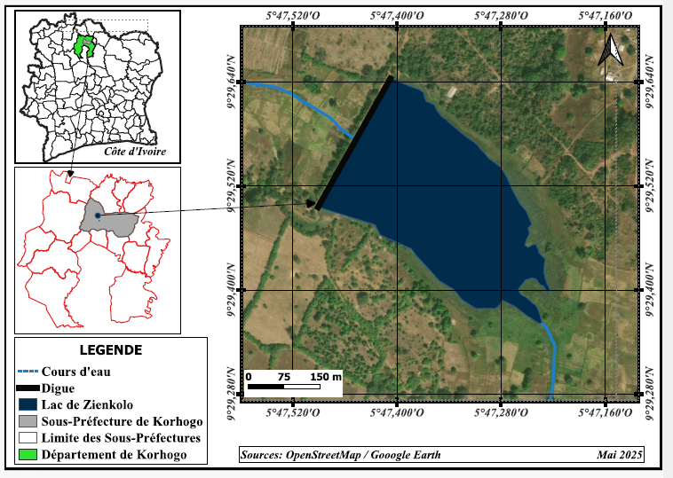
Figure 1 : Overview of the study area

2.3 Sampling and measurement of reproductive parameters
Monthly sampling was conducted from December 2024 to November 2025. The various specimens obtained through artisanal fishing were caught using gillnets and cast nets. A total of 351 specimens were examined and identified using the identification key by Paugy et al. (1992). For each specimen, the following were recorded: standard length and total length to the nearest millimeter; total weight and gutted weight to the nearest gram, gonad and liver weights to the nearest decigram, and sex and macroscopic sexual maturity stage (based on Fontana (1969)). Reproductive parameters specifically sex ratio (SR), size at first sexual maturity (L50), gonadosomatic index (GSI), hepatosomatic index (HSI), and condition factor (K) were then determined. The chi-square (χ²) test was used to compare the sex ratios for the different months and seasons with the theoretical sex ratio (1:1).
Sizes at first maturity were compared by sex using Statistica version 7.1 software.
- Sex ratio (SR)
The sex ratio makes it possible to assess the demographic structure and reproductive biomass of a given stock. It defines the relative proportion of the sexes (male and female) within a population. The sex ratio provides information on the balance of sexes within a population (Kartas and Quignard 1984). It is expressed as follows:
$SR=\frac{M}{F}$
SR: sex ratio; M: number of males; F: number of females;
- Size at first sexual maturity (L50)
The size at first sexual maturity makes it possible to estimate the fraction of the stock that is harvested before having reproduced at least once and which, therefore, will not contribute to stock renewal (Domain et al., 2000). It is also defined as the size at which 50% of the individuals in a population are sexually mature during the breeding season.
The L50 was determined by grouping the sampled individuals by sex and size class.
Next, the proportion of mature individuals in each size class was determined.
All individuals with gonads at stage III or higher were considered mature.
Size-proportion pairs for mature individuals were fitted to a sigmoid-type logistic curve (Amenzoui, 2010), the mathematical expression of which is as follows:
P = 1 / (1+e^{-(a+b*Lt)}) ;
L₅₀ = - $\frac{a}{b}$;
P = Proportion of mature individuals by size class
Lt = Total length
a and b = constants.
- Gonadosomatic index (GSI)
The gonadosomatic index (GSI) is the primary weight-based criterion for characterizing the developmental stages of sexual maturation in fish. A relatively high GSI value reflects an advanced stage of gonadal maturation, whereas relatively low values ​​indicate a state of sexual quiescence or immaturity (Boussou, 2013). Thus, the gonadosomatic index makes it possible to determine spawning periods during a species' sexual cycle (Analbery, 2004). Its mathematical formula is as follows:
$GSI=\frac{Pg}{Pev}x100$ ;
Pg: gonad weight in g;
Pev: eviscerated fish weight in g.
- Hepatosomatic index (HSI)
In fish, oogenesis and spermatogenesis require a significant amount of energy, which they store in the liver primarily in the form of lipids. Variations in liver weight are influenced by the reproductive status of the fish (Konan, 2013). It is calculated as follows:
$RHS=\frac{Pf}{Pev}x100$;
Pf: liver weight in g;
Pev: gutted fish weight in g.
- Condition factor (K)
The condition factor (K) reflects the fish's body condition in relation to the influence of ecological and physiological factors. It provides information on the storage of reserves required for gametogenesis (Fehri-Bedoui et al., 2002).
$$k=\frac{P}{{Lt}^{3}}x 100$$
P: weight of the fish in g
Lt: total length of the fish in cm.
3. Results and Discussion
3.1 Sex ratio
222 males and 129 females were identified out of a total of 351 specimens examined. In terms of numbers, males are more numerous than females. The sex ratio (males : females) of this population is 1:0.74, i.e., 0.74 females per male (Table 1). This sex ratio is significantly different from the theoretical 1:1 sex ratio (χ² = 24.64; p < 0.05). When accounting for monthly variation, the sex ratio is male-biased throughout the year, except in March (χ² = 3.66; p > 0.05). Seasonal variation in the sex ratio indicates a predominance of males across all seasons. It shows a significant difference between the number of females and the number of males in both the dry season (χ² = 8.53; p < 0.05) and the rainy season (χ² = 17.55; p < 0.05).
Table 1: Monthly and seasonal variations of sex proportion and sex ratio of O. niloticus caught in Lake Zienkolo, Côte d’Ivoire.
* : significant difference.
Month | Number of Females | Number of males | Total | Sex-ratio M:F | X²
December 2024 | 14 | 23 | 37 | 1 : 0.6 | 2.19
January 2025 | 9 | 14 | 23 | 1 :0.64 | 1.08
February 2025 | 25 | 23 | 48 | 1 :1.08 | 0.08
March 2025 | 22 | 11 | 33 | 1 : 2 | 3.66
April 2025 | 6 | 31 | 37 | 1 : 0.19 | 16.89*
May 2025 | 13 | 36 | 49 | 1 :0.36 | 10.79*
June 2025 | 22 | 47 | 69 | 1 :0.46 | 9.05*
July 2025 | 2 | 11 | 13 | 1 :0.18 | 6.23*
August 2025 | 4 | 14 | 18 | 1 :0.28 | 5.55
September 2025 | 2 | 3 | 5 | 1 :0.66 | 0.2
October 2025 | 10 | 9 | 19 | 1 :1.11 | 0.05
November 2025 | 3 | 5 | 8 | 1 :0.6 | 0.5
TOTAL | 129 | 222 | 351 | 1 :0.74 | 24.64*
Dry season | 78 | 119 | 197 | 1 :0.5 | 8.53*
Rainy season | 51 | 103 | 154 | 1 :0.5 | 17.55*
The sex ratio of the entire Oreochromis niloticus population is 1:0.74. This result indicates a predominance of males over females. Seasonal variation reveals a predominance of males in both the dry and rainy seasons. This result could be explained by the fact that several factors such as differential growth, movement associated with foraging, and sex-specific mortality rates influence the sex ratio in fish (Sylla, 2009). The male-biased sex ratio in Cichlid populations of the African Great Lakes could also be explained by their faster growth rate compared to females (Atse and al., 2009). The male-biased sex ratio could also be explained by the fact that, as O. niloticus is a mouth-brooding species, the lack of food during the breeding season may force the breeding adults to remain largely sedentary in areas where capture is difficult. Some authors, such as Djadji and al. (2013) and Poulet (2004), also note that a predominance of one sex is a phenomenon frequently encountered in many teleost fish species. The result obtained in the present study is consistent with that obtained by Akonkwa and al. (2016) in Lake Kivu, Congo. These authors found a sex ratio (1.67:1) biased towards males in the same species. Kidari (2023) also observed a male predominance in O. niloticus, with 61.36% of the population being male, in the Tlemcen region of Algeria.
3.2 Size at first sexual maturity and Monthly variation in sexual maturity stages
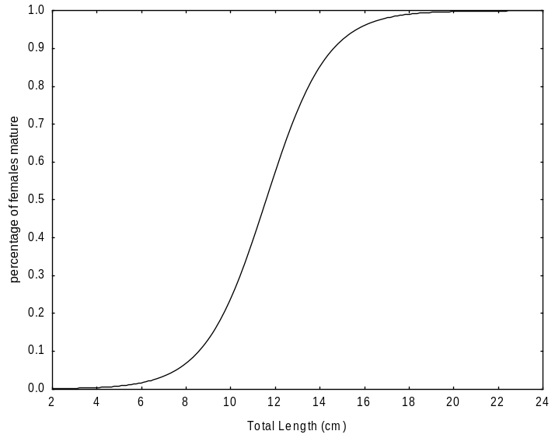The size at first sexual maturity observed in O. niloticus is 11.81 cm for females (Figure 2) and 14 cm for males (Figure 3). Females reach sexual maturity at a smaller size than males. This size difference is not statistically significant (χ² = 0.16; p > 0.05). The smallest mature individuals recorded measured 11 cm for females and 13.5 cm for males.

LT=11.81cm

Figure 2: Progression of sexual maturity in relation to length (Lt) in female O. niloticus from the Zienkôlô dam lake.
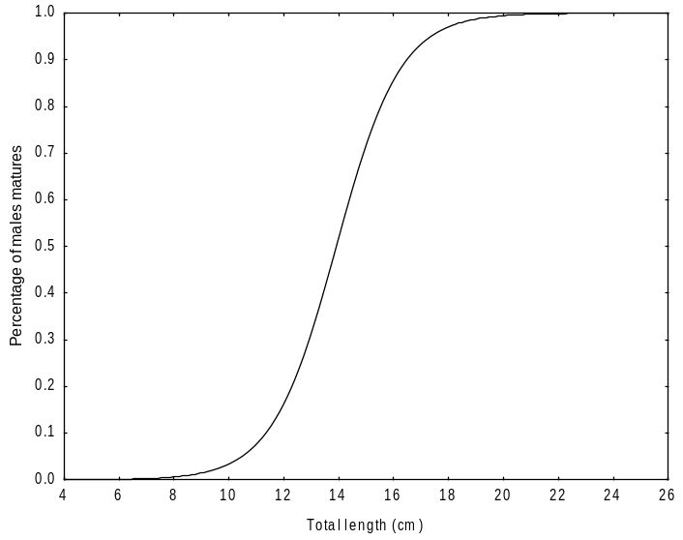

LT=14 cm

Figure 3: Progression of sexual maturity in relation to length (Lt) in male O. niloticus from the Zienkôlô reservoir.

Six stages of sexual maturity were observed in females in varying proportions throughout the year (Figure 4). Stage I females are present in the samples during December, January, February, and November. Stage 2 females are present in the samples in December, January, February, June, October, and November. Stage 3 is absent from the samples in May, July, August, November, and December. Stage 4 individuals are also absent from the catches during July, September, November, and December. Stage 5 females appear in the catches only from February to June and in August, whereas stage 6 individuals were encountered from February to August.

Figure 4: Changes in sexual maturity stages of female O. niloticus from the Zienkôlô dam Lake.
The size at first sexual maturity (L50) of Oreochromis niloticus in the Zienkôlô reservoir lake is 14 cm (total length) for males and 11.81 cm (total length) for females. This result indicates that females reach sexual maturity before males. Differences in size at maturity among individuals may depend on several factors, such as anthropogenic activities (overfishing), biological and/or ecological environmental factors, and energy allocation for gamete production (Koné and al., 2011). Results similar to ours were obtained by Mohamed and al. (2010) in the geothermal waters of southern Tunisia. The determined size at first sexual maturity (Lm50) was 11.3 cm for females and 12.5 cm for males. These authors observed that female O. niloticus reached sexual maturity at a smaller size than males. Unlike us, Akonkwa and al. (2016) found that male O. niloticus reached the size at first maturity before females in Lake Kivu, Congo. The size at first sexual maturity was 13.7 cm for males and 15.8 cm for females. Atse et al. (2009) reported that males of the Cichlidae Tylochromis jentinki reached sexual maturity earlier than females in the Ébrié Lagoon (Côte d’Ivoire). Les tailles de première maturité sexuelle étaient estimées à 11,8 cm et 12,6 cm respectivement chez les mâles et les femelles. The variability in size at first sexual maturity from one biogeographic zone to another could depend on food availability as well as the physicochemical conditions of the environment. This difference in size can also be explained by the ability of the breeding individuals to adapt to environmental factors, namely temperature, salinity, and food resources (Poulet 2004).
3.3 Gonadosomatic index (GSI) and reproductive period
The variation curve of the gonadosomatic index (GSI) follows a saw-tooth pattern and exhibits two peaks (Figure 4). The highest RGS values ​​are observed in May (3.88 ± 1.48) and October (3.36 ± 8.18).
These monthly variations reveal that Oreochromis niloticus in the Zienkôlô dam lake generally reproduces during the months of May and October, with greater intensity during the main rainy season specifically, in May. The minimum GSI values ​​were observed in December (0.14 ± 0.08) and November (0.25 ± 0.22).

Figure 5: Monthly variations in the gonadosomatic index (GSI) of female O. niloticus from the Zienkôlô dam lake.
Monthly analysis of the Gonadosomatic Index (GSI) and sexual maturity stages made it possible to examine the reproductive patterns of Oreochromis niloticus throughout the year. O. niloticus in the Zienkôlô dam lake exhibits year-round reproduction. The highest mean GSI values ​​were observed in May and October, with respective values ​​of (3.88 ± 1.48) and (3.36 ± 8.18). Results similar to ours were observed by Atse et al. (2009) in the Cichlidae Tylochromis jentinki in Ébrié Lagoon (Côte d’Ivoire). These authors observed that the spawning period of T. jentinki extends throughout the year, with a more pronounced peak from October to November the period during which the highest proportions of females at stages 4 and 5 were recorded. Un second pic de faible amplitude survient en avril.
3.4 Hepatosomatic Index (HSI) and Condition factor (k)
The monthly evolution of the HSI is similar to that of the RGI. The HSI curve follows a sawtooth pattern and moves in the same direction as the GSI curve (Figure 6). The HSI reaches its maximum value in May and October, with respective values ​​of 1.6 ± 0.66 and 1.8 ± 0.59. The minimum HSI value was recorded in June (0.7 ± 0.17).

Figure 6: Monthly variations in the gonadosomatic index (GSI) of female O. niloticus from the Zienkôlô dam lake.

Figure 7 illustrates the variation in the condition factor of female O. niloticus. The maximum value of the condition factor (k) was observed in December (2.07 ± 0.17), while the lowest values ​​were recorded in June (1.78 ± 0.18), July (1.52 ± 0.02), and October (1.7 ± 0.25).

Figure 7: Condition factor (K) of female O. niloticus from the Zienkôlô reservoir.
Comparison of the monthly variation curves for the GSI and HSI showed that these two indices move in sync. The peak of the GSI coincides with that of the HSI. The increase in liver weight is linked to the rise in reproductive activity. This result shows that O. niloticus is a fatty fish. It stores energy reserves in the muscles, in the perivisceral mesenteries, and under the skin. These reserves are then transferred to the liver and gonads to meet energy requirements during the reproductive period, which accounts for the low condition factor value observed during this time (Djadji et al. 2013).
4. Conclusion
The study indicates that Oreochromis niloticus in the Zienkôlô dam lake maintains reproductive activity throughout the year, with comparatively greater activity observed in May and October. Females attained the estimated size at first sexual maturity at 11.81 cm total length, whereas males attained maturity at 14 cm. Males were more abundant than females in the overall sample. Monthly variations in gonadosomatic index, hepatosomatic index, maturity stages and condition factor demonstrate temporal changes associated with reproduction. These results provide baseline information on the reproductive biology of O. niloticus in this reservoir and may support future investigations of population dynamics and fishery management. Management recommendations concerning capture size or fishing-gear selectivity should, however, be based on additional gear-selectivity and population-level evidence.
Declaration of AI Use

This manuscript was prepared through the intellectual contributions of the author(s) to the study design, data analysis, interpretation of results, and scholarly content. Grammarly and ChatGPT were used solely to assist with grammatical refinement and reference formatting during manuscript revision. The author(s) accept full responsibility for the accuracy, integrity, and final content of the manuscript.

Competing Interests
Authors have declared that no competing interests exist.
References
Aka-Koffi, N. M. (2003). Zooplancton des petits lacs de barrage du nord et du centre de la Côte d’Ivoire : communautés, biomasses, relations trophiques et impact de la prédation par les larves de chaoborus et des poissons. (Thèse de Doctorat, Université d’Abobo-Adjamé, Côte d'Ivoire) 296p.( Zooplankton of small reservoir lakes in northern and central Côte d’Ivoire: communities, biomass, trophic relationships, and the impact of predation by Chaoborus larvae and fish. (Doctoral thesis, University of Abobo-Adjamé, Côte d'Ivoire))
Akonkwa, B., Simon, A. M., Nshombo M. & Philippe, L. (2016). Quelques aspects de la reproduction des poissons du lac Kivu. Afrique Science 12(4) 240 - 255. http://www.afriquescience.info(Some aspects of fish reproduction in Lake Kivu. Afrique Science 12(4) 240–255. http://www.afriquescience.info)
Amenzoui, K. (2010). Variabilité des caractéristiques biologiques de la sardine, Sardina pilchardus (Walbaum, 1792) exploitée au niveau des zones de Safi, Agadir et Laâyoune (côtes atlantiques marocaines). (Thèse de Doctorat, Université Mohammed V– Agdal, Rabat). (Variability of the biological characteristics of the sardine, Sardina pilchardus(Walbaum, 1792), exploited in the Safi, Agadir, and Laâyoune zones (Moroccan Atlantic coast). (Doctoral thesis, Mohammed V University – Agdal, Rabat).)329p.
Atsé, B.C., Konan, K.J. & Kouassi, N.J. (2009). Biologie de la reproduction du Cichlidae Tylochromis jentinki dans la lagune Ebrié (Côte d’Ivoire). Cybium (Reproductive biology of the cichlid Tylochromis jentinki in Ebrié Lagoon (Côte d’Ivoire). Cybium)33(1), 11-19.
Cecchi, P., Gourdin, F., Koné, S., Corbin, D., Jackie, E. & Casenave, A. (2007). L’eau en partage ; les petits barrages de Côte d’Ivoire. Collection Latitudes 23, Editions de l’IRD, Paris, 295p. Éditions. https://doi.org/10.4000/books.irdeditions.5558
Dhraïef, M. N., Azaza, M.S. & Kraïem, M.M. (2010). Étude de la reproduction du tilapia du nil oreochromis niloticus en captivité dans les eaux géothermales du sud tunisien. Institut National des Sciences et Technologies de la Mer (INSTM). Bulletin de l’Institut National des Sciences et Technologies de la Mer. (Study of the reproduction of the Nile tilapia (Oreochromis niloticus) in captivity in the geothermal waters of southern Tunisia. National Institute of Marine Sciences and Technologies (INSTM). Bulletin of the National Institute of Marine Sciences and Technologies.)37, 89-96.
Djadji, G. L., Atse, B. C., Sylla, S., Konan, K. J. & Kouassi, N. J. (2013). Reproduction du Mugilidae Mugil cephalus Linné, 1758 dans deux complexes lagunaires (lagunes Ébrié et de Grand-Lahou) de la Côte d’Ivoire. International Journal of Biologie and Chemical Sciences (Reproduction of the mugilid Mugil cephalus Linnaeus, 1758 in two lagoon complexes (Ébrié and Grand-Lahou lagoons) in Côte d’Ivoire. International Journal of Biological and Chemical Sciences.)7(4), 1701-1716.
Domain, F., Chavance, P. & Bah, A. (2000). Notes sur la reproduction des espèces démersales du peuplement côtier guinéen. In La Pêche Côtière en Guinée - Ressources et Exploitation. (Domain F., Chavance P., Diallo A. eds.).( , P. & Bah, A. (2000). Notes on the reproduction of demersal species in the Guinean coastal fish assemblage. In Coastal Fisheries in Guinea – Resources and Exploitation. (Domain F., Chavance P., Diallo A. eds.).) CNSHB,393 p.
Ferri- Bedoui, R., Gharbi, H. & El Abed, A. 2002. Période de reproduction et maturité sexuelle de Liza aurata (poisson Mugilidae) des côtes Est et Sud tunisiennes. Bulletin de l’Institut National des sciences et Technologies de la mer, (Reproductive period and sexual maturity of Liza aurata (Mugilidae) off the east and south coasts of Tunisia. Bulletin of the National Institute of Marine Sciences and Technologies.)29, 11-15.
Fontana, A. (1969). Etude de la maturité sexuelle des sardinelles Sardinella eba et Sardinella aurita de la région de Pointe-Noire. ORSTOM, Série Océanographique,( Study of the sexual maturity of the sardinellas Sardinella eba and Sardinella aurita in the Pointe-Noire region. ORSTOM, Oceanography Series.) 7 (2), 101-114
Kartas, F. & Quignard, J. P. (1984). La fécondité des poissons téléostéens. Collection de Biologie des Milieux Marins. Masson Edition, Paris. (Fecundity of Teleost Fish. Marine Environment Biology Collection. Masson, Paris.)121p.
Kidari, R. (2023). Relation taille-poids chez le Tilapia d’élevage Oreochromis niloticus (Linnaeus, 1758) dans la région de Tlemcen. (Mémoire de MASTER, Université ABOUBEKR BELKAID – TLEMCEN, Faculté des Sciences de la Nature et de la Vie et Sciences de la Terre et de l’Université, Département Ecologie et Environnement, Algérie). 56 P.( Length-weight relationship of farmed tilapia Oreochromis niloticus (Linnaeus, 1758) in the Tlemcen region. (Master's thesis, Aboubekr Belkaid University – Tlemcen, Faculty of Natural and Life Sciences and Earth Sciences, Department of Ecology and Environment, Algeria))
Konan, K. S. (2013). Biologie et pêche des poissons capitaines. Polydactylus quadrafilis, Galeoides decadactilus et Pentanemus quinqarius de la pêcherie artisanale maritime de Grand-Lahou, Côte d’Ivoire. (Thèse de doctorat de l’Université Nangui Abrogoua, Côte d’Ivoire).( Biology and fishery of threadfins (Polydactylus quadrifilis, Galeoides decadactylus, and Pentanemus quinquarius) in the artisanal marine fishery of Grand-Lahou, Côte d’Ivoire. (Doctoral thesis, Nangui Abrogoua University, Côte d’Ivoire).) 184p.
Koné, N., Berte, S., Kraidy, A. L. B., Kouamelan, E. P. & Koné, T. 2011. Biologie de la reproduction du Clupeidae Pellonula leonensis (Boulenger, 1916) dans le lac de barrage de Kossou (Côte d’Ivoire). Journal of Applied Biosciences 41(Reproductive biology of the clupeid Pellonula leonensis (Boulenger, 1916) in the Kossou reservoir (Côte d’Ivoire). Journal of Applied Biosciences), 2797 – 2807.
Le Guen, T. (2002). Les barrages du Nord de la Côte-d’Ivoire : développement socio-économique et état sanitaire des populations. (Doctorat nouveau régime en Géographie, Université de Bretagne Occidentale). (Dams in Northern Côte d’Ivoire: Socio-economic development and the health status of the population. (Doctorate [New System] in Geography, University of Western Brittany).)467 p.
Paugy, D., Levêque, C. & Teugels, G.G. (2004). Poissons d’eaux douces et saumâtres de l’Afrique de l’ouest. IRD édition. Collection Faune et flore tropicale,( Teugels, G.G. (2004). Freshwater and Brackish-water Fishes of West Africa. IRD Éditions. Tropical Fauna and Flora Series.) 1270p.
Poulet, N. 2004. Le sandre (Sander lucioperca L.) : Biologie, comportement et dynamique des populations en Camargue (Bouches de Rhône, France). (Thèse de Doctorat de l’Université de Toulouse III). (: Biology, behavior, and population dynamics in the Camargue (Bouches-du-Rhône, France). (Doctoral thesis, University of Toulouse III).)286 p.
Sylla, S., Atsé, B.C., & Kouassi, N.J. (2009). Régime alimentaire de Trachinotus teraia (carangidae) dans la lagune Ebrié (Côte d’Ivoire), Cybium, (Diet of Trachinotus teraia (Carangidae) in Ebrié Lagoon (Côte d’Ivoire), Cybium,)32 (1) : 81-87.

