Original Research Article
Standardization of an In vitro Callus Induction Protocol Using Nodal Explants of Maize (Zea mays L.): An Elite Inbred Line

ABSTRACT
This study evaluated an in vitro callus induction protocol for maize (Zea mays L.) genotype CML1514 using split nodal explants. Healthy nodal segments were excised from 7 to 10 day-old in vitro raised seedlings and cultured on Murashige and Skoog (MS) medium supplemented with different concentrations and combinations of plant growth regulators. Seeds were surface sterilised with Tween-20 followed by 0.1% mercuric chloride and germinated in vitro prior to node excision; the excised nodes were further surface sterilised with 70% ethanol before culturing. For callus induction, nodal explants were cultured on MS medium containing ten combinations of 2, 4-dichlorophenoxyacetic acid (2, 4-D; 1.0-5.0 mg/l) with either 6-benzylaminopurine (BAP; 1.0-2.0 mg/l) or kinetin (1.0-2.0 mg/l). Among the tested treatments, MS medium supplemented with 5.0 mg/l 2, 4-D and 2.0 mg/l BAP showed the strongest callusing response, with callus initiation observed within 5.7 days and a callus formation frequency of 93.3%. BAP consistently promoted faster callus initiation than kinetin across all 2, 4-D concentrations tested. Of the ten media combinations, six produced compact, embryogenic callus, while the remaining four produced soft, non-embryogenic callus. The study indicates that nodal explants can be used for rapid, high-frequency callus induction in CML1514, providing a reliable foundation for subsequent somatic embryogenesis and plant regeneration. All experiments were conducted in triplicate and the data were subjected to appropriate statistical analysis.
Keywords: Plant tissue culture; nodal explants; 2, 4-D; BAP; kinetin; callus induction; Zea mays.

1. INTRODUCTION
Maize (Zea mays L.), commonly known as corn, is a prominent, high-yielding cereal crop belonging to the family Poaceae (Sleper and Poehlman, 2006). It is one of the most valued cereals in global agriculture and has been recognised as a food, feed and industrial crop for over several thousand years. This C₄ crop is widely used to meet food, fodder and industrial raw-material needs and possesses high photosynthetic efficiency along with considerable yield potential (Dahmardeh et al., 2009). Beyond its agronomic importance, maize exhibits wide ecological adaptability and a relatively short growth duration, making it one of the most important cereal crops worldwide (Doebley, 2004). Naturally distributed across tropical, subtropical and temperate agro-climatic regions, the global demand for maize is substantial, with world production estimated at about 1129.2 million tonnes (FAOSTAT, 2024). This demand is primarily met through conventional cultivation of elite inbred lines and hybrids.

Such demand is pushing breeding programmes towards biotechnological approaches for faster genetic improvement (McFarland and Kaeppler, 2025). The crop exhibits considerable genotypic variability in tissue culture responsiveness but generally shows a low and inconsistent regeneration frequency depending on explant type and culture conditions (Tomes and Smith, 1985). Furthermore, immature-embryo-based systems can show substantial seasonal and genotype-related fluctuations in embryogenic response (Manivannan et al., 2010). Plant tissue culture provides a valuable biotechnological strategy to overcome these bottlenecks, offering alternative pathways for rapid, genotype-independent regeneration and germplasm conservation (Pathi et al., 2013). In vitro callus induction can enable rapid, large-scale production of embryogenic tissue while supporting downstream genetic transformation (Kumar et al., 2022; Gudlavalleti et al., 2018; Tiwari et al., 2015). Successful in vitro morphogenesis relies heavily on the coordinated application of exogenous plant growth regulators, specifically auxins and cytokinins, within a nutrient-rich basal medium based on Murashige and Skoog (MS) salts and supplemented with sucrose as a carbon source. Given the importance of a rapid and genotype-independent explant source, the objective of this study was to optimise and standardise a rapid, highly reproducible in vitro callus induction protocol for maize using nodal explants.
Recent literature indicates that callus induction responses depend on explant type, culture conditions and plant growth regulator regimes (Fatima et al., 2025; Anyieni et al., 2024; Kumar et al., 2022; Sairam et al., 2014). Recent studies have demonstrated that in vitro culture using nodal explants is an effective approach for the propagation and conservation of maize germplasm, reducing dependence on seasonally limited immature embryos (Pathi et al., 2013; Mushke et al., 2016). However, the regeneration response depends on factors such as explant type, culture medium and plant growth regulator composition (Gudlavalleti et al., 2018). The findings of the present study further support the importance of optimising culture conditions for efficient callus induction. However, joint optimisation of surface sterilisation and 2, 4-D, BAP and kinetin regimes for a reproducible nodal-explant protocol remains insufficiently addressed for elite Indian inbred lines such as CML1514. The present study aimed to optimise a rapid and reproducible in vitro callus induction protocol for maize using nodal explants and to evaluate the effects of different concentrations and combinations of plant growth regulators on days for callus formation, percentage of callus formation and nature of the callus produced.

2. MATERIALS AND METHODS
Place and Duration of Study: The present study was conducted in the Plant Tissue Culture Laboratory, Department of Genetics and Plant Breeding, College of Agriculture, Raichur, University of Agricultural Sciences, Raichur, Karnataka, India, from 2025 to 2026.
2.1 Plant Material and Source of Explants
Healthy seeds of the elite maize inbred line CML1514, characterised by good combining ability, drought tolerance and nitrogen use efficiency were obtained from the College of Agriculture, Raichur. Seeds were washed thoroughly under running tap water to remove surface debris. Sterilised seeds were cultured aseptically on half-strength MS medium for in vitro germination and active nodal segments were harvested from 7 to 10 day-old in vitro raised seedlings, each segment split longitudinally into two uniform halves for use as explants (fig. 1).
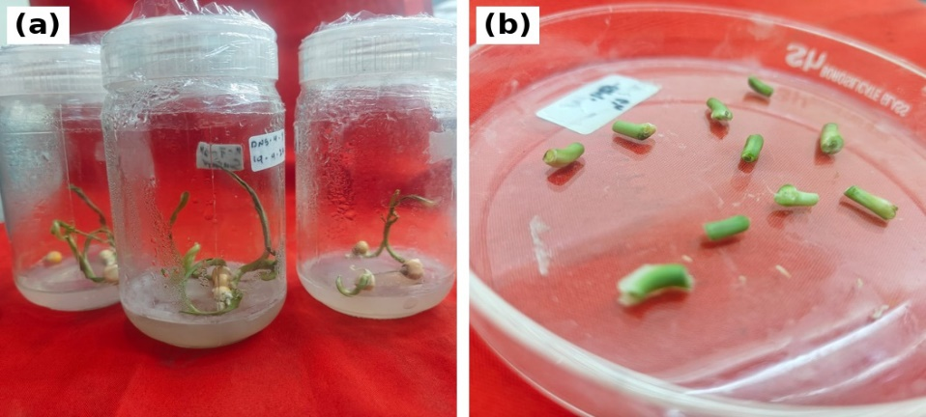
Fig. 1. Source of nodal explants of maize genotype CML1514: (a) 7 to 10 day-old in vitro raised seedlings; (b) nodal segments excised and split longitudinally for use as explants.
2.2 Surface Sterilisation
The sterilisation workflow was performed inside a clean, certified laminar airflow hood to preserve explant health while reducing fungal and bacterial contamination. Seeds were initially washed under running tap water to remove surface debris. Seeds were first treated with Tween-20 under gentle agitation for three successive washes, followed by treatment with a 0.1% (w/v) aqueous solution of mercuric chloride (HgCl₂) for three successive washes to remove surface-bound microorganisms. The chemical sterilant was then safely decanted and the seeds were subjected to 6-7 sequential rinse cycles with sterile distilled water to remove residual chemical sterilant prior to culture inoculation. Nodes excised from the resulting in vitro seedlings were further surface sterilised with 70% (v/v) ethyl alcohol and rinsed with sterile distilled water before being split and cultured.
2.3 Culture Medium and Culture Conditions
Nodal explants of maize were cultured on Murashige and Skoog (MS) basal medium supplemented with appropriate concentrations of plant growth regulators (PGRs) for callus induction. The culture medium contained 30 g/l sucrose as the carbon source. The medium was solidified with 8.0 g/l agar. The pH of the medium was adjusted to 5.8 prior to the addition of agar and sterilisation. The prepared medium was sterilised by autoclaving at 121 ºC under 15 psi pressure for 15-20 minutes. After inoculation, cultures were maintained in a growth room at 25 ± 2 ºC under a 16 h light/8 h dark photoperiod.
2.4 Preparation of Plant Growth Regulator Stock Solutions
Stock solutions of the various PGRs were prepared at a concentration of 1.0 mg/ml. The stock solution of 2, 4-D was prepared by dissolving the required quantity in a few drops of 1N NaOH and making up the final volume with distilled water. Similarly, the stock solutions of BAP and kinetin were also prepared. These stock solutions were stored in a refrigerator at 4 ºC and used whenever required for the preparation of treatment media.
2.5 Inoculation and Callus Induction
Under aseptic conditions, the damaged edges of the sterilised, split nodal explants were trimmed and horizontally inoculated into basal MS medium containing ten different combinations of 2,4-D (1.0, 2.0, 3.0, 4.0 and 5.0 mg/l) with either BAP (1.0-2.0 mg/l) or kinetin (1.0-2.0 mg/l) for callus induction (table 1). Four explant pieces were cultured per replicate on each medium combination (fig. 2). The percentage of responding cultures, the number of days for callus formation and the nature of the callus formed were recorded systematically after 30 days of culture.

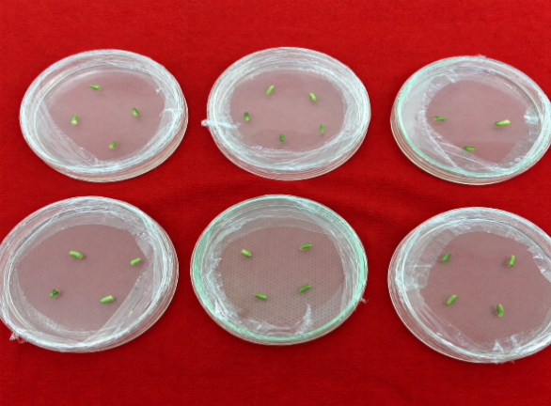
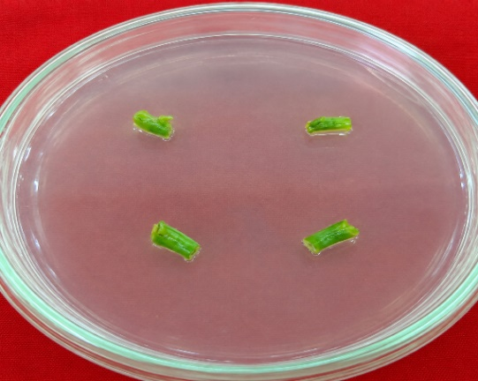

Fig. 2. Nodal explants immediately after inoculation on MS medium supplemented with 2, 4-D and BAP/kinetin for callus induction.
2.6 Data Collection and Observations Recorded
The cultures were observed periodically to record the number of days for callus initiation, the percentage of callus formation and the nature of the callus formed. The number of days for callus formation was recorded as the interval between culturing and the first visible sign of callusing. The percentage of callus formation was calculated as the number of explants forming callus divided by the total number of explants cultured, multiplied by 100. Callus that was compact, granular and nodular in texture was classified as embryogenic (EC) and callus that was soft, translucent and friable was classified as non-embryogenic (NEC).
2.7 Experimental Design
The study was carried out under controlled laboratory conditions following a completely randomised design (CRD). Each treatment consisted of three independent replicates and observations were recorded systematically from every replicate during the experimental period.
2.8 Statistical Analysis
The data obtained from all experimental treatments were subjected to one-way analysis of variance (ANOVA) using OPSTAT software and treatment means were compared using Duncan's Multiple Range Test (DMRT). Means followed by the same superscript letter are not significantly different.

3. RESULTS AND DISCUSSION
3.1 Effect of Media on Days for Callus Initiation
Axillary callusing was observed within 5.7-11.0 days of inoculation and the appearance of representative cultures at the callusing stage is shown in Fig. 3. Among the ten media combinations evaluated, MS medium supplemented with 5.0 mg/l 2, 4-D and 2.0 mg/l BAP consistently produced the fastest callus initiation response across the three independent replicates, with callus becoming visible within 5.7 days. Auxins such as 2, 4-D promote cell dedifferentiation and callus proliferation from the cut ends of the nodal explant. Lower 2, 4-D concentrations (1.0-2.0 mg/l) resulted in a slower initiation response, whereas kinetin-supplemented media generally required a longer duration for callus initiation than BAP-supplemented media at the corresponding 2, 4-D concentration, as shown in Table 2.

Table 1. Media Combinations Evaluated for Callus Induction from Nodal Explants
Sl. No. | Media Code | Media combination
1 | M₁ | MS + 2,4-D (1.0 mg/l) + BAP (1.0 mg/l)
2 | M₂ | MS + 2,4-D (2.0 mg/l) + BAP (1.0 mg/l)
3 | M₃ | MS + 2,4-D (3.0 mg/l) + BAP (1.5 mg/l)
4 | M₄ | MS + 2,4-D (4.0 mg/l) + BAP (2.0 mg/l)
5 | M₅ | MS + 2,4-D (5.0 mg/l) + BAP (2.0 mg/l)
6 | M₆ | MS + 2,4-D (1.0 mg/l) + kinetin (1.0 mg/l)
7 | M₇ | MS + 2,4-D (2.0 mg/l) + kinetin (1.0 mg/l)
8 | M₈ | MS + 2,4-D (3.0 mg/l) + kinetin (1.5 mg/l)
9 | M₉ | MS + 2,4-D (4.0 mg/l) + kinetin (2.0 mg/l)
10 | M₁₀ | MS + 2,4-D (5.0 mg/l) + kinetin (2.0 mg/l)
MS: Murashige and Skoog medium containing 3% sucrose and 0.8% agar.
Table 2. Effect of different media combinations on days for callus formation
Sl. No. | Media code | Media combination | Mean
1 | M₁ | MS + 2,4-D (1.0 mg/l) + BAP (1.0 mg/l) | 8.3^{cd}
2 | M₂ | MS + 2,4-D (2.0 mg/l) + BAP (1.0 mg/l) | 7.7de
3 | M₃ | MS + 2,4-D (3.0 mg/l) + BAP (1.5 mg/l) | 7.0^{def}
4 | M₄ | MS + 2,4-D (4.0 mg/l) + BAP (2.0 mg/l) | 6.7^{ef}
5 | M₅ | MS + 2,4-D (5.0 mg/l) + BAP (2.0 mg/l) | 5.7^{f}
6 | M₆ | MS + 2,4-D (1.0 mg/l) + kinetin (1.0 mg/l) | 11.0ª
7 | M₇ | MS + 2,4-D (2.0 mg/l) + kinetin (1.0 mg/l) | 9.7^{abc}
8 | M₈ | MS + 2,4-D (3.0 mg/l) + kinetin (1.5 mg/l) | 10.0^{ab}
9 | M₉ | MS + 2,4-D (4.0 mg/l) + kinetin (2.0 mg/l) | 9.3^{bc}
10 | M₁₀ | MS + 2,4-D (5.0 mg/l) + kinetin (2.0 mg/l) | 7.3de
 |  | CD at 1% | 1.84
 |  | SE(m) + | 0.45
Note: Treatments with same alphabets are not significantly different

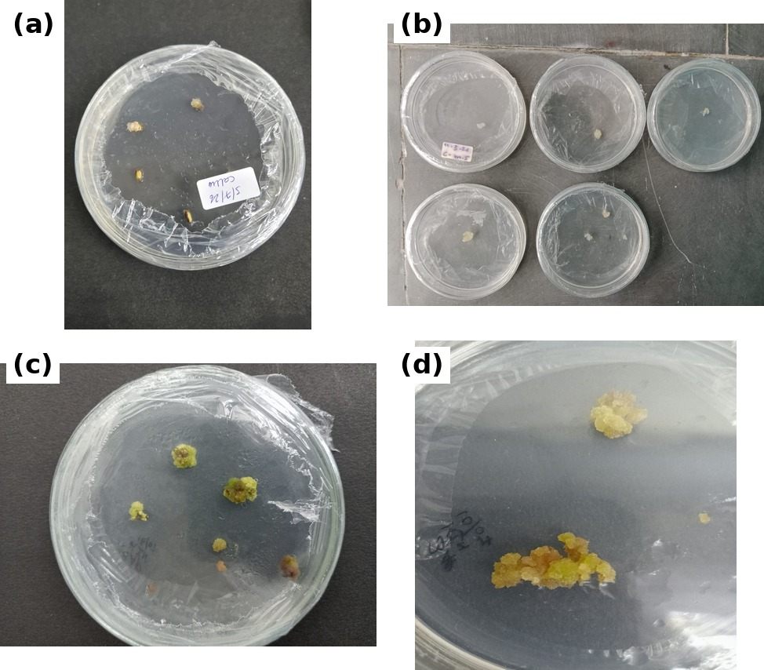

Fig. 3. Callus formation from nodal explants on different callus induction media: (a)-(d) compact, granular callus arising from the cut ends of explants.
3.2 Percentage of Callus Formation
Although lower concentrations of 2, 4-D induced callus, transferring the explant to media with higher auxin concentrations stimulated callus proliferation. The highest callus formation rate (93.3%) occurred on MS medium supplemented with 5.0 mg/l 2, 4-D and 2.0 mg/l BAP, on par with MS medium supplemented with 4.0 mg/l 2, 4-D and 2.0 mg/l kinetin (90.0%). The enhanced callus formation observed with increasing 2, 4-D concentration is consistent with the known role of auxin in regulating cell dedifferentiation and proliferation. Similar responses have been reported in maize, although the optimum concentration of plant growth regulators varies with the explant type and culture conditions (Manivannan et al., 2010; Kumar et al., 2022; Anyieni et al., 2024). In the present study, 5.0 mg/l 2, 4-D combined with 2.0 mg/l BAP produced the best callus formation response among the treatments evaluated, as shown in Table 3.
Table 3. Effect of different media on percentage of callus formation from nodal explant
Sl. No. | Media code | Media combination | Mean
1 | M₁ | MS + 2,4-D (1.0 mg/l) + BAP (1.0 mg/l) | 50.0de
2 | M₂ | MS + 2,4-D (2.0 mg/l) + BAP (1.0 mg/l) | 80.0^{ab}
3 | M₃ | MS + 2,4-D (3.0 mg/l) + BAP (1.5 mg/l) | 70.0^{bc}
4 | M₄ | MS + 2,4-D (4.0 mg/l) + BAP (2.0 mg/l) | 83.3^{ab}
5 | M₅ | MS + 2,4-D (5.0 mg/l) + BAP (2.0 mg/l) | 93.3ª
6 | M₆ | MS + 2,4-D (1.0 mg/l) + kinetin (1.0 mg/l) | 53.3de
7 | M₇ | MS + 2,4-D (2.0 mg/l) + kinetin (1.0 mg/l) | 36.7e
8 | M₈ | MS + 2,4-D (3.0 mg/l) + kinetin (1.5 mg/l) | 80.0^{ab}
9 | M₉ | MS + 2,4-D (4.0 mg/l) + kinetin (2.0 mg/l) | 90.0ª
10 | M₁₀ | MS + 2,4-D (5.0 mg/l) + kinetin (2.0 mg/l) | 60.0^{cd}
 |  | C.D. at 1 % | 21.20
 |  | SE(m) + | 5.27
Note: Treatments with same alphabets are not significantly different
3.3 Nature of Callus Formed
Callus initiation from the nodal explant was first observed as a swelling at the cut ends of the segment close to the axillary node, followed by proliferation of a whitish mass of cells. The embryogenic callus (EC) was compact, granular and nodular in texture, creamy-white to pale yellow in colour, while the non-embryogenic callus (NEC) remained soft, translucent, watery and friable throughout, lacking any organised or nodular structure. Six of the ten media combinations produced embryogenic callus (EC) and four produced non-embryogenic callus (NEC), with low or sub-optimal concentrations of 2, 4-D tending to favour the non-embryogenic type, as shown in Table 3 and Fig. 4.
Table 4. Effect of Media Combinations on Nature of Callus Formed
Sl.  No. | Treatment code | Media combination | Nature of callus
1 | M₁ | MS + 2,4-D (1.0 mg/l) + BAP (1.0 mg/l) | Non-Embryogenic callus
2 | M₂ | MS + 2,4-D (2.0 mg/l) + BAP (1.0 mg/l) | Embryogenic callus
3 | M₃ | MS + 2,4-D (3.0 mg/l) + BAP (1.5 mg/l) | Non-Embryogenic callus
4 | M₄ | MS + 2,4-D (4.0 mg/l) + BAP (2.0 mg/l) | Embryogenic callus
5 | M₅ | MS + 2,4-D (5.0 mg/l) + BAP (2.0 mg/l) | Embryogenic callus
6 | M₆ | MS + 2,4-D (1.0 mg/l) + kinetin (1.0 mg/l) | Non-Embryogenic callus
7 | M₇ | MS + 2,4-D (2.0 mg/l) + kinetin (1.0 mg/l) | Embryogenic callus
8 | M₈ | MS + 2,4-D (3.0 mg/l) + kinetin (1.5 mg/l) | Non-Embryogenic callus
9 | M₉ | MS + 2,4-D (4.0 mg/l) + kinetin (2.0 mg/l) | Embryogenic callus
10 | M₁₀ | MS + 2,4-D (5.0 mg/l) + kinetin (2.0 mg/l) | Embryogenic callus

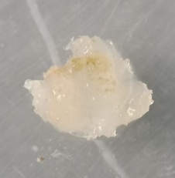
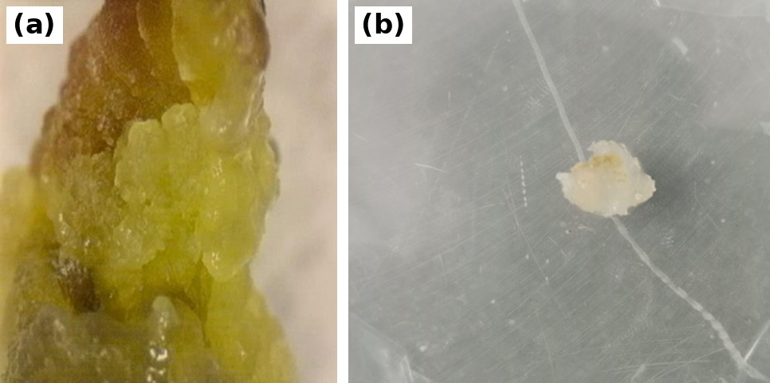
Fig. 4. Close-up view of the nature of callus formed from nodal explants: (a) embryogenic callus; (b) non-embryogenic callus.
A closely comparable classification of callus types was reported by Hodges et al. (1985), who found that immature embryos of maize cultured on medium containing 2, 4-D and kinetin produced friable, rhizogenic and nodular embryogenic callus, a description that closely matches the embryogenic callus obtained from the nodal explant of CML1514 in the present study. These findings indicate that genotype, explant age and the auxin-cytokinin balance play an important role in determining callus quality and embryogenic potential (Fatima et al., 2025).

4. CONCLUSION
The present investigation demonstrated the potential of an in vitro callus induction protocol for maize genotype CML1514 using nodal explants. Among the different concentrations of 2, 4-D and BAP evaluated, MS medium supplemented with 5.0 mg/l 2, 4-D and 2.0 mg/l BAP produced the highest callus formation frequency (93.3%), with callus initiation occurring within 5.7 days of culture. BAP was consistently superior to kinetin in promoting rapid callus initiation across all 2, 4-D concentrations tested and six of the ten media combinations evaluated produced compact, embryogenic callus. The protocol developed in the present study may provide a useful method for the rapid, genotype-independent callus induction and conservation of elite maize germplasm. The results indicate its potential application as a foundation for subsequent somatic embryogenesis and plant regeneration studies.

5. LIMITATIONS
This study was conducted under controlled laboratory conditions with three independent replicates per treatment. The evaluation was restricted to nodal explants of a single genotype (CML1514) and the tested 2, 4-D, BAP and kinetin concentrations. Statistical reporting was limited to ten treatment combinations and the callus induction response was assessed over a fixed 30-day culture period. Therefore, the reproducibility of the protocol beyond the tested conditions and across additional genotypes requires further validation.
Declaration of AI Use

This manuscript was prepared through the intellectual contributions of the author(s) to the study design, data analysis, interpretation of results, and scholarly content. Grammarly and ChatGPT were used solely to assist with grammatical refinement and reference formatting during manuscript revision. The author(s) accept full responsibility for the accuracy, integrity, and final content of the manuscript.
COMPETING INTERESTS
Authors have declared that no competing interests exist.

REFERENCES
Anyieni, D., Kimotho, R.N., Gitonga, N.M. and Muriithi, D.M. (2024). Utilization of mature embryos as an alternative explant source for in vitro regeneration of tropical maize (Zea mays L.) genotypes. Journal of Plant Biotechnology, 51(1), 1-12.
Dahmardeh, M., Ghanbari, A., Syasar, B. and Ramrodi, M. (2009). The role of intercropping maize (Zea mays L.) and cowpea (Vigna unguiculata L.) on yield and soil chemical properties. African Journal of Agricultural Research, 4(11), 1235-1240.
Doebley, J. (2004). The genetics of maize evolution. Annual Review of Genetics, 38, 37-59.
FAOSTAT. (2024). Crops and livestock products. Food and Agriculture Organization of the United Nations.
Fatima, I., Mazhar, A. and Azeem, F. (2025). Tissue culture optimization: maize callus induction and factors affecting the callus efficiency. Integrative Plant Biotechnology, 3(2), 73-100.
Gudlavalleti, P.K., Pagidoju, S., Muppala, S., Kodandarami, R.M. and Puligandla, S.K. (2018). Coleoptilar node - a season-independent explant source for in vitro culture in maize (Zea mays L.). Journal of Applied Biology and Biotechnology, 6(3), 20-28.
Hodges, T.K., Kamo, K.K., Imbrie, C.W. and Becwar, M.R. (1985). Tissue culture of maize (Zea mays L.): somatic embryogenesis in the callus tissue. Journal of Plant Physiology, 119, 435-441.
Kumar, K., Jha, A.K., Kumar, B., Karjagi, C.G., Abhishek, A., Gambhir, G., Aggarwal, C., Tyagi, A., Sharma, P., Pandey, P. and Rakshit, S. (2022). Development of an efficient and reproducible in vitro regeneration and transformation protocol for tropical maize (Zea mays L.) using mature seed-derived nodal explants. Plant Cell, Tissue and Organ Culture, 148(3), 557-571.
Manivannan, A., Kaul, J., Singode, A. and Dass, S. (2010). Callus induction and regeneration of elite Indian maize inbreds. African Journal of Biotechnology, 9(44), 7446-7452.
McFarland, F.L. and Kaeppler, H.F. (2025). History and current status of embryogenic culture-based tissue culture, transformation and gene editing of maize (Zea mays L.). The Plant Genome, 18(1), e20451.
Mushke, R., Yarra, R. and Bulle, M. (2016). Efficient in vitro direct shoot organogenesis from seedling derived split node explants of maize (Zea mays L.). Journal of Genetic Engineering and Biotechnology, 14(1), 49-53.
Pathi, K.M., Tula, S., Huda, K.M.K., Srivastava, V.K. and Tuteja, N. (2013). An efficient and rapid regeneration via multiple shoot induction from mature seed derived embryogenic and organogenic callus of Indian maize (Zea mays L.). Plant Signaling & Behavior, 8(10), e25891.
Sairam, R.V. et al. (2014). An efficient and rapid regeneration via multiple shoot induction from mature seed derived embryogenic and organogenic callus of Indian maize (Zea mays L.). Plant Signaling & Behavior, 9, e25891.
Sleper, D.A. and Poehlman, J.M. (2006). Breeding Field Crops, 5th edn. Blackwell Publishing, Ames, IA.
Tiwari, S., Agrawal, P.K., Pande, V. and Gupta, H.S. (2015). Callus induction and whole plant regeneration in sub-tropical maize (Zea mays L.) using mature embryos as explants. Indian Journal of Genetics and Plant Breeding, 75(3), 330-335.
Tomes, D.T. and Smith, O.S. (1985). The effect of parental genotype on initiation of embryogenic callus from elite maize (Zea mays L.) germplasm. Theoretical and Applied Genetics, 70(5), 505-509.

