Combined Effect of Hydro-Priming and Seed Storage Duration on Germination,
Growth, and Tolerance to Water Deficit in Maize (Zea mays L.)

Abstract
Maize (Zea mays L.) is the world’s leading cereal crop. In Côte d’Ivoire, maize is a strategic crop for food security and rural economies. Despite its importance, this crop is highly sensitive to early water stress. In the face of climate change, which poses a major constraint on cereal production, improving plants’ tolerance to water deficit through environmentally sustainable techniques such as seed hydro-priming is a key challenge. It is against this backdrop that the present study aims to evaluate the effectiveness of hydro-priming maize seeds in improving germination performance and seedling growth under different levels of water availability. The maize seeds underwent hydro-priming pre-treatment, followed by different storage periods (0, 1, 2 and 4 weeks), and were then assessed under four water regimes corresponding to 100 per cent, 50 per cent, 25 per cent and 12.5 per cent of field capacity. A completely randomised experimental design was adopted to analyse the combined effect of pre-treatment and water stress on germination and growth parameters. Seedling performance was assessed in terms of emergence rate, germination rate, plant height, number of leaves, leaf area, collar diameter, and biomass. The results showed that hydro-priming significantly improved seedling establishment compared with untreated seeds, particularly under conditions of severe water deficit. Hydro-primed seeds stored for a short period (1 to 2 weeks) performed best, with an improvement in germination rate of up to approximately 79 per cent under general conditions and values exceeding 90 per cent under certain water-deficient regimes. The treatment also promoted a significant increase in growth parameters, such as biomass, leaf development and root architecture. These results demonstrated that hydro-priming is a promising agroecological strategy for enhancing maize’s resilience to water stress induced by climate change.
Keywords: Zea mays L., hydro-priming, seeds, , germination, plant growth
INTRODUCTION
Maize (Zea mays L.) is the world’s leading cereal crop, with global production estimated at over one billion tonnes (FAO STAT, 2024). It is a strategic crop due to its major role in human nutrition, animal feed and the agri-food industries. In Côte d’Ivoire, national production is estimated at over 1.6 million tonnes (FAO STAT, 2024) and comes from several agroecological zones (Deffan et al., 2015). However, despite its importance, maize cultivation remains severely limited by several abiotic constraints, including water stress, which is currently one of the most pressing concerns. Insufficient water availability leads to a reduction in the water-holding capacity of plant tissues. This situation limits water uptake by the seeds, disrupts the metabolic processes associated with germination and can lead to uneven emergence of the stands (Kaya et al., 2006; Janmohammadi et al., 2008). In the long term, these disruptions affect vegetative growth and crop productivity. Against the current backdrop of climate variability, identifying sustainable strategies to improve maize’s resilience to water stress is therefore a major scientific and agronomic challenge.
Among the approaches developed to improve plants tolerance to abiotic stresses, pre-germination treatment of seeds by hydro-priming appears to be a promising strategy. This technique involves the controlled hydration of seeds, enabling the activation of metabolic processes linked to germination without allowing the radicle to emerge. Unlike simple imbibition, hydro-priming physiologically prepares the seed for faster and more uniform germination. These adaptations enable seedlings from primed seeds to maintain better metabolic activity and more efficient growth when water conditions become unfavourable. Several studies have thus shown that hydro-priming improves seedling vigour, emergence synchronisation and tolerance to water stress in several crop species, including maize (Marthandan et al., 2020; Aswathi et al., 2021). Accordingly, the overall objective of this study is to evaluate the effect of hydro-priming maize seeds on the resilience of young seedlings subjected to different levels of water deficit following various storage periods.
More specifically, the aim was, on the one hand, to assess the combined effect of hydro-priming and seed storage duration on germination and emergence parameters and, on the other hand, to characterise the morphological and biometric responses of seedlings grown from hydro-primed seeds subjected to different water regimes.

1. MATÉRIEL
The plant material used consisted of maize seeds (Zea mays L.) obtained commercially (Figure 1)
2. Description of the Study Area
The experiments were conducted at the Scientific and Innovation Center of Félix HOUPHOUËT-BOIGNY University in Bingerville (Figure 2). Located 12 km from the city of Abidjan, the economic capital of Côte d’Ivoire, the site lies between 5°21’ north latitude and –3°54’ west longitude (Doumbia, 2016).
Bingerville has a sub-equatorial climate with a bimodal pattern, characterized by four seasons: two dry seasons and two rainy seasons. The average temperature ranges from 25 to 30°C. Rainfall and average temperature for the period 1919–2020 were assessed and are shown in Figure 3. The climate is therefore hot and humid, with evergreen rainforest vegetation characterized by the presence of giant trees with unique structures (buttresses, roots, palettes, and stilts).
The topography is shaped by a geological substrate consisting of schist and granite. The soil is classified within the ferralsol family. It is a deep and highly desaturated soil. It consists mainly of sand in the coastal plain and, on the plateau, of sand at the surface and clay at depth. (Koutoua, 2019).

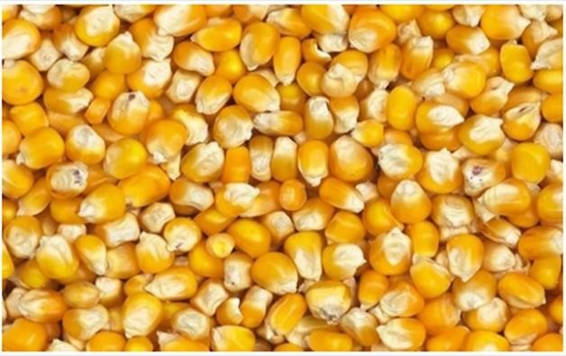

Figure 1: Corn kernels (Zea mays L.), yellow variety.

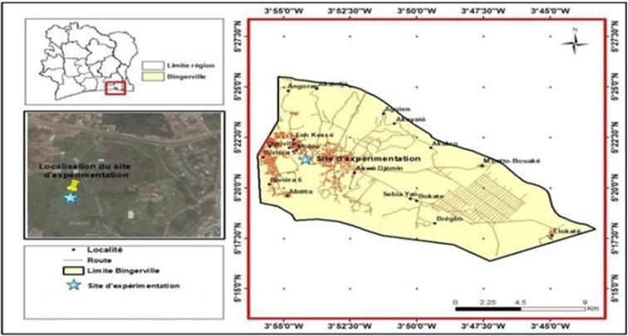

Figure 2: Map of the municipality of Bingerville showing the study site.

Figure 3: Rainfall and temperature records for the study area

2. METHODS
2.1. Experimental Design
The experimental design was a completely randomised block design with two factors: water regime and seed storage duration. Each experimental unit (field capacity × storage duration) was repeated four times (Figure 4).
2.2. Conducting the Experiment
2.2.1. Determination of Field Capacity and Water Status
The collected substrate was sieved and placed in an oven for 24 hours at 105°C. Disposable 200 ml pots were perforated at the bottom to allow water to drain out. The pots were then filled with soil that had been dried beforehand. The pots were then weighed to determine the mass of the pot containing dry soil (P2). Water was added until saturation, after which the soil was left to drain for 48 hours. The mass of the pots containing the drained soil was determined using a balance (P3). The respective masses of the dry soil and the drained soil were calculated using the following formulae.
Dry soil weight (PS) = P2 - P1 (1); Drained soil weight (PE) = P3 - P1 (2)

To calculate the volume of water retained in the drained soil (VEC), the following formula was adopted:
VEC (ml) = (PE – PS) X 1 ml/g

This water volume (VEC) corresponds to 100% of field capacity. This value is divided by 2, 4, and 8 to obtain water regimes of 50%, 25%, and 12.5%, respectively. Thus, the plants were subjected to the following stresses:
-T1: The soil is irrigated to 100% of its field capacity, representing normal irrigation conditions;
-T2: The soil is maintained at 50% of its field capacity, representing a fairly moderate water deficit;
-T3: The soil is maintained at 25% of its field capacity, representing a moderate water deficit;
-T4: The soil is maintained at 12.5% of field capacity, representing severe water deficit conditions.

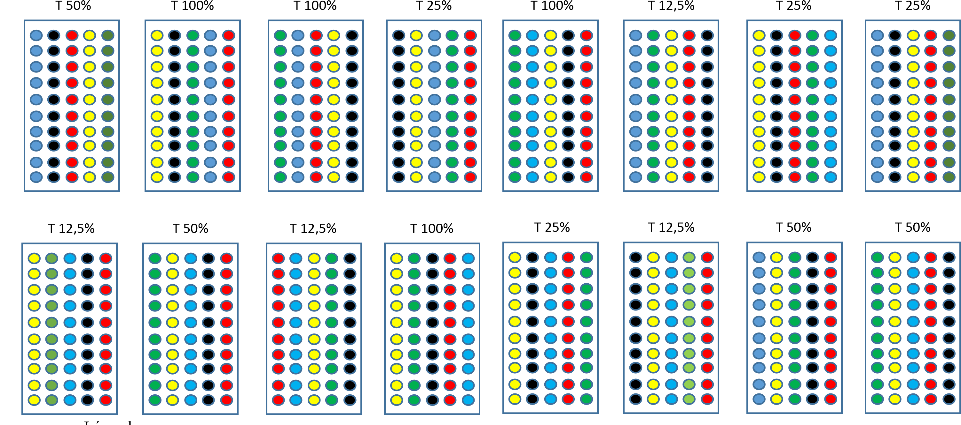
Figure 4: Completely randomized experimental design with 4 replicates
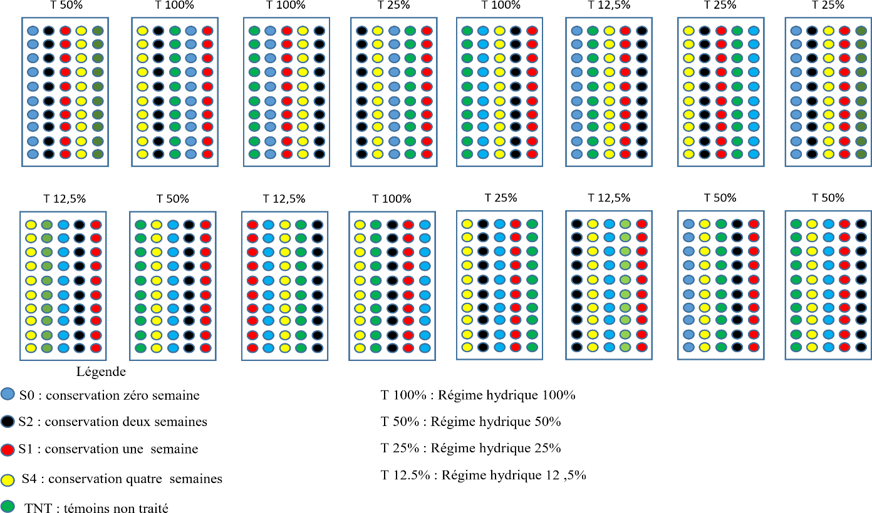
T100%: 100% water regime
T50%: 50% water regime
T25%: 25% water regime
T12.5%: 12.5% water regime
S0: 0-week retention
S2: 2-week retention
S1: 1-week retention
S4: 4-week retention
TNT: Untreated control

2.2.2. Hydro-priming and grain storage at different times
Pre-germination involved using a set of seven Petri dishes and 175 corn kernels. The kernels underwent the same treatments as before (disinfection). Twenty-five kernels were placed in each Petri dish, which had been pre-soaked with 6 ml of distilled water.
The boxes were placed in a room at a temperature of 25° C. The beans were dried for three days at a temperature of 25° C until they returned to their initial weight. After drying, the treated grains were wrapped in aluminum foil to create samples aged zero (S0), one (S1), two (S2), and four (S4) weeks.
A fifth batch of grains was used in this experiment. These were untreated grains that served as the control (TNT).
2.2.3. Determination of the Average Time to Radicle Emergence
The average germination time corresponds to the precise moment of radicle emergence. To determine this, four batches of 25 seeds each were disinfected in 1% sodium hypochlorite for 5 minutes. Next, the seeds were thoroughly rinsed with distilled water and then placed in four Petri dishes lined with a double layer of paper towels that had been pre-soaked with 6 ml of distilled water. The Petri dishes were incubated at room temperature. In each Petri dish, the time elapsed between the day the seeds were sown and the emergence of the radicle was recorded. The average germination time (AGT) was calculated for each Petri dish using the formula by Côme (1970):
∑𝐧. 𝐣𝐧
𝐓𝐌𝐆 = 𝐗 𝟏𝟎𝟎
𝐍

n: number of seeds that germinated per day
j: number hours after sowing
N: total number of seeds that germinated
2.2.4. Potting
The seeds are sown in pots filled with potting compost. One seed per pot was sown at a depth of 1 cm.
2.2.5. Crop Care After Seeding
The plants were watered according to different irrigation regimes (100%, 50%, 25%, and 12.5%) starting on the first day after seeding.
2.2.6. Determination of Germination Parameters
The following parameters were determined:
The emergence time is the time at which seedling emergence is observed. It is the time that elapses between sowing and the emergence of seedlings from the soil.
The daily emergence percentage, the number of seedlings that emerged each day at the same time, was recorded until the last day when no further seedling emergence was observed.
The daily emergence rate was calculated as the ratio of the number of seedlings that emerged each day to the total number of seeds sown.
The emergence rate was calculated using the following formula:
Total number of emerged seedlings
Emergence rate = 𝐗 𝟏𝟎𝟎
Total number of seeds sown

2.3. Statistical Analyses
STATISTICA version 7.1 was used to analyse the data collected. The analysis of variance (ANOVA) test was used to assess the effect of each water regime and storage time on the parameters. Where the null hypothesis H0 was rejected, the Newman-Keuls multiple comparison test at a 5 per cent significance level (α = 0.05) was carried out to rank the means.

3. RESULTS
3.1. Determination of the average germination time (time required for the radicle to emerge)
The average time for the radicle to emerge ranged from 16 hours to 33 hours depending on the grain lots, with an estimated average of 29.25 hours (Table I).
There was discussion about selecting a time shorter than 29.25 hours, so 27 hours was used as the time required for hydro-priming the corn seeds.
Table I: Average germination time for grains from four lots of corn.
Lots | Average germination time (hours)
Lot 1 | 31
Lot 2 | 30
Lot 3 | 20
Lot 4 | 28
Average | 29,25

3.2. Effect of Storage Time of Hydro-Primed Seeds and Water Regimes on Germination
In this study, a seed is considered to have germinated when a plant emerges from the growing medium (soil) (Figure 5).
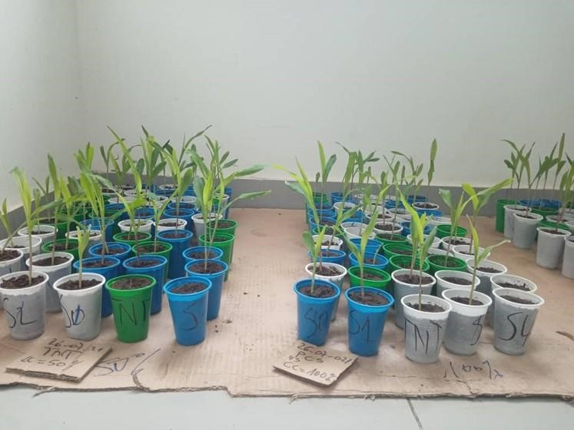
Figure 5: Corn plants that have emerged from the growing medium one week after sowing.

3.2.1. Effect of Seed Storage Time After Hydro-Priming on the Germination Rate
Figure 6 shows the germination rates as a function of storage time for seeds that underwent the hydro-priming process. Analysis of this figure reveals a germination rate exceeding 70% for all treatments. he lowest germination rate (72.5%) was observed in the control treatment, while seeds treated and stored for one week (S1) and two weeks (S2) showed the highest germination rate (79.37%). However, no statistically significant difference was observed among the germination rates.
3.2.2. Effect of Water Regime on the Germination Rate of Corn Seeds After Hydro-Priming
The results of this study showed that the water regime influenced the germination of corn seeds (Figure 7). In fact, the T4 treatment recorded the highest germination rate, at 93%. However, the germination rate for the T4 treatment differed significantly from those of the T2 (84.00%) and T1 (42.00%) treatments. The T1 treatment had the lowest germination rate (42%).
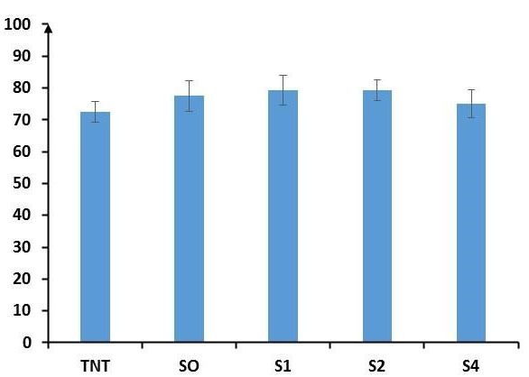
Germination percentage (%)

Storage time
Figure 6: Germination percentage of corn kernels at different storage times.
S0: Pre-germinated and unstored kernels; S1: Pre-germinated kernels stored for one week; S2: Pre-germinated kernels stored for two weeks; S4: Pre-germinated kernels stored for four weeks; TNT: Untreated kernels (control).

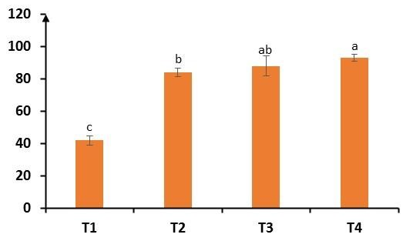
Germination percentage (%)
water balance

Figure 7: Germination percentage of corn kernels under different water regimes.
T1: 100% of field capacity, T2: 50% of field capacity, T3: 25% of field capacity, T4: 12.5% of field capacity.

3.3. Effect of water regimes on the growth parameters of seedlings derived from grains that underwent hydro-priming and were stored for different periods of time.
3.3.1. Growth of the aboveground parts of corn seedlings
The growth parameters evaluated were plant height (PH), collar diameter (CD), number of leaves (NL), leaf area (LA), fresh above-ground biomass (FAB), and dry above-ground biomass (DAB). Analysis of the study results presented in Table II shows that plant height varies among treatments depending on the water regime. Furthermore, regardless of the water regime, plants grown from pre-germinated, non-stored seeds (SO) were the tallest.
Regarding the number of leaves and the collar diameter, analysis of the table shows that the values for these two parameters were lower under the T4 water regime.
Leaf area was greatest under the T1 water regime (59.83 cm² obtained with S0), followed by the T2 water regime. In contrast, the T4 water regime had the smallest leaf areas, at 24.25 cm² (S0).
For dry above-ground biomass (DAGB), the lowest biomass values were obtained with the T3 irrigation system, where values did not exceed 0.33 g (S0), in contrast to the dry biomass of plants grown under T1, where the lowest values were 0.24 g (S2).
Table II: Growth of maize plants subjected to different water regimes combined with storage time.
CC | TC | HP (cm) | NF | DC (cm) | SF (cm²) | BAF (cm) | BAS (g)
T1 | SO | 14,54±0,74a | 6,4±0,16ab | 3,39±0,12a | 59,83±4,58a | 2,74±0,15a | 0,55±0,15a
T1 | S1 | 14,44±0,49a | 6,4±0,16ab | 2,95±0,26a | 54,64±3,68a | 2,66±0,17ab | 0,43±0,02b
T1 | S2 | 14,41±0,73a | 6,4±0,16ab | 2,92±0,1ab | 53,88±4,32ab | 2,23±0,2abc | 0,24±0,12b
T1 | S4 | 13,11±0,66a | 6,2±0,2abc | 2,88±0,14a | 49,85±3,4b | 2,33±0,21ab | 0,66±0,18a
T1 | TN | 14,75±0,7a | 6,6±0,22a | 3,04±0,15a | 55,95±5,45a | 2,67±0,17ab | 0,36±0,07b
T2 | SO | 14,34±0,45a | 6,5±0,17a | 2,9±0,13ab | 55,38±3,03a | 1,92±0,17bc | 0,31±0,11b
T2 | SI | 13,82±0,37a | 6,2±0,2abc | 3, 03±17ab | 52,8±4,43a | 2,06±0,21ab | 0,28±0,07b
T2 | S2 | 12,67±0,49a | 6,4±0,16ab | 3,07±0,08a | 42,99±3,04b | 2,08±0,13ab | 0,87±0,18a
T2 | S4 | 12,5±0,44ab | 6,3±0,21ab | 2,96±0,15a | 40,79±3,38b | 2,02±0,1abc | 0,57±0,11a
T2 | TN | 12,92±0,95a | 6,3±0,15ab | 2,92±0,07a | 41,13±1,46b | 1,85±0,14cd | 0,24±0,04b
T3 | SO | 14,4±0,41ab | 6,2±0,25ab | 2,81±0,12a | 84,38±37,4a | 2,21±0,24ab | 0,33±0,08b
T3 | SI | 14,11±0,59a | 6,5±0,17a | 2,92±0,08a | 48,83±5,34b | 1,82±0,16cd | 0,19±0,02c
T3 | S2 | 13,77±0,41a | 5,9±0,1abc | 2,8±0,09ab | 41,54±3,67c | 1,47±0,2de | 0,17±0,01c
T3 | S4 | 12,99±0,47a | 6±0,15abc | 2,68±0,11b | 38,48±2,28d | 1,6±0,20cde | 0,16±0,02c
T3 | TN | 12,84±0,44a | 5,9±0,18ab | 2,81±0,01a | 40,23±2,75c | 1,38±0,14ef | 0,15±0,02c
T4 | SO | 11,89±0,7bc | 4,9±0,18e | 2,38±0,12c | 24,25±2,63b | 0,82±0,13f | 0,19±0,05c
T4 | SI | 11,87±0,66b | 5,4±0,16de | 2,5±0,09bc | 34,18±1,71a | 1,32±0,17ef | 0,14±0,01c
T4 | S2 | 11,39±0,73c | 5,5±0,17de | 2,73±0,08b | 34,76±2,35a | 1,30±0,19ef | 0,30±0,12b
T4 | S4 | 11,85±0,49b | 5,6±0,16de | 2,61±0,07b | 32,17±3,27b | 1,27±0,11ef | 0,37±0,05b
T4 | TN | 10,18±0,74d | 5,4±0,27de | 2,61±0,21b | 32,34±5,13b | 1,27±0,29ef | 0,13±0,02c
p |  | 0,05 | 0,09 | 0,22 | 0,11 | 0,01 | 0,0003
HP: plant height; NF: number of leaves; DC: collar diameter; SF: leaf area; BAF: fresh aboveground biomass; BAS: dry aboveground biomass. T1: 100% of field capacity, T2: 50% of field capacity, T3: 25% of field capacity, T4: 12.5% of field capacity. TC: Storage time; CC: Field capacity. S0: Pre-germinated and unstored seeds; S1: Pre-germinated seeds stored for one week; S2: Pre-germinated seeds stored for two weeks. S4: Pre-germinated seeds stored for four weeks; TNT: Untreated seeds (control). ±: Standard error.
3.3.2. Growth of the underground parts of corn seedlings
The results showed that the number of roots (NR) decreases with water availability. This number ranges from 4.5 to 12, and the lowest number of roots was recorded under the 12.5% water availability treatment (T4) with the untreated control seeds (TNT). Seeds that were treated but not stored (SO) and those that were treated and stored for one week (S1), when watered with the 100% irrigation regimen (T1), had the highest number of roots (12).
Results similar to those for root number (RN) were observed for root length (RL). Root length (RL) was shorter under the TD water regime. In this T4 regime, the plants grown from SO seeds had the shortest root length (RL) (Table III).
For fresh aboveground biomass (FAB), the results showed that it was highest (2.18 g) in treatment T1 with seeds S2 and S4, and identical to that of the TNT control. The lowest fresh biomass values were observed in treatments T3S2 (0.43 g) and T4 TNT (0.49 g).
The analysis showed that for the T3 water regime, S0 recorded a significantly higher value, followed by S1, S2, and S4, compared to TNT, which had a low value. The results showed a higher LR for TNT, followed by S1, S0, S2, and S4. For BSF, S0, S1, S2, and S4 had statistically higher values, while TNT had a low value; the same observation was made for BSS. Under the T4 water regime, S0 exhibited a high number of roots as well as other growth parameters (LR, BSF, BSS). S1 and S2 recorded statistically identical values, followed by S4, with TNT showing the lowest value (Table III).
Table III: Comparison of the means of growth parameters measured on the underground parts of corn plants subjected to different water regimes combined with storage time.
CC (%) | TC | NR | LR | BSF | BSS
T1 | SO | 12±0,38a | 35,76±3,72a | 1,01±0,13bcd | 0,26±0,05cd
T1 | SI | 12±1,06a | 35,65±4,08a | 1,19±0,13bc | 0,38±0,05bcd
T1 | S2 | 11±0,97ab | 34,17±2,6a | 2,04±0,12a | 0,64±0,08b
T1 | S4 | 9,56±0,65abcd | 34,83±5,24a | 2,18±0,3a | 0,99±0,23a
T1 | TNT | 10,8±0,53abc | 38,68±2,67a | 2,18±0,33a | 0,289±0,07cd
T2 | SO | 8,6±0,65bcd | 27,82±2,49a | 0,81±0,11bcd | 0,26±0,05cd
T2 | SI | 8,6±0,65bcd | 31,22±2,56a | 0,89±0,12bcd | 0,35±0,07bcd
T2 | S2 | 8±0,87bcde | 35,8±4,16a | 0,98±0,12bcd | 0,34±0,07bcd
T2 | S4 | 8,3±1,16bcd | 34,57±4,36a | 1,34±0,19b | 0,53±0,12bc
T2 | TNT | 7,8±0,88bcde | 28,51±1,95a | 1,10±0,28bcd | 0,47±0,15bcd
T3 | SO | 8,1±0,59bcde | 32,36±2,46 | 0,65±0,07bcd | 0,2±0,03cd
T3 | SI | 7,7±0,82bcde | 34,18±2,65a | 0,73±0,14bcd | 0,26±0,06cd
T3 | S2 | 7,4±1,05bcde | 28,91±3,83a | 0,43±0,7d | 0,12±0,02d
T3 | S4 | 7,5±0,52bcde | 26,47±3,44a | 0,8±0,11bcd | 0,3±0,05cd
T3 | TNT | 7±0,7cde | 35,58±1,46a | 0,48±0,06cd | 0,13±0,02d
T4 | SO | 8±1,06bcde | 27,58±2,40a | 0,51±0,09cd | 0,1±0,02d
T4 | SI | 7,4±0,72bcde | 29,64±1,61a | 0,54±0,12cd | 0,14±0,02d
T4 | S2 | 7,3±0,79bcde | 29,09±1,51a | 0,57±0,09cd | 0,15±0,02d
T4 | S4 | 5,9±0,69de | 30,25±2,94a | 0,55±0,08cd | 0,16±0,03d
T4 | TNT | 4,5±0,65e | 29,78±4,58a | 0,49±0,06cd | 0,14±0,02d
P |  | 0,1 | 0,53 | 0,0001 | 0,0002

NR: number of roots; MRL: mean root length; FSB: fresh below-ground biomass; DSB: dry below-ground biomass; T1: 100% field capacity; T2: 50% field capacity; T3: 25% field capacity; T4: 12.5% ​​field capacity. ST: Storage time. FC: Field capacity. S0: Pre-germinated, non-stored grains; S1: Pre-germinated grains stored for one week; S2: Pre-germinated grains stored for two weeks; S4: Pre-germinated grains stored for four weeks; TNT: Untreated grains (Control). ±: Standard error.

3.3.3. Effect of Different Storage Durations on the Growth Parameters of Seedlings
Seeds that had undergone hydro-priming and were stored for different periods were germinated and watered according to different irrigation regimens during the growth phase. The averages of the growth parameters measured for the aboveground and underground parts are presented in Tables IV. Certain growth parameters, such as plant height, total number of leaves, collar diameter, leaf area, number of roots, average root length, fresh above-ground biomass, fresh below-ground biomass, dry aboveground biomass, and dry belowground biomass was assessed during the experiment; the results are summarized in Table IV.
In general, the watering regimen influenced the growth of all plant organs. Plant heights ranged from 11.44 to 14.25 cm. The tallest plants, which were statistically indistinguishable, were obtained with watering regimens T1, T2, and T3. The shortest plants were those watered with 12.5 ml of water. Regarding the number of leaves and the collar diameter, analysis of the table shows that the values for these two parameters were higher and statistically equivalent under the T1 (6.40; 3.04) and T2 (6.34; 2.98) irrigation regimes. The lowest values were observed under the T3 regime (6.10; 2.80), followed by T4 (6.10; 2.56). The same observation was made for dry above-ground biomass (DAGB). However, for this parameter, the T3 and T4 water regimes exhibited statistically equivalent DAGB values.
Leaf area was highest under the T1 (54.83 cm²), T2 (46.62 cm²), and T3 (50.69 cm²) water regimes. These values are statistically indistinguishable at the 5% significance level. The smallest leaf area was observed under the T4 regime (31.54 cm²).
As for fresh aboveground biomass (FAB), it decreased with water stress; that is, FAB decreases as the amount of water supplied to the plant decreases.

Table IV: Comparision of the mean values of growth parameters measured on corn seedlings subjected to different water regimes
CC | HP NF DC (cm) SF (cm2) BAF (g) B AS(g) NR LR (cm) BSF (g) BS S (g)
T1 | 14,25±0,30a 6,40±0,08a 3,04±0,08a 54,83±1,92a 2,53±0,08a 0,45±0,06a 11,1±0,37a 35,84±1,61a 1,72±0,12a 0,51±0,06a
T2 | 13,25±0,27b 6,34±0,08a 2,98±0,05a 46,62±1,64a 1,99±0,07b 0,45±0,06a 8,24±0,37b 31,58±1,47ab 1,02±0,08b 0,39±0,04b
T3 | 13,62±,23ab 6,10±0,08b 2,80±0,04b 50,69±7,72a 1,7±0,1c 0,20±0,02b 7,54±0,33bc 31,50±1,33ab 0,62±0,05c 0,20±0,02c
T4 | 11,44±0,25c 6,10±0,09c 2,56±0,06c 31,54±1,49b 1,20±0,09d 0,23±0,03b 6,62±0,39c 29,271±,22b 0,53±0,04c 0,14±0,01c

NT: control; HP: seedling height; NF: number of leaves; DC: collar diameter; SF: leaf area; BAF: fresh above-ground biomass; BAS: dry above-ground biomass; NR: number of roots; LR: root length; BSF: fresh below-ground biomass; BSS: dry below-ground biomass; CC: field capacity; T1: 100%; T2: 50%; T3: 25%; T4: 12.5%; S0: Pre-germinated seeds not stored; S1: Pre-germinated seeds stored for one week; S2: Pre-germinated seeds stored for two weeks. S4: Pre-germinated grains stored for four weeks; TNT: Untreated grains (control); ±: Standard error.

4. DISCUSSION
Plant production and the establishment of healthy crops depend heavily on seed germination, which is a crucial stage in the life cycle of higher plants (Puglia, 2024).
According to this study, it should be noted that, regardless of the type of water regime, hydro-priming improves the germination performance of corn. This could be explained by the fact that hydro-priming triggers and regulates pre-germination processes and also induces strong activation of certain genes responsible for water stress tolerance. These results are consistent with those reported by Paparella et al. (2015). They have all shown that hydro-priming triggers and regulates pre-germination metabolic processes, such as DNA repair, protein synthesis, the activation of antioxidant enzymes, and the modulation of gene expression involved in the response to water stress, thereby improving germination vigor and seedling tolerance to water-deficient conditions. Aswathi and al. (2022) and Mir et al (2021) also observed that priming improves the performance and vigor of corn, wheat, and cowpea under stressful conditions. However, what is entirely new in this study compared to all previous studies is the storage of treated seeds and the application of the treatment in the field. Our results demonstrated the effect of storage time on the germination period, germination rate, and number of seedlings emerging from hydro-primed seeds. The pretreated seeds stored on different dates exhibited good germination capacity under moisture regimes of 50%, 25%, and 12.5%. Thus, under water-stress conditions, untreated grains (TNT) have insufficient germination capacity and emergence rates. This result is consistent with those of Dezfuli and al. (2008); Sirwa, (2021) and Adinde and al. (2020), who noted that emergence rates vary significantly depending on the duration of pre-soaking, confirming that an optimal duration is essential for maximizing seedling establishment. In fact, Ahammad et al (2014) showed that, in corn, a treatment involving an 18-hour soak followed by surface drying yielded the best results in terms of germination percentage, germination index, and reduction in average germination time. Thus, it was observed that the treated and stored grains had significantly better germination performance than the controls under water regimes of 50%, 25%, and 12.5%. This shows that pretreated grains do not require a large amount of water for plant emergence. Furthermore, according to Tanwar and al (2021; 2023), hydro-priming for 8 to 12 hours significantly improves the germination rate and vigor indices of wheat seeds.
The results obtained for growth parameters show that pre-germination treatments lead to faster and more uniform germination and better seedling growth under adverse conditions. Indeed, the beneficial effects of hydro-priming are generally more pronounced when seeds are subjected to adverse environmental conditions (water stress, salinity or extreme temperatures) than under optimal germination conditions (Paparella et al., 2015; Ibrahim, 2016).
It has also been demonstrated that seeds stored under conditions SO and S1 exhibit more efficient plant growth compared with the control (TNT). Furthermore, it was observed that hydro-priming combined with specific water regimes significantly improved these parameters. The greatest plant height, leaf area and above-ground biomass were obtained under water regime T4, followed by T3 and T2. Under our experimental conditions, it should be noted that the storage times of pre-germinated seeds clearly showed improved plant growth in terms of height, number of leaves, leaf area and collar diameter when the seeds were pre-treated and stored for zero weeks (SO), one week (S1) and two weeks (S2). Thus, hydro-priming may be useful for mitigating the adverse effects of drought and improving germination in a water-stressed environment. These results are similar to those of Marthandan et al. (2020), who demonstrated that hydro-priming is a simple and effective strategy for mitigating the adverse effects of drought.
5. CONCLUSION
Abiotic factors are among the major challenges facing crop production. This phenomenon is also driven by climate change. Numerous studies are being carried out in this area to mitigate the effects of abiotic stress. Hydro-priming is used to break dormancy and also to improve seed vigour. Hydro-priming also plays a key role in helping plants adapt to water stress. This study was initiated to assess the effects of hydro-priming maize seeds on germination and growth under stressful conditions. On completion of this study, it can be concluded that hydro-priming of maize seeds improved germination performance, growth and development of seedlings derived from seeds treated and stored for different durations (SO, SI, S2, S4) under water regimes of 25 per cent and 12.5 per cent, compared with the control group. However, it is best to pre-treat the seeds but only store them for a short period (one to two weeks), as this yields the best results. Thus, hydro-priming could be a highly effective method for improving crop production, particularly under adverse water stress conditions. It is a simple and inexpensive technique that avoids the use of chemicals which could be harmful to the environment and human health. All the different grains that were pre-treated and stored for a short period showed tolerance to water stress. For future research, it would be necessary to conduct a field trial whilst monitoring the plants through to final production in order to assess the beneficial effect of hydro-priming on productivity and yield under water stress conditions.
Declaration of AI Use

This manuscript was prepared through the intellectual contributions of the author(s) to the study design, data analysis, interpretation of results, and scholarly content. Grammarly and ChatGPT were used solely to assist with grammatical refinement and reference formatting during manuscript revision. The author(s) accept full responsibility for the accuracy, integrity, and final content of the manuscript.

REFERENCES
Tanwar, H., Mor, V.S., Sharma, S., Khan, M., Bhuker, A., Singh, V., Yadav, J., et al. (2021). Optimization of on-farm hydropriming conditions in wheat: Soaking time and water volume have interactive effects on seed performance. PLOS ONE, 18(2). DOI:10.21203/rs.3.rs-1097189/v1
Tanwar, H., Mor, V.S., Sharma, S., Khan, M., Bhuker, A., Singh, V., et al. (2023). Optimization of ‘on farm’ hydropriming conditions in wheat: Soaking time and water volume have interactive effects on seed performance. PLoS ONE 18(1): https://doi.org/10.1371/journal.pone.0280962
Adinde, J. O., Omeje, T. E., Uche, O. J., & Agu, C. J. (2020). Impact of hydropriming duration on seed germination and emergence indices of sweet basil (Ocimum basilicum). Journal of Agricultural Science and Practice, 5(1). DOI:10.31248/JASP2019.177

Aswathi, K. P. R., Kalaji, H. M., & Puthur, J. T. (2022). Seed priming of plants aiding in drought stress tolerance and faster recovery: A review. Plant Growth Regulation, 97, 235–253. https://doi.org/10.1007/s10725-021-00755-z
FAOSTAT. (2024). Food and Agriculture Organization of the United Nations, Geneva. URL : https://www.fao.org/faostat/fr/#data/QC L
Deffan, K. P., Akanvou, L., Akanvou, R., Nemlin, G. J. & Kouamé, P. L. (2015). Evaluation morphologique et nutritionnelle de variétés locales et améliorées de maïs (Zea mays L.) produites en Côte d’Ivoire. Afrique Science.,( Morphological and nutritional characteristics of local and improved maize (*Zea mays* L.) varieties produced in Côte d’Ivoire. Afrique Science) 11 (3) : 181–196. https://www.scirp.org/reference/referencespapers?referenceid=1943423
Dezfuli, P. M., Sharif-zadeh, F., & Janmohammadi, M. (2008). influence of priming techniques on seed germination behavior of maize inbred lines ( Zea mays L .) ∑ Dn. 3(3), 2006–2009.Évaluation des mélanges multi-espèces de cultures de couverture en grandes cultures biologiques. (2020). https://www.researchgate.net/publication/256443333(Techniques regarding seed germination behavior of maize inbred lines (*Zea mays* L.) — Evaluation of multi-species cover crop mixtures in organic field crops.)
Sirwa, A. Qadir. (2021). Influence of different seed priming techniques on the growth and vigor of two (triticum aestivum l.) bread wheat genotypes. Journal homepage: https://doi.org/10.51470/PLANTARCHIVES.2021.v21.S1.278
Doumbia, I. (2016). Union des villes et commune de la côte d’Ivoire. Bingerville, 1p. (Union of Cities and Municipalities of Côte d’Ivoire. Bingerville, 1 p.)

Ahammad, K.U., Rahman, M.M., & Ali, M.R. (2014). Effect of hydropriming method on maize (Zea mays) seedling emergence. Bangladesh J. Agril. Res. 39(1): 143-150. https://doi.org/10.3329/bjar.v39i1.20164

Ibrahim,E.A. (2016). Seed priming to alleviate salinity stress in germinating seeds. Journal of Plant Physiology,192,38–46. https://doi.org/10.1016/j.jplph.2015.12.011
Janmohammadi, M., Dezfuli, P.M., & Sharifzadeh, F. (2008). Seed invigoration techniques to improve germination and early growth of inbred line of maize under salinity and drought stress. General. Applied. Plant Physiology., special issue, 34(3-4), 215-226. http://obzor.bio21.bas.bg/ipp/gapbfiles/v-34_pisa-08/08_pisa_3-4_215-226.pdf
Kaya, M. D., Okcu, G., Atak, M., Cikili, Y., & Kolsaric, O. (2006). Seed treatments to overcome salt and drought stress during germination in sunflower (Helianthus annuus L.). European. Journal. Agronomy., 24: 291-295. DOI:10.1016/j.eja.2005.08.001
Koutoua A.J. (2019). Planification urbaine et développement du grand Abidjan : cas des villes d’Anyama, de Bingerville et de grand-Bassam. Mémoire de thèse d’Urbanisation et Population.
Université Félix Houphouët Boigny,Abidjan Côte d’Ivoire, 353p. (Urban Planning and Development of Greater Abidjan: The Case of the Towns of Anyama, Bingerville, and Grand-Bassam. Thesis in Urbanization and Population.
Félix Houphouët-Boigny University, Abidjan.)
https://shs.hal.science/tel02435354v1/file/Th%C3%A8se%20JP%20vers%20publi%C3%A9%C3%A9.pdf
Marthandan,V., Geetha,R., Kumutha,K., Renganathan,V.G., Karthikeyan,A., & Ramalingam, J. (2020). Seed Priming: A Feasible Strategy to Enhance Drought Tolerance in Crop Plants. International Journal of Molecular Sciences, 21(21), 8258. https://doi.org/10.3390/ijms21218258
Paparella, S., Araújo, S. S., Rossi. G., Wijayasinghe, M., Carbonera, D., & Balestrazzi, Alma. (2015). Seed priming: state of the art and new perspectives. Plant Cell Reports, 34(8), 1281–1293. https://doi.org/10.1007/s00299-015-1784-y
Puglia, G. D. (2024). Reactive oxygen and nitrogen species (RONS) signalling in seed dormancy release, perception of environmental cues, and heat stress response. Plant Growth Regulation, 103, 9–32. https://doi.org/10.1007/s10725-023-01094-x
MIR, H. R., YADAV, S., & YADAV, S. (2021). Hydropriming associated physiological and biochemical changes responsible for the enhanced planting value of maize hybrid and its parental line seeds," Turkish Journal of Agriculture and Forestry: Vol. 45: No. 3, Article 9. https://doi.org/10.3906/tar-2006-77

