Evaluation of Turnip (Brassica napus) Production on Different Substrates in Côte d’Ivoire

.
ABSTRACT
The turnip is a vegetable crop that produces vegetables that are highly appreciated by urban populations. The plant contains various bioactive chemical compounds that help prevent several microbial infections and metabolic diseases, including cancer and diabetes. However, turnip production is severely limited by a shortage of cultivable soil due to rapid urbanization and numerous land conflicts. To increase production, farmers use chemical fertilizers. The widespread use of these fertilizers pollutes the environment and negatively affects crop yields.
Soilless cultivation offers an alternative to address the shortage of cultivable soil. The success of soilless cultivation depends on the composition of the substrate.
Thus, a study was conducted at the Ecole Normale Supérieure d’Abidjan from june through december 2025 to identify a suitable local substrate for growing turnips in soilless culture. Substrates formulated with mixtures of soil and compost in proportions of 25%, 50%, and 75% were tested for turnip production compared to a control consisting of soil. Growing pots were filled with the substrates, and turnip seeds were sown in them. The crops were arranged randomly under a shade structure. Watering was performed as needed to maintain substrate humidity. The germination rate, leaf area, plant height, and turnip yield were estimated.
The results showed that the substrate consisting of 50% compost and 50% soil performed better in terms of the number of turnip leaves and vegetable yield. The lowest values for these parameters were observed in plants grown in a 100% soil substrate.
A mixture of 50% compost and 50% soil is a suitable substrate for growing turnips in a soilless culture. The substrate identified in this study offers an alternative for restoring cultivated soils and contributes to the achievement of sustainable agriculture.

Keywords: Turnip, soilless cultivation, substrate, compost, yield, Côte d’Ivoire

1. INTRODUCTION

Food sufficiency is one of the major concerns of developing countries, including Côte d’Ivoire. Vegetable crops such as turnips contribute significantly to supplying urban markets with essential food items (Olahan, 2010). However, vegetable farmers’ production remains insufficient due to a lack of cultivated soil, which is linked, among other factors, to rapid urbanization and numerous land conflicts in Côte d’Ivoire (Kouakou et al., 2010; Useni et al., 2012). Faced with this situation, farmers generally resort to the heavy use of chemicals to increase crop yields (Dembélé et al., 2008; Gala Bi et al., 2011). This agricultural technique results in environmental pollution and the degradation of agricultural products, which often affects consumers’ health (Koutros et al., 2008). There are industrial substrates with high potential for increasing crop yields. However, their cost remains quite high, which means that most farmers in developing countries, who have limited resources, cannot obtain them (Elabed et al., 2018). The use of local substrates within easy reach of farmers would facilitate the cultivation of vegetable crops in proximity to cities (Çelebi, 2019). The use of various substrates in food crop production in soilless conditions thus appears to be an innovative technique worth exploring. Substrates composed of sawdust and potting soil have promoted better growth and development of tomato plants in Gabon (Nzengue et al., 2024). Compost used as a cultivation substrate in plastic pots has improved the yield of peanuts and millet (Mamane et al., 2026). The use of various local materials could help develop a suitable substrate for growing turnips. Thus, the objective of this study is to determine a formulation for a local substrate for turnip production under soilless conditions.

2. material and methods

2.1 Material

2.1.1 Plant material
The plant material used consists of seeds from a hybrid turnip variety called MAXIMUS. These seeds were commercially obtained from Technisem (Fig.1).
2.1.2 Cultivation substrates
In this study, the substrates considered are soil, compost, and a mixture of soil and compost in various proportions.

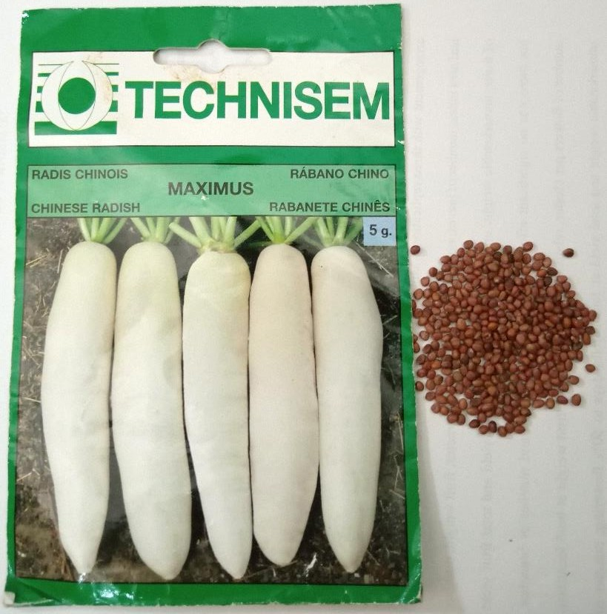.
Fig.1. Maximus turnip seeds

2.2. Methods
2.2.1 Experimental setups
The chosen experimental setup consists of a completely randomized block with three replicates. Each replicate of the experimental setup consists of three (3) rows, each containing 30 pots for each substrate combination, at a rate of six pots per treatment. This results in a total of 54 pots for each treatment. For this experiment, five treatments were considered:
- Treatment S1 consisting of 100% soil (control)
- Treatment S2 consisting of 100% compost
- Treatment S3 consisting of a mixture of 75% compost and 25% soil
- Treatment S4 consisting of a mixture of 50% compost and 50% soil
- Treatment S5 consisting of a mixture of 25% compost and 75% soil
2.2.2 Preparation of Growing Media
The collected substrates were prepared seven days before the experiment. The soil was collected from the experiment site. The compost was prepared from a mixture of plant debris from the site and organic waste collected at the ENS market near the experimental site. After the various mixtures were combined, the substrates were heat-sterilized by heating them in aluminum barrels. After cooling, the substrates were packaged in sterile bags according to the different treatments.
2.2.3 Sowing the Seeds
Five-liter plastic pots with holes in the sides were filled with substrate. Then, 1cm holes were made in each pot, and two seeds were placed in each hole and covered with substrate.
2.2.4 Monitoring and Maintenance of the Turnip Crop
2.2.4.1 Watering
This involved providing the amount of water necessary for proper plant growth during periods of low rainfall. The turnips were watered daily by hand, twice a day, when the rains became irregular.
2.2.4.2 Weed Control
Weed control is the practice of limiting the growth of weeds to reduce their negative impact on crops. Weed control was carried out manually.
2.2.4.3 Pest Control
Mechanical control measures were implemented against the caterpillars found on the turnips after symptoms were observed on the plants. This was done on a regular basis by manually removing the caterpillars from the plants.
2.2.5 Harvesting
The turnips were harvested by hand at maturity, after two months of growth, by carefully digging up the plants from each substrate.
2.2.6 Data Collection
2.2.6.1 Turnip Germination Rate
The germination rate is the ratio of the number of seeds that germinated to the total number of seeds sown, expressed as a percentage.
Number of seeds germinated
Germination rate (%) = x 100
Total number of seeds sown
2.2.6.2 Leaf Production in Turnips
Leaf production is the total number of leaves produced per plant. Ten turnip plants were randomly selected per experimental unit and per substrate, and the number of leaves produced was recorded.
2.2.6.3 Height of Turnip Plants
Plant height was measured on ten plants selected at random from each experimental unit and substrate, using a graduated ruler to measure the stem length from the collar to the tip of the tallest leaf.
2.2.6.4 Weight of Turnip Vegetables
At harvest, 10 plants were randomly selected from each substrate; the tuberous roots were then removed and weighed using a precision scale. Subsequently, the yield expressed as the total weight of turnip vegetables was estimated per hectare for each substrate. The yield is calculated using the following equation:
Total weight of harvested vegetables (kg)
Yield (kg/ha) =
Area (ha)
2.2.7 Statistical Analysis
The collected data were entered into Microsoft Excel 2007 and then imported into STATISTICA version 7.1 for analysis of variance (ANOVA) of the various parameters. When a significant effect was observed among the parameters studied, the means were compared using the Newman-Keuls test at a 5% significance level.

3. results and discussion
3. 1 Results
3. 1. 2 Germination of Turnip Seeds
The germination rate of turnip seeds on the tested substrates is shown in Fig. 2. Seed germination began three days after sowing and was complete by the sixth day of cultivation. The germination rate was highest on substrate S4 composed of 50% compost and 50% soil from the beginning of germination compared to the other substrates. With this substrate, the maximum germination rate was attained after six days of cultivation. The lowest germination rate was recorded for the compost substrate (S2) and the mixture of 75% compost and 25% soil (S5).

Fig. 2. Germination rates of turnip seeds on substrates
S1: substrate consisting of 100% soil, S2: substrate consisting of 100% compost, S3: substrate consisting of a mixture of 75% compost and 25% soil, S4: substrate consisting of a mixture of 50% compost and 50% soil, S5: substrate consisting of a mixture of 25% compost and 75% soil.

3. 1. 3 Turnip Growth on Various Substrates
The turnip plants performed well during cultivation. Furthermore, no mortality was recorded on the substrates (Fig. 3).

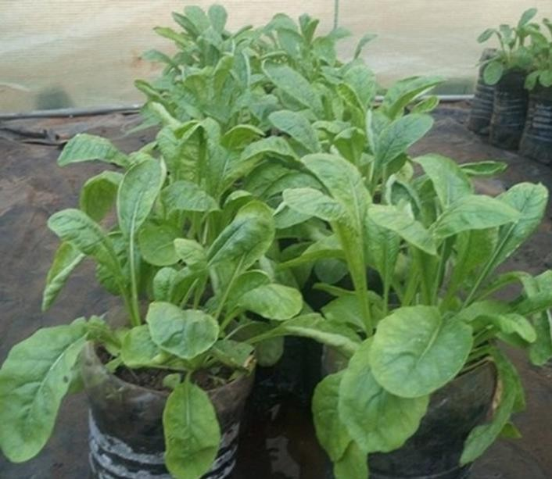
Fig. 3. Turnip plants growing on various substrates

3. 1. 3. 1. Evolution of the Number of Leaves
On the tenth day of cultivation, the plants produced the same number of leaves (4 leaves) on all substrates considered (Fig. 4). From that time, the number of leaves produced by the turnip increased gradually until it attained its maximum value on the 31st day of the experiment. The highest number of leaves was observed in the substrates consisting of a mixture of 50% compost and 50% soil (S4) and 25% compost and 75% soil (S5), with 13 and 12 leaves, respectively, as opposed to 10 leaves for the other substrates.

Fig. 4. Number of leaves produced during the growth of turnips on the substrates
S1: substrate consisting of 100% soil, S2: substrate consisting of 100% compost, S3: substrate consisting of a mixture of 75% compost and 25% soil, S4: substrate consisting of a mixture of 50% compost and 50% soil, S5: substrate consisting of a mixture of 25% compost and 75% soil.

3. 1. 3. 2. Plant Height
After 31 days of growth on substrates where no variation in plant size was observed, the plants’ heights were measured and recorded. The results are presented in Fig. 5. The height of the plants grown on substrates containing compost was higher than that of the control (100% soil). The greatest height was observed on substrate S2, which consisted exclusively of compost.

Fig. 5. Height of turnips grown on various substrates
S1: substrate consisting of 100% soil, S2: substrate consisting of 100% compost, S3: substrate consisting of a mixture of 75% compost and 25% soil, S4: substrate consisting of a mixture of 50% compost and 50% soil, S5: substrate consisting of a mixture of 25% compost and 75% soil.

3. 1. 4. Turnip Yield
At the end of the growing season, the turnips were harvested, and the yield in vegetable weight was estimated for each substrate. The experimental results are shown in Fig. 6. The yield at harvest was significantly higher on the substrate consisting of a mixture of compost and soil. The highest yield was recorded on substrate S4, which consisted of 50% compost and 50% soil (1,820 kg/ha). The lowest yield was registered on the control substrate, which consisted of 100% soil (383 kg/ha).

Fig. 6. Yield of turnips grown on various substrates
S1: substrate consisting of 100% soil, S2: substrate consisting of 100% compost, S3: substrate consisting of a mixture of 75% compost and 25% soil, S4: substrate consisting of a mixture of 50% compost and 50% soil, S5: substrate consisting of a mixture of 25% compost and 75% soil.
3.2. Discussion
Turnip seeds germinated faster in the substrate consisting of 50% compost and 50% soil. This could be explained by the aeration and water retention promoted by the mixture. The availability of sufficient water and oxygen rapidly initiates the seed germination process in plants (Kouadio et al., 2020). The softening of the seed coat following water absorption facilitated the entry of oxygen into the seed, which triggered the resumption of metabolic activity necessary for embryo development, as suggested by Ahoton et al. (2009). The embryo’s intense metabolic activity generally leads to seed germination. Catusse et al. (2008) demonstrated that seed germination is controlled by the embryo’s metabolic activities. Turnip plants produced a high number of leaves on substrates containing 25% and 50% compost. Incorporating compost into the soil at a moderate level certainly improved organ development in the plants compared to the control (soil alone). The positive impact of compost on leaf growth and turnip yield is attributable to improvements in the soil’s physicochemical properties, the nutrient diffusion rate, and its water-holding capacity (Diakhaté et al., 2018). Furthermore, substrates containing a mixture of compost and soil improve the biological properties and the crumbly structure of the soil (Konaté et al., 2018). The substantial amount of organic substance in compost stimulates the activity of microorganisms, thereby improving soil bioavailability (Takeda et al., 2009). Several other authors, such as Ihihi et al. (2014) and Ouédraogo (2016), cited by N’Gazoua et al. (2023), have demonstrated that composting organic waste provides an alternative to the limited availability of cultivated soil. It offers the advantage of not only limiting pathogens but also improving fertility and accelerating the availability of the nutrients it contains to plants. The resulting mineralization of organic material has enriched the soil with nutrients that plants can directly assimilate to build their various organs (Temgoua et al., 2012; Aziable et al., 2014). The development of aerial organs such as leaves has promoted optimal photosynthetic activity, which is necessary for the production of metabolic substances. The accumulation of these substances as reserves is beneficial for tuber formation in root vegetables. Mamane et al. (2026) demonstrated that the use of compost as a culture substrate in plastic pots significantly improves yields of millet and peanuts.
In this study, when compost was used in excess or served as the sole substrate, plant height was very high, but leaf production and root tuberization were inhibited. The compost’s excessive organic content, particularly nitrogen, caused significant stem elongation at the expense of other plant parts (Diakhaté et al., 2018).

4. Conclusion
The objective of this study was to determine the formulation of a soilless growing medium for turnips using local substrates. Four substrates were formulated and tested for turnip production compared to a control consisting solely of soil. The results showed that soil containing 25 to 50 percent compost promotes leaf growth and increases the yield of turnips in terms of vegetable weight. The ideal substrate determined in this study for soilless turnip cultivation consists of a mixture of 50 percent compost and 50 percent soil. The findings of this study offer significant benefits for the restoration of cultivated soils and the promotion of sustainable agriculture capable of supporting food security in Côte d’Ivoire. Further studies that take into account different varieties, chemical characterization of the tested substrates will make it possible to precisely recommend the appropriate soilless substrate for turnip cultivation.

Competing interests

The authors of this manuscript have declared that they have no conflicts of interest.

COMPETING INTERESTS DISCLAIMER:
Authors have declared that they have no known competing financial interests OR non-financial interests OR personal relationships that could have appeared to influence the work reported in this paper.

Declaration of AI Use

This manuscript was prepared through the intellectual contributions of the author(s) to the study design, data analysis, interpretation of results, and scholarly content. Grammarly and ChatGPT were used solely to assist with grammatical refinement and reference formatting during manuscript revision. The author(s) accept full responsibility for the accuracy, integrity, and final content of the manuscript.

References

Ahoton, L.E., Adjakpa, J.B., M’po, I.M., & Akpo, E.L. (2009). Effet des prétraitements des semences sur la germination de Prosopis africana Taub. (Fabaceae). Tropicultura, (Effect of seed pretreatments on the germination of Prosopis africana Taub. (Fabaceae). Tropicultura,)27(4), 233-238. Doi : http://tropicultura.org/text/v27n4/233.pdf
Aziable, E., Sanonka, T., Kokou, S., Magnoudéwa, B.B., Kokou, D., Koffi, K.A., Gado, T., & Gnon, B. (2014). Etude de la disponibilité du phosphore assimilable des composts de déchets urbains dans deux sols différents. European Scientific Journal February, (Study of the availability of assimilable phosphorus from urban waste composts in two different soils. European Scientific Journal, February.)10(6), 156-167.
Catusse, J., Strub, J., Job, C., Dorsselaer, A.V., & Job, D. (2008). Germination des graines et contrôle du métabolisme. Journal de la Société de Biologie,( Seed germination and metabolic control. Journal of the Society of Biology,) 202 (3), 223-229. Doi: 0.1051/jbio:2008024
Çelebi, M. (2019). Effects of different growing media on the yield in tomato, cucumber and pepper, and on seedling in tomato. Journal of Tekirdag Agricultural Faculty, 16 (2), 112–120. Doi: 10.33462/jotaf.332857
Diakhate, K., Toure, M.A., & Diatta, S., 2018. Effet du compost de JACADUR sur la fertilité du sol et la production du navet (Raphanus sativus), Journal of Chemical, Biological and Physical Sciences, (9)1, 068-81. Doi:10.24214/jcbps.B.9.1.06881
Dembélé, A., Oumarou, B., Traore, S. K., Mamadou K, Coulibaly, D.T., & Abba, T. (2008). The chemical control of the pests in the truck farming and the quality of vegetables in african urban cities: the health hazards and security of consumers. European Journal of Scientific Research, 20(4), 836-843.
Gala Bi, T.I., Camara, M., Yao-Kouame, A., & Keli, Z.J. (2011). Rentabilité des engrais minéraux en riziculture pluviale de plateau: cas de la zone de gagnoa dans le centre ouest de la côte d’ivoire. Journal of applied biosciences,( Profitability of mineral fertilizers in upland rainfed rice cultivation: the case of the Gagnoa zone in west-central Côte d’Ivoire. Journal of Applied Biosciences,) 46, 3153 – 3162. https://www.m.elewa.org/JABS/2011/46/12.pdf
Elabed, N., Msilini, I., Sadok, B.M., & Hadded M. (2018). Effect of different substrates on growth, yield and quality of tomato by the use of geothermal water in the South of Tunisia. GPH - Journal of Agriculture and Research, (1)1, 14-30. https://www.gphjournal.org/index.php/ar/article/view/56/42
Ihihi, A., Kitane, M., Lakhtib, I., Bahloul, A., Benqlilou, C. & El, K.K. (2014). Fabrication d’un nouveau compost équilibré à partir de la partie fermentescible des ordures ménagères et de la fiente de poulet; Scientical Editions Mersenne.( Production of a new balanced compost from the fermentable fraction of household waste and chicken manure; Scientific Editions Mersenne.)
Konate, Z., Abobi, H.D.A., Soko, F.D., & Yao-Kouame, A. (2018). Effets de la fertilisation des sols à l’aide des déchets ménagers solides compostés dans les décharges sur le rendement et la qualité chimique de la laitue (Lactuca sativa L.). (Effects of soil fertilization using composted solid household waste in landfills on the yield and chemical quality of lettuce (Lactuca sativa L.).)International Journal of Biological and Chemical Sciences, 12(4), 1611-1625. https://doi.org/10.4314/ijbcs.v12i4.9
Kouadio, K., Sanogo, S., Kouassi, E.K., & Doffou C.S. (2020). Effet des durées de conservation et du traitement à l’eau sur la germination des graines de Tieghemella heckelii Pierre ex A. Chev. (Sapotaceae) en Côte d’Ivoire, International Journal of Biological and Chemical Sciences, (Effect of storage duration and water treatment on seed germination of Tieghemella heckelii Pierre ex A. Chev. (Sapotaceae) in Côte d’Ivoire, International Journal of Biological and Chemical Sciences,)14(8), 2880-2892, https://dx.doi.org/10.4314/ijbcs.v14i8.18.
Kouakou, Y.E., Koné, B., Bonfoh, B., Kientga, S.M., N’Go, Y.A., Savane, I., & Cissé, G. (2010). L’étalement urbain au péril des activités agro-pastorales à Abidjan. Vertigo.( Urban Sprawl Threatens Agro-Pastoral Activities in Abidjan. Vertigo)
Koutros, S., Lynch, C.F., Xiaomei, M., Lee, W.J., Hoppin, J.A., Christensen, C.H., Andreotti, G., FreemanL, B., Rusiecki, J.A., Lifang, H., Sandler, D.P., & Alavanja, M.C.R. (2008). Heterocyclic aromatic amine pesticide use and human cancer risk: results from the U.S. Agricultural Health Study. International Journal of Cancer, 5(124), 206-1212.
https://doi.org/10.1002/ijc.24020

Mamane A.I., Mella M.T., Jamilou S.I., Mohamed A.S.A., Hassane Bi, Y., & Zanguina A. (2026). Effet des différentes doses de compost sur la croissance et le rendement des plants de mil Pennisetum glaucum (L.) R. Br.) et de l’arachide (Arachis hypogaea L.). Journal of Applied Biosciences,( Effect of different compost rates on the growth and yield of pearl millet (Pennisetum glaucum (L.) R. Br.) and groundnut (Arachis hypogaea L.) plants. Journal of Applied Biosciences,) (217), 24106 – 24121.
N’Ganzoua, K.R., Alla, K.T., Zadi, F., & Bakayoko, S. (2023). Effet Comparé du Temps de Compostage Sur la Fertilité Chimique de deux Fumures Organiques Couramment Utilisées en Maraîchage à Daloa-Côte d’Ivoire. ESI Preprints, (Comparative Effect of Composting Time on the Chemical Fertility of Two Organic Fertilizers Commonly Used in Market Gardening in Daloa, Côte d’Ivoire. ESI Preprints)107-124
Nzengue, E., Gnacadja, K.C., Mombo, S., Moundounga, M.Q., Mandjedi-Mandjedi, C., Ndiade, B. D., Biroungou, C., Zinga, K.C.R., lépengué, A.N., & mavoungou, J.F. (2024). Étude de l’impact des substrats locaux sur la germination et la croissance des plants de tomate de la variété BENTO 02 en pépinière au Gabon. Journal of Animal & Plant Sciences,( Study of the impact of local substrates on the germination and growth of BENTO 02 tomato seedlings in the nursery in Gabon. Journal of Animal & Plant Sciences) 60(2), 11004 -11014.
Olahan, A. (2010). Agriculture urbaine et stratégies de survie des ménages pauvres dans le complexe spatial du district d’Abidjan. Vertigo.( Urban agriculture and survival strategies of poor households in the Abidjan district spatial complex. Vertigo.)
Ouedraogo, R. (2016). Evaluation des effets de la fiente de volaille, du fumier de vache et du fumier de porc sur le flétrissement bactérien de la tomate. Mémoire de fin de cycle du Diplôme d’Ingénieur du Développement Rural, Option: Agronomie. Université Polytechnique de Bobo-Dioulasso, Institut du Développement Rural.( Evaluation of the effects of poultry litter, cow manure, and pig manure on bacterial wilt in tomatoes. Thesis for the Rural Development Engineer Diploma, Specialization: Agronomy. Polytechnic University of Bobo-Dioulasso, Institute of Rural Development.)
Useni, S.Y., Baboy, L.L., Nyembo, K.L., & Mpundu, M.M. (2012). Effets des apports combinés de biodéchets et de fertilisants inorganiques sur le rendement de trois variétés de Zea mays L. cultivées dans la région de Lubumbashi, (Effects of combined applications of biowaste and inorganic fertilizers on the yield of three Zea mays L. varieties grown in the Lubumbashi region.)Journal of Applied Biosciences, vol. 54, pp.3935-3943.
Takeda, M., Nakamoto, T., Miyazawa, K., Murayama, T., & Okada, H. (2009). Phosphorus availability and soil biological activity in an Andosol under compost application and winter cover cropping. Applied Soil Ecology, 42, 86–95. https://doi.org/10.1016/j.apsoil.2009.02.003
Temgoua, E., Ntangmotsafack, H., Njine, T. & Serve, M.A. (2012). Vegetable production systems of swamp zone in urban environment in West Cameroon: case of Dschang city. Universal Journal Reseach Technology, 2(2): 83-92.

