From Marshlands to Livelihood Shifts: A 30-Year Socio-Ecological Analysis of Coastal Adaptation in Côte d'Ivoire

Abstract— This study evaluates the socio-economic impacts of climate variability and the corresponding community-led adaptation strategies along the coastal zone of Côte d'Ivoire. The research integrates a socio-economic household survey (N = 280) with a diachronic land-use change analysis spanning 1986, 2000, and 2016. Perceptual data reveal that 99.6% of the population recognises climate change, with 81.4% attributing declining crop yields and household revenues directly to this phenomenon. To mitigate these impacts, local populations have developed diversified adaptation strategies. Land-cover mapping demonstrated that formerly unexploited marshlands (1986) were progressively converted into rice paddies by 2000 and 2016. Primary agricultural adaptations include staggered sowing, the introduction of improved crop varieties, soil fertilisation techniques, localised reforestation, motorised irrigation, and livelihood diversification. A minority of respondents have completely transitioned out of agriculture into commerce, transport, or urban and international migration.
Keywords: climate variability; land-use change; livelihood shifts; socio-ecological adaptation; coastal Côte d'Ivoire.

1. Introduction
Agriculture serves as the backbone of the Ivorian economy, contributing 22% of the GDP, sustaining two-thirds of household incomes, and generating approximately 75% of non-oil export revenues (Kpan, 2017). Because this agricultural model relies heavily on rainfall and stable atmospheric conditions, it exhibits high vulnerability to climate change (Oga et al, 2016).
While the scientific community has extensively documented the macro-level repercussions of climate change on human livelihoods, granular empirical data regarding smallholder perceptions and localised vulnerabilities in rural coastal areas—particularly in southeastern Côte d'Ivoire—remain sparse. This study fills this gap by assessing the adverse effects of climate variability on rural livelihoods from Abidjan to Aboisso and characterising the endogenous adaptation strategies developed by local populations to build climate resilience.
Recent peer-reviewed work reinforces the sensitivity of West African rain-fed agriculture to warming, rainfall variability, and climate extremes, while also emphasizing locally specific adaptation pathways (Sultan & Gaetani, 2016; Yapo et al., 2019). In Côte d'Ivoire, farmer-based evidence similarly documents perceived shifts in temperature and rainfall and the use of altered planting calendars, crop varieties, and livelihood diversification as responses to climatic stress (Kone et al., 2022). These findings provide a comparative basis for examining whether comparable socio-ecological responses are evident in the southeastern coastal corridor.
2. Materials and Methods
2.1 Study Area
The study area is located along the southeastern coast of Côte d'Ivoire, extending from Gonzagueville (Port-Bouët, Abidjan) to Aboisso. It covers 5,056 km² between longitudes 3°00' and 4°00' W and latitudes 5°00' and 5°30' N (Figure 1). Geologically, the region comprises 90% sedimentary basin formations in the south and 10% crystalline basement rock in the north and northeast (Aké, 2010). The local Attiean climate is characterised by four distinct seasons: a major rainy season (April–July), a minor dry season (August–September), an irregular minor rainy season (October–November), and a major dry season (December–March). The landscape is highly hydrographic, encompassing major lagoons (Ebrié, Aby, Adjin, Potou, Ono) and rivers (Comoé, Bia, La Mé, Soumié, Gbangbo, Djibi) (Kpan, 2017).
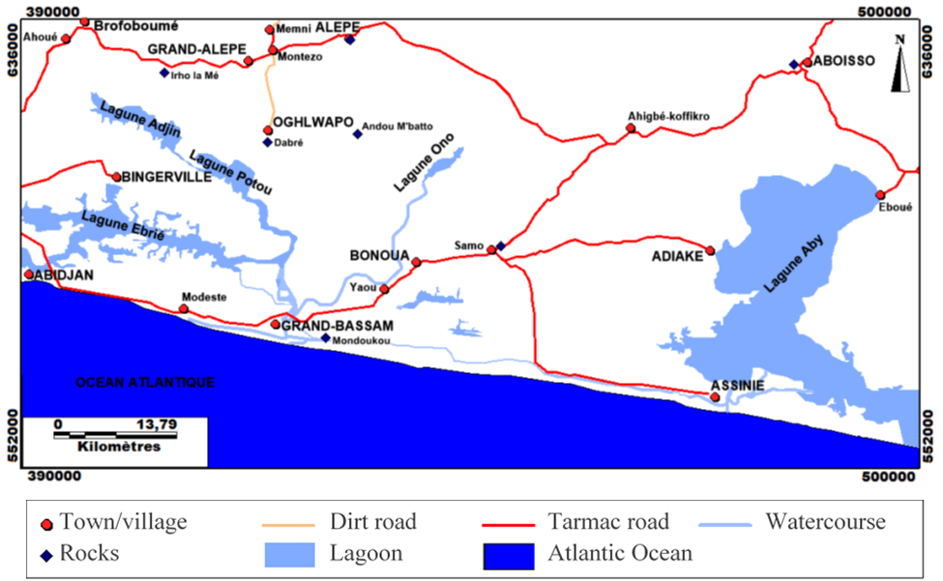

Figure 1: Study area
2.2 Data Collection and Sampling
Socio-economic data were gathered through a structured questionnaire containing 70 items. The questionnaire was administered by 10 trained enumerators to 280 participants (minimum age of 30) across the focal localities of Ahigbé-Koffikro and Samo along the Bonoua–Aboisso highway axis. The survey instrument was structured into four thematic modules: (1) Respondent demographics and baseline characteristics; (2) Climate change awareness and perceptions; (3) Socio-economic and financial consequences of climate anomalies; (4) Local adaptive actions and coping mechanisms.
2.3 Remote Sensing and Statistical Analysis
To quantify environmental changes, Landsat TM (1986) and ETM+ (2000, 2016) satellite images (Path =195; Row = 056) were acquired to generate diachronic land-use maps (Figure 2). Spatial data processing and supervised classifications were executed using ENVI 4.3 software. Descriptive and inferential statistical analyses of the socio-economic survey data were conducted using IBM SPSS Statistics 20.
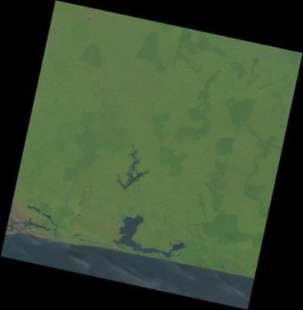
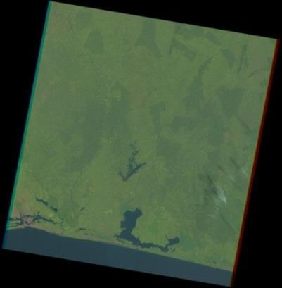
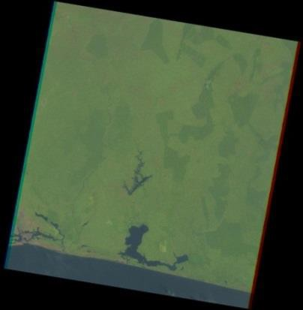

1986 2000 2016
Figure 2: Landsat 5 TM satellite images (1986) and Landsat 7 and 8 ETM+ satellite images (2000 and 2016)

3. Results
3.1 Population Perceptions of Climate Impacts
The survey sample displayed an age range of 30 to 84 years, with a mean age of 49 years. Climate change awareness is near-universal, with 99.6% of respondents reporting observable shifts over the past decade. Gender-disaggregated perceptual data show that 41.4% of men perceive an increase in rainfall intensity, while 26.8% observe a delayed onset of the rainy season.
Agriculture is the primary livelihood, engaging 57.5% of the population in Ahigbé-Koffikro and 55.5% in Samo. This is supplemented by commerce (25.0% in Samo; 16.2% in Ahigbé-Koffikro), civil service/salaried employment, and transport. Rubber (Hevea brasiliensis) and cassava are the dominant crops. Large-scale agro-industrial oil palm plantations (operated by PALMCI and PALMAFRIQUE) employ 25% of respondents in Ahigbé-Koffikro. Historically dominant crops like pineapple have fallen to fourth place, while coffee and cocoa production show significant declines.
Overall, 81.4% of farmers report substantial declines in crop yields and product quality, leading directly to decreased household incomes. Conversely, a small minority (7.2%) noted a temporary yield increase attributed to heavy rainfall in 2014, while salaried workers reported stable economic conditions.

The very high level of climate-change awareness observed here is consistent with evidence from other West African farming systems showing that farmers often perceive changes in rainfall timing, rainfall amount, and temperature that broadly correspond with instrumental climate records (Ayanlade et al., 2017; Kone et al., 2022). Such perceptions are analytically important because they can shape the selection and timing of farm-level adaptation measures, particularly in rain-fed systems where seasonal uncertainty directly affects crop establishment and yield formation (Sultan & Gaetani, 2016).
3.2 Environmental and Ecosystem Shifts
Respondents noted severe ecological disruptions linked to shifts in precipitation and rising temperatures, notably the localised extinction of flora and fauna. Specific losses include coffee trees and Thaumatococcus daniellii (locally used for text wrapping), alongside declines in pangolin and locust populations. Concurrently, climate-driven ecosystem degradation has accelerated coastal erosion and damaged rural access roads. Although mean annual rainfall remains high (~1,600 mm), the primary agricultural constraint is the increasing unpredictability and disruption of traditional crop seasons.
The reported ecological changes should be interpreted as the combined outcome of climatic stress and land-use pressure rather than as evidence of a single causal driver. Climate-model analyses project increasing warm extremes in Côte d'Ivoire, while remote-sensing studies elsewhere in the country document substantial forest conversion and land degradation associated with agricultural expansion and population pressure (Yapo et al., 2019; Kouassi et al., 2021). In the Abidjan lagoonal environment, long-term urban reclamation and wetland transformation further illustrate how anthropogenic modification can intensify the vulnerability of low-lying coastal ecosystems (Eguavoen, 2022).
3.3 Agro-Ecological and Autonomous Adaptation Strategies
Faced with economic strain, 32.7% of households transitioned out of primary crop production. Diversification pathways (Table I) include poultry farming, urban transport, and commercial reorientation. Within agriculture, farmers have systematically shifted away from water-sensitive crops (pineapple, coffee, cocoa, maize, and coconut) toward drought-resistant or water-efficient alternatives like rubber, oil palm, and cassava.
The portfolio of responses identified in the survey is consistent with adaptation pathways reported in West African smallholder systems, where shifting sowing dates, adopting more suitable varieties, diversifying crops or income sources, and adjusting land-management practices are recurrent responses to climate variability (Sultan & Gaetani, 2016; Kone et al., 2022). The observed movement toward lowland or wetland rice production also has a regional analogue: evidence from Côte d'Ivoire and Ghana indicates that adoption of inland-valley farming is shaped by household resources, farm size, competing perennial crops, and access to local institutions and services (Alemayehu & Van der Werf, 2026). Accordingly, the strategies recorded here are better viewed as context-dependent livelihood adjustments than as uniformly effective adaptations.
Table I. Local adaptation methods disaggregated by gender.
Adaptation Method | Male (%) | Female (%) | Total Share (%)
Soil Fertilisation Techniques | 20.8 | 9.3 | 30.1
Introduction of New Crops | 11.5 | 1.6 | 13.1
Livelihood Diversification | 7.1 | 0.0 | 7.1
Improved Crop Varieties | 4.4 | 0.5 | 4.9
Staggered Sowing / Multiple Re-seedings | 1.1 | 0.0 | 1.1
Localised Reforestation | 0.5 | 0.0 | 0.5
No Adaptation Action | 22.4 | 15.8 | 38.3
Other Strategies | 4.4 | 0.5 | 4.9

3.4 Diachronic Land-Use Change Analysis (1986–2016)
Supervised classification of satellite imagery demonstrated major spatial rearrangements over the 30-year study period. The overall classification accuracy was highly robust, yielding global accuracies of 99.35% (1986) and 98.92% (2000), with corresponding Kappa coefficients of 0.99 and 0.98. Table II presents the results showing the evolution of land cover classes from 1986 to 2016.
Table II. Evolution of land cover classes from 1986 to 2016.
Land Cover Class | 1986 Surface (%) | 2000 Surface (%) | 2016 Surface (%) | Net Change (%)
Agricultural Zones | 38.01 | 41.02 | 38.40 | +0.39
Water Bodies | 31.11 | 30.99 | 30.82 | -0.29
Built-up / Settlements | 11.09 | 12.25 | 18.80 | +7.71
Dense Forest | 16.94 | 14.86 | 7.56 | -9.38
Bare Soil | 0.16 | 0.88 | 4.42 | +4.26
Marshlands / Wetlands | 2.69 | 0.00 | 0.00 | -2.69
Key spatial dynamics reveal that built-up areas expanded by 7.71%, driven by demographic growth and urbanisation. Conversely, dense forests decreased by 9.38%, signalling severe deforestation. The diachronic land-use analysis highlights a major or crucially spatial rearrangement, characterized by the complete disappearance of the marshland class, which collapsed from 2.69% of the total study area in 1986 to 0.00% by the year 2000. This radical regression of surface wetlands is attributed to the combined effects of climatic and anthropogenic factors. On one hand, the region experienced prolonged and sub-continuous droughts between 1971 and 2000, which triggered a progressive drying out of low-lying wetland basins.
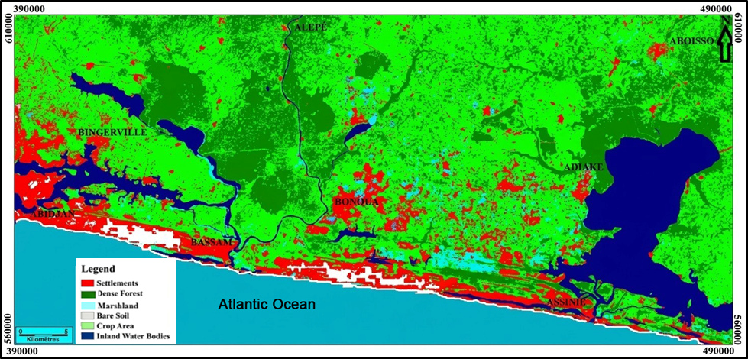
Figure 3: Land use and land cover map of the southeastern coastal zone in 1986: baseline status of forest and marshland ecosystems.
On the other hand, to cope with moisture deficits on the uplands, local populations deployed an autonomous adaptation strategy by opportunistically converting these dried marshland beds into rice paddies. This spatial dynamic highlights a structural shift toward wetland farming, transforming a vulnerable natural ecosystem into a livelihood resource to mitigate declining yields in traditional rainfed agriculture.
The direction of land-cover change is broadly consistent with longer-term evidence from Côte d'Ivoire, where Landsat-based studies have documented forest loss, agricultural expansion, and settlement growth over recent decades (Kouassi et al., 2021; Kouame et al., 2019). Around Abidjan, progressive reclamation and occupation of lagoonal and marshy margins have likewise reduced aquatic and wetland space, demonstrating that urban growth can directly reconfigure coastal land-water boundaries (Eguavoen, 2022). The conversion of former marshlands into rice fields in the present study is also compatible with the wider importance of lowland rice systems in Côte d'Ivoire, although such conversion should not be interpreted as exclusively climate-driven because agricultural demand, land availability, and institutional factors can also influence lowland adoption (Komatsu et al., 2022; Alemayehu & Van der Werf, 2026).

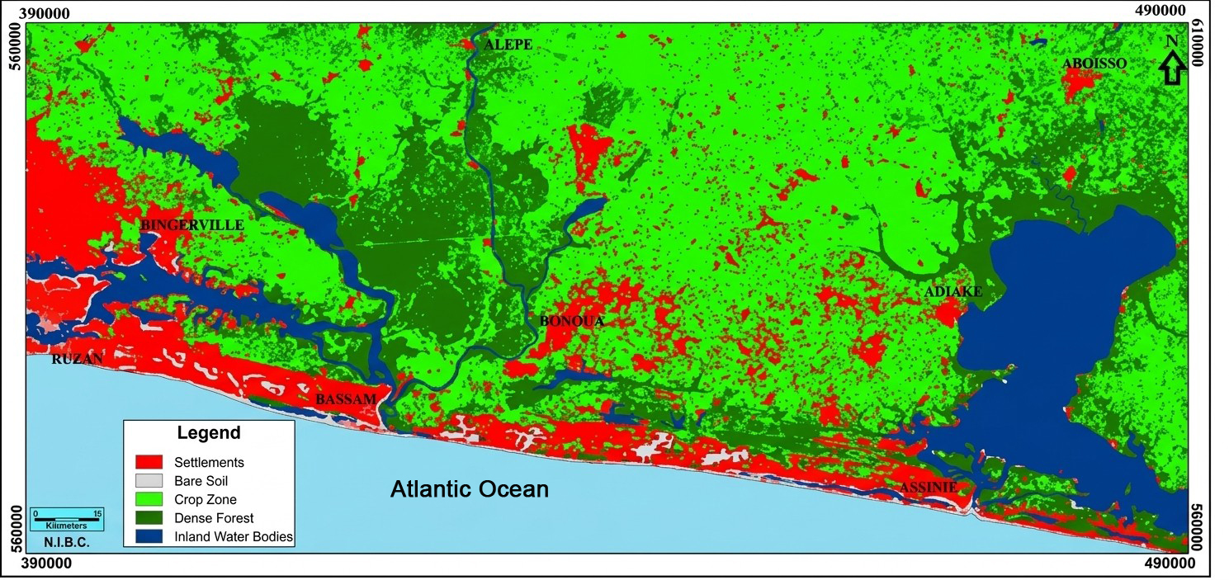
Figure 4: Land use and land cover map in 2000: markers of the initial agricultural transition phase and complete marshland loss.
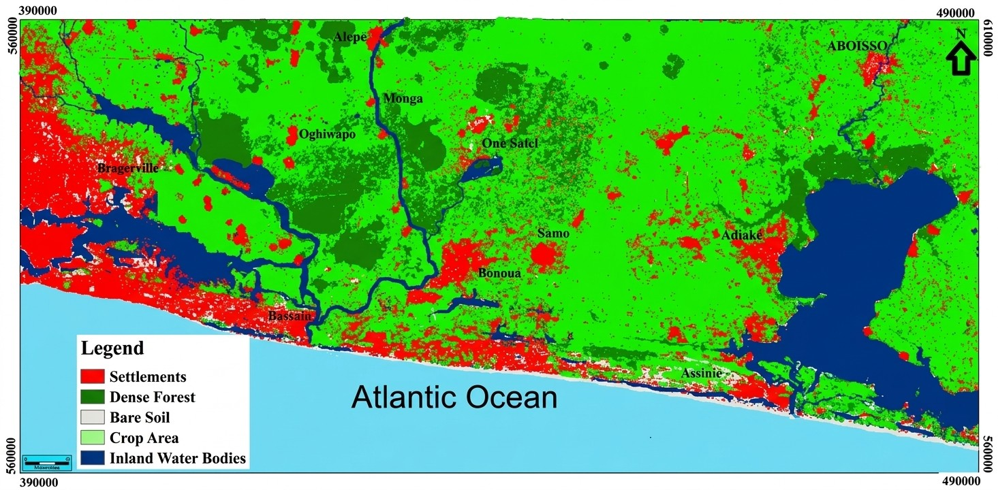
Figure 5: Land use and land cover map in 2016: intensification of anthropogenic pressure and urban expansion.

4. Discussion
The high alignment between local climate change perceptions in the Abidjan–Aboisso corridor and actual meteorological anomalies corroborates regional findings across West Africa (Al Hamndou and Requier-Desjardins, 2008; Balme, 2005, Soro, 2010; Soro, 2014). For instance, smallholder observations mirror findings from Dimbokro, Côte d'Ivoire, and rural Burkina Faso, where over 76% of farmers reported highly disrupted rainfall patterns (Diomandé, 2013; Ouédraogo et al, 2010; Yapi, 2014). The perceived drop in crop yields is directly explained by the shortening of the bioclimatic growing period, which fails to cover the full physiological growth cycle of traditional crops.
To preserve yields, the observed adoption of chemical/organic fertilisers and early-maturing, short-cycle crop varieties matches documented trends in regional climate adaptation literature (Global Water Partnership, 2010; UNDP, 2009). The systematic expansion of agricultural land into former marshlands underscores a structural transition towards opportunistic wetland farming as an autonomous defence against upland moisture deficits (Dioum, 2010; Dugué, 2012; Mbaye et al, 2011; Ouaga, 2009; Tidjani and Akponikpe, 2012).

Taken together, the results support a socio-ecological interpretation in which perceived climatic disruption, livelihood adjustment, and land-cover change interact rather than operate independently. Studies comparing farmer perceptions with meteorological records show that local observations can capture meaningful shifts in rainfall and temperature, but the strength and direction of perceived impacts remain context-specific (Ayanlade et al., 2017; Kone et al., 2022). This cautions against attributing every observed livelihood or ecological change solely to climate variability and supports consideration of demographic, land-use, and market pressures alongside climatic factors.
From an agricultural perspective, the observed emphasis on crop substitution, improved varieties, sowing adjustments, and lowland rice expansion is consistent with the broader adaptation literature for West Africa (Sultan & Gaetani, 2016). Modelling work indicates that higher temperatures can shorten rice growth duration and reduce yields in African rice systems, while evidence from Côte d'Ivoire shows that recent growth in lowland rice production has been driven substantially by expansion of cropped area as well as yield improvement (Van Oort & Zwart, 2018; Komatsu et al., 2022). The marshland-to-rice transition identified by the present land-use analysis can therefore be interpreted as one component of a wider livelihood response, but its ecological trade-offs warrant careful consideration where wetland functions are being replaced by agriculture.
Evidence from inland-valley farming in Côte d'Ivoire and Ghana further shows that household resource endowments and competing land uses influence whether farmers adopt lowland rice production, reinforcing that adaptive capacity is socially differentiated rather than uniform across households (Alemayehu & Van der Werf, 2026).
5. Conclusion
Smallholders in the southeastern coastal zone of Côte d'Ivoire face severe, direct threats from climate variability, which has disrupted traditional crop calendars and reduced agricultural yields and incomes for over a decade. In response, local populations have deployed diversified adaptation mechanisms. These range from field-level adjustments (soil fertilisation, improved varieties, staggered sowing) to structural socio-economic shifts (poultry farming, transportation, commercial migration). Furthermore, spatial dynamics confirm that landscape modifications—especially the transformation of ecologically valuable marshlands into rice fields—act as visible footprints of localised community adaptation to climatic stress.
Declaration of AI Use

This manuscript was prepared through the intellectual contributions of the author(s) to the study design, data analysis, interpretation of results, and scholarly content. Grammarly and ChatGPT were used solely to assist with grammatical refinement and reference formatting during manuscript revision. The author(s) accept full responsibility for the accuracy, integrity, and final content of the manuscript.

COMPETING INTERESTS DISCLAIMER:
Authors have declared that they have no known competing financial interests OR non-financial interests OR personal relationships that could have appeared to influence the work reported in this paper.

References
Ake, G.E. (2010) Impacts de la variabilité climatique et des pressions anthropiques sur les ressources hydriques de la région de Bonoua (Sud-Est de la Côte d’Ivoire) [Impacts of climate variability and anthropogenic pressures on water resources in the Bonoua region (South-Eastern Côte d’Ivoire)]. PhD thesis, University of Cocody-Abidjan, Côte d'Ivoire,( Impacts of climate variability and anthropogenic pressures on water resources in the Bonoua region (South-Eastern Côte d’Ivoire). PhD thesis, University of Cocody-Abidjan, Côte d'Ivoire) 191 p.
Al Hamndou, D. and Requier-Desjardins, M. (2008) 'Variabilité climatique, désertification et biodiversité en Afrique : s’adapter, une approche intégrée' [Climate variability, desertification and biodiversity in Africa: adapting, an integrated approach], VertigO - la revue électronique en sciences de l'environnement, 8(1). DOI: 10.4000/vertigo.5356.
Balme, M., Galle, S. and Lebel, T. (2005) 'Démarrage de la saison des pluies au Sahel: variabilité aux échelles hydrologique et agronomique, analysée à partir des données EPSAT-Niger' [Onset of the rainy season in the Sahel: variability at hydrological and agronomic scales, analysed from EPSAT-Niger data], Sécheresse, 16(1), pp. 15-22.
Diomandé, M. (2013) Impact du changement de pluviosité sur les systèmes de production agricoles en zone de contact forêt-savane de Côte d’Ivoire [Impact of changes in rainfall on agricultural production systems in the forest-savanna contact zone of Côte d’Ivoire]. PhD thesis, Félix Houphouët-Boigny University, Côte d'Ivoire, 190 p.
Dioum, A. (2010) Stratégies endogènes d’adaptation aux changements climatiques : recul des cultures sous pluie et extension de l’arboriculture associée dans la communauté rurale de Taïba Ndiaye [Endogenous strategies for adaptation to climate change: decline of rainfed crops and expansion of associated arboriculture in the rural community of Taïba Ndiaye]. Master's thesis, Cheikh Anta Diop University of Dakar, Senegal, 94 p.
Dugué, M-J. (2012) Caractérisation des stratégies d’adaptation au changement climatique en agriculture paysanne [Characterisation of adaptation strategies to climate change in smallholder agriculture]. Capitalisation study, Agronomes et Vétérinaires Sans Frontières (AVSF), 50 p.
Global Water Partnership (2010) Local adaptation initiatives in West Africa. Available at: http://www.gwpao.org (Accessed: 2 April 2014).
Kpan, O.J.G. (2017) Incidence de la variabilité climatique sur les ressources en eau, le développement agricole et la santé des populations dans le Sud-Est de la Côte d’Ivoire et prospectives : cas de la zone littorale d’Abidjan à Aboisso [Impact of climate variability on water resources, agricultural development and population health in South-Eastern Côte d'Ivoire and future outlook: case of the coastal zone from Abidjan to Aboisso]. PhD thesis, Félix Houphouët-Boigny University, Côte d'Ivoire, 225 p.
Mbaye, I., Sane, T. and Dieye, E.B. (2011) 'Changement climatique, perceptions et stratégies des populations de la ville de Ziguinchor au Sénégal' [Climate change, perceptions and strategies of the population in the city of Ziguinchor, Senegal], Proceedings of the Conference at Paul Verlaine University-Metz, France, 9 p.
Oga, Y.M.S., Adja, M., Yapi, A.F., Kpan, J.G., Baka, D., Yao, K.T. and Biemi, J. (2016) 'Projection de la variabilité climatique à l’horizon 2050 dans la zone côtière au Sud-Est de la Côte d’Ivoire (d’Abidjan à Aboisso)' [Projection of climate variability by 2050 in the coastal zone of South-Eastern Côte d'Ivoire (from Abidjan to Aboisso)], Larhyss Journal, (25), pp. 67-81.
Ouaga, H.N. (2009) Vulnérabilité, impacts et stratégies d’adaptation des populations locales à la variabilité et aux changements climatiques [Vulnerability, impacts and adaptation strategies of local populations to climate variability and change]. Regional Report, AGRHYMET Regional Centre, Niger.
Ouédraogo, M., Dembélé, Y. and Somé, L. (2010) 'Perceptions et strategies d’adaptation aux changements des precipitations: cas des paysans du Burkina Faso' [Perceptions and strategies for adaptation to rainfall changes: the case of farmers in Burkina Faso], Sécheresse, 21(2), pp. 87-96.
UNDP (2009) Programme d’Appui à la Réduction de la Pauvreté du PNUD 2009-2013, sous Programme Protection de l’Environnement et Gestion Durable des Ressources Naturelles (PGDRN). Project Document, United Nations Development Programme.( UNDP Poverty Reduction Support Programme 2009–2013, Environmental Protection and Sustainable Natural Resource Management (PGDRN) Sub-programme. Project Document, United Nations Development Programme.)
Soro, G. (2010) Évaluation quantitative et qualitative des ressources en eau souterraines dans la région des lacs (Centre de la Côte d'Ivoire). PhD thesis, University of Cocody-Abidjan,( Quantitative and qualitative assessment of groundwater resources in the Lakes Region (Central Côte d'Ivoire). PhD thesis, University of Cocody-Abidjan.) Côte d'Ivoire, 250 p.
Soro, T. (2014) Évolution des ressources en eau du bassin versant du Haut Bandama à Tortiya (Nord de la Côte d’Ivoire) dans un contexte de variabilité et de changement climatiques. PhD thesis, Félix Houphouët-Boigny University, Côte d'Ivoire, (Evolution of water resources in the Upper Bandama watershed at Tortiya (Northern Côte d’Ivoire) in the context of climate variability and change. PhD thesis, Félix Houphouët-Boigny University, Côte d'Ivoire.)250 p.
Tidjani, M.A. and Akponikpe, P.B.I. (2012) 'Évaluation des stratégies paysannes d’adaptation aux changements climatiques : cas de la production du maïs au Nord-Bénin', African Crop Science Journal, 20(Supplement s2), pp.( 'Assessment of farmers' strategies for adapting to climate change: the case of maize production in northern Benin', African Crop Science Journal, 20(Supplement s2),) 425-441.
Yapi, A.F. (2014) Étude de la variabilité climatique et son impact sur les ressources en eau de la zone côtière de la Côte d’Ivoire (d’Abidjan à Aboisso). (Study of climate variability and its impact on water resources in the coastal zone of Côte d’Ivoire)Master's thesis, Félix Houphouët-Boigny University, Côte d'Ivoire, 56 p.
Alemayehu, T., & Van der Werf, E. (2026). Adoption of inland valley farming and rice production practices: Evidence from smallholder farmers in Côte d'Ivoire and Ghana. Agricultural and Resource Economics Review, 55(1), 145–165. https://doi.org/10.1017/age.2025.10018
Ayanlade, A., Radeny, M., & Morton, J. F. (2017). Comparing smallholder farmers’ perception of climate change with meteorological data: A case study from southwestern Nigeria. Weather and Climate Extremes, 15, 24–33. https://doi.org/10.1016/j.wace.2016.12.001
Eguavoen, I. (2022). Reclamation and expulsion: Frontiers of city expansion and the loss of public and communal spaces at Abidjan’s lagoonal waterfronts. Urban Forum, 33, 367–392. https://doi.org/10.1007/s12132-021-09451-7
Komatsu, S., Saito, K., & Sakurai, T. (2022). Changes in production, yields, and the cropped area of lowland rice over the last 20 years and factors affecting their variations in Côte d’Ivoire. Field Crops Research, 277, 108424. https://doi.org/10.1016/j.fcr.2021.108424
Kone, I., Agyare, W. A., Gaiser, T., Owusu-Prempeh, N., Kouadio, K.-K. H., Kouadio, E. N., & Amponsah, W. (2022). Local cotton farmers’ perceptions of climate change events and adaptations strategies in cotton basin of Cote d'Ivoire. Journal of Sustainable Development, 15(3), 108–124. https://doi.org/10.5539/jsd.v15n3p108
Kouame, Y. M., Obahoundje, S., Diedhiou, A., François, B., Amoussou, E., Anquetin, S., Didi, R. S., Kouassi, L. K., Bi, V. H. N., Soro, E. G., & Yao, E. K. (2019). Climate, land use and land cover changes in the Bandama Basin (Côte d’Ivoire, West Africa) and incidences on hydropower production of the Kossou Dam. Land, 8(7), 103. https://doi.org/10.3390/land8070103
Kouassi, J.-L., Gyau, A., Diby, L., Bene, Y., & Kouamé, C. (2021). Assessing land use and land cover change and farmers’ perceptions of deforestation and land degradation in south-west Côte d’Ivoire, West Africa. Land, 10(4), 429. https://doi.org/10.3390/land10040429
Sultan, B., & Gaetani, M. (2016). Agriculture in West Africa in the twenty-first century: Climate change and impacts scenarios, and potential for adaptation. Frontiers in Plant Science, 7, 1262. https://doi.org/10.3389/fpls.2016.01262
Van Oort, P. A. J., & Zwart, S. J. (2018). Impacts of climate change on rice production in Africa and causes of simulated yield changes. Global Change Biology, 24(3), 1029–1045. https://doi.org/10.1111/gcb.13967
Yapo, A. L. M., Diawara, A., Yoroba, F., Kouassi, B. K., Sylla, M. B., Kouadio, K., Odoulami, R. C., & Tiémoko, D. T. (2019). Twenty-first century projected changes in extreme temperature over Côte d’Ivoire (West Africa). International Journal of Geophysics, 2019, Article 5610328. https://doi.org/10.1155/2019/5610328

