CASE REPORT
Reflex Supraventricular Tachycardia and Chest Pain Following the First Dose of Fixed-Dose Perindopril/Amlodipine in an Older Patient With Hypertension and Type 2 Diabetes Mellitus: A Case Report
Abstract
Background: Fixed-dose combinations (FDCs) of an angiotensin-converting enzyme (ACE) inhibitor and a dihydropyridine calcium-channel blocker (CCB) are recommended as initial therapy for most patients with arterial hypertension and are generally well tolerated. Reflex tachycardia has not previously been reported with the perindopril/amlodipine combination.
Case summary: A 70-year-old Caucasian man with arterial hypertension and type 2 diabetes mellitus developed chest pain 1 hour after the first dose of AlmirinComb 4/5 mg (perindopril 4 mg/amlodipine 5 mg). The prehospital ECG showed supraventricular tachycardia (SVT), which was terminated with adenosine (6 mg, then 12 mg); conversion to sinus rhythm was accompanied by transient inferior ST denivelation, and the chest pain resolved immediately. On arrival in the hospital he was pain-free, hemodynamically stable (blood pressure 162/90 mmHg, heart rate 82 beats/min), and in normal sinus rhythm without ST-segment changes; serial high-sensitivity troponin I values remained within the normal range. Cardiology consultation attributed the event to reflex tachycardia. According to the World Health Organization–Uppsala Monitoring Centre (WHO-UMC) causality assessment system, the reaction was classified as probable. He was discharged on nebivolol with scheduled ambulatory follow-up (Holter-ECG, exercise testing, echocardiography).
Conclusion: This case suggests that a first dose of an ACE inhibitor/dihydropyridine FDC can, rarely, trigger a reflex-mediated supraventricular tachyarrhythmia with chest pain in an older patient at high cardiovascular risk. Blood pressure and heart rate monitoring after the first dose, patient education on symptoms, and prompt pharmacovigilance reporting are advisable.
Keywords: perindopril; amlodipine; fixed-dose combination; supraventricular tachycardia; reflex tachycardia; adverse drug reaction; case report
Introduction
Arterial hypertension is the leading modifiable risk factor for cardiovascular morbidity and mortality worldwide, affecting an estimated 1.28 billion adults between 30 and 79 years of age.¹ Current guidelines recommend starting treatment with a two-drug combination—an ACE inhibitor or angiotensin receptor blocker together with a CCB or a thiazide/thiazide-like diuretic—for most patients, preferably as a single-pill fixed-dose combination to improve adherence, speed and quality of blood pressure control.^{1,2}
The combination of perindopril and amlodipine is among the most extensively validated ACE inhibitor/CCB pairings. In the Anglo-Scandinavian Cardiac Outcomes Trial–Blood Pressure Lowering Arm (ASCOT-BPLA), an amlodipine-based regimen with perindopril added as required was superior to an atenolol–thiazide regimen in reducing cardiovascular events, mortality, and new-onset diabetes.³ Perindopril-based therapy in patients with type 2 diabetes reduced macrovascular and microvascular outcomes in the ADVANCE trial.⁴ The single-pill perindopril/amlodipine combination lowers blood pressure more effectively than either component alone or placebo, with good tolerability, and has been reviewed favorably as first-step treatment.^{5,6,7}
Despite this favorable efficacy–safety profile, any potent vasodilator combination can produce an acute blood pressure fall with compensatory sympathetic activation. First-dose hypotension is a recognized phenomenon with ACE inhibitors in older patients, and short-acting dihydropyridines are classically associated with reflex tachycardia and palpitations. However, according to Micromedex, reflex tachycardia had not previously been reported with perindopril or amlodipine. In this paper a case of a 70-year-old man with hypertension and type 2 diabetes who presented with chest pain and ECG-documented supraventricular tachycardia 1 hour after his first dose of fixed-dose perindopril/amlodipine is described, plausible mechanisms are being reviewed, and the implications for first-dose monitoring in older, high-risk patients and being discussed.

Case Presentation
A 70-year-old Caucasian male with history of arterial hypertension and diabetes type II was brought to the Emergency Department (ED) of University Hospital Centre by T1 field emergency medicine team (physician, registered nurse and driver) because of an episode of chest pain that developed 1 hour after taking the first dose of the drug AlmirinComb 4/5 mg (contains perindopril 4 mg and amlodipine 5 mg). He took the drug around 9 a.m. and developed chest pain around 10 a.m. During the transport to the hospital the first ECG (Figure 1) showed supraventricular tachycardia and the physician administered adenosine 6 mg and then adenosine 12 mg, after which conversion to sinus rhythm occurred (Figure 2) with ST denivelations inferiorly. Immediately after conversion to sinus rhythm the patient stopped feeling chest pain. A dose of 300 mg of Andol was also administered before arrival to the hospital. At the moment of the first physical exam in the ED the patient was chest-pain free and the third ECG showed normal sinus rhythm without ST deviations (Figure 3). His vital signs were BP 162/90 mmHg, heart rate 82 bpm, oxygen saturation 96% on room air, respirations 16/min, temperature 36.5 °C. The physical examination was within normal limits. His laboratory test results were within normal limits: erythrocytes 5.27 ×10¹²/L, hemoglobin 163 g/L, hematocrit 0.485 L/L, MCV 92 fL, MCH 30.9 pg, MCHC 336 g/L, RDW 13.1%, leukocytes 4.9 ×10⁹/L, PT 1.18, INR 0.93, aPTT 25.9 s, glucose 7.2 mmol/L, BUN 5.8 mmol/L, creatinine 99 µmol/L, potassium 4 mmol/L, sodium 140 mmol/L, CRP less than 1 mg/L. The first high-sensitivity troponin I, obtained at 11:28 a.m., was 5.7 ng/L, and the second, obtained at 12:39 p.m., was 10.7 ng/L. The patient was monitored and observed, and during that period of time another two ECGs were obtained (Figure 4 and 5) showing normal sinus rhythm without any ST-segment dynamics. Chest X-ray was normal (Figure 6). The cardiologist was consulted and the conclusion was that the chest pain was associated with tachycardia, which was probably reflex tachycardia due to the drug AlmirinComb. The patient was discharged with new therapy: nebivolol 5 mg once a day in the morning, nitroglycerine in case of chest pain or very high BP values (180/110 mmHg), and Andol 100 mg once a day, until the next ambulatory follow-up at the cardiologist. Holter-ECG, ergometry and echocardiography were recommended, with additional laboratory tests (HbA1c, glucose, hepatogram, lipidogram) as further out-patient evaluation. The possible adverse-effect was reported to National reporting system (HALMED).

Discussion
The temporal sequence in this case is the cornerstone of the causal interpretation: a first-ever exposure to combined perindopril/amlodipine, symptom onset within approximately 1 hour, an ECG-documented regular narrow-complex tachycardia, termination by intravenous adenosine boluses (6 mg followed by 12 mg), and immediate relief of chest pain upon restoration of sinus rhythm. Adenosine remains the drug of choice for acute termination of hemodynamically stable narrow-complex SVT when vagal maneuvers fail, and its efficacy here indicates an atrioventricular (AV) node–dependent reentrant mechanism (AV nodal reentrant tachycardia or AV reentrant tachycardia).^{10,11}
The chest pain and the transient inferior ST deviations observed immediately after conversion are best explained as rate-related phenomena rather than acute coronary syndrome: the pain abated the moment sinus rhythm was restored, serial high-sensitivity troponin I values remained within the normal range of the assay, and all subsequent ECGs were free of ST-segment dynamics. Rapid regular tachycardia raises myocardial oxygen demand and shortens diastolic coronary perfusion, which can produce demand ischemia, chest pain, and repolarization abnormalities even in the absence of obstructive coronary disease. A coronary vasospastic mechanism cannot be definitively excluded, but the absence of ST-segment elevation, the immediate and complete resolution, and the uneventful subsequent course make it unlikely; scheduled ergometry and echocardiography will further address residual ischemic risk.
From a pharmacological standpoint, the event is mechanistically plausible. Dihydropyridines such as amlodipine lower blood pressure through arterial vasodilation; the acute fall in blood pressure unloads the arterial baroreceptors and provokes a reflex increase in sympathetic outflow with vagal withdrawal, which manifests as tachycardia, palpitations, and flushing. This reflex response is most pronounced with short-acting dihydropyridines and is usually attenuated with amlodipine because of its long elimination half-life and gradual onset of effect, which is precisely why amlodipine is considered largely free of reflex tachycardia.⁸ Nevertheless, a first dose of a two-drug vasodilator combination may lower blood pressure more steeply than either drug alone. ACE inhibitors are a recognized cause of first-dose hypotension in older patients, in whom reduced renal clearance, impaired cardiovascular reflexes, and comorbid heart failure or renal impairment increase susceptibility.⁹ Aging and type 2 diabetes further blunt baroreflex sensitivity, so a brisk first-dose pressure fall may generate an exaggerated and insufficiently buffered sympathetic surge—a setting in which an AV-node–dependent reentrant circuit can be triggered and sustained. The absence of hypotension on arrival in the ED does not argue against this mechanism, since the hemodynamic perturbation is transient and the patient had already converted to sinus rhythm by the time of hospital measurement.
It is also noteworthy that ACE inhibitors attenuate dihydropyridine-induced ankle edema by reducing precapillary hydrostatic pressure, a complementary pharmacodynamic interaction that underlies the rationale of the fixed combination.⁸ The same additive vasodilator effect, however, may translate into a larger initial blood pressure drop in susceptible individuals, as this case illustrates. Fixed-dose perindopril/amlodipine has otherwise shown a reassuring safety profile in randomized first-step and comparative trials, in which adverse events were mostly mild (cough, peripheral edema, flushing, dizziness, hypotension) and comparable to those of the component drugs.^{5,6,7}
Causality assessment supports a drug-related event. Using the WHO-UMC system, the reasonable time relationship, the clinical reasonableness of the response to withdrawal (no recurrence after the combination was stopped), the lack of a more plausible alternative explanation, and the objective ECG documentation fulfil the criteria for a “probable/likely” classification without the need for rechallenge, which would have been ethically unjustified.¹² Application of the Naranjo algorithm yields a score of 4 (possible) if de novo paroxysmal SVT is accepted as an alternative cause, and 6 (probable) if alternative causes are judged unlikely; the WHO-UMC “probable” classification adopted by the treating team therefore sits at the upper bound of structured assessments.¹³ Paroxysmal SVT can occur spontaneously in older adults; however, the tight temporal association with the first dose, the absence of any previous episode, and the immediate symptom resolution upon conversion argue in favor of a drug-triggered reflex mechanism.
Several patient-related factors plausibly increased susceptibility: advanced age (70 years), type 2 diabetes with probable subclinical autonomic dysfunction, a first exposure to both agents simultaneously, and uncontrolled hypertension at baseline. These are precisely the patients in whom guidelines advise lower initial doses, cautious up-titration, and early blood pressure (and, in practice, heart rate) monitoring after starting or changing ACE inhibitor–based therapy.^{9,15}
The management in this case followed current recommendations: prehospital recognition and pharmacologic cardioversion of stable narrow-complex SVT with adenosine,^{10,11} exclusion of acute coronary syndrome with serial ECGs and troponin measurements, and discontinuation of the implicated combination. The choice of nebivolol for subsequent antihypertensive therapy is rational: it is a highly β₁-selective blocker with nitric oxide–mediated vasodilatory properties, a favorable metabolic profile in patients with type 2 diabetes, and direct protection against reflex sympathetic tachycardia if vasodilator therapy is reintroduced, while nitroglycerin was sensibly reserved for acute symptom relief.
This report has limitations inherent to a single case: no electrophysiological study was performed, the in-hospital observation window was short, rechallenge was appropriately omitted, and a spontaneous first episode of paroxysmal SVT coinciding with the first drug dose cannot be excluded with absolute certainty. Nonetheless, case reports remain a signal-generating tool in pharmacovigilance, particularly for rare or unexpected reactions that randomized trials—which systematically exclude the frailest, highest-risk patients—are underpowered to detect.
Conclusion
This case suggests that, although previously unreported, the fixed-dose combination of perindopril and amlodipine may be associated with supraventricular tachycardia—most plausibly reflex-mediated—in patients with higher cardiovascular risk such as elderly individuals with type 2 diabetes and arterial hypertension. According to the WHO-UMC Causality Assessment System, this adverse effect may be classified as probable. Clinicians should consider blood pressure and heart rate monitoring after the first dose of ACE inhibitor/dihydropyridine combinations in older high-risk patients, should educate patients to seek immediate care for palpitations or chest pain after initiation, and should report suspected adverse drug reactions to their national pharmacovigilance centre to allow signal confirmation or refutation.
Declarations
Ethics approval and consent to participate: Not applicable.
Consent for publication: Written informed consent was obtained from the patient for publication of this case report and any accompanying images. A copy of the written consent is available for review by the journal.
Reporting guideline: This report was prepared in accordance with the CAse REport (CARE) guidelines.{14}
Conflicts of interest: The authors declare no competing interests.
Data availability: All data generated or analyzed during this study are included in this published article.
Declaration of AI Use

This manuscript was prepared through the intellectual contributions of the author(s) to the study design, data analysis, interpretation of results, and scholarly content. Grammarly and ChatGPT were used solely to assist with grammatical refinement and reference formatting during manuscript revision. The author(s) accept full responsibility for the accuracy, integrity, and final content of the manuscript.

References
1. Mancia G, Kreutz R, Brunström M, et al. 2023 ESH Guidelines for the management of arterial hypertension The Task Force for the management of arterial hypertension of the European Society of Hypertension: Endorsed by the International Society of Hypertension (ISH) and the European Renal Association (ERA). J Hypertens. 2023;41(12):1874-2071. doi:10.1097/HJH.0000000000003480
2. Williams B, Mancia G, Spiering W, et al. 2018 ESC/ESH Guidelines for the management of arterial hypertension. Eur Heart J. 2018;39(33):3021-3104. doi:10.1093/eurheartj/ehy339
3. Dahlöf B, Sever PS, Poulter NR, et al. Prevention of cardiovascular events with an antihypertensive regimen of amlodipine adding perindopril as required versus atenolol adding bendroflumethiazide as required, in the Anglo-Scandinavian Cardiac Outcomes Trial-Blood Pressure Lowering Arm (ASCOT-BPLA): a multicentre randomised controlled trial. Lancet. 2005;366(9489):895-906. doi:10.1016/S0140-6736(05)67185-1
4. Patel A; ADVANCE Collaborative Group, MacMahon S, et al. Effects of a fixed combination of perindopril and indapamide on macrovascular and microvascular outcomes in patients with type 2 diabetes mellitus (the ADVANCE trial): a randomised controlled trial. Lancet. 2007;370(9590):829-840. doi:10.1016/S0140-6736(07)61303-8
5.Shirley M, McCormack PL. Perindopril/amlodipine (Prestalia(®)): a review in hypertension. Am J Cardiovasc Drugs. 2015;15(5):363-370. doi:10.1007/s40256-015-0144-1
6. Laurent S, Parati G, Chazova I, et al. Randomized evaluation of a novel, fixed-dose combination of perindopril 3.5 mg/amlodipine 2.5 mg as a first-step treatment in hypertension. J Hypertens. 2015;33(3):653-662. doi:10.1097/HJH.0000000000000440
7. Mancia G, Asmar R, Amodeo C, et al. Comparison of single-pill strategies first line in hypertension: perindopril/amlodipine versus valsartan/amlodipine. J Hypertens. 2015;33(2):401-411. doi:10.1097/HJH.0000000000000409
8. Abernethy DR, Schwartz JB. Calcium-antagonist drugs. N Engl J Med. 1999;341(19):1447-1457. doi:10.1056/NEJM199911043411907
9. Tomlinson B. Optimal dosage of ACE inhibitors in older patients. Drugs Aging. 1996;9(4):262-273. doi:10.2165/00002512-199609040-00004
10. Brugada J, Katritsis DG, Arbelo E, et al. 2019 ESC Guidelines for the management of patients with supraventricular tachycardiaThe Task Force for the management of patients with supraventricular tachycardia of the European Society of Cardiology (ESC). Eur Heart J. 2020;41(5):655-720. doi:10.1093/eurheartj/ehz467
11. Page RL, Joglar JA, Caldwell MA, et al. 2015 ACC/AHA/HRS guideline for the management of adult patients with supraventricular tachycardia: A Report of the American College of Cardiology/American Heart Association Task Force on Clinical Practice Guidelines and the Heart Rhythm Society. Heart Rhythm. 2016;13(4):e136-e221. doi:10.1016/j.hrthm.2015.09.019
12. World Health Organization–Uppsala Monitoring Centre. The use of the WHO-UMC system for standardised case causality assessment. Uppsala, Sweden: WHO-UMC; 2018. Accessed October 2, 2026. https://www.who.int/docs/default-source/medicines/pharmacovigilance/whocausality-assessment.pdf
13. Naranjo CA, Busto U, Sellers EM, et al. A method for estimating the probability of adverse drug reactions. Clin Pharmacol Ther. 1981;30(2):239-245. doi:10.1038/clpt.1981.154
14. Gagnier JJ, Kienle G, Altman DG, et al. The CARE guidelines: consensus-based clinical case report guideline development. J Clin Epidemiol. 2014;67(1):46-51. doi:10.1016/j.jclinepi.2013.08.003
15. Specialist Pharmacy Service. ACE inhibitors and angiotensin II receptor blockers monitoring. NHS England. Published April 23, 2025. Accessed October 2, 2026. https://sps.nhs.uk/monitorings/ace-inhibitors-and-angiotensin-ii-receptor-blockers-monitoring/

Figure 1. SVT (around 10:30 a.m.)
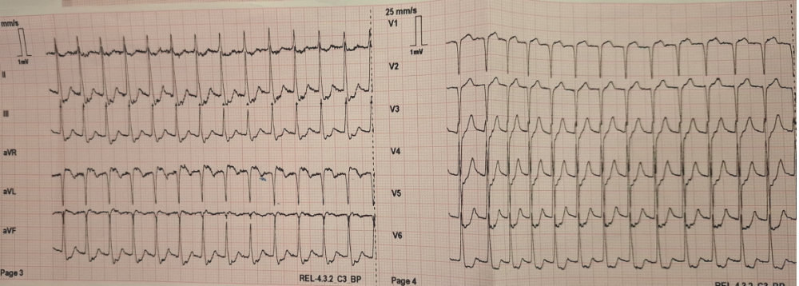

Figure 2. Sinus rythm after conversion with adenosine.
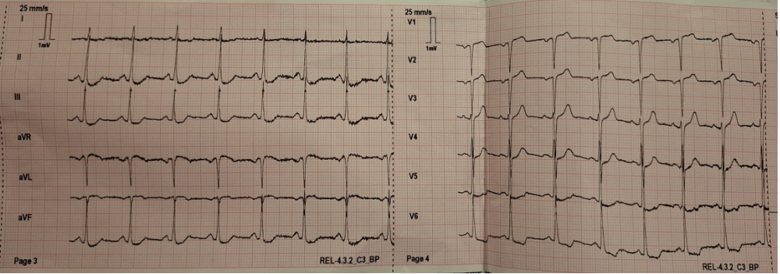

Figure 3. Sinus rythm in ED department: no ST-denivelations.
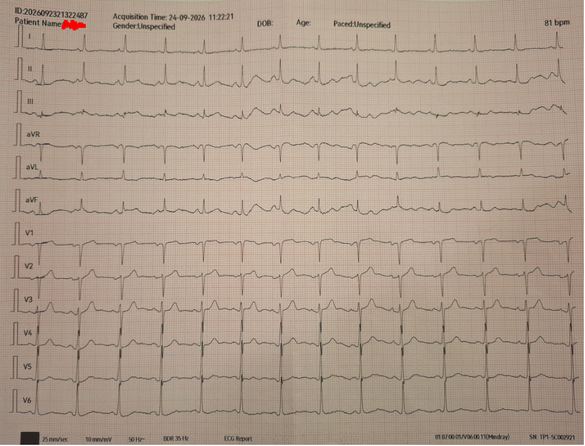

Figure 4. Follow up ECG
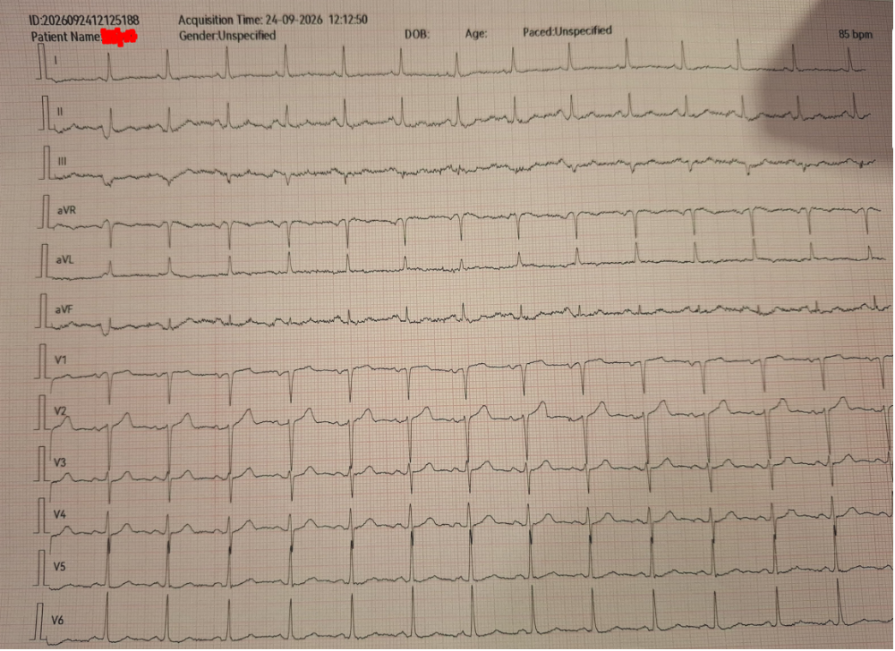

Figure 5. Follow-up ECG before discharge from hospital.
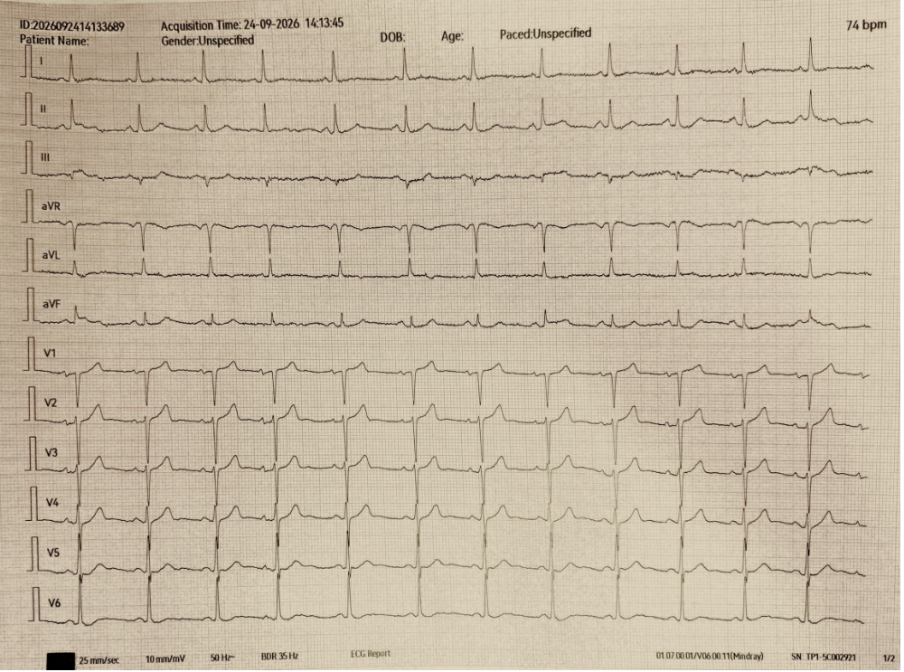

Figure 6. Chest X-ray
