Case study
Clinical and Dermoscopic Spectrum of Dermatofibrosarcoma Protuberans in Fitzpatrick Skin Phototype III: A Four-Case Series

.
ABSTRACT

Background: Dermatofibrosarcoma protuberans (DFSP) is a rare, slow-growing cutaneous sarcoma characterized by locally aggressive behavior and a high risk of local recurrence. Its variable clinical presentation may mimic several benign and malignant cutaneous lesions. Dermoscopy can provide useful diagnostic clues, although no single feature is specific.
Objective: To describe the clinical and dermoscopic characteristics of DFSP in patients with Fitzpatrick skin phototype III.
Methods: We retrospectively describe four histopathologically confirmed cases of DFSP, all occurring in patients with Fitzpatrick skin phototype III. Clinical and dermoscopic findings were assessed and compared with previously reported dermoscopic features.
Results: The patients were aged 19–47 years, including three women and one man. Lesions were located on the trunk and proximal lower extremities and presented as pink or brownish plaques, nodules, or hypertrophic lesions, including one recurrence within a surgical graft scar. Dermoscopy consistently demonstrated arborizing or linear vessels, a pink background, and white structureless or shiny areas in all four cases. A pigment network was observed in two cases, while yellowish structureless areas were present in three. The recurrent lesion showed prominent thick arborizing vessels over an erythematous fibrotic background. These findings support a multicomponent dermoscopic pattern involving vascular, pigmentary, and fibrotic structures.
Conclusion: DFSP exhibits considerable clinical and dermoscopic variability, which may contribute to diagnostic delay. In our series, the recurrent combination of arborizing or linear vessels, a pink background, and white structureless or shiny areas represented the most consistent dermoscopic pattern. Although none of these findings is pathognomonic, their combination may raise suspicion for DFSP and prompt histopathological confirmation. Larger studies are needed to clarify the influence of skin phototype on DFSP dermoscopy.

Keywords: Dermatofibrosarcoma protuberans; Dermoscopy; Cutaneous sarcoma; Skin phototype; Arborizing vessels.

1. INTRODUCTION

Dermatofibrosarcoma protuberans (DFSP) is a rare, slow-growing cutaneous sarcoma characterized by locally aggressive behavior and a high propensity for local recurrence, while the metastatic potential remains low. Its nonspecific clinical presentation may mimic benign lesions such as dermatofibroma, keloid, or morphea, potentially delaying diagnosis¹. Dermoscopy may provide additional diagnostic clues, although no single dermoscopic feature is considered pathognomonic ¹˒². We report the clinical and dermoscopic features of four histologically confirmed cases of DFSP in patients with Fitzpatrick skin phototype III.

2. CASE SERIES:

All four patients had Fitzpatrick skin phototype III, and the diagnosis of DFSP was histopathologically confirmed in all cases.

Case 1: A 40-year-old man with no relevant medical history presented with a painless lesion on the infraumbilical abdominal wall that had progressively enlarged over 1 year. Examination revealed a solitary, slightly firm, 3-cm pink tumor (Figure 1). Dermoscopy showed arborizing and linear vessels on a pink background, white structureless areas, and a discrete pigment network (Figure 2).

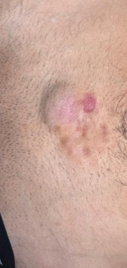
Figure 1 : Clinical presentation of dermatofibrosarcoma protuberans showing a pinkish-brown raised lesion.
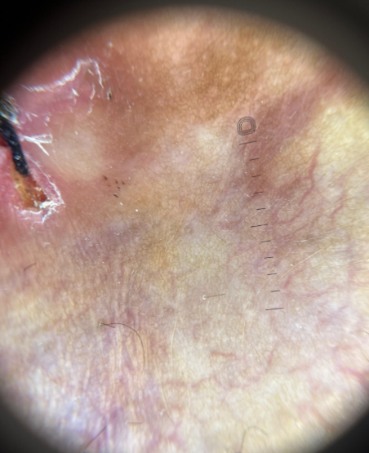
Figure 2 : Dermoscopic examination showing a pink background with branching linear vessels, white structureless areas, and a discrete pigment network.

Case 2: A 19-year-old woman with no relevant medical history presented with a progressively enlarging lesion on the medial aspect of the left thigh evolving for 9 months. Examination revealed a brownish plaque surmounted by multiple nodules (Figure 3). Dermoscopy showed arborizing vessels, pigment network, and white and yellowish structureless areas (Figure 4).
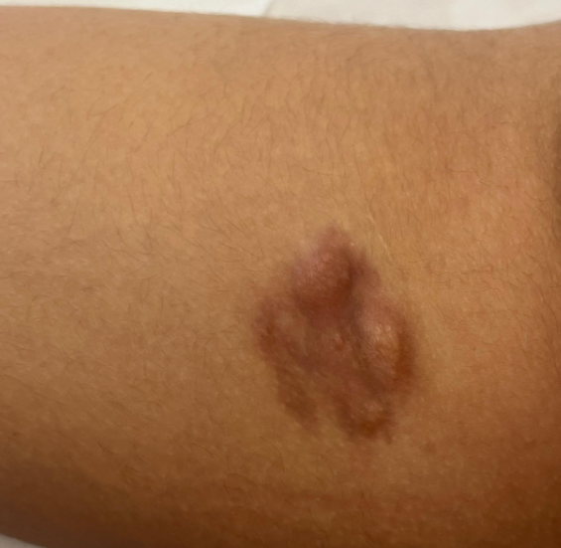

Figure 3 : Clinical presentation of dermatofibrosarcoma protuberans showing a brownish plaque with nodular areas on the medial aspect of the thigh.

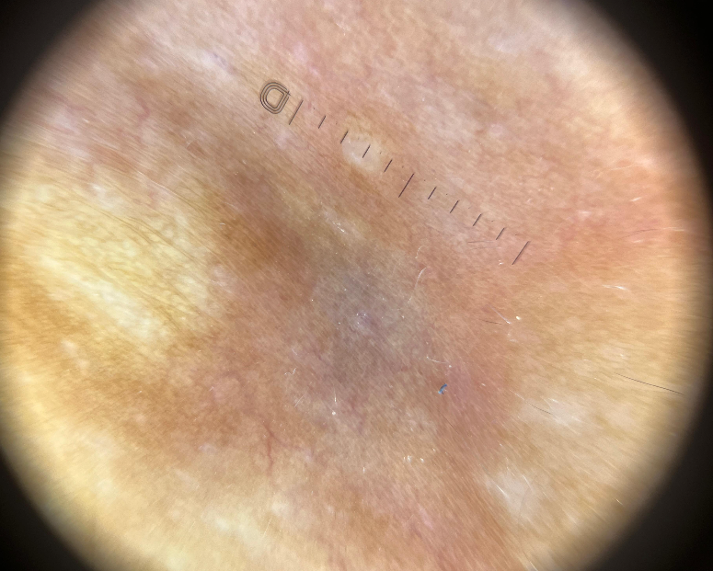
Figure 4 : Dermoscopic examination showing a prominent pigment network on a pinkish background, associated with fine branching vessels and both white and yellowish structureless areas.

Case 3 : A 47-year-old woman with a history of surgically treated DFSP 2 years earlier presented with four new lesions arising on the graft scar over the previous 3 months. Examination revealed four hypertrophic erythematous lesions within the scar (Figure 5). Dermoscopy showed thick arborizing vessels on an erythematous fibrotic background(Figure 6). Histopathological examination confirmed recurrent DFSP.

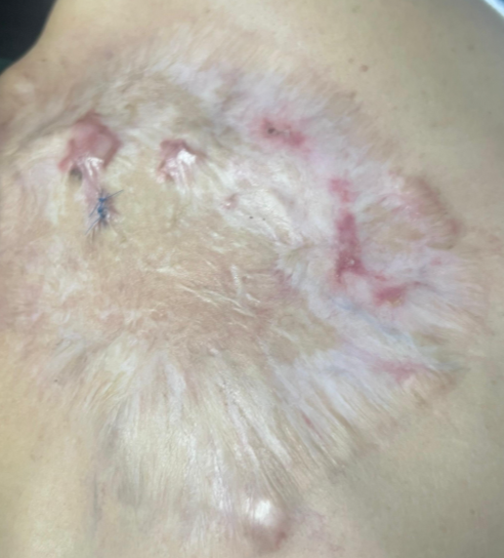
Figure 5. Clinical presentation of recurrent dermatofibrosarcoma protuberans showing multiple hypertrophic erythematous lesions arising within a graft scar.
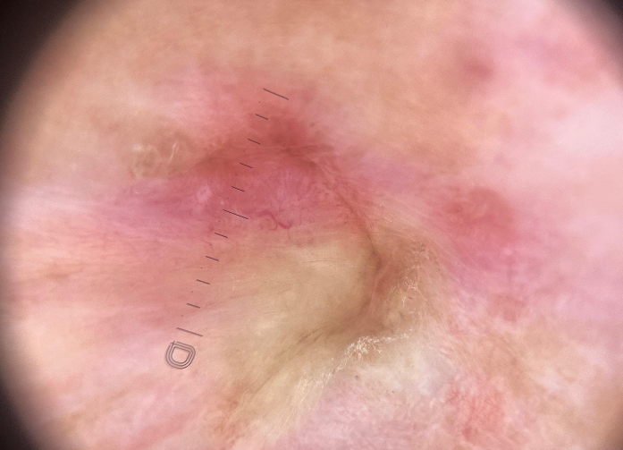
Figure 6 : Dermoscopic examination of recurrent dermatofibrosarcoma protuberans showing prominent branching vessels on a pinkish-red fibrotic background with white structureless areas.

Case 4 : A 35-year-old woman with no relevant medical history presented with a lesion at the root of the right thigh evolving for 6 months. Examination revealed a several-centimeter brownish plaque with erythematous areas that had failed to respond to several intralesional corticosteroid injections (Figure 7). Dermoscopy showed fine branching vessels, white shiny streaks, and yellowish structureless areas on a pink background (Figure 8).

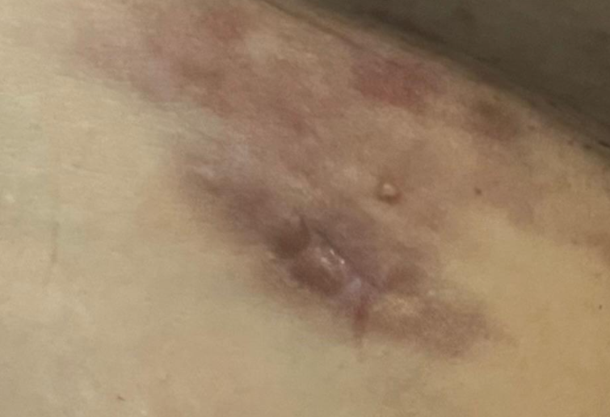
Figure 7 : Clinical presentation of dermatofibrosarcoma protuberans showing a brownish plaque with a raised nodular component and erythematous areas.

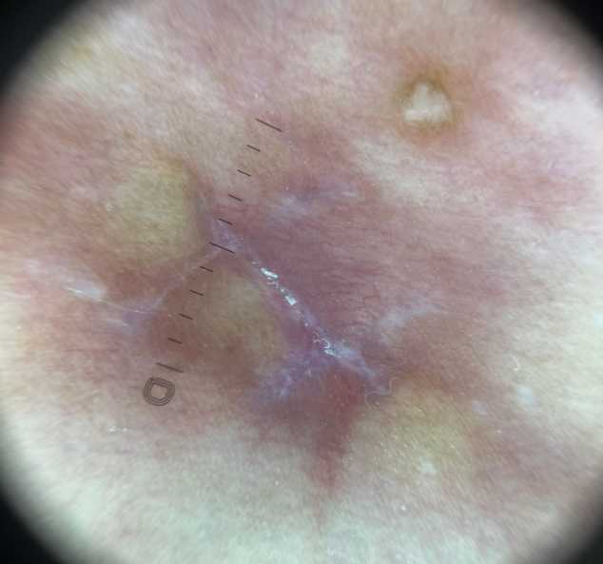

Figure 8 : Dermoscopic examination showing fine branching vessels, shiny white and structureless areas, and yellowish structureless areas on a pink background.

3. discussion

DFSP typically presents as a slowly enlarging, painless, indurated plaque or nodule, predominantly involving the trunk and proximal extremities. Its heterogeneous clinical appearance may result in confusion with dermatofibroma, hypertrophic scars, keloids, morphea, and other cutaneous tumors¹. Our series similarly showed varied clinical presentation despite a number of shared dermoscopic features.
The most consistent dermoscopic findings in our patients were arborizing or linear vessels, a pink background, and white structureless or shiny areas, observed in all four cases. Pigment network and yellowish structureless areas were less consistent. In a review of 32 patients, Escobar et al. reported vascular structures in 81% of DFSPs, pigment network in 78%, a pinkish background in 66%, shiny white streaks in 53%, and structureless hypo- or depigmented areas in 50%¹. Bernard et al. similarly identified vessels in 80% of 15 DFSPs, with arborizing vessels being the predominant vascular morphology³. These observations support a multicomponent dermoscopic pattern rather than a single specific criterion.
White streaks and structureless areas may reflect increased collagen deposition and fibrosis, whereas yellowish structureless areas, particularly described in atrophic DFSP, may correspond to superficially located adipose tissue secondary to dermal atrophy²˒⁴. These dermoscopic-histopathological correlations may help explain the coexistence of vascular, fibrotic, and yellowish structures in DFSP.
Skin phototype may also influence the dermoscopic appearance. Mustari et al. described four DFSPs in patients with Fitzpatrick phototypes IV-VI, with a pink background and pigment network present in all lesions². In contrast, all patients in our series had phototype III, and pigment network was observed in only two cases. Although the small sample size precludes any firm association between phototype and pigmentary structures, this difference suggests that the influence of skin pigmentation on DFSP dermoscopy warrants further investigation.
Another noteworthy finding was the recurrent DFSP in Case 3. Recurrence within a surgical scar may be difficult to distinguish clinically from scar tissue. Venturini et al. reported a recurrent DFSP displaying linear white and pink areas, structureless light-brown areas, and focal reticular pigmentation⁵. Our recurrent lesion instead showed prominent thick arborizing vessels on an erythematous fibrotic background. Changes in vascular and fibrotic structures within a scar in a patient previously treated for DFSP may therefore warrant further investigation and histopathological assessment.
No individual dermoscopic structure is specific for DFSP. Arborizing vessels may occur in keloids, while pigment network and white areas can also be encountered in dermatofibroma². The diagnostic contribution of dermoscopy therefore appears to lie in recognizing a combination of vascular, pigmentary, and fibrotic features. Dermoscopy should be considered an adjunct to clinical examination that may raise suspicion and prompt histopathological confirmation.
The main limitation of our series is the small number of patients, preventing assessment of the sensitivity or specificity of individual dermoscopic features and limiting conclusions regarding the influence of skin phototype. Nevertheless, the consistency of vascular, pink, and white structures across our four phototype III patients supports their potential usefulness as dermoscopic clues to DFSP.

4. Conclusion

This four-case series illustrates the variability of clinical and dermoscopic presentations of dermatofibrosarcoma protuberans in patients with Fitzpatrick skin phototype III. Branching or linear vessels, pink or erythematous backgrounds, and white structureless or shiny areas were prominent dermoscopic observations. Pigment networks and yellowish structureless areas were less consistently documented. The recurrent lesion demonstrated conspicuous vascular structures within a fibrotic surgical scar, emphasizing the importance of evaluating new lesions arising at previously treated sites. Although these observations may assist clinical recognition, none of the described dermoscopic features is specific to dermatofibrosarcoma protuberans. Dermoscopy should therefore be interpreted alongside clinical findings, with histopathological examination remaining necessary for confirmation. Further studies involving larger patient populations are required to clarify the variability of dermoscopic findings across different skin phototypes.

Competing interests
Authors have declared that no competing interests exist.
consent

Written informed consent was obtained from the patients for this case series and the accompanying clinical images.

Ethical approval

This report describes a two patients managed in the course of routine clinical care and did not require institutional review board approval. All procedures were performed in accordance with the ethical standards laid down in the 1964 Declaration of Helsinki and its later amendments.

Declaration of AI Use

This manuscript was prepared through the intellectual contributions of the author(s) to the study design, data analysis, interpretation of results, and scholarly content. Grammarly and ChatGPT were used solely to assist with grammatical refinement and reference formatting during manuscript revision. The author(s) accept full responsibility for the accuracy, integrity, and final content of the manuscript.

References

- Escobar GF, Ribeiro CK, Leite LL, Barone CR, Cartell A. Dermoscopy of dermatofibrosarcoma protuberans: What do we know? Dermatol Pract Concept. 2019;9(2):139-145. doi:10.5826/dpc.0902a10.
- Mustari A, Chauhan P, Chatterjee D, Vinay K. Dermoscopy of dermatofibrosarcoma protuberans in skin of colour: A study of four cases. Indian J Dermatol Venereol Leprol. 2024;90:801-803. doi:10.25259/IJDVL_325_2023.
- Bernard J, Poulalhon N, Argenziano G, et al. Dermoscopy of dermatofibrosarcoma protuberans: a study of 15 cases. Br J Dermatol. 2013;169(1):85-90.
- Güngör S, Büyükbabani N, Büyük M, Tarıkçı N, Kocatürk E. Atrophic dermatofibrosarcoma protuberans: are there specific dermatoscopic features? J Dtsch Dermatol Ges. 2014;12(5):425-427.
- Venturini M, Zanca A, Manganoni AM, Pavoni L, Gualdi G, Calzavara-Pinton P. In vivo characterization of recurrent dermatofibrosarcoma protuberans by dermoscopy and reflectance confocal microscopy. J Am Acad Dermatol. 2016;75(5):e185-e187.

