EFFECT OF FEED FORTIFIED WITH COOKED, UNCOOKED, AND GRILLED GROUNDNUT SEEDS (ARACHIS HYPOGAEA) ON LIPID PROFILE OF WISTAR RATS

ABSTRACT
Diet is a contributor to cardiovascular function as it regulates the amount of blood lipids and lipoproteins. This study investigated the effects of diets fortified with cooked, uncooked, and grilled groundnut (A. hypogaea) seeds on the serum lipid profile of Wistar rats. Thirty-five (35) rats were randomly assigned to seven (7) groups (A-G), with five (5) rats per group. The rats in group A were used as normal controls (NC), while the rest of the groups B-G were administered diets that contained a mixture of standard feed and processed groundnut seeds for a period of 28 days. Serum lipid profile data were analyzed using standard analytical procedures, and the results were reported as Mean ± Standard Error of the Mean (SEM). The total cholesterol (TC) was significantly higher (P<0.05) in rats fed 50% cooked groundnut (650.82 ± 81.84 mg/dL) and 50% grilled groundnut (643.03 ± 88.95 mg/dL) than in the normal control group (455.96 ± 38.91 mg/dL). In addition, high-density lipoprotein cholesterol (HDL-C) was also significantly higher (P<0.05) in rats that were fed 30% cooked groundnut (74.38 ± 2.79 mg/dL) and 50% uncooked groundnut (77.84 ± 7.06 mg/dL) than in the normal control group (65.49 ± 0.88 mg/dL). However, there were no significant differences observed in triglyceride, low-density lipoprotein cholesterol (LDL-C), and very-low-density lipoprotein cholesterol (VLDL-C) levels among the different groups of rats. Groundnut supplementation affected some of the serum lipid parameters, with the highest HDL-C levels observed in rats fed diets containing 30% and 50% uncooked groundnut. In contrast, total cholesterol increased significantly in the groups receiving 50% cooked and grilled groundnut. These findings suggest that the effects of groundnut on lipid profiles may depend on the processing method and inclusion level. Further studies are needed to establish their implications for cardiovascular health.
Keywords: Groundnut, Wistar rats, HDL-cholesterol, lipid profile, and processing method.

- INTRODUCTION
Cardiovascular disease (CVD) has placed substantial health-related burdens on economies across the globe (Collaborators GBDDI, 2020; Mensah et al., 2019). Cardiovascular disease (CVD), especially coronary heart disease (CHD) and stroke, constitutes the foremost cause of mortality and enduring disability globally (Roth et al., 2018). The timely identification and management of cardiovascular disease are essential for patient survival and sustained health. As reported in the Global Burden of Disease study, CVD cases and fatalities rose markedly from 1990 to 2019 (Roth et al., 2020). The greater part of these fatalities (80%) took place in low- and middle-income countries (LMICs) (Yusuf et al., 2020). Dietary interventions designed to lower blood cholesterol concentrations and modify blood lipoprotein concentrations are essential to the early detection and treatment of CVD. Groundnuts constitute the most extensively consumed nut globally and are progressively recognized as a functional food and protein extender. It (Arachis hypogaea L.) represents an inexpensive and significant source of plant protein. Groundnuts (Arachis hypogaea L.) are legumes originating in South America that have already disseminated worldwide (Hammons et al., 2016). Groundnut seeds serve as a substantial source of lipids, protein, and fatty acids for human consumption. With the exception of lysine, groundnut protein is comparatively abundant in the amino acids required for children's growth. Roasted groundnuts provide an excellent source of folate, niacin, and vitamin E, although they are likewise deficient in calcium, iron, vitamin A, vitamin C, and minerals.
Moreover, Yeh et al. (2002) demonstrated that roasting and blanching, processing techniques frequently applied to groundnuts, lead to the degradation of considerable quantities of B-complex vitamins. The skin, or inner shell, of groundnuts constitutes an abundant source of dietary fiber and natural antioxidants capable of scavenging free radicals. As a result, the nutritional value of the paste is enhanced when the inner shell is incorporated into the butter (Yuanyuan et al., 2014). As reported by Arya et al. (2016), the resveratrol concentration of groundnut butter is approximately three times greater than that of roasted groundnuts with their skin and is similar to that of grape juice. Groundnuts have been consumed worldwide in numerous forms, such as raw, boiled, oil-extracted, paste, roasted (snack), in energy bars and sweets, and by combining the paste with other snacks (Settaluri et al., 2012). Groundnuts possess a high fat content (48.75 g/100 g), yet they also contain a small amount of saturated fatty acids (6.43 g/100 g) and a large amount of unsaturated fatty acids (40.45 g/100 g) (Davis and Dean, 2016). Protein is the second most abundant nutrient in groundnuts. Depending on the study, it may contain lysine, methionine, or threonine as the limiting amino acid (Venkatachalam and Sathe, 2006).
Groundnuts have attracted attention as a functional food (Francisco and Resurreccion, 2008), since studies indicate that their consumption may improve cardiometabolic biomarkers and overall cardiovascular disease (Lokko et al., 2007; Reis et al., 2013; Guasch-Ferré et al., 2017; Barbour et al., 2015). Groundnuts contain bioactive compounds, including phytosterols, phenolic compounds, stilbenes, lignans, and isoflavonoids, which have been associated with several diseases (Jung et al., 2020). Among these, phytosterols, or plant sterol and stanol esters, are naturally present in the plant's cell membrane. Owing to their structural similarity, they compete with bodily cholesterol for absorption from the digestive tract once ingested. Hence, the inhibition of cholesterol absorption results in a decrease in blood cholesterol content. Therefore, phytosterols are able to reduce the risk of cardiovascular disease (CVD) and improve blood lipid profiles (Arya et al., 2016).
CVDs constitute the leading cause of morbidity and mortality globally, with dyslipidemia representing a principal risk factor. Current dietary interventions are subject to limitations, and cost-effective, nutrient-dense alternatives are required. A. hypogaea, which is rich in healthy fats and proteins and widely consumed in Africa, possesses potential health benefits. Nevertheless, its effects on lipid profiles remain uncertain. To address this issue, the present study examines the impact of a diet supplemented with processed (cooked, uncooked, and grilled) A. hypogaea seeds on lipid profile parameters in Wistar albino rats.
- METHODS
2.1 Sample Collection and Identification: The groundnut seeds used for this study were purchased from Eke Awka Market, Awka South Local Government Area, Anambra State, Nigeria. The sample was identified by a taxonomist in the Department of Botany, Faculty of Biosciences, Nnamdi Azikiwe University, Awka. The voucher number deposited in the herbarium of Nnamdi Azikiwe University, Awka is NAUH14^{A}.
2.2 Processing of Sample: The groundnut used was properly washed and de-shelled to get the groundnut seed, after which the groundnut seeds were divided into three portions for processing.
2.2.1 Grilled Groundnut: The first portion of the groundnut seeds was grilled on a frying pan containing sandy soil using a kerosene stove. The heated seeds were left to cool, then separated from the chaff of the pods and pulverized using a corona manual grinding machine. The now powdered grilled groundnut was stored inside a well-labeled airtight plastic container until use.
2.2.2 Cooked Groundnut: The second portion of the groundnut seeds was cooked using a kerosene stove in a pot containing water for 45 minutes until it was soft and edible for consumption. Next, the cooked groundnut seeds were dried at room temperature and pulverized using a corona manual grinding machine; the dried and powdered cooked groundnut was stored inside a well-labeled airtight plastic container until use.
2.2.3 Uncooked Groundnut: The third portion of the groundnut seeds was chopped into smaller pieces and air-dried for 10 days (one week and three days) at room temperature. Next, the nuts were pulverized using a corona manual grinding machine, and the now powdered uncooked groundnut was stored inside a well-labeled airtight plastic container until use.

2.3 Composition of the Rat Feed: The standard feed given to the rats was purchased from a feed dealer in Awka. The ingredients used in the compounding of the standard feed include grains and cereals, vegetables, protein meals, vitamins, minerals, essential amino acids, anti-toxins, and enzymes. The composition of the ingredients is as follows: Oil (6%), Protein (16%), Fibre (7%), Ash (10%), Calcium (0.95%), and Phosphorus (0.65%).
The feed was supplemented with processed groundnut (grilled, uncooked, and cooked) in the following percentages (30%, 50%, and 70%). Using an analytical weighing balance, the feed and respective groundnuts were each measured. These formulations were repeated until enough feed was prepared, which lasted for 28 days (4 weeks).
2.4 Study Design: A total of thirty-five (35) Wistar rats weighing between 140 g- 180 g were purchased from Chris Experimental Animal Farm and Research Laboratory, Awka, Anambra State, and randomized into seven groups of five rats each and used for the study. They were allowed to acclimatize, maintained, and housed in cages under standard environmental conditions (27°C ± 3°C, 12-hour light/dark cycle) in Chris Experimental Animal Farm and Research Laboratory, Awka. The rats were weighed, marked, and put into labeled cages.
The groupings were as follows:
Group A – Normal Control
Group B – 70% Standard Feed fortified with 30% cooked groundnut.
Group C – 70% Standard Feed fortified with 30% uncooked groundnut.
Group D – 70% Standard Feed fortified with 30% grilled groundnut.
Group E – 50% Standard Feed fortified with 50% cooked groundnut.
Group F – 50% Standard Feed fortified with 50% uncooked groundnut.
Group G – 50% Standard Feed fortified with 50% grilled groundnut.

Feeding of the Experimental Animals: The experimental animals were fed accordingly using the feed prepared for each group. The feeding was done for four (4) weeks, after which the rats were fasted and anesthetized with ketamine 60-80 mg/kg + xylazine 5-10 mg/kg i.p. before blood collection. Blood was collected by cardiac puncture and put in plain bottles for lipid profile analysis. The carcasses were properly disposed of by burying them.
2.5 Lipid Profile Determination
The lipid profile (Total Cholesterol, Triglycerides, High-Density Lipoprotein-cholesterol, Low-Density Lipoprotein-cholesterol, and Very Low-Density Lipoprotein-cholesterol) was determined using Randox test kits (Tietze et al., 1990). Low-density lipoprotein-cholesterol (LDL-C) was calculated using the standard formula (Friedewald et al., 1972). The procedure used was according to the manufacturer's instructions provided in the manual.
2.6 Statistical Analysis
The data obtained from the experiments were expressed as mean ± SEM and analyzed by one-way analysis of variance (ANOVA) followed by Dunnett's multiple comparison test. Statistical analyses were performed using GraphPad Prism, with statistical significance set at P<0.05.

- RESULTS
The results of the concentrations of Total cholesterol, HDL-C, triglycerides, LDL-C, and VLDL-C are presented below.

3.1 Results of the Total Cholesterol Concentration of Wistar Albino Rats Fed Feeds Fortified with Different Percentages of Cooked, Uncooked, and Grilled Arachis hypogaea Seeds.
The Total cholesterol level (fig.1), showed that there was no significant difference (P>0.05) in groups B, C, D, and F (70% standard feed fortified with 30% cooked A. hypogaea seeds, 70% standard feed fortified with 30% uncooked A. hypogaea seeds, 70% standard feed fortified with 30% grilled A. hypogaea seeds and 50% standard feed fortified with 50% uncooked A. hypogaea seeds respectively) when compared with normal control (group A). Groups E and G (50% standard feed fortified with 50% cooked A. hypogaea seeds and 50% standard feed fortified with 50% grilled A. hypogaea seeds, respectively) showed a significant increase (P<0.05) when compared with the normal control (Group A).
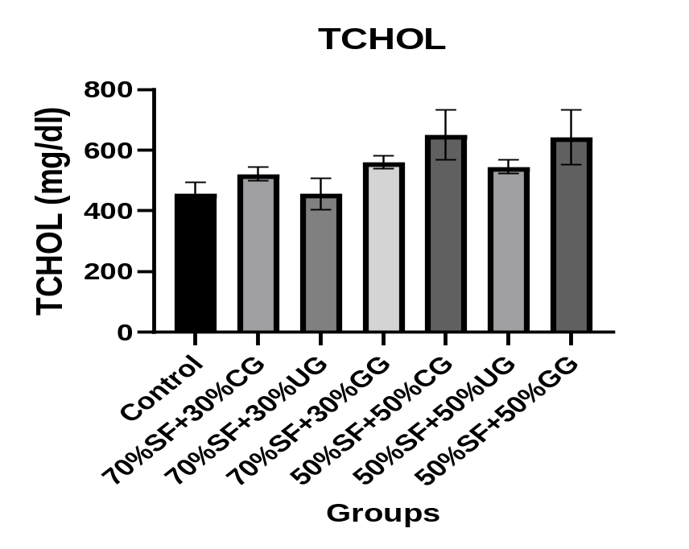
SF: Standard Feed
CG: Cooked Groundnut
UG: Uncooked Groundnut
GG: Grilled Groundnut

Figure 1: Total cholesterol concentration of Wistar albino rats fed feeds fortified with different percentages of cooked, uncooked, and grilled Arachis hypogaea seeds.

3.2 Results of the High-Density Lipoprotein Concentration in Wistar Albino Rats Fed Feeds Fortified with Different Percentages of Cooked, Uncooked, and Grilled Arachis hypogaea Seeds.
The High density lipoprotein level (Fig. 2), showed that there was no significant difference (P>0.05) in groups C, D, E, and G (70% standard feed fortified with 30% uncooked A. hypogaea seeds, 70% standard feed fortified with 30% grilled A. hypogaea seeds, 50% standard feed fortified with 50% cooked A. hypogaea seeds and 50% standard feed fortified with 50% grilled A. hypogaea seeds respectively)when compared with normal control (group A), while in groups B and F (70% standard feed fortified with 30% cooked A. hypogaea seeds and 50% standard feed fortified with 50% A. hypogaea seeds respectively) showed a significant increase(P<0.05) when compared with normal control (group A).
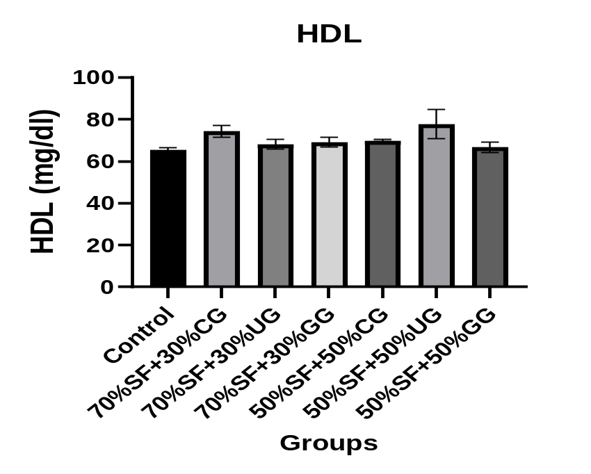
SF: Standard Feed
CG: Cooked Groundnut
UG: Uncooked Groundnut
GG: Grilled Groundnut

Figure 2: High-density lipoprotein concentration in Wistar albino rats fed feeds fortified with different percentages of cooked, uncooked, and grilled Arachis hypogaea seeds.
3.3 Results of the Triglyceride Concentration in Wistar Rats Fed Feeds Fortified with Different Percentages of Cooked, Uncooked, and Grilled Arachis hypogaea Seeds.
There was no significant difference (P>0.05) in groups B, C, D, E, F, and G (70% standard feed fortified with 30% cooked A. hypogaea seeds, 70% standard feed fortified with 30% uncooked A. hypogaea seeds, 70% standard feed fortified with 30% grilled A hypogaea seeds, 50% standard feed fortified with 50% cooked A. hypogaea seeds, 50% standard feed fortified with 50% uncooked A. hypogaea seeds and 50% standard feed fortified with 50% grilled A. hypogaea seeds respectively), when compared with normal control (group A) in figure 3.
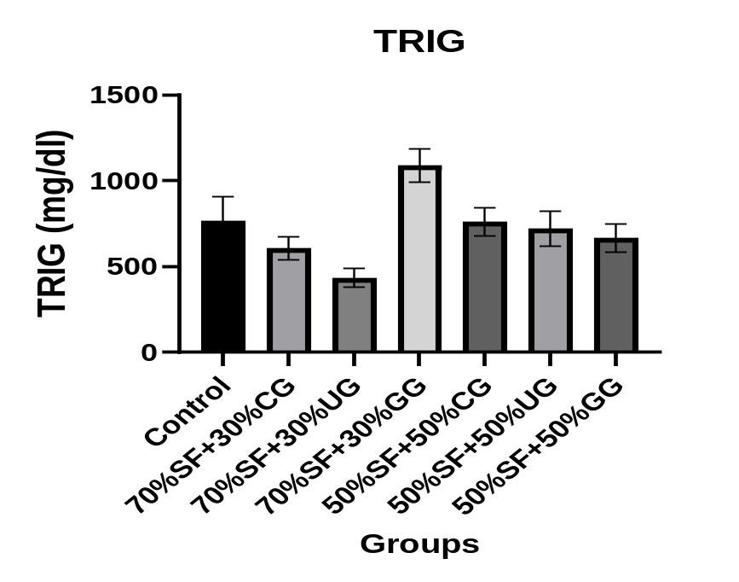
SF: Standard Feed
CG: Cooked Groundnut
UG: Uncooked Groundnut
GG: Grilled Groundnut

Figure 3: Triglyceride concentration in Wistar albino rats fed feeds fortified with different percentages of cooked, uncooked, and grilled Arachis hypogaea seeds.

3.4 Results of the Low-Density Lipoprotein Concentration in Wistar Albino Rats Fed Feeds Fortified with Different Percentages of Cooked, Uncooked, and Grilled Arachis hypogaea Seeds.

There was no significant difference (P>0.05) in groups B, C, D, E, F, and G (70% standard feed fortified with 30% cooked A. hypogaea seeds, 70% standard feed fortified with 30% uncooked A. hypogaea seeds, 70% standard feed fortified with 30% grilled A hypogaea seeds, 50% standard feed fortified with 50% cooked A. hypogaea seeds, 50% standard feed fortified with 50% uncooked A. hypogaea seeds and 50% standard feed fortified with 50% grilled A. hypogaea seeds respectively), when compared with normal control (group A) in figure 4.
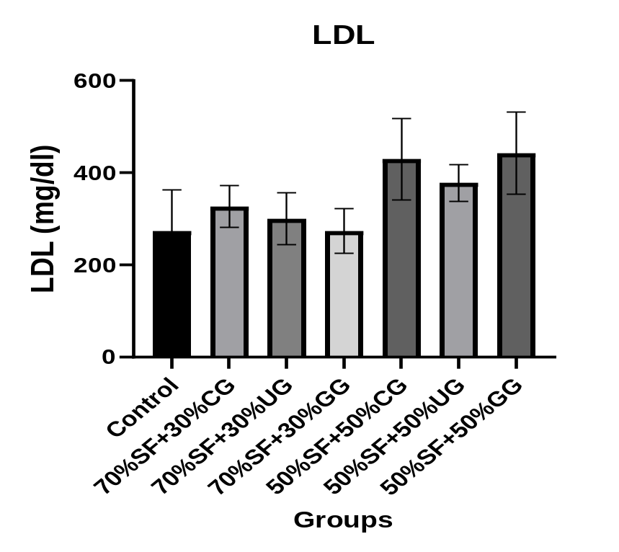
SF: Standard Feed
CG: Cooked Groundnut
UG: Uncooked Groundnut
GG: Grilled Groundnut

Figure 4: Low-density lipoprotein concentration in Wistar albino rats fed feeds fortified with different percentages of cooked, uncooked, and grilled Arachis hypogaea seeds.

3.5 Results of the Very Low-Density Lipoprotein Concentration in Wistar Albino Rats Fed Feeds Fortified with Different Percentages of Cooked, Uncooked, and Grilled Arachis hypogaea Seeds.
There was no significant difference (P>0.05) in groups B, C, D, E, F, and G (70% standard feed fortified with 30% cooked A. hypogaea seeds, 70% standard feed fortified with 30% uncooked A. hypogaea seeds, 70% standard feed fortified with 30% grilled A hypogaea seeds, 50% standard feed fortified with 50% cooked A. hypogaea seeds, 50% standard feed fortified with 50% uncooked A. hypogaea seeds and 50% standard feed fortified with 50% hypogaea seeds respectively), when compared with normal control (group A) in figure 5.
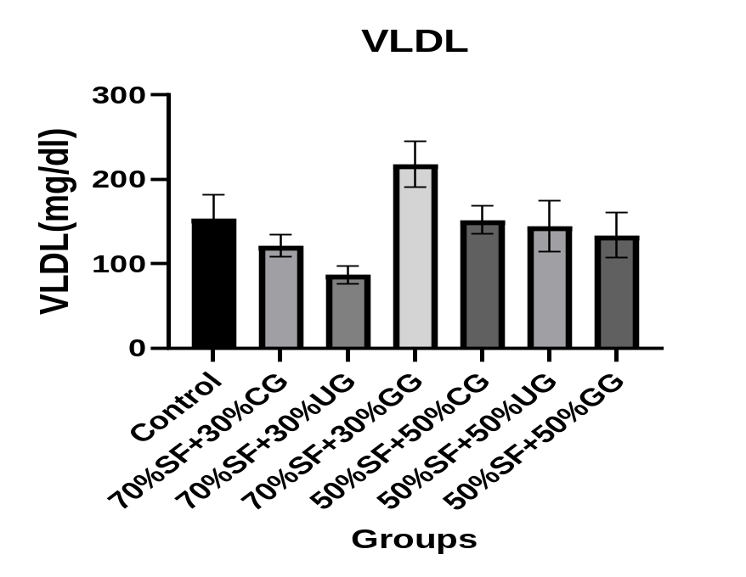
SF: Standard Feed
CG: Cooked Groundnut
UG: Uncooked Groundnut
GG: Grilled Groundnut
Figure 5: Very-low-density lipoprotein concentration in Wistar albino rats fed feeds fortified with different percentages of cooked, uncooked, and grilled Arachis hypogaea seeds.

- DISCUSSION
This study examined the effects of feeding Wistar rat diets supplemented with uncooked, cooked, and grilled groundnut (Arachis hypogaea) seeds on their serum lipid profiles. The results showed that the response varied with the processing method and the proportion of groundnut included in the feed. The most notable changes were observed in high-density lipoprotein cholesterol (HDL-C) and total cholesterol (TC). HDL-C concentrations increased in all the groundnut-supplemented groups, with the highest value recorded in rats fed uncooked groundnuts, followed by those given cooked and grilled groundnuts. In contrast, total cholesterol increased significantly in the groups receiving diets containing 50% cooked and 50% grilled groundnuts. Triglyceride (TG), low-density lipoprotein cholesterol (LDL-C), and very-low-density lipoprotein cholesterol (VLDL-C) did not differ significantly among the groups.
These findings suggest that groundnut supplementation affected selected components of lipid metabolism rather than producing uniform changes across all the lipid parameters measured. The increase in HDL-C across the supplemented groups was one of the notable findings of this study. HDL plays an important role in reverse cholesterol transport, through which cholesterol is transported from peripheral tissues towards the liver for further processing and elimination. Higher HDL-C concentrations are often associated with a more favourable lipid profile, although the concentration of HDL-C alone does not establish how effectively HDL functions or whether cardiovascular protection has improved. As discussed by Houston et al. (2023), the relationship between dietary factors and lipid metabolism involves several interacting processes.
In the present study, the higher HDL-C concentrations suggest that groundnut supplementation may have influenced lipoprotein metabolism in the experimental animals. However, further measurements would be required to determine the biological significance of this response. The highest HDL-C concentration was recorded in the group fed uncooked groundnuts. One possible explanation is that the seeds retained more of their original lipid composition and certain heat-sensitive bioactive compounds because they had not been exposed to thermal processing. Groundnuts contain substantial amounts of unsaturated fatty acids, together with phytosterols, tocopherols, phenolic compounds, and other constituents that may influence lipid metabolism and oxidative processes. These components have been associated with the lipid-modulating properties of groundnuts (Houston et al., 2023). Heating can alter some of these constituents, although the extent of the changes depends on the processing conditions. It is therefore possible that differences in the composition of the uncooked and processed seeds contributed to the variation in HDL-C observed in this study. However, since the fatty acid profile, phytochemical composition, and bioavailability of these compounds were not determined, this explanation remains a plausible interpretation rather than a confirmed mechanism.
Rats fed cooked groundnuts also showed higher HDL-C concentrations than the control group. Cooking in water may affect the food matrix differently from grilling, particularly because the seeds are exposed to moisture rather than direct dry heat. These conditions can influence the stability, extractability, and availability of certain nutrients and phytochemicals. The presence of water may also affect the extent of oxidative changes during heating, although it does not eliminate the possibility of lipid oxidation. Zhang et al. (2024) reported that processing methods such as boiling and roasting can produce differences in the nutritional composition and lipid quality of peanuts. The higher HDL-C observed in the cooked groundnut group may therefore reflect differences in the composition or availability of dietary constituents following processing.
Nevertheless, the present study did not directly establish which components were responsible for the observed response. The grilled groundnut group also showed an increase in HDL-C, although the value was lower than those recorded in the uncooked and cooked groundnut groups. Grilling exposes groundnuts to dry heat, which can alter their lipid composition and other chemical constituents. Because groundnuts contain substantial amounts of unsaturated fatty acids, some of these lipids may undergo oxidation when exposed to heat and oxygen. Zhang et al. (2022) reported that roasting and other high-temperature treatments can affect peanut lipid composition and promote the formation of lipid oxidation products. Such changes could influence the nutritional properties of the processed seeds and potentially affect their metabolic effects after consumption. However, because lipid oxidation products and fatty acid composition were not measured in the present study, it would be premature to attribute the lower HDL-C concentration in the grilled group directly to oxidative damage.
Other differences arising from processing, feed composition, or nutrient availability may also have contributed. Another important observation was the absence of significant differences in serum triglyceride concentrations among the experimental groups. Triglycerides are transported mainly in chylomicrons and VLDL particles, and their circulating concentrations are influenced by dietary fat intake, intestinal absorption, hepatic triglyceride synthesis, and the clearance of triglyceride-rich lipoproteins. The lack of a statistically significant difference suggests that the dietary treatments did not produce a detectable change in circulating triglyceride concentrations under the conditions of this experiment. This finding is consistent with the absence of significant differences in VLDL-C. However, a non-significant result does not necessarily mean that the treatments had no biological effect, particularly where the study may have had limited statistical power to detect smaller differences.
The significant increase in total cholesterol observed in the groups fed diets containing 50% cooked and 50% grilled groundnuts deserves particular attention. This finding differs from reports of favourable changes in selected lipid parameters following peanut consumption, including reductions in total cholesterol and LDL-C (Houston et al., 2023). The apparent difference may reflect variations in the amount of groundnut consumed, the composition of the experimental diets, the duration of feeding, the animal model, and the processing conditions. It is therefore important not to interpret the present result as evidence that groundnut consumption generally raises serum cholesterol. Rather, the findings suggest that the effects observed under the specific dietary conditions used in this experiment may differ from those reported in studies employing other levels of inclusion or dietary formulations.
The high proportion of groundnut incorporated into some of the experimental feeds may have contributed to the increase in total cholesterol. Groundnuts are energy-dense foods containing appreciable amounts of fat, and their inclusion at 50% of the feed represents a substantial dietary exposure. At this level, replacing a large proportion of the standard feed with groundnut could alter the overall energy density and balance of dietary macronutrients. These changes may influence cholesterol metabolism independently of the groundnut's individual bioactive compounds. For this reason, the nutrient composition of the experimental diets is important when interpreting the results. Information on total fat, saturated and unsaturated fatty acids, protein, carbohydrate and dietary fibre would help clarify whether the observed changes were associated with groundnut supplementation itself or with differences in the overall composition of the diets.
Processing-related changes in groundnut composition may also have contributed to the higher total cholesterol recorded in the cooked and grilled groups. Thermal treatment can influence fatty acid stability, the food matrix, and the concentrations of certain bioactive compounds. Under some conditions, heating may promote the oxidation of unsaturated fatty acids and the formation of secondary oxidation products (Zhang et al., 2022). These changes could potentially affect the handling of dietary lipids by the liver and other tissues. Nevertheless, the relationship between processing and serum cholesterol is unlikely to be explained by a single mechanism. Since the fatty acid composition, phytosterol content, and lipid oxidation products of the groundnut samples were not determined, the proposed explanation remains speculative. Direct analysis of these components would be necessary to establish whether processing-related compositional changes were associated with the cholesterol response observed in this study.
Interestingly, the increase in total cholesterol in the cooked and grilled groundnut groups was not accompanied by a statistically significant increase in LDL-C. Since total cholesterol represents the cholesterol carried in different lipoprotein fractions, changes in HDL and other fractions may contribute to the overall concentration. The higher total cholesterol therefore cannot be attributed to increased LDL-C on the basis of the present results. However, the absence of a significant difference in LDL-C does not establish which fraction accounted for the increase in total cholesterol.
The VLDL-C results provide further context for interpreting the lipid profile. VLDL particles are produced mainly by the liver and transport endogenous triglycerides through the circulation. The absence of significant differences in both VLDL-C and triglycerides suggests that the dietary treatments did not produce a detectable alteration in these measured components of triglyceride transport. Taken together, the findings indicate that the observed changes were selective, with the clearest differences occurring in HDL-C and total cholesterol rather than across all lipid parameters. Nevertheless, additional measurements of hepatic lipid metabolism and lipoprotein composition would be needed to determine the processes responsible for this pattern.
Overall, the results suggest that the processing method and level of groundnut inclusion may be important considerations when evaluating the effects of groundnut supplementation on serum lipids. Uncooked groundnuts produced the highest HDL-C concentration, whereas diets containing 50% cooked or grilled groundnuts were associated with significantly higher total cholesterol. In contrast, triglyceride, LDL-C and VLDL-C concentrations did not differ significantly among the groups. These findings highlight the fact that changes in one lipid parameter do not necessarily occur alongside similar changes in others. They also show why the effects of dietary groundnut should be interpreted in the context of the amount consumed, the composition of the feed, and the method of processing.
Further research is needed to clarify the factors responsible for these responses. Analysis of the fatty acid profile, phytosterol and tocopherol contents, phenolic composition, and lipid oxidation products of uncooked, cooked, and grilled groundnuts would help determine how processing alters the composition of the seeds. Measuring hepatic enzymes involved in lipid metabolism, markers of oxidative stress and relevant histopathological changes could provide additional information about the biological processes underlying the observed lipid responses. It would also be useful to investigate graded levels of groundnut inclusion while maintaining nutritionally comparable experimental diets. Such an approach would help establish whether the effects depend on the amount consumed and provide a sound basis for assessing the relevance of the findings to human dietary practices.

- CONCLUSION
The current experiment revealed that certain blood lipid parameters in Wistar albino rats were altered after the groundnut (Arachis hypogaea) incorporation into the diet, with the effect being dependent on the groundnut processing technique. The treatment increased HDL-C content across all groups compared to the control, with the highest value observed in the animals receiving uncooked groundnuts. On the other hand, the total cholesterol content was notably elevated in the rats fed with 50% cooked and 50% grilled groundnuts. The serum triglycerides, LDL-C, and VLDL-C levels in the experimental animals were not affected by the intervention. Altogether, the results suggest that the modification of lipid and bioactive constituent profiles of groundnuts by thermal processing impacts their further utilization by the organism. The relatively higher HDL-C level in the rats of the uncooked groundnut group could be explained by the higher amount of lipids and phytochemicals in this group compared to the others. Therefore, it can be concluded that the processing technology and the quantity of groundnuts incorporated into the diet affect its lipid-lowering properties.
Ethical approval
All authors hereby declare that “Principles of laboratory animal care” were followed. All experimental protocols were examined and approved by the Animal Research Ethics Committee of Nnamdi Azikiwe University, Awka, Nigeria, in line with the recommendations for Animal Care and Use in Research, Education and Testing (ACURET).
Declaration of AI Use

This manuscript was prepared through the intellectual contributions of the author(s) to the study design, data analysis, interpretation of results, and scholarly content. Grammarly and ChatGPT were used solely to assist with grammatical refinement and reference formatting during manuscript revision. The author(s) accept full responsibility for the accuracy, integrity, and final content of the manuscript.

Competing Interests
The authors have declared that no competing interests exist.

REFERENCES
Arya, S. S., Salve, A. R., & Chauhan, S. (2016). Peanuts as functional food: a review. Journal of Food Science and Technology, 53(1):31-41.

Barbour, J. A., Howe, P. R. C., Buckley, J. D., Bryan, J., & Coates, A. M. (2015). Effect of 12 weeks high oleic peanut consumption on cardio-metabolic risk factors and body composition. Nutrients. 7:7381–7398.

Collaborators, GBDDI (2020). Global burden of 369 diseases and injuries in 204 countries and territories, 1990-2019: a systematic analysis for the global burden of disease study 2019. Lancet, 396:30925–30929.
Davis, J. P., & Dean, L. L. (2016). Chapter 11 - Peanut Composition, Flavor and Nutrition A2 - Stalker, H. Thomas, in Peanuts, R.F. Wilson, Editor., American Oil Chemists' Society (AOCS) Press. p. 289-345.

Francisco, M. L., & Resurreccion, A.V. (2008). Functional components in peanuts. Critical Reviews in Food Science and Nutrition, 48(8):715-746.

Friedewald, W. T., Levy, R. I., & Fredrickson, D. S. (1972). “Estimation of the concentration of low–density lipoprotein cholesterol in plasma, without the use of preparative ultracentrifuge.” Clinical Chemistry. 18:499-502.

Hammons, R. O., Herman, D., & Stalker, H. T. (2016). Chapter 1 - Origin and Early History of the Peanut, in Peanuts, AOCS Press, pp. 1-26.

Houston, L., Probst, Y. C., Singh, M. C., & Neale, E. P. (2023). Tree Nut and Peanut Consumption and Risk of Cardiovascular Disease: A Systematic Review and Meta-Analysis of Randomized Controlled Trials. Advances in Nutrition: An International Review Journal, 14 (5): 1029-1049.

Jung, M., Kim, J., & Ahn, S. M. (2020). Factors associated with frequency of peanut consumption in Korea: a national population-based study. Nutrients, 12(5):1207.

Lokko, P., Lartey, A., Armar-Klemesu, M., & Mattes, R. D. (2007). Regular peanut consumption improves plasma lipid levels in healthy Ghanaians. International Journal of Food Sciences and Nutrition, 58:190–200.

Mensah, G.A., Roth, G.A., & Fuster, V. (2019). The global burden of cardiovascular diseases and risk factors: 2020 and beyond. Journal of the American College of Cardiology, 74:2529–2532.
Reis, C. E. G., Ribeiro, D.N., Costa, N. M. B., Bressan, J., Alfenas, R. C. G., & Mattes, R. D. (2013). Acute and second-meal effects of peanuts on glycaemic response and appetite in obese women with high type 2 diabetes risk: a randomized cross-over clinical trial. British Journal of Nutrition, 109:2015–2023.

Ros, E., & Hu, F. B. (2013). Consumption of Plant Seeds and Cardiovascular Health: Epidemiological and Clinical Trial Evidence. Circulation, 128:553–565.

Roth, G. A., Mensah, G. A., Johnson, C. O., Addolorato, G., Ammirati, E., Baddour, L. M., Barengo, N. C., Beaton, A. Z., & Benjamin, E. J.(2020). Global burden of cardiovascular diseases and risk factors, 1990-2019: update from the GBD 2019 study. Journal of the American College of Cardiology,76:2982–3021.
Roth, G. A., Abate, D., Abate, K. H., Abay, S. M., Abbafati, C., Abbasi, N., Abbastabar, H., Abd-Allah, F., Abdela, J., Abdelalim, A., & Geleijnse, J. M. (2018). Global, Regional, and National Age-Sex-Specific Mortality for 282 Causes of Death in 195 Countries and Territories, 1980–2017: A Systematic Analysis for the Global Burden of Disease Study 2017. Lancet, 392:1736–1788.

Settaluri, V.S., Kandala, V. C., Puppala, N., & Jaya, S. (2012). Peanuts and their nutritional aspects: a review. Food Science and Nutrition, 03(12):1644-1650.

Tietze, N.W., Finley, P. R., & Pruden, E. L. (1990). Clinical Guide to Laboratory Tests. 2nd Edition, W.B. Saunders, Philadelphia. 304-306.

Venkatachalam, M., & Sathe, S. K. (2006). Chemical composition of selected edible nut seeds. Journal of Agricultural and Food Chemistry, 54(13):4705-4714.

Yeh, J. Y., Resurreccion, A. V. A., Philips, R. D., & Hung, Y. C. (2002). Overall acceptability and sensory profiles of peanut spreads fortified with protein, vitamins, and minerals. Journal of Food Science, 67(5):1979-1985.

Yuanyuan, M., William, L. K., George, A. C., Ruthan, S., James, L. H., & Ronald, B. P. (2014). Effect of peanut skin incorporation on the color, texture, and total phenolics content of peanut butter. Journal of Food Process Engineering, 36(3):316-328.

Yusuf, S., Joseph, P., Islam, S., Mente, A., Hystad, P., Brauer, M., Kutty, V. R., Gupta, R., Wielgosz, A., AlHabib, K. F., Dans, A., & Lopez-Jaramillo, P. (2020). Modifiable risk factors, cardiovascular disease, and mortality in 155 722 individuals from 21 high-income, middle-income, and low-income countries (PURE): a prospective cohort study. Lancet, 395:795–808.
Zhang, Z., He, S., Zhang, L., Li, X., Jin, R., Liu, Q., Chen, S., Wang, J., & Sun, H. (2022). “The Potential Application of Vegetable Oils in the D‐Xylose and L‐Cysteine Maillard Reaction System for Meaty Aroma Production.” Food Research International, 155: 111081. 10.1016.
Zhang, Y., Zhu, W., Jin, Y., Xu, J., Zhou, W., Shen, T., Yang, A., Wu, Z., & Chen, H. (2024). Effect of Boiling and Roasting Treatments on the Nutrients, Lipid Quality, and Flavor of Peanuts. Food Science and Nutrition. 12(11):9314–9324.

