Pharmacognostical Characterization and Phytochemical Profiling of Mudgaparni (Vigna trilobata Linn.) using HPTLC Fingerprinting.

Abstract
Background: Mudgaparni (Vigna trilobata Linn.) is an important medicinal plant described in Ayurveda and included in Laghu Panchamoola. Although it is traditionally used for various therapeutic purposes, published information on its pharmacognostical and physicochemical characteristics remains limited.
Aim: To evaluate the pharmacognostical, physicochemical, phytochemical and chromatographic characteristics of Mudgaparni (Vigna trilobata Linn.) and generate baseline data for its identification and quality assessment.
Materials and Methods: Authenticated whole plant material was subjected to macroscopic and microscopic examination. Physicochemical parameters were determined according to the Ayurvedic Pharmacopoeia of India (API). Preliminary phytochemical screening was performed using aqueous and alcoholic extracts. HPTLC fingerprinting was carried out using methanolic extract with silica gel 60 F₂₅₄ plates and chloroform:ethyl acetate (4:6 v/v) as the mobile phase.
Results: Macroscopic and microscopic examination revealed characteristic features useful for plant identification. Physicochemical parameters were found to be within the limits prescribed by the API where available. Preliminary phytochemical analysis indicated the presence of alkaloids, flavonoids, tannins, saponins, sterols, phenolic compounds and proteins in both extracts. HPTLC analysis produced a reproducible chromatographic profile with several distinct peaks at 254 nm and 366 nm.
Conclusion: The present study provides pharmacognostical, physicochemical, phytochemical and HPTLC data for Mudgaparni (Vigna trilobata Linn.). These observations may serve as supportive reference information for the identification and quality evaluation of the plant and may be useful in future standardization and pharmacological studies.
Key Words: Mudgaparni, Vigna trilobata (Linn.), Phytochemical screening, Pharmacognosy, HPTLC, Standardization.

Introduction
Medicinal plants constitute an important component of Ayurvedic therapeutics and their quality largely depends on correct identification and proper standardization. Variations in geographical location, environmental conditions, harvest period and processing methods may influence the characteristics and chemical composition of herbal drugs. Therefore, pharmacognostical and physicochemical evaluation plays an important role in ensuring the identity and quality of medicinal plant materials.
Mudgaparni (Vigna trilobata Linn.), belonging to the family Fabaceae, is one of the drugs included in jivaniya mahakashaya. It is described in Ayurvedic literature for its balya (tonic), brimhana (nutritive) and rasayana (rejuvenative) properties and is used in the management of various conditions. Experimental studies have also reported the presence of several biologically active phytoconstituents and diverse pharmacological activities.
Despite its traditional importance, detailed pharmacognostical and analytical information on Mudgaparni (Vigna trilobata Linn.) is relatively limited. Establishing basic pharmacognostical, physicochemical, phytochemical and chromatographic characteristics may facilitate the identification of genuine plant material and support future quality evaluation.
Therefore, the present study was undertaken to examine the pharmacognostical features, physicochemical parameters, preliminary phytochemical profile and HPTLC fingerprint of Mudgaparni (Vigna trilobata Linn.) with the objective of generating baseline information for its identification and quality assessment.
Material & Methods
A. Plant Collection and Authentication
Mudgaparni (Vigna trilobata Linn.) seed were sown in agricultural fields at Ponugodu, Andhra Pradesh, during December coinciding with the onset of the winter season. The species is well adapted to drought conditions and can withstand prolonged dry periods owing to its deep taproot system. The seedlings developed into mature plants within approximately 1.5 months under natural field conditions. Upon attaining full maturity, the plants were harvested and shade-dried for 20 days to preserve their phytochemical constituents. The collected plant material was taxonomically authenticated by the Botanical Garden of Indian Republic, Botanical Survey of India (BSI-BGIR), Sector 38A, Gautam Budh Nagar, Noida. The specimen was authenticated under Authentication No. BSI/BGIR/1/TECH./2025/185, dated 21 January 2025.
B. Plant Sample Processing
The collected whole plant material and its powdered samples were stored in sealed, light-resistant containers under appropriate storage conditions in accordance with the guidelines prescribed in the Ayurvedic Pharmacopoeia of India. The dried plant material was processed to obtain both coarsely powdered and finely powdered samples, the latter being passed through a 60-mesh sieve. The coarse powder was utilized for powder microscopy, while the fine powder was employed for physicochemical evaluation, phytochemical screening and chromatographic analysis following standard pharmacognostical and analytical protocols.
C. Pharmacognostical Study
a. Macroscopic Examination
Macroscopic evaluation of the whole plant of Mudgaparni (Vigna trilobata Linn.) was carried out in the Pharmacognosy Laboratory, Department of Dravyaguna Vigyana, Ayurvedic and Unani Tibbia College and Hospital, New Delhi. Morphological characteristics, including structure, shape, size and texture were examined using unaided vision and a simple microscope (Olympus OIC). Organoleptic parameters, namely colour, odour and taste were assessed through standard sensory evaluation.
b. Microscopic Examination^{[1]}
i. Powder microscopy
Material - Powder of Mudgaparni (Vigna trilobata Linn.), Compound microscope (Zeiss Axiocam ICc5 microscope 10x, 40x magnifications), Glass slide, Watch glass, Brush, Distilled water, Glycerine, Cover-slips, Staining reagents (safranin, methylene blue).
Procedure – The whole plant of Mudgaparni (Vigna trilobata Linn.) was shade-dried, pulverized and sieved through 40–60 mesh, while the 80-mesh fraction was used for powder microscopy. The study was conducted in the Pharmacognosy Laboratory, Department of Dravyaguna Vigyana, Ayurvedic and Unani Tibbia College and Hospital, New Delhi. Wet and dry mounts were prepared by placing a small quantity of the sieved powder on clean glass slides; glycerine was added to one slide for the wet mount while the other was examined as a dry mount. The powder was spread uniformly using the edge of a glass slide held at an angle of 35°- 45° before microscopic examination.
ii. Transverse Section
Materials- Leaf, Stem, Roots of Mudgaparni (Vigna trilobata Linn.), Microscope (Olympus CX21i), Razor blade, Glass slides, Cover-slips, Brush, Petri dishes, Staining reagents (safranin, methylene blue).
Procedure - The whole plant sample of Mudgaparni (Vigna trilobata Linn.) was soaked in water to soften the tissues before preparing thin transverse sections with a sharp razor blade. Temporary and permanent mounts were prepared, stained with appropriate reagents and examined microscopically. The study was conducted in the Pharmacognosy Laboratory, Department of Dravyaguna Vigyana, Ayurvedic and Unani Tibbia College and Hospital, New Delhi.
C. Physico-chemical Study
The physico-chemical evaluation of Mudgaparni (Vigna trilobata Linn.) powder was performed as per the guidelines documented in Ayurvedic Pharmacopoeia of India.
a. Determination of Foreign Matter
Material - Powder of Mudgaparni (Vigna trilobata Linn.), Hand lens, Magnifying glass, Petri dish, Sieves.
Procedure – Approximately 100 gm of the dried plant sample of Mudgaparni (Vigna trilobata Linn.) was weighed and uniformly spread on a clean tray for visual inspection. The sample was examined under adequate illumination using the unaided eye and a 6x–10x magnifying lens to detect organic, inorganic and other extraneous matter, including foreign plant materials, insect fragments, sand, stones and other contaminants.
b. Determination of Moisture Content (Loss on Drying)
Material – Coarse powder of Mudgaparni (Vigna trilobata Linn.), Weighing scale, Evaporating dish, Hot air oven, Desiccator, Tongs, Spatula.
Procedure – Approximately 10 gm of the coarsely powdered Mudgaparni (Vigna trilobata Linn.) was accurately weighed into a tarred evaporating dish and dried in a hot air oven at 105°C for 5 hours. The sample was subsequently dried and weighed at 1hour intervals until the difference between two successive readings did not exceed 0.25%. A constant weight was considered to have been attained when two consecutive readings, obtained after drying for 30 minutes followed by cooling in a desiccator for 30 minutes, showed no significant variation.
c. Determination of Ash Values
i. Determination of Total Ash
Material – Fine powder of Mudgaparni (Vigna trilobata Linn.), Weighing scale, Silica crucible, Desiccator, Spatula, Muffle furnance, Tongs.
Procedure – Approximately 2 gm of the finely powdered Mudgaparni (Vigna trilobata Linn.) was accurately weighed into a tarred silica crucible and incinerated at a temperature not exceeding 450°C until free from carbon. The crucible was cooled in a desiccator, weighed and the total ash value was calculated as a percentage of the air-dried drug.
ii. Determination of Acid Insoluble Ash
Material – Fine powder of Mudgaparni (Vigna trilobata Linn.), Weighing scale, Silica crucible, Dilute Hydrochloric Acid, Desiccator, Spatula, Muffle furnance, Tongs, Ashless filter paper (Whatman 41).
Procedure – To the crucible containing the total ash of Mudgaparni (Vigna trilobata Linn.), 25 ml of dilute hydrochloric acid was added and the contents were boiled gently. The insoluble residue was collected on an ashless Whatman No. 41 filter paper, washed with hot water until get neutral and transferred back to the original crucible. The residue was dried, ignited to constant weight, cooled in a desiccator and weighed. The acid-insoluble ash value was calculated as a percentage of the air-dried drug.
d. Determination of Extractive Values
i. Determination of Water-Soluble Extractive Value
Material - Fine powder of Mudgaparni (Vigna trilobata Linn.), Weighing scale, Conical flasks, Evaporating dishes, Distilled water, Petri-dishes, Desiccator, Ashless Filter paper (Whatman 41), Hot air oven, Aluminium foil, Water bath.
Procedure – Approximately 5 gm of the finely powdered Mudgaparni (Vigna trilobata Linn.) was accurately weighed and macerated with 100 ml of distilled water in a closed flask for 24 hours, with frequent shaking during the first 6 hours and standing undisturbed for the remaining 18 hours. The extract was filtered and the filtrate was evaporated to get dried in a tarred shallow dish and dried at 105°C to constant weight. The water-soluble extractive value was calculated as a percentage of the air-dried drug.
ii. Determination of Alcohol-Soluble Extractive Value
Material - Fine powder of Mudgaparni (Vigna trilobata Linn.), Weighing scale, Conical flasks, Evaporating dishes, Ethanol, Petri-dish, Desiccator, Ashless Filter paper (Whatman 41), Hot air oven, Aluminium foil, Water bath.
Procedure – Approximately 5 gm of the finely powdered Mudgaparni (Vigna trilobata Linn.) was accurately weighed and macerated with 100 ml of ethanol in a closed flask for 24 hours, with frequent shaking during the first 6 hours and standing undisturbed for the remaining 18 hours. The extract was filtered and the filtrate was evaporated to get dried in a tarred shallow dish and dried at 105°C to constant weight. The alcohol-soluble extractive value was calculated as a percentage of the air-dried drug. (Table.1)
Table1.: Physicochemical parameters and their percentage evaluation formulae
Physicochemical Parameters(%) | Formulae
Moisture Content (Loss on Drying) | [(W₁ + X) - W₂] / X × 100%
Water Soluble Extractive Value | (W₂ - W₁) / X × 100%
Alcohol Soluble Extractive Value | (W₂ - W₁) / X × 100%
Total Ash | (A₂ - A₁) / X × 100%
Acid Insoluble Ash | (A₂ - A₁) / X × 100%
* X: Weight of Drug sample; W₁: Weight of an empty petri dish; W_{2:} Weight of the petri dish after drying (sample/extract); A_{1:} Weight of an empty silica crucible; A_{2:} Weight of silica crucible with ash
D. Phytochemical Study^{[3]}
Material – Aqueous, alcoholic extract of powder of Mudgaparni (Vigna trilobata Linn.) Dropper, Measuring cylinder, Conical flask, Beakers, Funnel, Test tubes, Test tube holder, Test tube stand, Filter paper (Whatman 41), Distilled water, Dragendroff’s reagent, Hydrochloric acid (HCl), Glacial Acetic acid, 10 % Ferric chloride (FeCl₃), Sodium Bicarbonate, Concentrated Sulphuric acid (H₂SO₄), Millon’s reagent, Fehling’s Solution A & B, Chloroform, Copper sulphate (CuSO₄), Potassium Hydroxide (KOH) and Sodium Hydroxide (NaOH).
Procedure – Extracts of Mudgaparni (Vigna trilobata Linn.) were prepared by the cold maceration method using a rotary shaker. Approximately 5 gm of the coarsely powdered drug was accurately weighed and macerated with 50 ml of distilled water or ethanol (1:10 w/v) in a stoppered conical flask. The mixture was shaken continuously on a rotary shaker for 6 hours and then allowed to stand undisturbed for the remaining 18 hours. The extract was filtered successively through muslin cloth and Whatman No. 41 filter paper to obtain a clear filtrate, which was used for preliminary phytochemical screening. ( Table.2)
Table.2: Phytochemical test, procedure, observation for detection of Primary & Seconadry Metabolite
Category of Metabolite | Name of Metabolite | Detection Test | Procedure | Observation
Primary | Carbohydrate | Fehling’s Test | 2 ml aqueous/ alcoholic filtrate, add 1 ml of each Fehling A & Fehling B to it then boil it for 5-10 minutes on a water bath | Red precpitate
Primary | Proteins | Milon’s Test | 1 ml of aqueous/ alcoholic filtrate, add 5 ml of distilled water and few (2-3) drops of Milon’s reagent | White precipitate
Secondary | Alkaloid | Drangendroff’s Test | 2 ml aqueous/ alcoholic filtrate, add few drops of dil. HCl then filter it to add 1 ml of Drangendroff reagent | Orange or Red precipitate
Secondary | Tannins | Ferric Chloride Test | 1 ml of aqueous/ alcoholic filtrate, add 5 ml of distilled water and few drops of 10% Ferric Chloride | Bluish-black or Brownish-green precipitate
Secondary | Flavonoids | Alkaline Test | 1 ml of aqueous/ alcoholic filtrate, add few drops of 20% Sodium Hydroxide and then dil. HCl is added | Yellow colour solution turns colourless (on addition of dil. HCl)
Secondary | Saponins | Froth Formation Test | 2.5 ml aqueous/ alcoholic filtrate, add 10 ml distilled water and shake vigorously for 2 minutes | Froth forms
Secondary | Glycoside | Keller-Killiani Test | 1 ml of aqueous/ alcoholic filtrate, add 1ml Glacial Acetic acid, few drops of 10% Ferric Chloride solution and conc. Sulphuric acid | Reddish-brown ring at junction of two layers
Secondary | Sterols | Salkowski Test | 2 ml of aqueous/ alcoholic filtrate, add 2 ml Chloroform and conc. Sulphuric acid | Pink or Red colour ring
Secondary | Phenols | Ferric Chloride Test | 2 ml of aqueous/ alcoholic filtrate (warm), add 2 ml of 10% Ferric Chloride solution | Blue or Green colour

E. High Performance Thin Layer Chromatography Study
The High Performance Liquid Chromatography (HPTLC) of Mudgaparni (Vigna trilobata Linn.) was performed at Delhi Pharmaceutical Sciences and Research University, New Delhi on April 01, 2025. 500 mg sample of Mudgaparni (Vigna trilobata Linn.) powder added in 5 ml of Ethanol. Then it was sonicate for 10 minutes and centrifuged at 2500/rpm for 10 minutes. The supernatant extract was used for the HPTLC Analysis. According to Ayurvedic Pharmacopoeia of India the main phytoconstituent documented for Mudgaparni (Vigna trilobata Linn.) is sterols so the favourable mobile phase was Chloroform : Ethyl Acetate 4:6 (v/v) and derivatisation agent was Anisealdehyde, Sulphuric Acid.
Results
Macroscopic features:
Table .3: Macroscopic Features of Mudgaparni (Vigna trilobata Linn.)
Parts | Colour | Shape | Size | Texture | Fracture
Root | Brownish-grey | Cylindrical | l: 2.5-15.0 cm  b: 0.1-0.2 cm | Rough | Fibrous
Stem | Pale green | Cylindrical | l: 12-55 cm  b: 0.1-0.2 cm | Grooved & Glabrous | Fibrous
Leaf | Dark greenish, pale green | Trifoliate | l: 1.3-2.5 cm | Soft, few & fine hairs | -
Flower | Yellow | Papilionaceous | - | Smooth | -
Fruit | Greyish-black | Sub-cylindrical | l: 2.5-7 cm  b: 3mm | Smooth & Glabrous | Fibrous
Seeds | Greyish-black | Oval | Tiny | Hard | -

Table 4: Organoleptic Features of crude Mudgaparni (Vigna trilobata Linn.)
S. No. | Organoleptic features | Vigna trilobata Linn. Whole plant (crude)
1. | Sound (Shabda) | -
2. | Touch (Sparsha) | Soft
3. | Colour (Rupa) | Dark greenish- grey
4. | Taste (Rasa) | No characteristic taste
5. | Odour (Gandha) | No characteristic smell

Table 5: Organoleptic Features of powder (dry) Mudgaparni (Vigna trilobata Linn.)
S. No. | Organoleptic features | Vigna trilobata Linn. Whole plant (powder)
1. | Sound (Shabda) | -
2. | Touch (Sparsha) | Coarse
3. | Colour (Rupa) | Pale greenish
4. | Taste (Rasa) | No characteristic taste
5. | Odour (Gandha) | Faint smell of tea leaves

b. Microscopic Study
i. Powder Microscopy
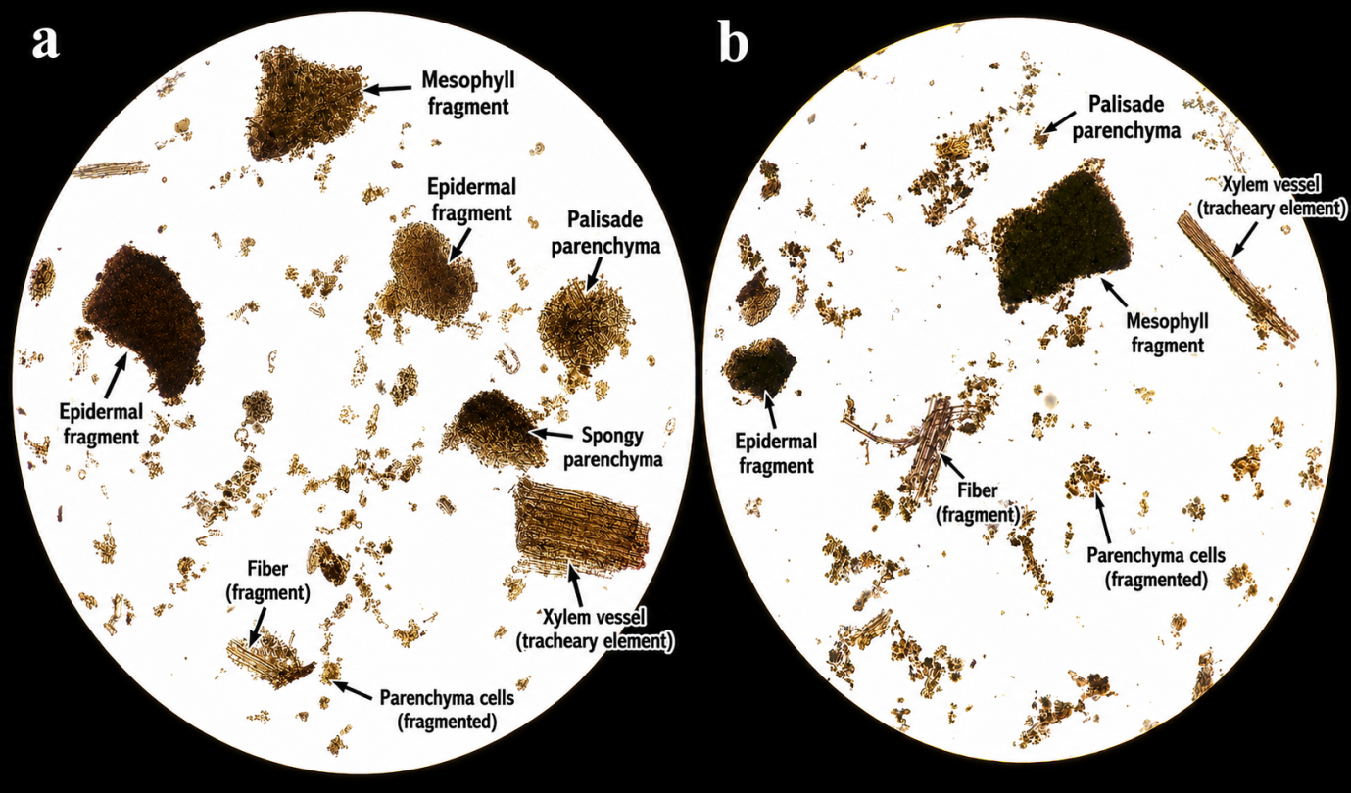
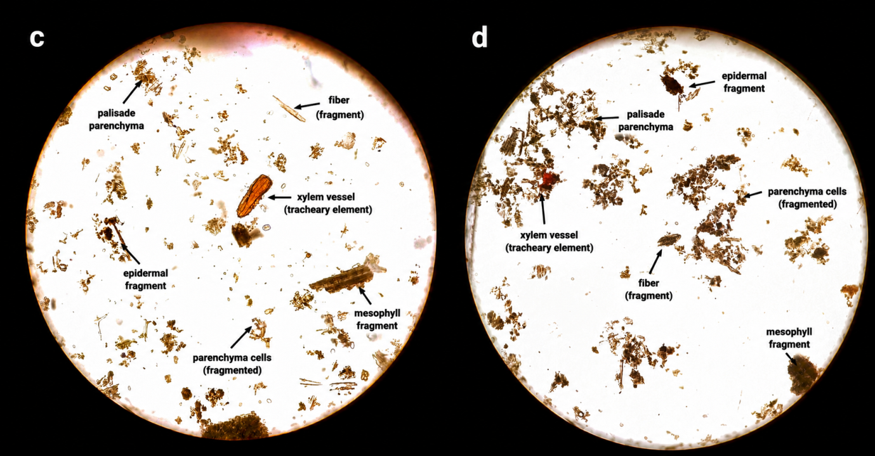
Fig1.: Powder microscopy of Mudgaparni (Vigna trilobata Linn.) whole plant powder
The powder showed distinct fragments of the epidermis, palisade parenchyma and spongy mesophyll. Fragments of mesophyll tissue occurred in compact aggregates, while palisade parenchyma appeared as elongated, closely arranged cells. Spongy parenchyma was observed as loosely arranged cellular fragments with intercellular spaces. Numerous fragments of parenchymatous cells were also present. Xylem vessels including elongated tracheary elements with thickened walls, were evident along with fragments of fibres.
ii. Transverse Section
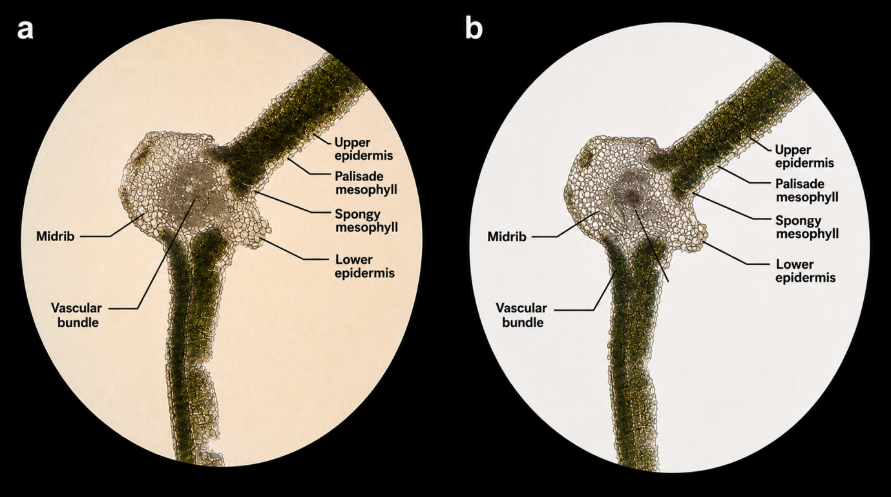
Fig 2: (a,b)Transverse section (TS) of Leaf of Mudgaparni (Vigna trilobata Linn.)
The transverse section of the leaf of Vigna trilobata Linn. exhibit a dorsiventral structure. The leaf was bounded by a single layer of compactly arranged upper and lower epidermal cells. The upper epidermis was followed by a distinct zone of elongated, closely arranged palisade mesophyll cells. Beneath the palisade region, the spongy mesophyll consisted of loosely arranged, irregularly shaped parenchymatous cells with prominent intercellular spaces. The midrib region was prominent and composed mainly of parenchymatous ground tissue containing a distinct vascular bundle. The vascular bundle was embedded within the midrib and surrounded by parenchymatous cells. The lower epidermis formed the outermost layer on the abaxial surface.
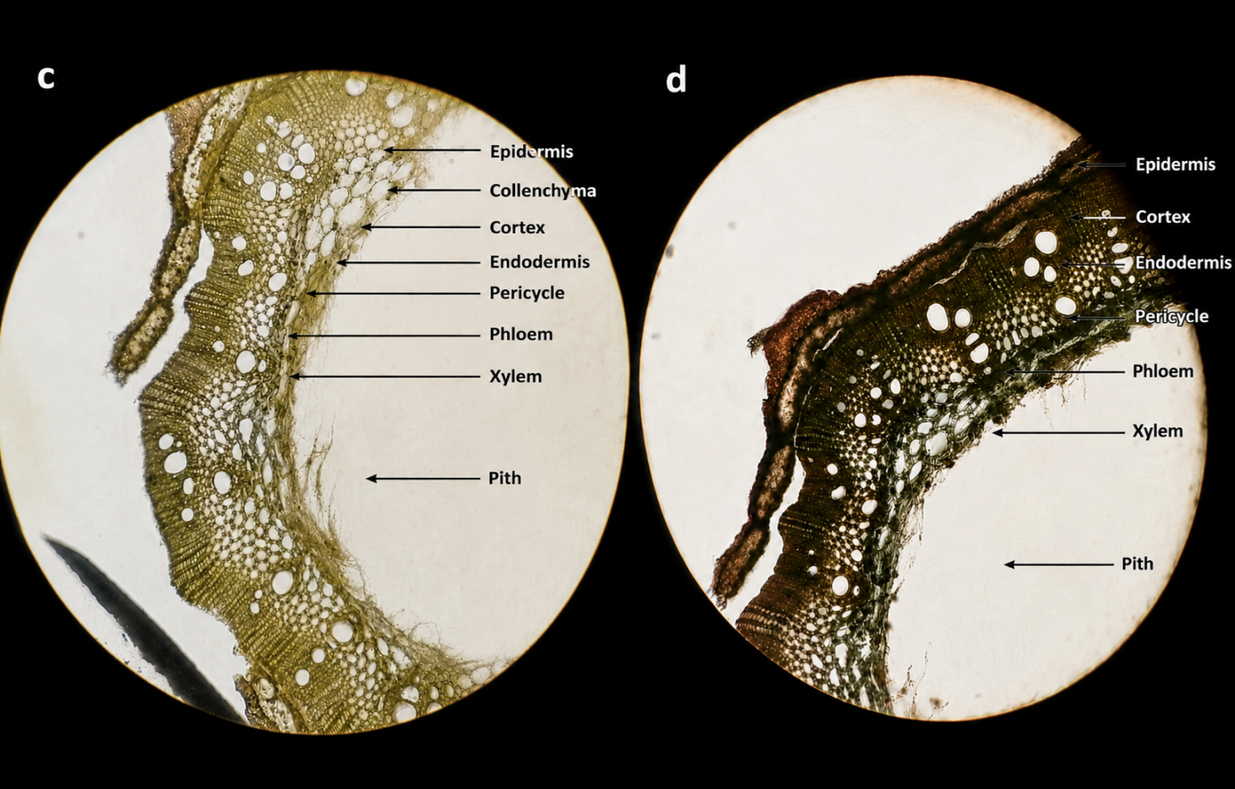
Fig .3:(c,d) Transverse section (TS) of Stem of Mudgaparni (Vigna trilobata Linn.)
The transverse section of the stem of Vigna trilobata Linn. showed a distinct epidermal layer forming the outermost covering. The epidermis was followed by a cortex composed of parenchymatous cells, with a zone of collenchymatous tissue observed beneath the epidermal region. A distinct endodermis demarcated the cortical region from the vascular tissue. The pericycle was present internal to the endodermis. The vascular tissues were arranged in distinct vascular bundles, with phloem occurring towards the outer side and xylem towards the inner side. The xylem consisted of prominent, thick-walled vessels of varying sizes. The central region was occupied by a broad, well-developed parenchymatous pith.
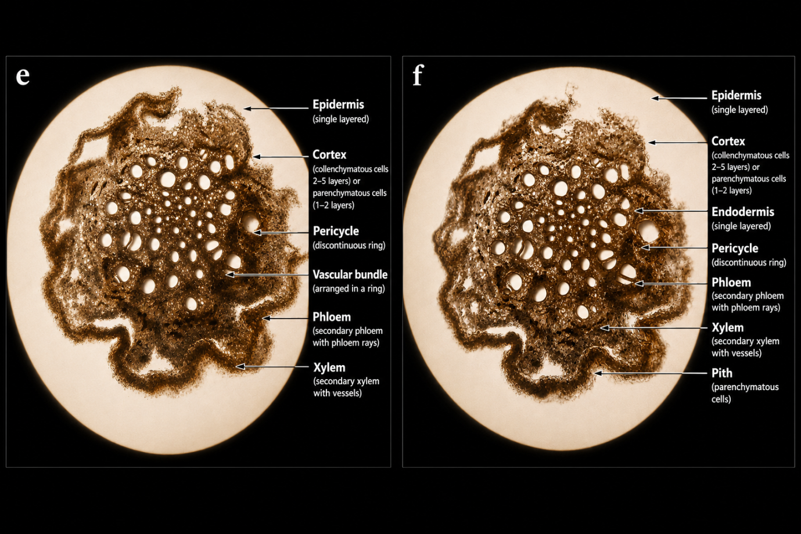
Fig .4:(e,f) Transverse section (TS) of Roots of Mudgaparni (Vigna trilobata Linn.)
The transverse section of the root of Vigna trilobata Linn. exhibit a distinct outer epidermal layer followed by a well-developed cortex. The cortex consisted of several layers of predominantly collenchymatous and parenchymatous cells. A distinct single-layered endodermis demarcated the cortex from the stele. The pericycle was present immediately inner to the endodermis and appeared as a discontinuous ring. The vascular bundles were arranged in a distinct ring, exhibiting secondary growth. The phloem occurred towards the outer region, while the xylem was situated towards the inner region and consisted of prominent secondary xylem with well-developed vessels. Phloem rays and xylem rays were also evident between the vascular tissues.
B. Physicochemical Study^{[2]}
Table 6: Physicochemical Study of Vigna trilobata Linn.
S. No. | Parameters | Mudgaparni (Vigna trilobata Linn.) Sample readings | Standard as per Ayurveda Pharmacopoeia of India
a | Foreign matter | 1.5% | ≤ 2%
b | Loss on Drying | 1% | Not mentioned
c | Total Ash | 9.9% | ≤ 11.5%
d | Acid-insoluble ash | 1.4% | ≤ 1.5%
e | Water-soluble extractive value | 10.3% | ≤ 11%
f | Alcohol-soluble extractive value | 2.9% | ≤ 3%

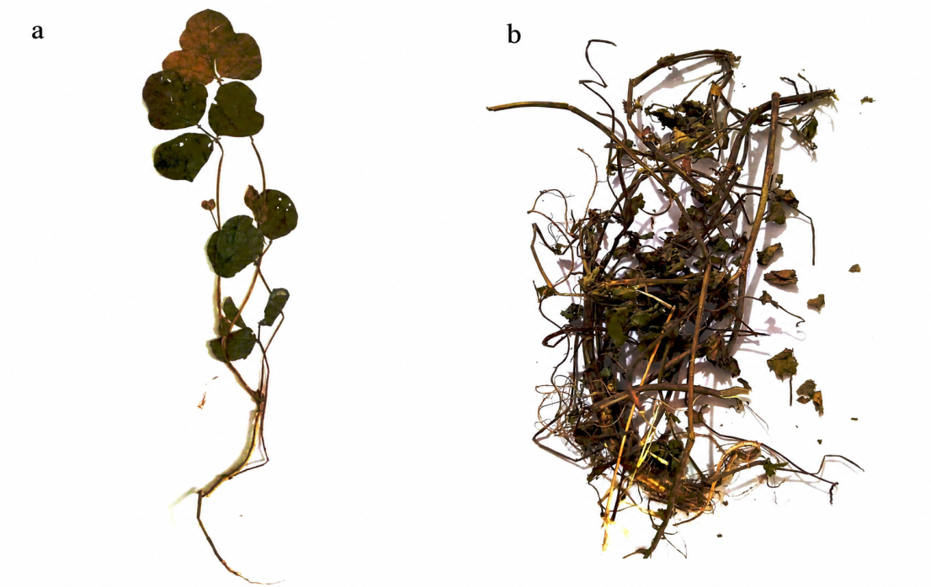
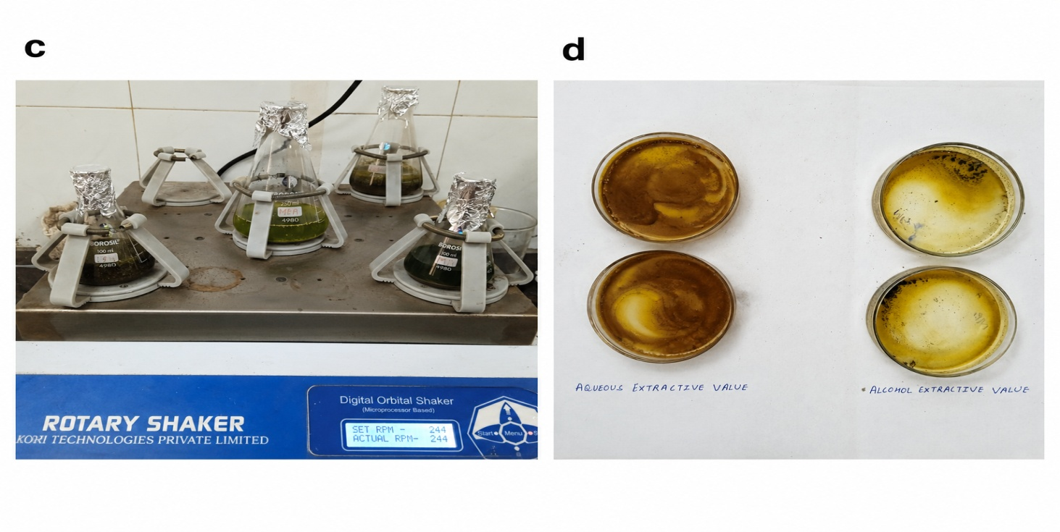
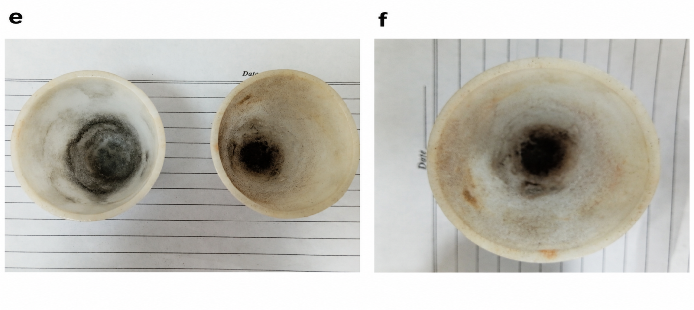
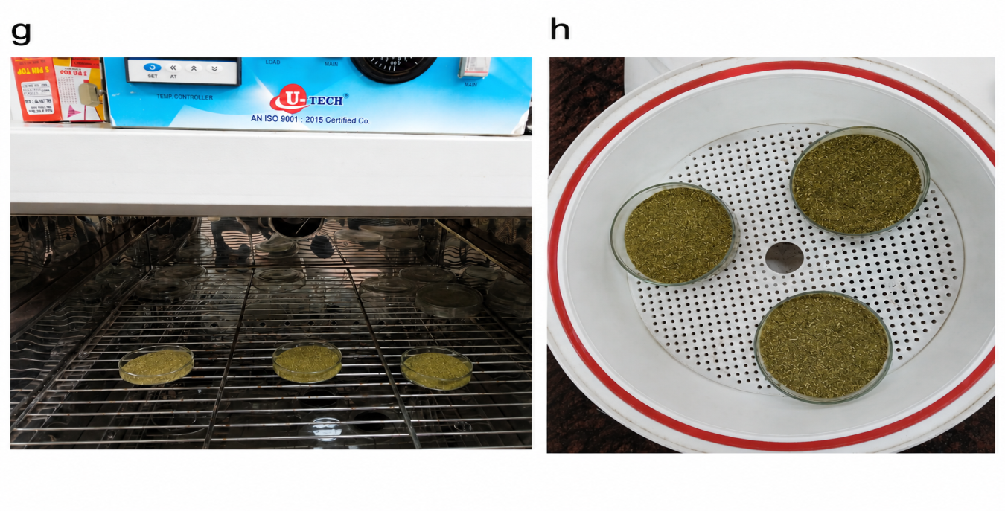
Fig 5: Physicochemical evaluation of Mudgaparni (Vigna trilobata L.) shows (a,b) Hebarium of Mudgaparni (Vigna trilobata Linn), Foreign Matter; (c,d): Aqueous & Alcohol Soluble Extractive values; (e,f): Total Ash value & Acid Insoluble Ash Value; (g,h): Moisture Content (Loss on Drying)
C. Phtytochemical Study^{[3]}
Table 7: Phytochemical Study of Vigna trilobata Linn.
S.No. | Phytochemical | Test | Observations
S.No. | Phytochemical | Test | Alcohol extract | Aqueous extract
1. | Alkaloid | Fehling’s Test | + | +
2. | Flavonoid | Alkaline Test | + | +
3. | Glycoside | Keller-Killiani Test | - | -
4. | Tannin | Ferric Chloride Test | + | +
5. | Saponin | Froth Formation Test | + | +
6. | Sterols | Salkowski’s Test | + | +
7. | Phenols | Ferric Chloride Test | + | +
8. | Carbohydrates | Fehling’s Test | - | -
9. | Proteins | Milon’s Test | + | +
+ indicates: Presence and - indicates: Absence
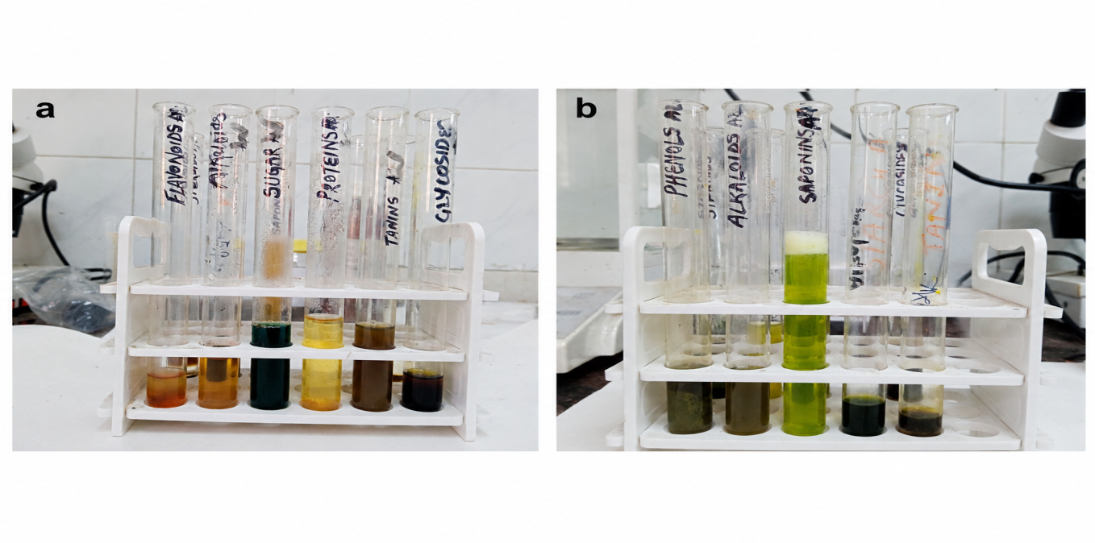
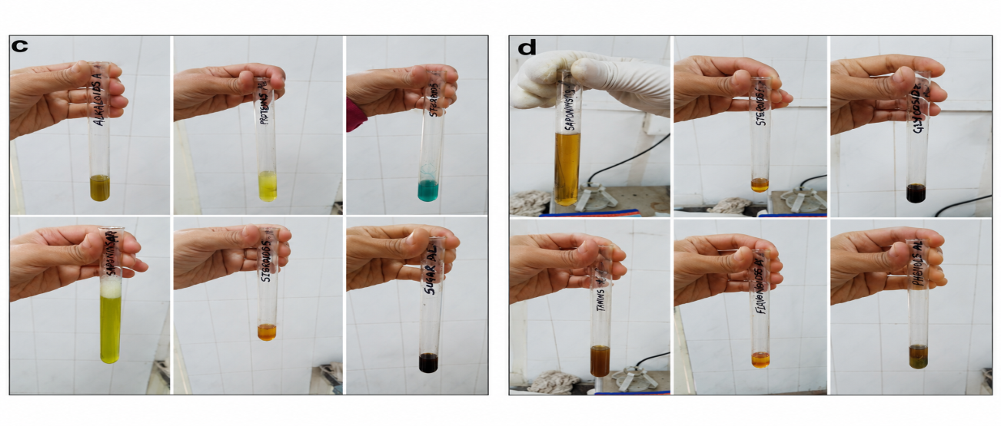
Fig .6: Phytochemical evaluation of Mudgaparni (Vigna trilobata Linn.) for Aqueous Extract & Alcoholic Extract
D. High Performance Liquid Chromatography^{[4]}
HPTLC analysis of the ethanolic extract of Vigna trilobata Linn. generated a well-resolved chromatographic fingerprint at both 254 and 366 nm. Six to seven peaks were observed at 254 nm and three to six peaks at 366 nm, indicating the presence of multiple detectable constituents. The major peaks at Rf values of approximately 0.89–0.95 accounted for the highest peak areas, while similar chromatographic profiles across different sample applications suggested good repeatability under the experimental conditions. The obtained fingerprint may serve as a reference profile for the identification and comparative quality assessment of Vigna trilobata Linn samples.
Table 8: High Performance Thin Layer Chromatographic Analysis of Vigna trilobata Linn.
Parameter | Observation
Sample
  Ethanolic extract of Vigna trilobata
  Stationary phase
  Silica gel 60 F₂₅₄
  Mobile phase
  Chloroform : Ethyl acetate (4:6 v/v)
  Detection wavelengths
  254 nm and 366 nm
  Number of peaks at 254 nm
  6–7 peaks
  Number of peaks at 366 nm
  3–6 peaks
  Major peak at 254 nm
  Rf ≈ 0.89 (58–60% peak area)
  Second major peak at 254 nm
  Rf ≈ 0.94–0.95 (23–24% peak area)
  Major peak 366 nm
  Rf ≈ 0.95 (49–50% peak area)
  Second major peak 366 nm
  Rf ≈ 0.86–0.87 (23–24% peak area)
  Minor peaks
  Rf ≈ 0.00–0.13, 0.75 and 1.00
Reproducibility | Similar Rf values observed in all tracks (1-4µL)

Discussion
The present study evaluated the pharmacognostical, physicochemical, phytochemical and chromatographic characteristics of Mudgaparni (Vigna trilobata Linn.) to generate baseline information for its identification and quality assessment.
An integrated evaluation that combines morphological, physicochemical, phytochemical and chromatographic evidence is consistent with multidimensional approaches to herbal-drug standardization, because complex botanical materials are more reliably characterized by complementary quality attributes than by a single test alone (Balekundri & Mannur, 2020; Kaundal & Kumar, 2025; Noviana et al., 2022).
Macroscopic examination demonstrated characteristic morphological features of the root, stem, leaves, flowers, fruits and seeds that are consistent with the botanical description of the species. Microscopic evaluation, including powder microscopy and transverse sections of different plant parts revealed diagnostic anatomical features that may assist in the identification of the crude drug particularly in powdered form.
Macroscopic and microscopic markers are particularly useful for authentication when crude drugs are traded as fragmented or powdered material, because diagnostic anatomical characters can help distinguish genuine material from morphologically similar substitutes or adulterants (Balekundri & Mannur, 2020; Kaundal & Kumar, 2025; Rashid et al., 2018). The diagnostic tissues observed in the present study therefore provide a morphological-anatomical basis for future comparative authentication of Vigna trilobata, although examination of additional populations would be required to establish the consistency of these features across geographical sources.
Physicochemical evaluation is routinely employed to assess the quality and purity of herbal drugs. The values obtained for foreign matter, total ash, acid-insoluble ash, water-soluble extractive and alcohol-soluble extractive were within the limits prescribed by the Ayurvedic Pharmacopoeia of India wherever standards are available. The low moisture content indicates that the sample was adequately dried, which may help reduce deterioration during storage. The comparatively higher water-soluble extractive value suggests that a greater proportion of extractable constituents are soluble in water.
Ash values, moisture content and solvent-extractive values are widely used as complementary indices of inorganic residue, storage-related deterioration and the proportion of solvent-extractable constituents in herbal raw materials (Balekundri & Mannur, 2020; Kaundal & Kumar, 2025; Rashid et al., 2018). In the present sample, the low loss on drying together with conformity of the reported physicochemical parameters to the cited pharmacopoeial limits supports acceptable raw-material quality under the tested conditions; however, these measurements should be interpreted as batch-specific data rather than universal limits for the species.
Preliminary phytochemical screening indicated the presence of alkaloids, flavonoids, tannins, saponins, sterols, phenolic compounds and proteins in both aqueous and alcoholic extracts, whereas glycosides and carbohydrates were not detected under. These findings are generally in agreement with previous reports on Vigna trilobata Linn., although qualitative phytochemical results may vary depending on the extraction method, solvent system and geographical source of the plant material.
Previous investigations of Vigna trilobata have documented a chemically diverse profile that includes flavonoid and phenolic constituents, while more recent seed-level profiling has demonstrated variation among accessions and the presence of multiple detectable metabolites (Gore et al., 2024; Seneviratne & Harborne, 1992; Zaheer et al., 2021). Accordingly, the qualitative detection of several metabolite classes in the present whole-plant extracts is plausible, but a negative preliminary reaction should not be interpreted as definitive absence because detection can depend on solvent selection, analyte concentration and assay sensitivity.
HPTLC analysis generated a distinct chromatographic fingerprint with multiple peaks at both 254 nm and 366 nm. The reproducibility of the chromatographic profile across different sample applications suggests that the method may be useful for comparative evaluation and quality assessment.Overall, the findings of the present study add to the available pharmacognostical and analytical information on Mudgaparni and may be useful as reference data for future investigations involving authentication and standardization of the plant.
Chromatographic fingerprinting is widely used for comparative assessment of complex herbal materials because the distribution and relative intensity of multiple zones or peaks can provide a broader identity pattern than reliance on a single constituent (Balekundri & Mannur, 2020; Gökbulut, 2021; Noviana et al., 2022). The repeated Rf pattern observed across the sample applications therefore supports the use of the present chromatogram as a preliminary reference fingerprint; nevertheless, formal analytical validation and comparison with independent batches would be required before establishing it as a routine quality-control specification.
Conclusion
The present study documented the pharmacognostical, physicochemical, phytochemical, and HPTLC characteristics of Mudgaparni (Vigna trilobata Linn.). The observed macroscopic and microscopic features may assist in the identification of the crude drug, while the physicochemical parameters provide basic information regarding its quality. Preliminary phytochemical screening indicated the presence of several classes of phytoconstituents and HPTLC analysis generated a characteristic chromatographic fingerprint of the ethanolic extract.
Although the findings are limited to qualitative and analytical evaluation, they provide baseline data that may be useful for future studies on the authentication, standardization and quality assessment of Mudgaparni (Vigna trilobata Linn.). Further investigations involving quantitative phytochemical analysis, isolation of marker compounds, pharmacological evaluation and clinical studies are required to better understand its therapeutic potential.
Limitations and Future Scope
The present study was limited to the pharmacognostical, physicochemical, preliminary phytochemical and HPTLC evaluation of Mudgaparni (Vigna trilobata Linn.). The phytochemical analysis was qualitative in nature and individual bioactive constituents were not identified or quantified. Furthermore, the investigation was conducted using plant material collected from a single geographical location and harvesting season. Nevertheless, the findings provide baseline information that may be useful for future investigations. Further studies involving quantitative phytochemical estimation, characterization of marker compounds using advanced analytical techniques, validation of the HPTLC fingerprint, comparative evaluation of samples from different geographical regions and seasons may contribute to a more comprehensive understanding of the quality, safety and therapeutic potential of Mudgaparni (Vigna trilobata Linn.).
Declaration of AI Use

This manuscript was prepared through the intellectual contributions of the author(s) to the study design, data analysis, interpretation of results, and scholarly content. Grammarly and ChatGPT were used solely to assist with grammatical refinement and reference formatting during manuscript revision. The author(s) accept full responsibility for the accuracy, integrity, and final content of the manuscript
References
1. Anonymous. The Ayurvedic Pharmacopoeia of India. Part I, Vol. II, New Delhi: Ministry of Health & Family Welfare, Government of India; [cited 2025, Oct.2021]. Available from: https://www.ayurveda.hu/api/API,Vol-2pdf.

2. Anonymous. The Ayurvedic Pharmacopoeia of India. Part I, Vol. VI, Appendix 2: Tests and Determinations. New Delhi: Ministry of Health & Family Welfare, Department of AYUSH, Government of India, 2008 [cited 2025, Oct.2021]. Available from: https://www.ayurveda.hu/api/API, Vol-6.pdf.

3. Kokate C.K., Purohit A.P., Gokhale S.B., Pharmacognosy. 55th ed. Pune: Nirali Prakashan; 2018. Appendix VII: Pathway to Screen Phytochemical Nature of Natural Drugs. p. A22-A27.

4. Illustrated HPTLC Laboratory Analysis, Quantification Analysis, Anchrom Enterprises India Private Limited, p. 1-14.
Balekundri, A., & Mannur, V. (2020). Quality control of the traditional herbs and herbal products: A review. Future Journal of Pharmaceutical Sciences, 6, 67. https://doi.org/10.1186/s43094-020-00091-5
Gökbulut, A. (2021). High performance thin layer chromatography (HPTLC) for the investigation of medicinal plants. Current Analytical Chemistry, 17(9), 1252-1259. https://doi.org/10.2174/1573411016999200602124813
Gore, N. T., Shaikh, S. S., Sule, V. A., Umdale, S. D., Mundada, P. S., Gaikwad, N. B., & Ahire, M. L. (2024). Understanding the nutritional profile of Vigna trilobata: A lesser-known, underexplored grain legume. Food and Humanity, 3, 100343. https://doi.org/10.1016/j.foohum.2024.100343
Kaundal, R., & Kumar, D. (2025). Current demands for standardization of Indian medicinal plants: A critical review. Medicine in Drug Discovery, 27, 100211. https://doi.org/10.1016/j.medidd.2025.100211
Noviana, E., Indrayanto, G., & Rohman, A. (2022). Advances in fingerprint analysis for standardization and quality control of herbal medicines. Frontiers in Pharmacology, 13, 853023. https://doi.org/10.3389/fphar.2022.853023
Rashid, S., Zafar, M., Ahmad, M., Lone, F. A., Shaheen, S., Sultana, S., Ashfaq, S., & Shinwari, M. I. (2018). Microscopic investigations and pharmacognostic techniques used for the standardization of herbal drug Nigella sativa L. Microscopy Research and Technique, 81(12), 1443-1450. https://doi.org/10.1002/jemt.23110
Seneviratne, G. I., & Harborne, J. B. (1992). Constitutive flavonoids and induced isoflavonoids as taxonomic markers in the genus Vigna. Biochemical Systematics and Ecology, 20(5), 459-467. https://doi.org/10.1016/0305-1978(92)90087-T
Zaheer, M., Kalim, A., Siddiqui, M. U. A., & Ahmed, S. (2021). Vigna trilobata (L.) Verdc: A review of medicinal uses, phytochemistry and pharmacology. Journal of Pharmacognosy and Phytochemistry, 10(2), 118-120. https://doi.org/10.22271/phyto.2021.v10.i2b.13971

