Effectiveness of a Planned Teaching Programme on Knowledge Regarding the Influence of Television on Behavioural Changes among High School Students in Jaipur: A Pre-Experimental Study

ABSTRACT
Background: Television and other screen-based media can influence adolescent knowledge, attitudes, emotions, daily routines, and behaviour. School-based health education may improve students’ awareness of these effects. Objective: To assess baseline knowledge regarding the influence of television on behavioural changes among high school students and evaluate the effectiveness of a planned teaching programme. Methods: A quantitative evaluative, pre-experimental one-group pre-test–post-test design was used. Sixty high school students in Jaipur were selected by purposive sampling. Knowledge was measured with a 25-item self-structured multiple-choice questionnaire. The tool underwent expert content validation and showed split-half reliability of 0.82. A planned teaching programme was delivered after the pre-test, and the post-test was conducted five days later. Data were analyzed using frequency, percentage, mean, standard deviation, paired t test, and chi-square test. Results: Before the intervention, 70.0% of students had poor knowledge and 30.0% had average knowledge; none had good knowledge. After the intervention, 73.3% had good knowledge, 26.7% had average knowledge, and none remained in the poor category. Mean knowledge score increased from 11.82 ± 2.63 to 19.82 ± 2.11. The paired t value was -20.40 (df=59; p<0.05), indicating a statistically significant improvement. Among the demographic variables examined, only self-reported health disturbances related to television viewing showed a significant association with pre-test knowledge (χ²=11.85, df=1, p<0.05). Conclusion: The planned teaching programme was effective in improving high school students’ knowledge regarding the influence of television on behavioural changes. School and community health nurses may use structured media-literacy education as part of adolescent health-promotion activities.
Keywords: high school students; television; behaviour; knowledge; planned teaching programme; adolescent health; nursing education

1. INTRODUCTION
Television remains an important source of information, education, entertainment, and social learning for children and adolescents. At the same time, heavy or poorly supervised screen exposure has been associated with behavioural concerns, reduced physical activity, sleep problems, academic difficulties, emotional symptoms, and exposure to violent or otherwise inappropriate content. The effects vary according to age, developmental stage, duration of exposure, programme content, and family supervision.1–8
Adolescents are especially responsive to observed behaviour and media messages. Social-learning perspectives suggest that behaviours portrayed by influential models can be observed, encoded, and reproduced, particularly when they appear rewarded or socially acceptable.9,20 In addition, school-age children increasingly use multiple digital media platforms, which can amplify exposure beyond traditional television.5,17,24
Indian studies have reported high levels of screen exposure among children and adolescents and have highlighted associations with developmental delay, limited physical activity, sleep problems, eye symptoms, headache, and behavioural or psychosocial difficulties.15–19,21–24 Although television may provide educational and prosocial benefits, students need the knowledge and skills to recognize harmful content, regulate viewing time, and make healthier media choices.10–12
Planned teaching programmes are a practical nursing strategy for school health promotion. The present study therefore evaluated whether a structured educational intervention could improve high school students’ knowledge regarding the influence of television on behavioural changes.
2. AIM AND OBJECTIVES
The aim of the study was to evaluate students’ knowledge regarding the influence of television on behavioural changes and determine the effectiveness of a planned teaching programme in improving that knowledge.
- To assess pre-test knowledge regarding the influence of television on behavioural changes among high school students.
- To assess post-test knowledge regarding the influence of television on behavioural changes among high school students.
- To compare pre-test and post-test knowledge scores.
- To evaluate the effectiveness of the planned teaching programme.
- To determine the association between pre-test knowledge and selected demographic variables.

3. CONCEPTUAL FRAMEWORK
The study was guided by Ludwig von Bertalanffy’s General System Model. Baseline characteristics and pre-test knowledge were treated as input; the planned teaching programme represented the throughput process; post-test knowledge represented output; and the findings provided feedback regarding the effectiveness of the educational intervention.
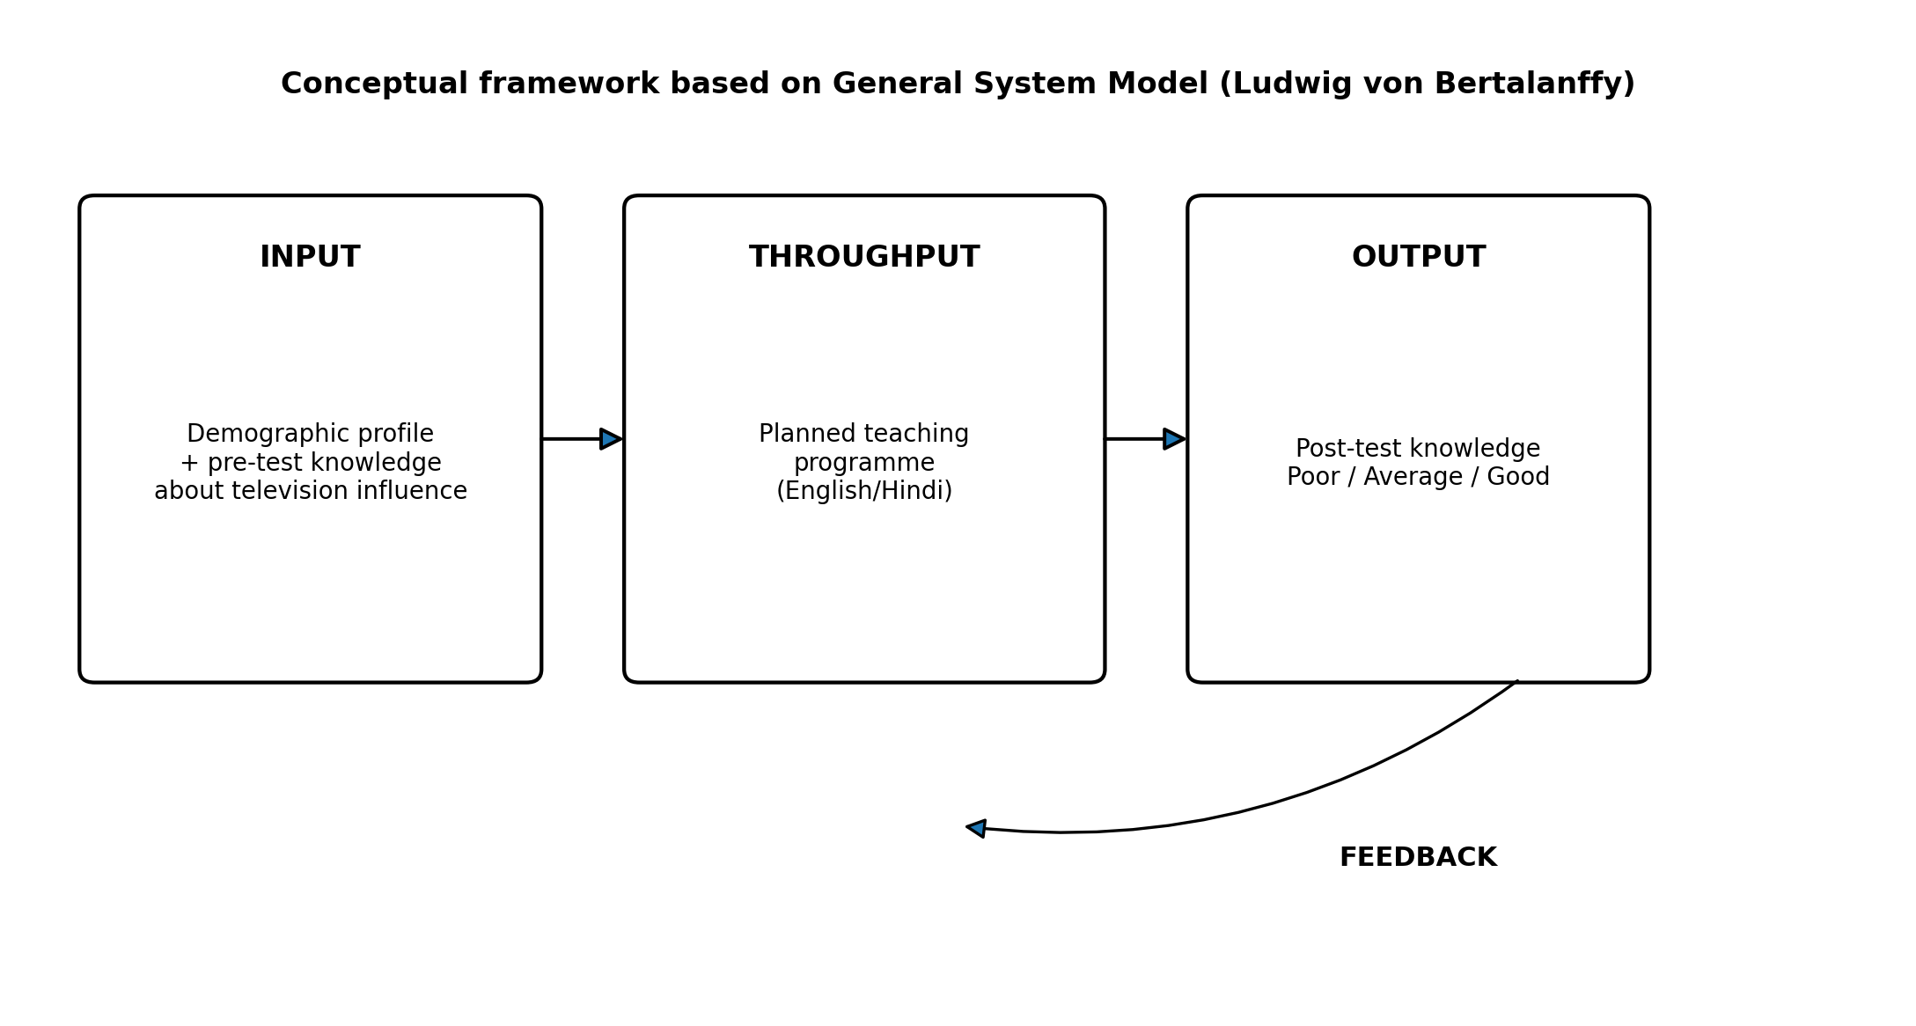
Figure 1. Conceptual framework based on the General System Model.

4. MATERIALS AND METHODS

4.1 Research approach and design
A quantitative evaluative approach was adopted. The study used a pre-experimental one-group pre-test–post-test design (O1–X–O2), with manipulation of the independent variable but no randomization and no control group.
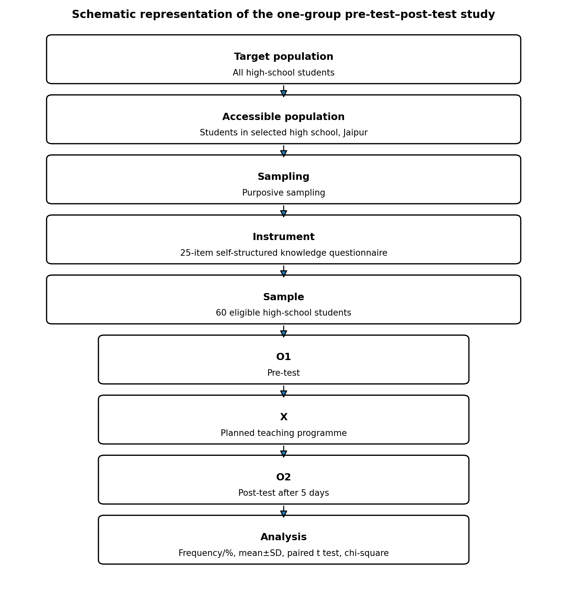
Figure 2. Schematic representation of the research design and study flow.

4.2 Setting, population, sample, and sampling
The study was conducted in a selected high school in Jaipur, Rajasthan. The target population comprised high school students, and the accessible population comprised students attending the selected school. A sample of 60 students was selected using purposive sampling. The dissertation abstract identifies participants as 14–18 years of age and of both sexes. Participants were required to be regular students, willing to participate, available during data collection, and able to understand English or Hindi.

4.3 Variables
The independent variable was the planned teaching programme regarding the influence of television on behavioural changes. The dependent variable was students’ knowledge regarding the influence of television on behavioural changes. Demographic and television-viewing characteristics were treated as background variables.

4.4 Instrument
Data were collected using a self-structured tool consisting of demographic/television-viewing items and a 25-item multiple-choice knowledge questionnaire. Each correct response received one mark and each incorrect response received zero, giving a possible total score of 0–25. The outcome analysis categorized knowledge as poor (0–13), average (14–18), or good (19–25). Content validity was established through review by five experts from Child Health Nursing. Split-half reliability, calculated using Karl Pearson’s correlation method during tool testing, was reported as 0.82.

4.5 Planned teaching programme
The planned teaching programme was developed from the study objectives, review of literature, expert consultation, and investigator experience. It was prepared in English and Hindi and focused on the influence of television on behaviour, beneficial and harmful effects of television exposure, and strategies to reduce negative effects. The teaching content was reviewed by experts and modified according to their suggestions.

4.6 Pilot study
A pilot study was conducted from 22 October 2024 to 9 November 2024 at Government Senior Secondary School, Khowarani Ji, Jamwaramgarh, Jaipur, with six students (10% of the main sample). Purposive sampling was used. Participants completed the pre-test, received the planned teaching programme, and completed a post-test on the seventh day. The pilot indicated that the study procedures were feasible.

4.7 Data collection procedure
Formal permission was obtained from the principal of the selected high school. The main study was conducted from 16 April 2025 to 10 May 2025. The investigator explained the purpose of the study, obtained written consent, assured confidentiality, and administered the pre-test. The planned teaching programme was delivered on the same day. The same knowledge questionnaire was used for the post-test five days later.

4.8 Statistical analysis
Demographic data were summarized using frequency and percentage. Mean and standard deviation were used for knowledge scores. A paired t test evaluated the difference between pre-test and post-test scores. Chi-square tests examined associations between pre-test knowledge grade and selected demographic variables. Statistical significance was considered at p<0.05.
5. RESULTS AND DISCUSSION

5.1 Participant characteristics and television-viewing profile
Variable | Category | n (%)
Age | <16 years | 45 (75.0)
Age | 17 years | 14 (23.3)
Age | >17 years | 1 (1.7)
Gender | Male | 34 (56.7)
 | Female | 26 (43.3)
 | Transgender | 0 (0.0)
Residence | Urban | 33 (55.0)
 | Semi-urban | 20 (33.3)
 | Rural | 7 (11.7)
Monthly family income | <₹10,000 | 5 (8.3)
 | ₹10,000–20,000 | 21 (35.0)
 | ₹21,000–31,000 | 23 (38.3)
 | >₹31,000 | 11 (18.3)
TV viewing per day | <1 hour | 4 (6.7)
 | 1–3 hours | 29 (48.3)
 | 4–6 hours | 22 (36.7)
 | >6 hours | 5 (8.3)
Programme usually watched | News | 1 (1.7)
 | Movies | 38 (63.3)
 | Comedies | 15 (25.0)
 | Reality shows | 5 (8.3)
 | Cartoons/anime | 1 (1.7)
 | Other | 0 (0.0)
Viewing companion | Alone | 23 (38.3)
 | Family | 32 (53.3)
 | Friends | 5 (8.3)
Missed daily activities due to TV | Yes | 31 (51.7)
 | No | 29 (48.3)
Negative emotions after TV | Yes | 40 (66.7)
 | No | 20 (33.3)
Health disturbances related to TV | Yes | 18 (30.0)
 | No | 42 (70.0)
Believes TV influences behaviour | Yes | 15 (25.0)
 | No | 45 (75.0)
Table 1. Demographic characteristics and television-viewing profile (N=60).
The sample was predominantly younger than 16 years (75.0%), male (56.7%), and urban (55.0%). Nearly half watched television for 1–3 hours daily (48.3%), and movies were the most commonly watched programme type (63.3%). More than half watched with family (53.3%). Approximately 51.7% reported missing daily activities because of television, 66.7% reported negative emotions such as anxiety or fear after viewing, and 30.0% reported health disturbances related to television viewing. Despite these experiences, 75.0% did not believe that television influenced their behaviour.

5.2 Pre-test and post-test knowledge grade
Knowledge grade | Pre-test n (%) | Post-test n (%)
Poor (0–13) | 42 (70.0) | 0 (0.0)
Average (14–18) | 18 (30.0) | 16 (26.7)
Good (19–25) | 0 (0.0) | 44 (73.3)
Total | 60 (100.0) | 60 (100.0)
Table 2. Comparison of pre-test and post-test knowledge grades.
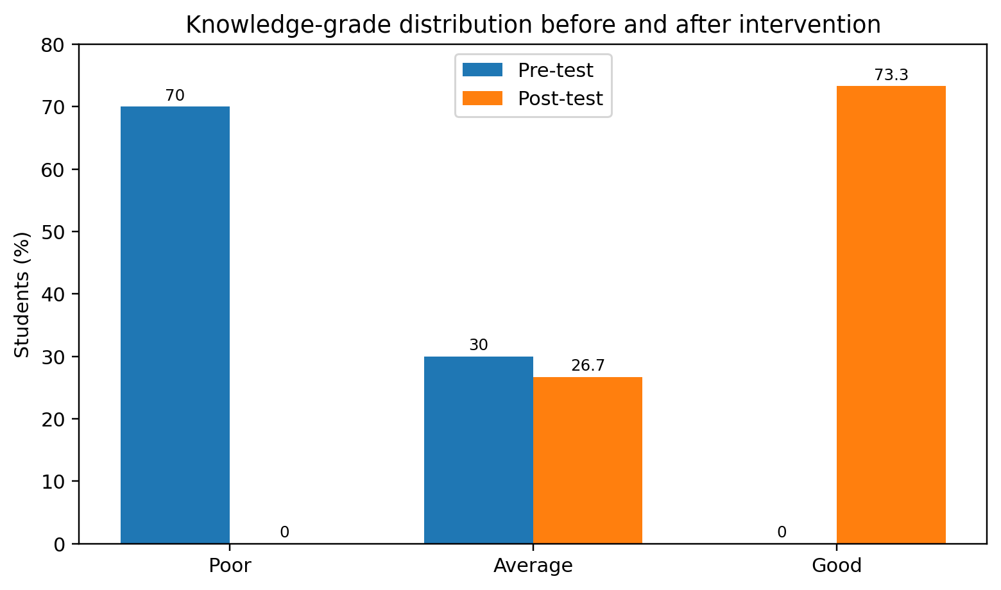
Figure 3. Knowledge-grade distribution before and after the planned teaching programme.
At baseline, 70.0% of students were in the poor-knowledge category and 30.0% were in the average category; no student had good knowledge. After the intervention, no student remained in the poor category, 26.7% had average knowledge, and 73.3% had good knowledge.
5.3 Effectiveness of the planned teaching programme
Assessment | Mean ± SD | t | df | p value | Inference
Pre-test | 11.82 ± 2.63 | -20.40 | 59 | <0.05 | Significant
Post-test | 19.82 ± 2.11
Table 3. Pre-test and post-test knowledge scores.
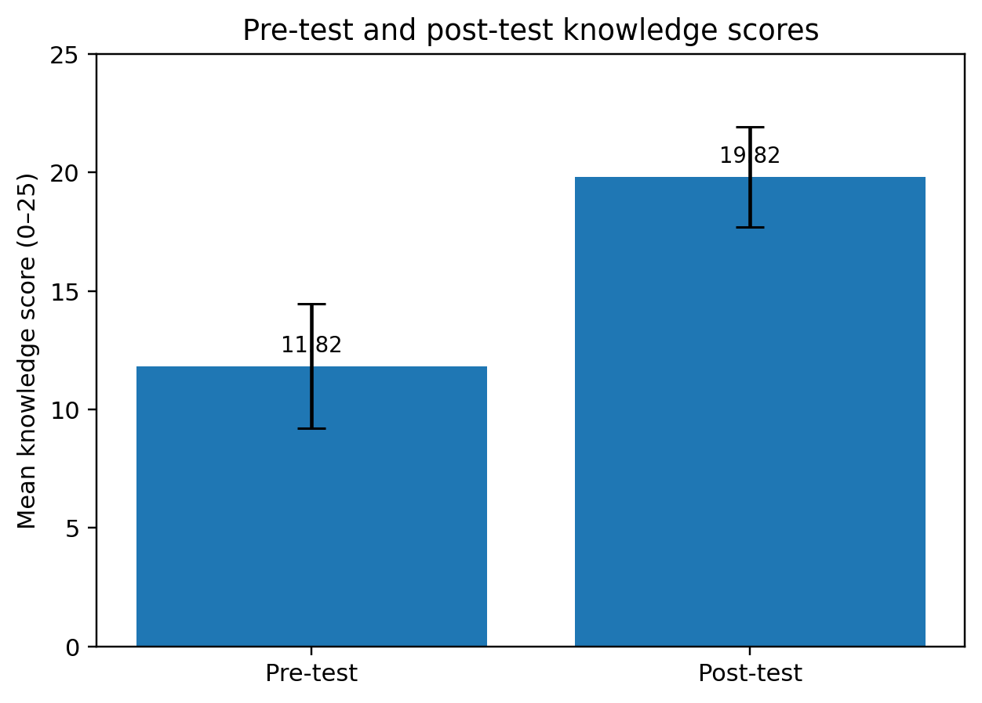
Figure 4. Mean knowledge score before and after the intervention (error bars show SD).
The mean knowledge score increased by 8.00 points, from 11.82 ± 2.63 in the pre-test to 19.82 ± 2.11 in the post-test. The paired t test was statistically significant (t=-20.40, df=59, p<0.05), demonstrating a substantial improvement in knowledge following the planned teaching programme.
5.4 Association of pre-test knowledge with selected variables
Variable | χ² | df | p value | Inference
Age | 0.46 | 2 | >0.05 | NS
Gender | 3.31 | 1 | >0.05 | NS
Area of residence | 5.39 | 2 | >0.05 | NS
Monthly family income | 5.68 | 3 | >0.05 | NS
TV viewing hours/day | 3.13 | 3 | >0.05 | NS
Type of TV programme | 5.70 | 4 | >0.05 | NS
Viewing companion | 2.43 | 2 | >0.05 | NS
Missed daily activities | 1.68 | 1 | >0.05 | NS
Negative emotions after TV | 1.42 | 1 | >0.05 | NS
Health disturbances related to TV | 11.85 | 1 | <0.05 | Significant
Belief that TV influences behaviour | 0.10 | 1 | >0.05 | NS
Table 4. Association between pre-test knowledge grade and selected demographic/television-viewing variables.
Pre-test knowledge was not significantly associated with age, gender, residence, family income, daily viewing duration, type of programme, viewing companion, missed daily activities, negative emotions after viewing, or belief that television influences behaviour. A significant association was reported only for health disturbances related to television viewing (χ²=11.85, df=1, p<0.05).
The study demonstrated a marked improvement in students’ knowledge after a planned teaching intervention. The shift from 70.0% poor knowledge at baseline to 73.3% good knowledge after teaching, together with an increase in mean score from 11.82 to 19.82, indicates that a short, structured educational programme can substantially improve awareness of television-related behavioural influences.
The baseline viewing pattern is notable. Almost half of participants watched television for 1–3 hours each day, more than one-third watched 4–6 hours, and entertainment-oriented content—especially movies and comedies—dominated viewing. Previous Indian and international literature has similarly described extensive screen exposure among children and adolescents and linked it with sleep disturbance, reduced physical activity, psychosocial problems, poorer academic outcomes, and other health concerns.15–18,21–25
Two-thirds of participants reported negative emotions after television viewing and nearly one-third reported health disturbances, yet three-quarters did not perceive television as influencing their behaviour. This gap between experienced effects and perceived behavioural influence supports the need for media-literacy education that helps students recognize less obvious emotional, social, and behavioural consequences of media exposure.
The significant paired t test supports the effectiveness of the intervention, consistent with studies reporting that structured teaching and digital health education can improve knowledge and encourage healthier screen-use practices among adolescents and families.27–31 Although the present study measured knowledge rather than long-term behaviour, improved knowledge is a necessary foundation for informed decision-making and self-regulation.
Only health disturbances related to television viewing were significantly associated with baseline knowledge. Other demographic factors were not associated with pre-test knowledge, suggesting that the educational need was broad across subgroups. However, because the design lacked randomization and a control group, causal inference should be made cautiously.
7. NURSING IMPLICATIONS

7.1 Nursing practice
- School and community health nurses can incorporate media-literacy counselling into adolescent health promotion.
- Nurses can counsel students and families regarding balanced viewing, content selection, sleep hygiene, physical activity, and recognition of emotional or health effects related to prolonged viewing.
- Students who report distress, sleep problems, headaches, eye strain, or interference with daily activities can be identified early and referred when necessary.

7.2 Nursing education
- Nursing curricula can include the health and behavioural effects of screen exposure and practical methods for designing school-based teaching interventions.
- Student nurses can use similar programmes during community and school-health postings to build health-education and evaluation skills.

7.3 Nursing research and administration
- Further studies can evaluate long-term behavioural outcomes, parent-involved interventions, peer-led education, and digital teaching formats.
- Nursing administrators can support school-health programmes, educational materials, interdisciplinary collaboration, and policies that promote healthy media use.

8. LIMITATIONS
- The study used a pre-experimental one-group design without a control group or randomization.
- The sample was limited to 60 students from a selected high school in Jaipur, limiting generalizability.
- Purposive sampling may introduce selection bias.
- The outcome focused on knowledge immediately after a short follow-up rather than sustained behaviour change.
- Some methodological details in the dissertation require clarification before journal submission, including formal ethics committee approval information and the final author-approved knowledge grading scheme.

9. RECOMMENDATIONS
- Conduct controlled or randomized studies with larger, multi-school samples.
- Use longer follow-up periods to determine whether knowledge gains translate into reduced screen time or healthier viewing behaviours.
- Compare interactive workshops, peer education, digital modules, and parent–student interventions.
- Include qualitative interviews or focus groups to explore students’ perceptions and barriers to healthy screen use.
- Develop and validate standardized culturally appropriate tools measuring knowledge, attitudes, media literacy, and behavioural outcomes.
- Evaluate cost-effectiveness when implementing school-based media-literacy programmes at scale.

10. CONCLUSION
The planned teaching programme significantly improved high school students’ knowledge regarding the influence of television on behavioural changes. The intervention shifted most students from poor or average baseline knowledge to good post-test knowledge and produced a statistically significant increase in mean scores. The findings support the role of structured school-based education, including nurse-led media-literacy initiatives, in promoting informed and healthier television-viewing practices among adolescents.

11. DECLARATIONS

Ethics and consent
The dissertation reports that formal permission was obtained from the principal of the selected high school, written consent was obtained from participants, and confidentiality was assured. An institutional ethics committee approval number and details of parent/guardian consent or student assent for minors were not stated in the dissertation and should be added or clarified before journal submission.

Declaration of AI Use

This manuscript was prepared through the intellectual contributions of the author(s) to the study design, data analysis, interpretation of results, and scholarly content. Grammarly and ChatGPT were used solely to assist with grammatical refinement and reference formatting during manuscript revision. The author(s) accept full responsibility for the accuracy, integrity, and final content of the manuscript.

12. REFERENCES
1. Muppalla SK, Vuppalapati S, Reddy Pulliahgaru A, Sreenivasulu H. Effects of excessive screen time on child development: an updated review and strategies for management. Cureus. 2023;15(6):e40608. doi:10.7759/cureus.40608.
2. Musau ML, Okoth U, Matula P. Impact of students’ exposure to electronic media facilities in their homes on parental involvement in management of students’ discipline in public day secondary schools in Kenya. European Scientific Journal. 2017;13(31):202–221. doi:10.19044/esj.2017.v13n31p202.
3. India television viewership 2023. Statista. Accessed in the dissertation 2024 May 16.
4. Nirusha K, Daniel VS, Bhanu Priya U. A descriptive study to assess the impact of television watching on behaviour among school-going children in selected schools at Guntur, Andhra Pradesh, India. Int J Sci Res. 2017;6(10):2067–2070.
5. Allchorne KK, Cooper NR, Simpson A. The relationship between television exposure and children’s cognition and behaviour: a systematic review. Dev Rev. 2017;44:19–58. doi:10.1016/j.dr.2016.12.002.
6. Mass media: functions and role. Study.com. Source cited in the dissertation.
7. American Academy of Child and Adolescent Psychiatry. TV violence and children. Source cited in the dissertation.
8. Eric O. The negative effects of new screens on the cognitive functions of young children require new recommendations. Ital J Pediatr. 2021;47:223.
9. Anderson CA, et al. The influence of media violence on youth. Psychol Sci Public Interest. 2003/2004;4(3):81–110. [Bibliographic year should be verified against the final journal source.]
10. Positive and negative influence of the media. Source cited in the dissertation.
11. Chassiakos YR, et al. Children and adolescents and digital media. Pediatrics. 2016;138(5):e20162593.
12. Impact of excessive screen time on children’s exam performance. Times of India. 2024 Mar 2. Source cited in the dissertation.
13. Polit DF, Hungler BP. Nursing Research: Principles and Methods. 7th ed. Philadelphia: Lippincott Williams & Wilkins; 2005.
14. Polit DF. Nursing Research: Principles and Methods. 7th ed. Philadelphia: Lippincott Williams & Wilkins; 2005.
15. Vardharajan S, Govindarajan A, et al. Prevalence of excessive screen time and its association with developmental delay in children aged <5 years: a population-based cross-sectional study in India. PLoS One. 2021;16(11):e0259393. doi:10.1371/journal.pone.0259393.
16. Meena P, Gupta P, et al. Screen time in Indian children by 15–18 months of age. Indian Pediatr. 2020;57(9):782–784.
17. Liu J, Riesch S, et al. Screen media overuse and associated physical, cognitive, and emotional/behavioural outcomes in children and adolescents: an integrative review. J Pediatr Nurs. 2023;69:71–83. doi:10.1016/j.pedn.2022.11.015.
18. Jain S, Shrivastava S, et al. Prevalence and determinants of excessive screen viewing time in children aged 3–15 years and its effects on physical activity, sleep, eye symptoms and headache. Int J Environ Res Public Health. 2023;20(3):2583. doi:10.3390/ijerph20032583.
19. Kiran T, Gupta M, et al. Development and evaluation of the digital-screen exposure questionnaire (DSEQ) for young children. PLoS One. 2021;16(8):e0254312. doi:10.1371/journal.pone.0254312.
20. Bandura A, Ross D, Ross SA. Transmission of aggression through imitation of aggressive models. J Abnorm Soc Psychol. 1961;63(3):575–582.
21. Hu Z, Bi S, et al. Association of screen exposure with psychosocial problems in primary school students. BMC Public Health. 2023;23.
22. Guo YF, Liao MQ, et al. Health-related behaviours among Chinese students during COVID-19: a cross-sectional study. BMC Public Health. 2021;21.
23. Xiang H, Lin L, et al. Associations of excessive screen time and early screen exposure with health-related quality of life and behavioural problems in preschoolers. BMC Pediatr. 2022;22.
24. Nakshine VS, Thute P, et al. Increased screen time as a cause of declining physical, psychological health, and sleep patterns. Int J Health Sci Res. 2022;12(7).
25. Wiguna T, Minayati K, et al. Influence of screen time on behavioural and emotional problems among adolescents: a COVID-19 comparison study. J Adolesc Health. 2024.
26. Santi, Herawati, et al. Implications of screen time for children’s health in online learning at 59 Siguntu Elementary School. Int J Multidiscip Educ Res. 2022;12(2).
27. Jones A, Armstrong B, et al. Identifying effective intervention strategies to reduce children’s screen time: a systematic review and meta-analysis. Int J Behav Nutr Phys Act. 2021;18:126.
28. Dos Santos PC, Bandeira A, et al. Effect of an intervention on the stage of behaviour change for TV viewing in Brazilian students. J Pediatr (Rio J). 2023;99(3).
29. Settipalle NA, et al. Effectiveness of structured teaching programme on influence of mass media on adolescence behaviour among their parents. Int J Nurs Educ Res. 2024;12(1).
30. Parveen N, Tyagi ZA. Effectiveness of structured teaching programme on knowledge regarding harmful effects of long screen viewing among adolescents. Int J Curr Res. 2022;14(10).
31. Raj D, Ahmad N, et al. Stop and Play: digital health education intervention to reduce screen time among preschoolers. JMIR Pediatr Parent. 2023;6(2):e38798.
32. Polit DF, Beck CT. Nursing Research: Principles and Methods. 7th ed. Philadelphia: Lippincott Williams & Wilkins; 2004.

