Environmental Patterns, Diversity, and Phytoplankton Composition in Urban Lakes of Yamoussoukro, Côte d'Ivoire

Abstract
Anthropogenic pressures to urban lakes can affect water quality and phytoplankton community structure. The study explored the taxonomic makeup, richness, abundance, diversity and environmental interactions of phytoplankton communities of eight urban lakes of Yamoussoukro, Côte d’Ivoire. Phytoplankton and physicochemical characteristics were studied bi-monthly from December 2015 to October 2017 at 28 sampling stations. In all, 191 taxa were discovered, representing 61 genera and five main phyla. Chlorophyta and Euglenophyta were the most diverse groupings, with 68.06% of the total taxonomic richness. Lake 5 had the highest taxonomic richness (103 taxa) and Lake 7 the lowest (11 taxa). Lakes 5, 6 and 8 showed much higher rarefied richness, Shannon diversity and Pielou evenness, whereas Lake 7 had the lowest values. Jaccard similarity between lakes was often low, suggesting that there were strong variances in phytoplankton composition. Lakes 5, 7, 8 and 9 were dominated by Cyanophyta whereas Lakes 0, 1 and 6 were dominated by Euglenophyta. Phytoplankton biomass and chlorophyll-a also exhibited geographic variability. PCA identified differing physicochemical gradients among lakes RDA demonstrated relationships between phytoplankton composition and nutrient, conductivity and oxygen gradients. Phytoplankton populations in general showed a strong geographical heterogeneity related to the different physicochemical conditions.
Keywords: Phytoplankton; Taxonomic diversity; Urban lakes; Water quality; Yamoussoukro
1.Introduction
Urban lakes are critical ecosystems that facilitate the regulation of drainage, recreational activities, and a variety of water uses. Nevertheless, their vulnerability to domestic, agricultural, and industrial inputs is exacerbated by their proximity to residential areas and human activities. These pressures have the potential to modify the physicochemical characteristics of water, increase the burdens of organic matter and nutrients, and facilitate the degradation of aquatic ecosystems and eutrophication (Zheng et al., 2024; Guo et al., 2023; Peng et al., 2021). The municipal lakes of Yamoussoukro, which were constructed in the late 1970s, are subject to a variety of pressures that are associated with the activities that occur within their catchments and along their shores. The ecological conditions of these water bodies may be impacted by the transport of refuse and sediments by runoff, as well as domestic, agricultural, and industrial discharges. Their hydrological, physicochemical, microbiological, and faunal characteristics have been the subject of previous research (N’Guessan et al., 2011; Kouakou et al., 2014; Nangoh et al., 2019). In this context, phytoplankton communities serve as a pertinent foundation for evaluating the ecological state of aquatic ecosystems. Variations in phytoplankton composition and abundance are valuable indicators of environmental conditions due to their sensitivity to environmental changes and their significant function in aquatic food webs (Zheng et al., 2024; Peng et al., 2021). Consequently, the assessment of taxonomic composition, richness, abundance, and diversity can offer supplementary information regarding the spatial and temporal variation of community structure. Nevertheless, the quantity of information regarding the structure and diversity of phytoplankton communities in the urban lakes of Yamoussoukro is restricted, despite this relevance. The purpose of this investigation was to evaluate the variation in phytoplankton communities' taxonomic composition and diversity in the urban lakes of Yamoussoukro in relation to the physicochemical characteristics of the water.. We evaluated the taxonomic composition, richness, abundance, diversity, and evenness of the water, and compared their variation to the physicochemical characteristics.
2. Materials and Methods
2.1. Study area and sampling design
The lakes in the town of Yamoussoukro were the subject of the current investigation. It is bounded by latitudes 6°40' N and 7°12' N and longitudes 5°24' W and 5° W (Fig.1). The study was conducted in the urban lake system of Yamoussoukro, central Côte d’Ivoire. Eight lakes (Lakes 0, 1, 5, 6, 7, 8, 9 and 10) were selected based on accessibility, lake area, and the presence of potential pollution sources. A total of 28 sampling stations were distributed among the eight lakes to account for the spatial characteristics of each water body. Lakes 2, 3 and 4 were excluded because they were located within the security perimeter of the Presidential area and were inaccessible. Sampling was conducted bimonthly from December 2015 to October 2017, resulting in 12 sampling campaigns. At each station, physicochemical measurements and phytoplankton samples were collected during the same sampling campaign

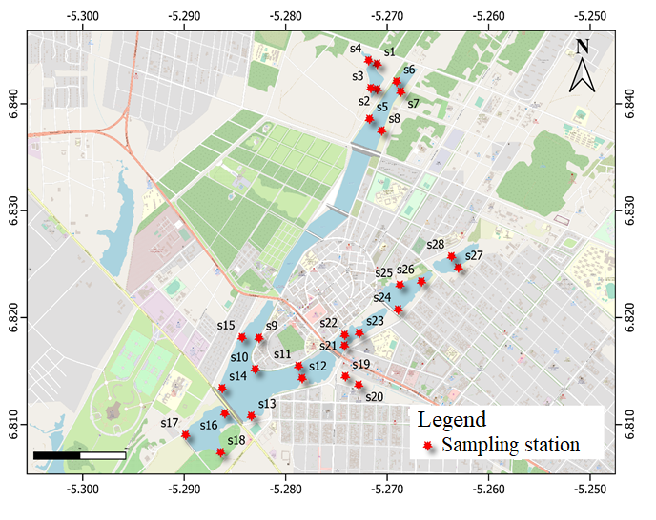
Fig.1. Location of the twenty-eight (28) sampling stations on the eight lakes surveyed
2.2. Physicochemical measurements
HACH Q40d multiparameter probes were employed to measure water temperature, pH, electrical conductivity, and dissolved oxygen in situ at a depth of approximately 10 cm below the water surface between 8:00 and 12:00. A Secchi disc was employed to measure the transparency of the water. In order to reduce the disturbance of the water column, physicochemical measurements were conducted prior to phytoplankton sampling. Water samples were collected in 1liter vials, stored in a cooler, and transported to the laboratory for nutrient analysis. Spectrophotometric methods were employed to ascertain the concentrations of ammonium, nitrite, nitrate, phosphate, and total phosphorus in accordance with the ISO standards reported in the original methodology.
2.3. Phytoplankton sampling and identification
Two types of phytoplankton samples were collected at each site. 20 L of water were sampled using a bucket and concentrated using a plankton net (mesh size 20 µm) for the qualitative investigation. In order to conduct quantitative analysis, water was extracted directly from the upper water stratum. Formalin was used to treat all samples at a final concentration of 5%. Conventional taxonomic references and identification keys for main phytoplankton groupings were employed to identify phytoplankton taxa under a light microscope. Identification was conducted at the species or infraspecific level, whenever feasible. In accordance with the modified Utermöhl method (Utermöhl, 1958) (NF EN 15204), quantitative analysis was conducted on 25 mL sub-samples. The samples were allowed to settle in a 25 mL sedimentation chamber for 4 hours. An inverted microscope was used to count cells, colonies, and filaments that were ≥2 µm in size at ×40 magnification. The number of cells per unit volume was used to express the density of phytoplankton.
2.4. Community structure and diversity indices
The phytoplankton community structure was defined by the taxonomic richness, relative abundance, occurrence frequency, Shannon diversity, Pielou evenness, and Jaccard similarity. The frequency of occurrence for each taxon was determined by the percentage of samples in which the taxon was present. The taxa were subsequently grouped according to their frequency of occurrence. The Shannon-Weaver diversity index (H′) was employed to estimate species diversity by analysing the relative abundance of taxa. The evenness index of Pielou (J′) was calculated as the ratio of the observed variety to the maximal theoretical diversity. The Jaccard similarity index was employed to determine the degree of similarity in phytoplankton composition between lakes. It was determined by the number of species that were shared between two communities.
2.5. Statistical analyses
The normality of biological and physicochemical variables was verified using the Shapiro–Wilk test, considering 5% significance level. Differences between lakes and sampling periods were examined using the Kruskal-Wallis test. Pairwise comparisons with the Mann–Whitney U test were used to examine significant differences. To provide an overview of the key physicochemical gradients and to evaluate correlations between sampling stations and environmental variables, Principal Component Analysis (PCA) was performed. Hierarchical cluster analysis was employed to discover groupings of comparable stations using the Ward’s approach and Euclidean distance. Relationships between phytoplankton composition and environmental variables were explored using a Redundancy Analysis (RDA). The investigation evaluated main phytoplankton taxa and significant environmental factors (temperature, transparency, conductivity, pH, dissolved oxygen, nitrate, orthophosphate and ammonium). Statistical significance was evaluated using a Monte Carlo permutation test (499 permutations).
3. Results
3.1. Physicochemical characteristics of the lakes
The physicochemical properties exhibit minimal variation across different stations within the same lake (Kruskal-Wallis test; p > 0.05) (Table 3). Consequently, the metrics of these physico-chemical attributes were categorised by lake to understand the unique inter-lake differences. The table (1) illustrates the regional discrepancies in the physico-chemical variables examined in the study. The temperature of the water varied from 27°C in lake 0 to 31°C in lake 9. The pH of the water varied between 6.5 (lake 0) and 8.1 (lake 9), while transparency ranged from 20 cm in lake 0 to 30 cm in lake 10. These variables did not exhibit significant differences (Kruskal Test P > 0.05). Conductivity and dissolved oxygen demonstrated notable disparities (p < 0.05). Conductivity measurements varied from 308 µS/cm (lake 10) to 902 µS/cm (lake 7). The Mann Whitney test (p < 0.05) indicated that the conductivity in lake 7 was markedly greater than in the other lakes. The highest concentrations of dissolved oxygen were 5.1mg/L in lake 5, 4.7mg/L in lake 8, and 6.8mg/L in lake 9, distinguishing them from the other lakes. Concerning nitrite levels, the measurements varied from 0.02 mg/L in lakes 0, 5, 6, 8, 9, and 10 to 0.1 mg/L in lake 7. Marked disparities (p < 0.05) among the lakes were identified, with lakes 1 and 7 being notably different from the remaining lakes. Nitrate levels throughout the study ranged from 2.81 mg/L (lake 0) to 21 mg/L (lake 7). The concentration of nitrates in lake 7 is markedly elevated compared to the other lakes (Mann-Whitney test, p < 0.05). The phosphate levels varied between 0.04 mg/L (lake 9) and 0.34 mg/L (lake 5), with lakes 5 and 8 exhibiting statistically significant differences compared to the other lakes (Mann Whitney test, p < 0.05). Ammonium concentrations fluctuated between 0.03 mg/L in lake 10 and 1.45 mg/L in lake 5, whereas total phosphorus levels spanned from 0.15 mg/L in lake 10 to 0.73 mg/L in lake 8. The two traits exhibited considerable variation throughout the lakes (Mann Whitney test, p < 0.05).
The first two axis of principal component analysis (PCA) explained 60.5% of the total physicochemical variability, with 33.7% and 26.8% of the variance explained, respectively (Fig.2). Lakes 5 and 8 were correlated with comparatively high phosphate, total phosphorus, dissolved oxygen, clarity and pH values. Lakes 6 and 7 were mostly associated with high amounts of nitrate, nitrite and conductivity, while Lakes 0, 1, 9 and 10 were characterised by relatively lower values of these variables.

Table 1. Variation of environmental parameters measured among the lakes
 |  | Lake 0 |  |  |  | Lake 1 |  |  |  | Lake 5 |  |  |  | Lake 6 |  |  |  | Lake7 |  |  | Lake 8 |  |  |  | Lake 9 |  |  |  |  | Lake 10
 | Min |  | Med | Max | Min |  | Med | Max | Min |  | Med | Max | Min |  | Med | Max | Min |  | Med | Max |  | Min | Med | Max |  | Min | Med | Max | Min |  | Med | Max
Temperature  (°C) | 27.1 |  | 27a | 28 | 27.2 |  | 27.5a | 27.8 | 28.5 |  | 29a | 29.4 | 27.4 |  | 28a | 28 | 28.5 |  | 29a | 29 |  | 26.8 | 28.4a | 29.6 |  | 29 | 31a | 32 | 27.5 |  | 28a | 29.7
Dissolved oxygen (mg/L) | 1.05 |  | 2.56a | 4.27 | 1.1 |  | 1.82a | 2.5 | 1.93 |  | 5.1b | 7.3 | 1.2 |  | 1.3a | 1.4 | 2.6 |  | 2.9a | 3.4 |  | 2.4 | 4.7b | 6.8 |  | 4.2 | 6.8b | 10.6 | 1.6 |  | 2.5a | 3.8
pH | 6.7 |  | 6.8a | 6.9 | 6.3 |  | 6.5a | 6.7 | 7.0 |  | 7.3a | 7.6 | 6.5 |  | 6.9a | 7.1 | 7 |  | 7.4a | 7.7 |  | 7.4 | 7.8a | 8.3 |  | 8.1 | 8.1a | 8.24 | 7.7 |  | 7.9a | 8
Conductivity  (µS/cm) | 271 |  | 341a | 459 | 249 |  | 315a | 359 | 402 |  | 430a | 454 | 335 |  | 413a | 438 | 828 |  | 902b | 987 |  | 390 | 434a | 488 |  | 317 | 339a | 353 | 286 |  | 308a | 329
Transparency (cm) | 15.2 |  | 20a | 22.3 | 18.5 |  | 22a | 24.4 | 19.2 |  | 25a | 30.5 | 17.5 |  | 22.2a | 29 | 20 |  | 21a | 22.7 |  | 22.4 | 25a | 29 |  | 25 | 27a | 30 | 27 |  | 30a | 33.6
Nitrate (mg/L) | 2.3 |  | 2.81a | 3.3 | 3.3 |  | 4.11a | 4.8 | 4.5 |  | 10.7a | 17.9 | 14.4 |  | 16.2b | 17.9 | 19.3 |  | 21b | 23.5 |  | 7.5 | 10.4a | 12.2 |  | 6.8 | 7.3a | 7.7 | 6.8 |  | 7.2a | 7.6
Nitrite (mg/L) | 0.06 |  | 0.06a | 0.08 | 0.02 |  | 0.02b | 0.02 | 0.02 |  | 0.02b | 0.03 | 0.01 |  | 0.02b | 0.04 | 0.08 |  | 0.1a | 0.14 |  | 0.02 | 0.02b | 0.03 |  | 0.01 | 0.01b | 0.02 | 0.01 |  | 0.02b | 0.03
Ammonium (mg/L) | 0.01 |  | 0,07a | 0.13 | 0.28 |  | 0.4a | 0.49 | 0.8 |  | 1.45b | 1.89 | 0.75 |  | 1.07b | 1.39 | 0.65 |  | 0.77b | 0.85 |  | 0.73 | 0.81b | 0.85 |  | 0.02 | 0.08a | 0.11 | 0.02 |  | 0.03a | 0.05
Phosphate (mg/L) | 0.03 |  | 0.05a | 0.06 | 0.08 |  | 0.08a | 0.11 | 0.21 |  | 0.34b | 0.43 | 0.09 |  | 0.10a | 0.12 | 0.07 |  | 0.09a | 0.1 |  | 0.18 | 0,2b | 0.22 |  | 0.01 | 0.04a | 0.07 | 0.03 |  | 0,05a | 0.08
Total phosphorus (mg/L) | 0.3 |  | 0.32a | 0.33 | 0.35 |  | 0.39a | 0.4 | 0.44 |  | 0.46b | 0.49 | 039 |  | 0.47b | 0.53 | 0.21 |  | 0.26c | 0.28 |  | 0.68 | 0.73b | 0.76 |  | 0.17 | 0.18c | 0.19 | 0.13 |  | 0.15c | 0.18
Different lettres (a, b and c) on two lakes refers significant difference between them (Mann-Whitney test, p<0.05); min = minimum value, med = median value and max = maximum value

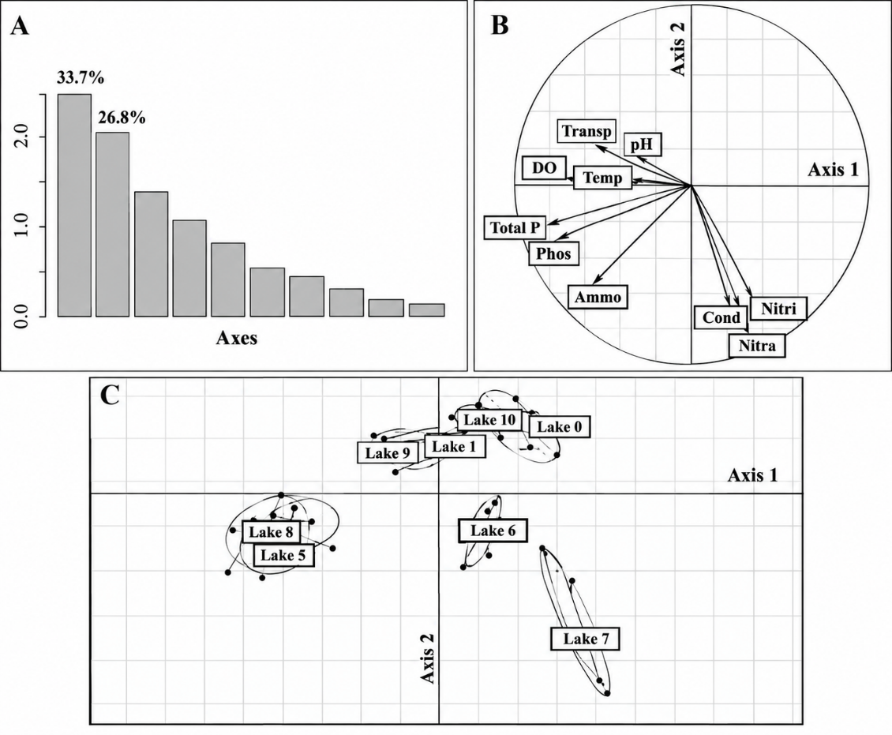

Fig. 2. Ordination of the physicochemical variables of the eight lakes using Principal Component Analysis (PCA), A = scree plot of eigenvalues; B=correlation circle; C=factor map; transp = transparency; DO = dissolved oxygen; Temp = temperature; phos = phosphates; ammo = ammonium; nitra = nitrates; nitri = nitrites; cond = conductivity; photo = total phosphorus.
3.2. Taxonomic composition and richness of phytoplankton
3.2.1. Taxonomic composition
A total of 191 phytoplankton taxa, belonging to 61 genera, 31 families, 15 orders and 8 classes, were identified across the eight urban lakes. The community comprised five major phyla: Chlorophyta, Euglenophyta, Cyanobacteria, Bacillariophyta and Dinophyta.
Chlorophyta were the most diverse group, with 69 taxa, followed by Euglenophyta with 61 taxa. Together, these two groups accounted for 68.06% of the total taxonomic richness. Cyanobacteria comprised 33 taxa, Bacillariophyta 26 taxa and Dinophyta two taxa. Within Chlorophyta, the most diverse genera were Scenedesmus (8 taxa), Monoraphidium and Desmodesmus (6 taxa each), and Tetraedron (5 taxa). Euglenophyta were mainly represented by Trachelomonas (24 taxa), Phacus (16 taxa) and Lepocinclis (7 taxa). Among Cyanobacteria, Oscillatoria (7 taxa) and Pseudanabaena (5 taxa) were the most diverse genera. Bacillariophyta were mainly represented by Gomphonema (7 taxa) and Pinnularia (6 taxa), while Dinophyta comprised one taxa each of Peridinium and Glenodiniopsis. Taxonomic richness differed markedly among lakes. Lake 5 had the highest richness, with 103 taxa, followed by Lake 8 (66), Lake 6 (53), Lake 9 (49), Lake 1 (48), Lake 0 (40) and Lake 10 (28). Lake 7 had the lowest richness, with only 11 taxa (Table 2). The relative contribution of the major taxonomic groups also differed among lakes. Euglenophyta dominated the communities of Lakes 0, 1 and 6, whereas Chlorophyta were dominant in Lakes 5, 8 and 10. Bacillariophyta were predominant in Lake 7.
3.2.2. Taxa occurrence
The occurrence analysis showed that accessory taxa predominated in Lakes 1, 8 and 9, representing 43.7%, 51.5% and 44.9% of the taxa, respectively. Accidental taxa predominated in Lakes 0, 5, 6 and 10, accounting for 37.5%, 45.6%, 54.5% and 50.0%, respectively. Lake 7 was characterized by similar proportions of constant and accessory taxa (45.4% each) (Table 2). Euglenophyta represented all constant taxa in Lake 1 and 50% of the constant taxa in Lake 6. They also accounted for 66.7% and 61.5% of constant taxa in Lakes 0 and 8, respectively. Trachelomonas volvocina showed a frequency of occurrence of 100% in all eight lakes. Chlorophyta predominated among constant taxa in Lake 5 and co-dominated with Bacillariophyta in Lake 9, whereas Bacillariophyta predominated among constant taxa in Lake 10 (Table 3).
Table 2: Proportions of constant, accessory, and accidental taxa in the different lakes of Yamoussoukro surveyed
LAKES | CONSTANT  TAXA (%) | ACCESSORY  TAXA (%) | ACCIDENTAL  TAXA (%)
Lake 0 | 27.5 | 35.0 | 37.5
Lake 1 | 16.6 | 43.7 | 39.6
Lake 5 | 16.5 | 37.8 | 45.6
Lake 6 | 14.5 | 30.9 | 54.5
Lake 7 | 45.4 | 45.4 | 09.0
Lake 8 | 16.6 | 51.5 | 31.2
Lake 9 | 14.3 | 44.9 | 40.8
Lake 10 | 14.3 | 35.7 | 50.0
Table 3: Proportions of phytoplankton phyla among the constant taxa identified in the lakes of Yamoussoukro surveyed
Proportions of constant taxa (%)
Phyla | Lake 0 | Lake 1 | Lake 5 | Lake 6 | Lake 7 | Lake 8 | Lake 9 | Lake 10
Cyanobacteria | 0 | 0 | 21.4 | 8.3 | 66.7 | 7.6 | 0 | 0
Euglenophyta | 66.7 | 100 | 28.6 | 50 | 0 | 61.5 | 14.3 | 25
Chlorophyta | 25 | 0 | 35.7 | 0 | 0 | 30.8 | 42.8 | 0
Bacillariophyta | 8.3 | 0 | 14.3 | 41.7 | 33.3 | 0 | 42.8 | 75
Dinophyta | 0 | 0 | 0 | 0 | 0 | 0 | 0 | 0
3.2.3. Taxonomic richness
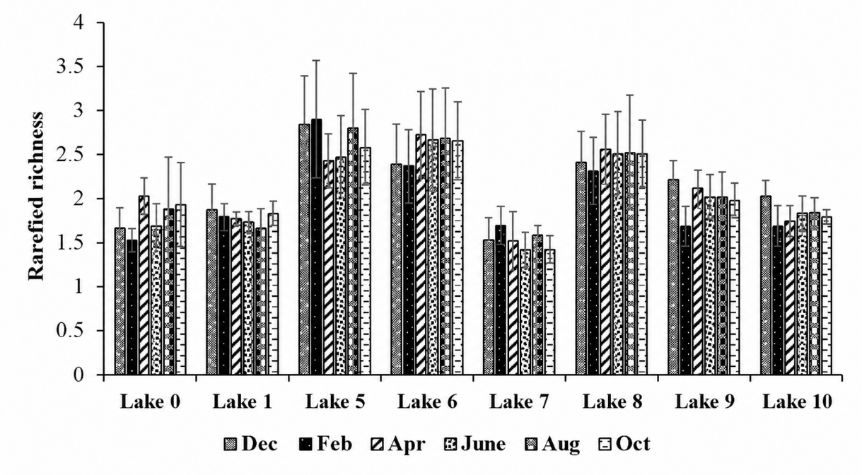
Rarefied richness differed significantly among lakes (Mann–Whitney test, p < 0.05), with higher values in Lakes 5, 6 and 8 and lower values in Lake 7 (Fig. 3). Median rarefied richness ranged from 1.50 to 2.02 in Lake 0 and from 1.66 to 1.86 in Lake 1. In Lakes 5 and 6, values ranged from 2.42 to 2.90 and from 2.36 to 2.72, respectively. Lake 7 showed the lowest values, ranging from 1.42 to 1.69. No significant temporal variation in rarefied richness was detected within individual lakes (Kruskal–Wallis test, p > 0.05).

Fig. 3. Spatio-temporal variations in the rarefied richness of phytoplankton recorded in the lakes of Yamoussoukro.
3.3. Phytoplankton diversity and community similarity
3.3.1. Shannon diversity and Pielou evenness

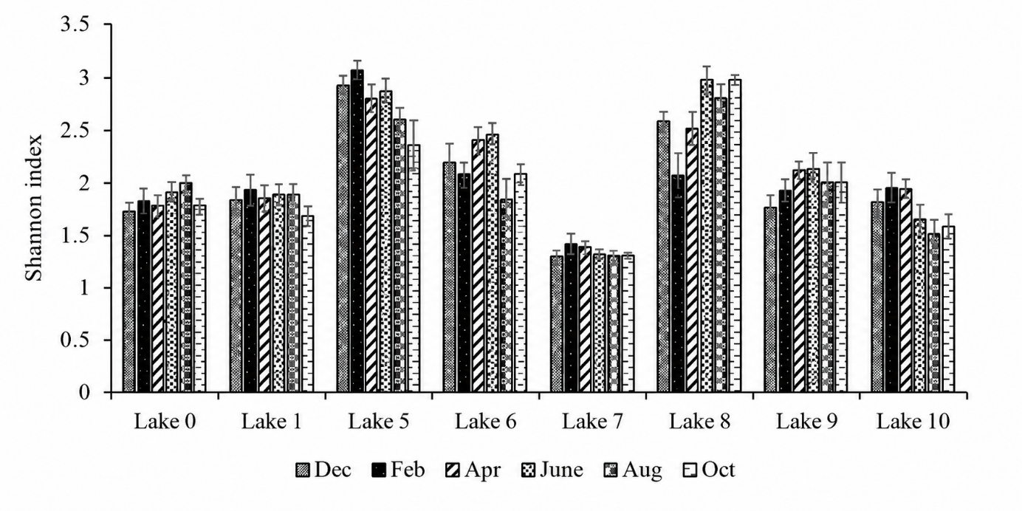
The Shannon diversity index was substantially different among the lakes and ranged from 1.3 to 3.0 (Kruskal-Wallis test, p < 0.05). The values in lakes 5, 6, and 8 were the highest, while lake 7 had significantly lower values (Mann-Whitney test, p < 0.05) (Fig.4). Shannon diversity in Lake 5 varied from 2.36 in October to 3.00 in February. The values in Lake 6 ranged from 1.84 to 2.47, while those in Lake 8 ranged from 2.10 to 2.98. Nevertheless, Lake 7 demonstrated the lowest readings, ranging from 1.30 in December to 1.42 in February. Individual lakes did not exhibit any substantial changes over time (p > 0.05). Pielou evenness also exhibits significant variation among lakes (p<0.05). The maximum values were observed in lakes 5, 6, and 8, while the lowest values were observed in lake 7 (Fig. 5). The evenness of Lake 5 ranged from 0.63 to 0.73, while Lake 6 ranged from 0.56 to 0.71 and Lake 8 ranged from 0.68 to 0.75. The values for Lake 7 ranged from 0.31 to 0.33. Statistically significant variations were not observed within specific lakes over time (p > 0.05).
Fig.4.Spatio-temporal variations in the Shannon index in the lakes of Yamoussoukro surveyed, Dec: December, Feb: February, Apr: April, Aug: August, Oct: October

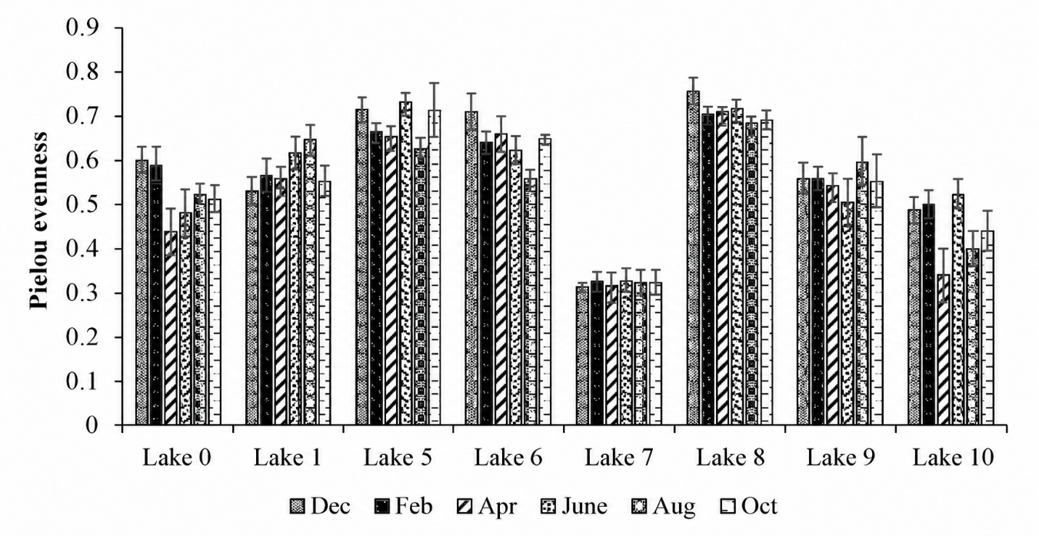

Fig.5. Spatio-temporal variations in the Pielou evenness index in the lakes of Yamoussoukro surveyed, Dec: December, Feb: February, Apr: April, Aug: August, Oct: October

3.3.2. Jaccard similarity
The majority of lakes exhibited relatively low overlap in phytoplankton composition, as indicated by Jaccard similarity coefficients (Table 4). The similarity between Lakes 5 and 8 was the highest (CJ = 0.50), with Lakes 0 and 1 following closely behind (CJ = 0.45). The similarity values of several lake pairings were extremely low, such as Lakes 0 and 7 (CJ =0.06) and Lakes 1 and 8 (CJ = 0.06). In general, the communities shared relatively few taxa among the lakes.

Table 4: Jaccard similarity index of phytoplankton communities in the surveyed lakes of Yamoussoukro.
 | Lake0 | Lake1 | Lake5 | Lake 6 | Lake7 | Lake 8 | Lake9 | Lake10
Lake 0 |  | 0.45 | 0.26 | 0.24 | 0.06 | 0.19 | 0.11 | 0.25
Lake1 |  |  | 0.21 | 0.36 | 0.08 | 0.08 | 0.06 | 0.29
Lake 5 |  |  |  | 0.20 | 0.14 | 0.50 | 0.18 | 0.2
Lake 6 |  |  |  |  | 0.14 | 0.15 | 0.15 | 0.21
Lake 7 |  |  |  |  |  | 0.10 | 0.11 | 0.17
Lake 8 |  |  |  |  |  |  | 0.40 | 0.2
Lake 9 |  |  |  |  |  |  |  | 0.20
Lake10

3.4. Phytoplankton abundance and biomass
3.4.1. Phytoplankton abundance
The significance of the primary taxonomic categories influencing phytoplankton density varied considerably among lakes (Fig. 6). Cyanobacteria constituted the predominant phylum in Lakes 5, 7, 8, and 9, contributing between 42.6% and 92.8% to the communities. Chlorophyta ranged from 0 to 39%, Euglenophyta from 2.43 to 14.5%, and Bacillariophyta from 0.86 to 13.8%. Euglenophyta prevailed in Lakes 0, 1, and 6, with 47.5-83.89% of total abundance, whilst Chlorophyta accounted for 3.81 to 42.36%. Cyanobacteria, Bacillariophyta, and Dinophyta comprised 0-11.82% of the total abundance in these lakes. Chlorophyta constituted 42.33% of the biomass in Lake 10, trailed by Euglenophyta at 23.23%, Bacillariophyta at 21.42%, and Cyanobacteria at 13%.

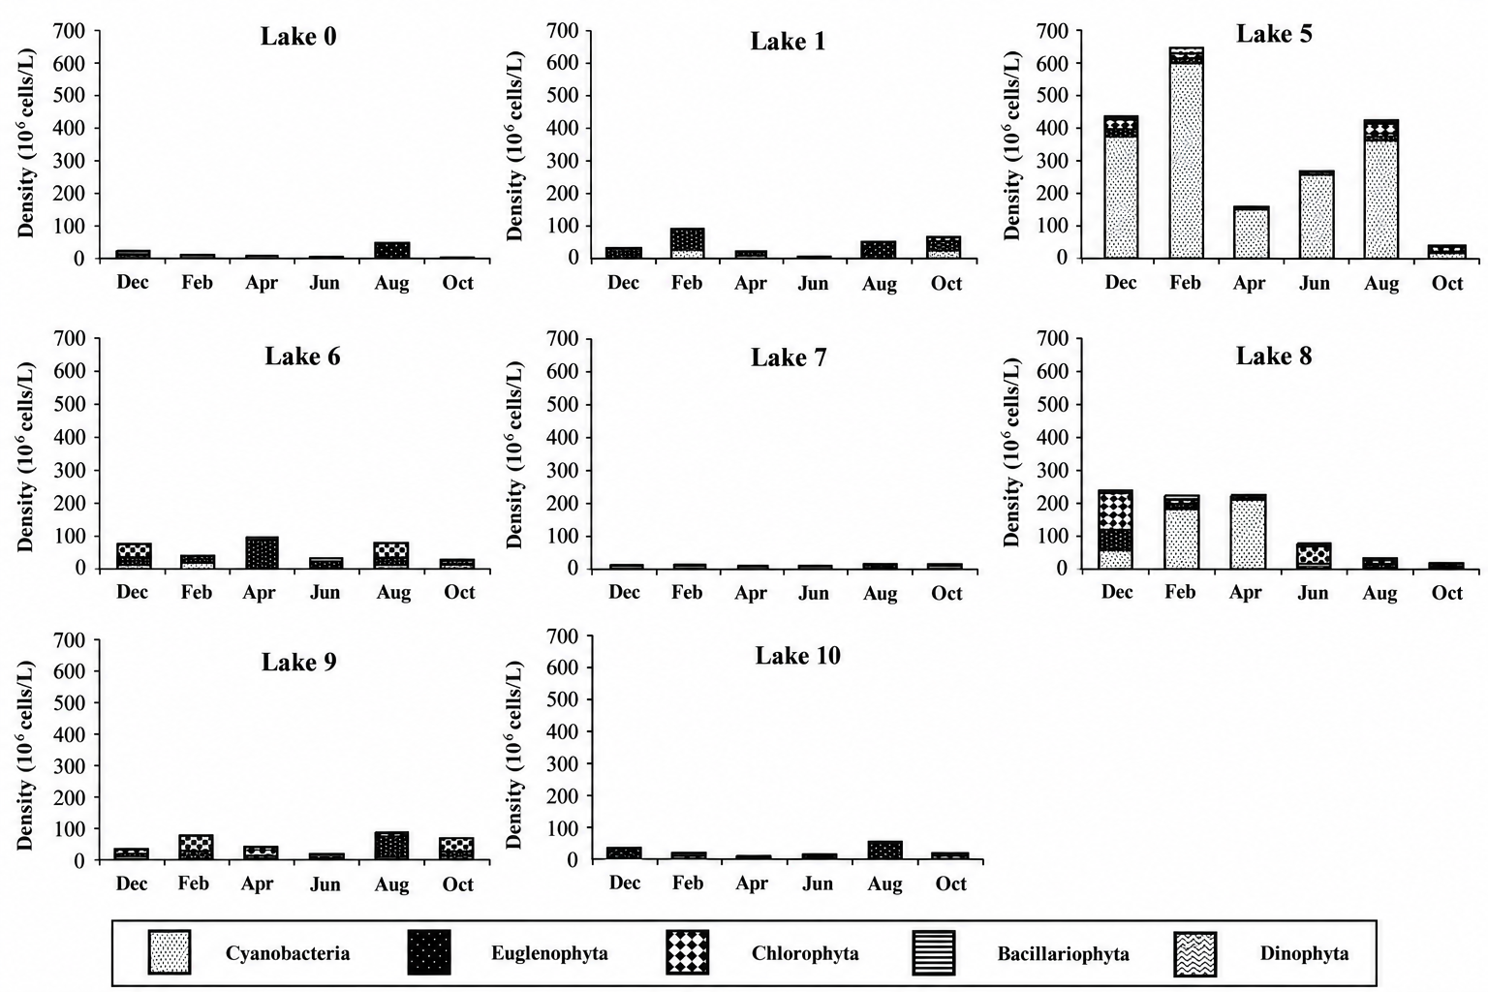

Fig. 6.Spatio-temporal variations in phytoplankton density by taxonomic group in the lakes of Yamoussoukro surveyed.
3.4.2. Phytoplankton biomass
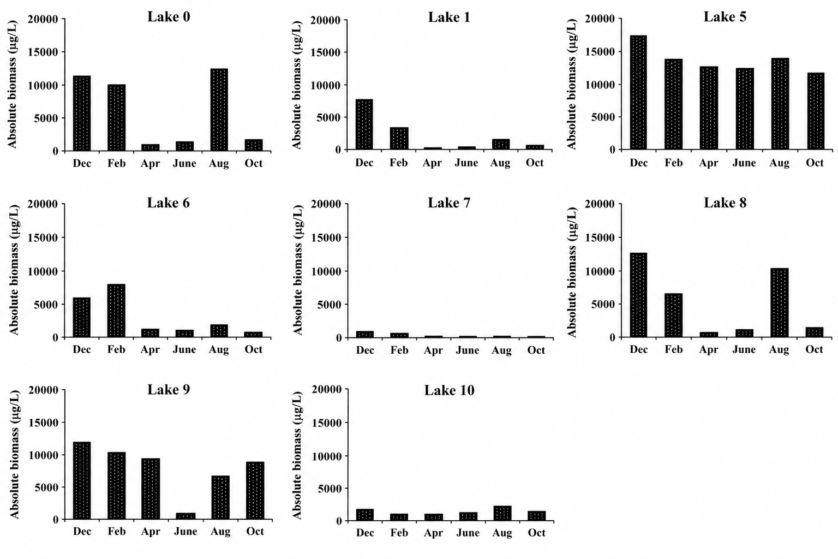
The biomass of phytoplankton, as assessed using biovolume, demonstrated significant geographical and temporal variability (Fig. 7). Lake 5 possesses the highest biomass, succeeded by Lakes 1, 8, and 9, however Lake 7 exhibits the least biomass. The minimal biomass readings were recorded in June for Lake 0, in April for Lakes 1 and 5, and in October for Lake 6. The peak biomass measurements occurred in August in Lake 0, in February in Lakes 1 and 6, and in December in Lake 5. Cyanobacteria significantly influenced the biomass maxima, representing more than 60% in Lake 0, 49% in Lake 1, and 54% in Lake 5. Euglenophyta contributed approximately 45% to the biomass increase in Lake 6 during February. Peak biomass concentrations were recorded in June (Lake 7), December (Lake 8), October (Lake 9), and February (Lake 10) across Lakes 7-10. The lowest values were recorded in Lake 7 in August, in Lakes 8 and 9 in June, and in Lake 10 in April. Cyanobacteria constituted almost 60% of the biomass during the sampling duration in Lake 7. Euglenophyta played a substantial role in the biomass of Lakes 9 and 10, accounting for approximately 50% and 81% respectively during their respective biomass maxima.

Fig. 7. Spatio-temporal changes in phytoplankton absolute biomass in the lakes of Yamoussoukro studied Dec: December, Feb: February, Apr: April, Aug: August, Oct: October

3.5. Chlorophyll-a concentration
Chlorophyll-a exhibited significant temporal and spatial variability among the eight lakes (Fig. 8). Markedly elevated levels were detected in lakes 5 and 8, while notably reduced levels were seen in lake 7 (Mann-Whitney test, p < 0.05). The chlorophyll-a levels in Lake 0 varied between 33.35 µg L⁻¹ in October to 65.0 µg L⁻¹ in December. Concentrations in Lake 1 varied from 56.5 µg L⁻¹ in October to 65.5 µg L⁻¹ in April. The levels in lakes 5 and 6 were significantly elevated, varying from 166.9 to 228 µg L⁻¹ and 97.9 to 145.3 µg L⁻¹, respectively. Lake 7 exhibited the minimal chlorophyll-a concentrations, fluctuating between 9.8 µg L⁻¹ in February and 12.4 µg L⁻¹ in April, whereas Lake 8 displayed elevated levels, ranging from 154 to 210 µg L⁻¹. The concentrations in Lakes 9 and 10 were 92.7-126 μg L⁻¹ and 27.5-39.2 μg L⁻¹, respectively. The spatial allocation of chlorophyll-a mirrored the findings of phytoplankton density and biomass, exhibiting peak concentrations in lakes 5, 6, 8, and 9, whereas lake 7 recorded the minimal quantities.
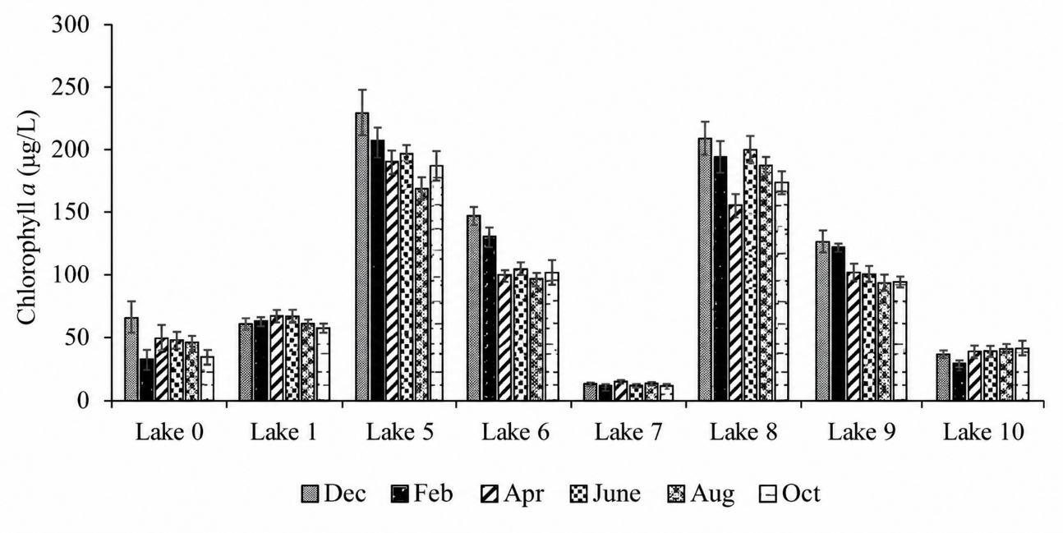

Fig. 8. Spatio-temporal variations in chlorophyll-a concentrations in the lakes of Yamoussoukro surveyed, Dec: December, Feb: February, Apr: April, Aug: August, Oct: October

3.6. Relationships between phytoplankton communities and physicochemical variables
Redundancy analysis (RDA) was conducted to examine the relationships between predominant phytoplankton taxa and physicochemical variables. The research focused on species constituting over 2% of community abundance with 10 environmental factors: temperature, pH, nitrate, phosphate, ammonium, dissolved oxygen, conductivity, nitrite, total phosphorus, and transparency (Fig.9). The initial two RDA axis accounted for 65% of the variance (40% for axis 1 and 25% for axis 2). Axis 1 exhibited a significant positive correlation with nitrate, conductivity, ammonium, and phosphate, while demonstrating a modest negative correlation with temperature. Euglena gracilis, Oscillatoria tenuis, and Oscillatoria limosa exhibited a positive correlation with conductivity, nitrate, and ammonium, particularly in Lake 7 during August and April. Axis 2 mostly pertained to total phosphorus and dissolved oxygen levels. Elevated levels of these variables were predominantly associated with Lakes 8 and 5. The RDA thereby unveiled a unique spatial arrangement of phytoplankton communities in relation to nutrient enrichment, conductivity, and oxygen gradients.

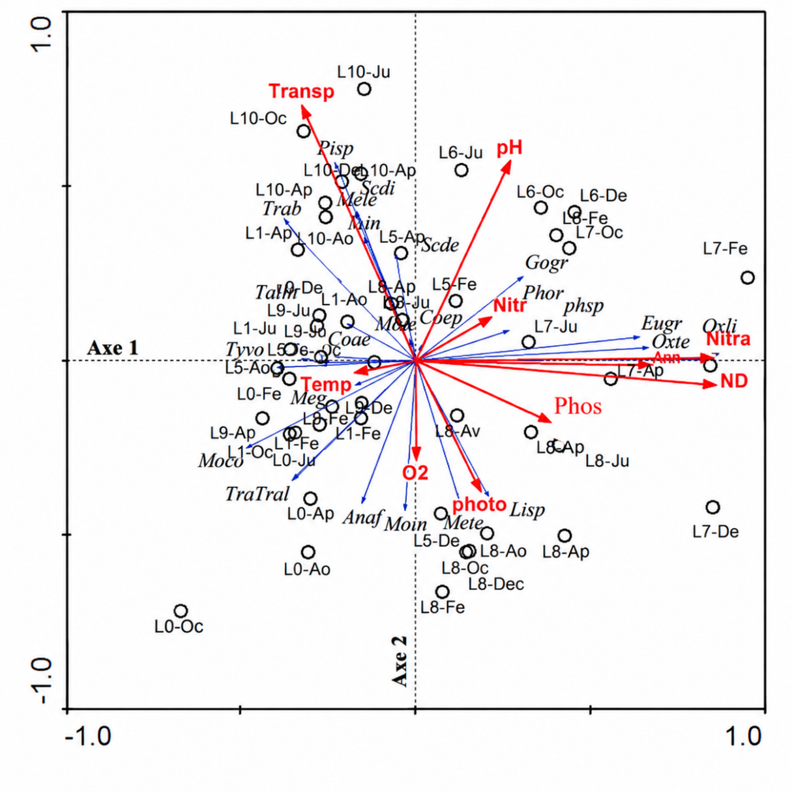

Fig.9. RDA ordination of phytoplankton taxa and physicochemical characteristics on the first two axs in the lakes of Yamoussoukro. Taxon abbreviations: see Table IV; T: temperature; CND: conductivity; O₂: dissolved oxygen; Nitra: nitrates; Ammo: ammonium; Transp: transparancy; phosphates; Phos: Photo: total phosphorous; Nitr: nitrites; L0: Lake 0; L1: Lake 1; L5: Lake 5; L6: Lake 6; L7: Lake 7; L8: Lake 8; L9: Lake 9; L10: Lake 10; De: December; Fe: February Av: April Ju: June Aou: August Oc: October

4. Discussion
A remarkable taxonomic richness of phytoplankton was observed in the lakes of the city of Yamoussoukro, with 191 taxa identified. The wealthiest in taxa was Lake 5, while Lake 7 was the poorest. The significant taxonomic richness observed in Lake 5 may be attributed to the diverse ecological niches. In fact, this lake exhibited substantial quantities of the primary nutrients associated with eutrophication, including nitrogen and phosphate. The low richness of lake 7 may be attributed to the fact that its waters are more akin to effluent. Additionally, aquatic vegetation covers more than 80% of this water body, which may limit the development of phytoplankton. Aquatic vegetation in a water body inhibited algal growth by reducing the penetration of solar radiation into the water (Peng et al., 2022). Chlorophyta and Euglenophyta dominated the phytoplankton community of the Yamoussoukro lakes, collectively comprising over 68% of the species. Additionally, the dominance of these two major groups has been documented in the tropical reservoir of Adzopé (Nangoh et al., 2019), in small reservoirs of the central and northern Côte d'Ivoire (Nangoh et al., 2019), in the Lake Guiers of Senegal (Peng et al., 2021), and in the lakes of the floodplains of Brazil (Peng et al., 2021). The remarkable ecological flexibility and ubiquity of Chlorophyta can account for their dominance. The high concentration of organic matter in domestic effluent and runoff from agricultural areas can be attributed to the prevalence of Euglenophyta. Euglenophyta genera Euglena, Phacus, and Trachelomonas were the most representative. Recent evidence confirms that euglenophytes are frequently associated with nutrient-rich and organically enriched freshwater environments (Sultana et al., 2024). Additionally, the Euglenophyta was the dominant species in the majority of lakes, and Trachelomonas volvocina was present in all lakes at a high frequency (100%). The high frequency of occurrence can be attributed to the nutrient-rich environment of these lakes. In fact, Euglenophyta thrive in streams that are rich in organic matter, and their blooms can have a detrimental impact on water quality (Sultana et al., 2024). The Shannon-Weaver index, Pielou's evenness score, and rarefied richness of lakes 5, 6, and 8 were significantly higher. The phytoplankton of these lakes was, as a result, significantly more diverse and evenly distributed. In this manner, these aquatic bodies may offer relatively favourable environmental conditions for a diverse array of taxa. In contrast, these indicators were significantly lower in Lake 7. The phytoplankton community in this water body was less uniformly structured and less diverse, indicating a high level of contamination. Potentially, this scenario may be associated with the elevated concentrations of nitrates and conductivity encountered in this lake. The trends in phytoplankton abundance in the lakes were essentially consistent with the patterns in phytoplankton biomass and chlorophyll-a. This was evident in the elevated chlorophyll-a values and phytoplankton abundance of lakes 5, 6, 8, and 9. The high phytoplankton biomass values may be attributed to the presence of species such as Eudorina elegans, Pandorina morum, Oedogonium sp., and Mougeotia sp., which are less abundant but have a high biomass. The high values of these parameters (abundance and biomass) observed in these lakes may be attributed to the periodic removal of floating aquatic vegetation. The removal of suspended aquatic vegetation may enhance the penetration of light, thereby enhancing the photosynthetic activity of algae. The lakes in the city center are also exposed to substantial quantities of nutrients from agricultural and household waste water. In reality, Lakes 5 and 8 are situated in densely urbanised areas, where a variety of commercial activities, including restaurants, maquis, and hotels, have emerged along their periphery. These enterprises discharge effluents, food waste, and other waste into the lakes on a daily basis, particularly in Lake 5, a large body of water that is connected to a significant population. In addition to these activities, numerous regions surrounding the lake have been transformed into informal landfills for residential waste and unregulated open-air sanitation. The Regional Hospital Center (CHR) drains its effluents into Lake 5. Organic trace elements, inorganic nutrients, temperature, and light are the regulating factors for the growth and succession of phytoplankton (Dokulil & Qian, 2021). Trachelomonas, Euglena, Microcystis, Gomphonema, Oscillatoria, Monoraphidium, Merismopedia, Scenedesmus, Phacus, Aphanocapsa, and Ulnaria were the most abundant taxa in the phytoplankton that was collected. These taxa are considered prominent in eutrophic waters (Zheng et al., 2024; Guo et al., 2023; Sultana et al., 2024). Consequently, the occurrence of these taxa is consistent with nutrient enrichment and organic inputs, although their interpretation should be supported by the measured physicochemical variables (Zheng et al., 2024; Sultana et al., 2024). These taxa serve as bioindicators of eutrophic environments (Sultana et al., 2024). In fact, N’Guessan et al. (2011) estimated that the Yamoussoukro lake system receives approximately 38,300 m³ of wastewater annually. In general, the warmest months (December, February, and August) were characterised by high abundance and biomass (phytoplankton and chlorophyll-a) values. The water bodies were relatively stable during this period, which may have facilitated biological processes, such as the complete reproductive and developmental cycles of algae (Pulsifer & Laws, 2021). Furthermore, this period was characterised by elevated temperatures. Enzymatic reactions are temperature-dependent, which is why temperature is a substantial environmental factor that influences phytoplankton physiology (Pulsifer & Laws, 2021). In reality, the photosynthetic activity of microalgae increases with temperature until it reaches an optimum temperature, at which point its photosynthetic capacity decreases (Dokulil & Qian, 2021). The temporal change of the phytoplankton community was not well visualised among the lakes, as evidenced by the application of RDA to the entire dataset of physicochemical parameters and the high relative densities of phytoplankton taxa in the various lakes. This may be due to the fact that the majority of the physicochemical parameters did not exhibit a significant difference between months, which suggests that they had a limited capacity to differentiate samples based on the month of sampling.
Conclusion
The objective of this investigation was to evaluate the taxonomic composition, diversity, and geographical and temporal dynamics of the phytoplankton communities in the urban lakes of Yamoussoukro. Chlorophyta and Euglenophyta were the most diverse groupings, with a total of 191 taxa discovered. Taxonomic richness, variety, evenness, abundance, biomass, and chlorophyll-a concentration were all significantly influenced by regional differences. Lake 5 exhibited the highest taxonomic richness and phytoplankton biomass, while Lake 7 exhibited the lowest richness, diversity, biomass, and chlorophyll-a concentrations. As evidenced by the low Jaccard similarity ratings, the phytoplankton composition varied significantly among these lakes. The primary physicochemical gradients identified by PCA were those related to nutrients, conductivity, dissolved oxygen, phosphorus, and transparency. The phytoplankton composition was particularly associated with the gradients of nutrients and conductivity in RDA. The temporal variation was less significant than the spatial variance. In general, the ecological status of the urban lakes of Yamoussoukro was evaluated using phytoplankton communities. Continuous monitoring is advised to improve the assessment of water quality and the management of lakes in a sustainable manner.
Declaration of AI Use

This manuscript was prepared through the intellectual contributions of the author(s) to the study design, data analysis, interpretation of results, and scholarly content. Grammarly and ChatGPT were used solely to assist with grammatical refinement and reference formatting during manuscript revision. The author(s) accept full responsibility for the accuracy, integrity, and final content of the manuscript.

REFERENCES
Dokulil, M. T., & Qian, K. (2021). Photosynthesis, carbon acquisition and primary productivity of phytoplankton: A review dedicated to Colin Reynolds. Hydrobiologia, 848(1), 77–94. https://doi.org/10.1007/s10750-020-04321-y
European Committee for Standardization. (2006). Water quality—Guidance standard on the enumeration of phytoplankton using inverted microscopy (Utermöhl technique) (EN 15204:2006).
Guo, W., Li, Z., Li, C., Liu, B., & Shi, W. (2023). Drainage ratio controls phytoplankton abundance in urban lakes. Water, 15(4), 683. https://doi.org/10.3390/w15040683
Kouakou, K. A., Aw, S., Adamou, M. M., Siaka, S., & Savane, I. (2014). Caractérisation des sédiments du système lacustre de Yamoussoukro (Côte d’Ivoire) et spéciation de leurs phosphores. Journal of Materials and Environmental Science, 5(4), 1013–1020.
N’Guessan, K. A., Konan, F. K., Bony, K. Y., Edia, O. E., Gnagne, T., Traoré, K. S., & Houenou, P. V. (2011). Prospects for rehabilitation of man-made lake system of Yamoussoukro (Ivory Coast). Procedia Environmental Sciences, 9, 140–147. https://doi.org/10.1016/j.proenv.2011.11.022
Nangoh, K. M., Adon, M. P., Edia, O. E., Niamien-Ebrottié, J. E., & Ouattara, A. (2019). Phytoplankton composition of the urban man-made lakes of Yamoussoukro (Côte d’Ivoire). Journal of Applied Biosciences, 140(1), 14281–14292. https://doi.org/10.4314/jab.v140i1.7
Peng, X., Zhang, L., Li, Y., Lin, Q., He, C., Huang, S., Li, H., Zhang, X., Liu, B., Ge, F., Zhou, Q., Zhang, Y., & Wu, Z. (2021). The changing characteristics of phytoplankton community and biomass in subtropical shallow lakes: Coupling effects of land use patterns and lake morphology. Water Research, 200, 117235. https://doi.org/10.1016/j.watres.2021.117235
Peng, X., Lin, Q., Liu, B., Huang, S., Yan, W., Zhang, L., Ge, F., Zhang, Y., & Wu, Z. (2022). Effect of submerged plant coverage on phytoplankton community dynamics and photosynthetic activity in situ. Journal of Environmental Management, 301, 113822. https://doi.org/10.1016/j.jenvman.2021.113822
Pulsifer, J., & Laws, E. (2021). Temperature dependence of freshwater phytoplankton growth rates and zooplankton grazing rates. Water, 13(11), 1591. https://doi.org/10.3390/w13111591
Sultana, S., Khan, S., Shaika, N. A., Hena, S. M., Mahmud, Y., & Haque, M. M. (2024). Ecology of freshwater harmful euglenophytes: A review. Heliyon, 10(8), e29625. https://doi.org/10.1016/j.heliyon.2024.e29625
Utermöhl, H. (1958). Zur Vervollkommnung der quantitativen Phytoplankton-Methodik. SIL Communications, 1953–1996, 9(1), 1–38. https://doi.org/10.1080/05384680.1958.11904091
Zheng, Y., Yu, J., Wang, Q., Yao, X., Yue, Q., & Xu, S. (2024). What drives the changing characteristics of phytoplankton in urban lakes: Climate, hydrology, or human disturbance? Journal of Environmental Management, 351, 119966. https://doi.org/10.1016/j.jenvman.2023.119966

