Entomological Infestation and Evolution of Peanut Losses During Storage in Northern Côte d’Ivoire

Abstract

Peanut (Arachis hypogaea L.) is an important food commodity in Côte d’Ivoire, and its storage helps ensure its availability beyond the harvest period. However, stored peanuts are exposed to various insect infestations that may result in quantitative and qualitative losses. The current study aims to identify the main insect pests associated with stored peanuts in the Korhogo Department and to assess the evolution of infestation and losses during storage. A survey was conducted among 120 actors in the sector, including 90 producers and 30 traders, distributed across three villages and three markets. Shelled and unshelled peanut samples were then monitored for 90 days in an insectarium. Adult insects were collected at the beginning of storage and subsequently after 45 and 90 days. A total of seven species belonging to two orders and seven families were identified: Caryedon serratus, Rhyzopertha dominica, Sitophilus zeamais, Tribolium castaneum, Cathartus quadricollis, Carpophilus dimidiatus, and Sitotroga cerealella. C. serratus was largely dominant, with a relative abundance of 93.09%, followed by T. castaneum (4.84%) and R. dominica (1.41%). The infestation rate, initially ranging from 6.90 to 10.74% in the unshelled samples and from 7.00 to 10.22% in the samples collected from the markets, reached 59.73–76.71% and 43.72–76.73%, respectively, after 90 days. Weight losses reached 19.51% of the samples studied. Diversity indices varied among sites, with the highest Shannon values recorded at Drogo (0.470) and the large Market (0.503). These results demonstrate the importance of C. serratus in the deterioration of stored peanuts and highlight the need to improve storage practices and develop integrated management strategies adapted to local conditions.

Keywords: Arachis hypogaea, storage, insect pests, post-harvest losses, Korhogo.

1. Introduction

Peanut (Arachis hypogaea L.) is a legume native to South America and widely cultivated in tropical, subtropical and warm temperate regions (Sharma et al., 2006; Guchi et al., 2014). It is an important food and oil crop in many African countries. At the global level, it is among the major food and oil crops (Reddy et al., 2011). In Côte d’Ivoire, peanut production mainly contributes to feeding the population and supplies various marketing and processing channels. A large proportion of the production is intended for local consumption, particularly in the form of peanut paste. The seeds also have important nutritional value due to their high lipid, protein and carbohydrate content. After harvest, storage is a crucial step in maintaining the availability of this food throughout the year. However, peanuts can be attacked by several insects during storage, resulting in quantitative and qualitative losses. These losses may result in weight reduction, deterioration of market quality, decreased germination capacity and alteration of the nutritional value of stored products. Stored-product pests therefore represent a major constraint to food preservation (Arthur, 2000). In several West African countries, losses caused by insects in stored food products can reach significant levels (Abdou et al., 2014). Peanuts are particularly susceptible to attacks by Caryedon serratus, which is considered one of their major storage pests. Studies conducted in Senegal and Burkina Faso have also highlighted the importance of this species in stored peanuts (Gueye et al., 2011). Despite the importance of peanuts in the food systems of northern Côte d’Ivoire, recent data on insects associated with stored peanuts remain limited in this area. Korhogo Department is a notably important area for the production and marketing of food crops. Knowledge of the pests present in stored products, and their dynamics is therefore a prerequisite for implementing appropriate management methods. The current study aims to invent insect pests of stored peanuts in the Korhogo Department and to assess the evolution of infestation and losses during storage. More specifically, the study aimed (i) to characterize storage practices and control methods used by producers and traders, (ii) to identify insects associated with stored peanuts and investigate their abundance and distribution, and (iii) to estimate damage and weight losses over 90 days of storage.

2. Material and methods

2.1. Study area
The study was conducted in the Korhogo Department, in northern Côte d’Ivoire, approximately 600 km north of Abidjan (Figure 1). It is the capital of the Poro Region and the Savane’s District. It covers an area of approximately 12,500 km². The area belongs to the dry tropical climate zone of the Sudano-Sahelian type. Two main seasons characterize this climate: a rainy season, generally occurring from May to October, and a dry season from November to April. Annual rainfall ranges from 1,100 to 1,600 mm. The region is mainly drained by the Bandama River and several of its tributaries (Jourda et al., 2006).
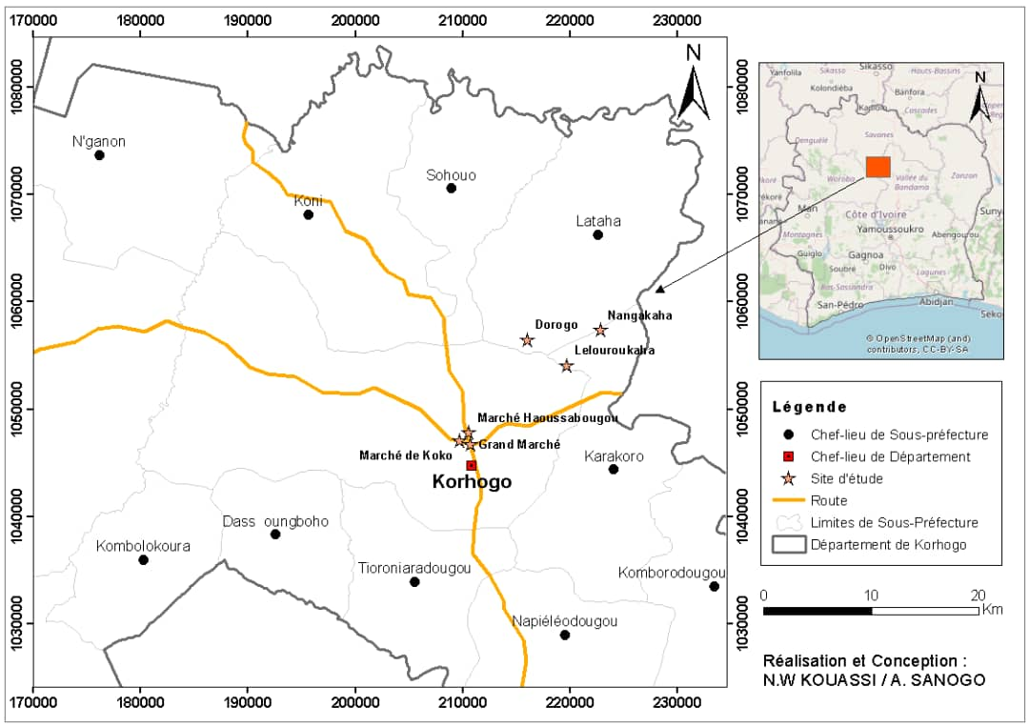

Figure 1: Location of the study area (Kouassi and Sanogo, 2026)

2.2. Survey of producers and traders
The survey was conducted in three villages, Nangakaha, Drogo and Lailouroukaha, as well as in three markets in the municipality of Korhogo: the city’s main market, Koko market and Haoussabougou market. A total of 120 people were surveyed, including 30 producers per village and 10 traders per market. The questionnaire mainly focused on the socio-demographic characteristics of the respondents, peanut storage methods, and the methods used to control pests.

2.3. Peanut sampling and storage
Peanut samples were collected from producers and traders. In the insectarium, 200 g of shelled peanuts and 200 g of unshelled peanuts were taken from each sample. The samples were subjected to an initial sieving to collect the adult insects already present. The samples were then placed in labeled jars and covered with muslin cloth, allowing air circulation while preventing insects from entering or leaving. The collected insects were preserved in vials containing 70% alcohol. Two additional sieving operations were carried out after 45 and 90 days of storage. This procedure made it possible to monitor the evolution of infestation during storage (Souleymane, 2023).

2.4. Insect identification
The collected insects were observed using a stereomicroscope or a trinocular microscope. Their identification was carried out based on morphological characteristics using the identification keys of Delobel and Tran (1993) and the catalogue of Fandohan et al. (2005). The individuals were classified according to their order, family, and species. The number of individuals belonging to each species was recorded to determine their relative abundance.

2.5. Assessment of infestation and weight losses
Loss assessment was carried out at the beginning of storage and then after 45 and 90 days. For each sample, healthy peanuts were separated from peanuts showing signs of infestation, and both fractions were weighed. The infestation rate was calculated from the ratio between the number of infested grains and the total number of grains examined: PA (%) = [Nga / (Nga + Ngs)] × 100 where Nga represents the number of infested grains and Ngs the number of healthy grains. Weight loss was determined from the weights of the infested and healthy fractions: PB (%) = [Pga / (Pga + Pgs)] × 100 where Pga corresponds to the weight of infested grains and Pgs to the weight of healthy grains. The method followed the protocol described by Gnimagnon (2013).

2.6. Diversity analysis
Species richness corresponded to the total number of species observed at each site. The relative abundance (Ar) of each species was calculated according to its number of individuals relative to the total number of individuals collected. According to the criteria used, a species was considered very abundant when Ar > 10%, abundant when 5% ≤ Ar < 10%, fairly abundant when 1% ≤ Ar < 5%, and less abundant when Ar < 1%. The occurrence frequency was also calculated. A species was considered constant when 50% ≤ C < 100%, frequent when 25% ≤ C < 50%, accessory when 5% ≤ C < 25%, and rare when C < 5%. The Shannon index and evenness were used to characterize the structure of insect communities.

2.7. Statistical analysis
Data entry, table preparation, and calculation of ecological indices were performed using R Studio and Excel 2019. Data normality was assessed using the Shapiro-Wilk test. Since the data did not follow a normal distribution, non-parametric tests were used to compare the variables studied. A principal component analysis (PCA) was also performed to examine species distribution and their association with the different study sites.

3. Results

3.1. Characteristics of Producers and Traders
In the villages, the surveyed individuals consisted of 53.33% women and 46.67% men, whereas in the markets, they were predominantly women (100%). In both the villages and the markets, the most represented age group was between 25 and 40 years (Figure 2).

Number of people
Market
Age range

Figure 2: Age range of the surveyed population

Most of the respondents had no formal education (73.33% in the markets and 82.22% in the villages) (Figure 3).

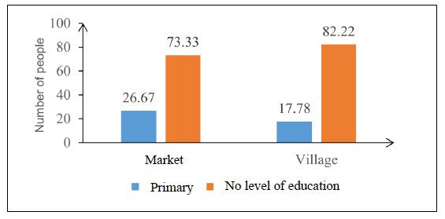
Figure 3: Educational level of the respondents

3.2. Storage methods and control methods
In the villages, peanuts were entirely stored in bags. Many of the producers surveyed (98.88%) store stocks from different harvests in the same storage location, while keeping the different crops in separate bags. Maize, rice, and cowpea were notably stored in the same locations as peanuts. At the village level, 76.67% of the respondents stored their stocks in houses, compared with 23.33% who stored them in warehouses. In the markets, peanuts were displayed in basins during the day and then stored in bags inside warehouses after sales. Insects were identified as the main storage pests by 95.55% of respondents in the villages and 76.67% in the markets. The other respondents mainly considered rodents to be the organisms responsible for the damage. All producers interviewed in the villages reported using chemical products against pests. Some also used Hyptis suaveolens, a plant locally considered to have insecticidal or repellent effects. In the markets, sorting and winnowing were the main control methods reported.

3.3. Taxonomic richness of insect pests
A total of seven species belonging to two orders and seven families were identified in the peanut samples. Species richness was seven species at Nangakaha and Drogo, five at Lailouroukaha, four at Haoussabougou market, four at Koko market, and three at the large market.

Table 1. Insect pests identified in stored peanut stocks
Orders | Families | Species | V1 | V2 | V3 | M1 | M1 | M3
Coleoptera | Tenebrionidae | Tribolium castaneum | * | * | * | * | * | *
Coleoptera | Silvaniidae | Cathartus quadricollis | * | * | * | * | * | *
Coleoptera | Nitidulidae, | Carpophilus dimidiatus | * | *
Coleoptera | Chrysomelidae | Caryedon serratus | * | * | * | * | * | *
Coleoptera | Curculionidae | Sitophilus zeamais | * | * | *
Coleoptera | Bostrichidae | Rhyzopertha dominica | * | * | * | *
Lepidoptera | Gelechiidae | Sitotroga cerealella | * | * |  |  |  | *
Richness | 7 | 7 | 7 | 7 | 5 | 4 | 3 | 4
V1: Nangakaha, V2: Drogo, V3: Lailouroukaha, M1: large market, M2: market of Koko, M3: market of Haoussabougou

3.4. Relative abundance of insect pest species
The species Caryedon serratus was by far the most dominant species across all samples, with a relative abundance of 93.09%. It was followed by Tribolium castaneum with 4.84% and Rhyzopertha dominica with 1.41%. The other species showed markedly lower relative abundances: Sitophilus zeamais (0.40%), Cathartus quadricollis (0.19%), Carpophilus dimidiatus (0.11%), and Sitotroga cerealella (0.03%) (Figure 4).

Figure 4: Relative abundance (Ar) of insect pests across all study sites

The total relative abundance recorded per site was higher at Haoussabougou (23.11%), followed by the large Market (19.18%) and Nangakaha (18.89%). Lailouroukaha accounted for 15.73%, Koko for 12.58%, and Drogo for 10.51%. The differences in relative abundance between the sites were not statistically significant according to the statistical analysis (Figure 5).

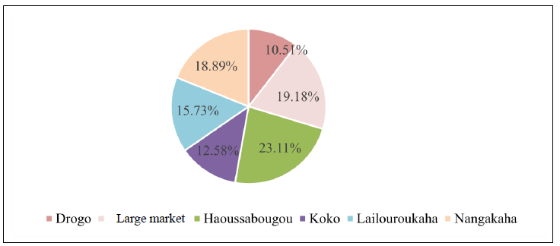

Figure 5: Relative abundance of insect pests according to the study sites

3.5. Dynamics of insects in samples from markets

In the samples collected from the markets, five species were identified during the monitoring period: T. castaneum, C. serratus, C. quadricollis, R. dominica and S. cerealella. At the beginning of storage, three species were present: C. serratus, C. quadricollis and T. castaneum. Their relative abundances were 53.99%, 7.35% and 38.66%, respectively. After 45 days, R. dominica appeared with a relative abundance of 0.16%. Species richness then reached four species. At the same time, the relative abundance of C. serratus increased to 76.40%, whereas that of T. castaneum decreased to 22.48% and that of C. quadricollis to 0.95%. After 90 days, R. dominica disappeared from the samples and S. cerealella was observed. C. serratus then reached a relative abundance of 92.48%, compared with 6.15% for T. castaneum and 1.23% for C. quadricollis. The frequency of occurrence of C. serratus also increased during storage. After 45 days, it reached 75%, and 76% after 90 days. T. castaneum showed frequencies of 72% and 70%, respectively, in the same periods.

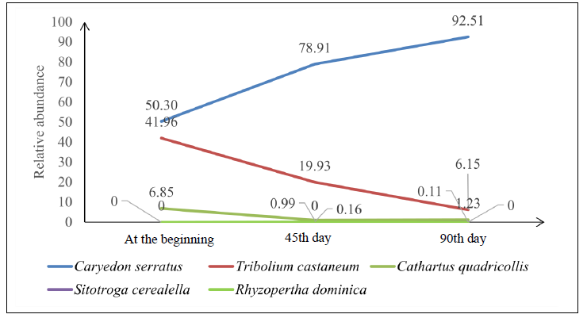
Figure 6: Curve showing the variation in species richness as a function of storage duration for samples from the markets

3.6. Dynamics of insects in samples from the villages
At the beginning of storage, five species were present in the samples from the villages. C. serratus, T. castaneum and C. quadricollis were the most abundant species, with 66.47%, 20.35% and 10.18%, respectively. C. dimidiatus and S. zeamais showed lower abundances, at 1.80% and 1.20%, respectively. After 45 days, species richness reached six species. C. serratus remained dominant, with a relative abundance of 78.11%. T. castaneum and C. quadricollis accounted for 12.23% and 5.56%, respectively. The frequency of occurrence of C. serratus reached 97% after 45 days, while that of T. castaneum was 93%. After 90 days, C. serratus remained the most frequently observed species, with a frequency of occurrence of 100%. T. castaneum and R. dominica had frequencies of 90% and 53.33%, respectively. S. cerealella and C. dimidiatus were much less frequent.

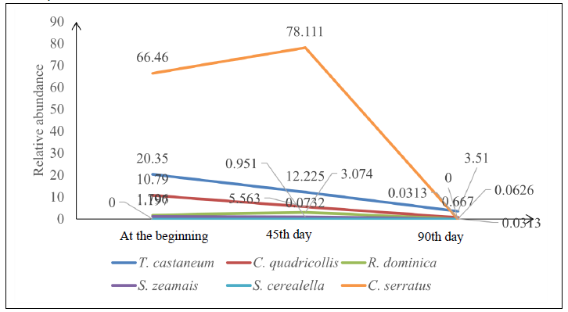

Figure 7: Curve showing the variation in species richness as a function of storage duration for samples collected from the villages

3.7. Nature and evolution of damage

Peanut samples showed several types of deterioration during storage. The damage observed included perforations of the grains and pods, weight reduction, and a decrease in market quality. A loss of germination capacity was also reported.
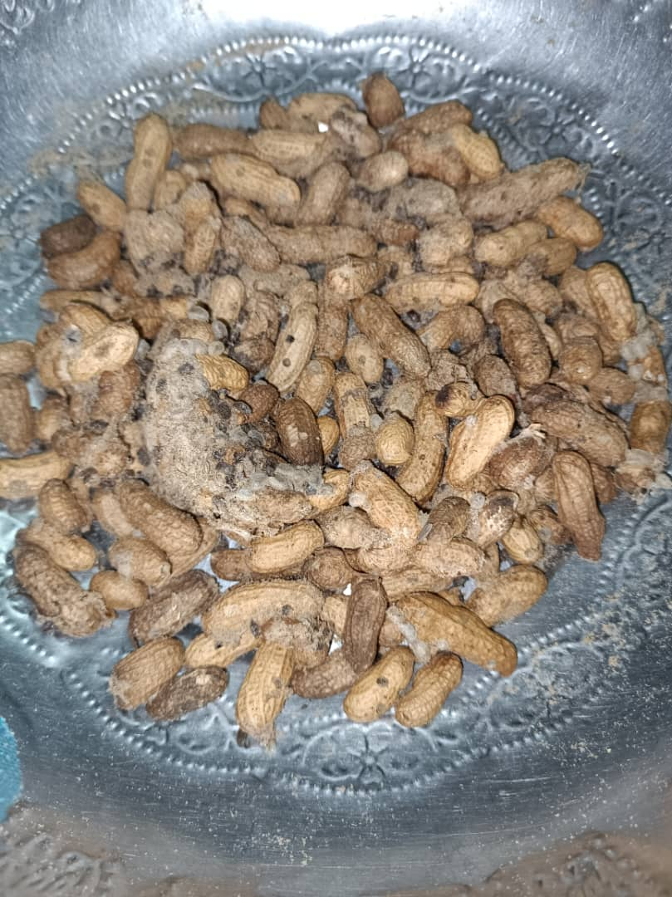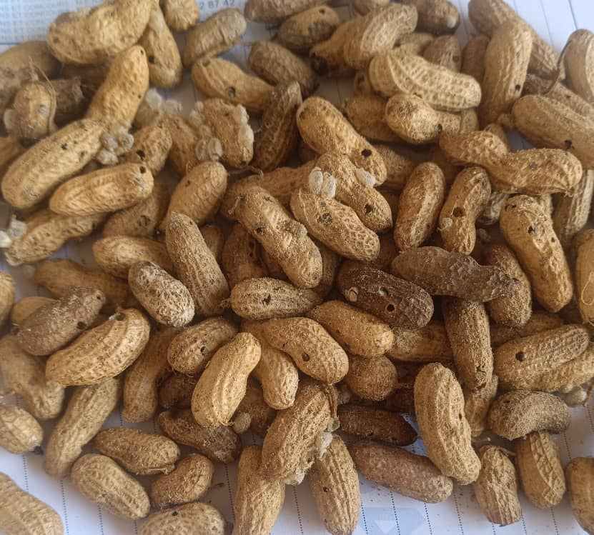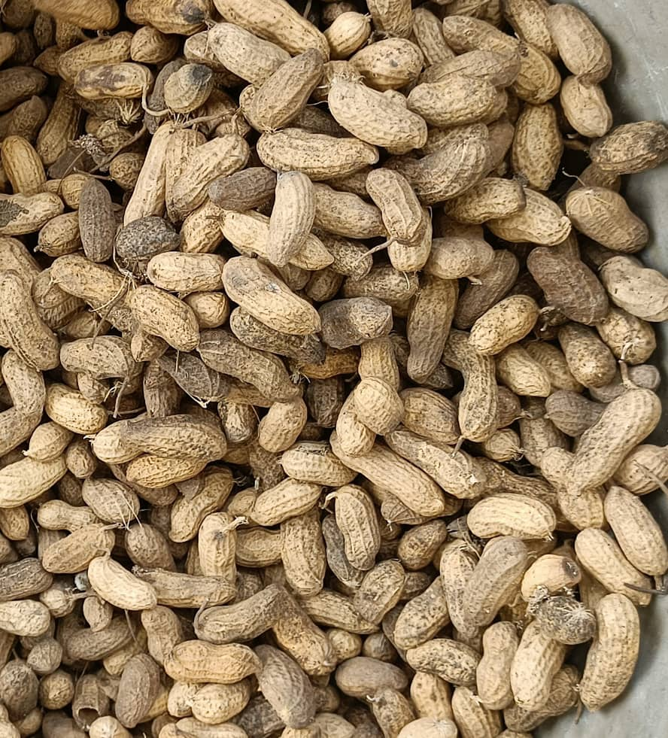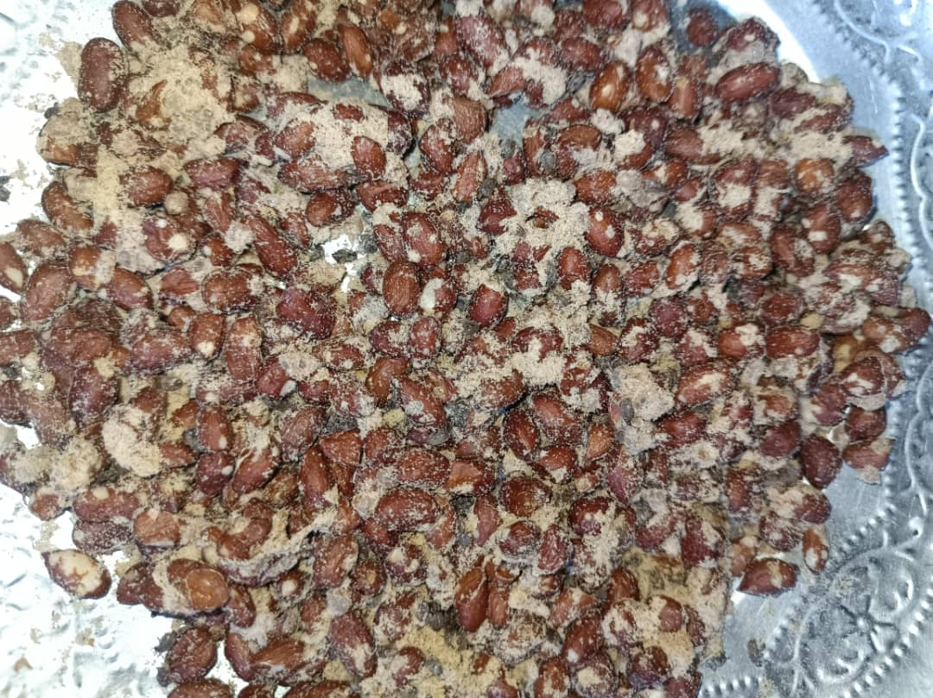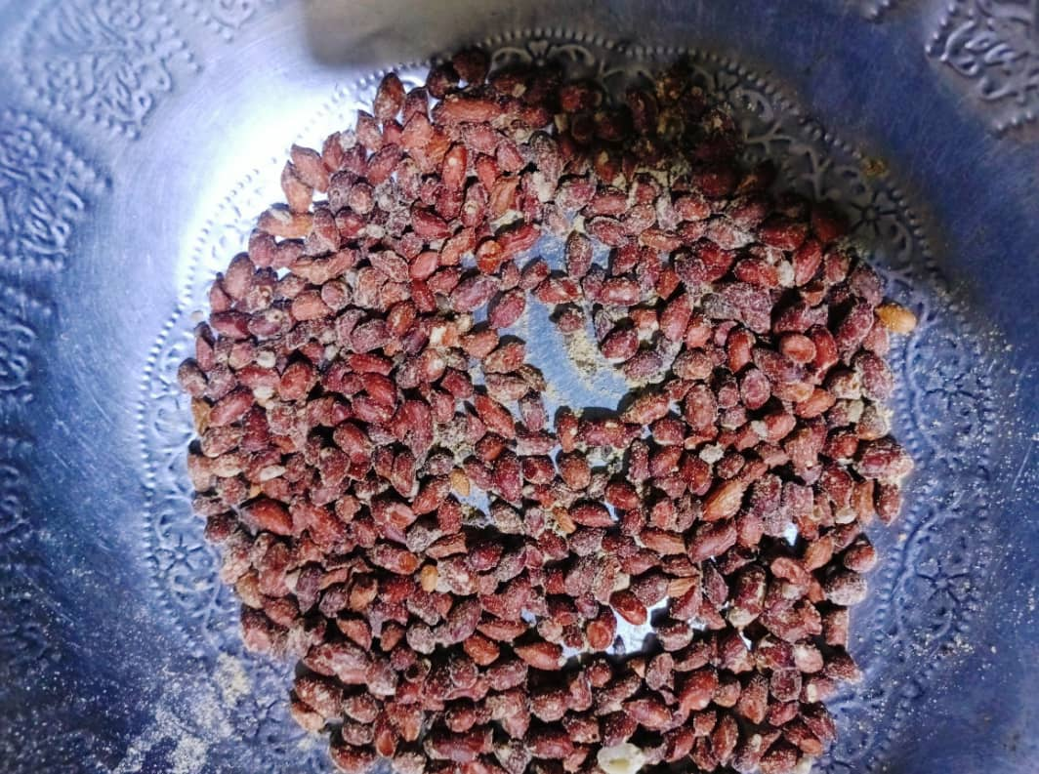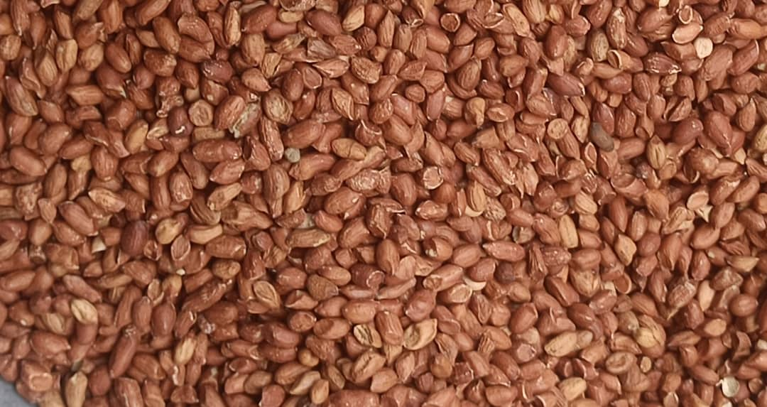
A
B
C
D
E
F

Village: (A: 0-day, B: 45 days, C: 90 days); Market: (D: 0-day, E: 45 days, F: 90 days)

Figure 8: Nature of Damage Caused by Insects to Groundnuts

At the beginning of storage, the infestation rate of unshelled peanuts ranged from 6.90 to 10.74%. In the shelled samples collected from the markets, it ranged from 7.00 to 10.22%. After 45 days, the infestation rate reached 10.09 to 28.71% for unshelled peanuts and 20.53 to 33.51% for the seeds collected from the markets. After 90 days, the infestation rate reached 59.73 to 76.71% in the unshelled samples and 43.72 to 76.73% in the shelled samples.

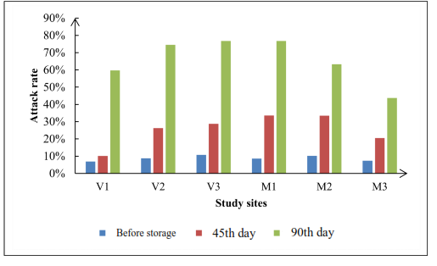

V1 : Nangakaha, V2 : Drogo, V3 : Lailouroukaha, M1 : large market, M2 : market of Koko, M3 : market of Haoussabougou
Figure 9: Insect pest infestation rate on peanut samples
prélevés

Weight losses also increased during storage. Before storage, they ranged from 3.24 to 6.01% in samples from the villages and from 0.74 to 2.37% in samples from the markets. After 45 days, they reached 5.28 to 7.86% in the villages and 3.14 to 10.78% in the markets. After 90 days, weight losses ranged from 13.22 to 19.51% in samples from the villages and from 13.67 to 20.91% in samples from the markets, depending on the sites and storage conditions.

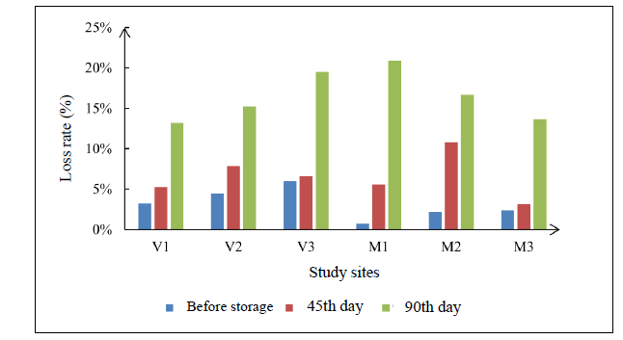
Figure 10: Weight loss rate of the collected peanut samples
V1: Nangakaha, V2: Drogo, V3: Lailouroukaha, M1: large market, M2: market of Koko, M3: market of Haoussabougou

3.8. Diversity indices
The Shannon index ranged from 0.220 to 0.503. The highest value was observed at the large Market (0.503), followed by the village of Drogo (0.470). The lowest values were recorded at Koko (0.220) and Haoussabougou (0.234). Species richness ranged from three to six species depending on the sites. Drogo and Nangakaha had a rich species of six species, whereas the large Market had only three species. The large Market recorded the highest evenness (0.458), while Nangakaha had the lowest value (0.140), indicating a strong dominance of certain species at this site.

Table 2: Diversity indices of insect pests according to the sites
Site | Shannon | Specific richness | Pielou’s species evenness
Drogo | 0.470 | 6 | 0.262
Large market | 0.503 | 3 | 0.458
Haoussabougou | 0.234 | 4 | 0.169
Koko | 0.220 | 4 | 0.159
Lailouroukaha | 0.294 | 5 | 0.183
Nangakaha | 0.251 | 6 | 0.140

3.9. Distribution of insect pest species
Principal Component Analysis showed that the first two axes explained 23.1% and 19.4% of the total variance, respectively. The representation highlighted the structuring of the insect communities according to the sites and the presence of certain species associated with several environments. The proximity observed between certain species, particularly S. zeamais and C. serratus, suggested an association in the samples studied. However, this proximity should be interpreted as an association in the abundance of data and not as direct evidence of niche sharing.
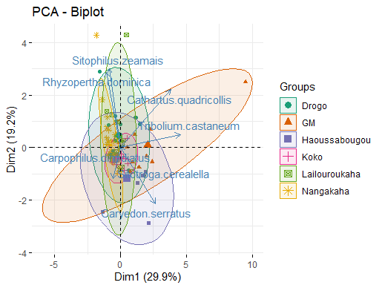
Figure 11: Distribution of insect pests across all study sites

4. Discussion

The study identified seven species of insect pests associated with stored peanuts in the Korhogo Department. This taxonomic richness confirms that peanut stocks constitute a favorable habitat for several groups of insects. Most of the species identified had already been reported in peanut stocks in other regions of West Africa. Gueye et al. (2011) notably reported several of these species in peanut stocks in Senegal. The strong dominance of Caryedon serratus, which accounted for 93.09% of the individuals collected, constitutes the main result of the study. This predominance is consistent with observations made in other peanut-producing countries. C. serratus is considered a primary pest of peanuts, capable of initiating infestation even before storage. Adults can lay eggs on the pods, and the larvae subsequently develop inside the seeds. This ability contributes to the persistence of infestation during storage. High levels of infestation by this species have also been reported in Burkina Faso and Senegal. The importance of C. serratus partly explains the rapid increase in the infestation rate observed during the 90 days of storage. Eggs or larvae present in the pods at the time of storage can continue their development and give rise to new adults. Sorting and sieving operations therefore do not necessarily eliminate all immature stages. This dynamic could explain the increase from relatively low infestation rates at the beginning of storage to levels exceeding 75% after 90 days. The infestation levels observed are comparable to those reported in some previous studies on the peanut bruchid. Matokot et al. (1987) reported damage levels of up to 60% in Congo, whereas other studies reported levels of up to 83% in Senegal. Gueye et al. (2011) also showed that a low initial infestation could result in substantial deterioration of seed stocks during storage. The increase in weight losses accompanies the increase in the infestation rate. The values recorded after 90 days, close to or exceeding 15% at several sites and reaching approximately 20%, show that infestation is not limited to visible deterioration of the products. Attacks can directly reduce the marketable mass. They can also lead to a decline in market value and a reduction in germination capacity. Stored-product insects may also contribute to contamination and deterioration of product quality (Dabrie et al., 2008; Elmaouhab, 2024). The storage practices observed also constitute an important factor to consider. In the villages, peanuts are predominantly stored in bags placed inside houses, and stocks from different harvests are kept in the same location. This storage method may favor the persistence of insect populations and their transfer from one stock to another. The presence of insects in stored products therefore requires not only curative treatments, but also preventive measures involving storage facility hygiene, cleaning of bags, and regular monitoring of stocks (Bouziane and Fassouli, 2021). The widespread use of chemical products by producers reflects the importance given to pest control. However, their use should be regulated to limit risks associated with residues and improper application practices. Integrated pest management approaches are particularly relevant in this regard because they allow different control methods to be combined according to the level of infestation and the characteristics of the stock (Josée and Bernard, 2006; Taponjou et al., 2002). In markets, sorting and winnowing are the main practices reported. These methods make it possible to remove part of the infested products while maintaining the visual quality of marketed peanuts. The local use of Hyptis suaveolens also deserves particular attention. Its use as a plant with insecticidal or repellent effects has been reported by producers, but its effectiveness against the main peanut pests, particularly C. serratus, should be experimentally evaluated before any large-scale recommendation. The differences in diversity observed among sites are mainly related to species richness and the dominance of C. serratus. The large Market had the highest Shannon index despite relatively low species richness, which can be explained by a more balanced distribution of individuals among the species present. Conversely, the low evenness values observed at some sites indicate a high concentration of individuals in one or a few species, mainly C. serratus. The results therefore show that the issue of pests stored peanuts in Korhogo is not limited to the presence of a diverse assemblage of species. It is mainly characterized by the dominance of a primary pest, C. serratus, whose populations can increase considerably during storage. The management of this species should therefore be a priority in local strategies aimed at reducing post-harvest losses.

5. Conclusion
This study made it possible to invent the insect pests associated with stored peanuts in the Korhogo Department. Seven species belonging to two orders and seven families were identified: Caryedon serratus, Tribolium castaneum, Rhyzopertha dominica, Sitophilus zeamais, Cathartus quadricollis, Carpophilus dimidiatus and Sitotroga cerealella. The entomological community was largely dominated by C. serratus, whose relative abundance reached 93.09%. Monitoring of the samples over 90 days showed a substantial increase in the infestation rate, with values reaching up to 76.71% in unshelled peanuts and 76.73% in shelled samples. Weight losses reached approximately 20% in the most severely affected situations. These results highlight the importance of insect pests in peanut storage in Korhogo and, particularly, the predominant role of C. serratus. Training producers and female traders in good storage practices, improving the hygiene of storage facilities, and regularly monitoring stored products are important measures for limiting losses. Further studies should focus on the biology and ecology of C. serratus under the conditions of northern Côte d’Ivoire, as well as on the evaluation of integrated management methods combining hermetic storage, biopesticides and, where necessary and legally authorized, appropriate chemical treatments.

Conflict of Interest
The authors declare that they have no conflict of interest in relation to the present study.
Declaration of AI Use

This manuscript was prepared through the intellectual contributions of the author(s) to the study design, data analysis, interpretation of results, and scholarly content. Grammarly and ChatGPT were used solely to assist with grammatical refinement and reference formatting during manuscript revision. The author(s) accept full responsibility for the accuracy, integrity, and final content of the manuscript.

References

Abdou, M.M., Mayaki, Z.A., Kadri A., Ambouta, J.M.K. & Dan, L.N. (2014). Effet de l’arbre Acacia senegal sur la fertilité des sols de gommeraies au Niger. International Journal of Biological and Chemical Sciences(Effect of the *Acacia senegal* tree on soil fertility in gum arabic groves in Niger. International Journal of Biological and Chemical Sciences) 7(6): 2328 – 2337.
Arthur, F.H. (2000). Impact of accumulated food on survival of Tribolium castaneum on concrete treated with cyfluthrin wettable powder. Journal of Stored Products Research, 36(3): 15 – 23.
Bouziane, N. & Fassouli, Y. (2021). Effet insecticide des extraits hydro-méthanolique de deux plantes médicinales sur les imagos de Tribolium castaneum (Coleoptera, Tenebrionidae). Mémoire de Master, Université Mouloud Mammeri de (Insecticidal effect of hydro-methanolic extracts of two medicinal plants on adult Tribolium castaneum moths (Coleoptera, Tenebrionidae). Master's thesis, Mouloud Mammeri University of)Tizi-Ouzou, 55p.
Dabrie, C.L.B., Ba, M.N., Sanon, A. (2008). Effects of crushed fresh Cleomeviscosa L. (Capparaceae) plants on the cowpea storage pest, Callosobruchus maculatus Fab. (Coleoptera: Bruchidae). International Journal of Pest Management, 54 (4), 319 – 326.
Delobel, A. et Tran, M. (1993). Les coléoptères des denrées alimentaires entreposées dans les régions chaudes. Faune Tropicale XXXII. (Beetles Infesting Stored Food Products in Hot Regions. Faune Tropicale XXXII)ORSTOM/CTA Eds, Paris: 424p.
Elmaouhab, Y. (2024). Étude bibliographique sur les effets des huiles essentielles dans la lutte contre les insectes ravageurs des denrées stockées. Université Mouloud Mammeri de Tizi-Ouzou, Faculté des Sciences Biologiques et des Sciences Agronomiques,( Literature review on the effects of essential oils in the control of insect pests of stored products. Mouloud Mammeri University of Tizi-Ouzou, Faculty of Biological and Agronomic Sciences,) 110p.
Fandohan, P., Goergen, G., Hell, K. & Lamboni, Y. (2005). Petit manuel d’identification des principaux ravageurs des denrées stockées en Afrique de l’Ouest. INRAB-IITA, (A Short Guide to Identifying Major Stored-Product Pests in West Africa. INRAB-IITA)4 – 19.
Gnimagnon, A. (2013). Inventaire préliminaire des insectes ravageurs de différentes formes de conservation du riz (Oryza sativa) au Sud-Bénin. Rapport de fin de formation, (Preliminary inventory of insect pests affecting various forms of stored rice (Oryza sativa) in southern Benin. End-of-training report.)39p.
Guchi, E., Ayalew, A., Dejene, M., Ketema, M., Asalf, B. & Fininsa, C. (2014). Occurrence of Aspergillus species in groundnut (Arachis hypogaea L.) along the value chain in different agro-ecological zones of Eastern Ethiopia. Journal of Applied Environmental Microbiology, 2: 309 – 317.
Gueye, M.T., Seck, D., Wathelet, J.P. & Lognay, G. (2011). Lutte contre les ravageurs des stocks de céréales et de légumineuses au Sénégal et en Afrique occidentale: synthèse bibliographique. Biotechnology, Agronomy and Society and Environment, (Control of pests of stored cereals and legumes in Senegal and West Africa: a literature review. Biotechnology, Agronomy and Society and Environment)15(1), 183 – 194.
Josée, B. & Bernard, E. (2006). Lutter contre les insectes nuisibles en agriculture biologique: intervenir en harmonie face à la complexité. Phytoprotection, (Combating insect pests in organic farming: intervening in harmony with complexity. Plant protection.)87(2): 83 – 90.
Jourda, J.P., Saley, M.B., Djagoua, E.V., Kouamé, K.J., Biémi, J. et Razack, M. (2006). Utilisation des données ETM+ de Landsat et d’un SIG pour l’évaluation du potentiel en eau souterraine dans le milieu fissuré précambrien de la région de Korhogo (nord de la Côte d’Ivoire): approche par analyse multicritère et test de validation". Revue de Télédétection,( Use of Landsat ETM+ data and GIS to assess groundwater potential in the Precambrian fractured environment of the Korhogo region (northern Côte d’Ivoire): a multi-criteria analysis and validation test approach." Revue de Télédétection) 5(4), 339 – 357.
Matokot, L., Mapangou-Divassa, S. & Delobel, A. (1987). Évolution de la population de Caryedon serratus (Ol.) (Coleoptera: Bruchidae) dans les stocks d’arachide au Congo. L’Agronomie Tropicale, (Population dynamics of *Caryedon serratus* (Ol.) (Coleoptera: Bruchidae) in stored groundnuts in the Congo. L’Agronomie Tropicale)42: 69 – 74.
Reddy, E.C., Sudhakar, C. & Reddy, N.P. (2011). Aflatoxin contamination in groundnut induced by Aspergillus flavus type fungi: a critical review. International Journal of Applied Biology and Pharmaceutical Technology, 2(2): 180 – 192.
Sharma, V., Purohit, G.R., Arya, R.S. & Harsh M. (2006). Evaluation of some complete rations in sheep incorporating unconventional feed resources of arid zone of India. Animal Nutrition and Feed Technology, 6(1): 135 – 141.
Souleymane, K.Y. (2023). Diversité et distribution des insectes ravageurs dans les stocks de mil vendus dans les marchés de la commune de Korhogo (Côte d’Ivoire). Université Peleforo Gon Coulibaly,( Diversity and distribution of insect pests in pearl millet stocks sold in the markets of the Korhogo commune (Côte d’Ivoire). Peleforo Gon Coulibaly University.) Korhogo, 53p.
Taponjou, L.A., Adler, C., Bouda, H. & Fontem, D.A. (2002). Efficacy of powder and essential oil from Chenopodium ambrosioides leaves as post-harvest grain protectants against six stored-product beetles. Journal of Stored Products Research, 38: 395 – 402.

