Sex Ratio and Length-Weight Relationship of Marcusenius Furcidens (Pellegrin, 1920) from Solomougou Dam Lake (Côte d’Ivoire)

Abstract
Knowledge of growth parameters contributes to the conservation and sustainable management of fish stocks. This study aimed to characterize the sex ratio and length-weight relationship of Marcusenius furcidens by sex and sexual maturity in commercial catches from Solomougou Dam Lake. A total of 199 fish were recorded over eleven sampled months, from March to February, with no observations in September. The sample comprised 106 females, 66 males and 27 individuals of undetermined sex. Fish were measured (Lt in cm) and weighed (Pt in g), and the data were processed using Excel and STATISTICA 7.1. Among the 172 sexed fish, the male:female ratio was 1:1.61, with females accounting for 61.63% (two-sided exact binomial test, P = 0.002834). Monthly female predominance remained significant in June and August after Holm adjustment. The overall relationship was Pt = 0.018993 Ltᵇ, with b = 2.719271, R² = 0.8659 and a 95% confidence interval for b of 2.5689-2.8696. Negative allometry was observed overall (P = 0.000299) and in females (P = 0.001560). In males, b did not differ significantly from 3 (P = 0.121471). Slopes did not differ significantly between sexes (P = 0.488388). Among sexed fish at stages I-V, slopes did not differ significantly among stages (F = 1.840; df = 4, 158; P = 0.123700). The catches showed female predominance and overall negative allometry. The equation provides a reference for converting length to weight within the observed range of 11-24 cm, subject to limitations associated with commercial catch sampling and fish of undetermined sex.
Keywords: Marcusenius furcidens; sex ratio; length-weight relationship; allometry; commercial catches; Solomougou

1. Introduction
Fish represent a major food resource worldwide. Their size, abundance and economic importance make them one of the best-studied groups in aquatic ecosystems (Koné et al., 2022; Kar, 1981).
Furthermore, the biological characterization of exploited fish provides useful information for monitoring and managing inland fisheries (Wagaw et al., 2024). In Côte d’Ivoire, Solomougou Dam Lake has substantial fisheries potential and supports fishing throughout the year (Kouassi et al., 2020). Marcusenius furcidens is among the six mormyrid species recorded in this lake by these authors. Analyses of sex ratio and length–weight relationships contribute to the biological characterization of this species in commercial catches. The sex ratio describes the relative representation of males and females in the sample (Wagaw et al., 2024), whereas the length–weight relationship allows weight to be estimated from length and allometry to be characterized within the sampled size range (Mahé et al., 2023; Wagaw et al., 2024).
The length–weight relationship is a useful tool for studying fish biology and ecology and for stock assessment to support management and conservation (Bolognini et al., 2013). It contributes to the characterization of fish stocks in aquatic ecosystems (Hossain et al., 2006) and allows fish weight to be estimated from length, particularly when assessing catch biomass (Froese, 2006).
Length–weight relationships for Marcusenius furcidens have previously been established in Ivorian reservoirs by Tah et al. (2012) and in Solomougou Dam Lake by Kouassi et al. (2020). Building on these studies, the present study aimed to characterize the sex ratio and its monthly and seasonal variation, together with the total length–total weight relationship by sex and sexual maturity stage, in commercial catches from Solomougou Dam Lake.
2. Material et methods

2.1. Study area
The study was conducted in Solomougou Dam Lake, northern Côte d’Ivoire, approximately 25 km from Korhogo, at 9°18′12″ N and 5°44′09″ W (Figure 1). Its catchment covers approximately 250 km², and the lake has a maximum surface area of approximately 500 ha (Traoré, 1996). The region has a Sudanian climate, with a dry season from November to April and a rainy season from May to October, with peak rainfall in August and September (Silué and Dogbo, 2022).

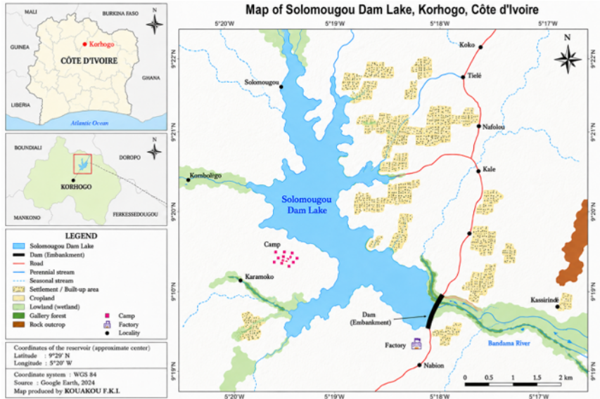
Figure 1 : Site d’étude
2.2. Sampling and data analysis
Sampling was conducted from March 2024 to February 2025. The lake supports an artisanal commercial fishery operated from dugout canoes. Fishers mainly use gillnets with mesh sizes of 25–80 mm, set in the late afternoon and retrieved the following morning. Landings from this fishery provided the specimens examined in the present study. No sampling was conducted in September because of flooding. Fish were identified using the guide by Gourène et al. (1995). For each specimen, standard and total lengths were measured to the nearest millimetre, and total weight was recorded to the nearest gram.
Following dissection, sex and sexual maturity stage were determined by macroscopic examination of the gonads using the scale of Durand and Loubens (1970). Classification was based on gonad size, colour, vascularization and consistency, as well as oocyte visibility and the presence of releasable gametes. Assessments were compared among three observers to assign a consensus stage. Individuals whose sex could not be identified were classified as being of undetermined sex.
The sex ratio (SR) was calculated as the number of males (M) divided by the number of females (F): SR = M/F. It describes the sex composition of the sampled commercial catches, excluding individuals of undetermined sex. The relationship Pt = aLtᵇ (Le Cren, 1951) was fitted by least squares following logarithmic transformation:
ln(Pt) = ln(a) + b ln(Lt).
Linear regression of ln(P) on ln(Lt) was used to estimate b and ln(a), together with the standard error of b and its 95% confidence interval. The coefficient of determination R² indicates the proportion of variance in ln(P) explained by ln(Lt). The hypothesis of isometry (b = 3) was evaluated using Student’s t-test. P-values for the three tests performed on all individuals, females and males were adjusted using the Holm method. The significance level was set at 5%.

3. Results
3.1. Overall sex composition
The sample comprised 106 females, 66 males and 27 individuals of undetermined sex, representing 53.27%, 33.17% and 13.57% of all specimens, respectively. Among the 172 sexed fish, females accounted for 61.63% and males for 38.37%. The male:female ratio was 1:1.61.
The departure from parity was significant (two-sided exact binomial test, P = 0.002834). The continuity-corrected chi-square test confirmed this result: χ² = 8.843; df = 1; P = 0.002942.
3.2 Monthly and seasonal variation
Monthly counts and test results are presented in Table 1. After Holm adjustment of P-values, female predominance remained significant in June (adjusted P = 0.041809) and August (adjusted P = 0.020142). In October, all six sexed fish were females, but the result was no longer significant after adjustment (adjusted P = 0.281250). In November, the sex ratio was based on only five sexed fish among the 22 specimens recorded.
Table 1. Monthly sex composition and binomial tests of parity
Month | Total n | M | F | Und. | Exact P | Holm P
March | 9 | 4 | 5 | 0 | 1.000000 | 1.000000
April | 20 | 12 | 6 | 2 | 0.237885 | 1.000000
May | 13 | 5 | 8 | 0 | 0.581055 | 1.000000
June | 16 | 2 | 14 | 0 | 0.004181 | 0.041809
July | 19 | 6 | 13 | 0 | 0.167068 | 1.000000
August | 14 | 1 | 13 | 0 | 0.001831 | 0.020142
October | 12 | 0 | 6 | 6 | 0.031250 | 0.281250
November | 22 | 1 | 4 | 17 | 0.375000 | 1.000000
December | 17 | 8 | 8 | 1 | 1.000000 | 1.000000
January | 21 | 14 | 17 | 0 | 0.720100 | 1.000000
February | 26 | 13 | 12 | 1 | 1.000000 | 1.000000

M: males; F: females; Und.: undetermined sex. Tests are based on M + F. September was not sampled. Figure 2 illustrates the counts of sexed fish.
During the sampled rainy-season months, 54 females and 14 males were identified, giving a male:female ratio of 1:3.86 and a female proportion of 79.41%. The binomial test yielded P ≈ 0.000001110 and Holm-adjusted P ≈ 0.000002220. During the dry-season months, 52 females and 52 males were identified (ratio 1:1; P = 1). The association between sex and season was significant: continuity-corrected χ² = 13.823; df = 1; P = 0.000201.

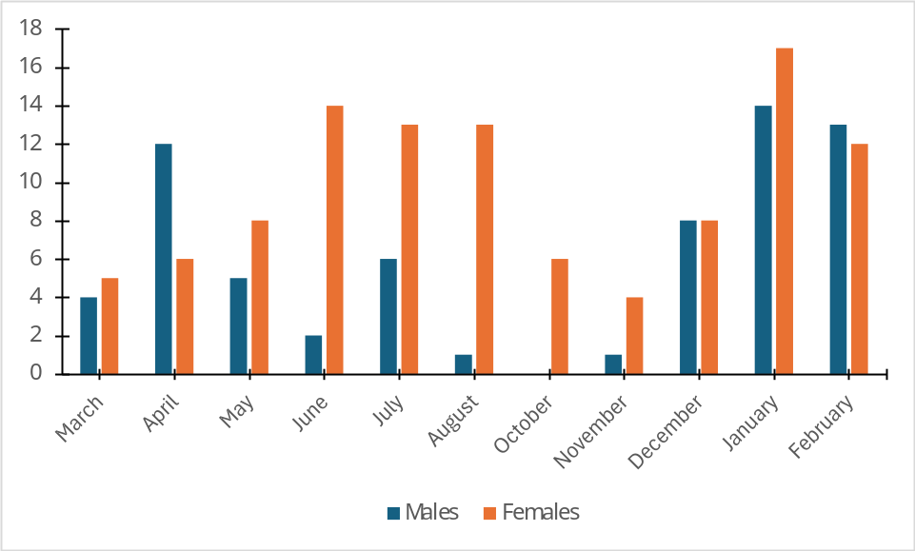

Figure 2: Monthly counts of female and male Marcusenius furcidens. Individuals of undetermined sex are excluded. September is not shown.
.

3.3 Length–weight relationships

Total length ranged from 11 to 24 cm and total weight from 15.5 to 115.6 g. The overall relationship was Pt = 0.018993 Ltᵇ, with b = 2.719271 and R² = 0.8659. The 95% confidence interval for b was entirely below 3 (2.5689-2.8696). The test indicated negative allometry: t = -3.682; df = 197; P = 0.000299; Holm-adjusted P = 0.000896. Parameters are presented in Table 2 and fitted relationships in Figure 3.
Table 2. Parameters and tests for the total length–total weight relationships.
Group | n | a | b | 95 % CI for b | R² | P (b=3) | Holm P
Overall sample | 199 | 0.018993 | 2.7193 | 2.5689-2.8696 | 0.659 | 0.000299 | 0.000896
Females | 106 | 0.025685 | 2.6210 | 2.3896-2.8523 | 0.8292 | 0.001560 | 0.003120
Males | 66 | 0.016747 | 2.7619 | 2.4588-3.0650 | 0.8381 | 0.121471 | 0.121471

Lt is expressed in cm and Pt in g. R² is calculated on the logarithmic scale. The overall fit includes individuals of undetermined sex.
In females, the equation was Pt = 0.025685 Ltᵇ, with b = 2.620965. The slope differed significantly from 3 (t = −3.249; df = 104; P = 0.001560; Holm-adjusted P = 0.003120), indicating negative allometry. In males, the equation was Pt = 0.016747 Ltᵇ, with b = 2.761892. The slope did not differ significantly from 3 (t = −1.569; df = 64; P = 0.121471).
For individuals of undetermined sex (n = 27), the exploratory fit yielded a = 0.018099,
b = 2.719642, R² = 0.9442 and a 95% confidence interval for b of 2.4472–2.9921. This category does not represent a distinct biological sex.
The standard errors of b were 0.07624 overall, 0.11666 in females and 0.15171 in males. Slopes did not differ significantly between sexes (t = 0.694; df = 168; P = 0.488388).
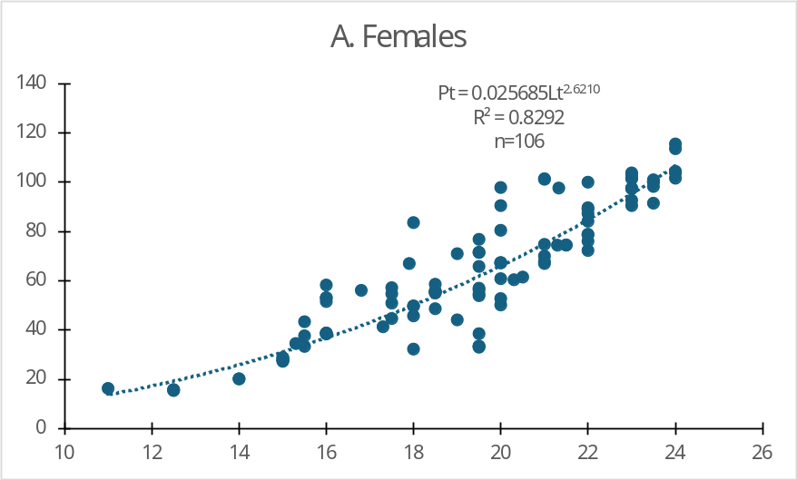

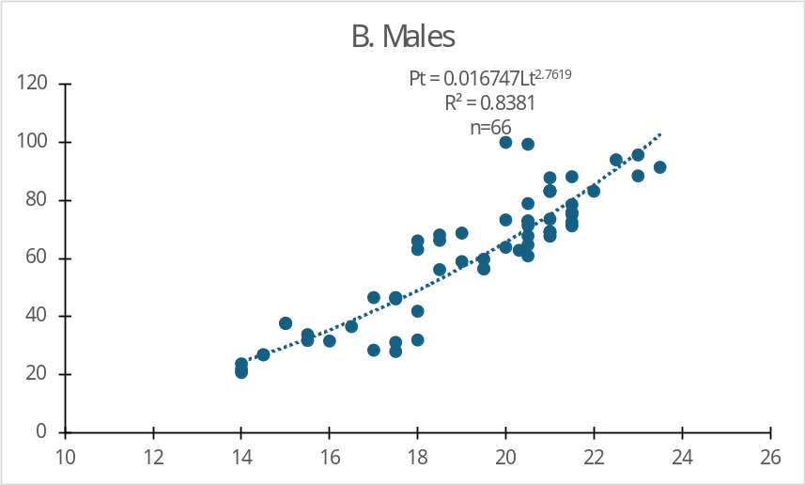
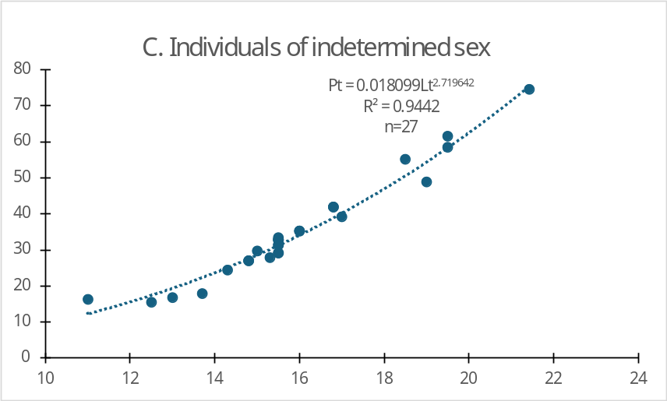
Figure 3: Total length-total weight relationships of Marcusenius furcidens. A: females; B: males; C: individuals of undetermined sex.

3.4 4 Sex ratio according to sexual maturity stage
Counts by stage are presented in Table 3. Code 0 included two females, two males and 27 individuals of undetermined sex. Females were more numerous at stages I and II, whereas males were more numerous at stage III, with no significant departure from parity after Holm adjustment. Stage IV comprised only 18 females. Stage V included 19 females and three males. Female predominance remained significant at stages IV (Holm-adjusted P = 0.000046) and V (Holm-adjusted P = 0.004277). The biological comparability of stage codes between sexes remains to be documented.
Table 3. Sex composition and tests of parity by stage code.
Stade | N total | M | F | Ind. | P exact | P Holm
0 | 31 | 2 | 2 | 27 | 1.000000 | 1.000000
I | 70 | 32 | 38 | 0 | 0.550413 | 1.000000
II | 32 | 14 | 18 | 0 | 0.596615 | 1.000000
III | 26 | 15 | 11 | 0 | 0.557197 | 1.000000
IV | 18 | 0 | 18 | 0 | 0.000008 | 0.000046
V | 22 | 3 | 19 | 0 | 0.000855 | 0.004277
Tests include only sexed individuals. Code 0 is not assigned a maturity interpretation in this analysis
3.5 Length-weight relationship according to sexual maturity stage
Regressions with sexes pooled included 70, 32, 26, 18 and 22 fish at stages I-V respectively (Table 4). The corresponding exponents b were 2.6683, 2.5188, 2.6296, 1.3201 and 2.2236. After adjustment of the five tests, negative allometry was observed at stages 1, 2, 4 and 5. At stage 3, b did not differ significantly from 3 (P = 0.606495), and its 95% confidence interval was wide (1.1649-4.0943).
Table 4. Total length–total weight relationships by stage for combined sexes
Stage | n | a | b | 95 % CI for b | R² | P(b=3) | Holm P
I | 70 | 0.021692 | 2.6683 | 2,3801-2,9566 | 0.8338 | 0.024763 | 0.049526
II | 32 | 0.034777 | 2.5188 | 2.1971-2.8404 | 0.8950 | 0.004688 | 0.018750
III | 26 | 0.022976 | 2.6296 | 1.1649-4.0943 | 0.3639 | 0.606495 | 0.606495
IV | 18 | 1.565372 | 1.3201 | 0.5578-2.0824 | 0.4572 | 0.000255 | 0.001276
V | 22 | 0.091463 | 2.2236 | 1.6375-2.8096 | 0.7580 | 0.011981 | 0.035944

Lt is expressed in cm and Pt in g. Only sexed fish at stages I-V are included; code 0 is excluded. The degrees of freedom for the tests of b = 3 are 68, 30, 24, 16 and 20, respectively.
Despite numerical variation in the exponents, the overall test comparing slopes was not significant (F = 1.840; df = 4, 158; P = 0.123700). These data therefore provide no evidence of slope heterogeneity among stages in the model tested.
4. Discussion
Females were significantly more numerous than males in the sampled catches overall, particularly during the rainy season. Fishing-gear selectivity, the sizes of fish caught and their availability in fishing areas may influence this composition. The data therefore do not allow female predominance to be attributed to higher survival or reproduction-related movements.
Individuals of undetermined sex accounted for 13.57% of the sample and were recorded mainly in November. Their exclusion from sex-ratio tests may affect the observed proportions if difficulties in sex identification disproportionately affect one sex. Furthermore, undetermined sex does not necessarily indicate that a fish is immature (Waddell et al., 2019).
The negative allometry observed in the overall sample indicates that weight increases less steeply than the cube of length. This relationship does not measure individual growth rate and is insufficient to infer poor nutritional condition. Its interpretation must account for the units used, the sampled size range and sample composition (Froese, 2006).
The length–weight relationships established by Tah et al. (2012) and Kouassi et al. (2020) provide reference data for M. furcidens in Côte d’Ivoire. However, they are based on standard length, whereas the present study uses total length. Their equations are therefore not directly interchangeable, and comparisons must also account for catch composition.
In females, the slope was significantly below 3, indicating negative allometry. In males, the confidence interval included 3, making the relationship compatible with isometry. However, slopes did not differ significantly between sexes. These results therefore do not establish a difference in allometry between males and females.
The exclusive presence of females at stage 4 and the small number of males at stage 5 limit the interpretation of differences in sex ratio among stages. These differences may reflect catch composition and the criteria used to classify maturity.
Negative allometry does not imply that fish lose weight during maturation. Slopes did not differ significantly among stages; our results therefore do not establish a difference in slope associated with sexual maturity. Interpretation must also account for the sex composition of the groups, sampling period and sampled size range, factors that may influence length–weight relationships (Mahé et al., 2023). At stage 3, the wide confidence interval indicates a low-precision slope estimate.

5. Conclusion
The sampled commercial catches of M. furcidens showed female predominance among sexed individuals, with a male:female ratio of 1:1.61. The length–weight relationship indicated negative allometry overall and in females. In males, the data remained compatible with isometry, and no significant difference in slopes between sexes was established.
Analysis by stage identified negative allometry at stages I, II, IV and V but did not establish an overall difference in slopes among stages. The overall equation provides a biometric reference for the sampled catches within the 11-24 cm length range. Its application and the generalization of the results must account for commercial catch sampling, fish of undetermined sex and the validation of observations.
Declaration of AI Use

This manuscript was prepared through the intellectual contributions of the author(s) to the study design, data analysis, interpretation of results, and scholarly content. Grammarly and ChatGPT were used solely to assist with grammatical refinement and reference formatting during manuscript revision. The author(s) accept full responsibility for the accuracy, integrity, and final content of the manuscript.

References
Bolognini, L., Domenichetti F., Grati F., Polidori P., Scarcella G., & Fabi G. (2013). Weight-Length Relationships for 20 Fish Species in the Adriatic Sea. Turkish Journal of Fisheries and Aquatic Sciences, vol. 13, pp. 563-568. DOI: 10.4194/1303-2712-v13_3_21
Froese, R. (2006). Cube law, condition factor and weight–length relationships: history, meta-analysis and recommendations. Journal of Applied Ichthyology, 22, 241–253. https://doi.org/10.1111/j.1439-0426.2006.00805.x
Hossain, M.Y., Ahmed Z. F., Leunda P. M., Jasmine S., Oscoz J., Miranda R., & Ohtomi J. (2006). Condition, length-weight and length-length relationships of the Asian striped catfish Mystus vittatus (Bloch, 1794) (Siluriformes: Bagridae) in the Mathabhanga River, Southwestern Bangladesh. Journal of Applied Ichthyology, vol. 22, pp. 304-307. https://doi.org/10.1111/j.1439-0426.2006.00803.x
Karr, J.R. (1981). Assessment of biotic integrity using fish communities. Fisheries of Bethesda. 7: 2-8.

Koné, N., N’Da, A. S., Boguhé G.F.D. H., & Berté, S. (2022). Relation longueur-masse et paramètres de population de Synodontis bastiani Daget, 1948 (Mochokidae) dans le fleuve Bandama en aval du barrage de Taabo (Côte d’Ivoire). Journal of Animal & Plant Sciences, 51 (3) : 9284-9296. https://doi.org/10.35759/JAnmPlSci.v51-3.
Kouassi, K. D., Diaby, M., Amon, Y. N., & N’da, K. (2020). Length-Weight relationship and condition factor for 22 freshwater fish species from Solomougou Dam Lake (Korhogo, Côte d’Ivoire). International Journal of Fisheries and Aquatic Studies, 8(1), 172–175.
Mahé, K., Baudrier, J., Larivain, A., Telliez, S., Elleboode, R., Bultel, E. & Pawlowski, L. (2023). Morphometric relationships between length and weight of 109 fish species in the Caribbean Sea (French West Indies). Animals, 13(24), 3852. https://doi.org/10.3390/ani13243852
Silué, P.D., & Dogbo, K. (2022). Gouvernance des barrages et développement des activités économiques en Côte d’Ivoire. In : Actes du colloque du 28 au 30 juin 2022 sur « La gouvernance à l’ère des changements globaux: situation, résilience et défis en afrique ». Biaka, Z.I., & Coulibaly, L. PASRES (Eds.). Revue trimestrielle en Sciences Sociales-Programme d’Appui Stratégique à la Recherche Scientifique, Tome 2: 304-322.
Tah, L., Gooré Bi, G., & Da Costa, K. S. (2012). Length-weight relationships for 36 freshwater fish species from two tropical reservoirs: Ayamé I and Buyo, Côte d’Ivoire. Revista de Biología Tropical, 60(4), 1847-1856
Traoré, K. (1996). État des connaissances sur les pêcheries continentales ivoiriennes. Rapport de consultation, Projet FAO TCP/IVC/4553.
Wagaw, S., Sisay, A., Bazezew, A., Enawgaw, Y., & Wosnie, A. (2024). Biological aspects of Oreochromis niloticus (Linnaeus, 1758) in Geray Reservoir (Ethiopia) for effective sustainable fisheries. Fisheries and Aquatic Sciences, 27(2), 100-110. https://doi.org/10.47853/FAS.2024.e11

