Original Research Article
Root colonization but no growth response in African eggplant (Solanum aethiopicum L.) inoculated with two indigenous and one commercial arbuscular mycorrhizal fungal inoculants

.
ABSTRACT

Background: African eggplant (Solanum aethiopicum L.) is an important vegetable crop in sub-Saharan Africa, but its productivity is constrained by declining soil fertility and increasing reliance on chemical inputs. Arbuscular mycorrhizal fungi (AMF) represent a potential sustainable biofertilization strategy, although the effectiveness of commercial and indigenous inoculants may vary depending on environmental conditions and plant–fungus interactions.
Aims: This study evaluated the ability of one commercial and two indigenous AMF inoculants originating from cassava- and maize-associated rhizospheres to colonize S. aethiopicum roots and influence plant growth.
Study design: Greenhouse conditions in Daloa, Côte d’Ivoire.
Place and Duration of Study: Jean LOROUGNON GUEDE University, Department of plant biology, between April and June 2024.
Methodology: A completely randomized design with four treatments and seven replicates was used: a commercial inoculant (CoM), an indigenous cassava-derived inoculant (CaM), an indigenous maize-derived inoculant (MaM), and a non-inoculated control. Mycorrhizal colonization frequency and intensity were assessed 40 days after transplanting, while plant growth and biomass production were monitored for 60 days. Results: All three inoculants established mycorrhizal colonization, with colonization frequencies exceeding 50%, whereas no colonization was detected in the non-inoculated control. However, colonization intensity remained low (≤10%), and no significant differences were observed among the commercial and indigenous inoculants. Similarly, no significant treatment effects were detected for plant height, collar diameter, number of leaves, flower-bud production, or fresh aboveground and belowground biomass.
Conclusion: These findings indicate that the indigenous inoculants evaluated were capable of colonizing S. aethiopicum roots at levels comparable to the commercial inoculant, but that this colonization did not result in measurable agronomic benefits under the experimental conditions. Longer-term experiments using larger root-zone volumes and contrasting water conditions, together with field trials, are needed to determine the agronomic potential of these indigenous inoculants for sustainable biofertilization of African eggplant in Côte d’Ivoire.

Keywords: Sustainable agriculture, Biofertilizer, Arbuscular mycorrhizae, Mycorrhizal colonization

1. INTRODUCTION

African eggplant (Solanum aethiopicum L.) is one of the most widely cultivated indigenous vegetables in sub-Saharan Africa and constitutes an essential component of local food systems. The crop is valued for its edible fruits and leaves, which provide dietary fiber, vitamins, minerals, and bioactive compounds with recognized nutritional and health-promoting properties (Choi & Choi, 2024). In addition to its contribution to household nutrition, African eggplant has an important economic role in smallholder farming systems, providing a source of income through commercial production and contributing to farmers’ livelihoods (Kasharu et al., 2019; Mvungi et al., 2025). Consequently, contributing to the improvement of the cultivation of this indigenous vegetable is considered an important strategy for strengthening food security, improving nutrition, and supporting rural livelihoods while promoting sustainable agricultural development.

Despite its importance, S. aethiopicum cultivation faces several constraints, including declining soil fertility, inadequate nutrient management, and increasing pest and disease pressures. However, in Côte d'Ivoire, to compensate for these constraints, farmers frequently rely on chemical pesticides and mineral fertilizers. Although mineral fertilization can rapidly improve crop performance and chemical pesticides allow crop protection, their long-term sustainability is increasingly questioned because of rising input costs and adverse environmental impacts. These limitations have stimulated growing interest in environmentally friendly alternatives capable of sustaining crop growth while restoring soil biological functions.

Among the biological approaches proposed for sustainable agriculture, arbuscular mycorrhizal fungi (AMF) have attracted considerable attention because of their capacity to simultaneously influence plant nutrition, growth, and stress resilience. AMF establish mutualistic associations with approximately 80% of terrestrial plant species, in which carbon compounds supplied by the host plant support fungal growth, while the extraradical mycelial network enhances the acquisition of mineral nutrients and water (Zhang et al., 2024). Meta-analytical evidence indicates that AMF inoculation can substantially improve plant biomass and nitrogen and phosphorus nutrition, although the magnitude of these effects depends on plant, fungal, and environmental factors (Wu et al., 2024). Beyond nutritional benefits, AMF can improve soil structure and water-use efficiency and enhance plant tolerance to drought, salinity, and temperature stress through coordinated physiological, biochemical, and molecular responses (Nie et al., 2024). They may also contribute to plant protection against soil-borne pathogens by stimulating host defense mechanisms and modifying the rhizosphere environment (Nie et al., 2024).
These multiple ecosystem services have positioned AMF as key components of sustainable agriculture and have contributed to the development of numerous industries producing commercial mycorrhizal inoculants worldwide (Vosátka et al., 2012). However, the effectiveness of mycorrhizal inoculation may vary depending on the origin of the fungal inoculum. In particular, indigenous AMF isolates may be better adapted to local soil and environmental conditions than exotic or commercial strains, potentially influencing their ability to establish symbiosis with host plants and to promote plant growth (Berruti et al., 2016a). Although considerable progress has been made in understanding AMF–plant interactions, important knowledge gaps remain for indigenous vegetable production systems in West Africa. Furthermore, information on the agronomic performance of locally produced AMF inoculants is not abundant (Kouadio et al., 2017; Séry et al., 2016), despite their potential advantages in terms of adaptation to local soils, lower production costs, and wider accessibility for smallholder farmers. Therefore, comparing commercial inoculants with indigenous inocula is important for determining whether locally sourced AMF can provide an effective alternative to commercially available products.
The present study was designed to assess the effects of one commercial and two locally produced AMF inoculants on Solanum aethiopicum root mycorrhizal colonization and growth under greenhouse conditions in Daloa, Côte d'Ivoire. By comparing commercial and indigenous inoculants under standardized conditions, this study provides new evidence regarding the context-dependent effectiveness of AMF inoculation and contributes to the development of sustainable biofertilization strategies for African eggplant cultivation in West Africa.

2. material and methods

2.1 Plant material

The eggplant seeds used in the experiment belonged to the BELLO variety. BELLO is an African eggplant cultivar belonging to the Solanaceae family, characterized by a mild flavor and early maturity, with the first harvest occurring approximately 60 days after planting and a total crop cycle of about 85 days. The fruits are globular in shape and weigh approximately 50 g on average. At maturity, they are cream-colored with green stripes. The seeds were purchased from Semivoire, a commercial seed supplier.

2.2 Arbuscular mycorrhizal Fungi inoculants
The fungal material used consisted of three mycorrhizal inoculants belonging to two categories: commercial and indigenous inoculants. The indigenous inocula consisted of mixtures of soil, AMF spores, and root fragments collected from the rhizosphere of cassava and maize fields. The commercial inoculant was supplied by the Quebec-based company Premier Tech Biotechnologies (PTB), which is recognized as one of the world’s leading producers and suppliers of mycorrhizal inoculants.

2.3 Experimental design, culture condition and data collection
To establish the nursery, eggplant seeds of the ‘Bello’ cultivar obtained from Semivoire were sown in perforated plastic trays to allow excess irrigation water to drain. The trays were filled with previously sterilized potting soil. The seedlings were watered once every two days. After reaching the four leaves stage, each plant was transplanted into a 3-L pot containing a substrate consisting of a mixture of sand and potting soil (1:2, v/v). The substrate was previously sterilized by autoclaving at 121 °C for 15 min, twice at a 24-h interval.

Seedlings were inoculated with AMF at the time of transplanting. Plants were inoculated with 200 g plant⁻¹ of the indigenous inocula, containing 200 AMF spores along with unquantified mycorrhizal propagules per plant. For the commercial inoculant, 15 g plant⁻¹ was applied, containing 7500 AMF spores along with unquantified mycorrhizal propagules per plant. The inoculants were placed in the planting holes in close proximity to the roots, following the application instructions provided for the commercial mycorrhizal inoculant supplied by Premier Tech Biotechnologies (PTB).

For this experiment, a completely randomized design was used, with seven replicates and four treatments: the commercial mycorrhizal inoculant (CoM), the indigenous mycorrhizal inoculum from a cassava field (CaM), the indigenous mycorrhizal inoculum from a maize field (MaM), and an uninoculated control.

Following transplanting, the plants were irrigated once every two days and maintained under greenhouse conditions for 60 days until flowering. Agronomic data such as plant height, collar diameter, number of leaves were recorded at seven-day intervals. At the end of the experiment, the number of flower buds and fresh aboveground and belowground biomass were also recorded. Mycorrhizal colonization frequency and intensity were assessed 40 days after transplanting.

2.4 Statistical analysis
Statistical analyses were performed using Statistica software, version 7.1. The effects of the treatments on agronomic and mycorrhizal colonization parameters were assessed using a one-way analysis of variance (ANOVA). The assumptions of normality of model residuals and homogeneity of variances were assessed before analysis. When the ANOVA indicated a significant treatment effect, means were compared using Fisher’s least significant difference (LSD) test at the 5% significance level.

3. results and discussion

3.1 Mycorrhizal colonization frequency and intensity
Significant differences were observed among treatments in terms of mycorrhizal colonization frequency and intensity (Figure 1). Complete absence of mycorrhizal colonization was observed in the roots of non-inoculated plants. In contrast, all inoculated plants were successfully colonized by AMF 40 days after transplanting, with mycorrhizal colonization frequencies exceeding 50% across all inoculated treatments (Figure 1). Fisher’s LSD post hoc test showed no significant differences among the three inoculated treatments, indicating that the significant overall treatment effect was primarily attributable to the absence of mycorrhizal colonization in the non-inoculated control (Figure 1). A similar pattern was observed for mycorrhizal colonization intensity, with no significant differences among the inoculated treatments. However, colonization intensity was generally low (<10%).

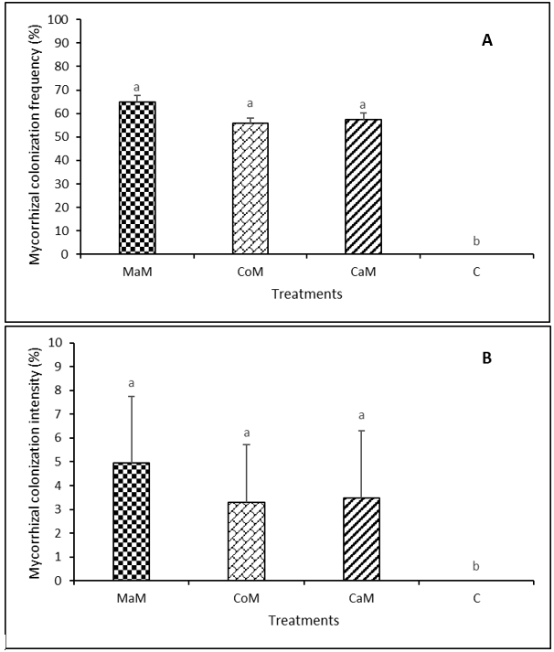
Fig. 1: Mycorrhizal colonization frequency (A). and intensity (B)
Bar graphs following the same letter in each graph are not significantly different at the 5% significance level. MaM: Maize mycorrhizal inoculum; CoM: Commercial mycorrhizal inoculant; CaM: Cassava mycorrhizal inoculum; C: Control with no mycorrhizal inoculum

3.2 Plant height, collar diameter and number of leaves
No significant differences among treatments were observed in the effects of AMF inoculation on plant height, collar diameter, or number of leaves throughout the experimental period (Figure 2). The mean height of plants inoculated with the commercial inoculant CoM increased from 13.71 ± 2.49 cm during the first week of measurements to 36.29 ± 6.76 cm during the final week of measurements (Figure 2A). For plants inoculated with the indigenous inoculants CaM and MaM, mean plant height increased from 13.81 ± 1.73 cm and 13.00 ± 2.49 cm, respectively, during the first week of measurements to 30.63 ± 6.88 cm and 34.13 ± 8.17 cm, respectively, during the final week of measurements (Figure 2A). Non-inoculated plants increased from 13.43 ± 1.59 cm during the first week of measurements to 34.00 ± 5.53 cm during the final week of measurements (Figure 2A).

The collar diameter of plants inoculated with the commercial inoculant CoM increased from 3.67 ± 0.67 mm during the first week of measurements to 5.59 ± 0.61 mm during the final week of measurements (Figure 2B). For plants inoculated with the indigenous inoculants CaM and MaM, collar diameter increased from 3.15 ± 0.36 mm and 3.55 ± 0.28 mm, respectively, during the first week of measurements to 5.43 ± 0.47 mm and 5.73 ± 0.36 mm, respectively, during the final week of measurements (Figure 2B). Non-inoculated plants increased from 3.20 ± 0.37 mm during the first week of measurements to 5.87 ± 0.61 mm during the final week of measurements (Figure 2B).

The number of leaves of plants inoculated with the commercial inoculant CoM increased from 6.00 ± 0.73 during the first week of measurements to 17.00 ± 5.36 during the final week of measurements (Figure 2C). For plants inoculated with the indigenous inoculants CaM and MaM, the mean number of leaves increased from 5.00 ± 0.66 and 5.00 ± 0.60, respectively, during the first week of measurements to 16.00 ± 1.79 and 16.00 ± 2.38, respectively, during the final week of measurements (Figure 2C). Non-inoculated plants increased from 5.00 ± 0.64 during the first week of measurements to 15.00 ± 1.68 during the final week of measurements (Figure 2C).
Overall, mycorrhizal inoculation did not significantly affect plant growth parameters compared with the non-inoculated control throughout the experimental period (Figure 2).

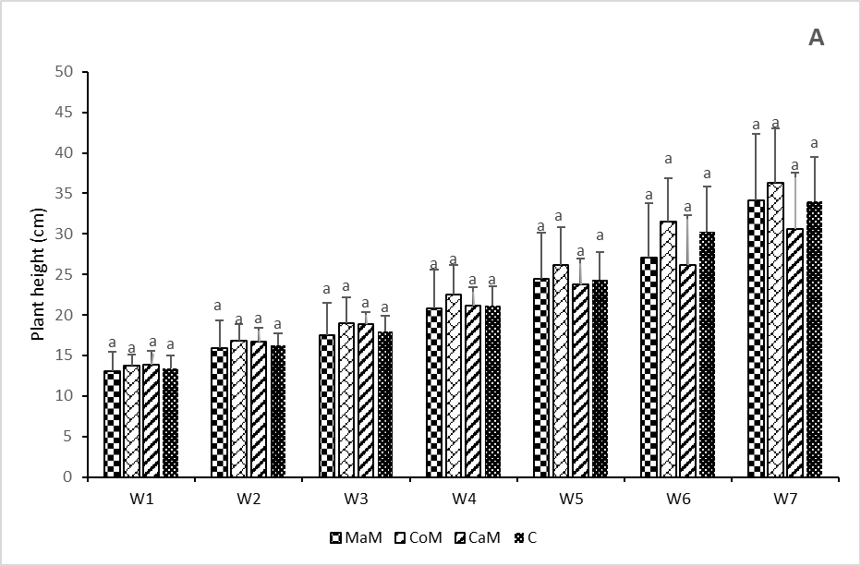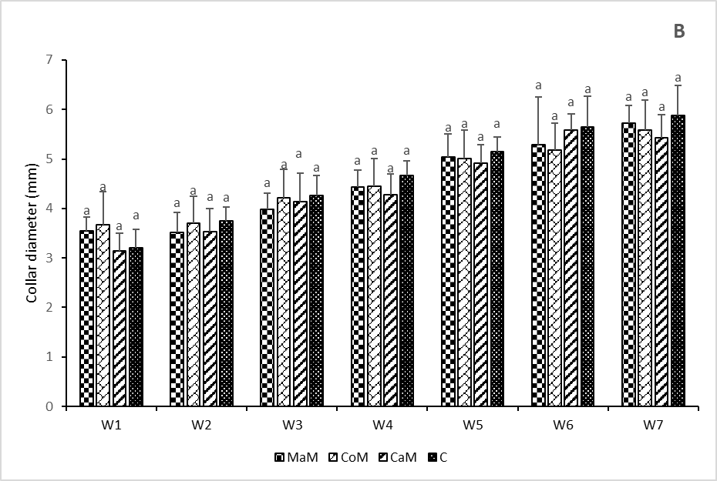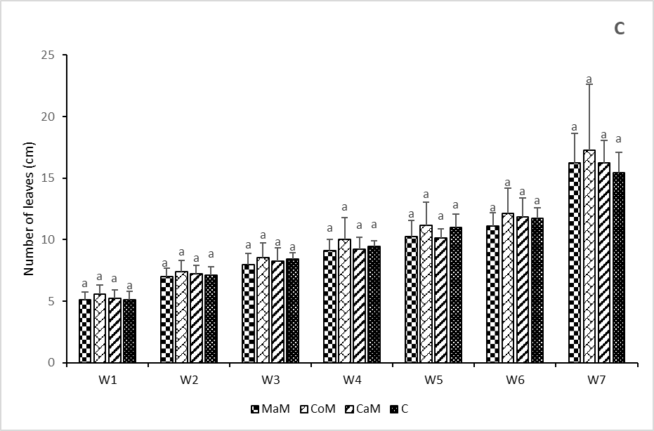
Fig. 2: Plant height, collar diameter and number of leaves from week 1 to week 7
Bar graphs following the same letter in each week are not significantly different at the 5% significance level. MaM: Maize mycorrhizal inoculum; CoM: Commercial mycorrhizal inoculant; CaM: Cassava mycorrhizal inoculum; C: Control with no mycorrhizal inoculum

3.3 Flower bud production and fresh biomass
No significant differences were observed among treatments in the number of flower buds produced by the plants (Figure 3A).
Plants inoculated with the commercial inoculant CoM produced 7 ± 2.50 flower buds. Plants inoculated with the indigenous inoculants CaM and MaM produced 6 ± 2.34 and 7 ± 1.76 flower buds, respectively (Figure 3A), whereas non-inoculated plants produced 8 ± 1.60 flower buds (Figure 3A).
No significant differences were observed among treatments in fresh aboveground and belowground biomass (Figure 3B). The fresh aboveground biomass of plants inoculated with CoM, CaM, and MaM was 22.65 ± 6.89 g, 26.23 ± 6.77 g, and 29.57 ± 3.74 g, respectively (Figure 3B), compared with 23.02 ± 3.38 g for the non-inoculated control plants (Figure 3B). Similarly, the fresh root biomass of plants inoculated with CoM, CaM, and MaM was 5.46 ± 2.48 g, 4.95 ± 1.26 g, and 8.89 ± 1.24 g, respectively, compared with 8.86 ± 1.02 g for the non-inoculated control plants (Figure 3B).

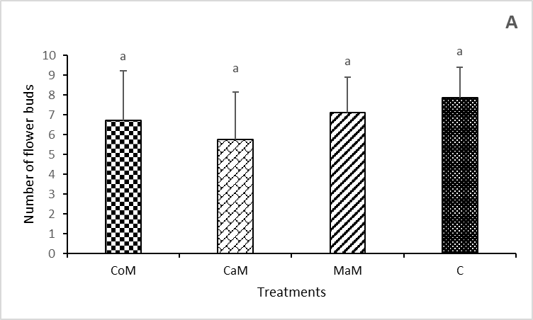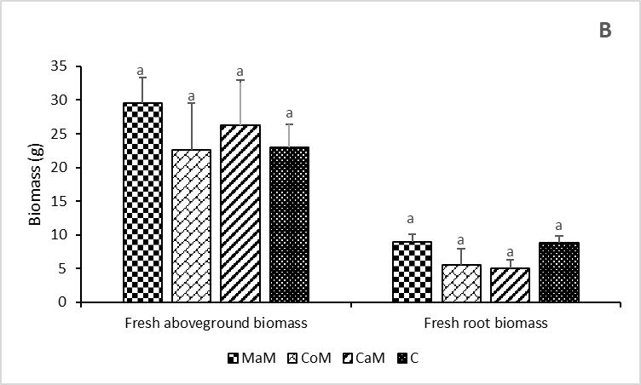
Fig. 3: Flower bud production and fresh biomass
Bar graphs following the same letter in each histogram group are not significantly different at the 5% significance level. MaM: Maize mycorrhizal inoculum; CoM: Commercial mycorrhizal inoculant; CaM: Cassava mycorrhizal inoculum; C: Control with no mycorrhizal inoculum

3.4 Discussion
The assessment of mycorrhizal colonization revealed that the roots of inoculated plants were successfully colonized by AMF. More than 50% of the inoculated plants exhibited mycorrhizal colonization, whereas no colonization was detected in the non-inoculated control. However, colonization intensity remained low (≤10%), and no significant differences were observed among the commercial and indigenous inoculants. These results indicate that all three inoculants were capable of establishing an association with S. aethiopicum under the experimental conditions, but that the extent of intraradical fungal development remained limited.
The difference between relatively high colonization frequency and low colonization intensity suggests that the establishment of the symbiosis did not necessarily translate into extensive fungal development within the root cortex. The effectiveness of AMF inoculation depends not only on the presence of viable propagules, but also on the compatibility between the fungal community and the host plant, the density and infectivity of the inoculum (Basiru & Hijri, 2022)
The duration of the experiment may also have influenced the extent of colonization. Root colonization by AMF is a dynamic process that develops progressively following contact between the host root and fungal propagules (Corona Ramírez et al., 2023). The 40-day assessment therefore provided a snapshot of the colonization process rather than a measure of its maximum potential. Nevertheless, the relatively short experimental period should not be considered the only explanation for the low colonization intensity, since the development of AMF colonization is also strongly influenced by plant–fungus compatibility and environmental conditions. Further experiments involving earlier and later assessments of root colonization would therefore be useful to determine whether the low intensity observed in the present study reflected delayed colonization or intrinsically limited fungal development.
The absence of significant differences in colonization intensity among the three inoculants is also noteworthy. Although indigenous AMF are frequently considered potentially better adapted to local soil and climatic conditions than non-local fungal material (Berruti et al., 2016b), such adaptation does not necessarily result in greater root colonization or plant growth under all experimental conditions. In the present study, the indigenous inoculants performed similarly to the commercial inoculant with respect to both colonization frequency and intensity. This suggests that the indigenous inocula contained AMF capable of recognizing and colonizing S. aethiopicum roots, but the experiment did not demonstrate a superior colonization capacity of indigenous inoculants under the conditions tested.
The lack of significant effects of AMF inoculation on plant growth should therefore be interpreted in light of the limited extent of root colonization. No significant differences were observed among treatments for plant height, collar diameter, number of leaves, flower-bud production, or fresh aboveground and belowground biomass. A similar absence of growth stimulation has been reported in some AMF inoculation experiments, particularly when root colonization remains limited (Plenchette et al., 2000). The establishment of mycorrhizal structures alone does not necessarily result in a measurable growth response, as the magnitude of the plant benefit depends on the functional contribution of the fungal symbiosis under the prevailing environmental conditions.
The controlled conditions of the present experiment may also have reduced the potential benefits of mycorrhization. Plants were maintained under greenhouse conditions and regularly irrigated, thereby reducing water limitation and other environmental stresses that can enhance the relative contribution of AMF to plant nutrient and water acquisition. Previous studies have shown that the benefits of AMF can become more pronounced under conditions of drought or other abiotic stresses (Chandrasekaran, 2022). The absence of a growth response in the present experiment should not be interpreted as evidence that the inoculants are agronomically ineffective, but rather as an indication that their potential benefits were not expressed under the specific experimental conditions used.
Finally, the relatively small root-zone volume may have imposed an additional constraint on plant development and potentially on the expression of the mycorrhizal symbiosis. Eggplant is sensitive to root-zone volume (Djidji & Fondio, 2013), and previous work has shown that root restriction can reduce several growth parameters (Kurunç & Ünlükara, 2009). The 3-L pots used in the present study provided a considerably smaller rooting volume than the containers used in some previous experiments with African eggplant, such as the 47-cm-long and 50-cm-diameter containers reported by Bolou-Bi et al., (2023). Under such conditions, root development may have been restricted before the plants reached their full productive potential, potentially limiting both the development of the fungal symbiosis and its contribution to plant growth.

4. Conclusion

This study evaluated, under controlled greenhouse conditions in Daloa, Côte d’Ivoire, the ability of one commercial and two indigenous AMF inoculants originating from cassava- and maize-associated rhizospheres to colonize the roots of Solanum aethiopicum and enhance plant growth. The results showed that all three inoculants established mycorrhizal associations with eggplant, with colonization frequencies exceeding 50% in inoculated plants, whereas no mycorrhizal colonization was detected in the non-inoculated control. However, colonization intensity remained low, and no significant differences were observed among the commercial and indigenous inoculants.Despite the establishment of mycorrhizal associations, AMF inoculation did not significantly improve plant growth or biomass production, as no significant treatment effects were detected for plant height, collar diameter, number of leaves, flower-bud production, or fresh aboveground and belowground biomass. The absence of a measurable agronomic response may have been related, at least partly, to the low intensity of root colonization. The relatively short experimental period, regular irrigation under greenhouse conditions, and restricted root-zone volume may also have limited the development and functional expression of the mycorrhizal symbiosis.Overall, the results indicate that the indigenous inoculants evaluated in this study were capable of colonizing S. aethiopicum roots at levels comparable to those achieved with the commercial inoculant. However, their agronomic potential cannot be established on the basis of root colonization under the conditions tested. The findings therefore highlight the importance of considering both the establishment of mycorrhizal symbiosis and its functional expression in the host plant when evaluating AMF inoculants.
Competing interests

Authors have declared that no competing interests exist.

Declaration of AI Use

This manuscript was prepared through the intellectual contributions of the author(s) to the study design, data analysis, interpretation of results, and scholarly content. Grammarly and ChatGPT were used solely to assist with grammatical refinement and reference formatting during manuscript revision. The author(s) accept full responsibility for the accuracy, integrity, and final content of the manuscript.

References

Basiru, S., & Hijri, M. (2022). The Potential Applications of Commercial Arbuscular Mycorrhizal Fungal Inoculants and Their Ecological Consequences. Microorganisms, 10(10), 1897. https://doi.org/10.3390/microorganisms10101897
Berruti, A., Lumini, E., Balestrini, R., & Bianciotto, V. (2016a). Arbuscular Mycorrhizal Fungi as Natural Biofertilizers : Let’s Benefit from Past Successes. Frontiers in Microbiology, 6. https://doi.org/10.3389/fmicb.2015.01559
Bolou-Bi, E. B., Chérif, M., Gnimassoun, E.-G. K., & Adjalla, L. A. (2023). Effect of vermicompost associated with mycorhizal fungi on the growth of eggplant in organic greenhouse agriculture. Tropical and Subtropical Agroecosystems, 26(1). https://doi.org/10.56369/tsaes.4180
Chandrasekaran, M. (2022). Arbuscular Mycorrhizal Fungi Mediated Enhanced Biomass, Root Morphological Traits and Nutrient Uptake under Drought Stress : A Meta-Analysis. Journal of Fungi, 8(7), 660. https://doi.org/10.3390/jof8070660
Choi, S. M., & Choi, C.-I. (2024). Nutritional Composition, Phytochemical Profiles, and Pharmacological Effects of Ethiopian Eggplant (Solanum aethiopicum L.). Nutrients, 16(23), 4228. https://doi.org/10.3390/nu16234228
Corona Ramírez, A., Symanczik, S., Gallusser, T., & Bodenhausen, N. (2023). Quantification of arbuscular mycorrhizal fungi root colonization in wheat, tomato, and leek using absolute qPCR. Mycorrhiza, 33(5‑6), 387‑397. https://doi.org/10.1007/s00572-023-01122-8
Djidji, A. H., & Fondio, L. (2013). Bien cultiver l’aubergine en Côte d’Ivoire [Fiche technique]. Direction de la recherche scientifique et de l’appui au développement-Direction des innovations et des systèmes d’information-Centre National de Recherche Agronomique.
Kasharu, A. k, Kizito, E. B., Masanza, M., Jjagwe, J., & Namutebi, A. (2019). Quantifying Physical and Economic Losses of African Indigenous Vegetable Solanum aethiopicum Along the Commercial Supply Value Chain. Journal of Economics and Sustainable Development, 10(2), 67.
Kouadio, A. N. M.-S., Nandjui, J., Krou, S. M., Séry, D. J.-M., Nelson, P. N., & Zézé, A. (2017). A native arbuscular mycorrhizal fungus inoculant outcompetes an exotic commercial species under two contrasting yam field conditions. Rhizosphere, 4, 112‑118. https://doi.org/10.1016/j.rhisph.2017.10.001
Kurunç, A., & Ünlükara, A. (2009). Growth, yield, and water use of okra (Abelmoschus esculentus) and eggplant (Solanum melongena) as influenced by rooting volume. New Zealand Journal of Crop and Horticultural Science, 37(3), 201‑210. https://doi.org/10.1080/01140670909510265
Mvungi, H.-H. A., Wanyama, R., Dinssa, F. F., Ngoteya, G., Sigalla, J., Minja, R., Bishop, G., & Schreinemachers, P. (2025). Production of African eggplant in Tanzania : Varieties, practices, profitability, and constraints. Frontiers in Sustainable Food Systems, 9. https://doi.org/10.3389/fsufs.2025.1461851
Nie, W., He, Q., Guo, H., Zhang, W., Ma, L., Li, J., & Wen, D. (2024). Arbuscular Mycorrhizal Fungi : Boosting Crop Resilience to Environmental Stresses. Microorganisms, 12(12), 2448. https://doi.org/10.3390/microorganisms12122448
Plenchette, C., Bois, J.-F., Duponnois, R., & Cadet, P. (2000). La mycorhization (Glomus aggregatum) du mil (Pennisetum glaucum). Étude et Gestion des Sols.
Séry, D. J.-M., Kouadjo, Z. G. C., Voko, B. R. R., & Zézé, A. (2016). Selecting Native Arbuscular Mycorrhizal Fungi to Promote Cassava Growth and Increase Yield under Field Conditions. Frontiers in Microbiology, 7. https://doi.org/10.3389/fmicb.2016.02063
Vosátka, M., Látr, A., Gianinazzi, S., & Albrechtová, J. (2012). Development of arbuscular mycorrhizal biotechnology and industry : Current achievements and bottlenecks. Symbiosis, 58(1), 29‑37. https://doi.org/10.1007/s13199-012-0208-9
Wu, Y., Chen, C., & Wang, G. (2024). Inoculation with arbuscular mycorrhizal fungi improves plant biomass and nitrogen and phosphorus nutrients : A meta-analysis. BMC Plant Biology, 24(1), 960. https://doi.org/10.1186/s12870-024-05638-9
Zhang, J., Zhao, R., Li, X., & Zhang, J. (2024). Potential of arbuscular mycorrhizal fungi for soil health : A review. Pedosphere, 34(2), 279‑288. https://doi.org/10.1016/j.pedsph.2024.02.002

