Original Research Article

Formulation and Evaluation of Mucoadhesive Buccal Patch of Clomipramine Hydrochloride for Enhanced Buccal Drug Delivery

ABSTRACT
Aims: To formulate and evaluate a mucoadhesive buccal patch of Clomipramine HCl to enhance buccal absorption, bypass hepatic first-pass metabolism, improve bioavailability, and provide sustained drug release.
Study design: Experimental laboratory-based formulation design and in-vitro characterization study.
Place and Duration of Study: Department of Pharmaceutics, Adhiparasakthi College of Pharmacy, Melmaruvathur, 2024-2026.
Methodology: Buccal patches of Clomipramine HCl were prepared by solvent casting method using varying concentrations/ratios of HPMC E15 and Carbopol 940 (Formulations F1–F6). Glycerin was used as plasticizer. The formulated patches were evaluated for physical appearance, weight uniformity, thickness, folding endurance, surface pH, drug content uniformity, swelling index, flatness, moisture absorption/loss studies, in-vitro drug release using USP dissolution apparatus II (phosphate buffer pH 6.8), release kinetics, SEM analysis, and 30-day stability studies according to ICH guidelines.
Results: Among six formulations (F1–F6), Formulation F3 (750 mg HPMC E15 and 250 mg Carbopol 940) was selected as optimal. F3 exhibited a thickness of 0.14 mm, surface pH of 6.52, folding endurance >300, drug content of 98.26%, and swelling index of 537.13%. It
achieved 82.52% cumulative drug release over 6 hours. Drug release kinetics best fitted the Higuchi model (R² = 0.9894). Stability testing after 30 days at room temperature confirmed physical stability and drug retention (97.52%).
Conclusion: The mucoadhesive buccal patch F3 formulated with HPMC E15 and Carbopol 940 demonstrated acceptable physicochemical properties and sustained buccal delivery of Clomipramine HCl.
Keywords: Clomipramine HCl; buccal patch; mucoadhesion; HPMC E15; Carbopol 940; sustained release; Higuchi model.
1. INTRODUCTION
Buccal drug delivery offers a convenient alternative to oral administration, potentially reducing gastrointestinal degradation and hepatic first-pass metabolism. The buccal mucosa is well vascularized, allowing drug absorption into systemic circulation. Mucoadhesive polymers help retain a formulation at the absorption site, supporting sustained release and improved bioavailability.
Among buccal dosage forms, patches are flexible and provide a measured dose with greater residence time than gels, which may be washed away by saliva. They commonly contain a drug-loaded mucoadhesive layer and may include a backing layer to control drug release.
Clomipramine hydrochloride is a tricyclic antidepressant used to treat obsessive-compulsive disorder, panic disorder, major depressive disorder, and chronic pain. It is also used to treat premature ejaculation. These features make mucoadhesive buccal patches a promising approach for localized or systemic drug delivery.
2. MATERIALS AND METHODS
2.1 Procurement of Drug and Excipient
Clomipramine HCl (provided by Shubham Pharmachem Pvt. Ltd, Mumbai), HPMC E15, Carbopol 940 (Jain Industrial Chemicals, Chennai), Tween 80 (Ocean Chemicals Pvt. Ltd), Ethanol, Glycerin, Sucrose, Vanillin (Chemical Laboratories).
2.2 Characterization of Drug
2.2.1 Organoleptic Properties
The color, odor, appearance, and taste of the drug were recorded using descriptive terminology.
2.2.2 Solubility Study
The solubility characteristics of a drug in an aqueous system are important, as a certain degree of water solubility is required to elicit a therapeutic response. The solubility of drug was recorded by using various descriptive terminology.
2.2.3 Determination of Melting point
A small amount of drug was loaded in capillary tube where one end of capillary tube was closed and kept in the melting point apparatus and the temperature was noted when the drug melted.
2.2.4 Drug-Excipient Compatibility Study
The drug and excipients selected for the formulation were evaluated for Physical and Chemical compatibility studies.
2.2.4.1 Chemical Compatibility Study
FTIR spectrophotometric analysis was performed to investigate the compatibility between the drug and excipients. The Bruker attenuated total reflection alpha technique was used for the analysis. The spectra of the pure drug, the physical mixture of the optimized blank, and CLOMOPT were recorded at a temperature of 25.0 ± 0.5 °C by placing the samples on a zinc solenoid crystal plate over the wavenumber 4000 to 400 cm⁻¹ and compare with the reference Pharmacopoeia.
2.2.5 Determination of λ max
10 mg of Clomipramine HCl was weighed and transferred to 10 ml of volumetric flask. The drug was dissolved and volume was made up to 10 ml using phosphate buffer pH 6.8 to obtain a stock solution of 1000 µg/ml (Stock solution I). 1 ml of this stock solution was again diluted with phosphate buffer pH6.8 up to 10 ml to obtain a solution of 100 µg/ml (Stock solution II). From stock solution II, 1ml was pipette out in a 10 ml volumetric flask. The volume was made up to 10 ml using phosphate buffer pH 6.8 to get a concentration of 10 µg/ml. This solution was then scanned at 254 nm in UV- Visible spectrophotometer to attain the absorption maximum (λ max).

2.2.6 Standard Curve for Clomipramine HCl
2.2.6.1 Preparation of Phosphate buffer pH 6.8
The phosphate buffer pH6.8 was prepared by dissolving 28.80 g of disodium hydrogen phosphate and 11.45 g of potassium dihydrogen phosphate in sufficient water. The solution was mixed well, and the final volume was made up to 1000 ml with distilled water.
2.2.6.2 Preparation of Stock solution
10 mg of Clomipramine HCl was weighed and transferred into a 100 ml volumetric flask. The drug was dissolved in phosphate buffer pH 6.8 and the volume was made up to 100ml using phosphate buffer pH 6.8 to obtain a stock solution of 100 µg/ml (Stock solution). From a stock solution 5, 10, 15, 20, 25 ml were transferred to a series of 100 ml volumetric flasks. The volume was made up with phosphate buffer pH 6.8. The absorbance of these solutions was measured at 254 nm against blank.
2.3 Formulation of Mucoadhesive Buccal Patch of Clomipramine HCl
Mucoadhesive Buccal Patch of Clomipramine HCl were prepared by Solvent casting method.
2.3.1 Preparation Process
By the solvent casting method, patches were prepared using HPMC E15 and Carbopol 940 in different concentrations. Glycerol acts as a plasticizer. Carbopol 940 (250 mg) was dispersed in water under stirring at 300 rpm for 10 minutes and was hydrated for 2 hours. HPMC E15 (750 mg) was dissolved in a 2:1 water–ethanol mixture, stirring at 400 rpm for 20 minutes and kept aside for 30 minutes. The hydrated Carbopol was incorporated into the HPMC solution and stirred at 400 rpm for 20 minutes, followed by resting for 30 minutes. Clomipramine hydrochloride (15 mg) was dissolved in 1 mL of water and was added to the polymer blend while stirring at 300 rpm for 15 minutes. Glycerin (0.20 g) and Tween 80 (0.15 g) were added separately under stirring. Sucrose (0.05 g) and vanillin (0.05 g) were dissolved in 2 ml of water and were incorporated into the mixture. The final solution was allowed to rest for 60 minutes to remove air bubbles. The solution was poured into Petri dishes and dried at room temperature for 3 days. The dried films were cut into 2 × 2 cm patches and were stored in airtight zip-lock covers.

Table 1: Formulation of Mucoadhesive Buccal Patch of Clomipramine HCl
Formulation | F1 | F2 | F3 | F4 | F5 | F6
Clomipramine HCl (mg) | 15 | 15 | 15 | 15 | 15 | 15
HPMC E15 (mg) | 1000 | 500 | 750 | 850 | 670 | 950
Carbopol 940 (mg) | - | 500 | 250 | 150 | 330 | 50
Glycerin (g) | 0.20 | 0.20 | 0.20 | 0.20 | 0.20 | 0.20
Ethanol (ml) | 5 | 5 | 5 | 5 | 5 | 5
Tween 80 (g) | 0.15 | 0.15 | 0.15 | 0.15 | 0.15 | 0.15
Distilled water (ml) | q. s | q. s | q. s | q. s | q. s | q. s
Sucrose (g) | 0.05 | 0.05 | 0.05 | 0.05 | 0.05 | 0.05
Vanillin (g) | 0.05 | 0.05 | 0.05 | 0.05 | 0.05 | 0.05

2.4 Characterization of Mucoadhesive Buccal Patch of Clomipramine HCl
2.4.1 Physical Appearance
All the formulated Clomipramine HCl patches were observed for surface texture, color, flexibility and smoothness.
2.4.2 Weight Uniformity
Individual patches were taken, patch size 2×2 cm² were cut and weighed using weighing balance and the average weight variation was calculated.
2.4.3 Thickness
The thickness of the patches was measured by screw gauge with least count 0.002 mm.
2.4.4 Folding Endurance
The folding endurance of the patches was determined by repeatedly folding one patch at the same place till it broke or folded up to 300 times, which is considered satisfactory to reveal good film properties.
2.4.5 Surface pH
In this test, patch was allowed in contact with 5 ml of distilled water for 60 min at room
temp. and then the pH measured by using pH meter, this done in triplicate and the mean value.
2.4.6 Drug Content Uniformity
Drug content uniformity was determined by dissolving the patch (dimension 2 x 2 cm) by
homogenization in 50 ml of an isotonic phosphate buffer pH 6.8 for 2 hours with occasional shaking. Aliquot 4 ml was withdrawn and diluted with phosphate buffer pH 6.8 up to 10 ml and the resulting solution was filtered through Whatman filter paper. The drug content was then determined by using UV spectrophotometer at 254 nm.
2.4.7 Swelling Index
A patch of 2x2 cm² size was weighed on a pre-weighed microscope slide. A 50 ml phosphate buffer pH 6.8 was added to a petridish containing the patch over the microscope slide. At regular time intervals for 60 min, the microscope slide was removed and weighed. The difference in weights gives the weight increase due to absorption of buffer and swelling of patch is calculated by the following equation:
Swelling Index = (W2-W1/ W1) x 100%
Where, W1 is the weight of buccal patch before dipping into phosphate buffer pH 6.8 and W2 is the weight of buccal patch after dipping in phosphate buffer pH 6.8 and wiped with filter paper.
2.4.8 Flatness
To determine the flatness of a patch, a strip was cut from the centre and two from each side of patch. The length of each strip was measured and variation in length was noted. This data was used to determine percent constriction and results were shown in the form of % flatness. 0 % constriction indicates 100 % flatness. It is calculated from following formula:
% constriction = L1- L2/ L1 × 100
Where, L1= Initial length of strip (cm) and L2= Final length of strip (cm)
2.4.9 Moisture Absorption Studies
Patches were selected from each batch and weighed accurately (W1 mg). These patches were kept in dessicator at room temperature for 24 hours. Then patches were taken out and exposed to 84% relative humidity using a saturate solution of Potassium chloride in another dessicator. Exposure was continued until a constant weight (W2 mg) was obtained. The percent moisture uptake was calculated using following formula: % Moisture uptake = (W2- W1)/ W2 × 100
2.4.10 Moisture Loss Studies
For this test, one patch from each batch was selected and weighed accurately (W1 mg). These weighed patches were kept in a desiccator containing Calcium chloride at room temperature for 24 hours. After the specified interval, patches were weighed again until a constant weight was obtained (W2 mg). The percent moisture content was calculated using following formula:
% Moisture content = (W1- W2)/ W1 × 100
2.4.11 In- Vitro Drug Release
Drug release from buccal patches was studied using USP dissolution apparatus type II, maintained at 37 ± 0.5 °C and stirred at 50 rpm. Each 2 × 2 cm² patch was fixed on a cover slip with cyanoacrylate adhesive. The mucoadhesive layer was kept in contact with the dissolution medium, while the backing layer was fixed to the slip. The cover slip was immersed in 500 ml phosphate buffer pH 6.8 to prevent floating and settle the patch. Aliquots of 5 ml were withdrawn at 15, 30, 60, 120, 180, 240, 300, and 360 min. Equal volumes of fresh buffer at the same temperature were replaced to maintain sink conditions. Drug concentration was analyzed by UV-visible spectrophotometer at λ max (254 nm).
2.4.12 Release Kinetic Study
To analyse the drug release method of each formulation, all the batches dissolution profile were fitted to Zero-order kinetics, First-order kinetics, Higuchi Model, Hixon Crowell, Korsmeyer-Peppas Models.
2.4.13 Scanning Electron Microscopy (SEM)
Patch morphology was analyzed using SEM. The selected sample was mounted on brass stubs with double-sided adhesive and sputter-coated for 30 s with gold-palladium under argon. The coated stub was then placed in the SEM chamber for examination.
2.4.14 Stability Studies
Stability testing was performed as per ICH guidelines to evaluate drug and formulation stability under environmental factors. The buccal patches were wrapped in aluminum foil and stored at room temperature for one month. After storage, they were examined for appearance, thickness, and drug content.
3. RESULTS AND DISCUSSION
3.1 Characterization of Drug
3.1.1 Organoleptic Properties
Clomipramine HCl was observed to be a white crystalline powder, odorless and solid powder.
The organoleptic observation provides a preliminary identity and quality check, but it is not sufficiently specific to establish drug identity. Accordingly, the visual finding is best interpreted together with instrumental characterization and validated analytical procedures reported for clomipramine (Ghumman et al., 2023; Rahman & Afaq, 2010; Ali et al., 2016).
3.1.2 Determination of Melting Point
The observed melting point of Clomipramine HCl was 192 ºC, which is in agreement with the standard value of 192 - 196 ºC.

The measured melting point near 192 °C is supportive of a crystalline clomipramine hydrochloride sample; nevertheless, thermal behavior can vary with solid-state form and experimental conditions. Thus, melting-point agreement should be considered complementary to spectroscopic and thermal characterization rather than a stand-alone identity test (Ghumman et al., 2023; Patel & Karvekar, 2019; Rahman & Afaq, 2010).
3.1.3 Solubility Studies
Clomipramine HCl was freely soluble in distilled water, ethanol, methanol, chloroform, 0.1N HCl and soluble in acetone.
The broad solubility observed across aqueous and organic media is consistent with the amphiphilic solution behavior of clomipramine hydrochloride. Because ionization, pH, and medium composition can alter apparent solubility and molecular association, these qualitative findings should be interpreted as medium-specific rather than as an intrinsic solubility constant (Naqvi et al., 2010; Rahman & Afaq, 2010; Ali et al., 2016).
3.1.4 Drug-Excipient Compatibility Study
3.1.4.1 Chemical Compatibility Study
A)
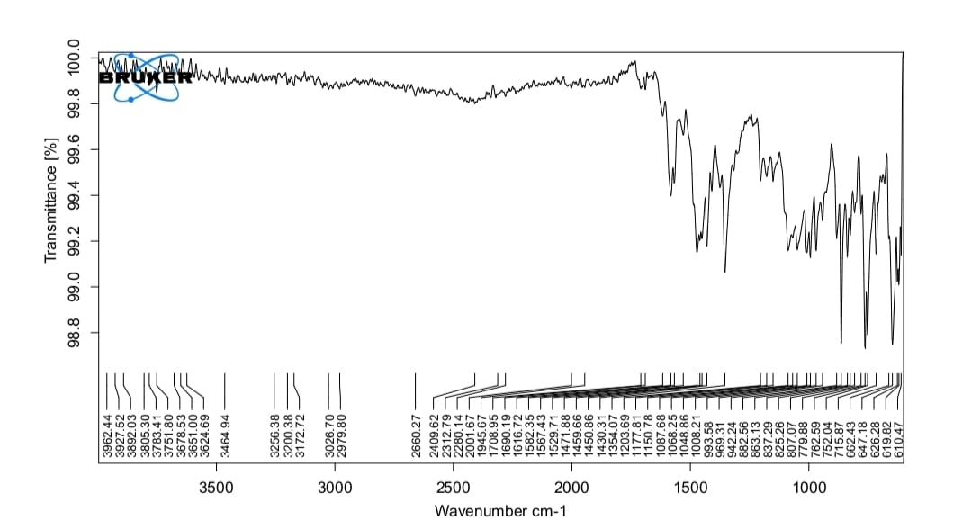
B)
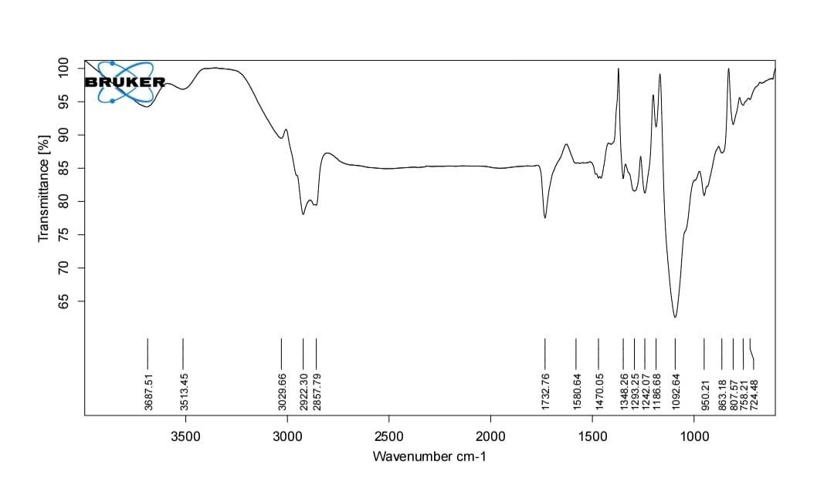
Fig. 1: A) FT-IR Spectrum of Clomipramine HCl and B) Clomipramine HCl, Tween 80, HPMC E15, Carbopol 940

Table 2: FT-IR spectral interpretation of Clomipramine HCl and Clomipramine HCl,
S. No. | Wave Number (cm⁻¹) | Types of Vibrations
1. | 1580.64 - 1582.86 | C=C Stretching
2. | 950.21 - 1087.68 | C-Cl Stretching
3. | 1203.69 - 2922.30 | C-N Stretching
4. | 2857.79 - 2979.80 | C-H Stretching
5. | 1092.64 - 2660.27 | N-H Stretching
Tween 80, HPMC E15, Carbopol 940

Retention of the principal drug-related FTIR bands in the multicomponent spectrum, without conspicuous new bands or major shifts, supports the absence of a detectable strong chemical interaction under the tested conditions. Similar use of FTIR as a compatibility screen has been reported in clomipramine and buccal-film formulations, although complementary thermal or solid-state methods are useful when subtle interactions are suspected (Ghumman et al., 2023; Salehi & Boddohi, 2017; Nair et al., 2021).
3.1.5 Determination of λmax for Clomipramine HCl by using Uv Spectroscopy
A)
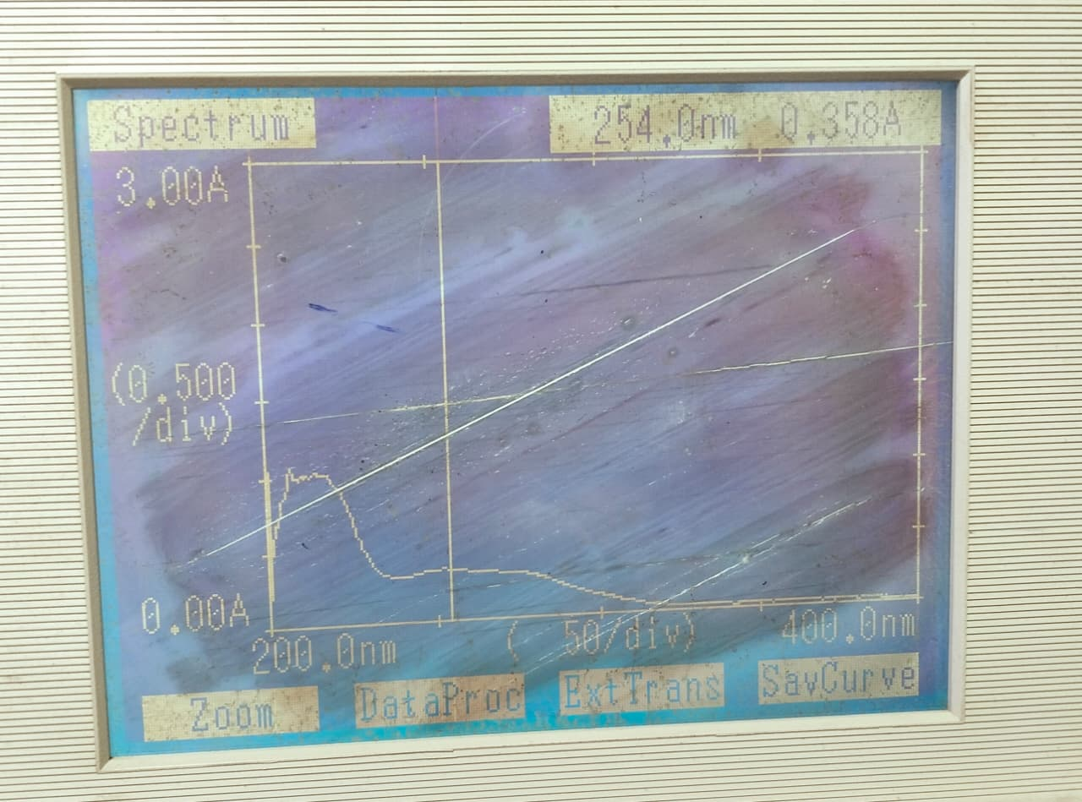
B)
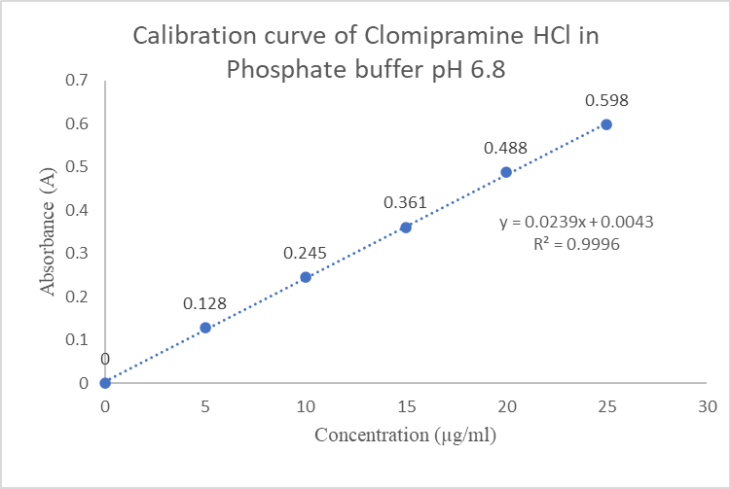
Fig. 2: A) UV Spectrum and B) Calibration curve of Clomipramine HCl using Phosphate Buffer pH 6.8

Use of 254 nm for clomipramine quantification has precedent in ultraviolet-detection methods, although the optimal analytical wavelength depends on solvent, matrix, and assay configuration. The recorded spectrum therefore provides method-specific justification for using 254 nm in the present phosphate-buffer assay (Aymard et al., 1997; Tanaka et al., 1997; Palego et al., 2000).
3.1.6 Standard Calibration Curve of Clomipramine HCl using Phosphate Buffer pH 6.8
The absorbance of the drug in of concentration ranging from 5-25 µg/ml was measured at a wavelength of 254 nm against blank.
Table 3: Data for Calibration curve of Clomipramine HCl using Phosphate Buffer pH 6.8
S. No | Concentration (µg/ml) | Absorbance (A)
1. | 0 | 0
2. | 5 | 0.128
3. | 10 | 0.245
4. | 15 | 0.361
5. | 20 | 0.488
6. | 25 | 0.598

Inference
It was found that the solutions show linearity (R2 = 0.9996) at a concentration of 5-25 µg/ml and obeys Beer Lambert’s law.
The high coefficient of determination (R² = 0.9996) indicates a strong linear concentration-response relationship over the tested 5–25 µg/mL range. Such linearity is an important prerequisite for quantitative drug-content and release measurements, although complete analytical validation also requires consideration of accuracy, precision, selectivity, and sensitivity (Rahman & Afaq, 2010; Ali et al., 2016; Michael et al., 2023).
3.2 Characterization of Mucoadhesive Buccal Patch of Clomipramine HCl
3.2.1 Physical Appearance
These parameters were checked simply with visual inspection of patches and by feel or touch.
A smooth and flexible appearance is desirable for buccal patches because visible defects can reflect nonuniform casting or poor polymer-plasticizer balance and may affect handling during application. Comparable visual and tactile criteria are routinely used during evaluation of solvent-cast mucoadhesive patches (Anu et al., 2020; Barde et al., 2022; Umarani et al., 2024).
3.2.2 Weight Uniformity
The individual weights of three different patches from each batch were weighed using digital balance and the average weight was calculated.
The limited variation in patch weight is relevant because mass uniformity indirectly reflects reproducibility of casting and can influence dose uniformity when the drug is dispersed throughout the polymeric matrix. Weight uniformity is therefore commonly evaluated together with thickness and drug-content uniformity in buccal patch development (Anil & Sudheer, 2018; Ikram et al., 2015; Shivane & Solanki, 2017).
3.2.3 Thickness
The thickness of the patch was measured using vernier caliper with least count 0.002 mm. The thickness ranged from 0.14 to 0.2 was shown in table 4.
The observed thickness range is consistent with the thin-film character expected for buccal dosage forms and should be considered together with mechanical flexibility and drug loading. Polymer amount and composition can alter film thickness and, consequently, hydration and release behavior, so the relatively narrow range supports acceptable manufacturing consistency among the batches (Habib et al., 2010; Gite et al., 2013; Dandge & Mundhe, 2024).
3.2.4 Folding Endurance
The folding endurance of the buccal patch from each batch was measured manually and it did not show any cracks even after folding at one place for more than 300 times.
Folding endurance above 300 indicates that the patches tolerated repeated mechanical deformation without visible cracking, which is favorable for handling and the dynamic environment of the oral cavity. Similar folding-endurance testing is widely used as a practical indicator of film flexibility and integrity in mucoadhesive buccal systems (Hussain et al., 2015; Zile et al., 2017; Pasi et al., 2021).
3.2.5 Surface pH
The surface pH of the buccal patch was determined to optimize both drug permeation and
mucoadhesion. The pH values of all the formulation were within the range of salivary pH.

Surface pH values close to the physiological salivary range are desirable because pronounced acidity or alkalinity may increase the risk of local irritation and can also influence polymer hydration and mucoadhesion. The observed values therefore support the suitability of the formulations for further buccal evaluation, while direct mucosal-tolerance studies would still be required for confirmation (Yousif & Maraie, 2015; Khatik et al., 2025; Chemate et al., 2016).
3.2.6 Drug Content Uniformity
The UV-visible spectrophotometric method was used to determine the drug content of Mucoadhesive buccal patch. The drug content of all the formulation ranged from 89 to 98 % was shown in table 4.
Table 4: Physical Parameters of Mucoadhesive Buccal Patch
Formulation Code | Weight Uniformiy (g) | Thickness (mm) | Folding Endurance | Surface pH | % Drug Content
F1 | 0.0396 | 0.16 | >300 | 6.75 | 89.14
F2 | 0.0403 | 0.18 | >300 | 6.28 | 92.10
F3 | 0.0513 | 0.18 | >300 | 6.52 | 98.26
F4 | 0.05 | 0.14 | >300 | 6.67 | 96.54
F5 | 0.0553 | 0.2 | >300 | 6.56 | 95.06
F6 | 0.0486 | 0.16 | >300 | 6.43 | 93.83

The drug-content range indicates formulation-dependent differences in recovery, with F3 showing the highest measured content. High and reproducible content uniformity is important in matrix-type buccal films because variability may translate directly into dose variability and can confound comparison of release profiles among formulations (Viswanad et al., 2018; Kumar et al., 2011; Salehi & Boddohi, 2017).
3.2.7 Flatness
Flatness is an important parameter for mucoadhesive buccal patches, as the patch should possess a smooth, uniform surface and retain its original dimensions without significant constriction over time. The flatness study was performed to evaluate whether the prepared patches met these requirements. All formulations exhibited identical strip length before and after cutting, confirming complete flatness (100%) with no constriction (0%).
Complete flatness with no measurable constriction indicates good dimensional stability after film formation. Dimensional stability is relevant because curling or contraction can reduce effective mucosal contact area and complicate reproducible application, whereas controlled film structure and mechanical integrity support consistent buccal performance (Morales & McConville, 2011; Nair et al., 2021; Salehi & Boddohi, 2017).
3.2.8 Swelling Index
The swelling index of each patch was determined by measuring its increased weight after a predetermined time. F3 showed optimal hydration and adhesion, with a swelling index of 537.13%, due to its balanced HPMC E15–Carbopol 940 ratio.
The substantial swelling observed for all formulations confirms rapid hydration of the hydrophilic polymer matrices. Hydration is required to mobilize polymer chains and expose functional groups involved in mucoadhesion, but excessive swelling may weaken matrix integrity; therefore, the intermediate swelling of F3 can reasonably be viewed as a balance between hydration and structural retention rather than simply as the maximum swelling response (Smart, 2005; Andrews et al., 2009; Muzib & Kumari, 2011).
3.2.9 Moisture Absorption Studies
Moisture absorption increased patch weight, with Carbopol 940–rich formulations showing
greater uptake due to its hygroscopic nature. Patches containing more HPMC E15 showed lower weight gain and maintained better structural stability.
The higher moisture uptake in Carbopol-rich films is consistent with the strong hydrophilicity of carbomer-containing matrices, whereas lower uptake may favor dimensional and mechanical stability during storage. Moisture sorption should nevertheless be controlled because excessive water uptake can soften films and alter drug release, while very low moisture can promote brittleness (Adhikari et al., 2010; Ikram et al., 2015; Vasantha et al., 2011).
3.2.10 Moisture Loss Studies
The moisture loss study showed a decrease in patch weight, with HPMC E15–rich formulations losing more weight due to lower hygroscopicity. Carbopol 940–based patches retained more moisture and therefore showed comparatively less weight loss.
Table 5: Characterization of Mucoadhesive Buccal Patch
Formulation Code | Swelling Index (%) | % Moisture Uptake | % Moisture Loss
F1 | 464.89 | 9.17 | 9.95
F2 | 627.75 | 11.62 | 10.84
F3 | 537. 13 | 11.39 | 10.48
F4 | 544.07 | 11.34 | 10.31
F5 | 579.99 | 11.52 | 10.66
F6 | 458.36 | 9.15 | 10.20

The moisture-loss values indicate that all formulations retained a measurable fraction of bound or absorbed water under desiccating conditions. This balance is important because residual moisture can contribute to flexibility, whereas excessive drying may increase brittleness and excessive retained moisture may compromise physical stability (Adhikari et al., 2010; Ikram et al., 2015; Vasantha et al., 2011).
3.2.11 In-Vitro Drug Release
Table 6: Cumulative % drug release
Time (Hrs) | Cumulative % Drug Release
Time (Hrs) | F1 | F2 | F3 | F4 | F5 | F6
0 | 0 | 0 | 0 | 0 | 0 | 0
0.25 | 19.9 | 20.32 | 21.43 | 21.01 | 20.46 | 20.73
0.50 | 26.03 | 25.34 | 27.15 | 25.76 | 25.89 | 26.17
1 | 28.96 | 28.27 | 29.38 | 29.24 | 28.41 | 29.80
2 | 32.59 | 34.82 | 45.14 | 38.86 | 37.47 | 38.17
3 | 44.03 | 44.72 | 54.48 | 45.42 | 44.72 | 44.30
4 | 52.25 | 52.67 | 63.97 | 55.04 | 54.63 | 53.65
5 | 62.85 | 63.55 | 72.06 | 63.13 | 62.44 | 62.16
6 | 79.87 | 80.29 | 82.52 | 81.96 | 81.68 | 81.40

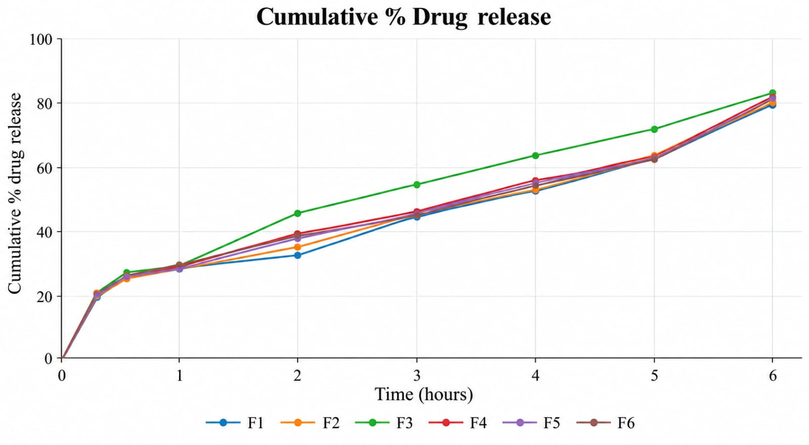
Fig. 3: Comparative in-vitro drug release of formulations F1-F6

All formulations showed progressive release over 6 h, with F3 reaching the highest cumulative value (82.52%) at the final sampling point. The separation of the profiles after approximately 2 h suggests that polymer composition increasingly influenced diffusion and matrix relaxation as hydration progressed, a pattern consistent with HPMC-based buccal matrices in which polymer viscosity and swelling regulate sustained release (Lodhi et al., 2013; Muzib & Kumari, 2011; Semalty et al., 2008).
3.2.12 Release Kinetic of F3
Table 7: Release kinetics of F3
Time (Hrs) | Cum. % drug release | Cum. % drug remaining | Log Cum. % drug remaining | √Time | Log  Time | Log Cum. % drug release | Cube root log Cum. % drug remaining
0 | 0 | 100 | 2 | 0 | - | - | 4.642
0.25 | 21.43 | 78.57 | 1.895 | 0.l5 | -0.602 | 1.331 | 4.289
0.50 | 27.15 | 72.85 | 1.862 | 0.707 | -0.301 | 1.434 | 4.191
1 | 29.38 | 70.62 | 1.849 | 1 | 0 | 1.468 | 4.123
2 | 45.47 | 54.53 | 1.737 | 1.414 | 0.301 | 1.658 | 3.8
3 | 54.48 | 45.52 | 1.658 | 1.732 | 0.477 | 1.736 | 3.583
4 | 63.97 | 36.03 | 1.557 | 2 | 0.602 | 1.806 | 3.301
5 | 72.06 | 27.94 | 1.446 | 2.236 | 0.699 | 1.858 | 3.03
6 | 82.52 | 17.48 | 1.242 | 2.449 | 0.788 | 1.917 | 2.596

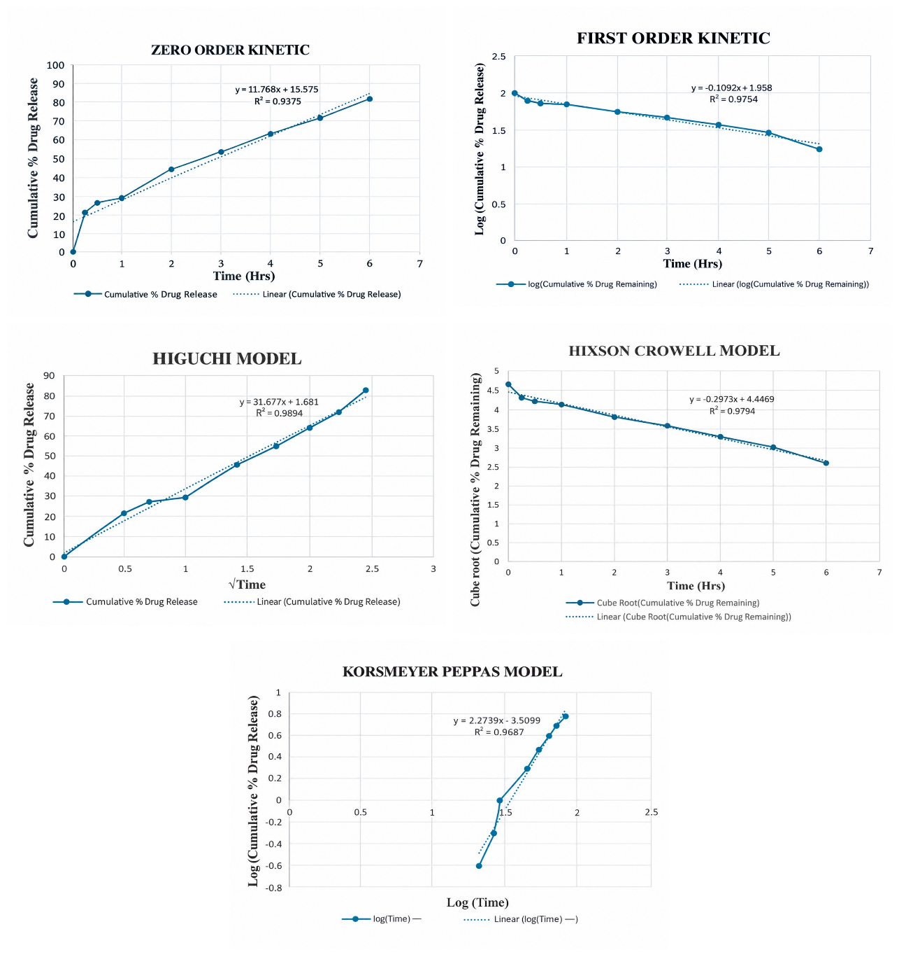
Fig.4: Release kinetics of F4 formulation: A) zero-order, B) first-order, C) Higuchi, D) Korsmeyer–Peppas and (E) Hixson–Crowell plots
Inference:
The drug release kinetics of the optimized mucoadhesive buccal patch (F3) were analyzed using various kinetic models. The Higuchi model showed the best fit (R² = 0.9894), indicating release through matrix hydration and gradual dissolution.
The superior fit to the Higuchi model supports a predominantly diffusion-associated release process from a hydrated matrix, but the model fit alone does not exclude concurrent swelling or erosion. Similar mucoadhesive films have shown Higuchi-type or mixed diffusion-relaxation behavior, indicating that interpretation of mechanism should consider both kinetic fitting and polymer hydration characteristics (Muzib & Kumari, 2011; Semalty et al., 2008; Vasantha et al., 2011).
3.2.13 Scanning Electron Microscopy (SEM) Analysis
The formulated buccal patches were subjected to scanning electron microscopic examination to characterize their surface morphology.
Fig. 5: SEM image of F3 formulation
SEM provides a qualitative assessment of surface topography and can reveal pores, cracks, drug crystals, or heterogeneity that may influence hydration and release. In comparable buccal-film studies, relatively uniform surfaces and limited visible defects have been interpreted as evidence of satisfactory dispersion within the polymeric matrix, although SEM should be considered complementary to physicochemical and release data (Salehi & Boddohi, 2017; Nair et al., 2021; Kumar et al., 2013).
3.2.14 Stability Studies of F3
The F3 formulation was subjected to stability studies as per ICH guidelines and the results shown in Table 8.
Table 8: Stability studies of F3
Stability conditions (F3) | Physical Appearance |  | Thickness (mm) |  | Drug content (%)
Stability conditions (F3) | Initial | Final  (30 days) | Initial | Final  (30 days) | Initial | Final  (30 days)
At room temp. | NC | NC | 0.14 | 0.14 | 98.26 | 97.52

*NC-No change

The absence of visible change and the small reduction in drug content from 98.26% to 97.52% over 30 days suggest short-term physical and chemical stability under the tested room-temperature condition. However, this finding is preliminary because a 30-day study cannot substitute for longer, controlled stability testing across defined temperature and humidity conditions; extended studies are needed to establish shelf-life and packaging requirements (Vasantha et al., 2011; Adhikari et al., 2010; Kumar et al., 2013).
4. CONCLUSION
The present study aimed to formulate and evaluate mucoadhesive buccal patches of Clomipramine HCl for sustained drug delivery. Preformulation studies confirmed the drug’s physicochemical properties and suitability for formulation. FT-IR analysis indicated no
significant interaction between the drug and the selected excipients. The UV method showed maximum absorbance at 254 nm and good linearity (R² = 0.9996). Six patch formulations (F1–F6) were prepared by solvent casting using HPMC E15 and Carbopol 940. The patches showed smooth, homogeneous surfaces, good flexibility, and a surface pH suitable for buccal application. Drug content ranged from 89.14% to 98.26%, with F3 showing the highest value. All formulations had 100% flatness, while swelling index values ranged from 458.36% to 627.75%. F3 showed a swelling index of 537.13% and cumulative drug release of 82.52% after 6 hours. The optimized F3 formulation contained 15 mg Clomipramine HCl, 750 mg HPMC E15, and 250 mg Carbopol 940. It also showed a thickness of 0.14 mm, surface pH of 6.52, and folding endurance exceeding 300 folds. Drug release increased gradually over 6 hours, indicating a sustained release profile. Among the tested kinetic models, the Higuchi model showed the best fit (R² = 0.9894). After 30 days at room temperature, F3 showed no significant change in appearance, thickness, or drug content. Overall, F3 was selected as the optimized formulation based on its physicochemical properties and drug-release performance.
Future Scope
- Ex-vivo permeation can be carried out.
- In-vivo evaluation need to be done.
- Long term stability studies need to be done.
COMPETING INTERESTS
Authors have declared that no competing interests exist.

Declaration of AI Use

This manuscript was prepared through the intellectual contributions of the author(s) to the study design, data analysis, interpretation of results, and scholarly content. Grammarly and ChatGPT were used solely to assist with grammatical refinement and reference formatting during manuscript revision. The author(s) accept full responsibility for the accuracy, integrity, and final content of the manuscript.

REFERENCE
- Anu A. L., Prasobh G. R., Subash Chandran M. P., Juno S., Subodh S. Satheesh, Aneesh Kumar A. L. and Pooja Nair K. R. A Review on Mucoadhesive Bilayer Buccal Patches. World Journal of Pharmaceutical Research. 2020; 9(2):259-271.
- Anjana Anil, Preethi Sudheer. Design and Evaluation of Mucoadhesive Buccal Patch of Ramipril. International Journal of Pharmaceutical Sciences Review and Research. 2018; 50(2):121-129.
- Fawzia Habib, Maha Abdel Azeem, Gihan Fetih and Mohamed Safwat. Mucoadhesive Buccal Patches of Lornoxicam: I- Development and In-Vitro Characterization. Bulletin of Pharmaceutical Sciences. 2010; 33:59-68.
- Gite Shital Shridhar, Shinkar Dattatraya Manohar, Saudagar Ravindra Bhanudas. Mucoadhesive buccal drug delivery: An Overview. Journal of Advanced Pharmacy Education & Research. 2013; 3(4): 319-332.
- Hussain Mohammed Asif, T. Rama Rao, Nusrath Ayesha, Maimuna Anjum and Mohammed Azizur Rahman. Design and Evaluation of Mucoadhesive Buccal Patches of Venlafaxine. British Journal of Pharmaceutical Research. 2015; 6(2):96-106.
- Harsha Rameshwar Barde, Dr. A. A. Harsulkar, Mohammad Zishan Ibrahim. Design, Development and Characterization of Bioadhesive Buccal Patches for better Therapeutic Efficacy. Journal of Emerging Technologies and Innovative Research. 2022; 9(6).
- Md. Ikram, Neeraj Gilhotra, Ritu Mehra Gilhotra. Formulation and optimization of mucoadhesive buccal patches of losartan potassium by using response surface methodology. Advanced Biomedical Research. 2015; 4:239.
- Nora Zawar Yousif and Nidhal Khazaal Maraie. Optimization and Evaluation of Metoclopramide Hcl as Mucoadhesive Buccal Patch. World Journal of Pharmaceutical Research. 2015; 4(2):79-99.
- N. Umarani, Saniya K. Meghana, G. Vaishnavi, D. Swathi, K. Ajay Prakash and N. Rohith Reddy. Formulation and Evaluation of Mucoadhesive Buccal Patches of Timolol Maleate. European Journal of Biomedical and Pharmaceutical Sciences. 2024; 11(10):200-204.
- Nihal Shaikh Shahid Khatik, Shaikh Imran, Faizan Khan. Mucoadhesive Buccal Patch. International Journal of Research in Pharmacy and Allied Science. 2025; 4(2):86-104.
- Pooja Shivane, Dharmendra Solanki. Formulation and Evaluation of Mucoadhesive Buccal Patch of Timolol Maleate. American Journal of PharmTech Research. 2017; 7(2).
- Pooja Dandge, Vinayak Mundhe. Formulation And Evaluation of Mucoadhesive Buccal Patches of Deflazacort. International Journal of Pharmaceutical Sciences. 2024; 2(10):550-565.
- S. Z. Chemate, Vaishali N. Garje, Shubhada A. Gayake. Formulation and Evaluation of Metformin Hydrochloride buccal patch. PharmaTutor; 2016; 4(7); 52-58.
- Shrutika Zile, Vaishali Wasnik, Shilpa Gawande, Bharti Bakde, Madhuri Channawar. Development and Evaluation of Mucoadhesive Buccal Patch. World Journal of Pharmaceutical Research. 2017; 6(8):1521-1533.
- Spandhana Pasi, Polapally Archana, Edulakanti Bhavana, Rachakonda Maheshwari, Erra Mounika, Aerla Manisha. Formulation and Evaluation of Mucoadhesive Buccal Patches of Timolol Maleate. International Journal of Advanced Research In Medical & Pharmaceutical Sciences. 2021; 6(6).
- Sahar Salehi, Soheil Boddohi. New formulation and approach for mucoadhesive buccal film of rizatriptan benzoate. Prog Biomater. 2017; 6:175-187.
- Vidya Viswanad, Chinmayi Ramachandran, Sivapriya G Nair, Gopika S Kumar, Vidya Viswanad. Formulation and evaluation of mucoadhesive buccal patch containing Imipramine hydrochloride. International Journal of Research in Pharmaceutical Sciences. 2018; 9(4):1409-1422.
- Varinder Kumar, Foziyah Zakir, Geeta Agarwal, Ankush Choudhary. Formulation and Evaluation of Buccal Patches of Venlafaxine. International Journal of Pharmacy and Biological Sciences. 2011; 1(3).
- Ghumman, S. A., Hameed, H., Noreen, S., Al-Hussain, S. A., Kausar, R., Irfan, A., Shabbir, R., Rana, M., Amanat, A., & Zaki, M. E. A. (2023). In vitro/in vivo evaluation of clomipramine orodispersible tablets for the treatment of depression and obsessive-compulsive disorder. Pharmaceuticals, 16(2), 265. https://doi.org/10.3390/ph16020265
- Rahman, N., & Afaq, N. (2010). Optimization and validation of spectrofluorimetric method for the determination of clomipramine hydrochloride via ion-pair complexation with alizarin red S. Analytical Methods, 2, 513–518. https://doi.org/10.1039/C0AY00017E
- Ali, E. A., Adawy, A. M., El-Shahat, M. F., & Amin, A. S. (2016). Simple spectrophotometric methods for determination of fluoxetine and clomipramine hydrochlorides in dosage forms and in some post-mortem biological fluids samples. Egyptian Journal of Forensic Sciences, 6(4), 370–380. https://doi.org/10.1016/j.ejfs.2016.05.007
- Patel, K. A., & Karvekar, M. D. (2019). A study on synthesis and characterization of various polymorphic forms of trimipramine maleate and clomipramine hydrochloride. Journal of Pharmaceutical Research, 18(3), 1–7. https://doi.org/10.18579/jopcr/v18.3.patel
- Naqvi, A. Z., Al-Ahmadi, M. D. A., Akram, M., & Kabir-ud-Din. (2010). Surfactants and ureas affect the cloud point of amphiphilic drug, clomipramine hydrochloride. Colloids and Surfaces B: Biointerfaces, 81(1), 152–157. https://doi.org/10.1016/j.colsurfb.2010.07.003
- Aymard, G., Livi, P., Pham, Y. T., & Diquet, B. (1997). Sensitive and rapid method for the simultaneous quantification of five antidepressants with their respective metabolites in plasma using high-performance liquid chromatography with diode-array detection. Journal of Chromatography B: Biomedical Sciences and Applications, 700(1–2), 183–189. https://doi.org/10.1016/S0378-4347(97)00327-7
- Tanaka, E., Terada, M., Nakamura, T., Misawa, S., & Wakasugi, C. (1997). Forensic analysis of eleven cyclic antidepressants in human biological samples using a new reversed-phase chromatographic column of 2 µm porous microspherical silica gel. Journal of Chromatography B: Biomedical Sciences and Applications, 692(2), 405–412. https://doi.org/10.1016/S0378-4347(96)00510-5
- Palego, L., Marazziti, D., Biondi, L., Giannaccini, G., Sarno, N., Armani, A., Lucacchini, A., Cassano, G. B., & Dell'Osso, L. (2000). Simultaneous plasma level analysis of clomipramine, N-desmethylclomipramine, and fluvoxamine by reversed-phase liquid chromatography. Therapeutic Drug Monitoring, 22(2), 190–194. https://doi.org/10.1097/00007691-200004000-00009
- Michael, A. M., Mahmoud, A. M., & Fahmy, N. M. (2023). Determination of clomipramine using eco-friendly solid-contact ionophore-doped potentiometric sensor. BMC Chemistry, 17, 27. https://doi.org/10.1186/s13065-023-00938-x
- Morales, J. O., & McConville, J. T. (2011). Manufacture and characterization of mucoadhesive buccal films. European Journal of Pharmaceutics and Biopharmaceutics, 77(2), 187–199. https://doi.org/10.1016/j.ejpb.2010.11.023
- Andrews, G. P., Laverty, T. P., & Jones, D. S. (2009). Mucoadhesive polymeric platforms for controlled drug delivery. European Journal of Pharmaceutics and Biopharmaceutics, 71(3), 505–518. https://doi.org/10.1016/j.ejpb.2008.09.028
- Smart, J. D. (2005). The basics and underlying mechanisms of mucoadhesion. Advanced Drug Delivery Reviews, 57(11), 1556–1568. https://doi.org/10.1016/j.addr.2005.07.001
- Vasantha, P. V., Puratchikody, A., Mathew, S. T., & Balaraman, A. K. (2011). Development and characterization of Eudragit based mucoadhesive buccal patches of salbutamol sulfate. Saudi Pharmaceutical Journal, 19(4), 207–214. https://doi.org/10.1016/j.jsps.2011.07.003
- Muzib, Y. I., & Kumari, K. S. (2011). Mucoadhesive buccal films of glibenclamide: Development and evaluation. International Journal of Pharmaceutical Investigation, 1(1), 42–47. https://doi.org/10.4103/2230-973X.76728
- Semalty, M., Semalty, A., & Kumar, G. (2008). Formulation and characterization of mucoadhesive buccal films of glipizide. Indian Journal of Pharmaceutical Sciences, 70(1), 43–48. https://doi.org/10.4103/0250-474X.40330
- Lodhi, M., Dubey, A., Narayan, R., Prabhu, P., & Priya, S. (2013). Formulation and evaluation of buccal film of ivabradine hydrochloride for the treatment of stable angina pectoris. International Journal of Pharmaceutical Investigation, 3(1), 47–53. https://doi.org/10.4103/2230-973X.108963
- Adhikari, S. N. R., Nayak, B. S., Nayak, A. K., & Mohanty, B. (2010). Formulation and evaluation of buccal patches for delivery of atenolol. AAPS PharmSciTech, 11(3), 1038–1044. https://doi.org/10.1208/s12249-010-9459-z
- Nair, A. B., Shah, J., Jacob, S., Al-Dhubiab, B. E., Patel, V., Sreeharsha, N., & Shinu, P. (2021). Development of mucoadhesive buccal film for rizatriptan: In vitro and in vivo evaluation. Pharmaceutics, 13(5), 728. https://doi.org/10.3390/pharmaceutics13050728
- Kumar, A., Bali, V., Kumar, M., & Pathak, K. (2013). Comparative evaluation of porous versus nonporous mucoadhesive films as buccal delivery system of glibenclamide. AAPS PharmSciTech, 14(4), 1321–1332. https://doi.org/10.1208/s12249-013-0014-6

