Original Research Article
Formulation and Evaluation of Famciclovir Loaded Transferosomal Gel as a Novel Topical Antiviral Drug Delivery System

ABSTRACT
Aims: To develop and evaluate Famciclovir-loaded transferosomal gel as a topical drug delivery system, addressing the limitations associated with conventional oral administration of this antiviral drug.
Study design: Experimental formulation development and in-vitro evaluation study.
Place and Duration of Study: Department of Pharmaceutics, Adhiparasakthi College of Pharmacy, Melmaruvathur, [2024-2026].
Methodology: Transferosomes were prepared by the ethanol injection method using soya lecithin and Tween 80 and incorporated into Carbopol 934 gel. Six formulations (F1–F6) were prepared and evaluated for entrapment efficiency and vesicular characteristics. The transferosomal gels were evaluated for drug content and in-vitro drug release.
Results: The optimized F4 formulation showed an entrapment efficiency of 91.7%, particle size of 167.4 nm, polydispersity index (PDI) of 0.380 and zeta potential of −33.5 mV. The optimized transferosomal gel exhibited 96.8% drug content and sustained in-vitro drug release, reaching 93.08% at 8 h.
Conclusion: The findings suggest that Famciclovir-loaded transferosomal gel may serve as a promising approach for topical delivery of Famciclovir.

Keywords: Famciclovir, Transferosomal gel, Topical drug delivery, Antiviral delivery, Carbopol 934, Herpes virus, In vitro drug release.
1. INTRODUCTION
Topical and transdermal drug delivery systems have gained considerable interest as alternatives to conventional routes of administration. Oral drug delivery may be associated with gastrointestinal limitations and first-pass metabolism, whereas topical administration can provide drug delivery directly to the intended site and may improve patient convenience.
Topical and transdermal administration can reduce gastrointestinal exposure and hepatic first-pass effects, but successful delivery remains constrained by the highly organized stratum corneum. Consequently, formulation strategies must balance drug solubility, carrier-skin interactions, and controlled release rather than assuming that topical application alone ensures adequate penetration (Benson, 2006; Fernández-García et al., 2020; Matharoo et al., 2024).
Transferosomes are highly deformable phospholipid-based vesicular carriers designed to facilitate drug transport across the skin. Their flexible lipid bilayer, consisting of a phospholipid and an edge activator, allows the vesicles to undergo deformation and enhances their ability to interact with the skin barrier. This makes transferosomes a potential carrier system for improving topical drug delivery.
Transferosomes address this barrier through a phospholipid bilayer containing an edge activator that increases membrane flexibility, while hydration gradients and lipid-skin interactions are proposed to contribute to transport within the stratum corneum. Evidence across foundational and contemporary studies supports enhanced dermal delivery by ultradeformable vesicles, although the extent to which intact vesicles traverse viable skin remains formulation- and method-dependent (Cevc & Blume, 1992; Kumar & Kumar, 2021; Oyarzún et al., 2021).
Recent reviews also emphasize that transferosomal performance is governed by the integrated effects of phospholipid composition, edge-activator type, preparation method, vesicle size, deformability, and storage stability, rather than by vesicle formation alone (Jasmin et al., 2024; Sijamol et al., 2024; Matharoo et al., 2024).
Famciclovir is an antiviral prodrug of penciclovir used in the management of herpes simplex and varicella-zoster virus infections. The development of a topical delivery system for Famciclovir may provide an alternative approach for localized drug administration while reducing dependence on conventional oral delivery.
Famciclovir is rapidly converted to penciclovir after oral administration, and its antiviral use in herpesvirus infections is well established; however, alternative formulation approaches continue to be investigated to improve local delivery and exposure profiles (Simpson & Lyseng-Williamson, 2006; Bhattacharyya et al., 2024; Kanugo et al., 2023).
The present study aimed to formulate Famciclovir-loaded transferosomes by the ethanol injection method, incorporate them into a Carbopol 934 gel, and evaluate the resulting transferosomal gel as a topical drug delivery system.
Transferosomal gels have also been investigated for acyclovir, luliconazole, gabapentin, chrysin, metronidazole, psoralen, and other actives, with formulation performance commonly assessed through vesicle size, entrapment efficiency, zeta potential, gel rheology, and in-vitro release (Nidbane et al., 2025; Gosavi et al., 2024; Fatima et al., 2023).
Similar evaluation frameworks have been reported across other transferosomal gel studies, supporting the selection of these critical quality attributes for comparative formulation screening (Humnabade et al., 2024; Madhulika & Gupta, 2023; Mishra & Tripathi, 2025; Shukla et al., 2019; Thakur et al., 2018).
2. MATERIALS AND METHODS
2.1 Procurement of drug and excipients
Famciclovir (provided by Sterile Gene Pharma, Puducherry), soya lecithin, Tween 80 (Ocean Chemical Pvt. Ltd, Chennai), Carbopol 934 (Chemical Laboratories), ethanol and distilled water.
2.2 Preformulation studies
2.2.1 Organoleptic properties
The Colour, Odour and taste of the drug are evaluated using descriptive terminology.
2.2.2 Solubility
It is important to know about the solubility characteristics of a drug in aqueous systems, since they must possess some limited aqueous solubility to elicit a therapeutic response. The solubility of the drug was recorded using various descriptive terminology.
2.2.3 Melting point determination
A small amount of drug was loaded in a capillary tube, one end of which was closed, and kept in the melting point apparatus; the temperature at which the drug melted was noted.
2.2.4 Drug–excipient compatibility studies
FTIR spectrophotometric analysis was performed to investigate the compatibility between the drug and excipients. FTIR spectra of the pure drug (Famciclovir) and of a mixture of the drug with excipients were taken. The samples were analysed between wave numbers 4000 and 400 cm⁻¹. The peaks of the pure drug were compared with those of the physical mixture of drug and excipients.
2.2.5 Determination of λ max
10 mg of Famciclovir was weighed and transferred to a 10 ml volumetric flask. The drug was dissolved and the volume was made up to 10 ml using phosphate buffer saline (pH 7.4) to obtain a stock solution of 1000 µg/ml (stock solution I). 1 ml of this stock solution was again diluted with phosphate buffer saline (pH 7.4) up to 10 ml to obtain a solution of 100 µg/ml (stock solution II). From stock solution II, 1 ml was pipetted into a 10 ml volumetric flask and the volume was made up to 10 ml using phosphate buffer saline (pH 7.4) to get a concentration of 10 µg/ml. This solution was then scanned at 200–400 nm in a UV-Visible spectrophotometer to obtain the absorption maximum (λ max).
2.2.6 Calibration curve of Famciclovir
2.2.6.1 Preparation of pH 7.4 buffer (phosphate buffer saline)
2.38 g of disodium hydrogen phosphate, 0.19 g of potassium dihydrogen phosphate and 0.8 g of sodium chloride were dissolved in 1000 ml of distilled water and stirred continuously until completely dissolved.
2.2.6.2 Preparation of stock solution
Accurately weighed 10 mg of Famciclovir was transferred into a 100 mL volumetric flask and dissolved in a small quantity of phosphate buffer saline (pH 7.4). The volume was then made up to 100 mL with the same buffer to obtain a standard stock solution of 100 µg/mL. From the prepared standard stock solution (100 µg/mL), working standard solutions of 2, 4, 6, 8 and 10 µg/mL were transferred to a series of 100 ml volumetric flasks. The volume was made up with phosphate buffer saline (pH 7.4). The absorbance of these solutions was measured at 222 nm against blank.
2.3 Formulation of Famciclovir transferosomes
Famciclovir-loaded transferosomes were prepared by the ethanol injection method. The composition of formulations F1–F6 is given in Table 1.
2.3.1 Organic phase
The organic phase was prepared by dissolving soya lecithin (phospholipid) and Tween 80 (edge activator) in ethanol with continuous magnetic stirring until a clear solution was obtained.
2.3.2 Aqueous phase
The aqueous phase was prepared by dissolving Famciclovir (hydrophilic drug) in phosphate buffer solution (PBS, pH 7.4). Both phases were maintained at the required temperature.
2.3.3 Preparation process
The ethanolic phospholipid solution is injected drop wise into the aqueous solution with continuous stirring for the respective time. The addition of ethanol causes the formation of smaller lipid aggregates which fuse to form larger vesicles. The mixture is then stirred for a sufficient period of time to allow for the complete removal of the ethanol and then subjected to sonication for particle size reduction.
Table 1. Formulation chart of Famciclovir transferosomes
Formulation code | Drug (mg) | Soya lecithin (mg) | Tween 80 (mg) | Ethanol (ml) | PBS pH 7.4 (ml)
F1 | 50 | 200 | 25 | 10 | 20
F2 | 50 | 300 | 25 | 10 | 20
F3 | 50 | 400 | 25 | 10 | 20
F4 | 50 | 300 | 15 | 10 | 20
F5 | 50 | 300 | 35 | 10 | 20
F6 | 50 | 300 | 25 | 10 | 20

2.4 Preparation of transferosomal gel
Accurately weigh Carbopol 934 (1% w/v) and disperse it into 80 ml of double distilled water in a beaker. Continuous stirring at 800 rpm is maintained for 1 hour to ensure proper dispersion of Carbopol 934 in water. After 1 hour of stirring, 10 ml of propylene glycol is added to the Carbopol 934 dispersion. This helps in enhancing the viscosity and consistency of the gel. The volume of the gel is adjusted to a total of 100 ml, likely by adding an additional 10 ml of double distilled water. The gel is subjected to sonication for 10 minutes using a bath sonicator. This helps in removing any air bubbles present in the gel, ensuring a smooth and homogeneous gel base.
2.5 Characterization of transferosomes
2.5.1 Optical microscopy
The prepared transferosomes were observed under a binocular compound microscope at 10X and 40X magnification for studying the shape and surface morphology.
2.5.2 Particle size and polydispersity index
Particle size was measured using a Zetasizer 300HS. Transferosomes were mixed with distilled water and then measured at 25 ºC. The diameter was calculated using the self-correlation coefficient based on the transferosomes light scattering brightness. PDI gauges a sample’s degree of heterogeneity according to its size polydispersity, which can result from sample agglomeration. The dynamic light scattering (DLS) method can be used to determine PDI. In terms of PDI, less than 0.1 denotes homogeneity and less than 0.4 denotes heterogeneity.
2.5.3 Zeta potential
Zeta potential was measured using a Horiba SZ100 spectrophotometer. The formulations were diluted with Millipore water before being subjected to measurements, and each measurement was performed in triplicate.
2.5.4 Scanning electron microscopy (SEM)
A scanning electron microscope was used to determine the morphology of the optimized formula. One drop of an optimal transferosomal suspension was applied to a copper grid coated with collodion, and the grid was allowed to stand for approximately two minutes to allow the transferosomes to stick to the collodion and dry. On the grid, one drop of uranyl acetate solution was then applied and left for one minute. After drying, the sample was examined using a scanning electron microscope.
2.5.5 Entrapment efficiency (EE%)
5 ml of transferosomal suspension was ultracentrifuged for 30 minutes at 10 °C and 4000 rpm. Following centrifugation, 1 mL of the supernatant was diluted with 9 mL of phosphate buffer saline (pH 7.4), and the absorbance at 222 nm was then measured using a UV-Vis spectrophotometer. The EE% of drug in the prepared transferosomes is calculated applying the following equation:
EE% = [Amount of Entrapped Drug / Total Amount of Drug] × 100
2.6 Characterization of transferosomal gel
2.6.1 Physical appearance
All prepared gel formulations were observed for their visual appearance, such as transparency, colour, texture, grittiness, greasiness, stickiness, smoothness and stiffness.
2.6.2 Spreadability
A modified apparatus was used for determining spreadability. The spreadability was measured on the basis of slip and drag characteristics of the gels. The modified apparatus was fabricated and consisted of two glass slides, the lower one fixed to a wooden plate and the upper one attached by a hook to a balance. The spreadability was determined using the formula:
S = mxl / t
where S is spreadability, m is the weight in the pan tied to the upper slide, l is the distance travelled and t is the time. For practical purposes the mass and length were kept constant and t was determined.
2.6.3 Viscosity
The viscosity of the gels was determined using a Brookfield viscometer. Spindle number S64 was operated at 12 rpm for 10 seconds at 37 ºC.
2.6.4 pH
The pH of the prepared transferosomal gels was determined using a pH meter. 500 mg of gel was incorporated into 10 ml of distilled water to create a homogeneous solution. After immersing the electrode in the suspensions, pH meter readings were recorded.
2.6.5 Drug content
1 g of gel was dissolved in a suitable solvent and filtered, and the volume was made up. The resultant solution was suitably diluted with solvent and the absorbance was measured at 222 nm using a UV-Visible spectrophotometer. Drug content was determined from the calibration curve.
2.6.6 In-vitro drug diffusion studies
The in-vitro drug release study was performed using a modified Franz diffusion cell on egg membrane in phosphate buffer solution (pH 7.4). The egg membrane was mounted horizontally on the receptor compartment of the Franz diffusion cell. The effective permeation area of the donor compartment exposed to the receptor compartment was 2 cm² and the capacity of the receptor compartment was 30 ml of phosphate buffer (pH 7.4) maintained at 37 ± 0.5 ºC and stirred by a magnetic bar at 100 rpm. Transferosomal gel formulation equivalent to 1 g of drug was placed on the membrane and the top of the diffusion cell was covered. At appropriate time intervals 5 ml aliquots of the receptor medium were withdrawn and immediately replaced by an equal volume of fresh phosphate buffer (pH 7.4). The samples were analysed spectrophotometrically at λmax.
2.7 Drug release kinetics
The in-vitro release data were analysed using the following kinetic models:
- Zero-order kinetics
- First-order kinetics
- Higuchi model
- Korsmeyer–Peppas model
- Hixson–Crowell kinetics

2.8 Stability studies
Stability testing plays a crucial role in the drug development process. The purpose of stability testing is to provide evidence on how the quality of a drug product varies with time under the influence of different environmental factors. Stability studies were carried out on the optimized formulation according to ICH guidelines. The optimized formulation was stored in a tight container at refrigeration temperature (4 ± 2 ºC) and room temperature (25 ± 2 ºC) for a period of one month. The formulation was evaluated before and after at periodic intervals for its physical appearance, drug content and entrapment efficiency.
3. RESULTS AND DISCUSSION
3.1 Preformulation studies
3.1.1 Organoleptic properties
Famciclovir was observed to be a white, odourless, solid powder.
Organoleptic examination provides a practical baseline for confirming the apparent identity and physical uniformity of the drug before formulation, and comparable transferosomal and preformulation studies routinely document colour, odour, and visible physical characteristics as part of initial characterization (Singh & Malik, 2025; Bhattacharyya et al., 2024; Fatima et al., 2023).
3.1.2 Melting point
The observed melting point of Famciclovir was 104 ºC, which is in agreement with the reported value of 103–104 ºC.
Thermal or melting-point characterization can complement identity assessment and can reveal changes in solid-state behavior when a drug is incorporated into a delivery matrix. Famciclovir formulation studies have similarly used thermal or solid-state characterization alongside spectroscopic methods to assess the drug before and after formulation (Singh & Malik, 2025; Iftikhar et al., 2025; Kanugo et al., 2023).
3.1.3 Solubility studies
Famciclovir was freely soluble in distilled water, methanol and 0.1 N HCl, and soluble in acetone and chloroform.
Solubility is a key preformulation variable because it influences drug partitioning between the aqueous phase, lipid bilayer, and gel matrix and therefore can affect loading, retention, and release from vesicular systems. For transferosomes, the balance between drug physicochemical properties and lipid or edge-activator composition is particularly important for achieving reproducible encapsulation and dermal delivery (Fernández-García et al., 2020; Bhattacharyya et al., 2024; Matharoo et al., 2024).
3.1.4 Drug and excipient compatibility studies
The FTIR spectra of the pure drug (Fig. 1A) and of Famciclovir with excipients (Fig. 1B) were compared. The characteristic peaks and the corresponding vibrations are interpreted in Table 2.
The preservation of characteristic FTIR bands without substantial new bands or marked shifts is commonly used as supportive evidence that no major chemical interaction occurred between the drug and excipients, although FTIR should be interpreted together with complementary solid-state analyses. Comparable famciclovir and transferosomal formulations have used FTIR for compatibility assessment before further performance testing (Bhattacharyya et al., 2024; Iftikhar et al., 2025; Fatima et al., 2023).
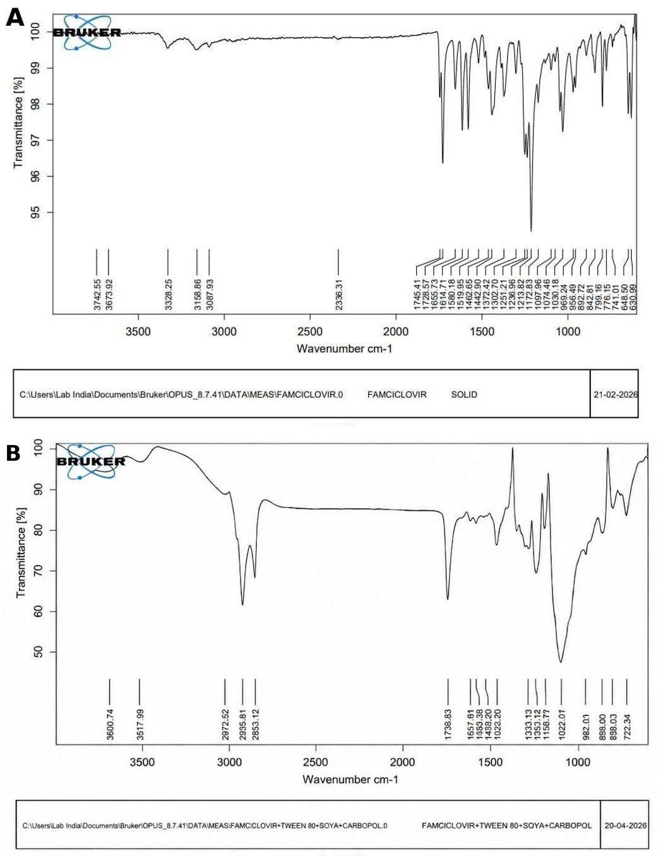
Fig. 1. FTIR spectra of (A) Famciclovir pure drug and (B) Famciclovir with excipients

Table 2. FTIR interpretation table
Wave number (cm⁻¹) | Types of vibrations
1022.01 – 1030.18 | C–N stretching
1728.57 – 1735.98 | C=O stretching
1557.81 – 1614.71 | C=N stretching
1158.71 – 1213.82 | C–O stretching

3.1.5 λ max of Famciclovir by UV spectroscopy
The λ max of Famciclovir was determined by UV spectroscopy as shown in Fig. 2A.
Published spectrophotometric methods for famciclovir report wavelength maxima that vary with solvent and analytical approach, underscoring the importance of determining λmax under the exact medium and instrument conditions used in the study (Srinubabu et al., 2006; Lotfy et al., 2010; Nizamuddin et al., 2007).
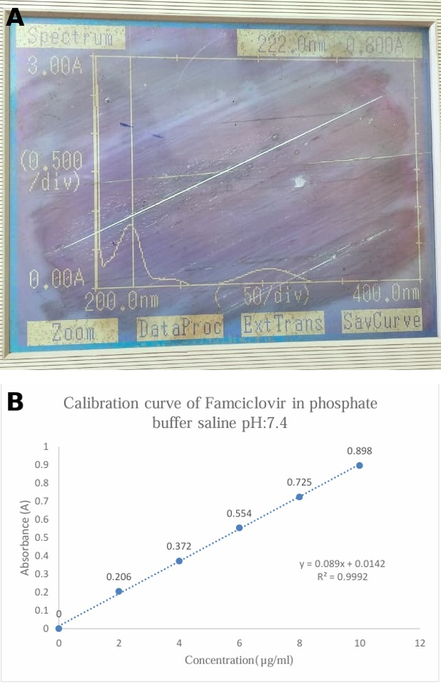

Fig. 2. (A) λ max of Famciclovir and (B) standard graph of Famciclovir in phosphate buffer saline pH 7.4
3.1.6 Calibration curve of Famciclovir
The calibration curve of Famciclovir in phosphate buffer saline (pH 7.4) is given in Table 3 and Fig. 2B. It was found that the solutions show linearity (R² = 0.9992) at a concentration of 2–10 µg/ml and obey Beer-Lambert’s law.
The strong linearity observed over 2-10 µg/mL supports the use of the calibration function for concentration estimation within this range. Comparable famciclovir analytical methods have demonstrated concentration-dependent linear responses after method-specific validation, while transferosomal-gel studies routinely apply spectrophotometric assays to quantify drug content and release samples (Srinubabu et al., 2006; Lotfy et al., 2010; Fatima et al., 2023).
Table 3. Calibration curve of Famciclovir in phosphate buffer saline pH 7.4
S. No | Concentration (µg/ml) | Absorbance
1 | 0 | 0
2 | 2 | 0.206
3 | 4 | 0.372
4 | 6 | 0.554
5 | 8 | 0.725
6 | 10 | 0.898

3.2 Evaluation of transferosomes
3.2.1 Entrapment efficiency
The entrapment efficiency of the prepared formulations was found to be in the range of 68.1–91.7% (Table 4). Among the formulations, F4 showed the highest entrapment efficiency (91.7%).
The 91.7% entrapment efficiency of F4 is within the high range reported for transferosomal gels and suggests that the selected phospholipid-to-edge-activator ratio favored drug retention within the vesicular system. Entrapment can change substantially with surfactant type and concentration because edge activators alter bilayer packing, membrane fluidity, and leakage behavior (Nidbane et al., 2025; Fatima et al., 2023; Fernández-García et al., 2020).
Table 4. Entrapment efficiency
Formulation | Entrapment efficiency (%)
F1 | 70.8
F2 | 73.5
F3 | 86.3
F4 | 91.7
F5 | 68.1
F6 | 79.2

3.2.2 Particle size and polydispersity index
The particle size analysis of the F4 transferosomal gel formulation was measured (Fig. 3A). The mean particle size and Z average was found to be 167.4 nm. This is within the nanometric range.
The measured polydispersity index (PDI) of the F4 transferosomal gel was found to be 0.380, which indicates a narrow particle size distribution. Since PDI values closer to zero represent
Monodispersity, the relatively low value obtained here signifies good uniformity and
homogeneity of vesicle size within the formulation.
A mean vesicle size of 167.4 nm is consistent with the nanoscale dimensions commonly reported for transferosomal formulations and may be advantageous for reproducible dispersion and skin interaction. However, a PDI of 0.380 is more appropriately interpreted as indicating moderate polydispersity rather than a strictly monodisperse population; PDI should be considered together with the full size distribution and measurement conditions (Danaei et al., 2018; Bhattacharjee, 2016; Gosavi et al., 2024).
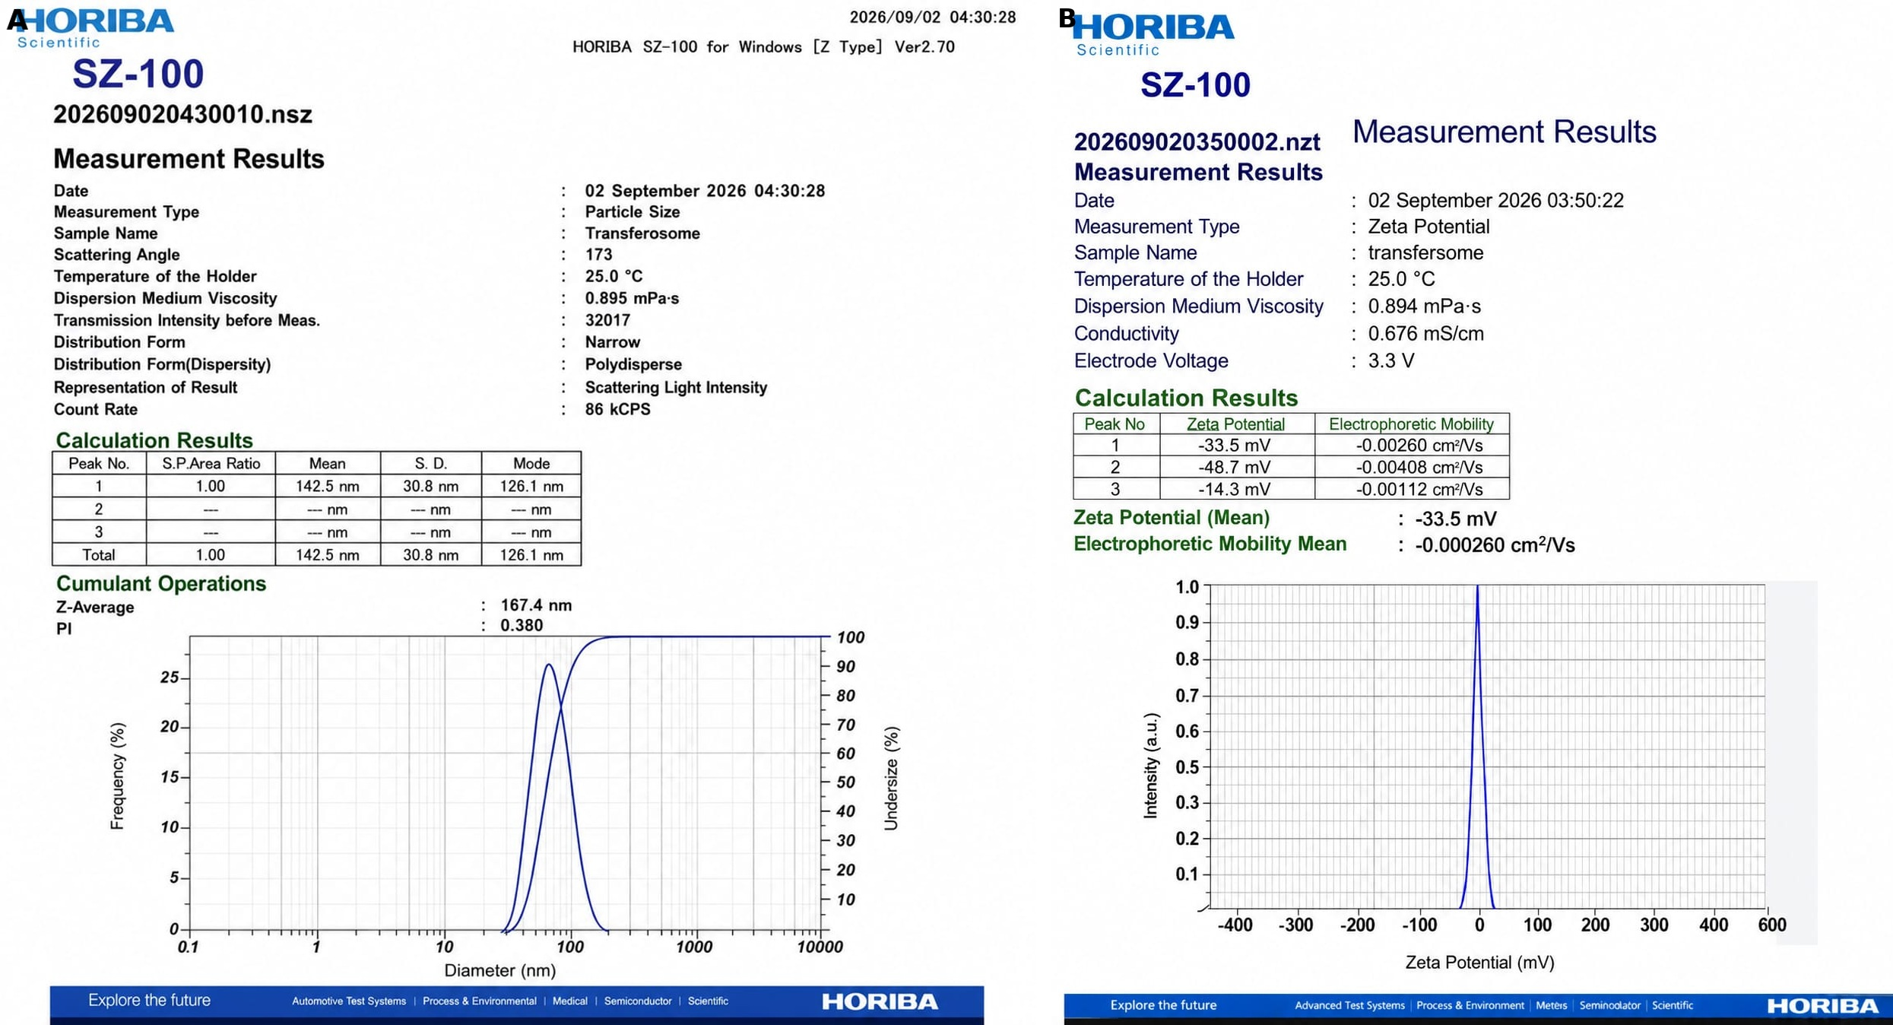
Fig. 3. (A) Particle size distribution and (B) zeta potential of F4 formulation
3.2.3 Zeta potential
The zeta potential of the F4 transferosomal gel formulation was found to be −33.5 mV (Fig. 3B), which shows that the formulation is stable.
The negative zeta potential of -33.5 mV indicates appreciable electrostatic surface charge and is consistent with values reported for other transferosomal gels. Absolute zeta-potential values around or above 30 mV are often associated with increased electrostatic repulsion, but colloidal stability also depends on medium composition, steric effects, vesicle concentration, and storage conditions (Bhattacharjee, 2016; Fatima et al., 2023; Madhulika & Gupta, 2023).
3.2.4 Scanning electron microscopy (SEM)
The transferosomes were subjected to microscopic examination for characterizing their size and shape (Fig. 4).
Microscopic morphology is useful for confirming vesicle formation, surface appearance, and the presence or absence of visible aggregation. Spherical or near-spherical vesicular morphology has been reported in several transferosomal formulations, although electron-microscopy appearance can be influenced by sample preparation and drying (Nidbane et al., 2025; Bhattacharyya et al., 2024; Fatima et al., 2023).
Fig. 4. SEM of Famciclovir transferosomes of F4
3.3 Evaluation of transferosomal gel
The pH, viscosity, spreadability and drug content of the transferosomal gel formulations are given in Table 5.
Table 5. Evaluation parameters of gel
Formulation code | pH | Viscosity (cps) | Spreadability (cm/sec) | % Drug content
F1 | 6.0 | 3110 | 11.2 | 75.3
F2 | 6.5 | 3520 | 12.8 | 78.7
F3 | 6.4 | 4010 | 11.5 | 88.2
F4 | 6.7 | 4180 | 15.7 | 96.8
F5 | 6.5 | 3460 | 13.4 | 72.9
F6 | 6.2 | 3740 | 12.9 | 85.7
Among the tested gels, F4 combined the highest drug content (96.8%) and spreadability (15.7 cm/sec) with the highest measured viscosity (4180 cps) and a pH of 6.7. In carbomer systems, pH, polymer-solvent interactions, and cosolvents such as propylene glycol can materially influence rheology, while rheological behavior and spreadability can in turn affect application performance and drug release from topical semisolids (Islam et al., 2004; Bonacucina et al., 2004; Jin et al., 2023). Comparable transferosomal-gel studies have likewise treated pH, viscosity, spreadability, and drug content as interrelated quality attributes rather than isolated endpoints (Humnabade et al., 2024; Dongare & Bhogale, 2024; Shukla et al., 2019).

3.4 In-vitro diffusion studies
The cumulative percentage drug release of formulations F1–F6 over 8 h is given in Table 6 and compared in Fig. 5.
Table 6. In-vitro diffusion studies of transferosomal gel (cumulative % drug release)
Time (h) | F1 | F2 | F3 | F4 | F5 | F6
0 | 0.00 | 0.00 | 0.00 | 0.00 | 0.00 | 0.00
1 | 11.99 | 12.39 | 13.07 | 13.20 | 13.33 | 11.97
2 | 18.57 | 20.66 | 24.04 | 27.34 | 25.47 | 17.89
3 | 28.88 | 28.48 | 34.79 | 35.42 | 33.86 | 26.48
4 | 35.73 | 40.45 | 44.86 | 49.15 | 47.65 | 37.67
5 | 51.69 | 50.67 | 62.35 | 62.49 | 60.75 | 52.00
6 | 62.54 | 65.91 | 72.58 | 75.56 | 71.84 | 63.86
8 | 79.12 | 81.59 | 88.43 | 93.08 | 85.92 | 79.86

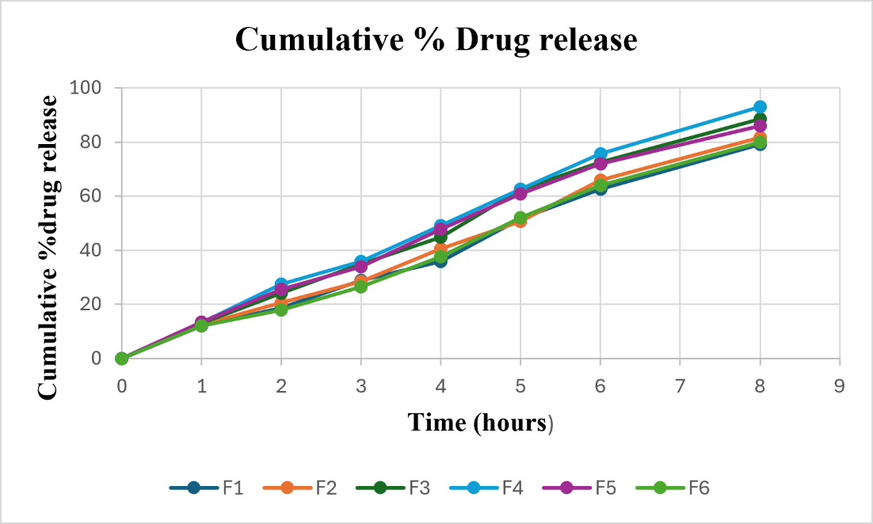
Fig. 5. Comparative in-vitro drug release of formulations F1–F6
F4 showed the highest cumulative release at 8 h (93.08%), followed by F3 (88.43%) and F5 (85.92%), indicating that the composition used for F4 provided the most favorable release profile among the tested formulations. Drug release from transferosomal gels reflects both vesicular properties and the semisolid matrix, so differences in lipid or surfactant composition, vesicle size, entrapment, and gel rheology can all contribute to the observed profile (Oyarzún et al., 2021; Fernández-García et al., 2020; Jin et al., 2023). Because the present diffusion study used an egg membrane rather than excised skin, the findings should be interpreted as comparative in-vitro release or diffusion data and not as direct evidence of human skin permeation or clinical transdermal delivery (Bhattacharyya et al., 2024; Matharoo et al., 2024; Dongare & Bhogale, 2024).
3.5 Drug release kinetics
The release kinetics of the optimized formulation F4 are given in Table 7 and plotted in Fig. 6.
Table 7. Release kinetics of F4 formulation
Time (h) | Cum. % drug release | Cum. % drug remain. | Log cum. % drug remain. | Sq. root of time | Log time | Log cum. % drug release | Cube root % drug remain.
0 | 0 | 100 | 2 | 0 | — | — | 4.642
1 | 13.2 | 86.8 | 1.939 | 1 | 0 | 1.121 | 4.428
2 | 27.34 | 72.66 | 1.861 | 1.414 | 0.301 | 1.437 | 4.173
3 | 35.42 | 64.58 | 1.81 | 1.732 | 0.477 | 1.549 | 4.012
4 | 49.15 | 50.85 | 1.706 | 2 | 0.602 | 1.692 | 3.705
5 | 62.49 | 37.51 | 1.574 | 2.236 | 0.699 | 1.796 | 3.347
6 | 75.56 | 24.44 | 1.388 | 2.449 | 0.778 | 1.878 | 2.902
8 | 93.08 | 6.92 | 0.84 | 2.828 | 0.903 | 1.969 | 1.906

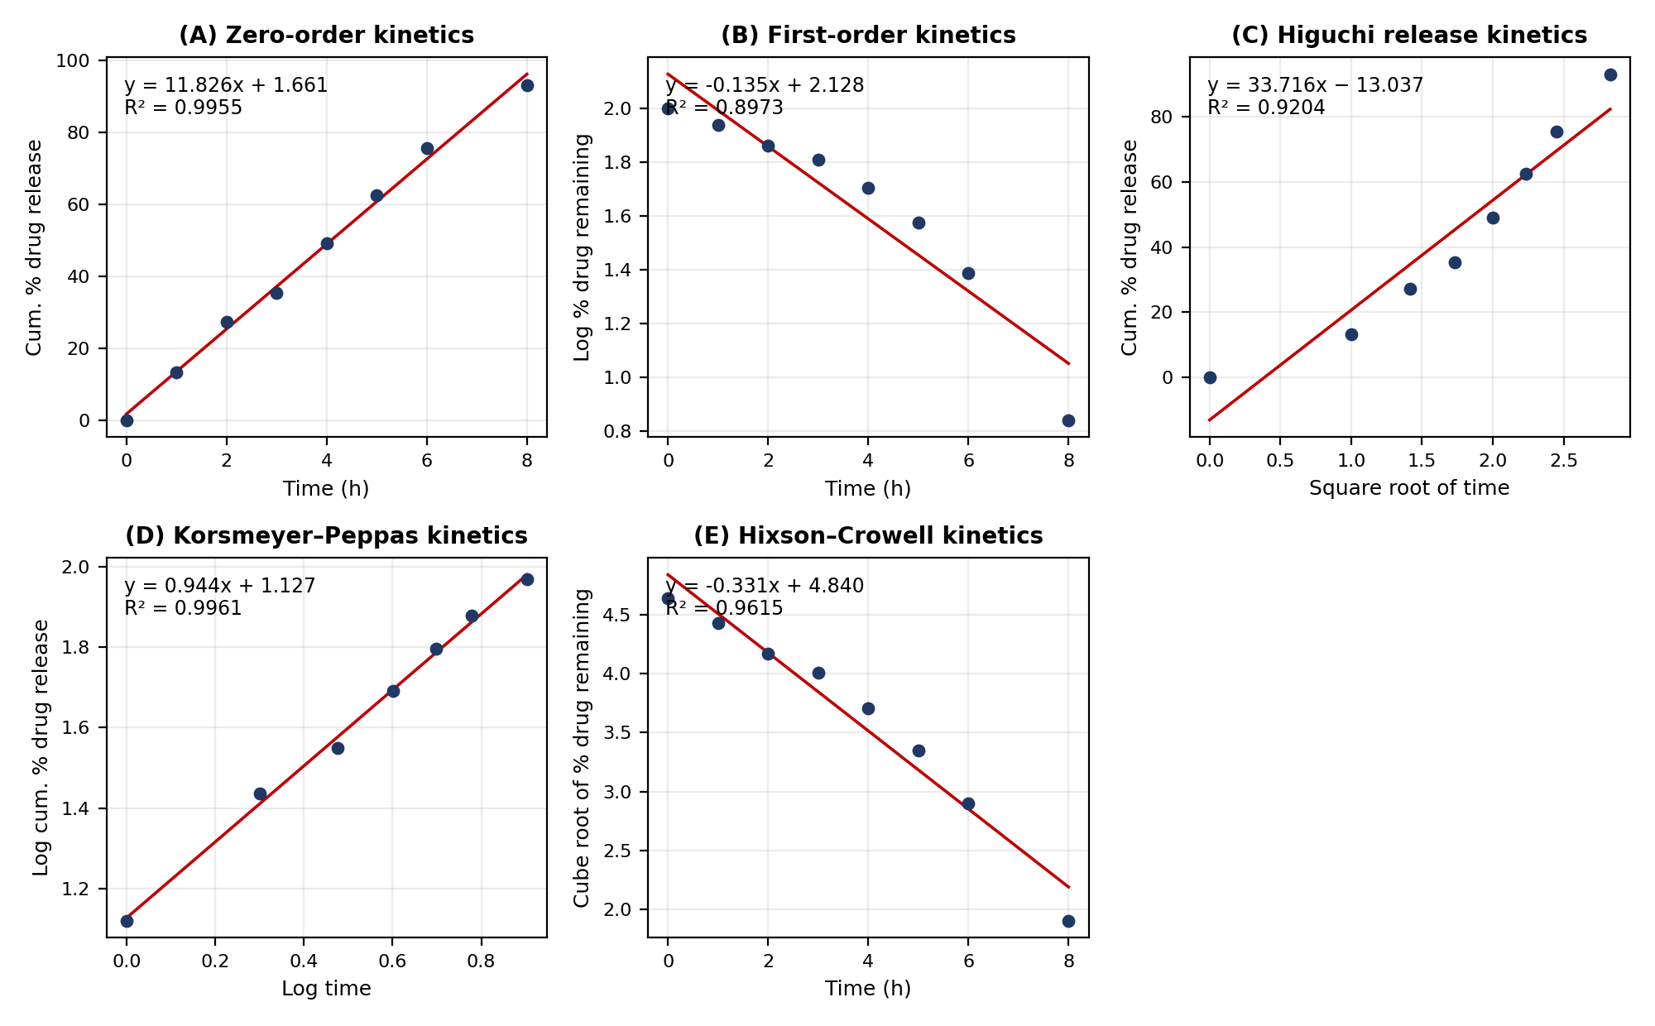
Fig. 6. Release kinetics of F4 formulation: (A) zero-order, (B) first-order, (C) Higuchi, (D) Korsmeyer–Peppas and (E) Hixson–Crowell plots
Inference. The formulation of F4 optimized transferosomal gel was analyzed for the drug release kinetics. The best fit model for the selected formulation was found to be the plot with zero-order and Peppas release kinetics. The correlation coefficient value (R² = 0.9961) indicates the best release.
The close fit to zero-order and Korsmeyer-Peppas models indicates that the observed release profile can be described by both a near-constant release-rate relationship and an empirical power-law model over the tested interval. Model selection should be based on comparative goodness-of-fit and mechanistic plausibility; for the Korsmeyer-Peppas model, interpretation of the transport mechanism additionally requires the release exponent (n), which is not reported here (Higuchi, 1963; Korsmeyer et al., 1983; Costa & Sousa Lobo, 2001). Similar transferosomal-gel studies have used these models to compare release behavior, but kinetic fitting should not by itself be taken as proof of a specific skin-permeation mechanism (Fatima et al., 2023; Mishra & Tripathi, 2025; Thakur et al., 2018).

3.6 Stability studies
Stability studies were conducted for the optimized formulation F4. The % entrapment efficiency and % drug content were assessed at room temperature and 4 ± 2 ºC for 1 month (Table 8).
Table 8. Stability studies of F4 formulation
Stability conditions | Physical appearance |  |  | Entrapment efficiency (%) |  |  | Drug content (%)
F4 formulation | Initial | After 15 days | After 30 days | Initial | After 15 days | After 30 days | Initial | After 15 days | After 30 days
At room temperature | NC | NC | NC | 91.7 | 90.9 | 90.1 | 96.8 | 96.1 | 95.8
4 ± 2 ºC | NC | NC | NC | 91.7 | 91.2 | 90.9 | 96.8 | 96.4 | 96.0
*NC – No change
After 30 days, the changes in entrapment efficiency and drug content were small under both conditions, with slightly greater retention at 4 ± 2 ºC than at room temperature. These data support short-term physicochemical stability under the tested conditions, but a one-month study is insufficient to establish a definitive shelf life because vesicular formulations can undergo time-dependent aggregation, leakage, oxidation, or other degradation processes (Waterman & Adami, 2005; Fernández-García et al., 2020; Matharoo et al., 2024). Longer-term stability testing with additional physical and chemical stability indicators would therefore be required for product-level stability claims (Bhattacharyya et al., 2024; Oyarzún et al., 2021; Sijamol et al., 2024).
4. CONCLUSION
The present study successfully developed Famciclovir-loaded transferosomal gel as a potential topical drug delivery system. Transferosomes were prepared by the ethanol injection method using soya lecithin and Tween 80 and subsequently incorporated into a Carbopol 934 gel base. Among the six formulations, F4 showed satisfactory physicochemical characteristics, with a particle size of 167.4 nm, PDI of 0.380, zeta potential of −33.5 mV and entrapment efficiency of 91.7%. The optimized transferosomal gel exhibited a pH of 6.7, good spreadability, suitable viscosity and 96.8% drug content. The formulation showed 93.08% in-vitro drug release at 8 h and demonstrated stability under the studied storage conditions. Overall, the developed Famciclovir transferosomal gel showed promising characteristics for topical drug delivery and may serve as a potential approach for localized antiviral therapy.
Future scope:
- In-vivo animal model studies can be carried out on the prepared gels.
- Long-term stability testing needs to be done.
- A skin irritation test needs to be done.
COMPETING INTERESTS
Authors have declared that no competing interests exist.
Declaration of AI Use

This manuscript was prepared through the intellectual contributions of the author(s) to the study design, data analysis, interpretation of results, and scholarly content. Grammarly and ChatGPT were used solely to assist with grammatical refinement and reference formatting during manuscript revision. The author(s) accept full responsibility for the accuracy, integrity, and final content of the manuscript.

REFERENCES
Benson, H. A. E. (2006). Transfersomes for transdermal drug delivery. Expert Opinion on Drug Delivery, 3(6), 727-737. https://doi.org/10.1517/17425247.3.6.727
Bhattacharjee, S. (2016). DLS and zeta potential - What they are and what they are not? Journal of Controlled Release, 235, 337-351. https://doi.org/10.1016/j.jconrel.2016.06.017
Bhattacharyya, S., Lakshmanan, K. T., & Muthukumar, A. (2024). Formulation and evaluation of a transferosomal gel of famciclovir for transdermal use. Turkish Journal of Pharmaceutical Sciences, 21(4), 303-312. https://doi.org/10.4274/tjps.galenos.2023.46735
Bonacucina, G., Martelli, S., & Palmieri, G. F. (2004). Rheological, mucoadhesive and release properties of Carbopol gels in hydrophilic cosolvents. International Journal of Pharmaceutics, 282(1-2), 115-130. https://doi.org/10.1016/j.ijpharm.2004.06.012
Cevc, G., & Blume, G. (1992). Lipid vesicles penetrate into intact skin owing to the transdermal osmotic gradients and hydration force. Biochimica et Biophysica Acta (BBA) - Biomembranes, 1104(1), 226-232. https://doi.org/10.1016/0005-2736(92)90154-E
Costa, P., & Sousa Lobo, J. M. (2001). Modeling and comparison of dissolution profiles. European Journal of Pharmaceutical Sciences, 13(2), 123-133. https://doi.org/10.1016/S0928-0987(01)00095-1
Danaei, M., Dehghankhold, M., Ataei, S., Hasanzadeh Davarani, F., Javanmard, R., Dokhani, A., Khorasani, S., & Mozafari, M. R. (2018). Impact of particle size and polydispersity index on the clinical applications of lipidic nanocarrier systems. Pharmaceutics, 10(2), 57. https://doi.org/10.3390/pharmaceutics10020057
Dongare, S. S., & Bhogale, V. P. (2024). Development, optimization and evaluation of psoralen loaded transfersomal gel for treatment of psoriasis. World Journal of Pharmaceutical Research, 13(5), 660-687. https://doi.org/10.20959/wjpr20245-30558
Fatima, A., Quraishi, N., & Babu, M. S. (2023). Formulation and in-vitro evaluation of gabapentin loaded transferosomal gel. Journal of Drug Delivery and Therapeutics, 13(12), 60-67. https://doi.org/10.22270/jddt.v13i12.6081
Fernández-García, R., Lalatsa, A., Statts, L., Bolás-Fernández, F., Ballesteros, M. P., & Serrano, D. R. (2020). Transferosomes as nanocarriers for drugs across the skin: Quality by design from lab to industrial scale. International Journal of Pharmaceutics, 573, 118817. https://doi.org/10.1016/j.ijpharm.2019.118817
Gosavi, A. A., Thorat, P. A., & Mulla, J. A. S. (2024). Formulation and evaluation of acyclovir loaded transferosomal gel for transdermal drug delivery. Journal of Drug Delivery and Therapeutics, 14(9), 122-130. https://doi.org/10.22270/jddt.v14i9.6786
Higuchi, T. (1963). Mechanism of sustained-action medication: Theoretical analysis of rate of release of solid drugs dispersed in solid matrices. Journal of Pharmaceutical Sciences, 52(12), 1145-1149. https://doi.org/10.1002/jps.2600521210
Humnabade, S. N., Nagoba, S. N., Nagare, S. K., Fugate, A. R., & Somwanshi, B. T. (2024). Formulation and evaluation of transferosomal gel as a potential therapy for treatment of cellulitis. African Journal of Biological Sciences, 6(14), 8650-8657. https://doi.org/10.48047/AFJBS.6.14.2024.8650-8657
Iftikhar, I., Barkat, K., Badshah, S. F., Ashraf, M. U., Mehmood, Y., Anjum, I., Shazly, G. A., Metouekel, A., Younous, Y. A., & Bourhia, M. (2025). Formulation of pH responsive polymeric hydrogels for prolonged delivery of famciclovir with biosafety evaluation. Scientific Reports, 15(1), 18686. https://doi.org/10.1038/s41598-025-96739-4
Islam, M. T., Rodríguez-Hornedo, N., Ciotti, S., & Ackermann, C. (2004). Rheological characterization of topical carbomer gels neutralized to different pH. Pharmaceutical Research, 21(7), 1192-1199. https://doi.org/10.1023/B:PHAM.0000033006.11619.07
Jasmin, M. K. P., Battu, S., & Vishwanath, B. A. (2024). Transferosomes for effective transdermal drug delivery. International Journal of Pharmaceutical Sciences Review and Research, 84(4), 10-21. https://doi.org/10.47583/ijpsrr.2024.v84i04.002
Jin, X., Alavi, S. E., Shafiee, A., Leite-Silva, V. R., Khosrotehrani, K., & Mohammed, Y. (2023). Metamorphosis of topical semisolid products - Understanding the role of rheological properties in drug permeation under the "in use" condition. Pharmaceutics, 15(6), 1707. https://doi.org/10.3390/pharmaceutics15061707
Kanugo, A., Deshpande, A., & Sharma, R. (2023). Formulation optimization and evaluation of nanocochleate gel of famciclovir for the treatment of herpes zoster. Recent Patents on Nanotechnology, 17(3), 259-269. https://doi.org/10.2174/1872210516666220622115553
Korsmeyer, R. W., Gurny, R., Doelker, E., Buri, P., & Peppas, N. A. (1983). Mechanisms of solute release from porous hydrophilic polymers. International Journal of Pharmaceutics, 15(1), 25-35. https://doi.org/10.1016/0378-5173(83)90064-9
Kumar, P. K., & Kumar, R. S. (2021). Review on transferosomes and transferosomal gels. Journal of Pharmaceutical Research International, 33(43B), 114-126. https://doi.org/10.9734/jpri/2021/v33i43B32532
Lotfy, H. M., Abd El-Moneim Abosen, M. M., & El-Bardicy, M. G. (2010). Stability-indicating methods for the determination of famciclovir in the presence of its alkaline-induced degradation product. Drug Testing and Analysis, 2(4), 188-199. https://doi.org/10.1002/dta.119
Madhulika, & Gupta, M. K. (2023). Formulation and development of transferosomal gel incorporating with chrysin for topical application. Indo American Journal of Pharmaceutical Sciences, 10(6), 170-176. https://doi.org/10.5281/zenodo.8127421
Matharoo, N., Mohd, H., & Michniak-Kohn, B. (2024). Transferosomes as a transdermal drug delivery system: Dermal kinetics and recent developments. WIREs Nanomedicine and Nanobiotechnology, 16(1), e1918. https://doi.org/10.1002/wnan.1918
Mishra, N., & Tripathi, A. (2025). Design and in vitro evaluation of transfersomal gel system: A novel approach for transdermal drug delivery. Journal of Neonatal Surgery, 14(15S), 2410-2419. https://jneonatalsurg.com/index.php/jns/article/view/8626
Nidbane, A., Dound, A., Satpute, K., & Syed, S. M. (2025). Development of a novel luliconazole transferosomal gel for enhanced antifungal delivery. Journal of Dermatologic Science and Cosmetic Technology, 2(1), 100071. https://doi.org/10.1016/j.jdsct.2025.100071
Nizamuddin, S., Gurupadayya, B. M., Ravi, M. C., Manohara, Y. N., & Appala Raju, S. (2007). Spectrophotometric estimation of famciclovir in bulk and tablet dosage form. Indian Journal of Pharmaceutical Sciences, 69(3), 451-453. https://doi.org/10.4103/0250-474X.34562
Oyarzún, P., Gallardo-Toledo, E., Morales, J., & Arriagada, F. (2021). Transfersomes as alternative topical nanodosage forms for the treatment of skin disorders. Nanomedicine, 16(27), 2465-2489. https://doi.org/10.2217/nnm-2021-0335
Shukla, K. V., Meshram, R., & Yadav, M. (2019). Formulation, development and evaluation of transfersomal gel of metronidazole. Journal of Drug Delivery and Therapeutics, 9(4-A), 642-645. https://doi.org/10.22270/jddt.v9i4-A.3544
Sijamol, C. S., Hasnamol, & Mahendran, S. (2024). From formulation to function: A review of transferosomes and their preparation methods. European Journal of Biomedical and Pharmaceutical Sciences, 11(11), 119-127. https://storage.googleapis.com/innctech/ejbps/article_issue/volume_11_november_issue_11/1730200002.pdf
Simpson, D., & Lyseng-Williamson, K. A. (2006). Famciclovir: A review of its use in herpes zoster and genital and orolabial herpes. Drugs, 66(18), 2397-2416. https://doi.org/10.2165/00003495-200666180-00016
Singh, A., & Malik, J. K. (2025). Preformulation studies of famciclovir: Vital part of formulation design. EAS Journal of Pharmacy and Pharmacology, 7(2), 40-46. https://doi.org/10.36349/easjpp.2025.v07i02.001
Srinubabu, G., Sudharani, B., Sridhar, L., & Seshagiri Rao, J. V. L. N. (2006). Development and validation of liquid chromatographic and UV derivative spectrophotometric methods for the determination of famciclovir in pharmaceutical dosage forms. Chemical & Pharmaceutical Bulletin, 54(6), 819-822. https://doi.org/10.1248/cpb.54.819
Thakur, N., Jain, P., & Jain, V. (2018). Formulation development and evaluation of transferosomal gel. Journal of Drug Delivery and Therapeutics, 8(5), 168-177. https://doi.org/10.22270/jddt.v8i5.1826
Waterman, K. C., & Adami, R. C. (2005). Accelerated aging: Prediction of chemical stability of pharmaceuticals. International Journal of Pharmaceutics, 293(1-2), 101-125. https://doi.org/10.1016/j.ijpharm.2004.12.013

