Original Research Article
Exploring the Potential of Heliotropium indicum Aqueous and Ethanolic Leaf Extracts as Novel Antioxidant and Anti-inflammatory Agents: A Comparative In vitro Study

Abstract
The search for novel antioxidant and anti-inflammatory agents is one of the most critical frontiers in modern medicine and pharmacology. Heliotropium indicum is widely used in traditional medicine, but the comparative in vitro antioxidant and anti-inflammatory activities of its aqueous and ethanolic leaf extracts remains unclear, and was investigated in this study. Aqueous and ethanolic leaf extracts of H. indicum was prepared using standard procedures. The in vitro antioxidant activity of both extracts was investigated using total antioxidant capacity (TAC), 2,2-Diphenyl-1-picrylhydrazyl (DPPH) radical scavenging, hydroxyl (OH) radical scavenging and nitric oxide (NO) radical scavenging assays. The in vitro anti-inflammatory activity of both extracts was investigated using albumin denaturation, membrane stabilization and antiprotease assays. Results obtained from this study revealed that both the aqueous and ethanolic leaf extracts of H. indicum showed dose-dependent antioxidant and anti-inflammatory activities across assays. The ethanolic leaf extract had significantly better antioxidant and anti-inflammatory potential across the various assays as evident by significantly (p < 0.05) lower IC₅₀ values. Hence, while both extracts possess appreciable antioxidant and anti-inflammatory activity, the ethanolic leaf extract of H. indicum could represent a better source of novel antioxidant and anti-inflammatory agents.
Keywords: Heliotropium indicum; Aqueous extract; Ethanol extract; Antioxidants, Anti-inflammatory

1. Introduction
Oxidative stress and inflammation are closely interconnected biological processes that contribute to the initiation and progression of numerous acute and chronic disorders (Altanam et al., 2025; Manful et al., 2025a). Oxidative stress occurs when the generation of reactive oxygen species (ROS) and reactive nitrogen species exceeds the capacity of endogenous antioxidant systems to neutralize them, resulting in oxidative damage to cellular lipids, proteins and nucleic acids (Birben et al., 2012; Qin et al., 2026; Sies, 2015). Although ROS are essential for normal cellular signaling and host defense, their excessive accumulation can activate redox-sensitive inflammatory pathways and promote the production of pro-inflammatory mediators (Manful et al., 2025b). Conversely, inflammatory responses can further enhance oxidative stress through the activation of immune cells and increased generation of reactive species, thereby establishing a self-perpetuating relationship between oxidative damage and inflammation (Altanam et al., 2025; Bellanti et al., 2025). Consequently, the identification of natural products capable of attenuating oxidative stress and inflammatory responses remains an important area of pharmacological research (Jia et al., 2018).
Medicinal plants represent a valuable source of structurally diverse secondary metabolites with antioxidant and anti-inflammatory properties. Phenolic compounds, flavonoids, terpenoids, tannins, and other valuable phytochemicals have been reported to exhibit free-radical-scavenging, metal-chelating and inflammation-modulating activities through several complementary mechanisms (Latif & Nawaz, 2026; Sun & Shahrajabian, 2023). The antioxidant activity of plant extracts is commonly investigated using in vitro assays such as 2,2-diphenyl-1-picrylhydrazyl (DPPH) radical scavenging, nitric oxide (NO) scavenging and related reducing or radical-scavenging methods (Chaves et al., 2020; Enyi et al., 2026). Similarly, in vitro models including inhibition of protein denaturation, membrane stabilization and inhibition of enzymes or mediators associated with inflammation have been employed as preliminary approaches for evaluating anti-inflammatory potential (Hassan et al., 2023; Sabalingam, 2025). These assays serve as fast, cost-effective preliminary screening tools to identify bioactive plant extracts or compounds with antioxidant and anti-inflammatory potentials (Cerulli et al., 2021; Sultana et al., 2026).
Heliotropium indicum L., known as Indian heliotrope, is a medicinal herb belonging to the Boraginaceae family that is widely distributed in tropical and subtropical regions. The plant has a history of use in traditional medicine for managing conditions associated with inflammation, pain, wounds and other ailments (Anupam, 2015; Sarkar et al., 2021). Experimental studies have also suggested antioxidant, antimicrobial, anti-inflammatory and other pharmacological properties of extracts or isolated constituents of the plant (Sarkar et al., 2021). Phytochemical investigations of H. indicum have demonstrated the presence of several classes of bioactive constituents, including phenolic compounds, flavonoids, glycosides, tannins, terpenoids and alkaloids, which may contribute to its reported biological activities (Ajoh et al., 2026; Shoily et al., 2026).
Despite the traditional use and reported pharmacological potential of H. indicum, comparative information on the in vitro antioxidant and anti-inflammatory activities of its aqueous and ethanolic leaf extracts remains limited. Direct comparison of these preparations is important because differences in solvent composition may translate into differences in extraction efficiency and bioactivity. Hence, the present study was designed to comparatively evaluate the in vitro antioxidant and anti-inflammatory activities of aqueous and ethanolic leaf extracts of H. indicum. By comparing the two extraction systems using standardized experimental approaches, the study seeks to determine whether the choice of solvent influences the biological activity of the leaf extracts and to provide preliminary evidence supporting the potential use of H. indicum as a source of antioxidant and anti-inflammatory agents.

2. Materials and Methods
2.1 Collection and Authentication of Plant
Fresh plants of Heliotropium indicum were harvested from an uncultivated land in Ughelli, Delta state, Nigeria. The plant was authenticated by Prof. Adewale Akinnibosun, of the Herbarium unit, Department of Plant Biology and Biotechnology, Faculty of Life Sciences, University of Benin, Benin city, Edo state, Nigeria with an assigned voucher number of UBH-H533.
2.2 Preparation of Heliotropium indicum Aqueous and Ethanolic Extracts
The leaves of H. indicum plant were plucked and rinsed thoroughly. The leaves were then air-dried under shade at room temperature for 14 days. The dried leaves were pulverized into fine powder and used for preparation of H. indicum aqueous and ethanolic extracts. The aqueous and ethanolic extracts were prepared using the maceration technique. Following extraction, the extracts were freeze-dried at the Department of Pharmacognosy, Faculty of Pharmacy, Delta State University, Abraka. The obtained freeze-dried samples were then stored in a refrigerator until further analyses.
2.3 In vitro antioxidant activity of H. indicum aqueous and ethanolic extracts
2.3.1 Total antioxidant capacity
The total antioxidant capacity of H. indicum aqueous and ethanolic extracts was determined using the phosphomolybdate assay as previously described by Prieto et al. (1999) with slight modifications. The assay is based on reduction of the phosphomolybdate ion (MoVI) resulting in the formation of a green phosphate (MoV) complex in the presence of an antioxidant, which is measured spectrophotometrically. Different dilutions (15.625, 31.25, 62.50, 125.00, 250.00, 500.00 and 1000 μg/ml) of H. indicum extracts (aqueous and ethanolic), as well as the standard (ascorbic acid) were prepared and 0.1 ml aliquot of the samples added to separate test tubes except the blank tube (control). Each of the concentrations was carried out in triplicates. To each of the tube, 1 mL of phosphomolybdenum reagent (comprising 0.6 M sulfuric acid, 28 mM sodium phosphate, and 4 mM ammonium molybdate) was added. After incubation for a period of 90 minutes at 95 ◦C using water bath and cooling of the samples to room temperature, their absorbances at 695 nm were recorded. The total antioxidant activity (phosphomolybdate inhibitory) of the plant extracts was calculated using the equation:
TAC (% inhibition) = [(Abs. of control − Abs. of sample)/(Abs. of control] × 100
The plot of the % inhibition was plotted against the concentrations and used to determine the concentration of the extracts at which 50% inhibition is observed (IC₅₀) in comparison to the standard.
2.3.2 2,2-Diphenyl-1-picrylhydrazyl (DPPH) assay
The DPPH free radical scavenging activity of the aqueous and ethanolic extracts of H. indicum was determined according to the method by Liyana-Pathiana and Shahidi (2005) with slight modifications. 1 ml of 0.135 mM DPPH prepared in methanol was mixed with 1 ml of the extracts (aqueous and ethanolic) and standard (ascorbic acid) ranging from 15.625 to 1000 μg/ml. The reaction mixtures were thoroughly vortexed and then left in the dark at room temperature for a period of 30 minutes. Thereafter, the absorbances were measured spectrophotometrically at 517 nm. The DPPH scavenging activity of the plant extracts and standard was calculated using the equation:
DPPH scavenging activity (%) = [(Abs. control – Abs. sample)]/(Abs. control)] × 100
Where; Abs. control is the absorbance of DPPH + methanol and;
Abs. sample is the absorbance of DPPH radical + sample (i.e. extracts or standard).
The plot of the % inhibition was plotted against the concentrations and used to determine the concentration of the extracts at which 50% inhibition is observed (IC₅₀) in comparison to the standard.
2.3.3 Nitric oxide scavenging assay
The method described by Oyedemi et al. (2010) with slight modifications was used to determine the nitric oxide radical scavenging activity of H. indicum in this assay. It relies on the fact that Sodium nitroprusside in aqueous solution at physiological pH spontaneously generates nitric oxide which interacts with oxygen to produce nitrite ions determined by the use of Griess reagents. Two milliliters of 10 mM sodium nitroprusside dissolved in 0.5 ml phosphate buffer saline (pH 7.4) was mixed with 0.5 ml of the plant extracts at various concentrations (15.625 to 1000 μg/ml). The mixture was incubated at 25 °C. After 150 minutes, 0.5 ml of incubated solution was withdrawn and mixed with 0.5 ml of Griess reagent [1.0 ml sulfanilic acid reagent (0.33% in 20% glacial acetic acid at room temperature for 5 minutes) with 1 ml of naphthylethylenediamine dichloride (0.1% w/v)]. The mixture was incubated at room temperature for 30 minutes. Thereafter, the absorbance was measured at 540nm. The amount of nitric oxide radicals inhibited by the extracts was calculated following this equation:
% inhibition of NO = [(Abs control – Abs sample)]/(Abs control)] × 100
Where; Abs control is the absorbance of NO radicals + methanol and;
Abs sample is the absorbance of NO radical + extract or standard.
The plot of the % inhibition was plotted against the concentrations and used to determine the concentration of the extracts at which 50% inhibition is observed (IC₅₀).
2.3.4 Hydroxyl radical scavenging assay
The hydroxyl radical scavenging activity of H. indicum aqueous and ethanolic extracts was determined using the Fenton reaction-based deoxyribose degradation assay as previously described by Gutteridge (1984) with slight modifications. In this method, generation of hydroxyl radicals (•OH) occurs through the reaction of Fe³⁺–EDTA, ascorbic acid and hydrogen peroxide, which subsequently degrade deoxyribose into products that react with thiobarbituric acid (TBA) to form a pink chromogen measurable at 532 nm. The reaction mixture contained, in a final volume of 1 ml, 2-deoxy-2-ribose (2.8 mM); KH₂PO₄-KOH buffer (20 mM, pH 7.4); FeCl₃ (100 μM); EDTA (100 μM); H₂O₂ (1.0 mM); ascorbic acid (100 μM) and various concentrations (15.625 to 1000 μg/ml) of the extracts. The reaction mixture was allowed to incubate for 1 hour at 37 °C and after incubation, 0.5 ml of the reaction mixture was mixed with 1 ml 2.8% TCA, after which 1 ml 1% aqueous TBA was added to it. The solution was then incubated at 90 °C for 15 minutes to allow color development. After the incubation, the solution was cooled down and the absorbance was measured at 532 nm against an appropriate blank solution. All tests were performed in triplicates. Percentage of inhibition will be evaluated by the following equation:
% inhibition= [(A₀-A₁) / A₀] × 100
Where: A₀ is the absorbance of the control and;
A₁ will be the absorbance in the presence of the samples.
2..4 In vitro anti-inflammatory activity of H. indicum aqueous and ethanolic extracts
2.4.1 Albumin denaturation assay
The method previously described by Chandra et al. (2012) was used with slight modifications. 0.2 ml of 1% egg albumin solution, 2 ml of the sample extract (aqueous and ethanolic of H. indicum) or standard (Diclofenac sodium) at varying concentrations (15.625 to 1000 μg/ml), and 2.8 ml of phosphate-buffered saline (pH 7.4) were mixed to form a reaction mixture with a total volume of 5 ml. For the control, a total volume of 5 ml was also created by combining 2 ml of distilled water, 0.2 ml of 1% egg albumin solution, and 2.8 ml of phosphate-buffered saline. The reaction mixtures were incubated at 37 °C for 30 minutes and then heated in at 70 °C for 15 minutes in a water bath. After cooling, the absorbances were measured at 280 nm. The % inhibition of albumin denaturation was determined using the equation:
% inhibition = [(Abs control – Abs sample)]/(Abs control)] × 100
The 50% inhibition (IC₅₀) of the extracts and standard were determined by plotting percentage inhibition against concentration.
2.4.2 Membrane Stabilization against Heat-Induced Hemolysis
This was carried out according to method previously described by Shinde et al. (1999) with slight modifications. Human blood was obtained by venipuncture from healthy volunteer, collected into heparinized tubes and centrifuged at 2000 rpm for 10 minutes at 4°C. After removing the plasma, red blood cells (RBCs) were washed for three successive times using phosphate buffer saline (PBS) (0.9% NaCl). The reaction mixture (2.0 ml) consisted of 1.0 ml of 10% human red blood cell (HRBC) and 1.0 ml of various concentrations of the aqueous and ethanolic H. indicum extracts (15.625, 31.25, 62.50, 125.00, 250.00, 500.00 and 1000 μg/ml) which was added to each test tube and mixed gently. The standard consisted of 1.0 ml of HRBC and 1.0 ml of various concentrations of diclofenac sodium (15.625, 31.25, 62.50, 125.00, 250.00, 500.00 and 1000 μg/ml). The control consisted of 1.0 ml of 10% erythrocyte suspension and 1.0 ml of normal saline alone. The experiment was performed in triplicates. The resulting solutions were heated at 56 °C for 30 minutes, cooled to room temperature and then centrifuged at 2000 rpm for 10 minutes. The supernatants were collected, and absorbance of each solution measured at 560 nm. The percentage inhibition of hemolysis was calculated using the equation:
% inhibition = [(Abs control – Abs sample)]/(Abs control)] × 100
The 50% inhibition of heat-induced hemolysis (IC₅₀) of the extracts and standard were determined by plotting percentage inhibition against concentration.
2.4.3 Antiprotease activity assay
The antiprotease activity of the extracts was carried out according to previously described method by Oyedepo and Femurewa et al. (1999) and Sakat et al. (2010) with slight modifications. The final reaction mixture in each test tubes consist of 1 ml 25mM Tris-HCl buffer (pH 7.4), 250 μL of trypsin and 1 ml of sample extracts and standard (diclofenac sodium) at varying concentrations (15.625, 31.25, 62.50, 125.00, 250.00, 500.00 and 1000 μg/ml). The mixture was then incubated for a period of 5 minutes at 37 °C. Thereafter, 1.0 ml of 0.8% (w/v) casein was added, and the mixture incubated for another 20 minutes. Following incubation, 2 ml of 70% perchloric acid was added to each test tube to arrest the reaction. The cloudy suspension obtained was centrifuged and absorbance of the supernatant read at 210 nm against the buffer as blank (control). The experiment was repeated in triplicates and percentage inhibition of protease activity was calculated using the equation:
% inhibition = [(Abs control – Abs sample)]/(Abs control)] × 100
The IC₅₀ of the extracts and standard were determined by plotting percentage inhibition against concentration.
2.5 Statistical Analysis
GraphPad Prism version 10 was used for statistical analysis. Results were represented as Mean ± SD of triplicate determinations. Students t-Test and One-way analysis of variance (ANOVA) followed by Tukey post-hoc analysis were used to analyze difference in group mean. A p-value less than 0.05 was considered statistically significant.

3. Results
3.1 In vitro antioxidant activity of H. indicum aqueous and ethanolic extracts
3.1.1 Total antioxidant capacity (TAC)
The comparative total antioxidant capacity (TAC) of the aqueous and ethanolic leaf extracts of Heliotropium indicum was determined using the phosphomolybdate inhibition assay, and the half maximal inhibitory concentration (IC₅₀) was extrapolated as shown below:
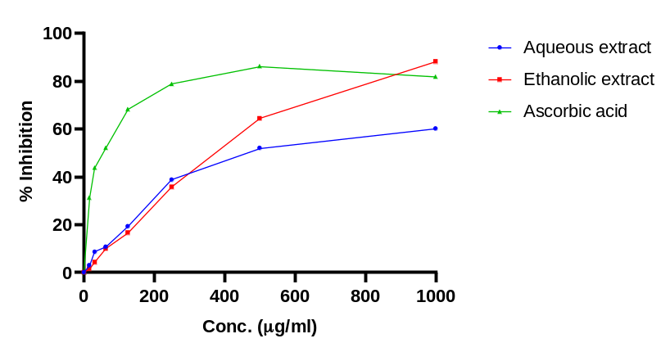
Figure 1: Percentage phosphomolybdate inhibitory activity of H. indicum extracts
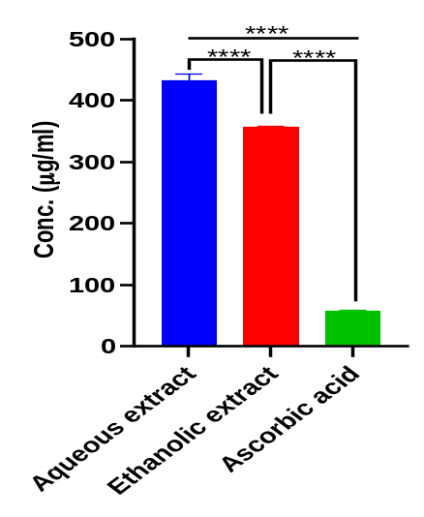
**** = Statistically significant
Figure 2: Bars showing TAC IC₅₀ values of H. indicum extracts
The results show that the ethanolic extract of H. indicum possess significantly higher total antioxidant capacity (phosphomolybdate inhibitory activity) as evident by the observed significantly (p < 0.05) lower IC₅₀ values (356.82 ± 1.66 µg/ml) when compared to that of the aqueous extract (432.14 ± 11.14 µg/ml). The TAC of the standard, ascorbic acid, was significantly (p < 0.05) higher than both extracts (IC₅₀ = 58.17 ± 1.10 µg/ml).
3.1.2 2,2-Diphenyl-1-picrylhydrazyl (DPPH) assay
The comparative DPPH inhibitory activity of the aqueous and ethanolic leaf extracts of Heliotropium indicum was determined and the half maximal inhibitory concentration (IC₅₀) was extrapolated as shown below:
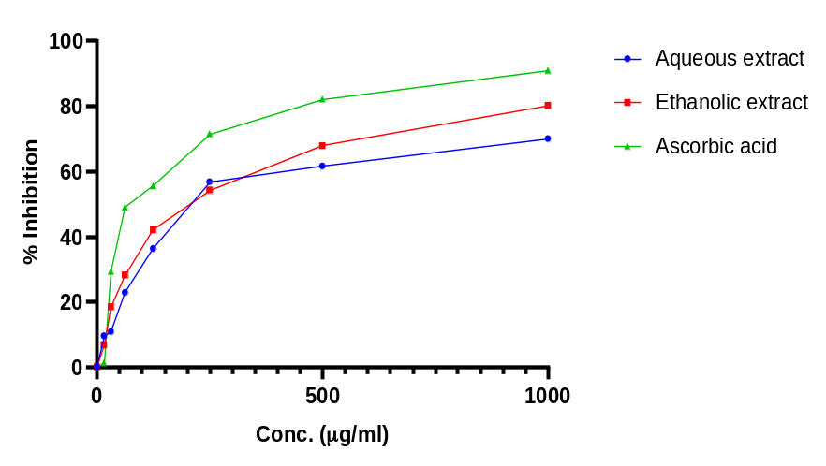
Figure 3: Percentage DPPH inhibitory activity of H. indicum extracts
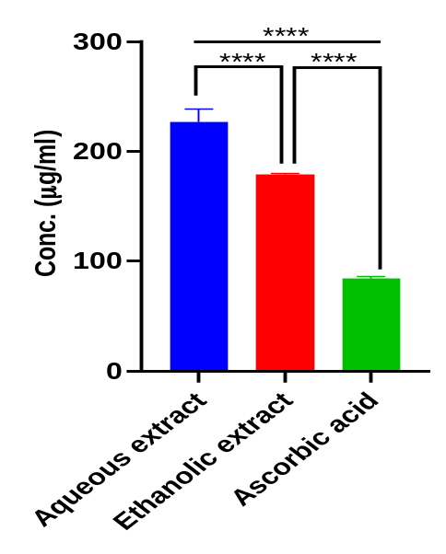
**** = Statistically significant
Figure 4: Bars showing DPPH IC₅₀ values of H. indicum extracts
The results show that the ethanolic extract of H. indicum possess significantly (p < 0.05) better DPPH inhibitory activity (IC₅₀ = 178.93 ± 1.14 µg/ml) when compared to that of the aqueous extract (IC₅₀ = 226.80 ± 11.87 µg/ml). The DPPH inhibitory activity of the standard, ascorbic acid, was significantly (p < 0.05) higher than both extracts (IC₅₀ = 84.13 ± 1.74 µg/ml).
3.1.3 Nitric oxide scavenging (NOS) assay
The comparative nitric oxide scavenging activity of the aqueous and ethanolic leaf extracts of Heliotropium indicum was determined and the half maximal inhibitory concentration (IC₅₀) was extrapolated as shown below:
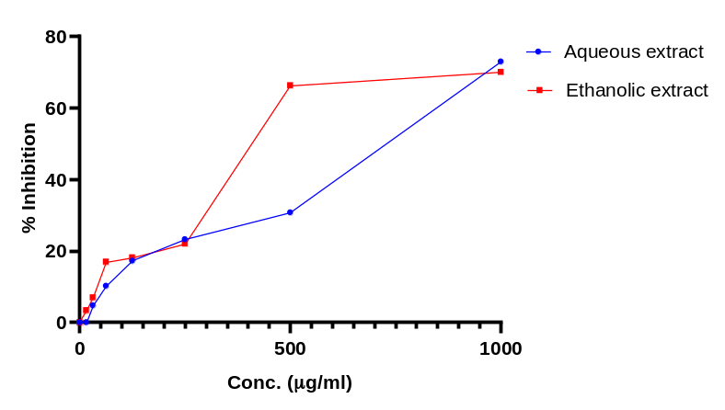
Figure 5: Percentage nitric oxide inhibitory activity of H. indicum extracts
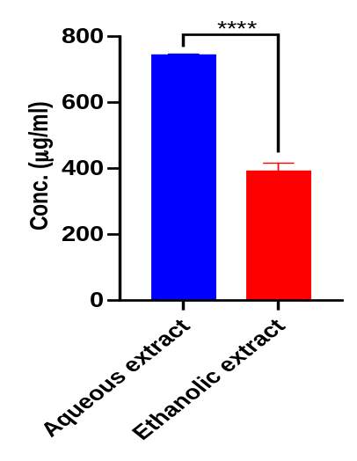
**** = Statistically significant
Figure 6: Bars showing NOS IC₅₀ values of H. indicum extracts
The results show that the ethanolic extract of Heliotropium indicum possess significantly (p < 0.05) higher NO scavenging activity (IC₅₀ = 390.83 ± 25.75 µg/ml) than the aqueous extract of Heliotropium indicum (IC₅₀ = 744.59 ± 3.79 µg/ml).
3.1.4 Hydroxyl radical Scavenging (HRS) activity
The comparative hydroxyl radical scavenging activity of the aqueous and ethanolic leaf extracts of Heliotropium indicum was determined and the half maximal inhibitory concentration (IC₅₀) was extrapolated as shown below:
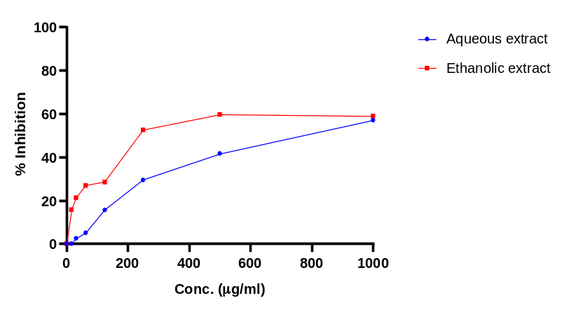
Figure 7: Percentage Hydroxyl radical scavenging activity of H. indicum extracts
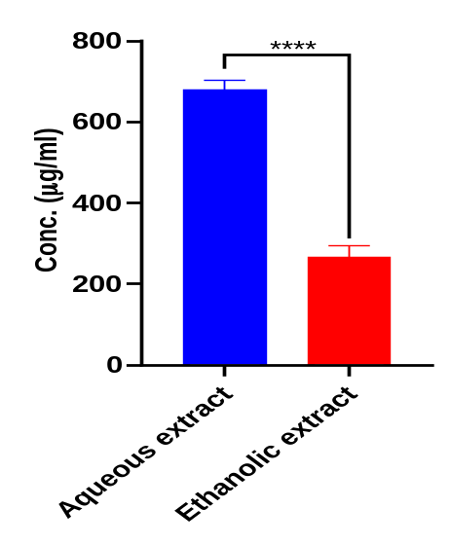
**** = Statistically significant
Figure 8: Bars showing HRS IC₅₀ values of extracts
The results revealed that the ethanolic extract of Heliotropium indicum possess significantly (p < 0.05) higher hydroxyl radical scavenging activity (IC₅₀ = 267.13 ± 27.97 µg/ml) than the aqueous extract of Heliotropium indicum (IC₅₀ = 679.29 ± 22.91 µg/ml).
Table 1: Summary of IC₅₀ values across in vitro antioxidant assays
Extract/Standard | IC₅₀ values (µg/ml)
 | TAC | DPPH | Nitric oxide | Hydroxyl radical
Aqueous H. indicum | 432.14 ± 11.14 | 226.80 ± 11.87 | 744.59 ± 3.79 | 679.29 ± 22.91
Ethanolic H. indicum | 356.82 ± 1.66 | 178.93 ± 1.14 | 390.83 ± 25.75 | 267.13 ± 27.97
Ascorbic acid | 58.17 ± 1.10 | 84.13 ± 1.74 | - | -

On the whole, the results obtained from the in vitro antioxidant assays (TAC, DPPH, NOS, HRS) revealed that the ethanolic extract of H. indicum possess significantly better antioxidant potential than the aqueous extract as evident by the significantly lower IC₅₀ values across assys. This suggests that the ethanolic extract had better potential in treating oxidative stress-related diseases when compared to the aqueous extract.
3.2 In vitro anti-inflammatory activity of H. indicum aqueous and ethanolic extracts
3.2.1 Albumin denaturation assay
The comparative albumin denaturation inhibitory activity of the aqueous and ethanolic leaf extracts of Heliotropium indicum was determined and the half maximal inhibitory concentration (IC₅₀) was extrapolated as shown in figure below:
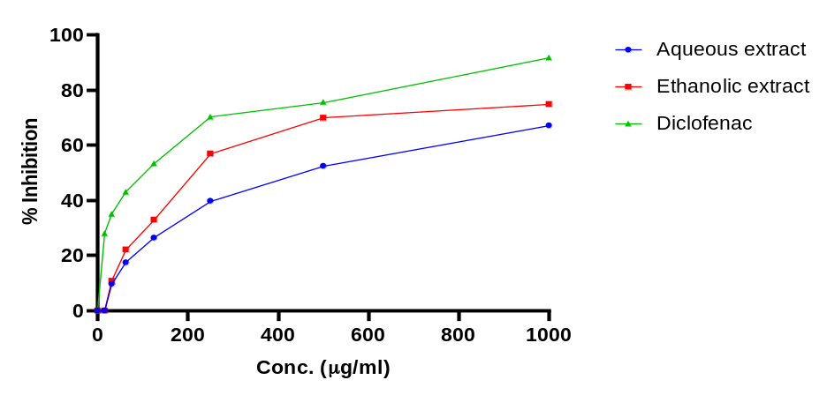
Figure 9: Albumin denaturation inhibitory activity of H. indicum extracts
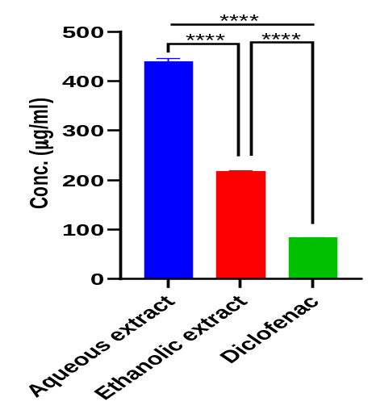
**** = Statistically significant
Figure 10: Bars showing albumin denaturation IC₅₀ values for H. indicum extracts
The results of the study revealed that the ethanolic extract of H. indicum significantly (p < 0.05) inhibited the denaturation of egg yolk albumin (IC₅₀ = 217.60 ± 2.09 µg/ml) better than the aqueous extract of Heliotropium indicum (IC₅₀ = 440.13 ± 6.43 µg/ml). The albumin denaturation inhibitory activity of the standard, diclofenac, was significantly (p < 0.05) higher than both extracts (IC₅₀ = 83.52 ± 0. 31 µg/ml).
3.2.2 Membrane Stabilization
The comparative RBC membrane stabilization (inhibition of heat-induced hemolysis) activity of the aqueous and ethanolic leaf extracts of Heliotropium indicum was determined and the half maximal inhibitory concentration (IC₅₀) was extrapolated as shown in figure below:
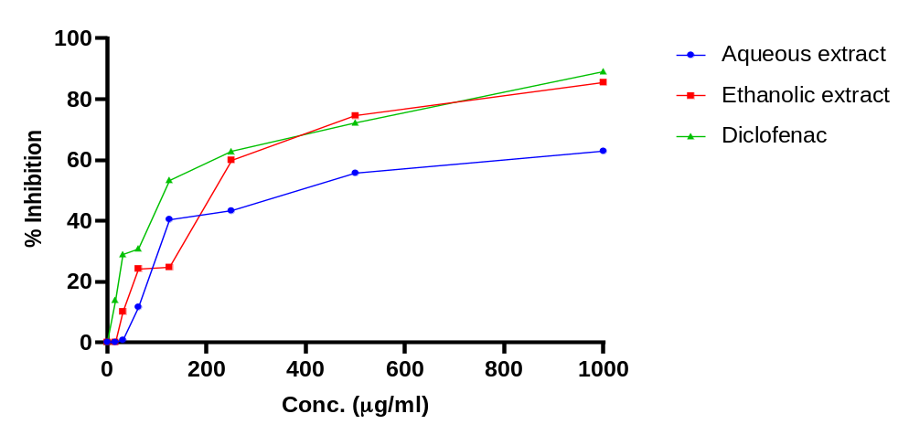
Figure 11: HRBC membrane stabilization (inhibition of heat-induced hemolysis) activity of H. indicum extracts
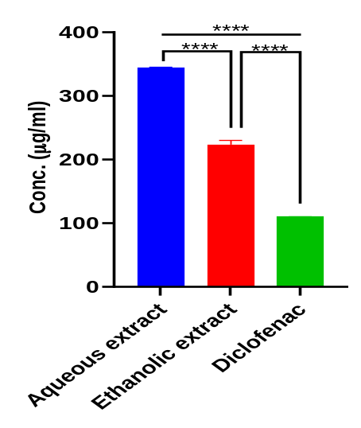
**** = Statistically significant
Figure 12: Bars showing IC₅₀ values for H. indicum extracts
The results of the study revealed that the ethanolic extract of H. indicum significantly (p < 0.05) inhibited heat-induced hemolysis of human red blood cells (IC₅₀ = 223.29 ± 6.91 µg/ml) in comparison to the aqueous extract of Heliotropium indicum (IC₅₀ = 343.89 ± 1.79 µg/ml), thereby stabilizing RBC membrane better than the aqueous extract. The RBC membrane stabilization activity of the standard, diclofenac, was significantly (p < 0.05) higher than both the aqueous and ethanolic extracts (IC₅₀ = 109.81 ± 0.43 µg/ml).
3.2.3 Antiprotease activity
The comparative antiprotease (inhibition of trypsin) activity of the aqueous and ethanolic leaf extracts of Heliotropium indicum was determined and the half maximal inhibitory concentration (IC₅₀) was extrapolated as shown in figure below:
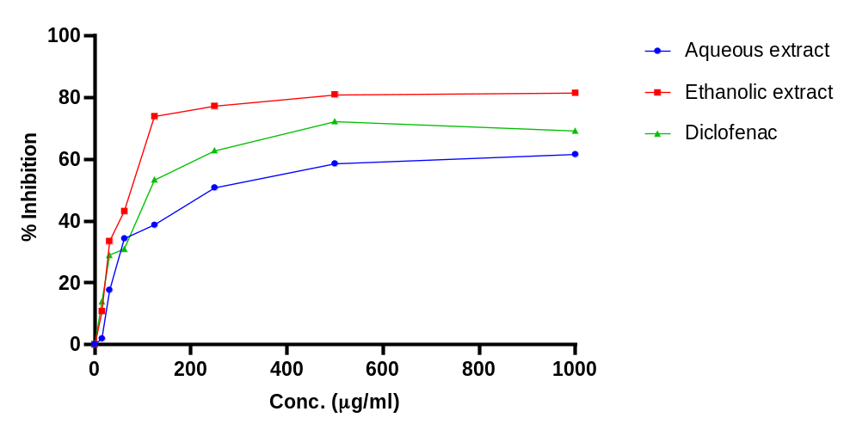
Figure 13: Antiprotease activity of H. indicum extracts
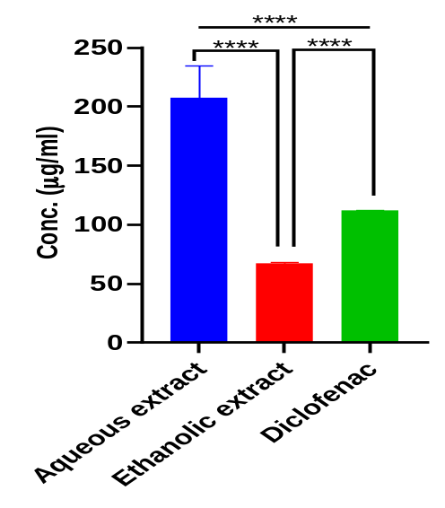
**** = Statistically significant
Figure 14: Bars showing Antiprotease IC₅₀ values for H. indicum extracts
The results of the study revealed that the ethanolic extract of H. indicum had significantly (p < 0.05) higher antiprotease inhibitory activity (IC₅₀ = 66.88 ± 1.34 µg/ml) in comparison to the aqueous extract of Heliotropium indicum (IC₅₀ = 207.36 ± 27.47 µg/ml), and diclofenac, the standard (IC₅₀ = 111.70 ± 0.41 µg/ml).
Table 2: Summary of IC₅₀ values across in vitro anti-inflammatory assays
Extract/Standard | IC₅₀ values (µg/ml)
 | Albumin denaturation | Membrane stabilization | Antiprotease
Aqueous H. indicum | 440.13 ± 6.43 | 343.89 ± 1.79 | 207.36 ± 27.47
Ethanolic H. indicum | 217.60 ± 2.09 | 223.29 ± 6.91 | 66.88 ± 1.34
Diclofenac | 83.52 ± 0. 31 | 109.81 ± 0.43 | 111.70 ± 0.41
On the whole, the results obtained from the in vitro anti-inflammatory assays (albumin denaturation, membrane stabilization, antiprotease) revealed that the ethanolic extract of H. indicum possess significantly better anti-inflammatory potential than the aqueous extract, and had activity closer to standard anti-inflammatory drug, diclofenac, than the aqueous extract.

4. Discussion
The search for novel antioxidant and anti-inflammatory agents is one of the most critical frontiers in modern medicine and pharmacology. While many treatments exist, the rising burden of chronic diseases and the limitations of current drugs make the search for new agents essential (Kulkarni et al., 2025). H. indicum is widely used in traditional medicine, but the comparative in vitro antioxidant and anti-inflammatory activities of its aqueous and ethanolic extracts remains unclear. The in vitro antioxidant activity of the aqueous and ethanolic leaf extracts of H. indicum was carried out using standard assays (total antioxidant capacity (TAC), 2,2-Diphenyl-1-picrylhydrazyl (DPPH), nitric oxide scavenging (NOS) and hydroxyl radical scavenging (HRS) assays), while the in vitro anti-inflammatory activity of the aqueous and ethanolic extract was carried out using albumin denaturation, membrane stabilization and antiprotease activity assays.
The total antioxidant capacity (TAC) assay was evaluated by determining the phosphomolybdate inhibitory activity of the extracts. The TAC by phosphomolybdenum method is a widely used quantitative spectrophotometric assay used to evaluate the antioxidant potential of sample extracts (Prieto et al., 1999; Hanafey, 2013). This is characterized by the ability of antioxidants to reduce molybdenum (VI) to molybdenum (V) and form a green phosphomolybdenum complex (Adekola et al., 2022). Both the aqueous and ethanolic extracts showed dose-dependent phosphomolybdate inhibitory activity in this present study, with the ethanolic extract showing better activity than the aqueous extract suggesting that the ethanolic extract could possess a better TAC than the aqueous extract.
The DPPH assay is an inexpensive and precise assay that is popularly used in screening substances for their antioxidant potential (Bouhlali et al., 2016). The DPPH radical is a violet-colored stable free radical with a characteristic absorbance at 517 nm that changes to pale yellow color upon reduction due to electron or hydrogen transfer (Pavithra and Vadivukkarasi, 2015). In the present study, the ethanolic and aqueous H. indicum extract scavenged DPPH radical in dose-dependent manner, with the ethanolic extract showing significantly better DPPH scavenging activity than the aqueous extract, although both were still significantly outperformed by the standard, ascorbic acid. This suggests that the ethanolic extract could possess significantly better radical scavenging activity than the aqueous extract.
Hydroxyl radicals are short-lived and highly reactive radicals with capability of being detrimental to important macromolecules like nucleic acids and proteins (Hayyan et al., 2016). Their high reactivity could damage cell and its components, making their removal a necessity (Dizdaroglu and Jaruga, 2012). Plants with considerable hydroxyl radical scavenging activity are good antioxidants. The ethanolic and aqueous extracts of H. indicum from this present study showed considerable dose-dependent hydroxyl radical scavenging activity. Also, the ethanolic extract showed better scavenging activity than the aqueous extract, suggesting better antioxidant activity of the ethanolic extract.
Nitric oxide (NO) is an important molecule that can react easily with the superoxide anion to produce peroxynitrite (ONOO⁻), a powerful oxidizing molecule leading to cellular damage (Rubbo et al., 1994). Plants with in vitro nitric oxide terminating ability are important source of antioxidants (Rao et al., 2013). The ethanolic and aqueous leaf extracts of H. indicum showed considerable dose-dependent nitric oxide scavenging activity in this study, with the ethanolic extract showing better activity than the aqueous extract.
Generally, the extracts had appreciable antioxidant activity following in vitro investigations, with the ethanolic extract showing better activity across assays than the aqueous extract. Initial phytochemical analyses had revealed higher total phenolic and flavonoid content in the ethanolic extract than the aqueous extract (Ajoh et al., 2026), which could explain the noticed superior antioxidant activity of the ethanolic extract. The in vitro antioxidant activity of H. indicum extracts could be due to presence of various phenols and flavonoids in the plant. The antioxidant activity of phenolic compounds from plants is as a result of their redox properties, allowing them to act as hydrogen donators, reducing agents, metal chelators and singlet oxygen quenchers (Cook and Samman, 1996; Lisjak et al., 2026).
Protein denaturation is a well-documented cause of inflammation (Kamala Lakshmi and Valarmathi, 2020). The ability of extracts and compounds to inhibit heat-induced albumin denaturation is used to screen for the anti-inflammatory property of such extracts and compounds (Williams et al., 2008). In the present study, the ethanolic and aqueous H. indicum extracts both inhibited albumin denaturation in concentration-dependent manner, with the ethanolic extract showing significantly better inhibition of albumin denaturation than the aqueous extract, although both were still significantly outperformed by the standard anti-inflammatory drug, diclofenac, suggesting that the ethanolic extract could represent a better anti-inflammatory agent than the aqueous extract.
Human red blood cell membrane stabilization assay is used to investigate the anti-inflammatory potential of compounds based on the resemblance between RBC membrane and lysosomal membrane (Righi et al., 2021). Following tissue injury or infection, activated neutrophils are known to release their lysosomal contents, which leads to tissue inflammation (Nathan, 2006). Considering the resemblance between lysosomal membrane and HRBC membrane, the ability of extracts or compounds to stabilize HRBC membrane suggests that they could potentially stabilize lysosomal membranes, preserve their structural integrity, and consequently inhibit inflammation (Righi et al., 2021). The ethanolic and aqueous H. indicum extracts both showed concentration-dependent inhibition of heat-induced HRBC hemolysis. Also, the ethanolic extract showed significantly better HRBC membrane stabilization than the aqueous extract, although both were still significantly outperformed by the standard anti-inflammatory drug, diclofenac, suggesting that the ethanolic extract could represent a better anti-inflammatory agent than the aqueous extract.
Proteases contribute to the damage of tissues, facilitate the migration of cells to inflammatory areas and break down components of the extracellular matrix, which are all important aspects of the inflammatory process (Berdyshev et al., 2022; Sabalingam, 2025). Compounds that are protease inhibitors are therefore potential anti-inflammatory agents. In this present study, the ethanolic and aqueous H. indicum extracts both showed dose-dependent protease (trypsin) inhibition. The ethanolic extract also showed better inhibitory activity than the aqueous extract. Interestingly, the ethanolic extract even showed better activity than diclofenac, a standard anti-inflammatory drug. The observed trypsin inhibition could have resulted from molecular interactions whereby bioactive compounds from the extract interferes with substrate binding by binding to amino acids at the enzyme’s active site (Kamboj et al., 2025).
The noticed anti-inflammatory activity of H. indicum extracts from this present study could be associated with the presence of bioactive compounds with known anti-inflammatory activity in these extracts (Ajoh et al., 2026). More so, secondary metabolites such as flavonoids, phenolics, alkaloids and terpernoids present in the extracts (Ajoh et al., 2026; Shoily et al., 2026) have been shown to possess anti-inflammatory activity in previous studies (Bhambhani et al., 2021; Gallily et al., 2018; Liu et al., 2018; Muthuraman et al., 2011; Weremczuk-Jeżyna et al., 2023).

5. Conclusion
The present study explored the antioxidant and anti-inflammatory potentials of H. indicum aqueous and ethanolic leaf extracts. Results revealed that both extracts showed dose-dependent antioxidant and anti-inflammatory activities across several assays suggesting that H. indicum leaf could represent a potential source of antioxidant and anti-inflammatory agents. Comparative evaluation showed that the ethanolic extract of H. indicum leaf possess better antioxidant and anti-inflammatory activities and could represent a better source of novel antioxidant and anti-inflammatory agents.

Declaration of AI Use

This manuscript was prepared through the intellectual contributions of the author(s) to the study design, data analysis, interpretation of results, and scholarly content. Grammarly and ChatGPT were used solely to assist with grammatical refinement and reference formatting during manuscript revision. The author(s) accept full responsibility for the accuracy, integrity, and final content of the manuscript.

Competing Interests
Authors declare that no competing interests exist.

References
Bellanti, F., Coda, A. R. D., Trecca, M. I., Lo Buglio, A., Serviddio, G., & Vendemiale, G. (2025). Redox imbalance in inflammation: The interplay of oxidative and reductive stress. Antioxidants, 14(6), 656. https://doi.org/10.3390/antiox14060656
Birben, E., Sahiner, U. M., Sackesen, C., Erzurum, S., & Kalayci, O. (2012). Oxidative stress and antioxidant defense. World Allergy Organization Journal, 5(1), 9–19. https://doi.org/10.1097/WOX.0b013e3182439613
Chaves, N., Santiago, A., & Alías, J. C. (2020). Quantification of the antioxidant activity of plant extracts: Analysis of sensitivity and hierarchization based on the method used. Antioxidants, 9(1), 76. https://doi.org/10.3390/antiox9010076
Jia, Z., Anandh Babu, P. V., Chen, W., & Sun, X. (2018). Natural products targeting on oxidative stress and inflammation: Mechanisms, therapies, and safety assessment. Oxidative Medicine and Cellular Longevity, 2018, 6576093. https://doi.org/10.1155/2018/6576093
Latif, R., & Nawaz, T. (2026). Medicinal plants and human health: A comprehensive review of bioactive compounds, therapeutic effects, and applications. Phytochemistry Reviews, 25, 2299–2342. https://doi.org/10.1007/s11101-025-10194-7
Manful, C. F., Fordjour, E., Ikumoinein, E., Abbey, L., & Thomas, R. (2025a). Therapeutic strategies targeting oxidative stress and inflammation: A narrative review. BioChem, 5(4), 35. https://doi.org/10.3390/biochem5040035
Manful, C. F., Fordjour, E., Subramaniam, D., Sey, A. A., Abbey, L., & Thomas, R. (2025b). Antioxidants and reactive oxygen species: Shaping human health and disease outcomes. International Journal of Molecular Sciences, 26(15), 7520. https://doi.org/10.3390/ijms26157520
Qin, Y., Qian, C., Li, W., Wang, Q., Sheng, Q., Chen, Z., Zhang, W., Li, W., Ge, G., Yan, Z., & Geng, D. (2026). Oxidative stress: Molecular mechanisms, diseases, and therapeutic targets. MedComm, 7(2), e70600. https://doi.org/10.1002/mco2.70600
Sabalingam, S. (2025). In-vitro approaches to evaluate the anti-inflammatory potential of phytochemicals: A review. Journal of Drug Delivery and Therapeutics, 15(1), 187–192. https://doi.org/10.22270/jddt.v15i1.6956
Sies, H. (2015). Oxidative stress: A concept in redox biology and medicine. Redox Biology, 4, 180–183. https://doi.org/10.1016/j.redox.2015.01.002
Sun, W., & Shahrajabian, M. H. (2023). Therapeutic potential of phenolic compounds in medicinal plants—Natural health products for human health. Molecules, 28(4), 1845. https://doi.org/10.3390/molecules28041845
Altanam, S. Y., Darwish, N., & Bakillah, A. (2025). Exploring the interplay of antioxidants, inflammation, and oxidative stress: Mechanisms, therapeutic potential, and clinical implications. Diseases, 13(9), 309. https://doi.org/10.3390/diseases13090309
Adekola, M. B., Areola, J. O., Fagbohun, O. F., Asaolu, F. T., Ogundepo, G. E., Fajobi, A. O., & Babalola, O. O. (2022). In vitro antioxidant and anti-inflammatory activities of ethanol stem-bark extract of Blighia sapida K.D. Koenig. Journal of Pharmaceutical Analysis, 12(2), 350–354.
Ajoh, A. I., Ikewuchi, J. C., Awhin, E. P., & Monanu, M. O. (2026). Phytochemical screening and gas chromatography-mass spectrometry (GC-MS) analysis of bioactive compounds in Heliotropium indicum aqueous and ethanolic leaf extracts. Asian Plant Research Journal, 14(5), 148–167. https://doi.org/10.9734/aprj/2026/v14i5403
Bouhlali, E. D. T., Sellam, K., Alem, C., & Filali Zegzouti, Y. (2016). In vitro antioxidant and anti-inflammatory properties of selected Moroccan medicinal plants. Journal of Applied Pharmaceutical Science, 6(5), 156–162.
Chandra, S., Chatterjee, P., Dey, P., & Bhattacharya, S. (2012). Evaluation of in vitro anti-inflammatory activity of coffee against the denaturation of protein. Asian Pacific Journal of Tropical Biomedicine, 2(1), 178–180.
Cerulli, A., Napolitano, A., Hošek, J., Masullo, M., Pizza, C., & Piacente, S. (2021). Antioxidant and in vitro preliminary anti-inflammatory activity of Castanea sativa (Italian cultivar “Marrone di Roccadaspide” PGI) burs, leaves, and chestnuts extracts and their metabolite profiles by LC-ESI/LTQOrbitrap/MS/MS. Antioxidants, 10(2), 278. https://doi.org/10.3390/antiox10020278
Enyi, K. C., Opajobi, A. O., Ajoh, A. I., Dunkwu, C. C., Orororo, O. C., Okwurinka, K., Mordi, J., & Onyesom, I. (2026). In vitro antioxidant activities and in vivo modulation of testicular oxidative stress markers by verminoside and specioside isolated from Spathodea campanulata. Emerging Frontiers in Translational Biomedical and Health Sciences, 2(1), 61–70.
Gutteridge, J. M. C. (1984). Reactivity of hydroxyl and hydroxyl-like radicals discriminated by release of thiobarbituric acid-reactive material from deoxy sugars, nucleosides and benzoate. Biochemical Journal, 224, 761–767.
Hasan, M. M., Islam, M. E., Hossain, M. S., Akter, M., Rahman, M. A. A., Kazi, M., Khan, S., & Parvin, M. S. (2023). Unveiling the therapeutic potential: Evaluation of anti-inflammatory and antineoplastic activity of Magnolia champaca Linn's stem bark isolate through molecular docking insights. Heliyon, 10(1), e22972. https://doi.org/10.1016/j.heliyon.2023.e22972
Kulkarni, A., Kulkarni, C. C., Pradeep, S. R., Poyya, J., Kudva, A. K., Radhakrishnan, V., & Khandagale, A. S. (2025). Role of anti-inflammatory and antioxidant properties of natural products in curing cardiovascular diseases. Current Issues in Molecular Biology, 47(11), 955. https://doi.org/10.3390/cimb47110955
Liyana-Pathiana, C. M., & Shahidi, F. (2005). Antioxidant activity of commercial soft and hard wheat (Triticum aestivum L.) as affected by gastric pH conditions. Journal of Agricultural and Food Chemistry, 53, 2433–2440.
Maswada, H. F. (2013). Assessment of total antioxidant capacity and antiradical scavenging activity of three Egyptian wild plants. Journal of Medical Sciences, 13, 546–554.
Oyedemi, S. O., Bradley, G., & Afolayan, A. J. (2010). In vitro and in vivo antioxidant activities of aqueous extract of Strychnos henningsii Gilg. African Journal of Pharmacy and Pharmacology, 4, 70–78.
Oyedepo, O. O., & Femurewa, A. J. (1995). Anti-proteinase and membrane stabilizing activities of extracts of Fagara zanthoxyloides, Olax subscorpioides, and Tetrapleura tetraptera. International Journal of Pharmacognosy, 33, 65–69.
Prieto, P., Pineda, M., & Aguilar, M. (1999). Spectrophotometric quantitation of antioxidant capacity through the formation of a phosphomolybdenum complex: Specific application to the determination of vitamin E. Analytical Biochemistry, 269, 337–341. https://doi.org/10.1006/abio.1999.4019
Sakat, S., Juvekar, A. R., & Gambhire, M. N. (2010). In vitro antioxidant and anti-inflammatory activity of methanol extract of Oxalis corniculata Linn. International Journal of Pharmacy and Pharmaceutical Sciences, 2(1), 146–155.
Sarkar, C., Mondal, M., Khanom, B., Hossain, M. M., Hossain, M. S., Sureda, A., Islam, M. T., Martorell, M., Kumar, M., Sharifi-Rad, J., Al-Harrasi, A., & Al-Rawahi, A. (2021). Heliotropium indicum L.: From farm to a source of bioactive compounds with therapeutic activity. Evidence-Based Complementary and Alternative Medicine, 2021, 9965481. https://doi.org/10.1155/2021/9965481
Shinde, U. A., Phadke, A. S., Nair, A. M., Mungantiwar, A. A., Dikshit, V. J., & Saraf, M. N. (1999). Membrane stabilizing activity—a possible mechanism of action for the anti-inflammatory activity of Cedrus deodara wood oil. Fitoterapia, 70(3), 251–257.
Shoily, S. A., Parvin, M. S., Kazi, M., Aqib, A. H., Hossain, M. S., Ahmed, R., Rafi, R. H., Barmon, J., Uddin, M. N., & Islam, M. E. (2026). Phytochemical profiling and computational docking studies revealing the potential anticancer and antioxidant properties of Heliotropium indicum L. Scientifica, 2026, 1079290. https://doi.org/10.1155/sci5/1079290
Sultana, T., Uzzaman, M., Patwary, M. K. A., Khan, L. M., Jihad, M., & Fardous, J. (2026). In vitro and in silico evaluation of antioxidant, anti-inflammatory, and antidiabetic activities of Allium schoenoprasum leaf extracts. Discover Chemistry, 3, 415. https://doi.org/10.1007/s44371-026-00869-1
Roy, A. (2015). Pharmacological activities of Indian heliotrope (Heliotropium indicum L.): A review. Journal of Pharmacognosy and Phytochemistry, 4(3), 101–104.
Berdyshev, I. M., Karaseva, M. A., & Demidyuk, I. V. (2022). Assay for protealysin-like protease inhibitor activity. Bio-protocol, 12.
Bhambhani, S., Kondhare, K. R., & Giri, A. P. (2021). Diversity in chemical structures and biological properties of plant alkaloids. Molecules, 26, 3374.
Cook, N. C., & Samman, S. (1996). Flavonoids—Chemistry, metabolism, cardioprotective effects, and dietary sources. Journal of Nutritional Biochemistry, 7, 66–76.
Dizdaroglu, M., & Jaruga, P. (2012). Mechanisms of free radical-induced damage to DNA. Free Radical Research, 46(4), 382–419.
Gallily, R., Yekhtin, Z., & Hanuš, L. O. (2018). The anti-inflammatory properties of terpenoids from Cannabis. Cannabis and Cannabinoid Research, 3(1), 282–290. https://doi.org/10.1089/can.2018.0014
Hayyan, M., Hashim, M. A., & Al Nashef, I. M. (2016). Superoxide ion: Generation and chemical implications. Chemical Reviews, 116(5), 3029–3085.
Kamboj, N., Kumar, R., Kumar, N., Pal, M., & Gautam, P. (2025). Antibacterial and antiprotease activities of fermented barnyard millet (Echinochloa frumentacea) protein hydrolysate. Food Chemistry: X, 27, 102511.
Kamala Lakshmi, B., & Valarmathi, S. (2020). In vitro anti-inflammatory activity of aqueous extract of Albizia lebbeck leaf (L.). Journal of Pharmacognosy and Phytochemistry, 9(5), 356–360.
Lisjak, M., Špoljarević, M., Ravlić, J., Lončarić, Z., & Galić, L. (2026). Phenolic compounds and antioxidant activity: Analytical methods and current knowledge—A review. Methods and Protocols, 9(2), 60. https://doi.org/10.3390/mps9020060
Liu, H., Ma, S., Xia, H., Lou, H., Zhu, F., & Sun, L. (2018). Anti-inflammatory activities and potential mechanisms of phenolic acids isolated from Salvia miltiorrhiza f. alba roots in THP-1 macrophages. Journal of Ethnopharmacology, 222, 201–207. https://doi.org/10.1016/j.jep.2018.05.008
Muthuraman, A., Sood, S., & Singla, S. K. (2011). The anti-inflammatory potential of phenolic compounds from Emblica officinalis L. in rat. Inflammopharmacology, 19(6), 327–334. https://doi.org/10.1007/s10787-010-0041-9
Nathan, C. (2006). Neutrophils and immunity: Challenges and opportunities. Nature Reviews Immunology, 6(3), 173–182.
Pavithra, K., & Vadivukkarasi, S. (2015). Evaluation of free radical scavenging activity of various extracts of leaves from Kedrostis foetidissima (Jacq.) Cogn. Food Science and Human Wellness, 4, 42–46.
Rao, S. B., Yogeetha, M., Ramakrishnaiah, H., & Nataraj, J. (2013). Free radical scavenging activity and reducing power of Gnidia glauca (Fresen.) Gilg. Journal of Applied Pharmaceutical Science, 3(6), 203–207.
Righi, N., Boumerfeg, S., Deghima, A., Fernandes, P. A. R., Coelho, E., Baali, F., Cardoso, S. M., Coimbra, M. A., & Baghiani, A. (2021). Phenolic profile, safety assessment, and anti-inflammatory activity of Salvia verbenaca L. Journal of Ethnopharmacology, 272, 113940.
Rubbo, H., Radi, R., Trujillo, M., Telleri, R., Kalyanaraman, B., Barnes, S., Kirk, M., & Freeman, B. A. (1994). Nitric oxide regulation of superoxide and peroxynitrite-dependent lipid peroxidation: Formation of novel nitrogen-containing oxidized lipid derivatives. Journal of Biological Chemistry, 269, 26066–26075.
Sabalingam, S. (2025). In vitro approaches to evaluate the anti-inflammatory potential of phytochemicals: A review. Journal of Drug Delivery and Therapeutics, 15(1), 187–192.
Weremczuk-Jeżyna, I., Gonciarz, W., & Grzegorczyk-Karolak, I. (2023). Antioxidant and anti-inflammatory activities of phenolic acid-rich extract from hairy roots of Dracocephalum moldavica. Molecules, 28(19), 6759. https://doi.org/10.3390/molecules28196759
Williams, L. A., O'Connor, A., Latore, L., Dennis, O., Ringer, S., Whittaker, J. A., Conrad, J., Vogler, B., Rosner, H., & Kraus, W. (2008). The in vitro anti-denaturation effects induced by natural products and non-steroidal compounds in heat-treated (immunogenic) bovine serum albumin is proposed as a screening assay for the detection of anti-inflammatory compounds, without the use of animals, in the early stages of the drug discovery process. West Indian Medical Journal, 57(4), 327–331.

